2024 ABORIGINAL AND TORRES STRAIT ISLANDER HEALTH ROUNDTABLE
  - Ngunnawal country | CANBERRA

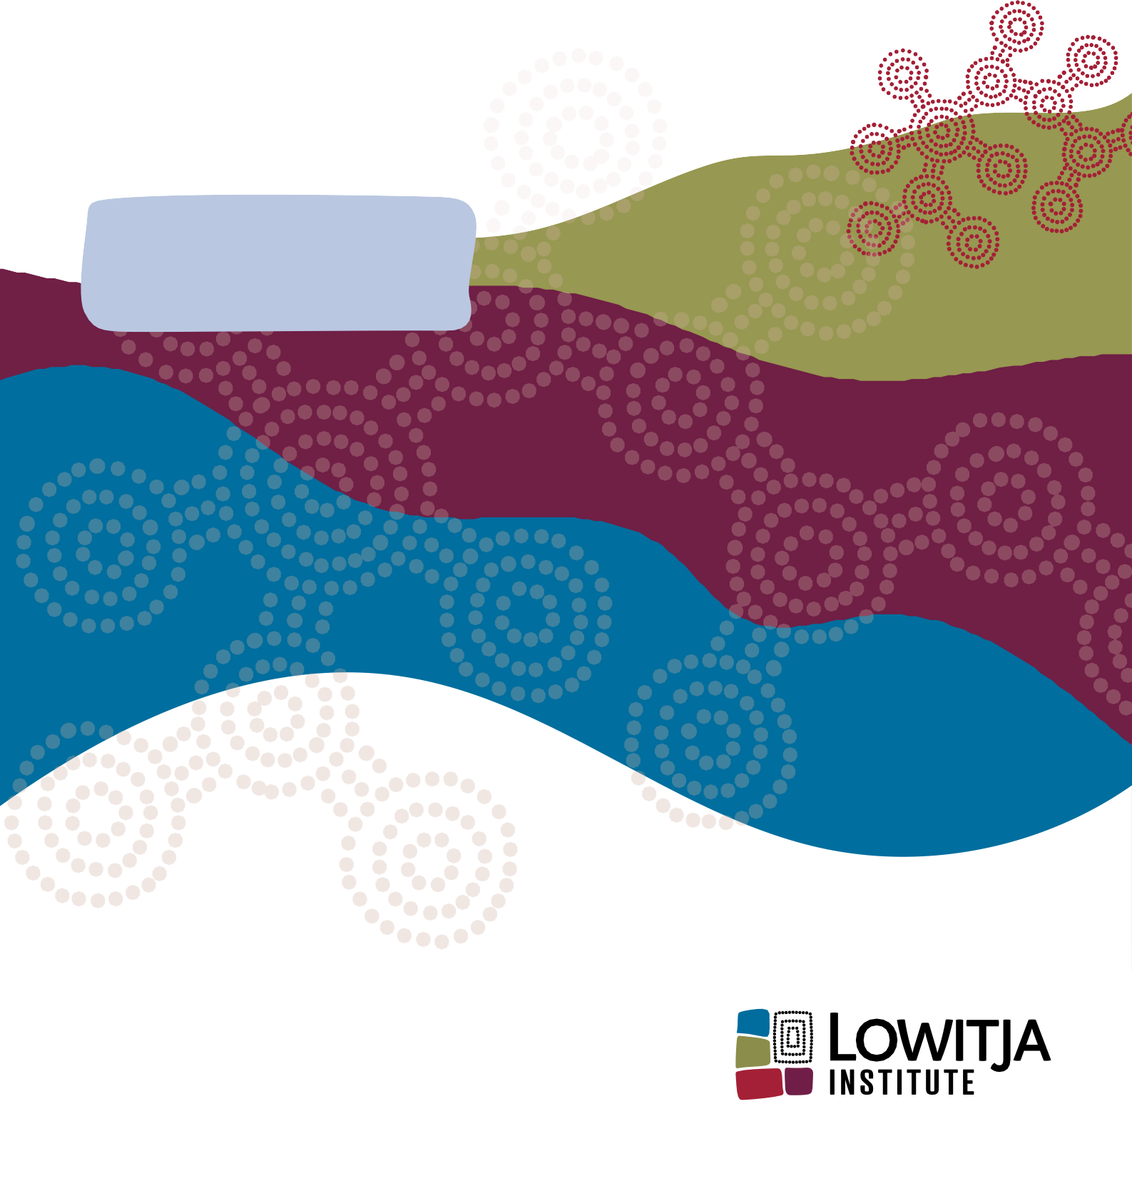
OUTCOMES REPORT
July 2024

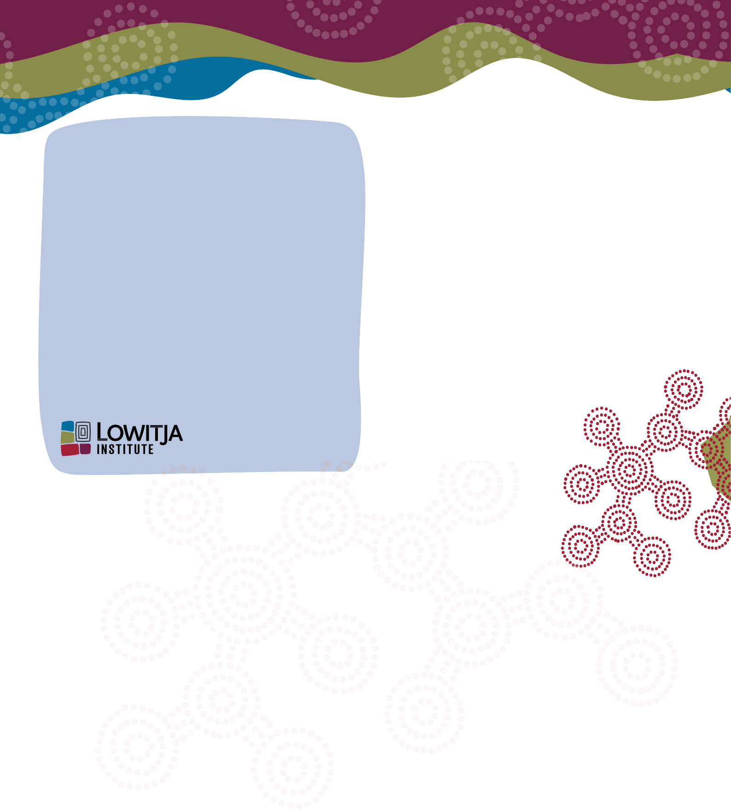
About Lowitja
Lowitja Institute is Australia’s only national Aboriginal and Torres Strait Islander community-controlled health research institute. Named in honour of its Patron, Dr Lowitja O’Donoghue AC CBE DSG, it works for the health and wellbeing of Australia’s Aboriginal and Torres Strait Islander peoples through high impact quality research, knowledge exchange, and by supporting a new generation of Aboriginal and Torres Strait Islander health researchers.
Established in January 2010, Lowitja Institute operates on key principles of Aboriginal and Torres Strait Islander leadership, a broader understanding of health that incorporates wellbeing, and the need for the work to have a clear and positive impact.
Prepared by Lowitja Institute
Graphic Design by Jacq Moon
Photography by Ray Kelly
Digital scribe images by Coolamon Creative
Contact
LOWITJA INSTITUTE
PO Box 1524, Collingwood Victoria 3066 AUSTRALIA
E: admin@lowitja.org.au
W: http://www.lowitja.org.au
Partners
This event was hosted by Lowitja Institute in partnership with Health Ministers and the Commonwealth Department of Health and Aged Care.
Contents
About the Roundtable Event 5
Setting the Scene 6
Closing the Gap 8
Session Overview 8
Discussion Points 8
What were the outcomes of discussion? 8
What further work and action is needed? 14
Building a health system which is culturally safe and free of racism 16
Session Overview 16
Discussion Points 16
What did we hear from the experts? 16
What were the outcomes of discussion? 17
National Definition of Cultural Safety 18
What further work and action is needed? 20
Potential actions and recommendations 20
The National Health Reform Agreement (NHRA) 22
Session Overview 22
Discussion Points 22
What further work and action is needed? 26
References 28

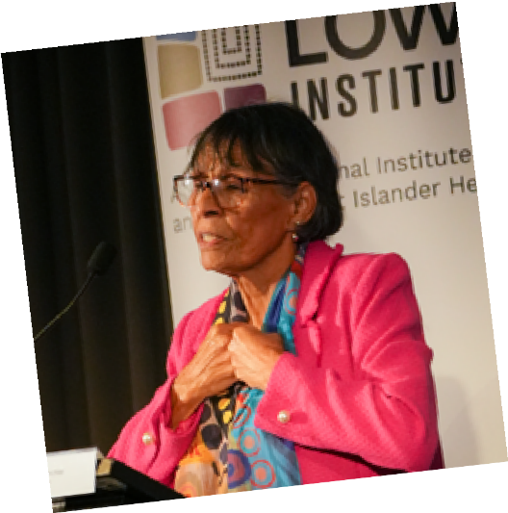
Aunty Violet Sheridan, custodian and Senior Ngunnawal elder
Acknowledgement of Country
Lowitja Institute respectfully acknowledges the Ngunnawal peoples, the Traditional Owners of the land on which this roundtable event was held. Lowitja Institute is grateful for the opportunity to meet in this place and for the generous welcome by Aunty Violet Sheridan, custodian and Senior Ngunnawal elder.

About the Roundtable Event

The Lowitja Institute hosted the Aboriginal and Torres Strait Islander Health Roundtable on Ngunnawal country on 22 March 2024.
The Aboriginal and Torres Strait Islander Health Roundtable brought together Health Ministers and Chief Executives, Aboriginal and Torres Strait Islander Collaboration Group members, NACCHO and Affiliates, the National Health Leadership Forum members, and other Aboriginal and Torres Strait Islander experts to discuss current and future health policies, strategies, and reforms.
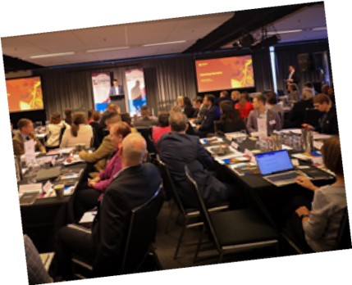
2024 Aboriginal and Torres Strait Islander Health Roundtable – Opening Addresses
The vision for the day was one of collaboration. Participants came together not being scripted, not already knowing the answers, but with the agreed understanding that our systems need to transform if we are to make real progress in improving health and wellbeing outcomes for Aboriginal and Torres Strait Islander peoples. The day was about listening to Aboriginal and Torres Strait Islander voices and leaders to help shape meaningful commitments to system transformation.
The Aboriginal and Torres Strait Islander Health Roundtable had a specific focus on the following topics identified by the Aboriginal and Torres Strait Islander Collaboration Group through input from the Aboriginal and Torres Strait Islander community controlled health sector:
- Closing the Gap
- Building a health system which is culturally safe and free of racism
- The National Health Reform Agreement (NHRA).
The desired outcomes from the Aboriginal and Torres Strait Health Roundtable were closely linked to the focus areas and included:
- Health Ministers and Governments recommit to working in partnership with Aboriginal and Torres Strait Islander peoples to implement the priority reforms detailed within the National Agreement on Closing the Gap.
- The voices and knowledge of Aboriginal and Torres Strait Islander peoples are elevated and centred in scoping the potential features of national cultural safety standards.
- Priorities for future negotiations on the National Health Reform Agreement (NHRA) are identified by Aboriginal and Torres Strait Islander peoples.
The Health Roundtable was facilitated by Dan Bourchier, a multi-award-winning journalist and broadcaster with the ABC. It featured a range of keynote addresses, designed to enable Aboriginal and Torres Strait Islander peoples to share their experience and expertise with each other and governments, as well as to identify priority areas where parties can work together and in partnership to achieve better outcomes.
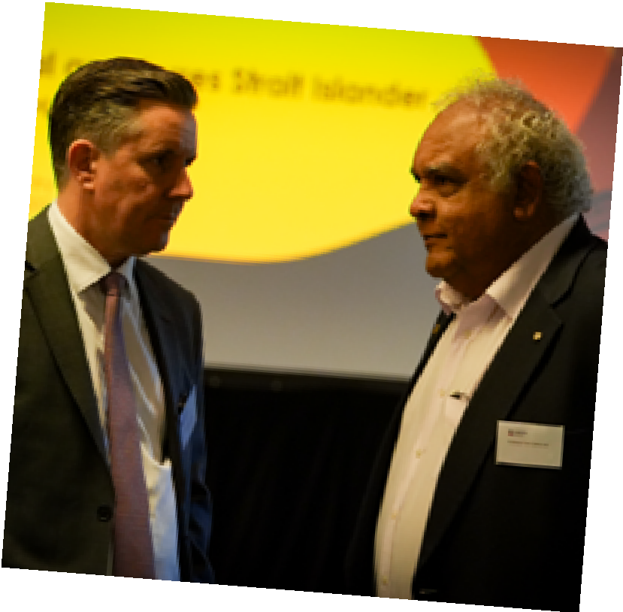
L to R: Hon. Mark Butler, Minister for Health and Aged Care and Professor Tom Calma AO

Setting the Scene
The Aboriginal and Torres Strait Islander Health Roundtable opened with an address from Lowitja Institute chairperson, Mr Selwyn Button, who set the scene for the day and paid tribute to Lowitja Institute’s patron and namesake, the late Dr Lowitja O’Donoghue.
Sharing the values that Dr O’Donoghue bestowed upon the Institute, Mr Button reminded attendees of Dr O’Donoghue’s legacy, being that her work was always for her people, and the successes she had were the grounded in her commitment to ensuring Aboriginal and Torres Strait Islander peoples had the opportunity to engage in guiding conversations with governments.
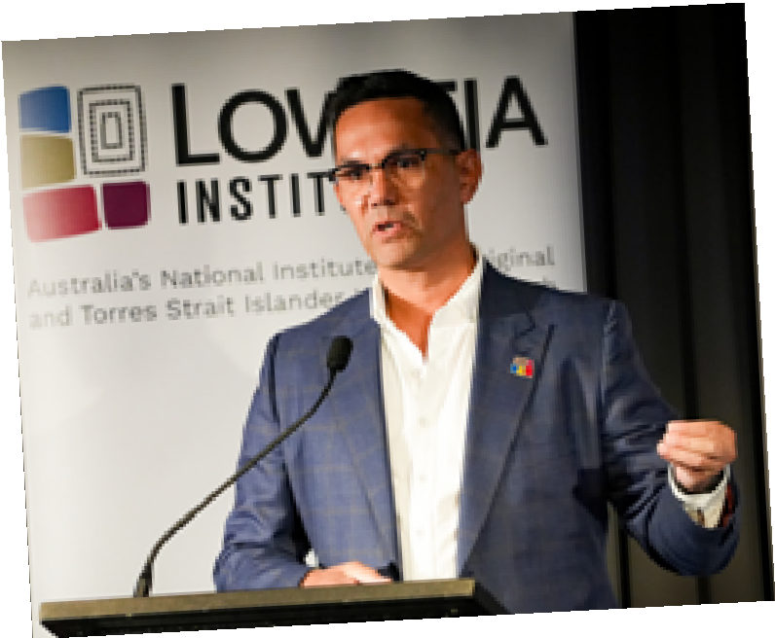
Mr Selwyn Button, Board Chair, Lowitja Institute
In opening the day, participants also heard from the Hon. Rachel Stephens-Smith MP, ACT Minister for Health, Minister for Children, Youth and Family Services, Minister for Disability and Minister for Aboriginal and Torres Strait Islander Affairs, and the Hon. Mark Butler, Commonwealth Minister for Health and Aged Care.
Minister Butler expressed his government’s ongoing commitment to closing the gap through supporting action towards the Priority Reforms. In reflecting on the latest Review of the National Agreement on Closing the Gap report^{i}, released by the Productivity Commission in January 2024, and the lack of progress towards meeting the socio-economic targets, the Minister for Health and Aged Care acknowledged the importance of finding new ways to listen, engage and co-design processes, as well as building the capability and footprint of the Aboriginal and Torres Strait Islander community-controlled health sector.
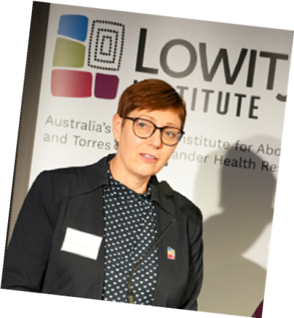
Hon. Rachel Stephens-Smith MP, ACT Minister for Health, Minister for Children, Youth and Family Services, Minister Disability and Minister for Aboriginal and Torres Strait Islander Affairs
These sentiments were echoed by Minister Stephens-Smith, who reaffirmed her commitment to continuing to work to close the gap and remarked on the privilege of sitting at the table alongside Aboriginal and Torres Strait Islander leaders in pursuit of purposeful action and shared decision making. She shared her hope that the roundtable would be an opportunity to ensure that Aboriginal and Torres Strait Islander voices are guiding government action.
Following opening remarks, a special presentation saw the Nous Group, alongside Craig Ritchie from Ngarra Group, present to the group on the National Review of Healthcare in Prisons, including the Terms of Reference and feedback from stakeholders on the discrepancies and barriers to appropriate healthcare inside prisons. The Review so far has included consultation with Peaks groups, Advocacy groups, states and territories, those with lived experience and other key stakeholders.
The Review has revealed Aboriginal and Torres Strait Islander peoples in prison often have complex healthcare needs, undiagnosed mental health issues and neurological conditions, and that these complex care needs must be recognised and reflected in the nature of the services provided. It was noted that commitments within the National Agreement on Closing the Gap, including enacting the Priority Reforms, are noticeably absent in custodial settings, including in system policy design and delivery. The system and experience of care is one of disconnect for many Aboriginal and Torres Strait Islander peoples within these custodial settings – disconnect from both their own health journey and from their families and communities.
Funding and access to Medicare in prison was raised by speakers as a significant barrier to accessing care, as were workforce challenges, including a lack of training opportunities across the system to ensure a streamlined and sustainable workforce pipeline.
The final report, due in mid-2024, will deliver a set of prioritised recommendations for reform to improve the health outcomes for Aboriginal and Torres Strait Islander peoples in custodial settings. During participant discussions, particularly in discussions amongst SA participants, the lack of culturally safe care in the prison setting, as well as a distinct lack of any continuity of care on discharge was also noted as a barrier to accessing care.
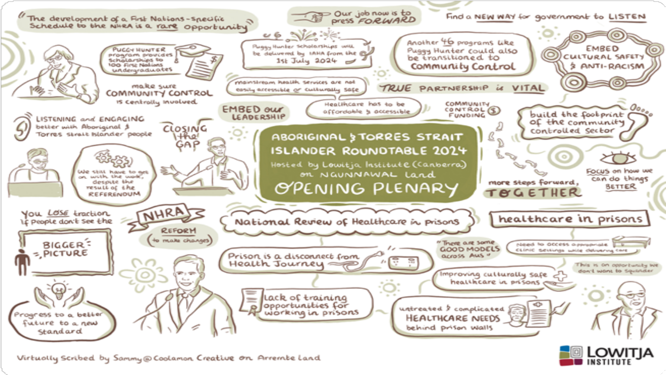


Closing the Gap

Session Overview
This session provided an opportunity to reflect on progress to date in implementing the priority reforms with the National Agreement on Closing the Gap, and the priority reforms’ potential impact on overcoming the health inequities experienced by Aboriginal and Torres Strait Islander peoples.

Discussion Points
Discussions focused on:
- Progress on priority reforms
- Potential impact of the priority reforms on health outcomes
- Areas for improved action in implementing the priority reforms.

What did we hear from the experts?
Donnella Mills, a proud Torres Strait Islander woman, representative of the Coalition of Peaks and Chair of the National Aboriginal and Torres Strait Islander Community Controlled Health Organisation (NACCHO) presented in this session. Donnella spoke on how to improve progress and action towards meeting the targets within the National Agreement on Closing the Gap. Notably, she called out the huge, $4.4 billion funding gap between community controlled and mainstream services, reminding those in attendance that the health gap cannot be closed in a realistic way if this funding gap persists, and that to address this the Aboriginal community controlled health sector must get its fair share of the mainstream funding envelope.
Donnella noted that more support is needed to address the health workforce crisis and governments must draw on the model and wisdom of Aboriginal and Torres Strait Islander community controlled health organisations.
Donnella reiterated calls for the full implementation of the National Aboriginal and Torres Strait Islander Health Plan 2021-2031^{ii}, and for governments to renew their commitment to the National Agreement on Closing the Gap. Full system transformation is required in hospital systems – and health systems more broadly –to address the barriers faced by Aboriginal and Torres Strait Islander people, and this reform must be led by Aboriginal and Torres Strait Islander communities and organisations.
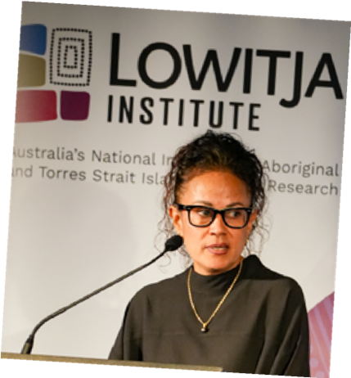
Donnella Mills, Chair of NACCHO
“ACHOs (Aboriginal and Torres Strait Islander community-controlled health organisations) are a living example of the Priority Reforms as they are a model that is designed and managed by communities themselves. Our ACCHOs have a major leadership role to play. We have been leading the way for over fifty years, and it’s taken government more than fifty years to recognise the power of ACCHOs in achieving health outcomes for our peoples.”
Donnella Mills

What were the outcomes of discussion?
Conversations in this session were in part reflective, with jurisdictions looking at the main reform initiatives they had commenced under the National Agreement on Closing the Gap’s frameworks, and in part forward-looking, in terms of considering what else still needed to be done to advance the Priority Reforms.
There was great enthusiasm around the topic of the National Agreement on Closing the Gap generally, with some jurisdictions also focusing in closely on the Special Presentation regarding healthcare in custodial settings, particularly the lack of culturally safe care in prisons and the lack of any continuity of care on discharge. Both topics were clearly of enormous importance to participants and conversations demonstrated a strong appetite for reform.
In terms of what has worked well under the National Agreement on Closing the Gap so far, what still needs to be done, and the challenges that governments and Aboriginal and Torres Strait Islander community controlled health organisations face along the way, much of the conversation reflected similar priorities and concerns as those highlighted in the Productivity Commission’s first three-yearly Closing the Gap Review^{iii}.
Overarching themes that emerged from breakout discussions included:
- Continuing to build the capacity of both governments and Aboriginal and Torres Strait Islander community controlled health organisations.
- The importance and key characteristics of strong, genuine partnerships.
- The need for further reform of funding mechanisms.
- Accountability and transparency as key drivers of trust.
- Whole-of-system reform as an essential step in transforming government organisations and eradicating institutional racism.

Building the capacity of governments and the Aboriginal and Torres Strait Islander community-controlled health sector
Many jurisdictions acknowledged that there remains an unmet need for all government agencies to develop a consistent, shared understanding of what is required by the National Agreement on Closing the Gap. Victoria flagged that while there are often strong relationships with Aboriginal and Torres Strait Islander community-controlled health organisations and excellent intentions at the level of Ministers and Departmental leadership, these do not always filter down to the service delivery levels of government agencies sufficiently.
Similarly, Tasmania observed that service-delivery government organisations (such as public hospitals) need to develop an understanding of the National Agreement equal to that held by Departments, Aboriginal and Torres Strait Islander community-controlled health organisations and policy specialists. Without this shared understanding, parties to the National Agreement will not be able to achieve the most effective engagement, co-design or collaboration. Tasmania also emphasised that all government staff have a responsibility to help close the gap in their work, rather than this being merely a discrete task for individual people who specialise in Aboriginal and Torres Strait Islander health.
It was also broadly accepted by jurisdictions that governments have significant work to do on their capacity to coordinate and collaborate across portfolios. NSW, Queensland, WA, SA and national representatives all reflected on examples of strong bilateral partnerships existing between individual agencies and Aboriginal and Torres Strait Islander peak organisations, which then faced major difficulties linking in with other government agencies.
Healthcare in custodial setting was held up as a key example of where cross-portfolio collaboration between health departments and justice/ correctional departments is urgently needed.
Representatives from SA and ACT spoke at length about the need for governments to support Aboriginal and Torres Strait Islander community-controlled health organisations to build sustainable capacity through upskilling, upscaling and infrastructure investment. Concerns were expressed that many governments have not yet demonstrated a coherent strategy for building and strengthening the community-controlled health sector in accordance with Priority Reform Two, despite the existence of four Sector Strengthening Plans. It was agreed that to best support the strengthening of the community controlled health sector, government must assess support needs discretely across organisations – levels of scale, capacity and experience vary greatly.
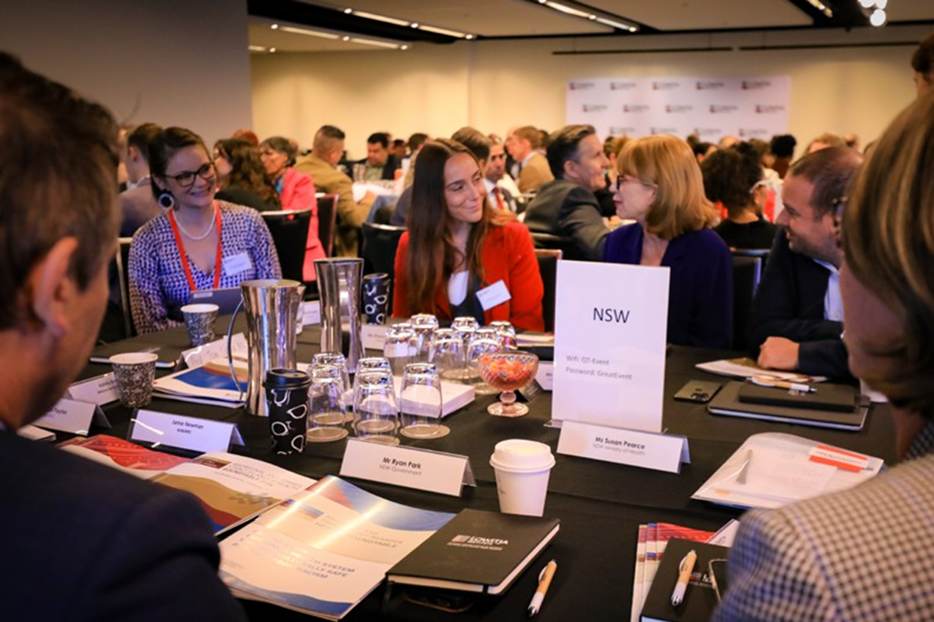

Strong partnerships
Several jurisdictions reflected on the importance of formalised partnership structures for effective collaboration between governments and Aboriginal and Torres Strait Islander community-controlled organisations, both within and outside the National Agreement on Closing the Gap framework. NT representatives noted, as an example, that the NT Aboriginal Health Forum (which includes Australian Government, NT Government and ACCHO representation) has already overseen the transition of 10 health services to community control over 12 years through the Pathways 2 Community Control program. SA representatives also noted that one of their first priorities in implementing the National Agreement had been to develop a formal State Partnership Agreement on Closing the Gap, which now provides the overarching framework for all State-level activities under the National Agreement.
Other jurisdictions, including NSW and Tasmania, discussed the need for new partnerships in specific areas of health policy and practice, such as clinical care and scaled-up transitions to community control. It was also noted that effective partnerships require all partners to have clarity and a shared understanding of the purposes, goals, monitoring and evaluation of any initiatives carried out by the partnership. Further, Victorian representatives highlighted a critical need to acknowledge and redress the power imbalances between government parties and Aboriginal and Torres Strait Islander community-controlled organisations in order to support strong partnerships based on mutual trust and respect – partnerships that genuinely involve sharing power for co-design. NSW noted the need for improved coordination and collaboration across portfolios such as disability. Noting the need for governments to commitment to implement the recommendations for reform included in the Final report of the Royal Commission into Violence, Abuse, Neglect and Exploitation of People with Disability.
Finally, Queensland, Tasmania and ACT noted that high-functioning partnerships are built on strong relationships of mutual respect and a genuine interest in what each partner’s work entails. It was mooted that these relationships (between government agencies and Aboriginal and Torres Strait Islander community-controlled health organisations) do not yet have enough strength or longevity in many jurisdictions
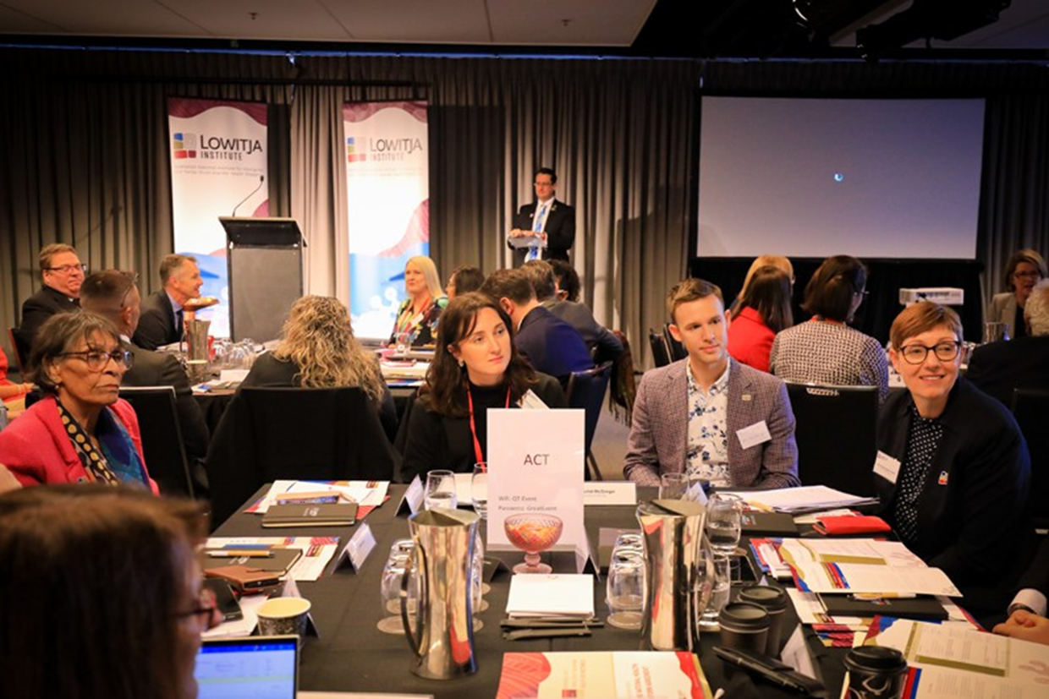

Funding mechanisms
All jurisdictions discussed the pivotal role of funding in enabling governments and Aboriginal and Torres Strait Islander community-controlled health organisations to achieve progress against the Priority Reforms, and in supporting Aboriginal and Torres Strait Islander health more broadly. Representatives from QLD, SA, NSW and Tasmania flagged that Aboriginal and Torres Strait Islander community-controlled health organisations needed greater stability, longevity and predictability of core funding – rather than short-term, project-based funding envelopes – in order to plan for the long-term future and develop mature, sustainable workforces.
Meanwhile, representatives from WA, ACT and NT highlighted that significant gaps continue to exist between the per-capita funding received by Aboriginal and Torres Strait Islander community-controlled health organisations and that allocated to mainstream health services, contrary to some explicit commitments in the National Agreement on Closing the Gap (such as clause 55).
As had also been noted in Donnella Mills’ keynote presentation, representatives agreed that redressing these gaps must be a key priority for governments in fulfilling their obligations under Priority Reform Two.

Accountability and transparency as drivers of trust
All jurisdictions spoke about the role of accountability and transparency in establishing relationships have a strong basis in trust. However, several jurisdictions’ Aboriginal and Torres Strait Islander community-controlled health organisation representatives argued that government parties are still not being genuinely held accountable for their actions under the National Agreement if there are no consequences for failure, including in health systems. It was agreed in VIC, NSW and NT discussions that, for Aboriginal and Torres Strait Islander communities to maintain trust in governments, they need to see concrete change on the ground. VIC representatives also proposed that Cabinet and budget processes need to incorporate Closing the Gap ‘impact statements’ as a key hurdle, similar to how environmental or gender impacts are currently assessed in some contexts, in order to demonstrate that the National Agreement on Closing the Gap is being given sufficient weight in policymaking overall.
In terms of a need for new accountability mechanisms, ACT and NT representatives both pointed to clause 67 of the National Agreement, which commits all governments to establishing an Independent Mechanism to monitor and report on the transformation of government institutions under Priority Reform Three. These Independent Mechanisms were spoken about as being key future structures for holding governments accountable to their commitments and ensuring transparency. ACT representatives stated that these Mechanisms should be appropriately funded and host a majority Aboriginal and Torres Strait Islander membership that is representative of the local community and/ or region, be accountable to their community, and be independent from State and Commonwealth Public Service agencies. For existing accountability mechanisms, NT representatives viewed the ACT’s Aboriginal and Torres Strait Islander Elected Body as a strong example of a structure for representation and accountability, albeit one that was established outside of the National Agreement’s frameworks.
VIC and ACT also highlighted the importance of sharing relevant, reliable, granular data for accountability –not only between health departments and Aboriginal and Torres Strait Islander community-controlled health organisations, but also in terms of data held by Local Health Networks/Districts and Primary Health Networks. Several Aboriginal and Torres Strait Islander community-controlled health organisations flagged that government agencies had still not commenced publishing (or even collecting) certain datasets that were of highest priority to Aboriginal and Torres Strait Islander communities, such as data on suicide and severe mental health concerns.

System reform
It was widely agreed that wholesale reform of health systems – rather than discrete new policies or programs – is essential to operationalising the National Agreement on Closing the Gap’s Priority Reform Three (‘systemic and structural transformation of mainstream government organisations to improve accountability and respond to the needs of Aboriginal and Torres Strait Islander people’). Much of the discussion in this vein focused on identifying and eliminating racism and embedding meaningful cultural safety. Organisational truth-telling, whereby mainstream health organisations reflect critically and honestly on their own biases and perpetration of racism, was flagged as a critical element of anti-racism and cultural safety.
NSW representatives spoke about how we cannot rely on individual/interpersonal racism ‘disappearing’ in order to achieve a culturally safe health system; rather, we need whole-of-system change in order to support organisation-level approaches. SA representatives agreed and discussed their hopes that the new statewide whole-of-SA-Government anti-racism strategy would make a significant contribution towards Priority Reform Three and in developing the capacity of the SA public sector to counteract racism more broadly.

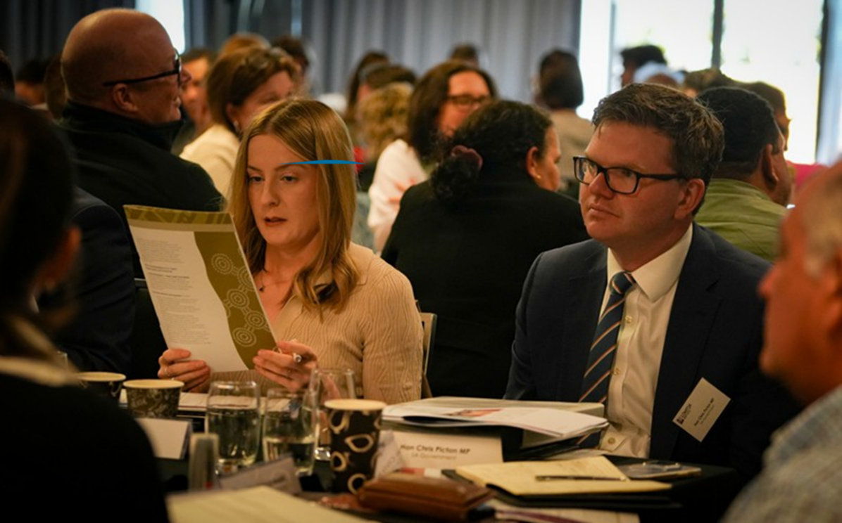
Gemma Paech, SA Government, and the Hon. Chris Picton, Minister for Health and Wellbeing South Australia

What further work and action is needed?
During the breakout discussions, some individual jurisdictional-level actions were identified to accelerate progress against the National Agreement on Closing the Gap and improve healthcare in custodial settings. However, the majority of breakout discussions spoke to potential actions that could be implemented by multiple jurisdictions, or nationally.

Potential actions and recommendation
Based on the breakout discussions, expert advice, and the Productivity Commission’s first three-yearly Review of the National Agreement on Closing the Gap, the following actions are recommended:

- All governments and Aboriginal and Torres Strait Islander community-controlled health peak bodies to accelerate the co-design and establishment of formal, ongoing, fully resourced Aboriginal and Torres Strait Islander health partnership structures in all jurisdictions.
These structures should:
- reflect the strong partnership elements set out in clauses 32 and 33 of the National Agreement on Closing the Gap;
- lead the development of health-specific actions in jurisdictional Closing the Gap Implementation Plans; and
- lead the delivery of relevant jurisdictional actions under the 2021–2031 National Aboriginal and Torres Strait Islander Health Plan, the 2021–2031 National Aboriginal and Torres Strait Islander Health Workforce Strategic Framework and Implementation Plan, and any supporting plans.
- Health departments at the Australian, State and Territory levels to treat Aboriginal and Torres Strait Islander community controlled health organisations as essential partners in the design and delivery of all Aboriginal and Torres Strait Islander-specific health initiatives.
- Health departments at the Australian, State and Territory levels to, wherever possible, review and update funding and contracting rules so that they explicitly incorporate accountability for health system funders to abide by the Closing the Gap Priority Reforms in commissioning processes.
Updates should include:
- Where funding and contracting rules are governed by another department (such as Treasury or Finance), health departments should initiate collaborative work with those departments to scope, plan and implement the changes needed to incorporate the Priority Reforms.
- Amendments to funding and contracting rules should bind health departments to work in ways that further strengthen the Aboriginal and Torres Strait Islander community controlled health sector, including by funding contracts that:
- support Aboriginal and Torres Strait Islander community controlled health organisations to build organisational capacity sustainably over the long term
- cover the full costs of service provision
- minimise administrative burden by avoiding duplication in reporting and accountability requirements
- allow communities to determine what performance indicators would best represent improved outcomes
- oblige funding agencies to share data with Aboriginal and Torres Strait Islander community controlled health organisations to enable them to do their work effectively.
- Health departments at the state, territory and commonwealth levels to accelerate progress against Priority Reform Four of the National Agreement on Closing the Gap,and advance the principles of Indigenous Data Sovereignty and Indigenous Data Governance.
- Health departments at the state, territory and commonwealth levels to consider accepting recommendations for reform made by the final report of the National Review of Healthcare in Prisons and commit to working with other relevant departments in their jurisdictions (such as justice and correctional services departments) to consider implementation of those recommendations substantively.
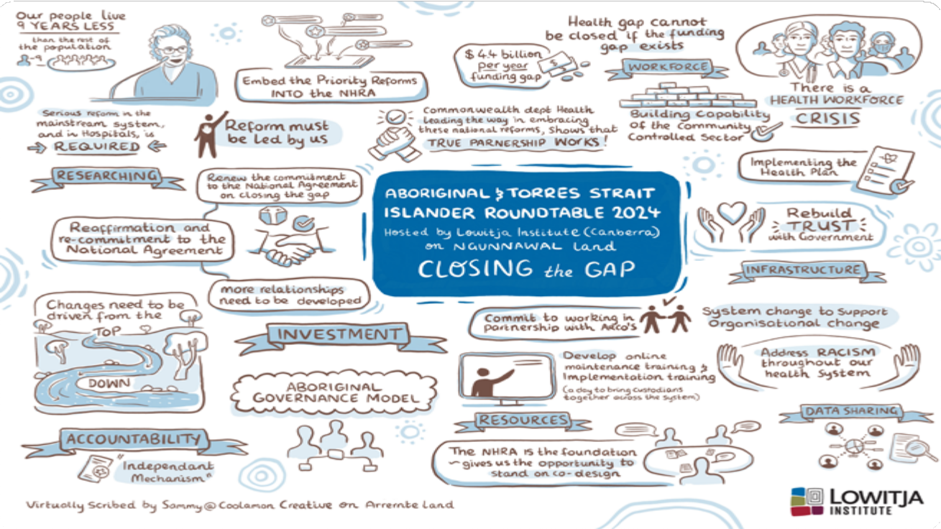

Building a health system which is culturally safe and free of racism

Session Overview
This session included discussions on how we recognise, understand and respond to racism within the health system as a precondition to embedding culturally safe practices and ensuring that Aboriginal and Torres Strait Islander peoples are able to access and benefit from the range of opportunities, programs and services within the health system.

Discussion Points
Discussions focused on:
- Findings from the mid-term review of the NHRA and the opportunity for inclusion of Aboriginal and Torres Strait Islander priorities, along with an overview of the approach of governments to developing an Addendum to this Agreement.
- Exploring how stakeholders could leverage the NHRA to drive outcomes under the National Agreement on Closing the Gap.
- Exploring opportunities for Aboriginal and Torres Strait Islander community-controlled health organisations to be acknowledged as critical partners in the health system through the NHRA.

What did we hear from the experts?
This session featured two keynote presentations, the first of which was from Professor Ray Lovett, who is a Wongaibon and Ngiyampaa man, the Study Director of Mayi Kuwayu and a social epidemiologist at the Australian National University. Professor Lovett spoke to interpersonal, internalised and systemic racism,reflecting on the significant increase in experiences of racism faced by Aboriginal and Torres Strait Islander peoples before, during and after the 2023 Referendum on establishing a Voice to Parliament.
Professor Lovett talked about having moved beyond a public health emergency of racism, into a public health crisis, and pointed to Mayi Kuwayu data to evidence this. One in five Aboriginal and Torres Strait Islander respondents to the Mayi Kuwayu study answered that they feel unsafe in healthcare settings. Results of this study also revealed that Aboriginal and Torres Strait Islander people’s exposure to discrimination increased considerably (about 5 percentage points) during the 18 months leading up to the referendum, both within the heath system and more broadly. This is the case for both individual interpersonal discrimination and healthcare discrimination.
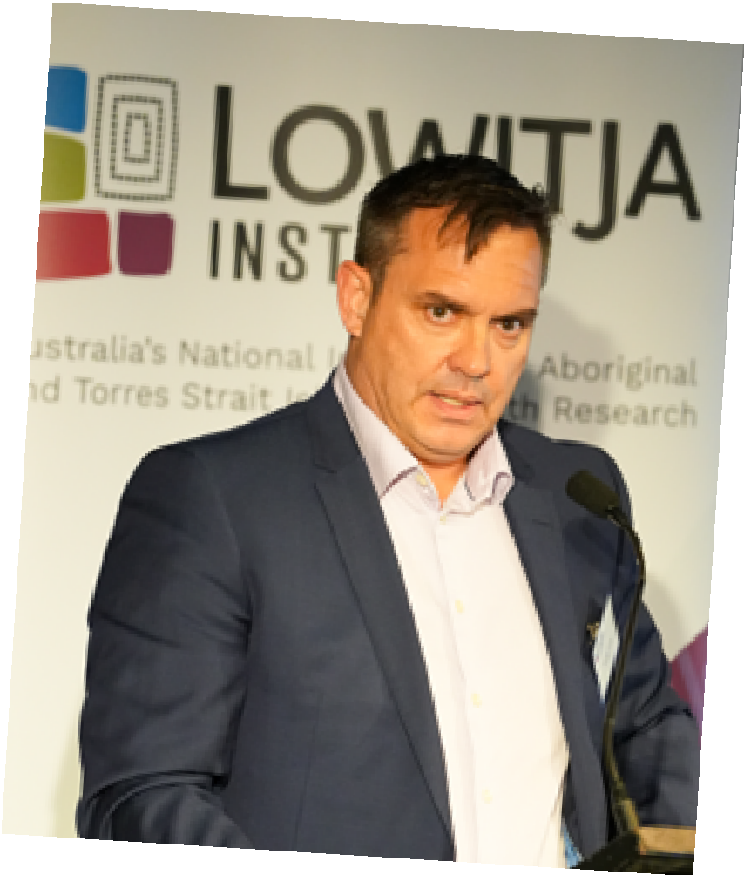
Professor Ray Lovett, Study Director of Mayi Australian National University
“People are part of systems… racism perpetrated by individual people can be amplified by the system in which it takes place.”
Professor Ray Lovett
Professor Lovett called upon governments to adopt a systems approach to addressing this crisis and the critical role that a racism accountability framework plays, both in enabling systems approaches and in tackling the problem of racism in our communities more broadly. This will also be necessary in implementing Priority Reform Three of the National Agreement on Closing the Gap.
Addressing racism with a systems approach will require significant investments of both funding and time. It will require professional development and cultural safety training for all staff within the health system to be embedded, alongside a process for culturally safe implementation reporting and a process for reporting experiences of racism. These accountability processes must also include a monitoring framework that tracks manifestations of racism and efforts to address it, including the enaction of necessary and appropriate consequences for staff who enact racist behaviours.
Jayde Fuller, National Director of Aboriginal and Torres Strait Islander Health Strategy at the Australian Health Practitioners Regulation Agency (AHPRA), followed on from Professor Lovett, sharing AHPRA’s definition of cultural safety and approach to embedding cultural safety in accreditation standards for health professionals. Jayde noted that a consistent definition for cultural safety at AHPRA was developed with Aboriginal and Torres Strait Islander leadership at the centre and has fostered a common understanding and shared language amongst health practitioners on what cultural safety is and how it must be embedded in the work they do.
APHRA’s work aims to alleviate siloing and set the standards on what a baseline for cultural safety must look like, with the aim that a shared language and understanding will allow for a consistent approach to cultural safety and addressing discrimination and racism across the health system.

What were the outcomes of discussion?
Conversations amongst all participants were action-focused with a clear commitment to cultural safety and accountability. All the breakout discussions were keenly focused on the agenda topics demonstrating the importance of these topics to participants and a desire for action following the roundtable. In 2023 the mid-term review of the NHRA made recommendations to inform future reforms. The NT breakout discussion strongly endorsed the mid-term review’s recommendation 38^{vi}, which is:
- Some clear overarching themes emerged from the breakout discussions, which included calls for:
- A national definition of cultural safety
- National cultural safety standards
- Standardised and mandated cultural safety training with auditing
- Monitoring and data on cultural safety training and results
- Government departments to work cross-portfolio and ensure systemic reform
- Strong leadership and accountability.

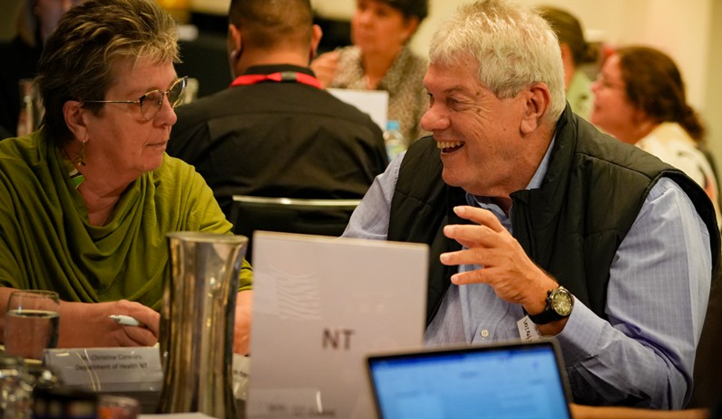

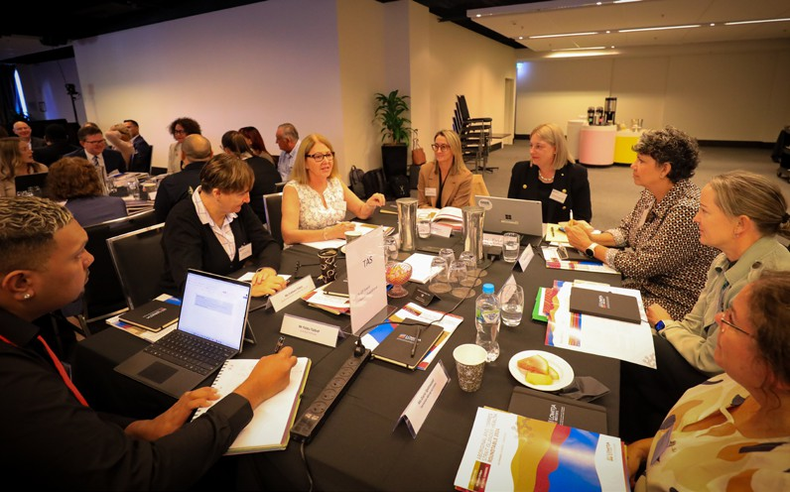

National Definition of Cultural Safety
The majority of jurisdictions agreed that an endorsed national definition of cultural safety is required. The NHRA was identified as a potential frontline mechanism to achieve this. NT representatives noted there was also a need to have a national definition of racism, as anti-racism work is inherent to understanding and ensuring cultural safety.
It was noted by WA participants that the Cultural Respect Framework 2016-2026, prepared by Australian Health Ministers’ Advisory Council’s National Aboriginal and Torres Strait Islander Health Standing Committee, provides a definition of cultural safety currently which is widely used across the state.

Implementing cultural safety standards
Several jurisdictions highlighted that national cultural safety standards should have broad application and reach. They should apply to non-Indigenous organisations, primary health care services and Aboriginal and Torres Strait Islander organisations, such as Aboriginal Medical Services, alike. They need to apply to all health professionals, including those in primary healthcare such as General Practitioners, and those doing locum work.
WA and QLD suggested that cultural safety standards should be embedded in accreditation processes and that all relevant stakeholders need to be working together in developing these standards. Key stakeholders identified included AHPRA, the Australian Council of Healthcare Standards, Aboriginal and Torres Strait Islander community controlled health organisations and peak bodies, and the Australian Commission on Safety and Quality in Health Care. At the service level, the ACT suggested a cultural competency framework be developed.
Tasmania and NSW noted that national standards should include addressing unconscious bias. As Professor Ray Lovett noted in the SA breakout discussion, organisations and health services should be required to demonstrate that they are treating all patients with respect and dignity, which would mean that patients with similar conditions should all receive the same quantity and quality of care. When Aboriginal and Torres Strait Islander patients are not receiving the same quantity or quality of care as non-Indigenous patients, this comes from unconscious biases. VIC wanted to see truth-telling about the health impacts of racism so that people understand the risks and how widespread racism is. This was noted as a powerful lever for change. Further, participants discussed the issue of enforceability, responsibility, and penalties for breaching cultural safety standards.
There are two applications for this discussion; there is the need to ensure that Aboriginal and Torres Strait Islander peoples who are health system users are protected from racism within the health system, and there is the need to ensure that Aboriginal and Torres Strait Islander healthcare professionals are not exposed to racism at work.
On the first, NSW suggested an evaluation of current processes and repercussions for racism in the health system and the subsequent development of a practical way that Aboriginal and Torres Strait Islander people can report racism. This process needs to be culturally appropriate and safe. Further, it was noted that Aboriginal and Torres Strait Islander people should receive education about what they can expect in terms of the level of culturally safe care they should experience in a healthcare setting, so that cultural unsafety and racism in the system can be properly identified and Aboriginal and Torres Strait Islander people are empowered to report it.
Regarding the second, it was noted that, as Professor Lovett’s research demonstrates, racism has measurable impacts on health outcomes, so racism in the workplace should be treated as a workplace safety issue. Both Tasmania and the NT wanted to see strict penalties for behaviours; deregistration or criminal penalties were suggested. It was noted that if you fall off a ladder at work, this triggers serious repercussions; the same should be true for racism at work.
QLD was mentioned as an example that could be replicated nationally; in January 2024, the state issued a health service directive (HSD) under the Hospital and Health Boards Act 2011 (Section 47), which requires all Hospitals and Health Service (HHSs) to develop First Nations Health Equity Strategies and associated implementation plans.

Cultural safety training
Participants discussed the need for capability building and extending, refining, and strengthening mandatory cultural safety training, particularly for allied health and administrative staff, and also locum staff. These roles are often first points of contact for patients, and it is therefore vital that those performing these roles are trained in cultural safety. It was noted that competency in cultural safety should be an entry point for all healthcare professionals.
Further, NT, WA and QLD participants all discussed the importance of ensuring that cultural safety training is standardised and includes anti-racism content; this must be supported by a set of quality standards which can be regularly reviewed and evaluated for effectiveness. Further, Tasmania and ACT participants specifically noted that mandatory training should be more frequent than the current 5-year cycle. On a cautionary note, VIC representatives discussed how mandatory training can come with the risk of resentment, so there is a need to carefully consider how to implement mandatory training in a way that mitigates against this risk. QLD and NT participants wanted to see regular cultural safety assessments of staff and suggested that AHPRA could develop clinical assessments for clinical staff or implement cultural safety tools in AHPRA registrations.
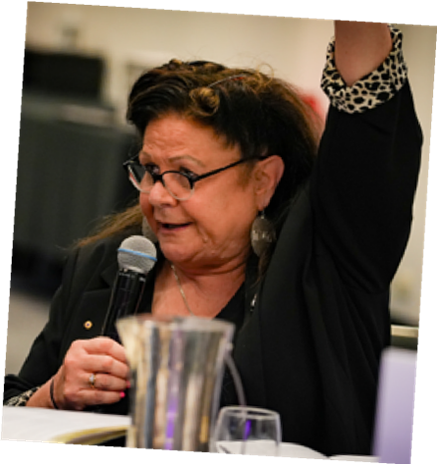
Jill Gallaher, CEO VACCHO

Leadership and accountability
The importance of leadership and accountability in creating change was discussed by many jurisdictions.
NSW and ACT discussed the importance of non-Indigenous people having champion roles in driving change. Further, it was noted by many jurisdictions that a whole-of-system reform is required; this means that the siloing of government departments needs to cease, and departments beyond health must all work together on this task. A systemic approach is required, which needs to be Aboriginal and Torres Strait Islander-led.
Cultural safety needs to be embedded in systems, and in clinical governance, which brings in AHPRA as a key stakeholder.
VIC suggested looking at the success of the Rainbow Tick accreditation process for a possible approach regarding cultural safety and suggested including a cultural safety criterion in Reconciliation Action Plans.
Further, national cultural safety standards would need to be measurable and reported on with appropriate key performance indicators. They must also be accompanied by a robust implementation plan. Potential indicators that were discussed included: clinical outcomes, such as [greater access] to [higher quality healthcare]; burden of illness and injury; rate of early or preventable deaths. South Australia discussed how a measure of cardiac re-vascularisation could be a useful example of a data point for comparison between Aboriginal and Torres Strait Islander and non-Indigenous patients. It was noted that primary care is currently a blind spot for data.

What further work and action is needed?
During the breakout discussions, some individual jurisdictional-level actions were identified. However, the majority of the breakout discussions spoke to potential actions that could be implemented by multiple jurisdictions, or nationally.

Potential actions and recommendations
Based on the breakout discussions and expert advice, the following actions are strongly recommended:
- The Commonwealth Department of Health and Aged Care adopt a national definition of cultural safety, which includes a definition of racism. In adopting a national definition the Commonwealth Department of Health and Aged Care should engage with key stakeholders such as Joint Council, the National Indigenous Australians Agency and the Coalition of Peaks to leverage existing work. In adopting a national definition, the following considerations should be embedded:
- Ensure that the definition is developed in co-design with Aboriginal and Torres Strait Islander experts, who are empowered to lead the process.
- Investigate including the new definition in the NHRA via the new Schedule and commit toa plan for the above to ensure that the definition is developed concurrently with the new Schedule.
- Investigate a national accreditation scheme to support widespread adoption of the national cultural safety standards.
- Develop an implementation plan which details how the national definition is adopted in relevant policies and by all stakeholders across each jurisdiction to ensure national consistency.
- All governments at the state, territory and commonwealth level to work in partnership with Aboriginal and Torres Strait Islander community controlled health organisations and experts to develop cultural safety standards to be applied nationally, which should have broad application and include primary health. This would include:
- The development of a framework for monitoring and evaluating the efficacy of the national cultural safety standards. This would include:
- A set of key performance indicators that requires input and action from all jurisdictions.
- A reporting schedule for all jurisdictions to monitor and review implementation of the standards.
- A national audit tool and auditing schedule to measure racism in hospitals.
- Undertake truth-telling at a national and state and territory level around Australia’s history and the experiences of Aboriginal and Torres Strait Islander peoples.
- Commonwealth Department of Health and Aged Care to facilitate a roundtable that brings together all relevant government departments, across all jurisdictions, to discuss how to work cross-portfolio in implementing cultural safety in health systems. Relevant stakeholders would include but are not limited to the National Indigenous Australians Agency, State and Commonwealth Education Departments and other education stakeholders. The focus of this roundtable would be to:
- Investigate updating education curriculums for undergraduate health professionals to include cultural safety training.
- Investigate including cultural safety and anti-racism education in schools.
- Relevant healthcare regulators to mandate and standardise cultural safety training for all health service staff, including Allied health, administrative and locum staff. This would include:
- Develop quality standards and auditing process to ensure that cultural safety training is consistent and effective.
- Ensure that training is required regularly and investigate the appropriate frequency for such training.
- Develop regular cultural safety assessments of staff.
- Consult with AHPRA regarding the implementation of cultural safety tools in AHPRA registration processes, and the development of clinical assessments for clinical staff.
- All government departments at the state, territory and commonwealth level with responsibility for workplace health and safety (WH&S) regulation to develop a cultural safety enforcement scheme that penalises racism in the workplace.
- Investigate options for the above, including determining the feasibility of including penalties for racist behaviours in WH&S regulations.
- All governments and Aboriginal and Torres Strait Islander community-controlled health peak bodies to engage with experts and investigate incorporating evidence based questions into consumer feedback surveys of the health system to allow experiences of cultural safety and racism to be accurately measured. An example is those developed as part of the Mayi Kuwayu survey

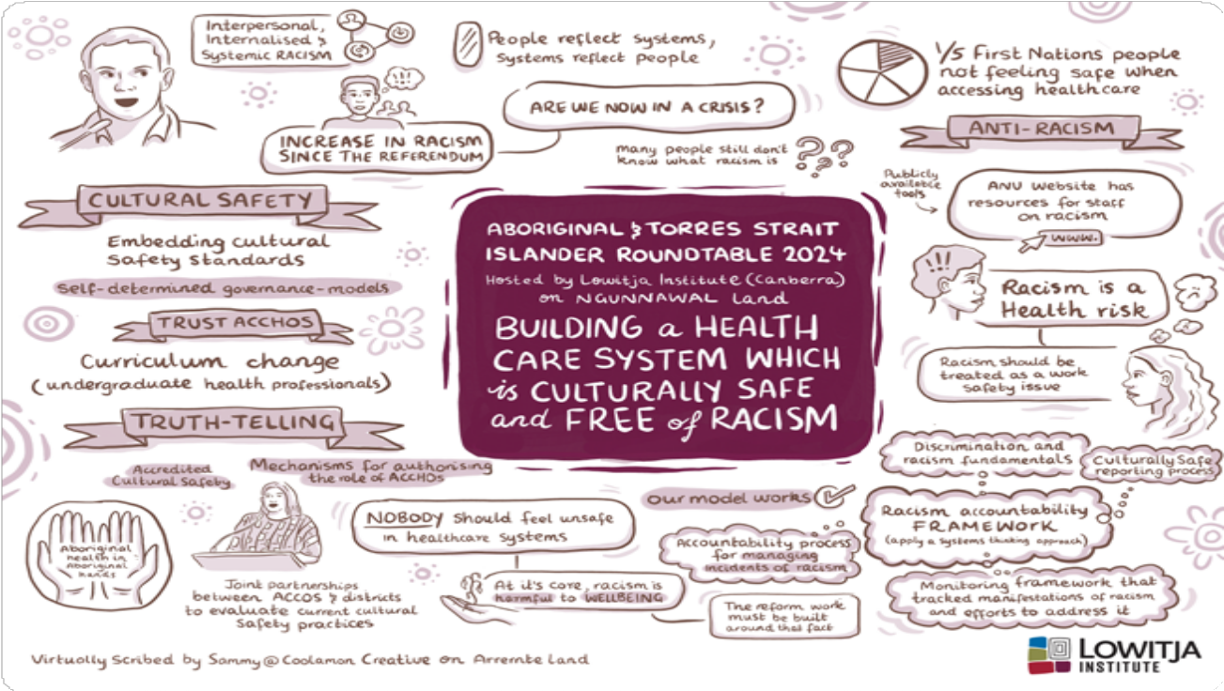

The National Health Reform Agreement (NHRA)

Session Overview
This session explored opportunities for health system reform in the NHRA to address the disparities in health outcomes experienced by Aboriginal and Torres Strait Islander peoples.

Discussion Points
Discussions focused on:
- Findings from the mid-term review of the NHRA and the opportunity for inclusion of Aboriginal and Torres Strait Islander priorities, along with an overview of the approach of governments to developing an Addendum to this Agreement.
- Exploring how stakeholders could leverage the NHRA to drive outcomes under the National Agreement on Closing the Gap.
- Exploring opportunities for Aboriginal and Torres Strait Islander community controlled health organisations to be acknowledged as critical partners in the health system through the NHRA.

What did we hear from the experts?
The National Health Reform Agreement (NHRA) is an inter-governmental agreement between the Commonwealth, State and Territory governments that sets out the shared intention to work in partnership to improve health outcomes for all Australians, by providing better-coordinated and joined-up care in the community, and by ensuring the future sustainability of the Australian health system.
Mr Blair Exell, Deputy Secretary for Health Strategy, First Nations and Sport in the Department of Health and Aged Care, introduced this session, providing an overview of the NHRA. He shared the Commonwealth Government’s commitment to ensuring that updates to the Agreement address the recommendations of the Mid-Term Review of the National Health Reform Agreement Addendum 2020-2025iv (the mid-term review), and are developed through a genuine co-design process with a resulting framework that reflects Aboriginal and Torres Strait Islander peoples’ priorities, perspectives and knowledges.

L to R: Dawn Schofield, IUIH, and Adrian Carson, IUIH
Mr Michael Walsh, Director-General of Queensland Health, and Mr Adrian Carson, CEO of the Institute for Urban Indigenous Health (IUIH), jointly presented on the outcomes of the mid-term review and the opportunity for inclusion of Aboriginal and Torres Strait Islander priorities in the Addendum.
Adrian discussed leveraging the NHRA to drive progress against the National Agreement on Closing the Gap and the need to embed the Aboriginal and Torres Strait Islander community controlled health sector’s values and models to achieve this. This would include changes to address the equity of health funding, moving beyond the Medicare benefit scheme (MBS) and grant-based funding for Aboriginal and Torres Strait Islander community controlled health organisations, and leveraging the capacity of the sector to deliver optimal care pathways. Another key element would be sharing and linking data and embedding Indigenous Data Sovereignty and Governance principles.
Finally, Adrian noted the importance of enabling self-determination through Aboriginal and Torres Strait Islander community controlled commissioning, and shared the Birthing in Our Community (BiOC) model as a case study of good practice.
“We know Aboriginal community controlled health services work better for our communities and are more cost-effective... you can’t afford not to invest in community control.”
Adrian Carson
Monica Barolits-McCabe, Acting Deputy CEO of the National Aboriginal Community Controlled Health Organisation (NACCHO), concluded this session’s presentations, reminding attendees of the value of Aboriginal and Torres Strait Islander wisdom and leadership. Mainstream healthcare services do not meet the needs of Aboriginal and Torres Strait Islander peoples as they should, with discharge against medical advice or ‘failure to complete care’ rates an example that clearly indicate many Aboriginal and Torres Strait Islander patients do not feel safe or receive adequate medical care. These rates are increasing for Aboriginal and Torres Strait Islander peoples, with one in 25 hospital visits over the period 2019–2021 ending in a decision to leave carev. In contrast, Aboriginal and Torres Strait Islander community controlled health organisations are built on the social and cultural determinants of wellbeing and are inherently culturally safe.
“Trust Aboriginal community controlled health services. It is Aboriginal health in Aboriginal hands.”
Monica Barolits-McCabe

What were the outcomes of discussion?
The Commonwealth Department of Health and Aged Care displayed its commitment to an Aboriginal and Torres Strait Islander Schedule in the NHRA, which was well received by participants. Participants conveyed optimism about the opportunity to support implementation of the National Agreement on Closing the Gap, improve funding equity, support the growth and wellbeing of the Aboriginal and Torres Strait Islander health workforce, and establish sound governance and accountability mechanisms via the new NHRA Schedule.
In 2023 the mid-term review of the NHRA made recommendations to inform future reforms. The NT breakout discussion strongly endorsed the mid-term review’s recommendation 38vi, which is:
The critical importance of improving the health of First Nations’ people through the National Agreement on Closing the Gap should be reflected in a future Agreement as an additional Schedule. The Schedule should reflect at least the following:
- A shared commitment to Closing the Gap, working in partnership with First Nations’ people.
- Specific actions to close the health gap with accountabilities assigned and performance assessed against agreed milestones, including cross-cutting targets.
- A shared commitment and requirement to work with ACCHOs and local communities in the design and commissioning of services and transitioning of services to community-control.
- A shared commitment to cultural safety in health service delivery with agreed measurement and reporting, including patient experience indicators.
- A shared commitment to embed appropriate governance of Indigenous data holdings held by all levels of government.
The New Schedule will need to be designed in a way that aligns with the shared whole of Health System Agreement approach. This means that the New Schedule should speak to the new Agreement as a whole and the new Agreement must align with and support the new Schedule^{vii}
Given the themes and content of discussion outlined below, it is clear that the proposed inclusions made by recommendation 38 align with participants’ aspirations.
Breakout discussions were largely focused on these key themes:
- Governance
- Drafting considerations
- Cultural safety
- Monitoring and accountability
- Funding equity
- Workforce
- Partnerships

Governance
The Department of Health and Aged Care’s proposed stakeholder engagement structure was approved during the session. Participants noted a caveat that ensuring local and regional involvement in the structure is essential.
Participants wanted to see Indigenous Data Sovereignty and Governance embedded in the NHRA, which includes but extends beyond the mid-term review recommendation 38(e)viii. NT participants noted that dataset integrity is required to measure the NHRA’s success and for sound decision-making. QLD participants suggested that the NHRA could authorise appropriate data-sharing.

Drafting considerations
A tiered approach was suggested for the negotiating process for drafting the new Schedule, including several groups that report to one another. Key features of these groups should include:
- Aboriginal and Torres Strait Islander leadership, including Coalition of Peaks involvement
- Intersection and engagement with the Aboriginal and Torres Strait Islander Collaboration Group
- A consistent approach and objectives across different groups.
NSW suggested including a Statement of Commitment.

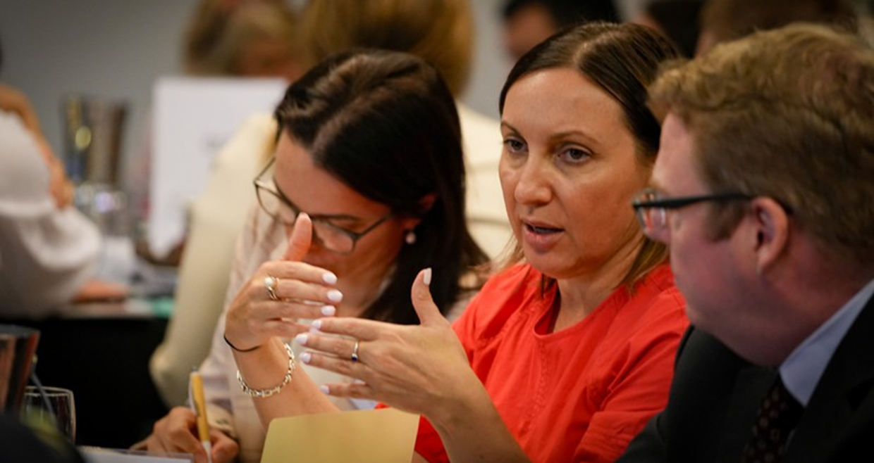
L to R: Melinda Turner and Blair Comley, Commonwealth Department of Health and Aged Care

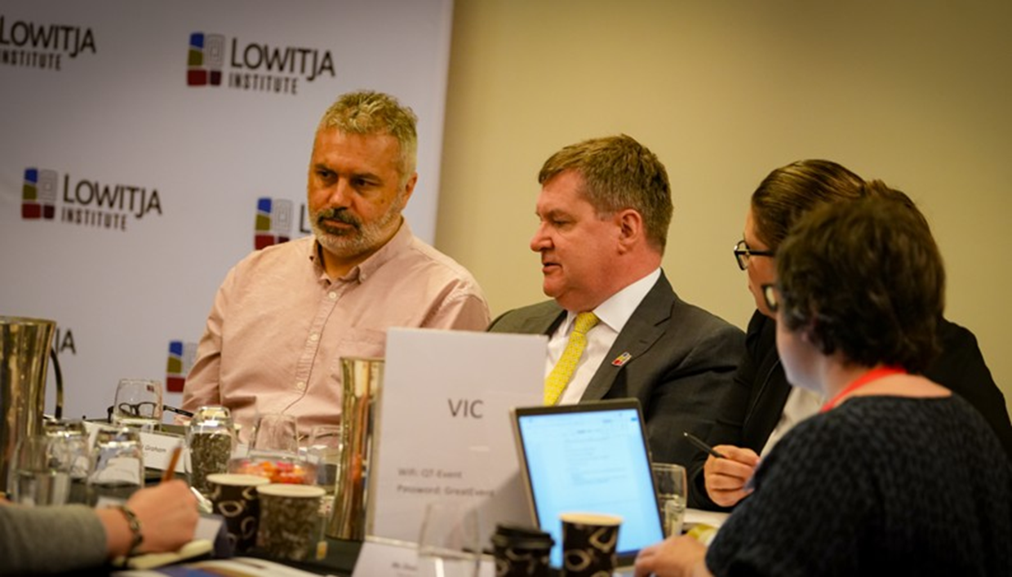
L to R: Michael Graham, VACCHO, and Professor Euan Wallace AM, Victorian Department of Health

Cultural safety
The potential for the NHRA to host a new national definition of cultural safety was raised in session two. This is in line with discussions about the need to embed the National Agreement on Closing the Gap’s principles and Priority Reforms in the new Schedule.

Monitoring and Accountability
Accountability was a strong theme in breakout discussions. As one representative noted, workforce was already included in the NHRA and yet this has not led to results. Accordingly, creating a strong accountability mechanism is going to be essential to ensuring that the new Schedule is effective.
Appropriate indicators need to be developed and outcomes need to be measured, including for cultural safety. Suggested indicators included experiences of racism, proportions of healthcare professionals who have undertaken cultural safety and anti-racism training, and proportions of healthcare professionals across the health system who are Aboriginal and Torres Strait Islander people. It was also suggested that frequency of discharge against medical advice/failure to complete care should be included as an indicator. Other suggestions included service stocktakes and numbers of partnerships. Further, it was noted by participants that indicators are needed against implementation of the National Agreement’s priority reforms to assess the appropriateness of funding allocations.
NT participants suggested that the NT Aboriginal Health Forum could monitor the NHRA in their jurisdiction.

Funding equity
Funding was a major topic for the majority of Commonwealth, State and Territory participants. Key points discussed include:
- Reforming commissioning processes to enable Aboriginal and Torres Strait Islander-led commissioning
- Reviewing primary health network (PHN) funding, especially integrated team care (ITC) funding, to explore where funding could go back to Aboriginal and Torres Strait Islander community-controlled health organisations
- Developing indicators to track funding for priority reforms.
The NHRA was seen as an opportunity to correct power imbalances that currently exist in funding, including a review of the split between Commonwealth and State and Territory funding. In summary, participants indicated a desire for the new Schedule to enable equitable funding decisions that direct funding to the highest areas of need and prioritise preventative healthcare and funding for primary health services. The new Schedule was viewed as an opportunity to facilitate genuine partnerships and trust-building.
Other ideas suggested by participants included:
- A review of the remote/regional/rural definitions, which currently prevent Victoria from being able to access large funding sources.
- Improving the current weightings for rural and remote MBS items due to the higher cost of delivering services in those areas and creating regional (weighted) ‘funding pools’ that could be shared between multiple healthcare organisations in a region to enable economies of scale and support workforce recruitment.
- Consideration of how more opportunities can be created for Aboriginal and Torres Strait Islander community-controlled health organisations to access funding that adequately compensate for the services that they provide. For example, Aboriginal and Torres Strait Islander community-controlled health organisations can operate on extended hours, and some provide services to non-Indigenous people, but are only funded for Aboriginal and Torres Strait Islander people.
- A review of funding models that considers the higher number of complex cases that present at Aboriginal and Torres Strait Islander community-controlled health organisations and the higher burden of disease in Aboriginal and Torres Strait Islander communities. Suggestions for alternatives included:
- Activity based funding
- Loading for the Aboriginal and Torres Strait Islander community-controlled health sector
- Removing Aboriginal and Torres Strait Islander-specific health funding from the jurisdictions cap
- The inclusion of cross-border funding.
- An NT representative suggested the creation of a Closing the Gap futures fund, which could then be used to fund Aboriginal and Torres Strait Islander health services and other relevant Aboriginal and Torres Strait Islander community-controlled organisations.

Workforce
Workforce was a key issue for SA, Tasmania, WA, NT, NSW, and the ACT.
Participants wanted to ensure that the NHRA connects to the National Aboriginal and Torres Strait Islander Heath Workforce Strategic Framework and Implementation Plan 2021-2031^{ix}. There is an opportunity for the NHRA to support career pathways, recruitment and retention of Aboriginal and Torres Strait Islander healthcare professionals. Participants asked how the NHRA can support job creation as well as address staff shortages in primary care, regional and local-level services. It was suggested that clinical services should be provided at the mainstream level.
It was agreed that supporting more regional and remote clinical placements for medical students was necessary, but some participants suggested that there may not be enough teaching doctors to enable this in some regional and remote settings. Given the popularity of regional and remote clinical placements among medical students, it was proposed that this shortage could be addressed by working with the Australian Medical Association, Australian Indigenous Doctors Association and speciality medical colleges.

Partnerships
Participants highlighted a need for the NHRA to support long-term agreements and partnerships, including at the operational level, in order to see significant outcomes. It was suggested that the NHRA could include a national template agreement between PHNs, Aboriginal and Torres Strait Islander community-controlled health organisations, hospitals and departments of health

What further work and action is needed?
Breakout discussions provided some clear topics for negotiations and future actions regarding the new Schedule to the NHRA. The following recommended actions would be the responsibility of all governments and Aboriginal and Torres Strait Islander community-controlled health organisations and peak bodies, as partners in the process of developing the new Schedule.

Potential actions and recommendations

Governance and drafting

- Commonwealth Department of Health and Aged Care to establish a governance and negotiation process as soon as possible (noting that the Department of Health and Aged Care’s proposed structure was endorsed in the roundtable), ensuring that:
- Local and regional representation is achieved
- The Coalition of Peaks is party to negotiations
- Decision making is Aboriginal and Torres Strait Islander-led.
- Commonwealth Department of Health and Aged Care to include the following proposed topics and questions for consideration in the drafting process:
- Replicating national governance models at a jurisdictional level
- Co-Secretariat responsibilities established between the government and the Aboriginal and Torres Strait Islander community-controlled health sector
- Ensure that there is room for independent experts where needed (for example, the National Aboriginal and Torres Strait Islander Health Plan) in NHRA drafting processes.
- Commonwealth Department of Health and Aged Care to ensure that the National Agreement on Closing the Gap, the National Aboriginal and Torres Strait Islander Health Plan 2021-2031 and the National Aboriginal and Torres Strait Islander Health Workforce Strategic Framework and Implementation Plan 2021-2031 are embedded in the NHRA. The NHRA should support delivery against these policies. In particular, ensure alignment with the Priority Reforms in the National Agreement.
- Commonwealth Department of Health and Aged Care to ensure that Indigenous Data Sovereignty and Governance is embedded within the NHRA, including a mechanism within the new Schedule to authorise appropriate data sharing.
- Commonwealth Department of Health and Aged Care to develop a monitoring and evaluation plan with a comprehensive set of indicators, determined by Aboriginal and Torres Strait Islander experts, and a plan for regular reporting. This should include Aboriginal and Torres Strait Islander leadership and oversight to ensure accountability.
- Commonwealth Department of Health and Aged Care to investigate how to embed mechanisms that encourage cultural safety in the health sector within the NHRA.
- Commonwealth Department of Health and Aged Care to embed funding equity within the new Schedule. This should be negotiated with Aboriginal and Torres Strait Islander stakeholders to ensure that the abovementioned factors discussed in the roundtable are considered and responded to. At a minimum, the process of negotiation should include a review of funding models that considers the higher number of complex cases presenting at Aboriginal and Torres Strait Islander community-controlled health services and the higher burden of disease in Aboriginal and Torres Strait Islander communities.
- Commonwealth Department of Health and Aged Care to review the definition of regional, rural, and remote for the purposes of funding under the NHRA.
- Commonwealth Department of Health and Aged Care to utilise the NHRA to support the Aboriginal and Torres Strait Islander health workforce, including support for career pathways, recruitment and retention of Aboriginal and Torres Strait Islander health workers.
- Commonwealth Department of Health and Aged Care to consider including a national template for partnership agreements between non-Indigenous entities and Aboriginal and Torres Strait Islander entities in the new Schedule.
- Commonwealth Department of Health and Aged Care to consider including in the new Schedule a requirement for major expenditures or policy/ legislative reforms made under the NHRA to provide ‘Closing the Gap Impact Statements’ in order to demonstrate that the National Agreement on Closing the Gap has been given sufficient weight in decision-making.

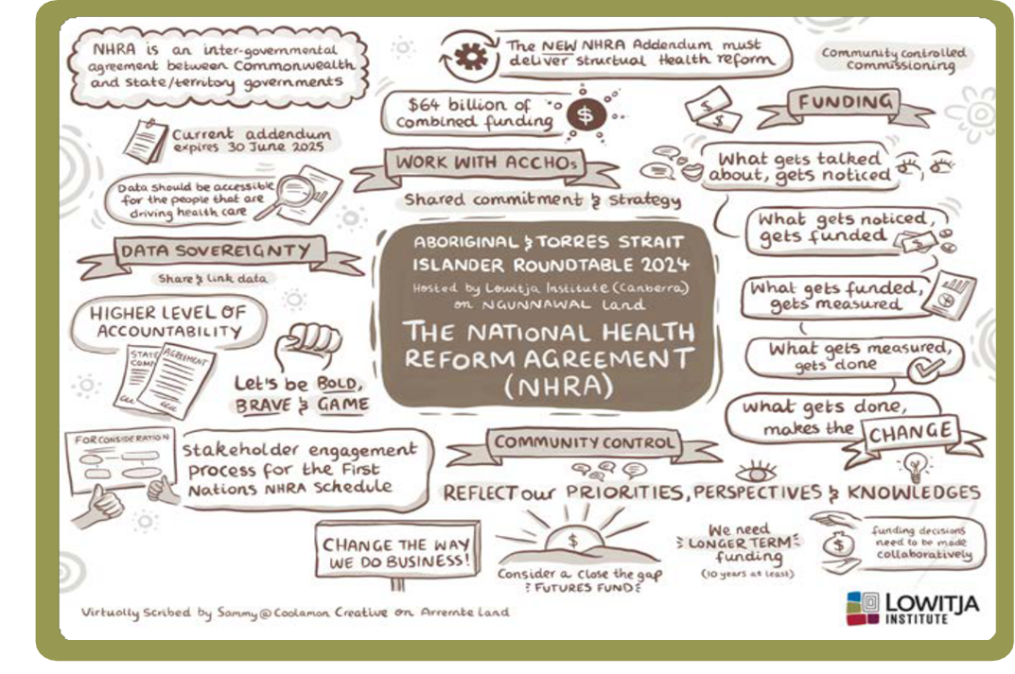

References
- Productivity Commission 2024, Review of the National Agreement on Closing the Gap, Study report, volume 1, Canberra
- Department of Health 2021, National Aboriginal and Torres Strait Islander Health Plan 2021-2031, Canberra.
- Productivity Commission 2024, Review of the National Agreement on Closing the Gap, Study report, volume 1, Canberra
- Department of Health 2023, Mid-Term Review of the National Health Reform Agreement Addendum 2020-25, Final Report, Canberra
- Australian Institute of Health and Welfare 2024, Indigenous Health Performance Framework, Measures – Tier 3 (Health system performance) – 3.09 Self-discharge from hospital, https://www.indigenoushpf.gov.au/ measures/3-09-discharge-against-medical-advice, accessed 24 May 2024.
- Department of Health 2023, Mid-Term Review of the National Health Reform Agreement Addendum 2020-25, Final Report, Canberra
- Department of Health 2023, Mid-Term Review of the National Health Reform Agreement Addendum 2020-25,Final Report, Canberra
- Department of Health 2023, Mid-Term Review of the National Health Reform Agreement Addendum 2020-25, Final Report, Canberra
- Department of Health 2022, National Aboriginal and Torres Strait Islander Health Workforce Strategic Framework and Implementation Plan 2021 2023, Canberra.

