Your toolkit for moving out of aged care

How to contact us
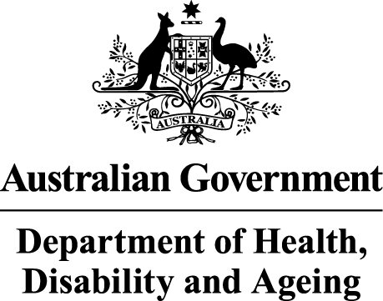 | The Australian Government Department of Health Disability and Ageing wrote this.  We say DHDA for short.  When you see the word we it means DHDA.  We wrote this with help from the  - National Disability Insurance Agency.  We say NDIA for short.
 | We wrote this in an easy to read way.  We use pictures to explain some ideas.
 | We have some words in bold.  This means the letters are thicker and darker.  These are important words.
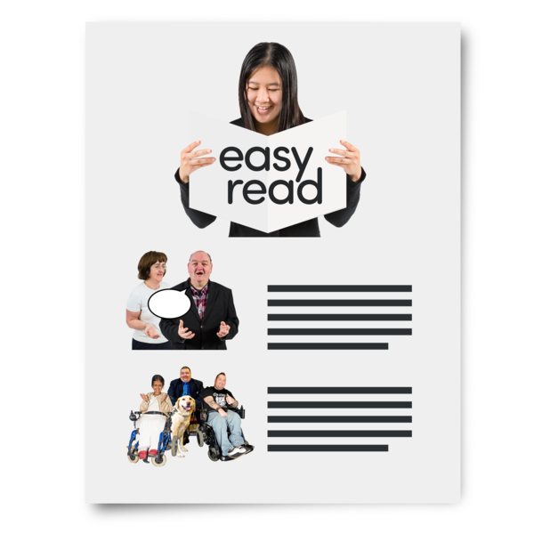 | This is an Easy Read summary of another document.  This means it has the most important ideas.
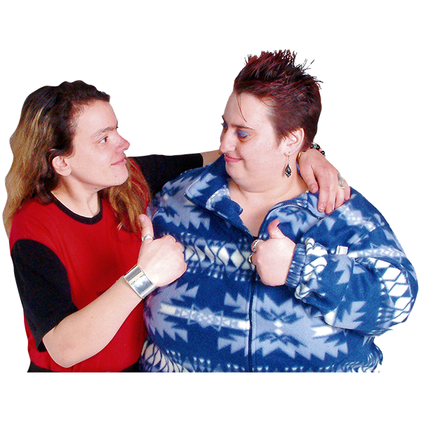 | You can ask for help to read this document.  You can ask  - A friend  - Family members  - A support person.
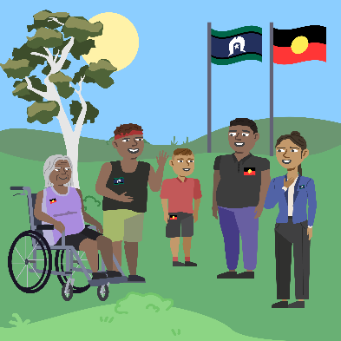 | We recognise Aboriginal and Torres Strait Islander people as the Traditional Owners of the land we live on.
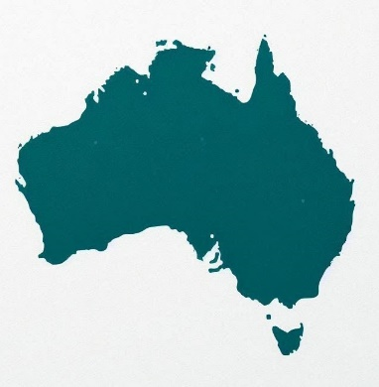 | They were the first people to live on and use the  - Land  - Waters.

 | This Easy Read has information about how you can  - Talk to someone  - Ask questions  - Get more information.
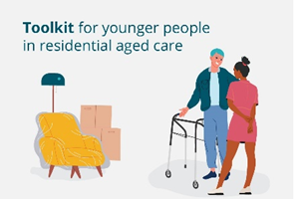 | If you have questions about the toolkit you can email  ypirac.secretariat@health.gov.au
 | If you have questions about getting support from the NDIA you can email  ndia.ypirac@ndis.gov.au
 | If you have questions about living in aged care you can email  health.ypirac@health.gov.au
 | You can look at the DHDA website for more information.  www.health.gov.au/ypirac  This website is not Easy Read.  You can have support to read the website.
 | You can call the NDIA to talk about moving out of aged care on  - 1800 800 110.
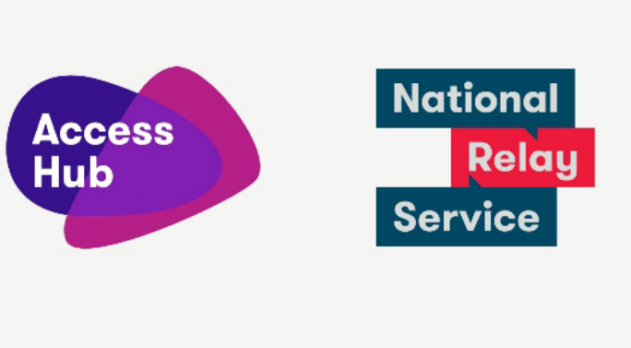 | The National Relay Service can support you to call the NDIA if you are  - Deaf  - Hard of Hearing  - Have a speech or communication difficulty.  To use the National Relay Service go to  www.accesshub.gov.au
Images in this Easy Read must not be used or copied without permission.

