Your toolkit for moving out of aged care

Chapter 4

Part 2 Moving
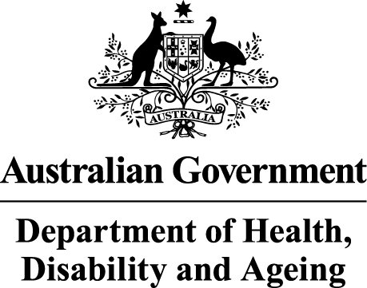 | The Australian Government Department of Health Disability and Ageing wrote this.  We say DHDA for short.  When you see the word we it means DHDA.  We wrote this with help from the  - National Disability Insurance Agency.  We say NDIA for short.
 | We wrote this in an easy to read way.  We use pictures to explain some ideas.
 | We have some words in bold.  This means the letters are thicker and darker.  These are important words.
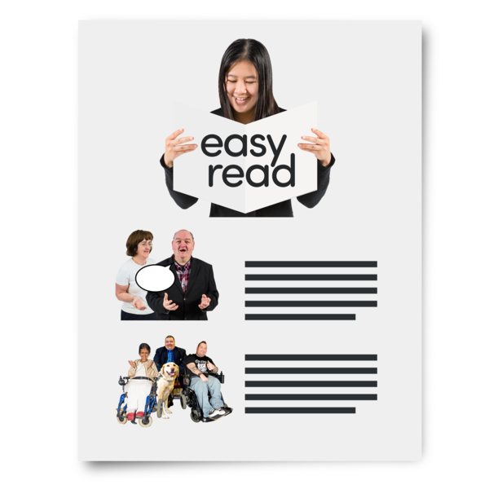 | This is an Easy Read summary of another document.  This means it has the most important ideas.
 | You can ask for help to read this document.  You can ask  - A friend  - Family members  - A support person.
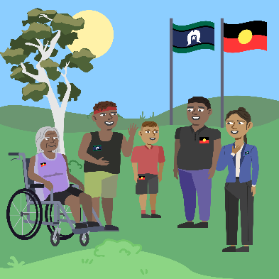 | We recognise Aboriginal and Torres Strait Islander people as the Traditional Owners of the land we live on.
 | They were the first people to live on and use the  - Land  - Waters.

Contents
About Chapter 4 | 5
Thinking about moving | 6
How much moving costs | 13
Working on your budget | 16
Support to pay for things you need | 19
More information | 23

About Chapter 4
 | This Easy Read is about Chapter 4.
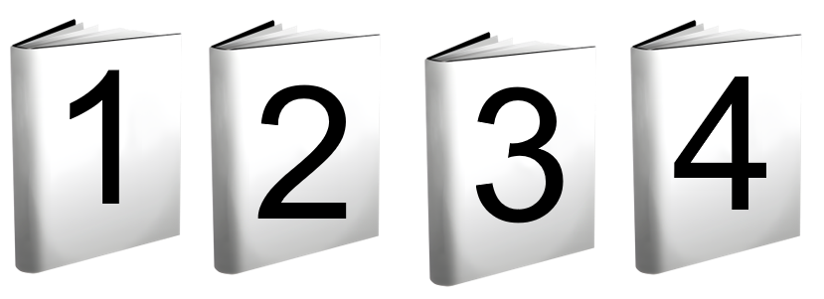 | Chapter 4 has Easy Read documents called  - Part 1 Choosing the right home  - Part 2 Moving  - Part 3 Making sure your needs are met  - Part 4 Learning new skills.
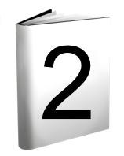 | This Easy Read is Part 2.  It is called Moving.
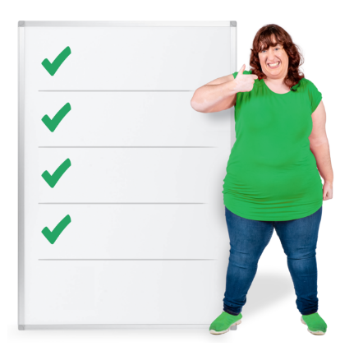 | It has information about  - Making a list for moving  - How much moving costs  - Working on your budget  - Support with money.  A budget is a set amount of money that you can spend on moving.

Thinking about moving
 | There is lots to think about when you are moving.  These are some things that can help you get ready to move.
 | - Packing can take a long time.  You can start packing some things early.
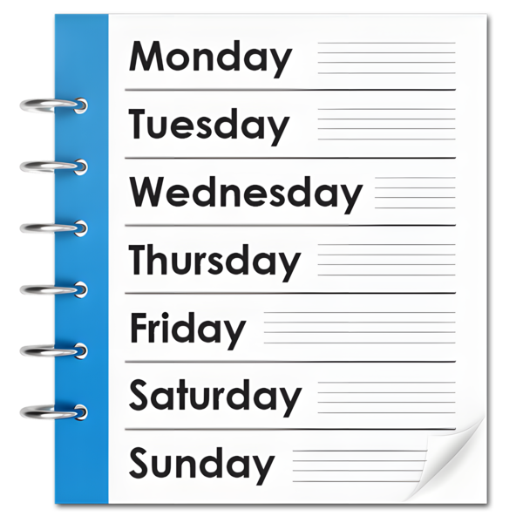 | You do not have to pack everything in 1 day.  You can get help to pack.
 | Write on the boxes.  Write the name of the room the box will go in to make it easier when you unpack like  - Kitchen  - Bedroom.
 | Plan how you will move your things.  You may choose to  - Rent a van to move your things  - Pay someone to help you move.
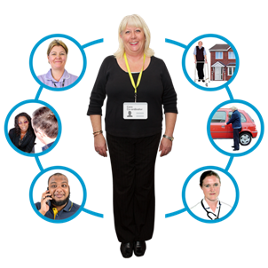 | You can ask your support coordinator for help with this plan.  A support coordinator is a person who helps you with your NDIS plan.
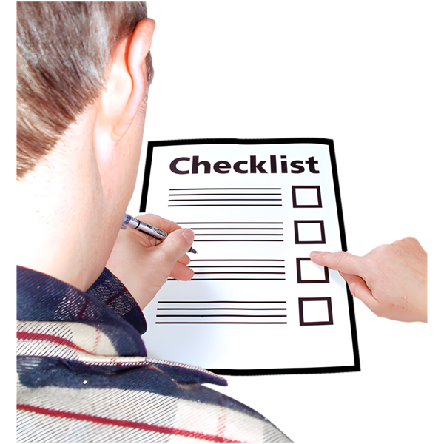 | - Make sure your new home is ready.
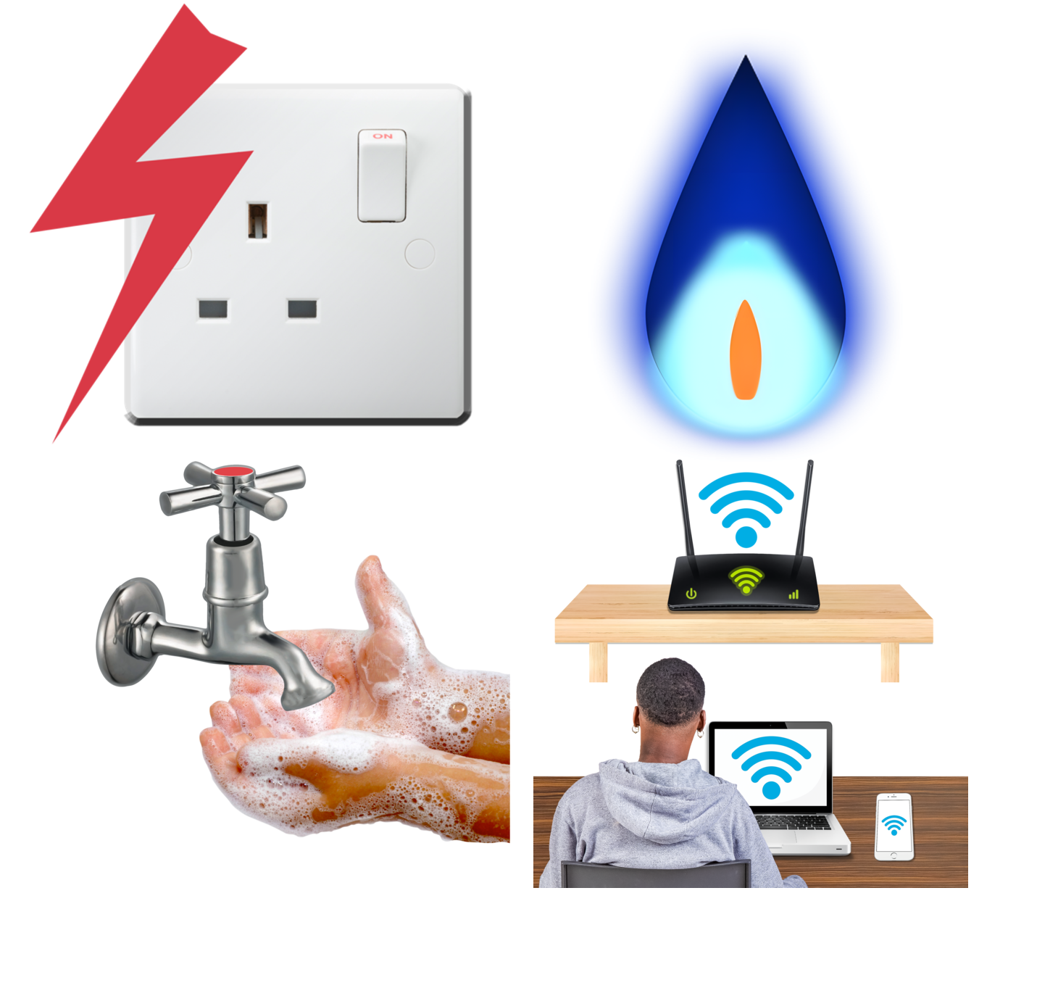 | You will need to set up  - Electricity  - Water  - Gas if your home has it  - Internet if you need it.
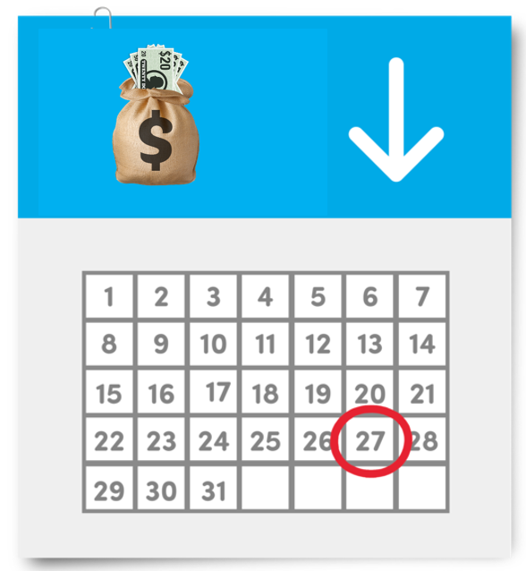 | You will get bills to pay.  You may need to pay them each month.  You can set up payments to come straight out of your bank account.
 | You can have support to organise these things.
 | You can work with your support coordinator to make sure  - Changes to your home will be finished before you move in
 | - Your supports are ready.
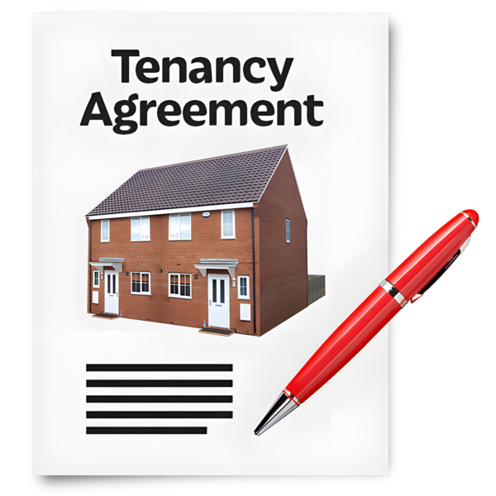 | You may need to sign a lease if you are renting.  A lease is an agreement for how long you can live somewhere.
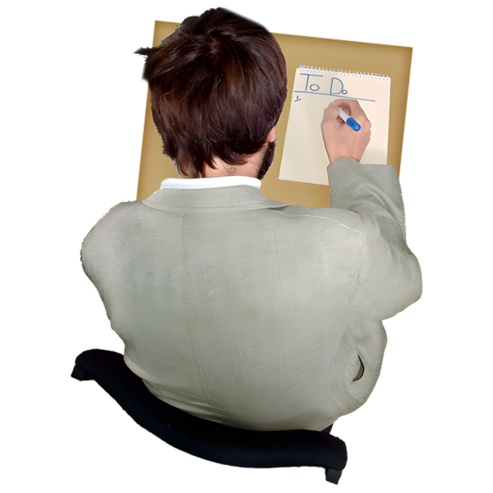 | - Get everything you need.  You may need things for your new home.  It may help to write a list.
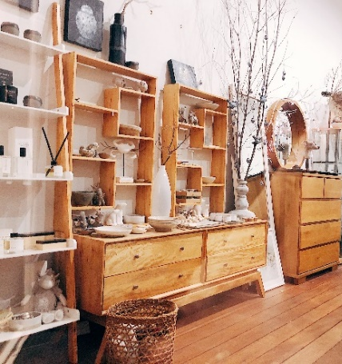 | You can get things you need  - Second hand like from a charity shop  - From friends or family  - From a shop.  You do not have to buy everything new.
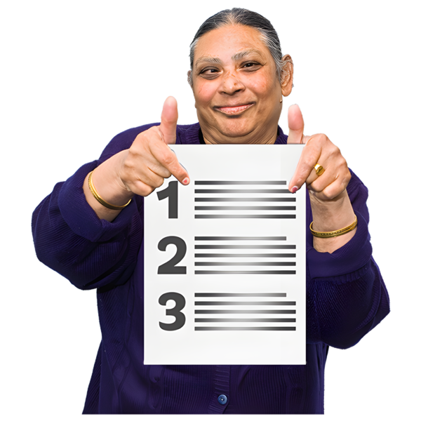 | These are some things that you may need.  This may not be everything you need.
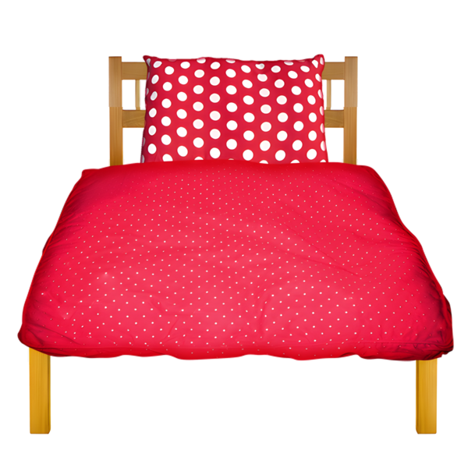 | In your bedroom you may need  - Bed  - Mattress  - Pillows  - Blankets  - Somewhere to put your clothes.
 | In your living room you may need a  - Lounge or chair  - Table  - TV.
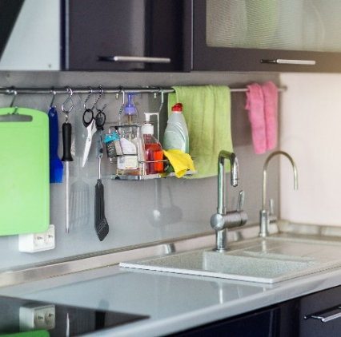 | In your kitchen you may need  - Things to cook with  - Plates and cups  - A fridge  - Things to wash your dishes.
 | In your bathroom you may need  - Towels  - Mats  - Toothbrush and toothpaste  - Soap and shampoo  - Toilet paper.
 | You may need things to clean with like  - Broom  - Mop  - Cloths  - Rubbish bags.
 | You may want to get things that make your home look nice like  - Door mats  - Rugs  - Photos  - Pictures  - Plants.
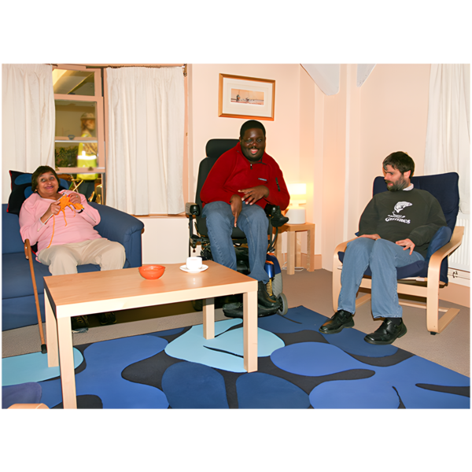 | Specialist disability accommodation will already have some of the things you need.  It is called SDA for short.  SDA is a place to live for people with disability who need a  - Home where they can safely get support  - Lot of support.  You can check what you need to bring if you are moving to SDA.

How much moving costs
 | Moving costs money.  It is important to plan how much money you want to spend to move.
 | Moving costs could be  - Buying things for packing like boxes  You can ask friends or shops for free boxes.
 | - Paying someone to help you pack
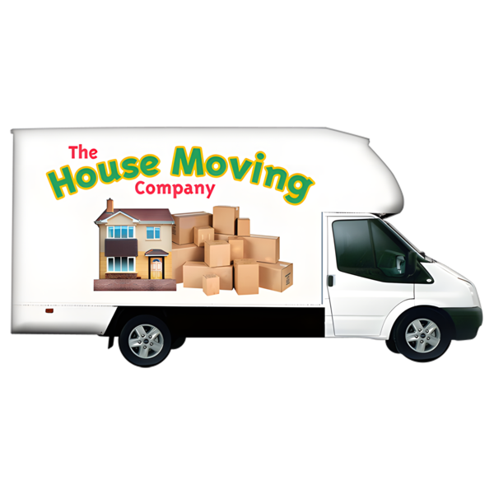 | - Paying someone to move your things  They are sometimes called removalists.
 | Removalists will  - Put all the boxes and furniture from your old home in their truck  - Drive to your new home  - Put your things at your new home.
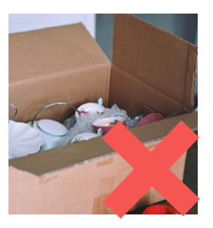 | They will not  - Unpack the boxes  - Put things away.
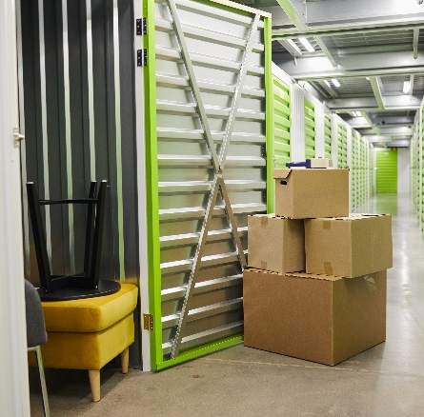 | You may need to pay to put your things in storage until you can move.  Your friends or family may be able to help store things for you.
 | You may need to pay someone to  - Help you unpack  - Set up your new home.  Your friends or family may be able to help you.
 | When you are in your new home you will need to start buying groceries like  - Food  - Drinks  - Toothpaste  - Toilet paper.

Working on your budget
 | It is important to think about how much it will cost to  - Move  - Live in your new home.
 | Making a budget can help you plan for how much things might cost.
 | We have a budget tool you can fill out.  It has lots of questions.  It will help you think of things you need to pay for in your new home.
 | It is on our website.  www.health.gov.au/sites/default/files/2025-07/younger-people-in-residential-aged-care-ypirac-toolkit.pdf
 | You can get help with your budget from  - Your family  - Your support coordinator  - Someone you trust.
 | You might not need to think about all the areas on the budget.  You can put a tick next to the areas that you need to plan for.
 | You can write down how much you think things will cost.  These might not be the exact amount.
 | You can keep track of how much money you spend.
 | You can use the extra spaces for things  - That are not on the list  - You think of later.
 | You do not have to fill out the budget if you do not want to.  You can choose.

Support to pay for things you need
 | There are different supports to help you pay for things when you move out of aged care.
There is lots of information on the Disability Gateway website.

www.disabilitygateway.gov.au/income-finance/support-healthcare
 | It has information about  - Income support  - Tax  - Cards and discounts.  Income support is money you get to help you.
 | Income support you may be able to get are  - Disability Support Pension  This is a payment for people with a disability who can not work.
There are rules for who can get this payment.

The rules are on this website.

www.servicesaustralia.gov.au/disability-support-pension
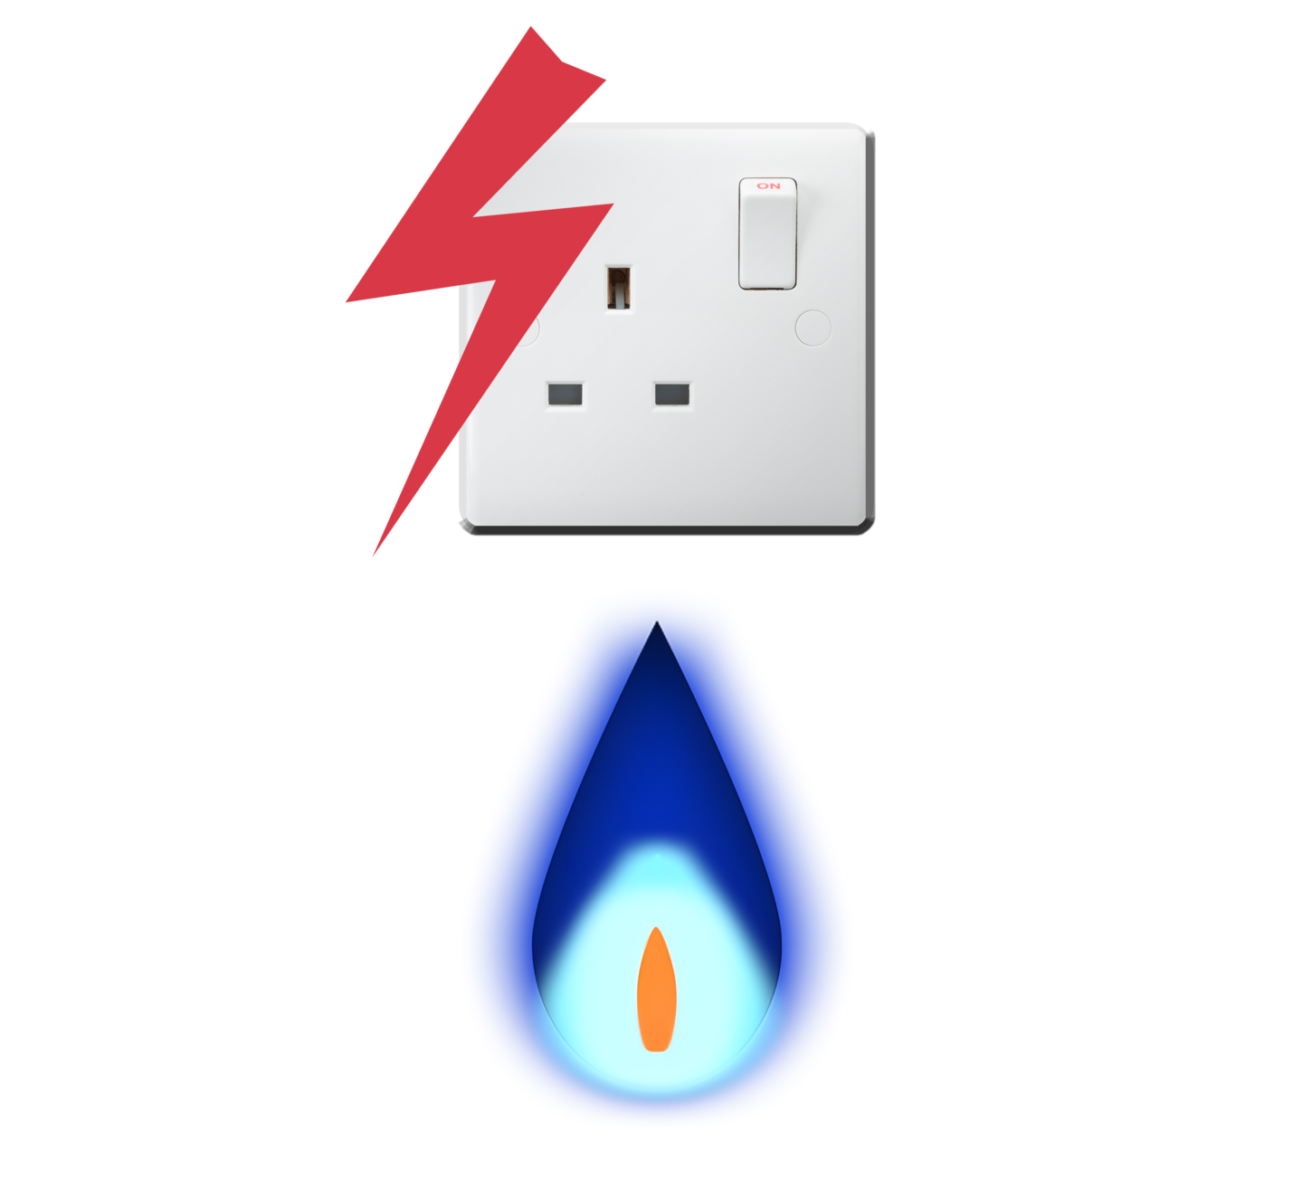 | - Energy Supplement  This can help pay for  - Electricity  - Gas.
There are rules for who can get this payment.

The rules are on this website.

www.servicesaustralia.gov.au/energy-supplement
 | - No Interest Loans Scheme  We call it NILS for short.  Interest is extra money you pay when you borrow money.  A loan is money you borrow from a person or a bank.
NILS are loans for people on low income.

You do not pay interest for NILS.
There are rules about

- How much money you can borrow
- What you can buy with the loan.

The rules are on this website.

goodshep.org.au/services/nils/
 | - National Companion Card.  This is a card that lets your support person visit activities with you for free.
There are rules about who can get this card.

The rules are on this website.

www.health.gov.au/our-work/companion-card

More information
 | The next Easy Read for Chapter 4 is  - Part 3 Making sure your needs are met.
It is on this website.

www.health.gov.au/ypirac

The website is not Easy Read.
 | The website also has Easy Read information for  - The 5 toolkit chapters  - Why we wrote the toolkit  - How to contact us.

Images in this Easy Read must not be used or copied without permission.

