Your toolkit for moving out of aged care
Chapter 5 Ongoing support
 | The Australian Government Department of Health Disability and Ageing wrote this.  We say DHDA for short.  When you see the word we it means DHDA.  We wrote this with help from the  - National Disability Insurance Agency.  We say NDIA for short.
 | We wrote this in an easy to read way.  We use pictures to explain some ideas.
 | We have some words in bold.  This means the letters are thicker and darker.  These are important words.
 | This is an Easy Read summary of another document.  This means it has the most important ideas.
 | You can ask for help to read this document.  You can ask  - A friend  - Family members  - A support person.
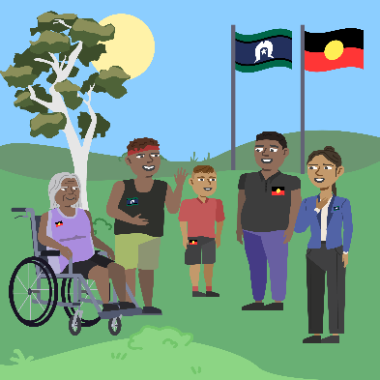 | We recognise Aboriginal and Torres Strait Islander people as the Traditional Owners of the land we live on.
 | They were the first people to live on and use the  - Land  - Waters.

Contents
About Chapter 5 | 5
Ask for a review of your NDIS funding | 7
How to change your NDIS plan | 10
Support after you move | 15
If something is wrong with your home | 18
Emergency housing | 20
More information | 21

About Chapter 5
 | This Easy Read is about Chapter 5.  It is called Ongoing support.
 | It has information about  - How to ask for a review of your NDIS funding  - How to change your NDIS plan  - Support after you move  - What to do if something is wrong with your home  - What to do if you need emergency housing.
 | A review is when your NDIS plan is checked to see if  - The right decisions were made  - Different supports should be in your plan.
 | Funding is money from the government.
 | Emergency housing is when you need to stay somewhere for a short time.

Ask for a review of your NDIS funding
If you are not happy with the funding in your NDIS plan you may be able to ask for a review.

There are 2 main types of reviews.
 | - Internal review  An internal review is when the NDIS check the decisions made in your plan.
 | You can ask for an internal review if you do not agree with  - Changes in your NDIS plan.  The NDIS will look at the decision again.
 | The NDIS website has information about how to ask for an internal review.  www.ndis.gov.au/participants/request-review-decision
 | Some decisions made by NDIS can not be reviewed.
The NDIS website has information about what decisions can be reviewed.

ourguidelines.ndis.gov.au/home/reviewing-decision/reviewing-our-decisions/what-decisions-can-we-review
 | - External review.  You can ask for another review if you are still not happy with the NDIS decisions.  This is called an external review.  An external review is done by the Administration Appeals Tribunal.  We call it AAT for short.
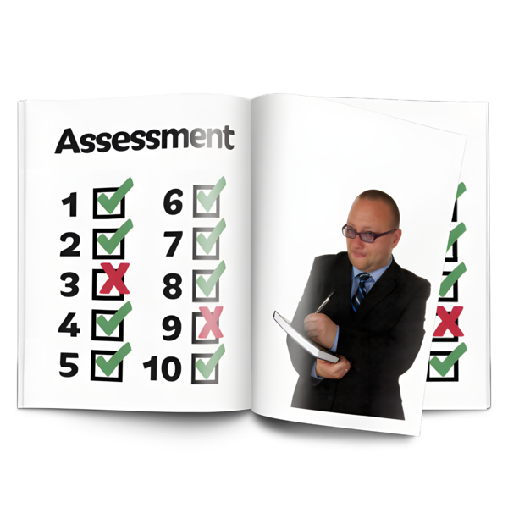 | AAT is not part of the NDIS.  AAT will check the decision the NDIS made.
The Housing Hub website has more information about NDIS reviews.

www.housinghub.org.au/resources/article/request-a-review-of-an-ndis-decision-that-i-dont-agree-with

How to change your NDIS plan
 | Your support needs may change when you move into your new home.  You may need  - More support  - Less support  - Different support.
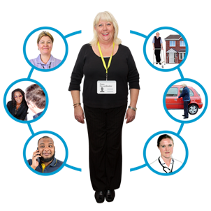 | It is important to talk to your support coordinator about what  - Is working well  - Needs to change.  A support coordinator is a person who helps you with your NDIS plan.
 | The NDIS will contact you near the end of your plan.  They may also contact you at other times to see if everything is ok.
 | You do not have to wait for the NDIS to contact you to make changes to your plan.  You can ask to change your NDIS plan at any time.
 | There are 2 ways to change your NDIS plan.
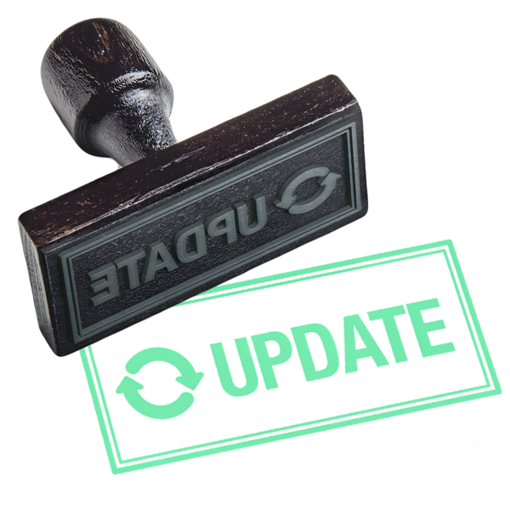 | - Plan variation  A plan variation means making a change to your current NDIS plan.
There are rules about what can change in a plan variation.

The NDIS website has information about the rules.

www.ndis.gov.au/participants/changing-your-plan#plan-variations
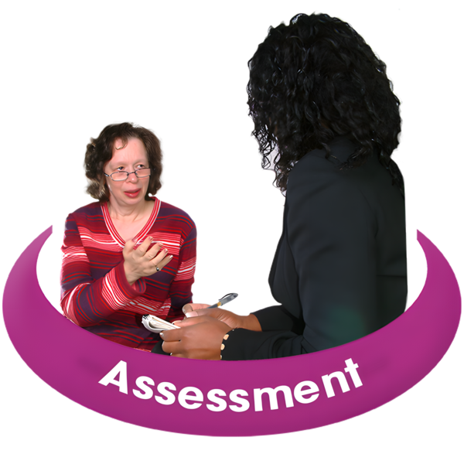 | - Plan reassessment.  A plan reassessment means making a new NDIS plan.
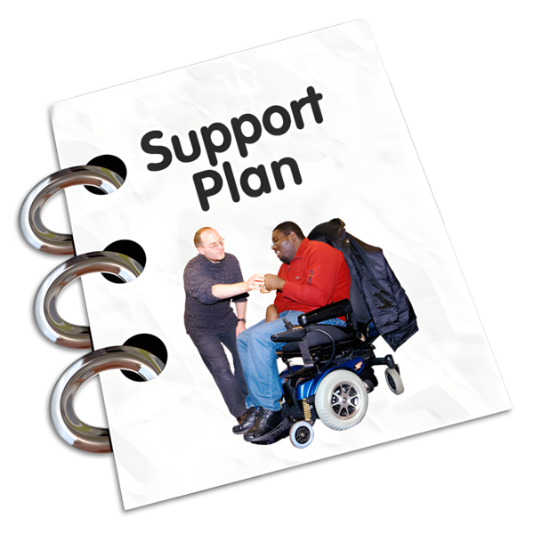 | You may need a plan reassessment if there have been changes to your support needs.
You can ask for a plan reassessment at any time.

The NDIS website has information about plan reassessments.

www.ndis.gov.au/participants/changing-your-plan#plan-variations
If you want to make changes to your NDIS plan you can

- Talk to your support coordinator.
 | The NDIS will need information to help them decide about changing your plan.  You can have support to get this information.
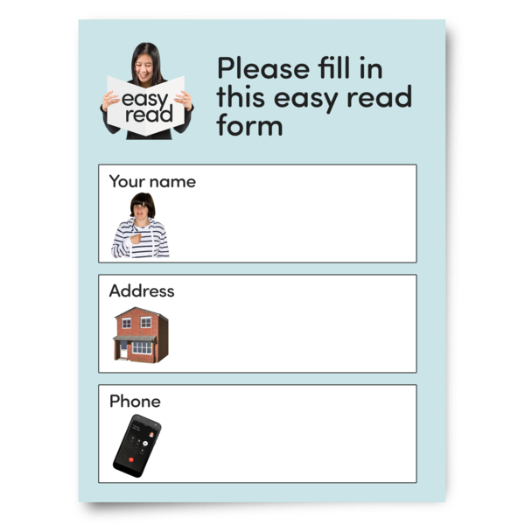 | There are 3 ways to contact the NDIS to make changes to your NDIS plan  - Fill out a form  The NDIS website has information about what you need to tell them.  www.ndis.gov.au/participants/using-your-plan/changing-your-plan/change-circumstances
 | - Call the NDIS  1800 800 110.
 | You can call them  - Monday to Friday  - 8am to 8pm.  They are closed on the weekend.
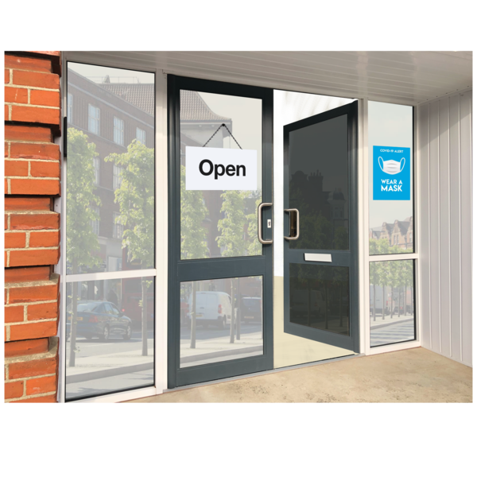 | - Go to a NDIS office.  The NDIS website has information about how to find an office close to you.  www.ndis.gov.au/contact/locations

Support after you move
 | The people who supported you during your move may be able to support you in your new home.
 | They could be people who are paid to support you like your  - Support coordinator  - Support workers.
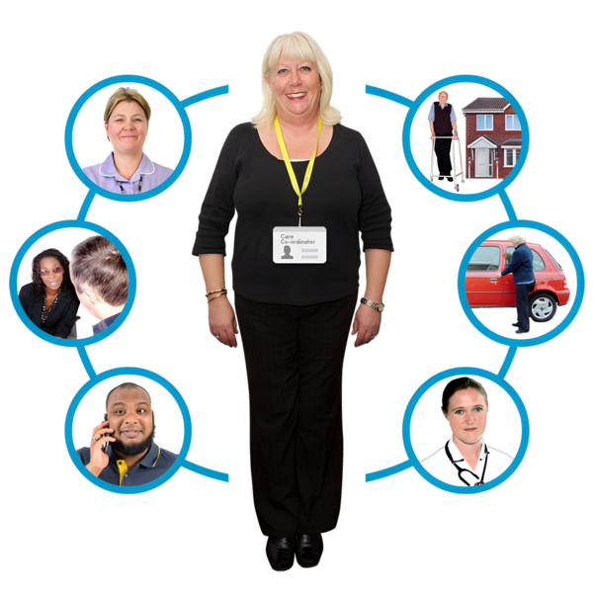 | Your support coordinator can  - Answer questions about living in your new home  - Make sure you have the right supports  - Talk about changes you need in your NDIS plan.
 | Your support workers can  - Help you settle into your new home  - Support you with your daily tasks  - Share issues with your support coordinator.
 | You can also have support from people who are not paid to support you like  - Family  - Friends  - Local community groups  - Peer support groups  - Advocacy groups.
 | Peer support is when people with disability get together to give each other support and advice.
 | Advice means to tell someone your ideas of how to do something.
 | Peer support groups can  - Connect you with people who have done the same as you.
 | Advocacy groups can  - Support you to understand your rights  - Speak up for you.
 | Your family and friends can  - Support you to settle in  - Help you find services  - Help make sure your needs are met.
 | Local community groups can  - Share information about services or groups in your area  - Support you to find activities in your community.

If something is wrong with your home
 | Sometimes you make decisions you think will be good.  Then you may change your mind.
Your support coordinator can help if you want to change something with your

- Home
- Supports
 | It is okay to want something different.
 | Your support coordinator can support you to think about  - A different type of home  - What will help you make decisions.  This can sometimes take time.
 | It is important to know that you deserve to live somewhere that  - You like  - Suits your needs  - Is safe  - Is comfortable.
 | You can tell someone if your home is not these things.

Emergency housing
 | Sometimes things change.  If you do not have a safe place to stay you can get help.
 | There is emergency housing all over Australia.
 | Emergency housing can help you if you are homeless.  Homeless means you do not have a home to live in.
There is information about emergency housing on this website.

my.gov.au/en/services/living-arrangements/finding-renting-and-buying-a-home/help-with-homelessness/help-if-you-re-homeless

More information
 | We wrote Easy Read information about  - The 5 toolkit chapters  - Why we wrote the toolkit  - How to contact us.
They are on this website.

www.health.gov.au/ypirac

The website is not Easy Read.

Images in this Easy Read must not be used or copied without permission.

