Your toolkit for moving out of aged care
Chapter 4
Part 1 Choosing the right home
 | The Australian Government Department of Health Disability and Ageing wrote this.  We say DHDA for short.  When you see the word we it means DHDA.  We wrote this with help from the  - National Disability Insurance Agency.  We say NDIA for short.
 | We wrote this in an easy to read way.  We use pictures to explain some ideas.
 | We have some words in bold.  This means the letters are thicker and darker.  These are important words.
 | This is an Easy Read summary of another document.  This means it has the most important ideas.
 | You can ask for help to read this document.  You can ask  - A friend  - Family members  - A support person.
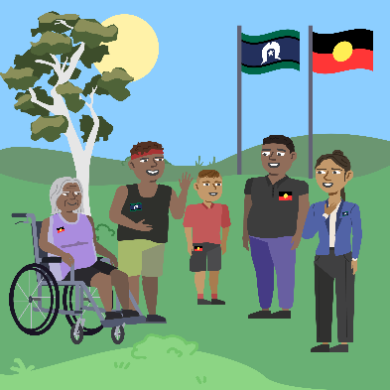 | We recognise Aboriginal and Torres Strait Islander people as the Traditional Owners of the land we live on.
 | They were the first people to live on and use the  - Land  - Waters.

Contents
About Chapter 4 | 5
Looking for a place to live | 7
Choose a home | 13
Your timeline for moving | 16
Plan your transition | 20
Make your transition plan | 22
More information | 23

About Chapter 4
 | This Easy Read is about Chapter 4.
 | Chapter 4 has Easy Read documents called  - Part 1 Choosing the right home  - Part 2 Moving  - Part 3 Making sure your needs are met  - Part 4 Learning new skills.
 | This Easy Read is Part 1.  It is called Choosing the right home.
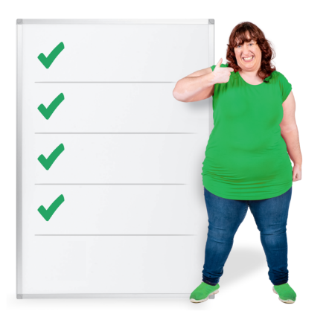 | It has information about how to  - Look for a place to live  - Choose a home  - Plan your move  - Plan your transition  - Make your transition plan.
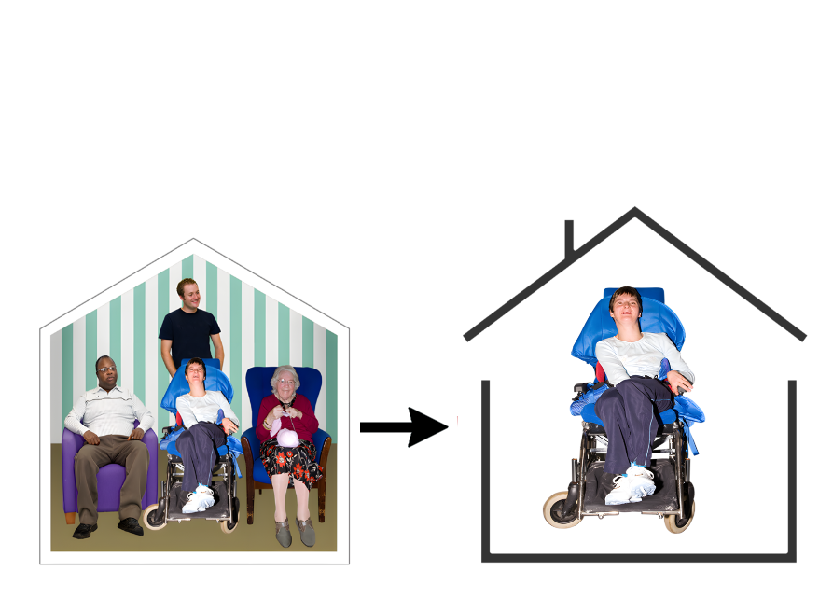 | Transition means a time when something is changing from 1 thing to another.  Like when you move to a new home.

Look for a place to live
 | When you are ready to start looking for a new home there are lots of things to think about.  You can have support with this.
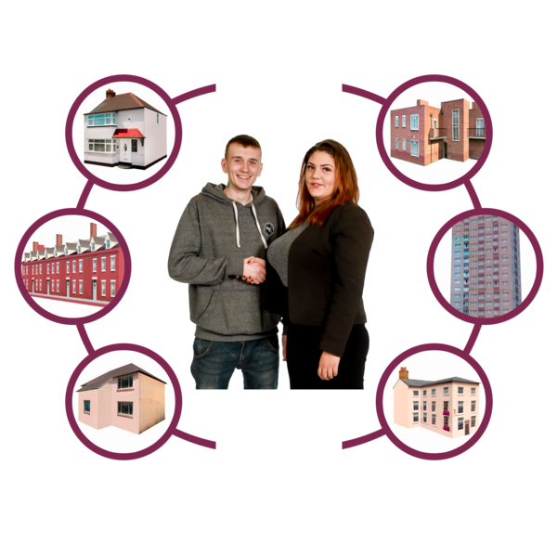 | There are different kinds of homes like  - Houses  - Townhouses  - Units.
 | There are lots of ways to look for a new home.  There are websites that show homes people can  - Buy  - Rent.
 | Rent is money you pay to the owner of the home so you can live there.
 | You can go to the websites  www.realestate.com.au  www.domain.com.au  www.allhomes.com.au
 | The Housing Hub may be able to help you find a home if you have NDIS.  Housing means homes for people to live in.
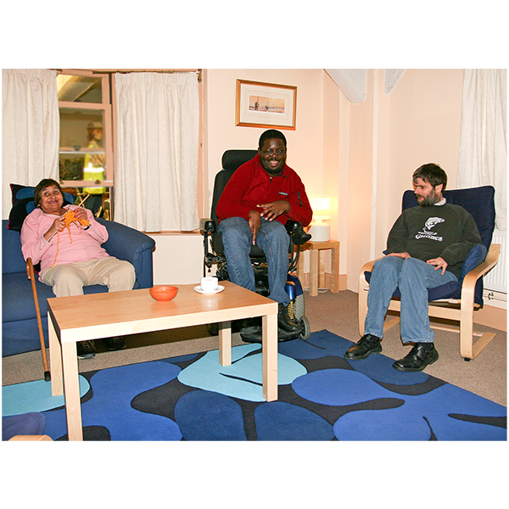 | The Housing Hub can help with  - Specialist disability accommodation  It is called SDA for short.  SDA is a place to live for people with disability who need a  - Home where they can safely get support  - Lot of support.
You can go to the website

www.housinghub.org.au

You can find information about the type of home you need.
 | Nest is a group that can help people with disability find homes that match their needs.
You can go to the website

gonest.com.au/
 | Your Place Housing can help people with disability find a home that is a good amount of money.  This can also be called affordable housing.
You can go to the website

yourplacehousing.com.au/
 | The Endeavour Foundation can help people find homes to live in on their own.
You can go to the website

www.endeavour.com.au
 | You can go to the MyGov website to apply for  - Social housing  - Public housing  - Community housing.  Governments look after these types of housing.
 | my.gov.au/en/services/living-arrangements/finding-renting-and-buying-a-home/help-with-homelessness/social-public-and-community-housing
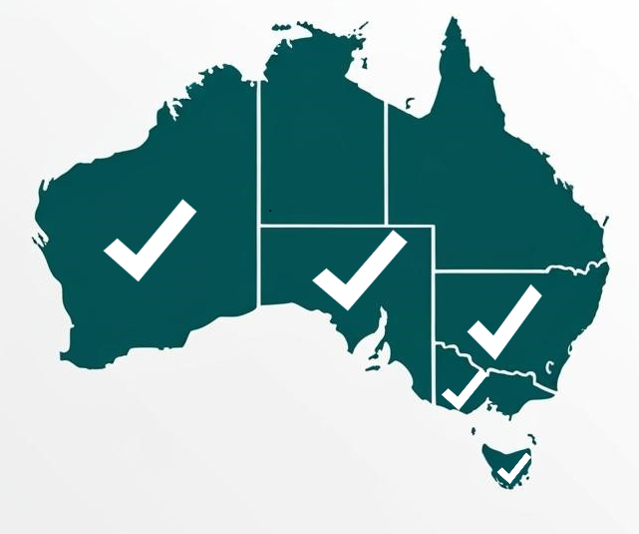 | Housing choices can help people with disability find a home in  - Victoria  - South Australia  - Western Australia  - New South Wales  - Tasmania.
You can go to the website

www.housingchoices.org.au/

Choose a home
 | You may have lots of feelings when looking for a new home.  It can be  - Exciting  - Confusing.
 | You may look at lots of homes.  It may be hard to choose which one is right for you.
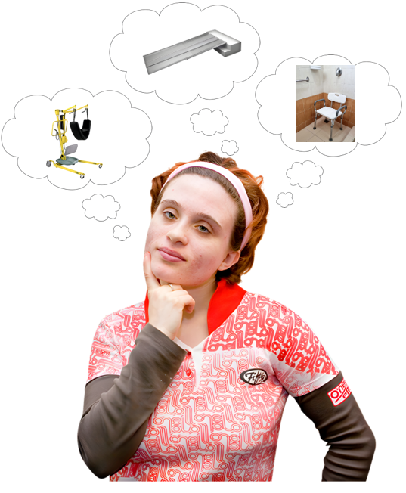 | You will need to think of your needs.  You may need room in the home for equipment like  - Hoist  - Shower chair  - Ramp.
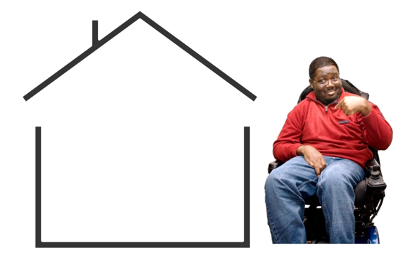 | You will need to look at the home to make sure it  - Is right for you  - Can be changed to meet your needs  - Is where you want to live.  You could bring someone to support you.
 | You can ask questions.  You may have lots of questions.  That is okay.
 | You can ask questions about  - Changes to the home  - When you can move in  - The area the home is in.  You can ask other questions too.
 | You can have help.  It is okay to ask for help.
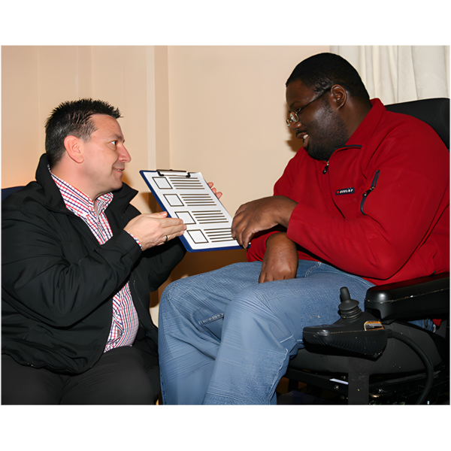 | You can ask your  - Family  - Friends  - Other people who support you.

Your timeline for moving
 | You can make a timeline for moving.  A timeline is a plan that says when things will happen.  The timeline has everything in order from first to last.  It can be good to see what needs to be done first.
 | The timeline will look different for everyone.  It will depend on  - What you are up to  - How much time you need.
 | These are some things you can think about when you are planning your timeline.  - Where you are up to in your move out of aged care.  You may not have found the right home yet.
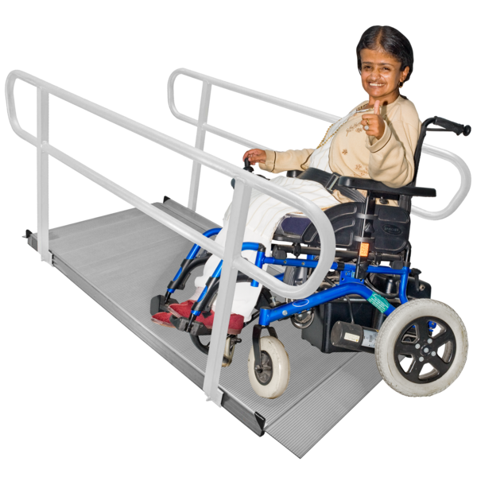 | - The changes your home may need.
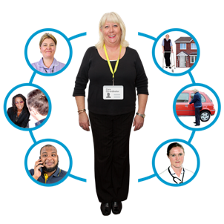 | You can talk with your support coordinator about how long changes may take.  A support coordinator is a person who helps you with your NDIS plan.
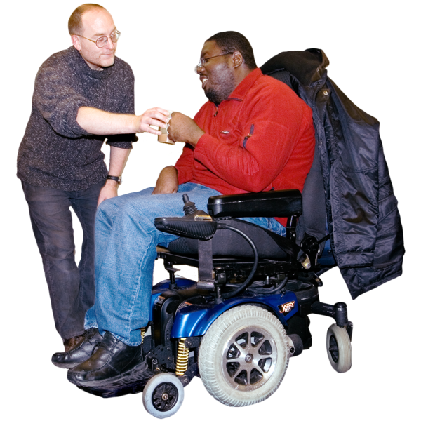 | - Your support needs.  You may need to wait for  - Supports  - Equipment.  You can talk with your support coordinator about how long this may take.
 | - If you are ready to move.  There is lots to do before moving.
 | You may need time to  - Pack your things  - Buy new things  - Get used to the idea of moving  - See the new area your home is in.
 | - The date you will move into your new home.  This is your moving day.
Before you move you need to make sure

- Your new home is ready
- Your supports are set up
- All changes to your home are finished.
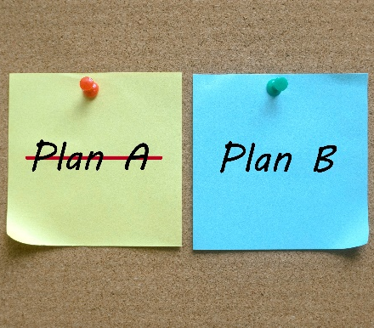 | - Sometimes your timeline may need to change.  That is okay.
 | You can talk with your support network to make any changes to your timeline.  Your support network are the people who help you in your daily life like  - Family  - Friends  - Other people you trust.

Plan your transition
 | It can be helpful to make a transition plan for moving out of aged care.  You can plan  - Who will support you  - What will happen  - What you think could make moving easier.
 | Your support coordinator will support you with this.
 | Your support coordinator will help  - Plan what needs to be done  - Organise your supports  - Make sure everything is ready for you to move in.
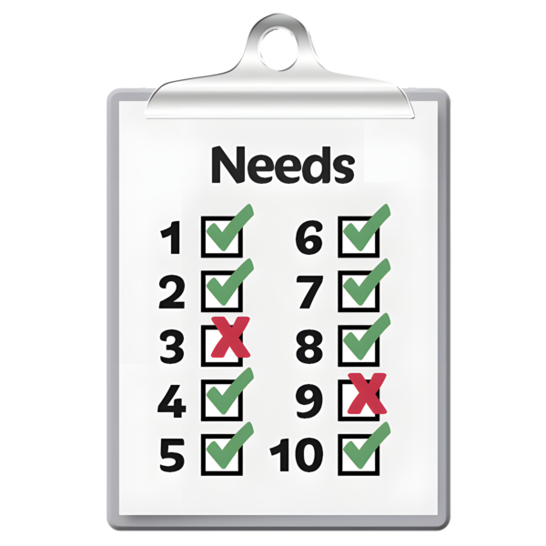 | A transition plan says  - What your home needs
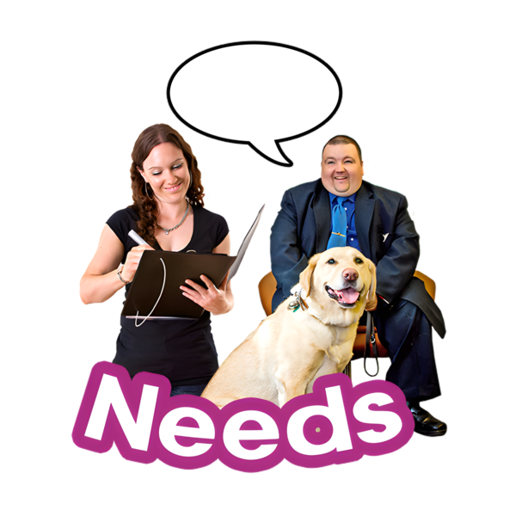 | - What supports you need
 | - Everything that needs to be done.  The transition plan has all the things in order from first to last.
Sometimes things do not go the way we plan.

That is okay.

You can talk with your support network if you need help.

Make your transition plan
 | We have a transition plan you can fill out.  The transition plan  - Has lots of questions.  - Will help you think about things you need to move out of aged care.
It is on our website
www.health.gov.au/sites/default/files/2025-07/younger-people-in-residential-aged-care-ypirac-toolkit.pdf
 | You can have support to  - Answer the questions  - Fill out the plan.
 | You could ask  - A family member  - Your support coordinator  - Someone you trust.

More information
 | The next Easy Read for Chapter 4 is  - Part 2 Moving
It is on this website.

www.health.gov.au/ypirac

The website is not Easy Read.
 | The website also has Easy Read information for  - The 5 toolkit chapters  - Why we wrote the toolkit  - How to contact us.

Images in this Easy Read must not be used or copied without permission.

