Your toolkit for moving out of aged care

Chapter 3

Part 1 Finding the right home
 | The Australian Government Department of Health Disability and Ageing wrote this.  We say DHDA for short.  When you see the word we it means DHDA.  We wrote this with help from the  - National Disability Insurance Agency.  We say NDIA for short.
 | We wrote this in an easy to read way.  We use pictures to explain some ideas.
 | We have some words in bold.  This means the letters are thicker and darker.  These are important words.
 | This is an Easy Read summary of another document.  This means it has the most important ideas.
 | You can ask for help to read this document.  You can ask  - A friend  - Family members  - A support person.
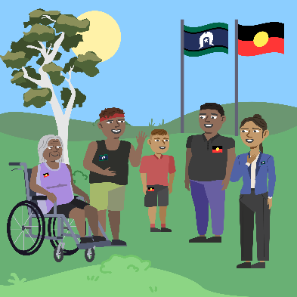 | We recognise Aboriginal and Torres Strait Islander people as the Traditional Owners of the land we live on.
 | They were the first people to live on and use the  - Land  - Waters.

Contents
About Chapter 3 | 5
Find the right home | 6
Capacity building funding | 8
Work towards your new home | 10
Make a goal to move | 12
Write your housing plan | 16
Your support coordinator can help | 19
Allied health professionals can help | 21
More information | 23

About Chapter 3
 | This Easy Read is about Chapter 3.
 | Chapter 3 has Easy Read documents called  - Part 1 Finding the right home  - Part 2 Changes to your new home  - Part 3 Your new community
 | This Easy Read is Part 1.  It is called Finding the right home.
 | It has information about how to  - Find the right home for you  - Work towards your new home  - Make a goal to move  - Write a housing plan.  Goals are things you want to do.  Housing means homes for people to live in.

Find the right home
 | Moving out of aged care is a big decision.  It is important to make sure you  - Find a home that is right for you  - Have the support you need.
 | If you have NDIS you may have funding to support you to  - Find a home  - Get support.  Funding is money from the government.
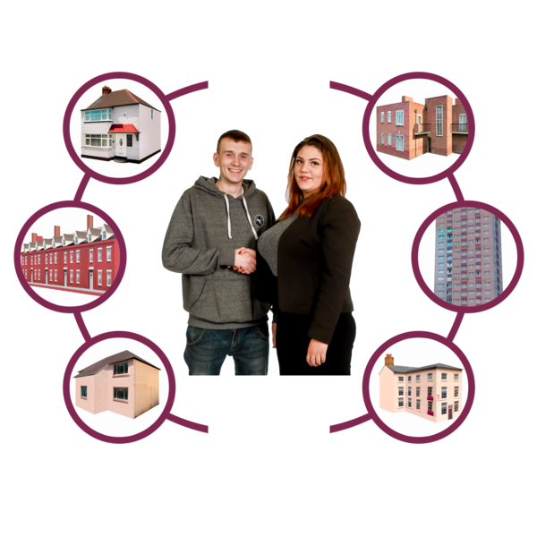 | You may get NDIS funding if you  - Can not look for a home on your own
 | - Do not have support to help you.
 | You may not get NDIS funding if you  - Can look for a home on your own
 | - Have a report about the type of home that would be good for you
 | - Have informal supports to support you.  Informal supports are people you are close to like  - Friends  - Family.  Informal supports are not paid to support you.

Capacity building funding
Capacity building funding is money in your NDIS plan.

Your NDIS plan will tell you if you have capacity building funding.

You can use capacity building funding to
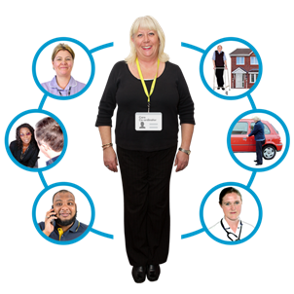 | - Have a support coordinator help you learn what homes may a good choice  A support coordinator is a person who helps you with your NDIS plan.
 | - Get reports that say what you need to live independently.  Independently means living separate to other people.  It also means doing things on your own.
 | There are rules for who can get capacity building funding.
 | You will need a goal in your NDIS plan about housing.  The goal could be to look at more homes that will meet your needs.

Work towards your new home
 | Working towards your new home is different for everyone.
If you have NDIS you may

- Ask for capacity building funding

 | - Write a goal to move in your NDIS plan
 | - Go to a planning meeting
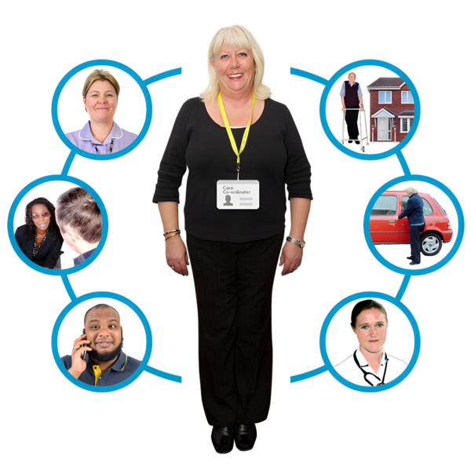 | - Work with your support coordinator and support team  They can help you find the home that meets your needs.
 | You may want to ask for funding in your NDIS plan for  - Your home  - Moving into your new home  - Changes your home will need.  - Support you need in your new home  - Assistive technology.
 | Assistive technology can be things to help you  - Speak  - Move  - See  - Hear.

Make a goal to move
 | It can be helpful to make a goal if you want to move out of aged care.
 | If you have NDIS you need to put your goal in your NDIS plan.
 | You can still make a goal to move out of aged care if you do not have NDIS.  You do not have to send your goal to anyone.  Your goal can help you talk to the people who support you about what you need.
 | You may be able to get funding to help you work towards your goal.
You may get NDIS funding to help

- Find your new home
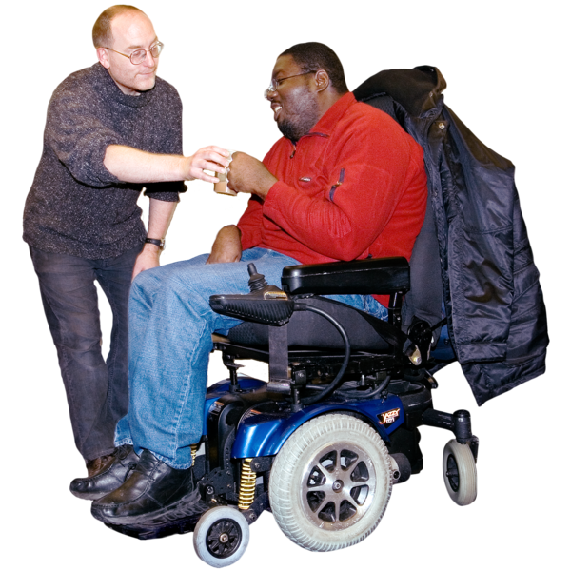 | - Get support to live safely in your home
 | - Get assistive technology
 | - Make changes so your home is safe for you.
 | You may not  - Need support in these areas  - Get funding for all these areas.
NDIS will

- Work out what you need.
- Make sure your funding is a good amount of money.
 | NDIS will make sure funding supports your  - Goals  - Inclusion in the community  - Disability.
 | NDIS will make sure your funding adds to the support you already have.
 | The NDIS has rules about funding to move out of aged care.  This website has information.  www.ndis.gov.au/participants/home-and-living/living-and-moving-out-residential-aged-care

Write your housing plan
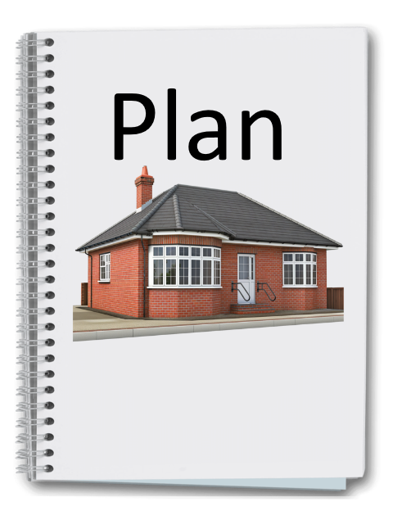 | It is a good idea to write a housing plan.
A housing plan tells the NDIS

- Your housing goals
 | - What type of home you would like
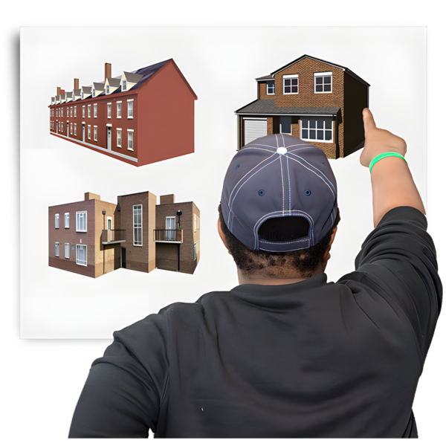 | - What types of homes you have lived in before.
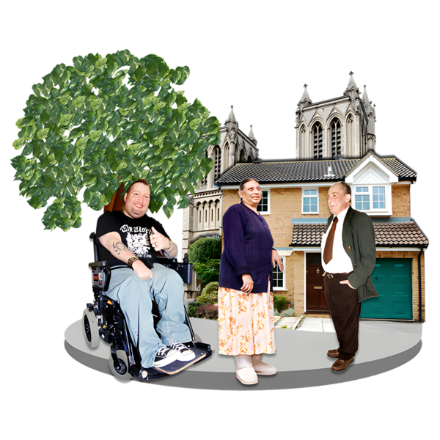 | Your housing plan also tells the NDIS  - What you do at your job  - Things you like to do  - How you take part in the community.
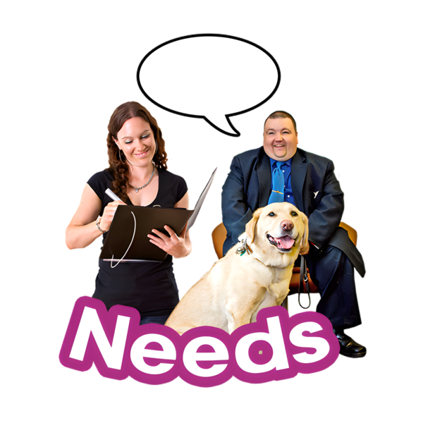 | Your housing plan has important information about  - Your disability  - Your support needs  - What type of home will suit your needs.
 | Your housing plan tells the NDIS how you will  - Move into your new home  - Learn new skills to live more independently.
 | If you have capacity building funding you may get support to write your housing plan from your  - Support coordinator  - Support team.
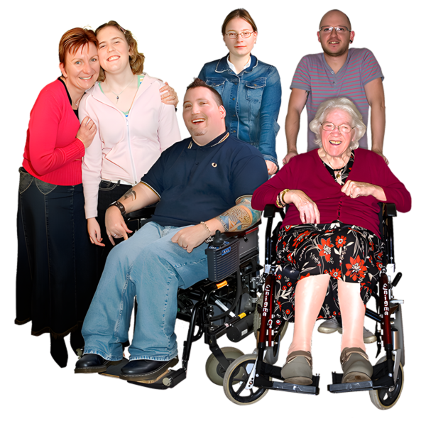 | If you do not have capacity building funding you may get support to write your housing plan from your  - Family  - Carers  - Nominees.
 | Nominees are someone you choose to  - Make decisions for you  - Do things for you.
The NDIS will read your housing plan.

This will help NDIS work out the funding you will need.

Your support coordinator can help
 | You may have funding for a support coordinator if you have NDIS.
Your NDIS plan will tell you

- If you have a support coordinator
- How much time your support coordinator can work with you.
 | You may be able to get up to 75 hours of support from your support coordinator.  Some people will not get this much support.
Your support coordinator can help you

- Write your housing plan
 | - Work out what type of home you would like
 | - Get assessments  Assessments help NDIS work out  - How your disability affects your life  - What supports you need.
 | If you do not have a support coordinator and you would like one  - You can look on the NDIS website.
The website is not in Easy Read.

www.ndis.gov.au/participants/using-your-plan/who-can-help-start-your-plan/support-coordination/finding-support-coordinator

Allied health professionals can help
 | Allied health professionals are people like  - Disability specialists  - Social workers
 | - Psychologists  Psychologists support your mental health.
 | - Occupational therapists.
Allied health professionals can

- Do assessments
- Write reports for the NDIS
- Support you to be safe in your new home.
 | You and your support coordinator can work with your allied health professionals.
 | The information can be put in your housing plan.

More information
 | The next Easy Read for Chapter 3 is  - Part 2 Changes to your home.
It is on this website.

www.health.gov.au/ypirac

The website is not Easy Read.
 | The website also has Easy Read information for  - The 5 toolkit chapters  - Why we wrote the toolkit  - How to contact us.

Images in this Easy Read must not be used or copied without permission

