Your toolkit for moving out of aged care

Chapter 2

Part 1 Understand the basics of moving
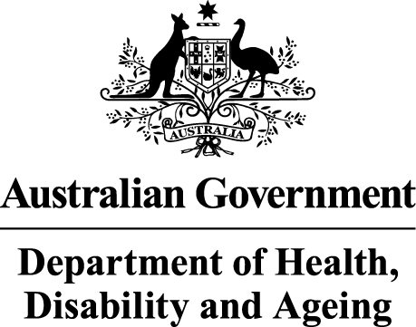 | The Australian Government Department of Health Disability and Ageing wrote this.  We say DHDA for short.  When you see the word we it means DHDA.  We wrote this with help from the  - National Disability Insurance Agency  We say NDIA for short.
 | We wrote this in an easy to read way.  We use pictures to explain some ideas.
 | We have some words in bold.  This means the letters are thicker and darker.  These are important words.
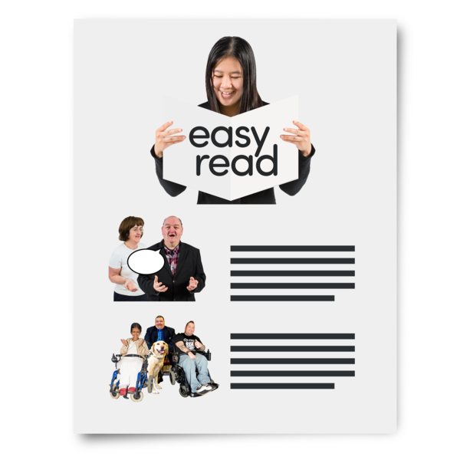 | This is an Easy Read summary of another document.  This means it has the most important ideas.
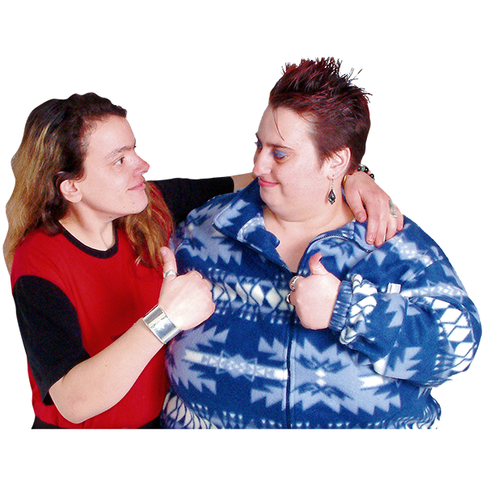 | You can ask for help to read this document.  You can ask  - A friend  - Family members  - A support person.
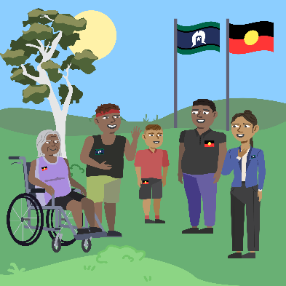 | We recognise Aboriginal and Torres Strait Islander people as the Traditional Owners of the land we live on.
 | They were the first people to live on and use the  - Land  - Waters.

Contents
About Chapter 2 | 5
Your rights | 6
Benefits of different homes | 7
NDIS supports | 14
Support to move | 18
It costs money to move | 19
More information | 22

About Chapter 2
 | This Easy Read is about Chapter 2.
 | Chapter 2 has Easy Read documents called  - Part 1 Understand the basics of moving  - Part 2 Stages of moving
 | This Easy Read is Part 1.  It is called Understanding the basics of moving.
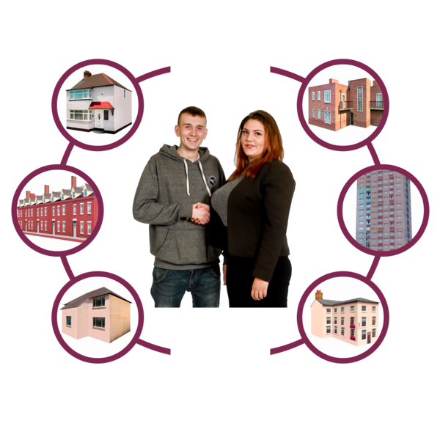 | It has information about  - Your rights  - NDIS Supports  - Benefits of different homes  - Support to move  - Costs of moving.  Benefits are good or helpful things.

Your rights
 | People with disability have rights.  Rights are rules about treating everyone  - Fair  - Equal.
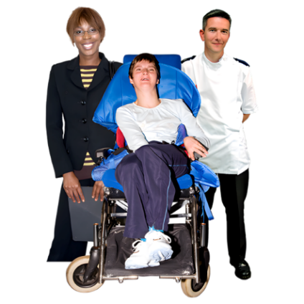 | You have the right to  - Have the support you need to live the life you want
 | - Make choices about your life.  You can have support to do this.
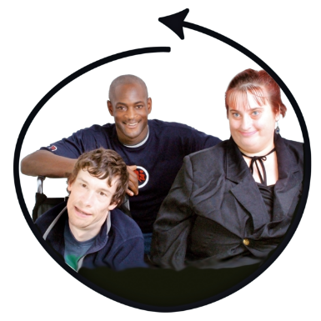 | - Be included in your community  Included means you can  - Take part  - Feel like you belong.

Benefits of different homes
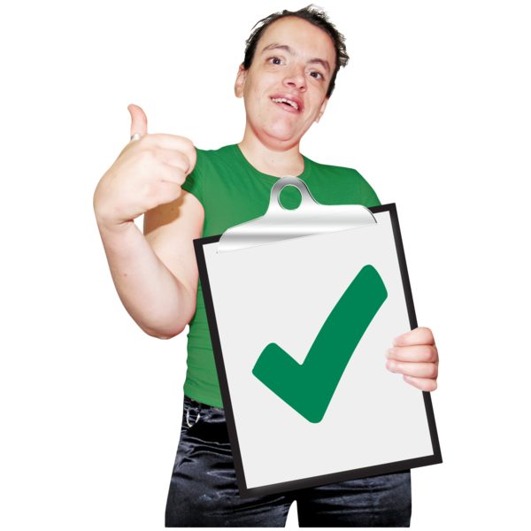 | There are different homes you can live in.  Each type of home has benefits.
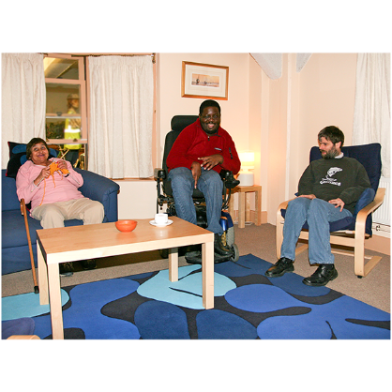 | You may be able to live in specialist disability accommodation if you  - Have NDIS  - Need lots of support.  We say SDA for short.
 | Some benefits of SDA are  - Your home is accessible  - Your support needs are met  - It is a safe place for you to get the supports you need.
 | SDA may be a good choice if you need lots of support with  - Eating and drinking  - Having a shower  - Making choices  - Moving around your home.
 | People who live in SDA pay rent.  Rent is money you pay to the owner of the SDA so you can live there.
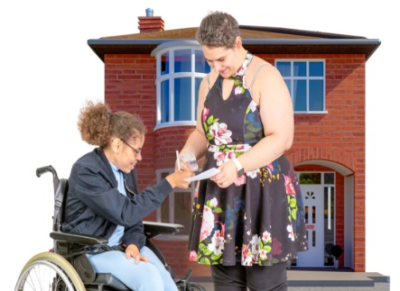 | You may be able to live in a home that is owned by somebody else.  You may need to pay rent to the owner.  This is called renting.
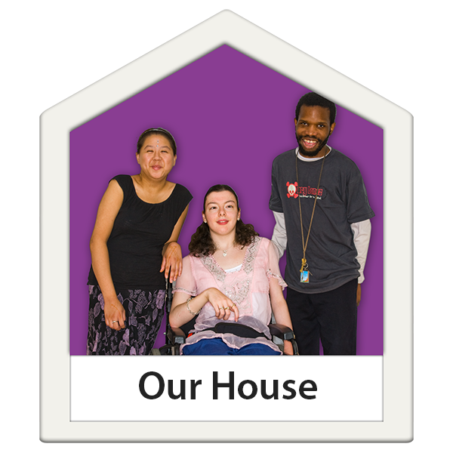 | You may be able to live with other people.  Everyone pays part of the rent.  This means rent may be cheaper for you.
Some benefits of renting are

- There are different types of homes
- You can look for a home in the area you want to live.
 | You may not be able to  - Find the exact home you want  - Stay in the home for a long time.
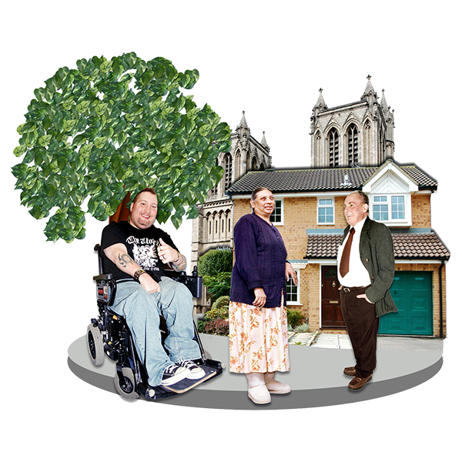 | You may be able to live in a home owned by  - The community  - A charity.
 | There are rules about who can live in these homes.  You need to follow the rules.  You will pay rent to the owner.
 | You may live with other people.
Some benefits of these homes are

- The rent may be cheaper than other homes
- There are different types of homes
- You can find a home that meets your needs
- You may live there a long time.
These homes may be a good choice if you

- Can wait for a home that meets your needs
- Are happy to share a home with other people.
 | You may be able to live in public housing.  Public housing means homes owned by the government for people to live in.
There are rules about who can live there.

You need to follow the rules.

You will pay rent to the government.
 | It can take a long time to get public housing.  There may be lots of people waiting for a home.
 | There may not be public housing in the area you want to live.
Some benefits of public housing are

- The rent may be cheaper than other homes
- You can live there a long time.
Public housing may be a good choice if you

- Can wait for a home that meets your needs
- Are happy to live in a different area.
 | You may be able to buy a home.  People may buy a home  - On their own  - With another person like a family member.
Some benefits of buying a home are you can

- Live there a long time
- Choose the home you want
- Use your NDIS funding to change the home to meet your needs.
 | Funding is money from the government.
Buying a home may be a good choice if you

- Have enough money
- Can find a home near support services like hospitals.

NDIS supports
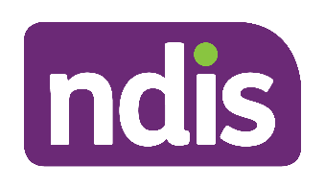 | If you have NDIS you may have funding for NDIS supports.  There are 3 types of NDIS supports funding.
 | - Supported independent living.  We call it SIL for short.  SIL is for people who need lots of support.
Some benefits of SIL are that you can

- Decide how you will be supported
- Get the support you need
- Have support to build skills.
SIL may be a good choice if you need

- Lots of support
- Someone with you all the time
- Support overnight.
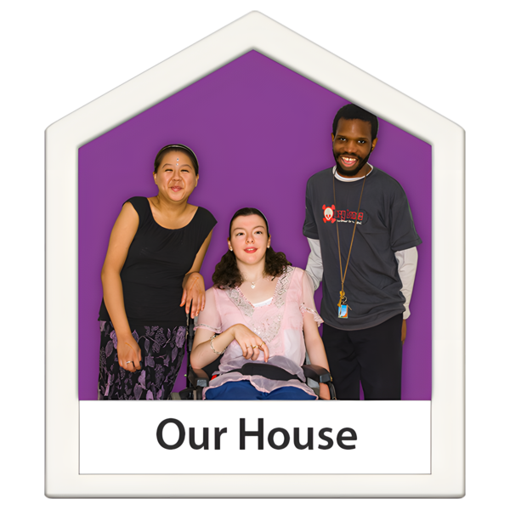 | You can choose to  - Live with other people who have NDIS  Or  - Live on your own.
 | - Individualised living options  We say ILO for short.  ILO funding supports you to think about  - How you want to live  - Where you want to live
Some benefits of ILO are

- You can have support in any home you choose to live in
- You can learn about the different homes to live in
- Your support can change to meet your needs.
ILO may be a good choice if you

- Need 6 hours of support at home every day
- Are ready to think about different ways to have support
- Do not need support all night.
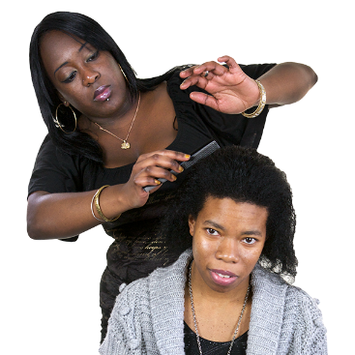 | - Personal care supports  Personal care supports are for everyday activities like  - Showering and dressing  - Using the bathroom  - Mealtimes  - Going to appointments.
Some benefits of personal care supports are

- You can be supported to be more independent with everyday tasks
- You may feel safer having someone there to help
- Everyday routines can be made easier
- You can choose how you want to be supported.
 | Personal care supports may be a good choice if you need up to 6 hours of support each day.
 | There are rules about how you use these 6 hours of support.
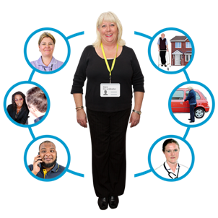 | Your support coordinator can give you more information about the rules.  A support coordinator is a person who helps you with your NDIS plan.

Support to move
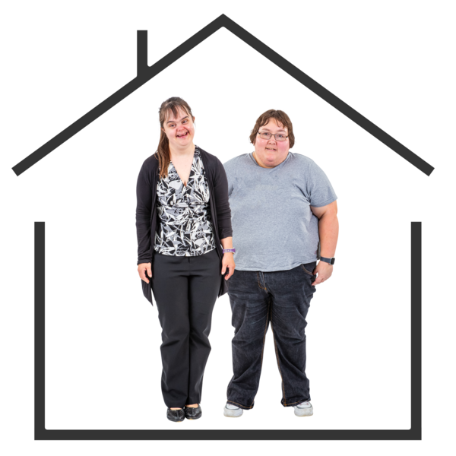 | You can have support to move out of aged care.
If you have a NDIS plan you can talk to

- Your support coordinator
 | - The NDIA  The NDIA looks after the NDIS.  - Email ndia.ypirac@ndis.gov.au  - Phone 1800 800 110
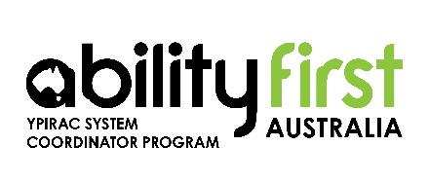 | If you do not have a NDIS plan you can talk to Ability First Australia.  - Email enquiries@abilityfirstypirac.org.au  - Phone 1800 771 663.

It costs money to move
 | It costs money to move out of aged care.  You may be able to get funding to help you.
 | It is important to learn about how  - Much things will cost  - To look after your money.  You can have support with this.
 | You may need to pay someone to  - Pack your things  - Drive your things to your new home  - Put your things away.
 | You will need money each month for  - Rent  Or  - Mortgage  A mortgage is when you borrow money from the bank to buy a home.  You will only pay for a mortgage if you buy a home.
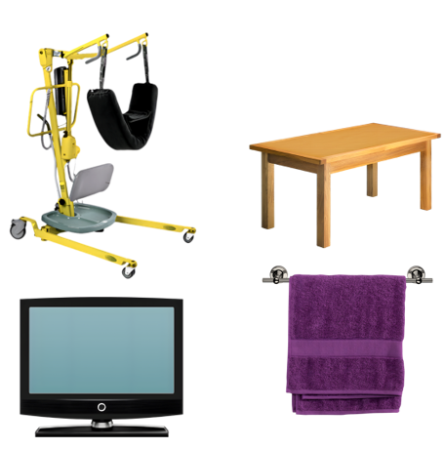 | You may need to buy things for your new home like  - Equipment like a hoist  - A couch and table  - TV  - Sheets and towels.
 | You will need money to buy things you use every day like  - Toilet paper  - Soap and shampoo  - Food and drinks.
 | You will need money to care for your health like  - Medicine  - Doctor appointments  - Medical supplies  - Assistive technology.
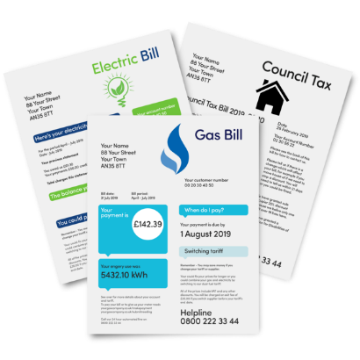 | You will need money for bills like  - Electricity  - Phone  - Internet.
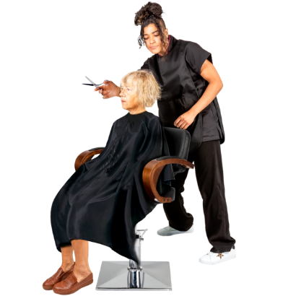 | You will also need money for things like  - Clothes  - Haircuts  - Holidays.
 | You may need money for things like  - Bus or taxi rides  - Activities like going to the movies  - Swimming pool or gym.

More information
 | The next Easy Read for Chapter 2 is  - Part 2 Stages of moving.
 | It is on this website.  www.health.gov.au/ypirac  The website is not Easy Read.
The website also has Easy Read information for

- The 5 toolkit chapters
- Why we wrote the toolkit
- How to contact us.

Images in this Easy Read must not be used or copied without permission

