Your toolkit for moving out of aged care

Chapter 1 Explore housing options

 | The Australian Government Department of Health Disability and Ageing wrote this.  We say DHDA for short.  When you see the word we it means DHDA.  We wrote this with help from the  - National Disability Insurance Agency.  We say NDIA for short.
 | We wrote this in an easy to read way.  We use pictures to explain some ideas.
 | We have some words in bold.  This means the letters are thicker and darker.  These are important words.
 | This is an Easy Read summary of another document.  This means it has the most important ideas.
 | You can ask for help to read this document.  You can ask  - A friend  - Family members  - A support person.
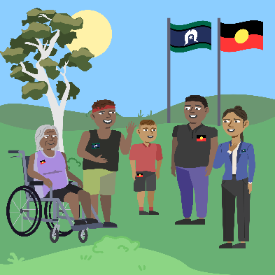 | We recognise Aboriginal and Torres Strait Islander people as the Traditional Owners of the land we live on.
 | They were the first people to live on and use the  - Land  - Waters.

Contents
About Chapter 1 | 5
Benefits of moving out of aged care | 6
Challenges of moving out of aged care | 7
Types of homes you can live in | 8
Funding to support you | 10
It takes time to move | 13
It costs money to move | 16
More information | 18

About Chapter 1
 | This Easy Read is about Chapter 1.  It is called Explore housing options.
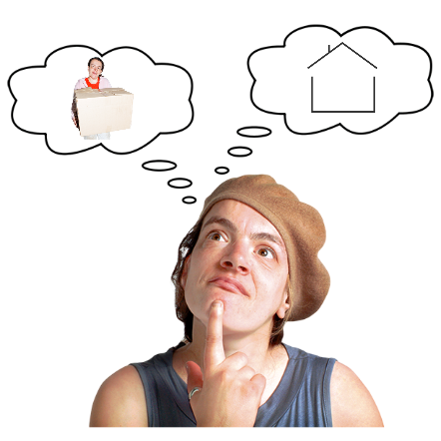 | It has information about  - Types of homes you can live in  - Funding to support you  - It takes time to move  - It costs money to move  - The benefits of moving out  - The challenges of moving out
 | Benefits are good or helpful things
 | Challenges are hard things.

Benefits of moving out of aged care
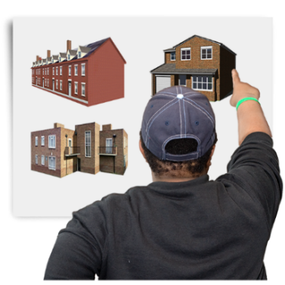 | Moving out of aged care has benefits.  Some benefits can be choosing  - Where you live
 | - Who you live with
 | - Who supports you
 | - How you spend your time.

Challenges of moving out of aged care
 | There can be challenges when you move out of aged care.  Some challenges can be  - It can be hard to find the right home
 | - You may need to learn new skills to be more independent in your new home  Independent means doing things on your own.
 | - You may worry about how your life will change.  There are people who can support you when you have challenges like  - Your family  - Your friends  - Other people you trust.

Types of homes you can live in
 | There are different types of homes you can live in.  You may be able to live in a home that is  - Owned by the government  This is called public housing.
 | The government has rules about who can live in public housing.  You need to meet these rules.  It can take a long time to get public housing.
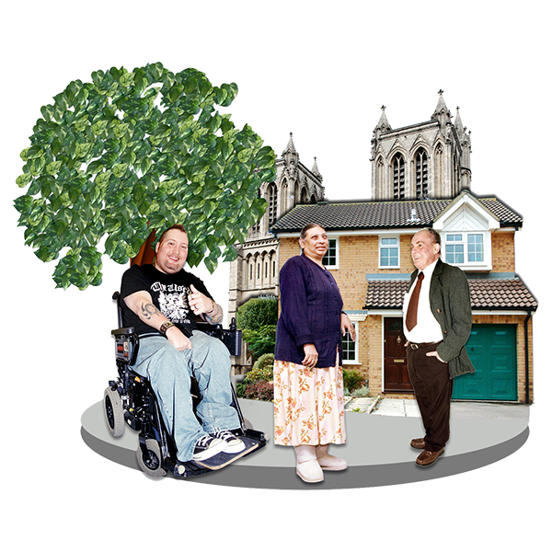 | You may be able to live in a home that is owned by  - The community  - A charity  - Somebody else.
 | You may need to pay rent.  Rent is money you pay to the owner of the home so you can live there.
 | You may be able to live with other people.  Everyone pays part of the rent.  This means rent may be cheaper for you.
 | You may be able to buy a home to live in.  People may buy a home  - On their own  - With another person like a family member.
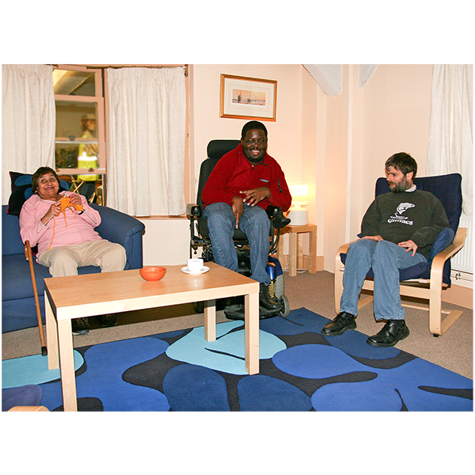 | You may be able to live in specialist disability accommodation if you  - Have NDIS  - Need lots of support.  We say SDA for short.

Funding to support you
 | When you are in your new home you can choose  - Who supports you  - How you are supported.
 | If you have NDIS you may have funding for NDIS supports.  Funding is money from the government.  Types of NDIS supports funding are
 | - Supported independent living.  We say SIL for short.  SIL funding is for support with  - Mealtimes  - Showering and dressing  - Everyday activities like cooking.
 | SIL is for people who need  - Lots of support  - Someone with them all the time.
 | - Individualised living options  We say ILO for short.  ILO funding supports you to think about  - How you want to live  - Where you want to live.
 | - Personal care supports  Personal care supports funding is for support with  - Showering and dressing  - Using the bathroom  - Mealtimes  - Going to appointments  - Moving around your home  - Using assistive technology.
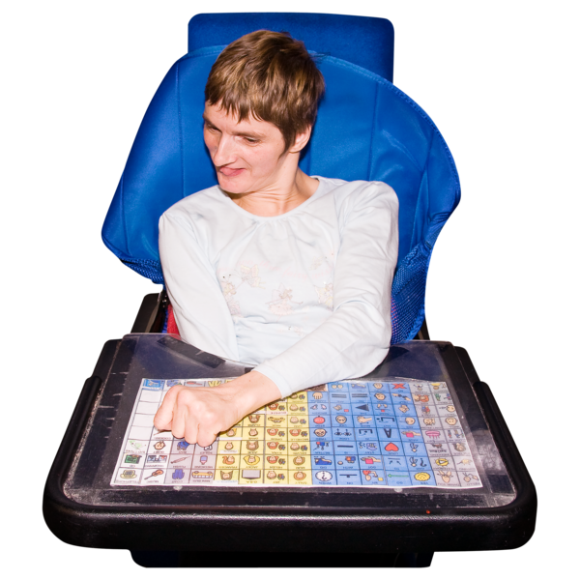 | Assistive technology can be things to help you  - Speak  - Move  - See  - Hear.
 | It is important to think about the type of home that  - Will meet your needs  - Is what you want.

It takes time to move
 | Moving out of aged care can take a long time.  It is important to  - Think about what you need  - Make a plan.  You can have support to do this.
You may be able to get NDIS funding to support your move.

It can take time to get NDIS funding.
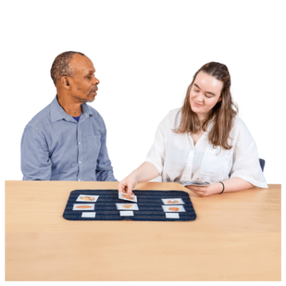 | You may need to have  - Meetings  - Assessments.  Assessments help NDIS work out  - How your disability affects your life  - What supports you need.
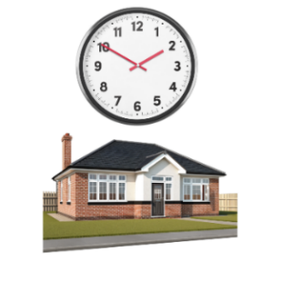 | It may take time to find the right home.
 | It may take time to get your home ready to move in.  Some homes may be ready in less than 1 year.  Some homes take longer.
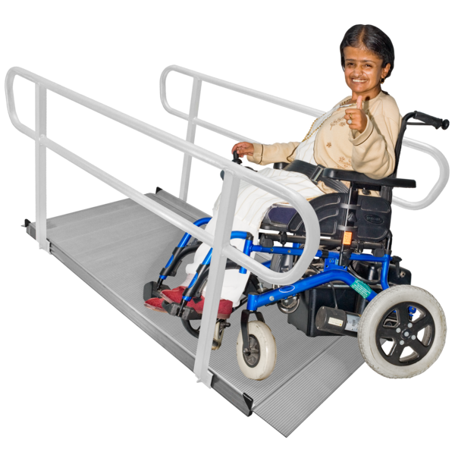 | You may need to wait for your home to be  - Built  - Changed to meet your needs.
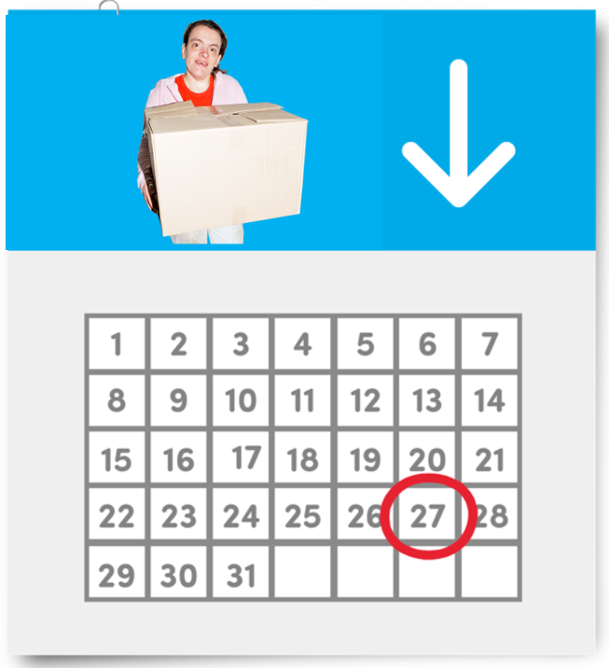 | When you buy a home there is a settlement period.  The settlement period is the number of days after you buy the home.  You own the home when the settlement period is finished.  It can take 90 days.  You will not be able to move in until after the settlement period.

It costs money to move
 | It costs money to move out of aged care.
 | You may need to pay someone to  - Pack your things  - Drive your things to your new home  - Put your things away.
 | In your new home you may need to pay for  - Food  - Bathroom things like shampoo and toilet paper  - Cleaning things  - Kitchen things like dish soap  - Sheets and towels  - Bills.  This list does not have everything you need to buy.
 | You may be able to get funding from  - Other government programs  - A charity  - Community groups.
 | You can ask for help from your  - Family  - Support Worker  - Support Coordinator.
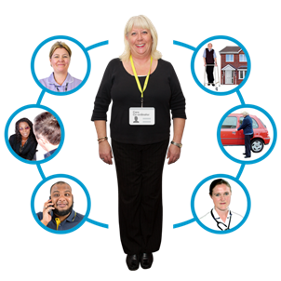 | A support coordinator is a person who helps you with your NDIS plan.

More information
We wrote Easy Read information about

- The 5 toolkit chapters
- Why we wrote the toolkit
- How to contact us.

 | They are on this website.  www.health.gov.au/ypirac  The website is not Easy Read.

Images in this Easy Read must not be used or copied without permission

