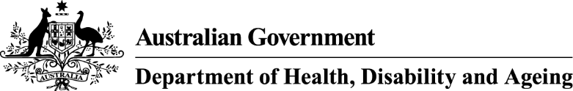

Privacy Notice
Support at Home program – Provider application for Care Management Supplement - APP 5 Notice

Your personal information is protected by law, including the Privacy Act 1988 and the Australian Privacy Principles (APPs).
Who is collecting your personal information?
Your personal information is being collected by the Department of Health, Disability and Ageing (the department/we).
Why does the department collect your personal information?
We collect your personal information for the purpose of determining applicability of the care management supplement for the Support at Home program.
What would happen if the department did not collect your personal information?
If you do not or are unable to provide your personal information the department may not be able to apply the care management supplement, if it has not already been applied.
Who will the department disclose your personal information to?
We disclose your personal information to Services Australia who administer the care management supplement to the service delivery branch account of the registered provider.
Access to and correction of your personal information
The department’s privacy policy contains information about how you may access and seek correction of your personal information.
Privacy complaints
The department’s privacy policy contains information about how you may complain about a breach of the Australian Privacy Principles or the Australian Government Agencies Privacy Code and how the department will deal with complaints.
Overseas disclosure of your personal information
We will not disclose your personal information to any overseas recipients.

Further information
You can read the department’s privacy policy here. You can obtain a copy of the APP privacy policy by contacting the department using the contact details set out at the end of this notice.
Consent
By providing your sensitive information to us, you consent to the Department of Health, Disability and Ageing collecting information for the purposes indicated above.
If you are providing the department with personal information about another individual, unless you are authorised to consent on their behalf, you will need to inform that individual of the contents of this notice and obtain their consent to the department collecting their personal information.
Contact details
If you wish to contact the department about a privacy-related matter, including questions about this notice, please contact the department’s Privacy Officer by one of the following methods:
- Post
Privacy Officer
Department of Health, Disability and Ageing
23 Furzer Street
WODEN ACT 2606

- Email
privacy@health.gov.au

- Telephone
02 6289 1555

