Final report
Review of the PHN Business Model and Mental Health Flexible Funding Stream

June 2025

Contents
About the review 3
Executive summary 5
PHN Business Model 5
Mental Health Flexible Funding Stream 12
Review of the PHN Business Model and MHFFS 14
Background 14
Review approach 15
Findings 16
PHN Business Model 16
Mental Health Flexible Funding Stream 27
Recommendations 31
PHN Business Model 31
Mental Health Flexible Funding Scheme 38
List of acronyms 39

About the review
The Department of Health, Disability and Ageing (the Department) engaged Boston Consulting Group to provide recommendations on the future of the Primary Health Networks (PHN) Business Model. In developing these recommendations, the review was required to examine the PHN Program in the context of the changing operating environment in both primary and mental health care, and to ensure the Program is structured to meet government objectives.
The scope of the review was guided by six key questions determined by the Department:
- Are the roles of PHNs clear and understood by stakeholders? How will the relative importance of the different roles need to evolve to meet broader changes in health policy and delivery?
- Is the governance of PHNs and the broader PHN Program appropriate, efficient and effective?
- Does the PHN Program support regional planning, capacity building, effective communication and engagement between relevant stakeholders?
- Do the current PHN Program funding arrangements support effective delivery of the objectives?
- What is the role of PHNs in commissioning services through the Mental Health Flexible Funding Stream within the mental health and suicide prevention system, and how effective has it been? How could that role evolve to be more efficient and effective?
- How can the Mental Health Flexible Funding Stream funding model be updated to meet the evolving role?
The review was conducted from November 2024 to June 2025 and included approximately 150 interviews, 130 submissions and 1,500 survey responses across all key stakeholder groups (see Table 1 below).
Table 1: Summary of consultation

 | Interviewees | Written submissions | Survey respondents
Central agencies | 6 | - | -
State government | 31 | 1 | 132
PHNs | 57 | 17 | 46
PHN Community Councils and Community Advisory Committees | - | - | 148
Peak bodies | 16 | 29 | 60
General practices | 5 | 9 | 307
Other local service providers | 27 | 73 | 595
Other | 36 | 2 | 172
Total | 148 | 131 | 1,460

Executive summary

PHN Business Model
The Primary Health Networks (PHN) business model comprises 29 not-for-profit organisations appointed as PHN Operators funded by federal government grants to deliver a range of locally responsive government programs that address community health needs. PHNs were established by the Australian Government in 2015 in response to recommendations of the 2014 Review of Medicare Locals, when the Government appointed 29 regional not-for-profit organisations as PHN Operators across 31 regions Australia-wide. The PHN model replaced Medicare Locals (established in 2011, with 61 regions), which replaced Divisions of General Practice (established in 1992, with 120 divisions). PHNs are responsible for driving local innovation to meet specific local health needs and supporting the consistent local delivery of national and co-commissioned programs and services. They deliver three core functions, known as ‘the 3Cs’: i. Coordinate and integrate local health care services in collaboration with Local Hospital Networks (LHNs) to improve quality of care, people's experience and efficient use of resources; ii. Commission primary care and mental health services to address population health needs and gaps in service delivery and to improve access and equity; and iii. Capacity build and provide practice support to primary care and mental health providers to support quality care delivery. PHNs currently deliver over 2,700 activities on behalf of the Department.
The primary health care landscape has evolved since PHNs were established, but the PHN business model has not changed. Broader shifts in the primary care landscape, including an ageing and growing population and a rising burden of preventable disease, have underscored the need for better integrated primary care. PHNs are expected to play a larger role with increasing responsibilities and their remit has expanded substantially since 2015, from delivering activities on behalf of four policy areas in the Department to delivering activity on behalf of 43 policy areas today. This expansion has been matched by a significant increase in investment, with total PHN funding nearly doubling from $968 million in 2016–17 to $1.89 billion in 2022–23. The role of PHNs has also evolved to include rapid delivery of national programs, such as Headspace and Covid-19 pandemic programs.
The Department engaged BCG to review the PHN Business Model in the context of the changing operating environment in both primary and mental health care, and to ensure the Program is structured to meet government objectives. The review found strong and widespread support for the PHN model, along with several valid concerns. Stakeholders recognised PHNs as critical enablers of locally responsive care that are valued for their commissioning capabilities, provider engagement and local knowledge – particularly in regions with complex needs. Many stakeholders pointed to strong examples of positive local impact, and to PHNs’ significant role in delivering critical national programs such as Urgent Care Clinics. At the same time, the views of many stakeholders could be summarised as a belief that the PHN Program’s full potential remains unrealised. In particular, capacity and performance are seen to vary significantly across PHNs, limited data on outputs and outcomes makes it hard to assess Program performance, and some stakeholders raised specific concerns regarding trust and engagement.
The review identified a negative feedback loop in which inherent tensions in the PHN model undermine stakeholder confidence, which contributes to an unwieldy and burdensome funding process that restricts the ability of PHNs to respond flexibly to local needs, which further undermines stakeholder trust and confidence (see
Exhibit 1).
Exhibit 1: Inherent tensions in the PHN Model drive a negative feedback loop
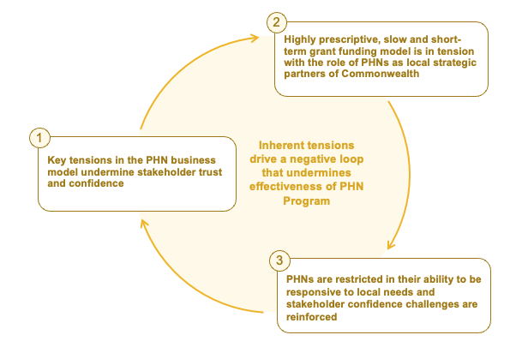
- Key tensions in the PHN business model undermine stakeholder trust and confidence. The first tension involves differing perspectives between stakeholders as to whether the model requires PHNs to be primarily accountable to general practices, to the Commonwealth, or to themselves as self-governing entities, leading to confusion and misaligned expectations. The second tension arises due to the difference between the current model’s approach that allows PHNs to set their own governance standards so long as they comply with the requirements of the Australian Charities and Not-for-profits Commission (ACNC), and the expectation of most stakeholders for organisations that manage significant public funds to have more consistent and robust governance. This tension underpins many of the concerns raised about trust and transparency and is exacerbated by a similar tension between the model’s encouragement of local design of engagement and many stakeholders’ expectations for greater consistency. The third key tension arises between the desire for an integrated perspective on PHN performance measurement, management and improvement, and the reality of a complex, many-to-many oversight relationship between PHNs and multiple policy areas of the Department. This has led to ineffective performance measurement and management at the individual PHN and overall program level.
- Stakeholder trust and confidence concerns contribute to a short-term, highly prescriptive and slow funding approach that is unwieldy and burdensome. The grant funding model, designed primarily for special purpose and competitive grants, is in fundamental tension with the PHN Business Model which has used a competitive tender process to give PHN operators an ongoing sole mandate from the Commonwealth to deliver local enhancements under the program. The processes associated with grant funding add a layer of administration that creates limited value. In addition, the grant schedules that accompany funding agreements are typically highly prescriptive and focussed on process controls (even for ostensibly flexible funding streams), requiring significant detailed reporting that does not deliver usable, aggregable insights on outputs and outcomes. Many grants are short term in nature, often only 1–3 years duration even for persistent programs, and are renewed at the last minute. Disbursement of funding typically takes 6–12 months from announcement to receipt by PHNs.

- Short-term, prescriptive and delayed funding undermine PHNs’ ability to plan and deliver locally responsive services. Short-term grants with late renewals constrains PHNs to simply rolling over funding and programs rather than enabling them to plan for and manage new and changing services in line with changing needs. Prescriptive schedules limit the ability of PHNs to tailor programs to local needs and may require directed activities that do not respond to the opportunities identified in local Needs Assessments. Delayed disbursements also lead to significant administrative burden, rushed commissioning and disruptions to service delivery. Combined, these impacts often leave local stakeholders conscious of a significant gap between the findings of local Needs Assessments and the activities actually funded.
The review recommends two streams of immediate reforms to the PHN Business Model. These reforms are designed to address the identified tensions in the PHN Business Model while retaining the existing Business Model. Reform Stream 1 – Raise confidence in PHNs focuses on a targeted set of interventions to clarify that the primary accountability of PHNs is to the Commonwealth, introduce minimum governance and engagement standards, and implement meaningful performance assessment. Reform Stream 2 – Improve process for funding includes a targeted set of interventions to simplify grant duration, reduce the prescriptiveness of schedules, and accelerate the disbursement of funding.

Reform Stream 1 – Raise confidence in PHNs focuses on a targeted set of interventions to clarify that the primary accountability of PHNs is to the Commonwealth, introduce minimum governance and engagement standards, and implement meaningful performance assessment
  - Reinforce that PHNs are funded to act on behalf of the Commonwealth in line with the provisions of their Deeds and are primarily responsible for delivering better health outcomes by improving local primary care through service coordination, provider capacity building and targeted commissioning

  - Introduce minimum governance and engagement standards:
  - Require PHNs to conduct internal minimum governance reviews using standardised guidelines
  - Require all PHNs to adopt a nationally consistent commissioning approach, based on the existing work that has been started by the PHN Cooperative (e.g. consistent RFP documents, KPIs)

  - Implement meaningful performance assessment:
  - Standardise and integrate key reporting using an annual ‘Needs, Programs, Outputs’ report for each PHN
  - Establish a ‘PHN Quality and Improvement’ team to conduct PHN operations and performance reviews, and recommend improvement actions to PHNs
  - Implement an underperformance escalation pathway to manage underperforming PHNs and ensure they respond to improvement recommendations

Reform Stream 2 – Improve process for funding includes a targeted set of interventions to simplify grant duration, reduce the prescriptiveness of schedules, and accelerate the disbursement of funding
  - Move to 3–5 year rolling grants for all persistent and core programs:
  - Articulate the impacts/limitations of short-term funding to policy areas and broader government to support a transition to longer terms for core funding and program funding
  - Set guidelines on the design and duration of program funding (e.g. three years) to allow meaningful tailoring and commissioning of services, with the exception of one-off/ad-hoc grants

  - Move to standard templates that cater to different levels of prescription required and focus on outputs:
  - Establish a clear ‘Service Offer’ with policy areas to establish the rules of when and how policy areas can use PHNs to deliver their programs (e.g. simplified schedules, minimum terms of funding)
  - Significantly reduce schedule length and, where possible, remove overly prescriptive activities and burdensome program-specific process control reporting
  - Create different templated versions of the grants process (e.g. high control, medium control, low control)
  - Ensure that reporting is commensurate with funding amount and duration, and that data collection is fully justified (e.g. high frequency only early in new policies)

  - Reduce administrative bottlenecks and introduce faster pathways for routine or low risk funding:
  - Investigate accelerated pathway for grants (including variations or extensions to existing funding) to achieve the most suitable outcomes
  - Continue using non-competitive and non-application-based grants where possible (unless the activity is specifically competitive)
  - Assess opportunities to triage PHN grants to lower risk templates when appropriate (e.g. PHN grants can default to 'complex/high risk' templates, despite the well-tested model and defined recipients)
  - Evaluate opportunities to operate under existing (more flexible) schedules, rather than defaulting to new Grant Opportunities
  - Consider options to expedite approval of 'standard' Grant Opportunity Guidelines (e.g. funding extension)

Delivering the reforms will require both immediate and ongoing investment. In the 12 months following agreement to adopt these reforms, the Department will need to make a one-off investment in PHN Branch resourcing to update funding deeds, simplify reporting, develop new policy proposals to support longer-term funding arrangements and stand up the new Quality Improvement team. Following this initial implementation period, a smaller ongoing increase to current funding levels will be required to support the PHN Quality Improvement team and enhanced PHN Branch responsibilities. The Department’s operating model will need to change with respect to the PHN program, with the PHN Program Board playing a stronger stewardship role.
Delivering the two streams of immediate reforms will increase trust, reduce administrative burden, distribute funds more effectively, and support PHNs to deliver ‘the 3Cs’. Making PHNs primarily accountable to the Commonwealth will help manage mis-aligned stakeholder expectations and build their trust and confidence. It will also provide clarity for PHN boards. Additionally, the reduction in reporting and administrative effort (e.g. activity work plans and fragmented funding requirements) would free up a portion of the 17,750–20,000 administrative staff hours per year per PHN for more strategic, value-adding work. A streamlined PHN funding model could significantly reduce time to disbursement. PHNs would have an improved ability to commission services aligned with local Needs Assessments, using best practice approaches and stronger coordination of care – particularly between adjacent PHNs.
The review also recommends that, three years after commencing the immediate reforms, the Department considers the option of moving to a new PHN model if the reforms have not delivered sustained improvements in PHN capability and capacity. Under this model, a not-for-profit Commonwealth entity would be established as the holding entity and enabling service provider for 31 local PHN Divisions, with each PHN retaining current boundaries, local staff, local offices and a local CEO, and holding similar delegations and authorities to maintain local autonomy and flexibility. PHN Boards and advisory groups would become Local Advisory Boards. PHNs would be funded via direct appropriations from Government with five-year core and four-year program funding. A shared services function would provide finance, HR, ICT, data and procurement, freeing up funds for investment in primary care. The PHN Branch of the Department would remain responsible for broader policy and program design.
This not-for-profit Commonwealth entity model would help to address remaining structural tensions in governance and engagement, performance management and funding processes, and unlock further efficiencies for reinvestment in primary care. The entity structure would improve PHN delivery even further – raising confidence in PHNs by clarifying roles and expectations, removing the need for grants and reducing administrative costs. These further system benefits and efficiencies could be directed towards more primary care programs, enabling stronger Commonwealth support of local health care delivery and offering potential for a collaborative governance model that engages a wide range of stakeholders. Longer term, bringing PHNs into a not-for-profit Commonwealth entity would also support more consistent integration between the Commonwealth, states and territories at the local level.
While this reform offers significant benefits, it would be complex, time-consuming and disruptive, and likely require legislative change and major shifts in contracts, systems and governance; as a result, the review recommends that the two streams of immediate reforms are first pursued for three years before this option is considered. The decision to move to a new model would ultimately rest with government.

Mental Health Flexible Funding Stream
The Mental Health Flexible Funding Stream (MH FFS) supports PHNs to commission place-based mental health care where existing services do not meet community needs. The MH FFS was introduced in 2016 to respond to widespread service gaps by aiming to improve access and address local priorities. The funding stream provides short-term grant funding to support services that fall between low intensity and high intensity services, with a focus on moderate-intensity support. It includes both specified and unspecified funding: specified funding supports nationally consistent programs and is more prescriptive, while unspecified funding gives PHNs greater flexibility to respond to local needs.
The MH FFS has many of the same tensions identified within the PHN Business Model, and the recommendations regarding the PHN Business Model will also support the MH FFS. During consultation, stakeholders shared similar concerns about governance, prescriptive schedules, short term funding and poor output and outcomes measurement. PHNs sought further clarity on the alignment between MH FFS purpose and funding, and PHN responsibilities. Most (19 of 29) PHNs reported that funding is prescriptive and inhibits their ability to fund initiatives to address local needs. Non-PHN stakeholders reported similar concerns about prescriptive MH FFS funding and advocated for greater flexibility to coordinate existing services and commission innovative services.
More specifically for the MH FFS, changes in the mental health funding landscape since 2016 mean that unmet needs are now more variable at a regional level. When the MH FFS was introduced in 2016, all PHNs faced widespread unmet mental health needs. The scheme was designed to ensure that a range of these needs were at least partially addressed. The additional funding delivered through specified and unspecified streams provided a welcome and reliable way to address priority gaps. Since then, the broader funding and service context has shifted, with increased investment, new national and state programs such as Headspace and Medicare Mental Health Centres, and Commonwealth and state agreements including the Fifth National Mental Health and Suicide Prevention Plan (2017-2022) and the National Mental Health and Suicide Prevention Agreement (2022-2026). These changes have contributed to more needs being met, leading to increased diversity of local unmet needs due to regional differences in demographics, workforce availability, culturally specific service gaps and the fragmentation of existing services.
The Needs Assessment process is viewed as an effective tool to identify local needs, however many PHNs report that the MH FFS funding and guidance processes and tools do not allow them to respond flexibly to the identified needs. Stakeholders generally view the Needs Assessments process as an effective way of identifying local needs. However, the combination of MH FFS funding streams, priorities, guidance documents, historical directions from the Department and prescriptive schedules means that, in the PHNs’ experience, the MH FFS is not able to be applied flexibly to meet the needs identified in their Needs Assessments. PHNs also reported that the MH FFS is overly focused on commissioning new services, when the best solutions to address unmet needs may involve coordination of existing services and capacity building across the workforce. In addition, under the current activity work planning and data capture approach, policy owners are not able to demonstrate the outputs produced for the significant investment in MH FFS, despite significant data being collected via the Minimum Data Set.
To address program-specific tensions in the MH FFS, the review proposes a set of reforms to streamline funding, align program logic with ‘the 3Cs’, and enhance planning and reporting. These reforms would be implemented at the same time as the two immediate reform streams relating to the PHN Business Model.
MH FFS Reform Stream – Streamline MH FFS funding
MH FFS 1: Consolidate MH FFS funding into a single stream
MH FFS 2: Empower PHNs to spend MH FFS across all aspects of ‘the 3 Cs’: commissioning, coordination and capacity building
MH FFS 3: Require PHNs to align their annual activity planning against their local Needs Assessment, Joint Regional Planning with LHNs/States and annual best practice guidance shared by The Department. Activity plans should include clear intended quantitative output or activity to enable the policy team to show what will be delivered for the MH FFS investment.

These reforms to the MH FFS would give PHNs greater flexibility to tailor services, reduce fragmentation across the care continuum, and improve the clarity and responsiveness of funding allocations. PHNs would be able to tailor services to meet their local needs more closely, as funds would not be apportioned to separate streams. Services across the stepped care continuum would be more coordinated and less fragmented as PHNs improve commissioning and capacity building.

Review of the PHN Business Model and MHFFS

Background
The Primary Health Networks (PHN) business model comprises 29 not-for-profit organisations appointed as PHN Operators, funded by federal government grants to deliver a range of locally responsive government programs that address local community health needs. PHNs were established by the Australian Government in 2015 in response to recommendations of the 2014 Review of Medicare Locals when the Government appointed 29 regional not-for-profit organisations as PHN Operators across 31 regions Australia-wide. The PHN model replaced Medicare Locals (established in 2011, with 61 regions) which replaced Divisions of General Practice (established in 1992, with 120 divisions). PHNs are responsible for driving local innovation to meet specific local health needs and supporting the consistent local delivery of national and co-commissioned programs and services. PHNs are funded by the Department of Health, Disability and Ageing (the Department) to commission services from local providers and practitioners to meet the health needs of their regions.
PHNs assess local community health needs and commission health services to meet those needs in line with government priorities. The current priorities comprise mental health, Aboriginal and Torres Strait Islander health, population health, health workforce, digital health, aged care, and alcohol and other drugs. PHNs deliver three core functions – known as ‘the 3Cs’:
- Coordinate and integrate local health care services in collaboration with Local Hospital Networks (LHN) to improve quality of care, people's experience and efficient use of resources
- Commission primary care and mental health services to address population health needs and gaps in service delivery and to improve access and equity
- Capacity build and provide practice support to primary care and mental health providers to support quality care delivery. PHNs currently deliver over 2,700 activities on behalf of the Department.
To determine which activities to conduct and which services to commission, PHNs conduct periodic Needs Assessments, informed by data and consultation with local health professionals, Local Health Networks (LHNs), clinical councils, community advisory committees, consumers and other relevant stakeholders. The Department is responsible for the governance of the overall PHN Program and performance management of each PHN. Individual PHNs are operated as not-for-profit organisations, each with its own internal governance processes and overseen by the ACNC.

Review approach
Since PHNs were established in 2015, Australia’s primary care sector has evolved significantly but the PHN Business Model has remained largely the same. In this context, the Department engaged Boston Consulting Group to provide recommendations on the future of the Primary Health Networks (PHN) Business Model. In developing these recommendations, the review was required to examine the PHN Program in the context of the changing operating environment in both primary and mental health care, and to ensure the Program is structured to meet Government objectives.
The scope of the review was guided by six key questions determined by the Department:
- Are the roles of PHNs clear and understood by stakeholders? How will the relative importance of the different roles need to evolve to meet broader changes in health policy and delivery
- Is the governance of PHNs and the broader PHN Program appropriate, efficient and effective?
- Does the PHN Program support regional planning, capacity building, effective communication and engagement between relevant stakeholders?
- Do the current PHN Program funding arrangements support effective delivery of the objectives?
- What is the role of PHNs in commissioning services through the Mental Health Flexible Funding Stream within the mental health and suicide prevention system, and how effective has it been? How could that role evolve to be more efficient and effective?
- How can the Mental Health Flexible Funding Stream funding model be updated to meet the evolving role?
To address the key questions, the review engaged a wide range of stakeholders – including PHNs, states, peak bodies and service providers – to identify tensions within the current model and make recommendations on the business model.
The consultation and analysis were completed over a six-month period and in five phases:
- Phase 1 (4 November to 29 November): Develop framework for the review and a baseline view of the PHN Business Model using desktop analysis.
- Phase 2 (2 December to 24 January): Gather stakeholder input to identify key issues and potential reforms, including 150 interviewees, 130 written submissions and 1,500 survey responses.
- Phase 3 (27 January to 21 February): Use stakeholder input and desktop analysis to develop findings and reform options.
- Phases 4 and 5 (24 February to 30 May): Targeted stakeholder engagement to refine design details and transition considerations.
The following findings are based on extensive research and consultation, including 150 stakeholder interviews, 130 written submissions, 1,500 survey responses and extensive desktop research.

Findings

PHN Business Model
The review found strong and widespread support for the PHN Business Model, along with several valid concerns. Stakeholders recognised PHNs as critical enablers of locally responsive care, valued for their commissioning capabilities, provider engagement and local knowledge – particularly in regions with complex needs. Many stakeholders pointed to strong examples of positive local impact, and to PHNs’ significant role in delivering critical national programs such as Urgent Care Clinics. At the same time, the views of many stakeholders could be summarised as a belief that the PHN Program’s full potential remains unrealised. In particular, capacity and performance are seen to vary significantly across PHNs, data on outcomes is limited making it hard to assess Program performance, and some stakeholders raised specific concerns regarding trust and engagement.
The review identified a negative feedback loop in which inherent tensions in the PHN model undermine stakeholder confidence, which contributes to an unwieldy and burdensome funding process that restricts the ability of PHNs to respond flexibly to local needs, which further undermines stakeholder trust and confidence (see Exhibit 2).
Exhibit 2. Tensions in the PHN model drive a negative loop
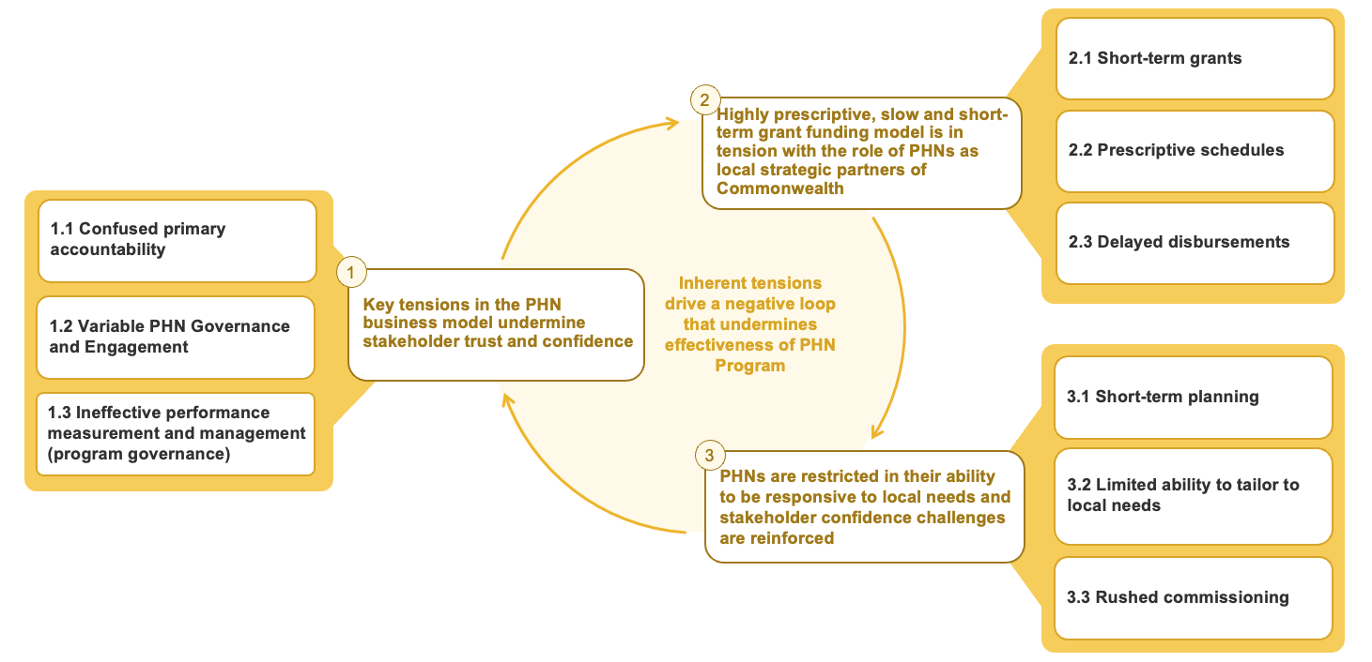

1. Key tensions in the PHN business model undermine stakeholder trust and confidence

1.1 Confused primary accountability
Stakeholders were broadly aligned that the aims of the PHN Program are to increase the efficiency and effectiveness of primary care services, particularly for people at risk of poor health outcomes, and improve the coordination of health care so that people receive the right care, in the right place, at the right time. Stakeholders were also aligned on the activities that PHNs undertake to achieve these objectives, namely coordinating care, commissioning services and building capacity in primary care (‘the 3Cs’) ​as set out in the PHN Strategy 2023–24. However, there was misalignment among stakeholders about the primary accountability of PHNs – whether PHNs are primarily accountable to general practices, to the Commonwealth, or whether they should operate as self-governing entities and be primarily accountable to themselves.
Primarily accountable to general practice
Some stakeholders appeared to work under an assumption that PHNs were established to improve the primary health care system by supporting general practice as the cornerstone of primary care. Consequently, they believed that accountability should be more strongly aligned to general practices. This view was expressed by GPs, general practices and their representatives. Some stakeholders suggested significant, minimum GP representation on boards (e.g. 50% was quoted by some stakeholders) and that PHNs should not commission services that “compete” with existing, local general practices.
Primarily accountable to the Commonwealth
Some stakeholders made clear that PHNs should be primarily accountable to the Commonwealth as their majority funder. They believed PHNs were established to optimise Commonwealth programs and primary care investments, including by providing a locally based implementation and support service that balances national priorities. This view rests strongly on the observation that funding and direction comes overwhelmingly from the Commonwealth and was often expressed by state governments and stakeholders in the Department, as well as some PHNs. These stakeholders also raised concerns about PHNs potentially being distracted by diversifying into other operations or lines of business.
Primarily accountable to themselves as self-governing entities
Some stakeholders indicated that PHNs should act as independent agents with primary accountability to themselves. In doing so, they would access diverse funding sources to broker, commission or advocate for solutions​ as they see appropriate for their local community. This view was put forward by multiple PHNs, arguing that by design they were established as self-governing entities independent of Government. In this view, the Commonwealth is one stakeholder among several that PHNs manage.
In interviews and written submissions, some stakeholders also sought greater clarity on the activities that PHNs should and should not undertake. Some also requested greater promotion of a consistent role and purpose of PHNs to governments and peak bodies. Clarifying the accountability of PHNs will help the PHN Program align the expectations of stakeholders across the health care system. This clarity will also be instrumental in resolving tensions across governance, engagement and funding.​

1.2 Variable PHN governance and engagement
Governance tensions
When the Australian Government selected 29 PHN Operators in a competitive process in 2015 to operate 31 PHNs, each PHN Operator was required to be established as a not-for-profit (NFP) organisation. As self-governing NFP organisations, PHNs must meet the governance standards set by the ACNC. Given the flexibility of these standards, governance practices vary significantly across the 29 PHN Operators, with differences in board composition, selection processes, membership structures, Conflict of Interest (CoI) practices and transparency with local stakeholders.
- Board membership, selection and membership: There are no common standards for Board membership, tenure limits or broader membership structures. For example, across PHN Operators, health care practitioners comprise between 20% to 80% of board members, and GPs between 0% and 44%. The average tenure of PHN board members varies from 2.2 to 7.7 years, with 45% of Boards having members with tenure over nine years. PHNs also had differing specifications on whether members must be organisations or individuals, with membership numbers ranging from three to 1,800.
Exhibit 3: 45% of PHN Boards have members with over 9 years' tenure​
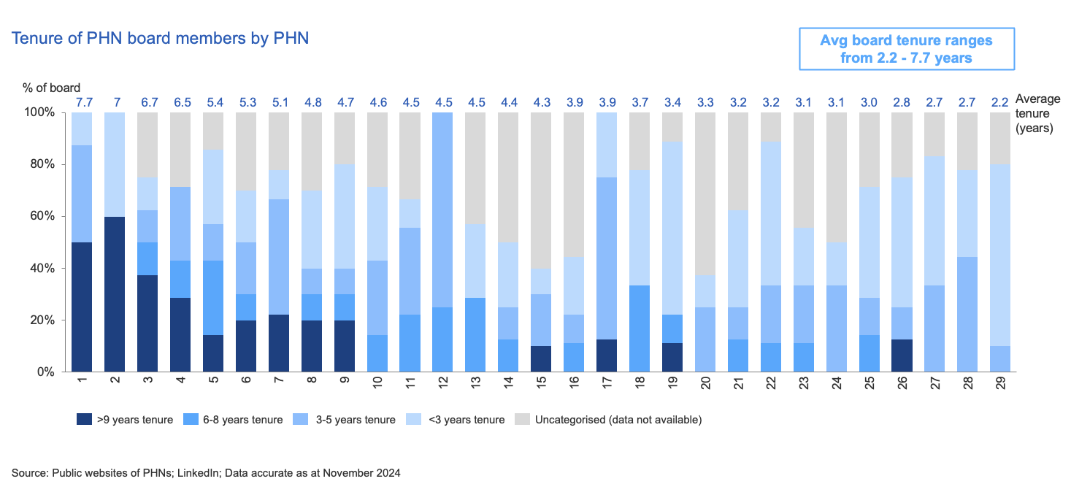
Source: Public websites of PHNs; LinkedIn; Data accurate as at November 2024
Exhibit 4: PHN membership models vary significantly across different PHNs, with membership numbers varying between 3 and 1,800+
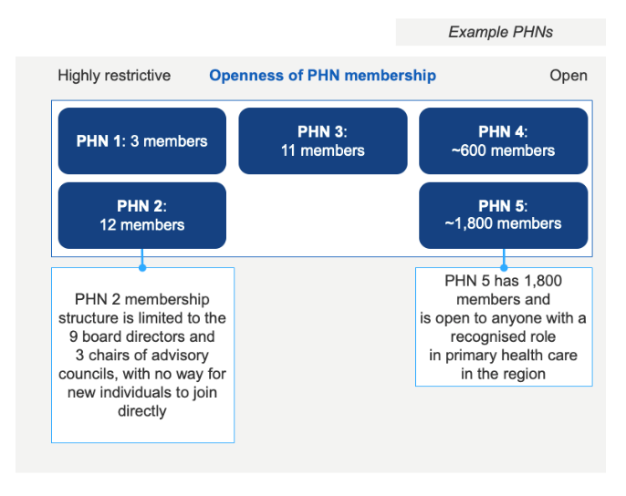
Source: PHN websites, stakeholder interviews

- Conflicts of Interest: COIs were raised by many service providers who perceived either risk or occurrences of conflicts, especially as many PHN Board members work locally in primary health care. Recent independent audits of 9 PHNs recommended stronger COI training, reinforced timelines for notifying the Department of COIs, and consistent use of COI tools such as registers for PHNs.
- Transparency: Many stakeholders raised concerns regarding transparency of PHN decision-making especially funding outcomes, with many stakeholders commenting that contract awards are not consistently published.
Stakeholder feedback highlights a clear tension between the model of self-governing PHN Operators, and stakeholder expectations for consistently high governance within organisations that manage significant public funds. Resolving this tension will be important to maintain trust among stakeholders and support the effective delivery of PHN activity.
Engagement tensions
PHNs engage with a broad range of stakeholders – including local GPs and general practices, LHNs, ACCHOs and other local providers – to understand local needs, design and commission local solutions, improve connections and build capacity.
Engaging a broad range of stakeholders can be challenging. For many stakeholders, PHN programs represent only a small share of their activity and focus, creating engagement challenges for stakeholders and the PHNs alike. PHNs use a range of formal and informal approaches for engagement, including locally tailored channels. Many PHNs reported that their engagement with LHNs was effective. PHNs also reported challenges engaging with local general practices and general practitioners, especially non-practice owning GPs.
Stakeholders broadly agreed that many aspects of local engagement work well, such as PHN advisory committees, LHN engagement and service delivery boundary alignment. However, some stakeholders were concerned about the effectiveness of this engagement. Some expected engagement to translate to more accountability to local stakeholders, especially to general practices. Some stakeholders, especially those who engage with more than one PHN, were concerned by the variation in how PHNs engage with stakeholders and the implications this has for effective and scalable engagement. These concerns were consistent with the divergent perspectives stakeholders raised on the primary accountability of PHNs. In particular:
- GPs reported highly variable experiences when engaging with PHNs. Half of GPs reported low effectiveness of engagement in the review survey. For many GPs, the underlying drivers reflected factors in the design of the PHN Program, such as short funding cycles and inflexibility of PHN funding. GPs also noted practices of the Department and PHNs that had an impact on trust, such as transparency on decision-making and COI practices. PHNs however reported that at the same time, they often have low responsiveness from GPs when conducting outreach efforts and that they often had better engagement with GP practice owners and managers, but non-practice owning GPs were hard to engage.
- State stakeholders reported that engaging with PHNs is critical for delivering local health services but it can be challenging when different PHNs within the same state use very different governance mechanisms and consultation practices. Stakeholders noted that this makes it difficult to coordinate state-wide priorities with PHNs.
- National providers, especially those operating in the mental health system, reported significant variation in the commissioning and reporting requirements when working with different PHNs, and the large work effort that this generates when bidding for and providing services across multiple PHNs.
- Some ACCHOs reported positive relationships with their PHN; however, many reported concerns that communication and engagement with ACCHOs is not done in a culturally safe and responsive manner and is not genuinely collaborative.

1.3 Ineffective performance measurement and management (program governance)
The overall governance of the PHN Program remains the same as when it was set up in 2015. The PHN Branch is responsible for overall program governance, performance management of each PHN and administration of all programs delivered through PHNs. However, in practice many policy areas also get involved in program delivery issues with many policy areas interacting directly with PHN Operators. Since the PHN Program was established, the number of policy areas in the Department that PHN Operators report to on program level performance has increased from four to 43. With this, tensions have emerged in relation to overall program governance.
Exhibit 5: Some PHNs reported that engaging with several policy areas of the Department requires significant resourcing
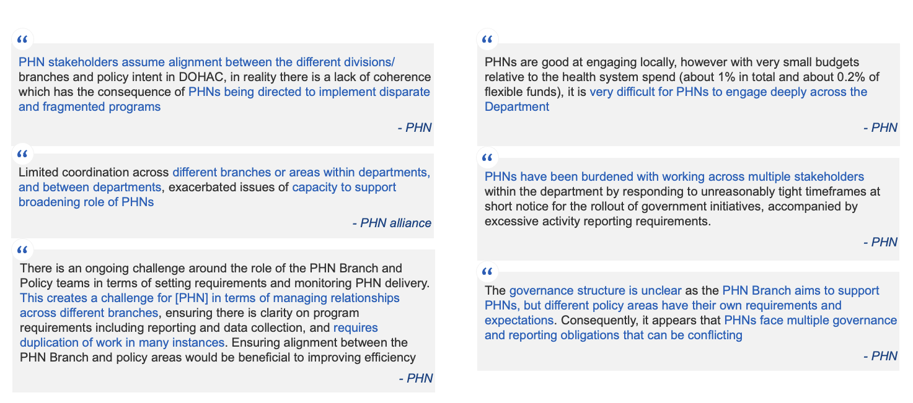
Source: Stakeholder interviews and focus groups
Stakeholders broadly noted that reporting processes between PHNs and the Department are challenging and resource intensive, with 29 PHN Operators delivering activity on behalf of 43 policy areas in the Department, which often seek to engage with PHNs directly. PHNs reported experiencing frequent occurrences where multiple Department stakeholders sought engagement on the delivery of policy priorities, particularly during reporting periods, leading to duplication and inefficiency for both the Department and PHNs.
Stakeholders have reported significant variation in performance and capacity maturity among PHNs, but acknowledge that limited information is available to assess this objectively or comprehensively. Current annual individual performance assessments are overly focused on financial tracking, and performance indicators don’t give meaningful insights into volume or quality of outputs or outcomes. The ANAO 2024 audit found PHN reporting overly focused on compliance, with some metrics outside PHN control.
While the Department has significant power through the existing grant arrangements to respond to PHN performance concerns, no formal interventions have occurred through the life of the program. Stakeholders suggested that a more formalised intervention model would support the Department to identify and improve poor performance and build capacity, noting this would be contingent on the availability of better performance data and a stronger capability to comprehensively assess operations and processes. In addition, a clear escalation pathway with voluntary, intermediate steps such as board observers or mandatory monthly reviews with the Department would provide additional intervention options before progressing to stronger interventions such as re-tendering.
Exhibit 6: PHNs, peak bodies and service providers requested a more formal performance management and intervention model for PHNs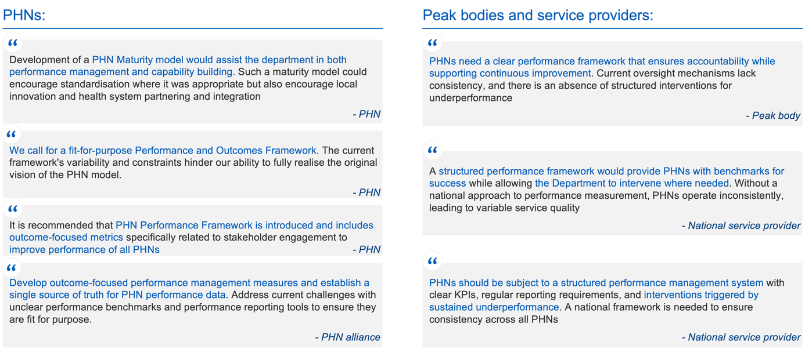
Source: Stakeholder interviews and focus groups

2. Stakeholder trust and confidence concerns contribute to short term, highly prescriptive and slow funding approach that is unwieldy and burdensome.
PHNs are funded by the Commonwealth using a grant-based model. PHNs pass about 90% of this grant income on to external service providers. PHNs’ total funding has grown at 9% each year, while funding of core operations and health system improvement has grown at 2% each year. Grant funding to PHNs is governed by the Commonwealth Grant Rules and Principles, which are designed primarily for competitive tendering. In practice, PHNs receive grants either as monopoly providers or through nominally competitive rounds. Both approaches involve highly prescriptive requirements, particularly in grant schedules, where policy areas specify detailed activities to be delivered. This creates administrative burden and delays. The grants process sits within a broader system that manages approximately 20,000 grants each year, contributing to systemic bottlenecks. These are often caused by multiple layers of central approval, including legal review (LSB), constitutional risk advice (AGS), policy clearance and Finance Minister approval. Stakeholders reported that disbursements can take between six and 12 months after budget announcements.
2.1 Short-term grants
Grant agreements for PHNs are often only for 1–3 years, even for long-running, successful programs. For example, the After Hours Program has received new 12-month allocations each year for the past seven years. Grant renewals are also often left till very late in the cycle, causing significant anxiety for providers and limiting ability for PHNs to plan for changes in service delivery. In the absence of strong performance measures, short-term grants have become a default control mechanism to manage perceived risk across the PHN Program.

2.2 Prescriptive schedules
Grant schedules are highly prescriptive and often focused on process compliance (even for ostensibly flexible funding streams), rather than outcomes. This puts a significant administrative burden on PHNs. PHNs each allocate between 17,750 and 20,000 staff hours per year to manage activity work plans, and financial and performance reporting across 73 fragmented funding streams, and produce up to 2,000 pages of documentation per PHN each year. Despite the sharp increase in scheduled activity and associated administrative workload, stakeholders noted that core funding has not increased in line with the expanding role of PHNs. Limited indexation has further reduced the value of core funding over time, making it increasingly difficult to deliver core functions effectively.

2.3 Delayed disbursements
Delays in funding disbursement are a persistent challenge that significantly constrain PHN delivery. Funding typically takes six months between being announced and being released to PHNs, given the lengthy grants processes that need to be fulfilled.
PHNs consistently described challenges in deploying funds due to delays between grant announcements and funds being made available, or carryover approval timelines, with 41% of PHNs reporting that these delays impacted their cash flow. These delays in funding disbursement and short-term grants contribute to PHN underspend, with only one in four PHNs spending their full annual allocation in 2022–23.
Stakeholders also raised concerns that future planned shifts in the grants process could create further delays, due to additional steps such as obtaining quotes, drafting online application forms and navigating layered approvals.
Exhibit 7: 71% of PHN CEOs and Board Chairs said the misalignment between funding release dates and program start dates has a significant impact on program delivery; 41% said delays impact cash flow
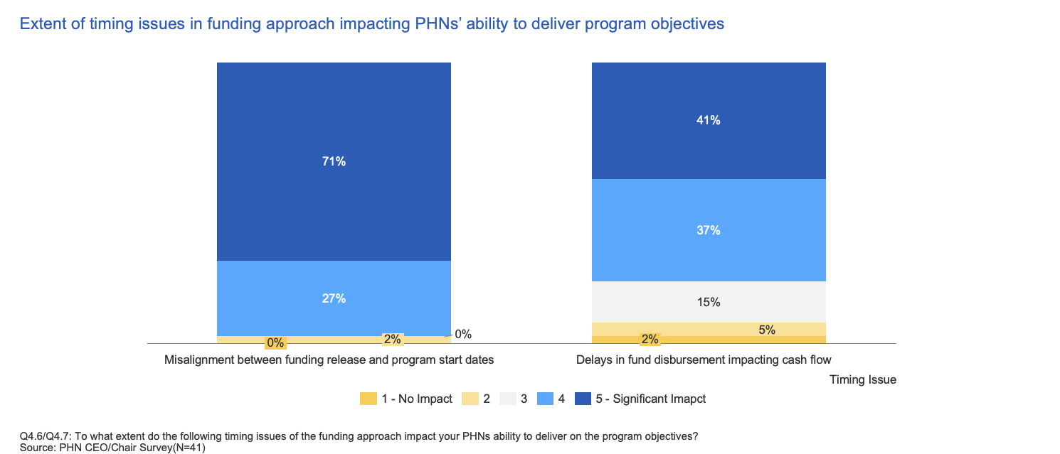
Source: Survey conducted by review team to PHN CEO/Chairs and PHN Stakeholders
Exhibit 8: PHNs and service providers noted that grant delays impact service delivery
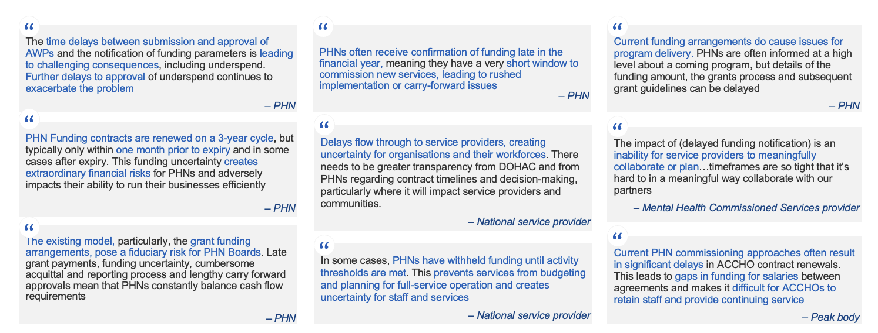
Source: Stakeholder interviews and focus groups

3. Short term, prescriptive and delayed funding undermine PHNs’ ability to plan and deliver locally responsive services

3.1 Short-term planning
Fragmented reporting, rigid activity definitions and short-term funding limit the ability of PHNs to plan for and respond to local priorities. These structural constraints reduce flexibility and make it harder to build stakeholder confidence in PHN effectiveness. Multiple PHNs and service providers noted that short-term grants disrupt local service delivery by affecting workforce stability and limiting the ability to attract experienced staff.
In surveys, 90% of PHN CEOs and Chairs and 55% of their stakeholders reported that short-term funding cycles, often 1–3 years, have a significant impact on the ability for PHNs to deliver program objectives. Funded service providers also highlighted risks of short-term funding to service continuity and attracting and retaining their workforces. They argued for more permanent funding for proven, successful services.
Exhibit 9: Short-term funding cycles have a significant impact on the ability for PHNs to deliver program objectives​
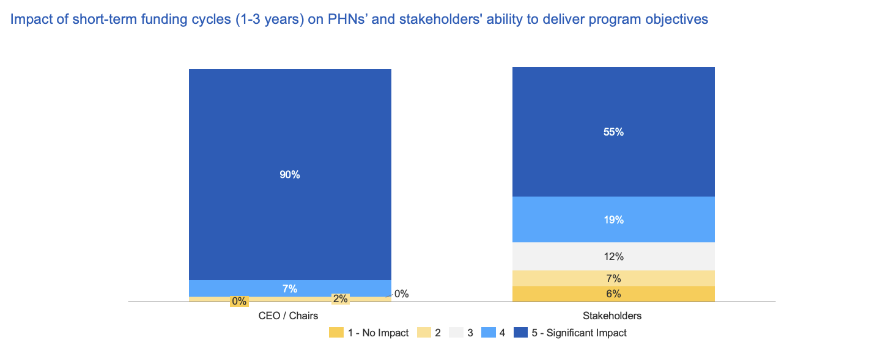
Source: Survey conducted by review team to PHN CEO/Chairs and PHN Stakeholders
Exhibit 10: PHNs and service providers reported challenges in funding approvals, with adverse implications for service delivery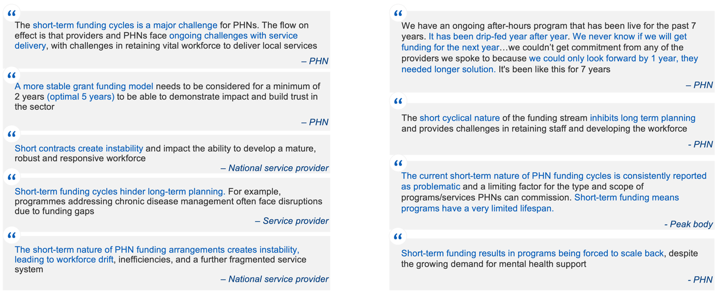
Source: Stakeholder interviews and focus groups

3.2 Limited ability to tailor to local needs
PHNs reported that prescriptive program rules (e.g. activities defined in Program schedules) prevent them from commissioning in line with Needs Assessments, despite strong intent to address local priorities. This limits implementation effectiveness in local communities. Nineteen of 29 PHNs stated that these constraints limit their ability to respond to identified gaps using non-clinical roles, digital tools or alternative models. Stakeholders also highlighted that rigid activity definitions are particularly misaligned with thin markets, where workforce limitations demand more flexible, place-based solutions.

3.3 Rushed commissioning
Many PHNs and service providers reported that delays in funding and service notifications negatively affected service delivery, with rushed commissioning cycles compressing the planning and scale-up of programs into unrealistic timeframes, and undermining service quality and workforce stability. 71% of PHNs reported that delays between the announcement and release of funding had significant impacts on their operations. In addition, 41% of PHNs reported that delays in funding availability directly affected their cash flow, constraining their ability to plan and commission effectively.

4. Other themes emerging from consultation with stakeholders.

4.1 Many stakeholders recognised opportunities for greater collaboration across PHNs to deliver better outcomes, more efficiently
PHNs and other stakeholders noted collaboration provides a means to avoid duplication of effort and reduce administrative burden, and to support innovation more systematically. For example, payroll, IT systems, HR and data engineering were cited as examples of back-office functions that could be shared. Some stakeholders also said collaboration was needed to share resources and knowledge, achieve consistent commissioning models and scale successful activities. Some stakeholders referenced the role that cooperative bodies have played in supporting consistency and collaboration across the 29 PHN Operators to date. Stakeholders also raised the concept of using meso-level (regional) structures or bodies to conduct activities at scale.

4.2 Some stakeholders, especially those with regional and rural presence, noted that the PHN role and approach needs to be flexible in thin markets
Some stakeholders noted that the type of funding and the prescriptiveness of activity associated with PHN funding is not always equally appropriate across different types of markets. In particular, stakeholders referenced that different commissioning processes are needed in thin markets.

4.3 Many stakeholders identified data and analytics as an area for improvement across the PHN Program and primary care more broadly
Many stakeholders commented on the lack of access to quality data, and the opportunities across the primary care system to improve data-linkage and interoperability in ways that could benefit the planning and measurement of PHN outcomes. More broadly, stakeholders also noted this data could be used to better inform policy and for financial planning and allocations.

4.4 Some stakeholders raised concerns on allocation of First Nations health funding through PHNs
PHNs and peak bodies noted that the current approach to funding First Nations health services, which channels funding through PHNs rather than directly to Aboriginal Community Controlled Organisations, may not align with the self-determination principles outlined in the Ninti One review. Stakeholders also expressed concern about the lack of clarity and delays in government decision-making on the review’s recommendations.

Mental Health Flexible Funding Stream
The Mental Health Flexible Funding Stream (MH FFS) delivers funding to support PHNs to commission place-based mental health care where existing services do not meet community needs. Introduced in 2016, the MH FFS responded to widespread service gaps by aiming to improve access and address local priorities. The stream provides short-term grant funding to support services that fall between low intensity and high intensity services, with a focus on moderate-intensity support. It includes both specified and unspecified funding: specified funding supports nationally consistent programs and is more prescriptive, while unspecified funding is intended to give PHNs greater flexibility to respond to local needs.
The MH FFS displays many of the same tensions identified within the PHN Business Model (see Exhibit 11). Stakeholders share similar concerns about governance, prescriptive schedules, short term funding, poor outcomes measurement. However, the broader funding and service context for mental health primary care has shifted, with increased investment, new national and state programs such as Headspace and Medicare Mental Health Centers, and Commonwealth and state agreements including the National Mental Health and Suicide Prevention Agreement (2022-2026). While more needs are being met, the diversity of local unmet needs has increased, based on regional differences in demographics, workforce availability, culturally specific service gaps and the fragmentation of existing services.
Exhibit 11: THE MH FFS is an example of broader PHN tensions that undermine trust, along with program-specific funding challenges that require targeted reforms
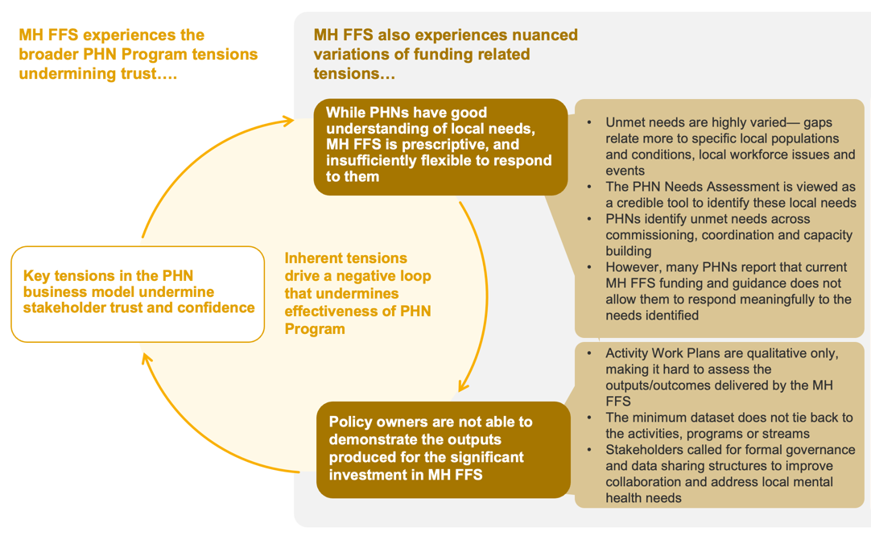

The funding and service delivery context for mental health has changed significantly since the MH FFS was introduce in 2016. When the MH FFS was introduced in 2016, all PHNs faced widespread unmet mental health needs. The scheme was designed to ensure that a range of unmet needs were at least partially addressed. Since 2016, the funding and service delivery context for mental health has evolved significantly. Commonwealth and State funding has grown, with the introduction of National and State-based programs including Headspace, Medicare Mental Health Centres and state-delivered community mental health programs. People also have access to services via new digital channels, including web-based, app-based and telehealth platforms. The total volume of MBS mental health services has increased by 3% per year, with the share of services delivered by psychologists rising from 44% to 48%. The size of the mental health workforce has also increased by 4% per year since 2016, with the number of psychologists growing around two times faster than GPs and psychiatrists.
The significant unmet need for mental health in each PHN region has become highly regionally specific, with each PHN experiencing a unique combination of commissioning, coordination and capacity gaps. Unmet needs increasingly reflect localised factors, such as service fragmentation, culturally specific needs, thin markets and local workforce shortages. PHNs reported a range of high priority gaps to address:
- Service gaps: There is a lack of services, with 35–82% of populations with a mental health condition not accessing mainstream (e.g. MBS) services.
- Coordination gaps: PHNs identified unmet needs in service coordination in their local Needs Assessments, which they expect to increase with the ongoing roll out of national programs and drive further fragmentation across the stepped care continuum.
- Capacity gaps: PHNs identified unmet needs in their respective and varied clinical workforces – the per-capita mental health practitioner workforce varies by up to 450% between the lowest and highest-resourced PHN regions.

Exhibit 12: 35-82% of populations with a mental health condition are not accessing mainstream (e.g. MBS) services
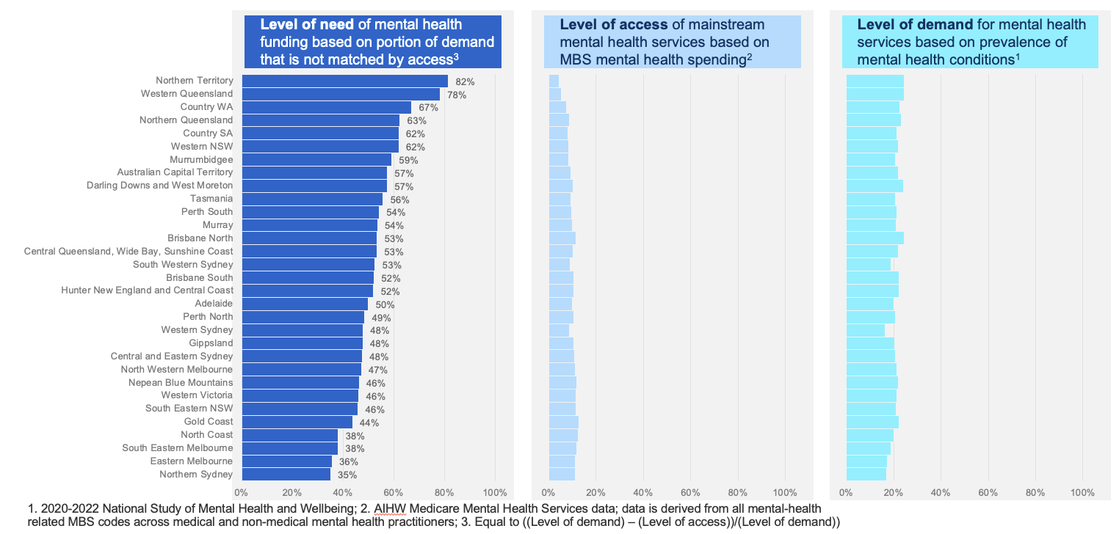
Source: 2020-2022 National Study of Mental Health and Wellbeing; 2. AIHW Medicare Mental Health Services data; data is derived from all mental-health related MBS codes across medical and non-medical mental health practitioners; 3. Equal to ((Level of demand) – (Level of access)) / (Level of demand)

Exhibit 13: Per-capita mental health practitioner workforce varies by up to 450% between the lowest and highest-resourced PHN regions
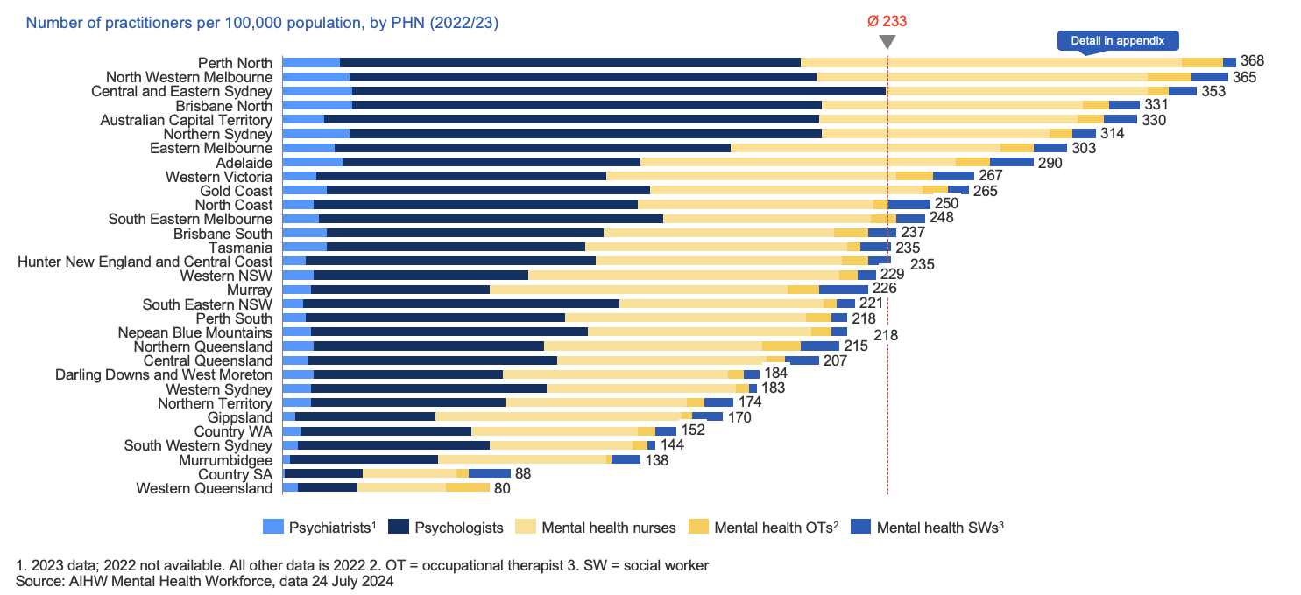
1. 2023 data; 2022 not available. All other data is 2022; 2. OT = Occupational therapist; 3. SW= Social worker
Source AIHW Mental Health Workforce, data 24 July 2024
Stakeholders outside the PHN network echoed these views and many pointed to the need for stronger investment in workforce development, particularly in thin markets.
While local needs are generally well understood by PHNs, their ability to address these needs is constrained by the MH FFS program. PHNs periodically undertake local Needs Assessments, and this process is generally viewed as effective by PHNs and their stakeholders. However, many PHNs report that the combination of MH FFS funding streams, priorities, guidance documents, historical directions from The Department, and prescriptive schedules does not allow them to respond meaningfully to the needs identified. Most (19 of 29) PHNs reported that the current funding structures prevent them from tailoring services to the needs identified in their assessments. While the grant opportunity guidelines have a broad definition of allowable activities, the reality for PHNs via the grant schedules and other guidance is often highly prescriptive. For example, PHNs reported that the MH FFS is overly focused on commissioning new and bespoke services that align with national priorities, when the solutions that are needed most to address unmet needs may involve coordination of existing services and capacity building across the workforce. Stakeholders also argued that current funding rules limit the ability of PHNs to coordinate and strengthen services that are already in place. Several emphasised that service innovation, including new models of care, cannot occur without greater flexibility in how funds are applied.
Exhibit 14: Most (19 of 29) PHNs report that funding is inflexible and inhibits their ability to fund initiatives to address local needs
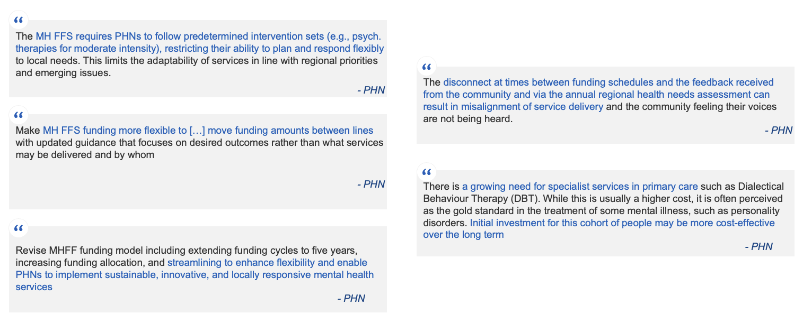
Source: Stakeholder interviews and focus groups
Under the current activity work plans and data capture approach, policy owners are not able to insightfully show the outputs produced for the significant investment in MH FFS. Each PHN follows an activity work planning process and captures significant data via the Minimum Data Set. However, activity work plans are qualitative only, making it hard to assess the outputs/outcomes. In addition, the minimum dataset does not currently allow an aggregated view of the scale, volume or reach of commissioned services, making it difficult to assess outcomes or track delivery across time or regions. This makes it difficult for policy owners to demonstrate the outputs produced for the significant investment in the MH FFS. Both policy teams and PHNs have called for more outcome or output-focused and aggregated reporting.

Recommendations

PHN Business Model
The review recommends two streams of immediate reforms to the PHN Business Model. These reforms are designed to address the identified tensions in the PHN Business Model while retaining the existing model.
- Reform Stream 1 – Raise confidence in PHNs focuses on a targeted set of interventions to clarify that the primary accountability of PHNs is to the Commonwealth, introduce minimum governance and engagement standards, and implement meaningful performance assessment.
- Reform Stream 2 – Improve process for funding includes a targeted set of interventions to simplify grant duration, reduce the prescriptiveness of schedules, and accelerate the disbursement of funding.
The two reform streams are designed to be implemented in parallel, over the coming year.
The review also recommends that, three years after commencing the immediate reforms, the Department considers the option of moving to a not-for-profit Commonwealth entity model if the reforms have not delivered sustained improvements in PHN capability and capacity. This model would help to address remaining structural tensions in governance and engagement, performance management and funding processes, and unlock further efficiencies for reinvestment in primary care. While this longer-term option offers significant benefits, it would be complex, time-consuming and disruptive, requiring legislative change and major shifts in contracts, systems and governance. As a result, the review recommends implementing the two streams of immediate reforms first.
The review also recommends targeted reforms to the MH FFS to ensure it better supports PHNs to deliver locally responsive mental health care. The MH FFS reforms include streamlining funding, aligning program logic with core PHN functions such as ‘the 3Cs’, and strengthening planning and reporting, including the use of output measures that can be consistently tracked and compared.

Reform Stream 1 – Raise confidence in PHNs
1.1 Accountability: Clarify that the primary accountability of PHNs is to the Commonwealth
- Reinforce that PHNs are funded to act on behalf of the Commonwealth in line with the provisions of their Deeds, and are primarily responsible for delivering better health outcomes by improving local primary care, through service coordination, provider capacity building and targeted commissioning
- 1.2 Governance and engagement: Introduce minimum governance and engagement standards
- Require PHNs to conduct internal minimum governance reviews using standardised guidelines. The PHN Quality and Improvement team could review concerns (see reform stream 1.3) and the Department can use the contract process to mandate changes where governance is found to be inadequate
- Require all PHNs to adopt a nationally consistent commissioning approach, based on the existing work that has been started by the PHN Cooperative (e.g. consistent RFP documents, KPIs)
- Encourage the Cooperative to continue and consider providing it direct funding. However, it should not evolve into a governance body that can direct individual PHNs or steer the overall PHN Program – it should remain as an entity focused on best practice sharing and collaboration:
- Providing direct funding to the Cooperative would allow the Department to require that the Cooperative’s primary role is to enable best practice sharing and collaboration
- The Cooperative may require incorporation in order to receive grant-based funding.
- Engage directly with PHNs to empower and support them to build culturally safe and responsive relationships with local stakeholders, including Aboriginal and Torres Strait Islander organisations, and enable meaningful collaboration tailored to local context
- Changes to current geographical boundaries are not recommended; there are no significant issues with current boundaries
- 1.3 Performance reporting and management: Implement meaningful performance assessment
- Standardise and integrate key reporting using an annual ‘Needs, Programs, Outputs’ report for each PHN:
- The new, mandated and standardised annual report would combine Needs Assessment, activity planning and performance reporting to enable a clear line of sight between local priorities, planned actions and measurable outputs; simple roll-up reporting; and meaningful comparison across PHNs
- Establish a ‘PHN Quality Improvement’ team to review performance and quality:
- The team would assess engagement, governance, commissioning, planning, internal management and delivery practices across PHNs, giving each PHN a report of strengths and improvement opportunities (e.g. rating from 1-3 on each dimension)
- Based on these assessments, the team would develop targeted recommendations for improvement for the PHN to implement.
- The team would be staffed by 2–3 people with senior operational PHN experience, ideally as independent contractors. They would assess performance against standards and provide structured feedback and improvement recommendations. Where improvement by PHNs is insufficient, they could recommend Departmental action
- Upon establishment, the team should have three months to develop a maturity and performance framework with PHNs
- The team should be implemented in tandem with the Department’s existing PMRF reforms, also removing the Department’s current Individual Performance Assessments
- PHN’s would be reviewed every three years, while underperforming PHNs would be re-reviewed the following year
- Implement an underperformance escalation pathway:
- The PHN Branch should establish an intervention pathway to manage serious or ongoing underperformance
- The pathway could include appointing an independent observer to a PHN Board or requiring monthly meetings on performance remediation efforts before considering more serious action such as re-tendering, which could potentially be limited only to existing operators (i.e. enabling the WAPHA model in other locations)

Reform Stream 2 – Improve process for funding
2.1 Grant duration: Move to 3–5 year rolling grants for all persistent programs
- Present a clear articulation of the impacts/limitations of short-term funding to policy areas and broader government to support a push to:
- Transition to longer terms (e.g. five years) on a rolling-basis for core funding (non-competitive, non-application-based)
- Transition to longer terms (e.g. four years) for program funding, with renewal advice provided to PHNs earlier (e.g. at least six months before the end of the current agreement), by establishing a common expectation with policy branches and broader government for persistent programs
- Set guidelines on the design and duration of program funding (e.g. three years) to allow meaningful tailoring and commissioning of services, with the exception of one-off/ad-hoc grants
- Ensure that expectations for the commencement of new services are adjusted for longer-term funding (e.g. six months between advice to PHNs and expected commencement)
2.2 Prescriptiveness of schedules: Move to standard templates that cater to different levels of prescription required and focus on outputs
- Establish a clear ‘Service Offer’ with policy areas to establish the rules of when and how they can use PHNs to deliver their programs (e.g. simplified schedules, minimum terms of funding). This Service Offer would set shared expectations and design guidelines early in the program development process, and would then be enforced by the Program Board, and policy areas would be assessed on their ongoing compliance to the Service Offer
- Significantly reduce Schedule length, and where possible, remove overly prescriptive Activities and burdensome program-specific process control reporting
- Consider implementing persistent and streamlined Schedules as addendums to Core Funding (e.g. similar to ‘Workforce Infection Control and Surge Capacity’)
- Create different, more templated versions of the grants process; specifically the schedules for the different types of programs:
- High control – Department defines purpose, process and output metrics (e.g. nationally consistent Programs, such as Urgent Care Clinics, or urgent response)
- Medium control – Department defines purpose and some output metrics, PHN defines further output metrics and process
- Low control – Department defines purpose only, PHN defines the output metrics and process to be included in activity work plans (e.g. Programs that are more effective under locally-determined delivery)
- Ensure that reporting is commensurate with the funding amount/duration and that data collection is fully justified (e.g. high frequency only early in new policies)
2.3 Accelerate disbursement: Reduce administrative bottlenecks and introduce faster pathways for routine or low-risk funding
- Investigate accelerated pathway for grants (including variations or extensions to existing funding), to achieve the most suitable outcomes
- Continue using non-competitive and non-application-based grants where possible (unless the Program is specifically competitive)
- Assess opportunities to triage PHN grants to lower risk templates (e.g. PHN grants can default to 'complex/high risk' templates, despite the well-tested model and defined recipients)
- Evaluate opportunities to operate under existing (more flexible) Schedules, rather than defaulting to new Grant Opportunities
- Consider options to expedite approval of 'standard' Grant Opportunity Guidelines (GOGs) (e.g. funding extension) to reduce the volume issue of grant approvals (approximately 20,000 approvals per year)
Delivering the two streams of immediate reforms will reduce administrative burden, distribute funds more effectively, and support PHNs to deliver ‘the 3Cs’. Raising stakeholder confidence in PHNs and improving the funding process would reduce the administrative load for PHNs and the Department, accelerate the distribution of funds, and build capacity to deliver locally tailored services. These benefits are underpinned by more efficient program administration. Simplifying reporting and funding requirements, such as activity work plans and fragmented schedules, could free up a portion of the 17,750 to 20,000 administrative staff hours currently spent each year by every PHN. These resources could be redirected to more strategic, value-adding work. A more consistent funding model would also shorten disbursement timelines, reducing service disruptions and improving planning. Together, these changes would help PHNs apply best practice commissioning approaches and improve coordination of care, particularly across neighbouring regions.
Delivering the reforms will require both immediate and ongoing investment. In the 12 months following agreement to adopt these reforms, the Department will need to make a one-off investment in PHN Branch resourcing to update funding deeds, simplify reporting, develop new policy proposals to support longer-term funding arrangements and stand up the new Quality Improvement team. Following this initial implementation period, a smaller increase to current funding levels will be required to support the PHN Quality Improvement team and enhanced PHN Branch responsibilities. The Department’s operating model will need to change with respect to the PHN program, with the PHN Program Board playing a stronger stewardship role.
Longer-term option: Consider moving to a new model to address remaining structural tensions
The review also recommends that, three years after commencing the immediate reforms, the Department should consider the option of moving to a new PHN model if the reforms have not delivered sustained improvements in PHN capability and capacity. Under this model, a not-for-profit Commonwealth entity would be established as the holding entity and enabling service provider for 30 local PHN Divisions, with each PHN retaining current boundaries, local staff, local offices, and a local CEO, and holding similar delegations and authorities to maintain local autonomy and flexibility. PHN Boards and advisory groups would become Local Advisory Boards. PHN staff would be employed by the not-for-profit Commonwealth entity, with flexibility to offer terms similar to current arrangements. PHNs would be funded via direct appropriations from Government with five-year core and four-year program funding. Thirty-one separate contracts would be replaced and a shared services function would provide finance, HR, ICT, data and procurement, freeing up funds for investment in primary care and supporting more consistent oversight and streamlined funding. The PHN Branch would remain responsible for broader policy and program design. (See Exhibit 15 for an illustrative view of the new entity structure.)
This model would help to address remaining structural tensions in governance and engagement, performance management and funding processes, and unlock further efficiencies for reinvestment in primary care. It would create a clear line of accountability between the Commonwealth and each PHN, while preserving local autonomy in key decision making. The entity structure would improve PHN delivery even further – raising confidence in PHNs by clarifying roles and expectations, removing the need for grants, and reducing administrative costs. It would also simplify the funding model by enabling direct appropriations to PHN Divisions of the not-for-profit Commonwealth Entity and reducing reliance on prescriptive schedules and carry-over approvals. These further system benefits and efficiencies could be directed towards more primary care programs, enabling stronger Commonwealth support of local healthcare delivery and offering potential for a collaborative governance model engaging a wide range of stakeholders. Longer term, bringing PHNs into a not-for-profit Commonwealth entity would also support more consistent integration between the Commonwealth, states and territories at the local level.
A detailed assessment of the costs and benefits of this new model is beyond the scope of this review and would only be meaningful once the impact of the two immediate streams of reforms is clear. While the new model offers significant benefits, it would be complex and time-consuming to design, legislate and implement. Moving to a new entity would likely require new legislation and careful design of the governance model to avoid centralising decision making and undermining the ability to maintain local responsiveness. The transition of existing service provider and employment contracts would be complex, as would alignment of different employment terms across PHNs. The loss of full salary packaging and other benefits would increase salary costs​, while access to deductible gift status could reduce opportunities for philanthropic contributions. ​Additionally, potential uncertainty during transition could lead to key people leaving the Networks. Transitioning systems, such as HR, payroll and IT systems, would require significant effort and investment.
As a result, the review recommends that the set of immediate reform streams are pursued first for three years before this option is considered. The decision to shift to this model should be considered if, following acceptance of the recommendations and appropriate support for implementation, the reforms have not delivered sufficient improvements in PHN capability, capacity or stakeholder confidence.

Longer-term option: Consider establishing a not-for-profit Commonwealth entity
Establish a not-for-profit Commonwealth entity as a separate entity within the Commonwealth to provide direct oversight, greater consistency and structural funding model changes:
- The entity would primarily function as a holding entity for the PHN Divisions, providing support and enablement
- The entity would comprise the ~30 local PHN Divisions, with each Division retaining current boundaries, local staff and local offices
- Each PHN Division would retain a local CEO to retain and recognise these CEOs as senior leaders in the local health system and ensure high-calibre talent continues to be attracted to PHNs
- The Coordinating Board would oversee the support and enablement function; it would not reduce current local decision rights of PHNs
- PHN Boards and advisory groups would become Local Advisory Boards
- Staff would be employed by the not-for-profit entity Primary Health Networks Australia, potentially outside of the APS, offering similar employment terms to today
- PHNs would be funded via direct appropriations from Government with five-year core and four-year program funding
- A shared services function would provide finance, HR, ICT, data and procurement, freeing up funds for investment in primary care
- The PHN Branch in the Department would remain responsible for broader policy and program design
- The entity would not engage in external advocacy or stakeholder representation

Exhibit 15: A not-for-profit Commonwealth entity could have PHN operations structured as ~30 local Divisions, funded by direct appropriations, freeing up funds to invest in primary care
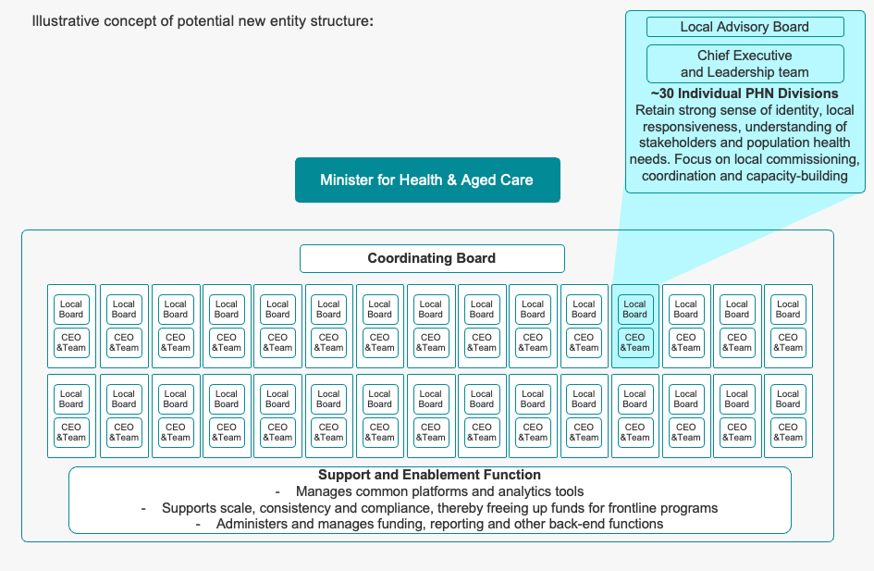
Longer term, bringing PHNs into a not-for-profit Commonwealth entity would support more consistent integration between the Commonwealth, states and territories at the local level. Instead of 31 separate not-for-profits – each with their own back-office functions and individual contracts with the Commonwealth – each PHN would have its own local staff and advisory board and be a division of a not-for-profit Commonwealth entity. The entity structure would improve PHN delivery even further by removing the need for grants, raising confidence in PHNs by clarifying roles and expectations, unlocking further system benefits and efficiencies that could be directed towards more primary care programs, enabling stronger Commonwealth support of local healthcare delivery and offering potential for a collaborative governance model engaging a wide range of stakeholders.

Mental Health Flexible Funding Scheme
To address program-specific tensions in the MH FFS, the review proposes a set of reforms to streamline funding, align program logic with ‘the 3Cs’, and enhance planning and reporting. These reforms would be implemented at the same time as the two streams of immediate reforms to the PHN Business Model.
MH FFS Reform Stream – Streamline MH FFS funding
MH FFS 1: Consolidate MH FFS funding into a single stream
MH FFS 2: Empower PHNs to spend MH FFS across all aspects of commissioning, coordination and capacity building
MH FFS 3: Require PHNs to align their annual activity planning against their local Needs Assessment, Joint Regional Planning with LHNs/States and annual best practice guidance shared by The Department. Activity plans should include clear intended quantitative output or activity to enable the policy team to show what will be delivered for the MH FFS investment.

Reforms to the MH FFS would give PHNs greater flexibility to tailor services, reduce fragmentation across the care continuum, and improve the clarity and responsiveness of funding allocations. PHNs would be able to tailor services to meet their local needs more closely, as funds would not be apportioned to separate streams. Services across the stepped care continuum would be more coordinated and less fragmented as PHNs improve commissioning and capacity building.

List of acronyms

3Cs | Coordination, Commissioning, Capacity Building
ACCHO | Aboriginal Community Controlled Health Organisation
ACNC | Australian Charities and Not-for-profits Commission
ANAO | Australian National Audit Office
COI | Conflict of Interest
GOG | Grant Opportunity Guideline
GP | General Practitioner
ICT | Information and Communications Technology
LHN | Local Health Network
MBS | Medicare Benefits Scheme
MDS | Minimum Data Set
MH FFS | Mental Health Flexible Funding Stream
PHN | Primary Health Network
PMRF | Performance Management and Reporting Framework

Two surveys were deployed – one for PHN CEOs & Chairs, and one for other stakeholders. Some questions were common across these surveys, while others were tailored to each group's context
Other includes consumers, public hospitals, education providers and other Departments
31 PHNs in total include 10 in New South Wales, 6 in Victoria, 7 in Queensland, 2 in South Australia, 1 in Tasmania, 1 in the Northern Territory and 1 in the ACT. There are 29 PHN Operators, as 1 operator administers all 3 PHNs in Western Australia.
Primary Health Networks (PHN) Strategy 2023–24, Department of Health, Disability and Ageing, https://www.health.gov.au/resources/publications/primary-health-networks-phn-strategy-2023-24?language=en
31 PHNs in total include 10 in New South Wales, 6 in Victoria, 7 in Queensland, 2 in South Australia, 1 in Tasmania, 1 in the Northern Territory and 1 in the ACT. There are 29 PHN Operators, as 1 operator administers all 3 PHNs in Western Australia.
Primary Health Networks (PHN) Strategy 2023–24, Department of Health, Disability and Ageing, https://www.health.gov.au/resources/publications/primary-health-networks-phn-strategy-2023-24?language=en
McGrathNicol Primary Health Networks Thematic Analysis 2024
PHN Cooperative is an unincorporated JV, to oversee the shared projects funded to benefit all PHNs e.g., Primary Health Insights. Members are elected by their state alliances to the PHN JVC Committee, holding positions on both Executive Committees to ensure alignment.

