Primary Health Network Program
Annual Performance Report
2022–23 and 2023–24



Acknowledgement
This document was developed by the Australian Government Department of Health, Disability and Ageing as part of the Primary Health Networks Program Performance and Quality Framework.
Copyright
© 2025 Commonwealth of Australia as represented by the Department of Health, Disability and Ageing
This work is copyright. You may copy, print, download, display and reproduce the whole or part of this work in unaltered form for your own personal use or, if you are part of an organisation, for internal use within your organisation, but only if you or your organisation:
(a) do not use the copy or reproduction for any commercial purpose; and
(b) retain this copyright notice and all disclaimer notices as part of that copy or reproduction.
Apart from rights as permitted by the Copyright Act 1968 (Cth) or allowed by this copyright notice, all other rights are reserved, including (but not limited to) all commercial rights.
Requests and inquiries concerning reproduction and other rights to use are to be sent to the Corporate Communication Branch, Department of Health, Disability and Ageing, GPO Box 9848, Canberra ACT 2601,or via e-mail to copyright@health.gov.au.
Disclaimer
Opinions expressed in PHN Program Performance Report 2022–23 and 2023–24 are those of the authors and not necessarily those of the Australian Government Department of Health, Disability and Ageing. Data may be subject to revision.

Contents
Acknowledgement 2
Executive Summary 4
Highlights 7
Financial Summary 8
Performance Report 10
1. Addressing Needs 10
2. Quality Care 15
3. Improving Access 29
4. Coordinated Care 43
5. Capable Organisations 51
Appendix – Performance and Quality Framework Indicators 52

Executive Summary
A Primary Health Network (PHN) is an independent organisation that is funded by the Australian Government to identify and address primary health care needs for their region. Each of the 31 PHNs throughout Australia is unique in its approach to managing health services based on what is required by their communities, in line with priority areas set by the Australian Government for mental health, Aboriginal and Torres Strait Islander health, population health, health workforce, digital health, aged care and alcohol and other drugs. PHN activities align with program objectives outlined in the PHN Program Performance and Quality Framework. PHNs vary in geography, population, remoteness and socio-economic disadvantage.

Figure 1: Map of Primary Health Network regions
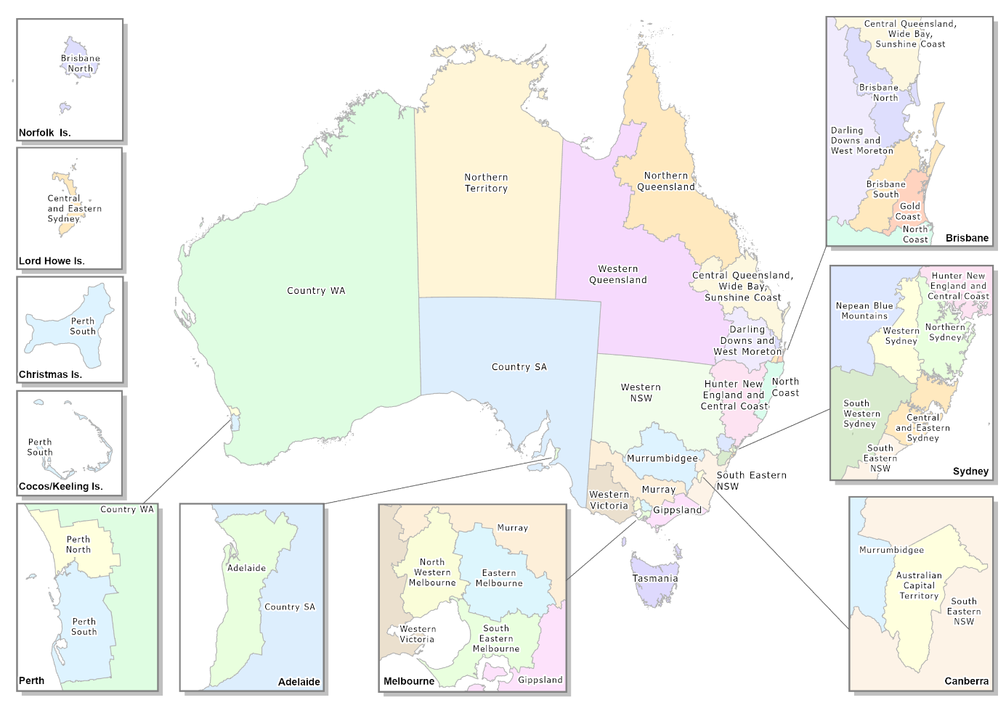
Individual PHN performance is assessed every 12 months to ensure that each PHN is meeting the objectives of the PHN program and helping to improve health care across their regions. The annual performance report is a consolidated review of PHNs performance both individually and collectively, evaluating the contribution of activities and functions delivered by PHNs towards achieving PHN program objectives.
This is the fifth PHN program annual performance report under the PHN Program Performance and Quality Framework and contains information for the 2022–23 and 2023–24 reporting periods. Both reporting periods have been included in this report to resolve the delayed publication of performance information and to address the recommendations of the Australian National Audit Office in the Effectiveness of the Department of Health and Aged Care’s Performance Management of Primary Health Networks audit report regarding the timeliness of reporting.
This report is arranged around the five outcomes contained in the PHN Program Performance and Quality Framework: addressing needs, supporting quality care, improving access, coordinated care and capable organisations, for all current performance indicators.
Performance information for individual PHNs has been introduced in this report in accordance with the recommendation of the Australian National Audit Office (ANAO) that the department ‘publish individual PHNs’ performance data and analysis in annual reports’. Individual reporting has been included to highlight high performance and identify areas for development, with the intention for PHNs to benefit from comparative analysis of performance. Financial information for the PHN program for the 2022–23 and 2023–24 financial years is also included in this report.
Another component of the department’s response to the ANAO audit is the development of the new Performance Measurement and Reporting Framework. This Framework will be progressively introduced from the 2024-25 Annual Report and incorporates a greater emphasis on outcome measures and a greater range of stakeholder input.
Factors affecting the PHN operating environment and broader healthcare landscape can influence performance and the achievement of outcomes. Major environmental events, such as bushfires and floods, can divert PHN resources to local emergency support in affected communities. During the two reporting periods there were several events that required mobilisation of PHNs to provide local assistance for such events.
While the COVID-19 emergency response ended early in the 2023–24 reporting period, ongoing adjustments to a post-COVID-19 healthcare environment have remained. This has included primary health care sector responses to the Japanese Encephalitis Virus and the inclusion of the shingles vaccine on the National Immunisation Program for older Australians, which created increased general demand for the vaccine.
More broadly, the primary health care sector is undergoing significant review and reform. This includes through the introduction of initiatives such as Medicare Urgent Care Clinics and MyMedicare, as well as changes to bulk billing incentives. Significant reviews to strengthen Australia’s primary health care system and health workforce have been completed and work is underway to implement findings and recommendations. The ongoing response to the Royal Commission into Aged Care Quality and Safety, the introduction of the Aged Care Act 2024 (Cth) and other aged care reforms also influences priorities and the delivery of services.

Highlights

- 234% increase in My Health Record cross views by general practices since the 2021–22 annual report |  | - In 2023–24, 27.2% of Aboriginal and Torres Strait Islander people in regional areas received a health assessment
 | 148% increase in My Health Record cross views by pharmacies since the 2021–22 annual report | 
- In 2023–24, all PHN commissioned alcohol and other drug service providers were accredited and actively delivering services | -  | - Increase in delivery of culturally safe mental health, alcohol and other drugs and mainstream primary health care services
 | In 2023–24, primary care services in residential aged care homes returned to pre-COVID rates | 

Financial Summary
Primary Health Network Program funding for the 2022–23 and 2023–24 financial years was $1.885 billion and $1.838 billion, respectively. When compared to 2021–22 funding ($1.562 billion) there has been an increase of approximately 20 per cent in 2022–23, continuing at a similar funding level for 2023–24. As the government implements primary health care initiatives, including as part of reforms to strengthen Medicare, PHNs continue to play a critical role in identifying and implementing services based on needs of their regions.
The Primary Mental Health Care schedule continues to be the highest proportion of funding provided to PHNs, at $720.2 million and $745.6 million for 2022–23 and 2023–24 respectively. Funding for mental health has increased overall, during the 2022–23 and
2023–24 periods, including through the National Mental Health & Suicide Prevention Agreement & Bilateral PHN Program, and growth in funding for Commonwealth Psychosocial Support. Specific mental health funding for COVID-19 has concluded and mental health support for bushfire affected Australians reduced to $0.1 million per year for each of the two reporting years.
The Strengthening Medicare – General Practice Grants Program ($193.2m in grants over two years from 2022–23 to 2023–24) was implemented in partnership with PHNs and the National Aboriginal Community Controlled Health Organisation (NACCHO). One-off grants between $25,000 and $50,000 for eligible general practices and Aboriginal Community Controlled Health Organisations (ACCHOs) were provided to make improvements to their practices, expand patient access and support safe and accessible quality primary care. The program, administered and managed by PHNs and NACCHO for general practices and ACCHOs respectively on behalf of the department, provided funding for enhancing digital health capability, upgrading infection prevention and control arrangements, and maintaining or achieving accreditation under the General Practice Accreditation Scheme. Grant amounts for each PHN were determined based on the estimated number and size of general practice applicants in the PHN region, with an overall uptake rate of 93 per cent for general practices and 99 per cent for ACCHOs.
Significant investment in the Medicare Urgent Care Clinics program for PHNs has continued during the two reporting periods. In four jurisdictions, PHNs are responsible for commissioning Medicare Urgent Care Clinics and have received significant investment during the two reporting periods ($35.2 million in 2022–23 and $68.9 million in 2023–24). The Australian government is working closely with PHNs to ensure Medicare Urgent Care Clinics continue to meet the program intent, are integrated with other local health services and meet the needs of local communities.
Investment in PHN support for aged care has continued during the 2022–23 and 2023–24 reporting periods, including through the Care Finder Program ($64.9 million in 2022–23 and $82.6 million in 2023–24). PHNs are responsible for commissioning and managing care finder services, leveraging their commissioning expertise and in-depth understanding of local community needs.

Table 1: PHN Program funding, 2022–23 and 2023–24
Funding | 2022–23 | 2023–24
Core Funding Schedule | $348.6 m | $350.3 m
Pilots and Targeted Programs | $231.7 m | $41.2 m
Medicare Urgent Care Clinics Programs | $35.2 m | $68.9 m
Primary Mental Health Care | $720.2 m | $745.6 m
Mental Health Supports for Bushfire Affected Australia | $0.1 m | $0.1 m
National Mental Health & Suicide Prevention Agreement & Bilateral PHN Program | $49 m | $117.8 m
Headspace Demand Management and Enhancement Program | $36.7 m | $17.3 m
Commonwealth Psychosocial Support | $116 m | $125.2 m
After Hours | $55.6 m | $62.5 m
Integrated Team Care | $67.7 m | $68.7 m
Drug & Alcohol Treatment Services Program | $118.3 m | $120.9 m
Community Health and Hospitals Program | $16.1 m | $10.1 m
Aged Care | $90.3 m | $108.4 m
Total | $1.885 b | $1.838 b

Performance Report
The PHN Program has two objectives outlined in the Performance and Quality Framework – to increase the efficiency and effectiveness of medical services, particularly for patients at risk of poor health outcomes, and to improve coordination of care to ensure patients receive the right care in the right place at the right time. In addressing the health needs of their region PHNs are also guided by the priority areas for targeted work and national priorities set by the Australian Government. Performance indicators are linked to outcome themes to align PHN activities to the two program objectives, with performance in this report grouped by four of the outcome themes specified in the PHN Program Performance and Quality Framework. A full table of indicators and their corresponding codes and titles are available at Appendix – Performance and Quality Framework Indicators.

Addressing Needs
Performance indicators for this outcome theme encompass activities conducted by PHNs to address the needs of people in their local region, including for Aboriginal and Torres Strait Islander people, and through fewer preventable hospitalisations for people with chronic conditions and vaccine preventable diseases.

P1 – Activities Address Prioritised Needs
All activities delivered by PHNs are required to address prioritised needs and/or national priorities. Relevant activities are captured in individual PHN Health Needs Assessments and included in related Activity Work Plans. All PHNs have reported and been assessed as meeting this indicator for the two reporting periods (2022–23 and 2023–24).

P2 – Health System Improvement and Innovation
All PHNs have been assessed as meeting this performance indicator for 2022–23 and
2023–24, which is measured by providing at least one example of a health system improvement, innovation or commissioning best practice. Examples provided include:
- the implementation of onsite support programs such as social work and dementia support services
- development of tools, including to track beds in residential aged care homes and assess risk of frailty in elderly community members
- the co-design of community services for identified needs, such as youth and mental health services and improving access to services for multicultural members of the community
- preventative health education programs, including for primary school children in low socio-economic communities.

P12 – Potentially Preventable Hospitalisations
Potentially preventable hospitalisation (PPH) data is used in PHN performance reporting to consider how effective health care is in local communities and whether higher rates are indicative of difficulty in accessing required and timely care. It is important to note that there can be other reasons for higher PPH rates, such as higher disease rates, lifestyle and other risk factors, as well as whether existing hospital services are sufficient. PPH rates can provide insight into the usage of health services and health inequalities, allowing PHNs to investigate and assess the health needs in their regions.
The overall rate of PPH is comprised of conditions in three sub-categories:
- Acute conditions (e.g. non-vaccine-preventable pneumonia, urinary tract infections, perforated ulcer, cellulitis, dental conditions and epilepsy)
- Chronic conditions (e.g. asthma, congestive cardiac failure, diabetes, COPD, hypertension and rheumatic heart diseases)
- Vaccine-preventable (e.g. pneumonia and influenza, varicella, measles, acute hepatitis B and mumps).
In 2023–24 there was an overall increase in the average rate of potentially preventable hospitalisations following multiple years of a decreasing rate. Rates continue to be higher in regional areas when compared to metropolitan areas, with the highest rates recorded in the Northern Territory.
Figure 2: Average rate of potentially preventable hospitalisations, per 100,000 population, age-standardised, 2019–20 to 2023–24
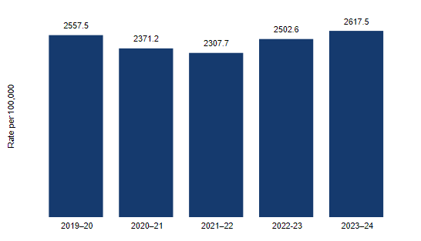
Increases in identified potentially preventable acute conditions (1171.4 per 100,000 population in 2021–22 to 1322.5 in 2023–24), chronic conditions (999.6 per 100,000 population to 1072.1 in 2023–24) and vaccine preventable conditions (154.9 per 100,000 population in 2021–22 to 252.4 in 2023–24) were recorded, suggesting further scope for support in these areas across the primary health care network.

Figure 3: Average rate of potentially preventable hospitalisations by type, per 100,000 population, age-standardised, 2019–20 to 2023–24
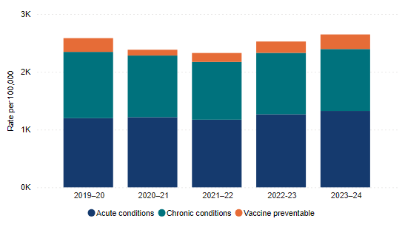

FN1 – Integrated Team Care – Delivery
The Integrated Team Care (ITC) program is a national program funded under the Indigenous Australian’s Health Programme since 2016. The program supports Aboriginal and Torres Strait Islander people with chronic conditions to access high-quality, culturally appropriate primary health care. The program supports access to an integrated, multi-disciplinary workforce provided by a team of Aboriginal and Torres Strait Islander Health Project Officers, Aboriginal and Torres Strait Islander Outreach Workers and Care Coordinators to improve the management of complex chronic disease for Aboriginal and Torres Strait Islander people. PHNs, as commissioning bodies for health services that provide individual support to clients, submit data on the number of services delivered during the reporting period to demonstrate the support provided for their region.
In 2022–23 a total of 657,273 individual services were provided to eligible people, with an increase to 760,045 services for 2023–24. While the total services provided has declined when compared to the previous reporting period (898,580 for 2021–22) the rate of services provided per eligible person has remained relatively stable at 0.9 services in 2023–24, an increase from 0.8 in 2022–23, and slightly lower than the 1.2 services provided in 2020–21. Three PHN regions have transferred funding and responsibility for the delivery of ITC services for their regions to the Institute for Urban Indigenous Health in 2022–23, therefore any comparison with reporting periods prior to 2022–23 must account for the reduced number of PHNs reporting directly on this indicator.

Figure 4: ITC services delivered by PHN, by category, per Aboriginal and Torres Strait Islander population, 2019–20 to 2023–24
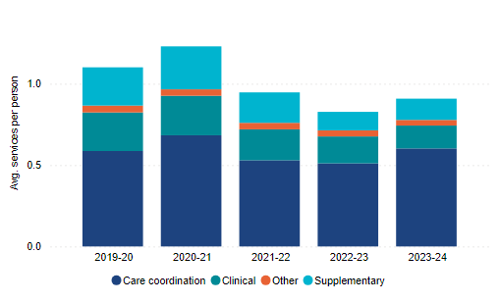

FN2 – Integrated Team Care services – Organisations
PHNs are required to collaborate with the Aboriginal and Torres Strait Islander health sector and adopt flexible approaches to contracting health services to ensure regional needs and local health priorities are met. Innovative approaches, and equitable investment in the community controlled sector and in improving cultural safety and responsiveness in mainstream health services, ensures that chronic disease management and care for Aboriginal and Torres Strait Islander people is culturally safe and accessible no matter where a client chooses to access care in their region.
PHNs engage with relevant providers in their region to ensure care requirements are able to be met and report on the types of organisations delivering Integrated Team Care services in their region. For the two reporting periods all PHNs have provided details of the providers engaged in delivering Integrated Team Care services, including Aboriginal Medical Services, Aboriginal Community Controlled Health Services, PHNs and mainstream primary health care providers. While some PHNs have engaged with a single provider, others are working with multiple providers.

O12 – Output and Outcome Performance Indicators
PHNs are encouraged to include output and outcome performance indicators in their contracts with commissioned service providers to support assessing the effect of these services on program outcomes over time. PHNs do not report on what performance indicators are included in contracts, with individual contracts and indicators relevant to the commissioned services. PHNs instead report on the overall number of contracts that contain output and outcome performance indicators.
Data is not available for the 2022–23 year as PHNs were not required to report on this indicator for that period. For 2023–24 there has been a significant decrease in the number of PHNs being assessed as meeting this indicator, with only 18 PHNs reporting an increase, or maintenance of existing level, in the number of contracts containing both output and outcome measures, compared to 25 PHNs in 2021–22. There were six PHNs who did not meet this criterion in 2021–22 when it was last reported, increasing to 13 for the 2023–24 reporting period, with three PHNs not meeting this criterion for both periods. While some decreases were minor for 2023–24 others have shown a significant decline in this indicator. It is unclear whether that is the result of PHNs not collecting data for this indicator or if the number of contracts with output and outcome performance indicators has reduced.

Conclusion
Overall, PHNs have demonstrated an understanding of the health care needs of their communities. All PHNs have needs assessments and activity work plans for their regions to provide details of how they will meet identified needs, including through plans for the improvement and innovation of services. Consideration of potentially preventable hospitalisations can provide insight for PHNs for areas of focus, with recent increases in preventable acute conditions, chronic conditions and vaccine preventable conditions indicating further scope for improvement in service delivery. Integrated Team Care performance indicators for Aboriginal and Torres Strait Islander people continue to be met, with a variety of organisations providing services. Acknowledging changes in reporting requirements, the decline in the reported rate of contracts for commissioned providers containing output and outcome performance indicators requires attention by PHNs for future reporting.

Quality Care
PHNs provide support to general practices and other health care providers in their regions to improve the quality, safety and appropriateness of care provided to meet the needs of the community. This outcome theme provides performance indicators that report on the activities undertaken by PHNs, including for Aboriginal and Torres Strait Islander people, and increasing the use of digital health services by health care providers.

P3 – General Practice Accreditation
Accreditation of general practices contributes to patient assurance of receiving safe and high-quality health care. The National General Practice Accreditation Scheme provides standards that must be met to obtain and maintain accreditation. PHNs support practices in meeting accreditation standards, leading to better patient outcomes.
Nationally, general practice accreditation rates are around 84 per cent although these vary considerably by PHN area. Two notable barriers to accreditation are the cost and effort required with smaller practices and those without a dedicated practice manager facing particular difficulties.
The rate of accreditation for the 2022–23 and 2023–24 reporting periods varied across PHNs, ranging from 60 to 96.2 per cent in 2022–23 and 60.8 to 97 per cent in 2023–24. While some PHN regions have reported increases, others have experienced decreases. Rates of accreditation assessed by metropolitan and regional classification, as well as by socio-economic disadvantage, are largely similar in terms of high and low rates.

Table 2: General practice accreditation rate, by PHN
PHN | 2019–20 | 2020–21 | 2021–22 | 2022–23 | 2023–24
New South Wales
Central and Eastern Sydney | 61.8% | 63.8% | 64.1% | 66.7% | 67.6%
Hunter New England and Central Coast | 73.4% | 86.1% | 68.6% | 91.4% | 90.5%
Murrumbidgee | 88.6% | 93.3% | 95.4% | 90.1% | 95.7%
Nepean Blue Mountains | 69.6% | 71.8% | 70.6% | 72.9% | 75.8%
North Coast | 89.4% | 89.3% | 84.3% | 88.8% | 81.6%
Northern Sydney | 73.5% | 70.6% | 72.9% | 73.9% | 75.9%
South Eastern NSW | 80.3% | 79.9% | 77.9% | 82.4% | 90.5%
South Western Sydney | 56.4% | 59.1% | 63.4% | 68.2% | 71.6%
Western NSW | 81.4% | 93.8% | 92.7% | 84.1% | 86.4%
Western Sydney | 77.2% | 79.3% | 73.9% | 75.7% | 85.6%
Victoria
Eastern Melbourne | 87% | 87.6% | 83.9% | 84.9% | 85.4%
Gippsland | 86.9% | 94.3% | 93.1% | 89.6% | 91.8%
Murray | 88.1% | 88.7% | 92.7% | 94.2% | 96.4%
North Western Melbourne | 71.6% | 73.2% | 73.7% | 78.8% | 76.9%
South Eastern Melbourne | 73.8% | 73.2% | 74.5% | 75.6% | 71.1%
Western Victoria | 85.9% | 83.8% | 85.7% | 84.2% | 93.8%
Queensland
Brisbane North | 80.1% | 75.1% | 81.5% | 82% | 88.4%
Brisbane South | 86.8% | 85.1% | 88.4% | 90.4% | 91.5%
Central Queensland, Wide Bay, Sunshine Coast | 85.7% | 92.7% | 87.2% | 88.9% | 87.9%
Darling Downs and West Moreton | 93% | 88.4% | 89.4% | 90.1% | 90.4%
Gold Coast | 85.4% | 86.1% | 86.4% | 86.8% | 90.5%
Northern Queensland | 87.2% | 88.8% | 109.8% | 94.9% | 77.6%
Western Queensland | 63% | 65.2% | 65.2% | 60% | 60.8%
South Australia
Adelaide | 83.8% | 85% | 85.5% | 84.6% | 85.1%
Country SA | 97.3% | 97.8% | 95.6% | 96.2% | 97%
Western Australia
Country WA | 70.2% | 71.1% | 82.4% | 82.4% | 84.2%
Perth North | 73.7% | 75.3% | 83.5% | 83.2% | 90.6%
Perth South | 75.6% | 80.2% | 88% | 88.5% | 94.1%
Tasmania
Tasmania | 93.8% | 95.1% | 95.7% | 94.1% | 93.4%
Northern Territory
Northern Territory | 80.4% | 80% | 81.4% | 82.9% | 88.1%
Australian Capital Territory
Australian Capital Territory | 83.3% | 90.9% | 95% | 93.2% | 92.5%

P4 – General Practice and Health Care Provider Support
PHNs provide support to general practices and other health care providers to appropriately and confidently meet the health needs of their region and improve service delivery. The nature and level of support varies according to identified need and may include information sharing, training, and workshops as well as targeted individual support. This support includes working with general practices and primary health professionals to develop clinical referral pathways to refer patients to local specialists and services. PHNs report on activities undertaken during the reporting period, with all PHNs assessed as having met expected outcomes for this indicator for both the 2022–23 and 2023–24 reporting periods.
Support provided by PHNs during the reporting periods for primary health care reform initiatives included:
- the introduction of MyMedicare, Strengthening Medicare general practice grants, and the Medicare Urgent Care Clinics program
- change management, workforce support, training and project management activities
- care management and workforce planning activities for residential aged care
- quality improvement activities including use of digital health technology.

P5 – My Health Record – Uploads
Digital health systems, such as My Health Record, provide secure access to health information for health care professionals and individuals. PHNs play an important role in encouraging primary health care providers to regularly use My Health Record to provide access to up-to-date health information, with performance assessed based on the number of uploads by health care providers in their regions. Data was previously reported as a percentage of general practices uploading documents at least once per week into My Health Record, however this has provided inaccurate results as it does not account for upload issues experienced with an intermediary platform that may prevent regular uploads. The data shown here is the average number of uploads per registered practice for each financial year.
For the 2022–23 and 2023–24 reporting periods previous trends continued, with increases of seven and 12.5 per cent respectively, resulting in an average upload rate of 7843.4 records per registered general practice in 2023–24. Increases have occurred across all states and territories, except Tasmania which has recorded a small decrease from 2021–22 but continues to record higher upload rates than other states and territories. Significant increases have been recorded from 2022–23 to 2023–24 for Western Australia (38.9 per cent) and the Australian Capital Territory (34.5 per cent), moving closer to comparable rates with other jurisdictions.

Figure 5: Uploads to My Health Record by general practices, by state, 2018–19 to 2023–24
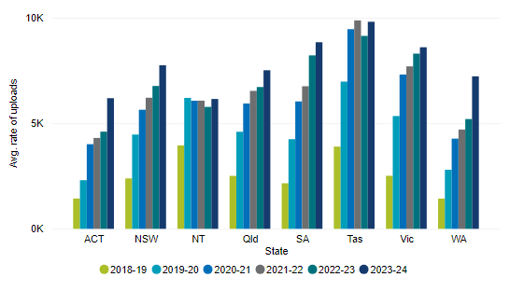

Upload rates continue to be higher in regional PHN areas than metropolitan, with upload rates for metropolitan areas in 2023–24 (7263.5 per registered general practice) slightly lower than the rate recorded by regional areas in 2021–22 (7296.2).

Figure 6: Uploads to My Health Record by general practices, by PHN remoteness, 2018–19 to 2023–24
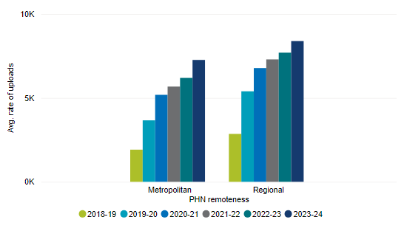

MH6 – Clinical Outcome Measures
The provision of mental health services in primary care is a key outcome for PHNs, with the highest proportion of overall funding provided to PHNs for the commissioning and coordination of mental health services for their regions. This indicator measures the proportion of completed episodes of mental health treatment that have recorded outcomes for patients at the start and end of the treatment episode. A high rate of completed outcome data enables PHNs and the department to analyse whether services commissioned by PHNs are improving outcomes for patients.
Across all PHNs the average rate of outcome reporting has continued to grow over the past two reporting periods, from 46.6 per cent in 2021–22, to 52.4 per cent in 2022–23 and 58 per cent in 2023–24. While the overall rate has increased, some states/territories have decreased (the ACT recorded a decline from 71.1 per cent in 2018–19 to 38.8 per cent in 2023–24, and Western Australia dropped from 80.5 per cent in 2020–21 to 60.2 per cent in 2023–24). The rate in the Northern Territory, while low, has grown over the time that data has been collected. Rates of outcome reporting are higher in PHNs in regional areas (57.5 per cent in 2022–23 and 61.5 per cent in 2023–24) than PHNs in metropolitan areas (47 per cent in 2022–23 and 54.2 per cent in 2023–24). This reflects continued growth in regional areas and smaller growth in metropolitan areas.

Figure 7: Rate of outcome data completed, by PHN remoteness, 2018–19 to 2023–24
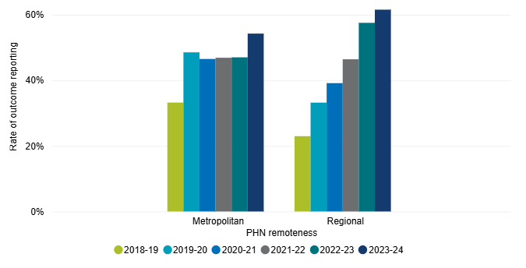

FN3 – Culturally Safe Alcohol and Other Drug Services
To support the provision of culturally safe services within their regions PHNs are required to report on how services are delivered in recognition of the six domains and focus areas outlined in the Cultural Respect Framework for Aboriginal and Torres Strait Islander Health 2016–26.
For the reporting periods, all PHNs have been assessed as meeting this indicator. Some examples of how PHNs have ensured cultural safety include reporting by providers about training for staff, audit processes and reporting on the appropriateness of provided services, consulting and co-designing services with local Aboriginal and Torres Strait Islander groups, the development of service standards and delivery models, and local cultural experiences and activities.

FN4 – Culturally Safe Mental Health Services
PHNs are funded to commission mental health services that improve access to integrated, culturally safe mental health services for Aboriginal and Torres Strait Islander people. Service providers are required to demonstrate that they deliver culturally safe services through behaviours, attitudes, policies, practices and physical structures that are respectful and tailored to Aboriginal and Torres Strait Islander people, the inclusion of Aboriginal and Torres Strait Islander staff and/or the delivery by providers appropriately skilled in the delivery of culturally safe services.
Following a drop in the average rate of delivered services in 2021–22, the overall average rate has increased over the two reporting periods (87 per cent in 2022–23 and 88.2 per cent in 2023–24).

Figure 8: Proportion of PHN-commissioned mental health services with evidence of cultural safety delivered to Aboriginal and Torres Strait Islander people, 2018–19 to 2023–24
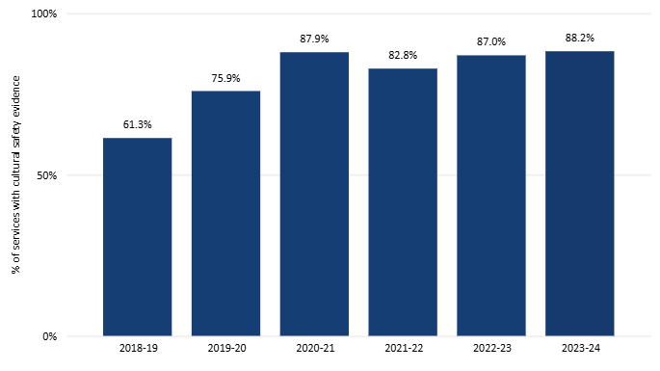

FN5 – Culturally Safe Mainstream Primary Health Care Services
The Integrated Team Care program plays a key role in building the cultural competency of mainstream primary care services so that eligible clients can access culturally safe, responsive health care wherever they choose to access. PHNs are required to conduct activities to support mainstream primary health care providers in their region to improve the delivery of culturally safe primary care health services. For reporting purposes, PHNs provide details of work undertaken to improve cultural safety in their regions, including activities such as delivery of cultural awareness training for staff and encouraging usage of relevant Medicare Benefits Schedule (MBS) items. For the reporting periods, relevant PHNs have been assessed as meeting the requirements of this indicator (three PHNs are not assessed against this indicator).
Across the two reporting periods PHNs have detailed several ways that they engage with their region’s mainstream primary health care providers for this indicator, including through appointed Indigenous Health Project Officers, Primary Health Coordinators and practice support teams, regular delivery of training to health care professionals about cultural awareness and sensitivity, targeted campaigns within the community and gathering feedback through surveys. PHNs have also provided information about building relationships with service providers and providing support to practices and practitioners.

FN6 – Aboriginal and Torres Strait Islander Health Workforce
PHNs provide support to improve the capability, capacity and proportion of Aboriginal and Torres Strait Islander identified health workers, to improve the quality of services offered to Aboriginal and Torres Strait Islander people, as well as the accessibility and cultural safety of services. PHNs report on formal/informal development opportunities and activities conducted during the reporting period. For the 2022–23 and 2023–24 reporting periods all PHNs have been assessed as meeting the requirements of this indicator.
PHNs have provided information about support through activities including the development and implementation of employment strategies, provision of scholarships and training, and specific roles to provide dedicated workforce support. PHNs have also detailed the establishment of communities of practice and other consultative groups as well as regular engagement with local Aboriginal Community Controlled Health Organisations.

PH1 – Childhood Immunisation
Childhood immunisation targets have existed for many years in Australia, with a target immunisation rate of 95 per cent coverage for prevention of diseases such as measles, rubella and polio. PHNs work with health care providers in their regions to identify and address barriers that may affect immunisation rates. PHN performance is not assessed against the rate of childhood immunisation in their region – the rate is used to understand the broader healthcare landscape.
The overall vaccination rate for all 5-year old children has shown a downward trend since the COVID-19 pandemic, with rates decreasing from 94.54 per cent in 2021–22 to 94.14 per cent in 2022–23 and 93.85 per cent in 2023–24. In 2023–24, vaccination rates for Aboriginal and Torres Strait Islander 5-year old children show higher coverage rates in all states and territories, with a national coverage rate of 95.23 per cent – higher than the national rate for all 5-year old children.

Figure 9: Average rate of fully immunised children at 5 years of age, 2018–19 to 2023-24
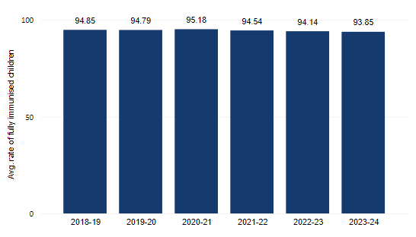

Vaccination rates in regional areas typically show a lower rate over various PHN regions, with regional Western Australia and the Northern Territory having some of the lowest coverage rates. Western Australia experienced a 0.67 percentage point decrease in 2023–24 (from 93.31 per cent in 2022–23 to 92.64 per cent), and the Northern Territory has experienced a reduction in the 2023–24 period of just over two percentage points (from 93.7 per cent in 2022–23 to 91.4 per cent). No jurisdictions recorded an increase in rates for 2023–24.
While Australia continues to enjoy some of the strongest coverage rates in the world, the recently released National Immunisation Strategy for Australia 2025–2030 acknowledges the slow downward trend and identifies infants and children as a priority population for improving access to immunisation.

PH2 – Cancer Screening
Cancer screening can assist in finding cancer in its early stages, it can identify changes to cells before they become cancerous and may also identify infections that could cause cancer in the future, such as human papillomavirus (HPV). The aim of cancer screening is to reduce the burden of cancer in the community, including the incidence, morbidity or mortality of the disease through early detection and intervention.
As with childhood immunisation targets, PHN performance is not assessed against screening rates in their regions. PHNs provide support to health care providers to understand and address population-based factors and to help to improve participation rates in screening programmes, particularly in regions with low participation.
Reporting for this indicator is limited by availability of data, with some data not being available until some time after the period to which it relates. Data for bowel and breast cancer screening is available inclusive of 2022–23 and cervical screening data is available for the 5-year period 2019–23.
Bowel cancer screening participation rates for the target population (50–74 years of age) have continued at a similar rate to 2020–21 (40.1 per cent) with a 39.3 per cent participation rate in 2021–22, increasing to 41.7 per cent in 2022–23. Rates across metropolitan PHN regions have grown at a slightly higher rate than regional PHN areas, with the Northern Territory showing a significantly lower participation rate than states and the Australian Capital Territory.

Figure 10: Bowel cancer screening rate as a proportion of target population, by PHN remoteness, 2014–15 to 2022–23
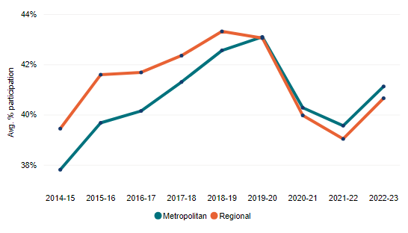

Figure 11: Bowel cancer screening rate as a proportion of target population, by PHN state group, 2014–15 to 2022–23
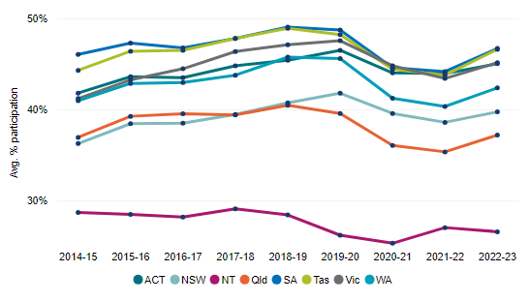

Following relatively stable breast cancer screening rates for the target population (50–74 years of age) from 2014–15 through to 2018–19, at just under 55 per cent, screening rates have declined over recent years, with COVID-19 impacting participation rates and access to services. An increase in screening rates in 2021–22 (49.5 per cent) and 2022–23 (51.2 per cent), while still lower than pre-COVID-19 rates, shows an upward trend in screening.

Figure 12: Breast cancer screening rate as a proportion of target population, age-standardised, 2014–15 to 2022–23
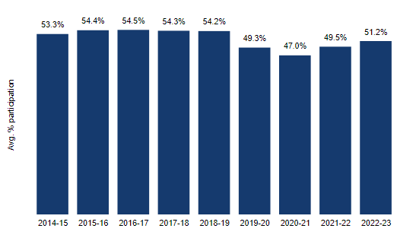

Screening rates continue to be slightly higher in regional areas, at 52.2 per cent in 2021–22 compared to 48 per cent for metropolitan areas, providing similar results to 2019–20 for metropolitan areas, but a slight decrease from 53.1 per cent in 2019–20 for regional areas. At a state and territory level, there has been a balance of increases and decreases, with the Northern Territory recording the lowest screening rate in 2021–22 of 33.9 per cent, a decrease from 36.4 per cent in 2019–20.
The collection and reporting of cervical screening data is provided across a five-year period, corresponding with testing recommendations, rather than as an annual rate of participation. As a result, the presentation of annual trends in screening participation for this report is limited.
Age-adjusted participation in cervical screening for the target population (25–74 years of age) for the 2019–23 period was 63.5 per cent, down from 68.6 per cent for 2018–22, although participation in 2023 when compared to 2021 and 2022 is higher. For the two five-year periods for which PHN-region data is available, almost all PHNs experienced a decrease in screening for the target population from the 2018–22 to the 2019–23 period.

W1 – Alcohol and Other Drug Services – Accreditation
Alcohol and drug treatment services are provided by a variety of organisations in Australia, with accreditation of service providers helping to ensure that delivered services are safe, professional and appropriate. PHNs are required to maintain accreditation details of commissioned service providers for their region, with the expectation that service providers are accredited or working towards accreditation.
Across all PHNs, one noted an accreditation rate of less than 100% in 2022–23, reporting that two of their six providers were not yet accredited. This was resolved in 2023–24, with all commissioned providers for all PHNs reported as being accredited.

W2 – Alcohol and Other Drug – Health Professionals
PHNs support service providers in the provision of drug and alcohol treatment services, including through training and education and the promotion of quality improvement in services provided. PHNs are required to provide details of completed training for the reporting period.
The number of PHNs assessed as meeting this indicator has reduced from the previous report for the 2021–22 reporting period (27 PHNs) to 24 PHNs in 2022–23 and 26 PHNs in 2023–24. For 2022–23, six PHNs have failed to provide details of training provided, and one PHN advised that delivery of training activity was not fully realised due to lack of uptake of the options provided. For 2023–24, three PHNs have been noted as failing to provide details of training provided, one PHN experienced delays in the commissioning of services, and one PHN advised that funding was directed to service delivery rather than training, as is permitted under the Schedule.

DH2 – Digital Health Systems
The adoption and use of digital health systems is an important component of a modern and accessible health care system that will meet the needs of all Australians. Support from PHNs in the uptake of digital systems by health care providers helps connect patients with relevant services safely and securely. PHNs currently report on the number of providers using digital health systems and are assessed on whether the rate of providers has increased during the reporting period.
For the 2022–23 reporting period 27 PHNs were assessed as meeting the requirements of this indicator, a small decrease from 2021–22 (28 PHNs). For 2023–24 the rate has further decreased to 25 PHNs.
Due to ambiguity in reporting requirements for this indicator as well as the changes in technology and the primary health care system over recent years there are limitations on meaningful assessment of PHN performance for this indicator. While assessment for the two reporting periods is based on use of digital health systems by general practices to determine the ongoing uptake of electronic resources, not all PHNs have reported against all formats. Further, several PHNs have also not reported on use of digital health systems by pharmacy or allied health professionals. The most reported format for digital health was for general practice telehealth services, which is now a common service offering. Given the limitations indicated, meaningful reporting on the rate of use of digital health systems is not possible. This indicator will be retired from reporting, with more useful measurement of the use of online health resources planned in the future.

DH3 – Data Sharing – Accredited General Practices
The sharing of de-identified patient data with PHNs by general practices is intended to improve the quality of care and the experience of patients in their regions. Through a broader view and analysis of general practice services being provided PHNs can assist practices in understanding the needs of their community. PHNs work with general practices in their regions to increase the amount of data being shared, reported as the total rate of accredited general practices sharing data with their local PHN. PHNs are assessed on the increase or maintenance of the rate of data sharing.
The number of PHNs assessed as meeting this indicator grew slightly in 2022–23, from 24 of 31 PHNs in 2021–22 to 25 PHNs before a decrease in 2023–24 to 22 PHNs. Assessment of performance does not consider increases in the number of accredited general practices for the PHN region.

Conclusion
Reporting on the delivery of high quality, culturally safe health care indicates PHNs have met performance requirements for this outcome theme. Accreditation rates for general practices have increased and PHNs have continued to provide relevant support to general practices and other health care providers. The recording of mental health outcomes by service providers and reporting of training by PHNs for alcohol and other drug services show mixed results, with a decrease reported for some PHNs and a small number of PHNs not providing the required information. All alcohol and other drug service providers were reported as being accredited.
Overall, there has been an increase in the provision of culturally safe services for Aboriginal and Torres Strait Islander people, as well as ongoing support activities for Aboriginal and Torres Strait Islander people in the health workforce.
Reporting on regular uploads to My Health Record and use of digital health tools and systems has been affected by unclear reporting requirements, however it is evident from the data available that PHNs are continuing to promote the benefits of the use of technology in supporting quality care.

Improving Access
Access to quality primary care services through a health care system that is simple to navigate should be available to all Australians, without limitations of location, background or disadvantage. Through providing access to care where and when it is needed, with consideration of identified priority areas, people will be better supported to be healthy and well. PHNs support their regions through activities and initiatives targeted at understanding, supporting and improving the delivery of primary care services to meet the needs of their communities.

P6 – General Practices – After-hours Services
PHNs assist with the delivery of after-hours health care services, including through commissioning of after-hours services and by supporting general practices and practitioners to provide health care services after hours for the community. Through these activities PHNs contribute to improving access to services where and when they are needed, leading to better health outcomes for patients. PHN performance is not assessed against this indicator, with the rate of general practices providing after-hours services used as an indicator of the ability of patients to access services. This report does not provide insights into the effect of Medicare Urgent Care Clinics and any relationship to engagement with general practice after-hours services.
Practice Incentive Program payments for after-hours services have continued to increase over the two reporting periods, from an overall rate of 80.4 per cent in 2021–22, to 82.1 per cent in 2022–23 and 82.4 per cent in 2023–24. The continued upward trend indicates that, at a national level, there is a greater ability to access services outside of regular hours for those requiring health care.

Figure 13: Rate of general practices receiving Practice Incentive Program payments for after-hours services, 2019–20 to 2023–24
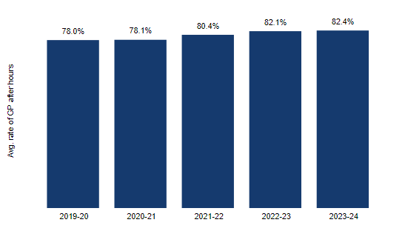

While the rate of access to after-hours health care services has grown nationally, access at a state/territory level has provided mixed outcomes. Access has continued to increase in New South Wales, Queensland, Victoria and Western Australia, South Australia experienced a drop in 2022–23, with a subsequent increase in 2023–24 and Tasmania experienced an increase in 2022–23 followed by a drop in 2023–24. Reduction in access can be seen in the Australian Capital Territory, although the overall rate of payment for after-hours services remains higher than for some states. Reporting for the Northern Territory is not included for this indicator due to variance in the count of general practices.

Figure 14: Rate of general practices receiving Practice Incentive Program payments for after-hours services, by PHN state group (excludes NT), 2019–20 to 2023–24
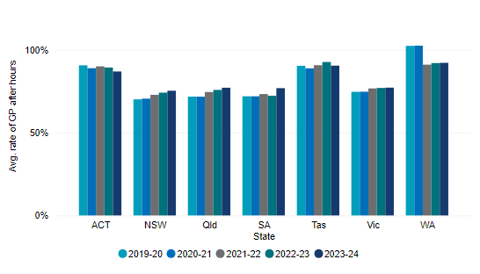

P7 – Emergency Department Presentations
As part of PHNs’ responsibility for improving access to general practice services, analysis of semi-urgent or non-urgent emergency department presentations is undertaken to provide insight into whether patients have sufficient access to general practice services. PHNs, as facilitators of primary health care services in their regions, should use the information available to support general practices to ensure appropriate services are accessible. A decline in presentations may indicate that patients are better able to access the care needed without attending an emergency department. As with the rate of after-hours services, the effect of the introduction of Medicare Urgent Care Clinics on presentation at emergency departments has not been considered in reporting for this indicator.
Presentations at emergency departments for lower urgency care have continued a downward trend in 2022–23 dropping 6.3 per cent for the age-standardised rate. While the overall average attendance at emergency departments has decreased for the second consecutive year (154.4 in 2020–21, 148.3 in 2021–22 and 139 in 2022–23), the reduction in presentations is disproportionately larger for metropolitan areas compared to regional and remote areas, indicating greater access to primary care services in more populous regions.

Figure 15: Average lower urgency emergency department presentations, per 100,000 population, age-standardised, by PHN remoteness, 2017–18 to 2022–23
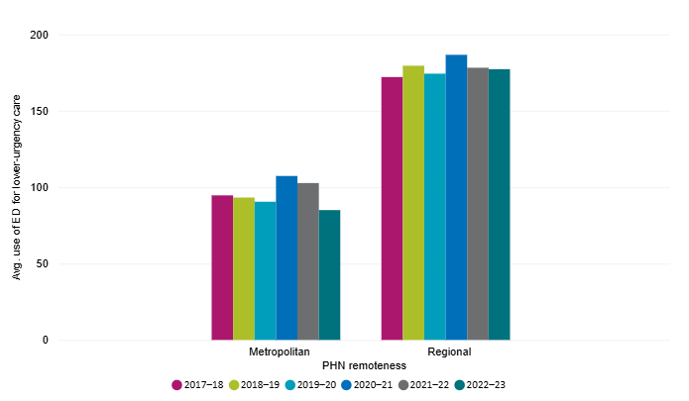
Age-standardised rates of lower urgency emergency department presentations by PHN region show a significant difference between metropolitan and regional areas. Country WA, Murrumbidgee, North Coast, Northern Territory, Western NSW and Western Queensland PHN regions have all consistently recorded average presentation rates of over 200 per 100,000 population (age-standardised rate) since 2017–18, with the average rate for Western NSW continually above 300 per 100,000, driving up averages for regional areas.

Figure 16: Average lower urgency emergency department presentations, per 100,000 population, age-standardised, by regional PHN, 2017–18 to 2022–23
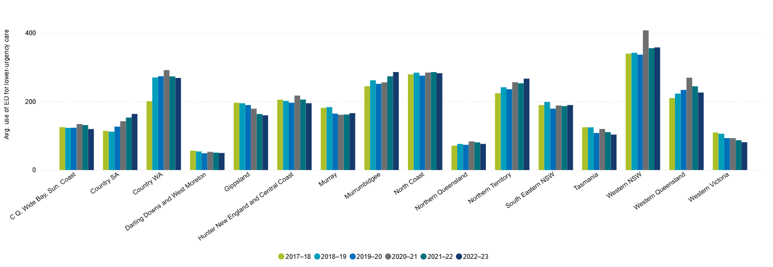
Most metropolitan areas record rates of under 150 per 100,000 population, with many recording rates under 100 presentations. Rates over time by PHN region have remained largely the same, with significant decreases for Brisbane North, Gold Coast and Northern Sydney representing a return to similar rates as those recorded in 2018–19.

Table 3: Average lower urgency emergency department presentations, per 100,000 population, age-standardised, by PHN
PHN | 2017–18 | 2018–19 | 2019–20 | 2020–21 | 2021–22 | 2022–23
New South Wales
Central and Eastern Sydney | 99.6 | 99 | 106.8 | 99.6 | 100.8 | 101.4
Hunter New England and Central Coast | 205.5 | 201.8 | 196.5 | 217.3 | 205.8 | 195.1
Murrumbidgee | 244.8 | 262 | 251.8 | 255.9 | 273.7 | 286.1
Nepean Blue Mountains | 130.9 | 131.9 | 119.7 | 127.6 | 123.4 | 123.1
North Coast | 279.5 | 284.2 | 275.5 | 284.6 | 286.1 | 282.6
Northern Sydney | 96.3 | 89.9 | 100.9 | 149 | 131.5 | 90.2
South Eastern NSW | 189.8 | 198.9 | 179.2 | 188.5 | 186.6 | 189.8
South Western Sydney | 101.3 | 101.1 | 94 | 87.3 | 95.5 | 88.8
Western NSW | 339.8 | 342.3 | 337 | 407.9 | 355.7 | 358.1
Western Sydney | 82.5 | 83.9 | 78.3 | 76.9 | 78.2 | 79.3
Victoria
Eastern Melbourne | 80.6 | 79.1 | 70.8 | 68.4 | 72.9 | 71
Gippsland | 196.4 | 194.9 | 189.8 | 179.1 | 163.6 | 159.7
Murray | 181.7 | 183.7 | 164.7 | 161.3 | 162.1 | 166.1
North Western Melbourne | 101.9 | 98 | 88 | 85.2 | 93.6 | 91.8
South Eastern Melbourne | 77.6 | 74.2 | 66.2 | 61.9 | 66 | 65.4
Western Victoria | 109.6 | 105.9 | 93.2 | 93.2 | 87.1 | 81.2
Queensland
Brisbane North | 84.7 | 83.5 | 96.3 | 186 | 155.2 | 87.5
Brisbane South | 75 | 72.6 | 72.3 | 84.8 | 83.7 | 71.5
Central Queensland, Wide Bay, Sunshine Coast | 125.2 | 123 | 123.5 | 134.2 | 131.3 | 119.7
Darling Downs and West Moreton | 56.6 | 54.2 | 48.9 | 53 | 50.8 | 49.8
Gold Coast | 71.9 | 71.2 | 90 | 182.1 | 168.1 | 60.4
Northern Queensland | 71.1 | 76.2 | 73.5 | 83.4 | 80.8 | 76.3
Western Queensland | 210.2 | 223.1 | 233.9 | 269.6 | 244.5 | 226.3
South Australia
Adelaide | 89.1 | 89.6 | 81 | 92.8 | 85.8 | 85.6
Country SA | 114.2 | 111.9 | 126.7 | 142.5 | 153.3 | 163.8
Western Australia
Country WA | 200.9 | 270.2 | 273.9 | 291.7 | 273.3 | 268.8
Perth North | 102.4 | 108.7 | 101.4 | 107.7 | 96.9 | 88.8
Perth South | 118.3 | 120.8 | 111.8 | 119.8 | 117 | 107.9
Tasmania
Tasmania | 125 | 124.6 | 108.2 | 119.9 | 110.6 | 103.4
Northern Territory
Northern Territory | 224.2 | 241.7 | 236 | 256.4 | 253.3 | 266.8
Australian Capital Territory
Australian Capital Territory | 126.4 | 117.8 | 101.2 | 117.3 | 110.9 | 101.9

MH1 – Low-intensity Psychological Interventions
Increasing access to low-intensity mental health services is fundamental to an integrated stepped care system of mental health service delivery. These services should provide patients who are at risk of mental illness, or who have mild mental illness, with easy to access appropriate mental health services without the need to engage with more intensive psychological interventions. PHNs are responsible for commissioning services based on the needs of their region, including for identified priority areas, providing easy access to high-quality, low-cost services, with or without referral.
Data for PHNs shows complex changes in reporting of services provided. While some PHN regions have shown growth, others have declined between 2022-23 and 2023-24. As a result, the overall assessment across PHNs provides mixed results.
Data are not comparable across PHNs or over time. There is notable variability in the data across PHNs and over time as some services are delivered under the Mental Health Flexible Funding Stream which allows PHNs to have a high degree of flexibility in how they deploy this funding (guided by detailed, evidence-based needs assessments). PHNs plan, commission and report on a broad range of mental health and suicide prevention services including low-intensity mental health services, child and youth services, psychological therapies for underserviced groups, services for people with severe mental illness, suicide prevention services and mental health services for First Nations people. Services are delivered in partnership with state and territory governments, general practitioners, non-government organisations and other related services, organisations and providers.

Table 4: Population receiving PHN commissioned low intensity psychological interventions, per 100,000 population, by PHN
PHN | 2022–23 | 2023–24
New South Wales
Central and Eastern Sydney | 76.9 | 70.7
Hunter New England and Central Coast | 112.8 | 121
Murrumbidgee | 304 | 319.8
Nepean Blue Mountains | 246.6 | 311.2
North Coast | 189.8 | 163.2
Northern Sydney | 67.1 | 82.8
South Eastern NSW | 41.9 | 61
South Western Sydney | 60.8 | 52.5
Western NSW | 52.1 | 9.8
Western Sydney | 70 | 105.4
Victoria
Eastern Melbourne | 73.3 | 57.1
Gippsland | 375 | 548.8
Murray | 0.5 | 22.7
North Western Melbourne | 111.9 | 136.7
South Eastern Melbourne | 36.5 | 28.3
Western Victoria | 35.7 | 76.3
Queensland
Brisbane North | 60.4 | 58.8
Brisbane South | 470.9 | 467.8
Central Queensland, Wide Bay, Sunshine Coast | 111.3 | 103.7
Darling Downs and West Moreton | 165.7 | 196.6
Gold Coast | 64.2 | 92.2
Northern Queensland | 179.2 | 238.8
Western Queensland | 787.2 | 842.4
South Australia
Adelaide | 35.4 | 52.2
Country SA | 90.9 | 207.8
Western Australia
Country WA | 323.9 | 268.9
Perth North | 168.3 | 116.9
Perth South | 295.8 | 190.2
Tasmania
Tasmania | 60 | 47.9
Northern Territory
Northern Territory | 248 | 779.4
Australian Capital Territory
Australian Capital Territory | 144.6 | 118.9

MH2 – Psychological Therapies
PHNs are required to commission psychological therapies, to provide mental health services where there are limited or not easily accessible Medicare Benefits Schedule subsidised psychological services, or to particular sub-populations that are not accessing available services to the same extent as the general population. Targeted groups may include people experiencing or at risk of homelessness, people living in remote communities, Aboriginal and Torres Strait Islander people, Culturally and Linguistically Diverse people, those who have experienced trauma or abuse, and women experiencing perinatal depression. Target groups are determined by PHNs based on local needs.
As with indicator MH1, assessment of PHN performance for this indicator requires consideration of changes in uptake of services over a broader period to understand the delivery of services. Please also refer to MH1 (page 34) for a statement on data variability and inability to compare figures across PHNs or over time.

Table 5: Population receiving PHN commissioned psychological therapies delivered by mental health professional, per 100,000 population, by PHN
PHN | 2022–23 | 2023–24
New South Wales
Central and Eastern Sydney | 304.6 | 175.5
Hunter New England and Central Coast | 568.5 | 518.5
Murrumbidgee | 653.6 | 524.1
Nepean Blue Mountains | 505.8 | 636
North Coast | 612.4 | 960.3
Northern Sydney | 340.5 | 352.7
South Eastern NSW | 322.7 | 169.5
South Western Sydney | 570.8 | 398.3
Western NSW | 533 | 484.8
Western Sydney | 480.3 | 447.3
Victoria
Eastern Melbourne | 131.3 | 83.8
Gippsland | 963.5 | 670.7
Murray | 904.5 | 856.3
North Western Melbourne | 368.9 | 485
South Eastern Melbourne | 220 | 202.1
Western Victoria | 660.6 | 473.2
Queensland
Brisbane North | 284.1 | 262.7
Brisbane South | 378.1 | 391.1
Central Queensland, Wide Bay, Sunshine Coast | 305.3 | 386.3
Darling Downs and West Moreton | 25.2 | 150.8
Gold Coast | 283.6 | 227.9
Northern Queensland | 1183.3 | 1313.8
Western Queensland | 1650.7 | 1582.5
South Australia
Adelaide | 351.9 | 278.6
Country SA | 859.3 | 798.5
Western Australia
Country WA | 342.3 | 372.9
Perth North | 145.3 | 231.7
Perth South | 61.9 | 169.6
Tasmania
Tasmania | 385.2 | 442.3
Northern Territory
Northern Territory | 701.4 | 935.7
Australian Capital Territory
Australian Capital Territory | 134.9 | 135.4

FN8 – Aboriginal and Torres Strait Islander – Health Assessments
As a priority area set by the Australian Government, PHNs support Aboriginal and Torres Strait Islander people to access appropriate primary health care, including through health assessments and regular health checks. The degree to which Aboriginal and Torres Strait Islander people are accessing a selection of primary health care services aimed at identifying and preventing poor health, as well as provision of multidisciplinary care, is measured as a proportion of Aboriginal and Torres Strait Islander people who have received a health assessment. This indicator does not have a criteria or target – it is used to understand the broader healthcare landscape and provide context for other performance indicators.
Over the two reporting periods the proportion of health assessments for Aboriginal and Torres Strait Islander people has increased following a decrease over the previous three reporting periods, to return to around the same rate as 2018–19 (24.2 per cent), increasing to 23.1 per cent in 2022–23 and 24.3 per cent in 2023–24. Rates continue to be higher in regional areas compared to metropolitan PHN regions. Populations of higher disadvantage continue to have a greater rate for health assessments, increasing more over the 2023–24 reporting period than lower disadvantage rates.

Figure 17: Proportion of Aboriginal and Torres Strait Islander people receiving health assessments, all age groups, by PHN remoteness, 2018–19 to 2023–24
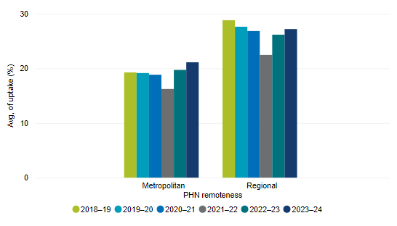

Figure 18: Proportion of Aboriginal and Torres Strait Islander people receiving health assessments, all age groups, by PHN disadvantage, 2018–19 to 2023–24
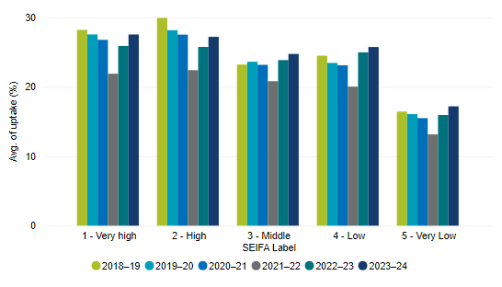

Health assessments by age group continue to be highest for Aboriginal and Torres Strait Islander people 50 years and over (32.6 per cent in 2022–23 and 34 per cent in 2023–24) and has increased overall since 2018–19 (31.7 per cent).

Figure 19: Proportion of Aboriginal and Torres Strait Islander people receiving health assessments, by age group, 2018–19 to 2023–24
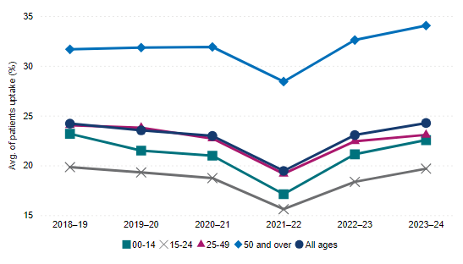

AC1 – Residential Aged Care Home Services
Primary health care services can be challenging for residents of residential aged care homes to access, sometimes leading to reliance on the hospital system to obtain required care. Through analysis of Medicare Benefits Schedule items as an indicator of access to general practice services PHNs can work with residential aged care homes to improve capability to care for residents in place rather than transferring to hospital. PHNs performance is not assessed against this measure, with data providing an understanding of the broader healthcare needs of their communities.
The average number of attendances of general practitioners per residential aged care patient has increased over the two reporting periods following a decline in 2021–22. The average number of visits per resident in 2023–24 was 17.5, an increase of 5.4 per cent from 2022–23 (16.6 attendances).

Figure 20: Average number of GP attendances in residential aged care homes, per patient, 2017–18 to 2023–24
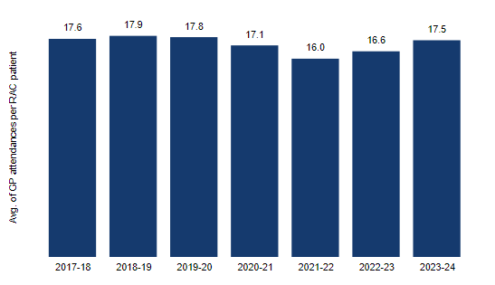

Increased or maintained rates were reported for all states or territories as well as across metropolitan and regional areas, with metropolitan areas continuing to show higher rates of attendance than regional areas.

Figure 21: Average number of GP attendances in residential aged care homes, per patient, by PHN remoteness, 2017–18 to 2023–24
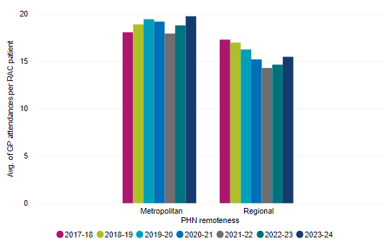

AC2 – Aged 65 and Over – Health Assessment
Supporting older people to live independently in their own home, manage their chronic conditions and avoid early entry to residential care can be improved through ensuring timely access to primary health care services. An increase in the rate of people 65 and over with a GP health assessment is used to inform PHNs about activities influencing care for older Australians.
Following a decline in this indicator for 2021–22 (14.6 per cent) there have been increases for this indicator for 2022–23 (17.1 per cent) and 2023–24 (17.8 per cent).

Figure 22: Proportion of people aged 65 years and over with a recorded health assessment, 2017–18 to 2023–24
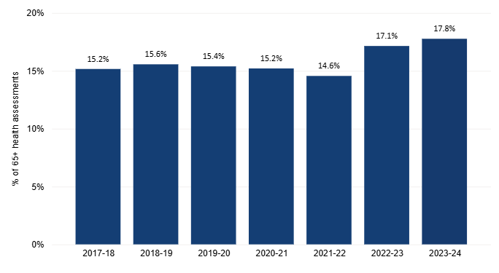
Regional areas have continued to have a slightly higher rate of health assessments for people aged 65 and over than metropolitan areas over both reporting periods, with just over one per cent more of the target population with a health assessment.

Figure 23: Proportion of people aged 65 year and over with a recorded health assessment, by PHN remoteness, 2017–18 to 2023–24
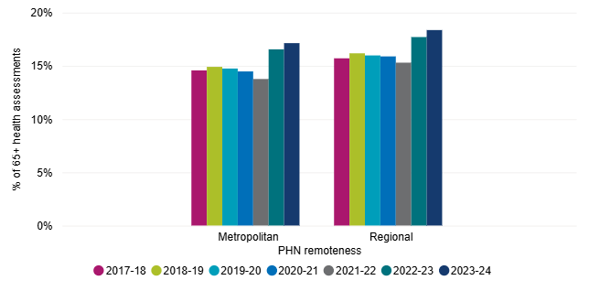

AOD1 – Active Alcohol and Other Drug Services
The monitoring of active delivery of drug and alcohol services by commissioned providers is used to assess the effectiveness of transition from design to delivery of services. Active delivery refers to patients being referred and accessing services. PHNs report on the increase or maintenance of the rate of providers actively providing services. For the two reporting periods all PHNs have been assessed as meeting this indicator, with all commissioned providers being reported as actively delivering services.

Conclusion
Based on the indicators used for reporting, there has been an overall increase in access to primary health care services for people, based on increases across most indicators for this outcome theme, particularly in metropolitan PHN regions. Improved access includes after-hours care and services for residents of aged care homes, with an associated decrease in lower urgency presentations at hospitals. Health assessments for people aged 65 and over and Aboriginal and Torres Strait Islander people have also increased, providing a broader understanding of healthcare needs. There have been mixed results for mental health indicators, with some PHNs performing strongly for relevant indicators, while others have experienced a reduction in services provided. PHNs continue to ensure the active delivery of services for alcohol and other drugs across all regions.

Coordinated Care
Coordinated health care supports all Australians to access the right care at the right time in the right place. By understanding the services available, demands on services and needs of their regions, PHNs can assist general practices and other health care providers to deliver appropriate services for their regions, including across priority areas.

P9 – Coordination of Care – Collective Health Care Needs
Using tools and processes that assist in understanding the collective health care needs of a patient a coordinated approach can be applied to ensure that all health care needs are being addressed. PHNs can work with health care providers, including general practitioners, to highlight the benefits of services such as health assessments, chronic disease management plans and multidisciplinary case conferences. Reporting for this indicator considers the use of Medicare Benefits Schedule (MBS) items to report on the uptake of coordinated services.
Following a drop in the 2021–22 reporting period to 10.6 million, the number of MBS items for this indicator has increased over both the 2022–23 reporting period (11.6 million) and the 2023–24 period (12.1 million).

Figure 24: MBS services for chronic disease assessments and management plans, 2017–18 to 2023–24
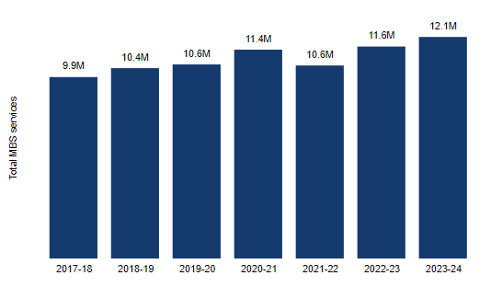

MBS items continue to be significantly higher in metropolitan areas than regional areas and across more populous states. Across levels of disadvantage, PHN regions rated as high and very high disadvantage had the lowest number of services reported, suggesting scope to improve services for these groups.

Figure 25: MBS services for chronic disease assessments and management plans, by PHN disadvantage, 2017–18 to 2023–24
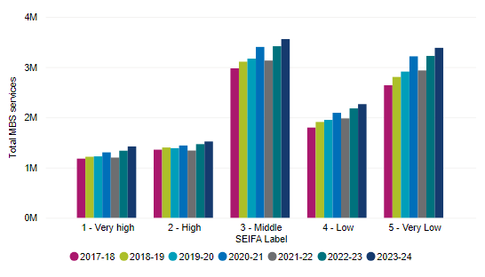

P10 – My Health Record – Cross views
The number of cross views of My Health Record provides information about access to patient health records by different health care providers. This indicator provides information that can give insight into health care providers working together to deliver coordinated care to a patient. PHNs support and encourage the increased use of My Health Record, with resulting increases in cross views providing supporting data used for reporting purposes.
There has been a significant increase in cross views of patient health records over the two reporting periods, in particular by general practices where the average number of records viewed has grown from 146.9 in 2021–22 to 315.4 in 2022–23 and 491.2 in 2023–24, representing a 234 per cent growth since 2021–22. The rate of views by pharmacies has also increased, from 34 in 2021–22 to 57.5 in 2022–23 and 84.3 in 2023–24, which is a growth of 148 per cent since 2021–22.

Figure 26: Average cross views per general practice, 2018–19 to 2023–24
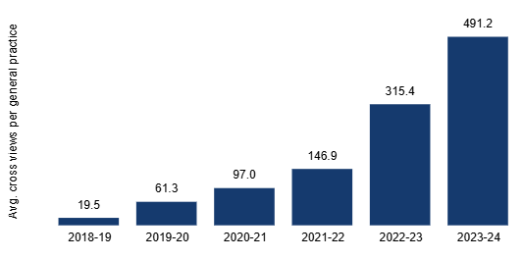

Figure 27: Average cross views per pharmacy, 2018–19 to 2023–24
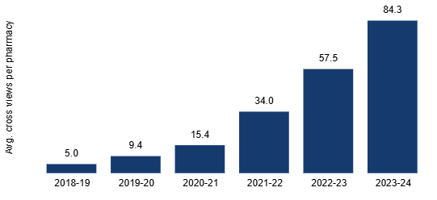
Cross views continue to be higher in regional areas for both general practice and pharmacy, with a substantial increase in regional cross views by general practice in 2023–24 (571.5 views). The number of cross views for pharmacies has experienced a higher rate of growth in metropolitan PHN areas than regional areas since the 2021–22 reporting period, increasing by 176 per cent compared to 134 per cent, however cross view rates in regional areas continues to be significantly higher.

Figure 28: Average cross views per general practice, by PHN remoteness, 2018–19 to 2023–24
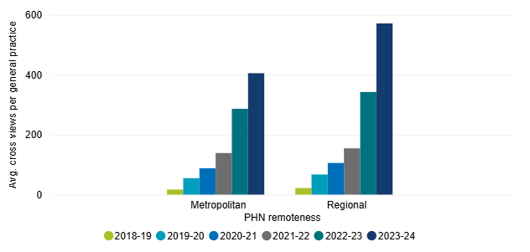

Figure 29: Average cross views per pharmacy, by PHN remoteness, 2018–19 to 2023-24
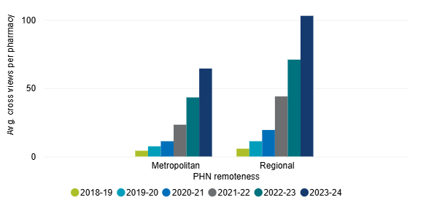

MH3 – Coordination of Care – Severe and Complex Mental Illness
PHNs are responsible for commissioning high intensity psychological services for people and clinical care coordination mental health services for patients with severe and complex mental illness. PHNs report on the increase or maintenance of service capacity to be assessed against this indicator, in turn providing an indication of activity and change over time.
Access to PHN commissioned services for people with severe and complex mental health needs has increased overall based on the average rate of active clients per 100,000 PHN residents reported for 2021–22 (107.6) to 109.7 in 2022–23 and 122 in 2023–24. The rate for 2023–24 is slightly lower than the rate for 2020–21 (125.8).
Figure 30: Average rate receiving PHN commissioned clinical care coordination services for people with severe and complex mental illness, per 100,000 population, 2018–19 to 2023–24

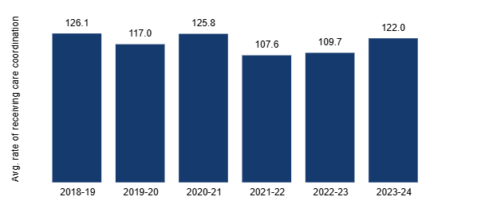
As with other mental health indicators, mixed results show complex changes in service delivery. Some PHNs have recorded large increases, others have seen a decrease and some PHNs have reported fluctuating rates across the six reporting periods.
Please refer to MH1 (page 34) for a statement on data variability and inability to compare figures across PHNs or over time.

Table 6: Population receiving PHN commissioned clinical care coordination services for people with severe and complex mental illness, per 100,000 population, by PHN
PHN | 2022–23 | 2023–24
New South Wales
Central and Eastern Sydney | 59.6 | 92
Hunter New England and Central Coast | 80.9 | 97.6
Murrumbidgee | 306.1 | 272.6
Nepean Blue Mountains | 58.3 | 48.3
North Coast | 119.9 | 138.3
Northern Sydney | 52.9 | 67.2
South Eastern NSW | 204.2 | 238.8
South Western Sydney | 41.6 | 32.1
Western NSW | 18.7 | 11.1
Western Sydney | 119.6 | 57.9
Victoria
Eastern Melbourne | 16 | 12.3
Gippsland | 402.9 | 470.8
Murray | 74.6 | 74.6
North Western Melbourne | 36 | 35.9
South Eastern Melbourne | 38.9 | 35.6
Western Victoria | 58.9 | 57.9
Queensland
Brisbane North | 53.7 | 93.6
Brisbane South | 112 | 110.7
Central Queensland, Wide Bay, Sunshine Coast | 69.2 | 51.4
Darling Downs and West Moreton | 121.8 | 135.2
Gold Coast | 48.4 | 43.8
Northern Queensland | 34.9 | 37.7
Western Queensland | 769.3 | 1064.7
South Australia
Adelaide | 47.3 | 16.5
Country SA | 125.9 | 141.9
Western Australia
Country WA | 21.4 | 17.9
Perth North | 47.2 | 44.1
Perth South | 35.8 | 37.4
Tasmania
Tasmania | 96.4 | 102
Northern Territory
Northern Territory | 109.3 | 117.2
Australian Capital Territory
Australian Capital Territory | 19.5 | 24.6

MH4 – Integrated Planning and Service Delivery
In partnership with Local Health Networks (or equivalent) and relevant stakeholders, PHNs are required to develop a Joint Regional Mental Health and Suicide Prevention Plan. Coordinated service delivery across multiple providers and jurisdictions is essential for identifying needs and gaps, as well as reducing duplication of services and inefficiencies. Plans should be reviewed regularly and updated as required.
For the 2022–23 and 2024–25 reporting periods all PHNs were assessed as meeting this indicator. One PHN received an extension for renewal of their Joint Regional Mental Health and Suicide Prevention Plan for their region.

MH5 – Suicide Prevention and Referral
PHNs are required to support a systems-based regional approach to planning and coordinating suicide prevention activities for their region. To ensure the utmost care and support for vulnerable individuals, PHNs are expected to work with Local Hospital Networks and other service providers to address the needs of people at risk of suicide, including Aboriginal and Torres Strait Islander people, and to give priority to follow-up care and support in the period after a suicide attempt.
Following a slight decrease in the average proportion of patients referred that were followed up within seven days for the 2022–23 reporting period to 66.5 per cent (from 67.8 per cent in 2021–22) the rate for 2023–24 has increased to 72.5 per cent – the highest rate recorded under the current reporting framework. The increase reflects a greater proportion of patients followed up in metropolitan PHN regions (68.8 per cent in 2021–22, 62.8 per cent in 2022–23 and 72 per cent in 2023–24) and continued steady growth in regional PHN areas (66.8 per cent in 2021–22, 70 per cent in 2022–23 and 73 per cent in 2023–24).

Figure 31: Proportion of people referred to PHN commissioned services due to a recent suicide attempt or because they were at risk of suicide followed up within 7 days of referral, 2018–19 to 2023–24

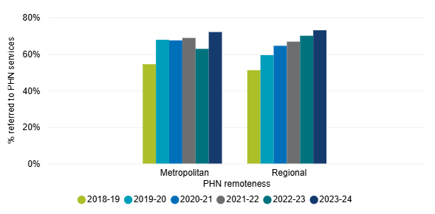

FN7 – Coordinated Care – Integrated Team Care
To support Aboriginal and Torres Strait Islander people with chronic conditions to receive coordinated care, PHNs have processes in place to identify, assess and complete enrolment in the Integrated Team Care program. PHNs report on processes in place for referral, intake and discharge for the ITC program.
For the 2022–23 and 2023–24 reporting periods all PHNs have been assessed as meeting this indicator (noting that three Queensland PHNs are no longer assessed for this indicator). Information provided by PHNs includes processes for triage, intake and prioritisation of clients, including utilisation of central intake services. PHNs have also detailed processes for engagement with general practices, ITC providers and Care Coordinators, as well as the operation of outreach programs.

AOD2 – Partnerships – Alcohol and Other Drug Services
Partnership and collaboration with key local stakeholders in the provision of drug and alcohol treatment services facilitate a coordinated approach to service delivery, allowing for an integrated approach to drug and alcohol treatment services. PHNs are assessed on the information provided of formalised partnerships and collaboration within the PHN region.
For the two reporting periods all PHNs have been assessed as meeting this indicator, providing information about working in partnership with local treatment service providers, state and local government, hospitals, Aboriginal and Torres Strait Islander organisations, and advisory and community groups.

Conclusion
An increase in the delivery of coordinated services has been supported by reported growth in the use of health needs assessment tools and clinical care coordination services, as well as processes to support Aboriginal and Torres Strait Islander people with chronic conditions through Integrated Team Care. Most PHNs have Joint Regional Mental Health and Suicide Prevention Plans in place and have continued to engage with key stakeholders for the delivery of alcohol and other drug services in their regions. The use of digital health technology to support the coordination of care has continued to grow and is particularly high in regional areas, providing valuable access to patient information regardless of location. Follow up services for referral to a PHN commissioned mental health service related to suicide has continued to increase, although PHNs are still not meeting the indicator benchmark of 100 per cent.

Capable Organisations
For PHNs to deliver a successful program they must have strong governance, reporting and compliance processes in place to support the delivery of outcomes. Through demonstration of robust commissioning processes, strong stakeholder engagement, and regular reporting, the performance of PHNs against outputs provides visibility and accountability of the delivery of the PHN program.

P13 – Health Care Professionals
To gauge capacity to meet the needs of PHN regions the number of health care professionals available provides valuable supporting data to assess the ability to deliver and improve services and assess trends in service delivery over time. This indicator also provides insight into the healthcare environment for PHN regions. Data for this indicator is used for individual performance assessments of PHNs and to calculate other indicators. PHNs are not assessed directly against this indicator and data is not included in program performance reporting.

O7 – Variance Report – Scheduled Activities
All PHNs are required to provide a variance report to indicate how their scheduled activities are tracking in terms of timeliness, actual expenditure and engagement with stakeholders. For the 2022–23 and 2023–24 reporting periods all PHNs have met this requirement. Findings for this indicator are used for individual performance assessments of PHNs and are not included in program performance reporting.

O13 – Annual Report and Audited Financial Statements
The submission of an annual report and audited financial statements to the department is a contractual obligation and a requirement of the Corporations Act 2001 (Cth). All PHNs have met this requirement for the two reporting periods. Findings for this indicator are used for individual performance assessments of PHNs and are not included in program performance reporting.

Conclusion
PHNs have fulfilled their obligations for the reporting periods for current indicators for this outcome theme.

Appendix – Performance and Quality Framework Indicators

Aged Care (AC) Indicators
AC1 – Residential Aged Care Home Services
AC2 – Aged 65 and Over – Health Assessment
Alcohol and Other Drugs (AOD) Indicators
AOD1 – Active Alcohol and Other Drug Services
AOD2 – Partnerships – Alcohol and Other Drug Services
Digital Health (DH) Indicators
DH2 – Digital Health Systems
DH3 – Data Sharing – Accredited General Practices
First Nations Health (FN) Indicators
FN1 – Integrated Team Care – Delivery
FN2 – Integrated Team Care services – Organisations
FN3 – Culturally Safe Alcohol and Other Drug Services
FN4 – Culturally Safe Mental Health Services
FN5 – Culturally Safe Mainstream Primary Health Care Services
FN6 – Aboriginal and Torres Strait Islander Health Workforce
FN7 – Coordinated Care – Integrated Team Care
FN8 – Aboriginal and Torres Strait Islander – Health Assessments
Mental Health (MH) Indicators
MH1 – Low-intensity Psychological Interventions
MH2 – Psychological Therapies
MH3 – Coordination of Care – Severe and Complex Mental Illness
MH4 – Integrated Planning and Service Delivery
MH5 – Suicide Prevention and Referral
MH6 – Clinical Outcome Measures
Organisational (O) Indicators
O7 – Variance Report – Scheduled Activities
O12 – Output and Outcome Performance Indicators
O13 – Annual Report and Audited Financial Statements
Program (P) Indicators
P1 – Activities Address Prioritised Needs
P2 – Health System Improvement and Innovation
P3 – General Practice Accreditation
P4 – General Practice and Health Care Provider Support
P5 – My Health Record – Uploads
P6 – General Practices – After-hours Services
P7 – Emergency Department Presentations
P9 – Coordination of Care – Collective Health Care Needs
P10 – My Health Record – Cross views
P12 – Potentially Preventable Hospitalisations
P13 – Health Care Professionals
Population Health (PH) Indicators
PH1 – Childhood Immunisation
PH2 – Cancer Screening
Workforce (W) Indicators
W1 – Alcohol and Other Drug Services – Accreditation
W2 – Alcohol and Other Drug – Health Professionals

Health.gov.au
All information in this publication is correct as at August 2025

https://www.health.gov.au/resources/publications/primary-health-networks-phn-performance-and-quality-framework
PHN remoteness aligns with the Australian Institute of Health and Welfare definition: https://www.aihw.gov.au/reports-data/population-groups/rural-remote-australians/glossary on AIHW classification
Level of disadvantage for a PHN region is based on the 2021 Index of Relative Socio-Economic Disadvantage, as part of the Australian Bureau of Statistics Socio-Economic Indexes for Areas (SEIFA) series.
Including by remoteness, socio-economic disadvantage, and state and territory groups which are based on PHN state and territory boundaries (Murray PHN includes the City of Albury).
Data from the Australian Bureau of Statistics, Australian Digital Health Agency, Australian Institute of Health and Welfare, Primary Mental Health Care Minimum Data Set, Australian Immunisation Register, Medicare Benefits Scheme and individual PHN 12-Month Performance Reports. Data tables for this report will be published separately on the Department of Health, Disability and Ageing website.
https://www.anao.gov.au/work/performance-audit/effectiveness-the-department-health-and-aged-cares-performance-management-primary-health-networks
Ibid, in response to Recommendation 6.
Ibid, Recommendation 5.
https://www.health.gov.au/news/end-of-covid-19-emergency-response?language=en
https://www.health.gov.au/our-work/strengthening-medicare-measures/increasing-access-to-primary-care
https://www.health.gov.au/committees-and-groups/primary-care-and-workforce-reviews-taskforce
https://www.royalcommission.gov.au/aged-care
Includes funding for the Strengthening Medicare – General Practice Grants Program, which provided grant funding over two years and ended on 30 June 2023. Income levels for all other Pilots and Targeted Programs activities have either grown or remained the same across the two years.
Headings throughout this report include performance indicator identifiers to connect reporting with the Performance and Quality Framework.
https://www.aihw.gov.au/reports/primary-health-care/potentially-preventable-hospitalisations-2017-2023/contents/potentially-preventable-hospitalisations
Explanation of age-standardised rates: https://www.aihw.gov.au/getmedia/996b2236-c728-4e84-a67b-e775a8bf6a17/hrra-x01.pdf.aspx
Definitions of potentially preventable conditions: https://meteor.aihw.gov.au/content/800169
https://www.health.gov.au/our-work/indigenous-australians-health-programme
Brisbane North, Brisbane South and Gold Coast PHNs.
https://www.health.gov.au/resources/publications/integrated-team-care-program-implementation-guidelines
Royal Australian College of General Practitioners (RACGP’s) response to Review of general practice accreditation arrangements consultation. Accessed 27/08/2025 RACGP-response-General-practice-accreditation-arrangements-review.pdf
An error in reporting practice numbers led to an incorrect result in 2021-22.
2023–24 and 2022–23 indicator data extracted from the Primary Mental Health Care Minimum Data Set as at 30 September 2024 and may differ from data used to assess PHN performance for this indicator for 2022–23. As a dynamic administrative data set that can change over time, caution should be used when comparing data presented in this report.
https://nacchocommunique.com/wp-content/uploads/2016/12/cultural_respect_framework_1december2016_1.pdf
Brisbane North, Brisbane South and Gold Coast PHNs transferred funding and responsibility for delivery of ITC services for their regions to the Institute for Urban Indigenous Health in 2022–23.
https://www.health.gov.au/resources/publications/national-immunisation-strategy-for-australia-2025-2030.
Australian Institute of Health and Welfare (2024) BreastScreen Australia monitoring report 2024, catalogue number CAN 162, AIHW, Australian Government at pp. 7–8.
Data for cancer screening is traditionally reported using collated PHN data; however, PHN data was unavailable at the time of reporting for 2020–21. As a result, national data has been used for reporting.
Excludes consideration of 2020-21 in trend due to unavailability of PHN data.
Screening recommendations changed from two-yearly to five-yearly from December 2017.
Australian Institute of Health and Welfare (2024) National Cervical Screening Program monitoring report 2024, catalogue number CAN 163, AIHW, Australian Government, p. 15.
Ibid, p. 19.
Reporting for this indicator is affected by delays in publication of relevant data, creating limitations in comparing data with other indicators for the reporting period.
2023–24 and 2022–23 indicator data extracted from the Primary Mental Health Care Minimum Data Set as at 30 September 2024 and may differ from data used to assess PHN performance for this indicator for 2022–23. As a dynamic administrative data set that can change over time, caution should be used when comparing data presented in this report. The data collection methodology changed in 2021-22. Data from 2018-19 to 2020-21 was self-reported to the department by PHNs using the PMHC MDS. From 2021-22, data is extracted directly from the PMHC MDS by the department.
2023–24 and 2022–23 indicator data extracted from the Primary Mental Health Care Minimum Data Set as at 30 September 2024 and may differ from data used to assess PHN performance for this indicator for 2022–23. As a dynamic administrative data set that can change over time, caution should be used when comparing data presented in this report. The data collection methodology changed in 2021-22. Data from 2018-19 to 2020-21 was self-reported to the department by PHNs using the PMHC MDS. From 2021-22, data is extracted directly from the PMHC MDS by the department.
https://www.aihw.gov.au/reports/primary-health-care/medicare-subsidised-care-2022-23/contents/about and https://www.aihw.gov.au/reports/primary-health-care/medicare-subsidised-gp-allied-health-specialist/contents/about
https://www.aihw.gov.au/reports/primary-health-care/medicare-subsidised-care-2022-23/contents/about and https://www.aihw.gov.au/reports/primary-health-care/medicare-subsidised-gp-allied-health-specialist/contents/about
2023–24 and 2022–23 indicator data extracted from the Primary Mental Health Care Minimum Data Set as at 30 September 2024 and may differ from data used to assess PHN performance for this indicator for 2022–23. As a dynamic administrative data set that can change over time, caution should be used when comparing data presented in this report. The data collection methodology changed in 2021-22. Data from 2018-19 to 2020-21 was self-reported to the department by PHNs using the PMHC MDS. From 2021-22, data is extracted directly from the PMHC MDS by the department.
Ibid.
Ibid.
Brisbane North, Brisbane South and Gold Coast PHNs transferred funding and responsibility for delivery of ITC services for their regions to the Institute for Urban Indigenous Health in 2022–23.

