PBS Approved Suppliers Portal
  - How to upload PDF forms or additional requested information
Table of Contents
1 Purpose of this guide 3
2 When to use Upload Documents 3
a) Additional requested information 3
b) PDF forms 3
Pharmacists 3
Deceased pharmacists 3
Hospital authorities 3
Medical practitioners 3
Ministerial Discretion 3
3 Important information 4
4 Download, complete and save a PDF form 4
5 Accessing the PBS Approved Suppliers Portal 4
6 Providing details about your documents 6
7 Adding files and uploading your documents 10
8 Contact us 13

Purpose of this guide
This guide provides instructions on how to upload PBS Approved Supplier PDF forms (and related attachments) and additional requested information via the PBS Approved Suppliers Portal (Portal) using the Upload Documents function.

When to use Upload Documents

Additional requested information
Use the Upload Documents function of the Portal to provide any additional information requested by the Department of Health, Disability and Ageing (department) or the Australian Community Pharmacy Authority (ACPA).
Additional information provided in support of a previously-submitted application will not be considered or placed on your application file unless the department or ACPA specifically requested the information.

PDF forms
Use the Upload Documents function of the Portal to submit the following PDF forms:

Pharmacists
- Notification of bank account details for an approved pharmacy - must be uploaded by a registered and signed in user of the Portal
- Authority to permit person(s) to enquire and/or sign claim forms on behalf of approved pharmacist(s) – must be uploaded by a registered and signed in user of the Portal
- Notification of change of pharmacy registered business (trading) name
- Notification of a change of company director(s)
- Application for permission to supply pharmaceutical benefits following bankruptcy or external administration
- Authority to authorise pharmacist(s) to sign claim forms on behalf of section 91/91B permission holder - must be uploaded by a registered and signed in user of the Portal

Deceased pharmacists
- Application for permission to carry on business as a pharmacist by the legal personal representative of a deceased approved pharmacist
- Authority to authorise pharmacist(s) to sign claim forms on behalf of section 91/91B permission holder - must be uploaded by a registered and signed in user of the Portal

Hospital authorities
- Application for a hospital authority to prescribe and/or supply pharmaceutical benefits and/or highly specialised drugs
- Authority to authorise pharmacist(s) to sign claim forms on behalf of a hospital authority - must be uploaded by a registered and signed in user of the Portal
- Notification of a prescribing-only hospital
- Notification of bank account details for a hospital authority - must be uploaded by a registered and signed in user of the Portal

Medical practitioners
- Application for a medical practitioner to supply pharmaceutical benefits
- Notification of bank account details for an approved medical practitioner - must be uploaded by a registered and signed in user of the Portal

Ministerial Discretion
- Request for Ministerial Approval to supply pharmaceutical benefits at particular premises

Important information
- While you do not need to sign in to the Portal to use the Upload Documents function, notification of bank details and authority to permit person(s) forms must be submitted by a signed in user.
- If you are signed in, you will be able to view the time and date of your submission and monitor its progress from My Dashboard/Uploaded Documents.
- If you are not signed in, you will receive email confirmation of the date and time of your submission.
- Please do not upload documents that are password protected.
- Please do not upload multiple unrelated PDF forms to a sub-category.
- PDF forms must be uploaded separately so that the unique details are captured in each case. This allows the form to be linked to the correct application or approval number for processing. If you upload multiple forms to a sub-category, they may not be processed.
- Multiple supporting documents, if requested, are permitted under the sub-category ‘Supporting documents for my application’.

Download, complete and save a PDF form
If you are submitting a PDF form, ensure you have downloaded the most up-to-date version of the relevant form available from the PBS Approved Suppliers website. Complete and save the form to your computer.

Accessing the PBS Approved Suppliers Portal
Type https://pbsapprovedsuppliers.health.gov.au into your browser. The preferred browsers are Google Chrome or Firefox.
- If you choose not to sign in to the Portal to upload your documents, simply select the ‘Upload Documents’ tab from the Home screen.
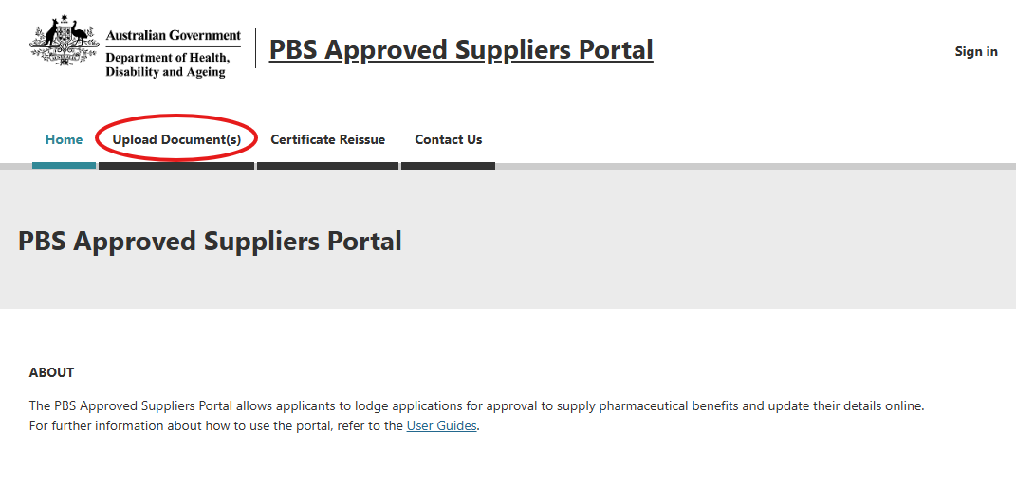
- If you choose to sign in to the Portal to upload your documents, sign-in as usual or, for further details on how to register and access the Portal for the first time, refer to How to register and sign in to the PBS Approved Suppliers Portal.
- When you have signed in, select the ‘Upload Documents’ tab from the Home screen.
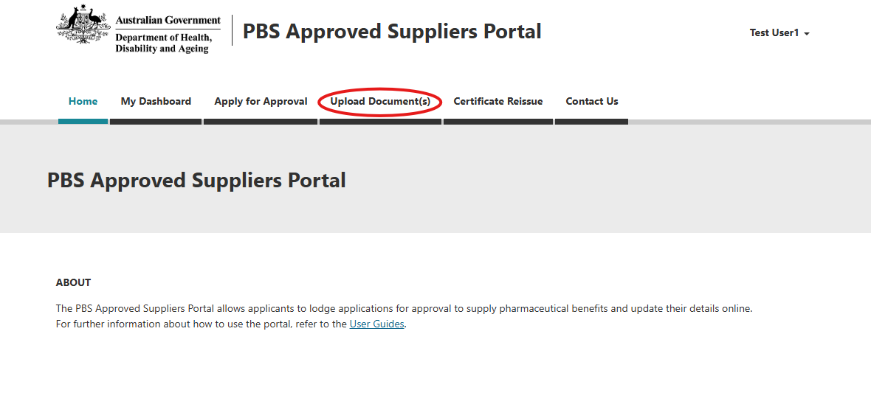
From this point, the process for uploading documents using the Upload Documents function is essentially the same whether you are signed in to the Portal or not.

Providing details about your documents
After you click on the Upload Documents tab, the following screen will be displayed:
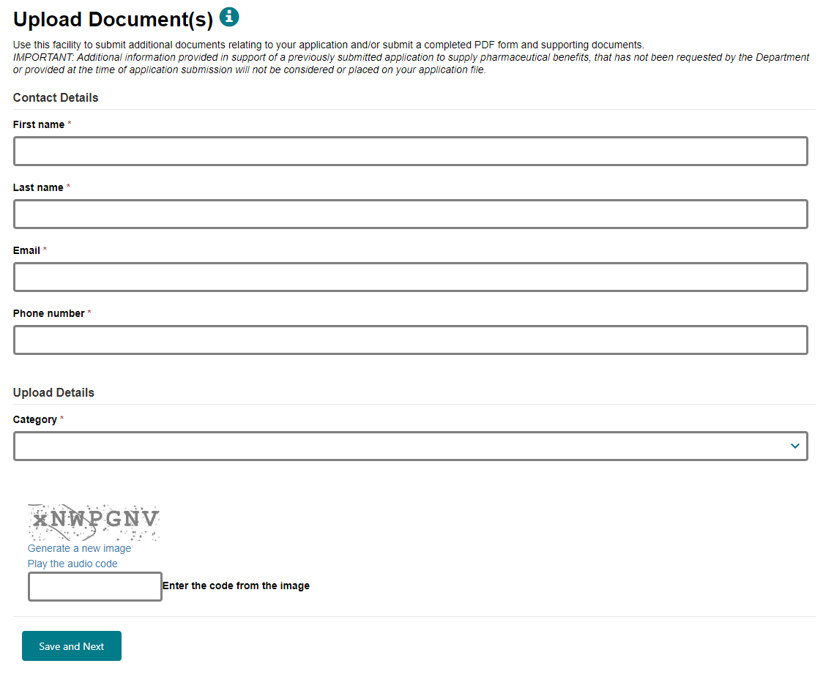
If you are signed in, the verification code is not required and will not be displayed.
- Enter your contact details then click on  under ‘Category’ to display a list of categories:
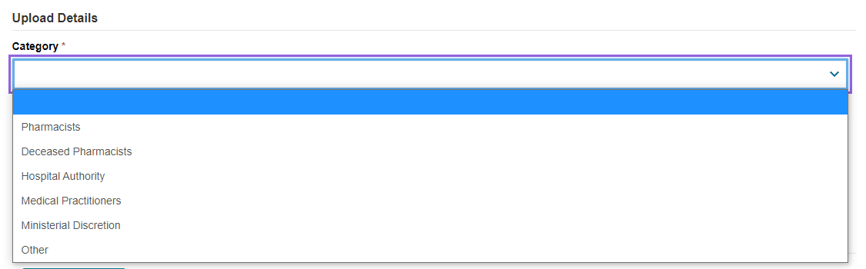
- Select the applicable category from the drop-down list. (In this guide, the ‘Pharmacists’ category is used as an example.)
- After you select a category, click on under ‘Sub-category’ to display a list of sub-categories:
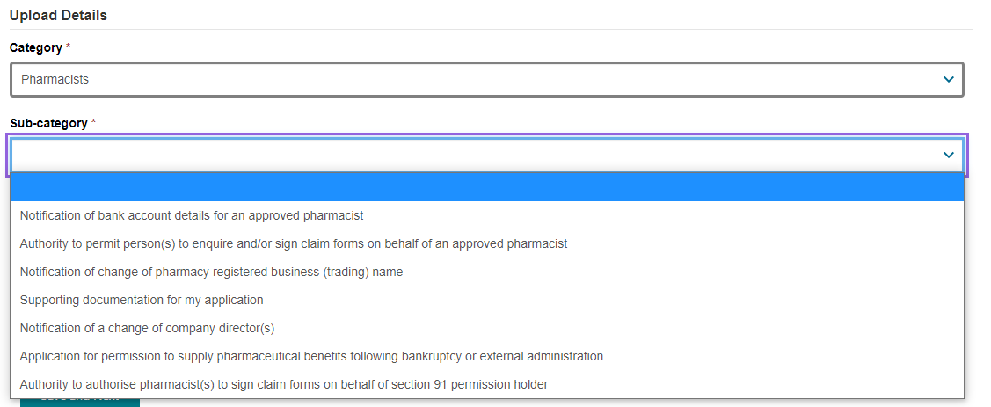
- Select the applicable sub-category from the drop-down list.
If you have selected ‘Notification of bank account details for an approved pharmacist’, the following will be displayed:
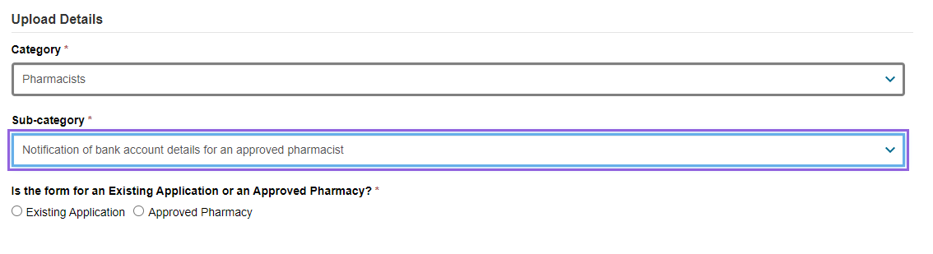
- Click on either ‘Existing Application’ or ‘Approved Pharmacy’.
Click on ‘Existing Application’ if this is your initial notification relating to an existing or recent application for which bank account details have never been provided.
Click on ‘Approved Pharmacy’ if this notification is to update bank account details already provided for an approved pharmacy.
If you have selected ‘Authority to permit person(s) to enquire and/or sign claim forms on behalf of approved pharmacist(s)’ the following will be displayed:
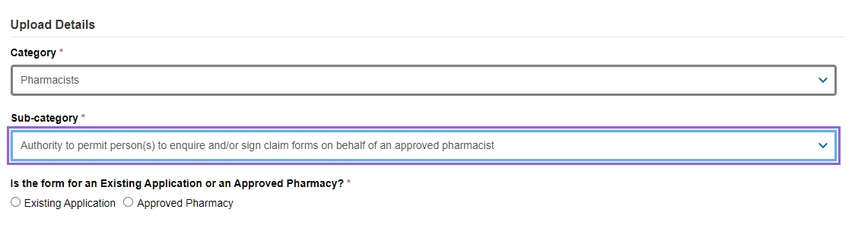
- Click on either ‘Existing Application’ or ‘Approved Pharmacy’.
Click on ‘Existing Application’ if this is your initial authority relating to an existing or recent application for which details of permitted persons have never been provided.
Click on ‘Approved Pharmacy’ if this authority is to update details of permitted persons already provided for an approved pharmacy.
Depending upon your selections, you will be asked to enter either your PBS Tracking Number or your Approval Number.
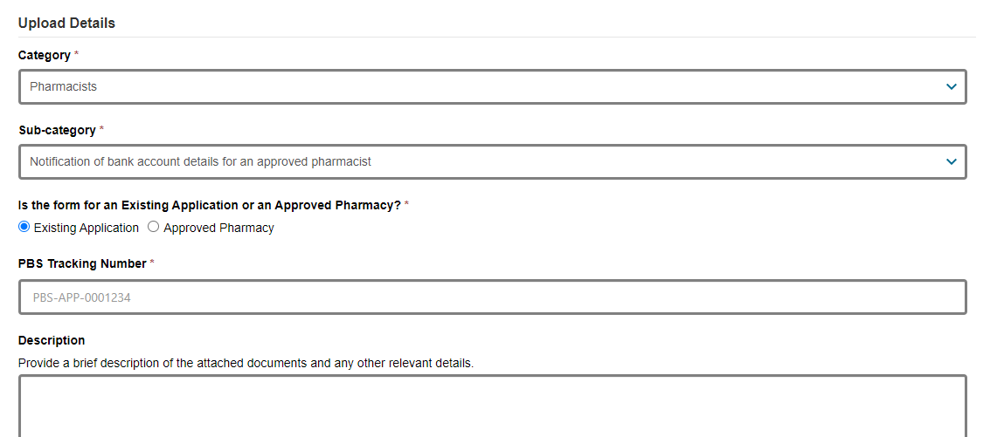
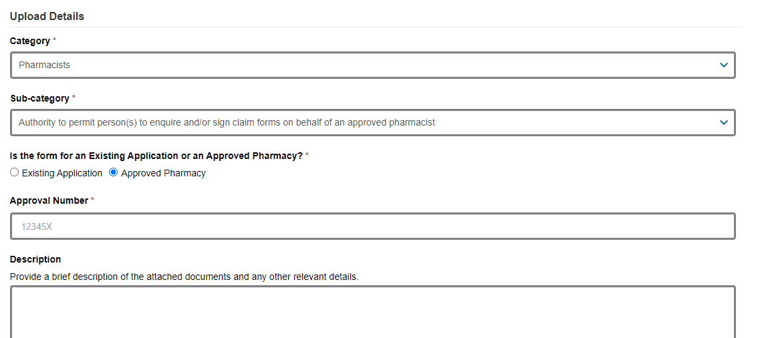
- Enter your PBS Tracking Number or Approval Number, as applicable.
As the PBS Tracking Number field is case sensitive, please enter this number in full and exactly as it appears in the Portal. This will ensure your submission is linked to your application.
For all other sub-categories, the following screen will be displayed. (In this example, ‘Notification of change of pharmacy registered business (trading) name’ is the selected sub-category.)
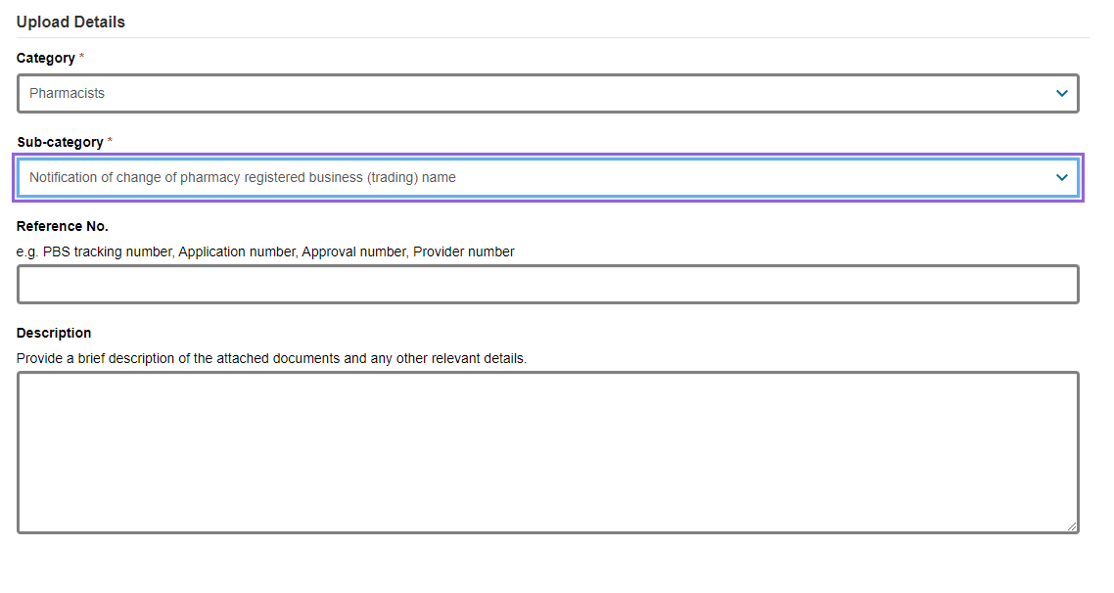
- Enter your PBS tracking number, Application number, Approval number or Provider number in the ‘Reference No.’ field.
Please ensure you enter the PBS tracking number or Application number exactly as it appears in the Portal (if applicable). If you do not have a reference number of any type, please enter your telephone number.
- While ‘Description’ is not a mandatory field, if you have selected the sub-category ‘Supporting documentation for my application’, please provide details of the documents you will be attaching and any other relevant details.
- If you are not signed in, enter the verification code.
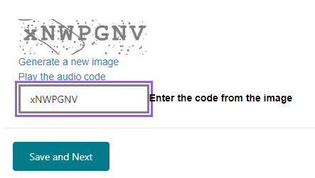
- When you have entered all the required information, click on ‘Save and Next’.

Adding files and uploading your documents
Please do not upload documents that are password protected.
Please do not upload multiple unrelated PDF forms to a sub-category.
PDF forms must be uploaded separately so that the unique details are captured in each case. This allows the form to be linked to the correct application or approval number for processing. If you upload multiple forms to a sub-category, they may not be processed.
Multiple supporting documents, if requested, are permitted under the sub-category ‘Supporting documents for my application’.
Each upload must be less than 50 MB. If you are uploading several files under ‘Supporting documents for my application’, or attachment(s) to a PDF form, their combined size must be less than 50 MB.
After you click on ‘Save and Next’, the following screen will be displayed:
  - 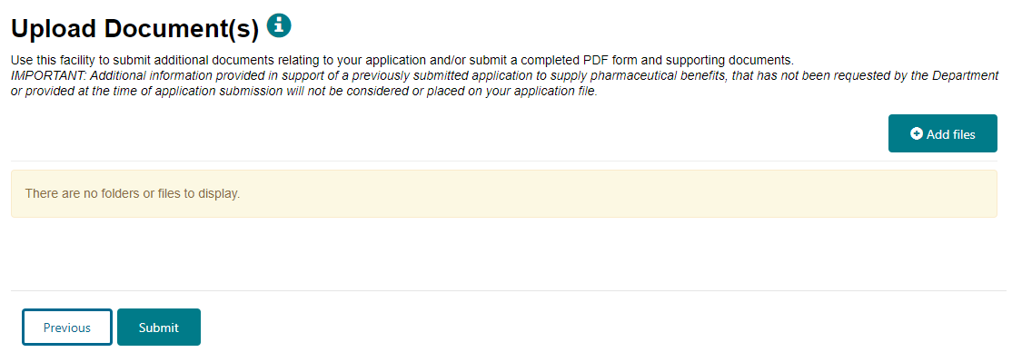
- Click on ‘Add files’.
The following screen (or similar depending on your browser) will be displayed:
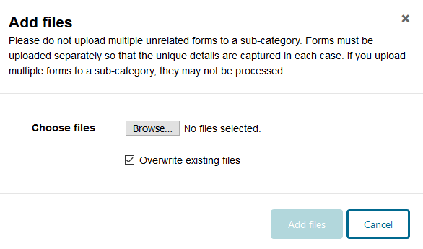
- Add files by clicking on the ‘Browse’ or ‘Choose Files’ button (depending on your browser).
The ‘Overwrite existing files’ checkbox defaults to selected. If you do not wish to overwrite a file of the same name already uploaded, ensure you uncheck this box before adding files.
- Double-click or open the selected file(s). The following screen will then display the file name (or number of files if more than one):
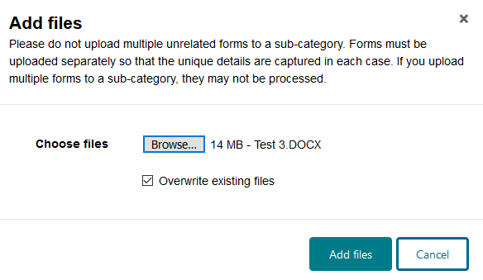
- Click on the ‘Add files’ button once more to complete the upload.
If you attempt an upload that is more than 50 MB you will receive an error message. To continue, click on the ‘Cancel’ button and try again with an upload that is less than 50 MB.
After you click on ‘Add files’, your uploaded documents will be listed on the following screen:
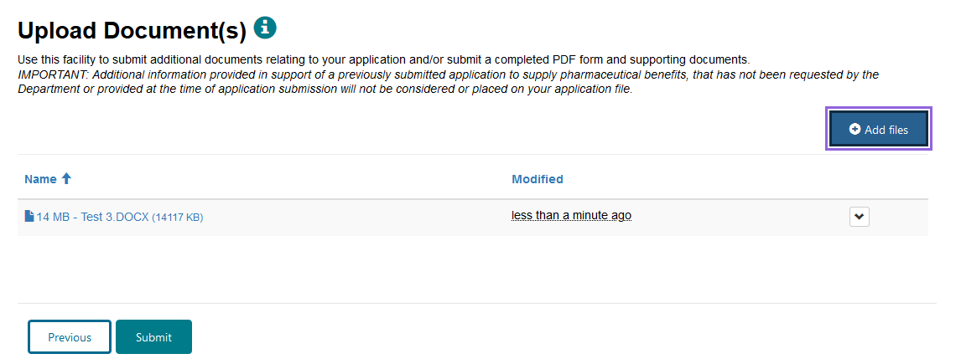
- If you need to delete an uploaded file, click on adjacent to that file name, and click on delete.
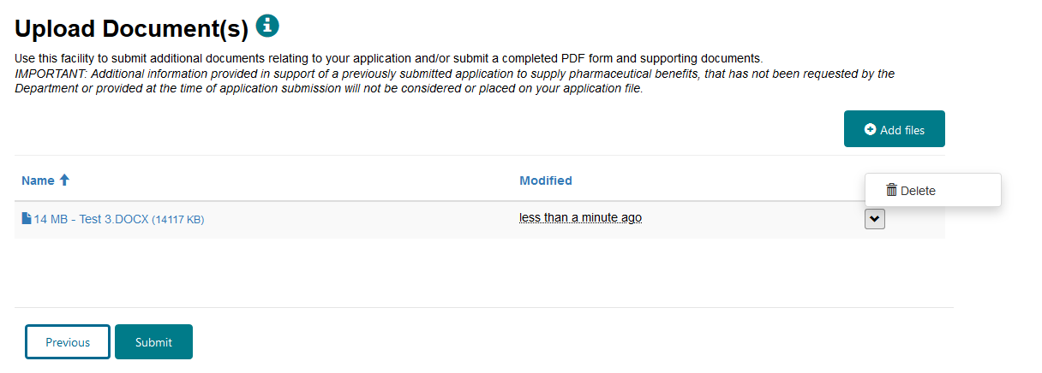
- Once you have uploaded your documents, click on ‘Submit’. The following notice will be displayed:
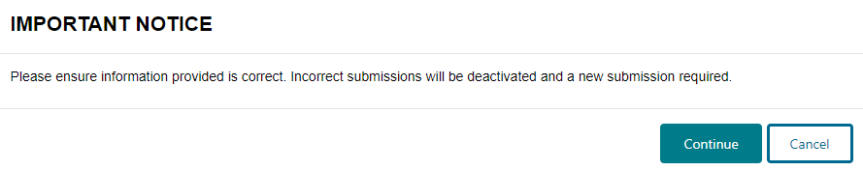
- If you are ready to submit your uploaded documents, click on ‘Continue’.
After you click on ‘Continue’, you will receive acknowledgement that your submission has been sent successfully.
If you are signed in, you will see the following acknowledgement screen and be able to view and monitor progress of your submission from My Dashboard/Uploaded Documents:
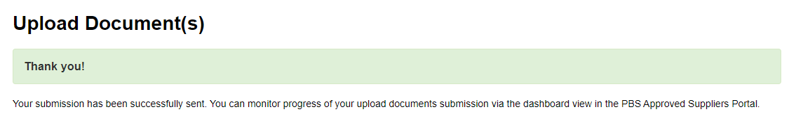
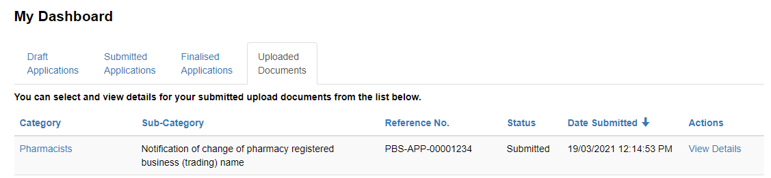
If you click on ‘View Details’, you will be able to view the following details:
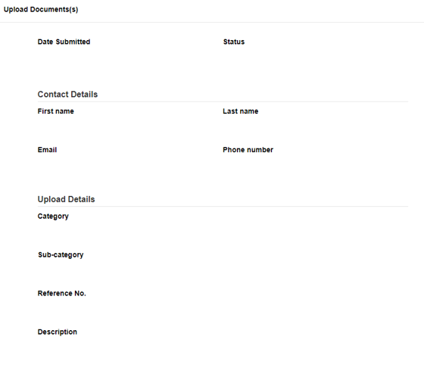
If you are not signed in, you will see the following acknowledgement screen and receive email confirmation of your submission.
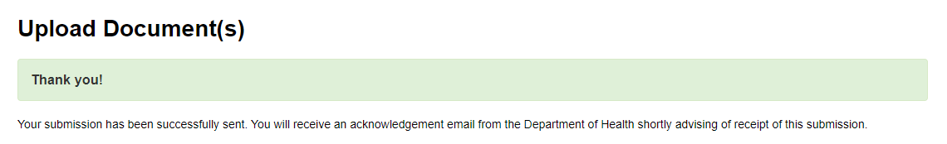

Contact us
If you have any questions about using the PBS Approved Suppliers Portal, PDF forms or Upload Document(s) function, please send an email with details of your enquiry to PBSApprovedSuppliers@health.gov.au, quoting the PBS tracking number, Application number, Approval number or Provider number (as applicable).

