PBS Approved Suppliers Portal
  - How to submit an application to relocate (with a change of ownership) an approved pharmacy
Contents
1) Purpose of this guide 4
2) When to use this online form 4
3) Pharmacy Location Rules – Applicant’s Handbook 4
4) Accessing the Portal 4
5) Applying for Approval 7
a) Continue an application in progress 7
b) Start a new application 7
6) Completing an application 8
a) Select the Pharmacy Location Rules item number 9
b) Select exemption being claimed (if applicable) 9
c) Provide applicant(s) details 10
d) Add an applicant pharmacist 11
e) Add an applicant organisation 13
f) Add an authorised person for an organisation 14
g) Provide details of a contact nominee for this application 15
h) Provide details of the proposed premises 16
i) How to attach documents 17
j) How to remove documents 20
k) Attach supporting documents 21
Attach applicant(s) documents 22
Attach Pharmacy Location Rules – Item Documents 22
Attach other documents 23
7) Provide payer details 25
8) Before progressing to the declarations section 26
9) Declarations 26
a) Sole applicant or authorised person submitting the application yourself 27
b) Attach the current owner(s) declaration form 27
c) Attach the Appointment of a representative form 28
d) Attach the Current Owner(s) Declaration form 29
e) Make the declaration 30
10) Submitting your application 30
11) Issue of an invoice for the application fee 32
12) Payment of the application fee upon submission 32
a) Credit card - EasyPay 32
b) EFT or BPAY 34
c) If the invoice is not generated upon submission 35
13) Download or pay an invoice from ‘My Dashboard’ 35
14) Tracking the status of a payment 36
15) Non-payment of an invoice 36
16) Resubmitting a returned application 36
17) If you need to contact us 37

Purpose of this guide
This guide provides instructions on how to navigate the PBS Approved Suppliers Portal (Portal), complete the online application form and submit an application to relocate (with a change of ownership) an approved pharmacy to supply pharmaceutical benefits at particular premises.
Note: The documents, Guides and forms referred to in this guide are available in the ‘Resources’ section of the PBS Approved Suppliers website.

When to use this online form
Use the online form Application for approval to relocate (with change of ownership) an approved pharmacy supplying pharmaceutical benefits if you are applying for such approval under section 90 of the National Health Act 1953.

Pharmacy Location Rules – Applicant’s Handbook
Refer to the Pharmacy Location Rules – Applicant’s Handbook before completing this form. The Applicant’s Handbook provides information about the Pharmacy Location Rules and what types of documentation must be attached when submitting this form.
If you are a first time user of the Portal, please refer to the guide – How to register and sign in to the PBS Approved Suppliers Portal.

Accessing the Portal
- Type https://pbsapprovedsuppliers.health.gov.au into your browser. The preferred browsers are Google Chrome or Firefox.
- Select the top right Sign in option; the green Sign in button will then display.
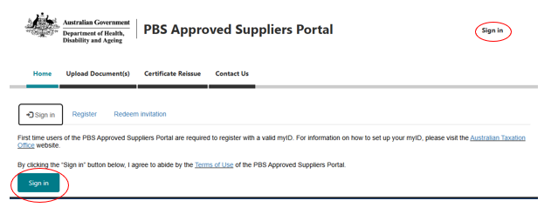
- Selecting ‘Sign in’ will take you directly to the myID code authentication screen where you will be required to login with your myID and accept or enter the unique authentication code into your smart device.
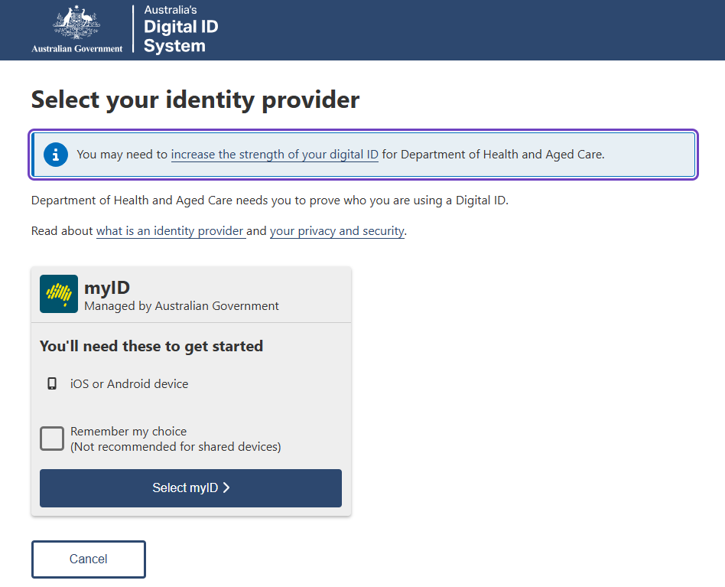
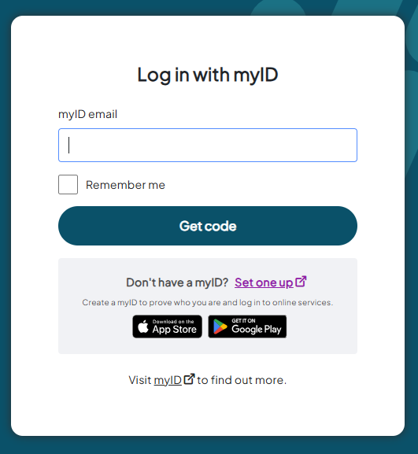
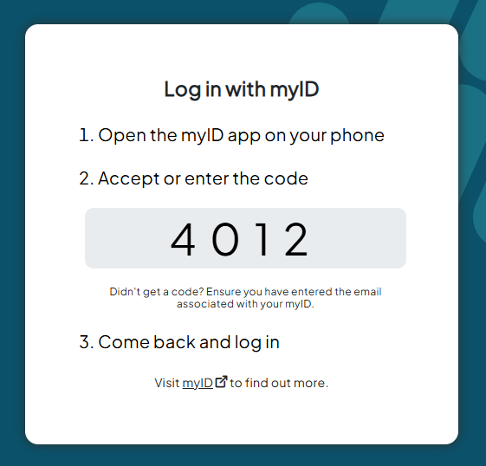
- Entering the unique authentication code on your myID app will take you to your Portal Home screen:
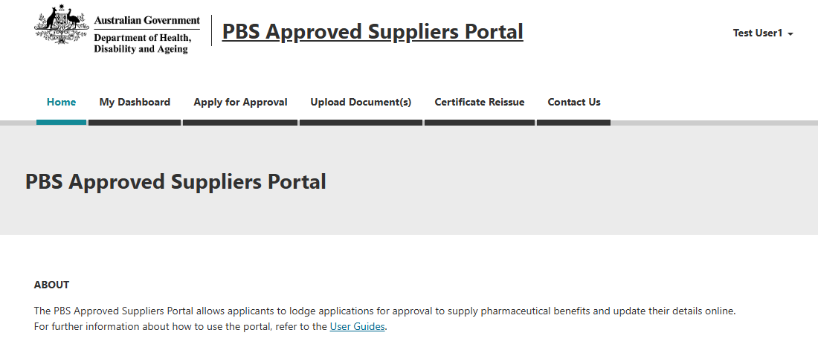
You can select one of the following options by clicking on the tabs in the navigation bar located across the top of the screen:
- My Dashboard
- Apply for Approval
- Upload Document(s)
- Certificate Reissue
- Contact Us
- FAQ
When you select ‘My Dashboard’ from the navigation bar, the following screen will be displayed:
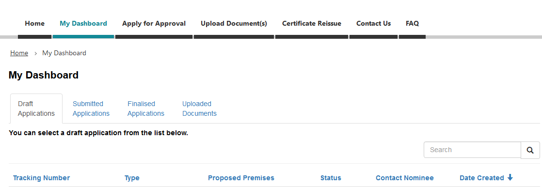
By selecting the relevant tab from ‘My Dashboard’, you can continue to work on draft or view submitted and finalised applications. You can also view a list and check the status of any documents you may have uploaded via ‘Upload Document(s)’.

Applying for Approval

Continue an application in progress
- To continue working on a draft application, click on the relevant tracking number from the ‘Draft Applications’ tab.

Start a new application
- To start a new application, select ‘Apply for Approval’ from the navigation bar or the Home screen.
The following screen will be displayed:
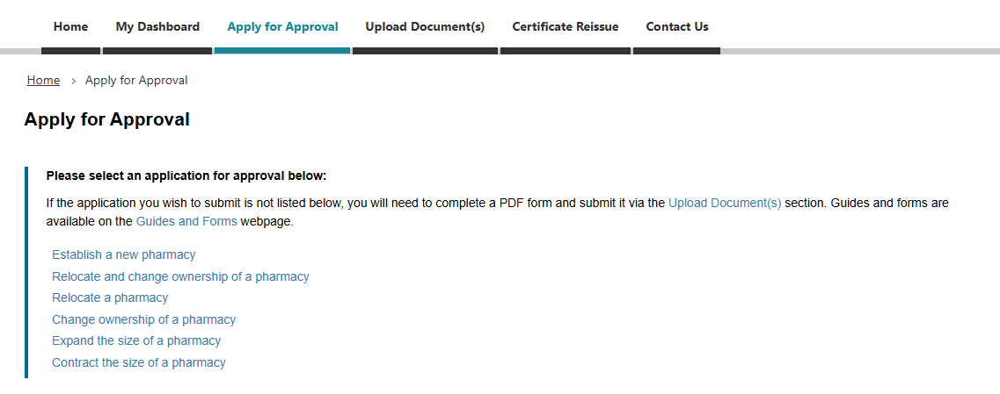
- Select ‘Relocate and change ownership of a pharmacy’.
After you select you application type, the following screen will be displayed:
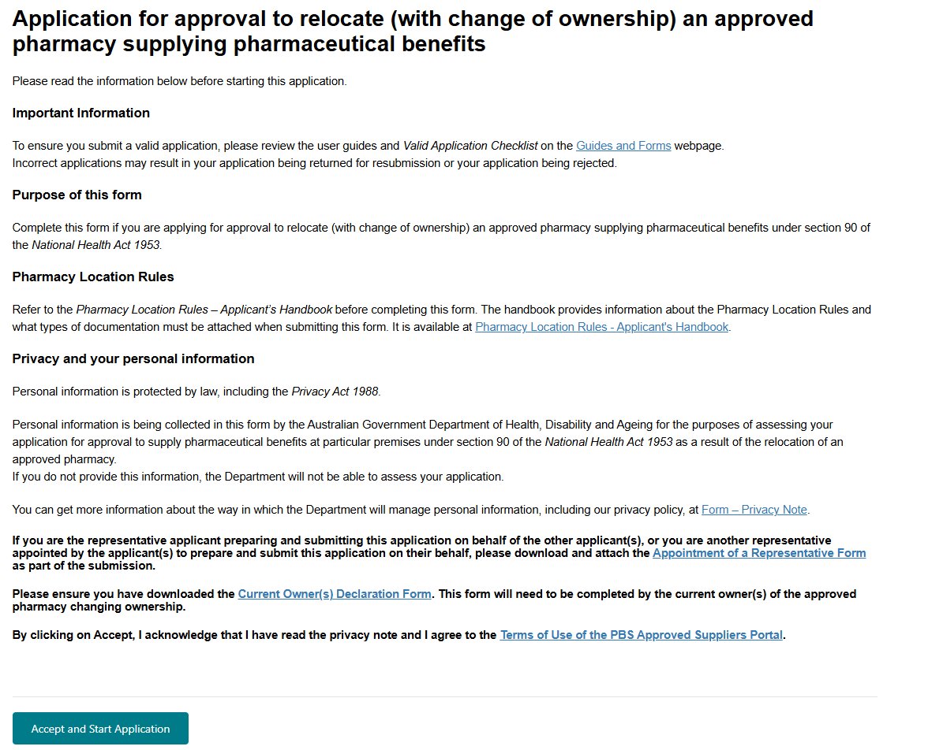
Please read the information contained in this screen to ensure you have selected the correct application type.
Ensure you have downloaded the Current owner(s) declaration form.
If you are submitting the application on behalf of the applicant(s) or multiple authorised person(s), ensure you have downloaded the Appointment of a representative to prepare and submit an application form.
Refer to the Valid Application Checklist for information about what constitutes a valid application.
Read the privacy note and accept the Terms of Use
- By clicking on Accept and Start Application, you acknowledge that you have read the privacy note and agree to abide by the Terms of Use of the PBS Approved Suppliers Portal.
- To proceed, click on: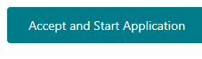

Completing an application
After you click on the ‘Accept and Start Application’ button, the following screen will be displayed:
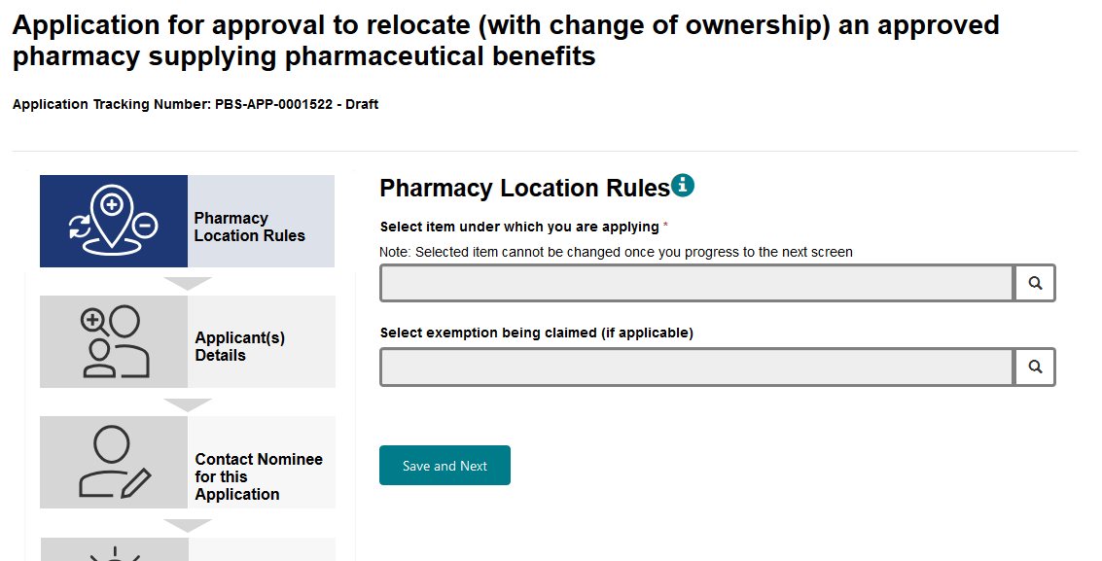
- To display a list of Pharmacy Location Rules item numbers relevant to a relocation application, click on the search icon

Select the Pharmacy Location Rules item number
After you click on the search icon, the following selection box will be displayed:
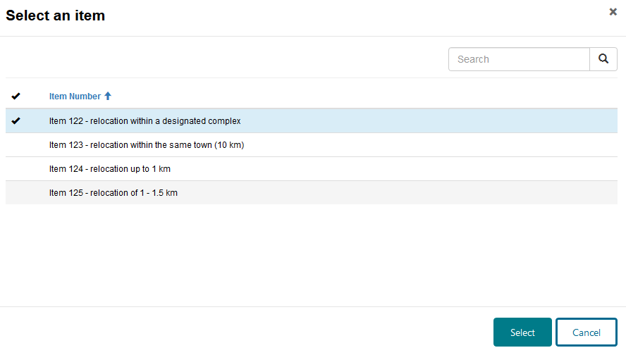
If the item of the Pharmacy Location Rules under which you wish to apply is not listed, you have selected the wrong application type from the Apply for Approval screen. You will need to click on the ‘Cancel’ button and navigate back to the Apply for Approval screen to select the correct application type.
- Highlight the relevant item number and click on the ‘Select’ button.
You will be returned to the Pharmacy Location Rules screen and your selected item will be displayed.
Check the Pharmacy Location Rule item number you have selected is correct because it cannot be changed once you continue to the next section. If you need to change the item number after you have moved to the next section, you will need to start a new application from the Apply for Approval screen.

Select exemption being claimed (if applicable)
On the date an application is made, one or more approvals in respect of the existing approved premises must have been in force for at least five years. If not, you must select the exemption being claimed.
- If you are claiming an exemption you can make your selection by clicking on the search icon for that field
After you click on the search icon, the following selection box will be displayed:
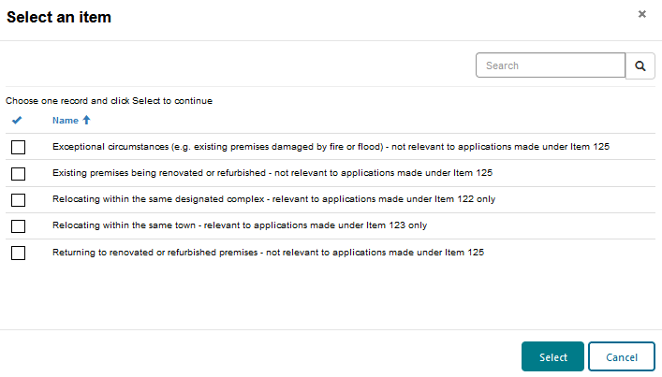
- Highlight the exemption being claimed and click on the ‘Select’ button.
- You will be returned to the Pharmacy Location Rules screen and your selected exemption will be displayed.
- To continue, click on

Provide applicant(s) details
After you click on the ‘Save and Next’ button, the following screen will be displayed.
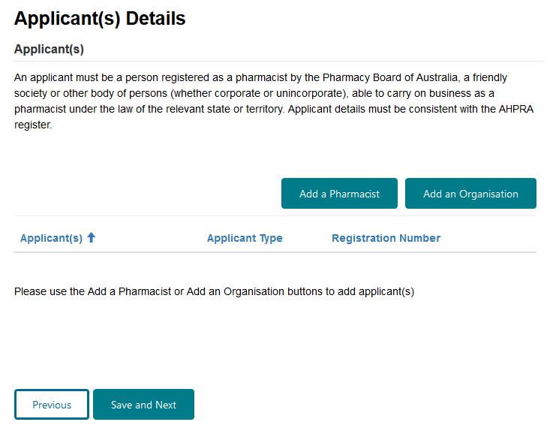
For applications involving a change of ownership, the applicant(s) must include all of the intended owners, for example, all incoming owners and if applicable, any current owners who are remaining as owners.
An applicant must be a person registered as a pharmacist by the Pharmacy Board of Australia, a friendly society or other body of persons (whether corporate or unincorporate), able to carry on business as a pharmacist under the law of the relevant state or territory.
An applicant can be an individual pharmacist or an organisation (i.e. company or friendly society).
The names of the applicant(s) must be consistent with the details that you provide to the relevant state or territory pharmacy approval authority when seeking approval to operate a pharmacy business at the proposed premises (with the exception of references to trusts on the state or territory approval).
If an applicant is an organisation, person(s) officially associated with that organisation must be added as authorised persons (refer to the Add an authorised person for an organisation section of this guide).
An authorised person for an organisation should not be added as an individual applicant pharmacist unless that person is applying for approval in his or her own right in addition to the organisation.
Each individual applicant pharmacist must be qualified to provide pharmacy services and details provided must be consistent with the AHPRA register.
If the applicant is a company, at least one authorised person for the company must be qualified to provide pharmacy services, and the details provided must be consistent with the AHPRA register.
Note that this does not apply if the applicant is a Friendly Society.
If an application involves bringing in a partner by selling a share of the pharmacy business, the current owner(s) must be listed in the current owner(s) declaration form as current owner(s) and in the application as applicant(s). Current owner(s) details must be consistent with the existing pharmacy approval.

Add an applicant pharmacist
- To add an individual applicant pharmacist, select 
The following dialogue box will be displayed:
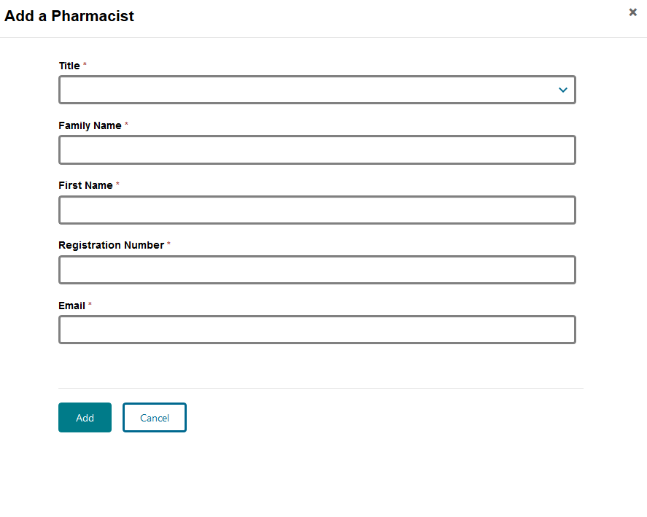
- Complete the pharmacist’s details.
- To save the pharmacist’s details, click on the ‘Add’ button.
You will be returned to the Applicant(s) Details screen and the applicant will be added to the application.
- If you do not want to save the pharmacist’s details, click on 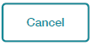
- You will be returned to the Applicant(s) Details screen and the applicant will not be added to the application.

Add an applicant organisation
- To add an applicant organisation, click on 
The following screen will be displayed:
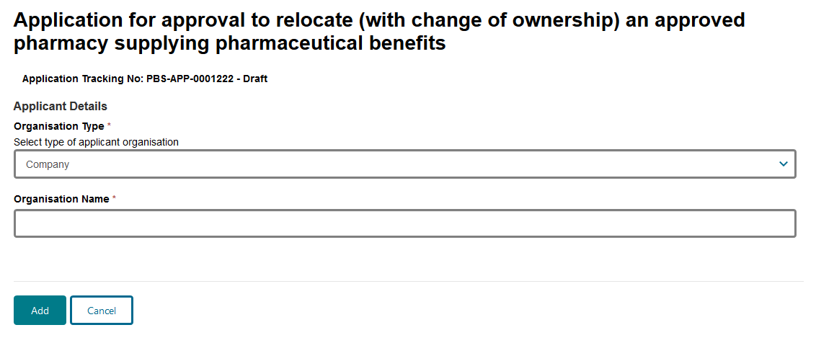
Click on  to display a list of organisation types.
The following screen will be displayed:
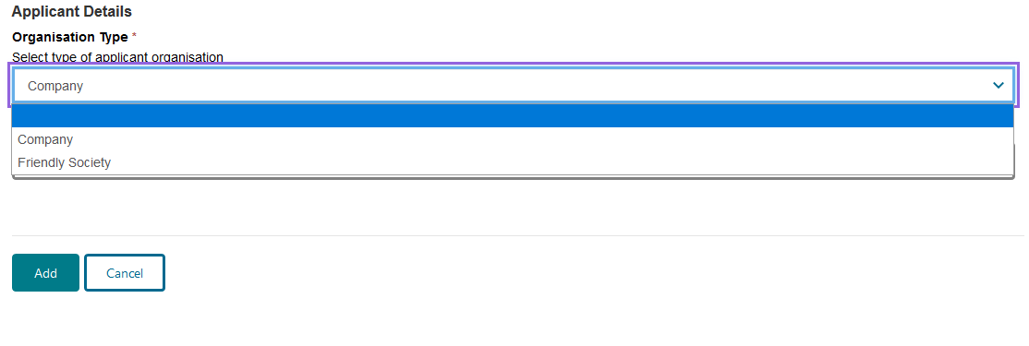
- Highlight the relevant organisation type, enter the organisation name and then click on the ‘Add’ button.

Add an authorised person for an organisation
After you click on the ‘Add’ button, the following will be displayed:
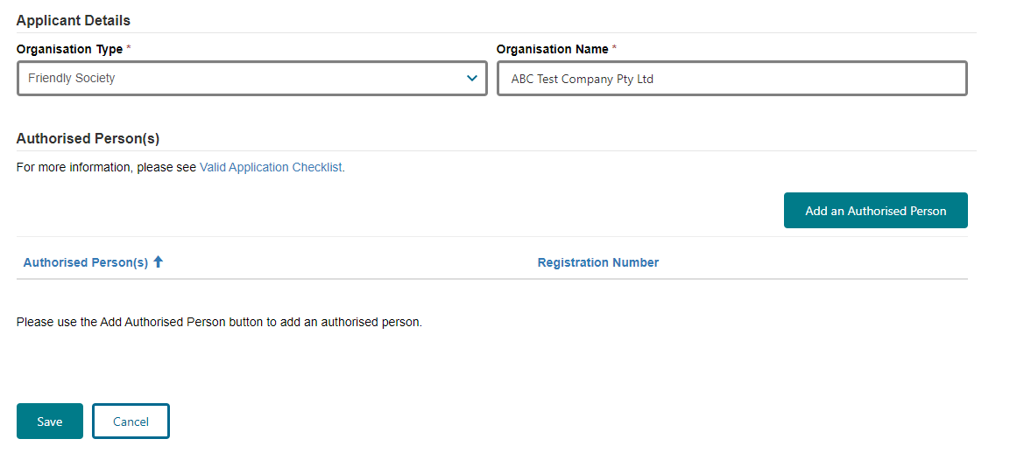
- To add an authorised person for the organisation, click on the ‘Add an Authorised Person’ button.
If an applicant is an organisation, person(s) officially associated with that organisation must be added to the application as authorised persons, for example:
- If the applicant is a company, all the director(s) must be added as authorised person(s). At least one authorised person for each company must be qualified to provide pharmacy services, and details provided must be consistent with the AHPRA register.
- If the applicant is a friendly society, all the board member(s) or directors and the secretary must be added as authorised person(s).
- You must provide details of all authorised person(s) for the organisation and these details must accord with documentary evidence (e.g. ASIC extract that lists the directors of the company and/or official list of friendly society board members) requested later in the application.
After you click on the ‘Add Authorised Person’ button, the following screen will be displayed.
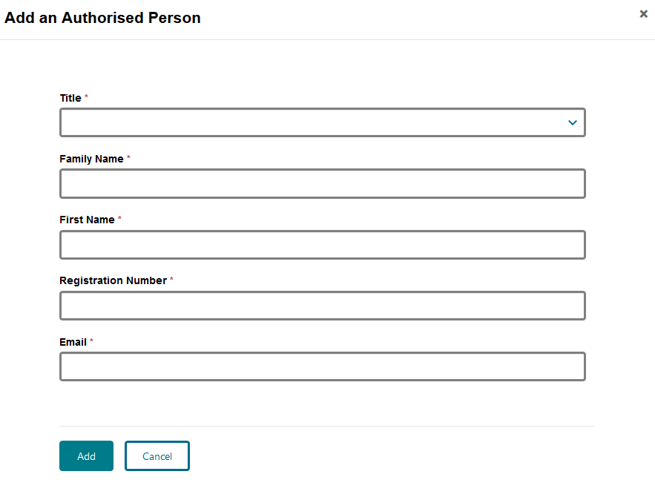
- Complete the mandatory fields and click on the ‘Add’ button.
- Once all authorised person(s) have been added for the organisation, click 
- To edit or remove an applicant from the Applicant(s) Details screen, select adjacent to the relevant applicant’s name and you will be given the option to edit or remove the applicant and/or authorised person from the application.
- To continue, click:

Provide details of a contact nominee for this application
After you click on the ‘Save and Next’ button, the Contact Nominee for this Application section will be displayed. This section is for you to provide details of either an applicant or other nominated person who is permitted to act on behalf of the applicant(s) on all matters relating to the application.
This section will default to the signed-in user; however, you are able to edit the fields if the contact nominee for the application is someone other than the signed-in user.
- Ensure all mandatory fields are completed and click:

Provide details of the proposed premises
After you click on the ‘Save and Next’ button, the Proposed Premises section will be displayed. This section is for you to provide details of the pharmacy business name and address of the proposed premises and the anticipated settlement/opening date.
The anticipated settlement/opening date cannot be in the past, today or on a weekend or ACT public holiday.
Please allow 5 business days between the ACPA meeting at which the application will be considered and the proposed opening date.
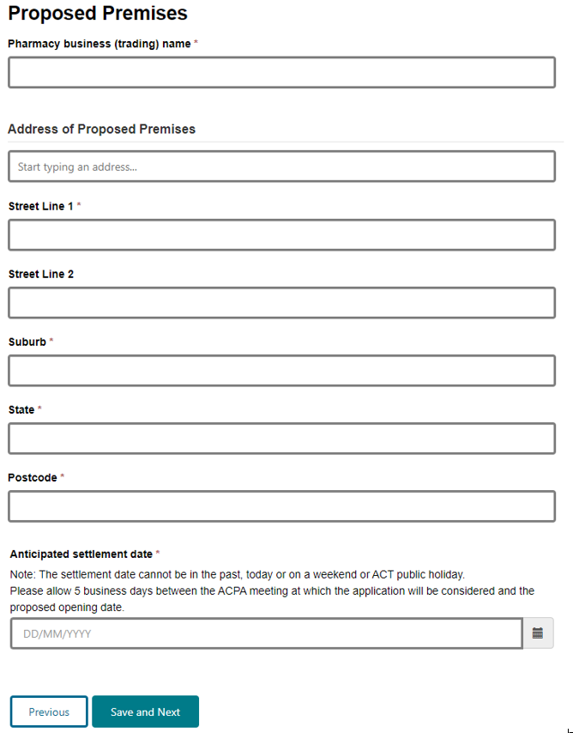
- Ensure mandatory fields are completed. If the correct address does not populate when you start typing the address of the proposed premises, enter the full and correct address manually, including the shop or tenancy number (if applicable) and the street number, in the ‘Street Line 1’ field.
- To continue, click:

How to attach documents
Please do not submit documents that are password protected.
- For each mandatory document listed at the Supporting Documents section, you will need to click on the arrow adjacent to the applicant or document name and then click on ‘Attach’. (The following screen is provided as an example only.)
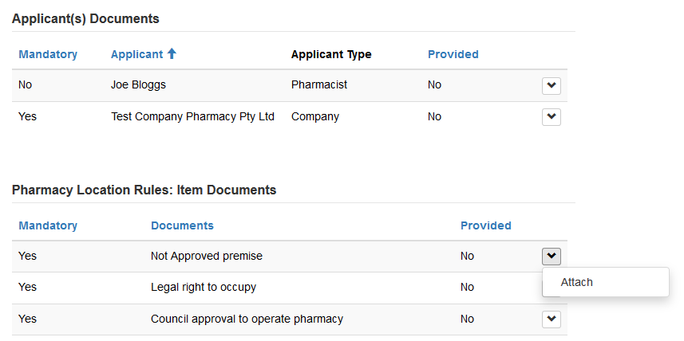
- After you click on ‘Attach’, the following screen will be displayed:
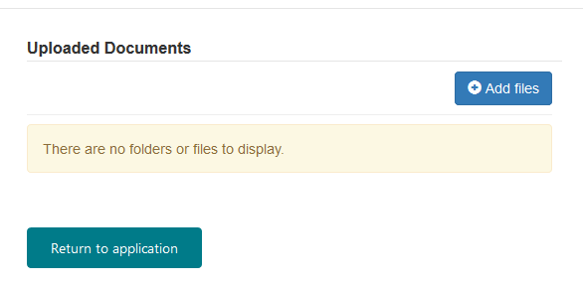
- Click on the ‘Add files’ button.
- Add file(s) by clicking on the ‘Browse’ or ‘Choose Files’ button (depending on your browser).
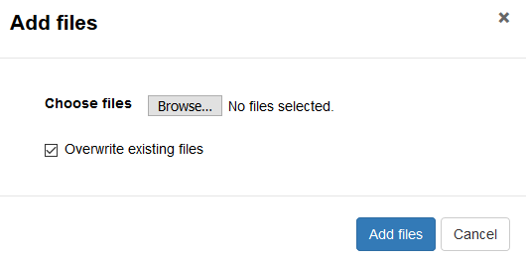
The ‘Overwrite existing files’ checkbox defaults to selected. If you do not wish to overwrite a file of the same name already uploaded, ensure you uncheck this box before adding files.
You can attach multiple files at a time and you can upload as many times as required, but each upload must be less than 50 MB (i.e. if you are uploading a single file, its size must be less than 50 MB; if you are uploading multiple files at once, their combined size must be less than 50 MB).
If you attempt an upload that is more than 50 MB you will receive an error message. To continue, click on the ‘Cancel’ button and then ‘Return to Application’ before trying again with an upload that is less than 50 MB.
- Double-click or open the selected file(s). The following screen will then display the file name (or number of files if more than one):
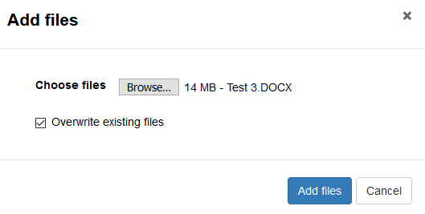
- Click on the ‘Add files’ button once more to complete the upload.
- Your uploaded documents will be listed on the following screen:
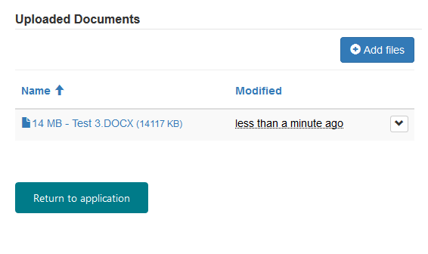
- When you have added all the relevant files, click on the ‘Return to application’ button.
- You will be returned to the Supporting Documents screen. The Provided column will show ‘Yes’ against each item when the documents have been attached. (The following screen is provided as an example only.)
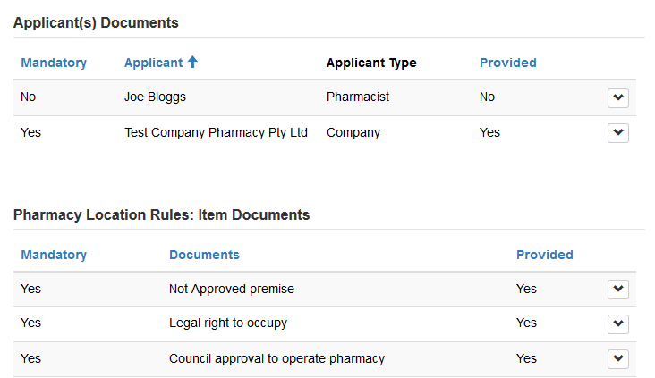

How to remove documents
- Click on the arrow adjacent to the applicant or document name for which you wish to remove a document and then click on ‘Edit’.
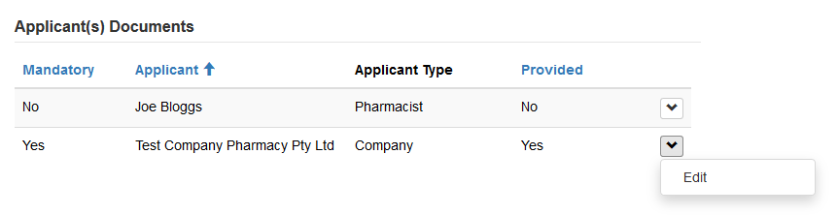
- Click on the arrow adjacent to the relevant file name and then click on ‘Delete’.
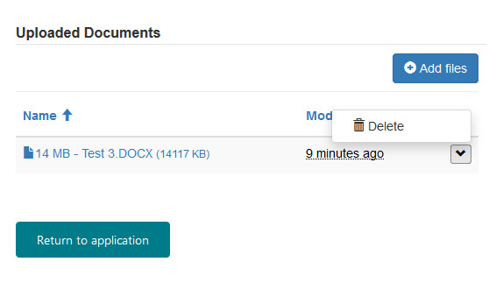
- Check and confirm that you want to delete the selected file by clicking on the ‘Delete’ button.
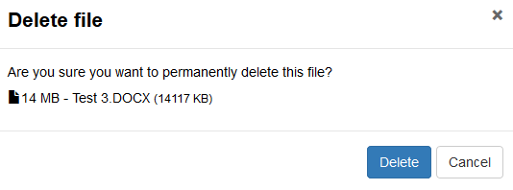
- After the file has been deleted, it will no longer be listed on the following screen:
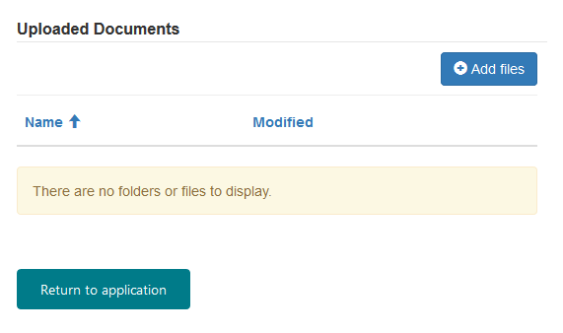
- Click on the ‘Return to application’ button. You will be returned to the Supporting Documents screen, and the Provided column will revert to ‘No’ against the item for which the document has been deleted.
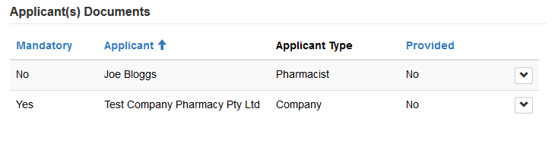

Attach supporting documents
After you click on the ‘Save and Next’ button from the Proposed Premises screen, the Supporting Documents section will be displayed. This section requires you to attach documentation to support your application.
For instructions on how to attach documents, refer to the How to attach documents section of this guide.
The Portal will request supporting documents based on your previous selections (i.e. applicant type and item number).
The screen below is an example of what you might see depending on your selections.
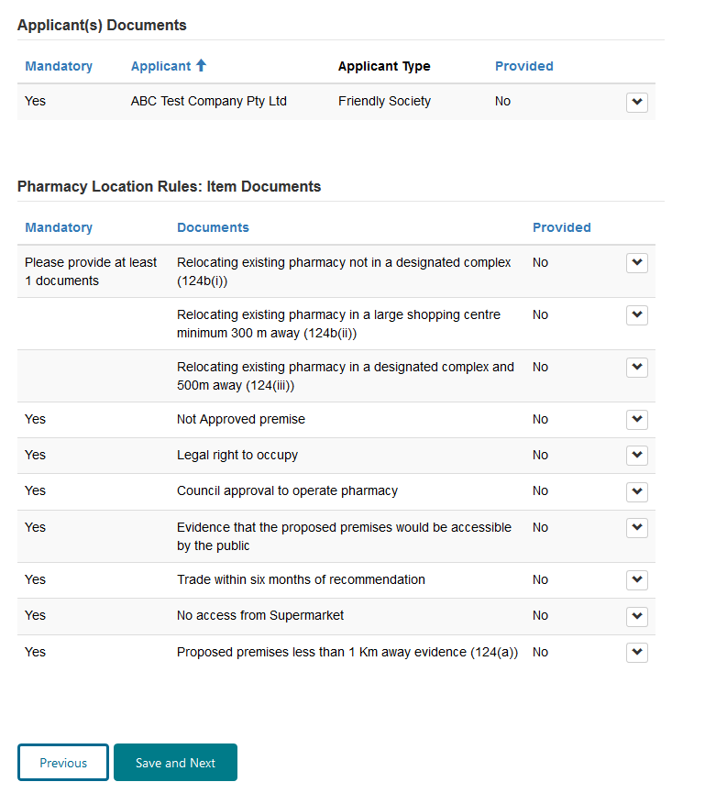

Attach applicant(s) documents
If an applicant is a company, you must attach evidence confirming the authority of the authorised person(s) to act on behalf of the applicant (e.g. a recent ASIC company extract that lists the Directors of the company).
If an applicant is a friendly society, you must attach an official document listing all board members and the secretary, or a recent ASIC company extract that lists the Directors and company secretary.

Attach Pharmacy Location Rules – Item Documents
The Pharmacy Location Rules require documentary evidence for the item under which you are applying. Refer to the Pharmacy Location Rules – Applicant’s Handbook before completing this form. The Applicant’s Handbook provides information about the Pharmacy Location Rules and what types of documentation must be attached when submitting this form.
Attach evidence for each mandatory document listed. Care should be taken to ensure consistency is maintained across submitted evidence for issues such as applicant(s) names and addresses of premises that may appear on several pieces of evidence.
If the same documentary evidence pertains to several mandatory documents, you should attach that evidence in each applicable instance.
You will not be able to progress to the next section until all mandatory documents have been attached. You may need to use the scroll bar at the right of the screen to see all mandatory documents.
When you have attached all your documents and are ready to continue, click:

Attach other documents
After you click on the ‘Save and Next’ button, the Other Documents section will be displayed. This section is for you to attach any other documents relevant to your application not already attached.
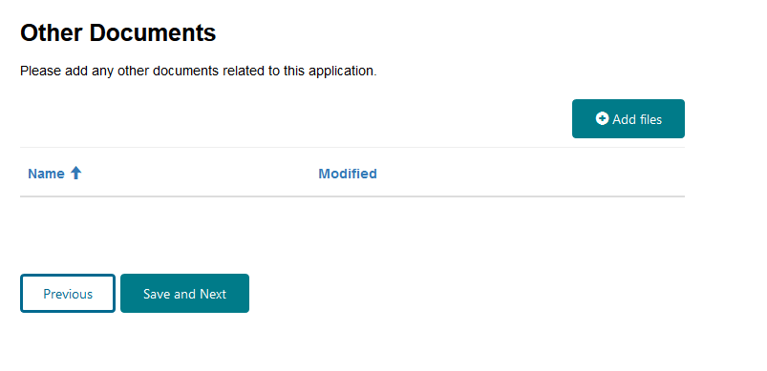
- If you do not need to attach other documents to your application, simply click on the ‘Save and Next’ button.
- If you do need to attach other documents to your application, click on the ‘Add files’ button and then follow the relevant steps provided in the How to attach documents section of this guide.
When you have attached other documents, you will be returned to the Other Documents section and the documents you have added will be listed.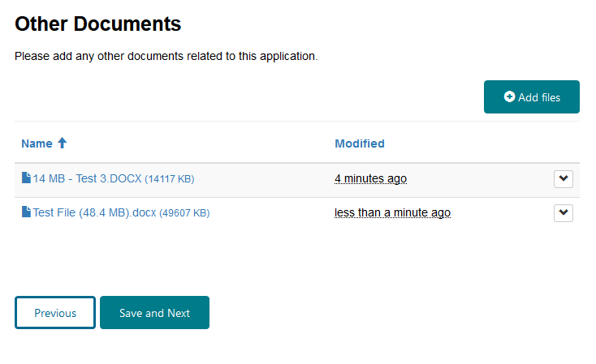
- When you have finished adding your other documents, click on the ‘Save and Next’ button.

Provide payer details
After you click on the ‘Save and Next’ button, the following screen will be displayed.
When you search on a valid ABN, the form will auto-populate the organisation name linked to that ABN.
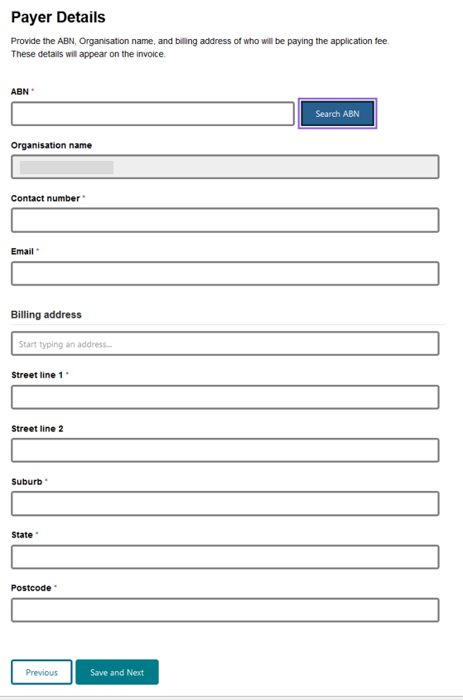
- Ensure all mandatory fields are completed and then click on the ‘Save and Next’ button.

Before progressing to the declarations section
After you click on the ‘Save and Next’ button, the following notice will be displayed:
No changes to the information you have provided in this application will be permitted once you click ‘Continue’.
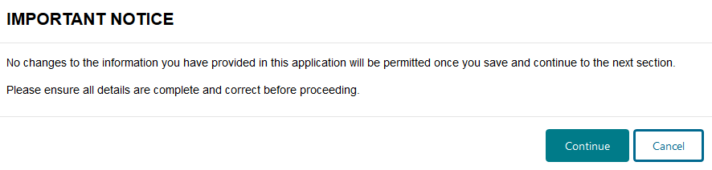
- When you are ready to proceed to the ‘Declarations’ section, click: 

Declarations
After you click on the ‘Continue’ button, the following Declarations screen will be displayed. 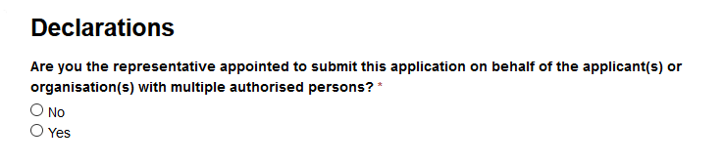
If you are the sole applicant/authorised person, you can choose to submit the application yourself or you can appoint a representative to submit the application on your behalf.
If there are multiple applicants and/or authorised persons for an organisation, you must appoint a representative to submit the application on behalf of all applicants and/or authorised persons.
The appointed representative can be one of the applicants or the contact nominee named in the application, or another person appointed by the applicant(s)/authorised person(s), but the appointed representative must be the person who is submitting the application via the Portal.

Sole applicant or authorised person submitting the application yourself
- If you are the sole applicant/authorised person named in the application, and you are submitting the application yourself, click on the ‘No’ button.
After you click on the ‘No’ button, the following will be displayed:
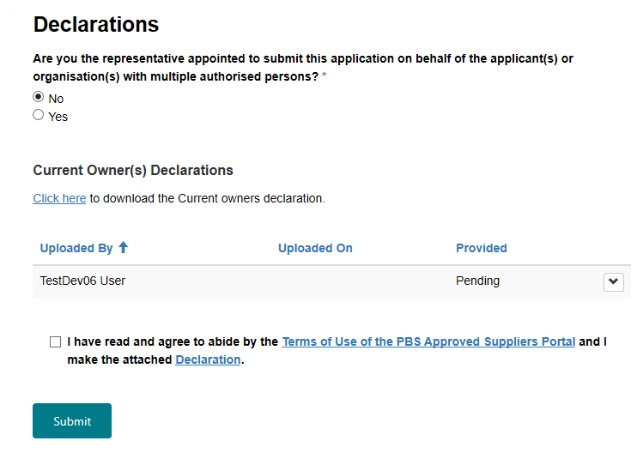

Attach the current owner(s) declaration form
- Attach the Current Owner(s) Declaration to the application by clicking on the and then clicking on ‘Attach’.
- After you click on ‘Attach’, the following screen will be displayed:
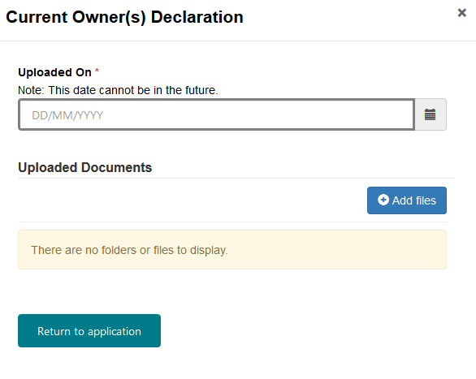
- Enter the date the Current Owner(s) Declaration was uploaded.
- Click on the ‘Add files’ button.
- Attach the Current Owner(s) Declaration by following the relevant steps provided at the How to attach documents section of this guide.
- When you have uploaded the form, click on the ‘Return to application’ button.
- You will be returned to the Declarations screen, and the Provided column will show that the Current Owner(s) Declaration has been provided.
You must attach the Current owner(s) declaration form to the application.
The Current Owners(s) Declaration form must be signed by all current owner(s).

Appointed representative submitting the application on behalf of the applicant(s)
- If you are the appointed representative preparing and submitting the application on behalf of the applicant(s)/authorised person(s), click on the ‘Yes’ button.
After you click on the ‘Yes’ button, the following screen will be displayed:
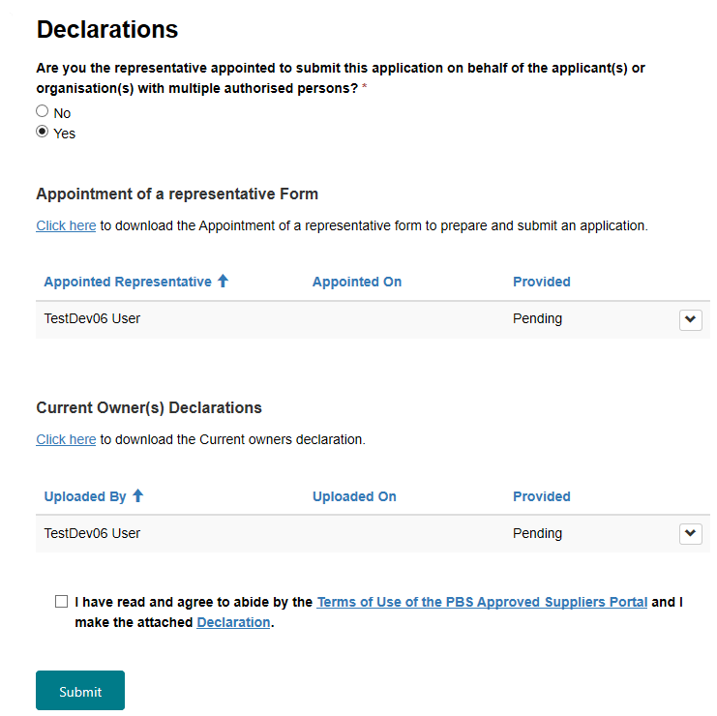

Attach the Appointment of a representative form
- Attach the appointment of a representative form to the application by clicking on and then clicking on ‘Attach’.
After you click on ‘Attach’, the following screen will be displayed: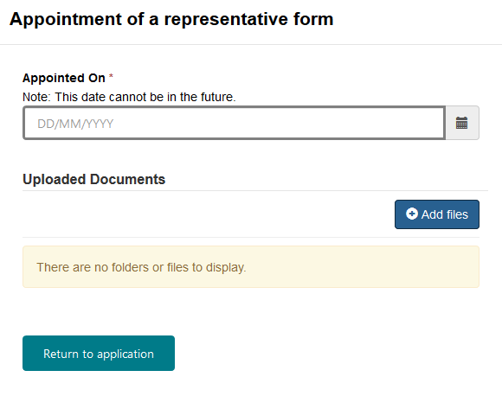
- Enter the date appointed.
- Click on the ‘Add files’ button.
- Attach the appointment of representative form by following the relevant steps provided at the How to attach documents section of this guide.
- When you have uploaded the form, click on the ‘Return to application’ button.
- You will be returned to the Declarations screen, and the Provided column will show that the appointment of a representative form has been provided.
If you are the appointed representative submitting this form on behalf of the applicant(s)/authorised person(s), you must attach the Appointment of a representative to prepare and submit an application form to the application.
The appointment of a representative form must be signed by all applicants and/or all authorised persons for an organisation.

Attach the Current Owner(s) Declaration form
- Attach the Current Owner(s) Declaration to the application by clicking on the and then clicking on ‘Attach’.
After you click on ‘Attach’, the following screen will be displayed:
- Enter the date the Current Owner(s) Declaration was uploaded.
- Click on the ‘Add files’ button.
- Attach the Current Owner(s) Declaration by following the relevant steps provided at the How to attach documents section of this guide.
- When you have uploaded the form, click on the ‘Return to application’ button.
- You will be returned to the Declarations screen, and the Provided column will show that the Current Owner(s) Declaration has been provided.
You must attach the Current owner(s) declaration form to the application.
The Current Owners(s) Declaration form must be signed by all current owner(s).

Make the declaration
- Review the ‘Terms of Use of the PBS Approved Suppliers Portal’ and the ‘Declaration’ by clicking on the relevant link.
- To proceed, you must check the box to:
- confirm your agreement to abide by the ‘Terms of Use of the PBS Approved Suppliers Portal’; and
- make the Declaration.

Submitting your application
- When you are ready to submit your application, click on:
You will not be able to submit the application until you have attached the appointment of a representative form (if applicable) and current owner(s) declaration and checked the box to confirm that you agree to abide by the Terms of Use of the PBS Approved Suppliers Portal and make the Declaration.
Review confirmation of successfully submitted application
After you click on the ‘Submit’ button, the following screen will be displayed when your application has been successfully submitted:
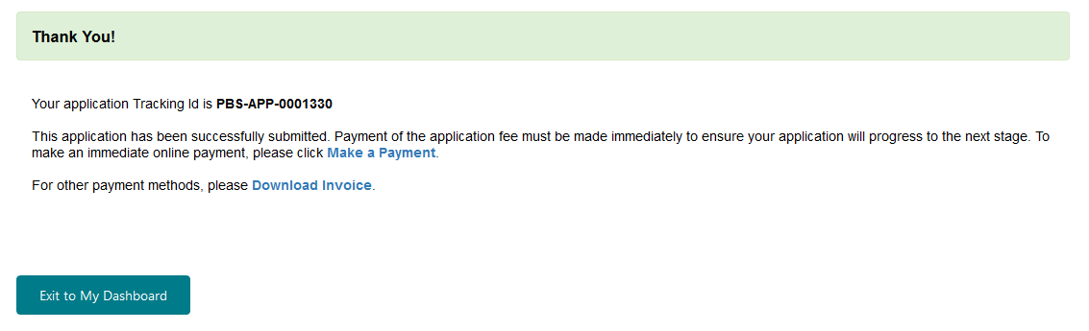
Take note of the application Tracking ID number
- Please take note of the application Tracking ID number, which you can use to identify and review the status of your application on your Dashboard. If you need to make an enquiry about your application, please quote the application Tracking ID number.
Application Numbers are provided for applications that are referred to the Australian Community Pharmacy Authority and will be issued only if an application has been verified by the department to be a valid application. Once verified, the status of your application will be updated to ‘In progress’ in the Portal and the Application Number will be visible on your Dashboard.

Issue of an invoice for the application fee
When you submit an online application form, in most instances, the invoice will be issued immediately and the following screen will be displayed:
The submission date and time will be recorded as the date and time a valid application is submitted, not when payment is finalised.

Payment of the application fee upon submission

Credit card - EasyPay
- If you wish to make a credit card payment upon submission, click on ‘Make a Payment’ from the above screen.
The Confirm and Pay screen will be displayed: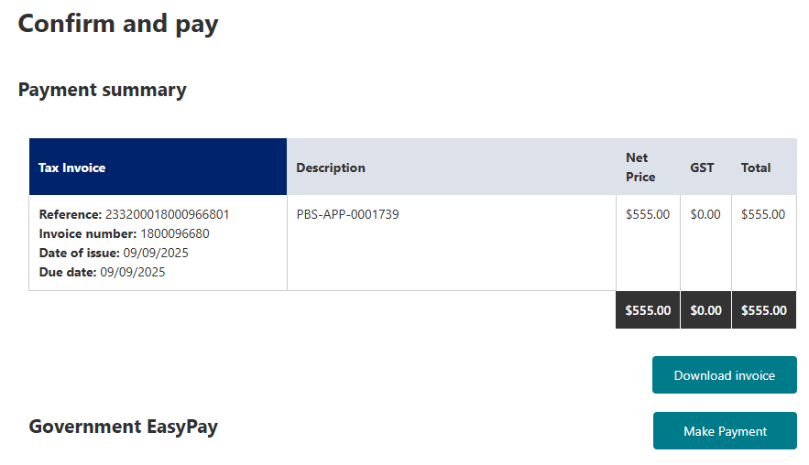
To make the payment, click on: 
You will be taken to the secure ANZ Worldline Payment Solutions shopping cart.
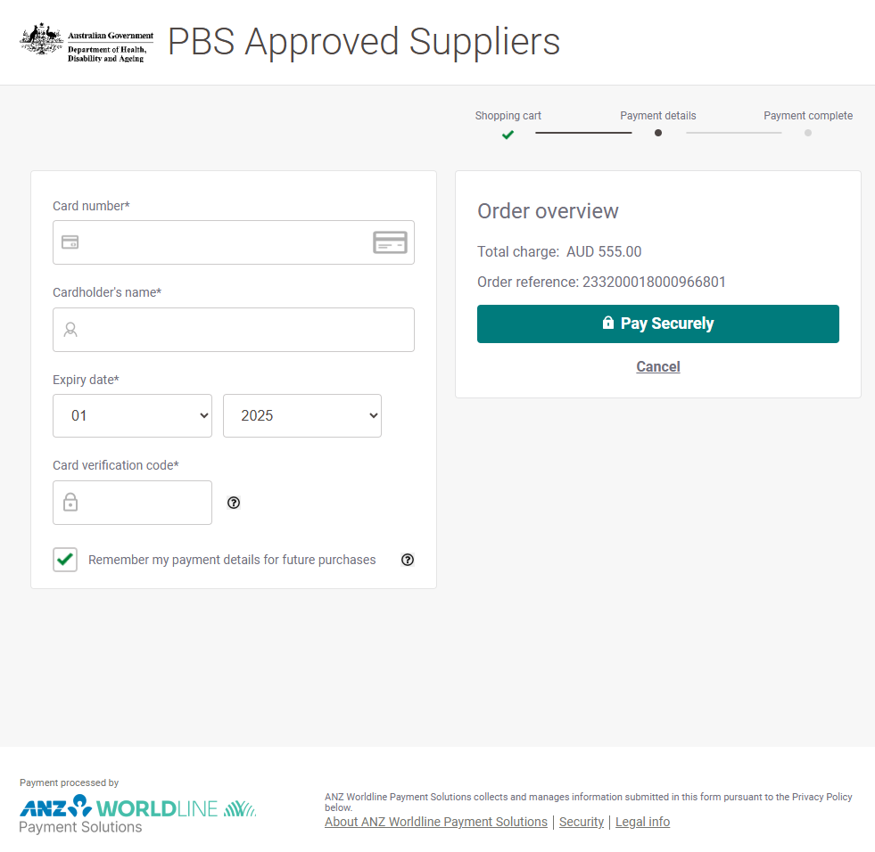
The total charge displayed will be the fee relevant to your application type.
Enter your credit card details
Check the details you have entered are correct and, when ready, click on the ‘Pay Securely’ button.
After you click on the ‘Pay Securely’ button, the following screen will be displayed:
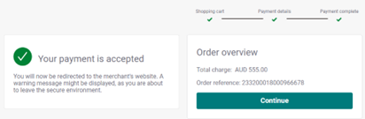
You will then be returned to the Portal, where the Payment summary screen will be displayed:
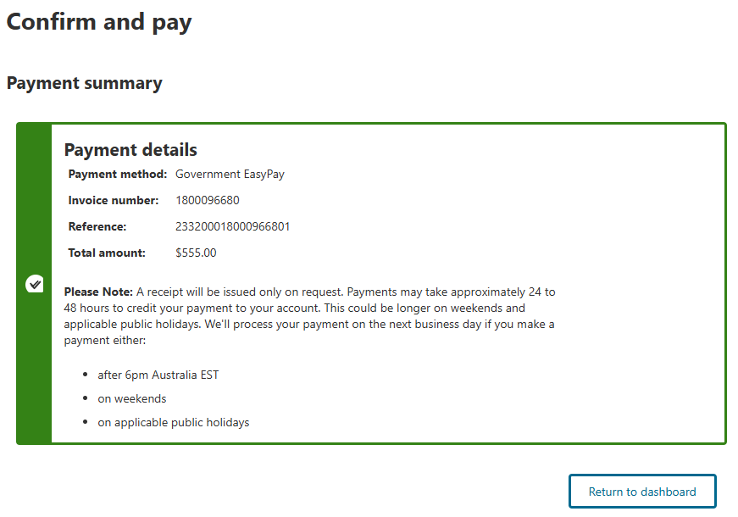
The Payment Status for the application on ‘My Dashboard/Submitted Applications’ will now show as ‘Paid – Waiting confirmation’. (Please note, once you have submitted an online payment, it may take up to 30 minutes for the ‘Payment Status’ to be updated on the Dashboard.)
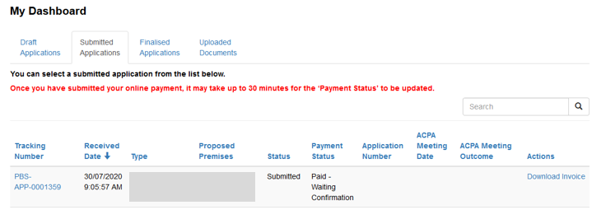

EFT or BPAY
If you wish to make an EFT or BPAY payment upon submission, you can download a PDF of the invoice from the application submitted confirmation screen or exit to ‘My Dashboard’ where download invoice and payment options will also be available. Refer to the Download or pay an invoice from ‘My Dashboard’ section of this guide.
If you choose this payment option, you must make payment immediately to allow for payment to be received and cleared within 7 calendar days of the invoice date. If the department does not receive full payment of the invoice in time for it to be cleared (finalised) within 7 calendar days from the invoice issue date, the application will be cancelled.

If the invoice is not generated upon submission
In some instances, due to timing or connection issues, the invoice will not be generated upon submission and, instead, the following screen will be displayed: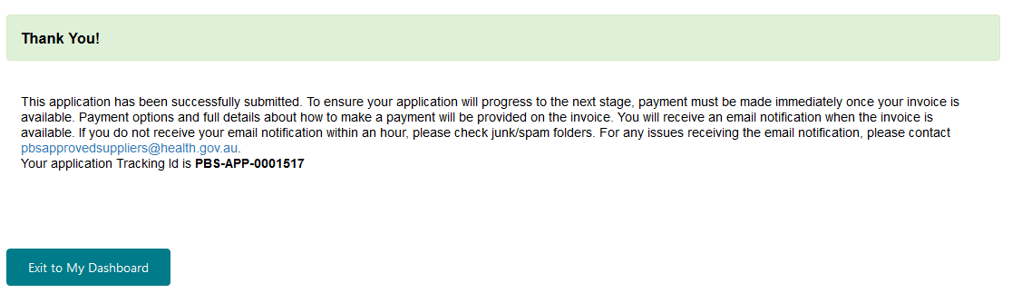
If this occurs, when the invoice has been generated, the application contact nominee (and, if different, the submitter) will receive an email advising that the invoice has been issued and is available in the Portal.

Download or pay an invoice from ‘My Dashboard’
Locate the relevant application tracking number from ‘My Dashboard/Submitted Applications’. Please note, only the person who submitted the application will be able to view the invoice on ‘My Dashboard’.
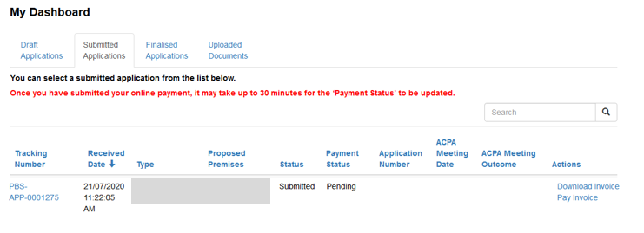
From ‘My Dashboard’, you will have the option of two ‘Actions’, either:
Click on ‘Pay Invoice’ to display the Confirm and Pay screen where you can make an online payment via credit card (refer to the Credit Card section of this guide); or
Click on ‘Download Invoice’ to download and/or save a PDF copy of your invoice for payment via other methods, details of which are provided on the invoice. Payment must be made immediately to avoid the risk of cancellation of the application.

Tracking the status of a payment
You can track the progress of application payments from ‘My Dashboard/Submitted Applications’, which will indicate a status of:
- Pending – will display if payment has not been made
- Paid - Awaiting confirmation – will display when payment via EasyPay has been made but is awaiting clearance
- Paid – will display when payment is finalised
Payment is considered finalised only when the status is Paid.
Please note, once you have submitted an online payment, it may take up to 30 minutes for the ‘Payment Status’ to be updated on the Dashboard.
An invoice for the application fee will require immediate payment to ensure the payment can be finalised by the department within 7 calendar days from the invoice issue date. Delayed payment may result in your application being cancelled.
Please be aware, processing takes longer for EFT and BPAY payments. If you delay making a payment by EFT or BPAY, it is unlikely the payment will be finalised within the 7 day period.

Non-payment of an invoice
If the department does not receive full payment of the invoice in time for it to be finalised within 7 calendar days from the invoice issue date, the application will be cancelled. The application contact nominee will be advised of the cancellation by email. To avoid cancellation of your application, please ensure payment is made immediately.
It is the applicant’s responsibility to ensure the payment is made in time for it to be finalised by the department within 7 calendar days from the invoice issue date; the department will not send a reminder.
Cancelled applications will appear on ‘My Dashboard/Finalised Applications’ with a status of ‘Cancelled’. Once an application and the associated invoice have been cancelled, they cannot be reinstated. If payment is received after the application and invoice have been cancelled, the department will contact you to arrange a refund.

Resubmitting a returned application
If your application has been deemed invalid , it will be returned to the submitter via the Portal.
Refer to the Valid Application Checklist for information about what constitutes a valid application.
The department will send an email to the application contact nominee detailing the reasons why the application has been deemed invalid and returned.
A returned application will be listed with the same tracking number under your Draft Applications on the My Dashboard screen.
Select the relevant application tracking number from your Draft Applications on the My Dashboard screen.
Provide the correct information or documentation as detailed in the email sent to the application contact nominee.
When you are ready to resubmit your application, follow the instructions provided in the Declarations and Submitting your application sections of this guide.
When an application is returned, any attachments and/or information provided at the Declarations section will be deactivated; therefore, you must reattach any documents provided at this section before resubmitting your application.
Resubmitted applications will not incur another fee and will not require payer details to be re-entered.
If your application was returned because of incorrect or missing documents at the Declarations section, ensure you fix the errors or omissions before resubmitting your application. If you do not, the application will be deemed invalid again and returned to you to be corrected and resubmitted.
The submission date and time will be recorded as the date and time the application is resubmitted.

If you need to contact us
If you have any questions about using the Portal or your application, please send an email with details of your enquiry and quoting the application Tracking ID number to PBSApprovedSuppliers@health.gov.au.

