PBS Approved Suppliers Portal
  - How to register and sign into the PBS Approved Suppliers Portal
Contents
1 Purpose of this guide 3
2 Key Information 3
3 If you do not have a myID 3
4 Linking business entities through RAM 3
5 Registering for the PBS Approved Suppliers Portal 4
6 Signing in to the PBS Approved Suppliers Portal with myID 5
7 Relationship Authorisation Manager 7
8 Creating a user profile (once only) 8
9 Invitation Codes 9
10 Linking additional entities to your myID 10

Purpose of this guide
This guide provides instructions on how to:
- Register for access to the PBS Approved Suppliers Portal (Portal).
- Sign in to the Portal using your myID.

Key Information
The Portal is administered by the Department of Health, Disability and Ageing (department).
myID is administered by the Australian Taxation Office (ATO) and is the Australian Government’s digital identity provider that allows you to prove who you are online. It is different to your myGov account.
Relationship Authorisation Manager (RAM) is also administered by the ATO and is an authorisation service that allows you to act on behalf of a business online when linked with your myID. You will use your myID to log into RAM.
See the ATO Online Services website for information on how to set up your myID and RAM.

If you do not have a myID
Information on how to set up myID is available at www.myid.gov.au.
As myID is not administered by the department, the department is unable to assist with enquiries related to myID.

Linking business entities through RAM
A principal authority needs to link to the business in RAM before others can be authorised to access government online services on behalf of the business. Information on how to link business entities through RAM is available at https://info.authorisationmanager.gov.au/
As RAM is not administered by the department, the department is unable to assist with enquiries related to RAM.

Registering for the PBS Approved Suppliers Portal
First-time users of the Portal are required to register with a valid myID. Information on how to set up your myID is available at www.myid.gov.au.
- Open the Portal by typing https://pbsapprovedsuppliers.health.gov.au into your browser. The preferred browsers are Google Chrome or Firefox.
The following screen will be displayed:

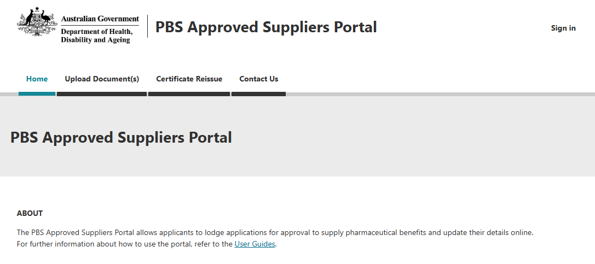
- Click on ‘Sign in’ at the top right hand corner and the following screen will be displayed:
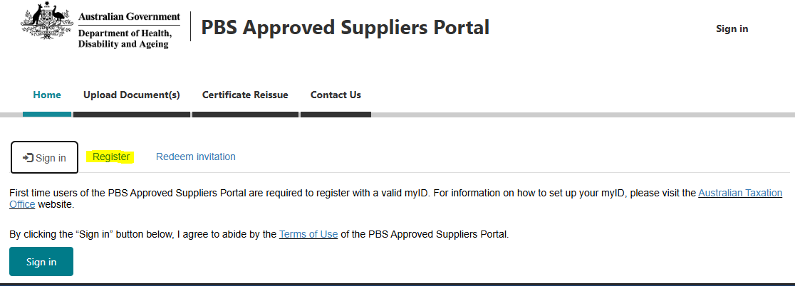
- Select the Register tab and then click on the ‘Register’ button. You will then be prompted to enter your email address and sign in via myID.

Signing in to the PBS Approved Suppliers Portal with myID
- Select the top right ‘sign in’ option; the Green ‘sign in’ button will then display.
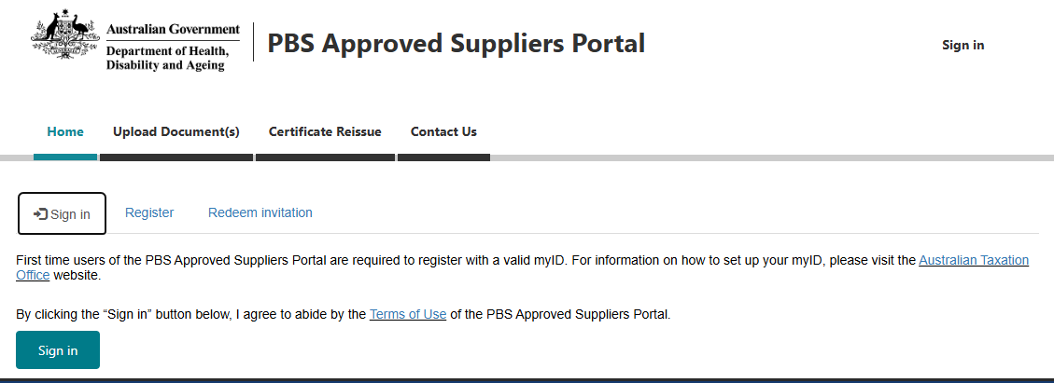
Selecting the green ‘Sign in’ button will take you to the following myID email login screen:
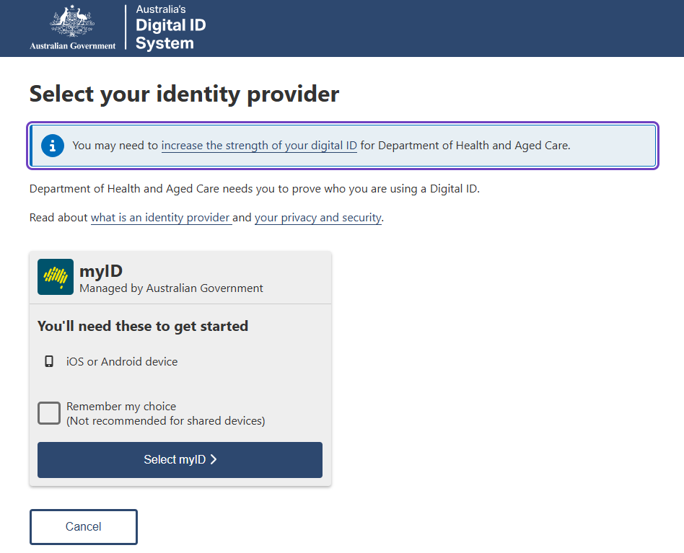
- Click on ‘Select myID >’ which will take you to the following screen
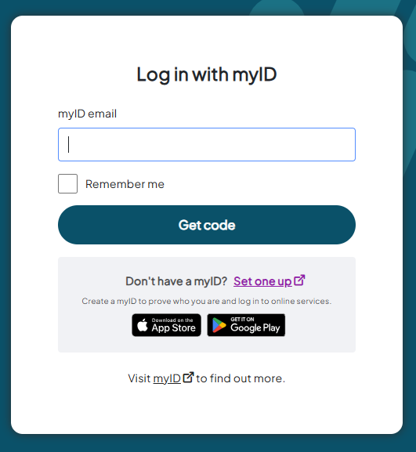
- Enter your myID email address and click on ‘Get Code’.
Once you have clicked on the ‘Get Code’ button, the following myID code authentication screen will be displayed:
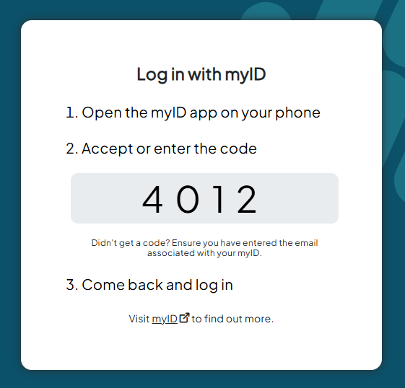
- Accept or enter the unique authentication code into your smart device.
Once you accept or enter the authentication code, the Portal Home screen will be displayed and you will have access to all standard Portal functions (My Dashboard, Apply for Approval, Upload Documents, Certificate Reissue).
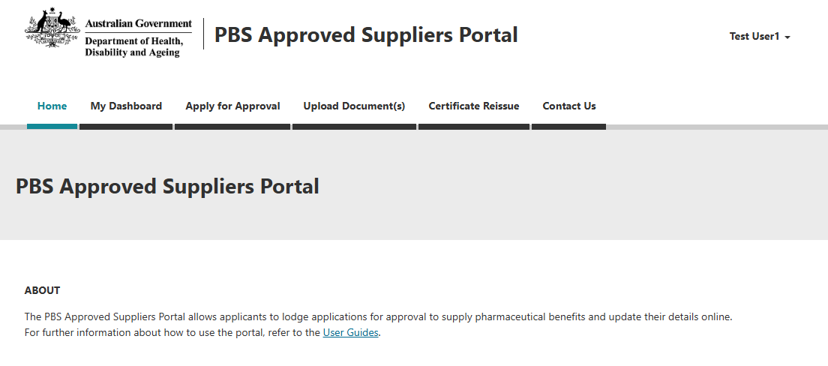

Relationship Authorisation Manager
If you have multiple entities attached to your myID, once you accept or enter the authentication code, the following Relationship Authorisation Manager (RAM) screen will be displayed:
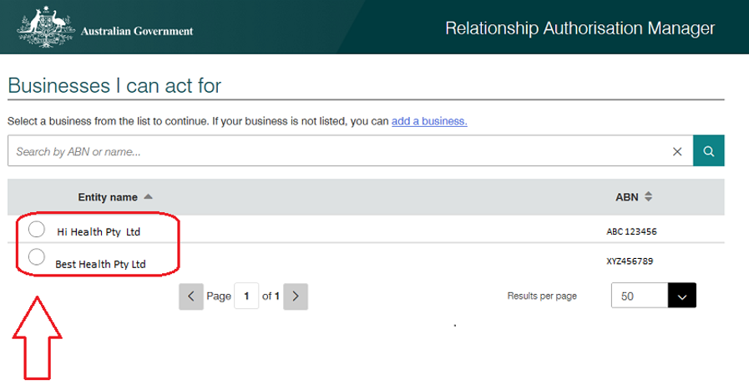
Select the Entity from the list and click ‘Continue’.
After you click on ‘Continue’, the Portal home screen will be displayed and you will have access to all standard Portal functions (My Dashboard, Apply for Approval, Upload Documents, Certificate Reissue).

Creating a user profile (once only)
If the myID email does not exist in the Portal under the selected Entity, the ‘Profile’ screen will be displayed. Enter all field details and click on the ‘Update’ button.
After a user profile has been created and linked to that myID, the Portal home screen will be displayed and you will have access to all standard Portal functions (My Dashboard, Apply for Approval, Upload Documents, Certificate Reissue).
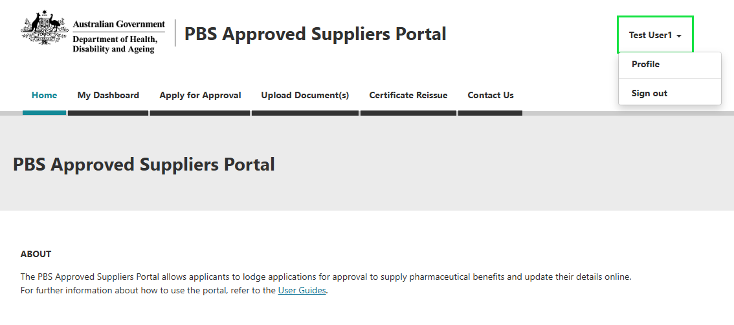
Once a user profile has been created, it cannot be changed again in the Portal. If you need to change the profile details, email PBSApprovedSuppliers@health.gov.au.

Invitation Codes
If you have registered a user profile previously, you may receive the following error message when attempting to login:
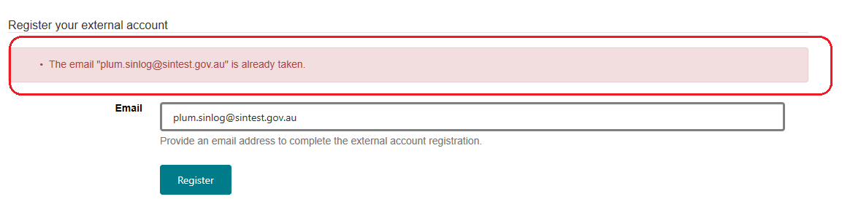
If this occurs, you will need to obtain an invitation code by sending an email to PBSapprovedsuppliers@health.gov.au, providing your myID email address and the business name to be linked, and request a ‘unique invitation code’.
You will receive the code by email. Once you have received the code, follow these steps:
- Access the Portal using the link https://pbsapprovedsuppliers.health.gov.au/Register?returnUrl=%2F
- Enter the unique invitation code provided in the email
- Check the ‘I have an existing account’ box
- Click ‘Register’
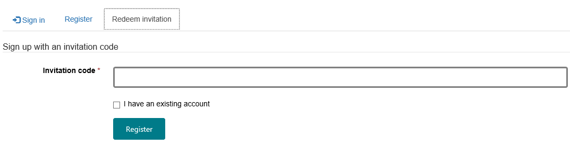
Once you have successfully redeemed your invitation code, you will be redirected to the Sign In page.
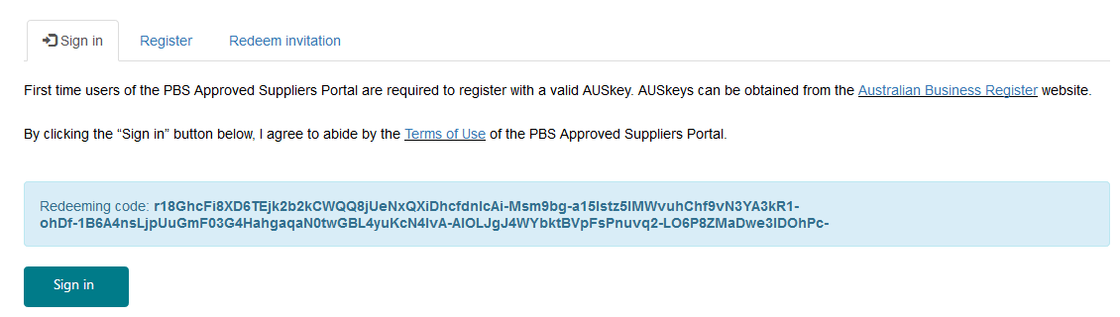
Click the green ‘Sign In’ button.
Sign in to the Portal with your myID and select the additional entity you wish to link to your existing Portal profile.

Linking additional entities to your myID
If your business name is not displayed under ‘Businesses I can act for’ on the RAM screen, visit the ATO website for information on how you can add a business to your myID – How to link your business in RAM.
When you have added your business to your myID, follow steps 6 (a) - (d) at the beginning of this guide to sign into the Portal.
At the RAM screen, under ‘Businesses I can act for’, select the relevant Entity and click on the ‘Continue’ button.
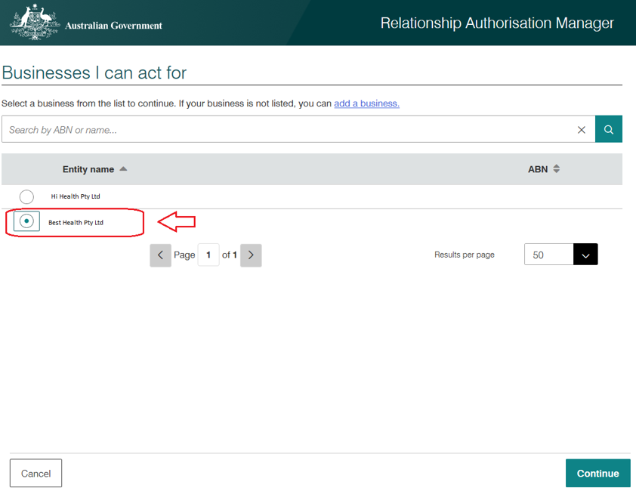
Once you click on the continue button, the Portal home screen will display and you should now have access to all standard Portal functions for the selected Entity (My Dashboard, Apply for Approval, Upload Documents, Certificate Reissue).
You will only be able to view applications made under the selected Entity. For example, if you started an application for Company A, and you login with Company B, you will not see the application initiated for Company A.

