Integrity and Safeguarding Bill

2025 Overview

Part 1
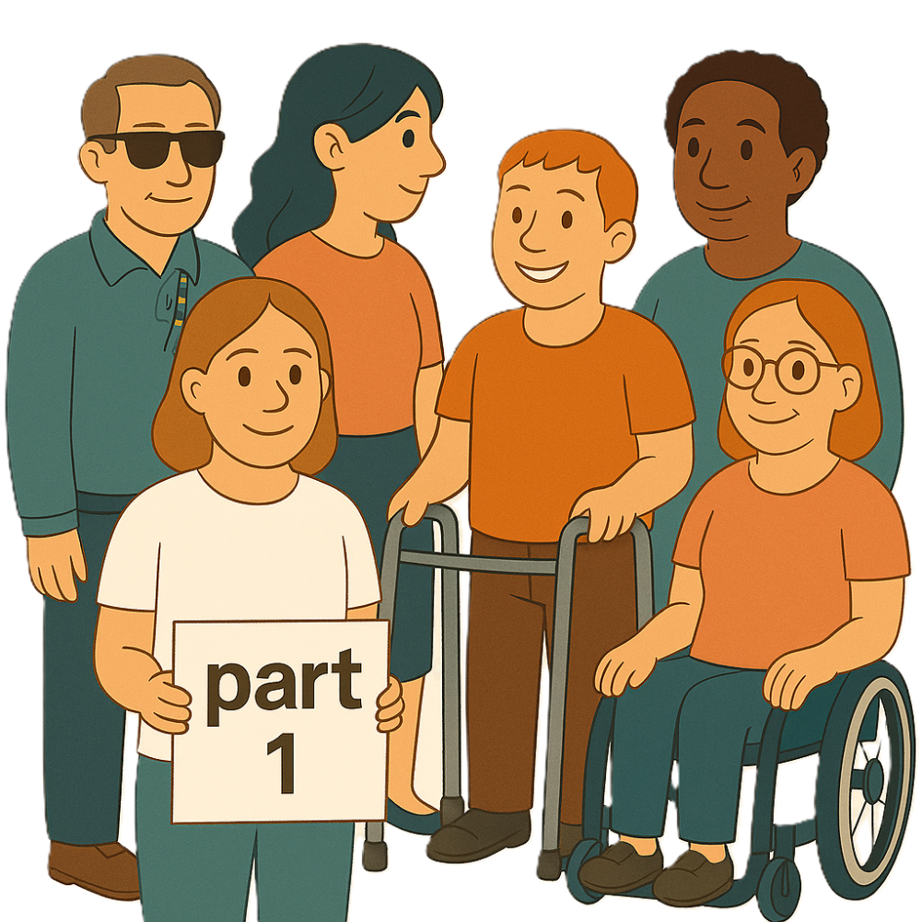
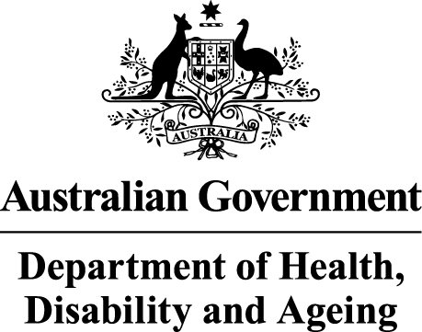 | The Australian Government Department of Health Disability and Ageing wrote this.  We say DHDA for short.  When you see the word we it means DHDA.
 | We wrote this in an easy to read way.  We use pictures to explain some ideas.
 | We have some words in bold.  This means the letters are thicker and darker.  These are important words.
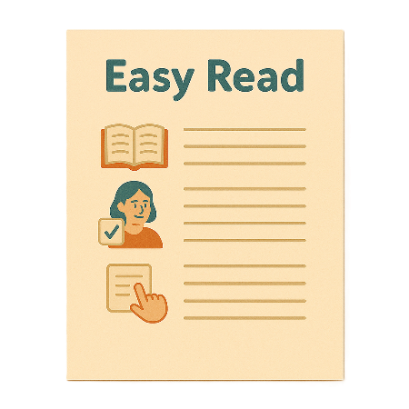 | This is an Easy Read summary of another document.  This means it has the most important ideas.
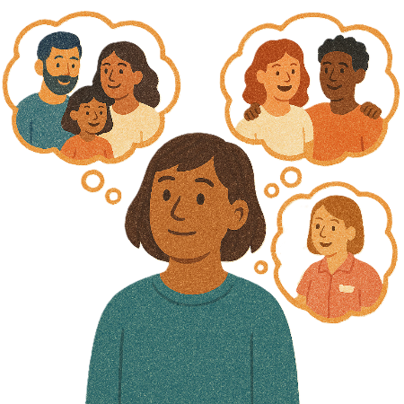 | You can ask for help to read this document.  You can ask  - A friend  - Family members  - A support person.
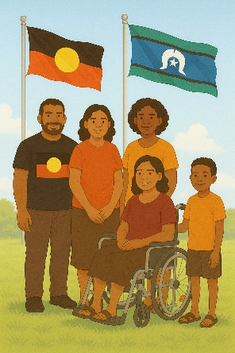 | We recognise Aboriginal and Torres Strait Islander people as the Traditional Owners of the land we live on.
 | They were the first people to live on and use the  - Land  - Waters.

Contents

Changes to NDIS laws | 5
About this document | 8
What happens if someone breaks NDIS laws | 14
Special powers | 22
More information | 23

Changes to NDIS laws

 | The government wants to make changes to the NDIS laws.  Laws are rules for how we live.  The changes are called the Integrity and Safeguarding Bill.  We call it the Bill for short.
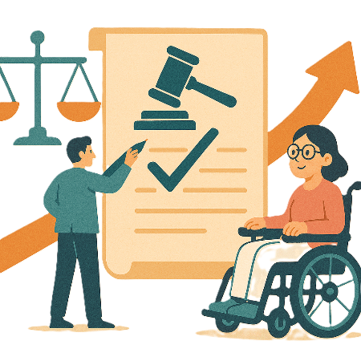 | Changes to laws are called amendments.  They help laws  - Change  - Be better.
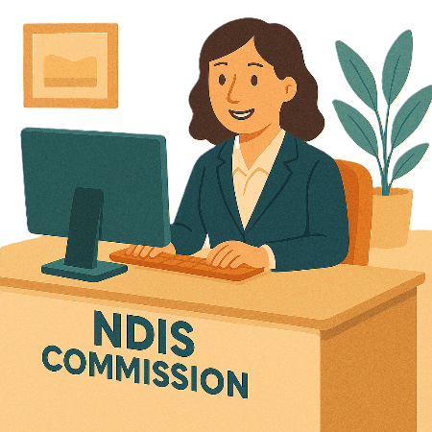 | The Bill will help make changes to  - NDIS Quality and Safeguards Commission  We call it NDIS Commission for short.
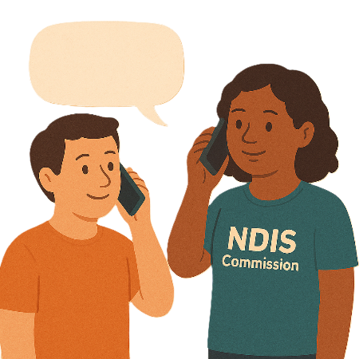 | The NDIS Commission  - Makes sure NDIS providers are doing a good job  - Listens to complaints about NDIS services.
 | Providers get money from your NDIS plan to help support you.
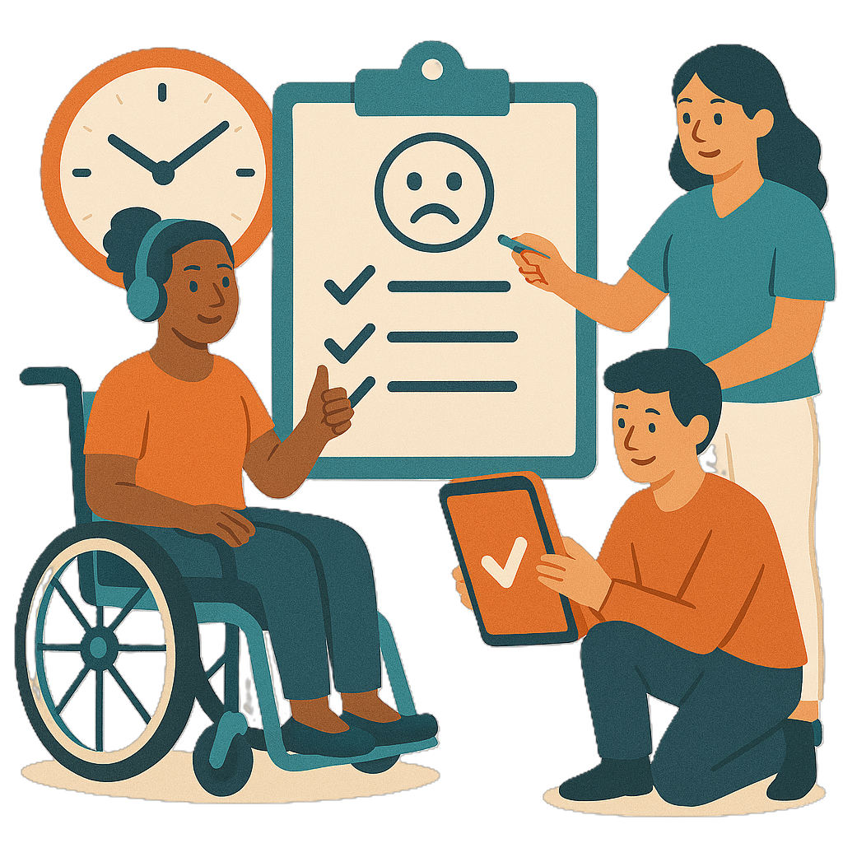 | Complaints are when you tell someone they have not done a good job.  Everyone has the right to make a complaint.
 | - National Disability Insurance Agency  We call it NDIA for short.  They look after the NDIS.
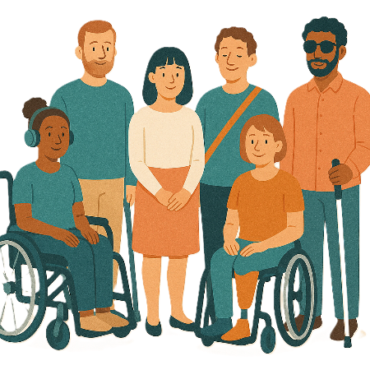 | The Bill will help  - Support people with disability who get NDIS to be safe  They can be called NDIS participants.
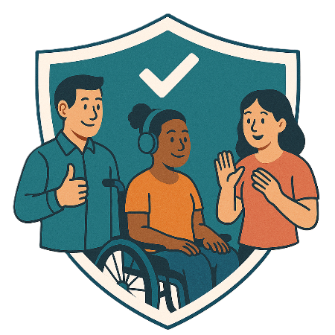 | - Help anyone who works for  - NDIS Commission  - NDIA  To do a good job.

About this document

 | This document is in 4 parts.
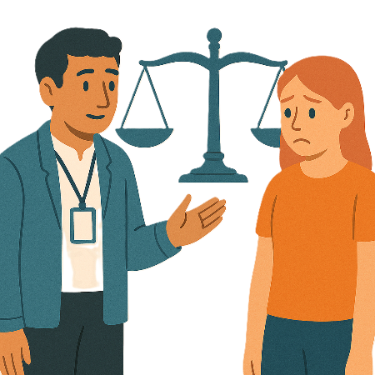 | Part 1 is about  - What will happen if someone breaks the NDIS laws
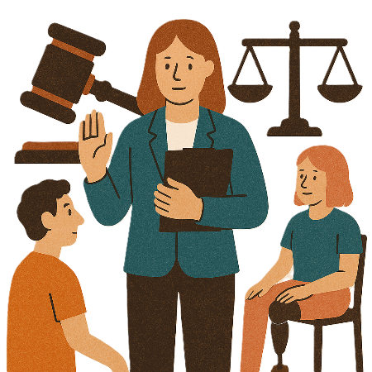 | - Special powers the government has to make sure the law is followed  This is called regulatory powers.
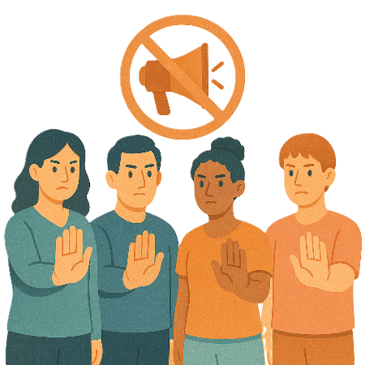 | Part 2 is about  - Anti-promotion orders  This says the things you can not share about your services.  It helps people follow NDIS rules.
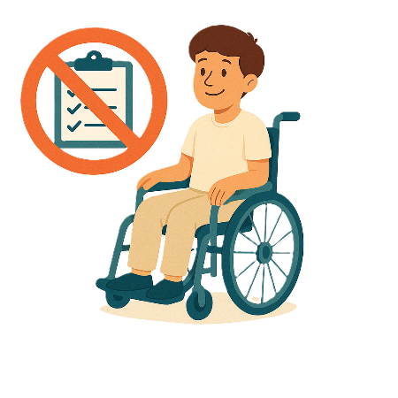 | - Banning orders  Banning orders stop people from doing  - Services  - Delivering supports.  In the NDIS market.  They help keep people with disability safe.
 | Delivering supports means giving help to people who need it.  It could be things like  - Personal care  - Help at home  - Help in the community.
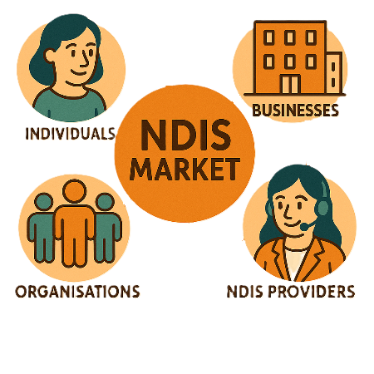 | The NDIS market is all the people who do  - Supports  - Services  Under the NDIS.  They can be  - Individuals  - Businesses  - NDIS providers  - Organisations.  Individual means 1 person.
 | - How the NDIS Commission gets information
 | - How information is used in courts  A court is where you go when there is a problem with the law.  In a court  - A judge listens to what happened  - People say what happened  - A judge decides what is fair and should happen.
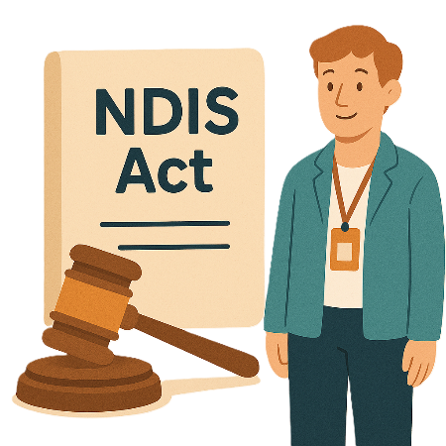 | Part 3 is about  - Changes to what happens if you do not follow the law
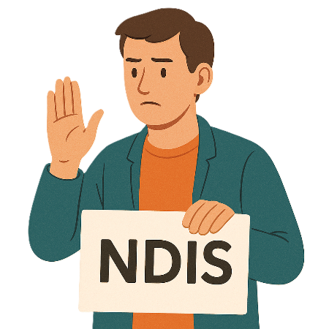 | Part 4 is about  - People with disability wanting to stop getting NDIS
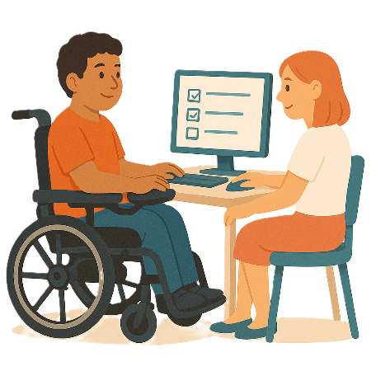 | - NDIS provider forms  These are forms that NDIS providers put in to get paid for the service or supports that they have done.
 | - Plan variations  Plan variations are when the NDIA changes things in a NDIS plan.  Like adding more money or supports to your plan.
 | You can read the other parts on our website.  www.health.gov.au/topics/disability-and-carers/reforms-and-reviews/ndis-act-changes  It is in Easy Read.

What happens if someone breaks NDIS law

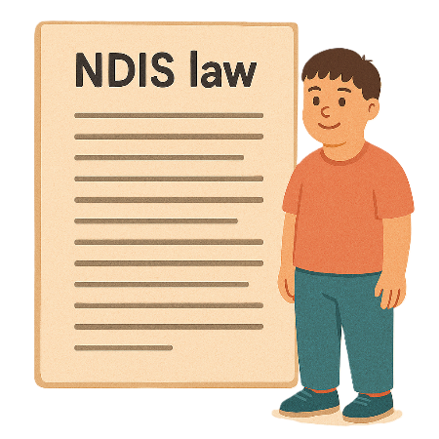 | The penalty framework says what will happen if someone breaks NDIS laws.  A framework is how we will do something.
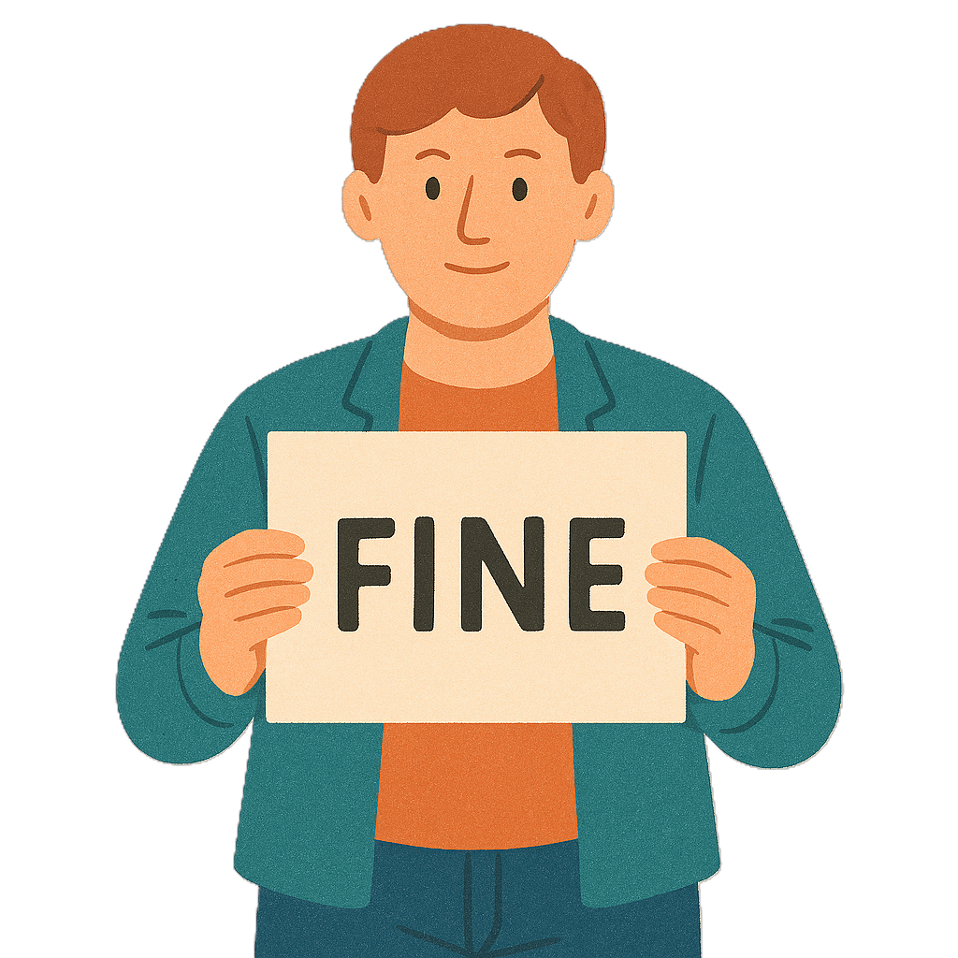 | It says  - What will happen if the provider breaks the law  They might need to pay a fine.  A fine is paying money to the government for breaking the law.
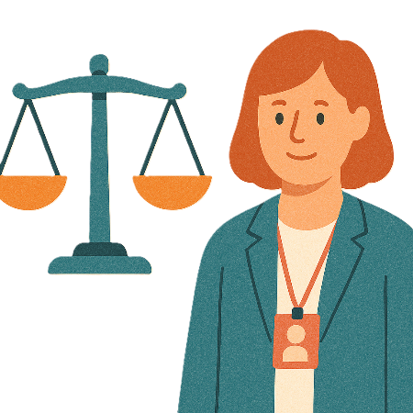 | - When you have broken the law  Like if you have  - Not followed the rules  - Given the wrong information on purpose.
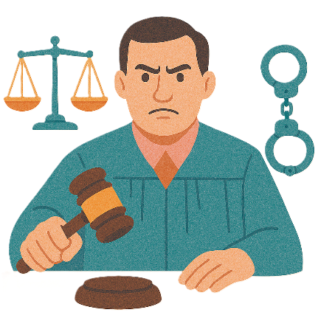 | - If what you have done is very serious.  This is called criminal offences.
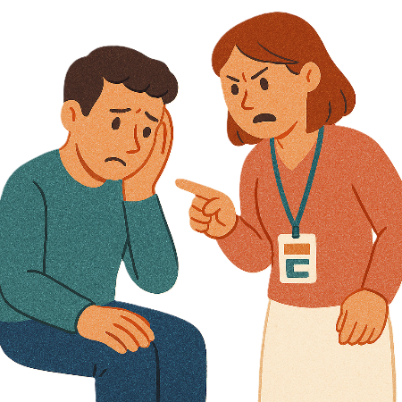 | If someone has done this they can  - Be in trouble with the police or government
 | - Go to court
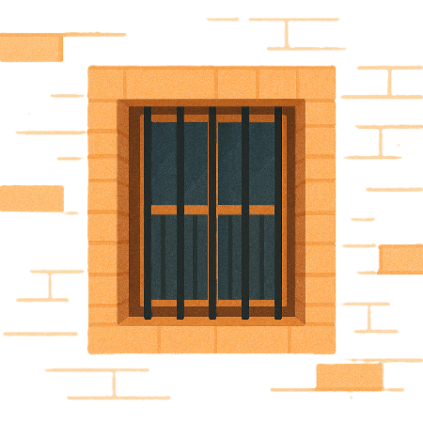 | - Go to jail
 | - Pay a fine.
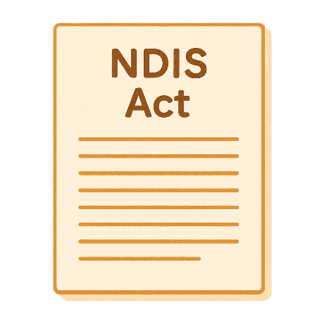 | The Bill wants to change  - How much people pay in fines when providers break the NDIS laws in a serious way
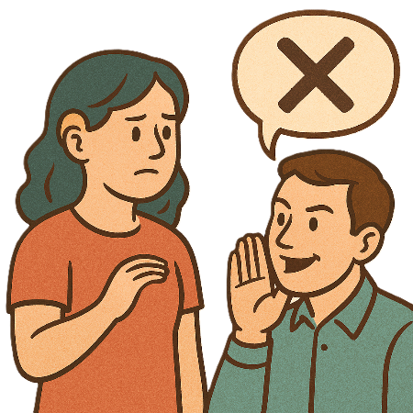 | - What happens when providers give the wrong information or documents on purpose
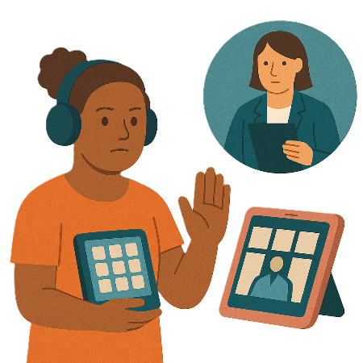 | - What happens if providers do not give information or documents to the NDIS Commission when they are asked to
 | - What happens if anyone uses or shares information that is only for the NDIS Commission.  This is called protected information.
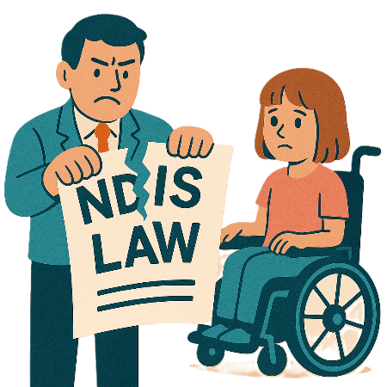 | There are also changes to what happens if the NDIS laws are broken in a serious way.
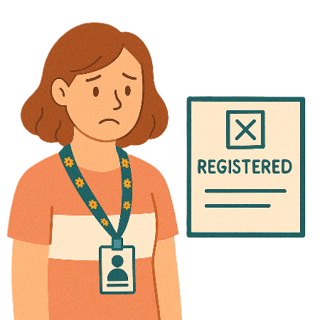 | This could be for  - A NDIS provider not being registered when they are supposed to be
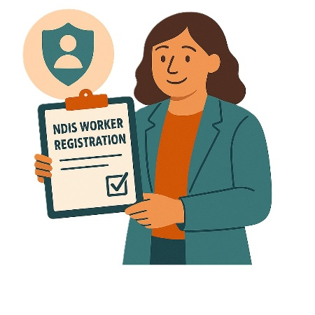 | Registered means they are  - On a list  - Follow rules.  It shows that you have the right skills to do certain services.
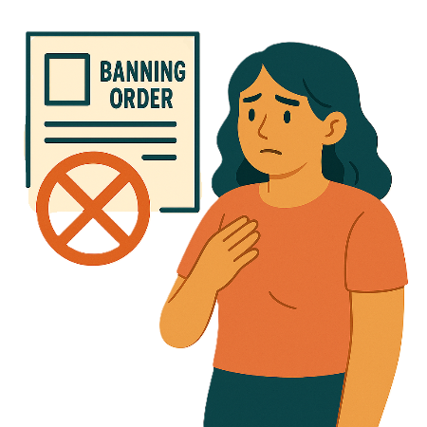 | - Not following a banning order
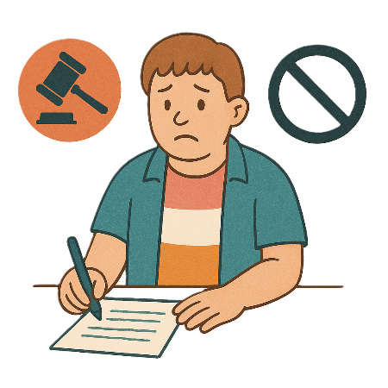 | - Giving the wrong information on purpose to be a registered NDIS provider
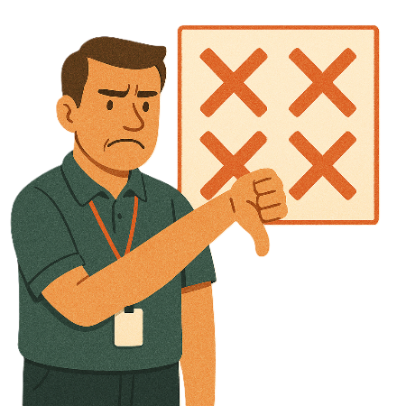 | - Not following the rules to be registered
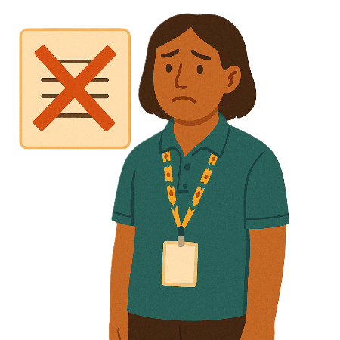 | - Not following the Code of Conduct  The Code of Conduct tells everyone the way to behave.
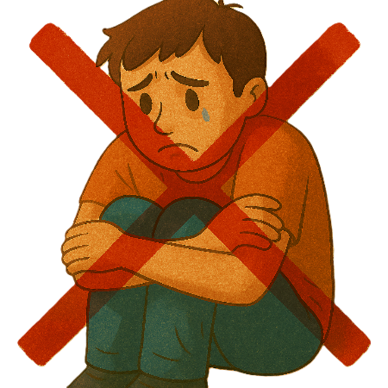 | - Harming someone  This can also include saying that you will harm them.  Harm means that something bad might happen to you.
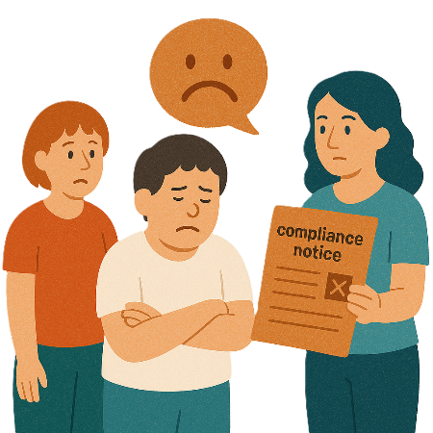 | - Not following a compliance notice  A compliance notice tells the provider what parts of the NDIS law they are not following.  Providers need to fix things in a certain amount of time.  It means they have time to fix things.
You can read about the changes to what will happen if you do not follow the law in part 3.

www.health.gov.au/topics/disability-and-carers/reforms-and-reviews/ndis-act-changes

It is in Easy Read.

Special powers

 | The Bill wants to make changes to words used in the law.  This is because there are  - New definitions  Definitions explain what a word or idea means.
 | - Changes to the language to make it easier to  - Read  - Understand.
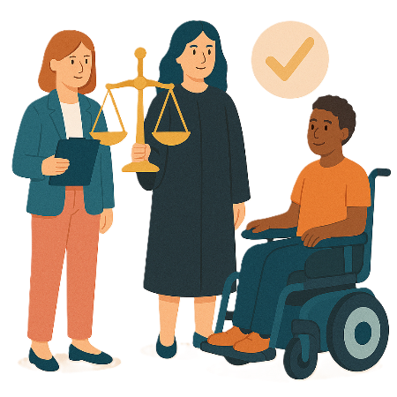 | It matches with what the NDIS Commission can already do.  This will make sure all providers follow the NDIS law.

More information

 | You can look at our website.  www.health.gov.au/topics/disability-and-carers/reforms-and-reviews/ndis-act-changes

Images in this Easy Read must not be used or copied without permission

