Contents

01 Implementation Framework 3
A shared national commitment 4
02 Commonwealth and other Action Plans 17
Commonwealth Action Plan (2025-26) 18
Priority 1: Improve access to immunisation 20
Priority 2: Build trust, understanding and acceptance 23
Priority 3: Use data more effectively 26
Priority 4: Strengthen the immunisation workforce 28
Priority 5: Harness new technologies 30
Priority 6: Reform governance and delivery 31

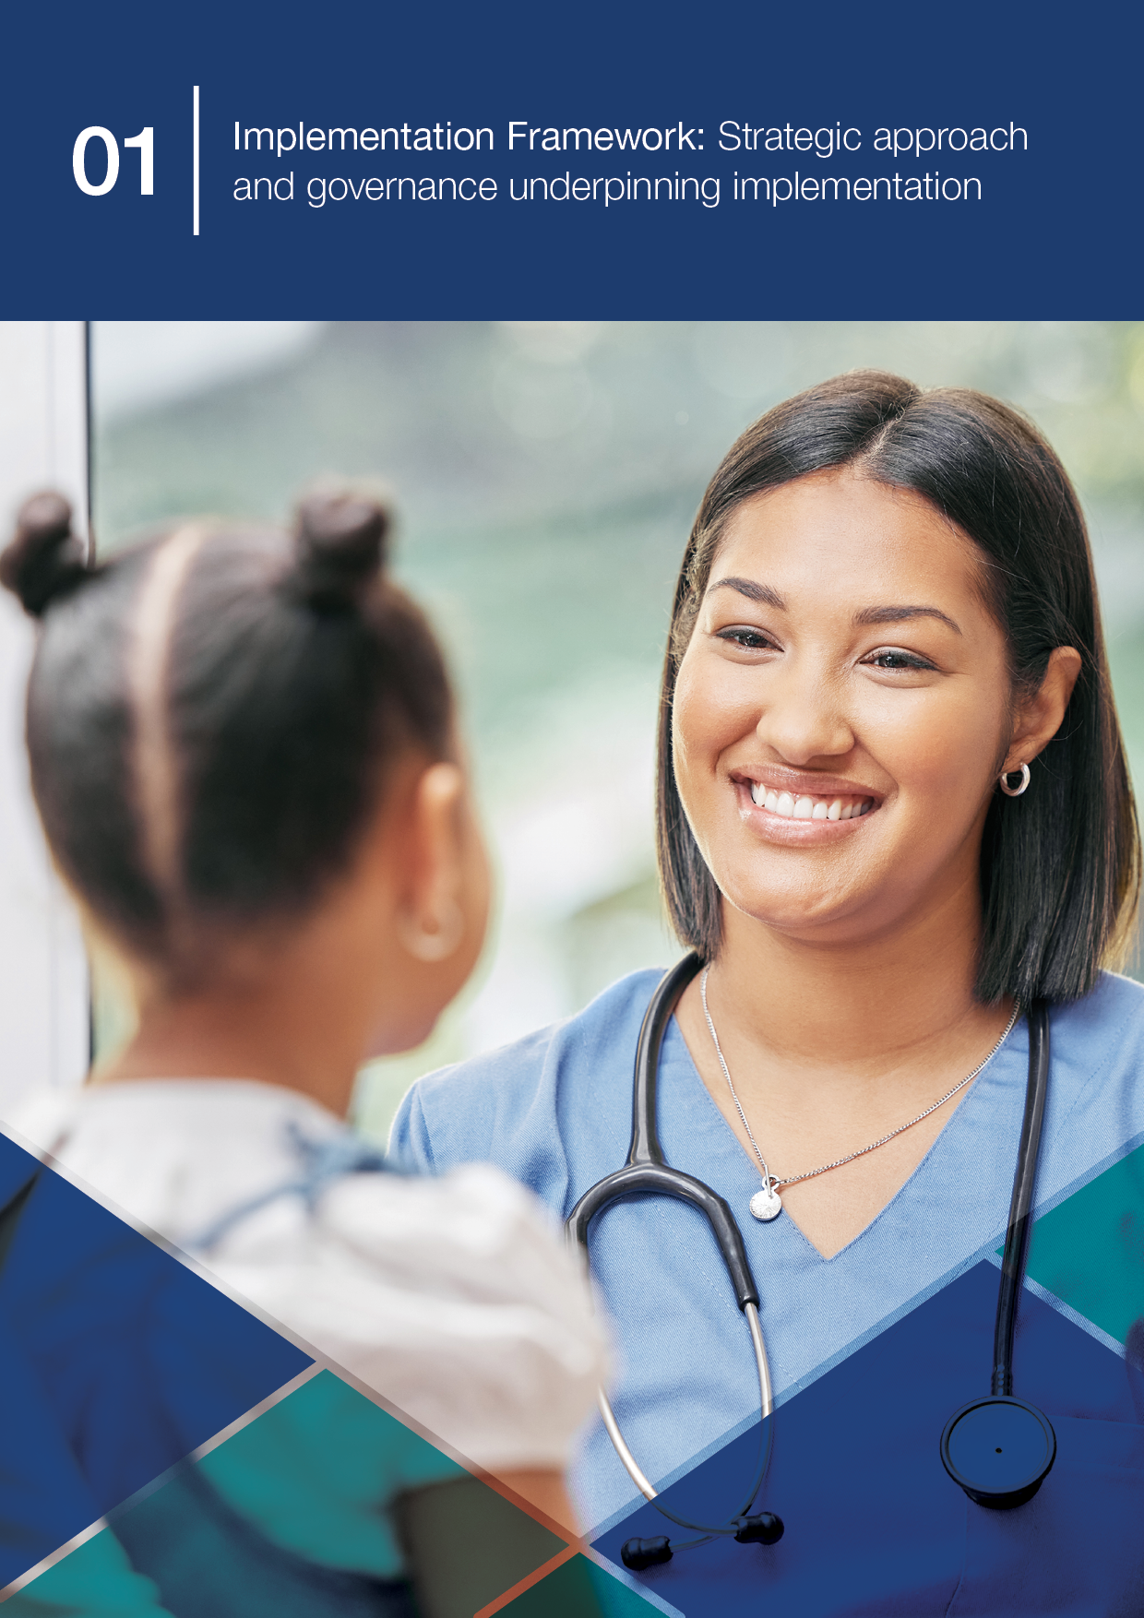
01 Implementation Framework

A shared national commitment
Immunisation is one of the most powerful tools in public health. It protects individuals, families, and communities from vaccine-preventable diseases and reduces pressure on our health system.
In Australia, immunisation is a shared responsibility. It is delivered through collaboration between governments, healthcare providers, communities, and individuals. This collective effort has underpinned our past successes and will continue to shape our response to future challenges.
The National Immunisation Strategy 2025–2030 sets a bold vision: a healthier Australia through immunisation. It provides a national framework for action, built around six Priority Areas. These areas reflect the aspirations, strengths, and roles of all parts of the immunisation system.

The Implementation Plan
This Implementation Plan (the Plan) translates the National Immunisation Strategy’s vision into action. It comprises several components that guide implementation, monitoring, and reporting. It includes an Implementation Framework, monitoring and evaluation elements, and operational components including Commonwealth and jurisdictional action plans. These elements work together to operationalise strategic goals, track progress through defined indicators, and support annual public reporting.
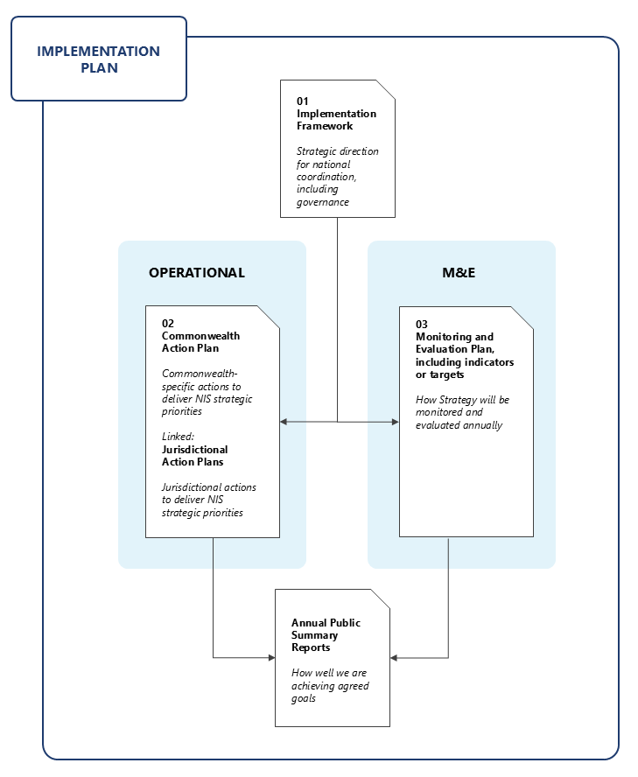
Figure 1. National Immunisation Strategy Implementation Plan components
The Plan focuses on current and evolving national activities led by the Commonwealth. It provides a foundation for coordinated progress toward achieving the priority areas and strategic goals of the strategy. These include improving immunisation coverage, enhancing equity and access, strengthening system resilience, and supporting innovation and workforce capability. In Part 2, the Plan provides a snapshot of key Commonwealth-led actions (and links to any jurisdictional plans) already underway. These actions support long-term system improvement and shared accountability.

Vision, Mission, and Strategic Priorities
The National Immunisation Strategy 2025–2030 (the strategy) is a forward-looking roadmap developed through consultation with governments, expert bodies, healthcare providers, and community representatives. It acknowledges both the achievements and pressures facing our immunisation system. Australia continues to maintain high immunisation coverage rates compared to other countries globally, reflecting strong programs and commitment within the sector. However, our system faces increasing complexity, persistent equity gaps, and the growing challenge of misinformation.

Vision
A healthier Australia through immunisation.

Mission
To reduce the impact of vaccine-preventable diseases through high uptake of safe, effective, and equitable immunisation across the lifespan.

Strategic Priorities
- Improve Access and Equity
Remove barriers and tailor approaches to ensure equitable access to vaccination, especially for those most at risk.
- Build Trust and Understanding
Foster public confidence and support informed decision-making through transparent communication and education.
- Use Data More Effectively
Strengthen data collection, analysis, and use to guide decisions and improve outcomes.
- Strengthen the Immunisation Workforce
Support and grow a skilled, diverse workforce to deliver high-quality immunisation services.
- Harness New Technologies
Leverage innovation to improve vaccine delivery, monitoring, and engagement.
- Implement Sustainable Reform
Embed robust governance, delivery mechanisms, and accountability to ensure long-term success.
Implementation of our strategy is aligned with the goals and priorities of a range of national and global strategies supporting improved health outcomes through increased vaccination coverage and disease control.
Domestically, our strategy and Plan complement the objectives of the National Preventive Health Strategy 2021-2030 and the National Strategy for the Elimination of Cervical Cancer in Australia. These strategies both prioritise immunisation as a key public health intervention. Implementation activities also contribute to achievement of goals in the Fourth National Hepatitis B Strategy 2023-2030, the National Aboriginal and Torres Strait Islander Health Plan 2021-2031, and the National Agreement on Closing the Gap. They contribute by promoting equitable access to vaccines and strengthening culturally appropriate immunisation services.
Further, our strategy is implemented in alignment with broader global initiatives including the Immunization Agenda 2030 led by the World Health Organization, the UNICEF Immunization Roadmap to 2030, and disease-specific strategies such as the Polio Eradication Strategy 2022-2026.
These strategic linkages reinforce Australia’s commitment to a coordinated, evidence-based approach to immunisation that supports national and global health security.

Translating strategic intent into action
The 2025-2030 strategy marks a shift from broad strategic intent to operational delivery. Previous strategies, including the 2019-2024 framework, set important foundations by articulating high-level goals such as supporting service providers, improving data systems, and promoting equitable access. These principles remain central to Australia’s immunisation efforts and support this new phase for a more targeted and accountable approach.
The Plan is not a restatement of the strategy’s Strategic Goals. It is a practical articulation of how those goals will be achieved, who will lead them, and what outcomes are expected. It reflects a system-wide commitment to:
- Action-oriented planning – supporting initiatives already funded, legislated, or in implementation, and identifying opportunities for new activities to address gaps.
- Clear accountability – through defined roles, and measurable targets.
- Transparency and adaptability – enabling alignment across jurisdictions and responsiveness to future needs.
The Plan supports a coordinated national system that is both practical and forward-looking.

Purpose and scope of this plan

Foundational activities
Successful implementation of the strategy will build upon foundational activities that ensure the continuity and effectiveness of Australia’s immunisation system. These functions are essential to maintaining the integrity of the National Immunisation Program (NIP) and provide the operational backbone for strategic reform and innovation.
Foundational activities include:
- Supporting vaccine registration and regulatory approval processes through the Therapeutic Goods Administration (TGA), to ensure safety and compliance prior to NIP listing.
- Listing vaccines on the NIP following rigorous health technology assessment processes to ensure safety, efficacy, and cost-effectiveness.
- Tendering for the supply of all vaccines listed on the NIP, ensuring secure, timely, and equitable access across the country.
- Funding and purchasing vaccines for eligible populations, enabling consistent delivery of immunisation services nationwide.
- Maintaining the Australian Immunisation Register (AIR), which provides a comprehensive national record of vaccinations and supports monitoring, evaluation, and policy development.
- Facilitating Medicare Benefits Schedule (MBS) and other payments for General Practitioners (GPs), supporting GPs to deliver immunisation services in primary care settings.
- Monitoring vaccine safety through post-market surveillance, including analysis of adverse event reports and emerging safety signals by the TGA, to ensure ongoing safety and maintain public confidence.
- Providing routine clinical guidance and updates to immunisation providers to support consistent, evidence-based service delivery across the system.
- Maintaining and updating the NIP Schedule and eligibility criteria, to ensure consistent access and delivery across jurisdictions.
- Ensuring alignment with national health priorities and frameworks, by routinely integrating immunisation program activities with broader public health strategies to support cohesive and consistent national health delivery.
The Commonwealth Government leads these activities which are critical to the functioning of the Australian immunisation system. They ensure that vaccines are available, accessible, and administered safely, while enabling data-driven decision-making and continuous improvement.

Advanced activities
Foundational activities ensure the continuity and integrity of the NIP. Under Part 2 of this Plan, the Commonwealth Action Plan outlines strategic initiatives that extend beyond these core functions. Examples include:
- NIP Vaccination in Pharmacy Program (NIPVIP), providing access to NIP vaccines through community pharmacies.
- First Nations Vaccine Uptake Support Grant to increase antenatal, childhood and adult vaccination uptake for First Nations people attending Aboriginal Community Controlled Health Services (ACCHSs).
- Upgrading and modernising immunisation data systems to enhance the accuracy, accessibility, and integration of vaccination data across platforms.
These initiatives are designed to directly advance one or more goals and priority areas of the strategy. Together, they build on the strong foundations of the NIP to drive innovation, address emerging challenges, and realise the full ambition of the strategy.
Foundational functions and the strategic initiatives outlined in the Commonwealth Action Plan represent a substantial investment in, and commitment to, Australia’s immunisation system. The total Commonwealth funding allocated to support immunisation program activities is over $664 million in 2025-26 alone.
The Commonwealth Action Plan is a dynamic component of this Plan and will be reviewed and updated regularly to reflect new initiatives, completed actions, and emerging priorities.
The Plan does not map all immunisation activities across Australia. Instead, it complements jurisdictional efforts and provides a national platform for collaboration and shared accountability. It is designed to evolve over time and will be reviewed and updated at least annually. Through this process, any new investments, changed priorities, or new agreed targets will be updated to reflect progress and guide next steps. This may include any future co-designed actions, allowing the Plan to expand and evolve with implementation partners across the immunisation system.

Strategic governance and advisory structures
A strong governance and advisory framework underpins the effective implementation of the strategy, ensuring alignment, accountability, and responsiveness across all levels of the system. This framework brings together decision-makers, experts, and stakeholders to guide strategic direction, monitor progress, and adapt to emerging needs.

Strategic governance
Governance structures provide the leadership and coordination necessary to translate national immunisation priorities into action. These bodies ensure that immunisation efforts are integrated with broader health objectives and that jurisdictions are supported in delivering locally tailored solutions.

Health Ministers’ Meeting (HMM)
The HMM offers high-level strategic oversight from Health Ministers, setting national targets and ensuring immunisation aligns with overarching health priorities.

Health Chief Executives Forum (HCEF)
The HCEF facilitates intergovernmental collaboration, coordinating implementation across jurisdictions and supporting shared accountability.

Australian Health Protection Committee (AHPC)
Chaired by the Australian Government’s Chief Medical Officer, the AHPC comprises Chief Health Officers from each jurisdiction. It advises on strategic issues and emerging risks, ensuring immunisation efforts are clinically informed, responsive, and aligned with communicable disease control strategies.

Jurisdictions
State and territory governments lead local implementation, developing actions that reflect community needs while remaining aligned with national goals. They actively participate in governance processes and champion inclusive delivery.

Advisory Structures
Advisory bodies play a critical role in shaping the strategic direction of the Strategy, offering expert guidance, surfacing sector insights, and fostering collaboration.

Strategic Reference Group (SRG)
The SRG is an advisory body that supports the implementation of the strategy. It provides strategic advice to guide the development and implementation of this Plan and its components and supports alignment of immunisation activities with the strategy’s six Priority Areas. This includes identifying opportunities to leverage existing evidence and partnerships and advising on stakeholder engagement strategies to strengthen implementation.
Membership includes:
- Commonwealth representatives, including the interim Australian Centre for Disease Control (CDC)
- State and territory representatives
- Independent subject matter experts.
The SRG may advise on commissioning of work through reviewing delivery priorities and funding opportunities identified through NIS Implementation Forums. It may also independently review methodologies or evaluation outputs. SRG advice informs Commonwealth positions and decision-making progressed through formal intergovernmental committees. It does not undertake implementation activities or hold operational responsibilities.

NIS Implementation Forums
The Forums serve as broad engagement platforms and may be convened periodically throughout the life of the strategy. Forums bring together diverse voices to identify barriers, highlight emerging community needs, and explore opportunities to strengthen delivery. Through ongoing dialogue and collaboration, they surface sector perspectives and support effective implementation. The format and focus of each forum may evolve to reflect changing priorities and emerging challenges.
These advisory structures and associated processes supporting implementation of the strategy are overseen by the Department of Health, Disability and Ageing (DHDA). The interim Australian Centre for Disease Control (CDC) will also actively support the development and implementation of the Plan and relevant activities to 2030.

National alignment through complementary planning and shared targets
The strategy supports a decentralised model, where each level of government develops its own Action Plan aligned to its roles and responsibilities. The Commonwealth leads on coordination, funding, regulation, and national systems, while jurisdictions lead on service delivery, workforce, and community engagement. These roles are also reflected in the Essential Vaccines Schedule (EVS) which supports the coordinated and effective delivery of the NIP and the strategy.
This Plan outlines Commonwealth-led actions. States and territories will develop action plans to reflect local priorities, service delivery contexts, and population needs. These jurisdictional action plans are developed independently but are designed to complement the national approach. A version of the jurisdictional action plans is submitted annually by states and territories as a Milestone under the EVS. Jurisdictions may choose to expand on EVS action plans in finalising their annual implementation strategies and activities to support achievement of the strategy’s goals.
Together, these efforts contribute to a national system, supported by shared strategic priorities, monitoring, and evaluation frameworks. Existing national forums and data infrastructure enable jurisdictions to report progress, identify gaps, and support continuous improvement.
To strengthen alignment, a suite of shared national indicators and targets as appropriate will be co-developed with jurisdictions and expert stakeholders. These indicators will provide a consistent framework for measuring progress in key areas such as vaccine coverage, equity, public confidence, and system performance.
By aligning expectations and performance measures, the strategy enables national consistency while preserving local flexibility. This supports shared accountability across all levels of the immunisation system.

Roles and responsibilities
Immunisation in Australia is a shared effort between the Commonwealth and state and territory governments. Each plays a distinct but vital role.

Commonwealth Responsibilities
The Commonwealth leads national coordination and system-level or foundational functions, including:
- Leading Health Technology Assessment processes through the Australian Technical Advisory Group on Immunisation and the Pharmaceutical Benefits Advisory Committee to ensure access to safe, effective, and cost-effective vaccines on the NIP.
- Developing national immunisation policy and managing the NIP to ensure consistency across jurisdictions.
- Procuring and funding vaccines listed on the NIP, ensuring equitable access for all eligible populations.
- Monitoring vaccine safety through post-licensure surveillance by the TGA, including analysis of adverse event reports and emerging safety signals.
- Managing the AIR to maintain accurate and comprehensive national vaccination records.
- Leading national consumer and health professional communication and education campaigns to promote public awareness and vaccine uptake.
- Monitoring immunisation coverage and performance to inform policy and program improvements.
- Driving research and innovation to strengthen immunisation systems, technologies, and practices.
- Providing MBS rebates to support immunisation service delivery by general practitioners and other authorised providers.
The Commonwealth delivers these functions through a range of foundational activities and improvement projects. Key system and program improvement actions are specifically detailed in Part 2 – Commonwealth and other Action Plans, which maps targeted activities to the strategy’s priorities. The Commonwealth Action Plan will be reviewed and updated regularly to reflect new or completed actions.

State and Territory Responsibilities
States and territories lead on service delivery and community engagement, including:
- Delivering immunisation services through general practices, pharmacies, community clinics, and in-reach and outreach programs.
- Implementing school-based, state and other locally delivered initiatives tailored to community needs.
- Funding and managing additional immunisation programs beyond the NIP, including programs for specific populations or local priorities.
- Providing program updates and education to strengthen immunisation workforce capability.
- Ensuring local immunisation workforce compliance with reporting vaccination data to the AIR and to local safety surveillance systems, to support national monitoring.
- Engaging immunisation stakeholders and communities to promote culturally safe and accessible immunisation services.
- Leading outbreak response and coordinating local public health actions in collaboration with national authorities.

Shared Responsibilities
Collaboration between governments is essential to achieving national goals. Shared responsibilities include:
- Jointly planning and setting priorities to align efforts across jurisdictions.
- Aligning and implementing annual Action Plans that reflect both national and local contexts.
- Building and maintaining shared monitoring and evaluation frameworks to assess performance and drive continuous improvement.
- Coordinating communication, public engagement, and education strategies to ensure consistent messaging and build public trust.
- Promoting equitable access for all priority populations, including First Nations peoples, culturally and linguistically diverse communities and people in remote areas.
- Jointly developing and maintaining national standards and guidelines, including for vaccine storage and handling and cold chain management, to ensure safe and effective delivery across all settings.
- Collaborating on digital tools and innovations to improve immunisation delivery and monitoring.
- Advancing the Closing the Gap agenda by promoting equitable access to immunisation for Aboriginal and Torres Strait Islander peoples, helping improve life expectancy through reducing the burden of vaccine-preventable disease.

Recognising the role of broader stakeholders
The success of the strategy relies on a wide network of partners beyond government. These stakeholders play essential roles in service delivery, community engagement, innovation, and building public trust.

Key Stakeholder Groups
- Healthcare professionals – promote and/or administer vaccines, engage with patients, their families and carers, and support data collection and reporting.
- Community organisations – deliver culturally safe outreach, education, and support, especially for locally defined priority populations.
- Aboriginal and Torres Strait Islander Community Controlled Health Organisations and health services – lead culturally appropriate community engagement, promote and deliver immunisations as part of comprehensive primary health care models, and inform culturally safe and effective immunisation policy and responses.
- Researchers and academic institutions – provide evidence, evaluation, and innovation to strengthen immunisation systems.
- Professional bodies, peak organisations, and training providers – support immunisation workforce development and training, standards, and advocacy.
- Consumers and community members (including consumer and priority population peak bodies) – share lived experience and insights to shape inclusive and responsive programs.

Stakeholder Engagement Mechanisms
Stakeholder input is embedded throughout the implementation process via:
- NIS Implementation Forums – which bring diverse perspectives into early planning, including lived experience, operational insights, and investment ideas.
- Consultation and co-design processes – including at the jurisdictional level, where local contexts and community need shape delivery.
- Monitoring and Evaluation activities – where stakeholder feedback helps assess system performance, equity outcomes, and opportunities for improvement.
By recognising and valuing these contributions, the Plan supports a whole-of-system approach that is inclusive, equitable, and responsive.

Monitoring, targets, and evaluation
Monitoring and evaluation (M&E) is essential to ensuring that national immunisation efforts are delivering meaningful, measurable, and equitable outcomes. This Plan commits to a nationally coordinated approach to monitoring focused on system performance rather than program compliance.

The Commonwealth will work in partnership with jurisdictions and stakeholders to develop a set of national immunisation performance indicators and targets, as appropriate. These measures will align with existing performance benchmarks in the EVS and the strategy’s six Priority Areas and will serve as a foundation for shared accountability. They will help track progress over time, identify areas requiring additional focus or investment, and support continuous improvement. Targets will be developed through national governance processes and expert consultation, drawing on data from the AIR and other relevant sources.
Once finalised, the national targets will be published as part of an M&E framework under this Plan that outlines how progress will be tracked, reviewed, and reported annually. This approach supports accountability while minimising duplication with existing program reporting. It also creates a foundation for shared learning across jurisdictions and sectors, supporting a more responsive and effective immunisation system.

Looking ahead
The publication of this Plan is a milestone in the delivery of our strategy. It provides visibility of current national actions and a foundation to support and align any new actions to 2030.
Over the life of the strategy, the department will regularly review and update the Plan to reflect progress, lessons learned, and emerging priorities. Key next steps include:
- Developing and publishing the national immunisation indicators and targets
- Continuing collaboration with key stakeholders and jurisdictions to align planning, investment, and reporting
- Updating the Commonwealth Action Plan at Part 2 to reflect new initiatives and evolving priorities
- Using national governance forums to drive improvement, support transparency, and ensure accountability.
By working together through this structured and coordinated approach, Australia will ensure its immunisation system remains strong, adaptive, and focused on achieving the best possible health outcomes for all communities.

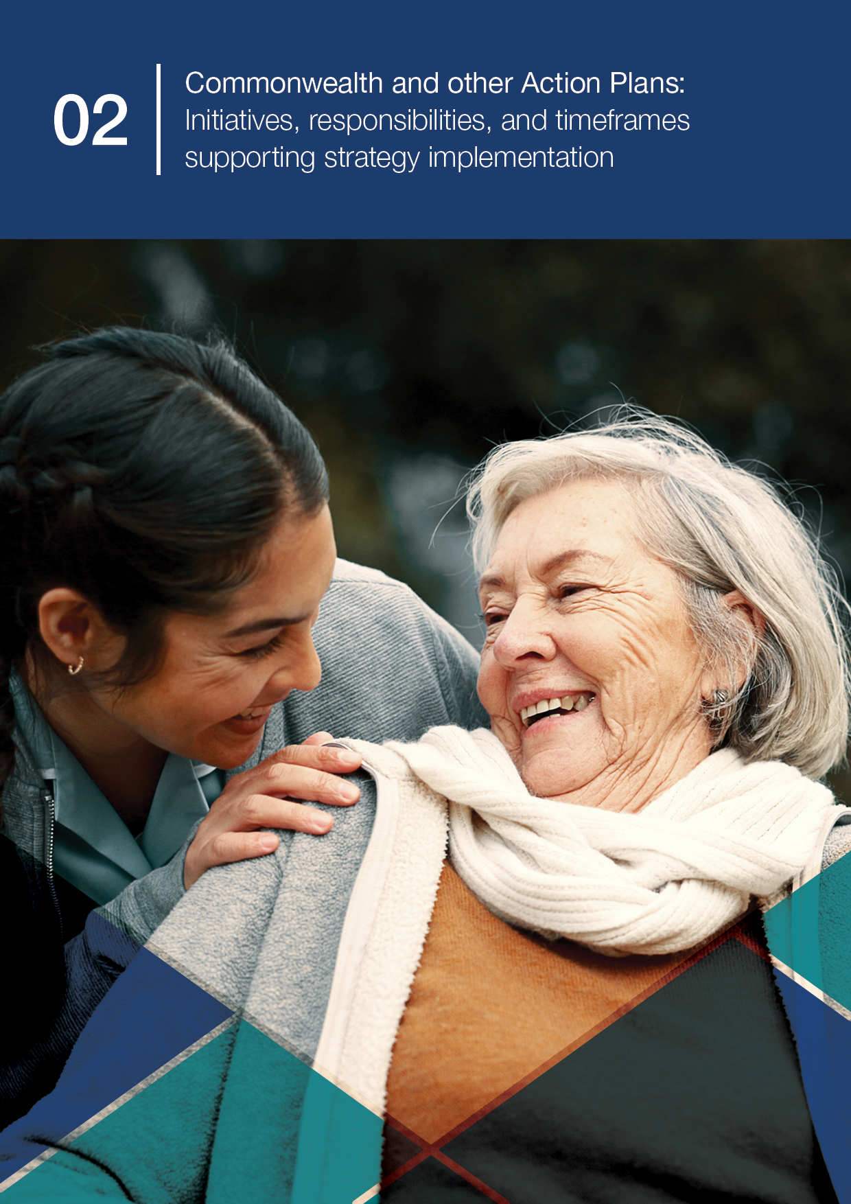
02 Commonwealth and other Action Plans

Commonwealth Action Plan (2025-26)
Part 2 of the Plan includes the Commonwealth Action Plan highlighting initiatives that drive the operational delivery of the National Immunisation Strategy 2025–2030. Building on foundational activities such as vaccine procurement, safety monitoring, and data management, this section focuses on strategic actions designed to strengthen equity, access, and system performance. It highlights targeted investments and programs that collectively advance the strategy’s six Priority Areas. These initiatives represent a dynamic, evolving suite of actions that will complement and link to jurisdictional activities as these are published, and reinforce a nationally coordinated approach to immunisation.

Commonwealth responsibilities
The Commonwealth plays a central role in coordinating and delivering foundational elements of Australia’s immunisation system. Details of these foundational responsibilities are not included in this Action Plan however provide the essential infrastructure that supports national immunisation efforts. Articulated in Part 1, these key responsibilities include but are not limited to:
- Supporting Health Technology Assessment processes
- Developing national immunisation policy and managing the NIP
- Procuring and funding vaccines listed under the NIP
- Post-licensure surveillance by the Therapeutic Goods Administration (TGA), including analysis of adverse event reports and emerging safety signals
- Managing the Australian Immunisation Register (AIR)
- Leading national consumer and health professional communication and education campaigns
- Monitoring immunisation coverage and performance
- Supporting research and innovation
- Providing Medicare Benefits Schedule (MBS) rebates to support immunisation service delivery.

Strategic focus of initial initiatives (2025-26)
The initiatives outlined in this Action Plan represent targeted Commonwealth-led efforts to progress the strategy. These initiatives are distinct from essential and ongoing foundational program activities. The initial Commonwealth Action Plan focuses on:
- Strategic initiatives already funded and in progress, including some activities that are ongoing or recurrent in nature.
- Deliberate efforts to strengthen the effectiveness, equity, and sophistication of immunisation program delivery.
- Activities designed to contribute to one or more Strategic Goals and Priority Areas of the strategy.
This document will be updated as governments announce new investments and activities.

Priority 1: Improve access to immunisation

Strategic focus
Improve access to immunisation, with a focus on equity for Aboriginal and Torres Strait Islander people and other priority populations.

Overview
Despite Australia’s high overall coverage, significant inequities remain. These include lower coverage among Aboriginal and Torres Strait Islander people, culturally and linguistically diverse (CALD) communities and people living in rural and remote areas.
National efforts must improve equity in immunisation access by supporting community-led approaches, improving data use to identify and respond to inequities, and ensuring services are culturally safe and accessible for all.
Initiative | Description | Lead/ delivery partner(s) | Timeframe | Intended outcome(s) | Related Strategic Goal(s)
1.1 National Vaccines Insight Project | Deliver the National Vaccination Insights project. This project will generate routine, systematic data and insights on vaccination barriers and drivers to inform strategies to improve vaccination uptake in different populations across Australia. | Lead: Department of Health, Disability and Ageing (DHDA)  Delivery partner (contract manager): Interim Australian CDC | 2025-26 | Contemporary understanding of vaccination barriers and drivers across different populations. | G1 – Partner with communities to understand barriers  G4 – Consider additional evidence-informed targets  G7 – Track community sentiment  G12 – Integrate/report timely data on diseases, coverage, safety, social/behavioural insights
1.2 NIP Vaccination in Pharmacy Program (NIPVIP) | Continuation of the NIP Vaccination in Pharmacy Program (NIPVIP), providing access to NIP vaccines through community pharmacies. | DHDA | Ongoing | Improved convenience, access to, and uptake of immunisation services, especially in areas with limited GP availability. | G2 – Innovative service delivery to increase equitable immunisation access  G3 – Ensure vaccine access and uptake to reach national targets  G14 – Embed immunisation in preventive healthcare  G23 – Strengthen collaboration between governments to deliver NIP vaccines
1.3 Maintain, coordinate, and chair a National Aboriginal and Torres Strait Islander cultural governance/reference group | Establish and maintain a National Aboriginal and Torres Strait Islander cultural governance group as a key consultative, codesign and oversight mechanism. This is a deliverable under Departmental current contract with the National Centre for Immunisation Research and Surveillance (NCIRS). The inaugural Group meeting was held on 29 August 2025. | NCIRS | 2025-26 | Aboriginal and Torres Strait Islander cultural governance embedded into immunisation research and policy.  Improved trust, cultural safety, and vaccination uptake among Aboriginal and Torres Strait Islander peoples. | G1 – Partner with communities to understand barriers  G3 – Ensure vaccine access and uptake to reach national targets
1.4 First Nations Vaccination Uptake Support Grant | Deliver the First Nations Vaccine Uptake Support Grant to increase antenatal, childhood and adult vaccination uptake for First Nations people attending Aboriginal Community Controlled Health Services (ACCHSs).  Evaluate the Grant Program’s objectives and outcomes via an independent evaluation consultant. The evaluation is an opportunity to identify ongoing support opportunities to enhance policy and program design to address First Nations vaccination access and uptake rates. | Lead: DHDA  Delivery partner (grant): NACCHO  Delivery partner (evaluation): Nous Group | 2025-26 | Increase vaccination rates in ACCHS that receive funding, resulting in lower vaccine preventable diseases.  Increase the number of staff in ACCHS trained to provide immunisation.  Increase the capacity of immunisation staff confident to deliver antenatal, childhood and adult immunisations.  Increase community-led and targeted immunisation messaging.  Increase ACCHS’ delivery of outreach services and targeted recall activities. | G1 – Partner with communities to understand barriers  G3 – Ensure vaccine access and uptake to reach national targets  G14 – Embed immunisation in preventive healthcare  G16 – Support First Nations health workforce contributions
1.5 Residential Aged Care Respiratory Vaccine Action Plan | Implement a Residential Aged Care Respiratory Vaccine Action Plan to support the sustained drive of respiratory vaccinations.  The Action Plan focuses on activities that enhance access, generate demand, and improve transparency to address key barriers. It includes key vaccinations COVID-19, Influenza, Shingles, Pneumococcal and RSV. | Lead: DHDA  Delivery partners:  Aged Care Safety & Quality Commission | Yearly | Increased access, demand, uptake, and transparency of key respiratory vaccinations in aged care facilities. | G1 – Partner with communities to understand barriers  G2 – Innovative service delivery to increase equitable immunisation access  G4 – Consider additional evidence-informed targets
1.6 Identify barriers to vaccine consent in residential aged care settings | Conduct research into the structural, behavioural, and motivational barriers to vaccine consent and uptake in residential aged care settings. | DHDA | 2025-26 | Contemporary understanding of barriers to vaccine consent in residential aged care, with clear suggestions on activities to improve consent pathways. | G1 – Partner with communities to understand barriers  G5 – Engage to build trust/ combat misinformation

Priority 2: Build trust, understanding and acceptance

Strategic focus
Build trust, understanding and acceptance of immunisation in communities.

Overview
Confidence in immunisation is high in Australia, but misinformation and disinformation can undermine trust. Communities and individuals may face different concerns depending on their experiences, cultural backgrounds, and information environments.
There is a need for clear, accurate, and respectful communication tailored to specific communities, and greater involvement of community voices in immunisation program design.
The strategy emphasises building relationships, supporting trusted messengers, and investing in research to understand drivers of trust and hesitancy.
Initiative | Description | Lead/ delivery partner(s) | Timeframe | Intended outcome(s) | Related Strategic Goal(s)
2.1 Community-based outreach – Expos and networks | Deliver targeted, culturally appropriate communication and outreach initiatives, including through expos, multicultural networks, and community-led engagement. | DHDA | 2025-26 | Build trust, share accurate vaccine information, and improve immunisation uptake among CALD, hard-to-reach, and underserved populations. | G1 – Partner with communities to understand barriers  G5 – Engage to build trust/ combat misinformation  G6 – Strengthen community partnerships for tailored strategies  G7 – Track community sentiment
2.2 First Nations-led co-designed education initiatives | Partner with select communities to co-design culturally safe and tailored vaccine education initiatives and materials. This activity aims to support culturally safe education and vaccine acceptance, and improved uptake for Aboriginal and Torres Strait Islander communities.  Routinely engage with the National Aboriginal Community Controlled Health Organisation (NACCHO) seeking feedback on activities to increase vaccine access for Aboriginal and Torres Strait Islander communities. | DHDA  Delivery partner: NACCHO | 2025-26 | Community-led education and improved acceptance, access, and uptake for Aboriginal and Torres Strait Islander people. | G1 – Partner with communities to understand barriers  G5 – Engage to build trust/ combat misinformation  G6 – Strengthen community partnerships for tailored strategies  G16 – Support First Nations health workforce contributions
2.3 SKAI for Consumers | Deliver and expand the Sharing Knowledge About Immunisation (SKAI) platform to provide accessible, evidence-based information and communication tools for consumers. | Delivery partner (contract manager): Interim Australian CDC  Delivery partner: NCIRS – Social Science Unit | 2025-26 | Informed vaccine decision-making through supportive, trusted conversations between consumers and healthcare professionals. | G1 – Partner with communities to understand barriers  G5 – Engage to build trust/ combat misinformation  G6 – Strengthen community partnerships for tailored strategies
2.4 Maternal Vaccination Schedule | Deliver a co-designed vaccination schedule and relevant resources to support understanding and acceptance of maternal vaccination.  The project will also deliver proposed implementation approaches to integrate the maternal vaccination schedule in the health sector and broader community. | Lead: DHDA  Delivery partner: Monash University | 2025-26 to 2027-28  Schedule delivered by December 2027. | Improved confidence of pregnant women and their families in the increasingly complex maternal vaccination landscape.  Health professionals equipped and confident to provide timely and appropriate vaccination guidance during pregnancy. | G1 – Partner with communities to understand barriers  G5 – Engage to build trust/ combat misinformation  G6 – Strengthen community partnerships for tailored strategies
2.5 Enhanced information strategies to counter misinformation | Build public trust and understanding of vaccination by improving the accessibility and clarity of immunisation information, addressing misinformation, and supporting health professionals with evidence-based resources.  This project consolidates multiple activities focused on content enhancement, stakeholder engagement, and strategic communication. | Lead: DHDA  Delivery partners: Australian Academy of Science and other academies, and technical science communication partners. | 2025-26 | Improved public access to clear, accurate, and culturally appropriate immunisation information. Strengthened public trust in vaccination.  Health professionals better equipped and more confident in addressing vaccine-related concerns.  Enhanced collaboration with scientific and research bodies to inform future strategies. | G5 – Engage to build trust/ combat misinformation  G6 – Strengthen community partnerships for tailored strategies  G8 – Strengthen skills of immunisation providers to support vaccination choices

Priority 3: Use data more effectively

Strategic focus
Use data more effectively to target immunisation strategies and monitor performance.

Overview
Data and evidence are essential for a responsive, equitable and high-performing immunisation system. However, data systems are fragmented, with variable capacity across jurisdictions and gaps in access to timely, linked, and actionable information.
Improving how immunisation data is collected, shared, and used will enable more effective service planning, delivery, and evaluation. This includes better integration of data across sectors and the use of linked data to identify under-immunised populations and areas of low coverage.
The strategy calls for nationally coordinated investment in data infrastructure, analytics, and equity monitoring.
Initiative | Description | Lead/ delivery partner(s) | Timeframe | Intended outcome(s) | Related Strategic Goal(s)
3.1 Data Governance Review | Conduct a comprehensive review and update of policies and procedures governing immunisation data access, authorisation, and release. This activity aims to strengthen data governance frameworks to ensure secure, ethical, and efficient use of immunisation data. | DHDA | 2025-26 | Improved transparency, stakeholder confidence, and alignment with national privacy and data-sharing standards. | G9 – Improve completeness and transparency of AIR data for optimal quality and utility  G11 – Expand data linkage for better program monitoring  G12 – Integrate/report timely data on diseases, coverage, safety, social/behavioural insights  G25 – Standardise M&E of vaccine programs to improve outcomes
3.2 Data Modernisation Project | Upgrade and modernise immunisation data systems to enhance the accuracy, accessibility, and integration of vaccination data across platforms. | DHDA | Oct 25 – Feb 26 | Improved data quality and accessibility for more accurate targeting and monitoring of immunisation efforts. | G9 – Improve completeness and transparency of AIR data for optimal quality and utility  G10 – Creation of comprehensive dashboard of coverage data  G11 – Expand data linkage for better program monitoring  G12 – Integrate/report timely data on diseases, coverage, safety, social/behavioural insights
3.3 Integrated National Forecasting Model | Integrate a national forecasting model with current AIR data, digital tools (e.g. the VAS), and predictive analytics to support vaccine procurement, distribution, and program planning. | DHDA | 2025-26 | Improved responsiveness to demand fluctuations, seasonal trends, and emergency scenarios. | G11 – Expand data linkage for better program monitoring  G19 – Strengthen program preparedness for new vaccines and technologies  G23 – Strengthen collaboration between governments to deliver immunisation programs
3.4 Public Health Data Network | The Public Health Data Network will be a federated data ecosystem of linkage-ready datasets.  The foundational analytical architecture will enable the Australian CDC to use linked data to evaluate priority vaccination projects. | Interim Australian CDC  Australian Bureau of Statistics (ABS)  Australian Institute of Health and Welfare (AIHW) | Implementation of Data Network Phase 1: 2025–26  Phase 2 and Phase 3 delivered incrementally over the next 3–5 years. | Improved data accessibility and vaccine policy decision-making. | G11 – Expand data linkage for better program monitoring  G12 – Integrate/report timely data on diseases, coverage, safety, social/behavioural insights  G18 – Build expertise across the immunisation workforce in all areas, including communications.
3.5 Systems for monitoring coverage and access – Aged Care and other groups | Establish systems to monitor coverage and access (including barriers) in Aged Care settings and for other priority groups, as required. This activity aims to improve vaccination program implementation in aged care settings and for vulnerable populations. | DHDA | 2025-26 | Improved program monitoring to support access for priority groups. | G3 – Ensure vaccine access and uptake to reach national targets  G9 – Improve AIR data to ensure quality and utility  G11 – Expand data analysis and reporting for program monitoring  G12 – Integrate/report timely data on diseases, coverage, safety, social/behavioural insights

Priority 4: Strengthen the immunisation workforce

Strategic focus
Strengthen the immunisation workforce.

Overview
Australia’s immunisation workforce includes nurses, general practitioners, Aboriginal and Torres Strait Islander health workers, pharmacists, public health professionals, and others. While strong, the workforce faces increasing pressures due to complexity, demand, and evolving technologies.
The strategy recognises the need to build workforce capacity, capability, and confidence to deliver safe, accessible, and culturally appropriate immunisation services. Investment in training, support, and innovative models of care is required to future-proof and sustain the immunisation workforce.
Initiative | Description | Lead/ delivery partner(s) | Timeframe | Intended outcome(s) | Related Strategic Goal(s)
4.1 SKAI for Health Professionals | Deliver and enhance the SKAI platform for health professionals, including CPD-accredited eLearning modules. This platform aims to strengthen provider confidence, communication skills, and capacity to support informed vaccination decisions across diverse populations. | Delivery partner (contract manager): Interim Australian CDC  Delivery partner: NCIRS – Social Science Unit | 2025-26 | A confident immunisation workforce equipped with evidence-based communication tools and accredited training to support informed vaccine decisions and improve uptake. | G8 – Strengthen skills of immunisation providers to support vaccination choices  G15 – Enable providers full scope of practice and harmonise workforce requirements nationally  G16 – Support First Nations health workforce contributions  G18 – Build expertise across the immunisation workforce in all areas, including communications
4.2 First Nations primary health care service vaccination delivery | Train and support First Nations health sector staff to deliver vaccinations confidently. | DHDA  Delivery partner: NACCHO | 2025-26 | A confident immunisation workforce supporting First Nations communities to access vaccinations in culturally safe settings. | G14 – Embed immunisation in preventive healthcare  G16 – Support First Nations health workforce contributions
4.3 Primary Health Network (PHN) Immunisation Support Program (ISP) | Maintain and enhance the PHN ISP, a community of practice enabling sharing of immunisation knowledge between PHNs and other key stakeholders including public health units. The program provides:  - access to an online platform of high-quality resources, education, news and updates, and network directories  - development of resources and education to address knowledge gaps  - networking opportunities. | DHDA  Delivery partner: NCIRS | 2025-26 | A confident and informed immunisation workforce enabling consistent practice and strengthened collaboration across PHNs and public health stakeholders. | G14 – Embed immunisation in preventive healthcare  G18 – Build expertise across the immunisation workforce in all areas, including communications

Priority 5: Harness new technologies

Strategic focus
Harness new technologies to respond to the evolving communicable disease and vaccine landscape.

Overview
The COVID-19 pandemic demonstrated the critical role of vaccines and the importance of being able to rapidly develop, approve, procure, and deliver new vaccines. To remain responsive and resilient, Australia must be prepared to adopt and integrate new vaccine products and technologies as they emerge.
The strategy aims to support rapid development, approval, and rollout of new vaccines; strengthen local manufacturing and supply chain resilience; use digital tools to enhance service delivery and data integration; leverage innovation to improve public engagement and combat misinformation; and systematically scan for new technologies and disease threats.
This priority ensures the immunisation system remains agile, future-ready, and responsive to evolving health challenges.
Initiative | Description | Lead/ delivery partner(s) | Timeframe | Intended outcome(s) | Related Strategic Goal(s)
5.1 Vaccine Pipeline Planning Framework | Develop a proactive framework to support early planning for new vaccines entering the pipeline. This may include horizon scanning, procurement planning, and communication strategies to ensure readiness for future vaccine introductions. | DHDA | 2025-26 | Improved preparedness for emerging vaccine technologies and delivery needs. | G19 – Strengthen program preparedness for new vaccines and technologies  G20 – Systematise horizon scanning for emerging and new VPDs and vaccines  G21 – Champion vaccine development and support commercialisation pathways

Priority 6: Reform governance and delivery

Strategic focus
Implement sustainable reform in vaccine program governance, program delivery, and accountability.

Overview
The immunisation system is a shared responsibility across governments, providers, and communities. Reform is required to strengthen national coordination, ensure accountability, and support innovation. This includes more agile, transparent, and inclusive governance arrangements that reflect contemporary challenges and delivery models.
The strategy calls for updated program architecture, shared accountability, and a culture of continuous improvement.
Initiative | Description | Lead/ delivery partner(s) | Timeframe | Intended outcome(s) | Related Strategic Goal(s)
6.1 Develop NIS Implementation Plan | Document and publish a clear, transparent plan outlining national-level immunisation actions funded, legislated, or in delivery. This plan will serve as a foundational tool for national coordination, accountability, and tracking progress against the strategy. | DHDA | 2025-26 | Establishment of a transparent and coordinated national framework to support sustainable reform. | G23 – Strengthen collaboration between governments to deliver NIP vaccines  G25 – Standardise M&E of vaccine programs to improve outcomes  G26 – Strengthen Australia’s regional and global contributions to immunisation
6.2 Develop NIS Monitoring, Evaluation and Learning Framework (MELF) including initial Indicators and Targets | Collaborate with jurisdictions, immunisation experts, and community stakeholders to design a MELF including measurable, evidence-informed immunisation indicators and targets. These metrics will align with the strategy’s priorities, support equity in vaccine access and uptake, and guide program performance and evaluation across the lifespan. | Lead: Interim Australian CDC  Delivery partner: DHDA | 2025-26 | A MELF for the strategy that provides nationally consistent, evidence-informed immunisation targets that enhance program accountability, support equitable coverage, and guide strategic planning and evaluation. | G4 – Consider additional evidence-informed targets  G9 – Improve completeness and transparency of AIR data for optimal quality and utility  G10 – Creation of comprehensive dashboard of coverage data  G25 – Standardise M&E of vaccine programs to improve outcomes
6.3 Monitor Performance under the Essential Vaccine Schedule 2025-28 | Track and assess jurisdictional performance against agreed targets under the Essential Vaccines Schedule, including childhood and HPV vaccination coverage. | DHDA | Annually from 2025-26 to 2027-28 | Strengthened accountability and improvements in immunisation outcomes nationally. | G3 – Ensure vaccine access and uptake to reach national targets  G9 – Improve completeness and transparency of AIR data for optimal quality and utility  G23 – Strengthen collaboration between governments to deliver NIP vaccines  G25 – Standardise M&E of vaccine programs to improve outcomes
6.4 NIP Sustainability Review | Conduct a comprehensive review of the NIP to assess its long-term financial sustainability, value for investment, and effectiveness in delivering equitable immunisation outcomes. | DHDA | 2025-26 | The NIP remains financially sustainable, evidence-based, and effectively governed to support equitable and responsive immunisation delivery. | G19 – Strengthen program preparedness for new vaccines and technologies  G21 – Champion vaccine development and support commercialisation pathways  G25 – Standardise M&E of vaccine programs to improve outcomes
6.5 Broaden Vaccine Assessment and Refine ATAGI Pathways | Implement health technology assessment (HTA) and NIP review recommendations to expand vaccine assessment criteria and streamline ATAGI processes. | DHDA | 2025-26 | More transparent, timely, and fit-for-purpose processes for programmatic vaccine decisions. | G19 – Strengthen program preparedness for new vaccines and technologies  G24 – Support policies that improve confidence in vaccine safety and accountability  G25 – Standardise M&E of vaccine programs to improve outcomes
6.6 Feasibility Study: No-Fault Vaccine Compensation for NIP vaccines |   Undertake a feasibility study to assess the design, implementation, and viability of a Commonwealth no-fault vaccine injury compensation scheme for NIP vaccines. The study will explore international and potential national models, legal and administrative frameworks, and stakeholder perspectives. | DHDA | 2025-26 | Report to inform government considerations regarding feasibility of a potential no-fault compensation scheme for NIP vaccines. | G24 – Support policies that improve confidence in vaccine safety and accountability (incl. scoping feasibility of no-fault compensation scheme)


health.gov.au
Last reviewed: December 2025

