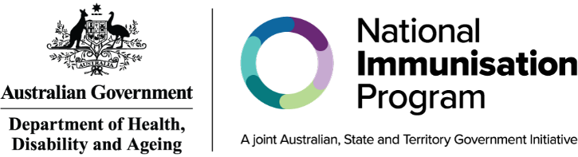

How to get a vaccine for your child
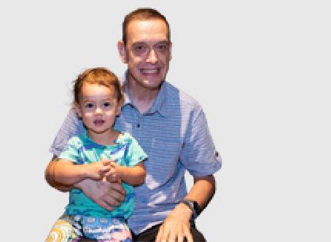
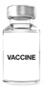

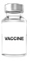
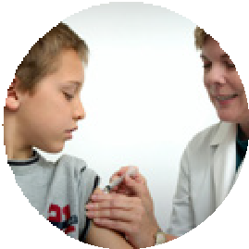


This information is about how to get a vaccine for your child.
Vaccines are medicines that can help stop children from getting sick.
Children get the vaccine
- With a needle in their arm or leg
- Or drops in their mouth.


Most of the time children get their vaccines from
- Doctor
- Nurse
- Health worker.
There are vaccines children should get when they are at certain ages.
For a list of what they are you can read our Easy Read fact sheet called What vaccines children should have.

Getting your childs information ready
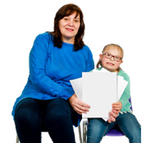
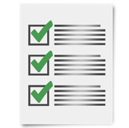
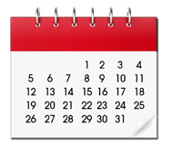
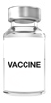
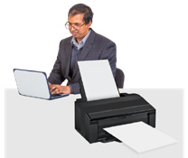
Before your child gets a vaccine it is a good idea to check their immunisation history statement.
An immunisation history statement is a list of all the vaccines your child has had.
You can also check it to see when your child needs their next vaccine.
You can ask your doctor for a copy of the immunisation history statement for your child.




To look at the immunisation history statement for your child you can also
- Call Services Australia on 1800 653 809 to ask for a copy
or
- Use the myGov mobile app
or
- Go to your myGov account and sign into your Medicare online account.
If you do not have Medicare you can use your Individual Healthcare Identifier in myGov.
An Individual Healthcare Identifier is a number you get to look at your health information.

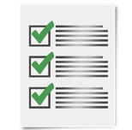
Your doctor will keep a list of all vaccines your child has had.

They will write it down in the personal health record booklet for your child.
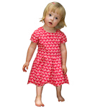


The personal health record booklet shows doctors all the health information for your child.

Your doctor will also add the vaccines your child has had to the Australian Immunisation Register.
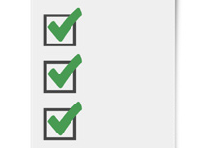
This is a big list that shows what vaccines everyone has had.

Where to get the vaccines
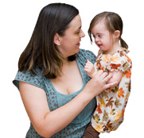
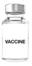
There are different places you can go to get your child a vaccine.
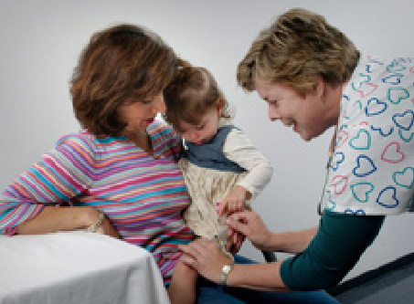
Your child can get their vaccines at their doctors office.


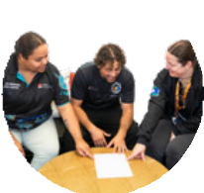
Your child can also get a vaccine in places like
- Community health centres
- Clinics run by your council
- Aboriginal Medical Services.


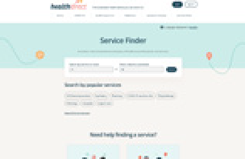
To find a health service you can go to https://www.healthdirect.gov.au/australian-health-services
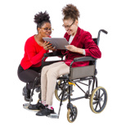
This website is not Easy Read.
You can ask for support to read it.
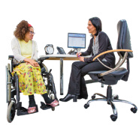

You might have to pay for the time you meet with your doctor or health worker.

This is called a consultation fee or administration fee.


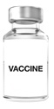
Vaccines are free for children if they get them at the age they are meant to.

If your child misses any vaccines they can get them later for free until they turn 20.
20
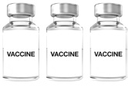

We have information about when children should get the different vaccines.

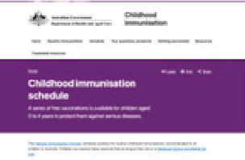


You can go to the website at www.health.gov.au/childhood-immunisation/immunisation-schedule
This website is not Easy Read. You can ask for support to read it.

When you meet with the doctor or nurse
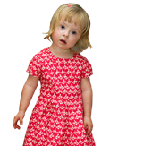

When you meet with the doctor or nurse bring the personal health record for your child.

The doctor or nurse might ask a few questions about your childs health.
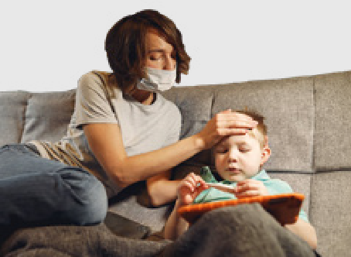
This is to make sure they are not sick.

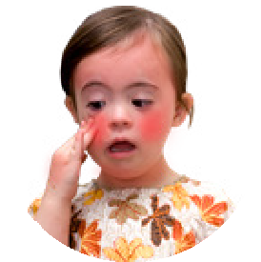


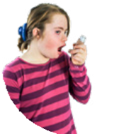
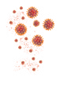
You should let the doctor or nurse know if your child
- Has a high fever
- Got sick after having a vaccine before
- Has a disease that makes them get sick more easily
- Gets medical treatment that can make them get sick easily.
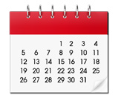
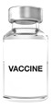
You should tell them if your child has had a vaccine in the last month.
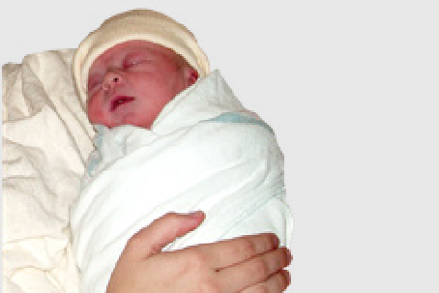
You should also tell them if your child was born before their due date.

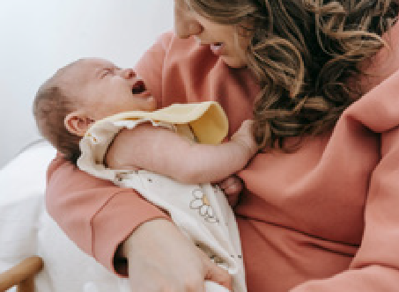
Your child should get their vaccines another time if they are sick on the day.
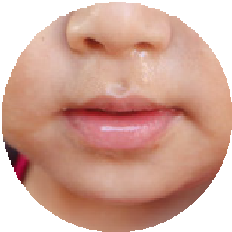
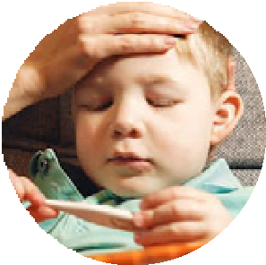
Babies can still get their vaccines if they only have
- A runny nose
- A little cold.

After the vaccines
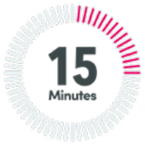
Your doctor will ask you to stay for 15 minutes after the vaccine.
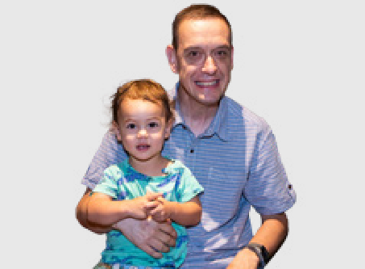
This is to make sure your child is ok after they get the vaccine.
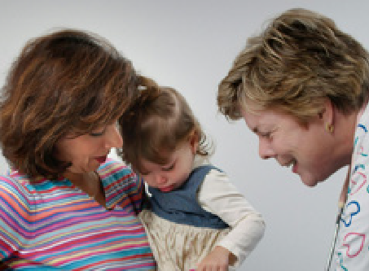
Your doctor knows how to help your child get better quickly if they are not ok after the vaccine.
Council for Intellectual Disability made this document Easy Read. CID for short. You need to ask CID if you want to use any pictures in this document.

