Support at Home program – consumer protections for prices
November 2025
Consumer protections are in place to ensure that Support at Home prices are reasonable and transparent, so you can make informed choices about your care.

Why might prices for my services change under Support at Home?
Under Support at Home, providers set their own prices for services as they did for the Home Care Packages Program. If you previously accessed Home Care Package services, the prices for your services under Support at Home may change.
Your provider will talk to you about any price changes ahead of asking you to agree to those changes.
Under the Home Care Packages Program, you were charged for a service (e.g. cleaning) and then charged separately for the cost of managing that package (e.g. third-party costs and staff travel).
Under Support at Home, the price for each service includes all those costs. This means the service price is the entire cost of delivering that service to you and will be the total amount charged to your budget. Your budget will only be charged for services that you receive.
Support at Home pricing will make it easier to see exactly how much care you have received and how much of your budget has been spent.
Learn more about the Support at Home program: MyAgedCare.gov.au/aged-care-programs/support-at-home-program

How do I know my prices are reasonable?
Reasonable prices reflect what it costs your provider to deliver services to you. They can include:
- the wages of your aged care workers
- travel to and from your house
- administration and overheads
- sub-contracting
- the provider’s costs of transitioning to Support at Home
- a margin to cover the cost of capital used in delivering the service.
To help you consider if your Support at Home prices are reasonable, you can compare your provider’s pricing with:
- other providers in your area using the Find a Provider tool on My Aged Care: MyAgedCare.gov.au/find-a-provider
- the indicative prices collected from Home Care Package providers in February 2025 (please note these are not price caps or recommended prices): health.gov.au/resources/publications/summary-of-indicative-support-at-home-prices

What are unreasonable prices?
Prices must take into account all the funding your provider already receives from government to provide your care. For example, if your provider gets subsidies or grants to deliver services in rural or remote regions, their prices must reflect that funding.
Your provider is not allowed to charge you separately for package management or travel. You cannot be asked to contribute to the cost of clinical care, including care management. If you see charges for these items, speak to your provider.

How will the government make sure prices are reasonable?
The Department of Health, Disability and Ageing (the department) and the Aged Care Quality and Safety Commission (the Commission) are working together to monitor pricing and will act if a provider is not following the law.
Additional consumer protections will make sure your Support at Home prices are reasonable and transparent:
- price caps will apply to Support at Home services from 1 July 2026
- providers must publish their prices for standard business hours for all their services on the My Aged Care website
- providers must keep evidence of what they have included in their prices – the department and the Commission can ask your provider to show us this evidence.

What contributions might I have to pay?
You will make no contribution for clinical support services that you receive, including care management. However, you may be assessed by government as needing to make contributions for ‘independence’ or ‘everyday living’ services.
Read more about participant contributions: MyAgedCare.gov.au/support-at-home-costs-and-contributions

Can I wait to sign a service agreement?
If you were already receiving Home Care Package services, you can keep receiving services under your existing Home Care Agreement until you sign a new Support at Home service agreement.
You can wait to sign a service agreement if you are unhappy with the prices or if you don’t understand why your prices are changing. However, you need to sign your new agreement within 90 days of receiving your confirmed contribution rate from Services Australia or your provider can cease your services.
If you’re new to in-home aged care, you need to have an agreement in place with a provider of your choice before accessing Support at Home services.
Read more about service agreements: MyAgedCare.gov.au/agreeing-support-at-home-services

Can I change providers?
You can change providers at any time – at no cost. Providers cannot charge you an entry or exit fee.
Use the Find a Provider tool on the My Aged Care website for information about providers in your area: MyAgedCare.gov.au/find-a-provider

What can I do if I am concerned about prices for my services?
If you are concerned about your Support at Home prices, you can ask your provider to explain their prices to you.
If you are still concerned, you can make a complaint to the Commission. If your provider cannot demonstrate that their prices are reasonable, the Commission can use its regulatory powers. This can include issuing a non-compliance notice requiring the provider to take specific actions. These actions may include changing their prices to make them more reasonable. If a provider refuses to comply, they may receive an infringement notice.
For assistance to make a complaint or to discuss pricing with your provider, you can contact the Older Persons Advisory Network (OPAN) on 1800 700 600.
Under Australian Consumer Law, providers cannot make misleading or deceptive statements about their prices or the reasons for a price change. The Australian Competition and Consumer Commission can investigate and act where businesses mislead participants about prices.
For more information
To find out more about Support at Home, visit: MyAgedCare.gov.au/aged-care-programs/support-at-home-program
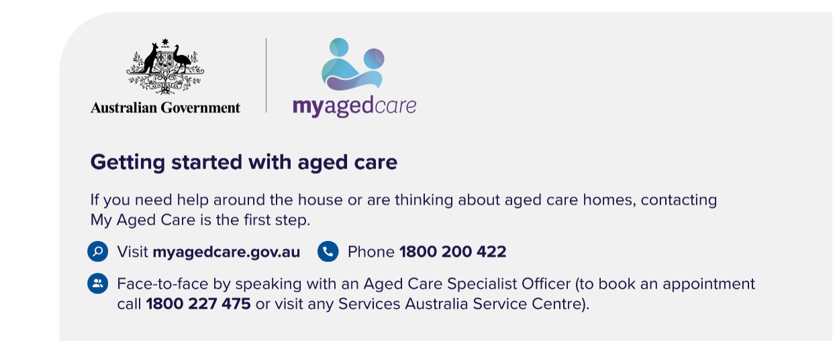
If you have questions or concerns about your aged care, including Support at Home, you can speak to an aged care advocate by calling the Aged Care Advocacy Line on 1800 700 600. Provided by the Older Persons Advocacy Network (OPAN), this free and confidential service is independent of both government and aged care providers. OPAN will connect you with a local advocate in your state or territory.

