Registering your practice on Healthdirect Australia’s National Health Services Directory

19 December 2025

Overview
Practices participating in the Bulk Billing Practice Incentive Program (BBPIP) must register as a ‘bulk billing only’ practice on Healthdirect Australia’s National Health Services Directory (NHSD). Practices are required to maintain registration for the entire period of participation in the program. Practices must ensure that all details on Healthdirect’s NHSD, including address, contact details and opening hours are accurate. Practices participating in BBPIP with multiple NHSD listings must ensure all listings are registered as ‘bulk billing only’.
Further information about the Healthdirect and signage requirements can be found here.
If you believe your practice is not yet registered on Healthdirect’s NHSD, you can check by searching for your practice on Healthdirect’s Service Finder.
If you believe your practice is already registered on Healthdirect’s NHSD, further information on how to update your listing in line with BBPIP requirements can be found here.

How to register your details
There are two main ways to register your practice details on Healthdirect’s NHSD:
Option 1: Directly through NHSD - Via the online registration form
Option 2: Indirectly through Provider Connect Australia™ (PCA™) – you can then choose to publish your data to the NHSD and other business partners.

Option one: Registering via NHSD
Steps to register:
- Open and complete the NHSD online registration form
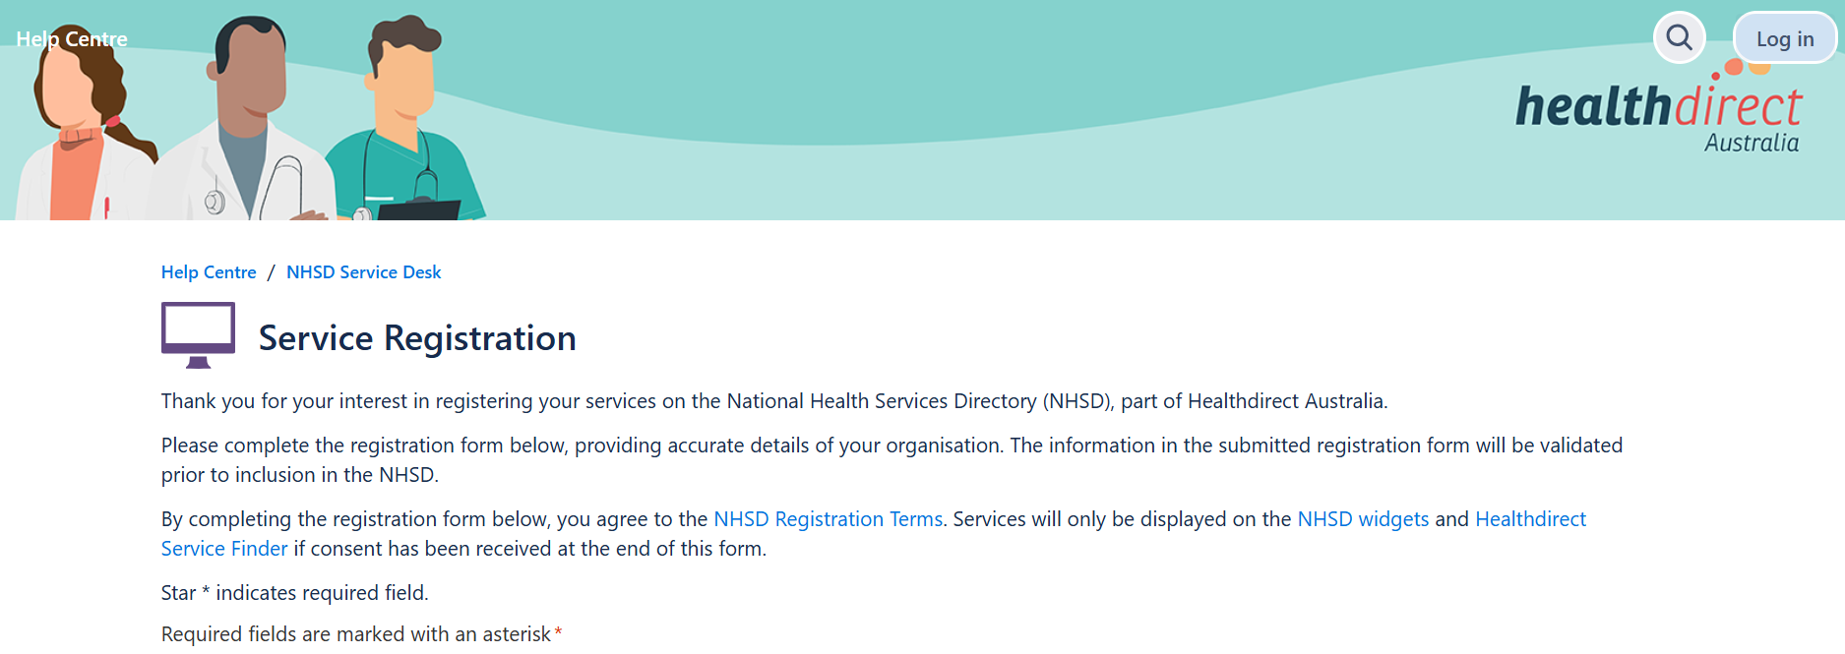
- Fill out your preferred email address for receipt of confirmation
- Enter your organisations ABN entity name/ABR legal name
- Enter your 11 digit ABN value, with not spacing before or after
- Enter your organisation name, this is the name consumers will see in the Service Finder
- Once you have provided this information, select I permit the NHSD publishing your service information for public use, including the Healthdirect Service Finder and the NHSD widget
- From the drop down box, select General Practice Service as your specific healthcare service
- Select if your service is restricted to only provide care for a specific population
- Enter key information about your service into the Service Description, if this is not captured elsewhere
    - You may wish to use this free text space to highlight you are a Medicare Bulk Billing Practice to the general public. Suggested text:
We are a Medicare Bulk Billing Practice. Most GP consultations are bulk billed for Medicare-eligible patients. Fees may apply for other services, please contact the practice for more information.
- Select Physical location – delivers healthcare services at a fixed street address
- Enter your physical address
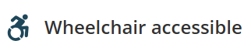
Select all the additional amenities your service provides. These will display as icons when consumers view your service
Enter a minimum of one service contact details e.g. phone, fax, email, website. This will be displayed on the NHSD
Select if appointments are or are not required
Select NO, referrals are not required for appointments

Select your billing option as Bulk billing only: no fee for this service with a Medicare card presented. This is a requirement to participate in BBPIP. The Bulk billing only logo will display on your NHSD listing
- Provide your operating hours.
The following questions relate to the practitioners listed as working at your practice. All practitioner information is published according to the setting indicated by the service, unless otherwise specified
- Indicate the number of practitioners to add to your listing. For each practitioner, provide their:
- Title, given name and surname
- Speciality and AHPRA registration number. Multiple specialities may be selected; General Practitioner must be one of these
- Gender and languages provided, in addition to English
- Advise if permission is given for the NHSD to publish the practitioner details for public use.
- Read and agree to the NHSD Registration Terms and Privacy Policy
- Enter you contact name and contact email address. These details are not displayed to the public, and are only used if NHSD needs to contact you for further information
- Click ‘Send’ at the bottom of the page to submit the form
- You will receive an acknowledgement receipt to your contact email address, to advise that your request has been received
- If any further information is required, a team member from Healthdirect’s NHSD will contact you.
- All listings for practices participating in BBPIP must be registered as ‘bulk billing only’
If you need assistance updating your listing, email nhsd@healthdirect.org.au.


Option two: Registering via PCA™
PCA™ enables registered healthcare organisations to maintain their business information in one place and share it with multiple partners in their healthcare service delivery.
Once organisations register via PCA™, it will automatically link to Healthdirect’s Service Finder, as well as other selected health service delivery partners, such as Primary Health Networks, healthcare directories, communication services, and more.
PCA™ is an initiative of the Australian Digital Health Agency.
Steps to register:
- Read the pre-registration checklist for PCA on digitalhealth.gov.au
- The pre-registration steps include:
Step 1: Ensure you have a PRODA account
Step 2: Make the Agency a contracted service provider in Health Professional Online Services (HPOS)
Step 3: Gather your organisation details
Step 4: Decide who will sign the participation agreement and requirement evidence of authority documents during registration.
- Add or update your healthcare services, ensuring you select ‘Bulk Billing Only’ as your billing option
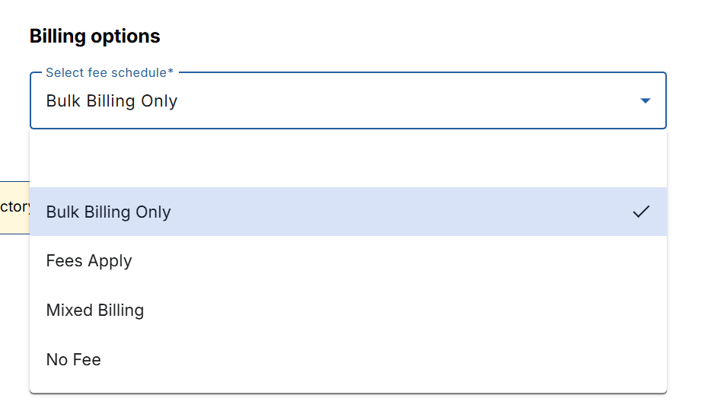
- All listings for practices participating in BBPIP must be registered as ‘bulk billing only’
- Tick ‘“Publish to National Health Services Directory” checkboxes.
For a more comprehensive list of steps, see the Australian Digital Health Agency ‘Register as an organisation’ webpage here.

Who can access Healthdirect’s NHSD
Everyone. Healthdirect’s NHSD is Australia’s most comprehensive free directory of healthcare professionals and services. Registering your practice in accordance with the Bulk Billing Practice Incentive Program: Healthdirect and signage requirements will:
- Improve awareness of bulk billing services for patients
- Help patients easily identify and access fully bulk billing (BBPIP registered) practices, reducing the need to research and compare options
- Provide assurance that participating practices will bulk bill, increasing patient confidence
- Support practices in attracting and retaining patients through clear identification of their bulk billing status.

More information
- BBPIP: Health.gov.au/BBPIP
- Healthdirect: Trusted Health Advice | Healthdirect
- Provider connect Australia™: digitalhealth/provider connect Australia.

