University Users

BRoSS User Guide

December 2025
V2.0

Contents

Introduction 3
Legislative changes 3
The Bonded Return of Service System (BRoSS) 3
Important Information 4
This Guide 4
BRoSS Login 11
BRoSS Functionality 12
Guidance 14
Add an Applicant 14
View the Full Participant List 16
Expand Individual Records 16
Download Participant List 17
Add a Note 17
Edit Record 19
Remove Applicant 20
Search to Edit or View a Participant 21
Log Out 22
Additional assistance 22

Introduction
The Bonded Medical Program (Program) came into effect from 1 January 2020. The Program was implemented to help address the shortage of medical professionals in regional, rural, and remote areas of Australia. The Program provides a Commonwealth Support Place (CSP) in a medical course at an Australian university in exchange for participants working in eligible locations after they graduate. On completion of their medical course the participant commits to working in an eligible location for up to 156 weeks as part of their ‘Return of Service Obligation’ (RoSO) under the Program.

Legislative changes

The Australian Government has recently amended Part VD of the Health Insurance Act 1973 to enhance the Bonded Medical Program (Program). Consequently, if a student withdraws from their medical course at an Australian university before graduating, they will not incur a Commonwealth Supported Place (CSP) debt and will no longer be considered a participant in the Program. However, they must log into BRoSS and action their withdrawal to ensure their record is updated accordingly.

Please note, it is a requirement under the Department of Education’s higher education providers’ funding agreements and Department of Health, Disability and Ageing memorandum of understanding that universities must not transfer a bonded participant to a non-bonded medical course place.

The Department is currently updating their processes and the BRoSS system to ensure these recent legislative changes are accurately reflected. In the meantime, when a student logs into BRoSS and requests a withdrawal, they may see a figure indicating an amount payable. The department will process the withdrawal request and update the student’s record to reflect a zero balance.

The Bonded Return of Service System (BRoSS)
To support the Program, the Department of Health, Disability and Ageing (Department) introduced BRoSS, a web portal, built to assist Program participants, university staff, other stakeholders, and the Department to effectively manage Program information and track participant progress whilst in the Program. BRoSS allows a Program participant to plan, monitor, and manage their obligations. The purpose of this manual is to aid the Universities in managing their firm offer applicant lists (Bonded CSPs) and review student status’ through their medical course in BRoSS.

University admission staff managing Program CSP applications will have secure BRoSS access to:
- enter applicant contact details
- maintain their firm offer list
- track applicant status for acceptance of the Program’s Terms and Conditions
- access resources to inform and support applicants and scholars
- report CSP withdrawals or changes in participant circumstances that impact course timelines.

Important Information
To access BRoSS, you are required to have a myID login.
- myID – an app you can download to your smart device or access online to verify your identity when using government online services.
Please note: a myID is different to a myGov account (www.myid.gov.au). Access needs to be arranged via your university and regular logins are required to retain active access.

- Relationship Authorisation Manager (RAM) – an authorisation service that allows you to act on behalf of a business or entity online when linked with your myID. You'll use your myID to log in https://info.authorisationmanager.gov.au/

Further information is available at:
• how to set up a Strong identity strength at www.myid.gov.au/setup
• the new set up process for existing users at www.myid.gov.au/help-managing-your-myid
For additional details on these digital authentication services, please refer to the following website: https://www.abr.gov.au/auskey/your-auskey-replacement.

This Guide
This Guide will assist University admission staff to access and use BRoSS. The Guide comprises of three sections:
- Registration – This is the first step that allows the university user to register with the Health Data Portal and receive access to BRoSS.
- BRoSS login - steps for logging in to BRoSS for the first time.
- BRoSS Functionality:
  - Guidance
  - Add an applicant
  - View the full participant list
Each Section has a series of steps and screen shots to guide university admissions staff through the process.
Registration
- Ensure you have a valid myID and the relevant Relationship Authorisation Manager (RAM) authorisations set up. For additional details, please check the following websites:
  - For myID setup and usage: https://www.myid.gov.au/
  - For RAM information: https://info.authorisationmanager.gov.au/
- Access the Health Data Portal: https://dataportal.health.gov.au
- The first time you do this, you will need to select Register (once you have Registered, you will need to select Log in). Additional instructions on how to register above or under the Health Data Portal.

The Data Portal home screen will display. Select the ‘Register’ option.

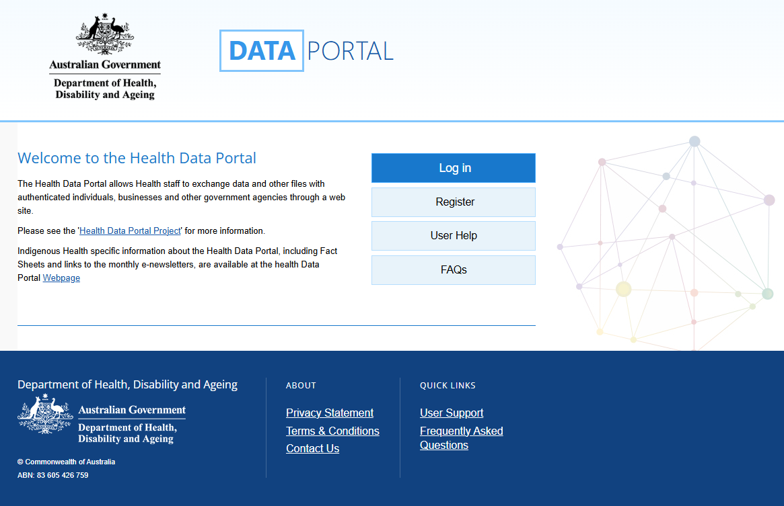

- The Health Data Portal (HDP) will prompt you for authentication to confirm you have a valid myID to be able to register for the HDP; read the instructions and then select ‘Next’.
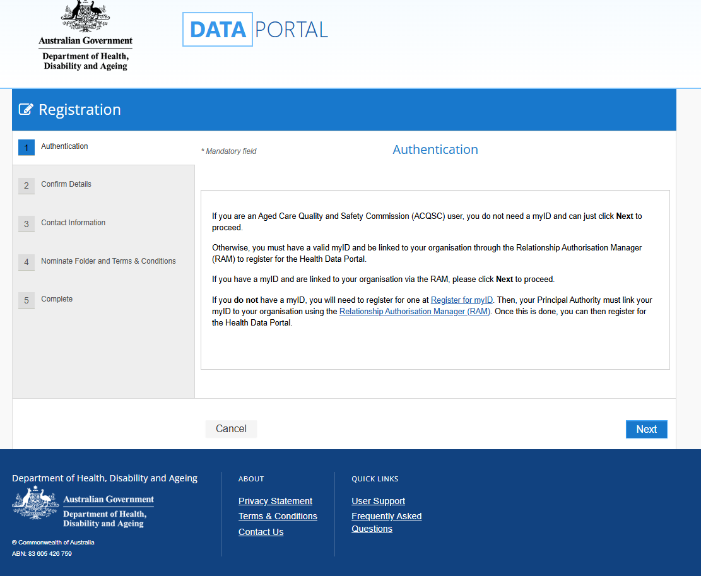

- The Health Authentication Gateway screen will be displayed. Click on the appropriate credential service to continue, for this instance select ‘Digital ID and RAM’. (Do not select ‘Login with myGov’ as this will take you to another screen).
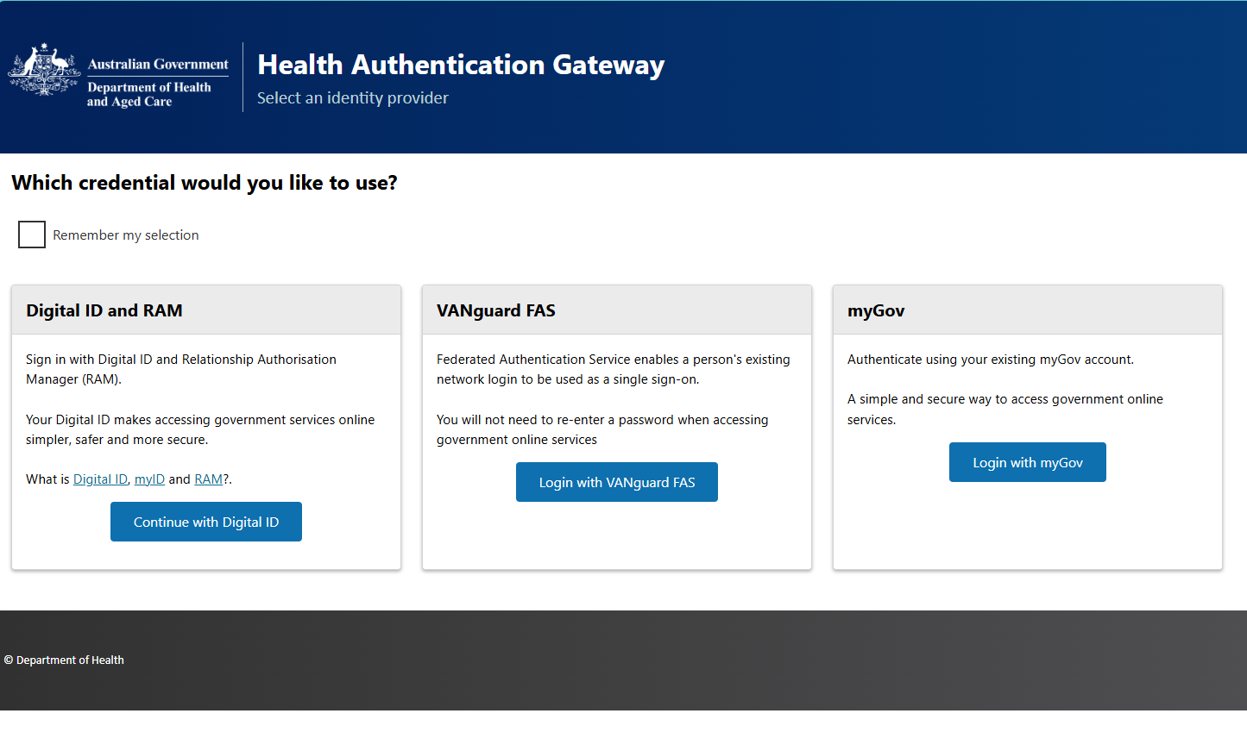
- The select your identity provider screen will display, select ‘Select myID’ to continue.
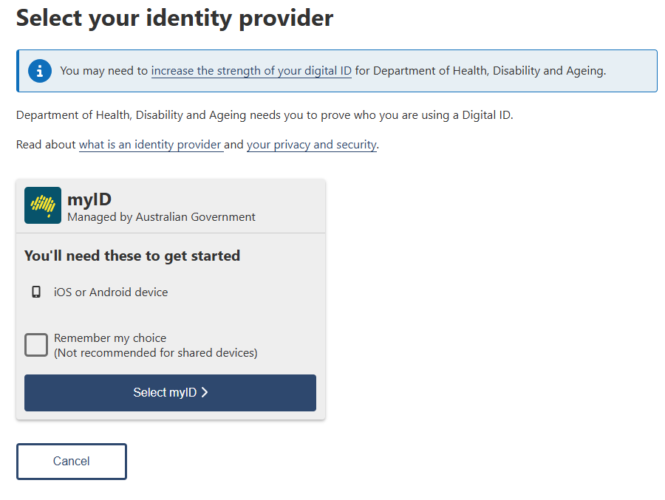

- The myID screen will display, enter your myID email address in the myID email field, then click ‘Get code’

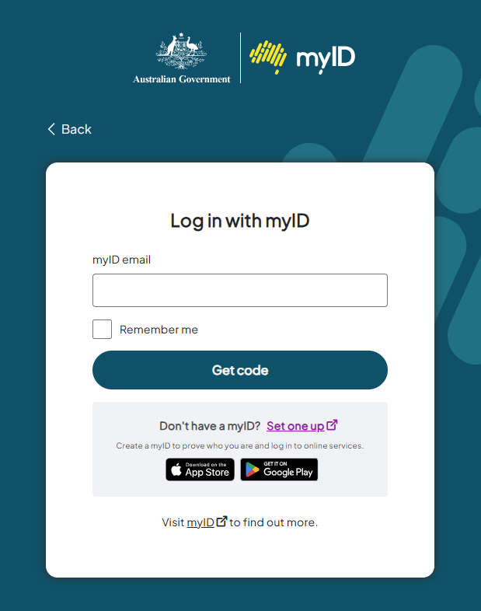

- Open the myID application on your phone and accept or enter your specific 4-digit code onto the screen, this will be updated every time you login. The Registration - Confirm details screen will display.

- The ‘Confirm Details’ screen open, confirm the onscreen details, then tick the certification box and click ‘Next’.
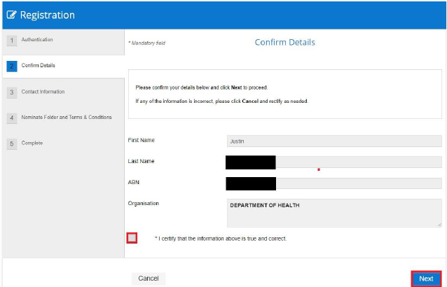
- The ‘Contact Information’ screen opens, enter your contact information, then click ‘Next’.
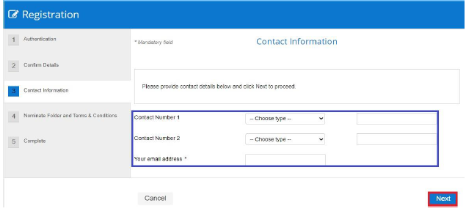
- The ‘Nominate Folder’ screen opens, select the ‘BRoSS’ folder from the drop-down list.
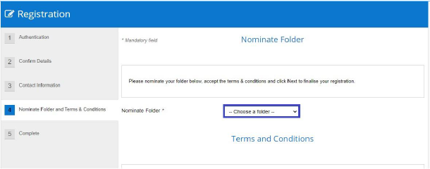
- Review and agree to the terms and conditions by clicking in the Agree box, then click ‘Next’.
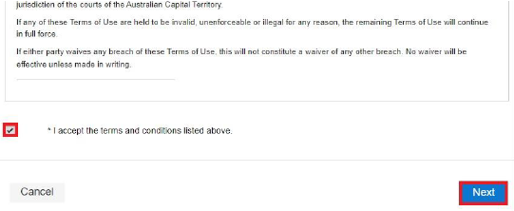
You have now successfully registered for the HDP. Your User Administrator will receive an email informing them they need to finalise your profile so you can use the HDP.
Please note: if the following screen fails to load within 5 minutes after agreeing to the terms and conditions: Please refresh/reload the page, agree to the terms and conditions again. An error screen will not be displayed. Please disregard this as the registration has been successful.

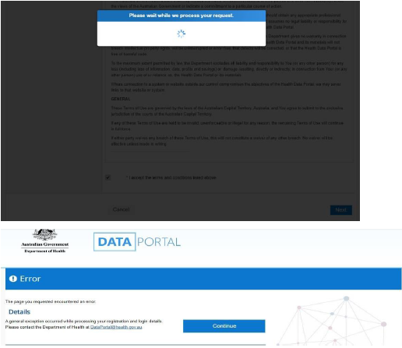
NOTE: if your credentials have not been set up or are incorrect, the following message will be displayed.
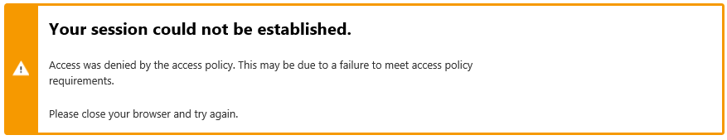
An email is generated to the address you specified following the authentication process, advising that a new BRoSS user has been registered and BRoSS roles can be added to the new user.
Once the department has assigned all roles and associated privileges to your account, an email will be sent advising that your BRoSS login is now available.

BRoSS Login
To log in to BRoSS, the user needs to authenticate by following the steps below.
- Access the Health Data Porta (HDP): https://dataportal.health.gov.au.
- Select Log in.

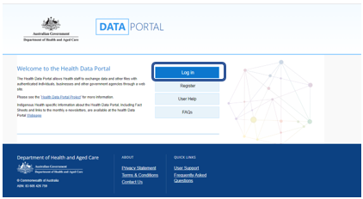

- Select ‘myID’ and authenticate.
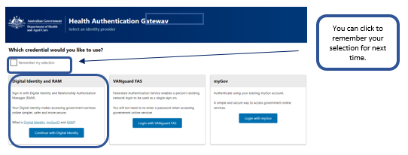

- Once authenticated, the HDP dashboard will open and you will be able to select ‘BRoSS’. To open you BRoSS dashboard.

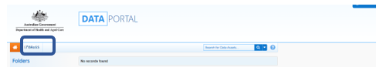

BRoSS Functionality
Once logged in, the following screen is presented. This is your main dashboard for BRoSS.
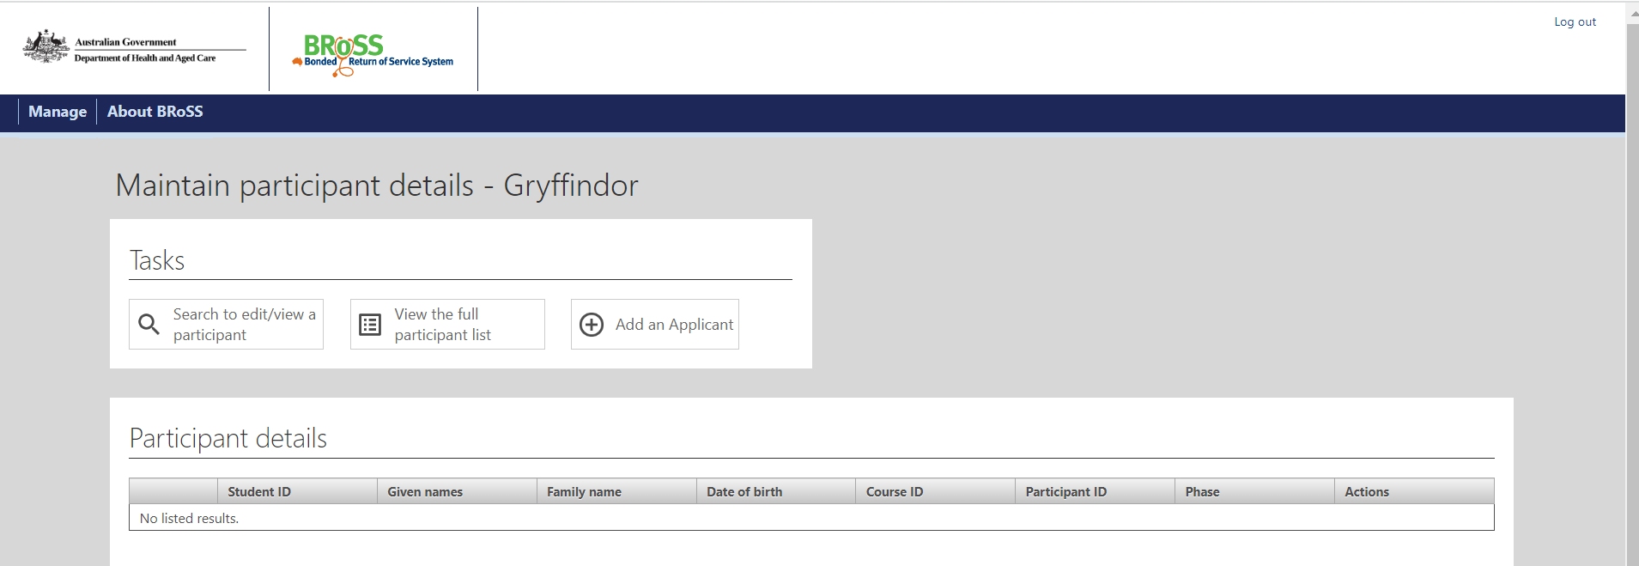
From any screen or activity window within BRoSS, you can return to this dashboard by hovering the mouse over ‘Manage’ in the top left corner and clicking on ‘Maintain participant details’.
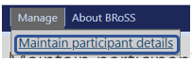
The ‘Maintain participant details’ screen includes the following tasks/functionality:
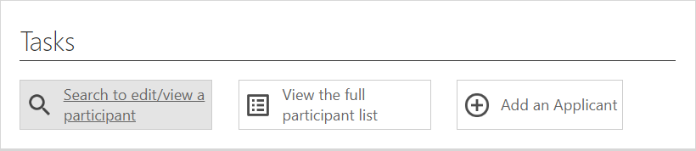
These Tasks will allow you to.
- Search to edit/view a participant – you can;
  - search for a bonded applicant or student at your university.
  - edit an applicant’s details.
  - view a student’s details.
- View the full participants list - you can;
  - export the list to excel.
- Adding an applicant – you can;
  - enter bonded CSP applicants.
Under the ‘About BRoSS’, there are external links to information about the Program:

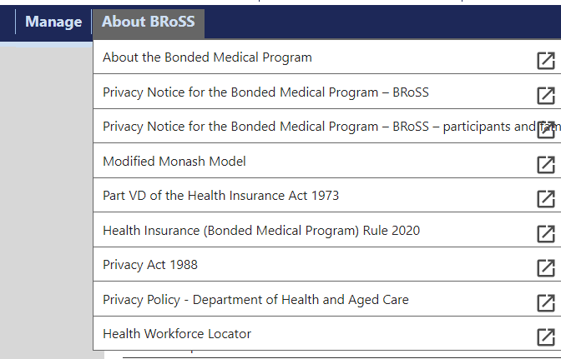

Here is a list of the links noted above:

About the Bonded Medical Program
https://www.health.gov.au/our-work/bonded-medical-program.

Privacy Notice for the Bonded Medical Program – BRoSS
https://www.health.gov.au/using-our-websites/website-privacy-policy/privacy-notice-for-the-bonded-medical-program-bross

Privacy Notice for the Bonded Medical Program – BRoSS – Participants and Family members
https://www.health.gov.au/using-our-websites/website-privacy-policy/privacy-notice-for-the-bonded-medical-program-bross-participants-and-family-members

Modified Monash Model
https://www.health.gov.au/topics/rural-health-workforce/classifications/mmm?language=und

Part VD of the Health Insurance Act 1973
https://www.legislation.gov.au/C2004A00101/latest/text

Health Insurance (Bonded Medical Program) Rule 2020 - https://www.legislation.gov.au/F2019L01513/latest/text

Privacy Act 1988
https://www.legislation.gov.au/C2004A03712/latest/text

Privacy Policy – Department of Health, Disability and Ageing https://www.health.gov.au/resources/publications/privacy-policy

Guidance
When performing tasks (Search to edit/view a participant, view full participant list or adding an applicant), each new screen includes a ‘Guidance’ tab. The ‘Guidance’ tab on the right-hand side of each section provides additional information and instructions to assist perform each task. Click on the arrow to expand the section and scroll down to access the information and click on the arrow again, to close the section.
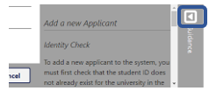

Add an Applicant
Before a new applicant can be added, BRoSS will use the ‘Student ID’ you enter and check for any existing records for that student to avoid creating a duplicate record.
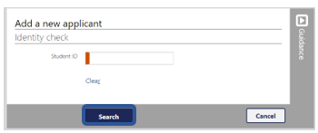
  - If the ‘Student ID’ already exists, the following notification will be displayed:
(Please contact the Program team – BondedMedicalProgram@health.gov.au, for assistance if this applicant needs to be used.)
- If the ‘Student ID’ does not exist, a different notification will be displayed, and the ‘Search’ button will change to ‘Proceed’.
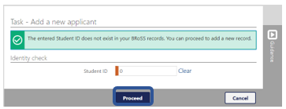
Upon clicking ‘Proceed’, the ‘Add a new applicant’ screen will be displayed. Fill in the mandatory fields (marked with orange) and click ‘Save’ to complete the task.
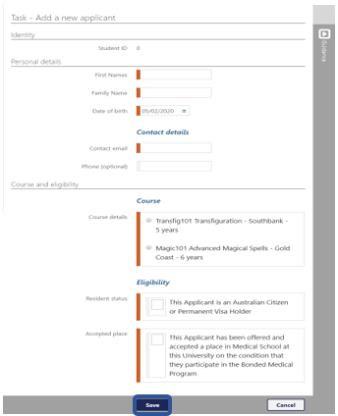
Clicking ‘Save’ will return you to your Dashboard.
NOTE: The functionality to add a new applicant into the Bonded Medical Program is only available from 1 January to 30 June each year.
If an applicant needs to be added outside of this period, contact the Program Team at bondedmedicalprogram@health.gov.au

View the Full Participant List
Upon clicking the ‘View the full participant list’ button, the system will display a notification showing how many matches were found, and a list of participants in a table.
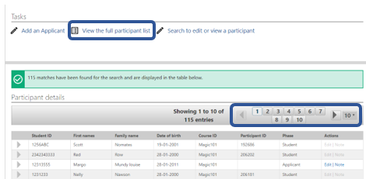
The search results will initially display a maximum of 10 records per page; if there are more than 10 records, the number of additional pages will also be displayed. To navigate directly to another page of records, select a page number; to navigate forwards or backwards through the records, one page at a time, click on the arrows to either side. By default, 10 records are displayed on each page; this setting can be changed to 25 or 50 by clicking the arrow to the right of the number in this box.
Under the column ‘Phase’ - it provides information on the listed individual’s status under the Program:
Applicant – offered a Bonded Medical Program place. University users can view both active and inactive applicants in this list.
Student – accepted their Bonded Medical Program place. University user will only see active Students in this list, once the student has completed their medical studies or withdrawn and it has been processed in BRoSS, they will be removed from the university view.

Expand Individual Records
To expand a search result so more information can be viewed about a participant, select the icon on the left side of the participant ID.
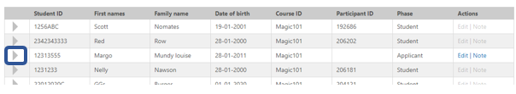

To minimise the record, select the icon.
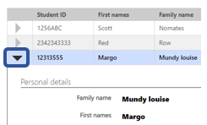

Download Participant List
At the base of each page of the search result list is an action to ‘Download participant list’.
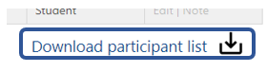
Clicking on this, will download the entire list of participants, including their Year of enrolment, into an excel spreadsheet which will be located in the user’s ‘Downloads’ folder.
Participant ID | Given names | Family name | Contact email | Student ID | Scheme | Phase | Status | University | Year of enrolment
The columns include:

Add a Note
Beside each displayed record, there are options to ‘Edit’ the record or update the information in ‘Note’.

Clicking on the ‘Note’ action enables the user to save an additional note for the participant. Notes are date and time stamped and therefore cannot be edited once saved. Only your university users and health users can view the notes attached to each applicant/participant record.
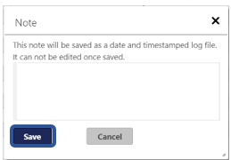
Once saved, the note will be displayed within an applicant/participant’s record.
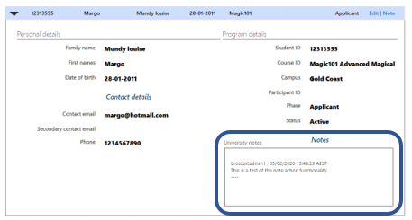

Edit Record
Clicking the ‘Edit’ action enables direct editing of the applicant’s details.
Note: you are only able to ‘Edit’ an ‘Applicant’s’ record. Once they become a ‘Student’ it is their responsibility to update their details.
You will have the capability to edit aspects of identity, personal details, course details and Program eligibility.
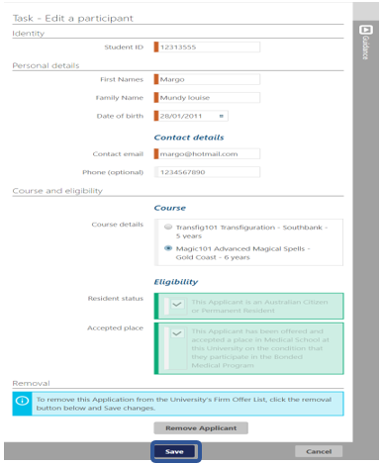
NOTE: University’s are only able to edit an Applicants record. Once the Applicant has agreed to participant and their Phase has updated to Student, their record becomes locked and the university can no longer edit the record.

Remove Applicant
Below the participant’s details in the ‘Edit a participant’ screen, there is an option to remove an applicant from the University Firm Offer List.
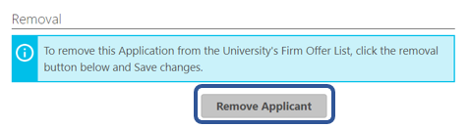
Clicking on this button will prompt a warning that the applicant will be withdrawn from the list and the button will change to read ‘Applicant has been removed’; clicking on this button will reverse the removal. However, neither action will be completed or recorded until the ‘Save’ button is clicked.
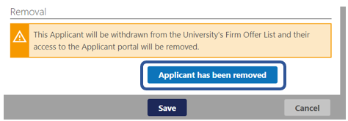

For applicants that have been removed, the option to restore the applicant will appear as an action against that name in the participant details search screens. Upon clicking ‘Restore applicant’, a confirmation screen will appear. Click ‘Yes’ or ‘No’ as appropriate.
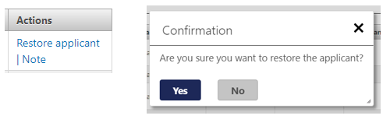

Search to Edit or View a Participant
Clicking on this option brings up the following screen.
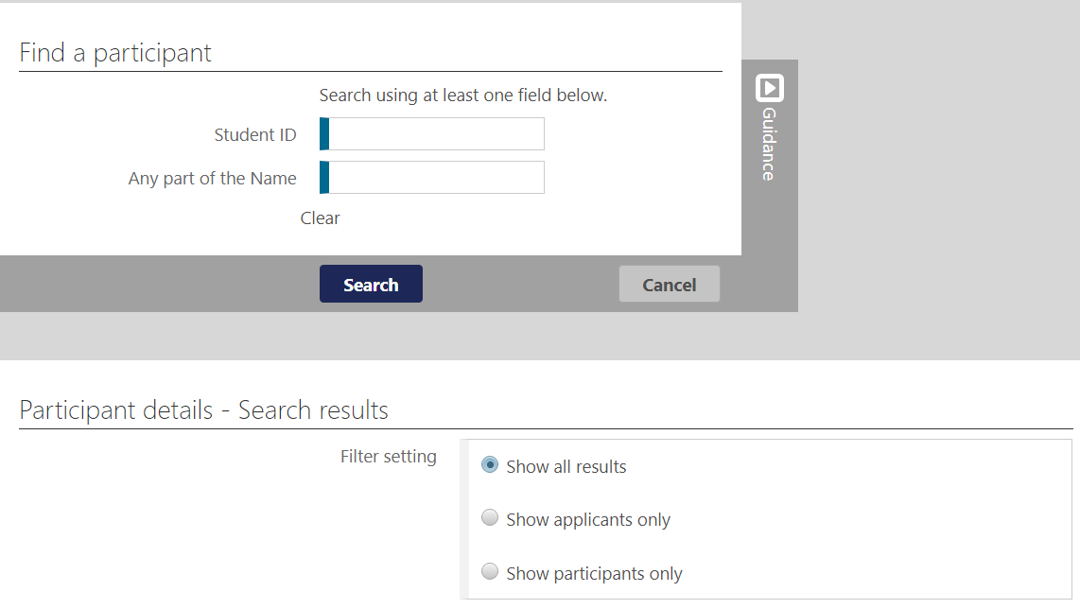
Results can be filtered to display all results, or only applicants or participants (Students).
A search can be conducted by Student ID or a name. Note that the system will return results for partial matches of a Student ID or a name. For example, searching for Student ID ‘123’ will return the following results:
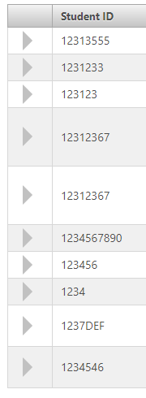
While a search against the name ‘se’ will return the following:
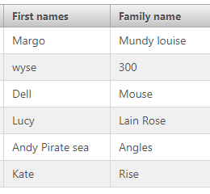
Providing more information for each field will better refine the search results e.g., if the exact name or Student ID is known, entering these will result in an individual record rather than many pages of results.

Log Out
To ‘log out’ of BRoSS, select the Log out link in the top right corner of the screen.
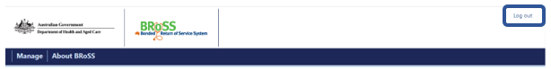

Then log out of the Data Portal by selecting the username in the top right corner of the screen and then Log out.
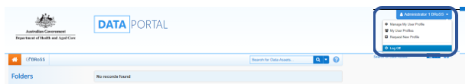

Additional assistance
If you require further Program information or assistance, please contact the Department of Health, Disability and Ageing at:
- Website: Bonded Medical Program which contains instructional BRoSS videos
- Email: BondedMedicalProgram@health.gov.au using the subject title format: Bonded Medical Program – your name – request type
- Telephone: 1800 987 104 (Monday-Friday, 8:30am to 5:00pm AEST/AEDT).

