Summary Needs Assessment Report
  - Better Renal Services Measure

Contents
Acknowledgements iii
Executive Summary iv
Key findings iv
Caveats v
Introduction 1
Project purpose 1
Project scope 1
Phase 1: Supply analysis 1
Phase 2: Demand analysis 2
Phase 3: Needs assessment 2
Phase 1: Supply analysis 2
Overview 2
Travel burdens 5
Wet season 7
Site capacity 8
Phase 2: Demand analysis 10
Overview 10
Estimating demand 10
Data sources 12
Results 15
Phase 3: Needs assessment 16
Overview 16
Estimated unmet demand 17
Key findings 17
Needs assessment 20
Community needs rating 21
Results 22
Appendix 23
Catchment needs rating 23
Wet season needs rating 24

Acknowledgements
The project team would like to thank all individuals and organisations who contributed to this work, particularly the Better Renal Services Steering Committee and the associated Working Group. Our sincere thanks for the invaluable time, knowledge and information they each provided throughout the development of this report.

Executive Summary
The Australian Government is investing $73.2 million to deliver up to 30 four-chair dialysis units and workforce accommodation on Country to support First Nations people with end-stage kidney disease under the Better Renal Services for First Nations Peoples Measure (BRS measure). The Department of Health, Disability and Ageing (the Department) and the National Aboriginal Community Controlled Health Organisation (NACCHO) have established the Better Renal Services for First Nations Peoples Steering Committee (the Committee) to provide advice on implementation of the measure and guide site selection.
There have been significant challenges in obtaining data to inform the Committee’s recommendations. While information exists on dialysis services, there is no national dataset capturing the home communities of patients. Additionally, there is no comprehensive view of service accessibility for remote communities. Given most patients in remote areas relocate for treatment, this information is essential for identifying high-needs communities that may be suitable for BRS sites.
The objective of the full report provided to the Committee is to provide the Committee with the best possible estimate of need and accessibility of dialysis services in regional and remote Australia. By drawing on a range of available datasets such as the Australian and New Zealand Dialysis and Transplant (ANZDATA) Registry and the National Key Performance Indicators (nKPIs) as well as data collected by service providers including Kimberley Renal Services and Purple House, the report has been able to model gaps in service coverage down to Indigenous Location (ILOC). By consistently mapping need for dialysis and access to treatment across communities, this work aims to help identify communities that have not submitted an Expression Of Interest (EOI) for the BRS Measure but where impact may be significant.
This report provides a summary view of the report scope, methodology and findings.

Key findings
- An estimated ~1,800 people in remote Australia require haemodialysis, 90% of whom are First Nations people.
- The analysis suggests that access to treatment is most limited in MMM 7 with ~800 people (69% of patients needing haemodialysis) unable to access treatment close to home. It is estimated that there is still unmet need in MMM 6 where a further ~300 people cannot access care near their community.
- An estimated 60% of dialysis need in MMM 6-7 is currently unmet in the patient’s home location, suggesting ~1,100 patients have relocated to access treatment.
- 33 remote1 communities are estimated to have more than eight patients that have likely relocated to access treatment. These communities may have sufficient demand for a four-chair dialysis unit. It is recognised that establishment of a new site depends on a range of additional factors such as community support, availability of necessary infrastructure and adjacent services such as aged care.
- Analysis also suggests that unmet need exists in places where sites already exist. In these cases, policy response options may include:
- Adding new chairs to existing sites
- Addressing critical enabling mechanisms such as workforce accommodation to support increased patient to chair ratios
- The potential service footprint of a new site has also been included as a factor for site placement consideration. Noting service catchment can be complex in remote settings and is not always appropriate, this information has been provided for case-by-case assessment. A map has also been provided to help identify wider catchments for communities if required.
- A significant number of remote patients (~700) are estimated to live in communities where demand would not be enough to sustain a new site. For these communities, alternative support options to help patients maintain connection to Country could include mobile sites and support for self-care dialysis.

Caveats
- The model is not intended to replace community-identified needs or the informed perspectives of communities themselves. Rather, its purpose is to highlight communities that may not have yet submitted an EOI but may have significant unmet need. It serves as one input into the decision-making process for site selection and must be considered alongside other critical factors.
- Estimated need provides an indication of patients currently accessing haemodialysis by their home location. It may not capture all persons who may require haemodialysis or those unable to return to their communities due to additional underlying health conditions or other factors.
- Modelling approaches inherently have limitations, and outcomes can only be as accurate as the data and assumptions they are based upon. Specifically, this model primarily considers demographic and geographic factors, based on the information available at the time of analysis. It does not account for the full range of variables influencing dialysis needs, such as individual health conditions or specific local healthcare infrastructure.
- This analysis does not represent the views of the individuals and organisations who provided data to support modelling.

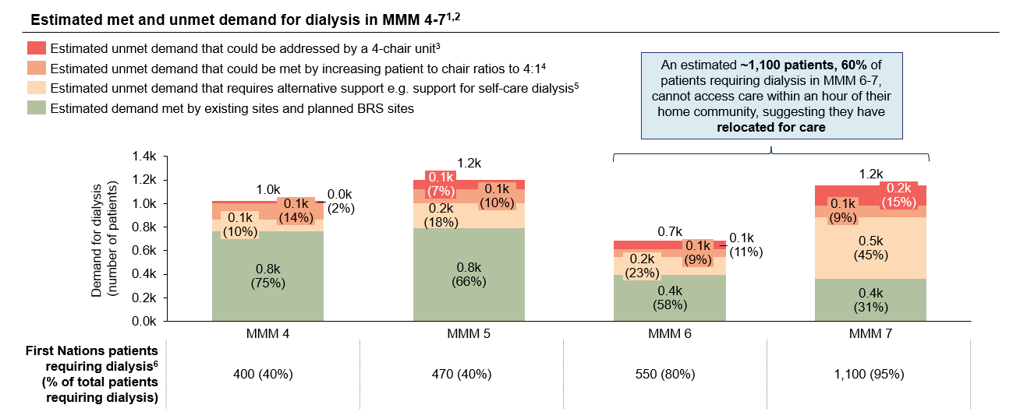
Figure 1 Summary of met and unmet need for haemodialysis in MMM 4-7
Figure 1 notes: Results are central estimates and based on analysis conducted on 31/01/2025
- Includes existing sites and planned BRS sites, excludes planned State and Territory sites
- ILOC centroids are based on population weighted MB centroids
- There are 8 or more patients requiring care (after accounting for need that could be met by addressing capacity constraints) that could be supported with a 4-chair unit operating on a 2 patient per chair ratio
- Some units in regional and remote areas operate on a 2:1 patient to chair ratio due to capacity constraints such as workforce shortages/lack of staff to administer treatment
- Less than 8 patients requiring care. Alternative support could include mobile dialysis or support for self-administered dialysis such as home dialysis
- Rounded to nearest 10 patients

Introduction

Project purpose
The objective of this project is to provide an estimate of current dialysis need by home location and to assess accessibility of services for each community in MMM 4 – 7. The findings of this report are intended to provide a sound and equitable method of identifying potential unmet need for dialysis. Estimates should be verified through consultation with relevant communities. Findings will be paired with additional operational and feasibility considerations such as available workforce and infrastructure.
The project was overseen by the Better Renal Services for First Nations Peoples Steering Committee (the Committee). The Committee established a Working Group to provide regular guidance on assumptions and data for the analysis and insights contained in this report.
The full project analysis and findings are presented to the Committee to inform their overall consideration of:

Site selection
- To identify communities that have not submitted an EOI but where impact would be significant.
- To support EOI evaluation by capturing unmet needs in nearby areas not covered by the community's self-assessment.

Operational planning
- To help gauge number of chairs required and workforce needs by providing an indication of the number of people expected to attend a new site from surrounding communities.

Future policy reform and additional support for communities
- To support other potential priorities for the Committee such as scoping the expansion of the MBS item 13105.
- To support consideration of mechanisms to reduce capacity constraints within existing sites.

Project scope
The project was delivered over three phases and focused on need for staffed haemodialysis services in MMM 4-7 communities:

Phase 1: Supply analysis

Objective
To evaluate the accessibility of existing and planned dialysis sites to regional and remote communities.

Scope
Communities: Communities were defined by Indigenous Locations (ILOCs). ILOCs are designed to represent small Aboriginal and Torres Strait Islander communities that are near each other or that share language, traditional borders or Native Title. Only MMM 4-7 ILOCs were considered, given the Measure’s focus on regional and remote areas.
Type of site: Only staffed haemodialysis sites that provided services in 2023 according to ANZDATA, opened in 2024 or are planned under the BRS measure were included in an assessment of supply. Self-care sites were excluded from this analysis.
Accessibility: Phase 1 considered how access to care may be impacted across 4 factors - travel distance, access to culturally appropriate care, availability of chairs and the impact of the wet season on travel - acknowledging that accessibility is broader than this subset.

Phase 2: Demand analysis

Objective
To estimate demand for dialysis services, accounting for patients’ home locations.

Scope
Demand: Demand was limited to demand for haemodialysis services due to the nature of data available. Estimates do not include patients with Stage 5 Chronic Kidney Disease (CKD) receiving other Kidney Replacement Therapy (KRT) or those who choose not receive treatment.

Phase 3: Needs assessment

Objective
To identify gaps in service coverage and areas of greatest need.

Scope
Suitability of sites: This analysis only considers a community's suitability on the basis of unmet demand and limited access to services. It is recognised that the establishment of a new site also depends on feasibility factors such the availability of quality water and infrastructure. These factors are not captured in site ratings.

Phase 1: Supply analysis

Overview

Objective
To evaluate the accessibility of existing and planned sites to regional and remote communities (MMM 4-7).

Context
First Nations patients in remote Australia face significant barriers to accessing dialysis, primarily due to distance to treatment and limited chair availability. Travel times over an hour often necessitate relocation, and the presence of a site does not guarantee access, as many remote locations have waiting lists. This analysis aimed to provide a complete assessment of the accessibility of sites (existing and planned under the BRS Measure) to communities in MMM 4-7 to identify those facing barriers to treatment.

Approach
This analysis evaluated four barriers to treatment, but recognises accessibility is broader than this subset:
- Travel burdens: For each ILOC, travel times were calculated to all existing and BRS planned sites to determine the time residents must travel to the nearest site.
- Accessibility of culturally appropriate care: Building on travel burden analysis, for each ILOC, time to the nearest Aboriginal Medical Service was determined (noting culturally appropriate care is broader than access to AMS care).
- Impact of wet season: Analysis identified communities with potentially restricted access to dialysis during the wet season.
- Site capacity: To determine whether a site has available chairs/demand can be met by a site, site capacity was estimated during this phase. Site capacity was estimated from the actual number of patients being serviced at sites. Theoretical capacity, assuming a 4 patient to chair ratio, was also estimated to determine the degree of unmet need that could be addressed by increased site capacity in Phase 3.
Table 1 below sets out the range of factors that impact access to care, that were considered for assessment.

Key findings
- An estimated 55% of the population in MMM 7 live more than an hour away to the nearest dialysis site. Accessibility is also limited in MMM 6 where 36% of the population live over an hour from the nearest site.
- Already selected BRS sites will mean an additional ~ 17k MMM 7 residents will soon be within an hour of a site that previously lived further away.
- There are significant remote population centres in MMM 6 and 7 where no dialysis sites are located within or close to communities.
- Some communities must travel over 6 hours to the nearest dialysis site.
Table 1 | Factors considered in evaluating barriers to dialysis access
Barrier to dialysis access |  | How barrier was/could be evaluated | How it was assessed
Travel | Distance to dialysis services | Estimated travel distances from all dialysis sites to remote communities to identify communities that must travel over an hour to a dialysis unit | Assessed
Travel | Impact of weather on travel | Identified communities in areas impacted by the wet season that are 30 – 60 minutes to the nearest site and so may be cut off from care | Assessed
Travel | Availability of transport options | Difficult to assess due to reliance on private transport in remote areas on the mainland and individual ferry timetables for islands | Indirectly assessed
Cultural considerations | Access to culturally safe care | Identified communities with no nearby AMS haemodialysis site | Assessed
Cultural considerations | Language barriers | Identify communities that do not have nearby sites within the same language group by overlaying languages from AIATSIS, although this may be better assessed on a case-by-case basis | Indirectly assessed
Capacity constraints | Sites at capacity/unable to support more patients | Estimated the number of patients sites can support and determined if less than nearby patients requiring dialysis | Assessed
Workforce | Availability of staff to administer care | Impact of staffing constraints on existing sites captured indirectly through site capacity analysis | Not assessed as more appropriately considered on a case-by-case basis or deprioritised due to project constraints
Workforce | Availability of nephrologists to manage care | The number of nephrologists in an LGA could be estimated using Health Workforce Data however this will not capture the availability of nephrologists to specific communities | Indirectly assessed
Financial barriers | Treatment expenses | Identify private billing clinics, although unlikely to be relevant in regional and remote areas | Indirectly assessed
Financial barriers | Additional expenses | Infer additional expenses from travel distance e.g. travel distances over a certain threshold require accommodation | Indirectly assessed

Travel burdens
For each ILOC, travel times were calculated to all existing and BRS planned sites to determine the minimum time residents must travel.

Methodology for estimating travel burdens
- Identified sites: Obtained addresses of 407 active sites from ANZDATA and communities selected for 16 BRS sites, identifying AMS sites
- Mapped sites: Determined geographical coordinates of sites using OpenStreetMaps
- Mapped Statistical Areas Level 1 (SA1): Determined the coordinates of the centre of each SA1.
- Estimated travel times: Estimated travel times between each SA1 and site based on location.
- Mainland: Travel times based on OpenStreetMaps driving duration. Travel speeds were verified to ensure times accounted for slower (e.g. 70 km/h) speeds on remote roads.
- Island: Travel times based on direct distance and ferry speeds of 25 km/hr.
- Identified nearest site: For each SA1, identified the nearest site and nearest AMS site based on travel times.
- Determined median travel time for each ILOC: For each ILOC, determined nearest site and travel times by taking the median SA1 travel time.
Sites were deemed to be potentially accessible if they were located within an hour of a community, as travel times over an hour are difficult for patients to sustain. Results highlight clear areas of limited access in remote areas.
Figure 2 | Heatmap of Indigenous Locations by drive time to nearest dialysis site
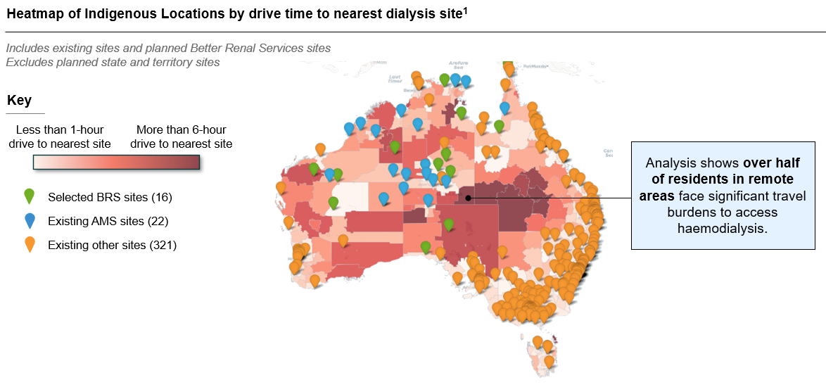
Figure 2 notes: Results are central estimates and based on analysis conducted on 31/01/2025
It is important to note that being within an hour of a site does not equate to access to care as many remote sites have waitlists. See unmet results for a complete assessment of accessibility.
Figure 3 shows that an estimated 55% of the population in MMM 7 live more than an hour away to the nearest dialysis site.
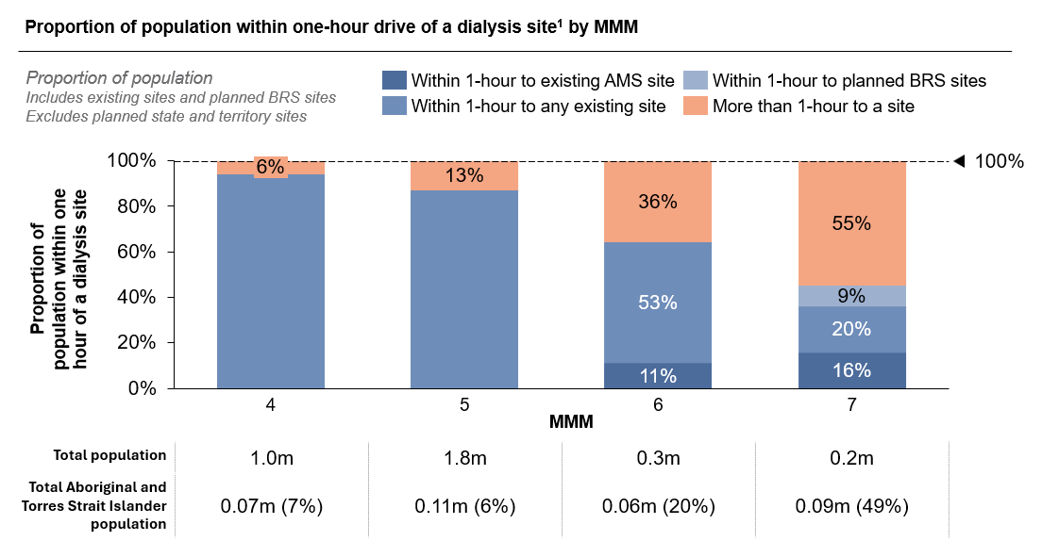
Figure 3 | Proportion of population within one-hour drive of a dialysis site by MMM
Figure 3 notes: Existing sites sourced from ANZDATA, received 22 November 2024.

Wet season
This analysis focused on the impact of the wet season on the ability of remote and regional communities to access care because of its recurring nature but acknowledges there are other weather events that adversely impact access to care. At risk communities were defined as those within wet season prone areas that would usually have access to care outside the wet season.
The analysis was conducted based on two assumptions:
Assumption 1:
Areas above a certain latitude are potentially impacted by the wet season (based on Bureau of Meteorology rainfall maps during October – April).
Areas below a certain latitude may be impacted by other weather events but not regularly impacted by the wet season.
Assumption 2:
Areas impacted may only be able to access sites within 30 minutes travel time. Travel times of more than 30 minutes assumed to be potentially inaccessible during the wet season, noting those over an hour are already inaccessible to communities.
Figure 4 | Areas potentially impacted by wet season
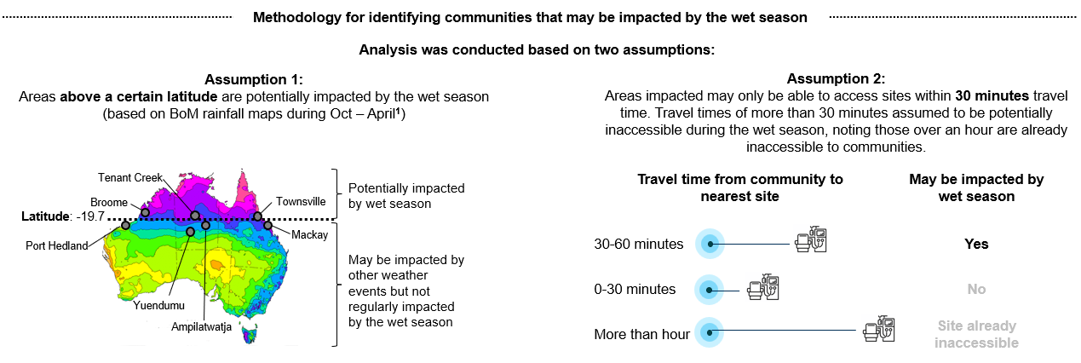
Figure 4 notes: Results are central estimates and based on analysis conducted on 04/02/2025.

Site capacity
ANZDATA, Purple House and MBS data were used to estimate current and theoretical capacity for regional and remote sites.
Table 2 | Methodology for estimating capacity of staffed haemodialysis sites
Type of site | Estimated current capacity  Estimated by evaluating actual servicing behaviour |  | Theoretical capacity  Estimated from chairs at sites and ratio of 4 patients per chair
Type of site | Data source | Measure | Data source | Measure
Hospitals | ANZDATA | Median number of unique patients each month, 2023 | ANZDATA Capacity Survey | Maximum of number of reported chairs x 4 and actual capacity
Purple House | Purple House | Number of patients at sites as of 15/01/25 | Purple House chair counts | Number of reported chairs x 4
Select remote sites | MBS | Median number of unique patients each month, 2023 | Researched | Number of reported chairs x 4
Remaining sites | ANZDATA | Median number of unique patients each month, 2023 | ANZDATA Capacity Survey, sites not included in Survey were researched | Number of reported chairs x 4
Where actual capacity is less than 4 patients per chair, findings estimate the proportion of unmet demand that could be addressed by increasing site capacity to 4 patients per chair. It is important to note that workforce shortages make sustaining this ratio in remote areas challenging, with most clinics operating at 2 patients per chair. These theoretical estimates are hypothetical only, and further engagement with the sector and service providers is needed to understand constraints and support that could be provided to address them.
Responsibility for the analysis and interpretation of the data contained in this report sits with the Department of Health, Disability and Ageing and does not represent the opinions of data custodians.

Phase 2: Demand analysis

Overview

Objective
To estimate demand for dialysis services across regional and remote communities, accounting for patients’ home locations.

Context
While data exists on the number of dialysis services provided, no dataset currently captures the home communities of patients at a national level or at a level suitable for site planning. This information is needed to estimate the degree of unmet need in remote communities to determine candidate locations for BRS sites.

Approach
Demand for haemodialysis by home ILOC was estimated through a 3-step approach:
- Data on areas with known haemodialysis demand by home ILOC was gathered.
- For areas where demand rates are unknown, rates were estimated based on the area’s remoteness and demographic distribution compared to reported areas.
- Demand rates were converted to number of persons and validated against ANZDATA at a jurisdiction level.

Key findings
- 1.6k First Nations people living in MMM 6 and 7 are estimated to require dialysis, of which ~600 are located more than an hour to a dialysis site.
- Even in MMM 7, demand for dialysis can exceed 16 patients (the capacity of 4-chair sites operating on a 4:1 patient to chair ratio).
- Analysis has also identified need in communities with no nearby dialysis sites.

Estimating demand
Approach to estimate haemodialysis demand by home ILOC for MMM 4-7:

Step 1: Reported demand rates where available.
- Identified and gathered data on areas with reported haemodialysis demand by home ILOC.

Step 2: Estimate demand rates where unavailable
- For areas where demand rates aren’t reported, rates were estimated based on the area’s remoteness and demographic distribution compared to reported areas.
- For example, if an area has a higher proportion of First Nations persons compared to reported areas, a higher demand rate would be estimated.

Step 3: Convert demand rates to number of persons
- Converted demand rates to number of persons by multiplying with population figures. Figures were validated against other data sources.
Estimated demand rates and numbers provide an indication of the current usage of haemodialysis by home location. It may not capture all persons who may require haemodialysis, for example those who have stage 5 kidney disease but have not yet begun treatment. Modelling does not account for patients who may be unable to return to community due to underlying health conditions or other factors.
Modelling approaches inherently have limitations, and outcomes can only be as accurate as the data and assumptions they are based upon. Specifically, this model primarily considers demographic and geographic factors, based on the information available at the time of analysis. It does not account for the full range of variables influencing dialysis needs, such as individual health conditions or specific local healthcare infrastructure.

Data sources
Several datasets were identified that provide a view of haemodialysis demand by home location. Table 3 sets out the datasets used in each step of the process to estimate demand for estimate haemodialysis demand by home ILOC.
Table 3 | Datasets used to estimate community demand for dialysis
Information source | Description | Included in analysis | Step 1: Provides number of ESKD patients by home ILOC | Step 2: Used to estimated relative rate of ESKD | Step 3: Used to validate estimates at an aggregate level
BRS EOI applications | Number of ESKD patients in communities that have applied for the BRS measure. | Yes | Yes | No | No
Kimberley Renal Services | Number of patients by CKD stage in the Kimberley region, including those currently receiving haemodialysis and those that have relocated for treatment. | Yes | Yes | No | No
Purple House | Number of haemodialysis patients and patients on waitlists for communities where Purple House sites located in the NT. Please note that waitlists do not reflect complete demand as the availability of other services in some areas may restrict patients from returning to home community. | Yes | Yes | No | No
South Australia Health | Home communities of haemodialysis patients in South Australia. | Yes | Yes | No | No
Territory Kidney Care | Linked primary care and hospital data from which home location for patients receiving treatment in regional centres could be inferred. | Not received | Yes | No | Yes
National Key Performance Indicators | Proportion of First Nations patients attending ACCHS’ and other select health services with biomarkers indicative of CKD. | Yes | No | Yes | No
National Aboriginal and Torres Strait Islander Health Survey | 2019 National Aboriginal and Torres Strait Islander Health Survey. | Yes | No | Yes | No
Australia and New Zealand Dialysis and Transplant Registry | Total number of patients receiving KRT therapy by treatment site. | Yes | No | No | Yes

Results
Estimated First Nations dialysis demand in MMM 6–7 is ~1,600 people, with around 600 residing more than one hour from the nearest dialysis site.
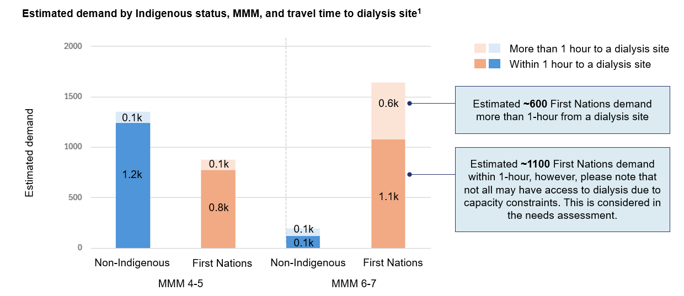
Figure 5 | Estimated demand by Indigenous status, MMM, and travel time to dialysis site
Figure 5 notes: Results are central estimates and based on analysis conducted on 31/01/2025.
- Includes existing sites and planned BRS sites, excludes planned State and Territory sites.

Phase 3: Needs assessment

Overview

Objective
To identify gaps in service coverage and areas of greatest need based on patient home location.

Context
Determining a community's suitability and relative priority for a dialysis site depends on several factors, including unmet demand and access to treatment. The objective of this phase was to combine these measures into a rating that can be used to identify potential sites for consideration by the Committee. Unmet need can also be segmented based on how it could be addressed, e.g., through additional chairs or by addressing service constraints.

Approach
- Estimated unmet need: Site capacity was distributed to ILOCs within an hour of a site to determine supply by ILOC. Unmet demand was then determined based on differences between estimated dialysis demand and supply.
- Prioritised communities for consideration: A community priority rating system was developed in consultation with BRS Analytic Working Group and ratings assigned to communities based on unmet demand and travel burdens.

Key findings
- Access to treatment is most limited in MMM 7 with an estimated ~800 people (69% of patients) potentially unable to access treatment close to home. There is still significant unmet need in MMM 6 with an estimated ~300 people unable to access care within their home community.
- 33 communities in MMM 6 and 7 are estimated through modelling to have more than 8 people who have likely moved off Country for treatment. These communities could be considered for two- or four-chair dialysis units. It is recognised that establishment of a new site also depends on feasibility factors such the availability of quality water and infrastructure, and peoples' ability to access other services they require such as aged care.
- In some cases establishment of a new two-chair or even four-chair site may still not meet estimated demand.
- Analysis also makes clear that unmet need exists in places where sites already exist. In these cases, policy response options could include:
- Adding new chairs to existing sites
- Addressing critical enabling mechanisms (operational funding, workforce) to support increased patient to chair ratios in remote settings
- A significant number of remote patients (~700) are estimated to live in communities where unmet demand would not sustain a new site. For these communities, alternative support options to help patients maintain connection to Country could include mobile sites and support for self-administered dialysis.

Estimated unmet demand
Bringing together a view of demand and access to care provides insight into unmet need by home location and how it could be addressed. Communities can fall into one of three categories:
- Met demand
There are enough haemodialysis chairs close to a community to provide care for all ESKD patients.
- Unmet demand – nearby site
There are nearby haemodialysis chairs but not enough to provide care for all ESKD patients.
How could this demand be addressed?
- Additional chairs at sites: there is sufficient unmet need (more than 8 patients requiring dialysis) for an additional 4-chair unit in a community.
- Support to address service constraints: demand could be met by increasing the capacity of existing units to achieve a ratio of 4 patients per chair.
- Alternative support: less than 8 additional patients require dialysis, support for self-administered dialysis and/or mobile dialysis could help bridge the gap of remaining need.
- 3. Unmet demand – no nearby site
There are no nearby haemodialysis chairs.
How could this demand be addressed?
- New sites: there is sufficient need (more than 8 patients requiring dialysis) for a new 4-chair unit in a community.
- Alternative support: less than 8 patients are estimated to require dialysis, alternative support to help patients maintain connection to Country such as mobile dialysis could be considered.

Key findings
An estimated 60% of dialysis need in MMM 6-7 is currently unmet in the patient’s home location, suggesting ~1,100 patients have relocated to access treatment.

Figure 6 | Estimated met and unmet demand for dialysis in MMM 4-7
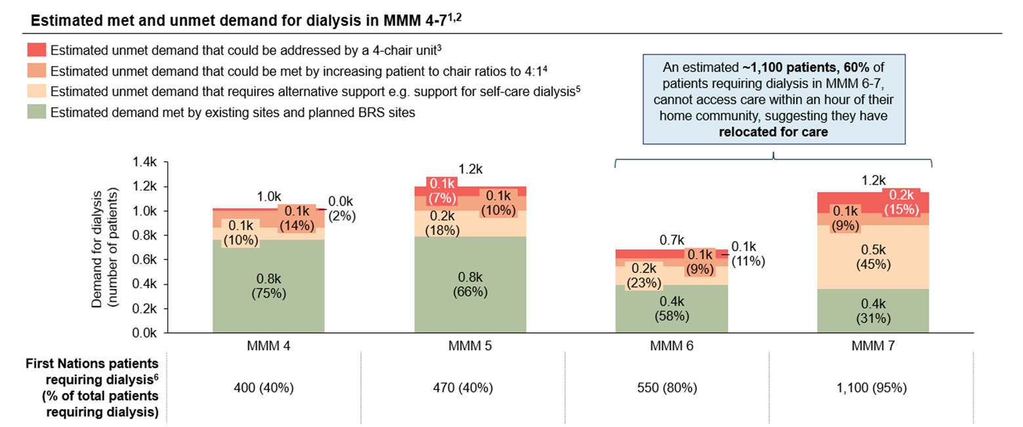
Figure 6 notes: Results are central estimates and based on analysis conducted on 31/01/2025
- Includes existing sites and planned BRS sites, excludes planned State and Territory sites.
- ILOC centroids are based on population weighted MB centroids
- There are 8 or more patients requiring care (after accounting for need that could be met by addressing capacity constraints) that could be supported with a 4-chair unit operating on a 2 patient per chair ratio
- Some units in regional and remote areas operate on a 2:1 patient to chair ratio due to capacity constraints such as workforce shortages/lack of staff to administer treatment
- There are less than 8 patients requiring care. Alternative support could include mobile dialysis or support for self-administered dialysis such as home dialysis
- Rounded to nearest 10 patients.

Needs assessment
Recognising that site suitability encompasses more than need, findings identify priority locations for further consideration. The decision around a community’s suitability for BRS site and/or other policy reform can be informed by the following two assessments:
1. Assessment of community need
This assessment is supported by this analytics project and is determined by –
- Unmet demand: estimated demand and site capacity are combined to estimate unmet demand for analysis.
- Travel time: used to identify communities without a nearby site / a site within 1-hour.
- Relative community needs rating: ratings are intended to help assess a specific ILOCs need for a site, with High and Highest referring to communities with sufficient need for a 4-chair site.
- Other factors (e.g. the impact of wet season and need of surrounding communities) are assessed on a case-by-case basis.
2. Assessment of other feasibility factors
Building on the assessment of community need, high-needs communities can then be assessed against other feasibility criteria, such as:
- Community support for a site
- Availability of land and utilities (e.g. power and water)
- Availability of workforce to support unit and provide clinical governance
It is important to note that need is only one factor that determines a community's suitability for a site. The purpose of the needs assessment is to identify priority communities that can then be considered against other criteria such as availability of supporting infrastructure to determine final site suitability.
In addition to the community needs rating, catchment and wet season ratings are provided. Communities are ranked by community needs rating, but two additional ratings have been provided in the Appendix for case-by-case assessment noting service catchment can be complex in remote settings and is not always appropriate and communities may already have contingency plans for the wet season:

Relative catchment needs rating
A relative needs rating based on unmet need for dialysis of communities within an hour of an ILOC i.e., an ILOC’s ‘catchment’, and drive time to the nearest site. Can be used to assess if a community could act as a dialysis hub. (Please see appendix for a detailed definition of this rating).

Wet season needs rating
A relative needs ratings adjusted for the impact of the wet season on travel time to the nearest site. Can be used to assess if a community’s relative need changes over the wet season. (Please see appendix for a detailed definition of this rating).

Community needs rating
Locations were assigned a relative rating based on level of unmet demand for dialysis in an ILOC and travel time.
Unmet demand is defined as the estimated number of haemodialysis patients in ILOC, less the number of patients that can be supported by sites in or within an hour of ILOC.
Figure 7 | Community needs rating
 |  | Estimated unmet demand in ILOC
 |  | 0 | Less than 4 | 4-8 | 8-16 | More than 16
Travel time to nearest site | Less than 1 hour | Need likely met | Lowest | Moderate | High | High
Travel time to nearest site | More than 1 hour |  | Low | Moderate | Highest | Highest
This rating is scored based on travel time to nearest site and estimated unmet demand in ILOC.
Travel time to nearest site is categorised into:
- Less than 1 hour
- More than 1 hour
Estimated unmet demand in ILOC is categorised into:
- 0 people
- Less than 4 people
- 4-8 people
- 8-16 people
- More than 16 people

Suggested interpretation of ratings
The rating is then ranked as one of the following four scores:
- Need likely met: There are estimated to be enough haemodialysis chairs to provide care for all ESKD patients, suggest to not consider community for site.
- Lowest – low: Estimated unmet demand for dialysis would likely not support full use of new chairs.
- Moderate: Estimated unmet demand could sustain a new site but not 4 chairs at full capacity.
- High-highest: Significant estimated unmet demand, considered highly suitable for site consideration.

Results
In MMM 4-7, there are estimated to be 34 ILOCs with a Community Needs Rating of High and 25 rated Highest. There are 59 ILOCs in total where unmet need is estimated to sustain an additional 2 or 4-chair unit.
Figure 8 | Number of ILOCs by Community Needs Rating in MMM 4-7
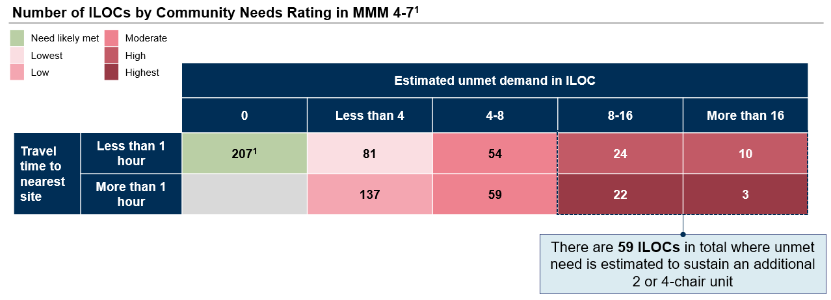
Figure 8 notes:
- Excludes communities with no need.

Appendix

Catchment needs rating
Locations were assigned a relative rating based on level of unmet need in their “catchment” and travel time.
Unmet demand is defined as the estimated number of haemodialysis patients in ILOC and within one hour from ILOC less the number of patients that can be supported by sites in or within an hour of ILOC.
Figure 9 | Catchment needs rating
 |  | Estimated unmet demand in catchment
 |  | 0 | Less than 4 | 4-8 | 8-16 | More than 16
Travel time to nearest site | Less than 1 hour | Met need | Lowest | Moderate | High | High
Travel time to nearest site | More than 1 hour |  | Low | Moderate | Highest | Highest
This rating is scored based on travel time to nearest site and estimated unmet demand in ILOC.
Travel time to nearest site is categorised into:
- Less than 1 hour
- More than 1 hour
Estimated unmet demand in ILOC is categorised into:
- 0 people
- Less than 4 people
- 4-8 people
- 8-16 people
- More than 16 people

Suggested interpretation of ratings
The rating is then ranked as one of the following four scores:
- Need likely met: There are estimated to be enough haemodialysis chairs to provide care for all ESKD patients, suggest to not consider community for site.
- Lowest – low: Estimated unmet demand for dialysis would likely not support full use of new chairs.
- Moderate: Estimated unmet demand could sustain a new site but not 4 chairs at full capacity.
- High-highest: Significant estimated unmet demand, considered highly suitable for site consideration.

Wet season needs rating
Locations impacted by the wet season were assigned a relative rating based on level of unmet need and travel time.
Unmet demand is defined as the estimated number of haemodialysis patients in ILOC less the number of patients that can be supported by sites within half an hour of ILOC (if ILOC is impacted by wet season).
Figure 10 | Wet season needs rating
 |  | Estimated unmet demand
 |  | 0 | Less than 4 | 4-8 | 8-16 | More than 16
Travel time to nearest site during wet season | Less than 1 hour | Need likely met | Lowest | Moderate | High | High
Travel time to nearest site during wet season | More than 1 hour |  | Low | Moderate | Highest | Highest
This rating is scored based on travel time to nearest site during wet season and estimated unmet demand in ILOC.
Travel time to nearest site during wet season is categorised into:
- Less than 1 hour
- More than 1 hour
Estimated unmet demand is categorised into:
- 0 people
- Less than 4 people
- 4-8 people
- 8-16 people
- More than 16 people

Suggested interpretation of ratings
The rating is then ranked as one of the following 4 scores:
- Need likely met: There are estimated to be enough haemodialysis chairs to provide care for all ESKD patients, suggest to not consider community for site.
- Lowest – low: Estimated unmet demand for dialysis would likely not support full use of new chairs.
- Moderate: Estimated unmet demand could sustain a new site but not 4 chairs at full capacity during wet season, and potentially out of wet season.
- High-highest: Significant estimated unmet demand during wet season, and potentially out of wet season – consider alongside catchment rating.

Health.gov.au
All information in this publication is correct as at February 2025

Indigenous Locations are designed to represent small Aboriginal and Torres Strait Islander communities (urban and rural) that are near each other or that share language, traditional borders or Native Title. The median total population for ILOCs in MMM 7 is 307.
MMM 6 and 7.
Assuming a 2:1 patient to chair ratio as is common due to staffing constraints in remote areas.
To be approximated by Indigenous Locations (ILOCs).
Registered nurse, an Aboriginal health worker, an Aboriginal and Torres Strait Islander health practitioner or medical practitioner.
Speed refers to straight-line speed. 25 km/hr is based on the ferry between Wurrumiyanga and Darwin. This is a simplified estimate of travel times given accessibility depends on the availability of ferries.
Indigenous Locations are designed to represent small Aboriginal and Torres Strait Islander communities (urban and rural) that are near each other or that share language, traditional borders or Native Title. The median total population for ILOCs in MMM 7 is 307.
Bureau of Meteorology (BoM) Rainfall Map from Oct 2022 – April 2023.
L61Z separations in hospital data were explored to assess capacity, however satellite sites often appeared to be reported under a parent hospital hence ANZDATA was used.
MMM 1-3 is not in scope.
Supply is assigned to ILOCs closest to sites first until supply is exhausted.
Supply is assigned to ILOCs closest to sites first until supply is exhausted.
Supply is assigned to ILOCs closest to sites first until supply is exhausted.

