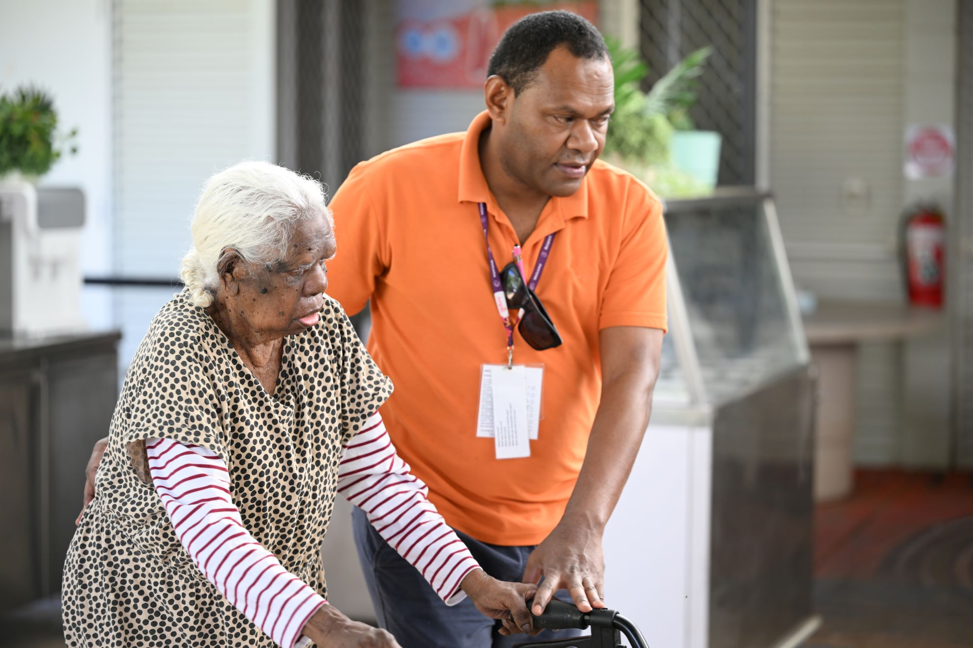


Australian National Aged Care Classification (AN-ACC) - Specialised Status Guide for Residential Aged Care Registered Providers

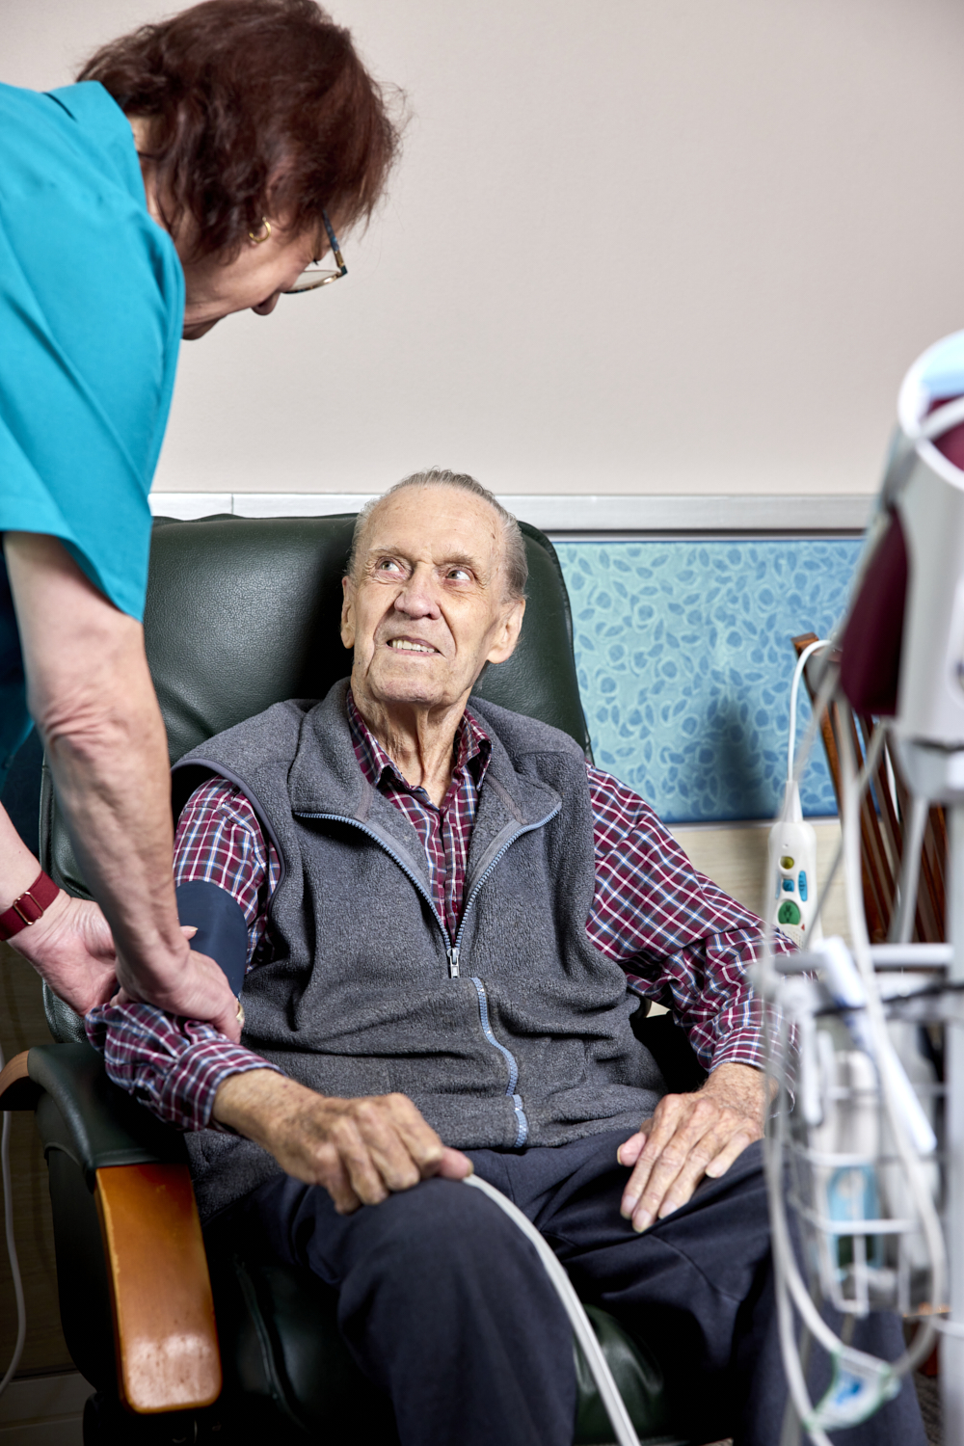

Contents
Creative Commons License 5
Restrictions 5
Attribution 5
Enquiries 5
About this guide 7
Purpose 7
Disclaimer 7
Guide updates 7
Section 1: Introduction 10
1. Introduction 11
1.1. Purpose 11
1.2. Introduction 11
1.3. What is Base Care Tariff (BCT) funding? 11
1.4. Pricing updates 12
1.4.1. IHACPA’s 2025-26 pricing advice 12
Section 2: Specialised BCT rates 14
2. Specialised BCT rates 15
2.1. What are specialised BCT rates? 15
2.2. Eligibility for specialised BCT rates 15
2.3. Specialised status application process 16
2.4. Specialised status assessment process 16
2.5. Duration of specialised status 17
2.6. Provider relinquishment of specialised status 17
Section 3: Specialised Homeless status 18
3. Specialised Homeless status 19
3.1. What is the Specialised Homeless status? 19
3.2. What are the Specialised Homeless status provider requirements? 19
3.3. Specialised Homeless status - Provider requirements - evidence examples 19
3.4. Specialised Homeless status –individual requirements 20
3.5. Individual eligibility assessment 21
3.6. Process for identifying individuals with a background of homelessness in the Provider Portal 22
3.7. Case Scenario 23
Section 4: Specialised Aboriginal and Torres Strait Islander status 24
4. Specialised Aboriginal and Torres Strait Islander BCT rates 25
4.1. What are the Specialised Aboriginal and Torres Strait Islander BCT rates? 25
4.2. Aboriginal and Torres Strait Islander registered provider requirements 25
4.3. Registered provider requirement - evidence examples 25
4.4. Specialised Aboriginal and Torres Strait Islander status – resident requirements 27
4.5. Case Scenario 27
Section 5: Additional Information 28
5. Additional Information 29
5.1. The Modified Monash Model (MMM) 29
5.2. Reconsideration of a specialised status decision 29
5.3. Specialisation Verification Framework 29
Section 6: Attachments 30
Attachments 31
Attachment A - Specialised Homeless Status Registered Provider Application Form 31
Attachment B - Specialised Aboriginal and Torres Strait Islander Status Registered Provider Application Form 31
Attachment C - List of aged care residents the registered provider considers meet homeless resident requirements 31
Attachment D - Specialised Homeless Status Resident Assessment Form 31

Creative Commons License

This publication is licensed under the Creative Commons Attribution 4.0 International Public License available from https://creativecommons.org/licenses/by/4.0/legalcode (“License”). You must read and understand the License before using any material from this publication.

Restrictions
The License may not give you all the permissions necessary for your intended use. For example, other rights (such as publicity, privacy and moral rights) may limit how you use the material found in this publication.
The License does not cover, and there is no permission given for, use of any of the following material found in this publication:
- the Commonwealth Coat of Arms. (by way of information, the terms under which the Coat of Arms may be used can be found on the Department of Prime Minister and Cabinet website http://www.dpmc.gov.au/government/commonwealth-coat-arms);
- any logos and trademarks;
- any photographs and images;
- any signatures; and
- any material belonging to third parties.

Attribution
Without limiting your obligations under the License, the Department of Health requests that you attribute this publication in your work. Any reasonable form of words may be used provided that you:
- include a reference to this publication and where, practicable, the relevant page numbers;
- make it clear that you have permission to use the material under the Creative Commons Attribution 4.0 International Public License;
- make it clear whether or not you have changed the material used from this publication;
- include a copyright notice in relation to the material used. In the case of no change to the material, the words “© Commonwealth of Australia (Department of Health and Aged Care) 2023” may be used. In the case where the material has been changed or adapted, the words: “Based on Commonwealth of Australia (Department of Health and Aged Care) material” may be used; and
- do not suggest that the Department of Health and Aged Care endorses you or your use of the material.

Enquiries
Enquiries regarding any other use of this publication should be addressed to the Branch Manager, Communication Branch, Department of Health and Aged Care, GPO Box 9848, Canberra ACT 2601, or via e-mail to copyright@health.gov.au.

About this guide

Purpose
The purpose of the Specialised Status Guide for Residential Aged Care Registered Providers (the Guide) is to provide information to registered providers on the AN-ACC funding model in relation to specialised status.

Disclaimer
This Guide addresses legislation in relation to the AN-ACC funding model that commenced on 1 October 2022.
The AN-ACC funding model is governed by the applicable aged care legislation and not this Guide. Residential care providers are responsible for understanding and complying with all legislation that is relevant to the delivery of residential care and respite care provided in a residential setting. This Guide is a general guide only and aspects of the legislation and policy have been simplified for ease of understanding. It is not a substitute for, and is not intended to replace, independent legal advice or legal obligations under the aged care legislation or provide any interpretation of the legislation.
Residential aged care providers and residents should consider the need to obtain their own independent legal advice relevant to their particular circumstances.
While we make every effort to make sure the information in this Guide is accurate and informative, the Department of Health and Aged Care (the department) does not make any representations nor provide any guarantees as to its accuracy, reliability, completeness or currency of the information. The department disclaims all and any liability to any person in respect of anything done by a person in reliance on this Guide, whether in whole or in part.

Guide updates
Date | Version | Content
08/12/2022 | 1.0 | Initial publication
22/12/2022 | 1.1 | To align the guide with the amendments made to the Specialised Homeless Care Recipient Assessment Form (sections 2.4, 3.5 and 6.5)
28/03/2023 | 1.1.1 | Section 3.5 – Update on retaining copy of the Specialised Homeless Care Recipient Assessment Form
21/03/2024 | 1.2 | Update to reflect changes to categories under the Modified Monash Model  New Section 1.4 on IHACPA pricing advice
6/11/2024 | 1.3 | Update to align with 1 October 2024 AN-ACC changes
9/09/2025 | 1.4 | Various updates to align with 1 October 2025 AN-ACC changes. Updated photos.
1/12/2025 | 1.5 | Various updates to align with the Aged Care Act 2024 and Aged Care Rules 2025

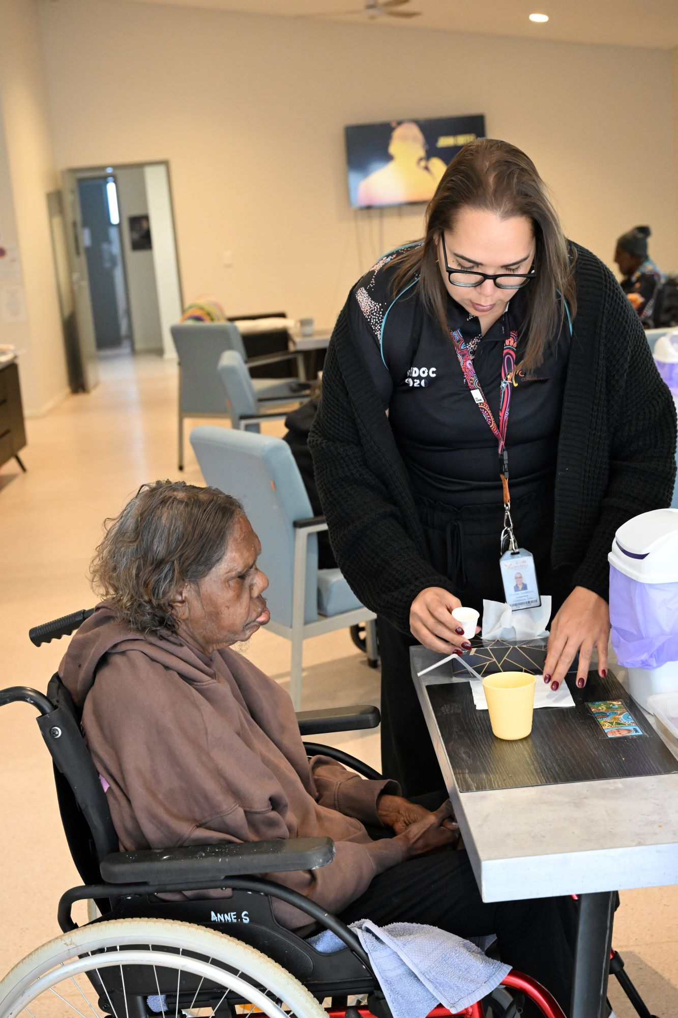

Section 1: Introduction
- Introduction
  - Purpose
This Guide outlines the eligibility criteria, application process, and operational requirements for Specialised Homeless and Specialised Aboriginal and Torres Strait Islander status (each a specialised status) under the Australian National Aged Care Classification (AN-ACC) funding model. It should be used by registered providers of residential care homes who have been determined to have or are intending to apply for specialised status in respect of any of their residential care homes.
  - Introduction
The AN-ACC funding model is a key component of the major aged care reforms implemented in response to the Final Report of the Royal Commission into Aged Care Quality and Safety. The AN-ACC funding model aims to provide more equitable funding to registered providers in respect of care recipients that better reflects the costs of delivering care.
The AN-ACC funding model comprises three components:
- a variable component that reflects the casemix classification of individual care recipients determined by an independent assessment (AN-ACC assessment) of their aged care needs
- a fixed component that reflects the characteristics of each residential care home, including its classification under the 2023 Modified Monash Model (MMM) from 1 October 2025 (previously the 2019 MM classification was used), and/or specialised status
- a one-off adjustment payment to cover the extra costs associated with transitioning an individual into a residential care home.
  - What is Base Care Tariff (BCT) funding?
BCT funding represents the ‘fixed’ component of care funding that is paid to a registered provider of a residential care home under the AN-ACC funding model.
BCT funding covers care costs that do not change significantly if there are changes in individuals’ characteristics, or with small changes in occupancy of a residential care home. For example, the cost of providing general oversight of individuals receiving residential care eating in common areas is determined by the overall needs of the residential care home and the number of such individuals, rather than the needs of any specific individual.
There are 7 BCT categories including four standard BCT rates that are determined by a home’s MM location and, in some circumstances, the number of operational beds a residential care home has, and three BCT rates in respect of homes that have specialised status (specialised BCT rates) (refer Table 1).
Each rate of BCT has a corresponding National Weighted Activity Unit (NWAU) that determines the amount of funding provided under that BCT. Rates of BCT are paid per occupied place for residential care homes in MM 1 – 5 locations and all homes with Specialised Homeless status, or per operational bed (excluding provisionally approved and offline places) for homes with Specialised Aboriginal and Torres Strait Islander status and residential care homes without Specialised Aboriginal and Torres Strait Islander status in MM 6 or 7 locations.
Table 1 – Rates of BCT, including NWAUs and payment calculations
BCT Category | Funding Basis | NWAU
Standard MM 1 | Occupied bed | 0.50
Standard MM 2 – 3 | Occupied bed | 0.53
Standard MM 4 – 5 | Occupied bed | 0.58
Standard MM 6 or MM 7 | Operational bed | Two-stage payment scale:  0.68 (rate for the first 29 beds)  0.52 (rate for beds 30+)
Specialised Homeless | Occupied bed | 0.92
Specialised Aboriginal and Torres Strait Islander, located in MM 6 | Operational bed | 0.78
Specialised Aboriginal and Torres Strait Islander, located in MM 7 | Operational bed | 1.80
Residential care homes automatically receive a rate of BCT based on their MM location unless they have been determined to have a specialised status.
The rate of BCT is determined at the individual residential care home level. A home can only have one rate of BCT at any time.
  - Pricing updates
The Government is responsible for setting the AN-ACC price and weightings that apply to AN-ACC’s fixed (BCT) and variable (classification) funding components. The Independent Health and Aged Care Pricing Authority (IHACPA) provides annual pricing advice to the Government to inform AN-ACC price adjustments.
IHACPA’s pricing advice reflects costing studies and analysis of financial data reported by providers. IHACPA may also make recommendations regarding adjustments to the NWAU values (weightings), including the weightings that apply to specialised BCTs, to ensure specialised BCT funding reflects the actual costs of delivering specialised care.
    - IHACPA’s 2025-26 pricing advice
IHACPA’s 2025-26 pricing advice included BCT NWAU reductions for all non-specialised residential care homes in remote and very remote MM 6 and MM 7 locations, as well as for specialised homeless and specialised Aboriginal and Torres Strait Islander homes.
In 2024 Government asked the department to review BCT policy settings for specialised and remote homes to ensure that the funding provided is appropriate and spent as intended.
The review will consider:
- the eligibility rules for specialised status
- the need to deliver appropriate care programs for vulnerable cohorts consistent with the additional care funding that is provided
- understanding the relationship between care costs and the proportion of specialised residents
- whether these costs are appropriately captured in financial reporting by providers
- under-occupancy levels in remote and very remote locations areas, including operational bed funding.
The review is expected to be completed by end of the first quarter of 2026.
For more information, please contact AN-ACC Operations: ANACCOperations@health.gov.au.

Section 2: Specialised BCT rates
- Specialised BCT rates
  - What are specialised BCT rates?
The three specialised BCT rates are in respect of residential care homes that have:
- Specialised Homeless status
- Specialised Aboriginal and Torres Strait Islander status and are located in a MM 6 location
- Specialised Aboriginal and Torres Strait Islander status and are located in a MM 7 location.
Specialised BCT rates have a higher NWAU than the standard MM based BCT rates, to reflect the additional costs of providing these specialised services.
  - Eligibility for specialised BCT rates
Registered providers must apply to the department to for a determination that a residential care home has Specialised Homeless status or Specialised Aboriginal and Torres Strait Islander status. If a residential care home is determined to have a specialised status, the registered provider will be paid the relevant specialised BCT rate in respect of the homes that have the specialised status.
In order for the System Governor (or delegate) to determine whether a residential care home has specialised status, the registered provider should provide evidence that they meet the relevant eligibility criteria. These criteria are summarised in Table 2 below. Registered providers must continue to meet these criteria in relation to a residential care home to maintain their specialised status and therefore the specialised BCT rate (refer Section 2.6).
Table 2 Specialised status eligibility requirements
Base Care Tariff rate | Provider Requirements | Care recipient Requirements
Specialised Homeless Status | The registered provider or one of its key personnel has demonstrated experience in providing, or the capacity to provide, specialist homeless programs.  The residential care home is providing such specialist programs, or the registered provider gives an undertaking to begin providing the specialist programs within 3 months of the application being made. | On the day before the application was made, at least 50% of the individuals receiving ongoing (permanent) residential care through the residential care home demonstrated complex behavioural needs and social disadvantage associated with their background as a homeless person.
Specialised Aboriginal and Torres Strait Islander Status, located in MM 6 | The residential care home is in a MM 6 location.  The registered provider or one of its key personnel has demonstrated experience in providing, or the capacity to provide, specialist Aboriginal and Torres Strait Islander programs.  The residential care home is providing such specialist programs or gives an undertaking to begin providing the specialist Aboriginal and Torres Strait programs within three months of the application being made. | On the day before the application was made, at least 50% of individuals receiving ongoing (permanent) residential care were Aboriginal and/or Torres Strait Islander persons.
Specialised Aboriginal and Torres Strait Islander, located in MM 7 | The residential care home is in a MM 7 location.  The registered provider or one of its key personnel has demonstrated experience in providing, or the capacity to provide, specialist Aboriginal and Torres Strait Islander programs.  The residential care home is providing such specialist programs or gives an undertaking to begin providing the specialist Aboriginal and Torres Strait programs within three months of the application being made. | On the day before the application was made, at least 50% of individuals receiving ongoing (permanent) residential care were Aboriginal and/or Torres Strait Islander persons.
  - Specialised status application process
Registered providers can apply for specialised status for any of their homes at any time, however a determination will only be made if the applicable eligibility criteria are met. Registered providers should use either the Specialised Homeless Status Registered Provider Application Form (refer Attachment A) or the Specialised Aboriginal and Torres Strait Islander Status Registered Provider Application Form (refer Attachment B). Completed application forms and any supporting documentation should be emailed to subsidiesandsupplements@health.gov.au.
All applications for the Specialised Homeless status must include a list of individuals receiving care that meet the care recipient requirements. An example of what this list must include is at Attachment C.
If a home is determined to have specialised status, the particular rate of BCT will apply from the start of the next payment period following the determination by the System Governor (or delegate).
NB: If a determination of specialised status is revoked on application by the registered provider the BCT rate will revert to a standard BCT rate for residential care homes.
  - Specialised status assessment process
The department will assess applications for specialised status using evidence supplied as part of the specialised status application process, as well as other information available to the department, such as resident assessment data (AN-ACC and/or ACAT), resident entry records, outcomes from the Verification of Specialisation project, and income information. The department may request additional information to further determine eligibility.
Registered providers will be advised in writing of the outcome of their application for a specialised status.
If a home is approved for the Specialised Homeless status, it is recommended that a Specialised Homeless Care Recipient Assessment Form be completed for each eligible individual receiving ongoing (permanent) residential care at that home who meets the relevant criteria in respect of homelessness.
  - Duration of specialised status
A specialised status will have effect for up to three years. Registered providers of homes with a specialised status must continue to meet all the eligibility requirements during the period of the determination.
Any change to a rate of BCT funding as a result of a change in specialised status will take effect from the beginning of the next payment period following the change.
  - Provider relinquishment of specialised status
A registered provider can revoke the specialised status of a home at any time for any reason, by giving written notice to the System Governor. Revocation of a specialised status at the request of the registered provider takes effect from the beginning of the next payment period after the date that the registered provider gave written notice.

Section 3: Specialised Homeless status
- Specialised Homeless status
  - What is the Specialised Homeless status?
The BCT rate paid in respect of services with Specialised Homeless status supports registered providers to cover the additional costs of providing specialised care to individuals receiving residential care with the complex behavioural needs and social disadvantage associated with their background as a homeless person.
  - What are the Specialised Homeless status provider requirements?
To be determined to have Specialised Homeless status, a registered provider must demonstrate that the relevant home delivers, or will deliver within 3 months of the application being made, specialist homeless programs, including but not limited to:
- programs and interventions to manage complex behavioural needs of persons with a background of homelessness
- programs to promote social engagement and participation of persons with a background of homelessness
- any other relevant programs or activities that the System Governor may consider appropriate.
  - Specialised Homeless status - Provider requirements - evidence examples
The following are examples of specialist homeless programs and supports that a home seeking specialised homeless status could either be providing or has the capacity to provide.
Table 3 Examples of evidence in support of Specialised Homeless status
Specialised programs and supports | Examples
The registered provider, or one of its key personnel of the registered provider, has demonstrated experience in providing, or the capacity to provide, specialised homeless programs. | Previous experience in providing access and care for homeless people.
The registered provider has established or has demonstrated the capacity to establish connections with local services and communities, including agencies that may refer and support individuals with a background of homelessness. | Connections that have been or will be established, including how these benefit care recipients with a background of homelessness.
The registered provider has programs and interventions to manage the complex behaviours and needs of care recipients with a background of homelessness. | Relevant programs and interventions.
The registered provider encourages and facilitates access to a broad range of services and supports relevant to the needs of care recipients with a background of homelessness. | Describe how individuals with a background of homelessness are encouraged and supported to access specialised support services and interventions.
The registered provider has programs to promote social engagement and participation by care recipients with a background of homelessness. | Describe how individuals with a background of homelessness are supported to participate socially at this service.
The registered provider has an established connection with a local mental health service or other organisation that assists individuals with a complex behavioural diagnosis and high support needs. | Connections that have been or will be established, including how these benefit homeless residents.
NB: While there is no direct relationship between specialised status and the Verification of Specialisation project (refer Section 5.3), where a home has been recognised under that project as a specialised homeless service, this may be considered as relevant evidence System Governor’s (or delegate’s) consideration in determining eligibility for the Specialised Homeless status.
  - Specialised Homeless status – individual requirements
For the purposes of meeting the Specialised Homeless status resident requirements, on the day before the application is made, a home must demonstrate that at least 50% of individuals receiving ongoing (permanent) residential care have complex behavioural needs and social disadvantage associated with their background as a homeless person (homelessness criteria).
An individual receiving ongoing (permanent) residential care who meets all of the following four criteria, as described in the Specialised Homeless Care Recipient Assessment Form may likely meet the criteria for Specialised Homeless status and the registered provider can rely on this evidence in support of their application:
- Has a history of homelessness:
  - Was living in a public place or temporary shelter; short-term crisis, emergency or transitional accommodation; boarding house, rooming house or private hotel; or supported community accommodation
  - Had no recent housing address
  - Had a long history of unsuccessful tenancies or unstable housing arrangements.
- Is eligible to receive the maximum basic rate of Australian social security pension, allowance, or benefit:
  - Person is eligible for the maximum basic rate of social security pension or benefit as defined in the Social Security Act; or
  - Service pension or disability pension as defined in the Veterans’ Entitlements’ Act.
- Has a behavioural diagnosis associated with one of the following disorders:
  - Dementia in Alzheimer’s disease including early onset dementia, late onset dementia, atypical or mixed type of unspecified dementia
  - Vascular dementia including acute onset dementia, multi-infarct dementia, subcortical vascular dementia, mixed cortical and subcortical vascular dementia, other vascular or unspecified dementia
  - Dementia in other diseases classified elsewhere including Pick’s Disease, Creutzfeldt-Jakob disease, Huntington’s disease, Parkinson’s disease, human immunodeficiency virus (HIV)
  - Other dementia including alcoholic dementia or unspecified dementia (such as presenile and senile dementia)
  - Delirium including delirium not superimposed on dementia, delirium superimposed on dementia, other delirium or unspecified delirium
  - Psychoses and depression/mood affective disorders including schizophrenia or other psychoses (such as paranoid states)
  - Neurotic, stress-related and somatoform disorders including phobic and anxiety disorder (such as agoraphobia and panic disorder), nervous tension/stress or obsessive-compulsive disorder
  - Intellectual and developmental disorders including mental retardation, intellectual disability or other developmental disorders including mental retardation, intellectual disability or other developmental disorders (such as autism, Rett syndrome, Asperger’s syndrome, developmental learning disorders, specific developmental disorders of speech and language, specific development disorder of motor function such as dyspraxia)
  - Other mental and behavioural disorders including mental and behavioural disorders due to alcohol and other psychoactive substance use (such as alcoholism, Korsakov’s psychosis (alcoholic), adult personality and behavioural disorders, speech impediment (stuttering or stammering)) or other mental and behavioural disorders not otherwise specified or not elsewhere classified (such as harmful use of non-dependant substances (for example, laxatives, analgesics or antidepressants), eating disorders (for example, anorexia nervosa or bulimia nervosa) or mental disorders not otherwise specified).
- Has challenging behaviours and need for intensive social support:
  - The person displays challenging behaviours which require ongoing management and prevention including one or both of the following:
- Episodic catastrophic behaviours such as severe physical and verbal abuse, violent mood swings, aggression
- The person is considered at high risk of leaving without warning with ongoing staff intervention required to prevent this from occurring
  - The person requires intensive social support or intensive assistance with continuing to perform activities of daily living including initiation of and assistance with one or both of the following:
- Personal care and hygiene matters (for example, shows aversion to showering and washing hands, has problems with toileting and dressing, requires assistance or guidance with meals)
- Social and recreational activities, with significant one-on-one staff intervention necessary to enable the person to participate in community activities.
  - Individual eligibility assessment
Registered providers should retain evidence that establishes that each individual receiving ongoing (permanent) residential care identified as such meets the homelessness criteria.
Eligibility is assessed and recorded using the Specialised Homeless Care Recipient Assessment Form (refer Attachment D), or through provision of other suitable evidence.
A registered provider should hold the form, and any other documents, that inform an application for specialised status as the department may request access to this information for the purpose of determining ongoing eligibility.
  - Process for identifying individuals with a background of homelessness in the Provider Portal
The homelessness criteria of a care recipient must be notified to Services Australia using the digital claiming channels. This can be done in the Services Australia Aged Care Provider Portal, by choosing the Homeless Indicator at Step 4 of the resident entry process (refer to Figure 2 below).
Figure 2 Homeless indicator in Services Australia portal
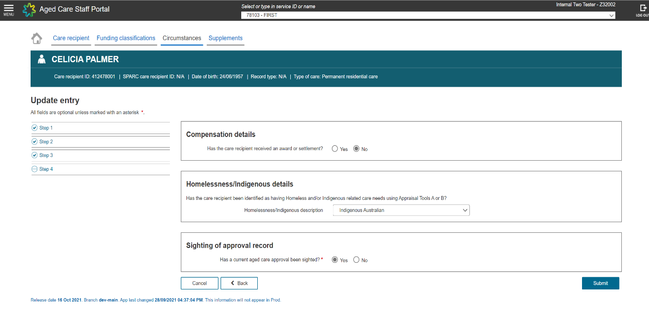
For assistance in completing the background of homelessness indicator in the Aged Care Provider Portal, registered providers can call Services Australia on 1800 195 206 Monday to Friday, 9 am to 5 pm, AEST or via email at aged.care.liaison@servicesaustralia.gov
  - Case Scenario
The following scenario considers eligibility for Specialised Homeless status where the home is in a MM 1 location.
Example Scenario:
A registered provider of a 60-bed home in a MM 1 location applies for Specialised Homeless status in respect of that home. The registered provider of the home has recently decided to specialise in caring for individuals with a background of homelessness, and the number of individuals receiving ongoing (permanent) residential care at the home who have a background of homelessness has increased to 31 of the home’s 58 occupied beds.
The home introduces specific programs and supports for individuals with a background of homelessness, including an outreach program, transport services, visiting medical and allied health services including general practice and counselling, and both individual and group activities to address specific behaviours and dependency issues. The home has provided evidence to support its eligibility, including of staff qualifications and experience, in accordance with the application form and Specialised Status Guide. The home has also been approved as a specialised homeless service as part of the Verification of Specialisation project.
The System Governor’s assessment:
The System Governor’s delegate may determine this home as meeting the requirements for Specialised Homeless status as the registered provider has demonstrated it has experience in delivering specialised services to individuals with a background of homelessness, and the home has a proportion of individuals receiving ongoing (permanent) residential care with a background of homelessness over 50% as at the day before the application was made.

Section 4: Specialised Aboriginal and Torres Strait Islander status
- Specialised Aboriginal and Torres Strait Islander BCT rates
  - What are the Specialised Aboriginal and Torres Strait Islander BCT rates?
The Specialised Aboriginal and Torres Strait Islander BCT rates aim to support registered providers to cover the additional costs of providing specialised care to Aboriginal and Torres Strait Islander individuals receiving residential care in remote and very remote locations.
  - Aboriginal and Torres Strait Islander registered provider requirements
For a home to be determined to have Specialised Aboriginal and Torres Strait Islander status, a registered provider will be required to demonstrate that it or one of its key personnel has experience in providing, or the capacity to provide, specialist care and services to Aboriginal and Torres Strait Islander individuals receiving residential care. This includes but is not limited to:
- programs to deliver care and services that are culturally safe for, and tailored to meet the particular needs of, Aboriginal or Torres Strait Islander individuals
- programs to promote social and cultural engagement and participation of Aboriginal or Torres Strait Islander individuals
- any other relevant programs and activities that the System Governor may consider appropriate.
  - Registered provider requirement - evidence examples
The following are examples of specialist homeless programs and supports that a home seeking specialised Aboriginal and Torres Strait Islander status could either be providing or has the capacity to provide.
Table 4 Examples of evidence in support of Specialised Aboriginal and Torres Strait Islander status
Programs and supports | Examples
A significant proportion of staff members identify as Aboriginal and/or Torres Strait Islander and are well resourced and supported by management to act as ‘champions’ within the organisation to support care recipients and other staff. | Description of the number, combined FTE and specific role the staff member(s) play(s) in championing specialised aged care for Aboriginal and Torres Strait Islander people and supporting other staff in professional development and learning opportunities.  Description of relevant activities undertaken by champion(s) and resourcing/support provided (e.g., training).
There are established connections and regular engagement between the registered provider and local Aboriginal and Torres Strait Islander community, including leaders and organisations. | Details of the established connection and engagement with local Aboriginal and Torres Strait Islander community, including any recent and/or planned activities.  The local Aboriginal and/or Torres Strait Islander community organisation(s) and leaders confirm(s) this connection. Evidence may include a Memorandum of Understanding.
At least 90% of staff have completed annual training in the aged care needs of local/regional Aboriginal and Torres Strait Islander peoples, including cultural safety and trauma-informed care delivery. | Details of training provided to staff over the past 12 months in the aged care needs of local/regional Aboriginal and Torres Strait Islander people, including cultural safety and trauma-informed care.  Provider specifies the proportion of all staff who undertook this training (minimum 90%, excluding agency staff). Training may include online training modules.
Registered provider offers services in local Indigenous language(s). | Details of services conducted and/or planned in local language(s).  Proportion of staff who are bilingual and bicultural is specified, and provider affirms that this reflects the cultural and linguistic background of aged care recipients.
Registered provider works in partnership with a local Aboriginal and Torres Strait Islander community organisation or appropriate representative to ensure that services are culturally safe and appropriate for the local Aboriginal and/or Torres Strait Islander community. | Details of the partnership with a local Aboriginal and Torres Strait Islander community organisation or appropriate representative and how services are designed or adapted for the Aboriginal and Torres Strait Islander community. Also supporting evidence of services’ appropriateness (e.g., acknowledgement from the community organisation).
At least one Aboriginal and/or Torres Strait Islander person sits on the governing body (egg, board) of the registered provider at the service level. | Description of governing body involvement/attendance by an Aboriginal and/or Torres Strait Islander representative.
Registered provider regularly recognises and participates in local cultural celebrations and/or days/events of local cultural significance. | Evidence of the registered provider’s recognition of/participation in/support for relevant events in the past 12 months.  Description of how cultural participation is encouraged and supported within the care environment.
Programs to deliver care and services are culturally safe for, and tailored to meet, the particular needs of the Aboriginal and Torres Strait Islander individuals receiving residential care. | Describe how cultural safety is embedded in care and services, including respecting cultural traditions such as men’s and women’s business.
NB: While there is no direct relationship between specialised status and the Verification of Specialisation project, where a home has been recognised under that project as a specialised Aboriginal and Torres Strait Islander service (and is located in a MM 6 or MM 7 location), this may be considered as relevant evidence for the System Governor’s (or delegate’s) consideration in determining eligibility for the Specialised Aboriginal and Torres Strait Islander status.
  - Specialised Aboriginal and Torres Strait Islander status – resident requirements
For the purposes of meeting the Specialised Aboriginal and Torres Strait Islander status care recipient requirements, on the day before the application is made, at least 50% of a home’s ongoing (permanent) residents must be Aboriginal and/or Torres Strait Islander persons. That is, a person of Aboriginal and/or Torres Strait Islander descent and/or a person who identifies as an Aboriginal and/or Torres Strait Islander person and is accepted as such by the community in which they live.
The System Governor (or delegate) will determine whether a care recipient is an Aboriginal and Torres Strait Islander person for this purpose, primarily through information from each individual’s pre-entry care approval assessment.
  - Case Scenario
The following scenario considers eligibility for a home in a MM 7 location for Specialised Aboriginal and Torres Strait Islander Status and the equivalent rate of BCT for that class.
Example Scenario
A registered provider with a 25-bed home in a MM 7 location applies for Specialised Aboriginal and Torres Strait Islander status. Occupancy at the home over the preceding 12 months has averaged 20 beds with an average of 12 out of 20 beds occupied by individuals receiving ongoing (permanent) residential care who are Aboriginal or Torres Strait Islander persons (as evidenced by their care approval assessments). The registered provider provides specific programs and supports for Aboriginal or Torres Strait Islander individuals through the home, including working closely with the local Aboriginal community, local Aboriginal medical service, drug and alcohol counselling service, and Elders group to address specific behaviours and dependency issues. Individuals receiving residential care are encouraged to engage in local cultural celebrations, some of which have taken place at the home. Four of the 20 permanent staff, including a key staff member, identify as Aboriginal or Torres Strait Islander persons.
The System Governor’s assessment
Based on the evidence provided by the registered provider, the System Governor (or delegate) may be satisfied this home meets the criteria for Specialised Aboriginal and Torres Strait Islander status, including that the home has the required proportion of current individuals receiving ongoing (permanent) residential care who are Aboriginal and/or Torres Strait Islander persons (that is, more than 50% of its occupied places as at the date before the application was made). As a result, the amount for the home is the BCT rate for a home that is in a MM 7 location and has specialised Aboriginal and Torres Strait Islander status.

Section 5: Additional Information
- Additional Information
  - The Modified Monash Model (MMM)
The MMM is a measure of remoteness and population size used by the department to define whether a location is metropolitan, regional, rural, remote, or very remote. Locations are categorised from MM 1 – 7, with MM 1 denoting a major city and MM 7 a very remote location. MM categories are based on the Australian Statistical Geography Standard – Remoteness Areas framework and are updated after each Census.
From 1 October 2025, the AN-ACC funding model uses the 2023 MM categories to determine rates of BCT. The AN-ACC funding model previously relied on the 2019 MM categories to determine rates of BCT.
A registered provider will be notified in advance if a MM boundary change will affect a home’s eligibility for Specialised Aboriginal and Torres Strait Islander status, and therefore its rate of BCT (e.g., where a home that had been determined to have Specialised Aboriginal and Torres Strait Islander status changes from being in a MM 6 location to a MM 5 location).
Registered providers can find the MM category of their residential care services by typing the street address into the health workforce locator tool and selecting 2023 as the MMM classification filter.
  - Reconsideration of a specialised status decision
Registered providers can request reconsideration of a decision by the System Governor (or delegate) not to make a determination of a specialised status.
Reconsideration requests should be addressed to the Secretary of the Department of Health, Disability and Ageing and emailed to subsidiesandsupplements@health.gov.au with any relevant information to support the request.
  - Specialisation Verification Framework
The department has developed a Specialisation Verification Framework that independently verifies claims by registered providers regarding specialisations in their delivery of services. The framework aligns with the Aged Care Act 2024. This includes people from Aboriginal and Torres Strait Islander communities, and people who are homeless or at risk of becoming homeless.
The Specialisation Verification Framework was developed in response to the Royal Commission recommendation that claims by Registered providers regarding specialisations are verified to improve the reliability of the My Aged Care Find a Provider tool.
If a registered provider has been verified as providing a specialised service under the Specialisation Verification Framework, this will be displayed on the My Aged Care website.
Recognition as a specialised home on the My Aged Care website under the Specialisation Verification Framework does not have any relationship to a home ’s specialised status under the AN-ACC funding model. Where a home of a registered provider has been recognised under the Specialisation Verification Framework as a specialised homeless service or a specialised Aboriginal and Torres Strait Islander home (in MM 6 or MM 7), this may be provided as evidence for specialised status under the AN-ACC funding model.
Where a home has been recognised as a specialised home on the My Aged Care website under the Specialisation Verification Framework, this does not mean the home has been determined to have specialised status under the AN-ACC funding model.

Section 6: Attachments

Attachments

Attachment A - Specialised Homeless Status Registered Provider Application Form
Specialised Homeless Status Registered Provider Application Form
This form should be used by registered providers of residential care homes to apply for Specialised Homeless status for any of their homes that meet both the registered provider and resident requirements for Specialised Homeless Status described in Section 3 of this Guide. A separate form is required for each home.

Attachment B - Specialised Aboriginal and Torres Strait Islander Status Registered Provider Application Form
Specialised Aboriginal and Torres Strait Islander Status Registered Provider Application Form
This form should be used by registered providers of residential care homes to apply for Specialised Aboriginal and Torres Strait Islander status for any of their homes that meet both the registered provider and resident requirements for eligibility for Specialised Aboriginal and Torres Strait Islander Status described in Section 4 of this Guide. A separate form is required for each home.

Attachment C - List of aged care residents the registered provider considers meet homeless resident requirements
Aged care resident FULL NAME | Aged care resident ACMPS ID or Aged Care ID number
Mary Smith | XXXXXX

Attachment D - Specialised Homeless Status Resident Assessment Form
Specialised Homeless Status Resident Assessment Form (it is recommended that this form be used to assess residents with a background of homelessness who entered the home on or after 1 October 2022)


