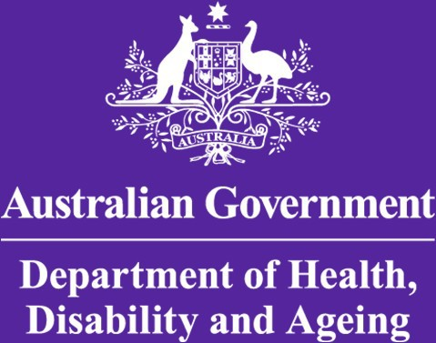
AUSTRALIAN TECHNICAL ADVISORY GROUP ON IMMUNISATION (ATAGI)
REPORT ON ATAGI DISCUSSIONS, NOVEMBER 2025
For General Practitioners
Issue date: 28 November 2025
Prepared by Assoc.Prof. Penny Burns and Dr Alan Leeb

Key updates:
At the most recent meeting of the Australian Technical Advisory Group on Immunisation (ATAGI) in November 2025, several key issues were discussed:

A decline in global and Australian immunisation coverage post COVID was observed, leading to:
- An increased risk of infectious disease outbreaks locally and exposure related to overseas travel.
- An increasing risk of measles cases and local outbreaks.
- The highest rates of pertussis cases since the pandemic.
- A large number of under-vaccinated Australians.
- Children being at a high risk of pertussis and measles.
2025 was a notable influenza season:
- Highest notifications of influenza on record with high inter-seasonal activity.

A new influenza product, LAIV (Live Attenuated Influenza Vaccine) FluMist® will be available in 2026:
- An intranasal influenza vaccine approved by the Therapeutic Goods Administration (TGA) for 2–17-year-olds.
- Not approved for 18-49 years old due to a lack of studies supporting effectiveness.
- There will be state based programs for 2026 in New South Wales, Queensland, Western Australia and South Australia (also available on the private market in 2026).
- Used extensively overseas – since 2003 in the United States of America and since 2013 in the United Kingdom in school-based programs.
- Delivered by one spray in each nostril.
- No exacerbation of asthma/wheeze.

How can GPs assist?
- Measles Mumps Rubella (MMR) catch-up is now funded for all adults born from 1966 onwards who have less than 2 doses on the Australian Immunisation Register.
- Infants over 6 months who are travelling internationally are now funded to have an additional MMR dose.
- Ensure timeliness of childhood and maternal vaccinations.
- Opportunistic review of every patient’s vaccination status.

Where can I get more information?
- Australian Immunisation Handbook updates on current vaccines www.immunisationhandbook.health.gov.au
- NCIRS website for immunisation updates including coverage reports www.ncirs.org.au
- LAIV report UK www.gov.uk/government/publications/which-flu-vaccine-should-children-have/flu-vaccines-for-children-and-young-people

