Adding provider bank account details for the Bulk Billing Practice Incentive Program

18 December 2025

Overview
All eligible providers participating in the Bulk Billing Practice Incentive Program (BBPIP) will receive the BBPIP incentive payment directly into their nominated bank accounts. To receive BBPIP incentive payments providers must add their bank account details in their Health Professional Online Services (HPOS) account. If a provider delivers services across multiple locations, they must add bank account details for each BBPIP participating practice location.

How to update provider banking details:
Providers must update their bank account details in HPOS for each BBPIP participating practice they work at by following the step-by-step instructions below.
- Log into your individual PRODA account
- Under ‘My linked services’ click Go to service on the Health Professional Online Services tile
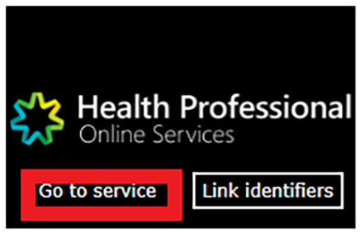
- If you are a member of a PRODA organisation, select No Organisation – Proceed as an individual only to proceed to HPOS
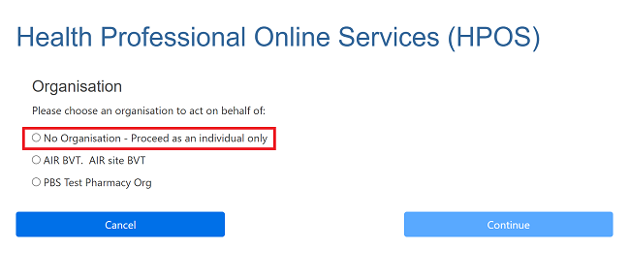
- In HPOS, select the ‘My details’ tile
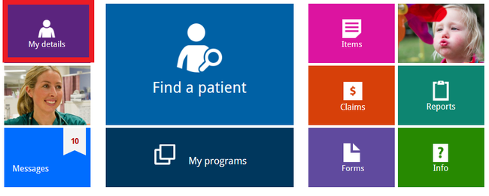
- On the ‘My details’ screen, select the ‘My personal details’ tile
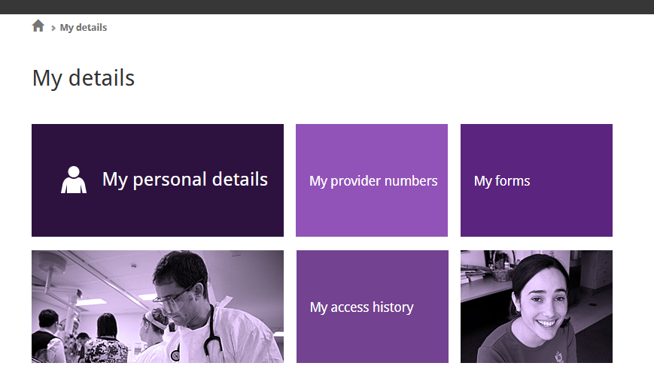
- On the ‘My personal details’ screen, select the ‘My banking details’ tile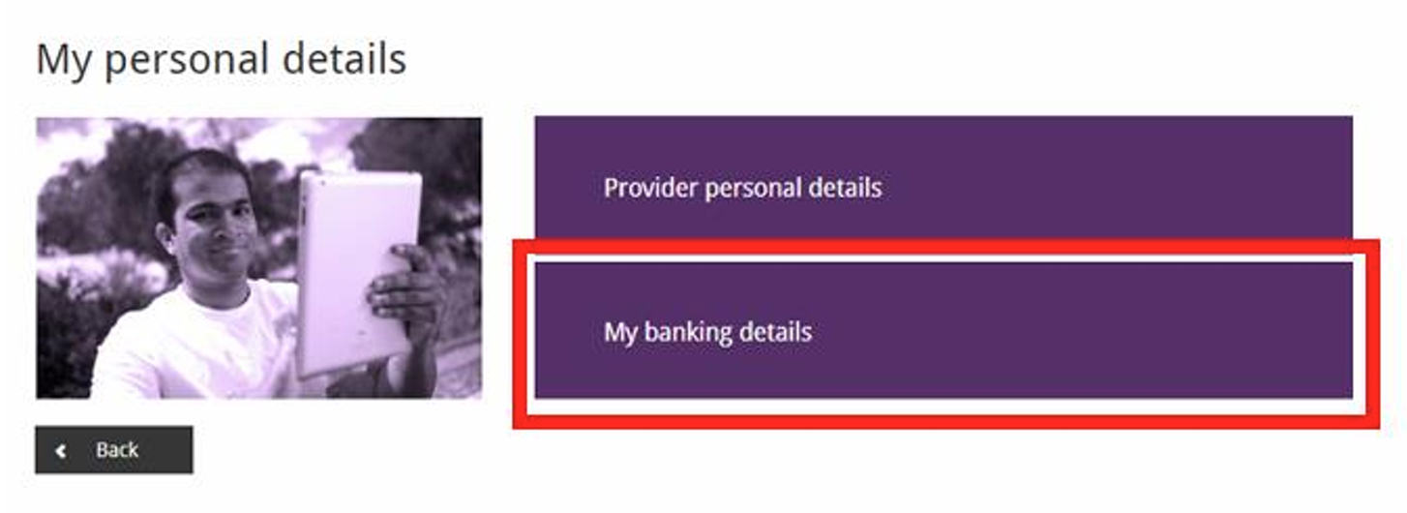
- The My banking details window will appear, displaying a list of your provider numbers, locations and registered programs
- Bank account details can be added or updated for your programs, using the ‘Action’ column on the right-hand side of the window. To receive you BBPIP incentive payments, you must Add your banking details for the ‘MyMedicare Incentives’ program at all the BBPIP participating practice locations where you work. If you have already added banking details, you can update them if needed.
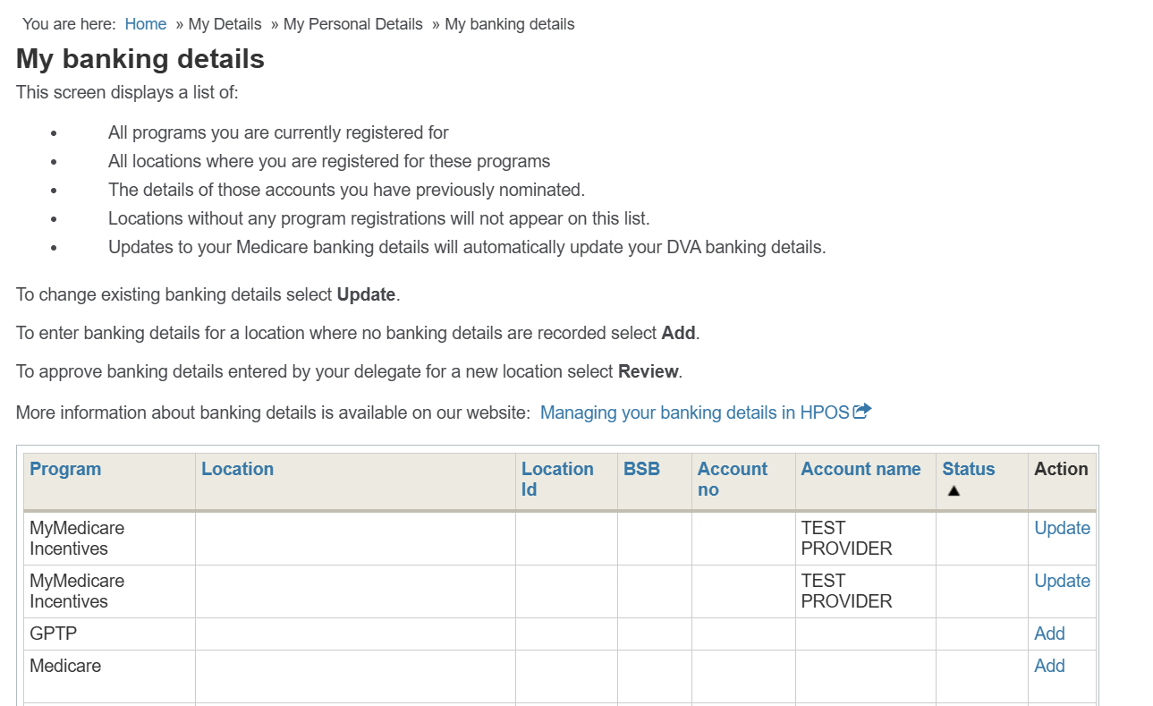
- Once you select to Add or Update your details, the banking details window will appear. The image below shows an example of the ‘Add banking details’ window.
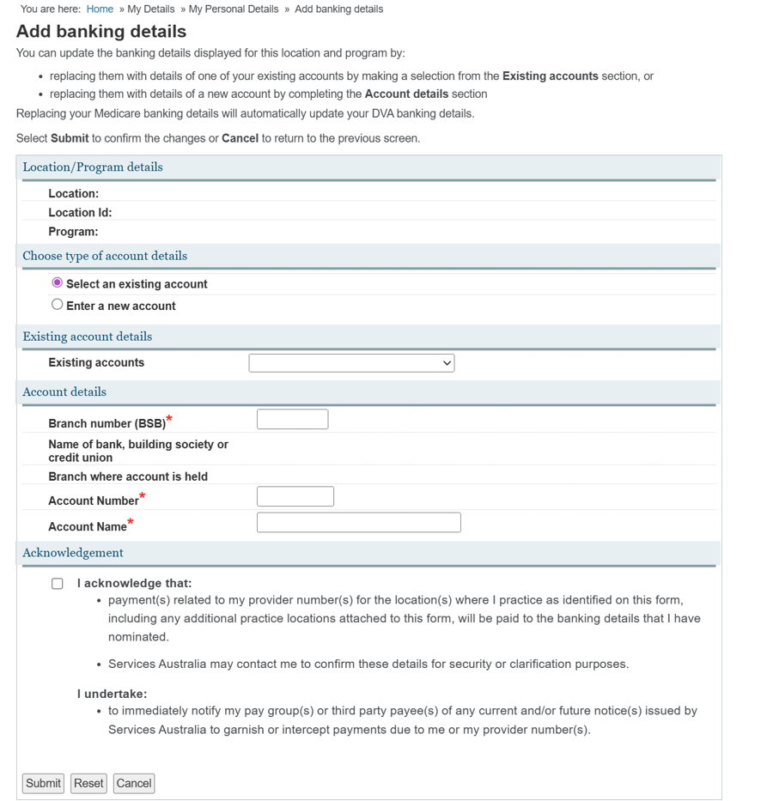
- Choose whether you would like to Select an existing account or Enter a new account. Use the drop-down feature to link to an existing account.
- Once you have entered the appropriate bank account details, you must read the acknowledgement and select the Acknowledgement checkbox to proceed.
- Once completed select ‘Submit’. A success screen will display to confirm details have been updated.
- Please ensure these steps are completed for each BBPIP participating practice location that you work at.
Changes will be visible in HPOS within 24 hours.

More information
- Services Australia webpage: Manage your details in HPOS - Health professionals
- If you require additional assistance with HPOS, please contact Services Australia on 132 150 (Option 2).

