Your toolkit for moving out of aged care

About the toolkit

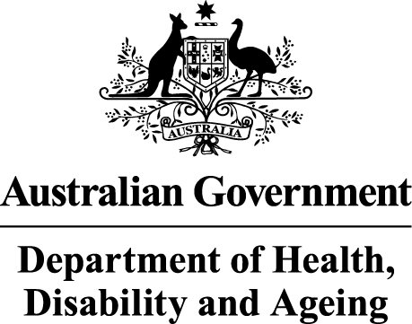 | The Australian Government Department of Health Disability and Ageing wrote this.  We say DHDA for short.  When you see the word we it means DHDA.  We wrote this with help from the  - National Disability Insurance Agency.  We say NDIA for short.
 | We wrote this in an easy to read way.  We use pictures to explain some ideas.
 | We have some words in bold.  This means the letters are thicker and darker.  These are important words.
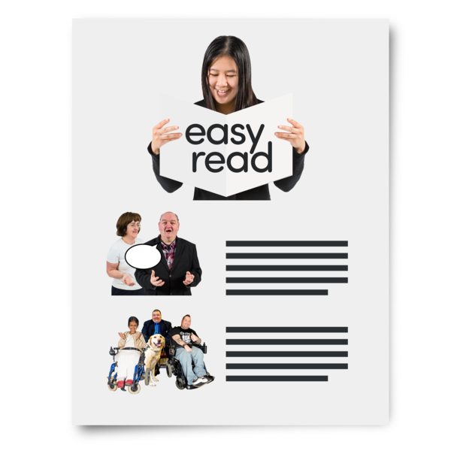 | This is an Easy Read summary of another document.  This means it has the most important ideas.
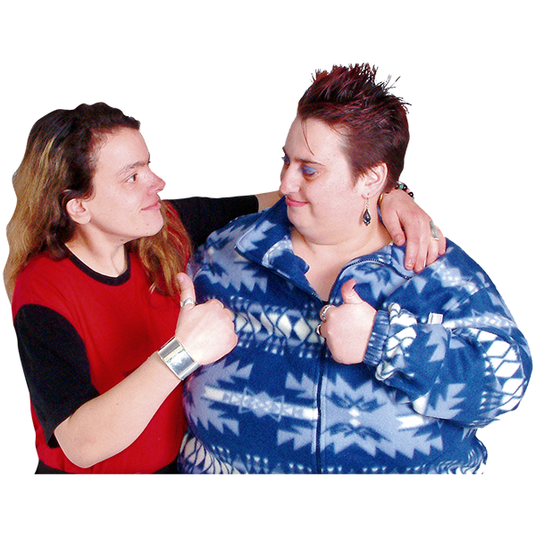 | You can ask for help to read this document.  You can ask  - A friend  - Family members  - A support person.
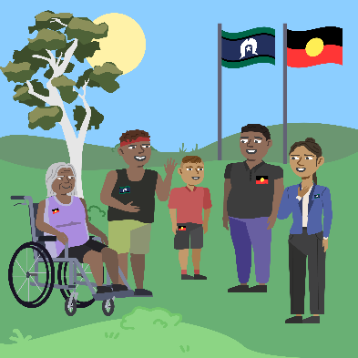 | We recognise Aboriginal and Torres Strait Islander people as the Traditional Owners of the land we live on.
 | They were the first people to live on and use the  - Land  - Waters.

Contents
What is the toolkit | 4
Why we made this toolkit | 6
How we made this toolkit | 8
This toolkit can help you | 10
More information | 11

What is the toolkit
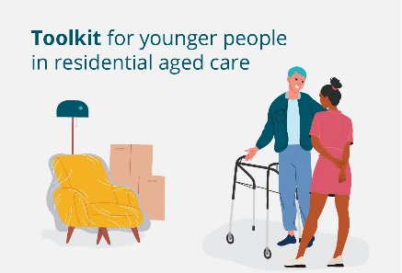 | Your toolkit for moving out of aged care is for  - Younger people with disability who live in aged care.  We say the toolkit for short.  It has all the information you need.
 | Younger people means people with disability who  - Are younger than 65
 | - Do not have a special reason for needing aged care.
 | The toolkit has information from groups who support people with disability.
 | The toolkit is for younger people in aged care who  - Have NDIS  - Do not have NDIS.
 | The people who might use the toolkit are  - You  - Someone who cares for you  - A family member  - Your nominees.
 | Nominees are people you choose to  - Make decisions for you  - Do things for you.

Why we made this toolkit
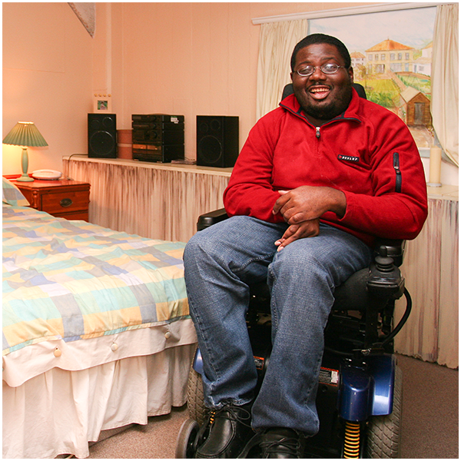 | The Australian Government thinks everyone should live in a home that is right for them.
 | The Australian Government has made a goal.
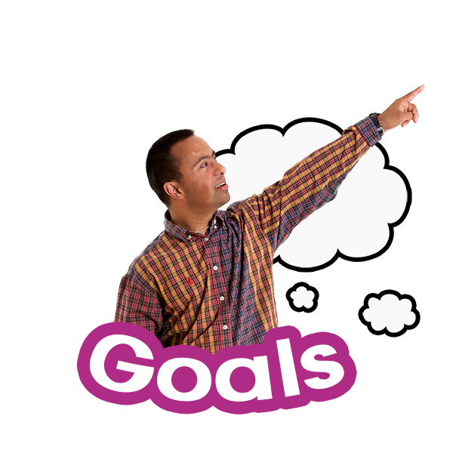 | A goal is something you want to do.  The goal is all younger people will have support to move out of aged care.
 | Aged care homes are not set up to support younger people with disability.
 | It is very important to know that you have the choice to  - Move out of aged care  - Stay where you live.

How we made this toolkit
 | We talked to younger people with disability who  - Live in aged care
 | - Used to live in aged care.
 | We talked to their families.
 | They wanted to know how to  - Find support
 | - Choose their new home
 | - Move to their new home
 | - Have a good life in their new home.

This toolkit can help you
 | You can learn about moving out of aged care.  The toolkit can help you make choices that are right for you.
 | You can choose  - Where you live
 | - Who you live with
 | - Who will support you.

More Information
 | There are 5 chapters in the toolkit.  We wrote Easy Read information about  - The 5 toolkit chapters  - How to contact us.
 | They are on this website.  www.health.gov.au/ypirac  The website is not Easy Read.

Images in this Easy Read must not be used or copied without permission.

