Support at Home program
  - A guide for older Aboriginal and Torres Strait Islander people, families and carers

Contents
Cultural safety in aged care 3
Getting started with aged care 4
About the Support at Home program 8
What supports you can get 9
Classifications and funding 16
Your contribution to your care 18
If you were on the Home Care Packages Program 20
Support to help you access aged care services 21
Other aged care programs to support you 22
Planning ahead for aged care 23

Aged care is changing to put older people at the centre of their care. The changes are also making sure eligible Aboriginal and Torres Strait Islander people aged 50 years or older have access to more culturally safe aged-care services.

Cultural safety in aged care
The new Aged Care Act is the main law that sets out the aged care system. It starts from 1 November 2025 and has an important Statement of Rights. This will help to make sure the voices and needs of all older people, including Aboriginal and Torres Strait Islander people, are at the heart of the aged care system.
Under the new Statement of Rights, you have the right to:
- access aged care that feels culturally safe
- choose someone from your family or community to support you
- communicate your wishes, needs and preferences
- take part in cultural activities where you can speak in language
- stay connected to community, Country or Island Home
- have your privacy respected
- raise issues when something isn’t right.
You also have the choice to have an aged care assessment with an Aboriginal and Torres Strait Islander organisation.
The Aged Care Quality Standards have also been strengthened to:
- put older people at the centre of aged care
- make aged care more inclusive
- support people living with dementia
- strengthen requirements for clinical care, food and nutrition
- provide stronger protections for you.
Learn more: MyAgedCare.gov.au/improving-australias-aged-care-system

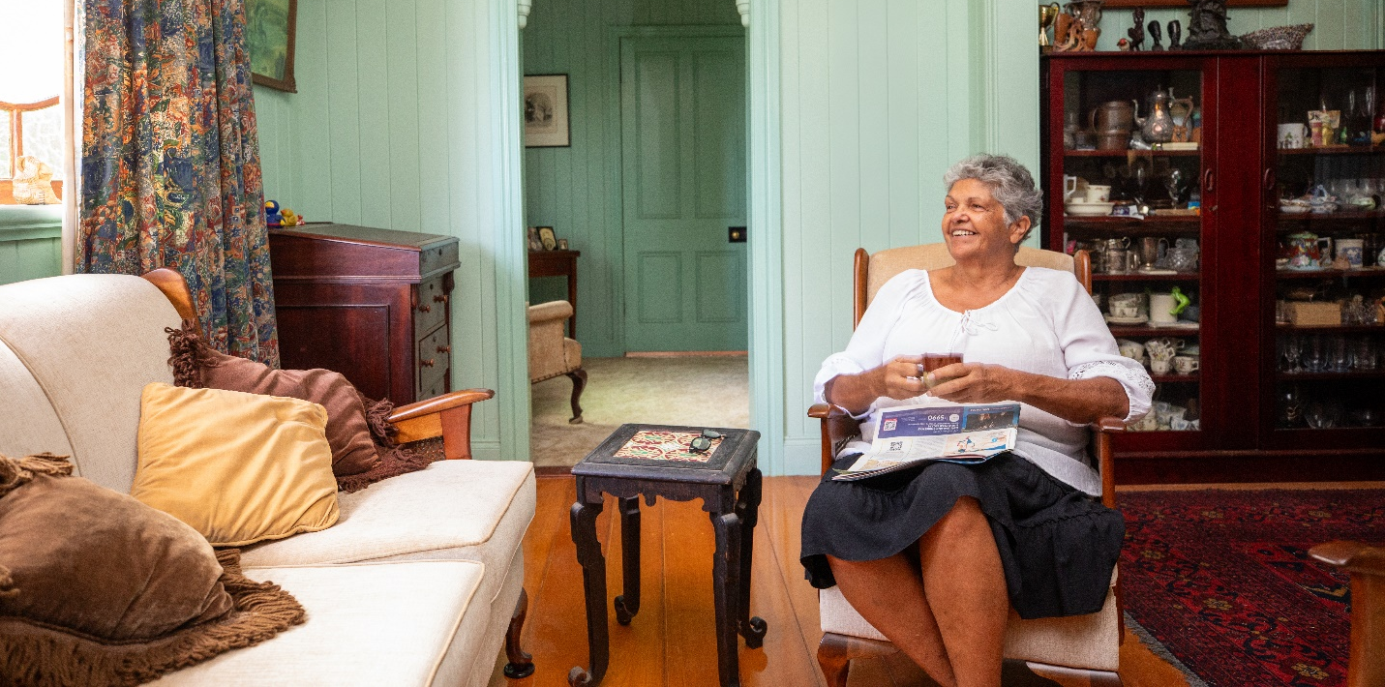
Getting started with aged care

Who can access aged care
Aboriginal and/or Torres Strait Islander people aged 50 and over may be eligible for aged care. You can apply for an aged care assessment to see what support is available.

Kinship carers
Getting an aged care assessment or accessing services won’t impact your kinship caring arrangements.
If you are a kinship carer, you can still access aged care. You must be aged 50 years or over to apply for aged care.
Aged care services can help you to keep caring for your family as you get older.

How to apply for an assessment
The first step to get government-funded aged care services is to check if you are eligible for an aged care assessment.
You can do this:
- through an Elder Care Support worker by emailing aged.care@naccho.org.au or seeing the list of Elder Care Support providers: health.gov.au/resources/publications/list-of-elder-care-support-providers
- online at the My Aged Care website: MyAgedCare.gov.au/assessment
- by calling My Aged Care on 1800 200 422
- in-person with an Aged Care Specialist Officer at a Services Australia office. Book an appointment by calling 1800 227 475.

How we assess for aged care
If your application to get an assessment is approved, you will be referred for an assessment. This involves a yarn with an assessment worker to talk about your aged care needs and support that you need at home. It can be done in person at your own home.

Support for a culturally safe aged care assessment
All aged care assessors have completed an introduction to cultural safety training. They must work with you respectfully to understand your needs in aged care services and how it matters to you and your family. They must listen to you and your family to try to observe local protocols to help you feel safe in your assessment.
You can have a trusted person nominated by you present during your assessment. This could be a:
- family member
- friend
- carer
- support service like an Elder Care Support worker, care finder or Older Persons Advocacy Network (OPAN) advocate (if requested and available)
- trusted person from your community.


Aboriginal and Torres Strait Islander aged care assessment organisations
Some Aboriginal and Torres Strait Islander organisations are offering aged care assessments in parts of Australia. The organisations are usually Aboriginal or Torres Strait Islander Community Controlled Organisations.
These organisations offer aged care assessments that are:
- culturally safe
- trauma aware
- healing informed.
They will support older Aboriginal and Torres Strait Islander people to get aged care services that suit their needs.
The assessments are done by Aboriginal and Torres Strait Islander people or by people trained by the organisation to be culturally safe, trauma aware and healing informed.
From 1 November 2025, you can log your preference on the My Aged Care online portal for an assessment with an Aboriginal and Torres Strait Islander organisation. If you choose one of these organisations, you can also bring someone you trust to support you and use an interpreter if needed.
As more Aboriginal and Torres Strait Islander organisations start offering assessments, they will be added to the Single Assessment System list of assessment organisations. Over time, more areas across Australia will be included.
Until then, older Aboriginal and Torres Strait Islander people can still get assessments through the existing Single Assessment System.

How to get an assessment with an Aboriginal and Torres Strait Islander organisation
You will be asked if your preference is to be assessed by an Aboriginal and Torres Strait Islander organisation when you:
- register with My Aged Care by phone or in person (this could be done with the help of an Elder Care Support worker)
- speak directly to an assessment organisation.
Learn more:
- health.gov.au/sas-organisations-by-location
- health.gov.au/our-work/single-assessment-system/about/workforce

Using My Aged Care
My Aged Care can give you:
- information on the different types of aged care services available
- an assessment of needs to identify eligibility and the right type of care
- referrals and support to find service providers that can meet your needs
- information on what you might need to pay towards the cost of your care.
To contact My Aged Care, you can ask an Elder Care Support worker to help you, or:
- call My Aged Care on 1800 200 422
- visit face-to-face by speaking with an Aged Care Specialist Officer (to book an appointment call 1800 227 475 or visit any Services Australia office)
- go online by visiting: MyAgedCare.gov.au/support-aboriginal-and-torres-strait-islander-people

About the Support at Home program
Support at Home helps older people live at home for longer. It starts from 1 November 2025.
Support at Home helps eligible Aboriginal and Torres Strait Islander people aged 50 years and over to get aged care that is:
- culturally safe
- trauma-aware
- healing-informed
- in or near your community.
The program has services, products, equipment and home modifications to support you as you age. This can help older Aboriginal and Torres Strait Islander people remain healthy, active and socially connected to their community.

How it impacts other home care programs
There are some impacts for other home care programs. Some won’t change.
- Support at Home replaces the Home Care Packages Program and Short-Term Restorative Care Programme.
- The Commonwealth Home Support Program will remain in place until it becomes part of the Support at Home program. This will happen no earlier than 1 July 2027.
- The National Aboriginal and Torres Strait Islander Flexible Aged Care Program will continue. It will not be replaced by Support at Home program.
Learn more:
- MyAgedCare.gov.au/support-home-program
- MyAgedCare.gov.au/NATSIFACP-assessment-outcome

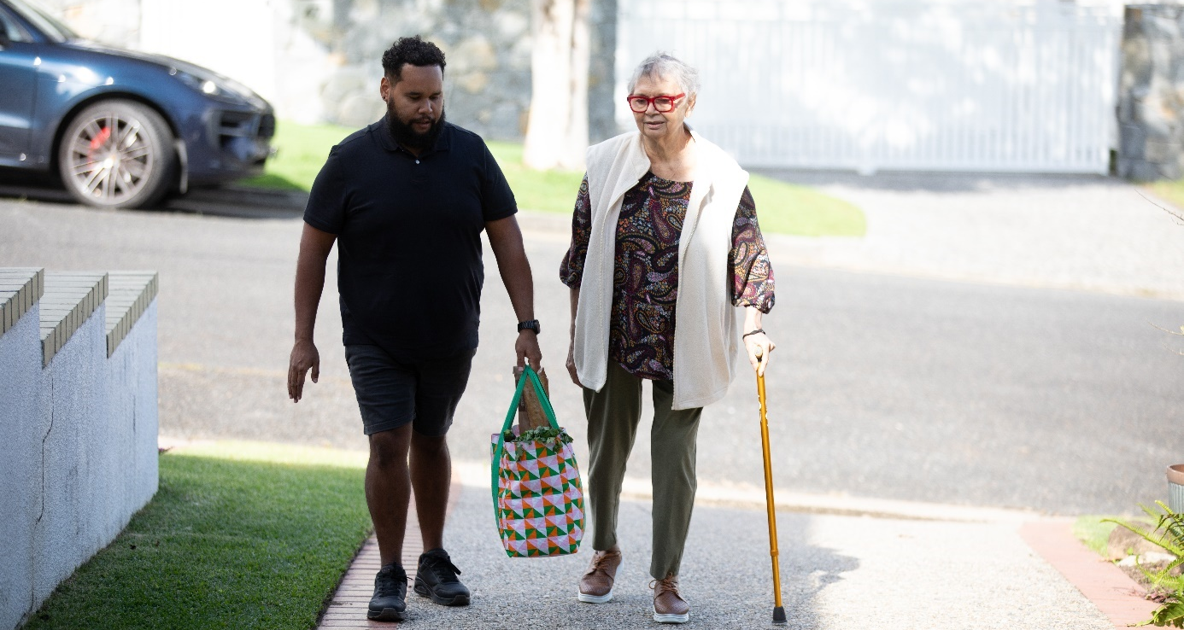
What supports you can get

If you are approved for Support at Home
After your assessment, you will get an outcome that tells you if you are approved and what for.
If you are assessed as eligible for the Support at Home program, you will receive a Notice of Decision and an individual support plan to share with your provider. This will include:
- a summary of your aged care needs and goals
- a classification and a list of your approved services
- if eligible, an approval for short-term supports, which may include a budget for:
  - Assistive Technology and Home Modifications scheme
  - Restorative Care Pathway
  - End-of-Life Pathway.

Services to help you to live at home for longer
Support at Home offers a range of long-term services so you can continue to live well at home. Based on your aged care assessment and eligibility, you will have access to an approved list of services. Your provider will help you choose the services you can get within your package budget.
This includes services that help you stay connected to culture and community such as:
- care that is tailored to your cultural and spiritual preferences as well as your physical needs
- help to join in cultural activities
- access to Aboriginal and Torres Strait Islander health practitioners and workers.
If you have an assessed need, you can get support for:
Clinical supports such as nursing care, occupational therapy and podiatry to help you live safely and independently at home in your community.
Independence supports such as help with showering, getting dressed, taking medications, respite care or support to participate in your usual activities, groups and cultural commitments. This includes transport or translation services based on your needs.
Everyday living such as cleaning, gardening, shopping or preparing meals that meet your cultural needs and preferences.
As your needs change, you can ask to change the services you get from the approved list at any time with your provider. They will support you to make sure the services you get meet your needs.
Learn more: health.gov.au/resources/publications/support-at-home-service-list

Short term supports
There are 3 types of short-term supports available under Support at Home. When you have your aged care assessment, your assessor will tell you if you are eligible for these.

Restorative Care Pathway
The Restorative Care Pathway helps you maintain and improve your independence through allied health services. This could include support from your aged care provider, or your local community-controlled health service if they deliver Support at Home services.
This pathway can help you:
- stay independent
- lower the need for more ongoing services
- do the activities you enjoy.
If you get help through the Restorative Care Pathway, you may get:
- up to 16 weeks of restorative care
- restorative care services on top of any ongoing Support at Home services you already receive
- an extra budget of about $6,000 (or up to $12,000 if needed) for nursing and/or allied health services. This includes access to Aboriginal and Torres Strait Islander health practitioners and workers
- access to helpful products, equipment and home modifications through the Assistive Technology and Home Modifications scheme if needed.
Learn more: MyAgedCare.gov.au/aged-care-programs/restorative-care-pathway

End-of-Life Pathway
Older people needing palliative care support to stay at home may be eligible for the End-of-Life Pathway.
You can be referred to get this support, even if you're not already in the Support at Home program.
With the End-of-Life Pathway, you can get:
- urgent in-home care, including help from Aboriginal and Torres Strait Islander health workers
- up to $25,000 over 3 months.
If you still need help after 12 weeks, you can ask for an assessment to keep getting Support at Home services.
This pathway works alongside other palliative care services offered by state and territory governments.
Learn more: MyAgedCare.gov.au/aged-care-programs/end-life-pathway

Assistive products for independent living
There are things you can get to help you stay living independently at home. This includes products (like a non-slip mat), equipment (like a wheelchair) and changes to your home (like a shower rail) to help you stay safe at home and in your community. Simple changes can make a big difference to your health.
If you are approved for this help through your aged care assessment, you may get funding for assistive technology, home modifications or both. Products, equipment and home modifications are done through the Assistive Technology and Home Modifications scheme.
The scheme includes many health workers who can help you choose the right equipment.

Assistive technology
Assistive technology is a type of support that helps make everyday tasks easier. It includes products and equipment to help you with things like:
- walking
- gardening
- cooking
- painting and crafting
- getting dressed.
If you are approved for assistive technology, you will be allocated a funding tier based on your level of support needs. The funding tiers are:
Funding tier  These are categories for different levels of support needs | Funding amount  This is the amount of funding for each tier | Allocation period  This is how long funding is provided for
Low | Up to $500 | 12 months
Medium | Up to $2,000 | 12 months (more time may be provided if you have a progressive condition)
High | Up to $15,000 (costs above $15,000 can be claimed if you have evidence of your needs) | 12 months (more time may be provided if you have a progressive condition)
Specified needs - assistance dogs | $2,000 annual funding for assistance dogs (ongoing maintenance) | An ongoing annual allocation
This funding may cover the following:
- assistive technology equipment and products
- repairs or maintenance of assistive technology items available on the AT-HM list
- prescription of items, where appropriate
- other related services for the equipment including:
  - delivery
  - set up of the equipment
  - training and education on safe use of the equipment
  - follow-up on effectiveness of the assistive technology in meeting needs.

Home modifications
Home modifications are changes to your home to make it easier and safer to get around.
There are things that can help you, if you need them, for example:
- using the bathroom, like a fixed rail to hold onto
- kitchen safety, like a non-slip floor surface, or easy-turn taps
- going outside safely, like a ramp at your door or sensor lights.
You may also be approved for changes to your home like your bathroom layout or widening doorways to allow for wheelchair access.
If you are approved for home modifications, you will be allocated a funding tier based on your level of support needs. The funding tiers are:
Funding tier  These are categories for different levels of support needs | Funding amount  This is the amount of funding for each tier | Allocation period  This is how long funding is provided for
Low | Up to $500 | 12 months
Medium | Up to $2,000 | 12 months  For progressive condition bundles, funding is available for 24 months (may be extended for another 24 months if required with declaration).
High | Up to $15,000 | 12 months/24 months  Providers may apply for a funding tier time extension of an additional 12 months for HM high tier (24 months in total).
There is a list with the products, equipment and home modifications available under the scheme.
Learn more: MyAgedCare.gov.au/aged-care-programs/assistive-technology-and-home-modifications-scheme

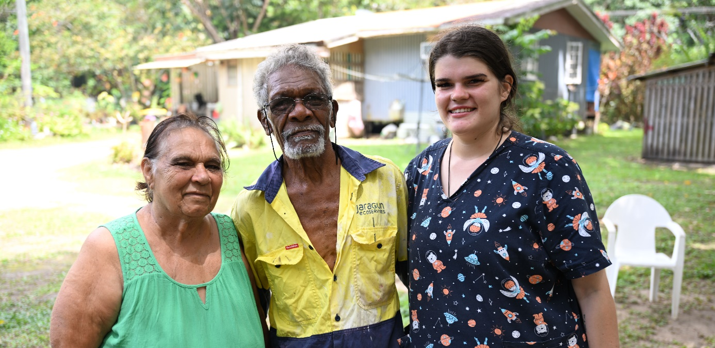
Support to manage your care
Under the program, you will get help to manage your care, budget and services. Your provider will support you and help you get the best results from your services.
If you get regular services, 10% of your quarterly budget will pay for care management by that provider. This amount will be the same even if you decide to self-manage some or all of your services.
Your provider also gets additional funding to support you as an older Aboriginal and/or Torres Strait Islander person. This is equal to 12 extra hours each year for each person who gets regular Support at Home services.
Your provider may help you with:

Services  These are the types of services to help manage your aged care | Description  This gives more information about what the services mean
Care planning | - Working with you to identify and assess your needs, goals, preferences and existing supports.  - Developing and reviewing your care plan.  - Reviewing your service agreement.
Service coordination | - Communicating with workers involved in your care and with you and your family or informal carers (if you consent).  - Managing your budget. Your provider must provide you with a monthly statement and respond to your questions about what is being paid. If you have not received those services, you can dispute it.  - Supporting you if you move to a different kind of care, or from hospital to home.
Monitoring, review and evaluation | - Having ongoing discussions about your care.  - Planning meetings between healthcare workers, the person getting care and their family or supporting people to yarn about and organise the care that’s needed.  - Making sure any changes to your needs are addressed.  - Watching out for any risks to your care needs or safety.  - Making sure your goals, needs and quality of services are being met.
Support and education | - Supporting you to make decisions about your care.  - Helping you to become more independent.  - Providing advice, information and resources about your care.  - Sharing information about living a healthy lifestyle.  - Helping with the aged care system.  - Problem-solving issues and risks.  - Ensuring your views, rights and concerns are heard and escalated.  - Assisting you with providing complaints and feedback.
Learn more: MyAgedCare.gov.au/aged-care-services/care-management

Organising your own care
Making decisions about the care you receive is important. Everyone in Support at Home should be supported to make decisions about their care.
Some people like to do more of the organising of their services themselves. This is called self-management. Self-management involves lots of different things, depending on your needs and how much you want to be involved. This could mean:
- organising your budget
- scheduling your own services
- choosing the staff you want to deliver services
- sometimes this can mean choosing workers from different organisations and arranging how they get paid.

If you want to do any of these things, you need to talk with your provider.

Classifications and funding

Classifications
Your aged care assessment helps us work out which level of support suits you best. The Support at Home program has:
- 8 classifications of ongoing care, matched to how much help you need
- 3 types of short-term support.
The more care you need, the higher your classification, support and budget for your care.

Budget for services
If approved for Support at Home you’ll be allocated a yearly budget to spend on approved services. This budget is split into 4 parts, one for each quarter of the year starting in January, April, July and October. Your budget is not provided to you directly as cash or in your bank account, it is managed by Services Australia. Services Australia may also be known as Centrelink.

Managing your budget
Services Australia is the government department that manages Support at Home budgets. They will hold the monies for your approved package for you. You will have a say in your services and their delivery with your provider. You don’t need to manage payments yourself.
You’ll have access to your full quarterly budget at the start of January, April, July and October. If you join part way through a quarter, you’ll get a smaller amount to cover the remainder of the quarter.
Funding for assistive products (AT-HM scheme) will be available upfront for a 12-month period in most instances.
You can use your budget for services listed in your Notice of Decision and support plan. Your provider will help you decide how to use your budget.

Every month, your provider will give you a detailed statement showing:
- what services you’ve used
- how much budget has been spent
- your remaining budget
- any contributions you’ve made towards the cost of your services.
You can ask your provider to explain their policies on what can be charged to your package. This can include examples where you might give late notice for a service change or a no-show to appointments.

Saving unused funds
If you're getting ongoing services through Support at Home but don’t use all your budget, you can carry over some unused budget from one quarter to the next. These saved funds can help cover unexpected needs, like if you, your carer or family member need to go away for Sorry Business or attend other cultural events.
There’s a limit to how much you can carry over from one quarter to the next. You can carry over the higher amount of either:
- up to $1,000 or
- 10% of your quarterly budget including supplements.
Learn more: MyAgedCare.gov.au/support-at-home-costs-and-contributions

Your contribution to your care
People who get Support at Home pay part of the cost of some services. This cost is known as a contribution. For example, you may need to pay some of the cost of general services such as cleaning. You only need to pay for the services you have received. You should check with your provider on their policies for contributions and how they will charge your package including for last minute service changes.
You won’t need to pay a contribution for clinical support services such as nursing and physiotherapy.

How your payment contribution is calculated
If approved for Support at Home:
- the amount you need to pay depends on an assessment of your income and assets
- you’ll pay a percentage of the cost of each service to your provider. This is your contribution
- we will pay the rest directly to your provider
- the percentage you pay depends on the type of service you receive.
Use the Support at Home fee estimator to better understand what your contributions may be: MyAgeCare.gov.au/support-at-home-fee-estimator

Standard participant contribution rates from 1 November 2025
Age Pension status  This is whether you receive the Age Pension from the government | Clinical care services  How much you need to pay towards these services | Staying independent  How much you need to pay towards these services | Everyday living services  How much you need to pay towards these services
Full pensioner | 0% | 5% | 17.5%
Part pensioner and eligible for a Commonwealth Seniors Health Card | 0% | Between 5% and 50% depending on income and assets | Between 17.5% and 80% depending on income and assets
Self-funded retiree | 0% | 50% | 80%

If you have trouble paying your contribution
If you can’t afford to pay your fees or contribute to your care costs, help may be available.
To apply for financial hardship assistance:
- complete the form: ServicesAustralia.gov.au/sa462
- send the form and any supporting information and evidence required to Services Australia: ServicesAustralia.gov.au/financial-hardship-assistance-eligibility-for-aged-care-cost-care
Services Australia will assess your application within 28 days. They will let you know in writing of their decision and what assistance you’re eligible for. If they need more information to assess your claim, they will contact you to ask for this.
You will not be asked to make contributions while your application is being assessed. However, contributions are not waived for the period when an application is being assessed and if the application is unsuccessful you will be required to pay those contributions.
For further information to help you plan your finances for aged care, visit: MyAgedCare.gov.au/financial-support-and-advice

If you were on the Home Care Packages Program
If you already get the Home Care Packages Program, from 1 November 2025, you will move to Support at Home. You will keep the same funding level and be able to choose services from the Support at Home service list.
If you are on the National Priority System waiting for a Home Care Package, you will automatically get a classification when a place is available.
If you need more restorative care after 1 November 2025, you will need a new assessment to get it under Support at Home. Any unspent funds from your Home Care Package will carry over and can be used for approved services or assistive technology.
Prices for your services may change under Support at Home. The government has rules to make sure prices are fair and clear. You can read the fact sheet for more details.

‘No worse off’ principle
The ‘no worse off’ principle means that if you were on a Home Care Package or approved for one by 12 September 2024, you will be no worse off with Support at Home. This means:
- you’ll pay the same or less under Support at Home
- if you didn’t pay fees before, you won’t pay fees now.
The lifetime cap of $84,572 still applies. The lifetime cap means that if you have paid a total of $84,572 in contributions to your home care services over time, you don’t need to pay any further contributions. The lifetime cap is indexed in line with the consumer price index twice a year.
Learn more: MyAgedCare.gov.au/support-at-home-costs-and-contributions
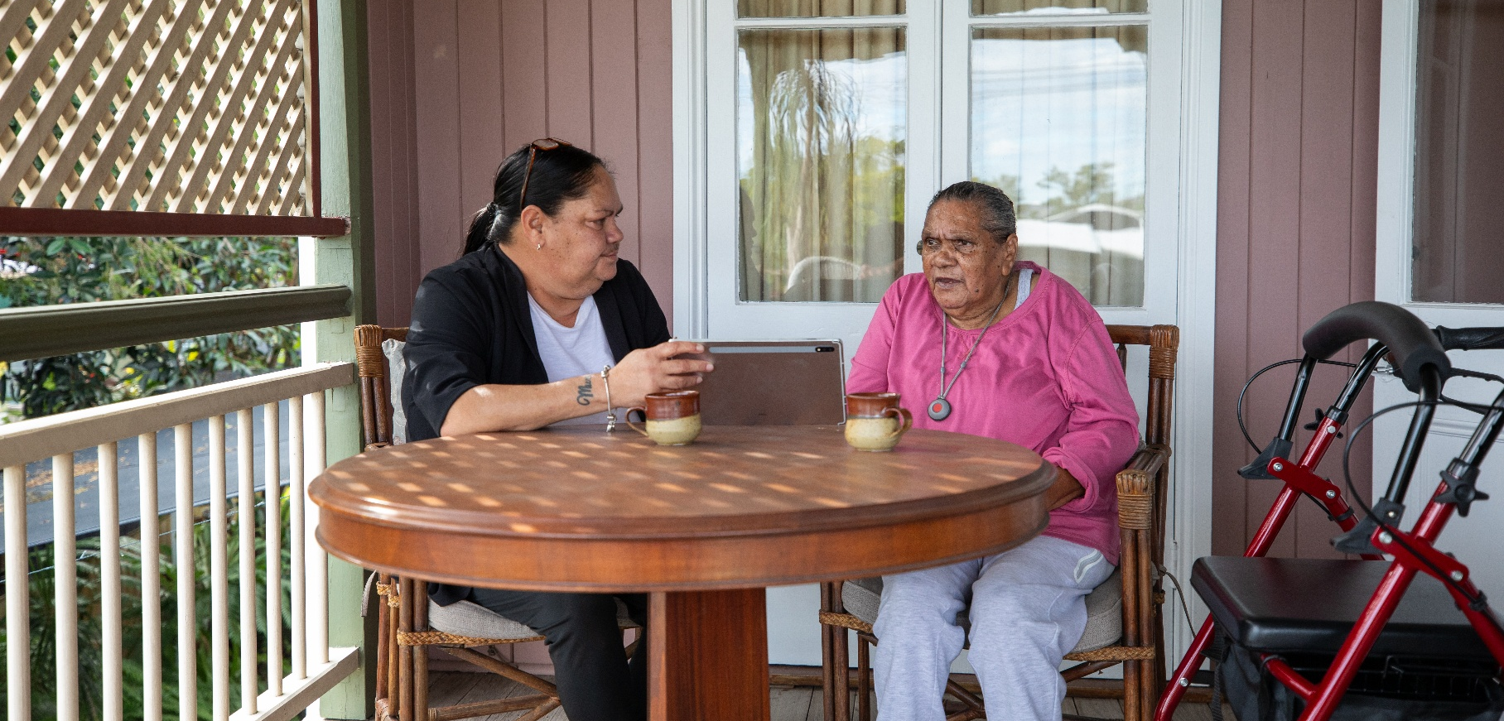

Support to help you access aged care services

Elder Care Support workers
Elder Care Support workers can help you understand aged care services, assessments and choose between different providers.
The Elder Care Support Program is delivered by the National Aboriginal Community Controlled Health Organisation. For support email aged.care@naccho.org.au
Learn more:
- MyAgedCare.gov.au/elder-care-support-program
- health.gov.au/resources/publications/list-of-elder-care-support-providers

National Aboriginal and Torres Strait Islander Ageing and Aged Care Council (NATSIAACC)
NATSIAACC works with their member organisations and governments to ensure Elders can access support and care that is culturally safe, trauma-aware and healing-informed, and recognises the importance of their personal connections to community and Country.
Learn more: natsiaacc.org.au

Older Persons Advocacy Network (OPAN)
OPAN provide free and confidential support for older people receiving government-funded aged care. They provide advocacy services to help you receive better aged care. They can help you understand your rights, find aged care services that are right for you, and try to solve any problems you’re having with your aged care.
They have a network of specialist Aboriginal and Torres Strait Islander advocates who can support you to get aged care that meets your needs.
Learn more: opan.org.au

Care finders
Care finders can help older people who need intensive help to access aged care services and other supports in the community. It is a free service for vulnerable people who have no one else who can support them.
Visit the My Aged Care website to see a list of care finders in your area.
Learn more: MyAgedCare.gov.au/help-care-finder

Other aged care programs to support you

National Aboriginal and Torres Strait Islander Flexible Aged Care Program (NATSIFACP)
The NATSIFACP provides a mix of aged care services for Aboriginal and Torres Strait Islander people.
The NATSIFAC Program will continue, it will not be replaced by Support at Home.
Learn more: MyAgedCare.gov.au/NATSIFACP-assessment-outcome

Planning ahead for aged care
It can help to start having conversations about aged care for you or your loved ones, even before needing any care or support.
Here are some other things you can look into to start thinking about aged care:
- talk to your GP or local health worker
- talk to a support service such as an Elder Care Support worker, care finder or OPAN advocate who can talk to you about how to find aged care that meets your needs
- visit My Aged Care to understand what support is available. The Support for Aboriginal and Torres Strait Islander people page is designed with needs of communities as the main focus: MyAgedCare.gov.au/support-aboriginal-and-torres-strait-islander-people
- check out and compare providers to find out which ones will suit you best: MyAgedCare.gov.au/find-a-provider
- sign up to receive EngAged, our monthly newsletter on aged care and ageing well: health.gov.au/aged-care-newsletter-subscribe
- follow the Council of Elders on Facebook and keep up with the work they’re doing: facebook.com/groups/AgedCareCouncilOfElders

- find out what we’re doing to help people in Australia age well: health.gov.au/topics/positive-ageing-is-ageing-well



