Support at Home program – Assistive Technology and Home Modifications (AT-HM) scheme
November 2025
The Assistive Technology and Home Modifications (AT-HM) scheme provides products, equipment and home modifications based on your assessed needs.

How can I get AT-HM supports if I am a new participant?
Your aged care assessment will determine if you need products, equipment (e.g. a wheelchair) or home modifications (e.g. a shower rail) to help you live safely and independently at home. If you are approved for the AT-HM scheme, funding is included in your support plan based on your needs. You may be approved to receive funding for either assistive technology or home modifications, or both.

How can I get AT-HM supports if I am moving from the Home Care Packages Program?
Home Care Package (HCP) care recipients transitioned to Support at Home on 1 November 2025, along with any unspent funds. Talk to your Support at Home provider about your assistive technology or home modifications needs – they can tell you how to use any unspent HCP funds to access the AT-HM scheme and request additional funding if needed.
You will need to use your unspent HCP funds before you can use AT-HM scheme funding. Participant contributions do not apply to your unspent funds.

How is the AT-HM scheme funded?
The AT-HM scheme is funded separately to your ongoing Support at Home services. This means, unlike the HCP Program, you won’t need to save money from your budget to get products, equipment and home modifications.
There are 3 short-term assistive technology and 3 home modifications funding tiers matched to the assistive technology and home modifications you may need: low, medium and high. You may access assistive technology funding over $15,000 if required to meet your assessed needs. This can be organised through your provider.
The funding will cover the items you need, as well as a health professional assessment if applicable. The funding will also cover any extra support to ensure you are able to use the item safely and effectively. We call these wraparound services.
The assistive technology funding tiers are:
Funding tier | Amount
Low | Under $500
Medium | Up to $2,000
High | Up to $15,000+
The home modifications funding tiers are:
Funding tier | Amount
Low | Under $500
Medium | Up to $2,000
High | Up to $15,000
Your AT-HM funds will not accrue over time and will be available for 12 months. Under some circumstances, such as having a specific progressive condition or needing complex home modifications, we may give you more time to use your funding.
If you have specific needs, such as for an assistance dog, you may be eligible for extra funding over a longer time.
If your needs change and you require additional equipment, products or home modifications after your AT-HM funding has expired you can be re-assessed to get access to further funding to meet your needs.

What items can I access under the AT-HM scheme?
The AT-HM list on our website lists the products, equipment and home modifications that are available under the AT-HM scheme: health.gov.au/resources/publications/assistive-technology-and-home-modifications-list-at-hm-list

How do I source assistive technology and home modifications once I’m approved?
Your provider will be responsible for arranging and sourcing your assistive technology and home modifications.
Your provider can help you to access some products and equipment directly, as listed in the AT-HM list. For more complex products or equipment, your provider may organise an assessment from a health professional who can prescribe items that meet your needs. For example, an occupational therapist.
All home modifications must be prescribed by an occupational therapist working within their professional scope of practice to ensure you are getting the right supports.

Will I have to contribute to my AT-HM costs?
Support at Home participant contributions apply to the AT-HM scheme. You may have to make a moderate contribution to the cost of the equipment, products or home modifications (and associated services) you need. You will not have to contribute to the costs of health professional assessments and prescriptions or wraparound services. These are categorised as clinical care and are fully funded by the government.
To learn more about participant contributions, visit: MyAgedCare.gov.au/support-at-home-costs-and-contributions
For more information
To find out more about the AT-HM scheme, visit: MyAgedCare.gov.au/aged-care-programs/assistive-technology-and-home-modifications-scheme
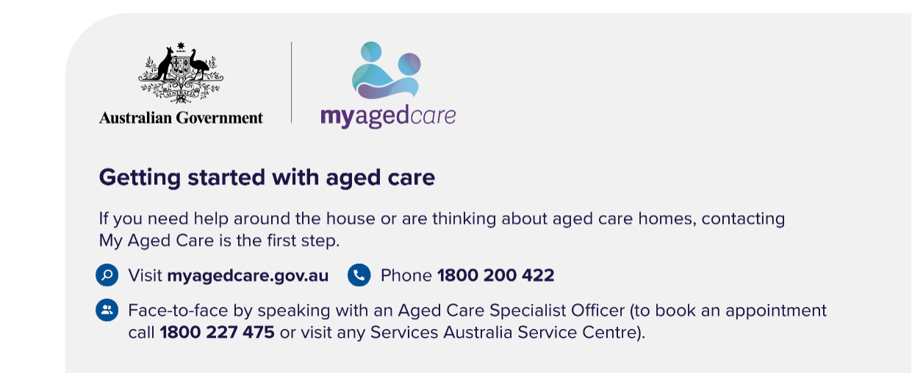
If you have questions or concerns about your aged care, including Support at Home, you can speak to an aged care advocate by calling the Aged Care Advocacy Line on 1800 700 600. Provided by the Older Persons Advocacy Network (OPAN), this free and confidential service is independent of both government and aged care providers. OPAN will connect you with a local advocate in your state or territory.

