New regulatory model
  - Guidance for Allied Health Professionals

Version
Contents
Key terms 4
Allied health in aged care 4
Overview of the new regulatory model 5
Sole traders and partnerships 5
New definitions under the new Act 6
How you can deliver allied health services in aged care 7
Delivery pathways 8
Provider registration 9
Registration categories 10
Overarching requirements of the new Aged Care Act 11
Strengthened Aged Care Quality Standards 12
Aged Care Provider Requirements Search tool 12
Support at Home program 13
Aged care regulatory and governance roles 14
How allied health professionals are regulated outside of government-funded aged care 14
FAQs 15
Summary for allied health professionals 18
Glossary of key terms 19
Resources 20
Contact 21

Key terms
This booklet uses terminology aligned with the Aged Care Act 2024 and Aged Care Rules 2025. Below are brief definitions of key terms used throughout.
For full definitions and legal references, see the Glossary of key terms on page 19.
Allied health professional – a qualified practitioner registered under the National Law to deliver allied health services.
Registered provider – an individual or organisation approved by the Aged Care Quality and Safety Commission (ACQSC) to deliver government-funded aged care services.
Associated provider – a subcontracted entity engaged by a registered provider to deliver aged care services on their behalf.
Aged care worker – a person employed or engaged by a registered or associated provider to deliver aged care services.
Service list – a list of aged care services eligible for government funding, as defined in the Aged Care Rules.
Subcontractors – this refers to entities that are subcontracted by the registered provider to deliver services, some of which may be funded aged care services.

Allied health in aged care
Allied health professionals play an important role in maintaining and improving the health and wellbeing of older people accessing aged care. They help older people stay healthy, independent and active longer through the provision of physical, social and daily support and other activities.
Some allied health professionals may be new to the aged care system, while others have provided services in aged care for many years.
Allied health professionals have reached out to the department to understand what the changes in aged care will mean for them under the new Aged Care Act 2024 (new Act), which came into effect on 1 November 2025. This includes understanding how they can deliver allied health services in a government-funded aged care setting.
This booklet outlines the regulatory changes that come into effect under the new Act. It outlines how allied health professionals can provide government-funded aged care services, including information about delivering services as an aged care provider, operating as an associated provider, and being engaged to deliver aged care services as an aged care worker.
This booklet further outlines the roles of the Department of Health, Disability and Ageing (department) and the Aged Care Quality and Safety Commission (ACQSC) and how they intersect in overseeing Australia’s aged care sector.
The new Aged Care Rules 2025 (Rules) and explanatory statement provide further detail on how the new Act will work, to ensure care is delivered in a safe, respectful and transparent way for older people.
Definitions and legal references are listed in the Glossary of key terms on page 19.

Overview of the new regulatory model
The new regulatory model sets out the roles and responsibilities of aged care providers, which came into effect on 1 November 2025.
The new model introduces:
- universal registration – a single registration for each provider across all aged care programs they deliver
- requirements that reflect the types of services delivered
- more protections that place the rights and needs of older people at the centre of their care to help them feel confident about their care
- ways for providers demonstrating excellence to be recognised, such as longer registration periods and graded audits against the strengthened Aged Care Quality Standards.
It also introduces whistleblower protections which play an important role in identifying and calling out misconduct.
The new model will make it easier for providers to operate across multiple aged care programs by simplifying the arrangements for entry to service delivery.

Sole traders and partnerships
One of the changes under the new Act is that sole traders and partnerships can apply to become registered providers for the first time. This opens the aged care market to more organisations and offers more choice to older people. Many allied health businesses operate under these models.
Allied health professionals can apply to become a registered provider under the new Act, if they choose. The individual or organisation will require an ABN and must be able to demonstrate their ability to deliver aged care services relevant to their proposed registration category. See page 10 for further information on how the ACQSC will register providers to deliver government-funded aged care services under the new Act.
Sole traders and partnerships should consider the requirements of delivering their proposed services before deciding to apply. For example, until at least June 2027, a single provider model will operate for the new Support at Home program. This means registered providers delivering services under Support at Home, will need to be registered in the relevant categories their care recipients require services in. See page 13 for further information on the Support at Home program.

New definitions under the new Act
The new Act introduces new definitions about what it means to be an aged care provider and aged care worker.
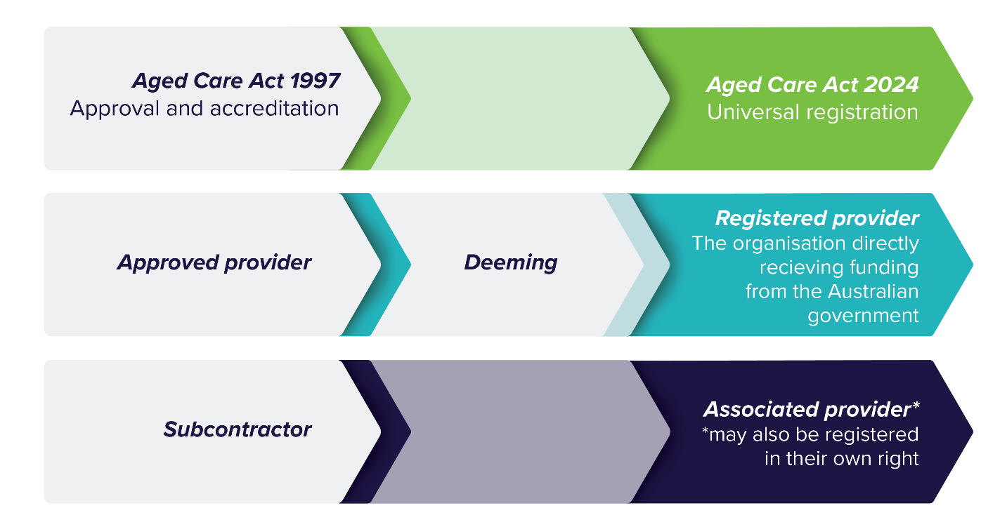
Figure 1: Transition from the Aged Care Act 1997 to the Aged Care Act 2024
Aged care providers
Approved providers will become registered providers
An aged care registered provider is an entity that is formally registered with the ACQSC to deliver government-funded aged care services.
To put it simply, the organisation that directly receives funding to deliver aged care services from the Australian Government must be a registered provider. If the registered provider engages other organisations to deliver some funded aged care services on their behalf, these organisations will be known as associated providers.
Subcontractors delivering funded aged care services will be known as associated providers
Associated provider is a new term being introduced by the new Act. It describes an entity that delivers government-funded aged care services on behalf of a registered provider. An associated provider may be a registered provider in their own right or may operate in the aged care system solely as a subcontractor and remain unregistered.
Service provision arrangements that previously existed between subcontractors and approved providers have not been affected by commencement of the new Act.
It is important to understand that registered providers cannot contract out their legal responsibilities. A registered provider remains responsible for ensuring their associated providers and their workers delivering services on their behalf comply with relevant requirements, regardless of whether the associated provider delivering those services is registered with the ACQSC.
Subcontracting arrangements for delivery of services which aren’t listed as funded aged care services will not be considered associated providers.
Aged care workers
Under the new Act, an aged care worker of a registered provider is:
- an individual employed or engaged (including as a volunteer) by the registered provider or associated provider, or
- an individual who is a registered provider (such as a sole trader).
Allied health professionals employed by a registered provider or associated provider are aged care workers under the new Act.
If an allied health professional applies to the ACQSC to become a registered provider as a sole trader, they will be delivering services as both a registered provider and an aged care worker.

How you can deliver allied health services in aged care
Under the new Act, government-funded aged care services must be delivered by:
- registered providers – organisations or individuals directly funded by the Australian Government
- associated providers – entities subcontracted by registered providers
- aged care workers – individuals employed or engaged by registered or associated providers.
Allied health professionals may also be engaged to provide services to privately paying clients. These arrangements remain the responsibility of the client and allied health professional to coordinate and are not regulated under the new Act.

Delivery pathways
Allied health professionals can participate in aged care in one or more of the following roles.

Registered provider
You may apply to become a registered provider and receive direct government funding. This includes sole traders and organisations. As a registered provider, you are responsible for ensuring all services—whether delivered directly or by an associated provider on your behalf—meet the requirements under the new Act and Rules relevant to your registration category.
Note: Legal responsibilities cannot be contracted out. The registered provider remains accountable for regulatory compliance, even if services are delivered by an associated provider.

Associated provider
If you are subcontracted by a registered provider to deliver government-funded aged care services on their behalf, you are considered an associated provider. This includes organisations delivering allied health services on behalf of a registered provider.
Example: An occupational therapist sole trader is subcontracted by a registered provider to deliver therapy under the Support at Home program.
It is possible to be an associated provider and a registered provider at the same time.
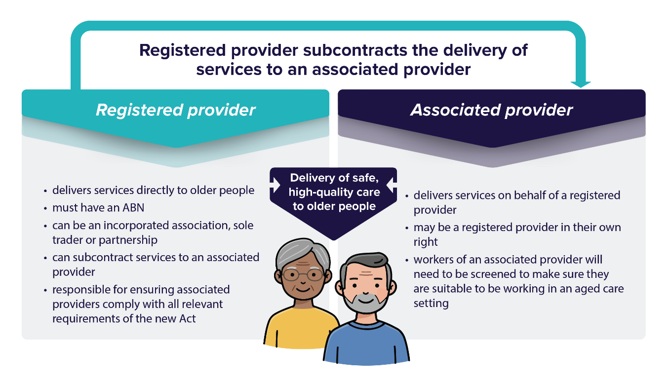
Example: Your organisation is registered with the ACQSC to deliver services under the Support at Home program. You also subcontract to provide speech pathology services in a residential aged care home, acting as an associated provider.
Figure 2: Who can be a registered provider and associated provider
The ACQSC has published guidance for associated providers including explaining the requirements of registered providers who use associated providers in the delivery of their aged care services.

Aged care worker
If you are employed or engaged, including as a volunteer, by a registered or associated provider, you are considered an aged care worker. This includes allied health professionals working within aged care organisations.
Important: Worker screening requirementsTraining, and compliance with the Aged Care Code of Conduct are mandatory for all aged care workers.
Note: Allied health services in aged care must be delivered according to your professional training and responsibilities and be aligned with your scope of practice. This includes maintaining accreditation/registration, ongoing professional development and any reporting obligations as required by your professional body.

Provider registration
From 1 November 2025, individuals or organisations can apply to the ACQSC to become a registered aged care provider under the new Act.
The ACQSC’s Provider Registration Policy and Registration Model provide more detail on the registration process and guiding principles.

Registration categories
There are 6 registration categories that group service types based on similar care complexity and risk.
Registered providers are not required to deliver all services in the categories they are registered in but should deliver at least one service. All registered providers will need to comply with their requirements and the Aged Care Code of Conduct.
The strengthened Quality Standards will apply to registration categories 4, 5 and 6, based on the services being delivered.
The 6 registration categories are:
Provider registration category | Description | Service types
Category 1 | Home and community services | - Domestic assistance  - Home maintenance and repairs  - Meals  - Transport
Category 2 | Assistive technology and home modifications | - Equipment and products  - Home adjustments
Category 3 | Advisory and support services | - Hoarding and squalor assistance  - Social support and community engagement
Category 4 | Personal and care support in the home or community | - Allied health and other therapy  - Personal care  - Nutrition  - Therapeutic service for independent living  - Home or community general respite  - Community cottage respite  - Care management  - Restorative care management
Category 5 | Nursing and transition care | - Nursing care  - Assistance with transition care
Category 6 | Residential care | - Residential accommodation  - Residential everyday living  - Residential services  - Residential clinical care
To deliver government-funded allied health services under the new Act, registered providers must be registered in Category 4 with the service type Allied health and therapy listed in their registration. The strengthened Quality Standards apply to this category.
Section 8-15 of the Rules outlines the government-funded aged care services that fall under the service type Allied health and therapy that can be delivered under the new Act.

Aged care service list
The aged care service list is set out in the Rules and includes all services under the service types that can be funded by the government.

Overarching requirements of the new Aged Care Act
Some conditions of registration will apply to all providers. For example:
- understanding and having systems in place to support the rights of older people receiving aged care services
- continuous improvement
- the Statement of Rights
- the Aged Care Code of Conduct
- incident management and complaints.
Section 142-1 of the Rules provides an outline of the conditions of registration.
Other conditions will be specific to a registration category and only apply to certain providers. For example:
- setting up an advisory board
- meeting financial and reporting requirements
- compliance with the strengthened Aged Care Quality Standards.
Registration requirements, related provider requirements and regulatory oversight will be linked to the registration categories and are proportionate to the service types being offered. Aged care providers will need to meet requirements under the new Act relevant to their registration category.
All providers will be subject to monitoring and risk surveillance under the ACQSC’s supervision model and risk-based suite of responses. All providers will be given a supervision status based on information the ACQSC has about their capability, capacity and commitment to meet their requirements. This supervision model includes managing risks effectively to prevent harms and to ensure providers uphold the rights in the Statement of Rights.
The four supervisory statuses escalate in terms of the intensity of the ACQSC’s intervention in responding to risk and include:
- Risk surveillance
- Targeted supervision
- Active supervision
- Heightened supervision
You can find more information in the ACQSC’s Regulatory Strategy 2025-26.

Strengthened Aged Care Quality Standards
The previous Aged Care Quality Standards have been strengthened as part of the new regulatory model and are now in place. The strengthened Quality Standards are designed to improve outcomes for older people and set clear expectations for providers in delivering quality aged care.
The strengthened Quality Standards apply to registration categories 4, 5 and 6 based on the services being delivered or specified in a funding agreement. The strengthened Quality Standards only apply to services being delivered in those registration categories and not to other services that the provider may deliver.
This means that registered providers delivering allied health services will be regulated by the ACQSC under the strengthened Quality Standards.
Providers delivering the service type Allied health and therapy under registration category 4 will be audited against strengthened Quality Standards 1-4.
It is the responsibility of the registered provider to ensure any associated providers delivering allied health services on their behalf comply with relevant requirements, including the strengthened Quality Standards.

Aged Care Provider Requirements Search tool
To help providers navigate their requirements, an interactive web search tool is available that highlights legislative requirements under the new Act and associated Rules. It is called the Aged Care Provider Requirements Search tool.
The term ‘requirements’ means all the conditions of registration, obligations and duties under the new Act and Rules. These provider requirements create protections to make sure that aged care in Australia is high quality, continuously improving and safe for older people.
The search tool is designed primarily for registered providers, or those interested in becoming a registered provider. Allied health professionals may also find the search tool useful to understand requirements that may apply to them should they choose to become a registered provider.
The search tool will return a list of requirements based on responses to questions about your role in the aged care sector, registration categories, services you deliver and how you are or will be funded.
Older people, carers, peak bodies, aged care workers and the wider community can also use the search tool to understand the requirements an aged care provider must meet when delivering care.
Resources on how to use the search tool are available on the new regulatory model resources page on our website.

Support at Home program
The new Support at Home program replaces the Home Care Packages Program and Short-Term Restorative Care Programme.
The Commonwealth Home Support Program will transition to the new program no earlier than 1 July 2027. Allied health professionals are likely to have delivered services previously under these programs.
Allied health professionals seeking to deliver Support at Home services may do so as a registered provider but need to consider whether they can meet all the Support at Home program and legislative requirements.
Alternately, they may subcontract with a registered provider to deliver allied health services as an associated provider.
Support at Home operates via a single provider model, whereby all services are managed and delivered by a single aged care provider. This means a single provider will oversee and deliver all Support at Home services for a participant, including care management and assistive technology, and home modifications (AT-HM) services.
It is a requirement that all participants receive care management services for the Support at Home program.
As a result, registered providers claiming for the delivery of Support at Home services must be registered into (at a minimum) Category 4 - Personal care and care support in the home or community. Support at Home providers must also meet Outcome 5.1 (Clinical governance) of strengthened Quality Standard 5: Clinical care.
Under the single provider model, providers can deliver services directly or can engage an associated provider to deliver some services on their behalf.

Aged care regulatory and governance roles
Under the new Act, the new regulatory model, the strengthened Quality Standards, feedback and complaints processes, and system governance, will be used collectively to determine how the department and ACQSC oversee and manage the aged care system.
The aged care regulatory and governance roles document will help you to understand the aged care regulatory and governance responsibilities of the department and ACQSC.
The department develops the laws and policies and seeks to ensure the aged care sector meets community expectations, especially those of older people accessing aged care, their families and carers.
The ACQSC works with aged care providers to make sure quality care is delivered and the laws governing aged care are followed. This includes registering and overseeing providers, monitoring providers, supporting continuous improvement and, when necessary, taking enforcement action.

How allied health professionals are regulated outside of government-funded aged care
The allied health workforce in Australia is regulated by either:
- national regulation by the Australian Health Practitioner Regulation Agency
- self-regulation by a professional association that certifies qualifications, sets and maintains standards and oversees professional development.
Allied Health Professions Australia (AHPA) is the peak advocacy and representative body for allied health professionals in Australia. It covers all health, disability and education systems where allied health services have a role.
Each allied health profession has its own professional association. Most professional associations are members of AHPA.
In addition, the National Alliance of Self-Regulating Health Professionals provides and maintains a framework of standards for self-regulating health professions. This facilitates national consistency in quality and support for self-regulating health professionals.
These national regulations are unaffected by the aged care reforms. They do not play a role in any decision of an allied health practitioner to apply to become a registered aged care provider or precipitate any decision by ACQSC to register any allied health organisation to deliver funded aged care services.

FAQs

I delivered allied health services in an aged care setting under the Aged Care Act 1997; have I been deemed as a registered aged care provider under the new Act?
On 1 November 2025, with the start of the new Act, government-funded providers were deemed, or transitioned, to the new regulatory model as registered providers based on the services they deliver. If you were not considered a current government-funded aged care provider in the lead up to the new Act, you have not been deemed as a registered provider.
If you deliver government-funded allied health services in an aged care setting via a subcontracting arrangement, you will now be known as an associated provider under the new Act. Transitioning to the new Act will not change any subcontracting arrangements that are currently in place.
Effective from 1 November 2025, if you are an allied health professional employed or subcontracted either by a registered provider or associated provider to deliver allied health services in aged care, you are considered an aged care worker. You must meet aged care worker screening requirements and comply with your employer’s contractual obligations, including working within your scope of practice and professional training.
Requirements of your professional body, including registration and continuing professional development, are unchanged.

What allied health services can be delivered under the service type Allied health and therapy?
The full list of government-funded aged care allied health services that fall under the service type Allied health and therapy can be found under section 8-15 in the Rules.

Will allied health workers need to get a worker screening check?
From 1 November 2025, all workers delivering government-funded aged care services will continue to need a police certificate (not older than 3 years) that does not record certain offences. Alternately, a NDIS worker screening check can be used.
Further information on the screening requirements for the aged care workforce, including the future of screening checks, can be found on our website.

Can I register as an aged care provider and only deliver allied health services?
This is possible but there will be limited opportunities to deliver only allied health services in the short term.
Organisations providing allied health services and sole traders can be registered providers. As part of the registration process, overseen by the ACQSC, prospective providers will indicate the service types they intend to deliver as a registered provider.
If an allied health organisation or professional wishes only to provide allied health services, they will need to be registered in Category 4 with the service type Allied health and therapy listed in their registration.
However, until at least 2027, Support at Home program recipients will need to have a single provider for all the services they require, including care management. This means that a Support at Home provider will need to be registered for all the service types that their care recipients require.

Do registered providers and allied health organisations need to enter into a brokerage agreement?
Registered providers may subcontract the delivery of allied health services through individuals or organisations. In these cases, where an arrangement is in place for specified delivery of funded aged care services on behalf of the registered provider, the allied health organisation is considered an associated provider. The registered provider remains responsible for ensuring its associated providers comply with relevant requirements under the new Act.
Whether or not to formalise this arrangement through a brokerage or subcontracting agreement is a decision for the parties involved. There is no legislative requirement to enter into a specific type of agreement under the new Act.
The registered provider remains responsible for legislative requirements relating to any services delivered by an associated provider. It is up to the registered provider to determine how it will ensure its associated providers meet relevant requirements under the Act, including required standards of care delivery where these apply. This decision should be based on the nature of the services being delivered and the provider’s business practices.
If a registered provider directly employs an allied health professional to deliver funded aged care services, the allied health professional is considered an aged care worker and not an associated provider.

I am registered with Ahpra. Does this mean I am already registered as an aged care provider?
No. Registration with Ahpra or with another professional organisation does not automatically register you as an aged care provider under the new Act. To become a registered aged care provider you will need to apply to the ACQSC to deliver government-funded aged care services.
Please refer to the information on delivery pathways on page 8.

I deliver allied health services as a registered NDIS provider. Do I need to register as an aged care provider?
No. If a NDIS provider does not wish to be the organisation that directly receives funding from the government to deliver aged care services, they do not need to register as an aged care provider with the ACQSC.
Current registered NDIS providers may decide to register with the ACQSC to become an aged care provider. Currently, the processes to become an aged care provider or a NDIS provider remain separate. There is nothing to prevent an organisation from being both.
A registered NDIS provider can also deliver services as an associated provider on behalf of a registered aged care provider.

Why does strengthened Aged Care Quality Standard 5 not apply to allied health services?
Under the new regulatory model, there will be 6 registration categories that group service types based on similar care complexity and risk.
The strengthened Quality Standards are applied to registration categories where risks to older people may be greater, such as in clinical or nursing care. Recognition of existing co-regulation of allied health professionals is embedded in the registration categories. This is why allied health has been included under category 4 and why strengthened Quality Standard 5 does not apply to the service type Allied health and therapy.
This recognises professional oversight and co-regulation through Ahpra and under the NASRHP which covers certain allied health professions.

Summary for allied health professionals
This summary provides key information for allied health professionals regarding the new regulatory model, under the Aged Care Act 2024. It outlines available roles, registration requirements, and important considerations for delivering government-funded aged care services.

Available Roles
Under the new Act, allied health professionals can deliver aged care services in three ways:
- As a registered provider: registered with the ACQSC to deliver services and receiving payments directly from the Australian Government.
- As an associated provider: subcontracted by a registered provider to deliver services.
- As an aged care worker: employed or engaged by a registered or associated provider.

Registration Requirements
To deliver government-funded aged care services, allied health professionals must register with the ACQSC. Sole traders and organisations can register under Category 4 for the service type 'Allied health and therapy'.

Aged Care Quality Standards and oversight
Providers registered under Category 4 will be audited against strengthened Quality Standards 1– 4. Registered providers are responsible for ensuring associated providers comply with all relevant requirements.

Screening Requirements
From 1 November 2025, all workers must have either a valid police certificate (not older than 3 years) or a NDIS worker screening check.

Support at Home Program considerations
Support at Home recipients must have a single provider for all required services, including care management. Registered providers must be registered for all service types they intend to deliver and cannot contract out legal responsibilities

Glossary of key terms
Term | Definition
Aged Care Quality and Safety Commission (ACQSC) | The national regulator of aged care services, protecting the health, safety and wellbeing of older people.  The ACQSC is responsible for registering, monitoring, and supporting aged care providers under the new Act.
Aged care worker | Aged care worker is defined under subsections 11(4) and 11(5) of the Aged Care Act 2024. This refers to an individual who is employed or otherwise engaged (including as a volunteer) by a registered provider or associated provider to deliver government-funded aged care services.  This includes allied health professionals working within aged care organisations. A sole trader who is a registered provider may also be considered an aged care worker when delivering services directly.
Allied health professional | Allied health professional is defined under Section 5-5 of the Aged Care Rules 2025 as a person registered (other than a student) under the National Law to practise an allied health profession. Includes practitioners regulated by professional bodies with which they are registered. Outside of government-funded aged care, allied health professionals are typically regulated through national registration or professional associations.  In this document, the term allied health professional refers specifically to accredited practitioners and registered health professionals who deliver government-funded aged care services.
Allied Health Professions Australia (AHPA) | A national peak body for allied health professionals that provides national policy and advocacy to optimise the role of allied health professionals in the Australian healthcare system.
Associated provider | Associated provider is defined under subsection 11(6) of the Aged Care Act 2024. This refers to an entity engaged by a registered aged care provider to deliver government-funded aged care services on their behalf.  Associated providers may be subcontracted organisations or sole traders. While they can deliver services, the registered provider remains legally responsible for ensuring all services meet the requirements of the Act.
Australian Health Practitioner Regulation Agency (Ahpra) | The national agency that regulates registered health practitioners, including many allied health professionals. Ahpra is responsible for implementing the National Registration and Accreditation Scheme in partnership with 15 National Boards, each overseeing a specific health profession.  Ahpra is a statutory authority established under the Health Practitioner Regulation National Law, which is enacted across all Australian states and territories.
National Alliance of Self Regulating Health Professions (NASRHP) | A formal membership body that provides a quality framework to support member organisations of self-regulating health professions. The framework aims to facilitate national consistency in quality and support and satisfy national and jurisdictional regulatory requirements.
NDIS worker screening check | A screening process used to assess whether a person is suitable to work in roles delivering NDIS or aged care services.
Registered provider | Registered provider is defined under subsection 11(2) of the Aged Care Act 2024. This refers to an individual or organisation that is registered with the Aged Care Quality and Safety Commission (ACQSC) to deliver government-funded aged care services.  In the context of this document, a registered provider is directly accountable for meeting all legislative and quality requirements under the new Act, including those related to services delivered by associated providers.
Registration categories | Six categories grouping service types by care complexity and risk. Providers must register in relevant categories to deliver specific services.
Service list | A list defined under Chapter 1, Part 3 of the Aged Care Rules 2025, outlining the types of services eligible for government funding.
Strengthened Quality Standards | Updated standards under the new regulatory model that apply to certain registration categories to ensure high-quality care.
Support at Home program | A new aged care program commencing 1 November 2025, replacing the Home Care Packages Program and Short-Term Restorative Care Programme. Operates under a single provider model.

Resources
Aged Care Act 2024 Statement of Rights – A4 Explainer
Aged Care Worker Screening Guidance Material
Becoming a registered provider and renewing your registration video
Code of Conduct for Aged Care
Regulatory Strategy 2025-26
Guidance for associated providers
Guide to Aged Care Law
Provider Registration Policy
Registration Model
Services in the service type Allied health and therapy (Aged Care Rules 2025)
Strengthened Aged Care Quality Standards
Support at Home guidance for health professionals
Support at Home program manual – A guide for registered providers
Working in aged care

Contact
If you have questions related to the delivery of allied health services in government-funded aged care, contact the relevant program areas below:
- Commonwealth Home Support Program at CHSPprogram@health.gov.au
- Support at Home at SAH.implementation@Health.gov.au
- National Aboriginal and Torres Strait Islander Flexible Aged Care Program at NATSIFACP@health.gov.au
- Multi-Purpose Services Program at MPSAgedCare@Health.gov.au
- Residential Aged Care at Residentialplaces@Health.gov.au

For any further questions or information about the new aged care regulatory model, please contact AgedCareRegModel@Health.gov.au

