Service and Support Portal User Guide - Part 1: Administrator Functions
Contents
1 Background and overview of the Service and Support Portal 3
1.1 Purpose of the Guide 3
1.2 Introduction to using the Service and Support Portal 3
1.3 Service and Support Portal Access 4
1.4 Staff roles in the Service and Support Portal 4
1.4.1 Homepage views by role type 5
2 The Administrator Role 8
2.1 Creating service delivery outlets 8
2.1.1 Creating or adding a new outlet 8
2.1.2 Viewing outlets 11
2.1.3 Editing the Organisation philosophy 12
2.1.4 Diverse Needs Specialisations 14
2.2 Service Items 15
2.2.1 Adding a service item 16
2.2.2 Editing a service item 21
2.2.3 Editing availability and waitlists for a service 23
2.2.4 Editing service delivery area 24
2.2.5 Attaching promotional material 28
2.2.6 Removing a service sub-type 30
2.2.7 Service attributes 32
2.2.8 Transferring service items 51
2.2.9 Activating or deactivating a service item 51
2.3 Maintaining service delivery outlets 53
2.3.1 Activating an outlet 53
2.3.2 Deactivating an outlet 55
2.3.3 Removing an outlet 57
2.3.4 Editing outlet details 58
2.4 Tasks and notifications 59
2.4.1 Viewing tasks and notifications 59
2.4.2 Managing task and notification preferences 62
2.5 Creating and maintaining staff accounts 65
2.5.1 Viewing staff accounts 65
2.5.2 Adding new staff accounts, allocating roles and outlets 65
2.5.3 Editing a staff account 68
2.5.4 Deactivating staff accounts 69
2.5.5 Removing staff accounts 70
2.6 Generating reports and accessing forms 72
2.6.1 Generating reports 72
2.6.2 Viewing reports 74
2.6.3 Accessing forms 74

Background and overview of the Service and Support Portal

Purpose of the Guide
The My Aged Care Service and Support Portal User Guide – Part One (User Guide) outlines how Commonwealth-funded service providers (providers) set up and maintain the My Aged Care Service and Support Portal (Portal) for your organisation.
The User Guide is split into two parts as follows:
- Part One (this document) provides an overview of the Portal and describes the functions an Administrator can perform.
- Part Two provides an overview of the Portal and describes the functions that a Team Leader or Staff Member can perform.
This guide does not cover:
- Detailed instructions on how to set up organisations in the Relationship Authorisation Manager, which can be found on the RAM website.
- Detailed instructions on how portal users obtain a myID (which can be found in the user guide Logging in to the Aged Care Systems.
! This symbol is used to highlight important information.

Introduction to using the Service and Support Portal
The Service and Support Portal is used to:
- Manage information about the services you provide.
- Manage referrals for service(s) issued by My Aged Care contact centre staff or aged care needs assessors (assessors) by accepting, rejecting, or placing on a waitlist.
- Update client records with information about services being delivered.
- Request that an assessor undertakes a Support Plan Review for a client.
- Report Serious Incident Response Scheme (SIRS) Priority 1 and Priority 2 incidents in residential, in-home, and Support at Home aged care services.
- Generate reports.
- Manage residential client classifications, reassessments, reconsiderations, and palliative care administration.
- Administering existing Diverse Needs Specialisations under the 2022 Framework.

Service and Support Portal Access
To access the Service and Support portal, each administrator must have a My Aged Care portal user account linked to a supported third-party authentication service. For more information regarding setting up users and logging into the system please refer to Logging in to the Aged Care Systems.

Staff roles in the Service and Support Portal
The person nominated as the Organisation Administrator needs to be the first person from your organisation to log in to the Portal. Refer to Logging in to the Aged Care Systems for more information.
The Organisation Administrator will be responsible for assigning roles to other staff; this can include assigning other staff the administrator role to help set up and maintain information about your organisation in the Portal. Roles should be assigned in accordance with the duties the person performs within your organisation.
! If you are assigned more than one role, this access will apply across all outlets you have been granted access to in the Service and Support Portal.
The tables on the following page outline the functions for each role within the Portal. It includes both client-focussed and organisation-focussed tasks.
Client Focussed Key Functions | Organisation Administrator | Outlet Administrator | Team Leader | Staff Member
Search for a client record  (for referred clients) |  |  | ü | ü
View client records  (for referred clients) |  |  | ü | ü
View referrals |  |  | ü | ü
Accept, reject, and revoke referrals |  |  | ü
View tasks and notifications | ü | ü | ü | ü
Manage organisation preferences  for tasks and notifications | ü
Manage outlet preferences for  tasks and notifications | ü | ü
View My Aged Care interactions | ü | ü | ü | ü
Add client service information |  |  | ü | ü
Transfer clients between services | ü
Submit notifications under the  Serious Incident Response Scheme | ü | ü | ü | ü
Organisation Focussed Key Functions | Organisation Administrator | Outlet Administrator
Request change to contractual information | ü | ü
Add outlets | ü
Manage outlets: edit, activate, deactivate, remove | ü | ü
Manage services: add, edit, activate, transfer  (Organisation Administrators only) or deactivate | ü | ü
Manage staff (organisation level): add, edit, deactivate, remove | ü
Manage staff (outlet level): add, edit, deactivate, remove | ü | ü

Homepage views by role type

Administrator homepage
Administrators at an Organisation level can view and manage information for the entire organisation in the Service and Support Portal. Administrators for one or more outlet(s) in the organisation (Outlet level) will only be able to view and manage information for the outlet(s) they have been assigned.
If you log in to the Service and Support Portal as an Administrator, you can view Tasks and notifications, My Aged Care interactions, Reports and Documents, Outlet administration, SIRS Notice, Government Provider Management System and Staff administration tiles on your homepage.
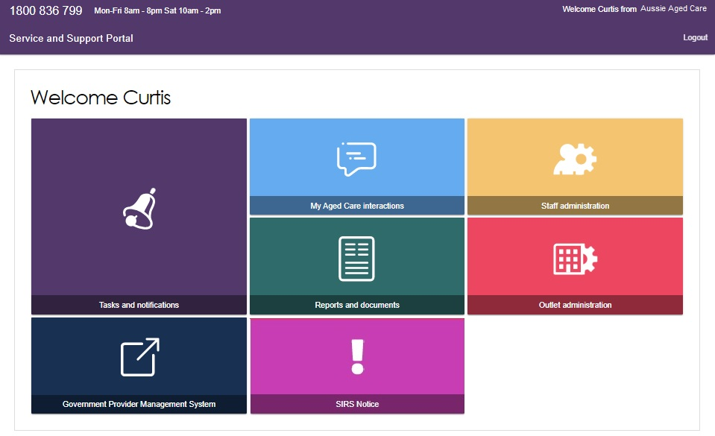

Team Leader homepage
People assigned the Team Leader role in the Service and Support Portal have the same functions as the Staff Member role but are also responsible for managing referrals for service(s).
If you log in to the Service and Support Portal as a Team Leader, you can view Service referrals, Find a client, Tasks and notifications, My Aged Care interactions, Reports and Documents, Retrieve a referral code, SIRS Notice, and Government Provider Management System tiles on your homepage.
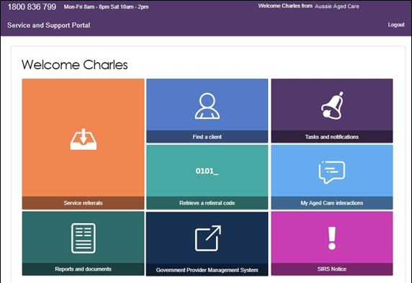
If you do not have access to the SIRS notice tile, your Administrator for Service and Support Portal can add the SIRS role to your staff profile.
For information on how to add the serious incident report tile for staff members please refer to the guide on How to use the Serious Incident Response Scheme Portal.

Staff Member homepage
People assigned the Staff Member role in the Service and Support Portal are responsible for adding and updating client service information in the client record.
If you log in to the Service and Support Portal as a Staff Member, you can view Service referrals, Find a client, Review requests, Tasks and notifications, My Aged Care interactions, Government Provider Management System and Reports and documents.
If you do not have access to the SIRS Notice tile, your Administrator for the Portal can add the SIRS role to your staff profile.
For information on how to add the SIRS Notice tile for staff members please refer to the guide on:
- How to access and use the Service and Support Portal for Serious Incident Response Scheme – Residential Aged Care services
If you have been assigned the SIRS role by your Organisation Administrator, you will have access to a SIRS Notice tile.
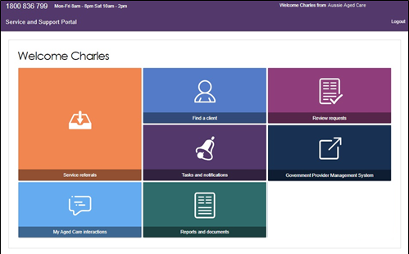

Homepage for users assigned multiple roles
If you log in to the Service and Support Portal as a user with Administrator, Team Leader, and/or Staff Member roles, you can view the functions for all your roles on the homepage.
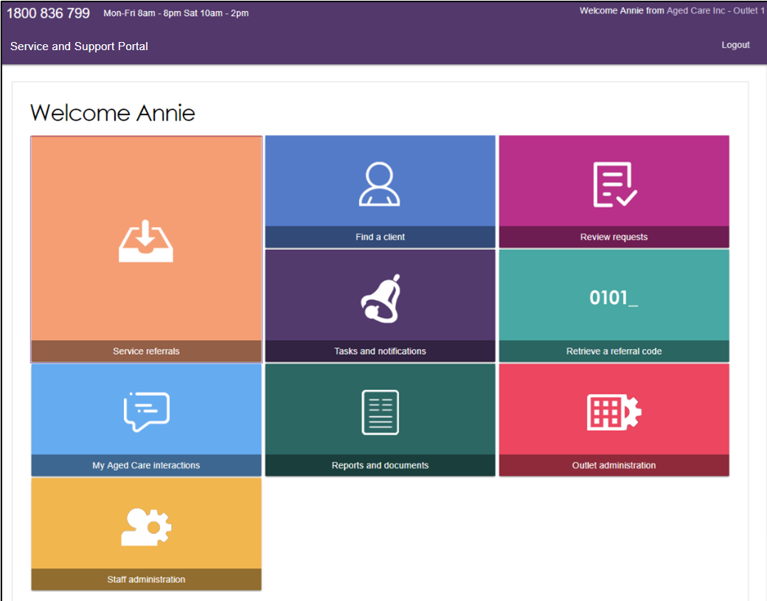

The Administrator Role
Service information is publicly displayed in the My Aged Care service finder (service finder) on the My Aged Care website.
My Aged Care contact centre staff and assessors use this service information to send referrals. Potential My Aged Care recipients and their support network use this service information to research and access services.
It is the Administrator’s responsibility to set up and maintain this information to ensure accurate referrals.

Creating service delivery outlets
Administrators will need to set up at least one outlet in the Service and Support Portal before they can add their organisation’s service information such as service items. Administrators can choose how to set up service(s) in the Portal: either all under one outlet or under multiple outlets.
Each outlet you set up can have different staff, service information, locations, and contact details recorded. Ideally, outlets should be established based on distinct delivery areas to manage client intake effectively and avoid overlapping delivery areas between outlets to prevent confusion and duplication of services .Refer to the user guide on Create service delivery outlets and add service information for further information about outlets.

Creating or adding a new outlet
Administrators need to set up outlets in the Portal before service information can be added. When you create an outlet, the status is set to Inactive by default. You must activate the outlet and create service items in an outlet before it can be made operational.
- From the Outlet administration page, select ADD NEW OUTLET.
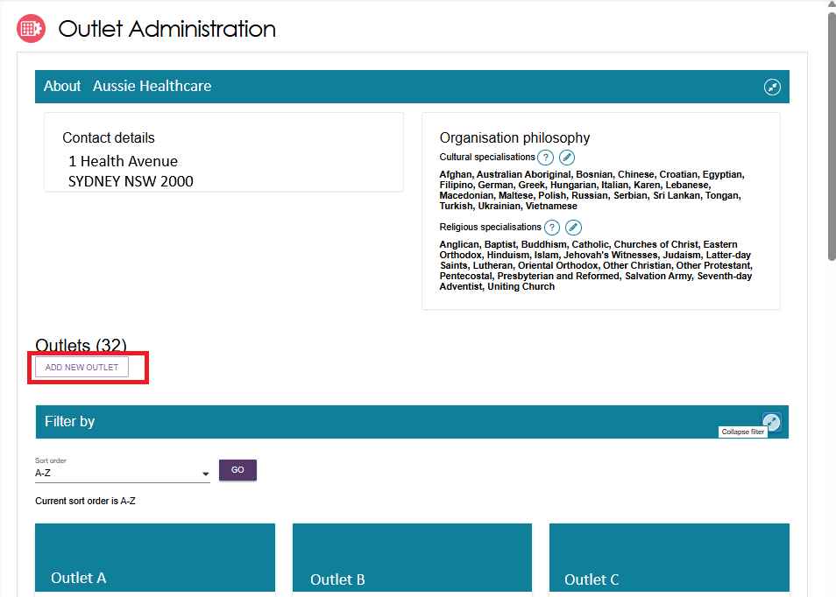
- Enter outlet details.
To add an outlet address, select ADD OUTLET ADDRESS.
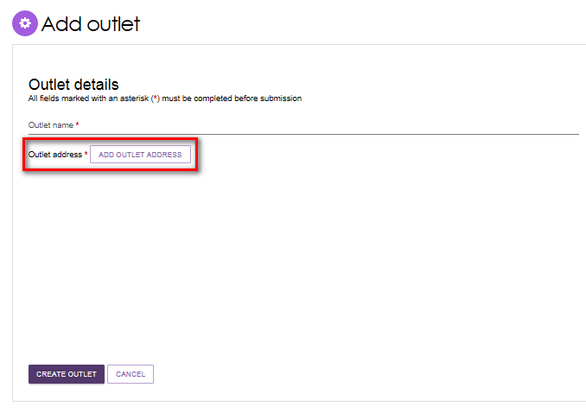
- Fill out your address details, then select VALIDATE THIS ADDRESS.
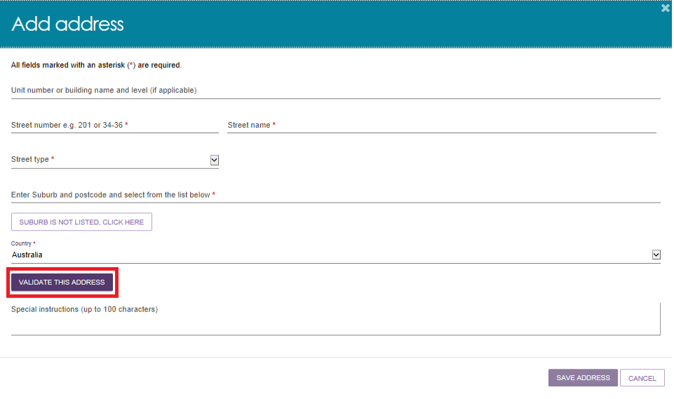
- Confirm that the address is displayed correctly, then select SAVE ADDRESS. If the address has been entered correctly but is not returned as a result, select Not found use entered address anyway.
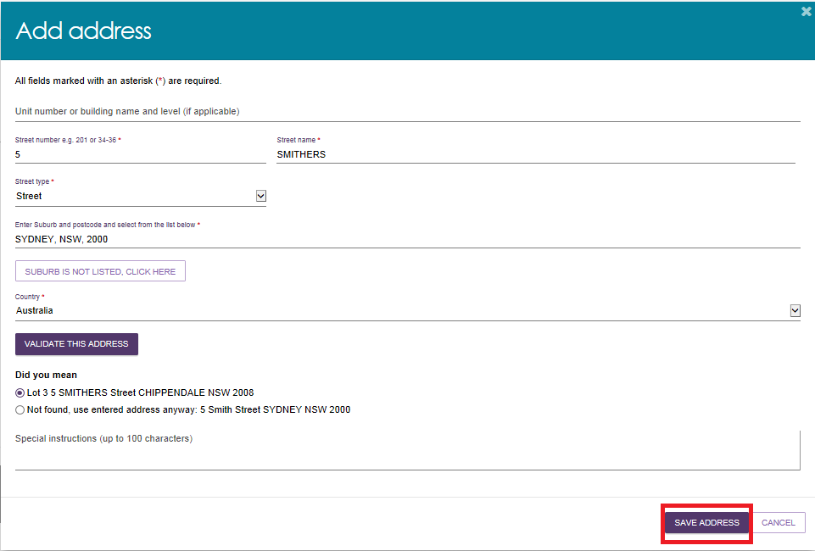
- Complete the remaining fields. Select CREATE OUTLET to save the record and create the outlet.
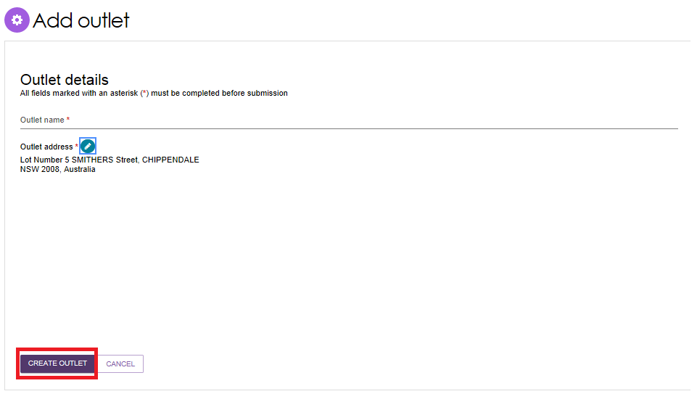
The outlet has now been created and the details for the outlet have been saved. Repeat this process for remaining outlets, if required.

Viewing outlets
To view outlets, follow the procedure below.
- Select Outlet administration from the homepage.
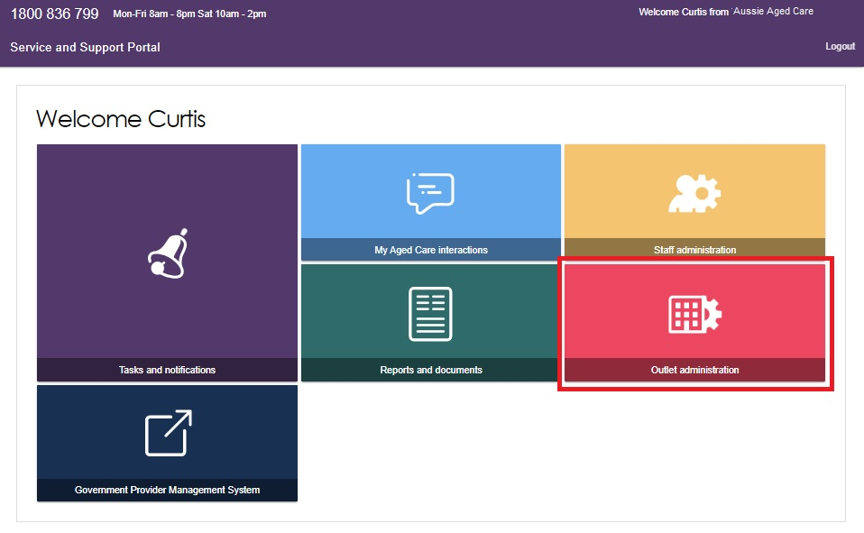
- From here, you can view all of the outlets for your organisation.
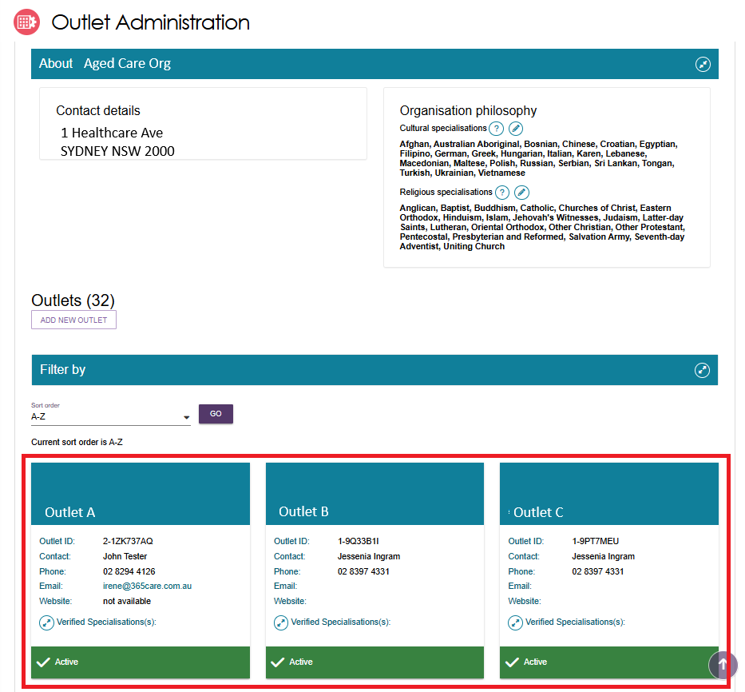

Editing the Organisation philosophy
Organisation philosophy attributes and other specialisations will be shown in the service finder results and displayed as part of the detailed information for each of your services. These attributes and specialisations are not verified by the Department.
- Add/edit cultural specialisations.
In the View Outlet page, select the Edit icon  next to Cultural specialisations to select those groups that you have a focus on providing culturally specific care to.
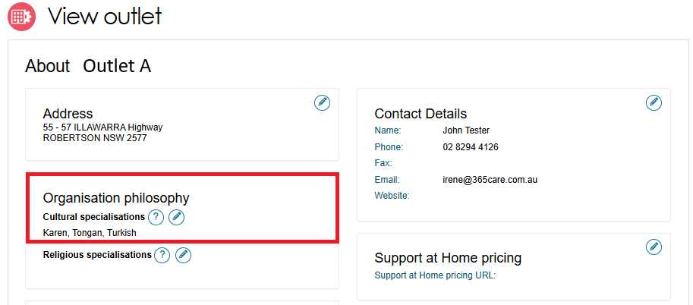
You can choose to apply this to all services in your organisation by using the SAVE AND APPLY TO ALL OUTLETS option or save as a default for all new services added by using the SAVE AND DON’T APPLY TO ALL OUTLETS option.
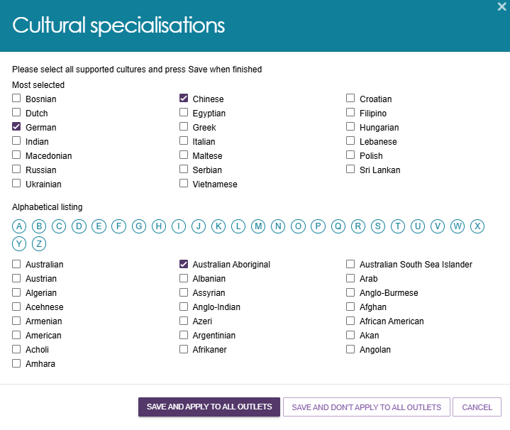
- Add/edit religious specialisations.
Select the edit icon next to Religious specialisations to indicate if you have a focus on delivering care that aligns with particular religious needs or values.
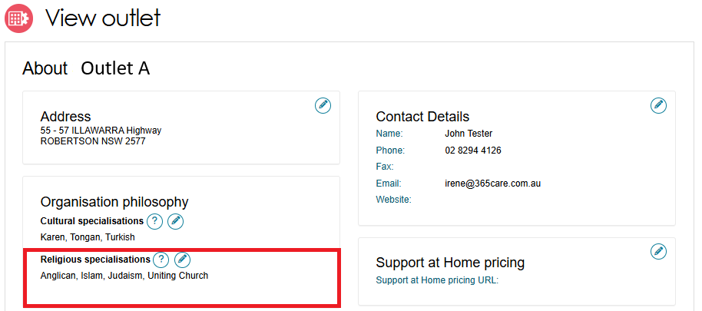
You can choose to apply this to all current services in your organisation by using the SAVE AND APPLY TO ALL OUTLETS option or save as a default for all new services added by using the SAVE AND DON’T APPLY TO ALL OUTLETS option.
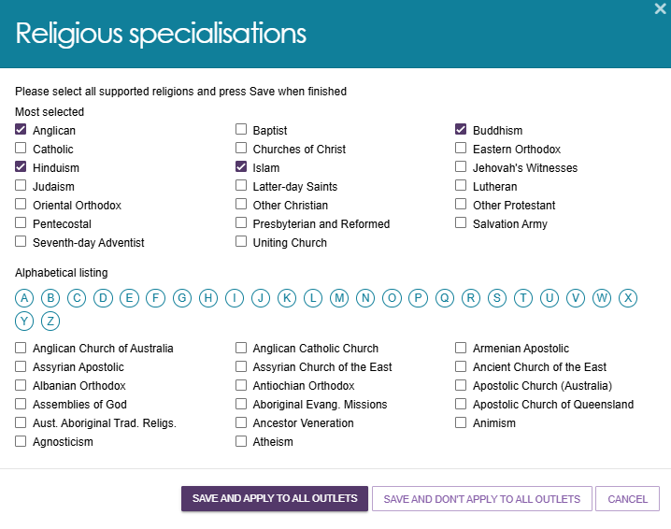

Diverse Needs Specialisations
All aged care services must provide care in which each consumer is treated with dignity and respect, with their identity, culture and diversity valued. While all service providers are required to deliver these inclusive care services, there are some that deliver specialised care for particular groups. Outlets with specific knowledge, expertise, and services, can apply to have their diverse needs specialisation verified. This helps older Australians with diverse aged care needs choose the care that best suits them.
Specialisations relating to a person’s community or background are verified under the My Aged Care Provider Specialisation Verification initiative. These specialisations are:
- Aboriginal and Torres Strait Islander peoples and communities
- people from culturally and linguistically diverse backgrounds
- people who are financially or socially disadvantaged
- veterans
- people who are homeless or at risk of becoming homeless
- care leavers
- parents separated from their children by forced adoption or removal
- lesbian, gay, bisexual, transgender, and intersex people
- people who live in rural or remote areas.
Providers who wish to make claims that their outlet specialises in the care of people identifying with one or more of the Diverse Needs groups will need to apply to have these claims verified by a third-party assessor. While all providers must demonstrate that they meet the Aged Care Quality Standards, providing specialised services for the Diverse Needs groups is an optional and additional step.
Successful verification depends on the outlet’s ability to demonstrate they provide specialised care. The Specialisation Verification Framework sets out the criteria providers are required to meet, and expected forms of evidence.
Verified specialisations will be published on the My Aged Care Provider profile. Providers who have not had their specialisation claim(s) verified will have those claims removed.
For more general information on the verification process, please refer to the Specialisation Verification for Aged Care Services website.
! Providers can only view and manage specialisations that were verified under the 2022 Specialisation Verification Framework in the Service and Support Portal.
From 1 November 2025, new Specialisation Verification applications will be assessed under the 2025 Framework.
Upon transferring a service to a new outlet, any diverse needs specialisations recorded against the service will be removed. The ability for outlet administrators to add/remove diverse needs specialisations against that service will be controlled by the current specialisation verifications in place at the new outlet.
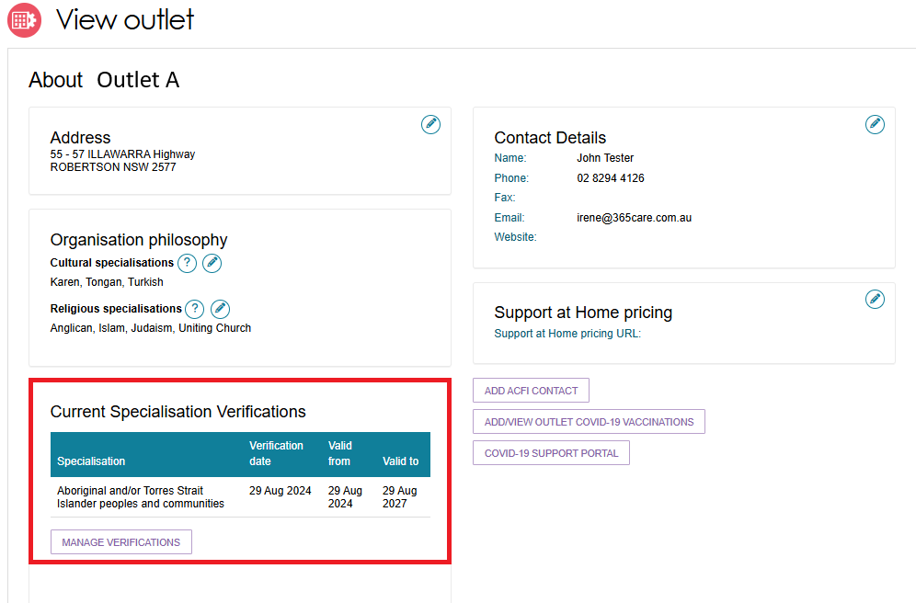

Service Items
You will need to create and maintain information about the aged care services that your organisation provides (known as service items in the Service and Support Portal) in order to receive referrals through My Aged Care.
Service items in general include:
- Service sub-types, for non-Support at Home programs
- Services, for Support at Home
- Service types, which are groupings of Support at Home services
- Service groups, which are groupings of Support at Home service types.
It is important that information about the services you provide is kept up to date as the information is publicly displayed for prospective My Aged Care recipients and their support network on the service finder on the My Aged Care website (www.myagedcare.gov.au), and used by My Aged Care contact centre staff and assessors to refer clients to service(s).
! Under the Aged Care Act 2024, from 1 November 2025:
• New service items are available. Some services offered under the Aged Care Act 1997 are no longer available.
• Some services continue in a different form.
• For more information about these changes please refer to the Department’s webpage on New Aged Care Act resources.
Services need to be linked to one or more of your outlets.

Adding a service item
Follow these steps to add a service item:
! From 1 November 2025, there will be new and renamed services in all Aged Care Programs. Previous applications will have their selected services remain the same, with new applications showing the updated service list. For more information on the service names, refer to the Aged care service list website.
- From the Outlet administration page, select the name of the outlet on the outlet card that you want to add a service item to. The View Outlet page then appears.
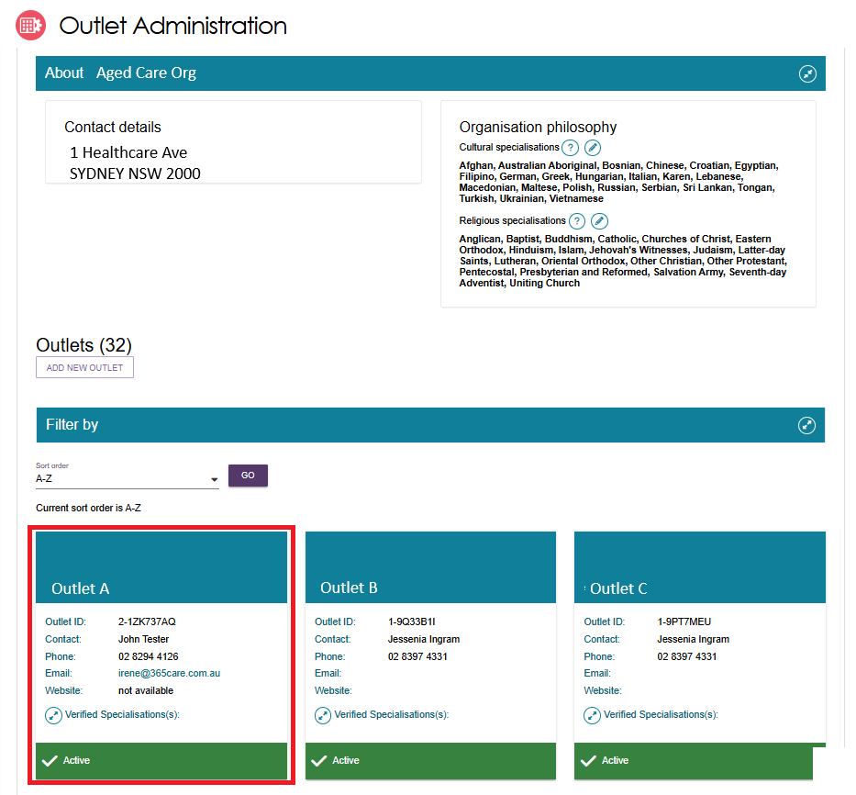

- From the View outlet page, select VIEW SERVICE ITEMS.
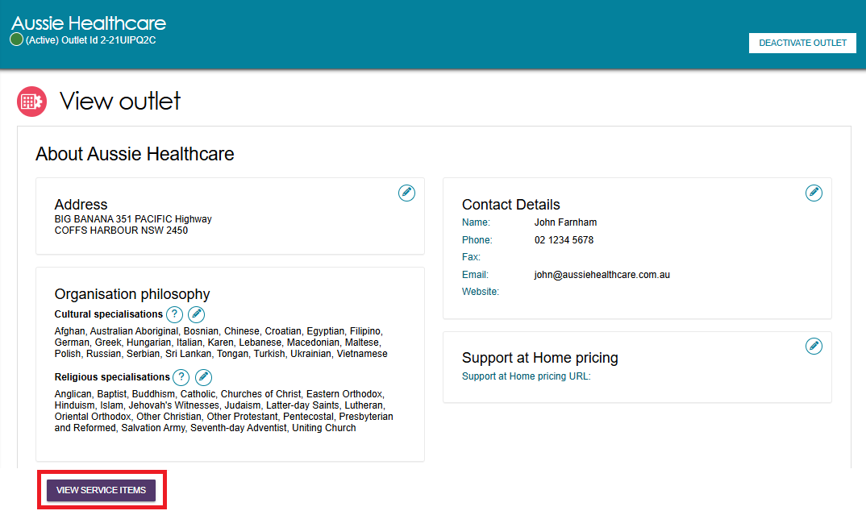
- From the View Service Items page, select ADD A SERVICE ITEM.
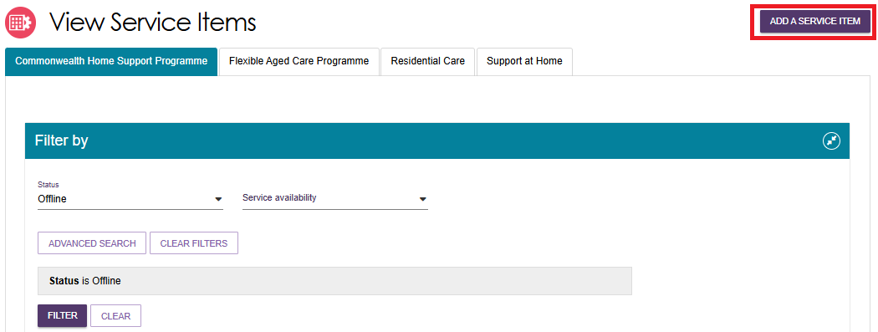
Select the program for the service that you wish to add.
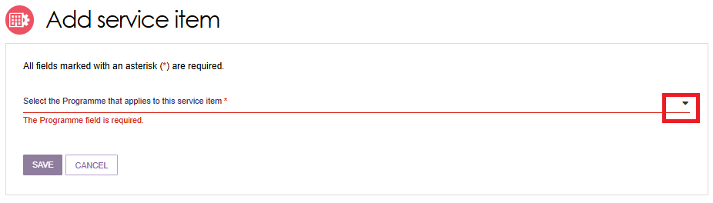
If applicable, select Funded or Non-funded for the program that you are adding.
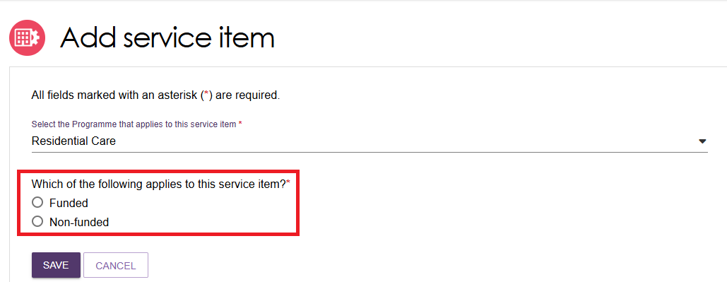
For Support at Home services this option will not be available as all services must be Commonwealth government subsidised. You will be asked to specify a unique service item name instead.
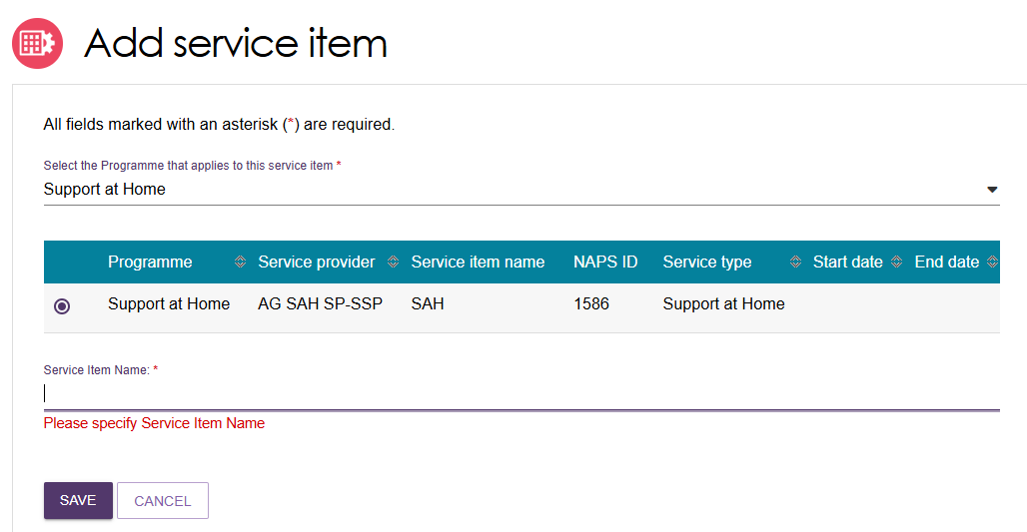
- Add the service item/s under the program.
For funded services, select the service you want to add to your outlet by selecting the relevant service item and then select SAVE. You can refine the list of service items by entering details and using the FILTER function.
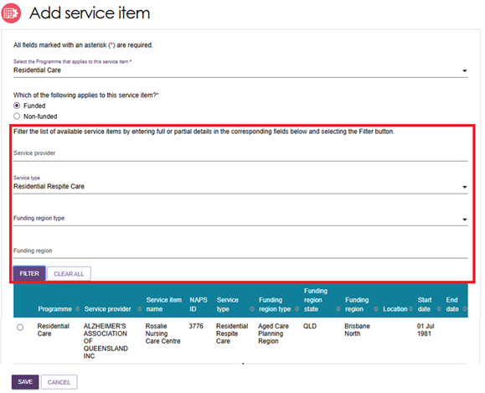
If you are adding a new Support at Home service, you will be required to enter a unique name for the service in the Service Item Name field that is displayed.
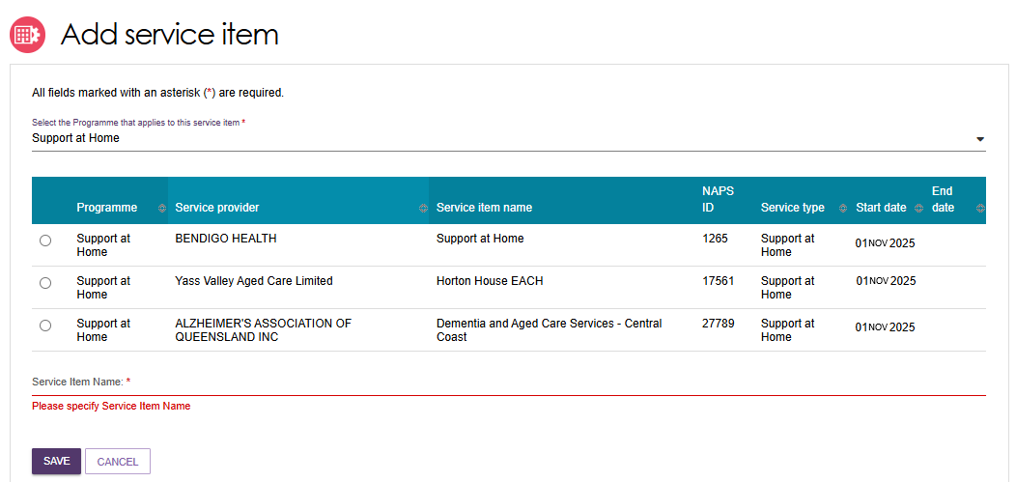

- The service item will now display in the Outlet details page under Services.
The new service will be listed with a status of Offline. A banner will also indicate that you have successfully added a service item to the outlet, and to remind you to Edit and Submit.
The status will need to be changed to Operational before it is displayed on the public service finder. Refer to Activating or deactivating a service item for more information.
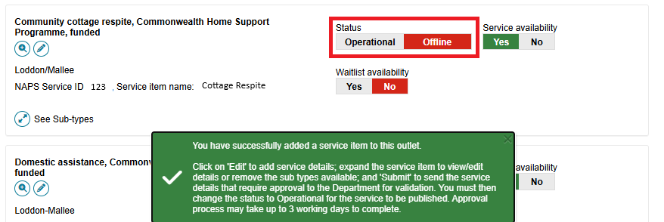
- Once service items have been added to an outlet, you can filter the list of services under a specific program by status, service availability and waitlist availability.
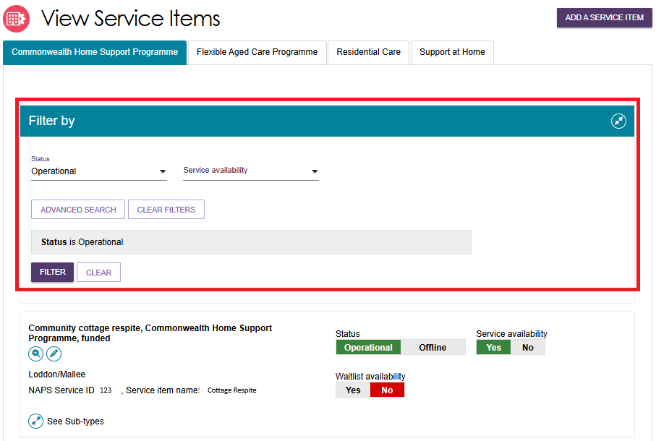

Editing a service item
You can edit service item details, including:
- Service item name
- Service delivery area
- Specialised services (refer to Editing the Organisation Philosophy)
- Promotional attachments (for residential facilities)
- Support at Home-specific attributes e.g. service-based pricing.
- Detailed description for the service item.
Service information will be displayed on the Service Finder on the My Aged Care website. When you update this information, the changes will appear on the Service Finder by the next day.
Follow these steps to edit service information:
! Only non-contractual information can be edited in the Service and Support Portal.
- From the Outlet administration page, select the name of the outlet on the outlet card that you want to add a service item to. The View Outlet page then appears.
- On the View outlet page, select VIEW SERVICE ITEMS then select the Edit (Pencil) icon next to the relevant service item, or next to the Support at Home heading.
Support at home service item example
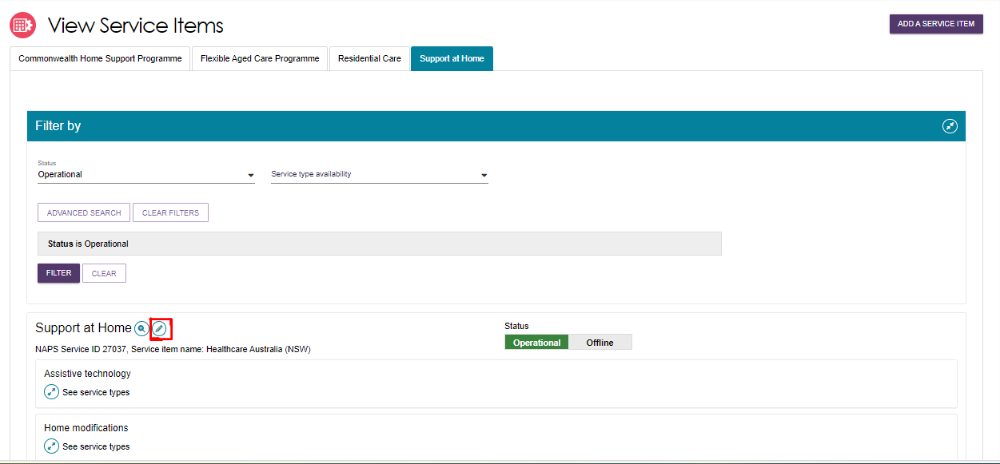
Non-support at home service item example
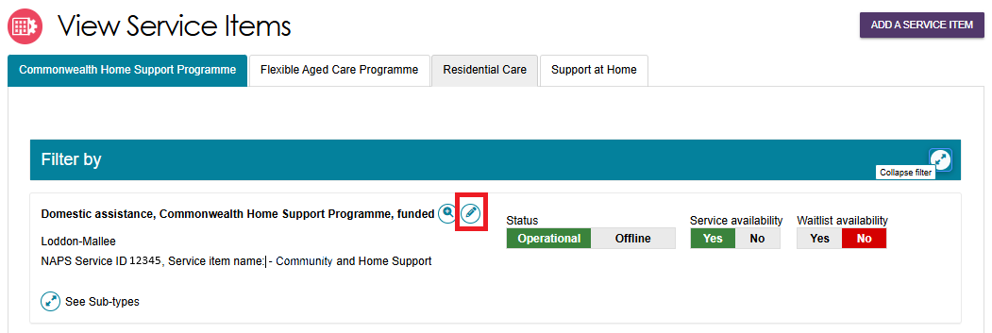
- The Service details page will display.
Make the required changes and select SAVE. Read-only information is contractual information and cannot be edited via the Service and Support Portal. Any additional service information can be added in the Service description free text field. This information will be displayed in the public service finder on the My Aged Care website to assist clients in selecting a provider.
! There are different options presented on a Support at Home service details page and a CHSP (Commonwealth Home Support Program) service details page.
Support at Home services are managed by delivery area. You can select multiple service types and items available within that area.
CHSP providers will remain limited to a single service type and ACPR (Aged Care Planning Region), based on contractual information for each service item.

Editing availability and waitlists for a service
To indicate that a waitlist is offered for a service, you must ensure the waitlist availability status on the service item is set to Yes – to show that a waitlist is available, or No – to show that there is no waitlist.
- From the Outlet administration page, select the name of the outlet on the outlet card that you want to add a service item to. Then from the View Outlet page, select View Service Items.
- Select the relevant service/waitlist availability status (yes / no) by toggling the Yes | No switch. The location of the Yes | No switches will depend on the type of outlet and service chosen.
Support AT Home example
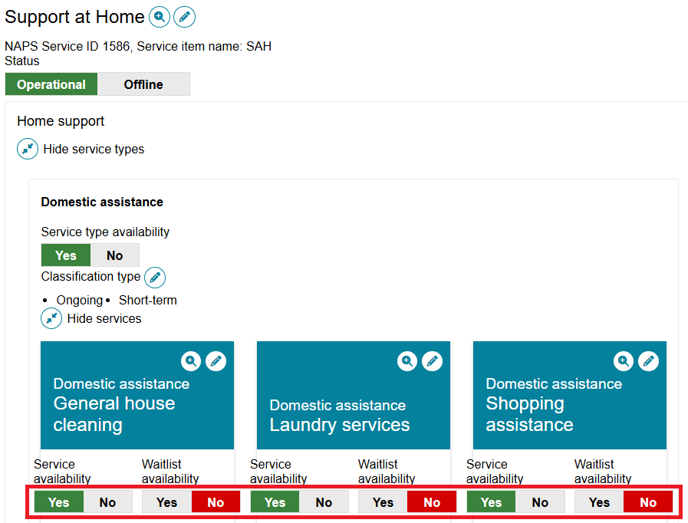
Non-support at home EXAMPLE
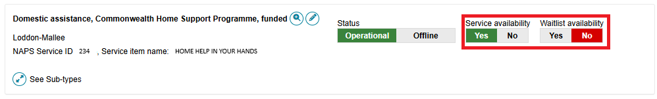

Editing service delivery area
Information about the areas you deliver Commonwealth-funded services in (referred to as service delivery areas in the Service and Support Portal) are pre-populated, based on your contractual information.
Service delivery areas can be edited for CHSP, Flexible Aged Care Program, and Residential Care service items. This functionality is not available for individual Home Support services. Changes apply to the entire Support at Home offering.
All providers (except residential care) must review their service delivery area information and edit if required. It is important that you ensure the service delivery area(s) is accurate. This information is publicly displayed in the service finders, and impacts the referrals sent by contact centre staff and assessors.
- From the Outlet administration page, select the name of the outlet on the outlet card that you want to add a service item to. Then from the View Outlet page, select View Service Items.
- On the View Service Items page, select the Edit icon next to the relevant service item, or next to the ‘Support at Home’ heading.

NOn-Support at home example
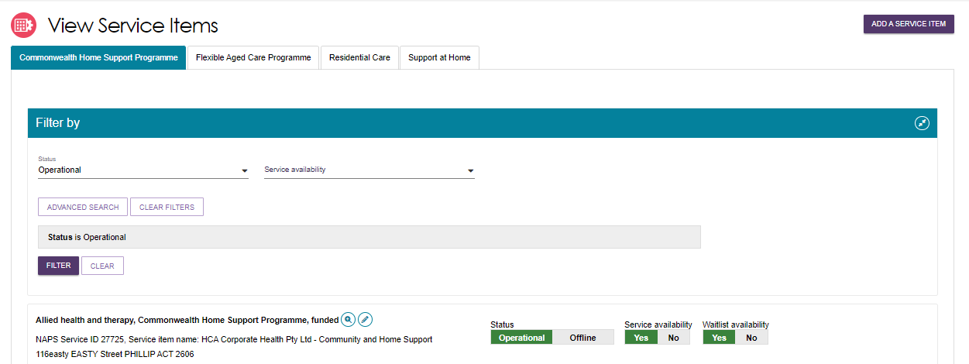
Support at home example
- The Service details page will display. Select Edit (Pencil) next to the Service delivery area section.

NON-SUPPORT AT HOME EXAMPLE
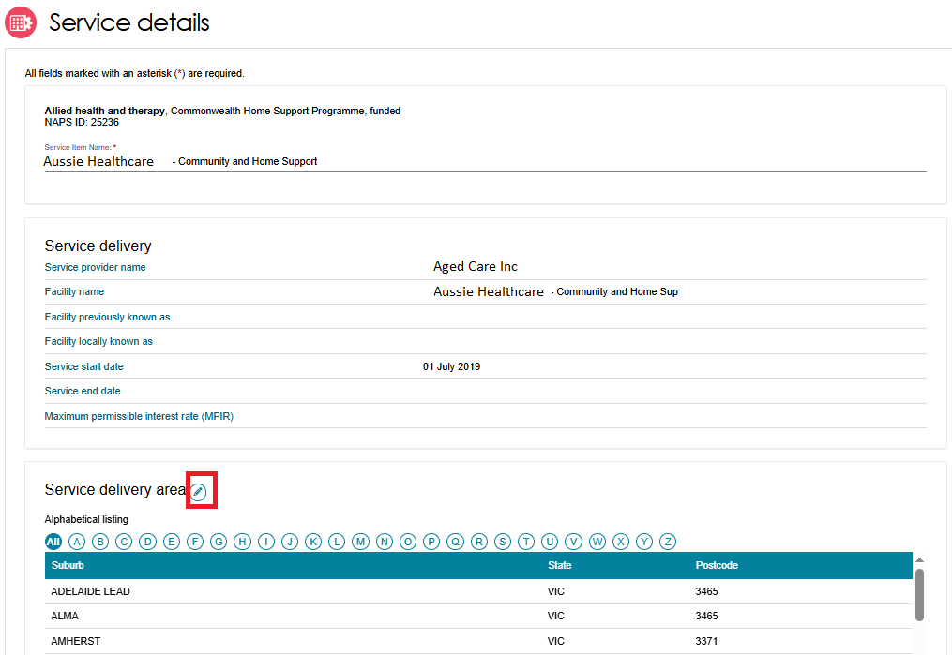
For Support At Home, there are no list of suburbs listed.
SUPPORT AT HOME EXAMPLE
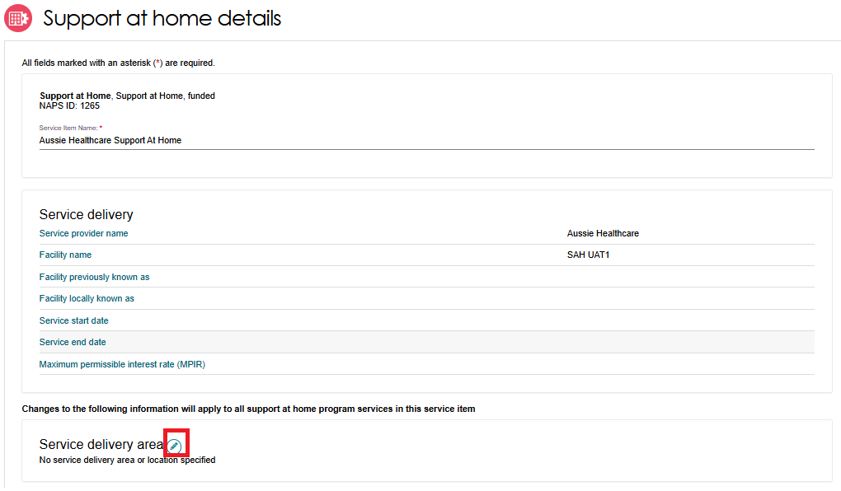

- Select the service delivery type. For residential services, select At provider location. For non-residential services, select At client location.
This step does not apply to Support at Home – both location options will be greyed out.
If you have selected At provider location, enter the address of the provider then select Validate This Address. Then select Save Changes.
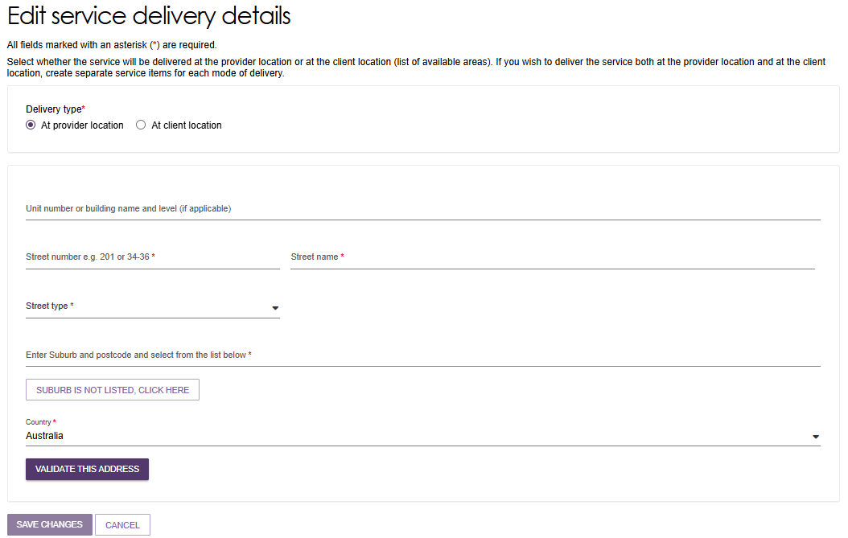
If you have selected At client location, you can choose the state or suburb(s) the service is delivered in. By default, the entire region, in which you are funded to provide service, is selected.
You can choose to search for a specific suburb to add, add all the suburbs in the selected state, or add all the suburbs in the selected region. To remove suburbs from the list, select the suburbs you wish to remove using the checkbox and select REMOVE SELECTED, or use REMOVE ALL to start configuring your list of suburbs from the beginning.
Finally, select Save Changes to save the selected suburbs. Select Cancel to go back to editing the service.
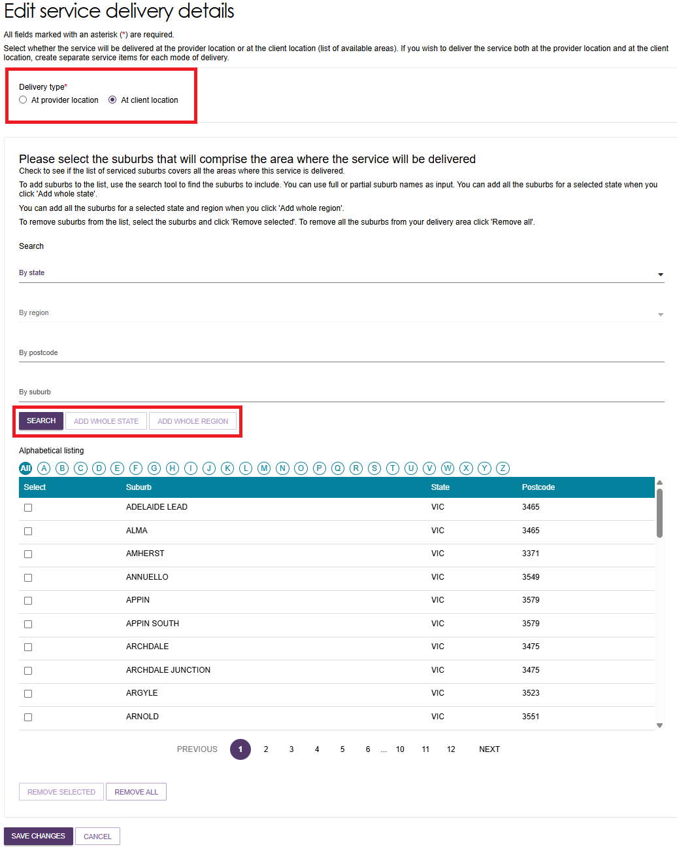

Attaching promotional material
Residential Care providers can add promotional material to be displayed in the service finder. Promotional material content will not appear on the Service Finder until it has been reviewed and approved by the Department. Approval takes two business days. Once approved, the material will be visible on the Service Finder on the My Aged Care website.
Support at Home, Transition Care and Commonwealth Home Support Programme (CHSP) providers have the option to attach promotional material in the portal; however, this material will not display on the service finder.
Follow these steps to attach promotional material (for example, photos, brochures, menus):
- From the Outlet administration page, select the name of the outlet on the outlet card that you want to add a service item to. Then from the View Outlet page, select View Service Items.
- On the View Service Items page, select your program’s tab (e.g. Support at Home) and Edit the relevant service item by selecting the Edit icon to the right of the service or program name.
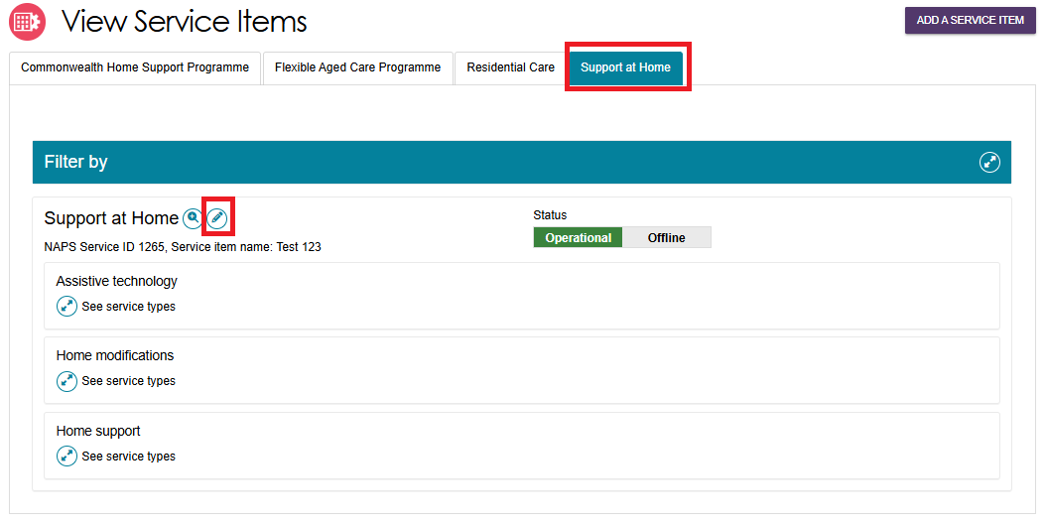
- The Service details page will display.
Scroll down to the Promotional section. Select Browse to find and attach your promotional material (file types supported include .jpg, .jpeg, .png, .pdf, .rtf, .doc and .docx) and select Save and Submit Requested Changes for Approval after entering information about the attachment.
The Feature Photo option in the Type of the attachment dropdown will be the primary image displayed to users of the service finder.
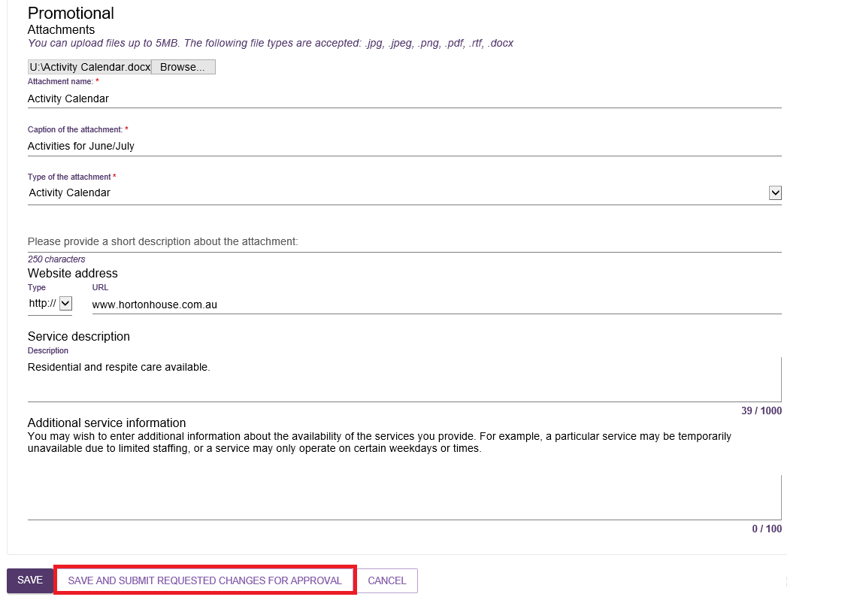
At the bottom of the screen, a confirmation will display, and a warning message will prompt you to submit the service item update to the Department for approval.
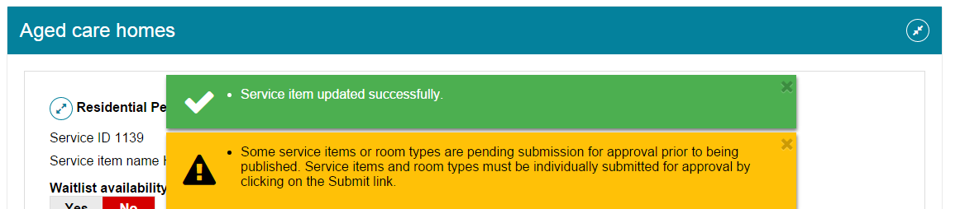

Removing a service sub-type
Follow these steps to remove a service sub-type for a service item (for non-Support at Home services).
! Support at Home services are pre-populated based on what the outlet or organisation is approved for (Provider registered category) and therefore cannot be deleted or removed from the Service and Support Portal.
- At the Outlet Administration Tile, Select the name of the outlet on the Outlet card you want to remove a service sub-type from. The View outlet page then appears. Select VIEW SERVICE ITEMS.
- Select the blue arrow next to See Sub-types under the service to see expanded service details.
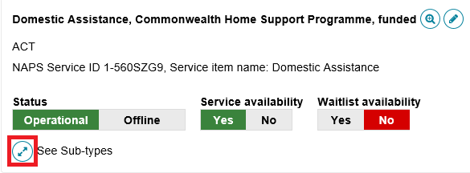
Then select ADD/REMOVE SUBTYPES.
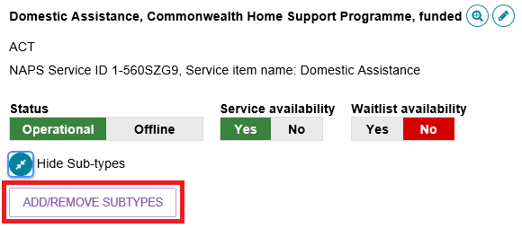
- In the Add/Remove Subtypes box, deselect the service/s you want to remove from the service item and select SAVE. The service will then be removed, and information about the service will not display in the service finder. Note that when removing subtypes, there must be at least one service remaining.
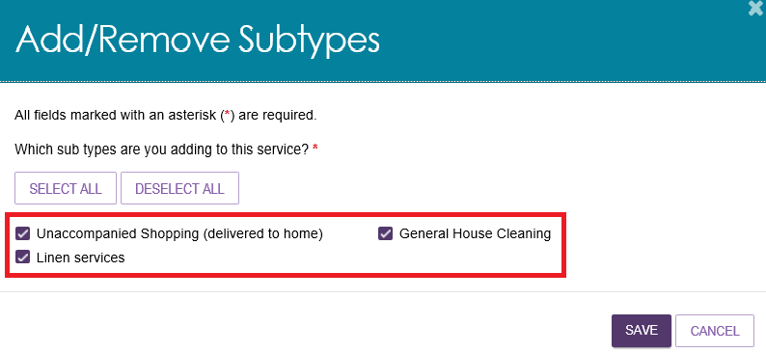

Service attributes
When you are configuring a service, a number of attributes specific to the delivery of your particular service will become available to select and display on the service finder. These include Diverse Needs Specialisations, Specialised Services and others mentioned in this section. They can be found in the Service Details page of the service item, or the Support At Home Details page of the Support at Home service.
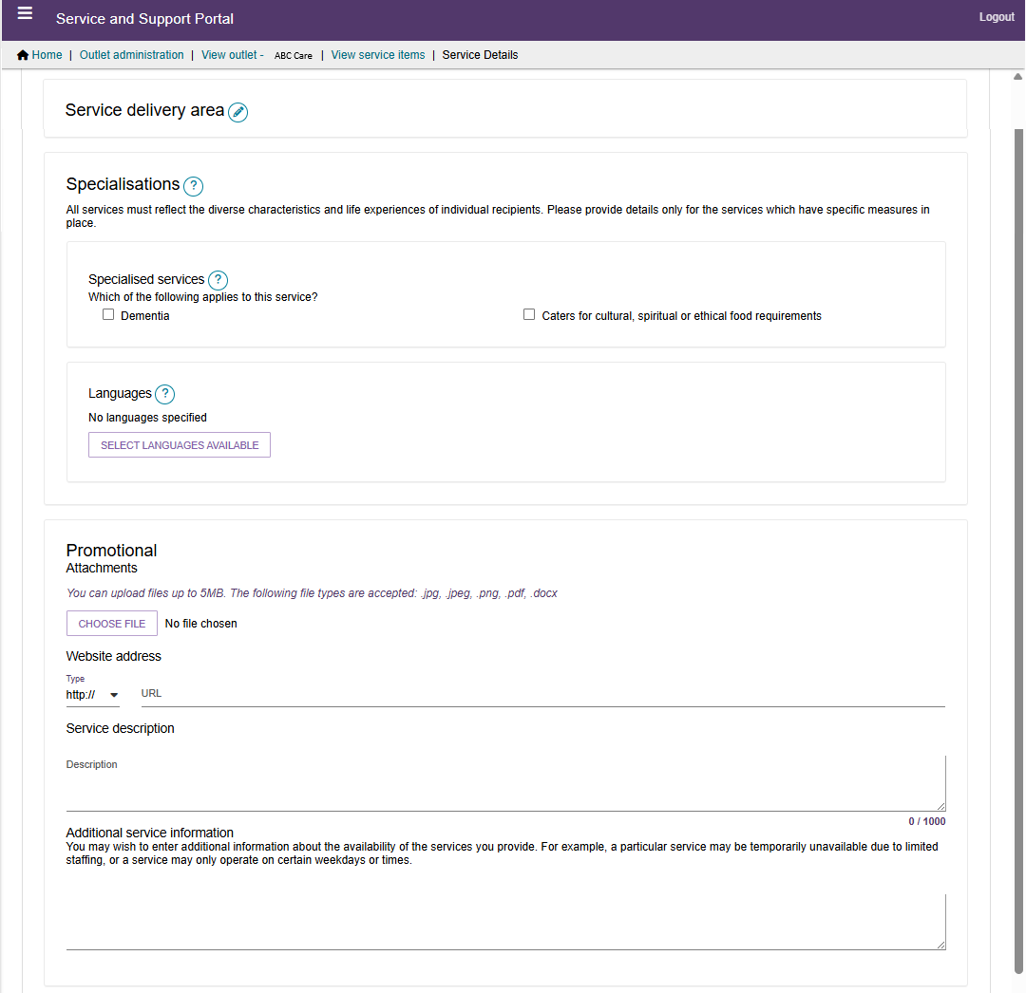

Classifications
For Support at Home services, you can modify the Classification type for either Ongoing or Short-term for each service type. For example, you prefer to offer a particular service type on an ongoing support period basis only.
- Navigate to the Support at Home service type that you want to edit the classification type for, by following the steps in Editing a service item. Then, select Edit (Pencil) next to the Classification Type.
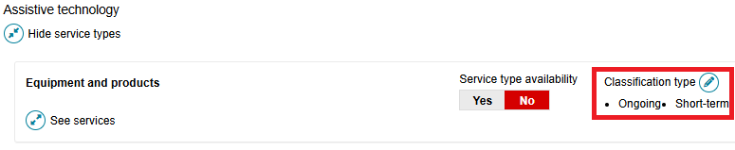
- At the pop up, select Ongoing and/or Short-term and select SAVE.
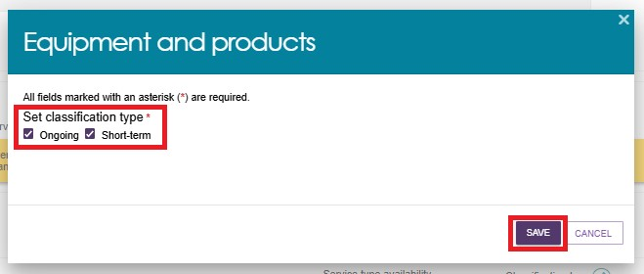

Specialisations
Specialisations is an umbrella term for 3 sub-groups: diverse needs, specialised services discussed below, and languages. Providers of all care types are able to identify their ability to provide services that cater to these specialisations.
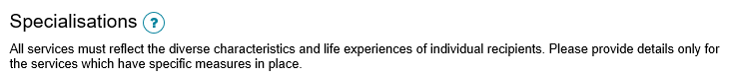
You can indicate that a service or outlet offers the following Specialised Services. Although these services are not verified, please select only those with specific measures in place which demonstrate your specialised service offering.
Specialised services will be displayed only for Support at Home and CHSP service items.
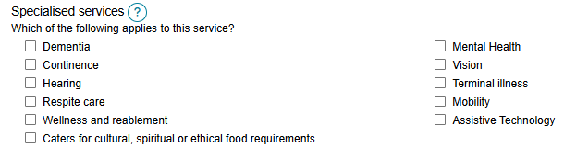

Languages
- To indicate that services are being delivered in a language other than English, select SELECT LANGUAGES AVAILABLE.
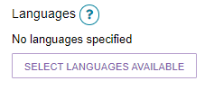
- Select one or more languages then select SAVE.
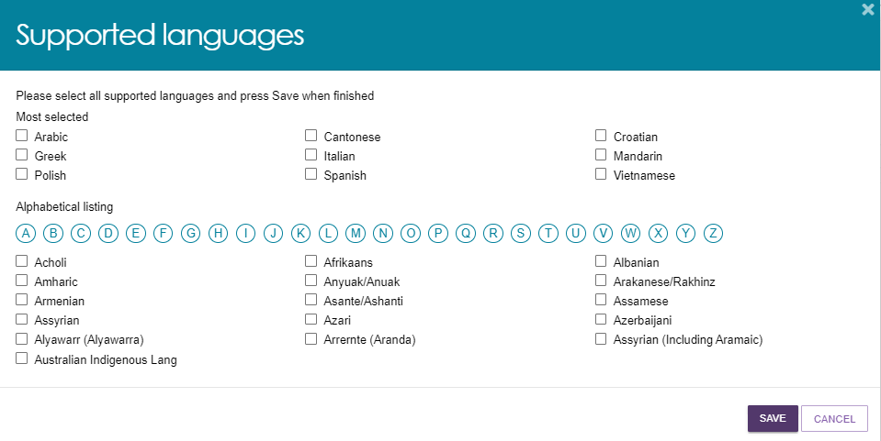
- The languages will be displayed. Select the Pencil (edit) icon to change languages.
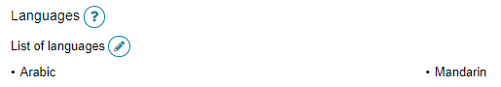

Hours of operation, staffing notes, transport notes
You can outline hours of operation for CHSP and some Support at Home services. By default, you can enter standard Monday to Friday, Saturday, and Sunday hours. You can also specify individual working days by using the Customise option.
To edit your hours of operation:
- Navigate to the Support at Home service type that you want to edit by following the steps in Editing a service item.
- Select the service you want to edit the hours of operation by selecting on the corresponding edit icon next to the service group, then the service sub-type.
For Support at Home services, Expand the service group and/or service type, then select the Edit icon next to the service.
NON-support at home example
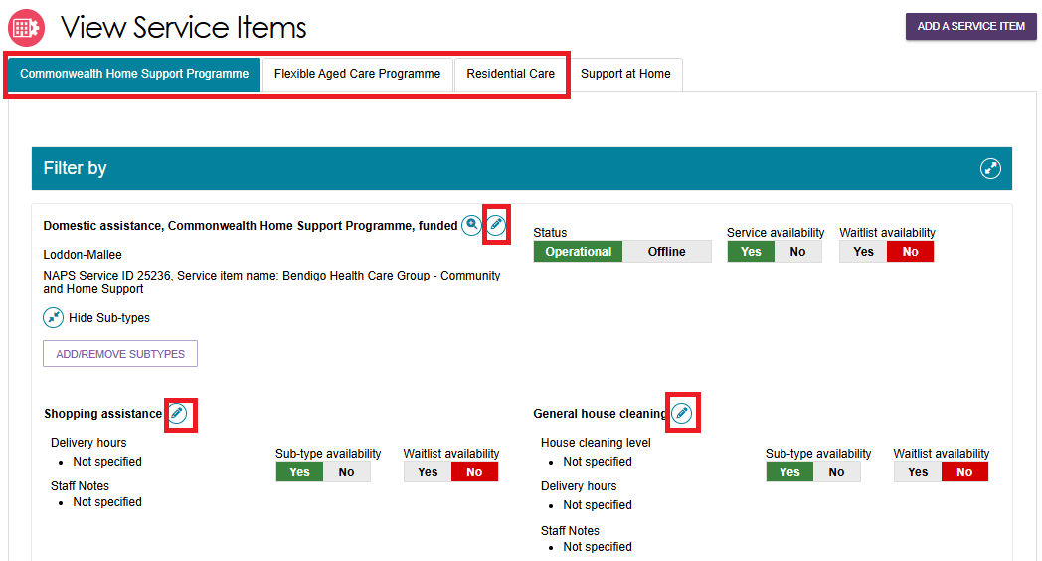
support at home example
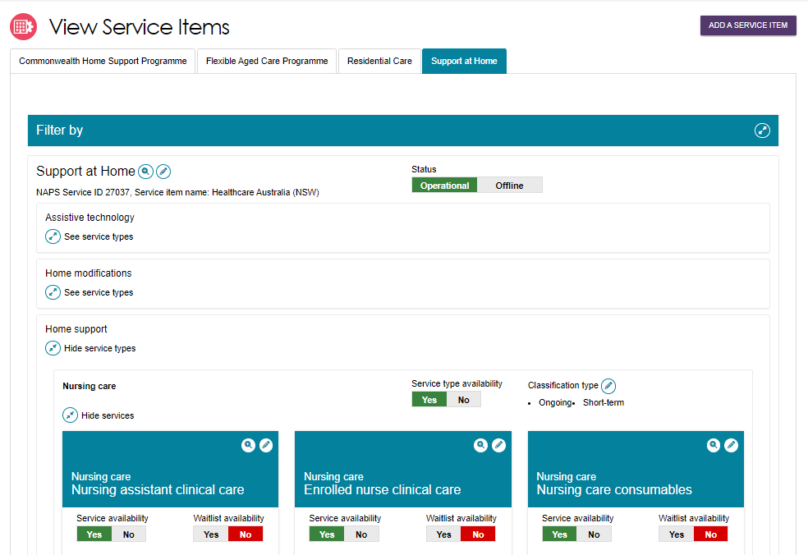

- Input the hours and save.
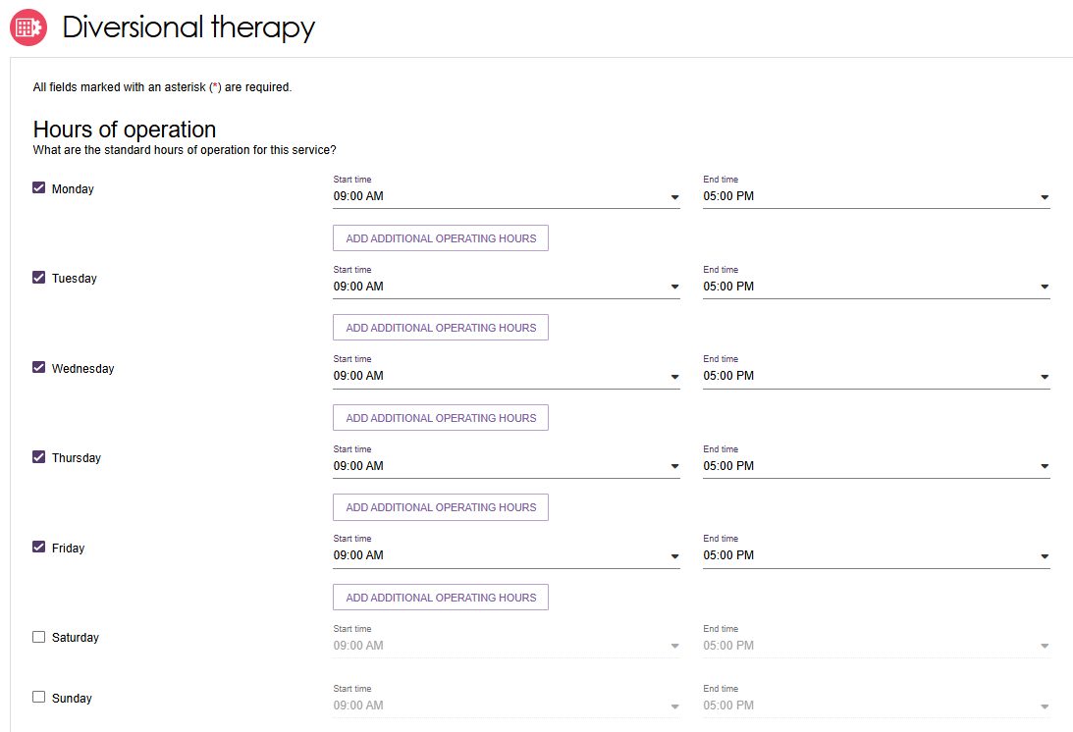
- On the same page, depending on the service chosen, you can also edit Staffing Notes for the service, how the service is delivered, whether Transport is included, and Pricing.
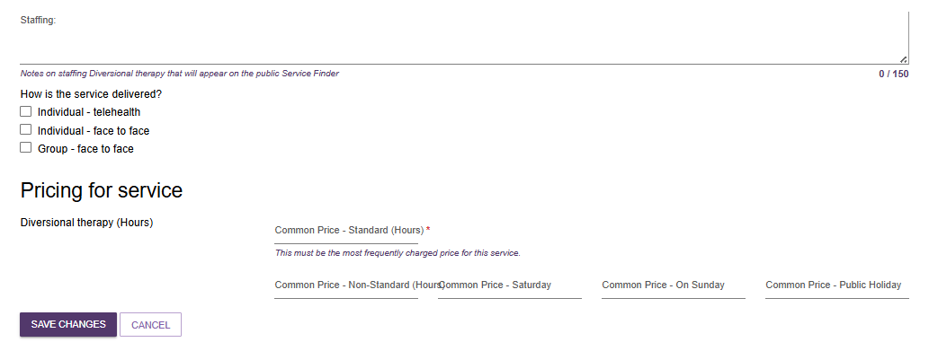
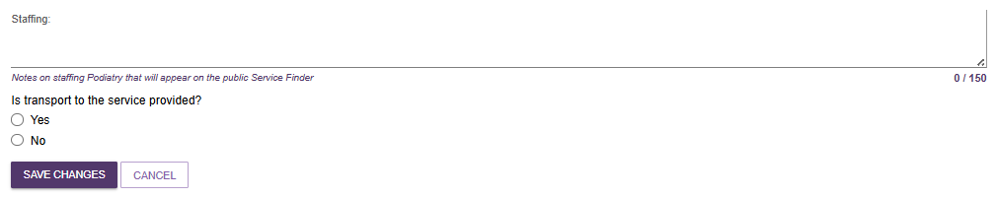

Service Description
You can enter any further information about your service here, and it will be displayed at the Service Finder.
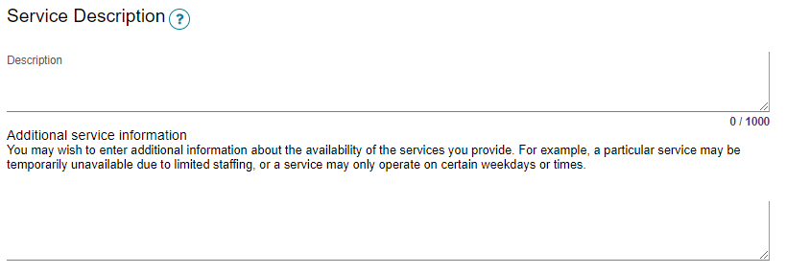

Pricing Information
Support at Home program outlets can upload pricing. Pricing information is also available for some CHSP services.
If pricing is not entered for a Support at Home service, you will not be able to:
- save a new service and make it Operational
- save changes to partially complete existing pricing information
- confirm that pricing information has been reviewed.
! Pricing is entered at the service level only. For Support at Home, Pricing changes apply to the outlet level and to the service group and service item levels.

Viewing pricing information
- Select the outlet from the Outlet Administration tile, then select ‘View Service Items’.
- Under the View Service Items page, select the Program, then select the Magnifying Glass (view) icon to the right of the service item name.
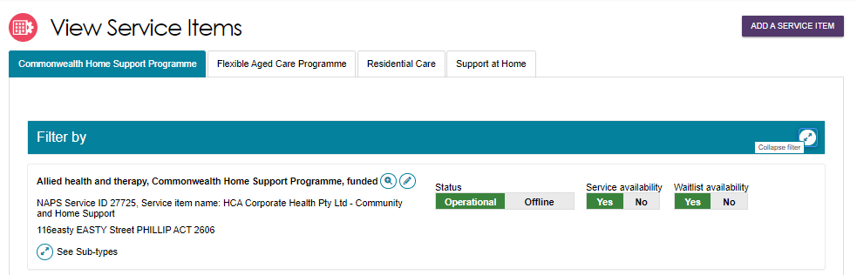

- To view outlet-wide information for Support At Home, select the Support at Home tab, then select the Magnifying Glass (view) icon to the right of the ‘Support At Home’ heading.
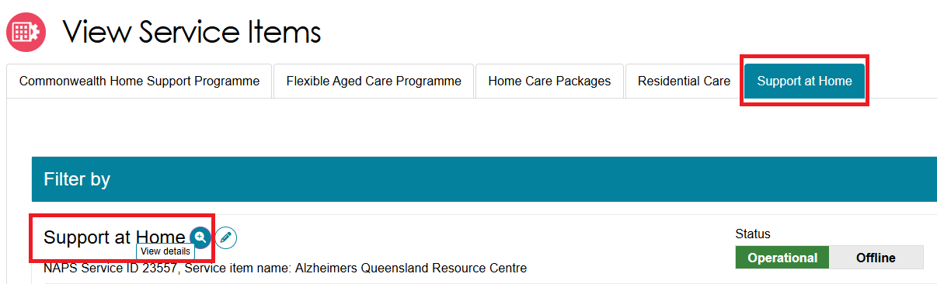
- To view individual Support At Home services, select the Support at Home tab, then expand any service groups/service types, then select the Magnifying Glass (view) icon of the appropriate service card.
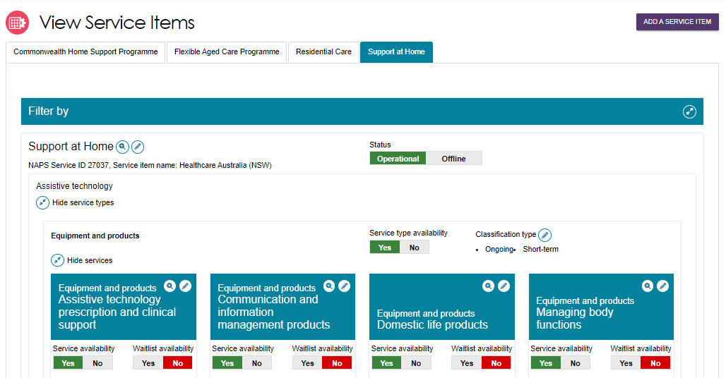

Updating pricing information
- Select the outlet from the Outlet Administration tile, then select ‘View Service Items’.
- Under the View Service Items page, select the Program, then select the Edit (Pencil) icon to the right of the service item name.
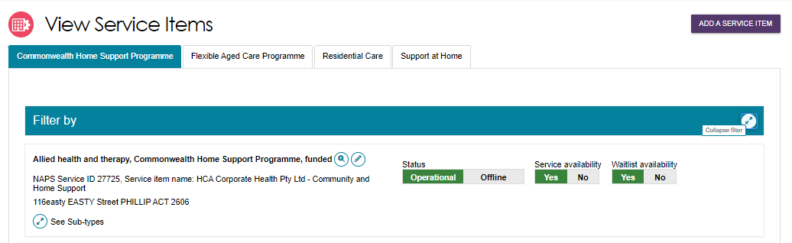

Updating Support At Home Pricing Information at the Outlet Level
In the Outlet Level, you can update the Full Price List including website link and pricing schedule.
- For All Support At Home services in your outlet, select the Support at Home tab, then the Edit (Pencil) icon to the right of the ‘Support At Home’ heading.
Alternatively, from the View Outlet page, select the Edit icon next to Support at Home pricing to edit the pricing information at the outlet level.
FROM VIEW SERVICE ITEMS PAGE
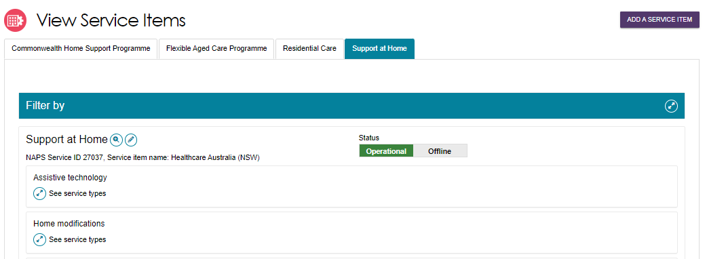
FROM THE VIEW OUTLET PAGE
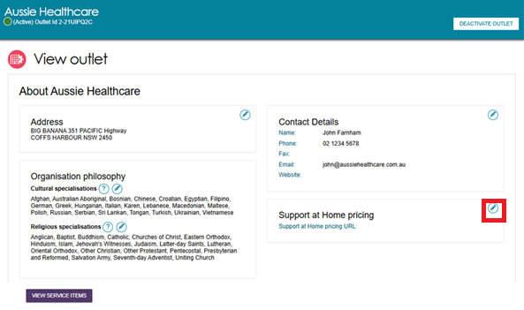

- Under the Full Price List section, a pricing schedule website link (URL) and/or a pricing schedule attachment can be added.
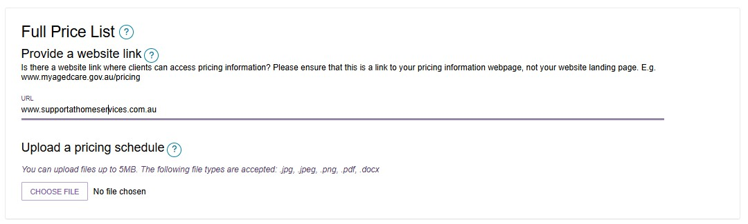
- To add a pricing schedule website link type in the URL in the Provide a website link section. Ensure that the website URL you enter is a valid website address. If you have copied the URL down from the Outlet the URL will be applied. If you need a specific area base price URL you can overwrite this URL.
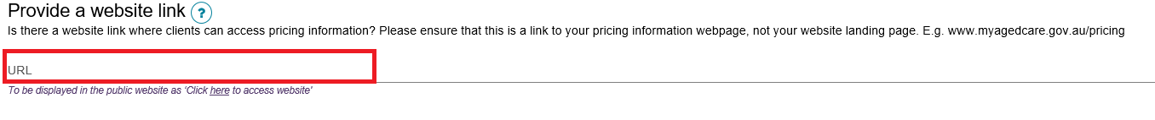
- To upload the pricing schedule attachment, you must select Browse… and choose the document (e.g. PDF file) you wish to upload. Name the attachment and provide a caption or short description of the attachment.
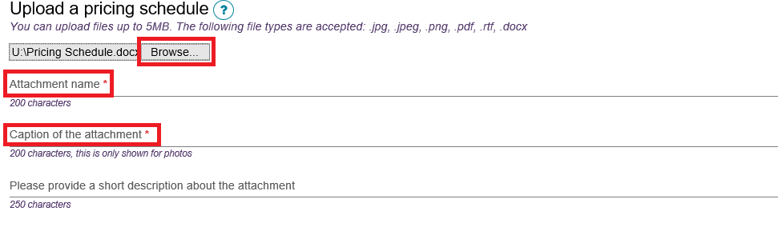
- You can now choose to:
- save and apply the pricing information to all Support at Home service items in that outlet,
- save locally (before applying to any services),
- apply these details to all your outlets (if you are an Organisation Administrator) or
- Cancel to discard any changes made.

Updating Support At Home Pricing Information at the Service Level
At the service level, you can update hourly or daily pricing for individual services. If pricing varies by region, you can also update the public URL for that service’s pricing directly at the service level.
- For individual Support at Home services, select the Support at Home tab, then expand any service groups/service types, then select the Edit (Pencil) icon of the appropriate service card.
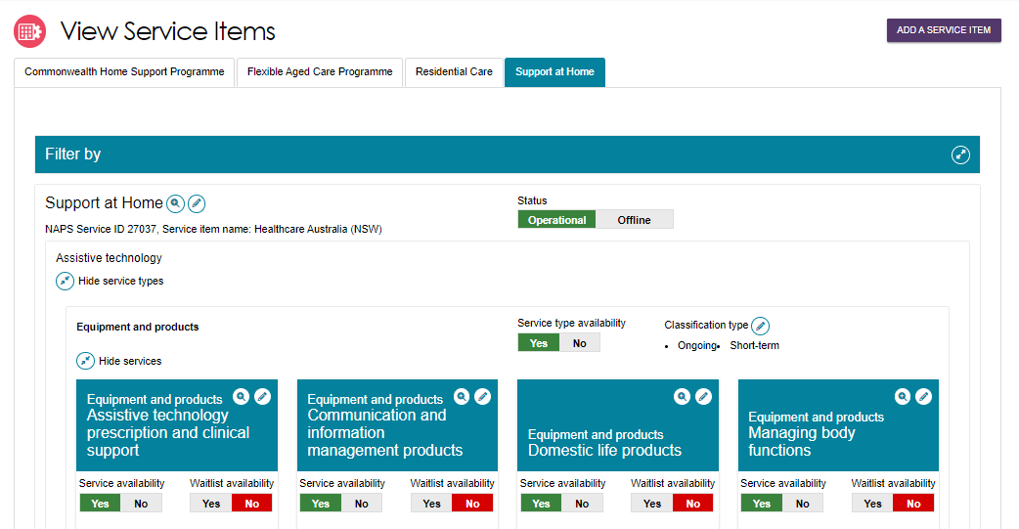
Update the Pricing for service section (if applicable), such as standard maximum, non-standard, Saturday, Sunday, and Public Holiday
s. (Consumables based services will default to ‘Market price’). This will be required to be completed for all services that this outlet provides before changing the service availability to Yes.
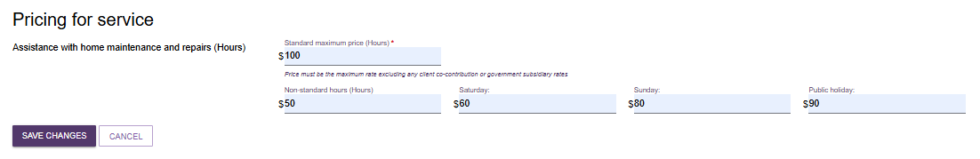
- If a service is on a waitlist, it is highly recommended to add service pricing to ensure this is visible on the Service Finder tools.
- Use the outlet-level pricing template to apply consistent pricing across services, but final display relies on service item or service-level entries. Only the service items within the selected outlet will be updated.
- Only information saved at the service item level will be displayed on the Service Finder. If you select SAVE at the outlet level this will save the information locally and will not be displayed in the My Aged Care Service Finder. To ensure your updates are visible publicly, select: SAVE AND APPLY TO ALL SERVICE ITEMS OF THIS OUTLET, this will apply the changes to each individual service item, so they display on the My Aged Care Service Finder.
All pricing information saved, including pricing schedule attachments, will appear by the next day on the service finder on the My Aged Care website, and do not require approval from the Department.

Rooms (Residential Care)

Add a room type
! This section applies to Residential Care only and does not apply to Commonwealth Home Support Program or Support at Home programs.
Residential Care providers can add information about the types of rooms their organisation offers. Follow these steps to add a room and room information. Fields marked with an asterisk (*) are mandatory.
- Select Outlet administration from the homepage. Select the name of the outlet on the Outlet Card you want to add room information to.
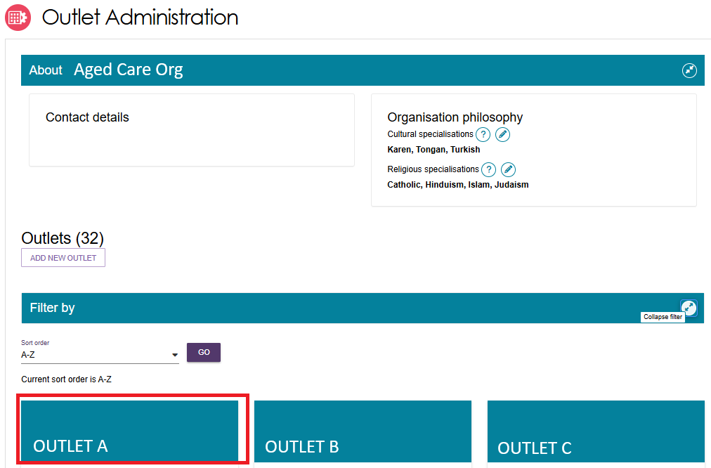
- The View outlet page appears. Select the VIEW SERVICE ITEMS button.
- From the View Service Items page, select Resident Care from the tab options. Choose your service. Select Expand (blue arrow) next to See room types.
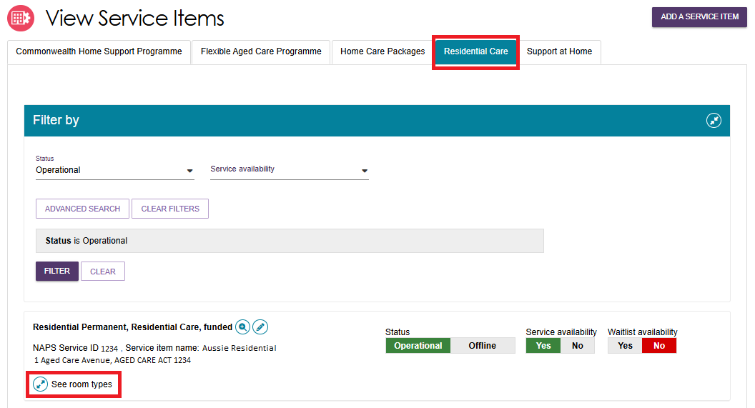
Then Select ADD ROOM TYPE.
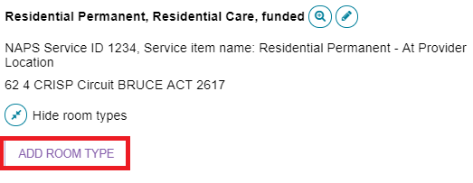
- The Room Type page appears. Enter required information in the General room information and Pricing information sections. Ensure mandatory fields (red asterisk) are completed.
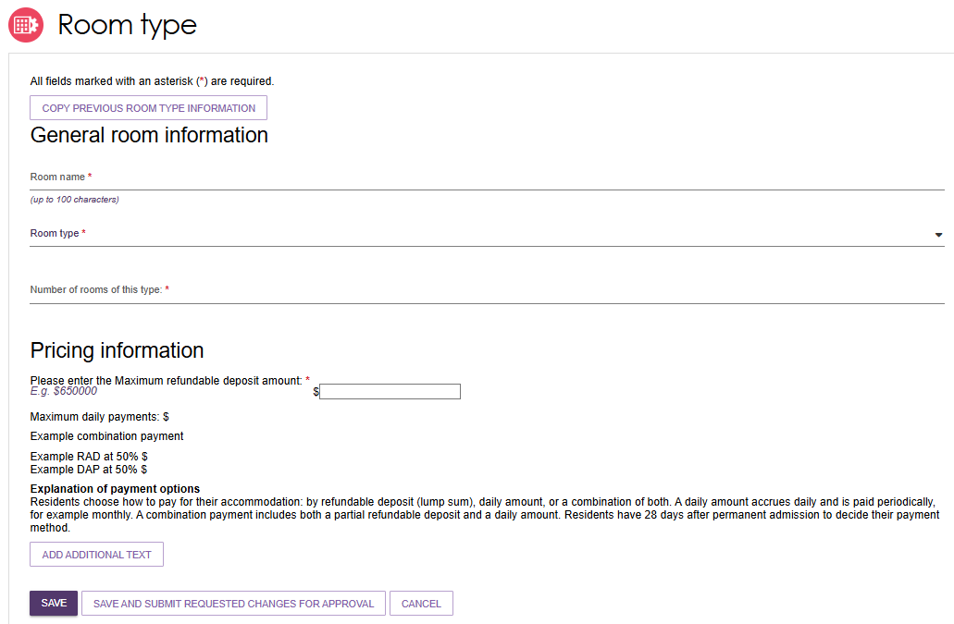
- In the Pricing Information section, enter the room’s Maximum Refundable Deposit (RAD) around. If you enter an amount over $750,000, the following information banner will appear.
To publish and charge a room price above a RAD of $750,000 (or the equivalent daily payment), you must have a valid approval from the Independent Health and Aged Care Pricing Authority (IHACPA), formerly known as the Aged Care Pricing Commissioner.
! If you do not have approval for your RAD price for the room type, you cannot publish or charge this price. Conditional approval does not constitute approval until you have received a satisfaction of conditions letter from IHACPA.
The below fields will appear and need to be completed for rooms priced over $750,000.
- Approval or Conditional Approval
- Date of IHACPA approval (or Aged Care Pricing Commissioner approval) – IHACPA approvals are valid for 4 years. Once you enter the required approval details for a room, you will receive automatic notifications when your approval is nearing expiry. These will be sent at 6, 4 and 2 months before your Date of IHACPA approval indicates expiry. Rooms will be removed from My Aged Care if 4 years passes from your Date of IHACPA approval.
- IHACPA approval reference number – This is only required if your approval was granted on or after 1 July 2024. Approval letters issued prior to 1 July 2024 do not have an approval number.
- You will also need to attach and name the IHACPA approval letter for the room.
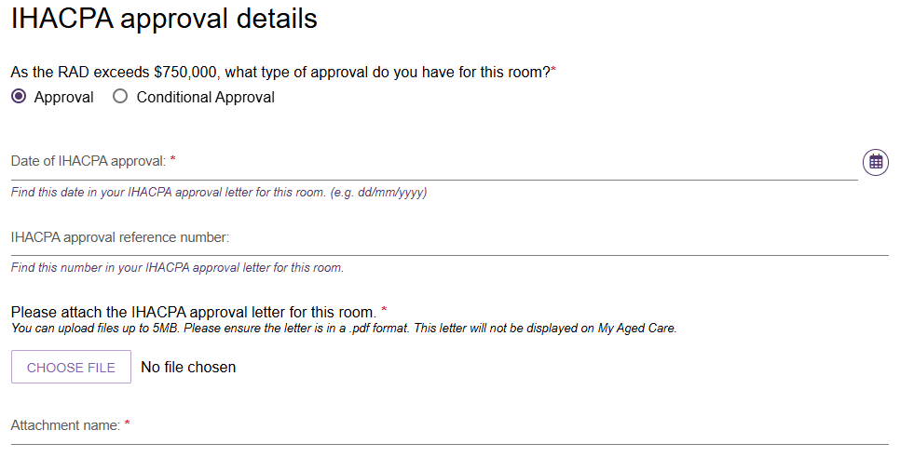
- Enter the required information under Key feature statement.
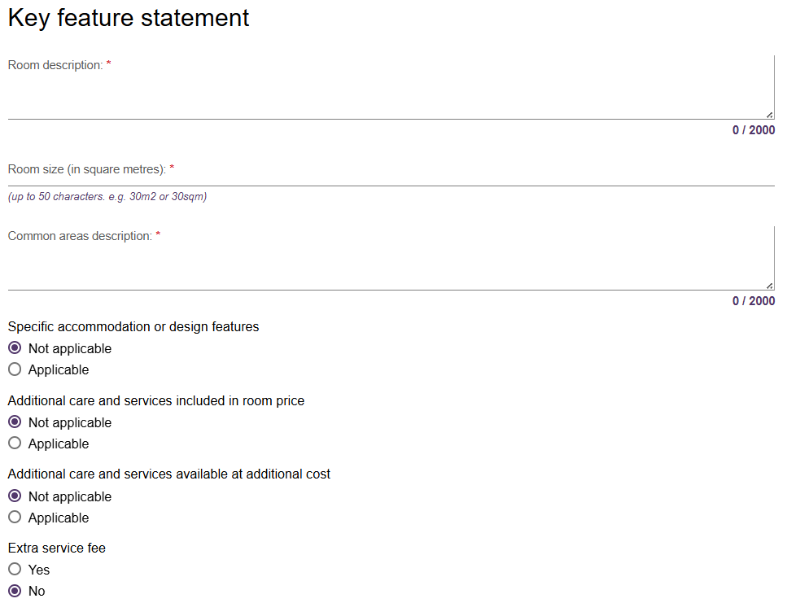
When entering room size (in square metres):
- if there is variation in room sizes, enter the size range of the room type from smallest to largest, e.g. 20sqm - 25sqm.
- indicate if the room size entered includes ensuite, e.g. 20sqm - 25sqm incl. ensuite.
- do not include private outdoor areas such as balconies or courtyards.
- Please ensure that the room size entered aligns with information provided to IHACPA in your application for these rooms.
- Select SAVE AND SUBMIT REQUESTED CHANGES FOR APPROVAL.
! If you select SAVE, this room information will be saved only and not submitted for publication.
This room information will be displayed on the service finder once approved for publication by the Department (allow three business days).
If your room is not approved for publication, you will receive an email explaining the action you need to undertake before resubmitting. You can update your room request and submit again.

Edit room details
Residential Care providers can edit existing room information. Follow these steps to edit a room. Fields marked with an asterisk (*) are mandatory.
- To edit the details for a room, select the edit (pencil).icon next to the room’s listing.
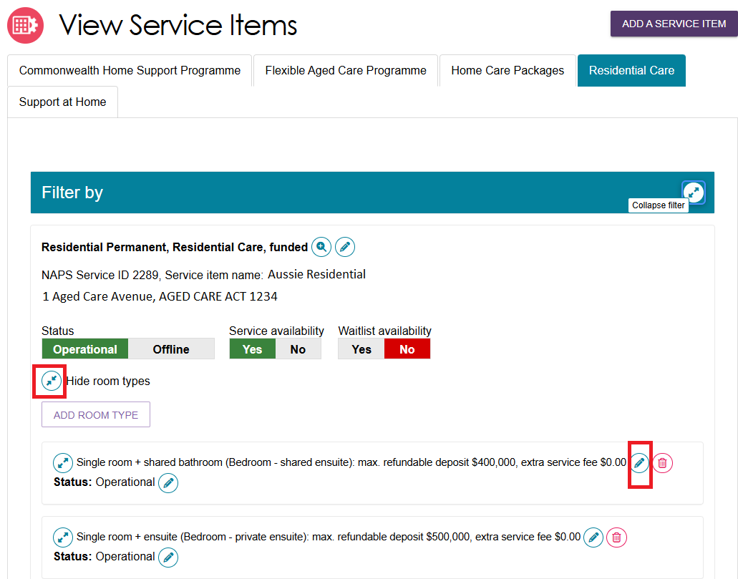
- The Edit Room Type page appears. Select the reason for resubmission from the drop-down menu and the continue to edit the details of the room.
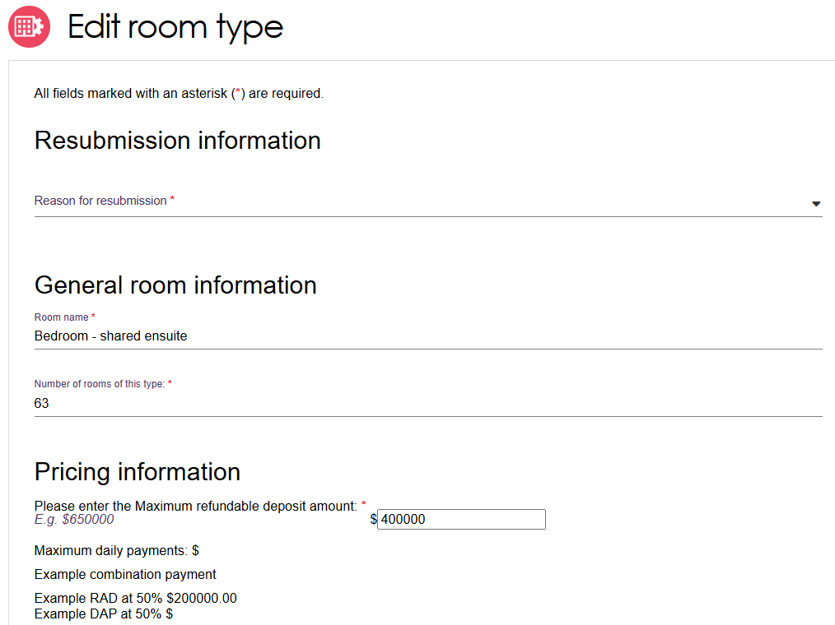
! Providers with an IHACPA approved maximum RAD over $750,000, can index the room price in line with legislation. For details on calculating the indexation of approved RADs visit www.ihacpa.gov.au.
If you have selected Indexation of approved max RAD as the Reason for resubmission, you can only change the room price. If you wish to change other fields for the room, select a different resubmission reason.
- Scroll down to the bottom of the page. Select SAVE AND SUBMIT REQUESTED CHANGES FOR APPROVAL.
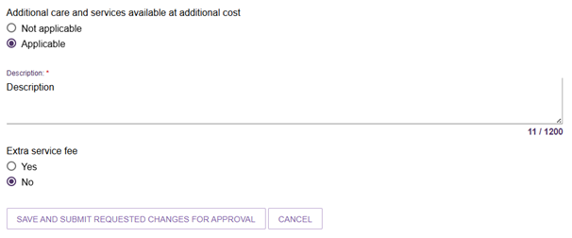
Once submitted, you will be redirected back to the View Service Items page and a green banner will display at the bottom of the screen confirming the edits were successfully submitted.

Change room status
- Select the edit icon (pencil) next to the Status of the room you want to set as Offline or Operational.
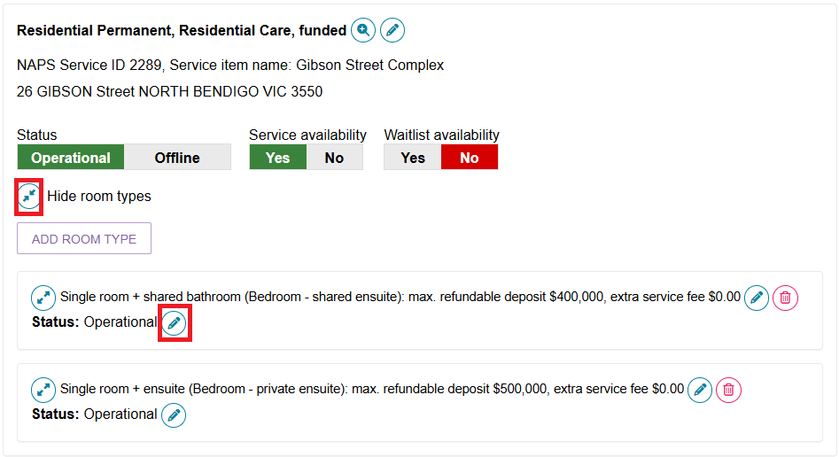
- From the pop-up select Offline (not displayed) from the change room status and select the reason for the change.
When you set the room to Offline a warning banner will appear advising that offline rooms are not displayed on My Aged Care.
Select SAVE.
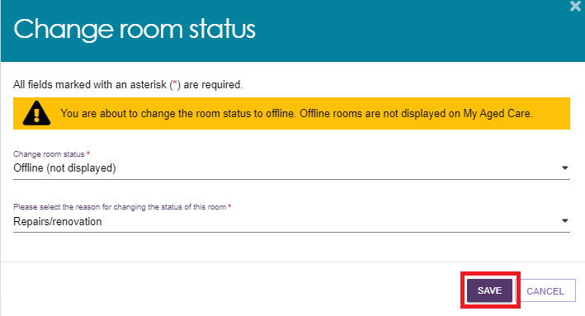
- A message will appear advising that you have successfully changed the status of the room. The status of the room will now display as Offline.

- If you wish to make an Offline room Operational, click on the edit icon (pencil) next to Status: Offline.
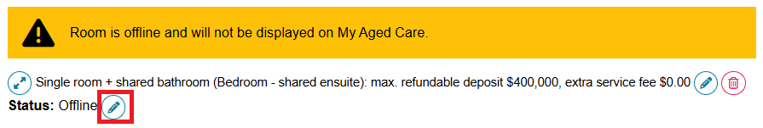
Select Operational (displayed) from the change status drop-down menu followed by the reason for the change. Then select SAVE.
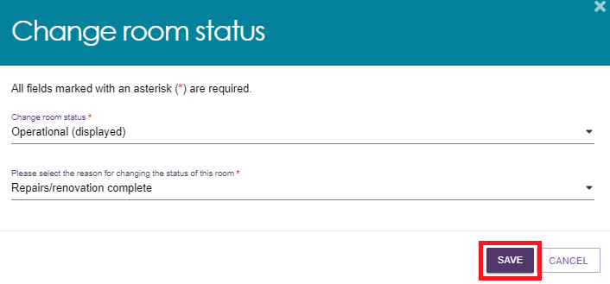
A green message will appear advising that you have successfully changed the status of the room and the room will show as Operational.
The room will be displayed on My Aged Care within 24 hours.


Delete a room
Residential Care providers can choose to permanently delete a room. Note that deletion of a room cannot be reversed.
- Select the delete icon (bin) next to the room you wish to delete.
Ensure you select the correct room as the deletion of a room cannot be reversed.
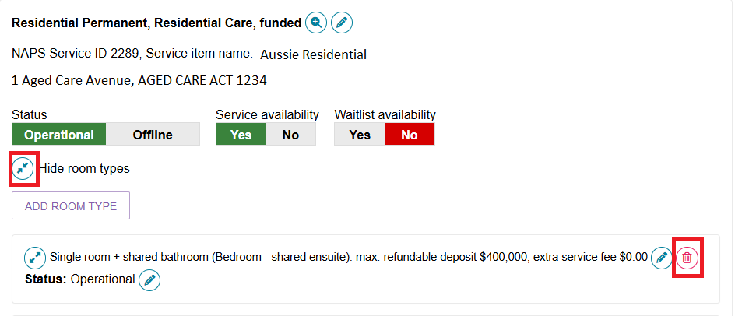
- From the pop-up, select the reason for deleting the room and select DELETE.
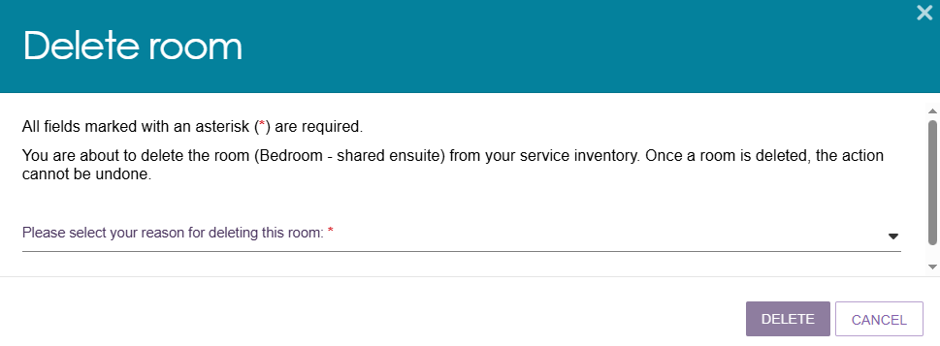
A green banner will display at the bottom of screen confirming the room has been successfully deleted.


Transferring service items
! Access to the functionality described in this guide has been disabled in the Service and Support Portal for ALL programs from 1st November 2025 until further notice.
If you require the transfer of services or clients, please contact the My Aged Care Service Provider and Assessor Helpline on 1800 836 799, who will be able to assist you.

Activating or deactivating a service item
The reasons for deactivating a service item typically include:
- Residential: Facility is no longer accepting residents.
- Commonwealth Home Support Program (CHSP): The service is no longer being delivered in the specified area.
- Support at Home: Selected services are no longer being delivered in the referral area.
Follow these steps to activate or deactivate a service:
- Select Outlet administration from the homepage, then select the outlet that contains the service items that you want to activate/deactivate, and then select VIEW SERVICE ITEMS.
- Select the appropriate tab corresponding to the program.
! The Residential Care tab should only be selected when working with Residential Care services. If you edit CHSP items, ensure the CHSP tab is selected.
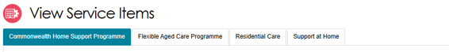
- For the services that have been added to the outlet, select Operational to activate the service item. Alternatively, select Offline to deactivate the service item under the Status heading.
Only Operational services will display in the service finders.
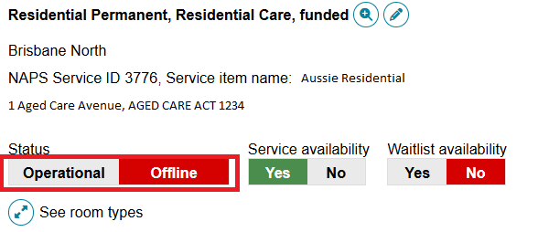
For Support at Home, the Operational or Offline status applies to every service group, service type and service that your outlet is approved for.
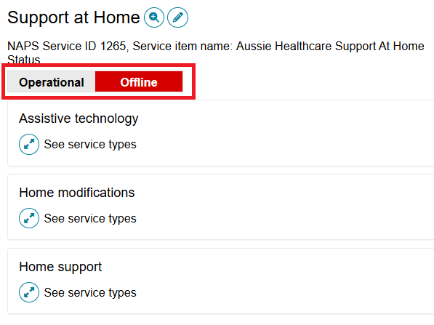
! The Offline status has replaced Inactive status and should be used to indicate where a funded service is not currently offered by the provider. For example, the service is at capacity. Services that are Inactive are services that are no longer funded by the Department. Inactive services will not be visible in the My Aged Care Service and Support Portal. Please contact the My Aged Care service provider and assessor helpline on 1800 836 799 if you have questions about your Inactive services.

Maintaining service delivery outlets

Activating an outlet
After service items are added, outlet(s) need to be made active so that:
- The service items display in the service finder.
- Contact centre staff and assessors can send electronic referrals to the appropriate outlet.
Follow these steps to activate an outlet:
- Navigate to the View Outlet details from the Outlet administration page for the outlet that you want to activate and select ACTIVATE OUTLET.
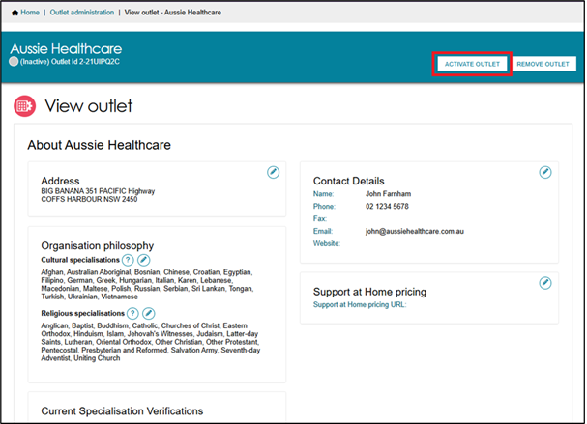
- Select ACTIVATE OUTLET to confirm that you wish for this information to be displayed in the service finder. A warning message will display:
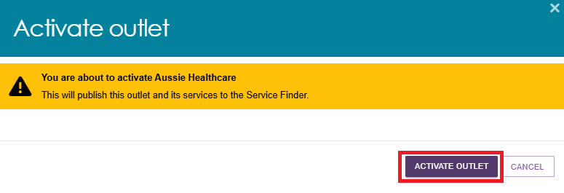
Your outlet is now active and operational service item information will display in the service finder and will display as Active in the Service and Support Portal.
Assessors can only match and refer to active services.

Card View
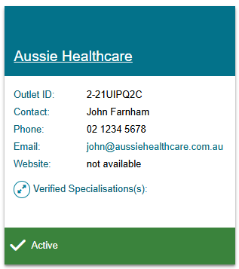
Outlet View
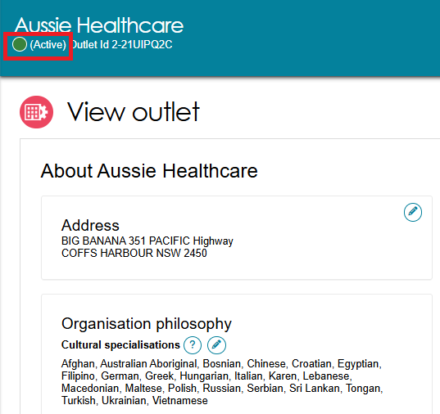

Deactivating an outlet
To remove an outlet from the service finder on the My Aged Care website, and stop referrals being sent to the outlet, it must be deactivated.
! An outlet cannot be made inactive if there are accepted and commenced services.
Follow these steps to deactivate an outlet:
- Select Outlet Administration from the homepage.
- Navigate to the View Outlet details from the Outlet administration page for the outlet that you want to deactivate and select DEACTIVATE OUTLET.
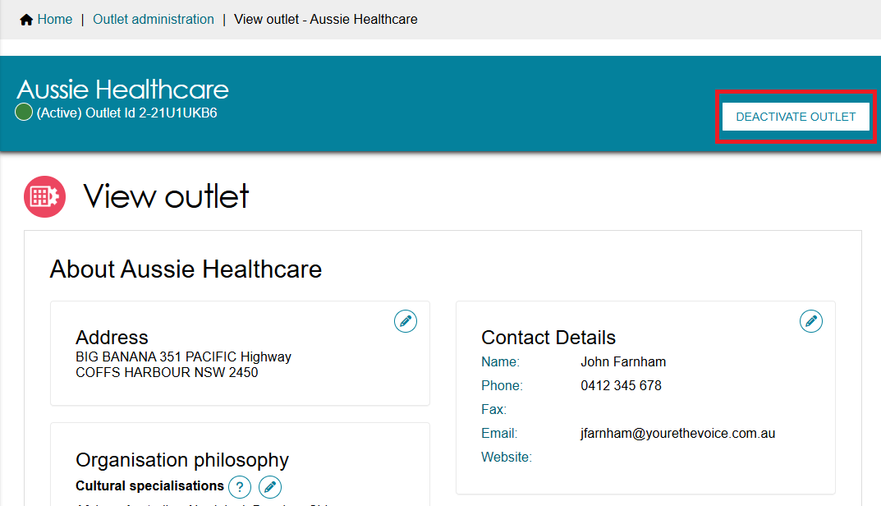
- Select DEACTIVATE OUTLET at the pop up to confirm that you wish to deactivate the outlet.
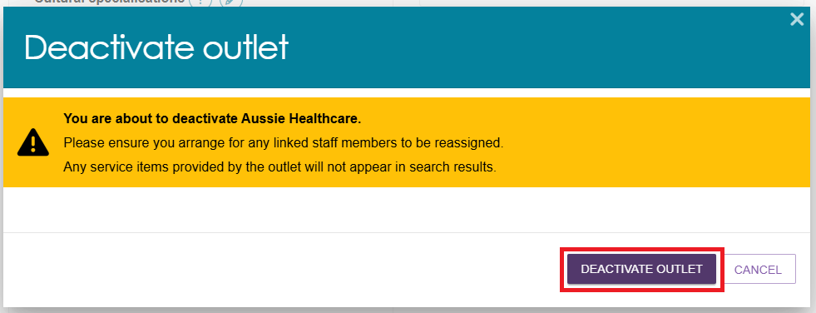
The outlet is now inactive, does not display on the relevant service finder or receive referrals, and displays as Inactive in the Service and Support Portal.

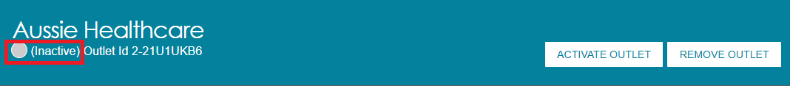

Removing an outlet
! If you want to create an outlet with the same name as the one you removed, you will need to call the My Aged Care service provider and assessor helpline on 1800 836 799.
To remove an outlet from the Portal, it must be in the status of Inactive. Follow these steps to remove an outlet:
- Select Outlet administration from the homepage.
- Navigate to the View Outlet details from the Outlet administration page for the inactive outlet you wish to remove and select REMOVE OUTLET.
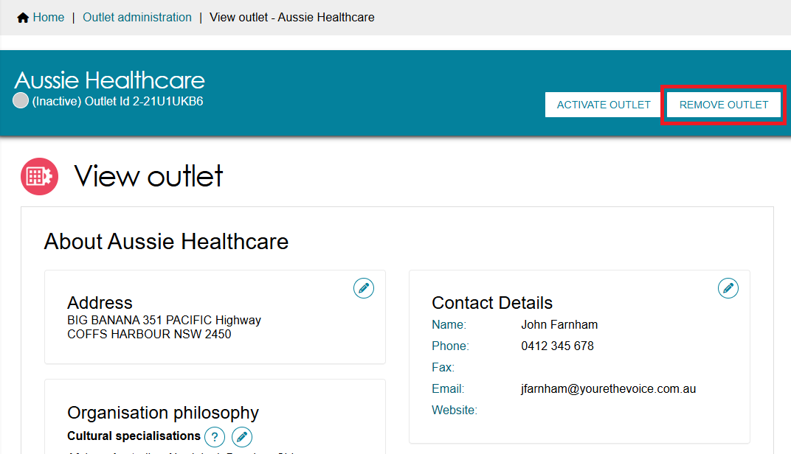
- Select REMOVE OUTLET to confirm you wish to remove the outlet.
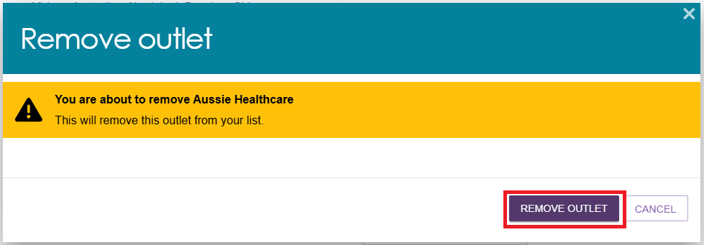
The outlet will no longer display in the Service and Support Portal.


Editing outlet details
Follow these steps to edit an outlet:
! Only non-contractual information can be edited in the Service and Support Portal.
- Select Outlet administration from the homepage.
- Select the name of the outlet on the Outlet card you want to edit.
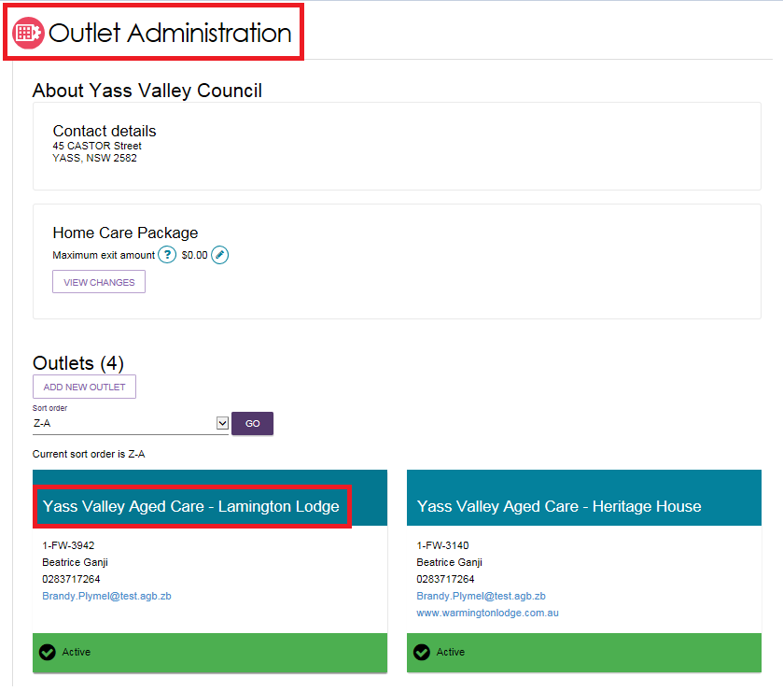
- On the View outlet page, select the area that you would like to edit, Address, Contact details or Organisation philosophy.
You can also change the Organisation philosophy when viewing your outlet information.
For more information on Organisation Philosophy refer to Editing the organisation philosophy.
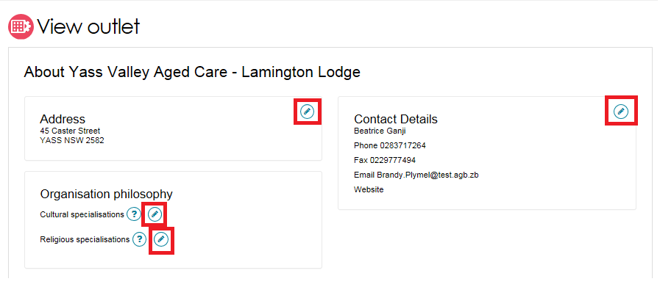
- Edit information and select SAVE CHANGES. To edit address details, select Edit next to the outlet address.
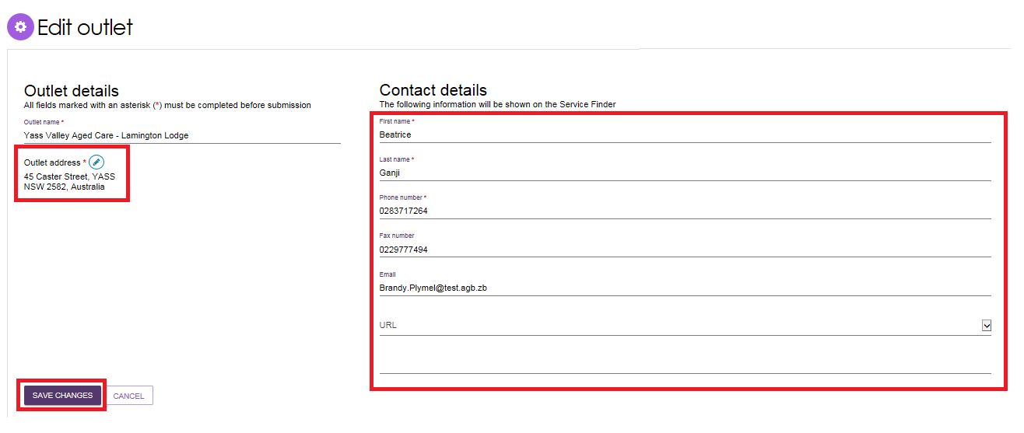

Tasks and notifications

Viewing tasks and notifications
Follow these steps to view tasks and notifications:
! You must log onto the relevant outlet to view its tasks. You can do this by selecting the outlet you wish to log in to next to the Logout link at the top right of the portal.
- Select the Tasks and notifications tile from the homepage.
To view tasks for your organisation, select Tasks. Select an outlet to view tasks related to that outlet.
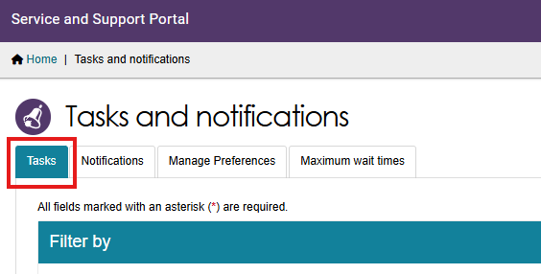
In the Tasks tab, you will be able to view all tasks that are relevant to your role. You can sort tasks by:
- Due date
- Category
- Title/Description
- Aged Care User ID
- Client name
- Activity ID.
! Tasks that have been marked as important for your outlet by your outlet administrator will be displayed with a visual indicator. The managing preferences section in this guide explains how to set tasks as important.
- To view notifications for your organisation, select Notifications. Select an outlet to view tasks related to that outlet.
You will only be able to see tasks and notifications that are associated to your outlet and for clients you are providing services to. Assessors will be able to see all tasks and notifications for clients.
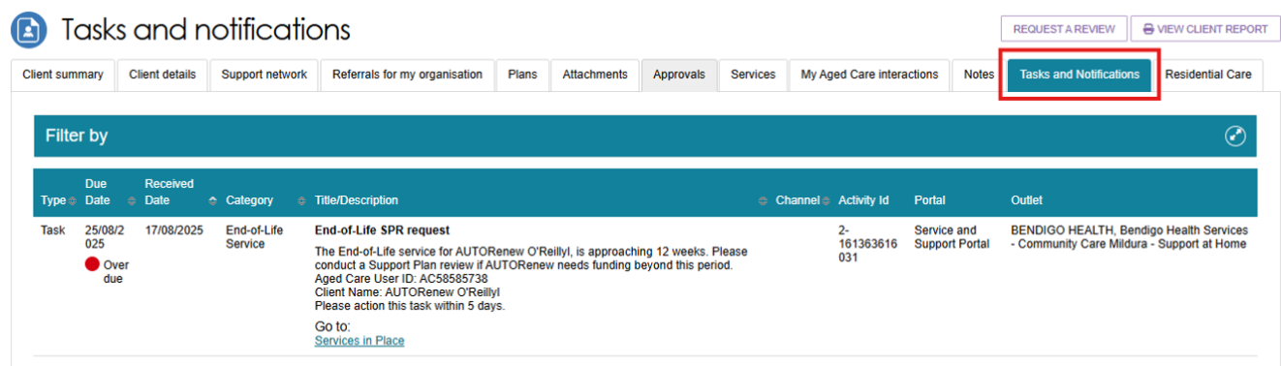
- You can search for specific tasks using the filter options or using custom filters in Advanced Search. Select the arrows to the right to expand or collapse the filter options.
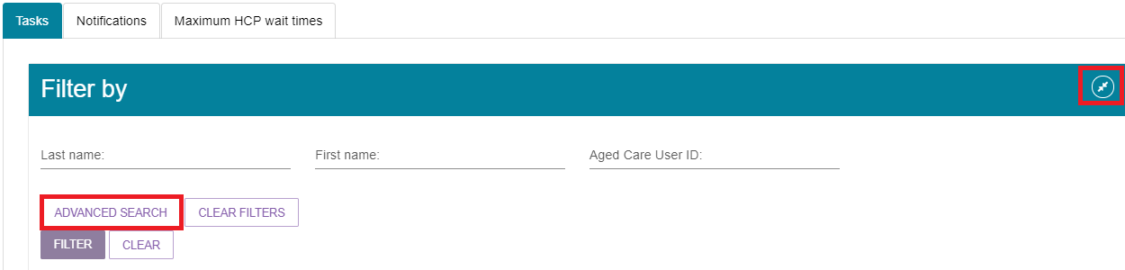
To apply custom filters, select ADVANCED SEARCH and choose filters from the drop-down menu and select ADD FILTER for each filter you want to apply. The filters include:
- Activity ID
- Aged Care User ID
- Category
- Date received
- Due date
- First name
- Last name
- Marked as important
- Overdue tasks
- Role
- Title.
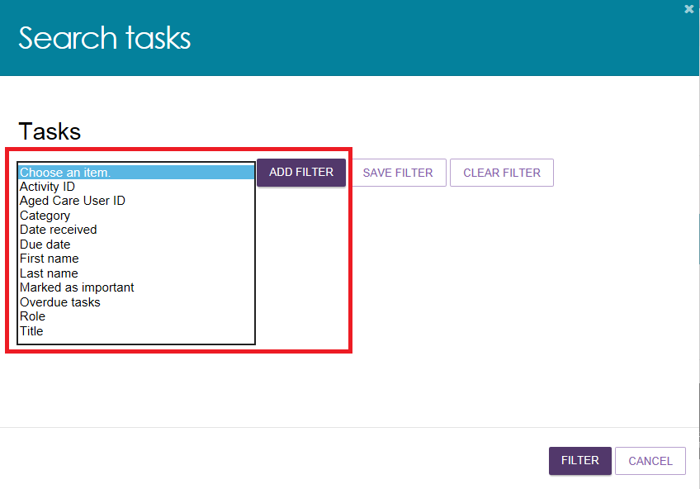
- The hyperlink under the task description will take you directly to the individual record and the section of the portal where you can action the task. Alternatively, you can navigate to the clients record by selecting the client’s Aged Care ID from the tasks list.
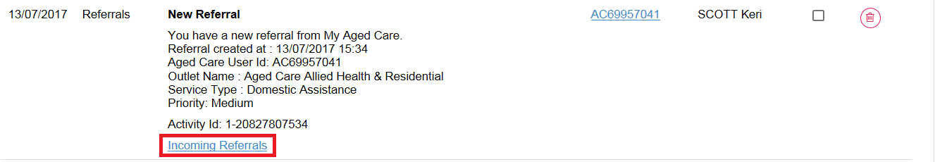
For example, selecting the link in an Overdue referral task will take you directly to the Incoming referrals tab where you can review the referral and determine whether to accept or reject the referral or place the client onto a waitlist, where appropriate.
Once the action required from the task has been completed, the task will automatically be removed from your task list.

Managing task and notification preferences
You must be an Administrator to manage task and notification preferences for your organisation or outlet. If you need to add this role to your user account, please see your organisation administrator.
As an Administrator, you will be able to:
- Edit email address and email frequency for new task and notifications
- Turn off visibility of notifications in the Portal
- View description of each task and notification, including which user types will be able to see them
- Edit individual task and notification preferences
- Mark a task or notification as important to your outlet.
These settings will affect all staff assigned to your outlet, so please ensure all staff are made aware of any changes you make.
- Select the Tasks and notifications tile from the homepage.
- Select the Manage Preferences tab.
If you are the Organisation Administrator, you will be able to select which outlet you want to configure task and notification preferences for. If you are the Administrator for your outlet, you will only be able to see your outlet’s preferences.
Then, select Change Preferences.
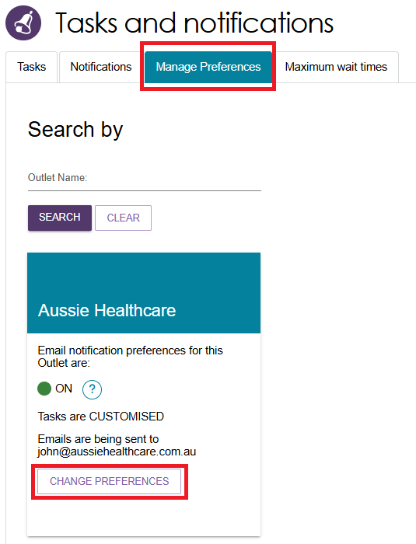
- The preferences page for the outlet will open. At the top of the page, you can configure the overall preferences for email preference, email address, email frequency and notification visibility in the portal.
You can choose to hide all notifications or hide individual notification types for the outlet. Selecting No to hide all means that no notifications for the outlet will be visible to staff associated with the outlet. Selecting No for an individual notification type means that only notifications of that type will be hidden for staff associated with the outlet.
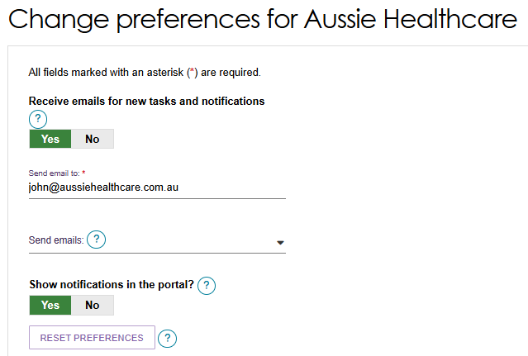
Tasks and notifications are sorted by category. Select the expander icon to expand/collapse each category.
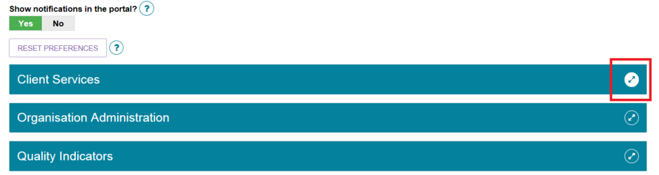
For each task or notification, you will be able to view:
- Type (e.g. task or notification)
- Title and brief description of the why the task or notification has triggered
- User type who can view or action the task or notification.
For each task or notification, you will be able to individually configure:
- Whether to send an email when a task or notification generate
- Frequency of email notification, if enabled
- Whether to display a task or notification as important in the portal.
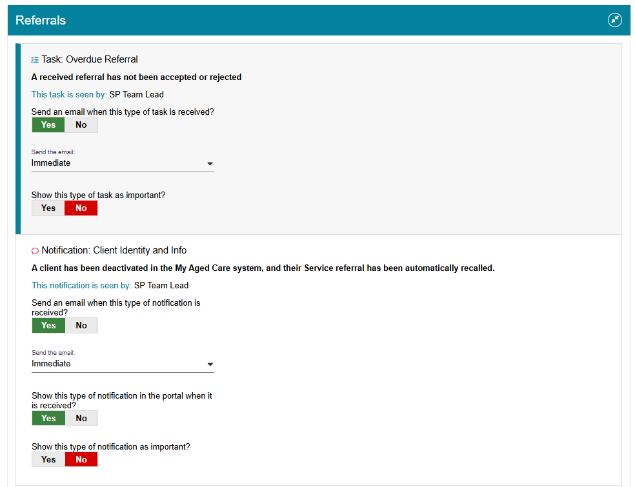
If you choose to mark a task or notification as important, staff within your outlet who can view that particular task or notification will see a visual indicator in their portal. For example, a notification of home care correspondence.
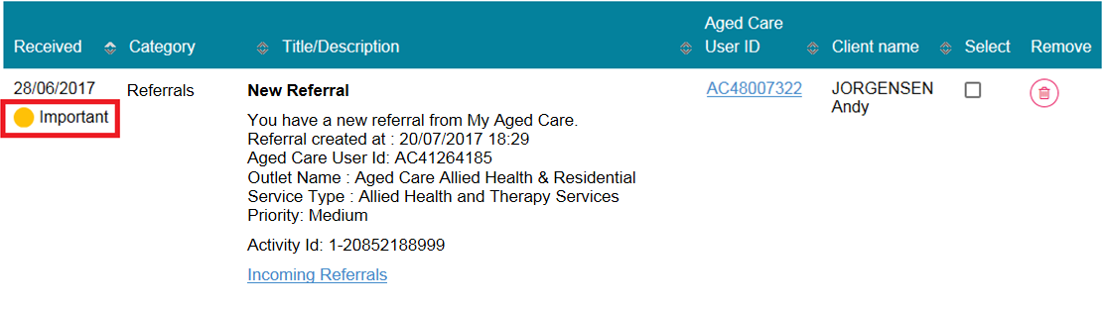
- Select SAVE when all changes have been made. You can reset the preferences by selecting RESET PREFERENCES at the top of the page.
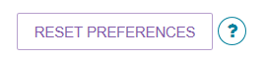

Creating and maintaining staff accounts
After you have created outlets for your organisation, you can create and maintain staff accounts. For more information about staff roles refer to Staff Roles in the Service and Support Portal.

Viewing staff accounts
By selecting Staff administration on the homepage, you can view all current staff that have access to the Service and Support Portal. You can sort staff alphabetically, or by the outlet(s) they are assigned to.
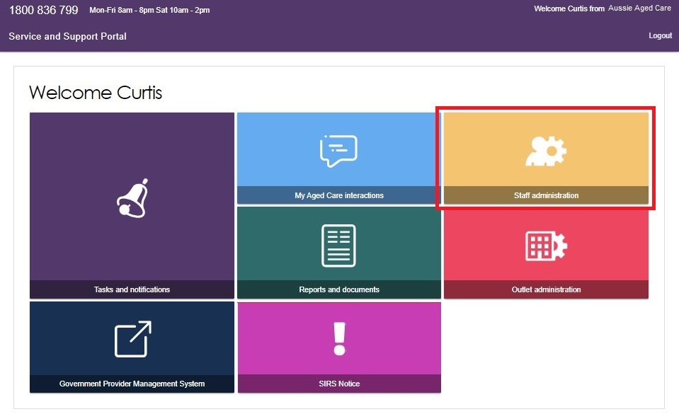

Adding new staff accounts, allocating roles and outlets
After you have created outlets for your organisation you can create staff accounts. You will need to assign roles to your staff and assign your staff to one or more outlets.
Staff can be assigned one or more roles (Administrator, Team Leader, Staff Member) at the same time within the Portal. Staff roles apply across all outlets to which they are assigned.
! Staff assigned to the Organisation Administrator role can manage all outlets for their organisation.
Staff assigned to the Outlet Administrator role for one or more outlets will only be able to manage services and staff for the outlet(s) they have been assigned.

Follow these steps to add a new staff account:
- Select Staff Administration from the homepage.
- Select ADD NEW STAFF from the staff administration page.
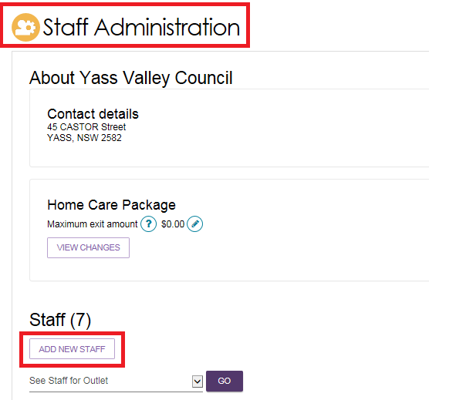
- You must enter staff details (First name, last name, unique email, and a contact number), assign role(s) to staff, and assign staff to one or more outlets. Next, select SAVE.
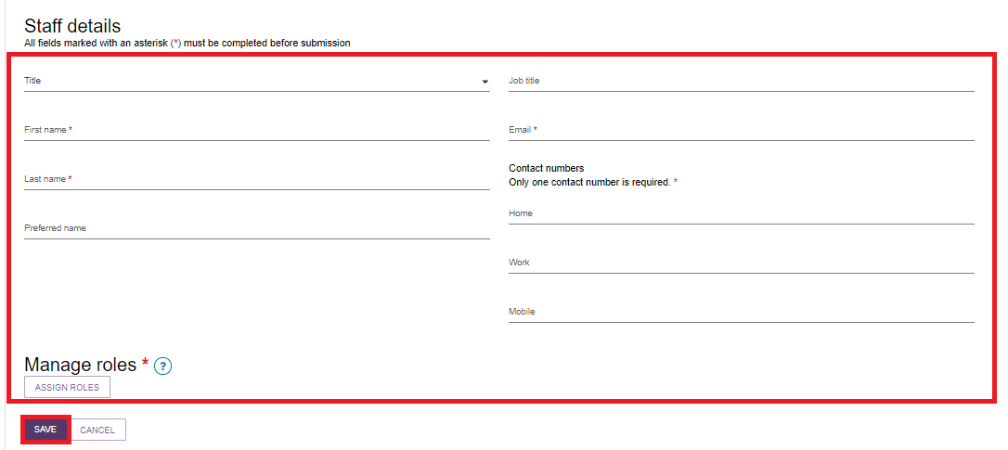
- You can assign staff to either the Organisation Level or Outlet Level. Organisation Level allows staff to access to the Organisation details, including all outlets for that organisation. Alternatively, you can choose to assign staff to access one, multiple, or all outlets under the Organisation.
Then, select SAVE and SAVE ROLES.

A person assigned the administrator role at the organisation level:
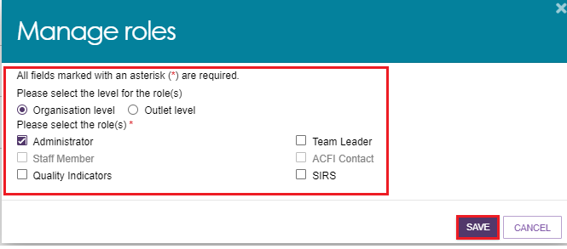
A person assigned the roles of administrator and team leader at the outlet level:
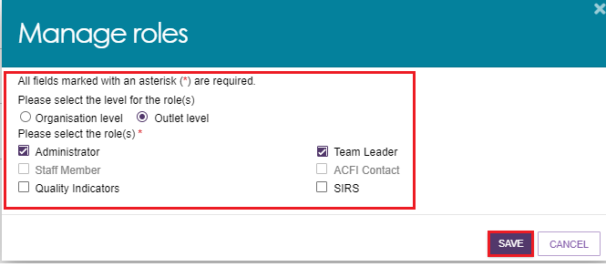
Choosing an outlet for the role
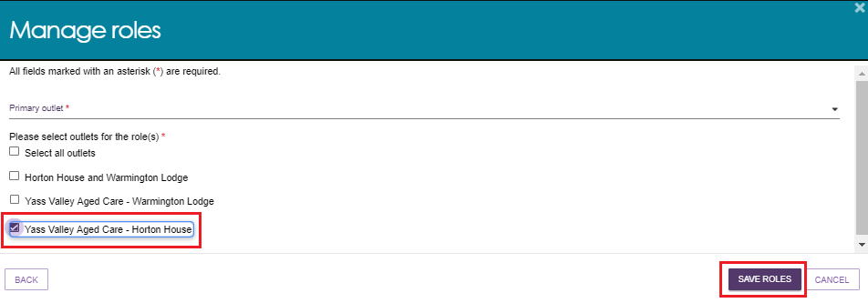
- Service Provider Administrators can add staff to additional roles in their outlet.
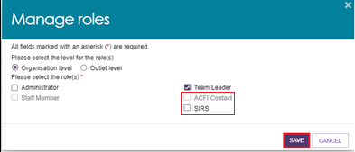
! The first time each staff member logs into the Service and Support Portal, they will need to follow the steps outlined in Logging in to the Aged Care Systems.

Editing a staff account
Follow these steps to edit a staff account:
- Select Staff administration from the homepage. Select the name on the Staff card that you want to edit.
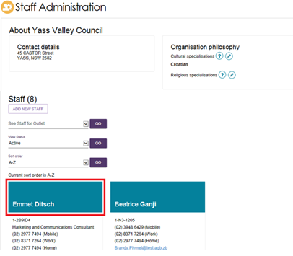
- Select EDIT STAFF DETAILS.
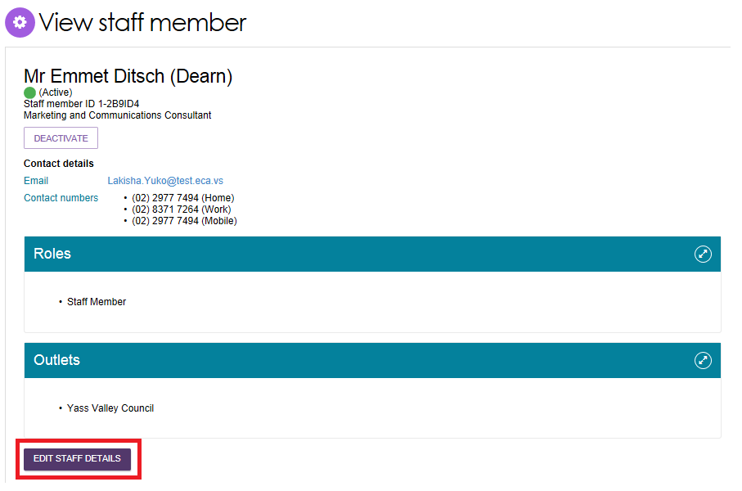
- Edit staff details and select SAVE.
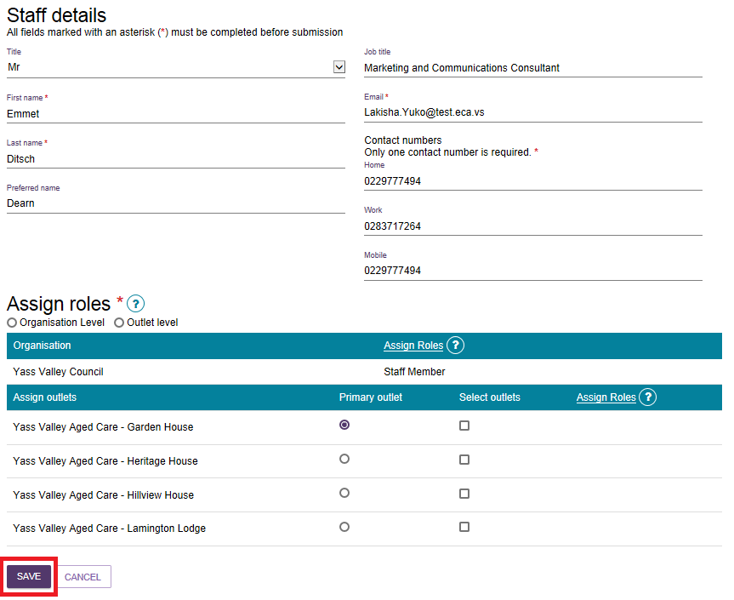

Deactivating staff accounts
Deactivating an account will permanently lock the account for the staff member and remove their access to the Service and Support Portal. Follow these steps to deactivate a staff account:
- Select Staff administration from the homepage. From the Staff Administration page, select the name of the staff member on the Staff card that you want to deactivate.
- From the View staff member page, select DEACTIVATE.
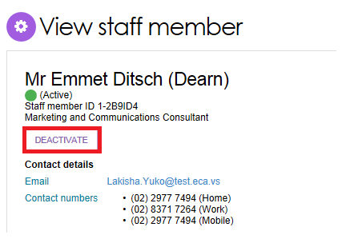
- Select DEACTIVATE ACCOUNT to confirm.
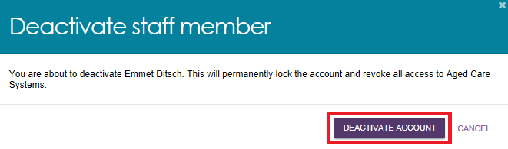
The staff member account will now appear as Inactive in the Service and Support Portal.

Removing staff accounts
Inactive staff members (that have previously been deactivated) can be removed from organisations and outlets and will no longer display in the Service and Support Portal.
! For information on removing a staff member’s authorisations in the Relationship Authorisation Manager (RAM), refer to Managing Authorisations. If you need to restore access for a staff member who has been removed, call the My Aged Care contact centre. You cannot re-create a portal user account using the same email address and myID.
Follow these steps to remove a staff account:
- Select Staff administration from the homepage. From the Staff Administration page, select Inactive from the View Status drop down menu to view inactive staff.
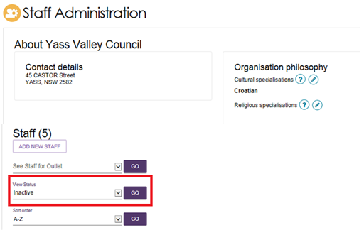
- Select the name of the staff member on the Staff card that you want to deactivate. The View staff member page appears.
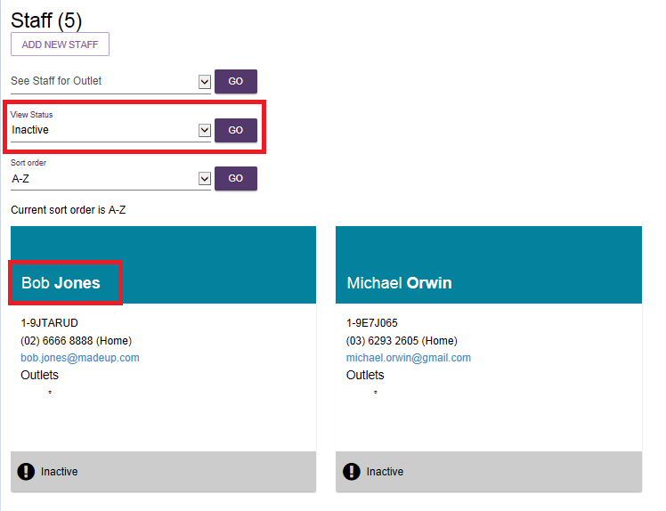

- From the View staff member page, select REMOVE.
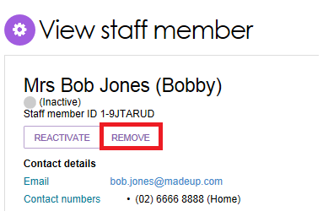
- Select REMOVE to remove the staff member from your staff list.
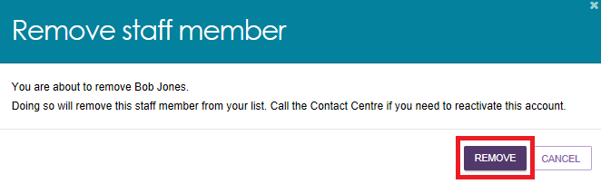

Generating reports and accessing forms
Providers can generate and view reports and access forms via the Service and Support Portal. You will also be able to use the Reports feature to print documents.

Generating reports
Administrators, Team Leaders, and Staff Members can generate reports. Follow these steps to generate a report:
- Select Reports and documents from the homepage. The Reports and forms page will be displayed.
- The Reports and forms page features a Reports tab and a Forms tab. The reports tab displays a list of Recently Requested Reports and Reports.
The Recently Requested Reports will display client record PDFs that have been generated by the user.
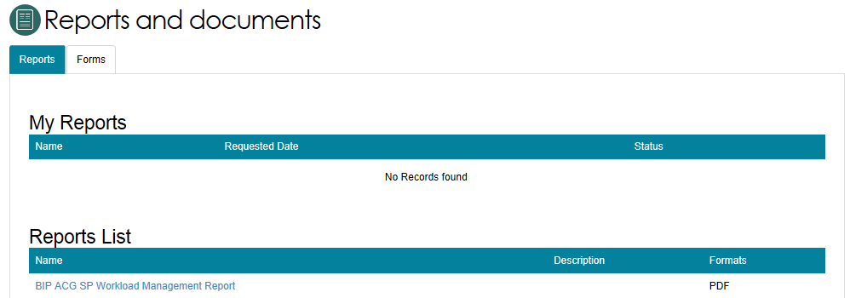
- To generate a report, select the name of the report in the Reports List.
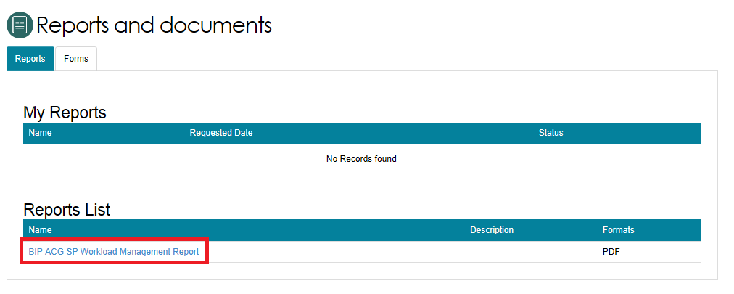
- Select the Outlet ID, enter a start and end date, and an output type (CSV or PDF), then select REQUEST REPORT. If you do not want to generate the report, select CANCEL.
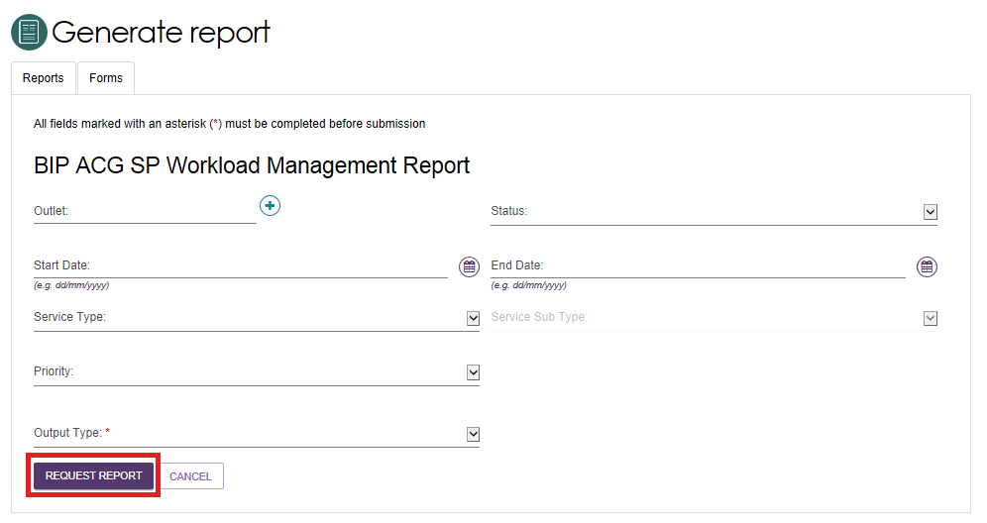

Viewing reports
Follow these steps to view reports:
- Select Reports and documents from the homepage. The Reports and forms page appears.
- In the Recently Requested Reports list, select View beside the report you would like to view.
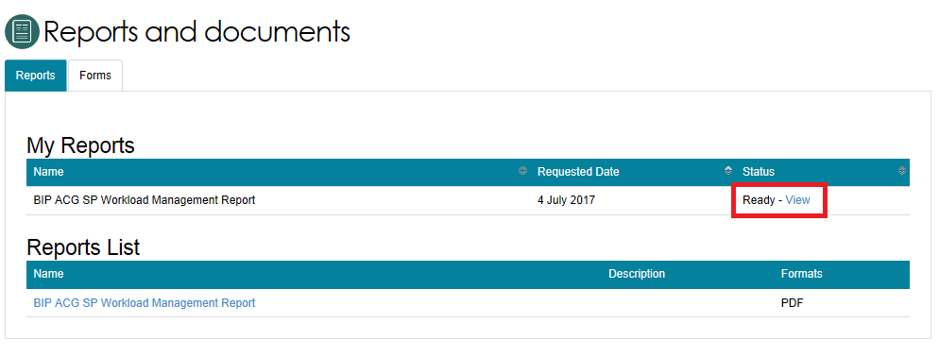
- Select the action you want to complete: Open, Save or Cancel the report.
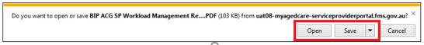

Accessing forms
Follow these steps to access forms:
- Select Reports and Documents from the homepage.
- Select the Forms tab. You can view a list of all available forms here.
