Service and Support Portal User Guide - Creating service delivery outlets and adding service information
This User Guide is for Administrators within the My Aged Care Service and Support Portal. It explains how to create and maintain information about service delivery outlets.
Information about aged care services provided by each service provider is publicly displayed in the service finder on the My Aged Care website. This information is also used by My Aged Care contact centre staff and assessors to refer clients for service(s).
This Guide is divided into the following topics:

Notes 2
Viewing Outlets 2
Creating or adding a new outlet 3
Editing the Organisation philosophy 5
Diverse Needs Specialisations 7
Adding service items to an outlet 8
Adding and removing service sub-types 11
Activating or deactivating a service item 12
Editing a service item 13
Adding and editing service attributes 15
Specialisations 17
Specialised Services 17
Languages 17
Hours of operation, staffing notes, transport notes 18
Service Description 20
Adding pricing information to a Support at Home outlet or Home Support service 20
Maintaining service and waitlist availability 25
Editing a service delivery area 26
Adding a room type to a residential facility 29
Activating an outlet 31
Deactivating an outlet 32
Removing an outlet from the Service and Support Portal 33
For more information or support 33

Notes
- Service information must be maintained by providers to ensure appropriate referrals are sent.
- Only Organisation Administrators in the Portal can create outlets. Staff can then be assigned to outlets and service delivery information can be added for each outlet.
- Only Organisation Administrators or Outlet Administrators can add or update service information.
- An outlet represents a point of client intake, which may be location-based. While it often reflects a physical site, it primarily functions as the entry point for service item delivery. You will need to set up one or more outlets in the Portal to add and maintain information about the services that your organisation delivers. To ensure that your services will be displayed on the service finders, you must set up an active outlet with an address and a service item under an operational outlet.
- Residential Respite Care and Home Support service providers will be required to complete pricing information. Home Support service providers will also be required to complete Home Support pricing information.
- For detailed information on the process to transferring services between outlets and clients between services refer to the Service and Support Portal User Guide - Advanced Outlet and Service Management - Transferring Clients and Services. This process does not currently apply to Home Support outlets.

Viewing Outlets
To view outlets, follow the procedure below.
- Select Outlet administration from the home page.
Team leaders and Staff members do not have access to the Outlet Administration tile.
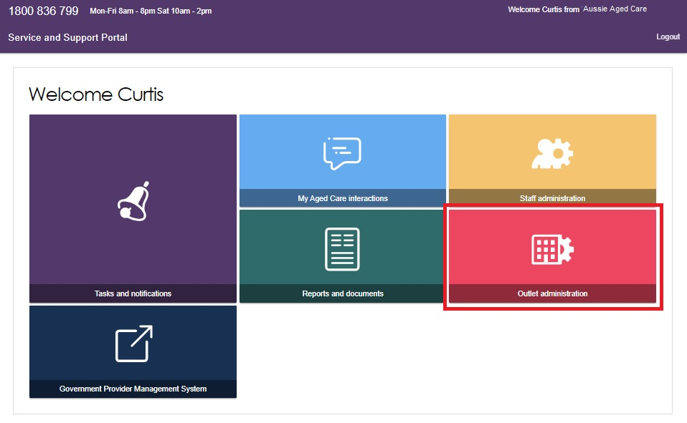

- You can now view all of the outlets for your organisation.
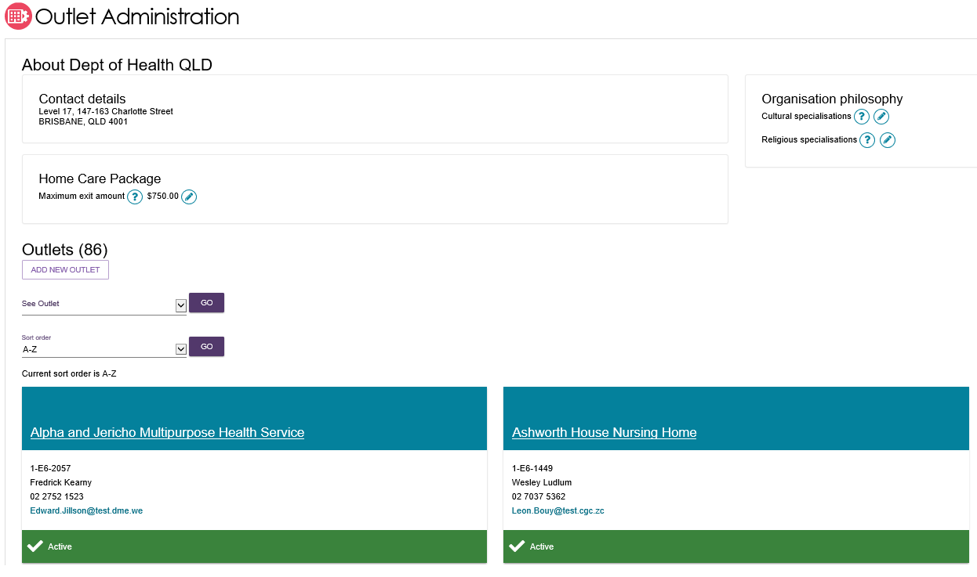

Creating or adding a new outlet
Administrators need to set up outlets in the Service and Support Portal before service information can be added.
When Administrators create an outlet, the status is set to ‘Inactive’ by default. You must activate the outlet and create service items in an outlet before it can be made operational. The process for activating an outlet is described later in this User Guide.
- Select Outlet administration from the home page.

- From the Outlet administration page, select ADD NEW OUTLET.
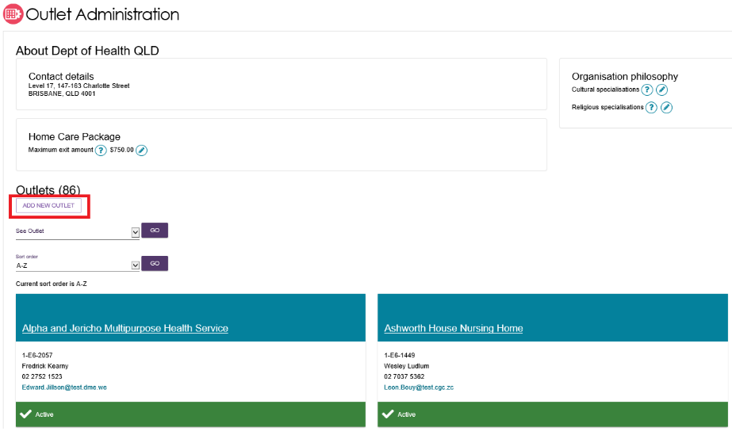
- Enter outlet details. To add an outlet address, select ADD OUTLET ADDRESS.
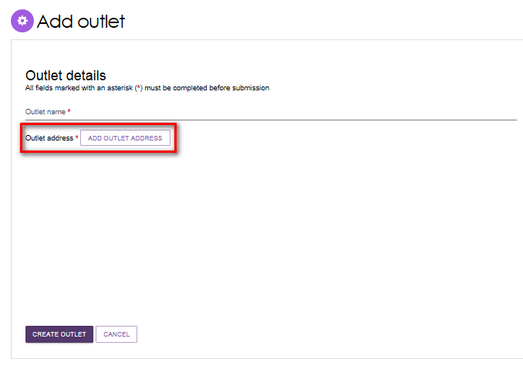
- Fill out your address details, then select VALIDATE THIS ADDRESS.
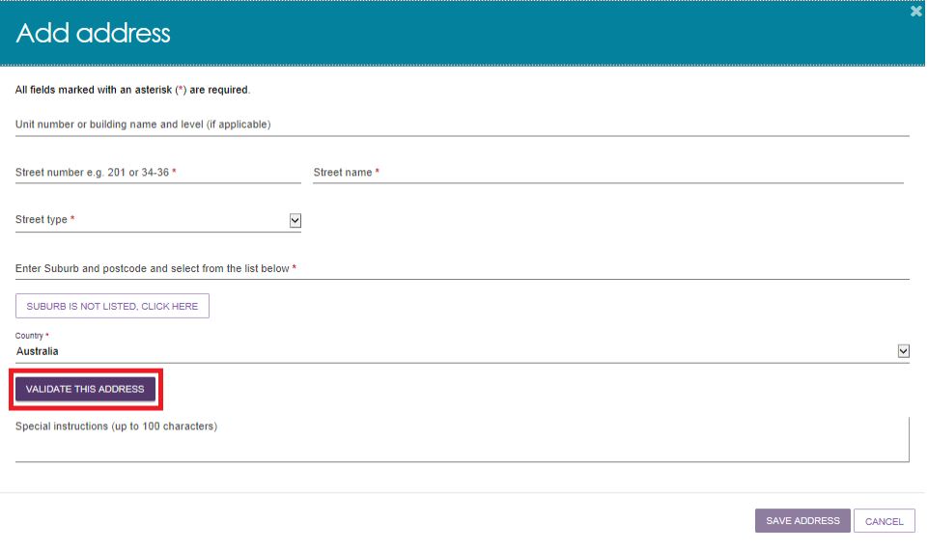
- Confirm that the address is displayed correctly, then select SAVE ADDRESS. If the address has been entered correctly but is not returned as a result, select Not found use entered address anyway.
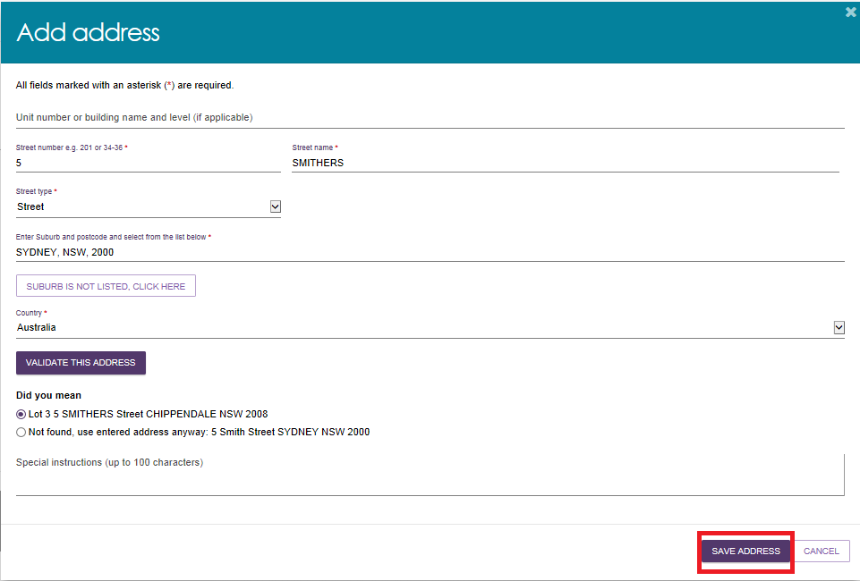
- Complete the remaining fields. Select CREATE OUTLET in order to save the record and create the outlet.
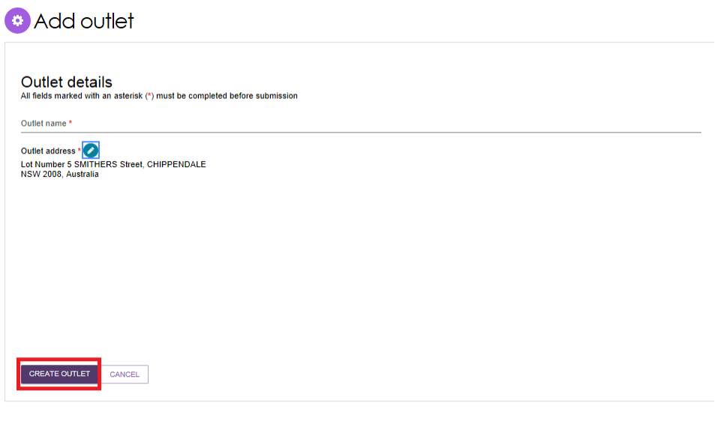
- The outlet has now been created and the details for the outlet have been saved. Repeat this process for remaining outlets, if required.

Editing the Organisation philosophy
- Add or edit cultural specialisations:
Select the Edit icon  next to Cultural specialisations to select those groups that you have a focus on providing culturally specific care to.
! Cultural Specialisations are not the same as Specialisations for Diverse Needs Groups, and are not verified. Both types of specialisations are displayed in the service finder results.
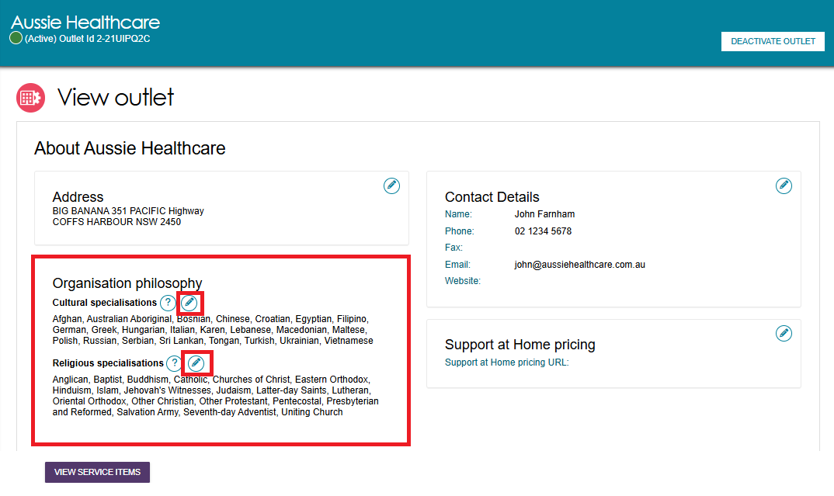
You can choose to apply this to all services in your organisation by using the SAVE AND APPLY TO ALL OUTLETS option or save as a default for all new services added by using the SAVE AND DON’T APPLY TO ALL OUTLETS option.
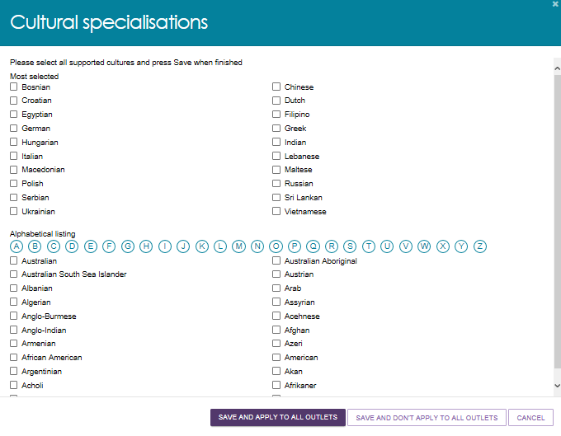

- Add or edit religious specialisations:
Select the Edit icon next to Religious specialisations to indicate if you have a focus on delivering care that aligns with particular religious needs or values.
You can choose to apply this to all current services in your organisation by using the SAVE AND APPLY TO ALL OUTLETS option, or save as a default for all new services added by using the SAVE AND DON’T APPLY TO ALL OUTLETS option.
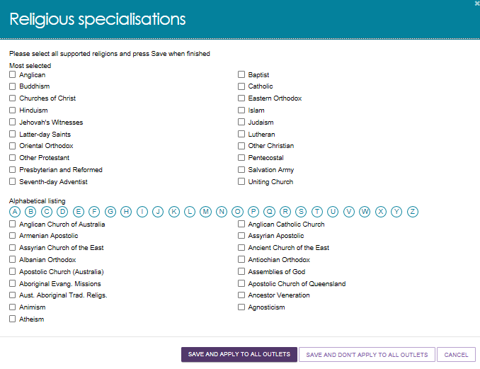

Diverse Needs Specialisations
All aged care services must provide care in which each consumer is treated with dignity and respect, with their identity, culture and diversity valued. While all service providers are required to deliver these inclusive care services, there are some that deliver specialised care for particular groups. Outlets with specific knowledge, expertise, and services, can apply to have their diverse needs specialisation verified. This helps older Australians with diverse aged care needs choose the care that best suits them.
Specialisations relating to a person’s community or background are verified under the My Aged Care Provider Specialisation Verification initiative. These specialisations are:
- Aboriginal and Torres Strait Islander peoples and communities
- people from culturally and linguistically diverse backgrounds
- people who are financially or socially disadvantaged
- veterans
- people who are homeless or at risk of becoming homeless
- care leavers
- parents separated from their children by forced adoption or removal
- lesbian, gay, bisexual, transgender and intersex people
- people who live in rural or remote areas.
Providers who wish to make claims that their outlet specialises in the care of people identifying with one or more of the Diverse Needs groups will need to apply to have these claims verified by a third-party assessor. While all providers must demonstrate that they meet the Aged Care Quality Standards, providing specialised services for the Diverse Needs groups is an optional and additional step.
Successful verification depends on the outlet’s ability to demonstrate they provide specialised care. The Specialisation Verification Framework sets out the criteria providers are required to meet, and expected forms of evidence.
Verified specialisations will be published on the My Aged Care Provider profile. Providers who have not had their specialisation claim(s) verified will have those claims removed.
! Providers can only view and manage specialisations that were verified under the 2022 Specialisation Verification Framework in the Service and Support Portal.
From 1 November 2025, new Specialisation Verification applications will be assessed under the 2025 Framework.
For more general information on the verification process, please refer to About Specialisation Verification.

Adding service items to an outlet
- From the Outlet Administration page, select the name of the outlet on the outlet card that you want to add a service item to.
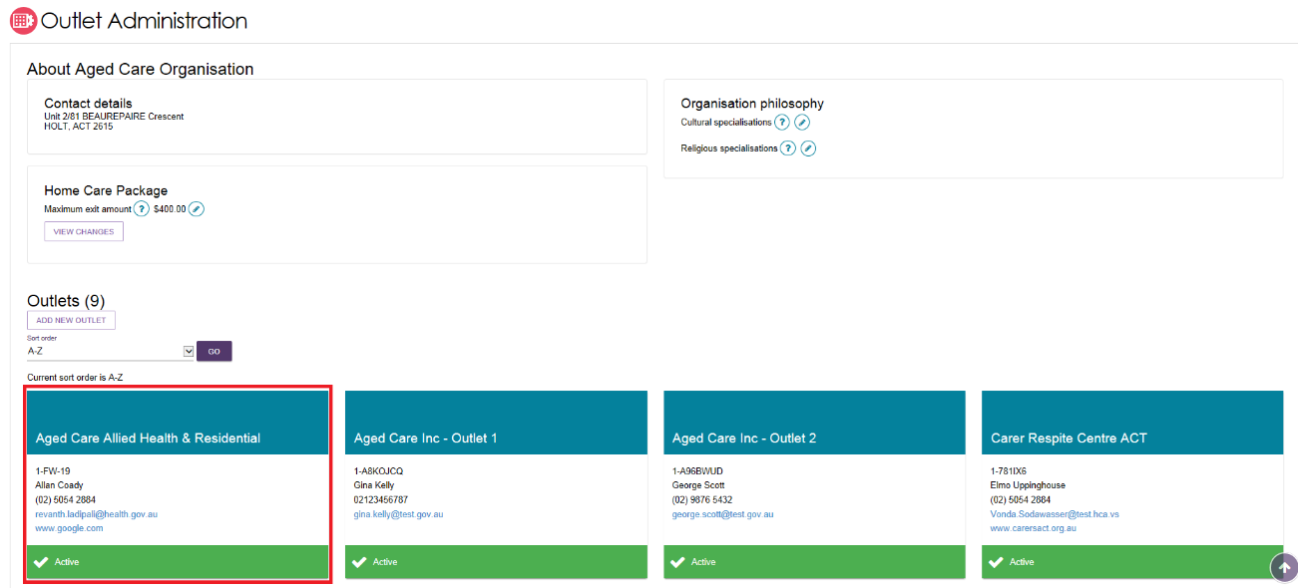
The View outlet page will be displayed.

- From the View outlet page, select VIEW SERVICE ITEMS.
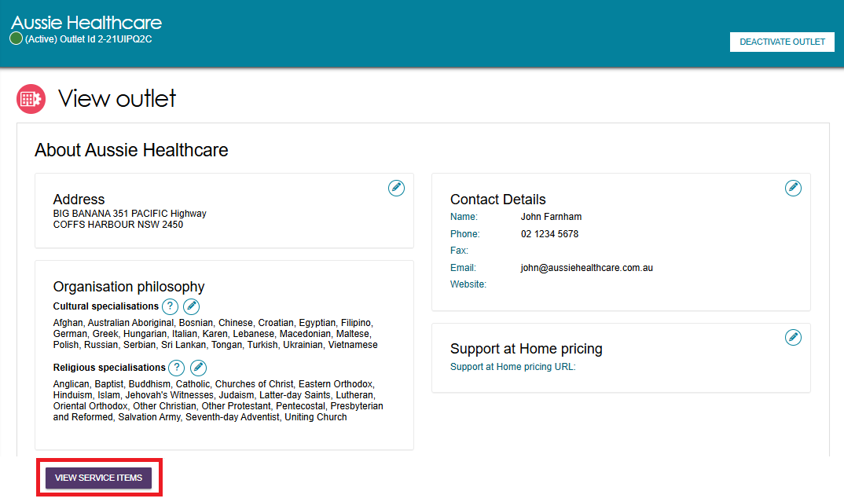
- From the View Service Items page, select ADD A SERVICE ITEM.
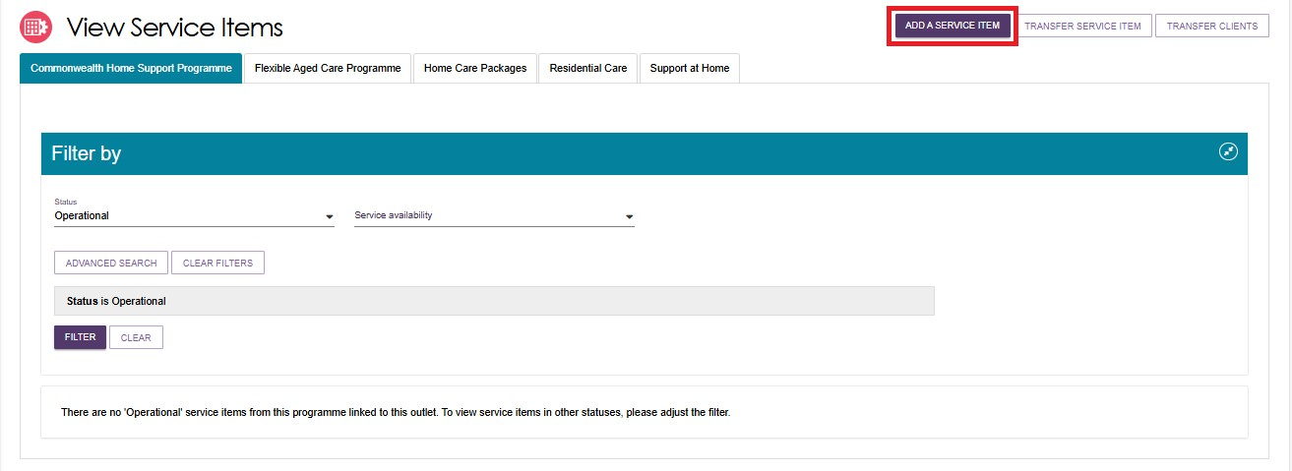
- Select the program for the service that you wish to add.
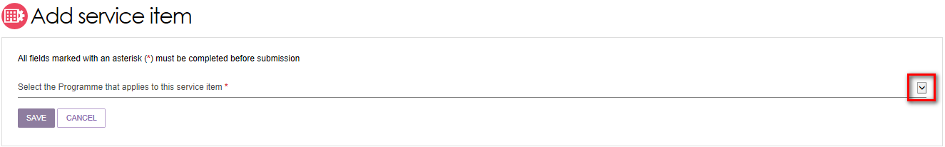
- Select Funded or Non-funded for the service that you are adding.
Funded refers to government subsidised services that are funded and approved by the Australian Government under a Commonwealth aged care programme.
Although the functionality currently exists in the Service and Support Portal to add non-funded services, non-funded services will not display on the My Aged Care website.
For the Commonwealth Home Support Program and Support at Home program, this option will not be available as all services must be Commonwealth government subsidised.
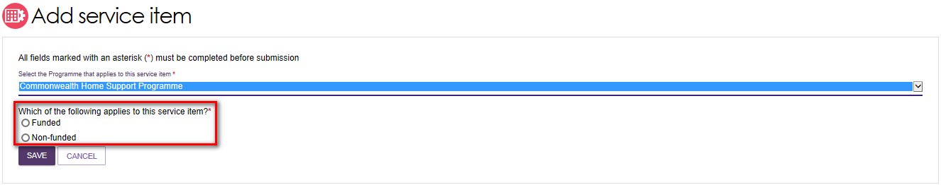
- Select the service you want to add to your outlet by selecting the relevant service item and then select SAVE. You can refine the list of service items by entering details and using the FILTER function.
If you are adding a new Home Support service (from the Support at Home program), you will be required to enter a unique name for the service in the Service Item Name field that is displayed.
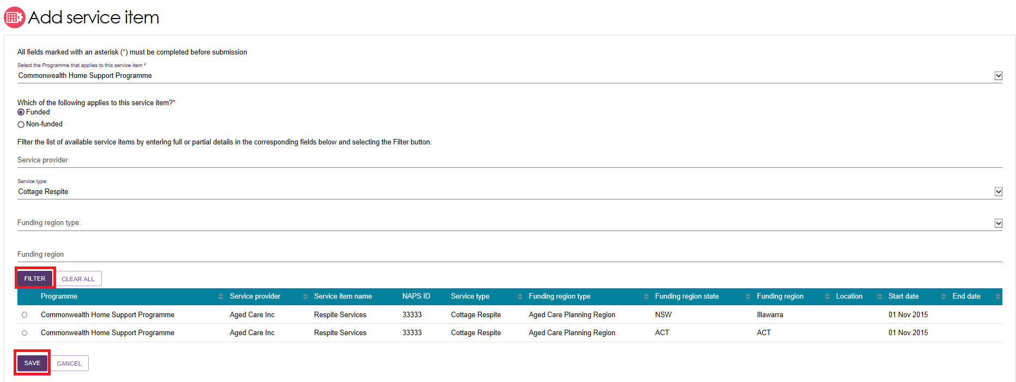
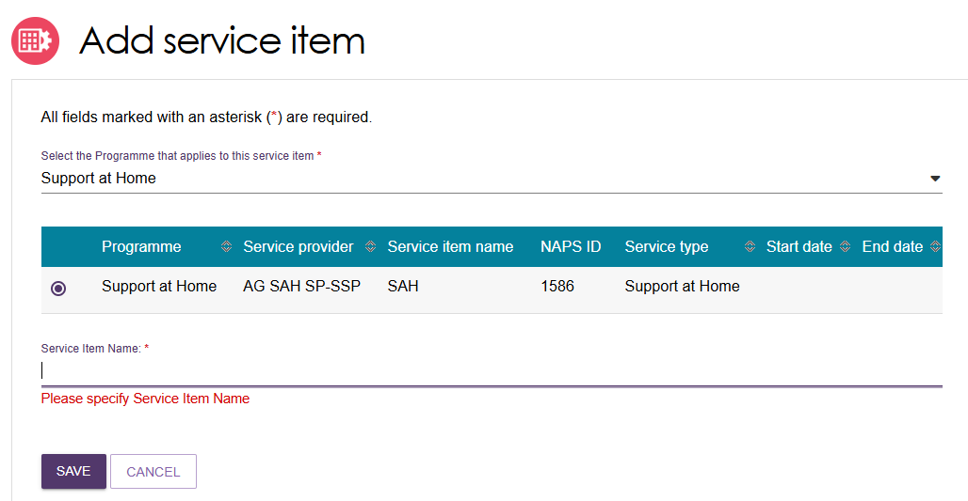
The service item will now display in the Outlet details page under Services. The service item will be defaulted to Offline and the status will need to be changed to Operational before it is displayed on the public service finder. The process for activating a service item is described later in this guide.
Once services have been added to an outlet, you can filter the list of services that are listed under a specific program by status, service availability and waitlist availability.

Adding and removing service sub-types
! This function do not apply to Home Support services, as each eligible outlet are automatically given all approved services within the Support at Home program.
Service sub-types can now be added or removed from the one single view screen.
- Navigate to the View Outlet details from the Outlet administration page for the outlet that you want to add a service sub-type to. Then select VIEW SERVICE ITEMS.
- Select See Sub-types below the service to see expanded service details.
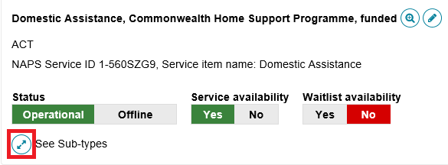
- Select ADD/REMOVE SUBTYPES.
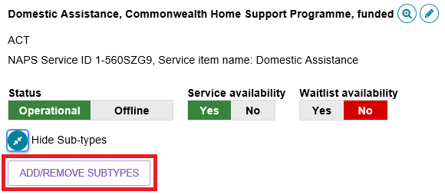
- The Add/Remove Subtypes screen will then be displayed where you can select or deselect the relevant sub types. Select SAVE.
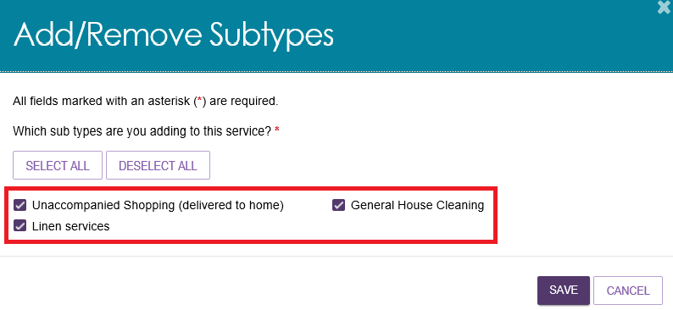

Activating or deactivating a service item
Navigate to the View Outlet details from the Outlet administration page for the outlet with the service item that you want to activate/deactivate and select VIEW SERVICE ITEMS.
For the services that have been added to the outlet, select Operational to activate the service item or Offline to deactivate the service item under the Status heading. For non-Home Support services the toggle is located at the right side of the screen next to the service name. For Home Support services, the toggle is located at the top of the service listing, and the toggle applies to all service types and services underneath the listing.
non-Home Support example
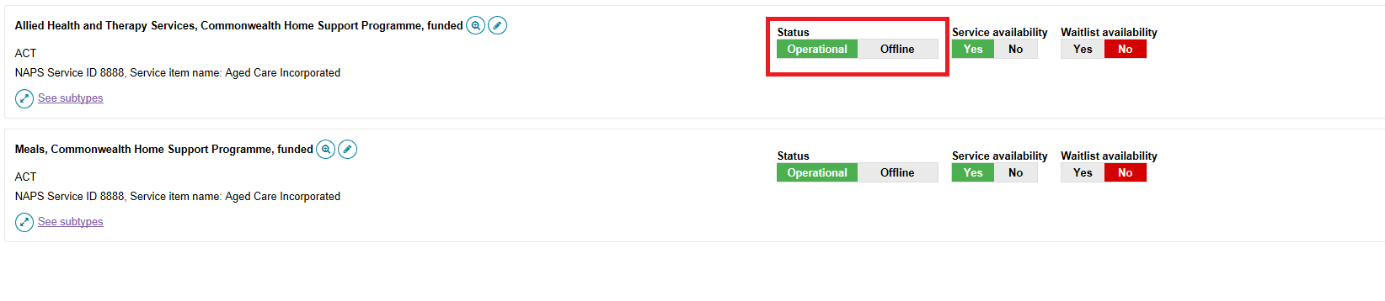

Home Support example
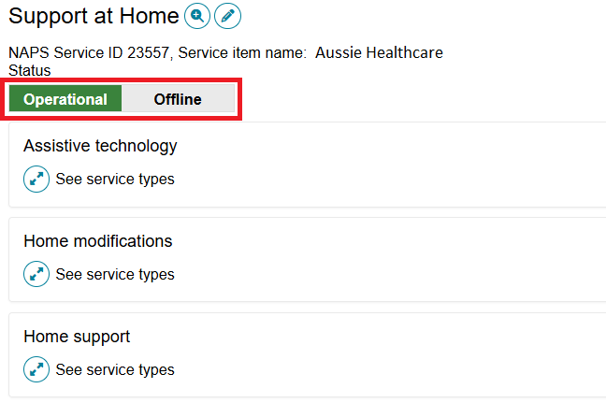
Only Operational services will display in the service finders.
The Offline status should be used to indicate where a funded service is not currently offered by the provider. For example, the service is at capacity.

Editing a service item
You are able to edit service details by selecting the Edit (Pencil) icon to the right of the service item and/or service group name you wish to amend.
Non Home Support Example
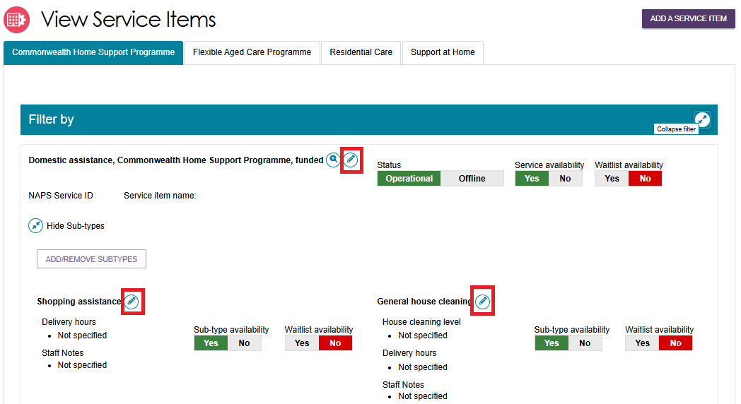

Home Support services example
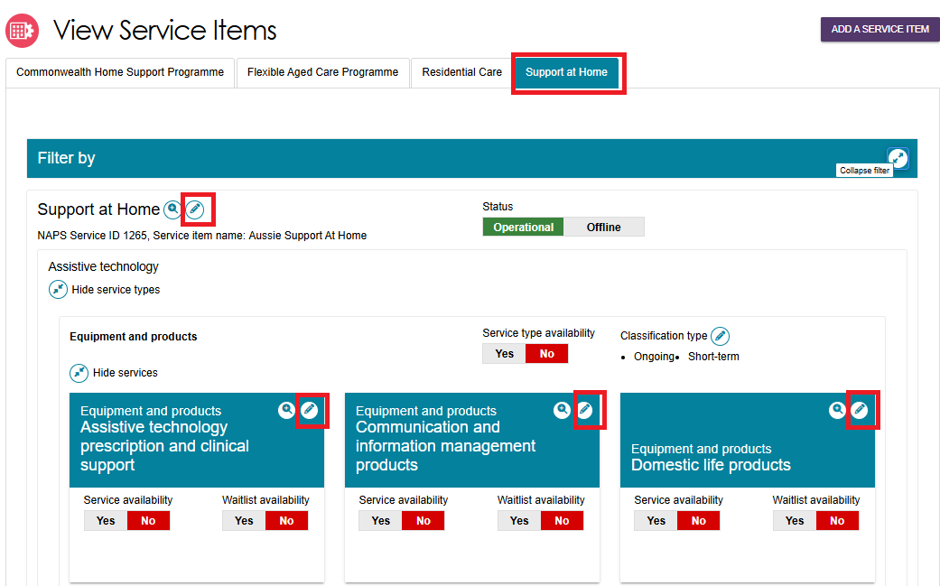
The details that can be edited include:
- Service item name
- Service delivery area
- If a service focuses on a specialised service area
- Upload promotional attachments (for residential facilities)
- Editing Home Support-specific attributes
- Entering a detailed description for the service item.
! For details about organisation philosophies and diverse needs specialisations, refer to Editing the Organisation Philosophy, Specialisations and Diverse Needs sections.

Adding and editing service attributes
Attributes for Support at Home, CHSP, and other programs are located in the Service Details section of the Outlet Administration tile. Some attributes are also displayed on the View Outlet page:
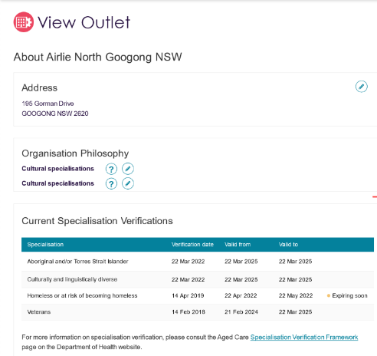
To access any of the service attributes, go to the service item’s Service Details page as follows:
- Select Outlet administration from the home page.

- From the Outlet Administration page, select the outlet.
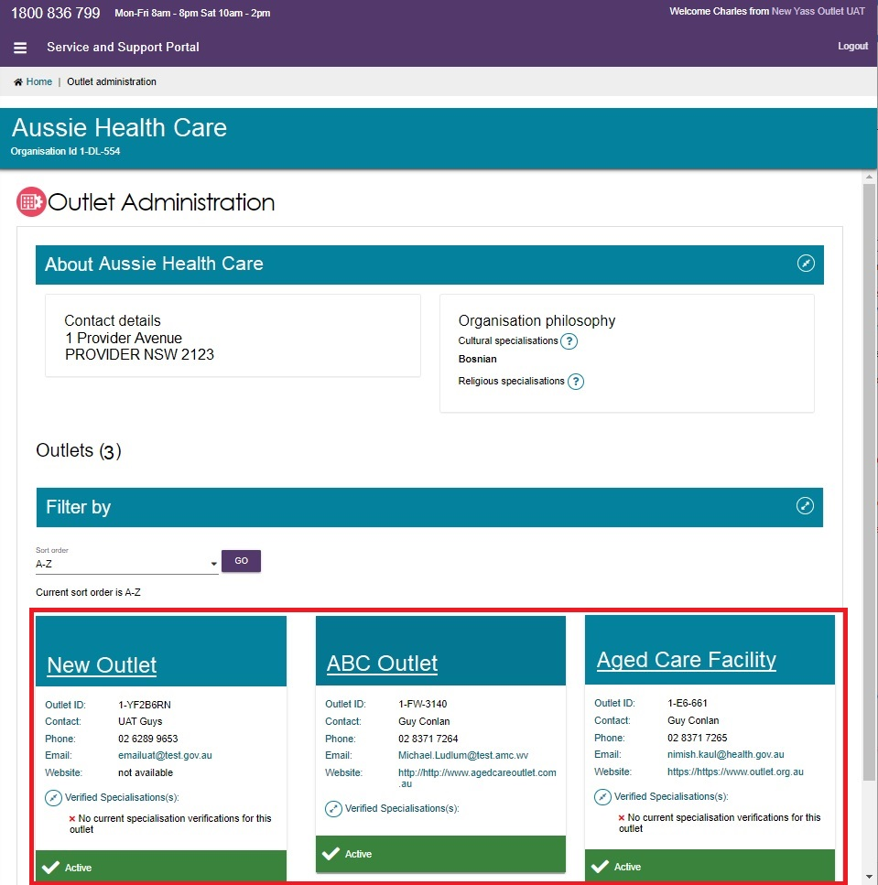
- Select VIEW SERVICE ITEMS.
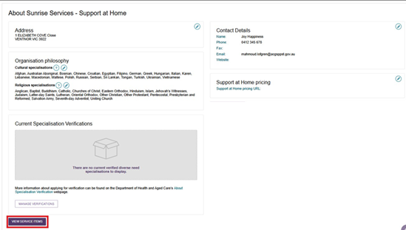
- Select the CHSP, Flexible Aged Care Program, Residential Care, or Home Support Service using their corresponding tabs.
The Service Details tab includes key attributes such as contact details, service delivery, service area, specialisations, hours of operation, pricing (if applicable), and service descriptions. The Specialisations section are further divided into Specialised Services and Languages. They are explained below.

Specialisations
Specialisations under the Organisation Philosophy heading are related to culture and language, and do not need to be verified. See Editing the Organisation Philosophy for more details.

Specialised Services
There are other specialised services that are not part of Diverse Needs, which you can indicate that a service or outlet offers. You should only select those with specific measures in place that demonstrate your specialised service offering, however they are not verified like the specialisations listed in Diverse Needs.
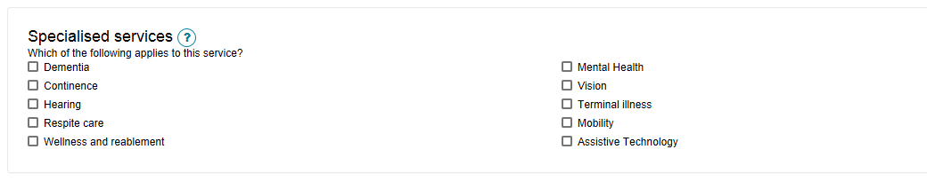

Languages
To indicate if this service caters for specific language requirements, select the languages in the Languages section. Select SELECT LANGUAGES AVAILABLE to bring up the selection and select SAVE to save the configuration.
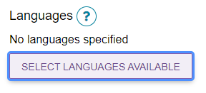
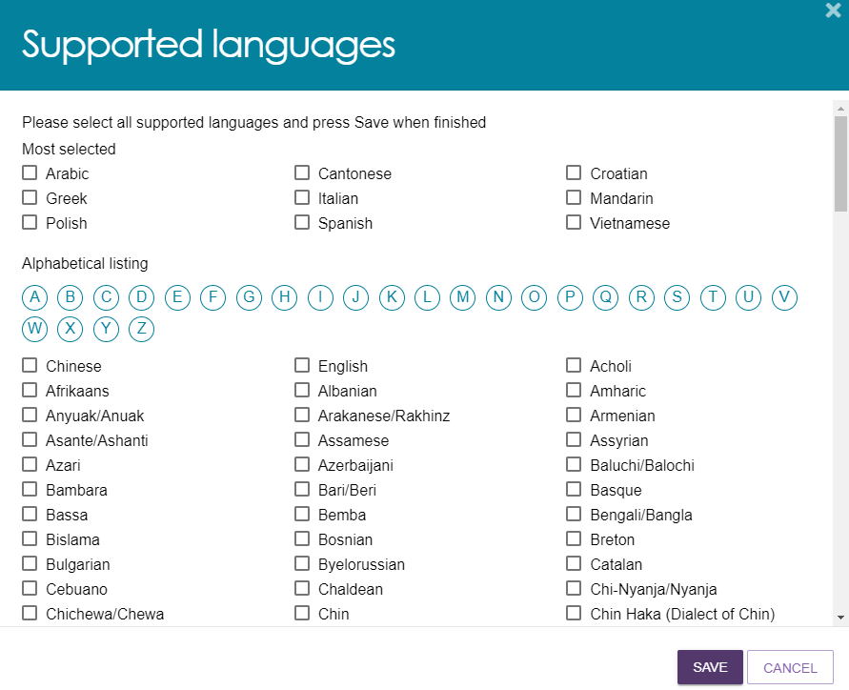
Once the language/s are selected and saved, they are shown under the List of languages.
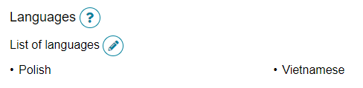

Hours of operation, staffing notes, transport notes
You can specify hours of operation, staffing notes and transport notes for your service when it is accessible by the client. By default, you can enter standard Monday to Friday, Saturday and Sunday hours. You can also specify individual working days by using the Customise option.
- Follow the instructions to navigate to the service listing.
- Select the service you want to edit by selecting the corresponding edit (pencil) icon.
For non-Home Support services, expand See Sub-types then select the Edit icon to the right of the service name.
For Home Support services, expand the service group, expand the service type, then expand the service listing. Select the edit icon to the right of the desired service’s card.
non-Home Support example
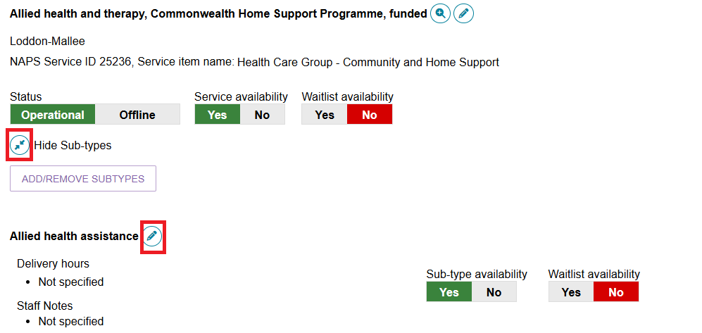
Home Support example
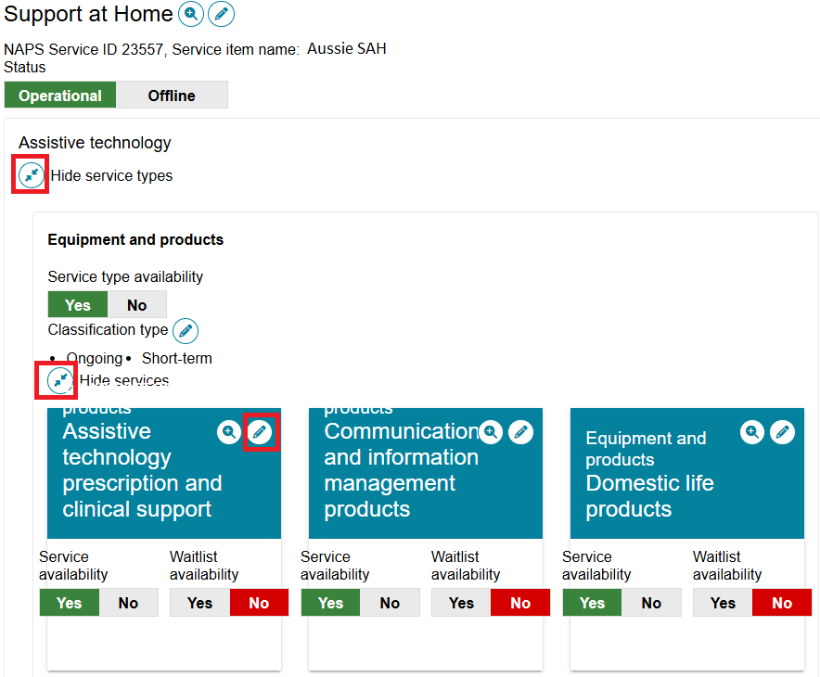
- Input the hours and save.
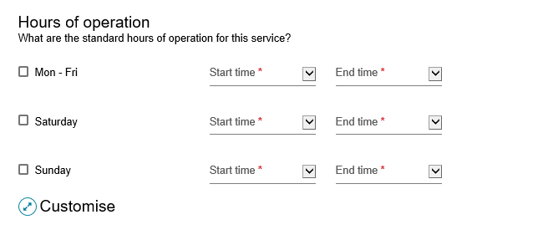
For Home Support services, you can also indicate additional hours of operation, staffing notes and the pricing for each service.
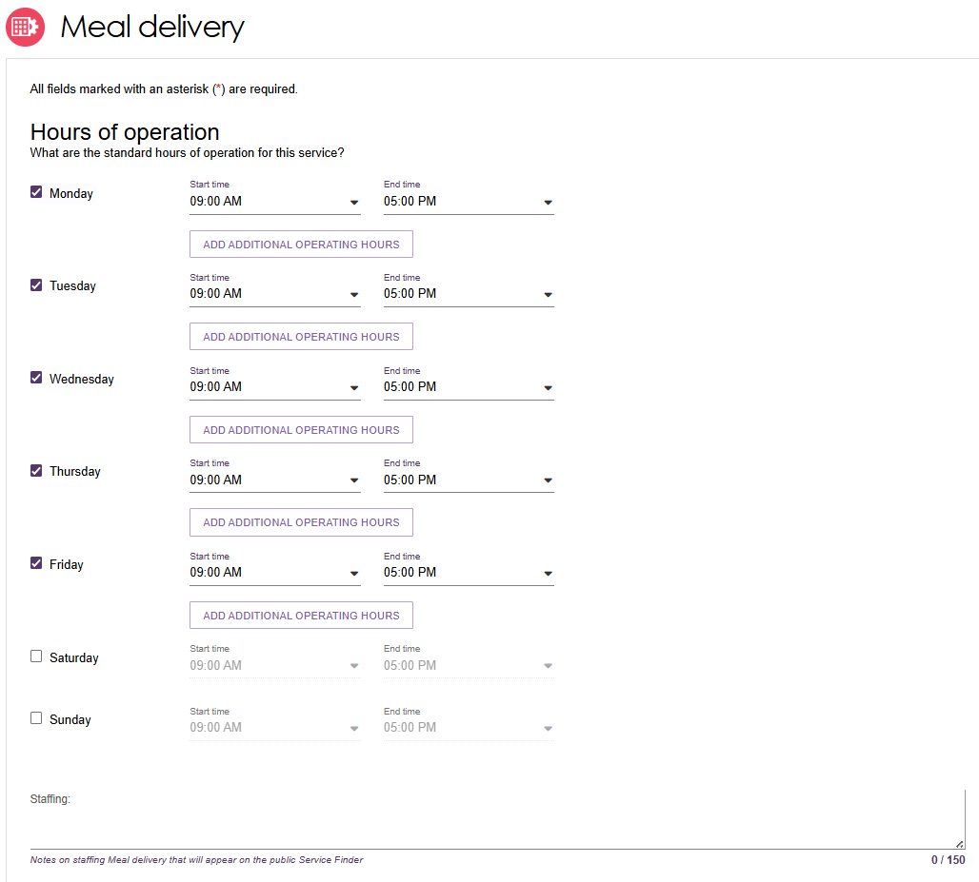
Some services also ask for information such as service delivery, transport notes and others.
Then, select Save Changes.
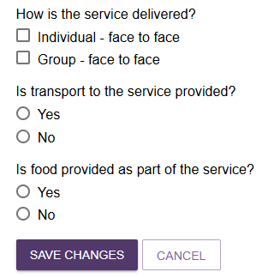
- Once the details are saved, it will display at the service level in the Portal.
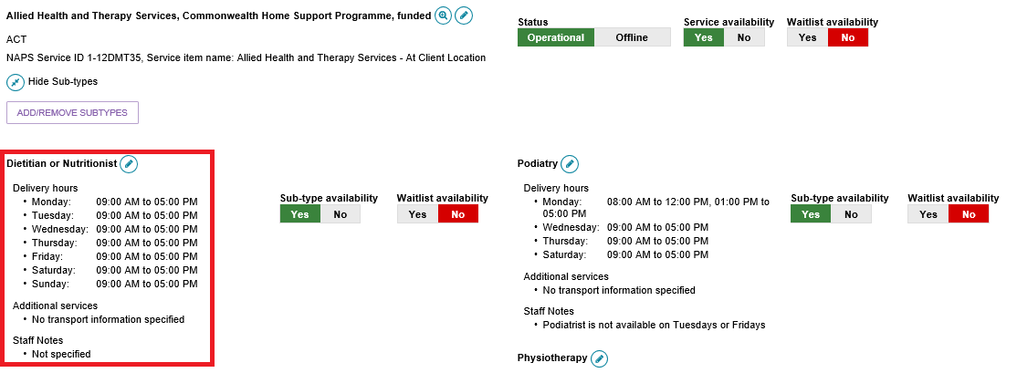

Service Description
You can input a description of your service and add any additional service information up to 1000 characters.
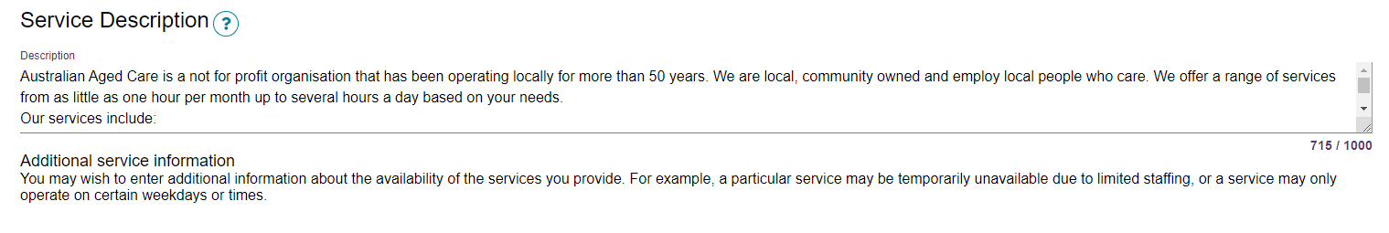

Adding pricing information to a Support at Home outlet or Home Support service
! Publishing pricing information is mandatory for all Support at Home outlets and Home Support services. If the service does not have the mandatory pricing information, you will not be able to:
a) Save a new service and make it Operational,
b) Save changes to partially complete existing pricing information,
c) Edit waitlist information
d) Confirm if you have reviewed pricing information.
All pricing information saved, including pricing schedule attachments, will appear by the next day on the My Aged Care service finder on the My Aged Care website, and do not require approval from the Department.
The help text against each pricing attribute provides further guidance on what specific information that providers should be entering.

Outlet Level
- For outlet level pricing changes, from the Support at Home tab in the View Service Items page, select the Edit icon next to the Support at Home heading.
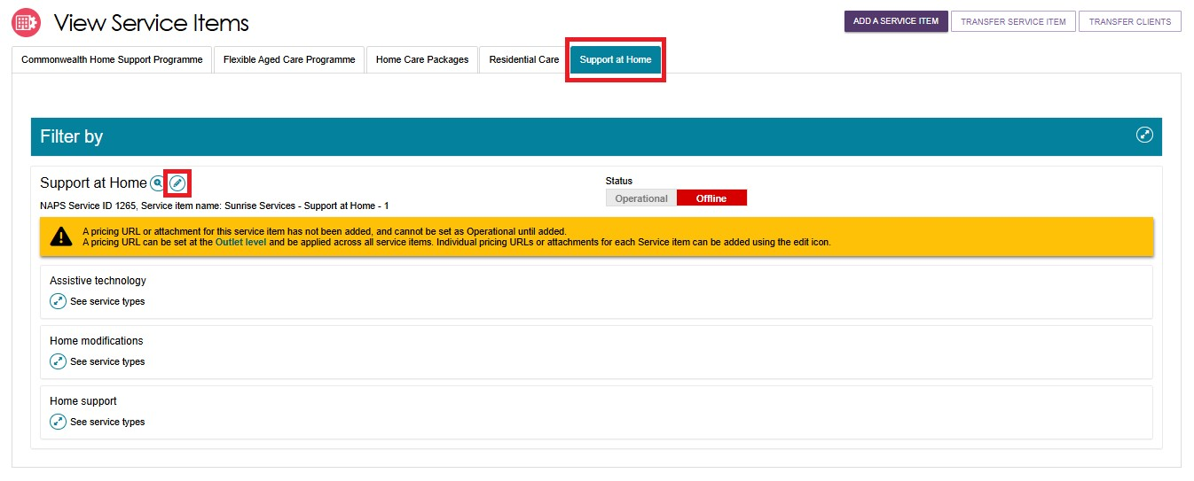
Alternatively, from the View Outlet page, select the Edit icon next to Support at Home pricing to edit the pricing information at the outlet level.
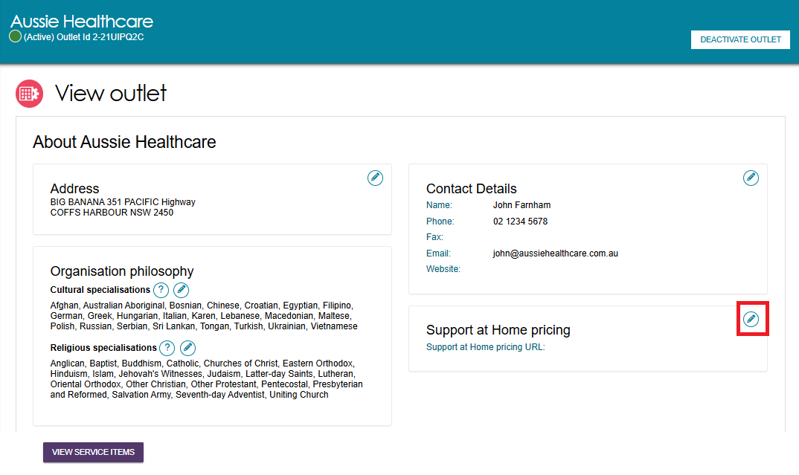
- The Support at Home Details page appears. Under the Full Price List section, a pricing schedule website link (URL) and/or a pricing schedule attachment can be added.
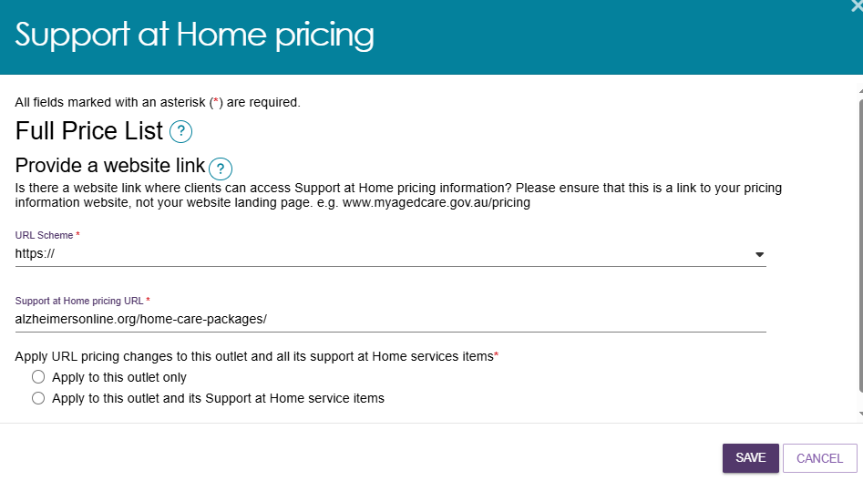
To add a pricing schedule website link type the URL in the Provide a website link section. Ensure that the website URL you enter is a valid, select either HTTP:// or HTTPS:// then the website address and including www. at the beginning of the URL.
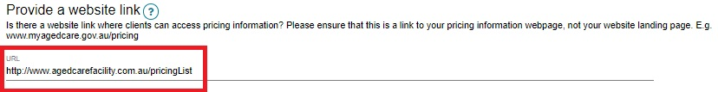
- To upload the pricing schedule attachment you must select Choose File and choose the document (such as a PDF file) you wish to upload, then select Open. The attachment’s name will then be displayed. Name the attachment and provide a caption. You can optionally add a short description of the attachment.
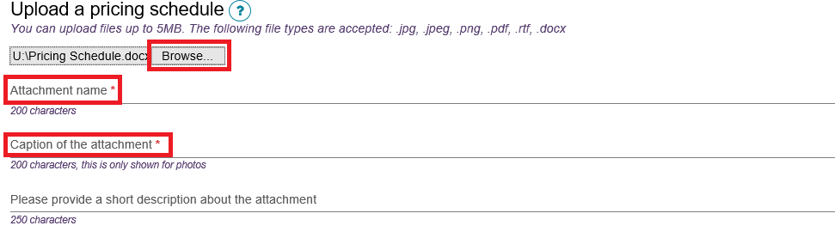
! When you edit pricing information at the outlet level, this is a pricing URL that you can save and apply to the services within a single outlet or all outlets in your organisation. This is best used when the pricing information for a number of your service items are the same. For service items that may need regional pricing you can overwrite the URL or supply different pricing that may be region based.
Only information saved at the service item level will display on the My Aged Care service finder. If you select SAVE at the outlet level this will save the information locally and will not display in the My Aged Care service finder. Select SAVE AND APPLY TO ALL SERVICE ITEMS OF THIS OUTLET to display your changes in the My Aged Care service finder.

Service level
- To view the Support at Home pricing service details you will need to expand the Service group and the service type. Select the edit button for the desired service card to set or edit pricing information for that service.
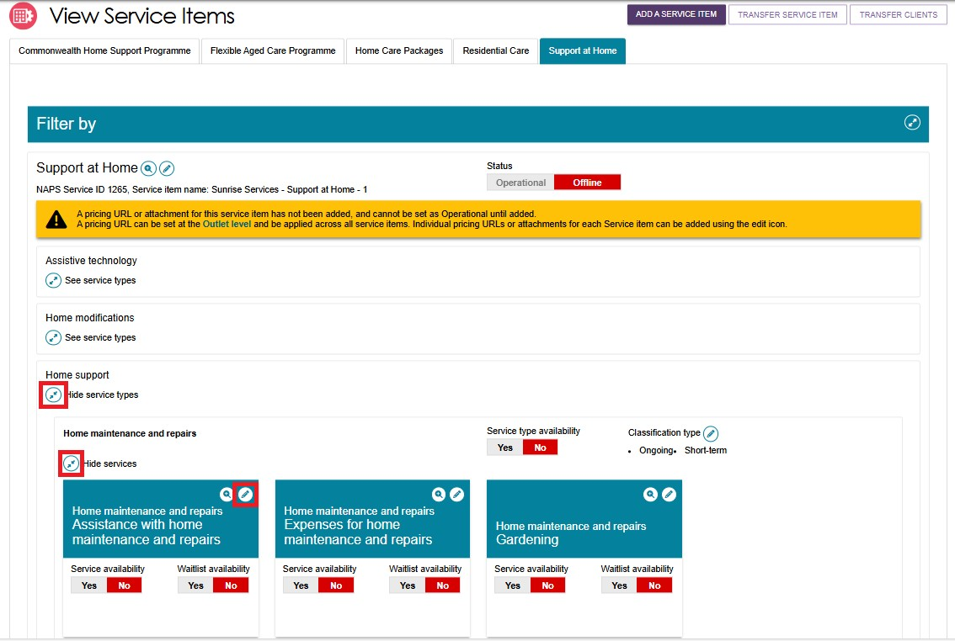
- From the service details page, fill out the mandatory price if applicable, known as the Standard maximum price, or the Common Price – standard.
Optionally you can enter pricing for non-standard hours, Saturday, Sunday, and Public Holiday.
Then, select Save Changes.
Standard Maximum Price example
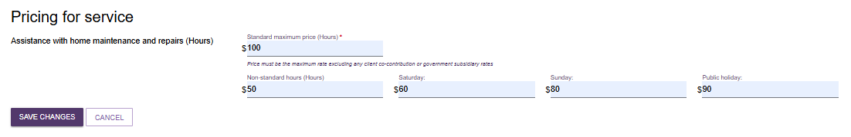
Common Price - Standard example
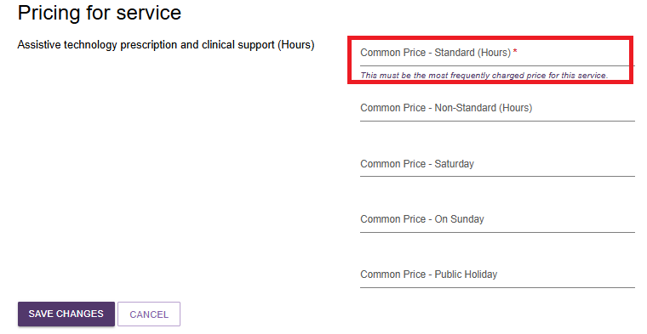
! Some services do not have prices that are editable. The price section will be greyed out.
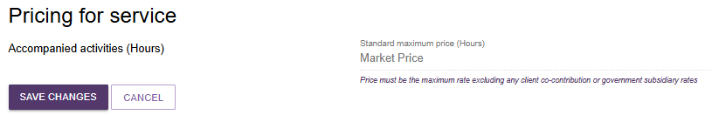
To view the pricing information entered, navigate back to the service where the pricing was updated, expand the service, and select the magnifier icon .
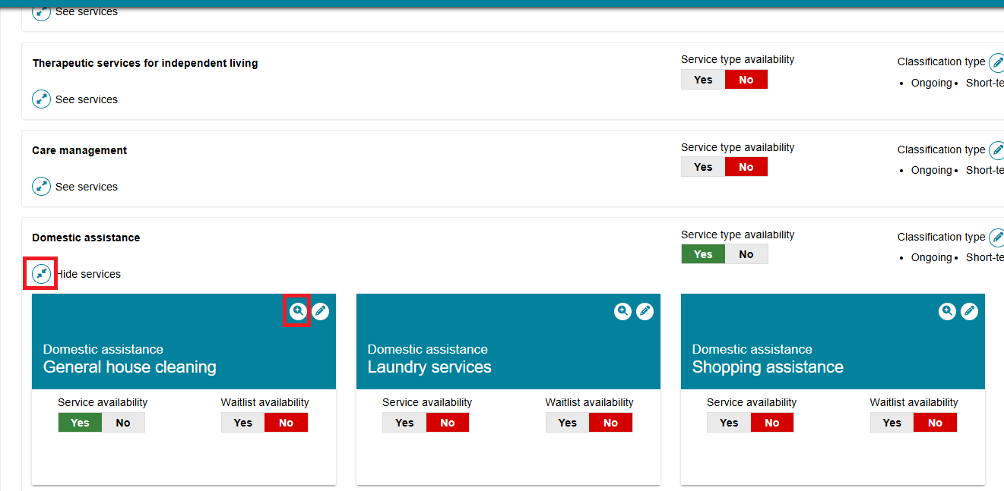
A pop-up window will appear with the pricing information for that service.
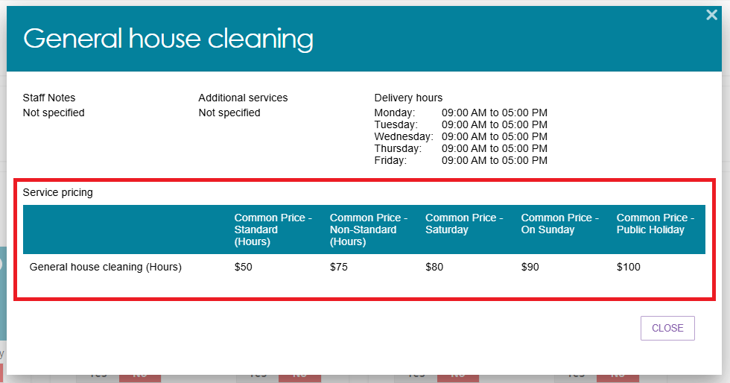

Maintaining service and waitlist availability
You can maintain information about the availability of service items via the Service and Support Portal.
To maintain a waitlist, you must ensure that the waitlist availability status on the service item is set to Yes to turn on the waitlist, or No to turn off the waitlist. Service and waitlist availability information will be displayed on the service finder via the My Aged Care website. When you change availability information it will appear by the next day on the My Aged Care service finder on the My Aged Care website.
- Navigate to the View Outlet details from the Outlet administration page for the outlet that you want to edit service and waitlist information and select VIEW SERVICE ITEMS.
- Select the relevant service/waitlist availability status (Yes / No).by toggling the Yes | No switch. The location of the Yes | No switches will depend on the type of outlet and service chosen.
For non-Home Support services such as CHSP or Residential Care: the toggles are to the right of each service heading, and at the sub-type level by expanding See sub-types.
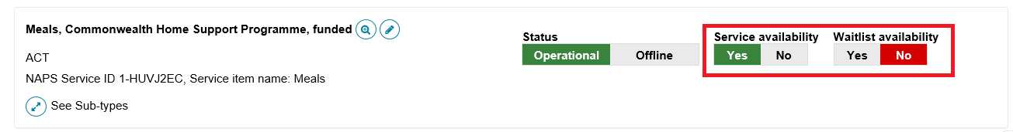
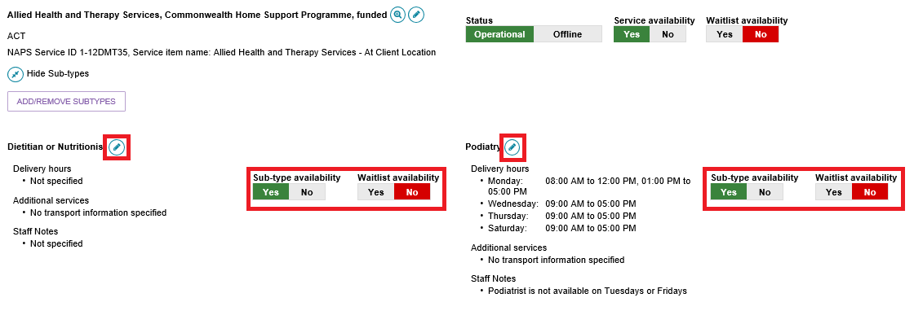
For Home Support services, expand the service group, then expand the service type, and finally expand the service. There is a service availability toggle and a waitlist availability toggle in each service’s card.
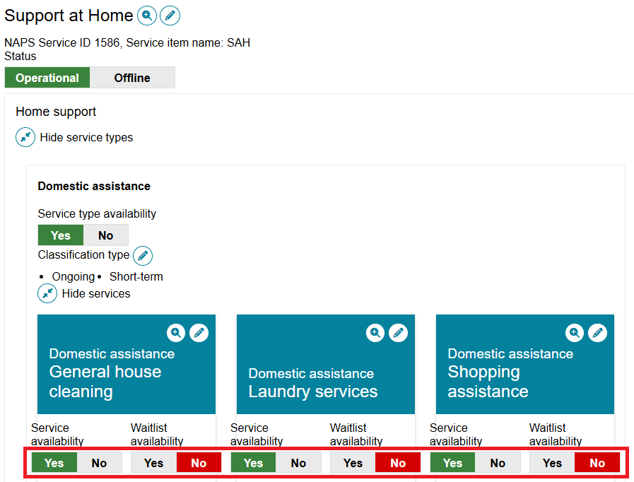

Editing a service delivery area
Information about the areas you deliver Commonwealth-funded services in (referred to as service delivery areas in the portal) are pre-filled, based on your contractual information. All providers (except Residential care) must review their service delivery area information and edit if required. It is important that you ensure the service delivery area(s) is accurate. This information is publicly displayed in the service finders and forms the basis of the referrals sent by contact centre staff and assessors.
For Home Support based services, select the at client location option. For Residential based services, select the at provider location option.
! For Home Support services, service delivery area details are defaulted to at client location. Any edits will apply for all service types and services underneath the Support at Home provider’s listing.
The steps to edit the service delivery area are outlined below.
- Navigate to the service item page from the Outlet Administration tile.
- On the View Service Items page, select Edit next to the relevant service item, or for the Support at Home program, the Edit icon next to the Support at Home heading.
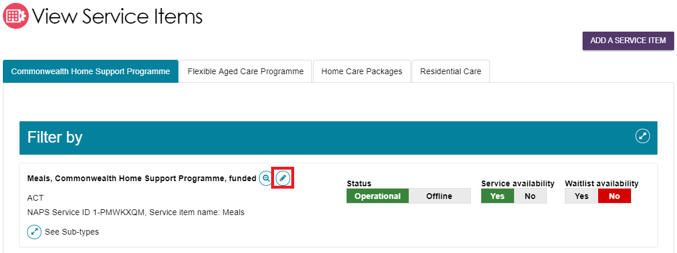
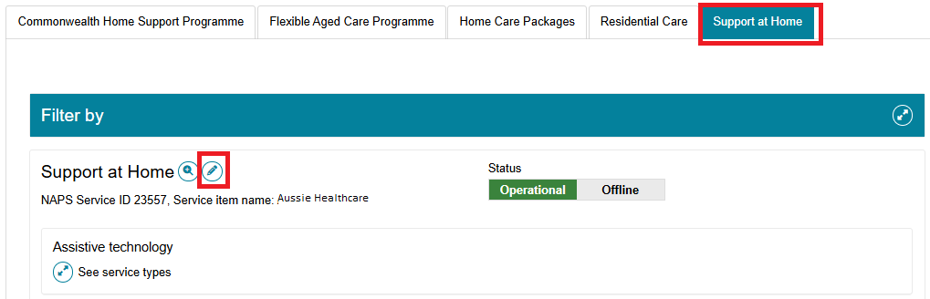
The Service details page will display.
- Select Edit next to Service delivery area.
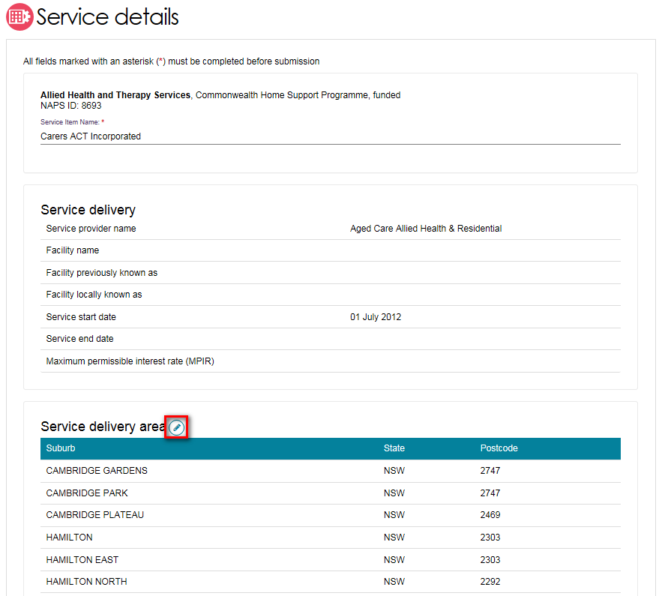
- The Edit Service Delivery Details page appears.
The Delivery type is defaulted to at client location, or at provider location, depending on the Program or service chosen.
For the Support At Home program, All the suburbs that the provider is approved for is pre-loaded. For national services, all areas of Australia are pre-loaded.
For At client location, by default, the entire region in which you are funded to provide service for is pre-loaded. You can choose to remove the suburb(s) the service is delivered in. You can choose to search for a specific suburb to add, add all the suburbs in the selected state, or add all the suburbs in the selected region.
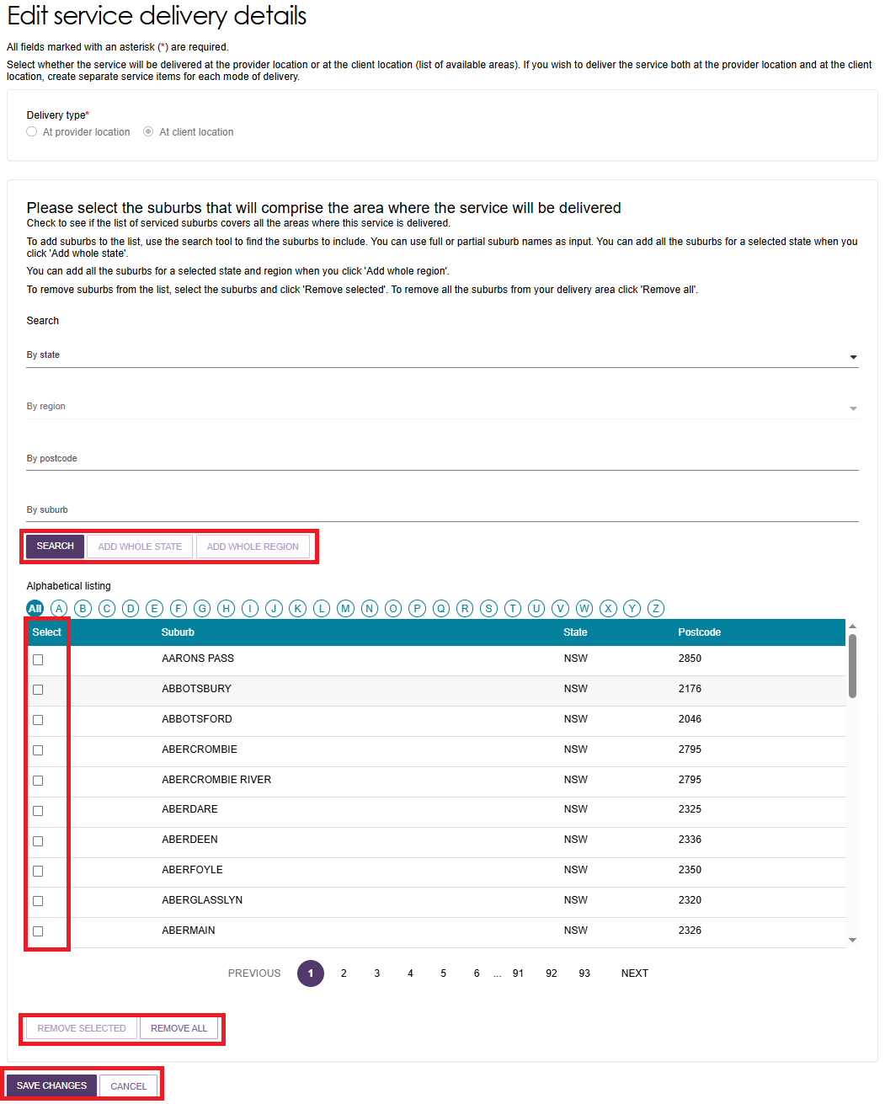
! The department recommends that service item delivery areas should not overlap. This means that the same suburb/s should be maintained across multiple service items.
- To remove suburbs from the list, select the suburbs you wish to remove using the checkbox and select REMOVE SELECTED, or use REMOVE ALL to start configuring your list of suburbs from the beginning. These changes are automatically saved. The list of serviced suburbs is automatically saved upon editing suburbs.
- Select Save Changes or Cancel to go back to editing the service.

Adding a room type to a residential facility
- Navigate to the service item page from the Outlet Administration tile.
- At the View Service Items page, navigate to a Residential Care service then select See room types.
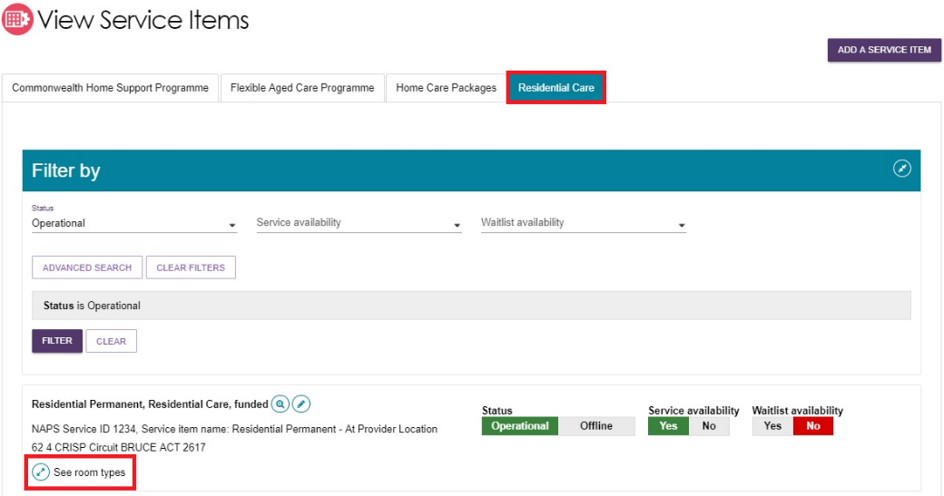
- Then select ADD ROOM TYPE.
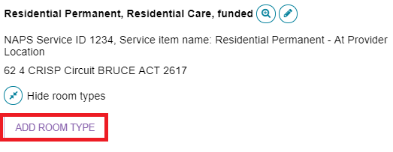
- The Room type page will be displayed. Enter the required information in the General room information and Pricing information sections. Fields marked with a red asterisk (*) are mandatory.
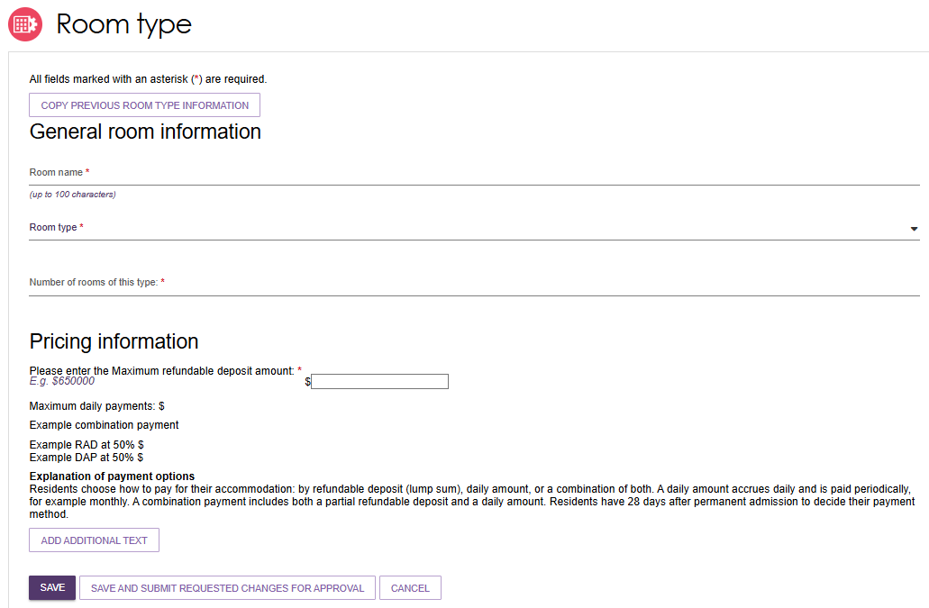
! Accommodation prices above a refundable deposit amount of $750,000 (or equivalent daily payment) must be approved by the Independent Health and Aged Care Pricing Authority (IHACPA).
If IHACPA have not approved this price, or you have not submitted an application for approval of this price, you cannot publish this price. You cannot charge this price until it is approved by IHACPA.
Please note that when an approval is granted IHACPA, the approved amount is not automatically updated on the My Aged Care website. Providers must update their own pricing information using the Aged Care Service and Support Portal.
- Enter the required information under Key feature statement. Select SAVE AND SUBMIT REQUESTED CHANGES FOR APPROVAL after all required information has been entered. This room information will display on the service finder once approved by the department (allow 3 business days).
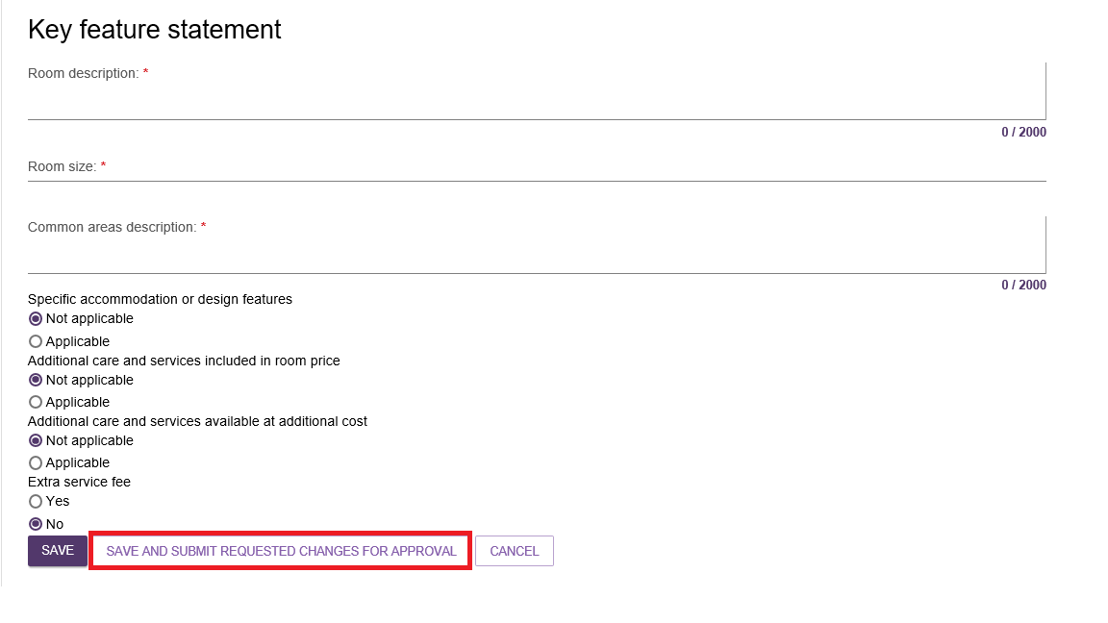
! If you save the room type but do not select Submit, you will be notified that there are room types requiring approval by the department and be prompted to submit the room type to the department prior to displaying on the public service finder.

Activating an outlet
After service items are added, outlet(s) need to be made active so that the following occurs:
- The service items display in the service finder.
- Contact centre staff and assessors can send electronic referrals to the appropriate outlet.
- Assessors can match and refer to active services.
- Navigate to the View Outlet details from the Outlet administration page for the outlet that you want to activate and select ACTIVATE OUTLET.
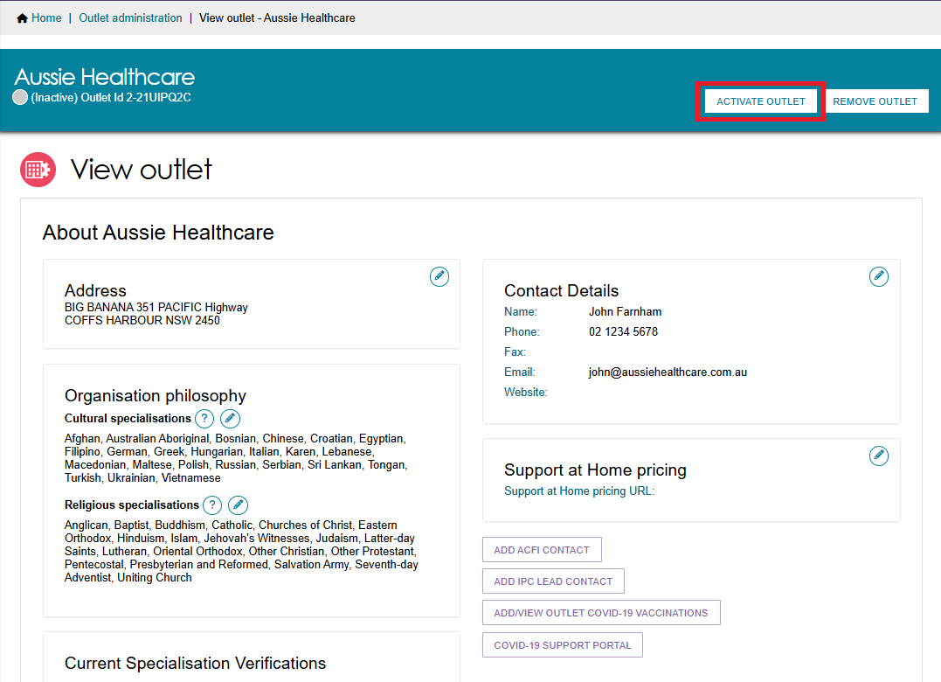
- Select ACTIVATE OUTLET at the bottom of the pop up, to confirm that you wish for this information to be displayed in the service finder. A warning message will display.
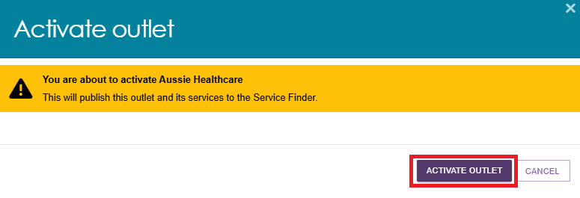
Your outlet is now active and operational service item information will display in the service finder, and will display as Active in the Service and Support Portal.
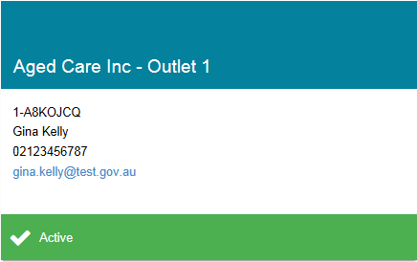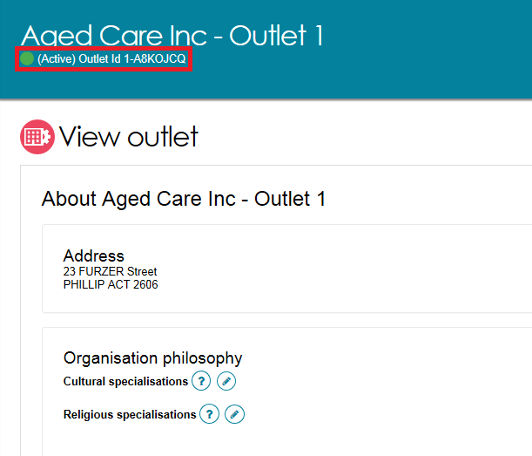

Deactivating an outlet
To remove an outlet from the service finders and stop referrals being sent to the outlet, it must be deactivated. An outlet cannot be made inactive if there are accepted and commenced services.
Navigate to the View Outlet details from the Outlet administration page for the outlet that you want to deactivate and select DEACTIVATE OUTLET.
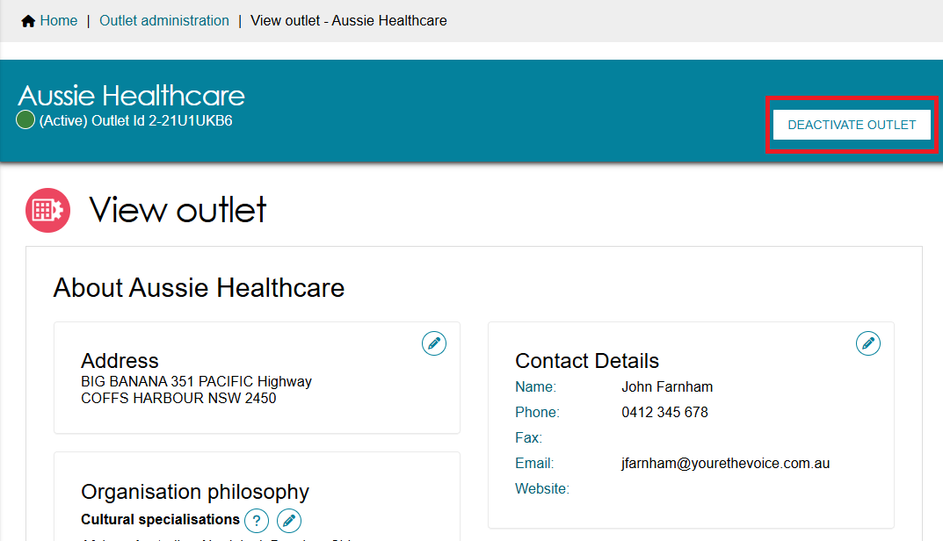
Select DEACTIVATE OUTLET again at the bottom of the pop up, to confirm that you wish to deactivate the outlet.
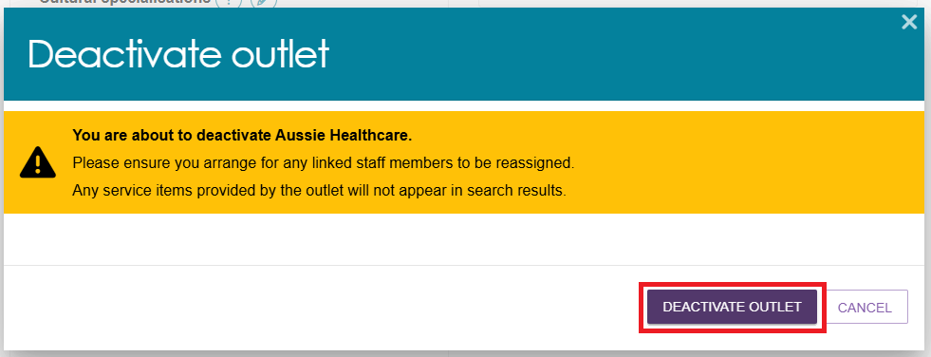
The outlet is now inactive, does not display on the relevant service finder or receive referrals, and displays as ‘Inactive’ in the Service and Support portal.

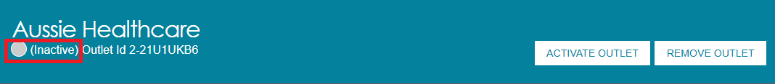

Removing an outlet from the Service and Support Portal
To remove an outlet from the Service and Support Portal, it must be in the status of ‘Inactive’.
- Navigate to the View Outlet details from the Outlet administration page for the inactive outlet you wish to remove and select REMOVE OUTLET.
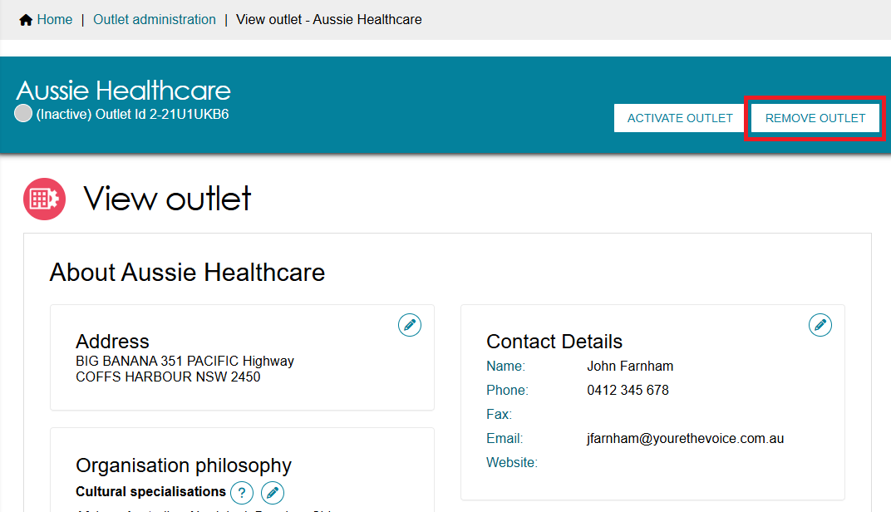
- Select REMOVE OUTLET at the bottom of the pop up, to confirm you wish to remove the outlet.
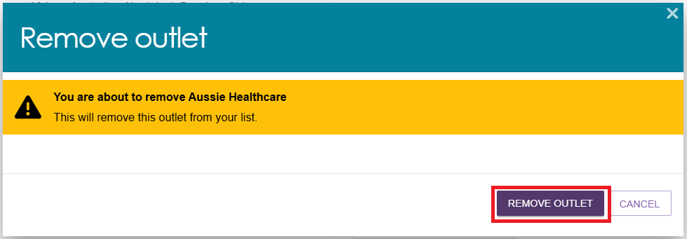
The outlet will no longer display in the Service and Support Portal.

! If you want to create an outlet with the same name as the one you removed earlier, you will need to call the My Aged Care service provider and assessor helpline on 1800 836 799.

For more information or support
Further information is available from the Service and Support Portal Resources page.
The My Aged Care service provider and assessor helpline is available on 1800 836 799.

