Service and Support Portal User Guide – Advanced outlet and service management: transferring clients and services
This guide is designed for:
- Administrators within the My Aged Care service and support portal
- Outlet Administrators who have access to more than one outlet.
This guide explains the procedures for transferring clients and services within and between outlets in an organisation.
This process will assist organisation administrators to restructure outlets set up for their organisation to meet their business needs.
This guide is divided into the following topics:

Notes 2
Transferring between outlets 3
Viewing the service transfer log 7
Transferring a client between services 9
Viewing the client transfer log 11
For more information or support 13

! Applicability (1st November 2025)
- Access to the functionality described in this guide has been disabled in the Service and Support Portal for ALL programs from 1st November 2025 until further notice.
- To request a transfer of services or clients, Organisation Administrators must email agedcaretransfers@health.gov.au using the email address linked to their organisation in the Service and Support Portal by including only the organisation name (no client information). The department will follow up to collect details of the transferring and receiving outlets, relevant services, clients or referrals, and their location.
The process described in the remainder of this guide is provided for reference purposes only and may be updated when the functionality is re-enabled.

Notes
- This document relates only to the functions able to be performed by an administrator at the organisation or outlet level.
- This functionality does not apply to residential care services, and providers should use the existing process using the Application to Vary Conditions of Allocation form.
- This functionality does not apply to Home Support services in the Support At Home program.
- If you are required to transfer clients between organisations, for example, as part of a merger or acquisition, contact the My Aged Care Service Provider and Assessor Helpline on 1800 836 799, who will be able to initiate the transfer of clients for you.

Transferring between outlets
Organisation administrators may choose one or multiple service items to transfer between outlets of an organisation in the service and support portal. Using this function, administrators can:
- select and list the service item(s) you wish to transfer
- select an outlet to which you may transfer service item(s)
- generate and export a report listing service referrals linked to the service item(s).
! Only departmental staff can transfer client records linked to an inactive outlet to an active outlet in the same assessment organisation, or to another assessment organisation.
- Select Outlet administration from the homepage.
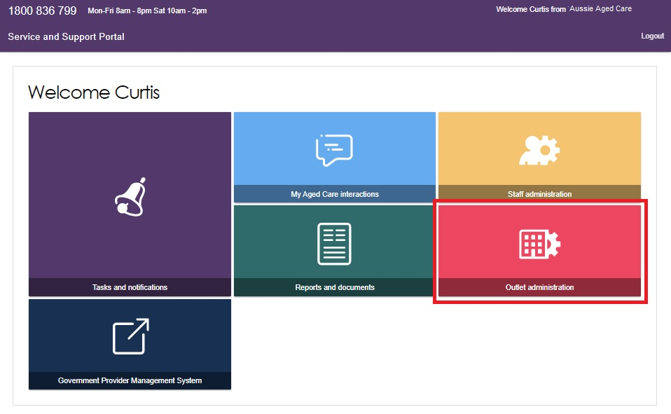
- Select the outlet that contains the service items you wish to transfer to a different outlet.
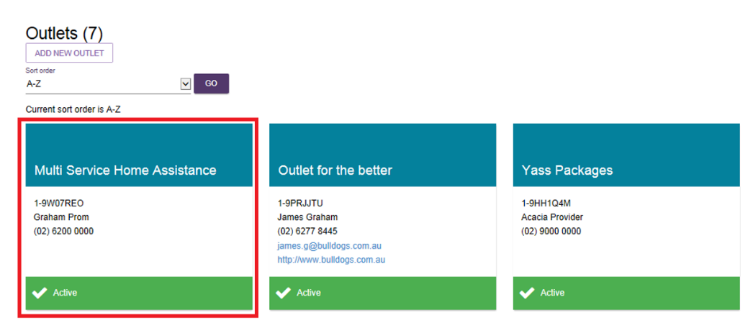
- Select the View service items button from the View outlet page.
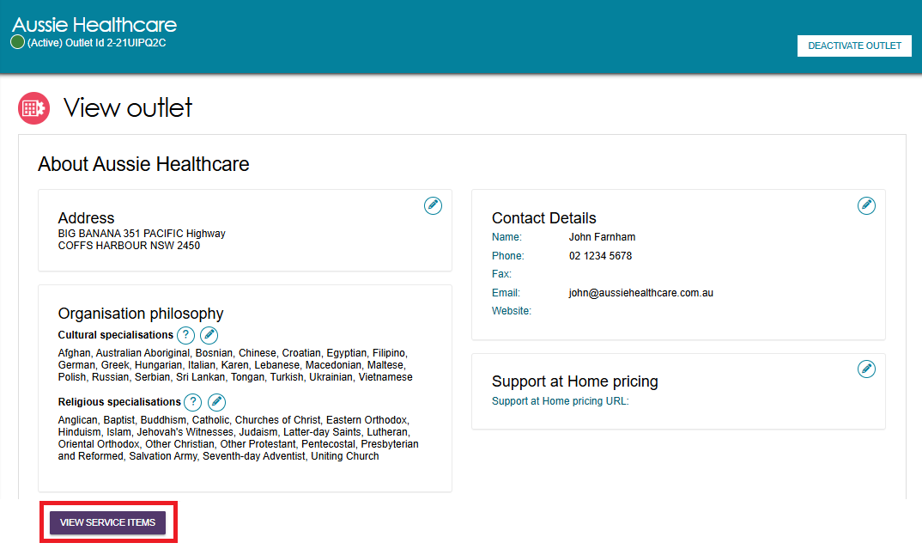
In the View service items page select the Transfer Service Item button.
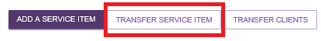
- Select the outlet you wish to transfer the service items to, using the list displayed. You can search for a specific outlet using the search function. Select ‘Next’ to continue.
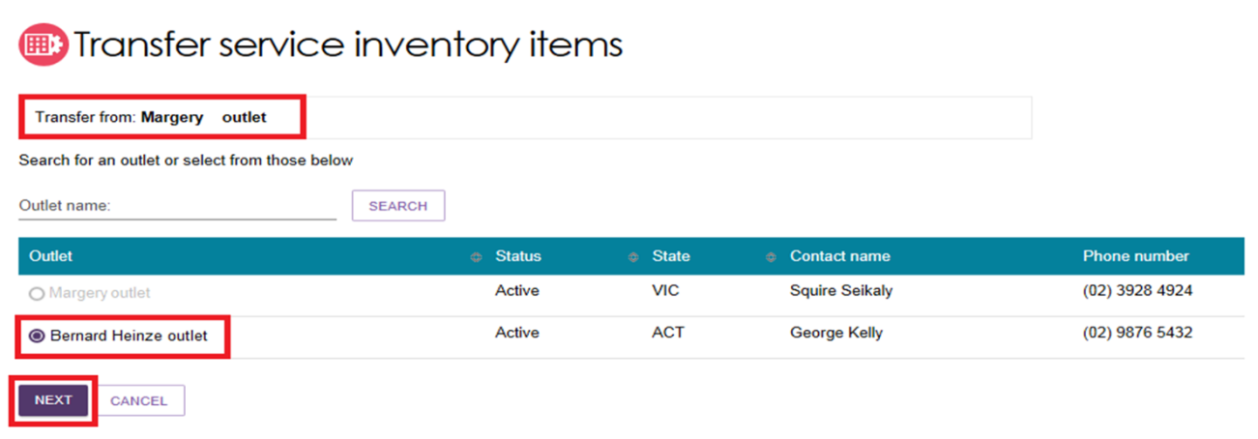
- Select the service item(s) that you want to transfer to another outlet. You can search for specific service items using the search functionality (by Program or Service type).
Each service item contains the service type, NAPS service ID, service item name, funding state and funding region. You can transfer up to a maximum of 25 service items.
Select Next to proceed to the next screen. If you select Cancel, you will exit the Transfer process and be re-directed to the View Outlet screen.
- Review the information to ensure that it is correct. You may wish to change the Service Item name.
- To remove a service item, select the red bin icon. To cancel the transfer, select Cancel.
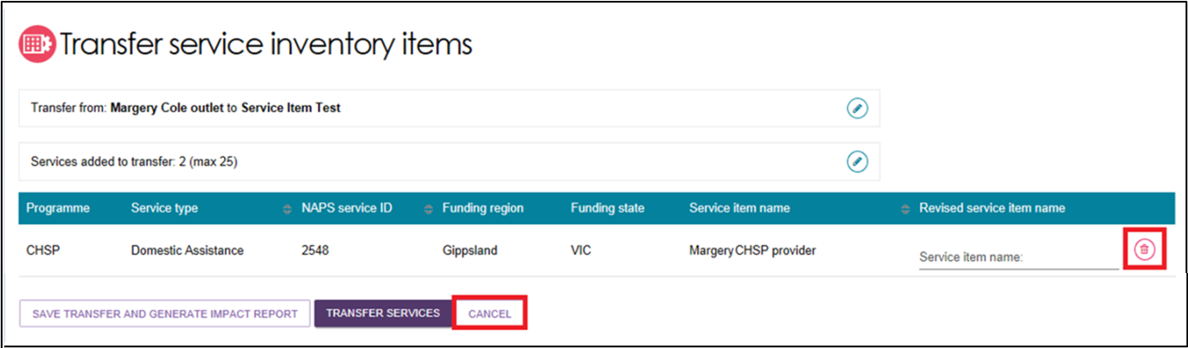
- To review any clients that may be impacted by the transfer, you can generate an ‘Impact report’ before proceeding with the transfer.
To generate the impact report, select the Save Transfer and Generate Impact Report button.
Once the report has generated, it will appear in the Reports and documents tab for five days. You can review the report and resume the transfer at a later stage.
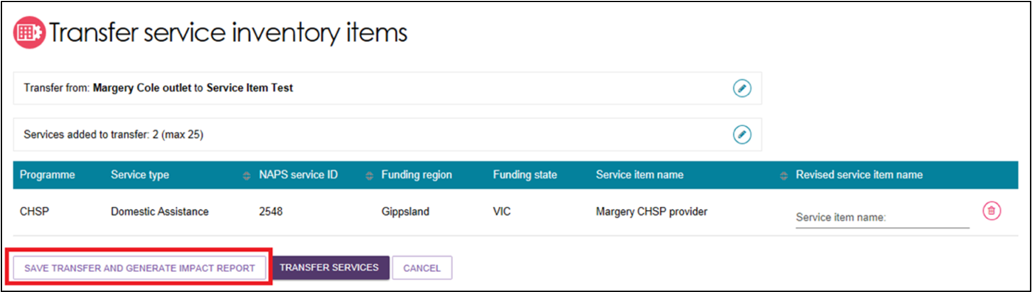
The following banner will display:
The ‘Transfer Impact Report’ may, on occasion, take some time to generate. If this happens, an alert message will prompt on screen.
You can navigate away from the Transfer Service Inventory Items screen and be notified when the ‘Transfer Impact Report’ completes.
Alternatively, you may choose to transfer service inventory items without reviewing the report at any time.
- If you have reviewed the impact of the transfer and want to proceed, select Transfer Services.
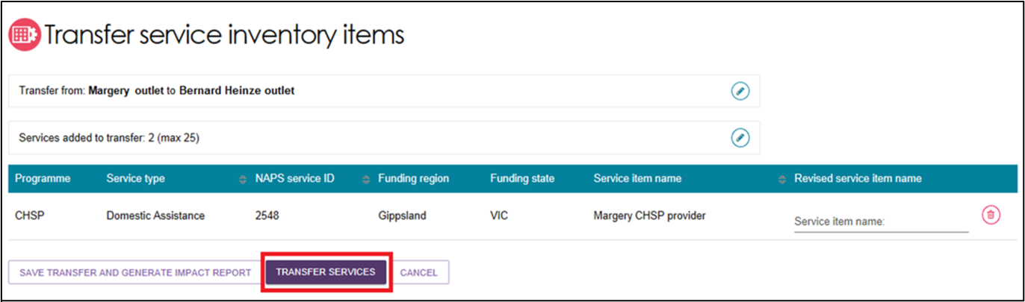
- To make any changes, select Cancel. To finalise the transfer, select Confirm Transfer.
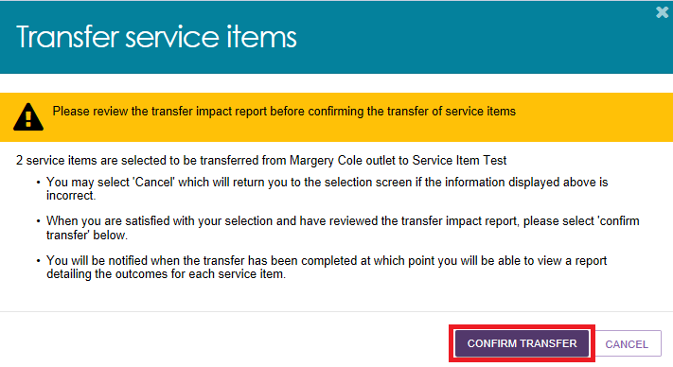
The transfer may take some time to complete. Review the status of the transfer by reviewing the service transfer log.

When the transfer action has started, the impacted records in the transfer process will be locked – the transfer process will run in the background.
Users will be able to view the records but cannot change the details until the transfer process has successfully completed.

Viewing the service transfer log
To review the status or details of previous and current service transfers, review the Transfer Log.
- Select Outlet administration from the homepage.
- Select an outlet to access the transfer log.
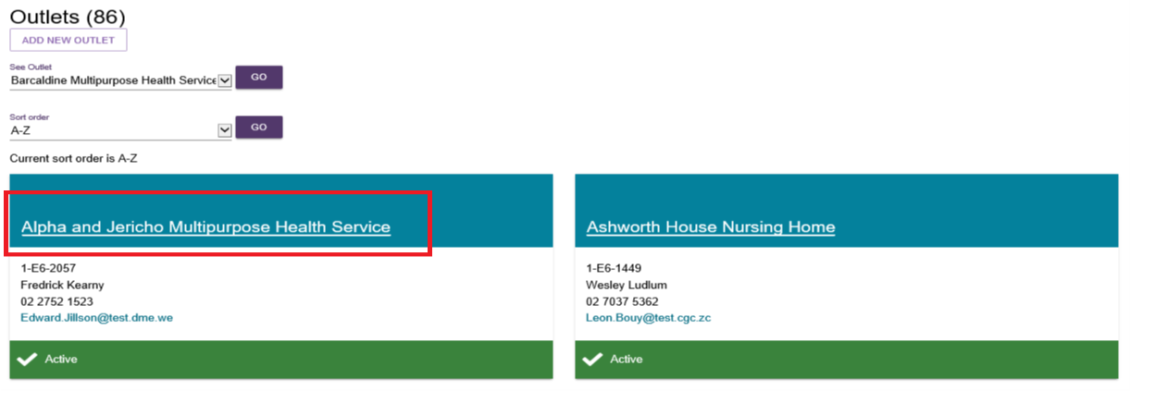
- Select the View service items button from the View outlet page.
- Select the View Transfer Logs button.
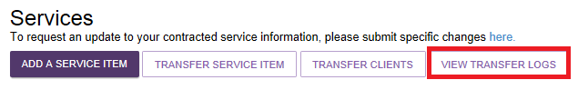
The Transfer Logs page appears. For each instance of log transfer, the following details are displayed:
- Transfer type (service or person)
- Transfer date
- Status (In progress, completed, completed with errors)
For more detailed information about the transfer, select the magnifying glass icon.
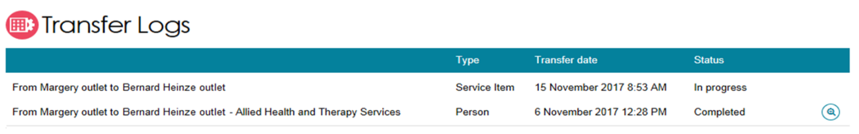
If a transfer has not been completed successfully, you can retry by selecting the magnifying glass icon, selecting the items you want to retry and then selecting the Retry Selected button.
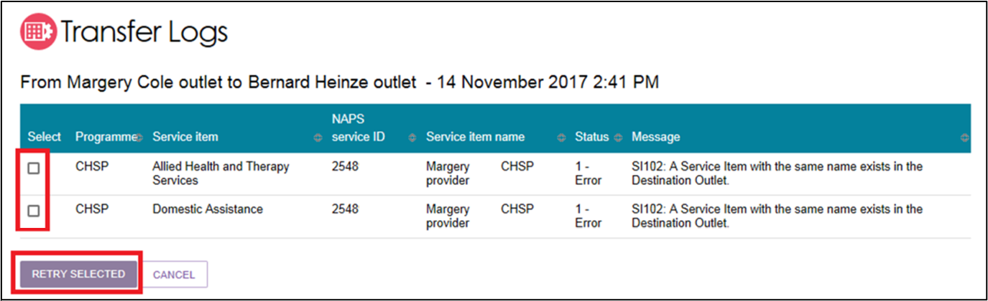
! If you continue to experience issues with transferring services, please call My Aged Care on 1800 836 799 for assistance.

Transferring a client between services
Organisation administrators may choose one or multiple clients to transfer between services (of the same service type) within an outlet or to another outlet within their organisation.
This functionality is not available for residential care (permanent and respite). Please follow the existing process using the Application to Vary Conditions of Allocation form.
Follow these steps to transfer a client(s) to another service:
- From Outlet administration select the outlet that contains the clients you wish to transfer to another service (the outlet you want to transfer clients ‘from’).
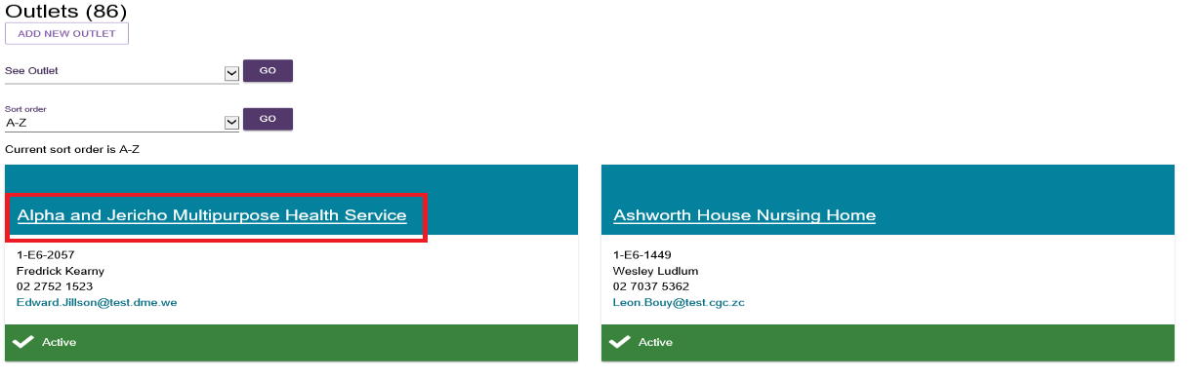
- Select the View service items button from the View outlet page.
- Select the Transfer Clients button to start the process of transferring client(s) to another service.

- Select the service that the client(s) is currently linked to. You can use the search functionality to find specific service types. Select Next to continue.
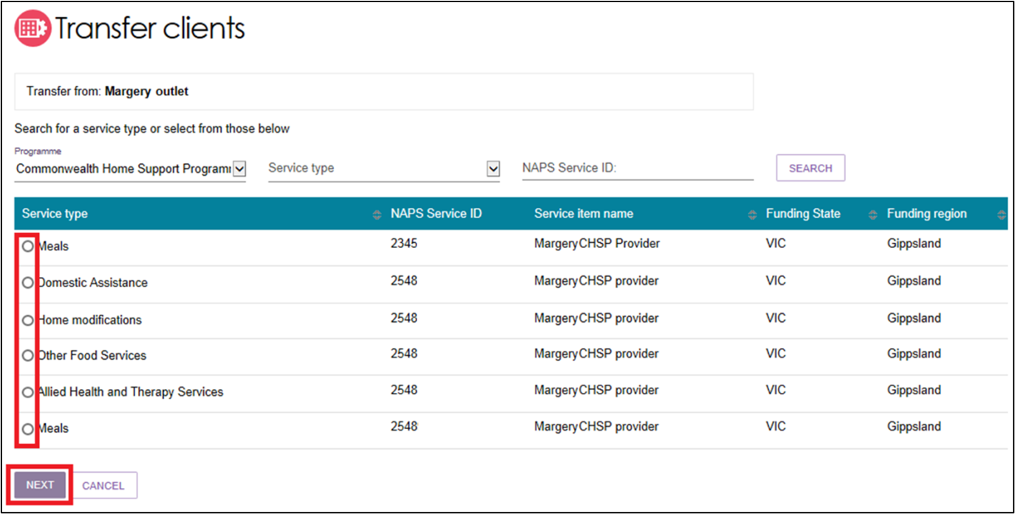
- You can choose to transfer clients to another service within the same outlet or transfer clients to another service under another outlet. Choose from one of these options and select Next.
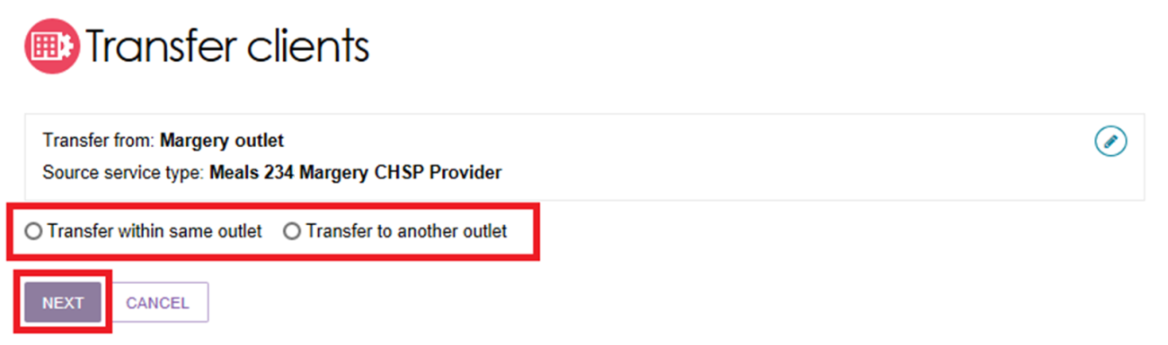
If you select Transfer to another outlet (for Organisation Administrators only) you will not be able to proceed unless you select an outlet.
- Select the service that you want to transfer the clients to, from the list displayed.
Select Next to continue.
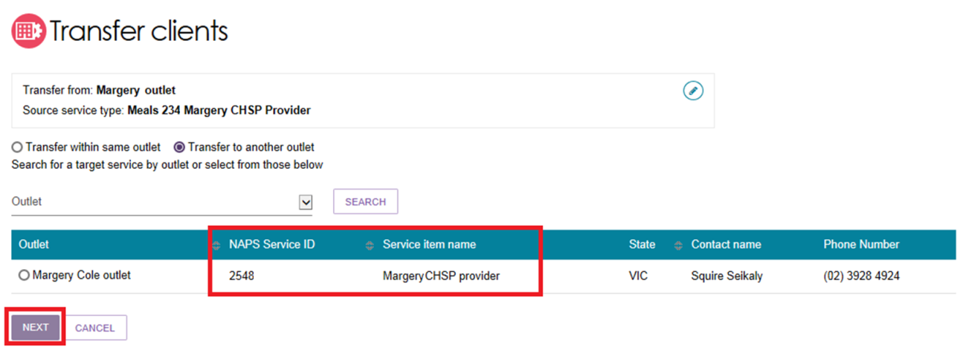
Select the client(s) that you wish to transfer to the new service. Select Transfer clients to continue. You can also search for client to transfer by their last name, first name, or their Aged Care User ID. You can transfer up to a maximum of 50 clients at one time.
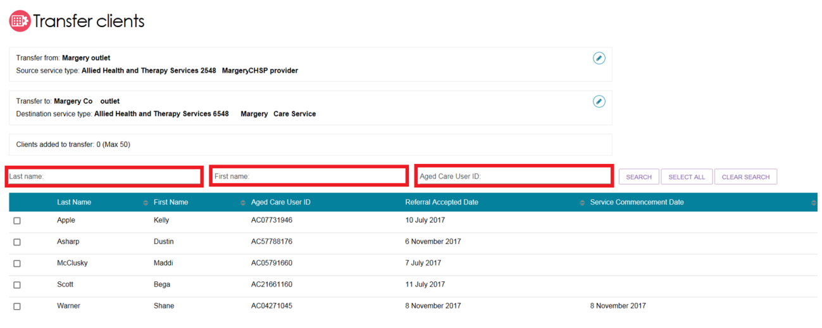
- Review the information about the transfer. To make any changes, select Cancel. If correct, select Confirm transfer to complete the process.
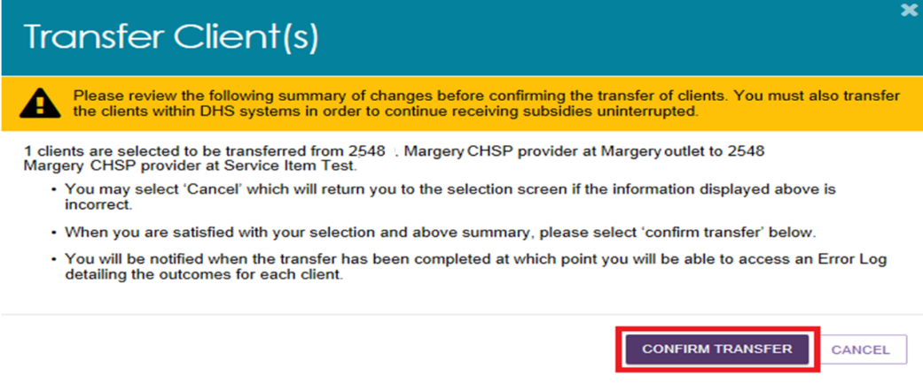

Viewing the client transfer log
To review the status or details of previous and current client transfers, review the Transfer Log.
- Select Outlet administration from the homepage.
- Select an outlet to access the transfer log.
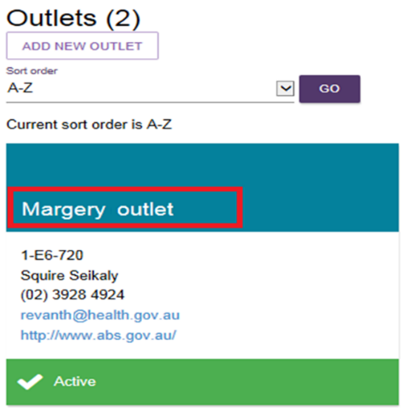
- Select the View service items button from the View outlet page.
- Select the View Transfer Logs button at the top right of the screen.
The transfer log will display information about past and current service and client transfers, including:
- Transfer type (service or person)
- Transfer date
- Status (In progress, completed, completed with errors)
For more detailed information about the transfer, select the magnifying glass icon.
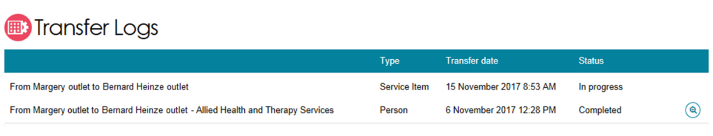
If a transfer has not been completed successfully, you can retry by selecting the magnifying glass icon, selecting the items you want to retry and selecting the Retry Selected button.
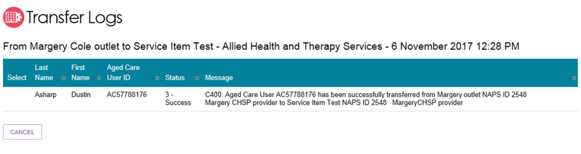

For more information or support
Further information is available in the My Aged Care - Service and Support Portal Resources available on the department’s website.
The My Aged Care Service Provider and Assessor helpline is available on 1800 836 799.

