Medicare Bulk Billing Practice signage and information for patients about eligible services

Medicare Bulk Billing Practice signage
Large decal 1,000mm wide x 680.7mm high

Small decal 600mm wide x 408.4mm high
The decals are printed on white vinyl with removable adhesive backing. The large decal can be used on large internal or external glass windows and internal walls. The small decal can be applied to internal or external doors and windows as well as internal walls.
General A3 posters 297mm wide x 420mm high
  Option 1 |   Option 2

Posters are printed on 170gsm satin paper. They can be applied to entrance, waiting room or reception areas.

Information for patients about eligible services
Consumer A3 poster 297mm wide x 420mm high

Posters are printed on 170gsm satin paper.

DL flyer 100mm wide x 210mm high
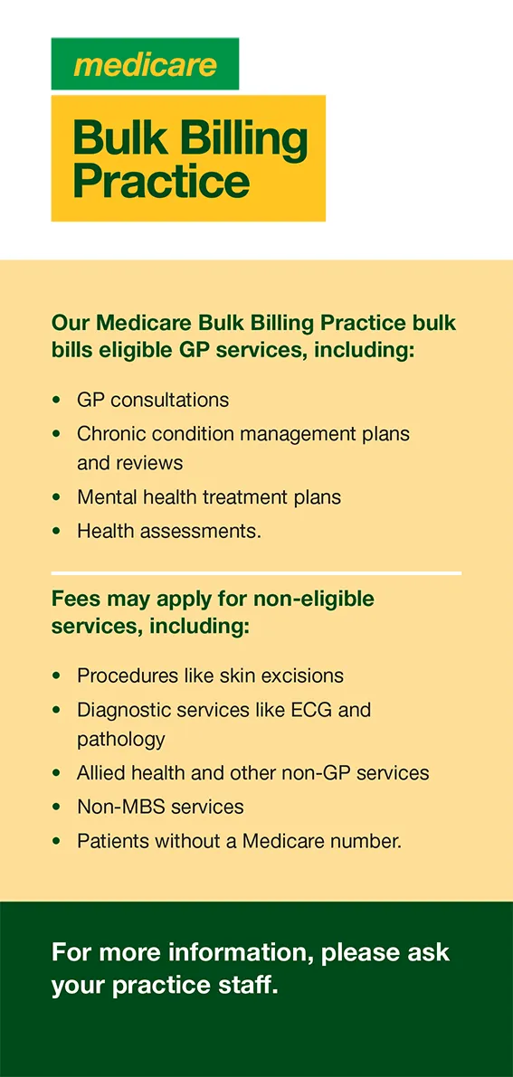
DL flyers are printed on 110gsm satin paper.

