Logging in to the Aged Care Systems
This guide covers how to log into the:
- My Aged Care Assessor Portal
- My Aged Care Hospital Portal
- My Aged Care Service and Support Portal
- Government Provider Management System Approved Provider Portal
- Government Provider Management System Registered Provider Portal.
Using:
- myID and Relationship Authorisation Manager (RAM)
- VANguard Federated Authentication Service (FAS).
The term Aged Care Systems will be used in this guide to encompass the Portals mentioned above.
This guide contains the following topics:
Key differences between the authentication methods 3
myID and Relationship Authorisation Manager (RAM) 4
Key benefits of using myID and RAM 4
User roles 4
Setting up your myID 5
Linking your business 7
Setting up RAM by Nominating a Principal Authority 7
Nominating an Organisation Administrator in Aged Care Systems 7
New Users 7
Authorising new users in RAM 8
Setting up a new RAM authorisation 9
Logging in to your Aged Care System using myID 13
Logging in after Account Activation 18
Selecting for multiple organisations 18
Managing Authorisations in RAM 19
VANguard Federated Authentication Service 19
Key benefits of using VANguard FAS 19
Setting up VANguard FAS 20
Logging in for the first time using VANguard FAS 20
Logging in after account activation 23
Using both myID/RAM and VANguard FAS 23
Further Information, Enquiries and Technical Support 23

Key differences between the authentication methods
Feature or function | myID and RAM | VANguard FAS
Obtaining credentials | Each user individually downloads the myID app on a compatible device and registers for an account. Their authorisation must be set up by a principal authority or authorisation administrator in RAM. A user must accept their authorisation in RAM before they can use their myID to log in to Aged Care Systems. | Automatically given to all users on the corporate network, and accessible any time the user is logged in to the corporate network.
Passwords | If the password is forgotten, the user must re-install the myID app on their device and set up their myID using the same email and identity documents used when they first set up their account. | Forgotten corporate network passwords are managed by the organisation. No additional password required.
Cancelling authorisation | If the user leaves the organisation, their RAM authorisation must be cancelled manually. | If the user leaves the organisation, their access to the portals will be automatically removed when their corporate network access is removed.
Access to Aged Care Systems | Each user has a myID credential tied to their Aged Care System account. Users select the myID option on the portal login page and authenticate with their myID app every time they access the portals. | Users do not require additional usernames or passwords for the portals. User selects their organisation during the first time they login. Subsequent log-ins are transparent to the user.
IT network | Effective for organisations with one or multiple networks. | Effective when all users are on one network.
Active Directory | Effective for organisations with one or multiple Active Directories. | Effective when all users are on one Active Directory.
Remote access | Access via any internet connection, however staff can only access the portals if they have access to a device used to register their myID. (A myID can be set up on multiple devices for increased flexibility.) | Users logged into their corporate network remotely (on any computer) will be able to access the portals using FAS.
IT set up | Users download the myID on a compatible smart device.  RAM can be accessed on any device, including a desktop, using a compatible browser. | Depending on your organisation’s IT capability, may require IT set-up and additional costs. In most cases connecting with VANguard should be straight forward without significant or costly changes.

myID and Relationship Authorisation Manager (RAM)
To access online services on behalf of a business or entity you need to use:
- myID - an app you download to your smart device that lets you prove who you are when using government online services. myID is an authentication service that sits within the government’s Digital ID system.
- Relationship Authorisation Manager - an authorisation service that allows you to act on behalf of a business or entity online when linked with your myID. You'll use your myID to log in.
Delivered by the Australian Taxation Office, myID and RAM provide a flexible and secure way to access selected government online services. No additional IT set-up is required by organisations, and connections can be created in a few simple steps by users on their own device.

Key benefits of using myID and RAM
Organisations may wish to consider using myID and RAM because of the following benefits:
- Free whole of government solution, used to access many other government online services.
- Provides staff with greater flexibility to conduct business anytime, anywhere without accessing their organisational network.
- Connections can be created in a few simple steps by users on their own device.
- Convenient login option with no IT support required to set up or maintain user credentials.

User roles
The following table summarises service-specific roles, including what each person needs to do during this transition period. These roles are referenced throughout this user guide.
Role | Who is this? | Responsible for
Principal authority | A business owner or eligible associate listed on an ABN in the Australian Business Register.  In smaller organisations, this person may also be an Organisation Administrator, a My Aged Care or GPMS portal user. | - Setting up their organisation in RAM  - Creating authorisation requests for new users, including authorisation administrators  - Managing authorisations to ensure users’ details and agency access are up to date
Authorisation administrator | A person who has administrator privileges in RAM on behalf of their delegated organisation. | - Creating authorisation requests for new users, including other authorisation administrators  - Managing authorisations to ensure users’ details and agency permissions are up to date
Authorised user | A person who has accepted an authorisation request to act on behalf of an organisation. | - Representing their organisation when transacting with government online services
New user | A person who has not yet registered with myID and/or RAM. | - Setting up their myID digital identity  - Accepting their authorisation request
Organisation Administrator | The person who sets up and manages an organisation in Aged Care Systems including portal user accounts for individuals connected to the organisation. | - Ensuring Aged Care System users in their organisation have continued access to Aged Care Systems
Aged Care System user | An individual who needs to access Aged Care Systems (e.g. the provider or assessor portal). | - Accepting their authorisation request and linking their myID to their Aged Care System count

Setting up your myID
! Before you can log in to your Aged Care System for the first time, you’ll need to activate your myID by completing the following steps.
- Download the free myID app from the Apple App Store or Google Play Store, compatible with most smart devices.
- Set up your myID with a unique email address using at least two of the following Australian identity documents to achieve a Standard identity strength (your name must match in all documents).
- Passport (not more than three years expired)
- Driver’s license (including learner permit)
- Birth certificate
- Medicare card
! Individuals should use a personal email address when registering their myID to assure continued access to their digital identity. This should not be the same email address that is used by your organisation to issue your RAM authorisation or Aged Care System account.
! If you are linking your business, check your personal details as listed on the Australian Business Register are up to date and other nominated individuals within your organisation are still current.
! If you cannot achieve a Standard identity strength, you can set up your myID with a Basic identity strength. A Basic myID only requires a unique email address and grants access to all Aged Care Systems.
! Aged Care System users do not need to use the same email address for registering their myID, linking to RAM or being registered for portal access. Organisations may prefer to issue RAM authorisations and Aged Care System registration requests to the individuals’ professional email address.
! The app is used only to authenticate with the Aged Care Systems and users can continue to use their preferred device to undertake their business activities.
- Contact your organisation administrator to create a RAM authorisation for your myID. This authorisation will allow you to act on behalf of your organisation when interacting with online government services.
! The email address which is used for your RAM authorisation must be the same email address which is used as your user account for the Aged Care System. This should be a professional email address personally assigned to you and linked to your organisation. The email should not be a personal email address or a group/shared email address.
! Only Principal authorities and RAM authorisation administrators can create RAM authorisations. Your Organisation Administrator may be a RAM authorisation administrator or know someone who is.
- Accept the RAM authorisation request emailed to your nominated email address. You should receive an ‘Authorisation request’ email from the Australian Taxation Office (ATO) with an authorisation code.
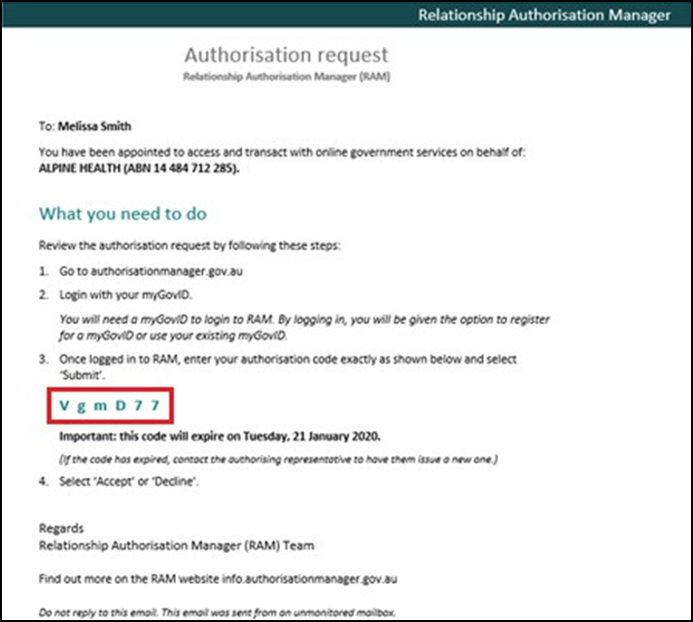
- Log in to RAM using your myID and enter your authorisation code.
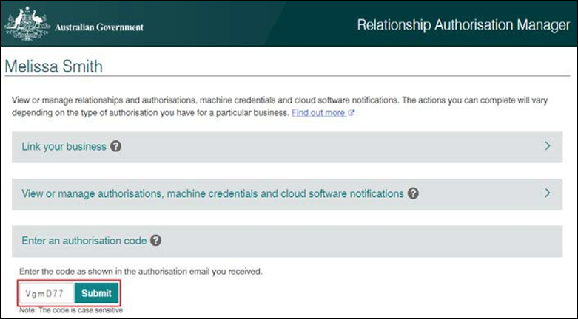
You have now successfully linked your myID to your organisation.
! Your RAM authorisation code is only valid for seven days. If you require a new authorisation code, please contact your RAM Organisation Administrator.

Linking your business
If you are linking your business, follow these additional steps:
- Once you have logged in to RAM, select link my business to find your businesses.
- Add in your address details.
- Select your businesses, enter your email address, and click send email to receive a verification code.
- Enter the code, click verify and continue.
- View the summary of the selected businesses and select the checkbox to declare you understand and accept. Click Submit.
- A message will display confirming your business is successfully linked. Click Continue.

Setting up RAM by Nominating a Principal Authority
To set up RAM, your organisation must first nominate the Principal Authority. The Principal Authority needs to be the first link to the business in RAM, and must have a Standard myID. Once linked, the Principal Authority is responsible for setting up authorised users and RAM authorisation administrators. Visit the RAM Get Started website to find out who are eligible.

Nominating an Organisation Administrator in Aged Care Systems
In order to gain initial access to a portal, your organisation will need to nominate an Organisation Administrator.
The Organisation Administrator is the initial user to gain access to the portal for your organisation. This may or may not be Principal Authority for RAM. The Department is responsible for setting up this user for each organisation.
The Organisation Administrator will be responsible for setting up the structure of your organisation in the My Aged Care portal and creating staff user accounts in all portals, including additional administrator accounts as required. The administrator details provided for your organisation should be the person who is most suitable to set-up these details.
To nominate the Organisation Administrator for your organisation, you will need to contact the My Aged Care service provider and assessor helpline on 1800 836 799 with your contact details, organisation name, ABN and PRV ID (if applicable). Please note, your PRV ID is sent to the Responsible Person (listed in your contract and/or agreement) when your service organisation is added to the Aged Care System.

New Users
Users added by their Organisation Administrators will receive an email notification inviting them to join their organisation on the Aged Care System.
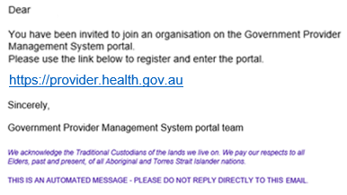
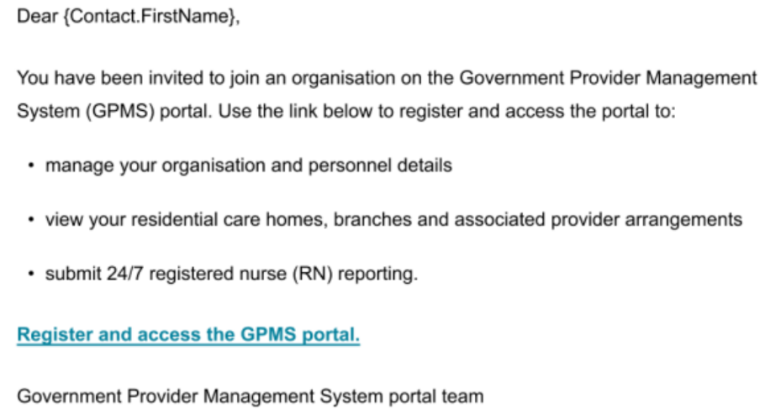

Authorising new users in RAM
! Before you can authorise a user to act on behalf of your organisation, they must also have an active myID.
Ensuring staff who require access to the Aged Care System are connected to their organisation using the myID and Relationship Authorisation Manager (RAM) can be the responsibility of anyone within an organisation. However, it is particularly relevant to principal authorities and authorisation administrators in RAM to note the following:
- You can create Standard or Basic authorisation requests in RAM. Administrators must be set up with a Standard authorisation.
- An authorisation administrator is a business representative who can manage (add, edit or remove) authorisations for one or more organisations in RAM. By default, this person is granted full access to all participating government online services for the organisation.
- A representative’s authorisation strength must match their myID identity strength:
- To accept a Standard authorisation request, a representative needs to upgrade their myID to Standard by verifying at least 2 supported Australian identity documents.
- If a representative can only achieve a Basic myID, you will need to set up a Basic authorisation for them. Basic authorisations may not be accepted by all government online services and are valid for a maximum of 12 months.
- A representative’s full name must match the name on their myID before they can accept their authorisation request.
- Nominate an email address the representative can access to retrieve their authorisation code. The email address which is used for your RAM authorisation must be the same email address which is used as your user account for the Aged Care System. This should be a professional email address personally assigned to you and linked to your organisation. The email should not be a personal email address or a group/shared email address.
- No error will display for an incorrect name or email address. If you’ve made a mistake or the representative’s details need to be updated, you’ll need to edit the pending authorisation and resend the request.
- Representatives need to log in to RAM within seven (7) days to accept their authorisation request. After seven days, the principal authority or authorisation administrator will need to re-issue the request.

Setting up a new RAM authorisation
! To use the RAM you will need to use a compatible browser. The following browsers are compatible with RAM:
- Google Chrome version 39+
- Mozilla Firefox version 30+
- Apple Safari version 5+
- Log in to Relationship Authorisation Manager and select View or manage authorisations, machine credentials and cloud software notifications to view all the entities you can act for.
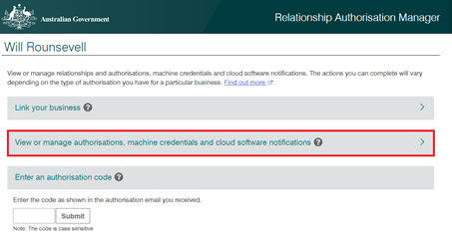
- Select the organisation you would like to add an authorisation to.
- You can search for organisation by name or by ABN if needed.
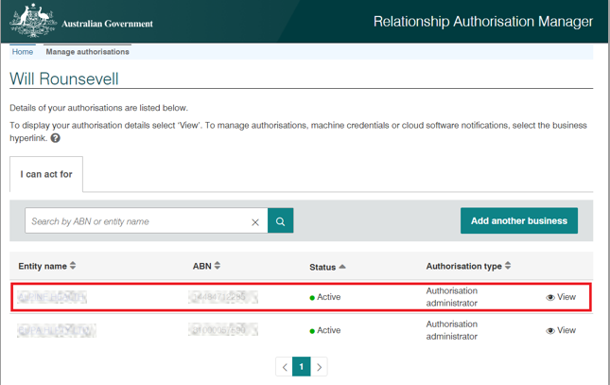

The Manage authorisations page will display with a list of all the authorisations for your organisation.
- Click Add new user.
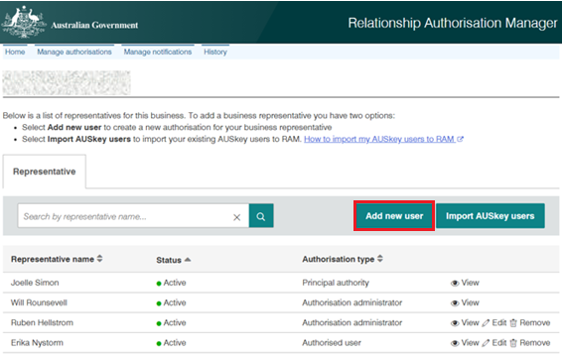
You will be taken to the Add authorisation web form.
- Select the representative type – Standard or Basic.
- Choose the representative type you wish to grant from the dropdown:
- Standard — select this option for a business representative who has a Standard myID identity strength.
- Basic — select this option if the business representative can only achieve a Basic myID identity strength.
- Select Continue.
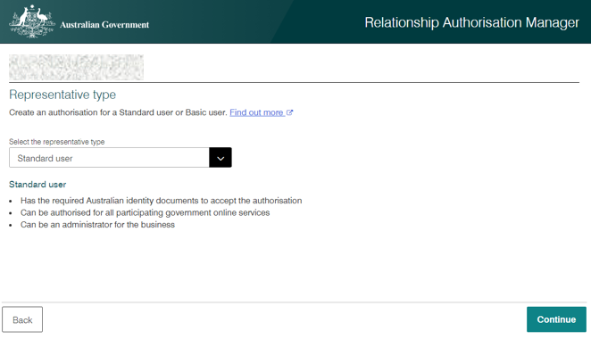
The Representative details page will display.
- Enter the representative’s details on the Representative details page.
- Complete the business representative’s details including their full name and email address.
- The representative’s full name must match the name they used to set up their myID.
- The email address does not need to match the representative’s myID email. The email address which is used for your RAM authorisation must be the same email address which is used as your user account for the Aged Care System. This should be a professional email address personally assigned to you and linked to your organisation. The email should not be a personal email address or a group/shared email address.
- Click Continue.
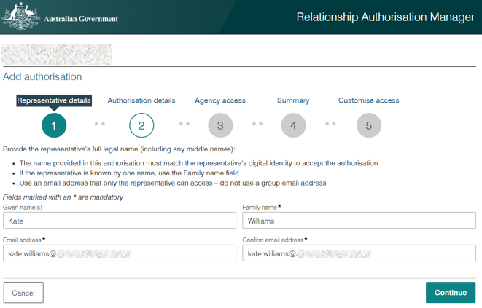
- Set the representative’s authorisation strength and duration on the Authorisation details page.
- Indicate if you’d like the representative to become:
- An authorisation administrator – a person who can manage (add, edit or remove) authorisations for one or more organisations in RAM.
- A machine credential administrator – a person who can manage (add, edit or remove) machine credentials on behalf of the organisation.
You can set an expiry date for a representative’s authorisation using the End date field (optional for Standard authorisations)
- Click Continue.
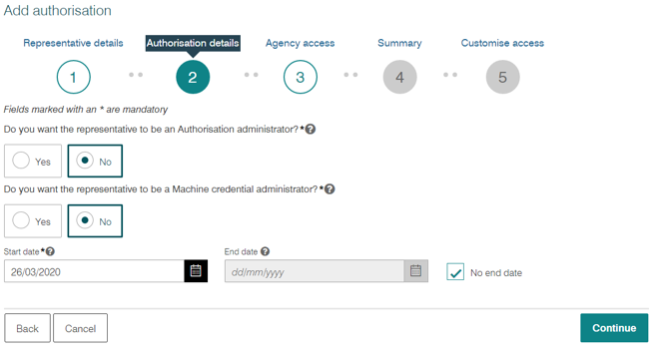
The Agency access page will display.
- Set agency access for your Organisation to Full or Custom (for Standard authorisations) and select other agencies as needed.
- You can grant access to multiple agencies at once (optional)
- Click Continue.
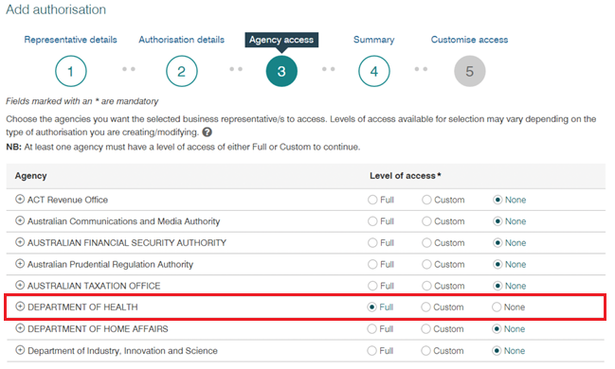
The Summary page will display.
If custom access is selected, you will be redirected to the Australian Taxation Offices Access Manager to set permissions.
- Review details on the Summary page.
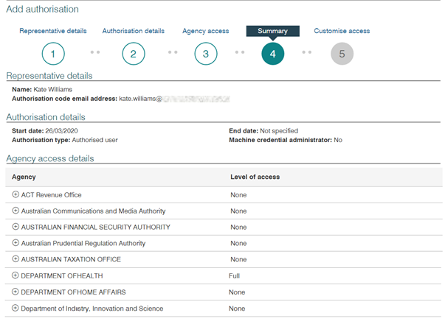
- Accept the Declaration.
- Select the checkbox to declare you understand and accept the declaration.
- Click Submit
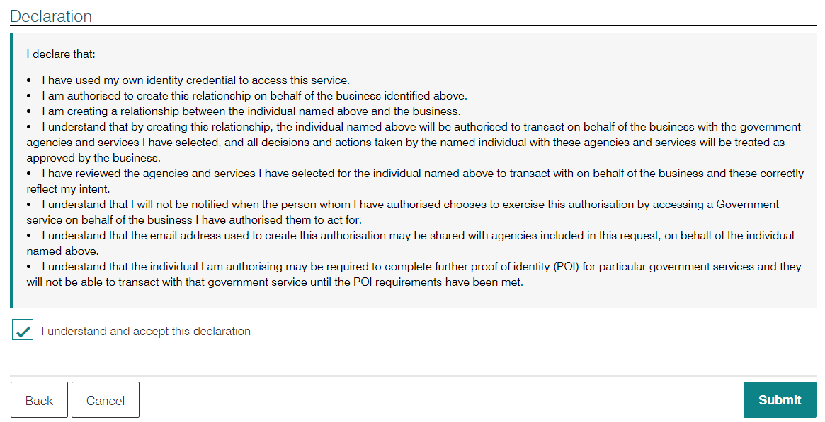
An authorisation request will be emailed to each representative with a 6-digit authorisation code, which is used to accept or decline the request.
Authorisations will remain as pending until they are accepted by the representative. You will receive a notification for each representative who has accepted their authorisation request.
- Click Continue to return to the Manage authorisations page.
- To resend a code (for Pending authorisations):
- Log in to RAM
- Select View or manage authorisations, machine credentials and cloud software notifications
- Select the business name associated with the user
- Click View next to the user’s name
- Click Re-issue a code under Authorisation code details
- Confirm the code re-issue by selecting Continue in the confirmation page.

Logging in to your Aged Care System using myID
Before you can log in, you must activate your Aged Care System user account. Follow the steps below to activate your account and link it to your myID.
- Navigate to your portal by clicking the relevant link below:
- My Aged Care Assessor Portal
- My Aged Care Hospital Portal
- My Aged Care Service and Support Portal
- Government Provider Management System Approved Provider Portal
- Government Provider Management System Registered Provider Portal
The following steps show the process of logging into the My Aged Care Service and Support Portal for the first time as an example, these steps can be used for all Aged Care Systems, detailed in this user guide, as they follow the same basic steps.
- Visit the My Aged Care Service and Support Portal on the Department's website.
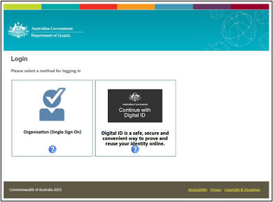
- Select the Continue with Digital ID tile.
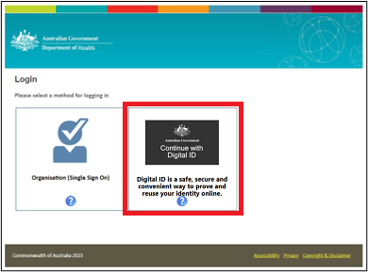
- Choose Digital ID Authentication as the authentication method, and then select Next.

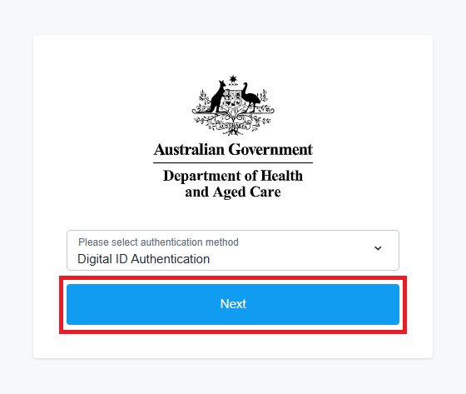
- You will be taken to the Digital ID System page where you will be choosing your identity provider. Click Select MyID.
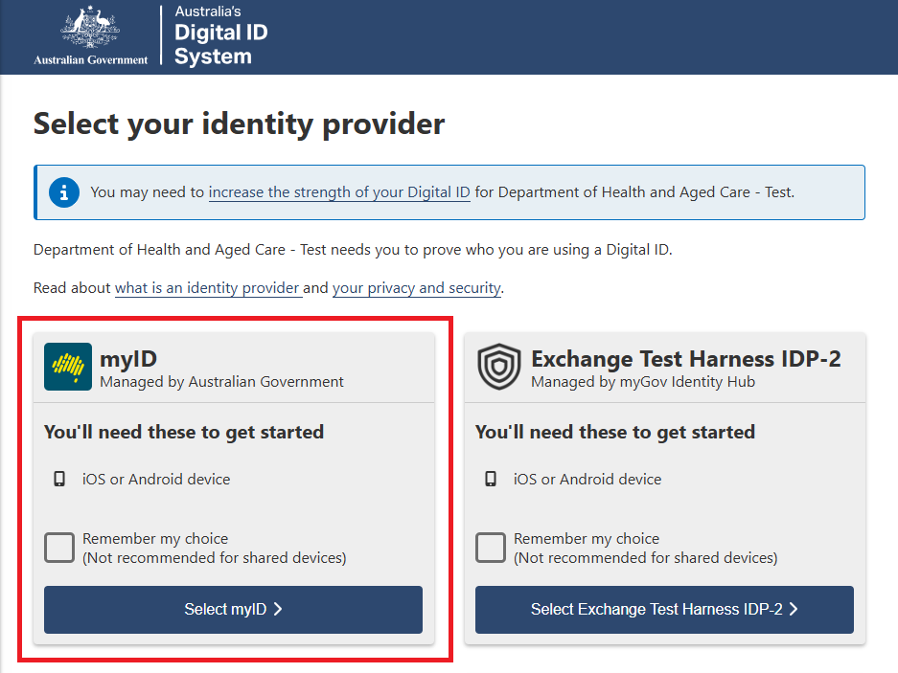
- The myID login will appear. Enter the email address associated with your myID and select Get code.
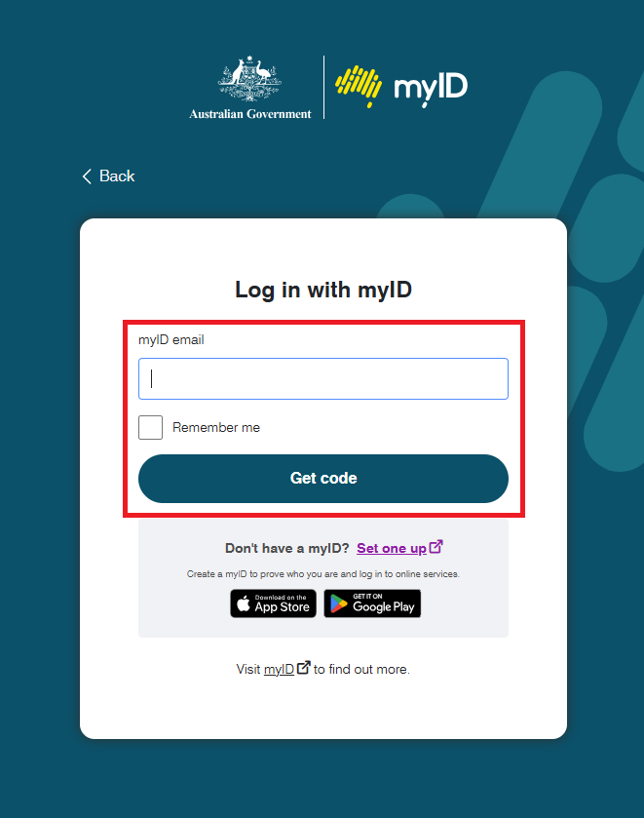
- The myID login page will display an authorisation code. Log in to your myID app on your device and enter this code.
- You will be redirected to a Department account activation screen.
Enter the email address linked to your Service and Support Portal user account, then select Continue.
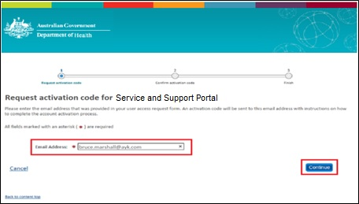
- You will receive an email with an activation code. This activation code is only required for logging into the portal for the first time. If you do not receive an email with your activation code, call the My Aged Care service provider and assessor helpline on 1800 836 799.
- Enter the activation code you were provided in the email and select Confirm.
! Your activation code is valid for 5 days. If you require a new authorisation code, please select Resend Activation Code.
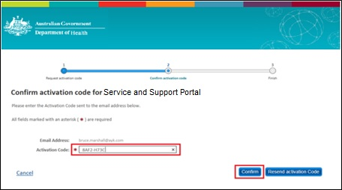
Your account has now been successfully activated and linked with your myID.
- Select the Go to Aged Care Service and Support Portal link to be directed to the portal.
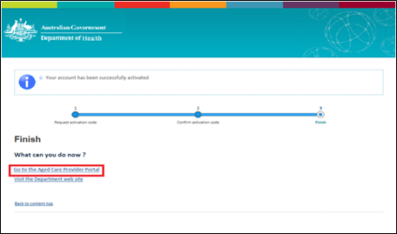
- You will be redirected to the Service and Support Portal home page.
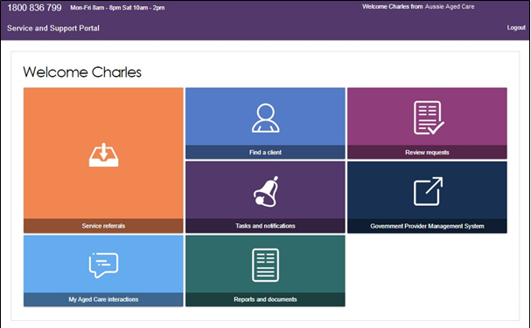
! myID is linked to a unique Aged Care Organisation which will allow you to log into the My Aged Care and GPMS Portals. If you require access to multiple Aged Care Organisations, a unique myID is required per Organisation.

Logging in after Account Activation
After you’ve activated your Aged Care System user account, you can continue to log in to your desired portal using your myID by following steps 1 through to 7 in the ‘Logging in to your Aged Care System using myID’ section of this guide.

Selecting for multiple organisations
Some users may work for multiple organisations. When this is the case, RAM will provide a list of organisations at the end of the myID login process.
To select the organisation you want to login to, complete the following steps:
- In the Relationship Authorisation Manager screen, select the radio button of the authorised organisation you want to access.
- Select the Continue button.
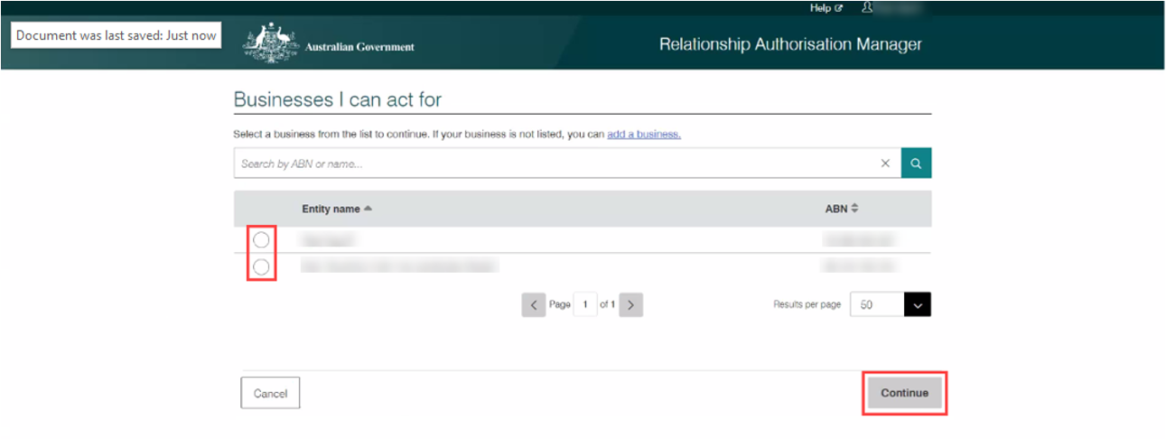

Managing Authorisations in RAM
To edit or remove an existing authorisation, a Principal Authority or RAM authorisation administrator can follow the steps below.
- Log in to RAM
- Select Manage authorisations.
- Select the business name associated with the user.
- Click Edit or Remove (to permanently end the user’s authorisation).
The edits you can make to an authorisation will depend on the status of their authorisation.
Authorisation Status | What can be edited
Pending | Authorised users name and email address  Authorisation start and finish dates  Authorisation administrator status  Agency access level
Accepted or Active | Authorisation start and finish dates  Authorisation administrator status  Agency access level
Inactive | None

VANguard Federated Authentication Service
VANguard Federated Authentication Service (VANguard) is a login option supported by Aged Care Systems. The service integrates with an organisation’s local network, allowing individuals to reuse their username and password to log in to systems owned by external agencies without sharing the user’s credentials.
VANguard is delivered by the Department of Industry, Science, and Resources and is suitable for any organisation with corporate network infrastructure that supports Single Sign-On (SSO) or includes an Identity Management System (for example, Active Directory Federation Server). This is more common in larger organisations.
VANguard FAS is suitable for government and non-government organisations wanting to use the Aged Care Systems.
VANguard users authenticate once with an Aged Care System and subsequent logins are seamless, not needing additional credentials (such as myID) or additional software on their computer.
There are no fees payable to VANguard for using FAS.

Key benefits of using VANguard FAS
Benefits for Aged Care System users:
- Improved user experience through federated access, allowing users to single sign on using their organisational network.
- Staff do not need to set up or remember an additional credential to login.
- Increased flexibility as users can log in using their desktop and their credentials are not tied to a single device.
Benefits for organisations:
- Seamless access to the Aged Care Systems, allowing Assessor Portal, Service and Support Portal, Hospital Portal and GPMS Portal users to perform key tasks that support clients and help to manage their workload.
- Outlets will no longer have an administrative load to manage authorisations in RAM for staff accessing the Aged Care Systems.
- Simple set-up without significant changes, providing minimal disruption to an outlet’s activities (assuming appropriate IT infrastructure exists).
- Access to Aged Care System is managed through the outlet’s existing administrative processes as staff are employed or leave.
- Implementing FAS may enable access to other Government online services with little or no additional effort.

Setting up VANguard FAS
Once you have discussed with VANguard the suitability of FAS for your organisation and determined that you would like to progress, set-up will include:
- Installation of an Identity Management System (if one does not exist already)
- Provision of support documentation by VANguard
- Configuration of access by VANguard including troubleshooting advice to assist your integration.
VANguard can provide access to FAS within 15 working days, subject to the organisation’s readiness to integrate.
During the establishing stage, users will be able to use their myID to access the Aged Care Systems.

Logging in for the first time using VANguard FAS
After your organisation administrator has set up your Aged Care System user account, follow the steps below to link your portal account to the VANguard FAS authentication service.
- Access your portal by selecting one of the links below:
- My Aged Care Assessor Portal
- My Aged Care Hospital Portal
- My Aged Care Service and Support Portal
- Government Provider Management System Approved Provider Portal
- Government Provider Management System Registered Provider Portal

- On the portal login page, select the Organisation (Single Sign On) option.
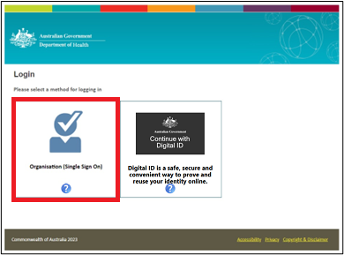
- Depending on your organisation’s setup, you may be presented with a Security Warning Trusted Site pop-up. Click Yes to this pop-up each time it appears.
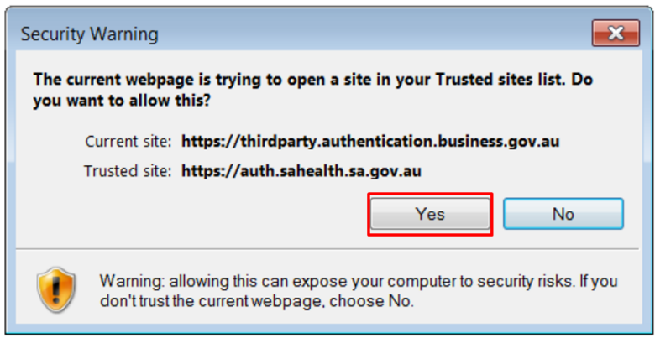
You will be taken to an Australian Government Authentication Service page.
- Select your organisation from the drop-down menu.
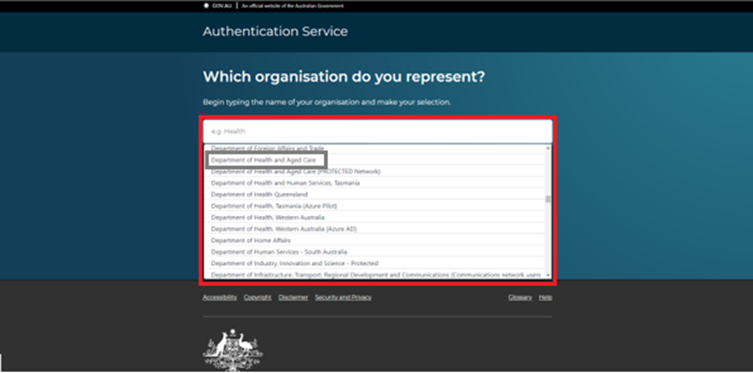
You will be redirected to the relevant Aged Care System and asked to activate your portal account. (If you select the wrong organisation, you will be redirected back to the organisation selection page to try again.)
- Enter the email address linked to your Aged Care System user account and select Continue.
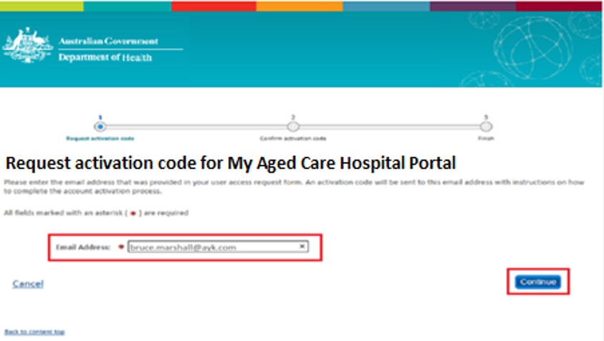
- You will receive an email with an activation code. This activation code is only required for logging into an Aged Care System for the first time.
! If you do not receive an email with your activation code, call the My Aged Care service provider and assessor helpline on 1800 836 799.
- Enter the activation code you were provided via email and select Confirm.
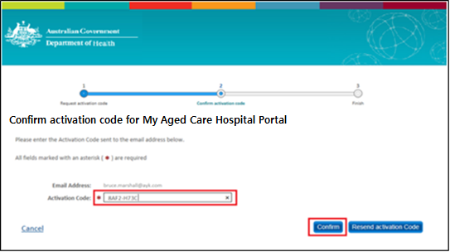
Your account has now been activated and linked to your organisation via the VANguard FAS service.
- Select the link directing you to the relevant portal you have been provided access to (Assessor, Service and Support portal, Hospital portal or GPMS portal):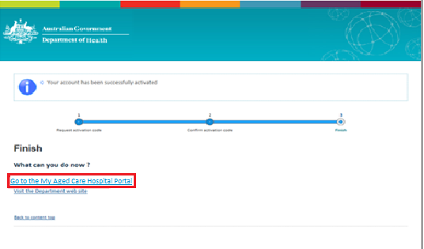
Your relevant Aged Care System homepage will be displayed.

Logging in after account activation
After you’ve activated your Aged Care System user account, you can continue to log in to your desired portal using your Vanguard FAS by following the first 4 steps you used to log in for the first time.
! Bookmark the relevant portal link for easy access to your portal in the future.

Using both myID/RAM and VANguard FAS
myID/RAM and FAS are separate methods for accessing Aged Care Systems.
Organisations may choose to use both myID/RAM and FAS authentication based on their portal needs.
If users require access to two or more of the My Aged Care Assessor Portal, Service and Support Portals, GPMS Portal, and/or the Hospital Portal simultaneously, both myID/RAM and FAS are required. In this scenario, it is recommended that FAS is linked to each user’s primary portal for an improved login experience.

Further Information, Enquiries and Technical Support
Visit the myID and RAM websites for more information relating to these services, and for technical support, check:
- myID – Help or
- Relationship Authorisation Manager - Help
If you are unable to find what you are looking for on the myID or RAM websites, please refer to the Online services help | Australian Taxation Office (ato.gov.au) for assistance.
Visit VANguard website for more information relating to this service or email the VANguard service desk with your question and contact details.
The My Aged Care service provider and accessor helpline is available on 1800 836 799. The helpline provides technical support and general information to registered provider, assessors, and hospital staff using our reporting systems and portals. The helpline is available from 8am to 8pm Monday to Friday, or 10am to 2pm Saturday (local time).

