
Better thinking. Better advice. | healthconsult.com.au

The Royal College of Pathologists of Australasia
  - Quality Use of Pathology

Health Consult final report for the Australia pathology workforce review project
24 June 2024

Acknowledgements
The development of this report was overseen by representatives from the Royal College of Pathologists of Australasia (RCPA) who assisted the HealthConsult team throughout this project.
We also acknowledge the dedication and time spent by members of the RCPA’s Expert Reference Groups (ERG) who completed multiple rounds of consultation and expert advice as part of this project, as well as Pathology Australia (PA) and Public Pathology Australia (PPA).

Disclaimer
This report has been prepared as outlined in our project plan for this work dated 18 January 2024. HealthConsult has indicated within this report and in all deliverables the sources of the information presented. HealthConsult has taken all reasonable precautions to verify the information referenced in this report. However, the published material is being distributed without warranty of any kind, either expressed or implied. This report has been prepared at the request of the RCPA in accordance with the terms of our contract for this work. Any use that a third party makes of the work, or any reliance on or decisions to be made based on it, are the responsibility of such third parties. Decisions made or actions taken as a result of our work shall be the responsibility of the parties directly involved in the decisions or actions.

Abbreviations
ABS Australian Bureau of Statistics
ACT Australian Capital Territory
AI Artificial intelligence
AP Anatomical Pathology
BEA Board of Education and Assessment
CAGR Compound annual growth rate
CI Confidence intervals
ERG Expert Reference Groups
ETS Exponential triple smoothing
FCFM Faculty of Clinical Forensic Medicine
FOMP Faculty of Oral and Maxillofacial Pathology
FTE Full-time equivalent
IT Information technology
MBS Medicare Benefits Schedule
MMM Modified Monash Model
NHWDS National Health Workforce Dataset
NPAAC National Pathology Accreditation Advisory Council
NSW New South Wales
NT Northern Territory
PA Pathology Australia
PPA Public Pathology Australia
QUPP Quality Use of Pathology Program
RCPA Royal College of Pathologists of Australasia
SIMG Specialist International Medical Graduate
STP Specialist Training Program
WA Western Australia

Contents
Executive Summary 9
1. Introduction 18
2. Methodology 22
3. Overview of the current workforce 37
4. Key outcomes – Australia 55
5. Summary of recommendations 97
6. Workforce plan 101
Appendix A Sensitivity analysis 108
Appendix B Summary of additional trainees required by discipline 114

Tables
Table 1: Summary of the recommendations 16
Table 2: Comparison of modelling methodology between the KBC 2018 report and HealthConsult in 2023-24 35
Table 3: Summary of recommendations and role of RCPA 98
Table 4: Strategies to address increasing the number of pathologists in the Australian workforce 102
Table 5: Strategies to decrease the workload of pathologists in Australia 104
Table 6: 95% confidence intervals for the Australian total demand forecast 108
Table 7: Outcome of the Australian pathologist model under scenario 4 compared to the original model (variation in workforce capacity) 112
Table 8: Outcome of the Australian FFSc model under scenario 4 compared to the original model (variation in workforce capacity) 112
Table 9: Summary of additional trainees required by discipline over a five, 10 or 15-year timeframe 114

Figures
Figure 1: Workforce gaps in absolute and relative terms for Australian pathologists and FFSc and Australian pathologists by discipline for five, 10 and 15 years 14
Figure 2: Pathology disciplines within Australia 19
Figure 3: Pathway to Fellowship with the Faculty of Science 20
Figure 4: Overview of the key steps within the project methodology 23
Figure 5: Mapping of MBS Pathology Groups to RCPA pathology disciplines for modelling 25
Figure 6: Summary of the Markov ‘Stock and Flow’ model 28
Figure 7: Summary data sources used for supply modelling 29
Figure 8: Fellows in Australia by discipline (2017 to 2022) 38
Figure 9: Trainees in Australia by discipline (2017 to 2022) 39
Figure 10: Gender breakdown of pathologists in Australia by discipline, 2022 40
Figure 11: Age breakdown of pathologists in Australia by discipline, 2022 41
Figure 12: Fellows per 100,000 people in States and Territories and Australia overall (2017-22) 42
Figure 13: Trainees per 100,000 people in States and Territories and Australia overall (2017-22) 42
Figure 14: Pathologists by MMM, 2023 43
Figure 15: Proportion of pathologists in private or public practice by State, 2023 44
Figure 16: Established but unfilled pathologist positions in Australia by state and discipline 45
Figure 17: Additional pathologists required to meet future (5-year) workload in Australia by state and discipline 46
Figure 18: Reason for pathologist vacancies in Australia 46
Figure 19: FSc Fellows in Australia by discipline (2017 to 2022) 48
Figure 20: Gender breakdown of FFSc in Australia by discipline, 2022 49
Figure 21: Age breakdown of FFSc in Australia by discipline, 2022 50
Figure 22: FFSc per 100,000 people in States and Territories and Australia overall (2017-22) 51
Figure 23: Senior scientists or equivalent pathology-supporting roles in Australia by metropolitan or rural areas, and private or public practice 52
Figure 24: FCFM and FOMP Fellows in Australia (2017 to 2022) 53
Figure 25: Gender breakdown of FCFM and FOMP in Australia, 2022 53
Figure 26: Age breakdown of FCFM and FOMP in Australia, 2022 54
Figure 27: The vision, themes and priorities of the National Medical Workforce Strategy 2021-31 57
Figure 28: Actions to support priority three of the National Medical Workforce Strategy 2021-31 58
Figure 29: Model outcomes for the total Pathologist workforce in Australia 60
Figure 30: Additional FTE trainees required to bridge the gap for Australian pathologists in five, ten and 15 years 61
Figure 31: Model outcomes for Anatomical Pathologists in Australia 63
Figure 32: Additional FTE trainees required to bridge the gap in AP in five, ten and 15 years 64
Figure 33: Model outcomes for Chemical Pathologists in Australia 65
Figure 34: Additional FTE trainees required to bridge the gap in Chemical Pathology in five, ten and 15 years 66
Figure 35: Model outcomes for Forensic Pathologists in Australia 67
Figure 36: Additional FTE trainees required to bridge the gap in Forensic Pathology in five, ten and 15 years 68
Figure 37: Model outcomes for General Pathologists in Australia 69
Figure 38: Additional FTE trainees required to bridge the gap in General Pathology in five, ten and 15 years 70
Figure 39: Model outcomes for Genetic Pathologists in Australia 72
Figure 40: Additional FTE trainees required to bridge the gap in Genetic Pathology in five, ten and 15 years 73
Figure 41: Model outcomes for Haematologists in Australia 74
Figure 42: Fewer FTE trainees required to bridge the gap in Haematology in five, ten and 15 years 75
Figure 43: Model outcomes for Immunopathologists in Australia 76
Figure 44: Additional FTE trainees required to bridge the gap in Immunopathology in five, ten and 15 years 77
Figure 45: Model outcomes for Microbiologists in Australia 78
Figure 46: Additional FTE trainees required to bridge the gap in Microbiology in five, ten and 15 years 79
Figure 47: Model outcomes for total FFSc workforce in Australia 81
Figure 48: Additional trainees (headcount) required to bridge the gap in FFSc in five, ten and 15 years 82
Figure 49: Outcomes of the Australian pathologist total model under scenario 1 compared to the original model 109
Figure 50: Outcomes of the Australian FFSc model under scenario 1 compared to the original model 110
Figure 51: Outcomes of the Australian pathologist model under scenario 3 compared to the original model (5% increase in retirement for those aged 55 or older) 111

Executive Summary
On 19 June 2023, the Royal College of Pathologists of Australasia (RCPA) engaged HealthConsult to:
“Deliver the Australia Pathology Workforce Review”

Background
The review of the Australian pathology workforce has been undertaken to understand the current and expected future composition of the workforce and to inform the design of workforce planning strategies that will ensure its growth and sustainability. This project follows from a 2018 workforce study commissioned by RCPA that found the projected future demand for Australian Pathologists and senior scientists was higher than the workforce supply, and that significant gaps were developing. Since the 2018 report was completed, there has been increasing recognition of pathology workforce shortages and other workplace issues by national and jurisdictional health departments and individual pathology service providers across the public and private sectors.
This document presents the final report for the project. It presents the outcomes of modelling on the pathology and senior scientist workforces across Australia, summarises the issues impacting these workforces and provides recommendations to support the sustainability of the pathology workforce in Australia into the future.

Methodology
The initial focus of the review was to gain insight into the current state of the pathology workforce in Australia and to identify key issues and challenges. The work included undertaking a review of data and information provided by RCPA, data sourced from the public domain, a scan of publicly available literature, and extensive stakeholder consultations. It produced an environmental scan (a separate document) that articulated important trends and issues that are influencing the workforce.
The gathered data was then synthesised to identify the most relevant and robust data source required to undertake the workforce modelling. Through this process, data gaps were identified, and the assumptions developed, which were then tested and validated with RCPA’s ERGs, and State and Regional Councillors.
Separate workforce models were developed in Microsoft Excel. Two models were constructed, namely for: Australian pathologists; and the Australian Fellows of the Faculty of Science (FFSc). The models applied a Markov ‘stock and flow’ approach for forecasting supply and exponential triple smoothing forecasts for the demand for pathology services. The time horizon for the models spanned 15 years, from 2022 to 2037. The Australian pathologist model was based on FTE at the request of the RCPA, due to several pathologists having joint appointments. Headcount was used for the other model (FFSc for Australia) as FTE data could not be reliably sourced.
Finally, recommendations on workforce planning strategies were developed based on the outcome of the project work undertaken to improve the sustainability of the pathology workforce in the future. Both the model results and recommendations were tested and refined through a series of workshops with the RCPA project team, the RCPA Board, ERGs, State and Regional Councillors, Pathology Australia (PA) and Public Pathology Australia (PPA). This process ensured the outcomes of the workforce modelling, and associated recommendations were appropriate, realistic, relevant, and representative of both demand and supply of the pathology workforce, now and in the future.

Key outcomes

Key current issues
Stakeholder consultations identified broad agreement there is a current shortage of both pathologists and senior scientists in Australia, across both the public and private sectors. Shortages were considered critical in some disciplines. The current shortages are expected to become worse in the future because, for most disciplines, demand growth is not being met by a corresponding increase in workforce FTE.
The main demand drivers for pathology services included:
- increasing complexity of testing per patient with the growth of personalised medicine and the use of genomics
- increase in population life expectancy which is resulting in more tests overall; particularly as people age
- advances in medicine that mean many people with complex illnesses are living longer (e.g. cancer and transplantation patients). These patients often require more (and more complex) tests
- ongoing introduction of new tests and screening techniques as medicine and technology continue to evolve.
One of the most significant barriers identified to increasing the pathology workforce pipeline was the lack of funding. Funding limitations impact training numbers and supervision capacity, the number of positions available for qualified Fellows to take up once qualified and investment in infrastructure. Funding is required from the Australian government to avoid current workforce shortages becoming worse in the future.
The lack of fees indexation for Medicare Benefits Schedule (MBS) items for nearly three decades is also widely understood to have adversely impacted the pathology sector, as MBS fees are the major source of income for private laboratories in Australia. MBS fees are also an important income source for the public sector. It is noted that the recent Federal Budget included the reintroduction of annual indexation for selected pathology services from 1 July 2025. However, current MBS fees are not likely to be reflective of the cost of providing each test, due to the stagnation of the fees paid for such an extended period. Additionally, not all pathology fees will be indexed under the Budget measure. There were multiple reported consequences of not increasing MBS fees such as restricting the ability to grow the workforce and take on additional trainees, as well as limiting investment in infrastructure to evolve pathology.
Stakeholders reported difficulties aligning the allocation of funding under the Commonwealth Government’s Specialist Training Program (STP) to where training is predominately delivered. Metropolitan-based training positions in the public and private sectors provide trainees with exposure to the broadest possible range of pathology tests and access to supervision compliant with requirements, however, public sector positions are not funded by STP and are therefore fully reliant on funding from jurisdictional health authorities. Additionally, metropolitan-based training correlates to the centralised service delivery of pathology services, with pathology tests for rural and regional patients often being processed centrally.
Initially, key identified shortages were thought to be in Genetic Pathology, Immunopathology and Chemical Pathology. From the review and analysis that has been undertaken, there were three disciplines with issues that were particularly noteworthy:
- Anatomical Pathology (AP): AP is the largest discipline within pathology, accounting for nearly 50% of the pathologist workforce. It also has the highest workforce shortages in absolute numbers of FTE. Additionally, AP is one of the most labour-intensive disciplines, and workforce capacity is being challenged by growing complexity from the emerging presence of precision and personalised medicine.
- Genetic Pathology (including biochemical genetics and cytogenetics): Genetic Pathology is the newest pathology discipline. Demand is continually growing at a rate higher than for other disciplines, and the number of Genetic Pathologists is not keeping pace with the level of need. There is a high level of interest in wanting to become a Genetic Pathologist (currently a waiting list), but a limited number of training positions are available, which are largely Commonwealth funded, and in some instances are short-term, time-limited positions (including seven Genetic Pathology training positions where funding is due to expire in 2025). Limitations in supervisor capacity are also restricting trainee throughput for Genetic Pathology.
As Genetic Pathology continues to evolve, new tests are being developed. Significant time lags are being experienced between new tests being established and inclusion on the MBS, which has created funding challenges for Genetic Pathology.
The crossover of Molecular Pathology and genetics with most other disciplines also creates challenges in upskilling the existing workforce. Incorporating Molecular Pathology in the general curriculum for the Fellowship pathway across all disciplines also needs to be considered, which has commenced in some disciplines, but needs to be implemented at an accelerated pace.
- General Pathology: The number of General Pathologists is decreasing significantly. They also have the oldest age profile of any discipline and, therefore, will likely have a higher proportion of retirements in the next 10 to 15 years, adversely impacting the supply of General Pathologists in the workforce. Several stakeholders hypothesised this discipline may not exist in 10 to 15 years, which would leave a significant capability gap because General Pathologists may play a significant role in ensuring compliance for rural and regional laboratories against the National Pathology Accreditation Advisory Council (NPAAC) requirements. This issue presents a significant challenge for the RCPA to examine alternative ways of meeting the compliance requirements under NPAAC, especially in regional and rural areas.

Model outcomes Australian pathologist workforce
Figure 1 summarises the outcomes of modelling. The workforce gaps are presented for pathologists in Australia, FFSc in Australia and for each pathologist discipline in Australia both as absolute numbers as well as a proportion of the relevant workforce at a future point in time. The data is presented at five-year intervals across the 15 years modelled (2027, 2032 and 2037).
From an overall perspective for:
- Australian pathologists: the estimated workforce gap is 122 FTE in 2027, representing 8% of the workforce, increasing to 186 FTE in 2032 and 291 FTE in 2037 (15% of the workforce). The modelling demonstrates a worsening in the workforce shortage in both real and relative terms.
- FFSc in Australia: current shortages are predicted to worsen to a critical level. The forecast undersupply in 2027 of 59 headcount (28% of the workforce) is expected to increase to 151 headcount (82% of the workforce) by 2037.
The common pattern from the modelling is that workforce gaps are growing in relative and real terms over the next 15 years. Noting the overwhelming opinion from the consultations is that the situation is already critical, this indicates that the issue will only worsen unless action is taken to redress existing shortages.
The prior review of the pathology workforce was undertaken for RCPA by KBC Australia in 2018. There were several important differences in the modelling approach, most notably KBC used headcount for the Australian pathologist model and HealthConsult used FTE. While the workforce models are not readily comparable, the outcomes contain the same message, i.e. there is a shortage in the pathology workforce that is growing and will continue to worsen unless changes are made.
Some of the key outcomes from modelling individual disciplines within the Australian pathology workforce showed:
- AP is the discipline with the largest adverse workforce gap in absolute terms. In 2027 the gap was estimated to be 78 FTE (or 8% of the workforce), growing to 132 FTE (or 12% of the workforce) by 2037. Growth in both demand and complexity are driving this outcome.
- Chemical Pathology proportion of projected workforce shortage was also of note. By 2037 there is expected to be a 48% shortfall in the workforce required, which is a gap of 39 FTE.
- Forensic Pathology had a predicted shortfall of 8 FTE in 2027 (14% of the workforce) this adverse gap widens to 18 FTE (29% of the workforce) in 2037.
- Genetic Pathologists proportionally have the largest undersupply of all disciplines in 2027. In 2027 the 19 FTE shortage is 80% of the workforce, with the gap widening to 101% of the workforce or 27 FTE by 2037. Similar to AP, both growth in demand and complexity are driving this outcome.
- General Pathologists have the highest proportional undersupply by 2037, where the adverse gap of 35 FTE is 137% of the workforce. This is reflective of the older age profile of this discipline and the declining number of registrars who are willing to undertake this training pathway.
- Haematologists are the only discipline showing an oversupply. In 2027 the model outcomes are indicating an oversupply of 21 FTE or 10% of the workforce, growing to 32% of the workforce by 2037. This is driven by the discipline having the highest number of new Fellows of any discipline (including AP), despite MBS demand decreasing. There is a large portion of Haematologists with dual qualifications with the Royal Australasian College of Physicians, resulting in a trend of increasing number of Haematologists who are increasingly spending less time in laboratories. Despite the predicted increases, this is not thought to impact laboratories as most of these Haematologists will be working in patient-facing roles.
- Immunopathology had the third largest proportionate workforce gap amongst the disciplines in 2027 at 26% or 10 FTE. In 2037 the adverse gap widens to 44% or 19 FTE.
- Microbiology had a gap of 10 FTE in 2027 which is 6% of the Microbiology workforce. By 2037 the adverse gap widens to 32 FTE or 16% of the workforce.
Figure 1: Workforce gaps in absolute and relative terms for Australian pathologists and FFSc and Australian pathologists by discipline for five, 10 and 15 years
NB: the ‘Australia Total’ may not equal the summation of each discipline due to unique capacity assumptions that have been applied for some disciplines
Source: HealthConsult analysis

Sensitivity analysis
Analysis was undertaken to understand how sensitive the outcomes of the workforce models are to changes in key assumptions. The results of the sensitivity analyses suggest that the predicted workforce shortfalls may worsen:
- In the scenario where future demand increases by 5% over the baseline demand assumed in the models, the impact on the models in 2037 is:
the Australian pathologist workforce shortfall widens from 291 FTE to 401 FTE (an increase of 110 FTE or 37.8%)
the Australian FFSc workforce shortfall widens from 151 headcount to 168 headcount (an increase of 17 headcount or 11.3%)
- In the scenario where an additional 5% of pathologists aged 55 or older retire in each five-year period, the impact on the model outcomes in 2037 would be:
the Australian pathologist workforce shortfall increases from 291 FTE to 338 FTE (an increase of 47 FTE or 16.1%)
- In the scenario where pathologists choose to work fewer hours in the future (which would reduce overall workforce capacity), the impact on 2027 of a 5% decrease in hours would be:
the Australian pathologist workforce shortage would increase by 75%, from 122 FTE to 214 FTE
the Australian FFSc workforce shortage would increase by 24%, from 59 headcount to 73 headcount

Recommendations
10 recommendations have been made in this report to address key issues, gaps and opportunities that have been identified Table 1. The recommendations that have been developed have been workshopped with the RCPA Board, ERGs, RCPA project team and other key stakeholders.

Table 1: Summary of the recommendations
Recommendation | Priority
Recommendation 1: Advocate to the Australian Government for increased access to funding for training positions  Continue to advocate for the Commonwealth Government to increase access to, and availability of, STP and other funding streams that support training in Australia. | High
Recommendation 2: Advocate to jurisdictional Governments for an increase in access to funding for training positions  Continue to advocate to jurisdictional Governments for increased access to additional funding to be appropriated specifically for pathology training positions | High
Recommendation 3: Continue advocacy for all MBS fees for pathology items to receive annual indexation, for MBS items to be fit for purpose and reflect costs of service provision, and inclusive of new tests as they evolve  RCPA continues to advocate to the Commonwealth Government to review MBS fees for pathology items and highlights the need for a broad review of MBS items to assess if they are fit for purpose, including if reflective of the current cost of service provision. It is noted that in the course of this review, the 2024-25 Commonwealth Budget announced the reintroduction of annual indexation for selected pathology services (including Haematology, Immunology and AP service groups) from 1 July 2025 | High
Recommendation 4: Develop a pathology technology and innovation plan as a ‘road map’ to support increased efficiency  Develop a pathology technology and innovation plan as a ‘road map’ to support increased efficiency, supported by research and evaluation | High
Recommendation 5: Add new roles to the pathology workforce to capitalise on the benefits of technology  Support the implementation of the technology and innovation ‘road map’ by continuing to add new roles in bioinformatics, data analytics and software engineers to the pathology workforce to access and capitalise on the benefits of technology. | Medium
Recommendation 6: Streamline the SIMG pathway, while ensuring compliance with existing standards  Review the SIMG pathway to identify opportunities to streamline the process by which internationally trained pathologists are assessed, and the duration of training required to be completed to attain RCPA Fellowship. Any change in the process must maintain appropriate skill level, orientation and onboarding to ensure the quality of service delivery and patient safety is maintained | High
Recommendation 7: Strategic review of future requirements for Molecular Pathology  Conduct a strategic review of future requirements for Molecular Pathology | High
Recommendation 8: Develop a strategic approach to the future of the General Pathology discipline  Develop a strategic approach to the future of the General Pathology discipline to guide decision-making around its future role in the pathology workforce | Medium

Introduction
On 19 June 2023, the Royal College of Pathologists of Australasia (RCPA) engaged HealthConsult to
“deliver the Australia Pathology Workforce Review.”

The Royal College of Pathologists of Australasia
The RCPA is the principal organisation representing the medical field of pathology in Australia. RCPA is responsible for the training and professional development of Pathologists, as well as the promotion of the science and practice of pathology. The activities and purpose of the RCPA align with its mission to ‘train and support pathologists and senior scientists to improve the use of pathology testing to achieve better healthcare’.
Pathology is the study of the causes, nature, and effects of disease on the body. It involves the examination and exploration of disease-related changes in tissues, blood, and other body fluids. Pathology underpins the diagnosis, treatment, screening, monitoring, and research associated with almost all acute and chronic diseases. Thus, the pathology sector plays a vital role in reducing the impact of preventable and treatable diseases. Pathology was placed in the spotlight during the COVID-19 pandemic, where diagnostic testing was central to understanding and responding to the pandemic.
Pathologists are specialist medical practitioners who have completed the training required to undertake the study of pathology. They are equipped with the skills necessary to identify and monitor the effects of disease on body tissues. Pathologists play a critical role in all healthcare services as they provide other medical practitioners and healthcare workers with the information required to make a diagnosis and identify appropriate treatment options.
Pathologists either work with patients indirectly in their role as consultants to referring medical practitioners, or they work directly with patients alongside other treating clinicians. Within the field of pathology, eight areas of activity relate to disease-type methods used in practice (Figure 2).
Figure 2: Pathology disciplines within Australia
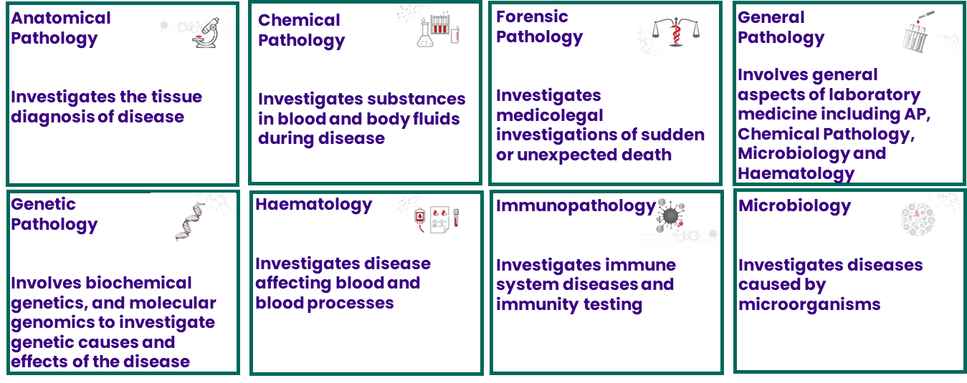
Source: Developed from information on the RCPA website
Senior scientists play a vital role in the functioning of a pathology laboratory and are involved in tasks such as the creation of assays and research and development in both an analytical and clinical capacity. Four pathways available to attain Fellowship with the Faculty of Science (FSc) are summarised in Figure 3.
Figure 3: Pathway to Fellowship with the Faculty of Science
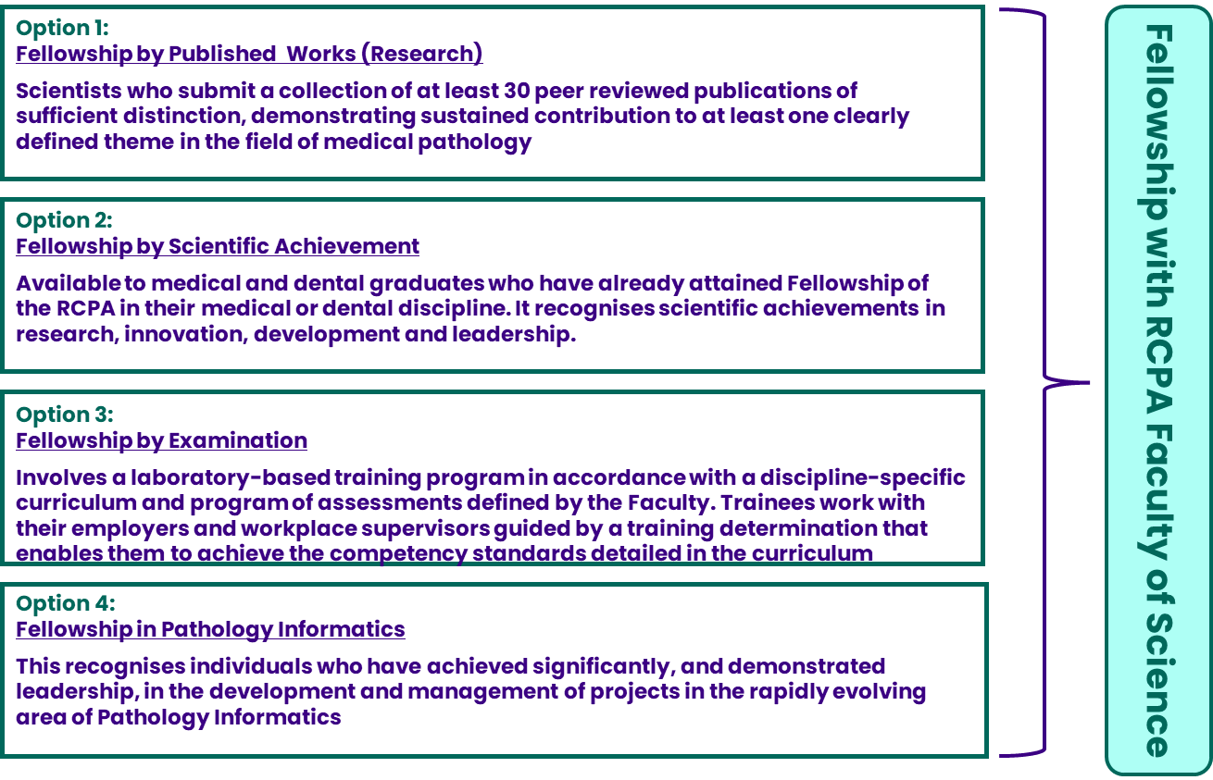
Source: RCPA
Working alongside other health professionals, the roles of qualified and skilled leading pathology scientists include:
- clinical aspects of test selection, interpretation and application
- method development, instrumentation, statistical analysis, quality management, and the business and regulatory aspects of laboratory testing
- understanding of technology and its limitations
- leading and conducting research
- understanding how the storage, transmission and analysis of digitised pathology information is dependent on information technology (IT)
Discussions within this document regarding senior scientists and clinical scientists are limited to only those who have Fellowship with the FSc.

Project scope and objectives
Through this project, RCPA sought to:
- Explore the current state of the pathology workforce in Australia, with a particular focus on its composition, distribution, and future direction.
- Provide insight into the current demand for and supply of pathologists across Australia through extensive consultation with key stakeholders across public and private pathology sectors in both countries.
- Develop two separate workforce projection models over 15-year planning horizons, beginning from 2023 for:
- Australian pathologists by discipline and jurisdictions
- Australian Fellows of the Faculty of Science (FFSc) by discipline and jurisdictions
- Identify recommendations on workforce planning strategies that can address any current or expected future challenges or opportunities.

Purpose and structure of this report
This report presents the outcomes of the work done by this project. It outlines the method and approach, key assumptions and outcomes from the workforce modelling, the agreed preferred options to address workforce issues facing the pathology sector and the associated recommendations.
The structure of this report is as follows:
- Chapter 2 presents the modelling methodology, limitations and key assumptions used to develop the pathology workforce models
- Chapter 3 presents an overview of the current pathology workforce in Australia
- Chapter 4 presents the workforce model outcomes for Australia (for both pathologists and FFSc) and the recommendations that have been developed
- Chapter 5 provides a summary of the recommendations and RCPA's suggested role in progressing the recommendations
- Chapter 6 provides the workforce plan for pathologists in Australia

Methodology
This Chapter describes the methodology used to develop the workforce models for pathologists and FFSc, including the data sources used, key assumptions and limitations.
  - Key points of note
    - Pathology disciplines not included in workforce models
While the Faculty of Clinical Forensic Medicine (FCFM), the Faculty of Oral and Maxillofacial Pathology (FOMP) and the Faculty of Post-mortem Imaging (FPMI) Fellows and Trainees form part of the pathology workforce, it was agreed with the RCPA to exclude these Faculties from the workforce modelling process, due to the small workforce size which would not allow the development of a robust workforce model. However, a review of the current workforce numbers of the FCFM, FOMP and FPMI is included in Section ‎3.1.3.
    - Presentation of Australian workforce capacity modelling results
Although the model allows the dissection of supply, demand and capacity within each Australian State or Territory, the centralised nature of pathology services and the absence of reliable data on cross-border flows of pathologists limits the validity of estimates of over or under-supply in each State or Territory. Modelling of over or under-supply for each discipline is therefore presented at a national level, rather than by jurisdiction. This issue was particularly highlighted in the Northern Territory (NT), where pathology tests are mostly processed in other jurisdictions; thus capacity modelling for the NT is not likely to reflect true supply/demand. It has therefore been agreed with RCPA that no individual model be presented in this report for NT, but the data is included in the whole of Australia model.
  - Overview
The approach adopted to deliver this project is summarised in Figure 4. The project has been completed:
- by conducting an environmental scan
- undertaking a wide range of consultations with key stakeholders including representatives from each discipline, every Australian state and territory, public and private sectors and peak bodies to understand trends, developments and issues that may influence the workforce modelling and workforce planning strategies
- engaging with and seeking input from the RCPA Board, ERGs and State and Regional Councillors; and working closely throughout each stage of the project with the RCPA project team
- gathering, synthesising and analysing quantitative and qualitative data pertaining to characteristics of the workforce
- developing the options for formulating assumptions in the workforce model and seeking input from the RCPA Board, ERGs, State and Regional Councillors, RCPA project team, PPA and PA through a series of workshops
- Developing, testing and refining recommendations on workforce planning strategies to improve the sustainability of the pathology workforce in the future.
Figure 4: Overview of the key steps within the project methodology
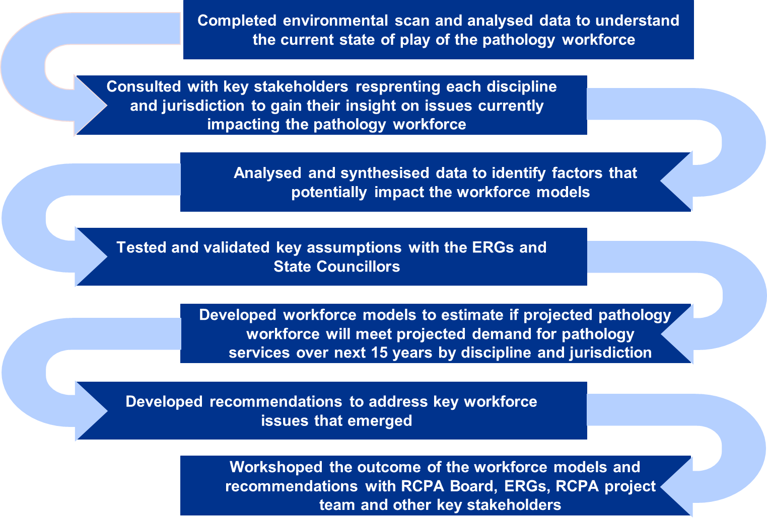
Source: HealthConsult
Two workforce supply and demand models were developed to deliver the scope requested by the RCPA, namely, models focused on:
- Australian pathologists
- Australian FFSc
While a consistent approach has been applied to each model, modifications and differential assumptions have been used across the models to address the identified challenges and issues unique to each cohort. All the key assumptions and variations for each specific model are documented within this Chapter.
The Analysis Plan dated 1 March 2024 details the approach taken to develop the workforce models. It included an overview of all identified data sources and the rationale for selecting them.
Feedback, guidance and input were sought from ERGs on key assumptions used in the modelling. The existing Advisory Committees for each discipline assumed the role of the ERGs for this project. The assumptions developed to address gaps identified in the data were presented to relevant ERGs.
Additionally, online and offline feedback was sought from various expert stakeholders when required to address specific issues across disciplines or sectors.
  - Demand modelling
The following presents the approach adopted to model demand for pathology services from 2023 to 2037.
    - Data sources
For Australia, only Medicare Benefits Schedule (MBS) data could be obtained, as efforts to obtain data on public pathology volumes were not successful due to sensitivities surrounding the release of this data. This limitation was also encountered in the RCPA’s 2018 workforce modelling report. MBS data is mostly (although not exclusively) representative of pathology services delivered to private patients in a private setting or private patients in a public hospital and may not capture work undertaken in public laboratories. Advice was sought from the ERGs regarding data adjustments to make the estimated demand more representative of both the public and private sectors. A detailed examination of the data sources identified and the reason a source was selected for use within the models can be found in the Analysis Plan dated 1 March 2024, which is a separate document.
MBS data was extracted by jurisdiction to allow further analysis to be undertaken at a state and territory level. However, it should be noted that MBS data assigns geographical location based on the postcode of the patient, and not the location where the test was conducted (see Section ‎2.3.3 Representative Demand).
    - Demand modelling approach
Focusing on the MBS data, HealthConsult worked with the RCPA to agree on the relevant in-scope pathology groups within the MBS to be included for demand modelling. Historical data from 2015-16 to 2022-23 was extracted from Services Australia’s Medicare Item Reports and analysed. A data cleansing process was undertaken. A summary of the MBS groups included and the mapping to RCPA disciplines can be seen in Figure 5.
Figure 5: Mapping of MBS Pathology Groups to RCPA pathology disciplines for modelling
MBS Group | Pathology discipline
MBS Group | AP | Chem | Foren | General | Genetic | Haem | Immuno | Micro
G1: Haematology
G2: Chemical Pathology
G3: Microbiology
G4: Immunology
G5: Tissue Pathology
G6: Cytology
G7: Genetics
NB: Chem = Chemical, Foren = Forensic, Haem = Haematology, Immuno = Immunopathology, Micro = Microbiology; for pathology disciplines where there was no specific correlation to an MBS group, a combination of MBS groups was used based on advice from RCPA; Forensic used the total of all MBS groups, General Pathology used 50% AP (G5 Tissue and G6 Cytology) and 16.67% each of G1 Haematology, G2 Chemical Pathology and G3 Microbiology. Noting that there may be some cross-over between MBS groups and pathology disciplines
For Forensic Pathology and General Pathology, there was no direct correlation to specific MBS data. After discussion with RCPA, it was agreed to use the following demand assumptions for these subspecialties:
- Forensic Pathology: the total demand trend for all disciplines was used as the representative trend for modelling purposes. There are no MBS item codes for this discipline as the work undertaken is on deceased persons.
- General Pathology: representative demand was agreed to be a weighted combination of 50% AP and 16.67% each of Haematology, Chemical Pathology and Microbiology, as this was expected to be representative of a typical mix of services provided by a General Pathologist.
The historical time series data was then used to complete an initial demand forecast for the period from 2024 to 2037 using Microsoft Excel’s exponential triple smoothing (ETS) algorithm. The algorithm considers seasonality, trends, and errors in the data to provide a more accurate forecast. The model was adjusted to ensure any forecast of negative integers was assumed to be constant at zero, and there was some data smoothing applied for outliers during years affected by COVID-19 (2020-22), particularly in Microbiology. Data smoothing used the historical pre-COVID-19 linear trend line to estimate demand during 2020-22, via Excel’s linear forecast based on 2016-2019 MBS data.
    - Key assumptions and limitations
The following summarises the key assumptions and limitations applied to the demand model. These assumptions were presented and agreed upon with the RCPA project team and ERGs.
Representative demand
The measure of demand, based on historical service provision, presented in the model is a representative figure only and is not intended to be the actual number. The changes in MBS services over the past eight years reflect changes in private patient billing for relevant pathology-related items determined to be in scope and do not include services provided by doctors to public patients in public hospitals.
Based on advice from stakeholders and ERGs some adjustments were made to the demand data to counter the limitations noted, these included:
- The composition of the total representative demand for pathology services in Australia was assumed to be 50% public and 50% private.
- For public demand, an additional 6% per annum was added to represent the increase in workload volumes that were reported during consultations to be experienced by the public laboratories.
An additional limitation in the use of MBS data relates to the jurisdiction (i.e. state or territory) breakdown of MBS data, as this is determined according to the address (at the time of claiming) of the patient to whom the service was rendered. This is a limitation associated with this MBS data, as in reality there is a high level of cross-border flows of pathology tests, and it may be more robust to view demand at an Australia-wide level rather than state-by-state. To acknowledge the potential variation in demand forecasting, demand estimates were tested via sensitivity analysis (see ‎Appendix A.1.).
Current unmet demand
There is no definitive measure of existing unmet demand within the pathology sector, or for a specific discipline (although it is commonly accepted that there is a shortage of pathologists in most disciplines, which was reinforced during consultations). Given the absence of a quantifiable measure of unmet demand, a conservative assumption has been made that there is no unmet demand in the workforce in the historical years from which future demand has been projected. This means that current unmet demand will be built into the model forecasts. Survey data provided information on current unfilled vacancies across the pathology workforce, but this may not necessarily equate to measurable demand. Analysis of current unfilled vacancies for Australian pathologists has been provided in Chapter ‎3, and a 5% increase in demand to test this potential effect is presented in ‎Appendix A.1.
COVID-19
COVID-19 caused large changes in health service utilisation patterns in Australia, including pathology services. There were notable variations in demand for pathology testing over this period, particularly for Microbiology where significant demand increases were observed due to COVID-19-related testing (+36.4% between 2019-20 and 2020-21, and +67.2% between 2020-21 and 2021-22). As such, COVID-19 potentially resulted in some anomalies in the pathology demand data that would impact the subsequent demand forecast if it was not adjusted.
The demand for Microbiology was methodically adjusted by testing the variance in compound annual growth rate (CAGR) between historic data (2016 to 2023) and forecast data (2023 to 2030). Where the variance was greater than 3.0% (indicating an inflated forecast), historic outliers between 2020-21 and 2022-23 were smoothed using Excel’s linear forecast.
Therefore, demand modelling is based on MBS data from July 2015 to June 2023. While the impact of COVID-19 has been considered during the modelling process, ultimately the model includes COVID-19-affected data. The limitations associated with using this data in the forecasting model should be noted when considering the outcomes of the model.
  - Supply modelling
The following presents the approach adopted to modelling pathology workforce supply for both pathologists and FFSc.
    - Supply modelling approach
The supply side of the model adopts a Markov ‘Stock and Flow’ approach, taking the baseline stock (noting that the ‘stock’ refers to the current supply) for each model (i.e. either pathologists or FFSc for Australia) and modelling the probability of flows in and flows out of the workforce to predict future supply at five-year intervals.
Inflows are the number of new entrants that the model assumes will join the pathology workforce, that is newly qualified Fellows either via:
- attaining Fellowship after completion of domestic training, or
- SIMG pathway.
Outflows are the number of people in the current pathology workforce that the model assumes will leave for several reasons including:
- retirement
- attrition for other reasons such as career changes.
Figure 6 summarises this Markov modelling methodology.
Figure 6: Summary of the Markov ‘Stock and Flow’ model
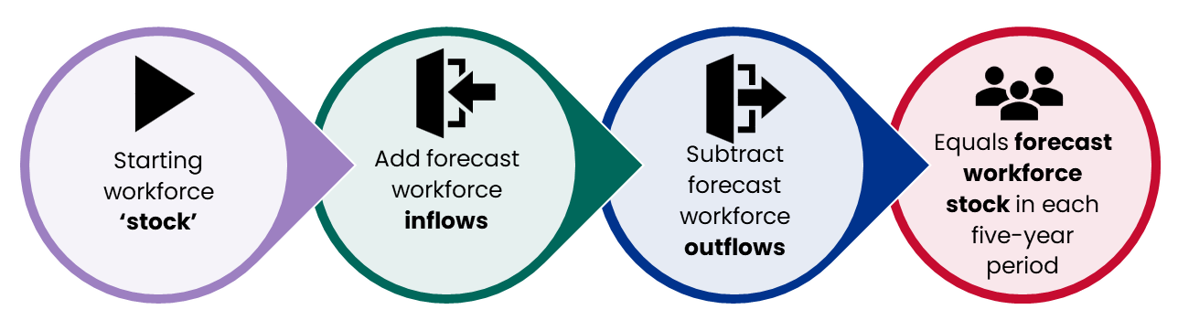
Source: HealthConsult
Within this report:
- ‘stock’ is used to refer to the existing pathology workforce and
- ‘supply’ is used to refer to the anticipated future pathology workforce.
    - Data sources for supply modelling
Multiple data sources were examined and assessed in the development of each component of the supply modelling. These included:
- Data provided by RCPA
- RCPA database: provided baseline current stock and retirement data for pathologists and senior scientists in Australia by discipline and jurisdiction from 2011 to 2022 in five-year age brackets and by gender. All data was on a headcount basis.
- KPI Board of Education and Assessment (BEA) reports: reports provided by RCPA that included data on the number of new Fellows by discipline by year for a five-year period. The data provided was on a headcount basis.
- National Health Workforce Dataset (NHWDS): for FTE pathologists by discipline and jurisdiction for the period 2013 to 2022 in 15-year age brackets. No data on senior scientists is available within this dataset. There is some data on education and training from 2017 to 2018 and retirement intentions from 2021 by 10-year age bracket.
There were a few other sources that were found and reviewed to potentially use for data on the pathology workforce including the Australian Health Practitioner Regulation Agency (Ahpra) and the Australian Bureau of Statistics (ABS). However, the RCPA database and the NHWDS contained the required breakdown of the workforce by discipline and age and therefore were the preferred data sources. At the request of the RCPA, FTE data was used in the modelling, where possible.
The data sources ultimately used for each component of supply modelling are summarised in Figure 7, distinguishing between where full-time equivalent (FTE) and headcount (H/C) data have been used. For further detail on the data sources considered and why the following have been chosen, please refer to the Analysis Plan dated 1 March 2024, (which is a separate document).
Figure 7: Summary data sources used for supply modelling
 | Australian pathologists | Australian FFSc
Starting workforce i.e. ‘stock’
NHWDS (FTE)
RCPA data (H/C)
Inflows
RCPA KPI BEA reports (H/C) for avg no. of new trainees
Outflows
RCPA data (H/C) retirements
NHWDS = National Health Workforce Dataset; H/C = headcount; FTE = full-time equivalent
Source: HealthConsult
    - Key assumptions and limitations
The following summarises the key assumptions and limitations applied to the supply models.
Base pathology stock and the use of FTEs
The NHWDS data was used for the Australian pathologist model, which is based on FTE. In consultation with RCPA, this was determined to be the most reflective measure of the current workforce, as there is a relatively high proportion of pathologists with joint qualifications, especially Haematologists who may only work a small fraction of their overall time in laboratory work.
However, for stock and flow modelling, some adjustments were required to be made to the Australian pathologist model:
- Age in the NHWDS was only available in 15-year age brackets, so to estimate age in more granular five-year brackets, total FTEs were taken from the NHWDS and proportioned according to the RCPA’s five-year age brackets.
- There was no current inflow data (i.e. new Fellows entering the workforce) available from the NHWDS (most recent data was five years old and did not have the required level of granularity). Therefore, inflows were estimated using the RCPA’s headcount data, which was then converted to FTE to be consistent with the base stock data. A conversion rate for headcount to FTE was derived for each discipline by applying the proportion of the NHWDS FTEs to headcount from the RCPA Fellows database, for the current stock. This ratio was then applied to the new Fellow figures for each discipline to estimate inflows on an FTE basis. The exception was Genetic Pathology where FTEs were not available from the NHWDS, so the average conversion rate across all pathology disciplines was used.
- It was deemed more robust to use actual historic outflows (i.e. retirements and attrition) rather than retirement intentions from the NHWDS. Thus, outflows were determined as a rate of retirement in each age group based on the RCPA’s database of actual retirements from 2017 to 2023, which were applied to the model as rates. Therefore, retirements did not require the same FTE adjustment as inflows.
For the other model (Australian FFSc), this is not a consideration as the base stock, inflows and outflows were all in headcount.
New entrants
- The expected future number of new entrants for pathologists in each discipline in the Australian model has been held constant, based on the average number of new Fellows over the past five years, as agreed with RCPA. This is due to the fluctuation in new trainees over the previous years.
- The number of new entrants for FFSc in the Australian model has been held constant, based on the average number of new Fellows over the past five years by discipline, as agreed with RCPA. This is due to the fluctuation in new trainees over these five years.
Retirements
Future retirement rates are based on the actual retirement data for the past five years (2017 to 2023), provided by RCPA. There was a data cleansing process undertaken as some Fellows had multiple retirement dates listed. Advice was sought from the ERG, and it was agreed that the current retirement patterns are likely to continue, however an increase in retirements in the future is tested via sensitivity analysis (see ‎Appendix A.3). The proportion of retirements between 2017 and 2023 within each five-year age bracket was then derived and applied across the two models as follows, as agreed with RCPA:
- Australian pathologists: the total retirement rate by five-year age bracket for all Australian pathologists was applied in five, ten and 15 years across each discipline.
- Australian FFSc: total retirement rate by five-year age bracket for all Australian FFSc applied in five, ten and 15 years across each discipline.
Career breaks
No reliable data on career breaks could be obtained. As a result, career breaks are assumed to ‘balance out’ in the model, i.e. those leaving for career breaks are equal to those coming back in from career breaks.
  - Capacity modelling
The following outlines how demand and supply were brought together to analyse the capacity of the workforce and identify whether potential shortfalls may arise in future. The process of bringing demand and supply together to estimate over or under-supply is referred to as ‘capacity modelling’, as it describes the expected level of capacity that currently exists (for oversupply) or the level that would need to be created to meet demand (for under-supply).
    - Capacity modelling approach
Demand and supply were brought together by determining the average number of units of demand (i.e. services provided) undertaken by each pathologist or FFSc per year in recent years. Demand is then divided by supply to determine ‘workforce capacity’ for each year. For most disciplines, the average workforce capacity for the past six years (2017 to 2022) was calculated and taken to represent the number of service units that each pathologist could reasonably undertake each year into the future. The average capacity was then multiplied by the forecast supply to determine the likely future throughput of the workforce. The gap between the likely throughput (for the forecast supply) and the throughput from the demand forecasting allows the estimation of over or under-supply of pathologists, assuming the historical level of productivity (work units per pathologist) is maintained. There were, however, some exceptions based on ERG advice, listed below:
- Across the two models, stakeholders advised that the past measures of capacity would not be reflective of the future capacity for AP and Genetic Pathology, due to an increase in test complexity (i.e. time required per patient/test) in recent years. Advice on the level of variation in capacity was sought from ERGs. Thus, for these disciplines, the most recent year of actual data (2022) was taken as the baseline capacity, with an additional complexity factor applied from 2023 onwards (see ‎2.5.2 below for further detail).
- For the Australian pathologist model, advice was received regarding joint qualifications for Haematologists. We were advised that there is a higher proportion of Haematologists obtaining dual qualifications with the Royal Australasian College of Physicians. While this results in more Haematologists, on average a Haematologist is proportionally working less time in laboratories, which was consistent with the monotone decreasing trend in the ratio of FTE to headcount seen in the data. Advice was sought from ERGs that confirmed that this pattern was expected to continue over the next five years. Therefore, the most recent year of actual data (2022) was taken as the baseline capacity, with an additional factor for reducing laboratory hours applied from 2023 to 2027 (see ‎2.5.2 below)
- For the Australia FFSc models, the average of the past five years from (2018 to 2022) has been used, as an above-average increase in new FFSc occurred from 2017 to 2018, distorting capacity figures. Therefore 2017 has been excluded from the capacity calculation.
The estimated workforce over or undersupply is the difference between the throughput of pathologists/FFSc estimated to be required to meet the projected demand and the throughput of pathologists/FFSc projected based on workforce capacity at a given point in time.
The model ultimately demonstrates workforce gaps (shortages or surpluses) arising where additional (estimated undersupply) or fewer (estimated oversupply) pathologists/FFSc are required.
    - Key assumptions and limitations
The section looks at the assumptions and limitations in relation to capacity analysis. For some disciplines, assumptions have been modified to reflect discipline-specific ERG advice on recent trends and likely future trends, based on the ERG’s expert knowledge.
Capacity assumption for AP
Consultation with stakeholders flagged the impact growing complexity is having on capacity in AP, where the work volume per patient was reported to be increasing. This was tested with the ERG, and it was agreed that an assumed increase in complexity of 20% would occur over the next 15 years. This adjustment was applied by reducing the volume (capacity) of services an AP delivers per year, by 1.3% from 2023 to 2037 (i.e. 20% spread over 15 years).
Capacity assumption for Genetic Pathology
Consultation with stakeholders also highlighted the impact growing complexity is having on the capacity of Genetic Pathologists, where the volume of work per patient is also increasing. This was tested with the ERG, and it was agreed that the complexity issue needs to be factored into Genetic Pathology quicker than AP, with an adjustment of 20% over the next five years deemed appropriate. This adjustment has been applied by reducing the volume (capacity) of services a Genetic Pathologist processes per year, by 4% from 2023 to 2028 (i.e. 20% spread over five years), after which time the volume stays at this reduced 20% from 2028 to 2037.
Capacity assumption for Haematology
The advice provided by the Haematology ERG on the impact of the increasing number of Haematologists obtaining dual qualifications suggested the trend of working fewer hours in the laboratories is likely to continue over the next five years. A factor of 1.4% reduced laboratory time (a linear forecast from the historic reductions) has been compounded each year from 2023 to 2027, after which the ratio of time spent in laboratories by Haematologists has been assumed to stabilise.
Future changes in capacity
The model assumes that the pathology workforce is ‘in balance’ at the level of the historical average i.e., the past workload and productivity of pathologists are assumed to be the required and achievable level in the future. The most recent data (2022) could have been used to reflect the most recent workloads, however, COVID-19 fluctuations place limitation on the utility of this approach. Even with demand adjustments, there was a 3% increase in units of work per Australian pathologist from 2018-19 to 2019-2020, followed by a 1.9% decrease between 2020-21 and 2021-22, and then a 5.4% increase from 2021-22 to 2022-23. Assuming the workforce is in balance based on average historical workforce capacity aims to ‘even out’ these variations. Note that this aligns with the 2018 report, which also had inbuilt unmet demand in the baseline data.
In reality, workload and/or productivity will change over time, with stakeholders pointing to a potential decrease in workload in future as pathologists reported a desire to work fewer hours than historically. Therefore, changes in workload have been included as a sensitivity analysis (see ‎Appendix A.4).
  - Sensitivity analysis
Sensitivity analysis is the alteration of key model parameters to see how sensitive the model is to changes in these variables. Sensitivity analysis has been undertaken as part of the workforce modelling to test the robustness of the models and is presented in ‎Appendix A. Each variation is presented as a scenario that provides an alternative model outcome for the future pathology workforce needs compared to the base case. The scenarios and the magnitude of variation have been informed by publicly available literature, consultation feedback, and RCPA and ERG advice.
  - HealthConsult methodology compared to KBC Australia 2018 report
The prior review of the pathology workforce was undertaken for the RCPA by KBC Australia in 2018. There are several important differences in the modelling approach that should be borne in mind when comparing the results of KBC’s modelling and those presented in this report. In summary:
- the KBC results were reported in headcount, whilst HealthConsult results for Australian pathologists are reported in FTE as requested by the College.
- Data sources used to identify the base workforce ‘stock’ were different. The NHWDS was used to derive the base workforce ‘stock’ in this review, as it was agreed that this was the most complete and reliable source of up-to-date FTE pathology data. However, the base workforce stock used in KBC’s model was derived from headcount data sourced from an RCPA member survey.
- HealthConsult’s model methodology differs from KBC’s in several important ways. The main differences are:
- KBC used the CAGR of MBS services to predict future demand. This is an increase at a constant rate of 3.8% per annum for Australia overall. HealthConsult has used an exponential smoothing algorithm, which results in a CAGR of approximately 2.4% (but this fluctuates across time periods).
- HealthConsult used the historical rates of trainees obtaining Fellowship to estimate future inflows. It is not clear from their report how KBC modelled inflows.
- It seems that KBC assumes 100% of the workforce over 65 years will retire by the time they turn 75 years, whereas HealthConsult has calculated the historical probability of a pathologist retiring for each age group and used this to estimate future outflows.
- As per ERG advice, HealthConsult has included complexity adjustments of up to 20% for AP and Genetic Pathology. This change has been modelled by increasing the pathologist's time required to deliver those tests. HealthConsult has also reduced the proportion of time worked in laboratories by Haematologists. Both changes result in a decrease in pathologist's time available to process pathology work and therefore the HealthConsult model predicts greater workforce shortages than would be the case if these adjustments were not made.
With any modelling, a longer forecast period typically means greater levels of variation, as patterns in the historical data are embedded into the projections. So, while the actual numbers of the workforce model are not comparable, the outcomes contain the same message, i.e. there is a shortage in the pathology workforce that is growing and will continue to worsen unless changes are made. A detailed comparison of the two approaches is summarised in Table 2.
Table 2: Comparison of modelling methodology between the KBC 2018 report and HealthConsult in 2023-24
Model component | KBC method | HealthConsult method
Demand | For the two demand scenarios:  - High demand scenario: historic annual MBS test volumes used as a measure of demand, with average compound growth used as the basis to project future demand, with a specific weighting for AP  - Low demand scenario: historic growth in workforce size was used as a measure of demand, with the average growth rate applied to project future demand.  No data on public demand or service volumes could be obtained. | Historic annual MBS test volumes used as a measure of demand, input into Excel’s ETS forecast to estimate future demand levels. Modifications were made to the historical data for known anomalies such as the impact of COVID-19 on test volumes for Microbiology. Adjustments were made to capacity assumptions for known and anticipated changes in service delivery.  No data on public demand or service volumes could be obtained.
Supply - baseline stock | Headcount data from the RCPA database was used for all models.  A descriptive analysis of hours worked and jointly qualified pathologists for each discipline was included in the Australian pathologist model. | FTE data from the NHWDS was used for the Australian pathologist model. Headcount data from the RCPA was used for the Australian FFSc model.
Supply - inflows | It is not entirely clear what the assumptions supporting this section of the KBC models are, however, it seems new Fellows enter each model at an aggregate level (i.e. no age assumption for when new Fellows enter the workforce). | Examined the past numbers of trainees and new Fellows in each discipline and assumed the historical average of new Fellows entering the workforce each year would continue. New Fellows enter the model within five-year age brackets, based on the historical age at which trainees obtained Fellowship.
Supply -outflows | Determined the number of pathologists or FFSc over 65 years of age, and assumed they will all retire in the next ten years. | Determined the retirement rates for each five-year age group based on the actual retirements for the past five years, and assumed the rate of retirement within each age bracket would remain constant over the next five, ten and 15 years.
Capacity and complexity | Weighted MBS services were used for AP (Tissue Pathology and Cytology) using Relative Time Units, to reflect the complexity of tests in the discipline. | After ERG advice, adjustments were applied to reflect the increased complexity of testing impacting both AP and Genetic Pathology. A 20% complexity factor is phased into both disciplines: AP is phased in over 15 years, and Genetic Pathology is phased in over five years.  There is also a 1.4% per annum adjustment to reflect the anticipated reduction of average hours worked for Haematologists from 2023 to 2027, as the trend in the growing number of joint appointments is expected to continue during this period.
Source: KBC Australia report, Pathologists and Senior Scientists Workforce Modelling, Final Report, July 2018 and HealthConsult work

Overview of the current workforce
This Chapter presents a high-level overview of the current pathology workforce in Australia for both pathologists and FFSc, looking at composition by dimensions including jurisdiction, discipline, age and gender. For further analysis, see Environmental Scan (13 October 2023), a separate paper.

Australian pathology workforce
The following section presents an overview of the pathologist and FFSc workforce in Australia, including current workforce numbers and composition across disciplines, states and territories and other demographic information where the available data allows. The survey data relates to the Workforce Review Project for Pathologists, Trainees and Senior Scientists Vacancy Survey 2023 (‘the survey’).

Overview of the current pathologist workforce in Australia
Discipline overview
Analysis of data provided by RCPA shows that the number of pathologists in Australia has grown by 284 (14% in total, or 2.8% per year) since 2017 on a headcount basis, from 1,999 to 2,283 pathologists in 2022 (Figure 8). This represents 1,472 FTE pathologists according to the NHWDS.
Key discipline-related trends identified were that:
- AP accounts for almost half of all pathologists in Australia, although growth in AP (9.6% between 2017 to 2022) was lower than the overall growth for pathologists.
- Haematology was the fastest-growing discipline in Australia, having grown 27% between 2017 and 2022.
- the number of General Pathologists declined by 16% between 2017 and 2022.
Figure 8: Fellows in Australia by discipline (2017 to 2022)
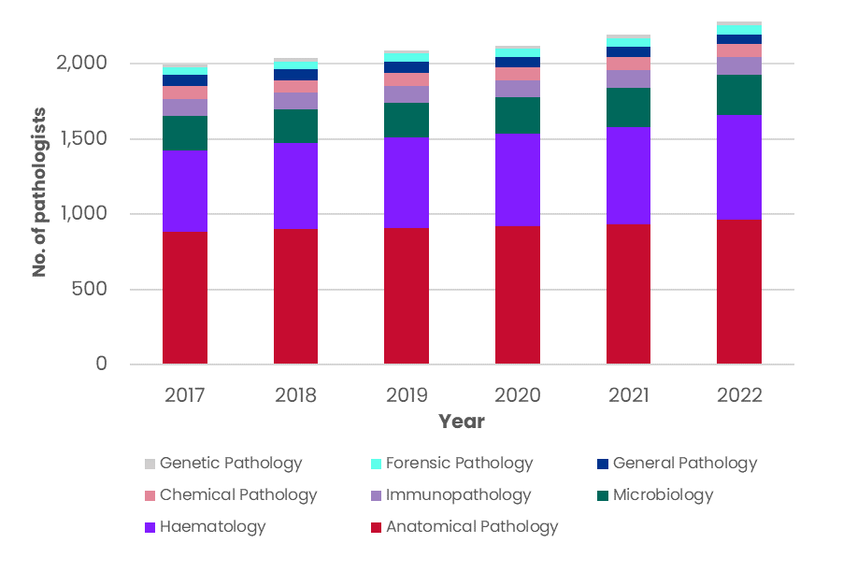
NB: the above data is headcount
Source: RCPA Fellows data, 2017-2022
Figure 9 shows that the number of trainees in Australia has not seen the same growth, with an increase of 0.6% or by a headcount of three between 2017 (544 headcount trainees) and 2022 (547 headcount trainees). This is negligible, especially given the level of growth in demand over the same period. AP had the most trainees with 235 in 2022 (43% of total trainees), followed by Haematology with 178 trainees and Microbiology with 59 trainees. General Pathology had the fewest trainees with four in 2022 down from six in 2017, and Genetic Pathology had the highest growth between 2017 and 2022, increasing by 433% or from three trainees to 16 trainees.
Figure 9: Trainees in Australia by discipline (2017 to 2022)
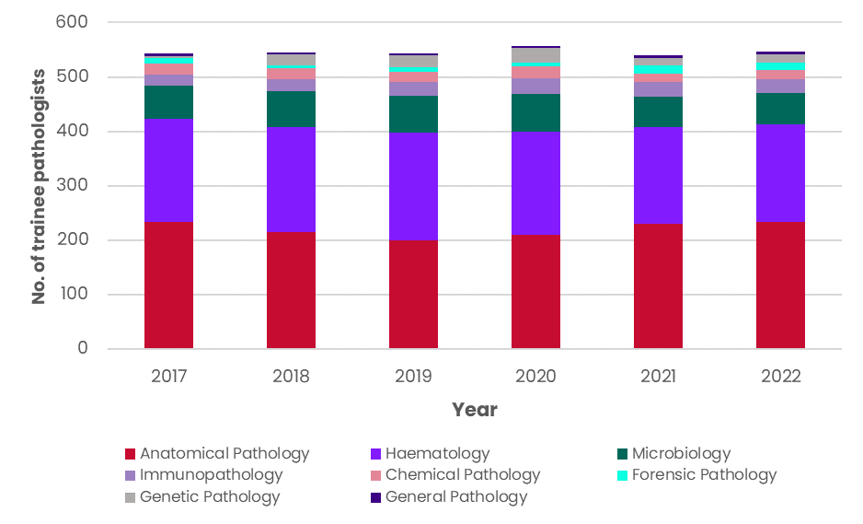
NB: the above data is headcount
Source: RCPA Trainees data, 2017-2022
Age and gender
Figure 10 demonstrates the gender breakdown of pathologists by discipline using headcount, for the most recent year of available data (2022). Among the eight disciplines:
- AP has the highest proportion of female pathologists at 55% (530 pathologists)
- Forensic Pathology is the only discipline other than AP with more female (32 or 52%) than male (29 or 48%) pathologists on a headcount basis, however, female Forensic Pathologists account for 42% of total FTEs
- General Pathology and Genetic Pathology have the smallest proportion of female pathologists (25% or 16 pathologists and 32% or 8 pathologists respectively) on a headcount basis
- Although there were more male than female pathologists by headcount in Haematology (52% male) and Microbiology (51% male), there were more female FTE pathologists in both disciplines, accounting for 55% of total FTEs in Haematology, and 53% of total FTEs in Microbiology
Figure 10: Gender breakdown of pathologists in Australia by discipline, 2022
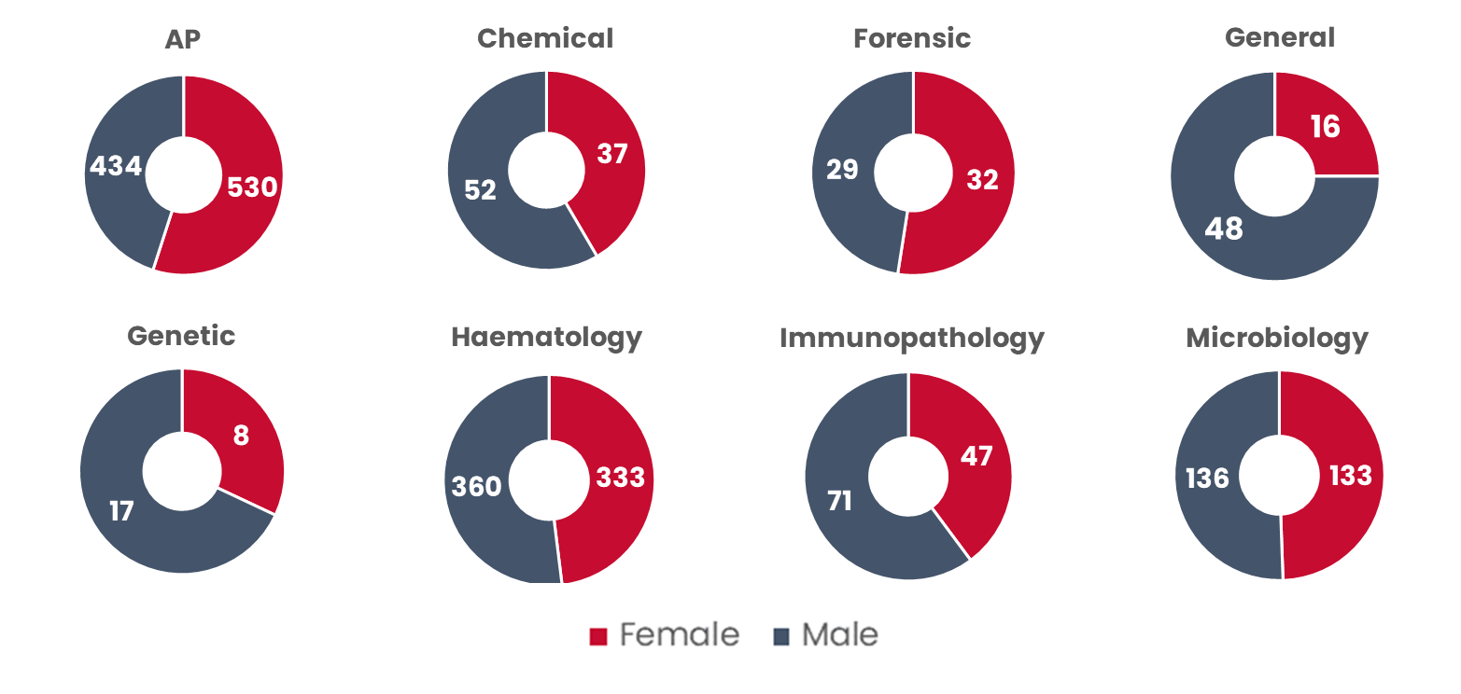
NB: the above data is headcount
Source: RCPA Fellows data, 2022
Figure 11 shows the age breakdown of each pathology discipline. The analysis highlights that:
- General Pathology has the oldest workforce, with 42.2% aged 65 or older, and just 3.2% aged under 40
- Haematology has the greatest proportion of pathologists aged under 35 (6.5%) and between 35-39 (19.8%) but has the smallest proportion aged 65+ (7.7%)
- Genetic Pathology has the second highest proportion of its workforce aged 65+ (24.0%) but also the second highest proportion aged under 40 (20.0%).
Figure 11: Age breakdown of pathologists in Australia by discipline, 2022
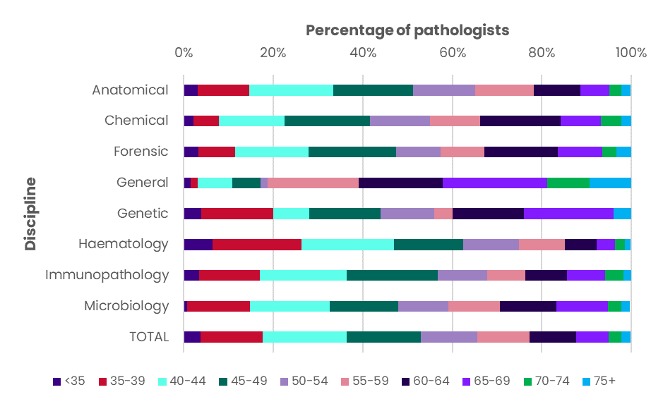
NB: the above data is headcount
Source: RCPA Fellows data, 2022
Jurisdictional breakdown of pathologists and trainees
Figure 12 and Figure 13 demonstrate the trends in pathologists and trainees per 100,000 population of each Australian state and territory, and Australia overall. Analysis of the geographic distribution of pathologists in Australia highlighted:
- significant challenges in the NT, where the number of pathologists increased by only one between 2017 and 2022, and the number of trainees fell by one from four in 2017 to three in 2022. In 2022, the NT had 4.39 pathologists per 100,000 people, which was half the Australian average (8.78 per 100,000 people).
- growth in pathologists from 2017 to 2022 across most jurisdictions except South Australia. Per 100,000 people, pathologists in South Australia dropped from 8.50 in 2017 to 7.91 in 2022. The number of trainees dropped from 2017 to 2022 for NSW (from 2.61 trainees per 100,000 to 2.45, a 6% decrease), Victoria (from 2.13 per 100,000 to 1.93, a 9% decrease), WA (from 1.89 to 1.87, a 1.5% decrease), Tasmania (from 2.84 to 1.75, a 38% decrease) and the NT (from 1.61 to 1.20, a 26% decrease).
- a slight increase in the number of pathologists per capita across Australia, from 8.13 per 100,000 people in 2017 to 8.78 in 2022, but a decrease in trainees per capita, from 2.21 per 100,000 people in 2017 to 2.10 in 2022.
Figure 12: Fellows per 100,000 people in States and Territories and Australia overall (2017-22)
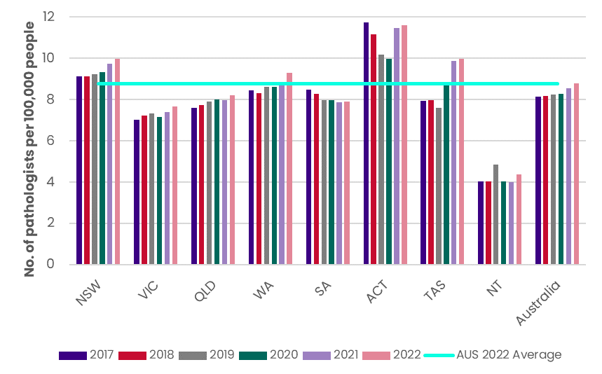
NB: the above data is headcount
Source: RCPA Fellows data, 2017-2022
Figure 13: Trainees per 100,000 people in States and Territories and Australia overall (2017-22)
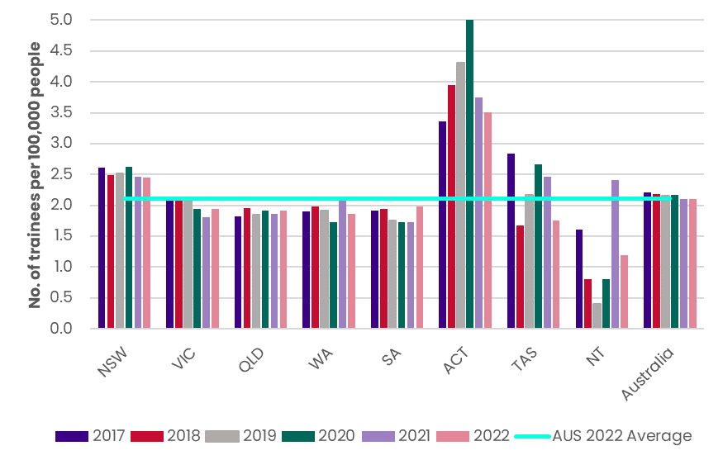
NB: the above data is headcount
Source: RCPA Trainees data, 2017-2022
Figure 14 demonstrates a significant concentration of pathologists (91.8%) in major cities in Australia (i.e., Modified Monash Model (MMM) 1). Noting that this correlates with the centralised model for the delivery of pathology services, with pathology tests for rural and regional patients often being processed centrally.
Figure 14: Pathologists by MMM, 2023
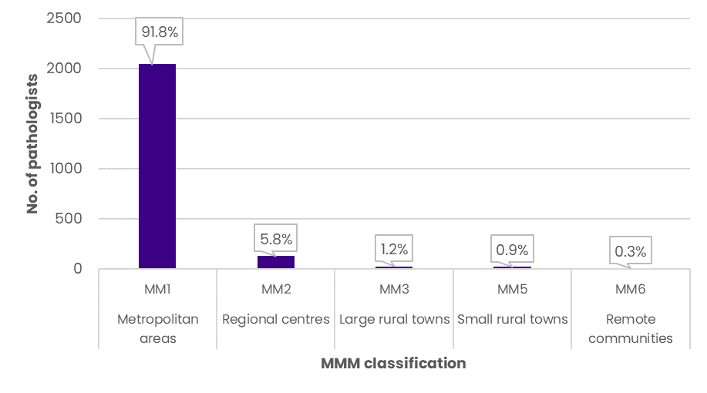
NB: the above data is headcount; there were no pathologists in MMM4 or MMM7 areas. For further information on the MMM see: health.gov.au/topics/rural-health-workforce/classifications/mmm
Source: RCPA provided postcode data, December 2023
Every Australian State or Territory had more public than private pathologists (Figure 15). The NT has the highest proportion of public pathologists at 84.6% public (n=11), 7.7% private (n=1) and 7.7% other (n=1). Queensland has the highest proportion of private pathologists with 36.9% private, 49.8% public and 13.4% other. The RCPA survey results showed a consistent pattern across jurisdictions, with a higher proportion of 60.1% (FTE) of pathologists working in public laboratories, and 39.4% working in private or not-for-profit laboratories.
There were also more public than private trainees according to RCPA data, with 78.2% of Australian trainees based in public laboratories, 21.3% based in private laboratories and 0.5% categorised as “other”. Tasmania (n=8) and the NT (n=3) reportedly had 100% of trainees in public settings, whilst SA (n=38) had 97.4% and the ACT (n=18) had 89% in public settings. Victoria had the most trainees in private laboratories, with 52 or 40% of Victoria’s total 129 trainees in private settings.
Figure 15: Proportion of pathologists in private or public practice by State, 2023
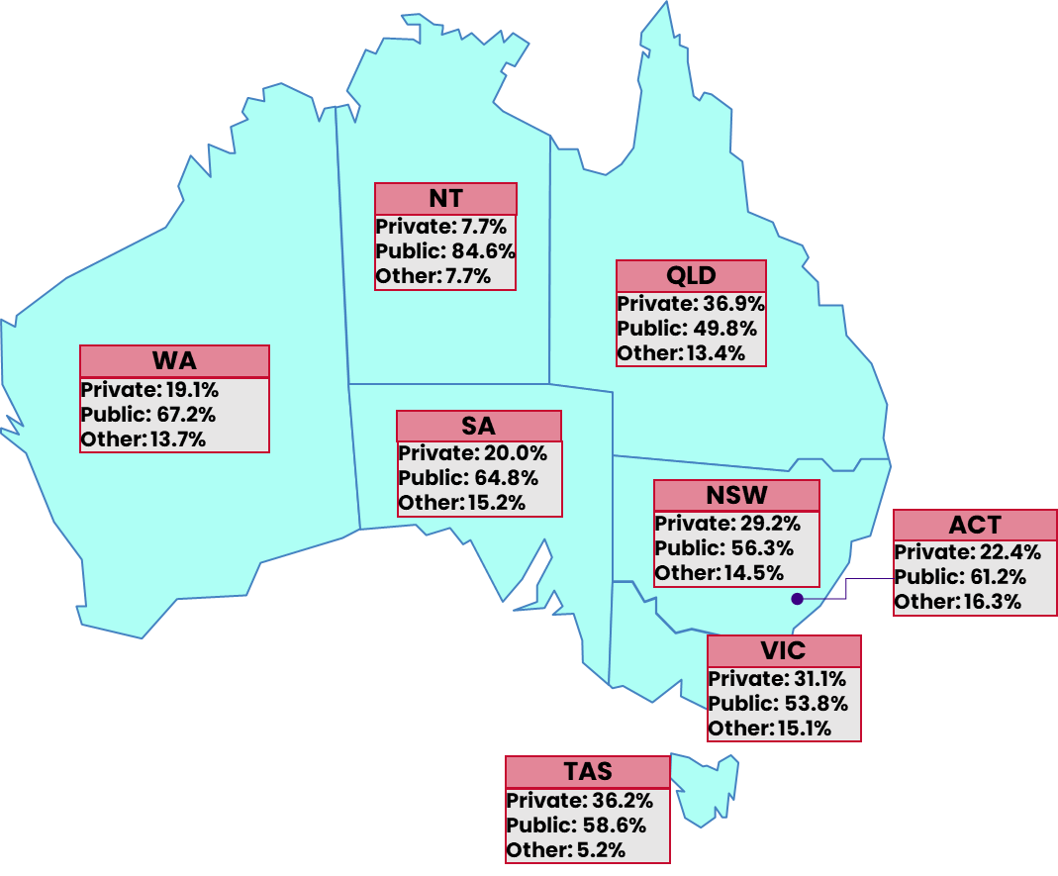
NB: “Private” includes Private and Not-for-Profit, and “Other” includes Research and Other; the above data is headcount
Source: RCPA provided private and public split data, 2023.
Workforce vacancies
As noted in Section ‎2.3.3 there is no current, reliable measure of unmet demand., as while vacancies exist this does not necessarily mean there is a corresponding unmet demand. However, analysing the level of vacancies in established positions does provide some insight into the current state of the pathologist workforce in Australia.
Responses from the RCPA’s survey allow an estimation of workforce vacancies across jurisdictions and disciplines. There were 53 responses collected from Australian laboratories, including an estimated 1,152 FTE pathologists across the country. 39 respondents (74%) identified current or future vacancies in the pathology workforce. Notably, some laboratories did not respond to the survey, and the 1,152 FTE from the survey is 326 FTE or 28% lower than the 1,478 FTE according to the NHWDS. Therefore, the survey may underrepresent current workforce vacancies in some disciplines or jurisdictions.
The survey responses indicated that at the time there were 80 FTE established pathologist positions unfilled across Australia, representing 7% of the total 1,152 FTE according to the survey. This included 30 FTE vacancies in WA (21% of WA’s 142 FTE according to the survey), 21 in Victoria (8% of Victoria’s 254 FTE according to the survey) and 10 in NSW (2% of NSW’s 431 FTE according to the survey) (Figure 16). 74 of the 80 FTE (93%) of established but unfilled positions had been unfilled for longer than three months. AP accounted for over half of the unfilled positions (44 FTE total, 39 FTE for longer than three months), followed by Microbiology (9 FTE total, 8 FTE for longer than three months), Haematology (8 FTE total, all for longer than three months) and Chemical Pathology (8 FTE total, all for longer than three months). The responses estimated zero unfilled positions in Forensic Pathology.
Figure 16: Established but unfilled pathologist positions in Australia by state and discipline
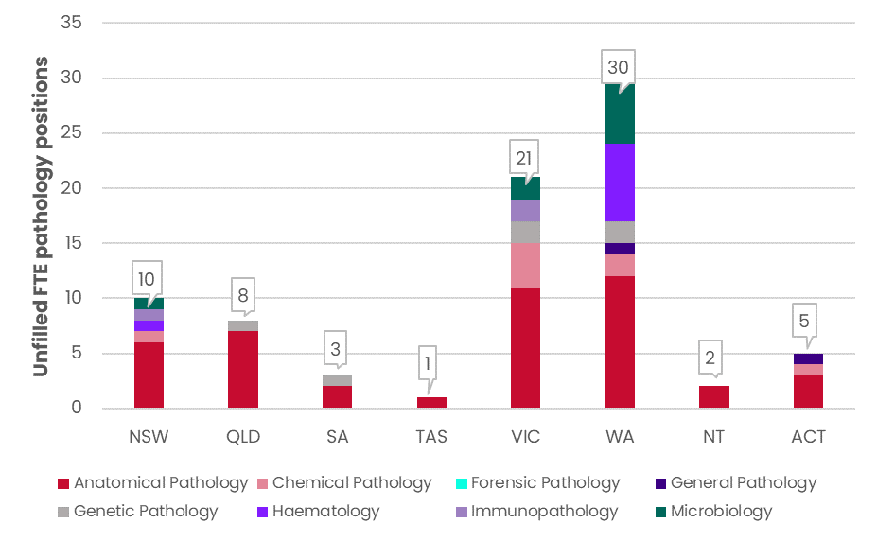
Source: RCPA Survey Australia, question 7
Survey responses regarding the number of additional pathologists required to meet future workload are depicted in Figure 17. The responses estimate an additional 249 FTE pathologists across all disciplines and jurisdictions will be required in five years, which is a 22% increase on the total estimated 1,152 FTE according to the survey. AP was the discipline with the largest number of vacancies (117 FTE) followed by Haematology (37 FTE), Microbiology (27 FTE) and Genetic Pathology (24 FTE). Amongst the states and territories, Victoria required the most additional FTEs with 70 (a 28% increase on the current 254 FTE according to the survey), followed by Queensland with 63 (a 34% increase on the current 187 FTE according to the survey), and WA with 38 (a 27% increase on the current 142 FTE according to the survey).
Figure 17: Additional pathologists required to meet future (5-year) workload in Australia by state and discipline
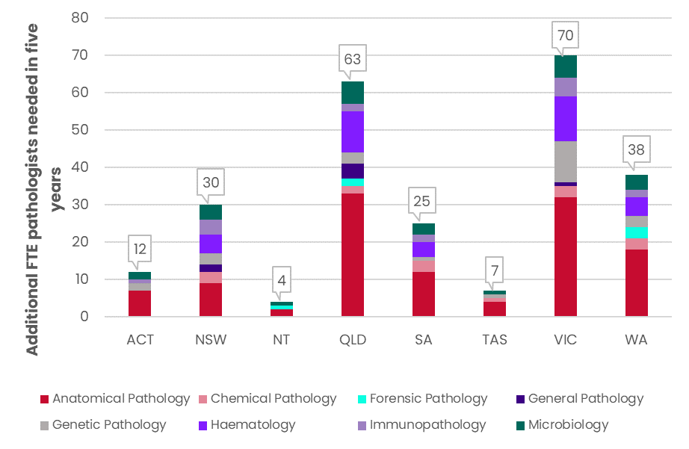
Source: RCPA Survey Australia, question 9
The reasons provided in the survey for vacancies (both current unfilled positions and future additional positions) are shown in Figure 18. The main reason for pathology vacancies in Australia was a shortage of pathologists (39% of responses who identified vacancies), followed by an increasing workload (24%), and no funding (16%).
Figure 18: Reason for pathologist vacancies in Australia
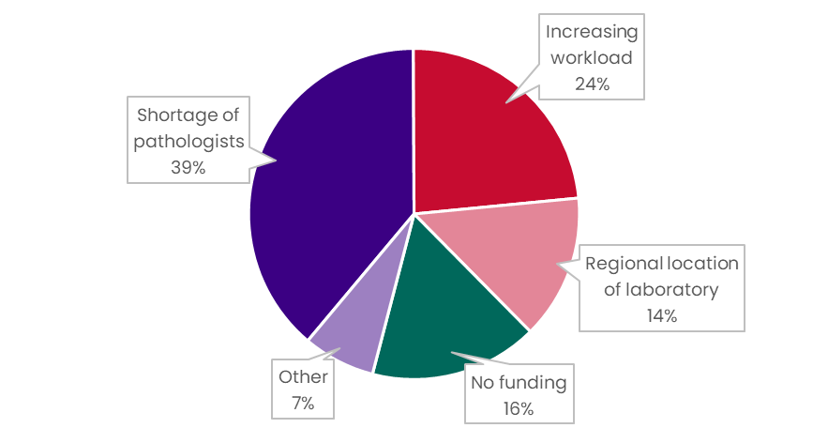
NB: “Other” included: newly budgeted positions that are being advertised, the increasing complexity of work, requirements for overseas pathologists are too strict - only UK grads accepted, change in life work balance with reduced FTE per person, inability to recruit internationally because the exams are seen as a barrier, shortage in highly specialised workforce- paediatric AP, some specialities have difficulty attracting to Canberra/part-time not attractive/competing with clinical load
Source: RCPA Survey Australia, question 10

Overview of the current senior scientist workforce in Australia
Discipline overview
The RCPA survey estimated there were 1,134.2 FTE senior scientists or equivalent roles across Australia’s pathology organisations, however, just 12.6% (143 FTE) of these were reported to have RCPA FFSc recognition or access to the pathway. According to the survey, key findings in relation to these scientists included:
- Disciplines within Australia with the highest number of clinical scientists who meet the NPAAC definition were Genetic Pathology (75 FTE); Microbiology (46 FTE) and Chemical Pathology (37 FTE).
- Disciplines within Australia with the highest number of clinical scientists who have delegated responsibility (under NPAAC) for supervision of specific tests were Genetic Pathology (26 FTE); Chemical Pathology (14 FTE) and Microbiology (7 FTE).
- Disciplines within Australia with the highest number of scientists with RCPA FFSc recognition are Chemical Pathology (38 FTE) Genetic Pathology (37 FTE); and Microbiology (19 FTE).
The below analysis focuses on only those who have FFSc recognition and is based on headcount data only, unless otherwise specified.
According to RCPA data, Fellows in the FSc have increased by 71 headcount or 46% from 155 headcount in 2017 to 226 headcount in 2022, as shown in Figure 19. The discipline with the highest number of FFSc according to the RCPA data in 2022 was Genetic Pathology with 52 headcount FFSc. The number of FFSc in AP doubled from 20 headcount FFSc in 2017 to 40 headcount in 2022. There was also significant growth in Microbiology increasing from 18 headcount (2017) to 33 headcount (2022) senior scientists, an increase of 15 headcount or 83%. The discipline with the lowest number of FFSc was General Pathology, with one FFSc in 2017, increasing to three FFSc in 2022.
Figure 19: FSc Fellows in Australia by discipline (2017 to 2022)
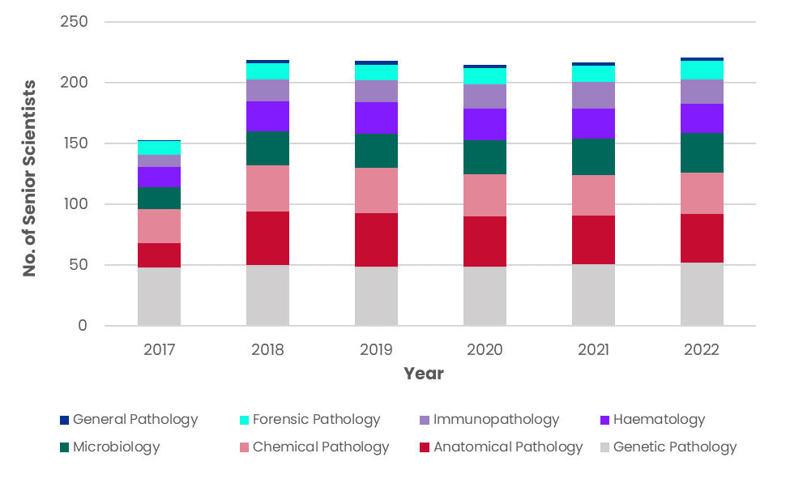
NB: AP includes Cytopathology; the above data is headcount
Source: RCPA FSc Fellows data, 2017-2022
Age and gender
Compared to total pathologists in Australia with 49.8% female and 50.2% male workforce, FFSc in Australia had a much more male-centric workforce, with 29.4% female (n=65) and 70.6% male (n=156) workforce (Figure 20). Every discipline in FSc had more male than female workers; the highest proportion of female scientists occurs in Haematology, with 45.8% female (n=11). General Pathology had 100% male FFSc (n=3), whilst the biggest discipline, Genetic Pathology, had 73.1% male (n=38) and 26.9% female (n=14) senior scientists.
Figure 20: Gender breakdown of FFSc in Australia by discipline, 2022
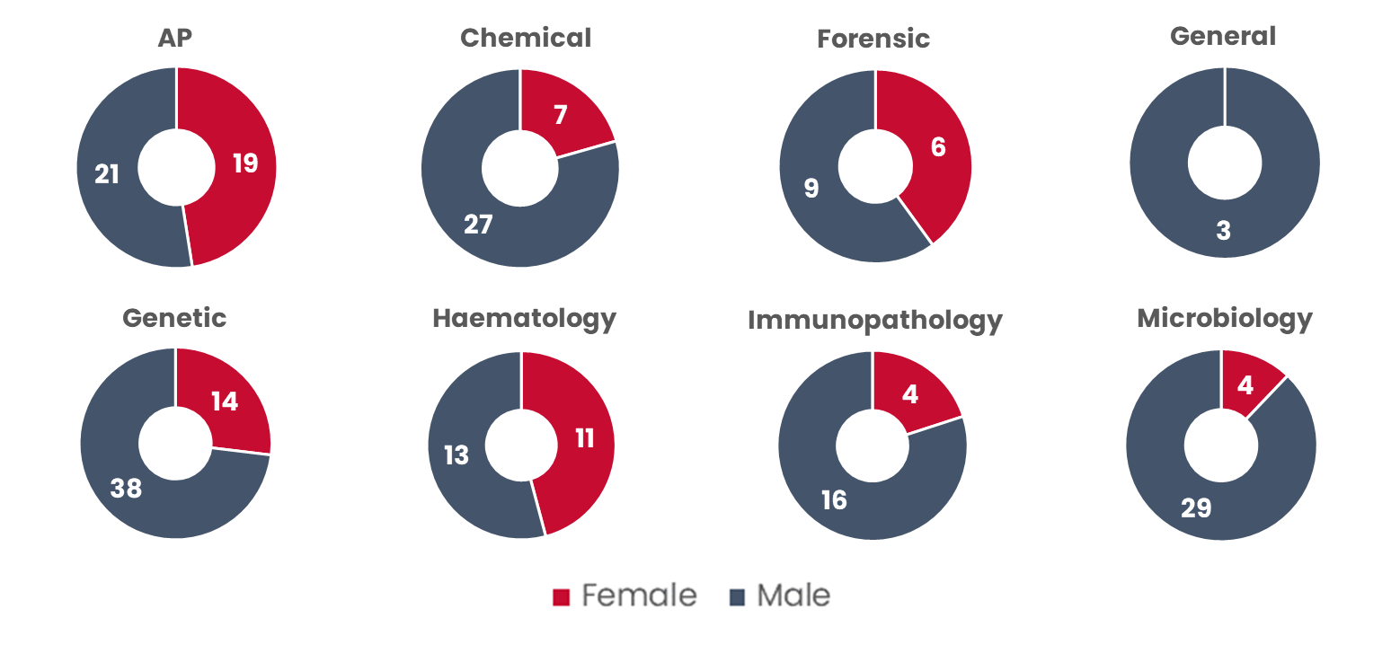
NB: AP includes Cytopathology; the above data is headcount
Source: RCPA FSc Fellows data, 2017-2022
Figure 21 demonstrates the age breakdown of FSc disciplines in Australia in 2022. Immunopathology had the highest proportion of scientists aged 65 or over, with 50.0% of FFSc (n=10) in these age groups. 100% of General Pathology FFSc are 60 or older. Genetic Pathology and Microbiology were the only disciplines with any FFSc under 40 (3.8% and 6.1% respectively).
Figure 21: Age breakdown of FFSc in Australia by discipline, 2022
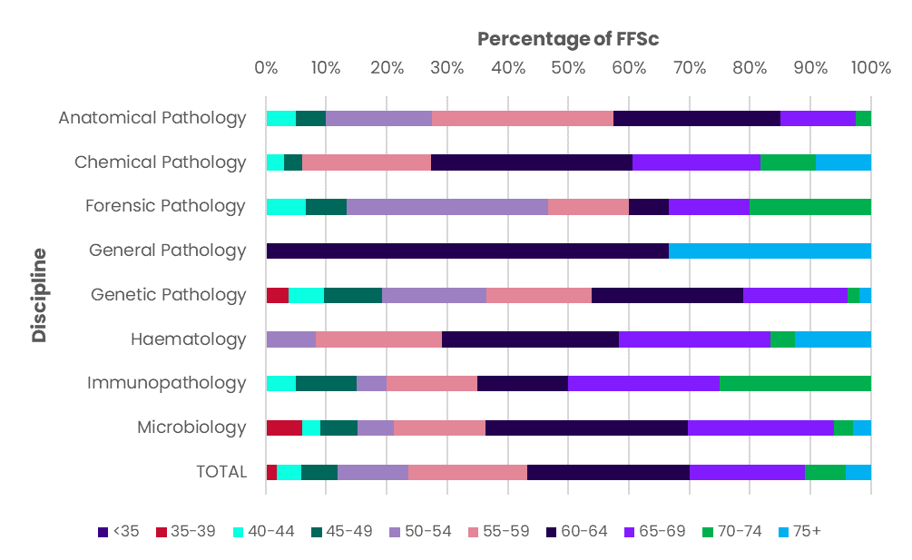
NB: AP includes Cytopathology; the above data is headcount
Source: RCPA FSc Fellows data, 2022
Jurisdictional breakdown of scientists
Within Australia, South Australia had the highest number of FFSc per capita in each of the six years, with 1.83 FFSc per 100,000 people in 2022 (Figure 22). This is more than double the Australian number of 0.87 per 100,000 people.
Queensland recorded the highest growth in FFSc per capita, from 0.30 (2017) to 0.51 (2022) an increase of 67%. Notwithstanding this growth, Queensland still had the lowest number of FFSc per population of any state in Australia (except the NT which had no senior scientists).
Figure 22: FFSc per 100,000 people in States and Territories and Australia overall (2017-22)
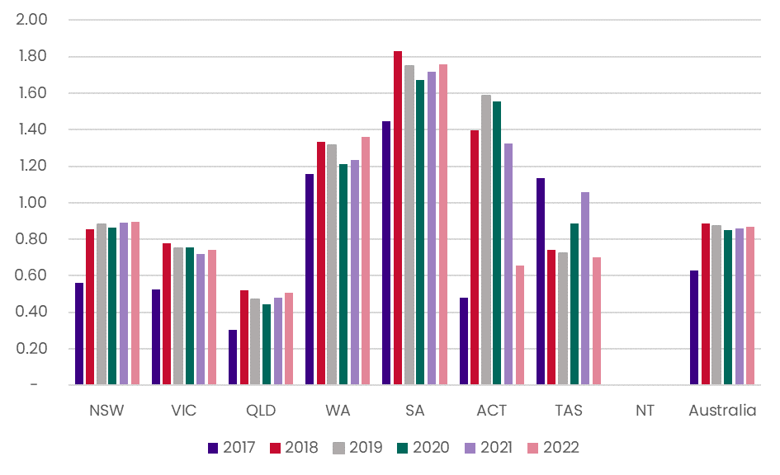
NB: the above data is headcount
Source: RCPA FSc Fellows data, 2017-2022
According to the RCPA survey (noting this includes clinical scientists and senior scientists as well as FFSc):
- 86.8% worked in laboratories in metropolitan areas (985.0 FTEs) (Figure 23)
- 11.0% worked in regional/rural areas (124.3 FTEs)
- 2.2% in outer metropolitan areas (24.9 FTEs)
When looking at the split by sector of senior scientists (or equivalent roles):
- 720.3 (FTEs) or 63.5% worked in public laboratories and 36.5% (413.9 FTEs) were in private laboratories.
- in metropolitan areas, 61.2% were public and 38.8% private.
- rural areas comprised 94.4% public laboratory workers and 5.6% private laboratory workers.
Figure 23: Senior scientists or equivalent pathology-supporting roles in Australia by metropolitan or rural areas, and private or public practice
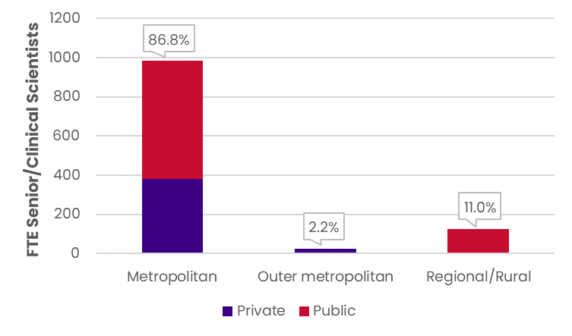
Source: RCPA Survey Australia, question 6
Workforce vacancies
The RCPA survey data included responses from scientists who are not FFSc, as well as FFSc, and thus vacancy analysis has not been included here.

Overview of the current FCFM, FOMP and FPMI workforce in Australia
The number of Fellows in the FCFM and FOMP has been decreasing in Australia since 2017 (Figure 24). Fellows in the FCFM have declined by 12.7%, from 71 in 2017 to 62 in 2022, and Fellows in the FOMP have declined by 25.6% from 39 in 2017 to 29 in 2022.
Figure 24: FCFM and FOMP Fellows in Australia (2017 to 2022)
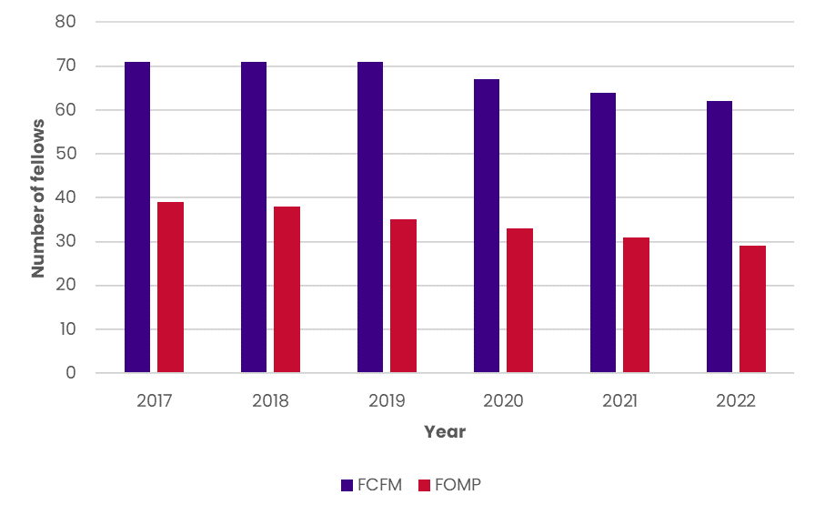
NB: the above data is headcount
Source: RCPA FCFM and FOMP Fellows data, 2017-2022
The gender breakdown of the FCFM and FOMP is illustrated in Figure 25. The FCFM had the higher proportion of female Fellows, at 61.7% female (n=37) and 38.3% male (n=23). The FOMP had 26.7% female Fellows (n=4) and 73.3% male Fellows (n=11).
Figure 25: Gender breakdown of FCFM and FOMP in Australia, 2022
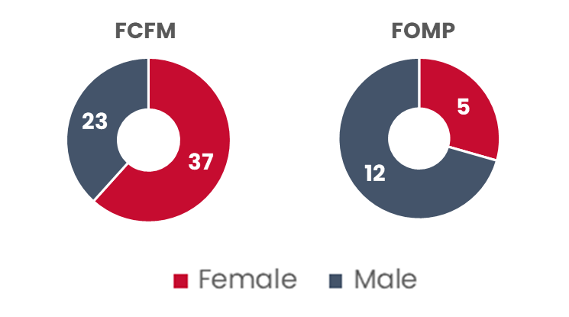
NB: excludes members who have already been captured as pathology Fellows in one of the eight disciplines (Fellow type “FEL”); the above data is headcount
Source: RCPA FCFM and FOMP Fellows data, 2022
Figure 26 shows the age breakdown of FCFM and FOMP in Australia. 13.3% of the FCFM had unknown age (light purple bar, n=8), and 18.3% were aged 65 or over (n=11). The largest age group in the FCFM was the 50-54 group, with 20% of Fellows (n=12). Comparatively, the largest age group in the FOMP was 65-69, with 26.7% of Fellows (n=4), and 53.3% were aged 65 or over (n=8). The FOMP had no Fellows aged under 40, whilst the FCFM had one Fellow under 40 (1.7%).
Figure 26: Age breakdown of FCFM and FOMP in Australia, 2022
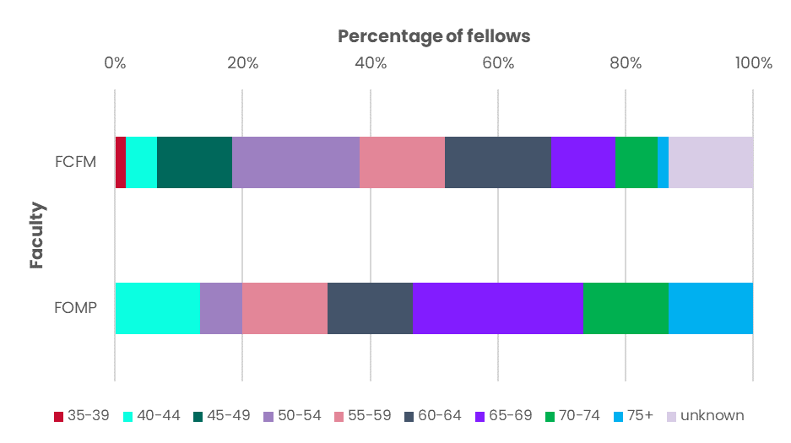
NB: excludes members who have already been captured as pathology Fellows in one of the eight disciplines (Fellow type “FEL”); the above data is headcount
Source: RCPA FCFM and FOMP Fellows data, 2022
The FPMI was established in 2022, with 20 Fellows in Australia in this first year, increasing to 34 in 2023. However notably, many of these Fellows are also qualified as pathologists and thus are included in Section ‎3.1.1; the following analysis excludes these jointly qualified pathologists. In 2024, amongst the remaining 12 Fellows of the FPMI:
- seven Fellows (58%) had unknown gender, whilst three Fellows (25%) were male and two were female (17%).
- nine Fellows (75%) had unknown age, whilst one Fellow was 50-54, one was 55-59 and one was 65-69.
- four Fellows were working in SA (33%) and in Victoria (33%), three fellows (25%) in NSW, and one in Queensland (8%)
- three Fellows (25%) were in the public sector, one (8%) was working in Not-for-Profit and eight (67%) had an unknown status.

Key outcomes – Australia
This Chapter presents the findings from workforce modelling and stakeholder consultations in relation to Australian pathologists overall and by discipline, as well as for the SS workforce. Additional details on modelling outcomes for the pathologist workforce in Australia (including sensitivity analysis) are provided in ‎Appendix A.

Key outcomes of projected future workforce for Pathologists in Australia
Key issues
Currently (as of 2022), there are 2,283 headcount pathologists in Australia according to the RCPA database, or 1,472 FTE pathologists according to the NHWDS. Stakeholder consultations identified broad agreement there is currently a shortage of pathologists within Australia across both the public and private sectors. Shortages are considered critical in some disciplines. RCPA survey data indicates that there are currently 80 FTE funded positions for pathologists vacant in Australia, representing 5.4% of the total 1,472 FTE workforce (using the raw survey numbers, which may not be a full representation of the workforce). One of the noted side effects that emerged from a workforce shortage was pathologists having less time available to train the next generation (due to competing work pressures). Concern was expressed this may impact trainee experience, wellbeing, and work readiness.
To address the workforce shortage there needs to be an available supply of pathologists to enter the workforce. There are two clear sources to increase the physical number of pathologists, including:
- increasing the number of trainees, which requires additional funding and pathologists to provide supervision. Both factors were identified as existing barriers to growing the workforce, and
- increasing the number of SIMGs entering Australia. This would require looking at opportunities to streamline the process for medical specialists trained overseas to be recognised as a qualified pathologist by RCPA. However, noting that there is currently a worldwide shortage of pathologists. Any change in the process must maintain appropriate skill level, orientation and onboarding to ensure the quality of service delivery and patient safety is maintained.
Barriers also need to be considered. Availability of funding was strongly promoted as a key barrier to increasing the pathologist workforce, with funding limitations impacting training numbers, the number of positions available for qualified Fellows and investment in infrastructure.
The lack of indexation for MBS items for nearly three decades is also widely understood to have adversely impacted the pathology sector, as MBS fees paid are the major source of income for private laboratories in Australia. MBS fees also provide income to most public laboratories from services paid by private patients. It is noted that the recent Federal Budget will reintroduce annual indexation for selected pathology services (Haematology, Immunology, and AP service groups) from 1 July 2025. However, the issue remains that the current fees are not likely to reflect the cost of providing each test, due to the stagnation of the fee paid for such an extended period. The impacts of the lack of indexation were reported to be similar to those related to funding for training positions.
The Specialist Training Program (STP) is an initiative of the Australian Commonwealth Government designed to extend vocational training for specialist registrar positions outside traditional metropolitan teaching hospitals, with a focus on training in rural and remote areas and private laboratories.
However, pathology is different to many other medical specialties in that pathologists for most disciplines are often not required to be in the same location as the patient. This is evidenced by most pathology specimens for rural and remote patients being transferred to metropolitan laboratories for testing, diagnosis and reporting. Due to this difference, it is reportedly challenging for RCPA to meet rural pathology training targets due to a lack of appropriate supervision and/or a limited number and complexity of tests performed in laboratories located outside of major cities. STP guidelines prohibit the application of funds to metropolitan positions in the public sector, despite the fact that metropolitan hospitals and laboratories service rural and regional patients, thus affecting the allocation of training positions in public laboratories in metropolitan areas, which are reliant on jurisdictional health budget funding.
The current approach to delivering the best quality training to registrars in pathology contrasts with the Australian Government’s National Medical Workforce Strategy (‘the Strategy’). The approach outlined in the Strategy does not directly apply to pathology, for the reasons that have been outlined above, and additionally, the centralised delivery model of pathology services also results in economies of scale supporting the sustainability of the workforce. The medical workforce, which includes pathology, plays a significant role in the quality, accessibility, effectiveness, and sustainability of the healthcare system. Unfortunately, unequal access to healthcare services is still a major concern. Through the Strategy, the Australian Government is seeking to address these issues through better planning for the future medical workforce.
The Strategy includes five priorities, for action with priority three recognising the need to reform training pathways, including those for pathology specialists (Figure 27). This was also a recommendation of the RCPA’s 2018 Workforce Study, which highlighted the current and future shortage of Australian pathologists and senior scientists.
Figure 27: The vision, themes and priorities of the National Medical Workforce Strategy 2021-31
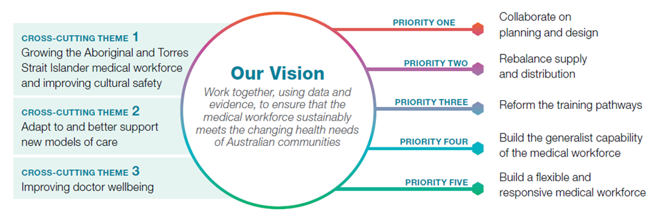
Source: National Medical Workforce Strategy 2021-31
Specific actions that are proposed within priority three are summarised in Figure 28. While some of these actions are proposed for implementation in the short-to-medium-term (two to five years), actions related to increasing specialist training in areas of need (Action 11) and establishing a national pool of training places (Action 12), are only expected to be achievable over the longer term. Further, Actions 11 and 12 may not be directly applicable or practical for pathology training due to the centralised delivery of the specialty.
Figure 28: Actions to support priority three of the National Medical Workforce Strategy 2021-31
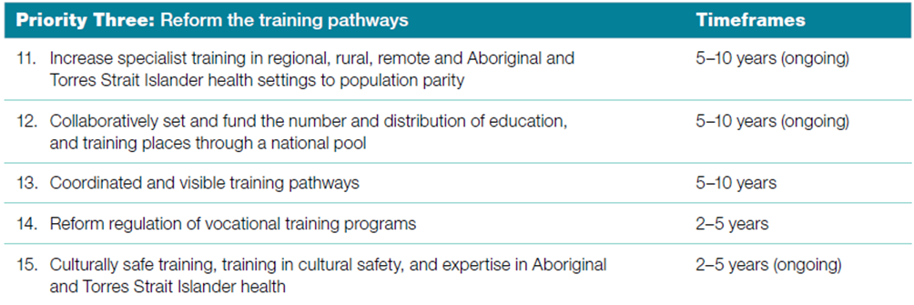
Source: National Medical Workforce Strategy 2021-31
Stakeholders advised that additional investment in positions in the pathology sector is required to redress the current situation in the Australian workforce. This will likely require funding sourced from a combination of Commonwealth and states and territories. This includes investment not only in additional training positions and resources for adequate supervision but funded senior medical officer positions for trainees to transition into once they have completed their training.
Another common theme amongst stakeholders was a perceived need to ‘grow our own’ pathologists. This strategy supports planning for the future, for young pathologists to stay where they have established roots, and to ensure equity in the training burden amongst the jurisdictions (noting that accessing training positions is not the only reason why pathologists move between states and territories). Ensuring the training pipeline within a jurisdiction also supports succession planning was another issue that was raised by stakeholders.
Growing demand and complexity of pathology were highlighted as a key issue during consultations, and this is placing additional pressure on an already stretched workforce. The key drivers of demand and reasons why there is likely to be continuing growth for pathology services included:
- Complexity of testing per patient with the emergence of personalised medicine and the use of genomics
- Increase in population life expectancy which is resulting in more tests overall; particularly as people age
- People having increased life expectancy with multi-comorbidities (e.g. cancer and transplantation patients), proportionally require a higher and more complex level of testing
- Continual introduction of new tests and screening as medicine and technology continue to evolve.
Views on the impact of technology in pathology, including artificial intelligence (AI) and digital pathology, were varied between stakeholders. There was a consensus that while evolutions in technology are inevitable, AI and digital pathology are not anticipated to significantly impact practice within the next decade. As a result, now is the time to research, assess, evaluate, and plan for the future in this space. Most stakeholders viewed technology as a tool to assist and support the pathology workforce, rather than a mechanism to replace the workforce. It is also important to ensure that any decisions or future directions are compliant with relevant standards and legislative requirements.
Multiple stakeholders noted the increasing trend of part-time and fractional work for emerging Fellows, with many seeking greater work-life balance than previous generations (see Appendix ‎A.3). This translates into emerging pathologists wanting to work fewer hours than their predecessors, and an acceptance that they will earn less as a result. This shift in the workforce has broader ramifications, as it means that FTE as a proportion of headcount will reduce over time. Additional management resources will also be needed to manage the increased number of staff.
Other issues specific to each discipline are explored in the section where the outcomes for each discipline are presented.
Workforce model outcomes
Figure 29 presents the outcomes of the workforce model for all pathologists within Australia.
Figure 29: Model outcomes for the total Pathologist workforce in Australia
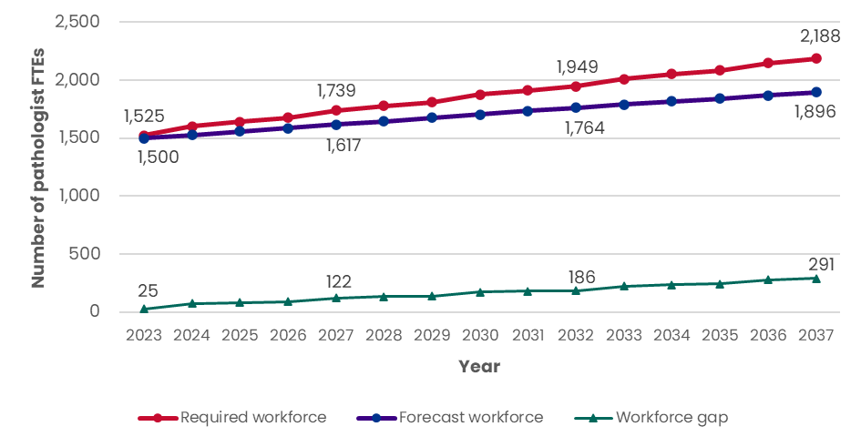
NB: some numbers in the model outcomes may not sum due to rounding
Source: HealthConsult analysis
The current workforce is projected to increase from 1,500 FTE in 2023 to 1,896 FTE by 2037 (+26%). By 2037, the expected number of pathologists required to meet forecast demand is 2,188 FTE, resulting in an undersupply of 291 FTE or 15% above the forecast workforce by 2037. The model shows a growing level of undersupply over the 15-year forecast period, indicating that by 2037 the situation will be worse than the current state unless changes are made to reduce the growth in the anticipated workforce gap.
The survey found that if funding was available there would need to be an additional 249 FTE pathologists over the next five years to meet expected demand within Australia. This is consistent with the modelled outcomes presented in Figure 29, in which the anticipated number of additional pathologists required to meet demand was 239 FTE in 2027 (1,500 FTE forecast compared to 1,739 FTE required in 2027). The greatest regions of need from the RCPA survey data were in Victoria and Queensland.
Stakeholders highlighted that the lack of funding was the largest impediment to training more pathologists and ensuring the ability to provide adequate supervision. Survey data found the most reported reason for vacancies in funded positions was a shortage of pathologists, increasing workload and funding impacting the current for the current state of the pathology workforce in Australia.
Change in trainees numbers required to address the forecast gap
The model currently estimates there will be 65.4 FTE graduating trainees per annum. To address the anticipated shortfall in pathologists in Australia an additional 21.4 FTE trainees would need to be trained each year over the 15-year period, equating to a total of 86.8 FTE trainees required each year. To shorten the timeframe in which the gap is bridged would require an additional 20.7 FTE trainees over 10 years or an additional 31.1 FTE trainees over five years to be trained each year, as shown in Figure 30.
Figure 30: Additional FTE trainees required to bridge the gap for Australian pathologists in five, ten and 15 years
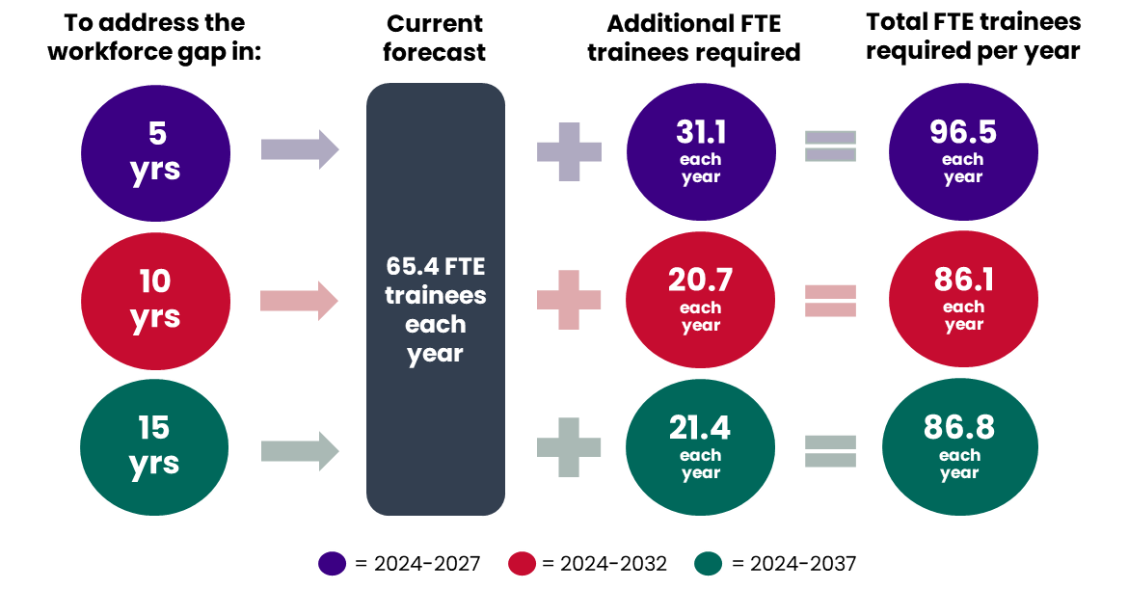
NB: trainee refers to the number of graduating trainees per year
Source: HealthConsult analysis

Projected future Pathologist workforce in Australia, by discipline
The following sections report on the key findings that have been identified for each pathology discipline in Australia throughout the project, including outcomes from both stakeholder consultations and the workforce modelling process.

Anatomical Pathology
Key issues
As discussed in Section ‎3.1.1, AP accounts for nearly half (42%) of all pathologists within Australia and currently is one of the disciplines experiencing the greatest shortages. In many areas, AP shortages were reported to be critical. Currently (2022 data) there are AP trainees in every jurisdiction in Australia. The current level of staffing resources, including both pathologists and trainees, was widely viewed by stakeholders as not being able to meet the level of current demand for AP services. Increasing demand needs to be mirrored with increases in staffing resources, which historically has not happened.
This view is supported by RCPA survey data which showed AP accounted for 55% (44 FTE) of all funded vacancies in Australia, and represents 4.8% (44 FTE vacancies over 919 FTE total AP workforce) of the current AP workforce. Western Australia (WA), Victoria and Queensland had the highest number of current vacancies.
As one of the most labour-intensive pathology disciplines, the challenges associated with limited resourcing are exacerbated for AP, with limited opportunities for support to be provided by FFSc. There were several compounding factors impacting the growing demand for AP noted by stakeholders including:
- increasing demand from a growing population that is living longer
- growing complexity in testing, especially with the diagnosis of some cancers and the application of precision medicine resulting in some patients needing up to 60+ slides
- additional requirements with the introduction of Structured Pathology Reporting of Cancer Protocols
In response to these challenges, some stakeholders suggested that the increasing workload and time pressures on the AP workforce have the potential to adversely affect patient safety by impacting clinical pathways, increasing the risk of misdiagnosis and diagnostic errors. Staff safety and retention issues were also highlighted as risks due to excessive fatigue and ‘burnout’ from high workload.
One stakeholder also flagged that there may be a lack of understanding of the difficulties and impact on the workload of AP by the other medical specialists who request pathology tests. Greater insight and clearer expectations around turnaround times and the need for tissue sampling in selected large specimens may alleviate some of the pressure on AP.
Workforce model outcomes
As discussed, a 20% complexity factor was applied at 1.3% per annum from 2023 to 2037 within the AP model to reflect the decreasing number of tests able to be processed by an AP due to the growing complexity of testing. This complexity factor was agreed upon based on guidance provided by the ERG.
Figure 31: Model outcomes for Anatomical Pathologists in Australia
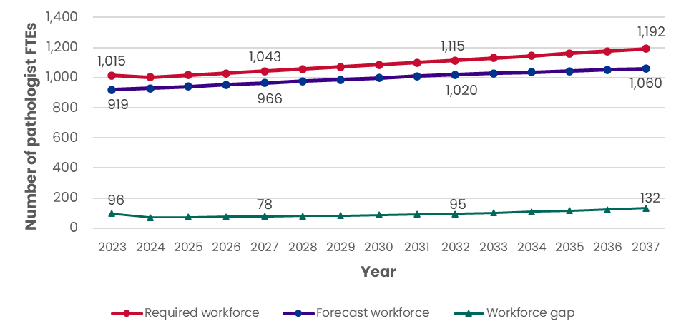
NB: the scales in the workforce model outcome graphs are not consistent across disciplines;
graphs by discipline are not designed to be comparable; some numbers in the model outcomes may not add due to rounding
Source: HealthConsult analysis
The model forecast for AP in Figure 31 shows that the gap in undersupply is growing over time. The projected workforce is anticipated to be 1,060 FTE in 2037, while 1,192 FTE are expected to be required to meet the anticipated level of demand. This results in a workforce gap of 132 FTE for AP by 2037, which is 12% more than the forecast workforce.
The survey found that if funding was available, AP had the highest perceived need for additional pathologists over the next five years to meet anticipated demand at 117 FTE (or 47%) within Australia. This is consistent with the modelled outcomes presented in Figure 31, which estimate the number of additional pathologists required to meet demand to be 124 FTE in 2027 (1,043 required in 2027 compared to 919 the forecast in 2023). The greatest areas of need were in Queensland, Victoria and WA.
Stakeholders highlighted that the lack of funding was the largest impediment to training more APs and ensuring the ability to provide adequate supervision. Survey data found reasons for vacancies in funded positions were a shortage of pathologists, increasing workload and funding.
Change in trainees numbers required to address the forecast gap
The model currently estimates there will be 33.9 FTE graduating trainees per annum. To address the anticipated shortfall in AP in 2037 an additional 10.4 FTE trainees would need to be trained each year over the 15-year period. To shorten the timeframe in which the gap is bridged would require 11.3 FTE over 10 years or 20.7 FTE over five years of additional trainees each year, as shown in Figure 32.
Figure 32: Additional FTE trainees required to bridge the gap in AP in five, ten and 15 years
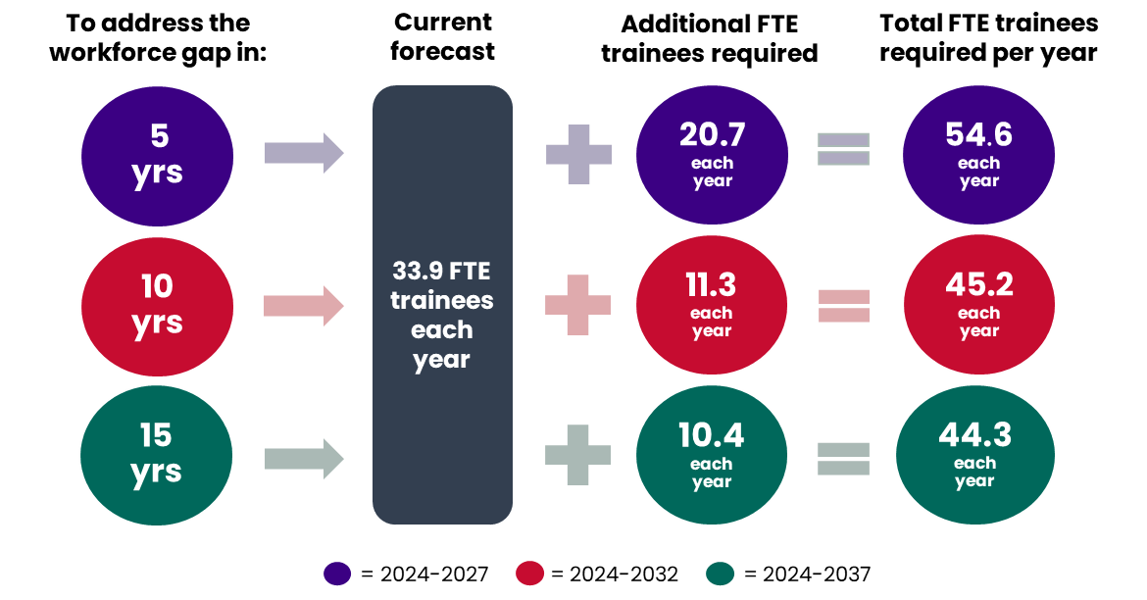
NB: trainee refers to the number of graduating trainees per year
Source: HealthConsult analysis

Chemical Pathology
Key issues
Chemical Pathology represents approximately 4% of pathologists in Australia (see Section ‎3.1.1). Workforce shortages were not considered as significant in Chemical Pathology, however, there were still localised challenges reported by some stakeholders. Cyclical fluctuations were reported in the ability to recruit Chemical Pathologists. Some jurisdictions reported struggling to recruit, while others indicated having a full complement (for the first time in a while) within this discipline.
Most reported that automation of processes has been adopted, which allows for a larger role for FFSc in Chemical Pathology. Currently (2022 data) there are no trainees for Chemical Pathology in ACT, NT or Tasmania
Survey data indicated that there were 8 FTE of unfilled positions in Chemical Pathology. This represents 10% of the total unfilled pathology positions across Australia or 11% (8 FTE vacancies over 72 FTE current workforce) of the existing Chemical Pathology workforce. Most vacancies were reported in Victoria and WA.
Workforce model outcomes
The workforce model outcomes for Chemical Pathology are presented in Figure 33.
Figure 33: Model outcomes for Chemical Pathologists in Australia
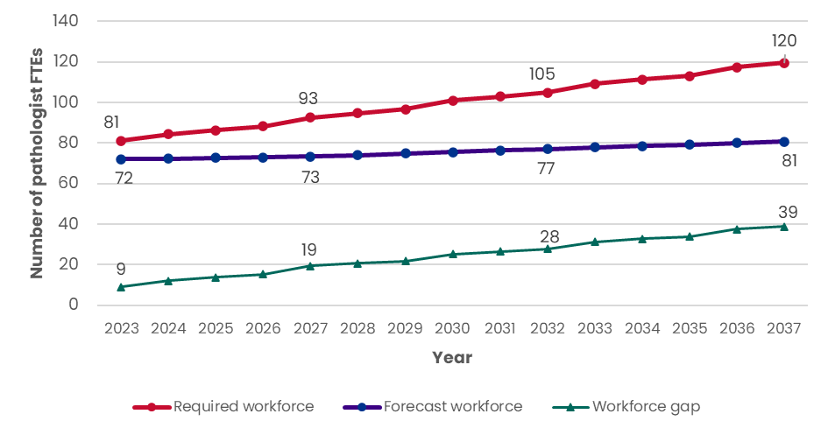
NB: the scales in the workforce model outcome graphs are not consistent across disciplines;
graphs by discipline are not designed to be comparable; some numbers in the model outcomes may not add due to rounding
Source: HealthConsult analysis
The model forecast for Chemical Pathology demonstrates a growing undersupply. The projected workforce is anticipated to be 81 FTE in 2037, while 120 FTE Chemical Pathologists are required to meet the anticipated level of demand. This results in an adverse gap of 39 FTE by 2037, which is 48% more than the forecast workforce.
The RCPA survey data indicated that an additional 15 FTE Chemical Pathologists would be needed to meet future demand over the next five years, spread relatively consistently across jurisdictions. This level of need aligns with the model outcomes, which anticipate by 2027 93 FTE Chemical Pathologists will be required, an increase of 21 FTE over the next five years (93 required in 2027 compared to 72 forecast in 2023).
Change in trainees numbers required to address the forecast gap
The model currently estimates 2.7 FTE graduating trainees per annum. To address the anticipated shortfall in Chemical Pathology in 2037, an additional 3.6 FTE trainees would need to be trained each year over the 15-year period. To shorten the timeframe in which the gap is bridged would require 5.3 FTE additional trainees each year over five years as demonstrated in Figure 34.
Figure 34: Additional FTE trainees required to bridge the gap in Chemical Pathology in five, ten and 15 years
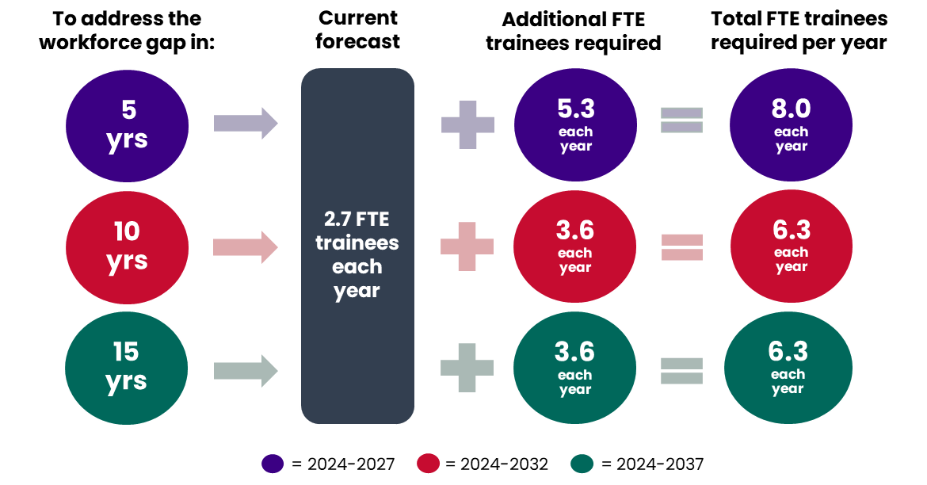
NB: trainee refers to the number of graduating trainees per year
Source: HealthConsult analysis

Forensic Pathology
Key issues
Currently, Forensic Pathologists represent approximately 3% of all pathologists in Australia (see Section ‎3.1.1). Stakeholder consultations highlighted that Forensic Pathology is predominantly a centralised service that is provided mainly in major metropolitan centres, which allows the consolidation of resources and equipment in one location. However, it was flagged that this may change in the future if there is significant growth in regional areas.
Forensic Pathology is unique compared to other pathology disciplines, and although the number of Forensic Pathologists is relatively small, there was reportedly little difficulty in recruiting staff. RCPA survey data indicated that there are no funded vacant positions within Australia for Forensic Pathologists.
However, one stakeholder perceived a shortage of locally trained Forensic Pathologists as currently there are overseas-trained Forensic Pathologists employed in every jurisdiction in Australia because there are not enough locally trained Fellows. It was further noted that not every jurisdiction in Australia has Forensic Pathology trainees. It was reported that South Australia has not had a Forensic Pathology trainee in the last 10 years. Currently (2022 data) there are no Forensic Pathology trainees in ACT, South Australia or NT.
Measuring demand for Forensic Pathology is difficult. As previously described, there is no MBS data for Forensic Pathology and stakeholders advised work volume is not determined by the number of autopsies performed, as there is a significant amount of reporting and paperwork required irrespective of whether a postmortem is undertaken.
Workforce model outcomes
The workforce model outcomes for Forensic Pathology are presented in Figure 35.
Figure 35: Model outcomes for Forensic Pathologists in Australia
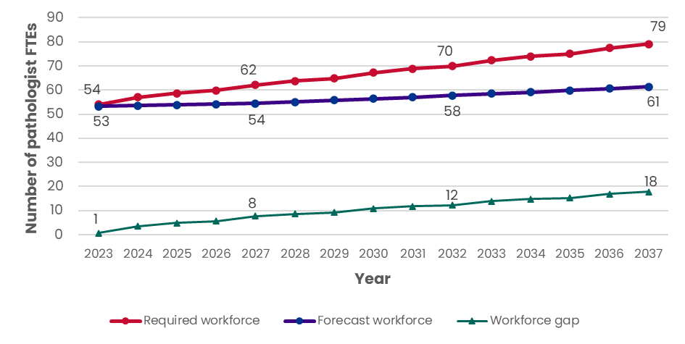
NB: Forensic Pathology demand has been assumed to be 100% public; the scales in the workforce model outcome graphs are not consistent across disciplines, graphs by discipline are not designed to be comparable; some numbers in the model outcomes may not add due to rounding
Source: HealthConsult analysis
The workforce model forecast for Forensic Pathology demonstrates a growing undersupply. The projected workforce is anticipated to be 61 FTE in 2037, while it is anticipated that 79 FTE Forensic Pathologists are required to meet the anticipated level of demand. This results in an adverse gap reaching 18 FTE by 2037, which is 29% more than the forecast workforce.
The survey data indicated that an additional 6 FTE Forensic Pathologists would be needed to meet future demand over the next five years, with a particular need indicated in WA, Queensland and NT. This level of need aligns with the model outcomes, which anticipate by 2027 62 Forensic Pathologists would be required, an increase of 9 FTE (62 FTE required in 2027 compared to 53 FTE forecast in 2023).
Change in trainees numbers required to address the forecast gap
The model currently estimates 2.2 FTE graduating trainees per annum. To address the anticipated shortfall in Forensic Pathology in 2037, an additional 1.5 FTE trainees would need to be trained each year over the 15-year period. To shorten the timeframe in which the gap is bridged would require 2.2 FTE additional trainees annually over five years as demonstrated in Figure 36.
Figure 36: Additional FTE trainees required to bridge the gap in Forensic Pathology in five, ten and 15 years
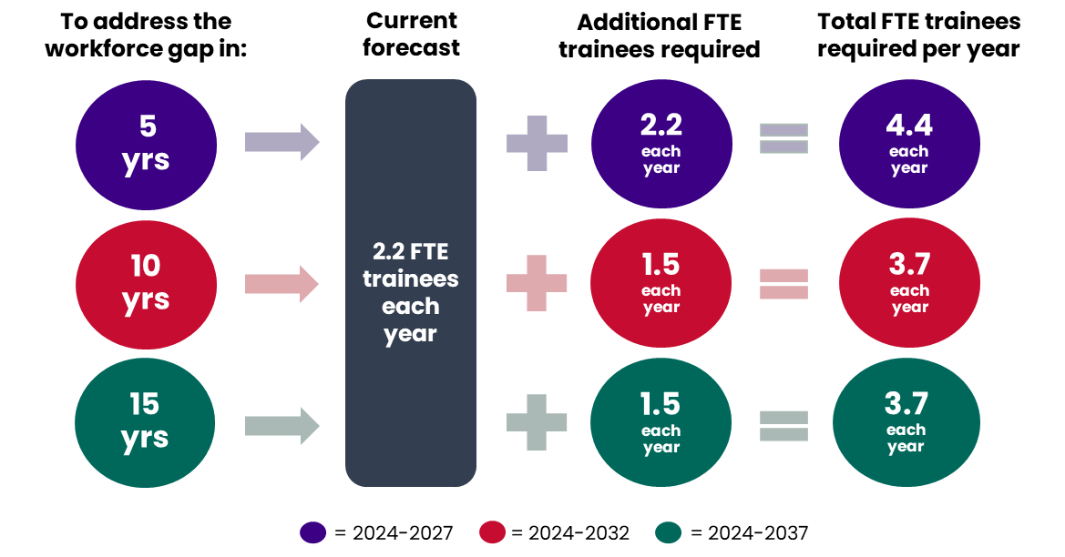
NB: trainee refers to the number of graduating trainees per year
Source: HealthConsult analysis

General Pathology
Key issues
The number of General Pathologists is decreasing, and they currently represent approximately 3% of the pathologist workforce in Australia (see Section ‎3.1.1). General Pathologists have the oldest age profile of any discipline in the pathology workforce (42.2% aged 65 or over in Australia as detailed in Section ‎3.1.1). Trainees within this discipline are decreasing, with most jurisdictions having no trainees in General Pathology. Currently (2022 data) there are General Pathology trainees in only Queensland and Victoria. One of the biggest challenges in training General Pathologists reported was the amount of information required to be imparted to one person. Multiple stakeholders hypothesised that the General Pathologist pathway may not exist in 10 to 15 years.
However, it was noted the important role General Pathologists currently play in ensuring compliance with supervision requirements under NPAAC, especially in rural and regional laboratories. One stakeholder, a General Pathologist, highlighted that Category G laboratories are often too small to have pathologists with specific disciplines to provide the required supervision, making General Pathologists important in this situation.
The RCPA survey reported that there are only two fully funded, unfilled General Pathology positions, one in WA and one in ACT.
Workforce model outcomes
The workforce model outcomes for General Pathology are presented in Figure 37.
Figure 37: Model outcomes for General Pathologists in Australia
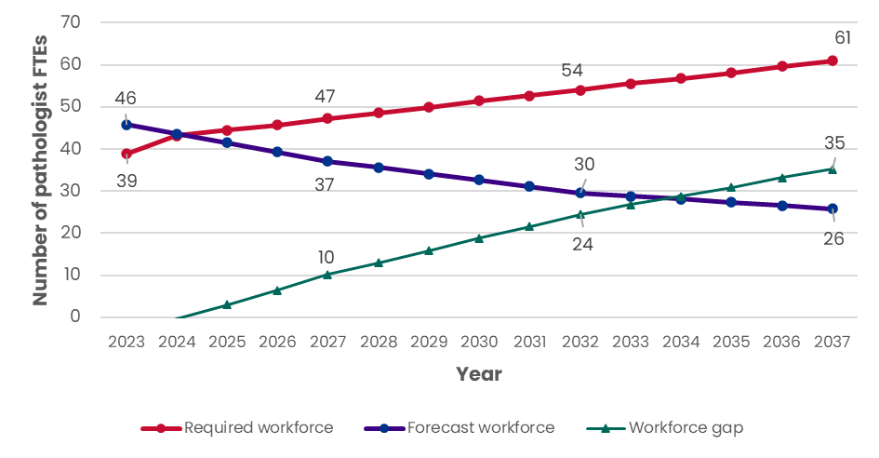
NB: the scales in the workforce model outcome graphs are not consistent across disciplines;
graphs by discipline are not designed to be comparable; some numbers in the model outcomes may not add due to rounding
Source: HealthConsult analysis
The model forecast shows a decrease in the number of General Pathologists from 46 FTE in 2023 to 26 FTE by 2037, while the number needed to meet anticipated demand increases to 61 FTE by 2037. This results in an undersupply of 35 FTE in 2037, which is 137% above the forecast supply of General Pathologists.
The survey data indicated that an additional 7 FTE General Pathologists would be needed to meet future demand over the next five years, with a particular need indicated in Queensland (4 FTE), NSW (2 FTE) and Victoria (1 FTE). This aligns with the model outcomes, which anticipate by 2027 47 General Pathologists would be required, an increase of 8 FTE compared to what is required in 2023 (39 FTE).
Change in trainees numbers required to address the forecast gap
The model currently estimates 0.8 FTE graduating trainees per year. To address the anticipated shortfall in General Pathology in five years, an additional 2.5 FTE trainees would need to be trained each year, as demonstrated in Figure 38. However, imminent retirements in General Pathology would mean that the number of trainees needed to graduate over ten or 15 years will increase, requiring an additional 3.3 FTE trainees over the current forecast, or an increase of 0.8 FTE to bridge the gap in 2032 and 2037, respectively.
Figure 38: Additional FTE trainees required to bridge the gap in General Pathology in five, ten and 15 years
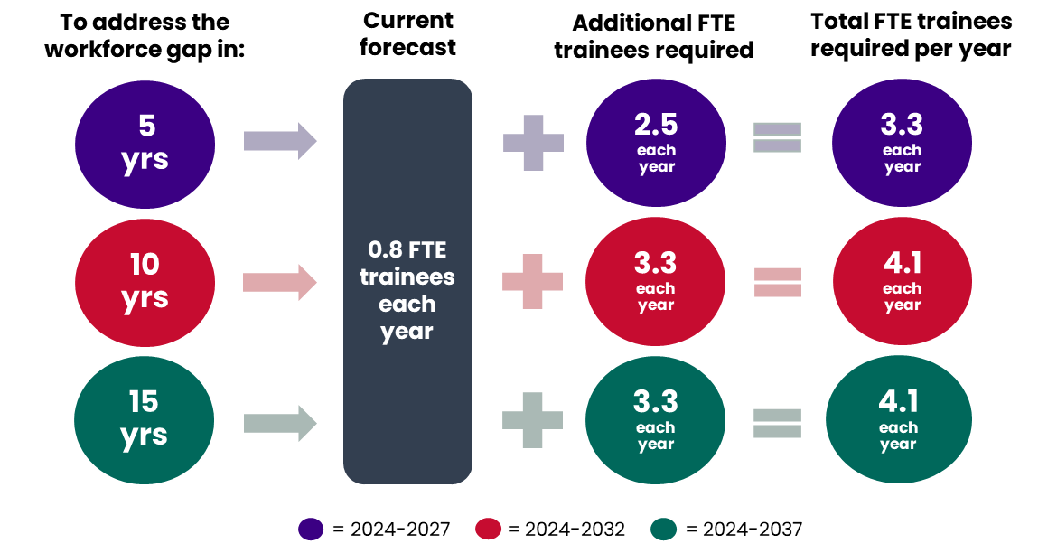
NB: trainee refers to the number of graduating trainees per year
Source: HealthConsult analysis
The decline in the General Pathologist workforce is a significant challenge for RCPA and will require that it examine strategies to change the General Pathology pathway that will entice registrars to undertake this training program. Alternatively, the College could look at different approaches for meeting NPAAC supervision requirements, especially in smaller laboratories in regional and rural areas, in addition to ensuring the sustainability of the future workforce in these areas.
It is noted that the RCPA has previously tried to implement a Clinical Pathologist role that encompassed a smaller number of specialties to try and address the emerging issue within General Pathology. However, this was not successful due to a lack of registrars wanting to undertake this pathway.

Genetic Pathology
Key issues
Genetic Pathologists represent 1% of all pathologists in Australia (see Section ‎3.1.1). Stakeholders widely identified a significant need for more Genetic Pathologists across the system. It was generally reported that the current situation represents a critical shortage. Demand for Genetic Pathology is increasing, and trends are rapidly changing. Governments are reportedly ‘pushing’ precision and preventative medicine particularly in cancer, resulting in more pressure to use genomics in pathology.
Stakeholders flagged that the MBS is not keeping pace with the evolution of tests within genetics and genomics, which is forcing patients to self-fund tests that are not listed on the MBS. This results in some patients who require a test not being able to access it. It also impacts pathologists who spend considerable time preparing MBS submissions to have items added to the MBS. This dynamic also speaks to the latent demand for genetic testing that is not ‘visible’ through the MBS.
The emergence of new (and often increasingly complex) tests is also driving demand for Genetic Pathology. To reflect this a 20% complexity factor was applied at 4% per annum from 2023 to 2027 within the Genetic Pathology model, to reflect the decreasing number of tests that can be processed by a Genetic Pathologist due to their increasing complexity. This complexity factor was included based on guidance from the ERG.
Molecular Pathology and its intersection with genetics in most other disciplines was also raised as an issue. This creates the challenge of upskilling and extending the scope of practice of the existing pathologist workforce, as well as ensuring Molecular Pathology training is incorporated into the general curriculum for the Fellowship pathway across all disciplines. These measures will be required to ensure that the next generation of pathologists has the Molecular Pathology skills required to meet demand.
Currently (2022 data) there are no Genetic Pathologist trainees in ACT, NT, Tasmania or WA. Concern was raised that one-off funding accessed through the STP specifically to fund seven Genetic Pathologist training positions was due to expire in 2025. This would reduce the number of training positions beyond 2025 unless an additional source of funding was secured. One stakeholder informed that they had nine applicants for Genetic Pathology training, demonstrating the level of interest in the discipline, but inadequate funding to be able to support the training positions.
The survey data indicated that 6 FTE funded positions are vacant, representing 8% of all funded vacancies within Australia, or 26% (6 FTE vacancies over 23 current workforce) of the existing Genetic Pathologist workforce. The main reason provided for the vacancies was the shortage of pathologists to fill the roles emphasising the critical shortage that currently exists in this discipline.
Workforce model outcomes
The workforce model outcomes for Genetic Pathologists are presented in Figure 39.
Figure 39: Model outcomes for Genetic Pathologists in Australia
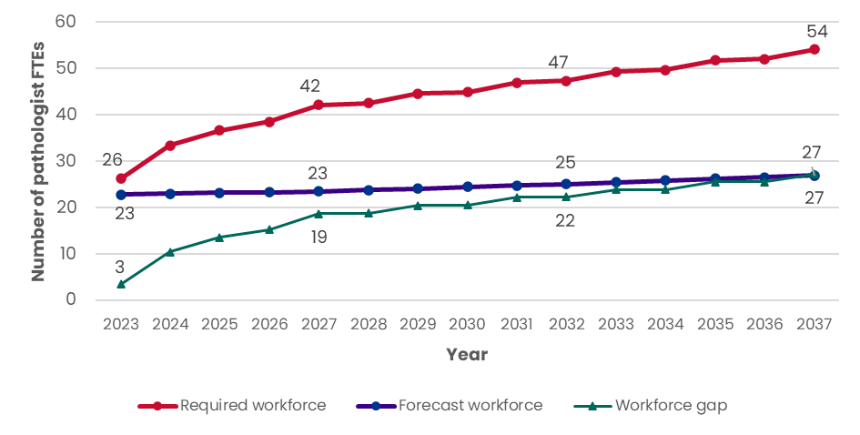
NB: the scales in the workforce model outcome graphs are not consistent across disciplines;
graphs by discipline are not designed to be comparable; some numbers in the model outcomes may not add due to rounding
Source: HealthConsult analysis
The model forecast anticipates that the shortage of Genetic Pathologists will increase over time. The projected workforce is anticipated to be 27 FTE in 2037, while 54 FTE Genetic Pathologists are expected to be required to meet the anticipated level of demand. This results in a gap of 27 FTE by 2037, which is a 101% increase in the forecast supply.
According to RCPA survey data, if funding was available, an additional 24 FTE Genetic Pathologists would be needed to meet future demand over the next five years. This represents a 141% increase in the current reported workforce. Additional positions would be needed in all jurisdictions, but most notably within Victoria which reported 11 FTE required within the next five years. This level of need is higher than the forecast supply under the workforce model assumptions, which anticipate 42 FTE Genetic Pathologists would be required in 2027, an increase of 19 FTE over the forecast workforce in 2023 (23 FTEs).
Change in trainees numbers required to address the forecast gap
The model currently estimates 1.3 FTE graduating trainees per annum. To address the anticipated shortfall in Genetic Pathologists predicted by the model, an additional 2.6 FTE trainees would need to be trained each year over the 15-year period. To shorten the timeframe in which the gap is bridged would require 5.2 FTE trainees annually over five years as demonstrated in Figure 40.
Figure 40: Additional FTE trainees required to bridge the gap in Genetic Pathology in five, ten and 15 years
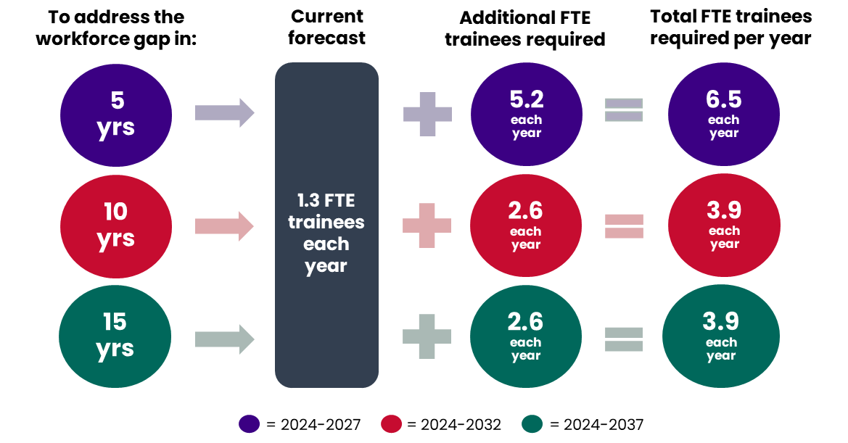
NB: trainee refers to the number of graduating trainees per year
Source: HealthConsult analysis

Haematology
Key issues
Haematologists account for approximately 30% of the pathologist workforce in Australia (see Section ‎3.1.1). It was generally agreed that the number of Haematologists across jurisdictions was reasonable. Stakeholders flagged training for Haematologists can be challenging as it requires two years of clinical experience and two years of laboratory experience. Some stakeholders identified that obtaining access to the laboratory time was sometimes difficult, especially in metropolitan areas. RCPA survey data indicated that currently there are 8 FTE vacancies in Haematology, or 10% of all funded unfilled positions in Australia, or 4.4% of the current Haematology workforce (8 FTE vacancies over 180 FTE workforce). Seven of the vacancies were reported in WA. Currently (2022 data) there are Haematology trainees in every jurisdiction within Australia.
MBS data demonstrates a downward trend in demand for Haematology services, even though Haematologists have the highest number of newly qualified Fellows of any pathology discipline. This was thought to be related to Haematologists often being fractional appointments as a significant proportion have joint qualifications with the College of Physicians.
Data analysis, stakeholder consultation and members of the Haematology ERG confirmed that the average hours worked by Haematologists is decreasing, with anecdotal advice that approximately 20% of a Haematologist's time is spent in the laboratory. This has resulted in an adjustment factor of 1.4% per year being applied to the workforce model to continue the decreasing trend in hours worked for the next five years. Both the ERG and RCPA thought that this would likely stabilise in the future, as registrars realise that laboratory positions may not be available and that trainees become aware there is the option to undertake training in a single discipline.
Workforce model outcomes
The workforce model outcomes for Haematologists are presented in Figure 41.
Figure 41: Model outcomes for Haematologists in Australia
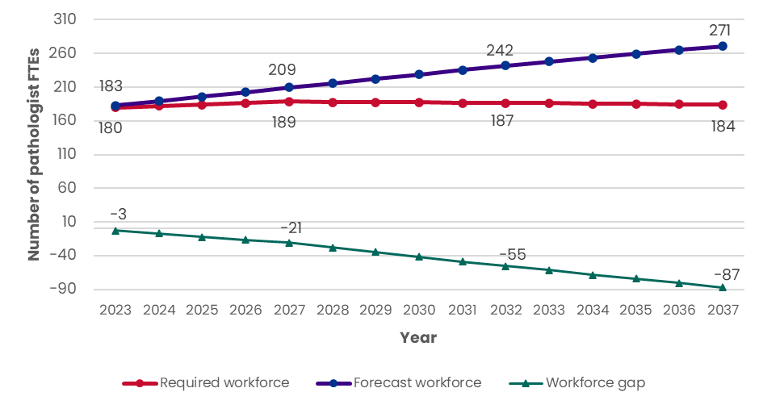
NB: the scales in the workforce model outcome graphs are not consistent across disciplines;
graphs by discipline are not designed to be comparable; some numbers in the model outcomes may not add due to rounding
Source: HealthConsult analysis
The model outcome for Haematology was contrary to the trend in all other disciplines and predicts a likely oversupply of Haematologists by 2037. It is anticipated that Haematologists will grow from 183 FTEs in 2023 to 271 FTEs in 2037, while the anticipated workforce required for the level of demand slightly increases from 180 FTE to 184 FTE. This means that in 2037 there is anticipated to be an oversupply of 87 FTE Haematologists.
RCPA survey data indicated that over the next five years, 37 FTE additional Haematologists would be required to meet future needs. This level of need somewhat aligns with the model for projected workforce numbers but differs from the anticipated workforce needed. An increase of 9 FTE is expected to be required by 2027 to meet demand, while the forecast workforce is anticipated to increase from 183 FTE to 209 FTE over the same period; an increase of 26 FTE. The locations identified from the survey data with the highest need for additional Haematologists were Victoria and Queensland.
Change in trainees numbers required to address the forecast gap
As noted, the workforce model indicates that the national Haematology workforce is in oversupply. The model currently estimates 9.8 FTE graduating trainees per annum. To address the anticipated surplus of Haematologists in 2037, a reduction of 6.3 FTE trainees would be needed each year over the 15-year period (Figure 42). However, the level of dual qualifications should also be monitored. If this number were to decrease this would also impact the future workforce needs, as this change would likely increase the average laboratory hours worked by a Haematologist, rather than continuing the current trend of a decrease in the average laboratory hours worked for the next five years.
Figure 42: Fewer FTE trainees required to bridge the gap in Haematology in five, ten and 15 years
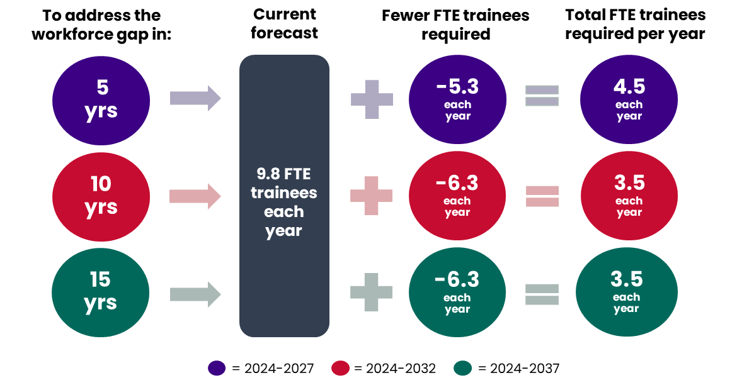
NB: trainee refers to the number of graduating trainees per year
Source: HealthConsult analysis

Immunopathology
Key issues
Immunopathologists represent approximately 5% of all pathologists in Australia (see Section Error! Reference source not found.). Stakeholders reported a shortage of Immunopathologists in most jurisdictions, noting that they were very hard to find, especially in smaller jurisdictions such as Tasmania, where all immunology work is outsourced to the mainland. There is a growing workload in public laboratories resulting from higher rates of antimicrobial resistance and more infections. Currently (2022 data) there are no Immunopathologist trainees in NT or Tasmania.
RCPA survey data indicated that there are currently 3 FTE unfilled funded Immunopathology positions, which represents 4% of all funded vacancies in Australia, or 8.6% (3 FTE vacancies over 35 FTE current workforce). The vacancies reported in the survey data were in Victoria and NSW.
Workforce model outcomes
The workforce model outcomes for Immunopathologists are presented in Figure 43.
Figure 43: Model outcomes for Immunopathologists in Australia
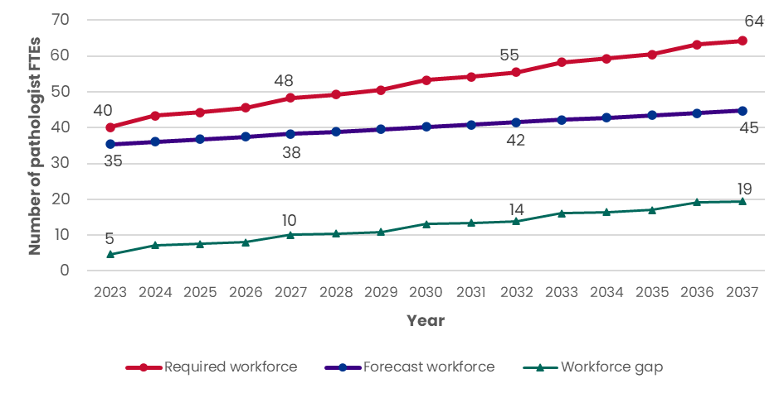
NB: the scales in the workforce model outcome graphs are not consistent across disciplines;
graphs by discipline are not designed to be comparable; some numbers in the model outcomes may not add due to rounding
Source: HealthConsult analysis
The model forecast for Immunopathology demonstrates a growing undersupply. The projected workforce is anticipated to be 45 FTE in 2037, while 64 FTE Immunopathologists are required to meet the anticipated level of demand. This results in a gap of 19 FTE by 2037, which is 44% above the forecast workforce required.
RCPA survey data indicated that an additional 16 FTE Immunopathologists would be needed to meet future demand over the next five years, spread relatively consistently across jurisdictions. This level of need is slightly higher than the model outcome, which anticipates an increase of 13 FTEs would be required by 2027 (48 FTE required in 2027 compared to the 35 FTE forecast in 2032).
Change in trainees numbers required to address the forecast gap
The model currently estimates 1.5 FTE graduating trainees per annum. To address the anticipated shortfall in Immunopathology in 2037, an additional 1.5 FTE trainees would need to be trained each year over the 15-year period. To shorten the timeframe in which the gap is bridged would require 1.8 FTE over 10 years or 2.7 FTE additional trainees annually over five years, as demonstrated in Figure 44.
Figure 44: Additional FTE trainees required to bridge the gap in Immunopathology in five, ten and 15 years
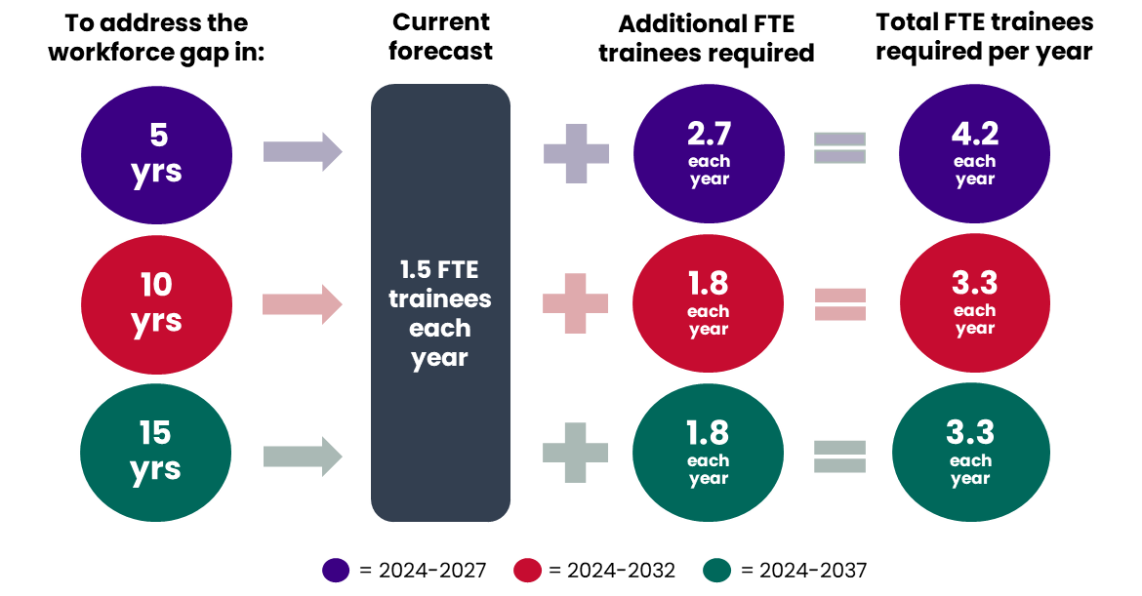
NB: trainee refers to the number of graduating trainees per year
Source: HealthConsult analysis

Microbiology
Key issues
Microbiologists represent approximately 12% of all pathologists in Australia (see Section ‎3.1.1). Stakeholders noted that most Microbiologists also have qualifications in infectious diseases, with one stakeholder noting the uniqueness of joint trainees across Microbiology, Haematology, and Immunopathology within Australia. Currently (2022 data) there are no Microbiology trainees in ACT or NT.
Microbiology volumes were significantly impacted during COVID-19, which reflected the higher testing volumes during this period. Stakeholders noted that public laboratories are continuing to experience steady growth in Microbiology even though the main impacts of COVID-19 have passed. More testing is being undertaken because of availability and with the emergence of more screening tests, which is similar to AP.
Again, similar to AP there are fewer opportunities for FFSc to have an increasing role in Microbiology than in some other disciplines as they are not trained to ‘look down a microscope’.
The survey data showed that currently there are 9 FTE (or 11%) fully funded vacancies within Australia, or 5.6% (9 FTE vacancies over 160 FTE workforce). Six of these vacancies were in WA.
Workforce model outcomes
The workforce model outcomes for Microbiologists are presented in Figure 45.
Figure 45: Model outcomes for Microbiologists in Australia
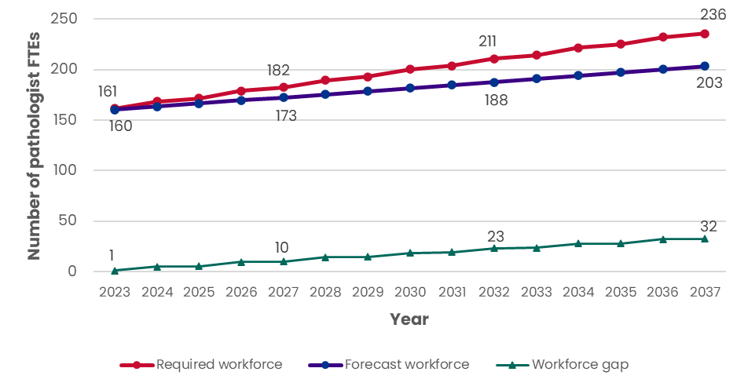
NB: the scales in the workforce model outcome graphs are not consistent across disciplines;
graphs by discipline are not designed to be comparable; some numbers in the model outcomes may not add due to rounding
Source: HealthConsult analysis
The model forecast for Microbiologists demonstrates a growing undersupply. The projected workforce is anticipated to be 203 FTEs in 2037, while 236 FTE Microbiologists are required to meet the anticipated level of demand. This results in a gap of 32 FTEs by 2037, which is an increase of 16% over the forecast workforce.
According to RCPA survey data, an additional 27 FTE Microbiologists would be needed to meet future demand over the next five years, spread relatively evenly across jurisdictions. This level of need is slightly higher than the model outcome, which anticipates by 2027, an additional 22 FTE will be required compared to 2023 (182 FTE required in 2027 compared to the 160 FTE forecast in 2032).
Change in trainees numbers required to address the forecast gap
The model currently estimates 7.6 FTE graduating trainees per annum. To address the anticipated shortfall in Microbiologists in 2037, an additional 2.3 FTE trainees would need to be trained each year over the 15-year period. To shorten the timeframe in which the gap is bridged would require 2.9 FTE additional trainees annually over five years, as demonstrated in Figure 46.
Figure 46: Additional FTE trainees required to bridge the gap in Microbiology in five, ten and 15 years
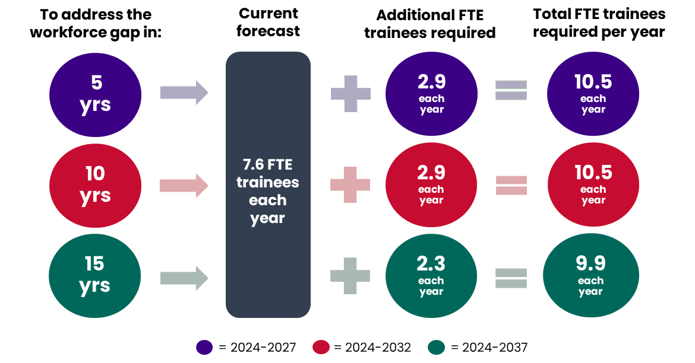
NB: trainee refers to the number of graduating trainees per year
Source: HealthConsult analysis

Key outcomes of projected future workforce for FFSc for Australia
Key issues
In 2022 there were 215 headcount FFsc in Australia (see Section ‎3.1.2). FFSc has the highest presence in Genetic Pathology (52 headcount), followed by AP (40 headcount) and Chemical Pathology (35 headcount). The lowest FFSc were reported in General Pathology (3 headcount). RCPA survey data indicated that there are currently 18 FTE funded positions vacant in Australia for clinical scientists (including, but not limited to FFSc). Haematology had the highest number of funded vacancies, followed by AP and Chemical Pathology. By region, NT was the greatest area of need with 10 FTE or 55% of all vacancies.
Most stakeholders flagged that scientists often leave the pathology workforce as there is no clearly defined pathway for them, and they can often find better-paid positions in other sectors. This is a significant concern, as one stakeholder described scientists as the backbone of a pathology laboratory. For those who wish to become an FFSc one of the most significant barriers is that there are few funded training positions for scientists undertaking the FFSc program. The impact of non-funded training positions on FFSc trainees is the need to complete training in their own time and around other work commitments, which lengthens the time required to attain Fellowship.
Stakeholders flagged the uncertainty of how FFSc are viewed and their role in the pathology workforce, especially within the clinical environment. There are multiple pathways to attain Fellowship with the FSc (Figure 3). There is potentially a role for RCPA to promote and strengthen messaging that FFSc in diagnostic roles have achieved Fellowship via the examination pathway, to create greater acceptance within the pathology workforce.
Developing scope of practice statements that outline what responsibilities an FFSc can undertake in a diagnostic role would provide greater clarity of their role and function in the workforce (noting that this will likely vary by discipline). Scope of practice statements may also allow FFSc to operate to the top of their scope of practice and thereby alleviate pressure on pathologists. An example of this is the initiative by RCPA to develop a specimen ‘cut-up’ training program that allows scientists to upskill in this area and thus relieve AP and registrars of this function. However, any initiatives need to maintain the distinction that an FFSc is not a pathologist and is not a substitute for a qualified pathologist.
Several jurisdictions flagged that they are pursuing different training and development opportunities for scientists; often working in conjunction with RCPA.
Mechanisms to increase the number of FFSc would strengthen the pathology workforce and support being able to meet future demand. However, similar to the pathologist workforce, there is a need for adequate funding to be able to achieve this. Additional funding is required to support training programs to increase the number of FFSc and to support an increase in the number of positions available for FFSc once Fellowship has been obtained.
Workforce model outcomes
Figure 47 presents the outcomes of the model for all FFSc within Australia.
Figure 47: Model outcomes for total FFSc workforce in Australia

NB: some numbers in the model outcomes may not add due to rounding
Source: HealthConsult analysis
The current workforce is projected to decrease from 218 headcount in 2023 to 184 headcount by 2037 (Figure 47). However, by 2037 the number of FFSc required to meet the level of demand will increase to 336 headcount. The model outcome shows significant growth in undersupply, reaching 151 headcount by 2037 (a shortfall of 82%). This is a significant concern for a workforce that is already under-resourced.
The RCPA survey reinforced this shortage and found that if funding was available there was a perceived need for an additional 220 FTE clinical scientists over the next five years to meet expected demand within Australia (including, but not limited to just FFSc). By discipline, the areas of greatest need in the survey were AP (21%) and Chemical Pathology (18%), and by region in Queensland (39%) and Victoria (25%).
Change in trainees numbers required to address the forecast gap
The model currently estimates 6 headcount graduating trainees per annum. To address the anticipated shortfall modelled for FFSc in Australia in 2037 an additional 12 headcount trainees would need to be trained each year over the next 15 years. To shorten the timeframe in which the gap is bridged would require 13 headcount over 10 years or 15 headcount over five years of additional trainees annually as demonstrated in Figure 48.
Figure 48: Additional trainees (headcount) required to bridge the gap in FFSc in five, ten and 15 years
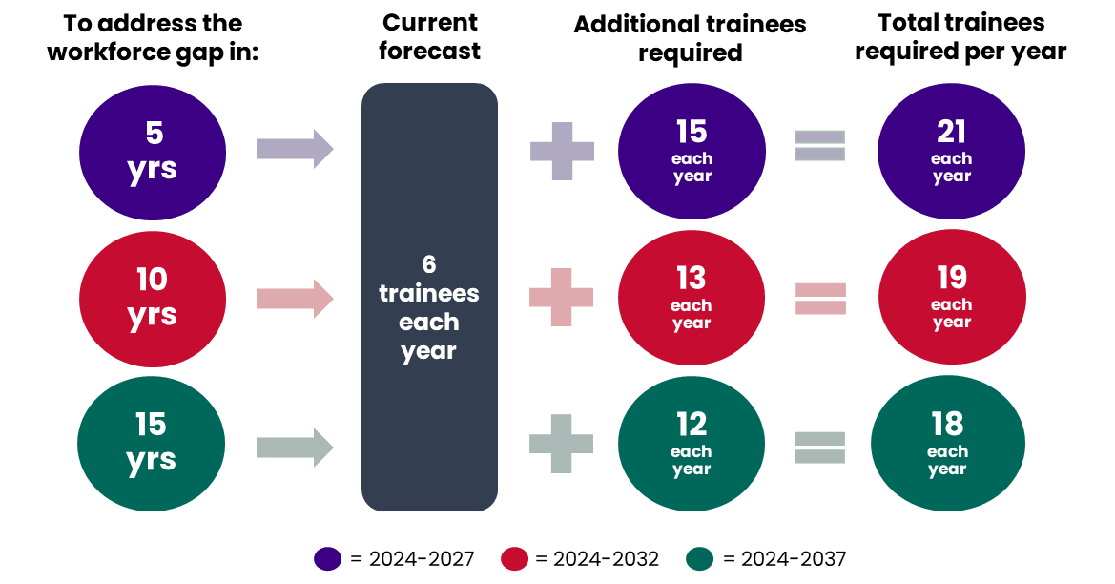
NB: trainee refers to the number of graduating trainees per year
Source: HealthConsult analysis

Recommendations for the Australian workforce
This section presents the recommendations that have been developed to support the sustainability of the pathology workforce in Australia. The recommendations have been presented to the RCPA Board, ERG, State and Regional Councillors as well as the RCPA project team. The recommendations have been grouped into three categories:
- Recommendations for funding to support workforce sustainability (recs 1-3)
- Recommendations for workflows, roles and responsibilities (recs 4-6) and
- Recommendations to address specific issues (rec 7-8)

Recommendations for funding to support workforce sustainability
Three recommendations could be considered to improve the sustainability of the pathology workforce through changes to funding arrangements. They include:
- Recommendation 1: Advocate to the Australian Government for increased access to funding for training positions
- Recommendation 2: Advocate to jurisdictional Governments for an increase in access to funding for training positions.
- Recommendation 3: Continue advocacy for all MBS fees for pathology items to receive annual indexation, for MBS items to be fit for purpose and reflect costs of service provision, and inclusive of new tests as they evolve

Recommendation 1: Advocate to the Australian Governments for increased access to funding for training positions
  Proposed recommendation | Continue to advocate to the Commonwealth Government to increase access to, and availability of, STP and other funding streams that support training in Australia.
  Issues/challenges that would be addressed | - Training: additional funding would allow more training positions to be created, thus increasing the pipeline of pathologists needed to address current shortages and meet future demand  - Training setting: training for pathologists is different to many other medical specialties in that for most disciplines the pathologist is not required to be in the same location as the patient, therefore an effective use of training funding is to allocate to metropolitan laboratories, as they conduct the required range and volume of tests and are therefore best placed to support robust training.
  Discipline(s) and/or jurisdiction(s) impacted | - All disciplines  - All jurisdictions in Australia
  Implications to consider with this recommendation | Advocate to the Australian Government to increase access to STP funding to:  - Broaden the STP policy and guidelines to allow STP funding to be allocated to training positions in metropolitan public laboratories. This would help to ensure the delivery of a sustainable training pipeline, noting the differences in pathology training models relative to many other medical specialties; noting that rural and regional patients are serviced by metropolitan pathologists  - Increase the prioritisation of STP funding to pathology, to address the current critical workforce shortage  - Increase the overall level of funded STP positions allocated to pathology to grow the training pipeline to meet future needs, in both the public and private sectors  Advocate for increased access to other Australian Government funding sources for pathology training positions:  - Draw on the outcomes of this review to highlight the current and future workforce shortage impacting the likely ability to meet future demand for pathology services, and the need for dedicated funding for additional training positions supported by adequate supervision
Suggested priority | High priority as the funding for training positions is essential to be able to meet future demand for pathology services. Accessing additional government funding would allow the creation of more training positions where they are most needed. This would address the current challenges that were reported around increasing the training pipeline to generate the number of pathologists required to meet current and future demand.

Recommendation 2: Advocate to jurisdictional Governments for an increase in access to funding for training positions
Proposed recommendation | Continue to advocate to jurisdictional Governments for increased access to additional funding to be appropriated specifically for pathology training positions
Issues/challenges that would be addressed | - Training: additional funding could allow more public sector training positions to be created, thus increasing the pipeline for pathologists needed to address current shortages and meet future demand  - Supervision: the current shortage in the pathology workforce requires an increase in the number of trainees. This is dependent on an adequate level of pathologists to provide supervision, which currently constrains trainee throughput.
Discipline(s) and/or jurisdiction(s) impacted | - All disciplines  - All jurisdictions in Australia
Implications to consider with this recommendation | Advocate to jurisdictional Governments for funding to support training positions in pathology highlighting the following issues:  - The current and predicted future shortages are likely to mean future demand for pathology services cannot be met without funding for additional training positions  - Funding for training needs to be quarantined within providers so that it is not lost within the overall pathology budget  - Funding for both the training positions and supervision needs to be considered
Suggested priority | - High priority as additional funding is essential to increase the training pipeline required to meet future demand for pathology services

Recommendation 3: Continue advocacy for all MBS fees for pathology items to receive annual indexation, for MBS items to be fit for purpose and reflect costs of service provision, and inclusive of new tests as they evolve
Proposed recommendation | RCPA continues advocacy to the Commonwealth Government to review MBS fees for pathology items and highlights the need for a broad review of MBS items to assess if they are fit for purpose, including if reflective of the current cost of service provision., It is noted that in the course of this review, the 2024-25 Commonwealth Budget announced the reintroduction of annual indexation for selected pathology services (including Haematology, Immunology and AP service groups) from 1 July 2025
Issues/challenges that would be addressed | - Funding was a major issue identified as restricting the growth of the pathology workforce especially for the private sector, limiting the ability to invest in infrastructure. Additionally, most public sector funding for pathology is based on the MBS schedule and therefore the MBS fee level has a flow-on effect  - Sustainability of pathology services under the current MBS schedule, including if the current MBS items and fees reflect the services they are funding  - Training: additional funding could allow more training positions to be created, thus increasing the pipeline of pathologists needed to address shortages and meet future demand. It would also contribute to ensuring an adequate number of pathologists to supervise trainees
Discipline(s) and/or jurisdiction(s) impacted | - All disciplines  - All jurisdictions in Australia
Implications to consider with this recommendation | Continue to advocate to the Commonwealth Government for annual indexation for all pathology services, by highlighting:  - The need for annual indexation for all pathology fees including Chemical Pathology, Microbiology and Genetic Pathology not included in the recent Budget announcement. Indexation on these items would support the ability to grow the workforce to meet demand in disciplines where significant shortages exist across both the public and private sector  - The need for a broad review of current pathology MBS items and fees to assess if they reflect the current services provided, especially with the emergence of new tests/techniques, the growing level of complexity and additional reporting requirements  - Current funding levels are limiting the capacity to invest in infrastructure that would improve the efficiency of pathology services  - The impact of time lags between when a new test is established to when it is added to the MBS on equitable access to the test, which may potentially impact the health of individuals.
Suggested priority | High priority as after the stagnating income sourced from MBS fees for nearly three decades, all pathology services need annual indexation rather than selected services, as limited funding was considered one of the most significant contributing factors to the current critical shortage, and unless addressed, the lack of growth in MBS fees will directly impact the future sustainability of the pathology workforce.

Recommendations to improve workflows, roles and responsibilities
This section presents three recommendations that could be considered to improve the sustainability of the pathology workforce through changes to workflows, roles and responsibilities.
The workforce modelling predicts that there will not be enough pathologists in almost all disciplines (except for Haematology) to meet the expected level of demand in Australia. The reasons for the predicted shortages are multifactorial and include the length of the training pipeline and funding shortfalls (for training positions and additional positions for qualified Fellows to transition to after the completion of training) in both the public and private sectors. The results of recent studies, along with stakeholder consultations, also highlighted high rates of turnover and burnout across the pathology workforces.
Therefore, recommendations to improve the efficiency of pathologist workflows are proposed to provide additional capacity within the existing workforce. The following recommendations are detailed below:
- Recommendation 4: Develop a pathology technology and innovation plan as a ‘road map’ to support increased efficiency
- Recommendation 5: Add new roles to the pathology workforce to capitalise on the benefits of technology
- Recommendation 6: Streamline the SIMG pathway.

Recommendation 4: Develop a pathology technology and innovation plan as a ‘road map’ to support increased efficiency
Proposed recommendation | Develop a pathology technology and innovation plan as a ‘road map’ to support increased efficiency, supported by research and evaluation
Issues/challenges that would be addressed | - AI and digital pathology: explore the feasibility of adopting new technologies by undertaking further research and validation of the ways AI and digital pathology could be implemented to maximise the efficiency, accuracy and standardisation of the workforce, noting the current limitations of AI use in pathology  - Workload pressures on the current workforce: embracing technology may support the workforce to alleviate current pressures due to workforce shortages, and provide greater flexibility in where services are delivered (for some disciplines). It should be noted that technological change is not expected to reduce the need for the pathology workforce.  - Culture and work patterns: efficiencies generated through technology may support the growing trend among the workforce for greater work-life balance  - Complexity and demand: embracing technology may generate process efficiencies that should go some way to counterbalance the impact of growing complexity and demand for pathology services
Discipline(s) and/or jurisdiction(s) impacted | - All disciplines  - All jurisdictions in Australia
Implications to consider with this recommendation | - Research and assess the applicability of digital and AI tools that may be potential options to support the pathology workforce, as an initial planning step  - Develop a pathology technology and innovation plan as a ‘road map’ to identify what technology tools should be adopted, how and by whom, and to improve pathology workflows, ensuring that appropriate standards and guidelines are developed to support the initiatives, noting that the benefits of AI are expected to accrue in the longer term as the technology is further developed for use in pathology services  - The technology and innovation plan should have regard to broader national frameworks such as the National Digital Health Strategy and The Digital Health Blueprint and Action Plan 2023-2033.  - It will be critical to bring together the right mix of experience, knowledge and skill sets to develop the plan and test the options that are proposed.  - Secure the investment of funds required to develop the plan through RCPA budgets or advocacy to government(s). Ensure that this is separate from other funding needed to develop pathology services such as funding for additional training positions and indexation for MBS items.  - Adopt a national approach to consultation and research to develop the plan, to ensure consistency in implementation and rollout, system interoperability and to identify economies of scale.  - Develop a robust change management plan, and educate all members of the pathology workforce to maximise the benefits that can be derived from the plan
Suggested priority | High priority as technology is and may continue to be a significant presence in the future for pathology, it is important to be at the forefront to guide the change and ensure that the technology is used appropriately, that the process is well managed and the opportunities available are harnessed to obtain the greatest positive impact on the pathology workforce. RCPA is well-placed to be the facilitator of this change.

Recommendation 5: Add new roles to the pathology workforce to capitalise on the benefits of technology
Proposed recommendation | Support the implementation of the technology and innovation ‘road map’ by continuing to add new roles in bioinformatics, data analytics and software engineers to the pathology workforce to access and capitalise on the benefits of technology.
Issues/challenges that would be addressed | - As per recommendation 4, i.e.:  - improve efficiency  - alleviate workload pressures  - improve culture/work patterns, and  - counterbalance the impact of growing complexity and demand.
Discipline(s) and/or jurisdiction(s) impacted | - All disciplines  - All jurisdictions in Australia
Implications to consider with this recommendation | - Planning for this recommendation will need to be considered within the pathology technology and innovation ‘road map’, to specify the type and mix of additional skills and professionals that will be required to optimise the usage of technology, noting the work that has been undertaken within the FFSc workforce to recruit bioinformaticians.  - Need to assess the current capabilities of the pathology workforce and the capabilities that will be required in the future to understand the gaps that need to be addressed.  - Consider processes to allow for greater engagement with IT professionals working in the pathology workforce, including RCPA-facilitated forums to disseminate and share learnings.  - Planning work should aim to identify what skills can be ‘added on’ to those of existing pathologists (without adding significantly to workload), and what new professionals need to be included.  - Planning will also need to consider how any new roles will be integrated and function effectively within the existing pathology roles  - Funding sources for new positions will need to be identified. The Commonwealth Government’s Quality Use of Diagnostics, Therapeutics and Pathology Program could be explored as an avenue to pilot alternative workforce models as a ‘proof of concept’.
Suggested priority | Medium priority as defining the future composition for the pathology workforce is complementary to the pathology technology and innovation plan ‘road map’. Undertaking this long-term planning will support the future-proofing of the pathology workforce.

Recommendation 6: Streamline the SIMG pathway, while ensuring compliance with existing standards
Proposed recommendation | Review the SIMG pathway to identify opportunities to streamline the process by which internationally trained pathologists are assessed, and the duration of training required to be completed to attain RCPA Fellowship. Any change in the process must maintain appropriate skill level, orientation and onboarding to ensure the quality of service delivery and patient safety is maintained
Issues/challenges that would be addressed | - Workload pressure: by streamlining the process to allow specialists with qualifications obtained in other countries to work in Australia in line with the Independent Review of Australia’s Regulatory Settings Relating to Overseas Health Practitioners (‘the Kruk review’).  - Training burden: any opportunity to reduce the length of training required will reduce the training burden on trainees and supervisors.
Discipline(s) and/or jurisdiction(s) impacted | - All disciplines  - All jurisdictions in Australia
Implications to consider with this recommendation | - Review the application process for SIMGs to identify opportunities to reduce the administrative burden of completing the application process. This could increase the number of SIMGs applying to obtain Fellowship with the RCPA while ensuring that the current standards are maintained.  - Review current training in other countries to see if additional alignments are identified to the Australian standards and therefore completion can be recognised by RCPA while ensuring that the current standards are maintained.  - Assess opportunities and practicality of creating a ‘fast-track’ training option for certain SIMGs to attain Fellowship with the RCPA, thus bringing forward when they can enter the workforce as fully qualified pathologists, especially for disciplines with the greatest shortages.  - Any change in the process must maintain appropriate skill level, incorporating orientation and onboarding to ensure the quality of service delivery and patient safety is maintained
Suggested priority | High priority as reducing the time taken for SIMGs to attain Fellowship with the RCPA provides a direct increase in the number of pathologists in the workforce contributing to alleviating the current shortage viewed as critical in some areas.

Recommendations to address specific issues
This section presents two recommendations that could be considered to address specific issues relating to disciplines. The following recommendations are detailed below:
- Recommendation 7: Strategic review of future requirements for Molecular Pathology
- Recommendation 8: Develop a strategic approach to the future of General Pathology discipline

Recommendation 7: Strategic review of future requirements for Molecular Pathology
Proposed recommendation | Conduct a strategic review of future requirements for Molecular Pathology
Issues/challenges that would be addressed | - Shortages of pathologists with Molecular Pathology skills in the workforce: this recommendation would aim to increase pathologists with Molecular Pathology skills across all disciplines by incorporating molecular training into the general curriculum for each discipline (noting this has commenced in some disciplines, but the pace of implementation needs to be accelerated), and providing opportunities for existing pathologists to expand their scope in Molecular Pathology as it pertains to their discipline
Discipline(s) and/or jurisdiction(s) impacted | - All disciplines  - All jurisdictions in Australia
Implications to consider with this recommendation | A strategic review of future Molecular Pathology requirements should consider:  - where Molecular Pathology services are required and who is best placed to deliver them, noting the crossover between those specialising in Molecular/Genetic Pathology (Genetic Pathologists) and most other pathology disciplines  - development of an operating model for the delivery of Molecular Pathology i.e. is a centralised model optimum or is quality of care enhanced through localised service delivery?  - training options such as:  - incorporating Molecular Pathology into the general curriculum across all pathology disciplines, noting that there may be challenges with the supervision of these modules under the traditional apprenticeship model due to the low number of pathologists who currently hold scope in Molecular  - ensuring that Molecular Pathology modules across different disciplines align with a common focus and direction where appropriate  - increasing the scope of practice of pathologists in other disciplines in Molecular Pathology as it pertains to their speciality  - understanding how the challenges presented by Molecular Pathology are being addressed internationally as part of model design
Suggested priority | High priority as Molecular Pathology is a ‘hot topic’ with growing demand and the evolution of pathology seeing genetic and genomic testing impacting all disciplines. Planning for the future of this service is essential. RCPA is well placed to facilitate the development of the map to guide the future direction.

Recommendation 8: Develop a strategic approach to the future of General Pathology discipline
Proposed recommendation | Develop a strategic approach to the future of the General Pathology discipline to guide decision-making around its role in the pathology workforce
Issues/challenges that would be addressed | - Shortages of pathologists within General Pathology: General Pathologists are decreasing in number. General Pathology has the highest age profile of any discipline in the pathology workforce (42.2% aged 65 or over in Australia). The number of trainees is decreasing, with some jurisdictions having no trainees in General Pathology. This is thought to be linked to the amount of information that needs to be imparted to each trainee. Some stakeholders have suggested that the General Pathologist pathway may not exist in 15 years  - Supervision requirements: the role that General Pathologists play in ensuring compliance with supervision requirements under NPAAC, especially in rural and regional laboratories
Discipline(s) and/or jurisdiction(s) impacted | - All disciplines  - All jurisdictions in Australia
Implications to consider with this recommendation | A detailed review of the future of General Pathology should:  - Determine the future role of General Pathology as a discipline in the pathology workforce covering:  - review the role and function of General Pathologists, identifying changes required to make the discipline more relevant in the current environment  - identify opportunities to streamline the broad-spectrum training across multiple disciplines required to be undertaken by General Pathology trainees  - identify strategies to promote and recruit General Pathology trainees  - Consider the role of General Pathologists in respect of:  - How compliance is achieved with the current supervision requirements under NPAAC, especially in regional and rural laboratories  - Impact on other disciplines in the pathology workforce and on the delivery of pathology services outside of major cities, including on how is best met in these areas.
Suggested priority | Medium priority as while General Pathology is currently part of the pathology workforce, in the coming 10 to 15 years is likely to decrease in presence, due to the age of the current General Pathologists and the lack of registrars undertaking the General Pathology training pathway. Changes in the approach to General Pathology will need to be implemented to ensure General Pathology remains part of the future pathology workforce.

Summary of recommendations
This Chapter presents a summary of the recommendations that have been developed to address key issues, gaps and opportunities that have been identified.
The recommendations that have been developed have been workshopped with the RCPA Board, ERGs, RCPA project team and other key stakeholders.
The focus of the recommendations is to address issues that have been identified to support the sustainability of the workforce. Table 3 summarises the recommendations and the role of RCPA in progressing each option.

Table 3: Summary of recommendations and role of RCPA
Recommendation | Priority | Role of RCPA in progress recommendation
Recommendation 1: Advocate to the Australian Government for increased access to funding for training positions  Continue to advocate for the Commonwealth Government to increase access to, and availability of, STP and other funding streams that support training in Australia. | High | RCPA's role is to lobby the Commonwealth Government of Australia for additional funding for training positions in Australia
Recommendation 2: Advocate to jurisdictional Governments for an increase in access to funding for training positions  Continue to advocate to jurisdictional Governments for increased access to additional funding to be appropriated specifically for pathology training positions | High | RCPA's role is to lobby the Australian Government for additional funding for training positions in pathology
Recommendation 3: Continue advocacy for all MBS fees for pathology items to receive annual indexation, for MBS items to be fit for purpose and reflect costs of service provision, and inclusive of new tests as they evolve  RCPA continues advocacy to the Commonwealth Government to review MBS fees for pathology items and highlights the need for a broad review of MBS items to assess if they are fit for purpose, including if reflective of the current cost of service provision., It is noted that in the course of this review, the 2024-25 Commonwealth Budget announced the reintroduction of annual indexation for selected pathology services (including Haematology, Immunology and AP service groups) from 1 July 2025 | High | RCPA's role is to continue to advocate to the Commonwealth Government of Australia for annual indexation for MBS fees relating to pathology services and for fees to be set at an adequate level  Additionally, highlight the impact of time lags between when a new test is established and when it is added to the MMBS
Recommendation 4: Develop a pathology technology and innovation plan as a ‘road map’ to support increased efficiency  Develop a pathology technology and innovation plan as a ‘road map’ to support increased efficiency, supported by research and evaluation | High | RCPA's role is to facilitate the research, evaluation and development of the technology roadmap for Australia  RCPA’s role is to work with Governments at all levels, Commonwealth states and territories to achieve system consistency and system interoperability
Recommendation 5: Add new roles to the pathology workforce to capitalise on the benefits of technology  Support the implementation of the technology and innovation ‘road map’ by continuing to add new roles in bioinformatics, data analytics and software engineers to the pathology workforce to access and capitalise on the benefits of technology. | Medium | RCPA's role is to facilitate identifying the additional roles that will be required, how to engage with them, and ensure guidance and standards, where appropriate, are in place
Recommendation 6: Streamline the SIMG pathway, while ensuring compliance with existing standards  Review the SIMG pathway to identify opportunities to streamline the process by which internationally trained pathologists are assessed, and the duration of training required to be completed to attain RCPA Fellowship. Any change in the process must maintain appropriate skill level, orientation and onboarding to ensure quality of service delivery and patient safety is maintained | High | RCPA to undertake a review of the current SIMG pathway to ascertain if there are opportunities to streamline the process for internationally trained medical specialists to enter the Australian workforce  Potentially apply to access grant monies to support this project, such as a Quality Use of Pathology Program (QUPP) grant
Recommendation 7: Strategic review of future requirements for Molecular Pathology  Conduct a strategic review of future requirements for Molecular Pathology | High | RCPA's role is to facilitate a review of future requirements of Molecular Pathology in Australia. Implementing identified training needs to extend the scope of practice of existing pathologists and incorporate it in the general curriculum content for training pathways where relevant. However, noting that the development of an operating model for Molecular Pathology is beyond the remit of the RCPA, as they cannot alter how services are delivered
Recommendation 8: Develop a strategic approach to the future of General Pathology discipline  Develop a strategic approach to the future of the General Pathology discipline to guide decision-making around its future role in the pathology workforce | Medium | RCPA's role is to facilitate a review of the current General Pathology discipline to determine its role and function in the future of the pathology workforce

Workforce plan
This Chapter draws on the recommendations to present a workforce plan to address the current and predicted continuing shortage of pathologists in the Australian workforce.

Current challenge
This report has demonstrated that there is a critical shortage of pathologists. The issue has been widely acknowledged since the 2018 review undertaken by KBC, especially as there has been minimal growth in the number of trainees over the past six years (an increase of three headcount trainees or 0.6% from 2017 to 2022, see Figure 9). Thus, the problem which is already acknowledged to be critical will continue to exacerbate into the future unless action is taken.
At the broadest level, strategies for action can be considered in two categories:
- Strategies to increase the workforce: these strategies focus on increasing the pipeline to grow the number of pathologists in the Australian workforce to meet the anticipated level of demand.
- Strategies to reduce the workload: these strategies look at reducing the workload so that the pathologists in the workforce are better able to service the increasing level of demand
The strategies described here draw on the recommendations that have been presented in Section ‎4.4.

Strategies to address current workforce shortages
The strategies are presented for the whole pathologist workforce, as the challenges being faced are mostly consistent across the pathology sector and it is considered that the strategies are equally applicable across disciplines.

Strategies to increase the workforce
Table 4 presents the strategies focused on increasing the number of pathologists in Australia to ensure a sustainable pathology workforce able to meet future demand.
Table 4: Strategies to address increasing the number of pathologists in the Australian workforce
Strategy | Priority | Timing
Strategy 1: Increase the number of trainees to ensure the training pipeline can support the anticipated level of future demand  Increasing the number of trainees will directly result in more qualified pathologists who have obtained Fellowship with the RCPA and can enter the Australian pathology workforce. This strategy is to increase the number of trainees to the level required to meet future demand in Australia. Three options are presented over various time periods:  - To redress the issue within a five-year time period, an additional 31.1 FTE trainees would be required over the current 65.4 FTE, taking the total pathology trainees to 96.5 FTE trainees each year, or  - To redress the issue within a 10-year time period, an additional 20.7 FTE trainees would be required over the current 65.4 FTE, taking the total pathology trainees to 86.1 FTE trainees each year, or  - To redress the issue within a 15-year time period, an additional 21.4 FTE trainees would be required over the current 65.4 FTE, taking the total pathology trainees to 86.8 FTE trainees each year  The above number relates to Australia in total, however, a breakdown of the number of trainees by discipline is presented in ‎Appendix B. | High | Short to medium term (2-10 years)  (dependent on the time option selected for this strategy and securing the funding needed to implement)
Strategy 2: Advocate to the Australian Government for increased access to funding for training positions  Increasing the number of trainees requires additional funding. This strategy is to advocate to the Australian Government to increase the funding provided to pathology training positions. Currently, the Australian Government funds the STP program, however, the allocation and operational guidelines do not suit the pathology specialty.  Specifically, pathology services operate on a predominantly centralised service model, therefore the current STP guidelines need to be broadened to allow allocation of funding to training positions in metropolitan public laboratories. This would acknowledge the difference in pathology training models relative to many other medical specialties; especially as rural and regional patients are serviced by metropolitan pathologists.  Thus, increased priority and access to STP funding for pathology training positions in metropolitan settings is required to support increases in training positions to the levels specified in Strategy 1.  Additionally, it is noted that some STP funding such as the Flexible Approach to Training in Expanded Setting (FATES) is allocated as time-limited funding and makes planning for a sustainable trainee pipeline challenging. | High | Immediate  (1-2 years)
Strategy 3: Advocate to State and Territory Governments for an increase in access to funding for training positions  Increasing the number of trainees requires additional funding. This strategy is to advocate to State and Territory Governments to increase access to additional funding, specifically appropriated for pathology training positions. Training funding needs to not only be applied to trainee positions but also to ensure that training positions have the supervision required. State and Territory funding is required to support increases in the number of trainees to the levels specified in Strategy 1. | High | Immediate  (1-2 years)
Strategy 4: Continue advocacy for all MBS fees for pathology items to receive annual indexation, for MBS items to be fit for purpose and reflect costs of service provision, and inclusive of new tests as they evolve  The stagnation of fees on the MBS for pathology for the best part of three decades has contributed to the current workforce shortage, by restricting the growth of the pathology workforce especially for the private sector, limiting the ability to invest in infrastructure, improve efficiency and evolve pathology services. Additionally, most public sector funding for pathology is based on the MBS schedule and therefore the MBS fee level has a flow-on effect.  This strategy is for the RCPA to continue advocacy to the Australian Government to undertake a broad review of MBS items and fees for pathology services to assess if they are fit for purpose, including if they reflect the current cost of service provision, and to develop processes to ensure that new tests are incorporated onto the MBS on a timely basis.  It is noted that the 2024-25 Commonwealth Budget announced the reintroduction of annual indexation for selected pathology services from 1 July 2025. | High | Immediate  (1-2 years)
Strategy 5: Streamline the SIMG pathway, while ensuring compliance with existing standards  In addition to increasing the number of training positions in Australia, more pathologists could be sourced from overseas. In the current international environment, where there is a worldwide shortage of pathologists, the processes to apply to be recognised by the RCPA to be able to work in Australia need to be as efficient and streamlined as possible, while ensuring the current standards are maintained.  This strategy is to review the existing SIMG pathway to identify opportunities to streamline the process by which internationally trained pathologists are assessed, and the duration of training required to be completed to attain RCPA Fellowship. Any change in the process must maintain appropriate skill level, orientation and onboarding to ensure the quality of service delivery and patient safety is maintained. | High | Short to medium-term  (2-10 years)

Strategies to reduce workload
Table 5 presents the strategies focused on reducing the workload for pathologists in Australia to meet future demand. These strategies are designed to allow a higher volume of tests to be processed per pathologist.
Table 5: Strategies to decrease the workload of pathologists in Australia
Strategy | Priority | Timing
Strategy 6: Develop a pathology technology and innovation plan as a ‘road map’ to support increased efficiency  This strategy is to develop a pathology technology and innovation plan as a ‘road map’ to support increased efficiency within the pathology sector, supported by research and evaluation. Better use of technology may alleviate the workload pressure on pathologists.  Exploration and evaluation of the feasibility of adopting new technologies need to be undertaken to validate the ways AI and digital pathology could be employed to maximise the efficiency, accuracy and standardisation of pathology service delivery (noting the current limitations of AI use in pathology). This research could be used to inform the development of a ‘road map’ to improve pathology workflows, ensuring that appropriate standards and guidelines are developed to support the initiatives. It will be critical to bring together the right mix of experience, knowledge and skill sets to develop the plan and test the options that are proposed  The technology and innovation plan should have regard to broader national frameworks such as the National Digital Health Strategy and The Digital Health Blueprint and Action Plan 2023-2033. | High | Short to medium-term  (2-10 years)
Strategy 7: Add new roles to the pathology workforce to capitalise on the benefits of technology  This strategy focuses on supporting the implementation of the technology and innovation ‘road map’ by continuing to add new roles such as bioinformatics, data analytics and software engineers to the pathology workforce to access and capitalise on the benefits of technology. The creation of these extra positions has the potential to alleviate the workload pressure on pathologists.  The ‘road map’ developed in Strategy 6 will likely see the continuing emergence of professionals other than pathologists and traditional scientists being active in the delivery of pathology services. A needs assessment of the pathology workforce is required to identify the capabilities required and who is best placed to provide them. The integration process will need to be planned, including mechanisms for the additional professionals to engage with the RCPA. | Medium | Medium to long-term  (10-15 years)
Strategy 8: Strategic review of future requirements for Molecular Pathology  There is a growing crossover between Molecular/Genetic Pathology and most other disciplines. Therefore, there is a need to determine where (by discipline) Molecular Pathology is required, and how and who is best placed to deliver these services.  The focus of this strategy is to conduct a strategic review of future requirements for Molecular Pathology. The aim is to increase the number of pathologists who have skills in Molecular Pathology within the pathology workforce, thereby alleviating some of the current workload pressure on Genetic Pathologists, which is one of the disciplines of critical shortage.  This can be achieved by incorporating Molecular Pathology training into the general curriculum for each discipline (noting this has commenced in some disciplines, but the pace of implementation needs to accelerate), and providing opportunities for existing pathologists to expand their scope in Molecular Pathology as it pertains to their discipline. | High | Short to medium-term  (2-10 years)
Strategy 9: Develop a strategic approach to the future of General Pathology discipline  Currently, the presence of General Pathologists in the pathology workforce is diminishing. General Pathologists have the highest age profile of any discipline combined with a decreasing number of trainees entering the General Pathology training pathway. These characteristics will lead to significant shortages of General Pathologists.  This strategy is to develop a strategic approach to determining the future role of the General Pathology discipline in the pathology workforce. This incorporates identifying changes that may need to be made to make the discipline more sustainable, and how to promote and recruit trainees to this training pathway. The strategy will need to consider how General Pathologists contribute to compliance with the NPAAC supervision requirements and support the delivery of pathology services in rural and regional locations. | Medium | Short to medium-term  (2-10 years)

Timeline
 |  | Immediate (1-2 years) | Short term (2-5 years) | Medium term (5-10 years) | Long term (10-15 years)
Strategies to ↑ workforce | Strategy 1: Increase the number of trainees to ensure the training pipeline can support the anticipated level of future demand
Strategies to ↑ workforce | Strategy 2: Advocate to the Australian Government for increased access to funding for training positions
Strategies to ↑ workforce | Strategy 3: Advocate to State and Territory Governments for an increase in access to funding for training positions
Strategies to ↑ workforce | Strategy 4: Continue advocacy for all MBS fees for pathology items to receive annual indexation, for MBS items to be fit for purpose and reflect costs of service provision, and inclusive of new tests as they evolve
Strategies to ↑ workforce | Strategy 5: Streamline the SIMG pathway, while ensuring compliance with existing standards
Strategies to ↓ workload | Strategy 6: Develop a pathology technology and innovation plan as a ‘road map’ to support increased efficiency
Strategies to ↓ workload | Strategy 7: Add new roles to the pathology workforce to capitalise on the benefits of technology
Strategies to ↓ workload | Strategy 8: Strategic review of future requirements for Molecular Pathology
Strategies to ↓ workload | Strategy 9: Develop a strategic approach to the future of General Pathology discipline

Sensitivity analysis
This Appendix explores how changes to the model parameters (called scenarios) may change the outcomes of the workforce analysis. The scenarios are informed by publicly available issues, input from the RCPA Board and ERGs, consultations with key stakeholders and the RCPA.
Each scenario will be presented as an alternative model outcome for the future pathology workforce compared to the original base model.

Scenario 1: Increases in future demand
Statistical analysis in the form of confidence intervals (CIs) was initially run on demand forecasting to determine the potential variation in demand to be tested for scenario 1, expecting a variation of 5-10%. CIs describe the variance of the demand forecast by providing a range of estimates above and below the forecast value, with 95% certainty that the actual value falls within this range. The results of the statistical analysis indicated a high level of forecast accuracy, with the upper and lower bounds at less than 0.9% of actual demand value over the next ten years (Table 6). As a result, a 5% variation in demand was chosen for scenario 1 and tested across the pathology workforce models.
Table 6: 95% confidence intervals for the Australian total demand forecast
CI | 2024 | 2025 | 2026 | 2027 | 2028 | 2029 | 2030 | 2031 | 2032
Lower bound | 288,428,321 | 295,339,504 | 301,614,950 | 312,958,388 | 320,267,315 | 326,144,051 | 337,885,242 | 344,795,467 | 351,069,962
Actual | 291,070,683 | 298,003,090 | 304,299,924 | 315,665,246 | 322,995,882 | 328,894,487 | 340,658,039 | 347,590,446 | 353,887,279
Upper bound | 293,713,045 | 300,666,676 | 306,984,897 | 318,372,104 | 325,724,449 | 331,644,923 | 343,430,835 | 350,385,425 | 356,704,597
± value as a % of actual | 0.9% | 0.9% | 0.9% | 0.9% | 0.8% | 0.8% | 0.8% | 0.8% | 0.8%
Source: HealthConsult analysis of MBS data
Under scenario 1:
- demand increased (by 5%)
- the forecast workforce remained the same in each model
- the required workforce grew, thus increasing the workforce gap. Results across each model are described in the following sections.

Impact on the Australian pathologist model
Figure 49 compares the required workforce and workforce gap in the original model (i.e. the base model presented in the body of the report) to the model under scenario 1, which incorporates a 5% increase in demand. The workforce gap increased from a 122 FTE gap under the original model in 2027, to a 209 FTE gap under scenario 1, an increase of 87 FTEs, or 71.3%. The workforce gap under scenario 1 was larger than the original model in all years, reaching 401 FTE in 2037 compared to 291 FTE under the original model. This is an increase of 110 FTE or 38%.
Figure 49: Outcomes of the Australian pathologist total model under scenario 1 compared to the original model

Source: HealthConsult analysis

Impact on the Australian FFSc model
Increasing demand by 5% under scenario 1 increased the required FFSc workforce in 2037 to 353 FFSc which was 17 headcount or 5% higher than the original model (336 FFSc) (Figure 50). The workforce gap under scenario 1 was higher than under the original model for all future modelled years (2024-2037), with the scenario 1 gap reaching 168 headcount in 2037, compared to the 151 headcount gap of the original model.
Figure 50: Outcomes of the Australian FFSc model under scenario 1 compared to the original model

Source: HealthConsult analysis

Scenario 3: Increase in pathologists retiring at an earlier age
After consultation with stakeholders, it was suggested that, in line with many medical specialties post-COVID-19,, pathologists may retire earlier than what has occurred historically. Therefore, scenario 3 tests a 5% increase in those aged 55 or older retiring in five, ten and 15 years. Under scenario 3:
- retirement rates for the 55-59, 60-64, 65-69, 70-74 and 75+ age groups increased by 5%
- the required workforce remained the same within each model
- the forecast workforce decreased, thus increasing the workforce gap. The results for each model are described in the following sections.

Impact on the Australian pathologist model
Under earlier retirement, the forecast workforce decreased from 1,617 FTE under the original model in 2027, to 1,591 FTE under scenario 3. The workforce gap, therefore, increased from 122 FTE pathologists to 147 FTE pathologists. This was an increase of 25 FTEs, or 20%. In 2037, the workforce gap under scenario 3 gap is 47 FTE or 16% higher than the original model (338 FTE under scenario 3 compared to 291 FTE in the original model).
Figure 51: Outcomes of the Australian pathologist model under scenario 3 compared to the original model (5% increase in retirement for those aged 55 or older)

Source: HealthConsult analysis

Scenario 4: Variation in workforce capacity, including hours worked and productivity
The pathologist and FFSc workforce is assumed to be ‘in balance’ at the level of the average historical workforce capacity i.e., the past workload and productivity of pathologists is assumed to be at an achievable level in the future. However, stakeholder consultations highlighted a strong preference for reduced working hours amongst younger and newly graduated pathologists. This was supported by an analysis of publicly available NHWDS data on weekly hours of pathologists in 2013 compared to 2022; the proportion of those who worked 50+ weekly hours fell from 24.1% in 2013 to 17.5% in 2022 (a 6.6% reduction), and the proportion of those working 35-49 hours increased from 49.4% in 2013 to 55.7% (a 6.2% increase).
Therefore, the workload and/or productivity of the pathology workforce may change over the next ten years. To see what the likely impact of altering capacity has on the workforce model outcomes across a range of variations (10% increase, 5% increase, 2.5% increase, 1% increase, 1% decrease, 2.5% decrease, 5% decrease or a 10% decrease) is explored under scenario 4.

Impact on the Australian pathologist model
Table 7 demonstrates how increases or decreases in the capacity of Australian pathologists will change the future workforce gap. If, in 2032, the capacity of pathologists increased by 10%, the workforce gap would reduce from 185.5 FTE under the original model, to 8.3 FTE. If capacity decreased by 5% in 2032 (similar to the previous ten-year trend seen in the NHWDS hours worked data between 2013 and 2022), then the workforce gap would increase from 185.5 FTE under the original model to 288.1 FTE, equivalent to a 55% increase.
Table 7: Outcome of the Australian pathologist model under scenario 4 compared to the original model (variation in workforce capacity)
Year | Workforce gap (FTEs) if workload changes by:
Year | 10% increase | 5% increase | 2.5% increase | 1% increase | 0%  (original model) | -1% decrease | -2.5%  decrease | -5% decrease | -10% decrease
2023 | (113.6) | (47.6) | (12.2) | 9.9 | 25.0 | 40.4 | 64.1 | 105.3 | 194.4
2024 | (71.4) | (2.0) | 35.3 | 58.5 | 74.4 | 90.6 | 115.5 | 158.8 | 252.5
2025 | (65.9) | 5.1 | 43.3 | 67.0 | 83.3 | 99.9 | 125.4 | 169.7 | 265.7
2026 | (63.7) | 8.9 | 47.8 | 72.1 | 88.7 | 105.6 | 131.7 | 176.9 | 274.9
2027 | (36.0) | 39.2 | 79.6 | 104.8 | 122.0 | 139.6 | 166.6 | 213.5 | 315.2
2028 | (28.7) | 48.3 | 89.6 | 115.4 | 133.0 | 151.0 | 178.6 | 226.6 | 330.7
2029 | (28.6) | 49.8 | 91.9 | 118.1 | 136.1 | 154.4 | 182.5 | 231.4 | 337.4
2030 | 0.9 | 82.1 | 125.7 | 152.9 | 171.5 | 190.4 | 219.6 | 270.2 | 379.9
2031 | 6.2 | 89.1 | 133.5 | 161.3 | 180.2 | 199.6 | 229.3 | 281.0 | 393.0
2032 | 8.3 | 92.7 | 138.0 | 166.2 | 185.5 | 205.2 | 235.5 | 288.1 | 402.1
Source: HealthConsult analysis

Impact on the Australian FFSc model
A 5% decrease in capacity would increase the workforce gap for Australian FFSc by 15% in 2032 (from 107 headcount FFSc to 123 headcount FFSc) (Table 8). Although the workforce gap would be reduced under a 10% increase in capacity, there would still be a gap of 80 FFSc in 2032.
Table 8: Outcome of the Australian FFSc model under scenario 4 compared to the original model (variation in workforce capacity)
Year | Workforce gap (headcount) if workload changes by:
Year | 10% increase | 5% increase | 2.5% increase | 1% increase | 0%  (original model) | -1% decrease | -2.5%  decrease | -5% decrease | -10% decrease
2023 | (5) | 5 | 11 | 14 | 16 | 19 | 22 | 29 | 42
2024 | 8 | 19 | 25 | 28 | 31 | 33 | 37 | 44 | 58
2025 | 16 | 27 | 33 | 37 | 39 | 42 | 46 | 52 | 67
2026 | 23 | 35 | 41 | 44 | 47 | 49 | 53 | 60 | 75
2027 | 35 | 46 | 52 | 56 | 59 | 61 | 66 | 73 | 88
2028 | 43 | 55 | 61 | 65 | 68 | 71 | 75 | 83 | 98
2029 | 51 | 63 | 70 | 74 | 76 | 79 | 83 | 91 | 107
2030 | 63 | 76 | 82 | 87 | 89 | 92 | 97 | 105 | 121
2031 | 72 | 84 | 91 | 96 | 98 | 101 | 106 | 114 | 131
2032 | 80 | 93 | 100 | 104 | 107 | 110 | 115 | 123 | 140
Source: HealthConsult analysis

Summary of additional trainees required by discipline
Table 9 provides a summary of the additional trainees required to address the currently projected shortages over a five-year, 10-year or 15-year option by discipline.
Table 9: Summary of additional trainees required by discipline over a five, 10 or 15-year timeframe
Discipline | Timeframe | Current trainees per year  FTE | Additional trainees per year  FTE | Total trainees per year  FTE
Anatomical Pathology | 5 years | 33.9 | 20.7 | 54.6
Anatomical Pathology | 10 years | 33.9 | 11.3 | 45.2
Anatomical Pathology | 15 years | 33.9 | 10.4 | 44.3
Chemical Pathology | 5 years | 2.7 | 5.3 | 8.0
Chemical Pathology | 10 years | 2.7 | 3.6 | 6.3
Chemical Pathology | 15 years | 2.7 | 3.6 | 6.3
Forensic Pathology | 5 years | 2.2 | 2.2 | 4.4
Forensic Pathology | 10 years | 2.2 | 1.5 | 3.7
Forensic Pathology | 15 years | 2.2 | 1.5 | 3.7
General Pathology | 5 years | 0.8 | 2.5 | 3.3
General Pathology | 10 years | 0.8 | 3.3 | 4.1
General Pathology | 15 years | 0.8 | 3.3 | 4.1
Genetic Pathology | 5 years | 1.3 | 5.2 | 6.5
Genetic Pathology | 10 years | 1.3 | 2.6 | 3.9
Genetic Pathology | 15 years | 1.3 | 2.6 | 3.9
Haematology | 5 years | 9.8 | (5.3) | 4.5
Haematology | 10 years | 9.8 | (6.3) | 3.5
Haematology | 15 years | 9.8 | (6.3) | 3.5
Immunopathology | 5 years | 1.5 | 2.7 | 4.2
Immunopathology | 10 years | 1.5 | 1.8 | 3.3
Immunopathology | 15 years | 1.5 | 1.8 | 3.3
Microbiology | 5 years | 7.6 | 2.9 | 10.5
Microbiology | 10 years | 7.6 | 2.9 | 10.5
Microbiology | 15 years | 7.6 | 2.3 | 9.9

Public Pathology Australia (2011). ‘Scope of Practice of the Scientific Workforce of the Pathology Laboratory’, accessed from https://publicpathology.org.au/wp-content/uploads/2016/01/Scope-of-Practice-Document.pdf
www.rcpa.edu.au/getattachment/8ea145b1-5b2b-4eb9-b242-ff95a75825e5/Faculty-of-Science-brochure.aspx
www.rcpa.edu.au/getattachment/8ea145b1-5b2b-4eb9-b242-ff95a75825e5/Faculty-of-Science-brochure.aspx
RCPA welcomes new measures for Medicare-funded pathology services announced in 2024-25 federal budget, Media release 15 May 2024
Accessed via https://www.rcpa.edu.au/Fellows/Specialist-Training-Program
Australian Government Department of Health (2021). ‘National Medical Workforce Strategy 2021-31: Investing in our medical workforce to meet Australia’s health needs’, accessed from https://www.health.gov.au/sites/default/files/documents/2022/03/national-medical-workforce-strategy-2021-2031.pdf
RCPA. (2023). RCPA/Victorian Department of Health Pathology Workforce Review.
KBC Australia (2018). ‘Pathologist and Senior Scientist Workforce Modelling Final Report July 2018’, RCPA.
Moberly, T. (2023). More doctors are choosing to retire early. British Medical Journal (BMJ), 381(1), p1450, doi: 10.1136/bmj.p1450
Hext, T. (2023). The great retirement: has COVID-19 fast forwarded demographics? Australian Financial Review. Retrieved from: https://www.afr.com/markets/debt-markets/the-great-retirement-has-covid-19-fast-forwarded-demographics-20230106-p5caqi

