Government Provider Management System

Quick Reference Guide: How to edit a user in the Approved Provider portal
Organisation Administrators can edit user accounts. Organisation Administrator will only be able to add, edit and remove GPMS users within the Approved Provider portal.

Editing user roles
To edit a user’s roles, complete the following actions:
- In the Manage users screen, locate the user to edit, and select the Manage link.
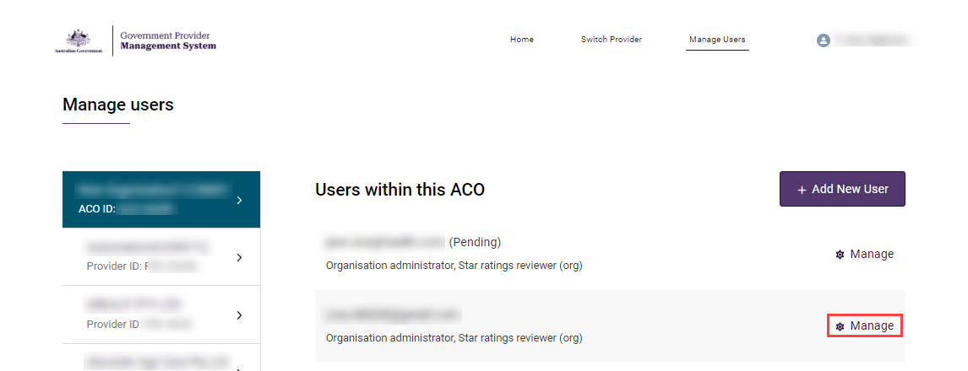
- The editable options will differ depending on if the user was created at the organisation or provider level.
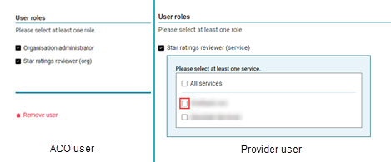

To edit the user’s roles:
- For organisation level users select and/or deselect the Organisation administrator and/or Star ratings reviewer (org) check boxes.
- For provider level users select and/or deselect the All services and/or individual services check boxes.
- Select the Save button.

The Manage Users screen will display again. The user will receive an email notification advising their access roles have been changed.

Removing a user from GPMS
To remove a user from GPMS, complete the following actions:
- In the Manage users screen, locate the user to remove, and select the Manage link.
- Scroll to the bottom of the screen and select the Remove user link.
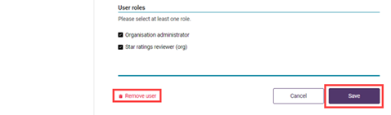
- A modal will display advising the selected user will be removed at the current level of the organisation and the action cannot be undone. Select the Remove button to proceed.
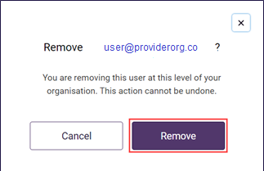

The Manage users screen will display again. The user will no longer be listed.

If users require further assistance with GPMS, please contact the My Aged Care service provider and assessor helpline on 1800 836 799, Monday to Friday (8am to 8pm) and Saturday (10am to 2pm) local time across Australia.
For translating and interpreting services, call 131 450 and ask for My Aged Care on 1800 836 799.
To use the National Relay Service, visit About the National Relay Service (NRS) | Access Hub or call 1800 555 660.
To access sign language interpreting and captioning services through Deaf Connect, call 1300 773 803 or email interpreting@deafconnect.org.au.

