Government Provider Management System

Quick Reference Guide: How to add a user in the Approved Provider portal
Organisation Administrators can add new users to the GPMS Approved Provider portal. These new users can be added either at the organisation level or at the provider level. The level the new user is added to will determine what kind of access roles can be attributed to them.

Adding a user at the organisation level
To add a new user at the organisation level, complete the following actions:
- In the Manage users screen, ensure the ACO account is highlighted, and select the + Add New User button.
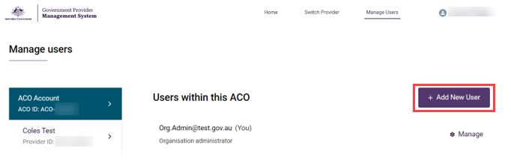
- In the Add new ACO user screen, enter the new user’s company email address and select the Next button.
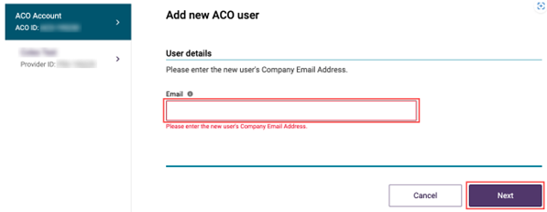
If the user does not exist in the GPMS provider portal, proceed to step 3. If user does exist in GPMS provider portal, the user will receive a notification of this. Go to step 4.
- Add the new user’s Salutation, First name, Surname, and Date of birth. If the date of birth is not provided, a default date of 19/01/1900 can be entered for the user.
- Under User roles, tick the check box for Organisation administrator and/or
Star ratings reviewer (org)
- Select the Add User button.

Adding a user at the provider level
To add a new user at the provider level, complete the following actions:
- In the Manage users screen, ensure the provider account is highlighted, and select the + Add New User button.
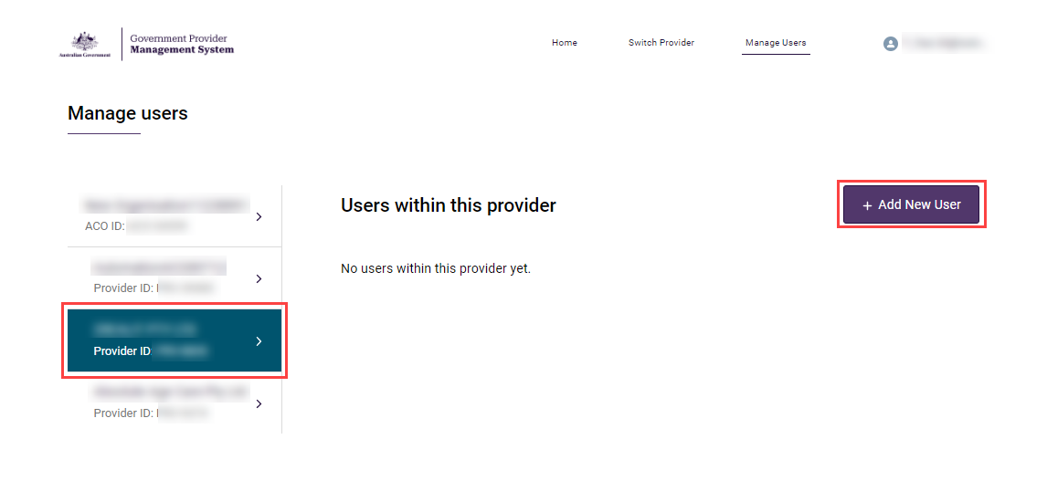
- In the Add new provider user screen, enter the new user’s company email address and select the Next button.
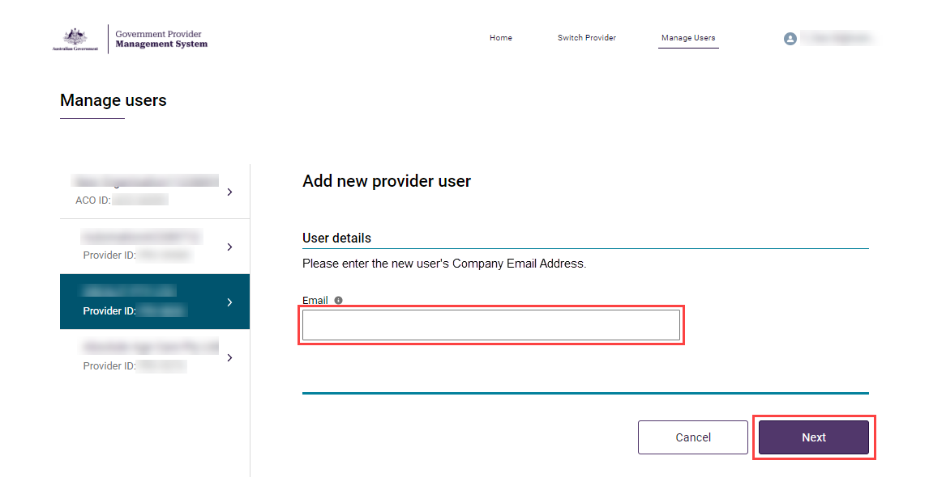
- Add the new user’s Salutation, First name, Surname, and Date of birth.
- Under User roles, tick the check box for Star ratings reviewer (service).
- Tick the check box for All services to let the new user view the Star Ratings for all the listed services or tick the check box for services individually.
- Select the Add User button.
The Manage Users screen will display again. A green banner will display at the top of the screen advising an invitation has been sent to the new user. The new user will need to select the link in the email and log into GPMS to complete their registration.
If users require further assistance with GPMS, please contact the My Aged Care service provider and assessor helpline on 1800 836 799, Monday to Friday (8am to 8pm) and Saturday (10am to 2pm) local time across Australia.
For translating and interpreting services, call 131 450 and ask for My Aged Care on 1800 836 799.
To use the National Relay Service, visit About the National Relay Service (NRS) | Access Hub or call 1800 555 660.
To access sign language interpreting and captioning services through Deaf Connect, call 1300 773 803 or email interpreting@deafconnect.org.au.

