Government Provider Management System
User Guide: 24/7 Registered Nurse Reporting
October 2025
Version 1.1
From 1 November 2025, under the Aged Care Act (the Act), Approved Providers will become known as Registered Providers. Users will login into GPMS for Registered Providers to submit mandatory reporting. This Government Provider Management System (GPMS) User Guide provides an overview of how to access, complete and submit 24/7 Registered Nurse (RN) report from November 2025 onwards.

Contents
1 Introduction 3
1.1 Purpose 3
1.2 Before proceeding 3
1.3 Login to the GPMS portal 4
2 Further information and support 4
3 24/7 Registered Nurse Reporting 5
3.1 Accessing 24/7 application and RN report 5
3.2 Completing 24/7 RN report 6
3.3 Submitting 24/7 RN report 12
3.4 Calculating 24/7 RN eligibility 14

Introduction
Registered providers (providers) must have at least one RN on‐site and on duty at each approve residential care home (home) they operate 24 hours a day, 7 days a week. This provides residents with better access to clinical care and improves resident safety.
Providers are required to submit a monthly report in the GPMS (24/7 RN reporting application) in respect of each of the homes where residential care was provided. This includes homes for which they have an exemption from the 24/7 RN responsibility.
The information collected is used to support the Aged Care Quality and Safety Commission’s monitoring and compliance activities in relation to the 24/7 RN responsibility.
Aged care homes operating through the National Aboriginal and Torres Strait Islander Flexible Aged Care Program and the Multi-Purpose Services Program are not required to complete monthly 24/7 RN reporting in GPMS.
24/7 RN supplement
A 24/7 RN supplement, including a reduced rate of the supplement, is available to eligible homes to support the cost of delivering 24/7 RN care.
To be eligible for this supplement in respect of their home(s), providers must complete their RN report on time by the 7th day after the end of the month.
See the department’s website for more information about the supplement and full eligibility criteria.

Purpose
This User Guide has been designed to support providers with the actions below from the commencement of the new Act and access to the Registered Provider portal (3 November 2025):
- Access the 24/7 application and RN report.
- Complete a 24/7 RN report.
- Submit a 24/7 RN report.

Before proceeding
Please be advised of the following:
The Department of Health, Disability and Ageing will retain records of your access to GPMS and when prompted, you must accept the GPMS Terms of Use to be able to access the system.
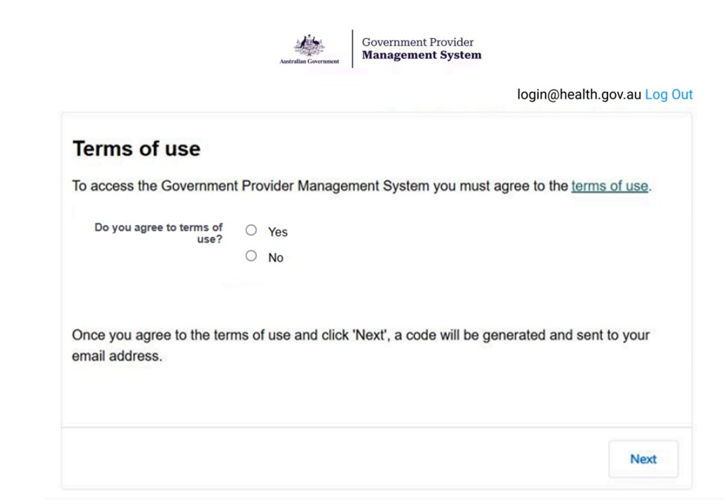

Login to the GPMS portal
To login to the GPMS Registered Provider portal, please visit the GPMS Landing Page, then select the tile for GPMS – Registered Provider portal.
If you require assistance logging into the GPMS portal, please refer to the GPMS Logging in to the Aged Care Systems.

Further information and support
Visit the 24/7 registered nurse reporting website for more information.
Contact ANACCOperations@health.gov.au if you need to:
- re-open a report because it has been submitted incorrectly; or
- request an extension to the reporting due date because you are unable to submit a report on time due to unexpected circumstances, such as ICT issues or natural disasters.
For more information on GPMS please refer to the Government Provider Management System webpage.
If you require further assistance to login to GPMS please contact the My Aged Care service provider and assessor helpline on 1800 836 799, Monday to Friday (8am to 8pm) and Saturday (10am to 2pm) local time across Australia.
For translating and interpreting services, call 131 450 and ask for My Aged Care on 1800 836 799.
To use the National Relay Service, visit About the National Relay Service (NRS) | Access Hub or call 1800 555 660.
To access sign language interpreting and captioning services through Deaf Connect, call 1300 773 803 or email interpreting@deafconnect.org.au.

24/7 Registered Nurse Reporting

Accessing 24/7 application and RN report
24/7 RN reporting is completed through the GPMS Registered Provider portal.
The primary purpose of the 24/7 RN reporting application is to allow providers to fulfil their obligation to report on how they are meeting the 24/7 RN responsibility in respect of each of their homes. To aid providers in meeting the 24/7 RN responsibility, the 24/7 RN supplement and the reduced/alternate rate 24/7 RN supplement will be paid to those that meet the eligibility criteria. The 24/7 RN Reporting application will facilitate the calculation of eligibility for the supplement.
The 24/7 RN reporting application can only be accessed by approved residential aged care service providers with the RN Submission - Service role.
If you are an Organisation Administrator, you are required to add the RN Submission - Service role for staff that will have responsibility for 24/7 RN reporting.
New GPMS users will receive a welcome email that provides a link to the GPMS portal and next steps.
Once you have logged in to the GPMS Registered Provider portal, you can access the 24/7 RN reporting application, by completing the following actions:
- In the GPMS Registered Provider portal landing page, select the 24/7 Registered Nurse Reporting tile.
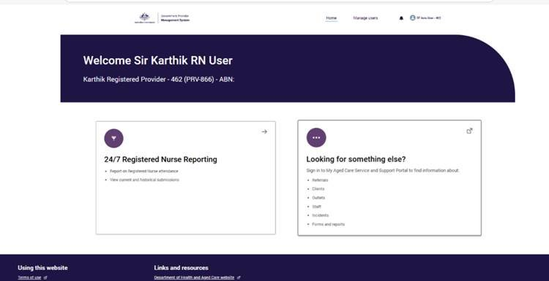
- The 24/7 Registered Nurse Reporting page will display the list of all homes currently associated with your provider.
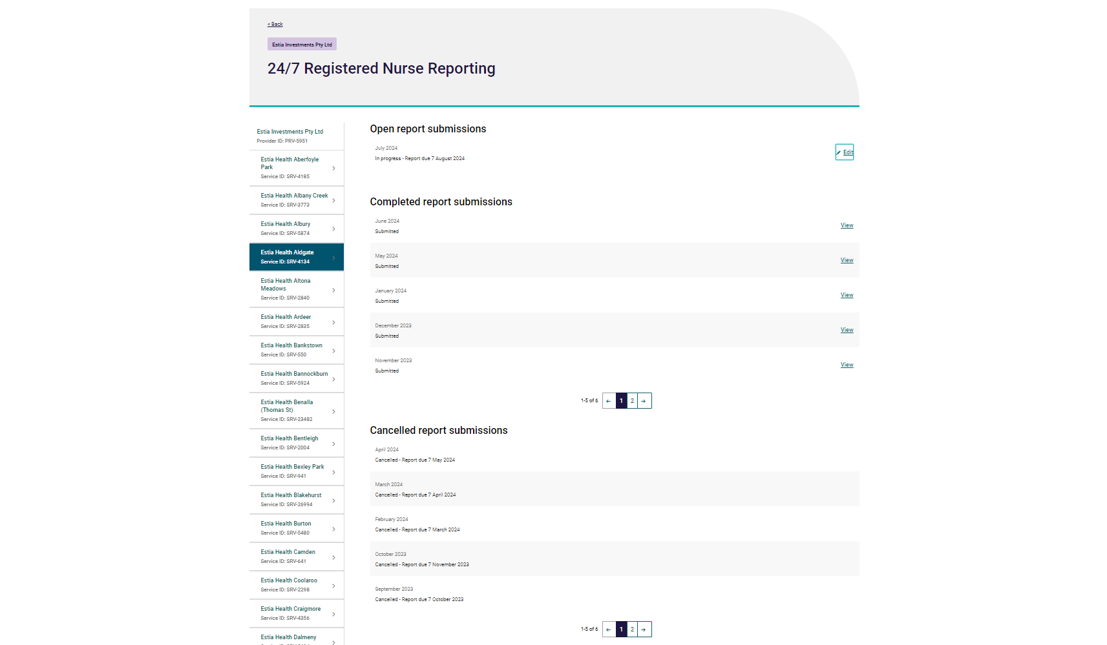
- You can select any home that you are authorised to view and report on.
By selecting the home you will be able to view the home’s report for each month. You will be able to view all reports that are open for submission under Open report submissions, and submitted reports under Completed report submissions.
Reports can have the following statuses:
- Not started: The report hasn’t been actioned yet.
- In progress: Started entering and saving data, but haven’t submitted yet.
- Submitted: Report has been submitted.
- Resubmission: Report is open for resubmission.
- Resubmitted: The report has been resubmitted.

Completing 24/7 RN report
- To begin editing a home’s monthly report, click Edit next to the reporting period.
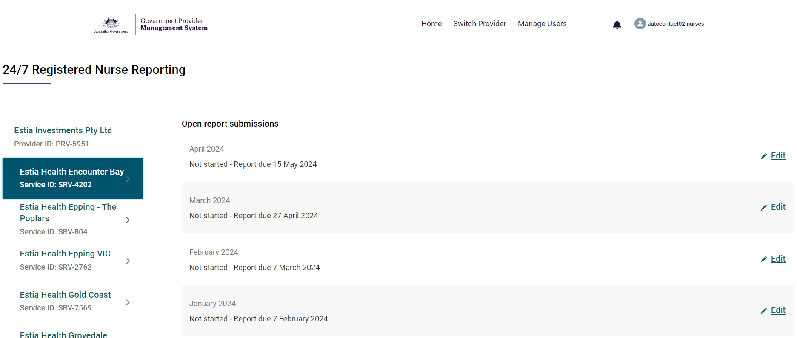
Please note:
If an extension to submit your 24/7 RN report has been granted for the calendar month it will be displayed next to the approved period.
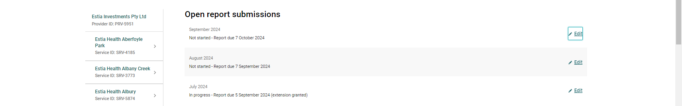
- Once you begin to edit a report, the ‘Before you start’ page will appear. This provides information on how to complete the report.
From this page onwards, the left side of the screen will display the progression of the report.
A green tick will appear when a section is complete.
A blue circle will appear in the section currently being worked on.
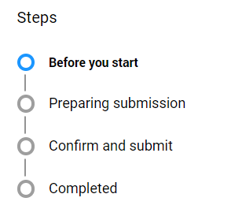
Example of the Before you Start page.
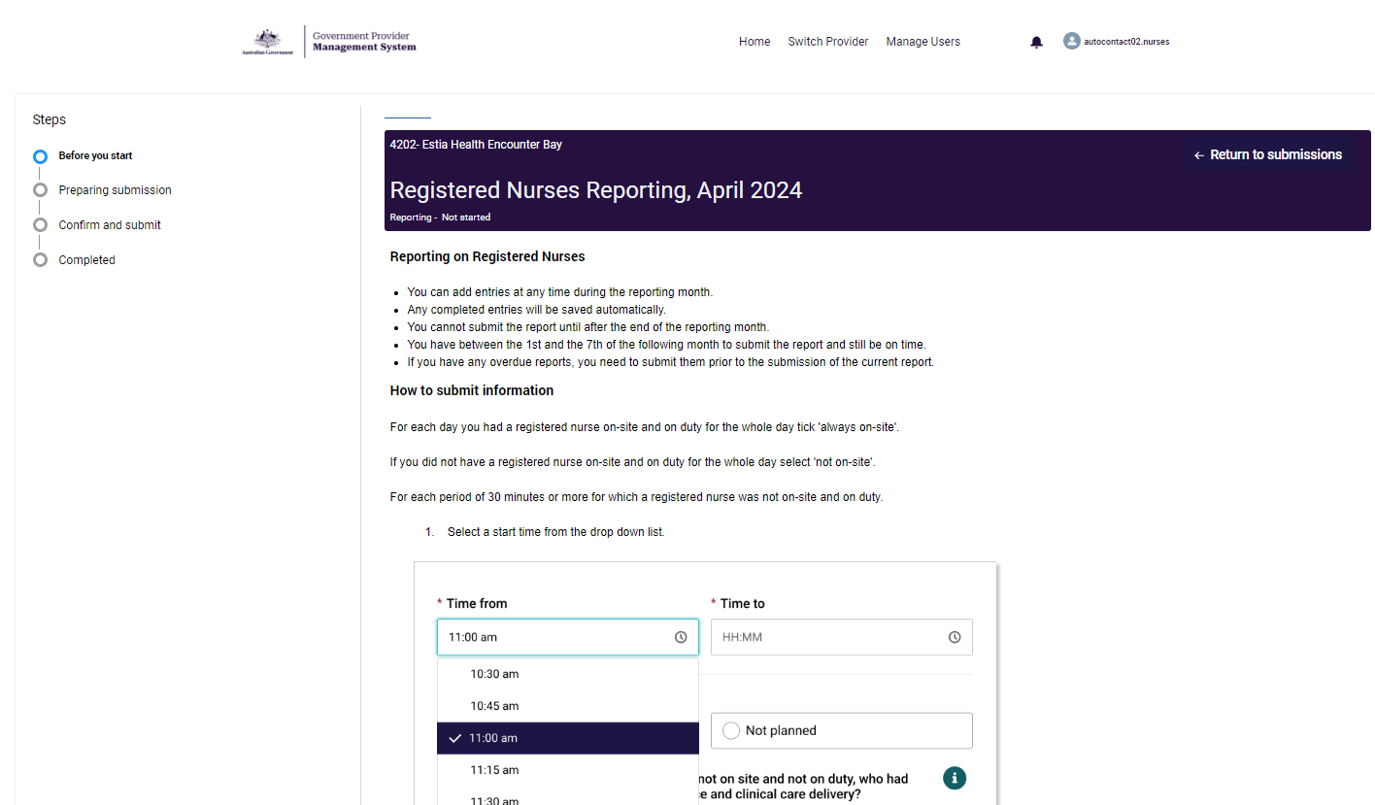
- The next page is the ‘Preparing submission’ page.
This page is the report itself where you are able to enter nursing coverage information.
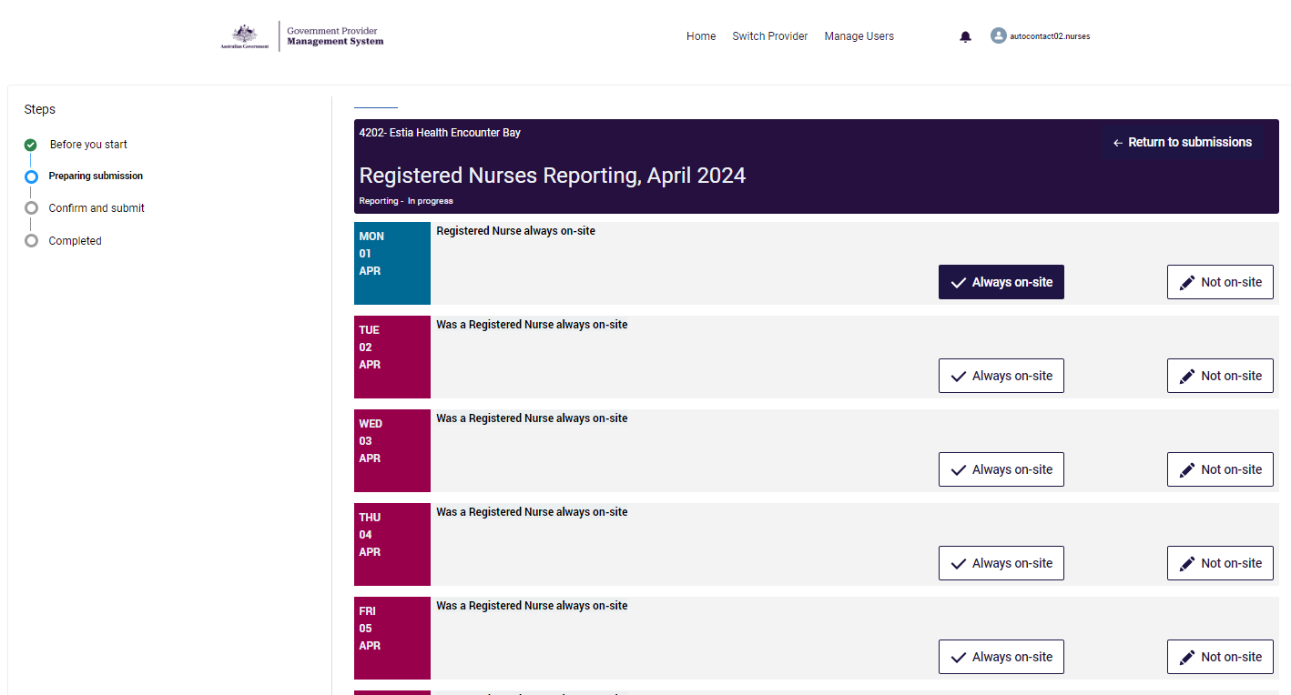
Please note:
● You are only required to report on the days in which your home is operational. Any days in which your home is non-operational will be greyed out. If they are not, before submitting your report, please contact ANACCOperations@health.gov.au and ask them to fix this issue before submission.
● Upcoming days will be greyed out and not available to be filled.
● Days that are not yet completed will be pink.
Complete the steps on the following page to record information for each operational day in the reporting month:
If the home had at least one RN on-site and on duty for the full day:
- Select Always on site.
If the home did not have an RN on-site and on-duty for 30 minutes or more for a particular day:
- Select Not on site and record the following additional details:
The Time period in which no RN was available.
- Select a start time from the drop down list.
- If necessary edit the start time to the correct time.
- Select a finish time from the drop down list.
- If necessary edit the finish time to the correct time.
- Select if the RN Absence Was planned or not planned.
- Select who had delegated responsibility for nursing practice and clinical care delivery for the time period.
  - Select one of the following;
    - Enrolled Nurse
    - Personal Care Worker or Assistant in Nursing
    - Other member of staff
    - No One
  - If an Enrolled Nurse (EN), Personal Care Worker (PCW)/Assistant in Nursing (AIN) and Other member of staff had delegated responsibility then only select the EN option.
  - If a PCW/AIN and Other member of staff had delegated responsibility, then only select the PCW or AIN option.
  - If there was no delegation in place, select ‘No One’.
- Select what additional support, or alternative arrangements, (if any) the person with delegated responsibility had access to whilst there was no RN on-site and on duty.
  - If there were multiple options available to the delegated person then please select the highest ranking option.
  - Select one of the following:
    - 1 - RN in immediately adjacent co-located health facility who can attend in person
    - 2 - RN on-call who can attend in person
    - 3 - NP on-call who can attend in person
    - 4 - GP on-call who can attend in person
    - 5 - RN on-call who is unable to attend in person
    - 6 - NP on-call who is unable to attend in person
    - 7 - GP on-call who is unable to attend in person
    - 8 - Specialist telehealth services
    - 9 - None of the above
- Select whether the on-call support (if any) had access to residents’ clinical records.
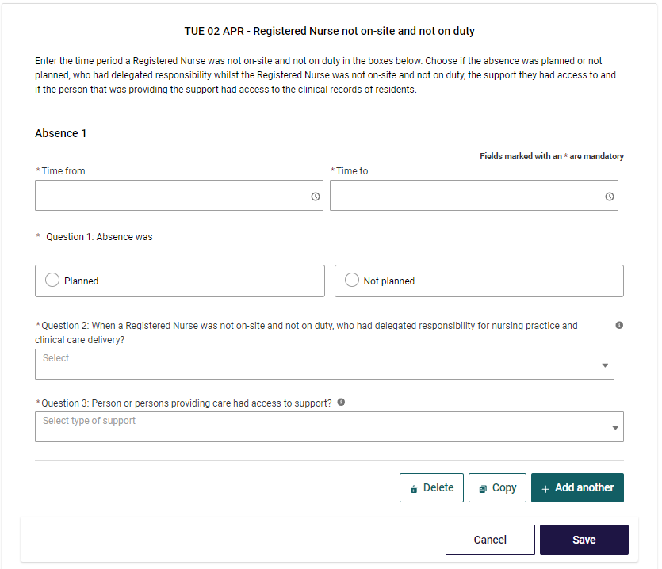
- Additional time periods can be inserted by selecting the + add another button.
- A time period can be deleted by selecting the delete button.
- A line can be copied by selecting the copy icon.
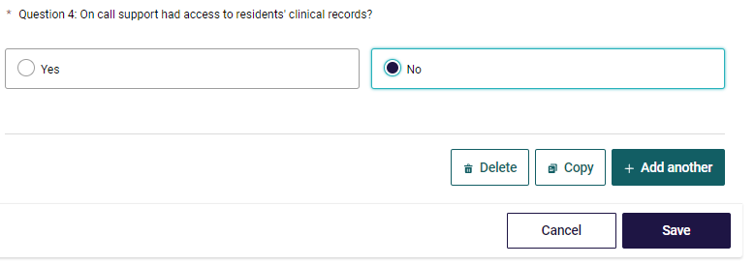
Guidance on what is considered to be on-site and on duty, including examples, can be found in the Care minutes and 24/7 registered nurse responsibility guide.

Submitting 24/7 RN report
● To meet your reporting obligations (and be eligible for the 24/7 RN supplement), you must complete and submit their report by 11:59PM AEST on the seventh (7th) day of the month following the reporting period.
● If you do not meet this deadline, you are still expected to report late. The system will allow the report to be submitted late.
● In order to submit a report for the next month, reports for all previous months must first be submitted (i.e. you will not be able to submit the December 2025 report until the November 2025 report is successfully submitted).
- You can submit the report from the first day of the following report month if you have completed the RN coverage report for each day. Once you have completed the report, select continue.
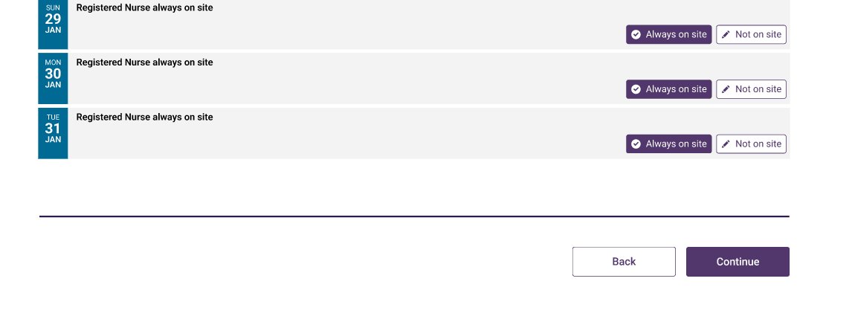
- If an absence was reported at any time during the month then you will have to answer additional questions before you complete your submissions. These questions are only asked once.
- For the reporting month, select whether the alternative arrangements included an option to transfer residents to a local health facility.
- If yes, select what type of local health facility was available.
  - Select one of the following;
    - Another residential facility with 24/7 RN coverage that is under the same approved provider
    - Multi-Purpose Service/ Unit
    - Hosptial with an emergency department
    - Other
  - If Other is selected, then a free text field will be displayed for the user to populate.
- For the reporting month, select how long the position has been vacant for from the following;
  - If there was no vacancy, select not applicable
  - Less than 3 months
  - 3-6 months
  - Greater than 6 months
- Select if you were actively recruiting to fill the vacancy for the reporting month.
- If you were not actively recruiting, select whether you filled the RN vacancy for the reporting month.
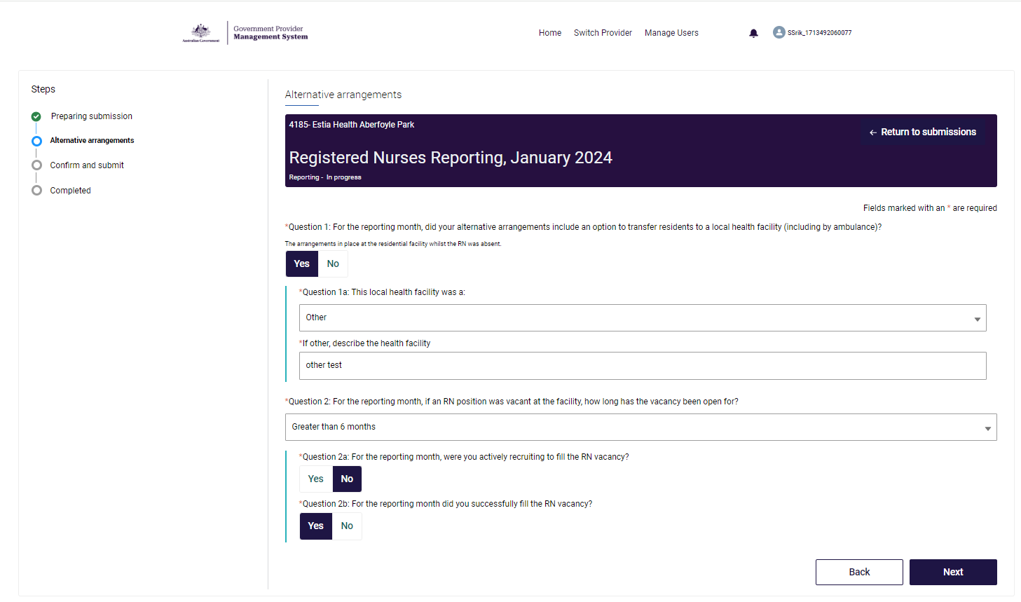
- The Submission Overview page will display a summary of the submission and the declaration details which you must agree to in order to submit the report.
- Providers will not be able to submit the report until after the end of the month.
- Providers cannot submit a report if any operational days do not have a response recorded (incomplete).
- Providers cannot submit a report if any previous month reports have not been submitted.
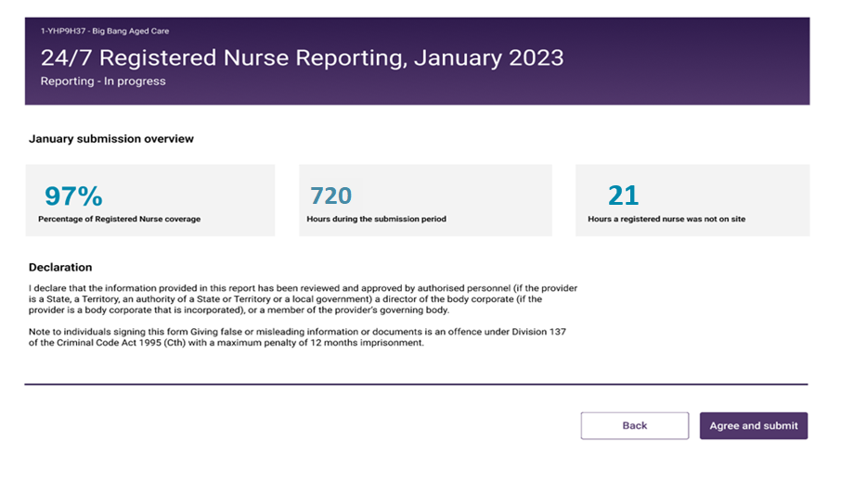
- After selecting Agree and submit the completed page will display which confirms that the report has been submitted and locked. The Completed screen will display a summary of the submission.
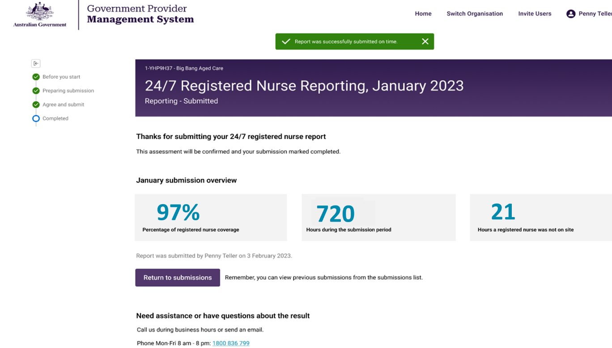
Please note:
● If the report was successfully submitted on time (i.e. by 11:59 AEST of 7th day of the month), a green text box will appear at the top of the screen advising that the report was successfully submitted on time.
● Eligibility for the 24/7 RN supplement will only be calculated when the report is submitted and finalised, and you have received the green confirmation text box.
● If the report was successfully submitted but submitted late, a red text box will appear at the top of the screen advising that the report was successfully submitted late. In this instance, the facility will not be eligible for the 24/7 RN supplement for that month.

Calculating 24/7 RN eligibility
Upon submitting your report, the Department will calculate your supplement eligibility.
The payment of the supplement for eligible providers will be made within the current claim cycle line with other residential aged care subsidies and supplements.
Please note:
● The 24/7 RN supplement will be paid as part of a monthly claim to providers in respect of eligible homes.
● Advice of payment will be included on the monthly payment statement from Services Australia.
● Submission of the 24/7 RN report prior to submitting a monthly claim will allow for the supplement to be paid in the current claim cycle and be included in advance payment calculations.

