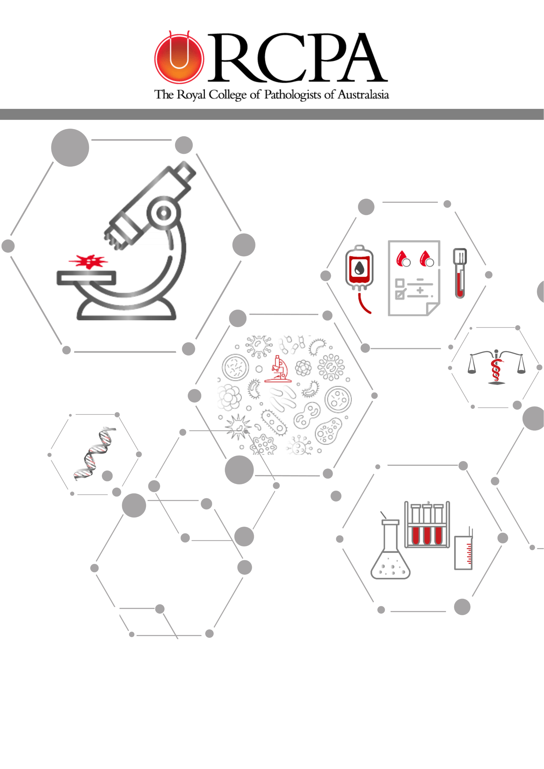
Document Control
Date | Version | Status | Action | Responsible
30 May 2024 | V1.0 | Final | For submission | V White

Contents
Document Control 2
1. Glossary of terms & acronyms 4
2. Project Description 5
3. Executive summary 5
4. Activities and Outcomes 7
5. Issues addressed 17
6. Evaluation Strategies 18
7. Findings and recommendations 20
8. Appendices 22

Glossary of terms & acronyms
Acronym | Detail
ACD | Australasian College of Dermatologists
ACEM | Australian College of Emergency Medicine
ACRRM | Australian College of Rural and Remote Medicine
ADG | Australian Doctor Group
DoHAC | Department of Health and Aged Care
EOI | Expression of Interest
GP | General Practitioner
HTML | HyperText Markup Language
IT | Information Technology
JMO | Junior Medical Officer
Kentico | Web content management system
LOINC | Logical Observation Identifiers Names and Codes
LTO | Lab Tests Online (now PTex)
MBS | Medicare Benefits Schedule
NBCSP | National Bowel Cancer Screening Program
NCSP | National Cervical Screening Program
PO | Project Officer
PTEx | Pathology Tests Explained (Formerly LTO)
RACGP | Royal Australian College of General Practitioners
RACP | Royal Australasian College of Physicians
RANZCR | Royal Australian and New Zealand College of Radiologists
RCPA | Royal College of Pathologists of Australasia
RCPA Manual | RCPA Manual of Use and Interpretation of Pathology Tests
SC | Steering Committee
SNOMEDId | Systematized Nomenclature of Medicine Identifier
SPRC | Structured Pathology Reporting of Cancer

Project Description
The Project was designed to undertake a thorough review of existing pathology tests and clinical conditions in the RCPA Manual of Use and Interpretation of Pathology Tests (RCPA Manual) 7th Edition to identify any obsolete tests for exclusion and new tests for inclusion. In addition, the resulting 8th edition of the RCPA Manual is available electronically via the RCPA website and as an app, providing greater functionality and accessibility for new and existing users. The RCPA Manual app now provides users with a portable, accessible, comprehensive resource to facilitate and support pathology test selection. This resource, downloadable via both the Apple Store and Google Play, is easily accessible to assist with educating pathology requesters, and provide guidance on the most appropriate, efficient, best practice pathology requesting.

Executive summary
The RCPA formed a Steering Committee with representation from experts within each subdiscipline of pathology to undertake a comprehensive review of the RCPA Manual of Use and Interpretation of Tests (RCPA Manual) 7th Edition and subsequently to develop the RCPA Manual 8th Edition alongside a new companion mobile app. The RCPA Manual 8th Edition was published on the Royal College of Pathologists website in December 2023. The new RCPA Manual App was completed in January 2024 and made freely available via the Apple Store and Google Play on 01 February 2024. This milestone release marks a significant evolution from print to online to a mobile app, reflecting the RCPA’s commitment to providing cutting-edge resources for healthcare professionals.
To achieve this, the Steering Committee co-opted experts to review and update 598 existing pathology test entries and 623 clinical presentation and diagnosis entries. Over a period of 18 months, the Steering Committee met on 8 occasions and the resulting 8th Edition now features 586 pathology entries, a reduction from the previous edition of 598 entries – with 78 outdated test entries being archived and 64 new test entries included. In addition, 622 clinical entries were reviewed, 71 outdated entries archived and 7 new test entries included, resulting in 559 clinical entries. The RCPA Manual underwent a meticulous examination to ensure its continued relevance and accuracy, reflecting advancements in pathology practice and technology that can continue to be provided as a fundamental resource for referring practitioners.
Key considerations during the review process included:
- Content relevance: ensuring that the RCPA Manual content remains aligned with contemporary pathology practices and reflects the latest advancements in pathology
- Accuracy and precision: maintaining the highest standards of accuracy and precision in test descriptions, clinical presentations and diagnostic criteria to uphold the integrity of the RCPA Manual
- Inclusion of emerging technologies: integrating information on emerging technologies and methodologies to provide comprehensive guidance to referring practitioners
- User experience enhancement: improving the user experience by incorporating user-friendly features, resource links and development of a companion mobile app.
This resulting app allows for offline use and provides enhanced accessibility, particularly for healthcare professionals working in remote and regional locations, aiming to empower users with the same comprehensive information found in the RCPA Manual, now conveniently available at their fingertips.
Clinical Prof. John Burnett, RCPA Fellow and Editor of the RCPA Manual said:
“The RCPA Manual is particularly useful for GPs, providing them with updated and comprehensive information to make informed decisions about pathology testing. With the new app's offline functionality, GPs in remote and regional areas can access critical information even without internet connectivity, enhancing their ability to deliver quality care."
The outcome of this rigorous review process is the development of the RCPA Manual 8th Edition, which preserves the integrity of its predecessors but also reflects the evolution of pathology practice. Through the development and delivery of a companion mobile app, the Project recognises the increasing reliance on digital tools, and provides convenient access to a wealth of information digitally - reflecting the RCPAs dedication to ensuring the accuracy and relevance of the information provided in a contemporary format.
This has been reflected in the number of downloads of the mobile app since it was launched by the RCPA President on 01 February in the RCPA member newsletter “Pathway” with approximately 600 app downloads in the first week. Since this time, General Practitioners (GPs) have also been made aware of the new Edition and app via an online article published in NewsGP, the Royal Australian College of General Practitioners member newsletter.
The RCPA Communications Team were instrumental in designing a new logo for the RCPA Manual and links to download the app on the RCPA Manual landing page. There is a promotional banner on the main landing page of the RCPA website to create awareness of the new Edition and app. Further promotion of the RCPA Manual occurred during February and March with articles in Pathology Today and Pathway (RCPA publications), ongoing posts on RCPA social media and the major launch at Pathology Update 2024. Steering Committee Chair Dr John Burnett introduced the RCPA Manual app before the Innovation Plenary [Sunday 03 March], and delegates at the conference have provided positive feedback.
The RCPA Manual 8th Edition, along with its companion mobile app, stands as a testament to the ongoing commitment of the RCPA to excellence in pathology education and practice. It serves as an indispensable resource to pathologists, medical professionals and students, empowering them with the knowledge and guidance necessary for best practice patient care in the dynamic landscape of modern healthcare.

Activities and Outcomes
This Other Report outlines the activities completed from 01 April 2022 through to 30 April 2024 with respect to delivering the agreed Milestones for the Project as outlined in the Agreement and Deed of Variation 2 executed 09 January 2023. The following key activities have been completed:

Completed a gap analysis of the existing RCPA Manual to review pathology tests and clinical scenarios to identify relevant pathology tests and clinical information for inclusion.
- Appointed a full-time Project Officer (PO), casual PO and formed a Steering Committee (SC) with expert pathologists representing each discipline. The SC held 7 meetings online and 1 face to face meeting over the period of the Project. The Discipline experts were recognised for their contribution to the project by being listed as the editors of the RCPA Manual 8th edition (See Appendix A). The Project Team agreed the project scope and deliverables that were incorporated into the Activity work plan for the project (See Appendix B).
- Extracted 7th edition RCPA Manual data was presented to the SC in a user-friendly editable format for the purposes of a gap analysis, review and update. The Project team dissected and assigned all Pathology Tests and Clinical Problem topic entries to respective discipline experts for review. Each entry was reviewed for currency and relevancy to referring practitioners, then determined for inclusion in the 8th edition or if obsolete, for exclusion. The list of obsolete entries was circulated amongst the SC, and agreement was reached to archive these entries. Entries for inclusion were reviewed, and where necessary, those entries requiring multi-disciplinary input were allocated for secondary reviews by appropriate discipline experts. Additional support in reviewing and updating entries was provided to the SC from subject matter experts, other volunteer Fellows and the College Project Team. Figure 1 below summarises the overall changes made to these two sections between the 7th to 8th editions of the RCPA Manual.
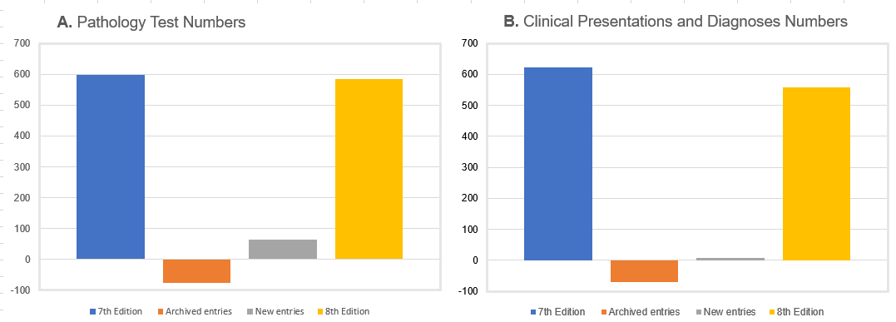
Figure 1: Summary of changes to: A. Pathology Test and B. Clinical Presentations and Diagnosis entry numbers between the 7th and 8th editions of the RCPA Manual.
- The 8th edition of the RCPA Manual was published with a total of 586 Pathology test entries, including 64 newly developed entries. The gap analysis resulted in the exclusion of 78 Pathology Tests which were archived. Pathology test entry titles and keywords were updated to reflect the RCPA preferred standardised pathology requesting and reporting terminology (as published in the RCPA SPIA Guideline) and/or common usage, with alternative names and SPIA synonyms included as cross-references in Keywords. Furthermore, two additional fields (SNOMED-CT ID and LOINC) were created and updated for pathology requesting and reporting codes to the pathology test entries (where relevant) reflecting RCPA SPIA Guidelines. This update was agreed to encourage the use of standardised pathology requesting and reporting terminology, coding, and units of measurement. The Systemized Nomenclature of Medicine – Clinical Terms (SNOMED CT®) code is an internationally standardised clinical terminology used in over 90 countries and is designed for recording clinical information in electronic health records. Logical Observation Identifiers Names and Codes (LOINC) numbers are universal clinical terminology for health facilitating the electronic exchange of measurements, observations, and documents. Both code types were included for the pathology test entries where available and appropriate. These were provided as a guide with the proviso that these may differ between laboratories depending on testing methodologies, units of measure and specimen types. The reference interval field was also updated to the standardised Australasian Harmonised Reference Intervals for Chemical Pathology where appropriate.
- The “Clinical Problems” section review and update resulted in an agreement by the SC to rename the section “Clinical Presentations and Diagnoses” to more accurately reflect the content. The 8th edition features 559 clinical entries, a reduction from the previous edition of 622 entries – with 71 outdated entries being archived and 7 new test entries included.

RCPA Manual linkages: Updated Manual to include relevant links such as the MBS, PTex (formerly LTO) and national registries.
- A new “Medicare” field was created for the Pathology Test section to include information on the availability of Medicare benefit rebate status and links to the MBS item number search tool. This information was included for 578 Pathology Tests. Additionally, item numbers were only provided for newly introduced genetic tests to help educate users on these new tests.
- A new “resources” subheading was added to the Pathology Test section to provide users with links to helpful relevant external sources where there was a direct relationship to a pathology test. Links to Pathology Tests Explained (formerly Lab Tests Online) were added for 262 pathology test entries. These links provide practitioners with convenient patient-focused information. Links to other resources, such as the RCPA Genetic Tests and Laboratories Catalogue, RCPA Structure Pathology Reporting of Cancer Protocols, and national registries, were also included, as outlined in the table below.
Resource | Number of Linked Entries
Medicare Benefits Scheme | 553
Pathology Tests Explained | 262
RCPA Genetic Catalogue of Tests and Laboratories | 43
RCPA - Structured Pathology Reporting of Cancer Protocols | 19
National Cancer Screening Registries | 5
- The Project Team also created several other helpful internal linkages to assist end users in navigating to related information in the RCPA Manual, including within the following newly created diagrams:
  - Chart A - Blood tube chart and recommended order of draw (see Figure 2 A below), a visual guide developed together with the SC to accompany the information contained in the Specimen Collection section.
  - RCPA Manual Figure 3: A guide to routine antenatal testing (see Figure 2 B below), a visual representation of the key tests suggested at the various stages of pregnancy and birth.
A.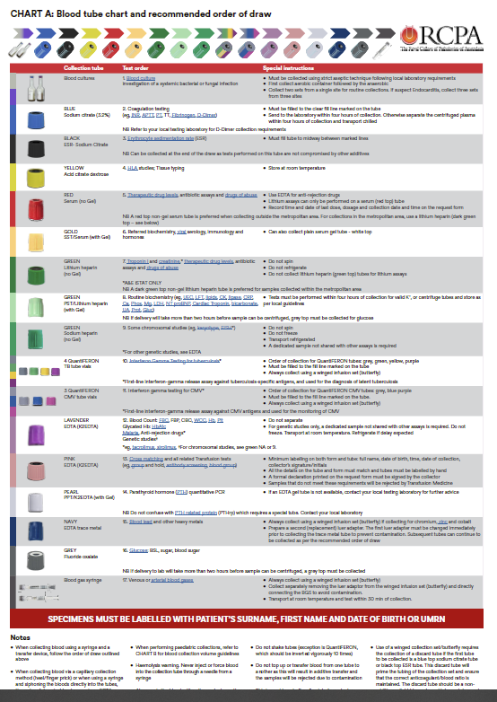 B. 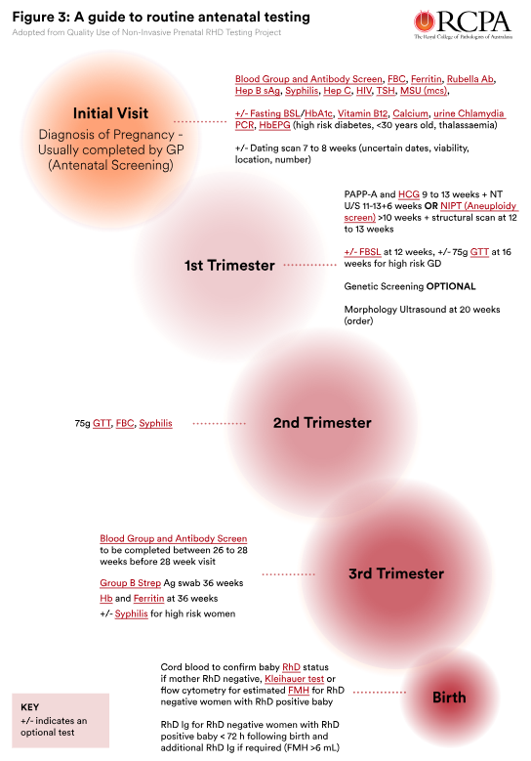
Figure 2: New RCPA Manual graphics had hyperlinks embedded for the RCPA Manual Pathology Tests referred to in the diagrams to improve the user’s experience.

Developed suitable Information Technology Requirements for the RCPA Manual 8th edition website version
- The test environment of the RCPA website was created and successfully used to manage review and update of the RCPA Manual data for the 8th Edition. Also, specially developed Word templates were created and used for the addition of the newly developed Pathology Test and Clinical entries.
- The 8th Edition of the RCPA Manual was published on the Royal College of Pathologists website in late December 2023. This soft launch of the 8th edition was conducted ahead of schedule to enable data and functionality testing. The testing allowed minor errors and bugs to be addressed by the Project Team before the marketing and launch activities (outlined in section 4.5) commenced in early 2024.
- A new RCPA Manual logo was designed as part of the launch (see Figure 3 A below) to help distinguish it from the other manuals on the College website (B). It incorporated the RCPA crest and tree of life, which the College had utilised in earlier print editions in a way that keeps with the Manual’s history.
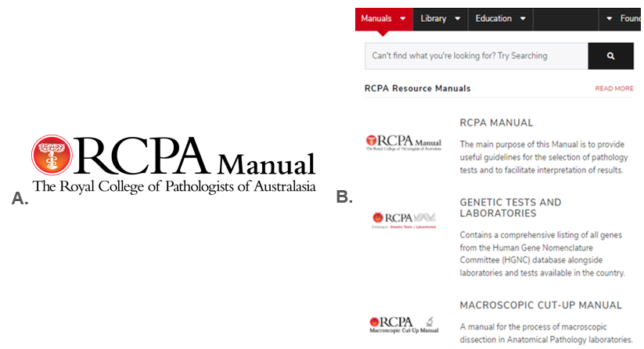
Figure 3: A. New RCPA Manual logo B. RCPA Manual and other resources listed in the Manuals section of the RCPA website.

Developed a digital app to improve online functionality and usability
- The Project Team appointed an external software developer, Eventium, to develop the RCPA Manual app with agreed specifications and delivery timelines. The Project Team and external volunteers completed testing to identify areas for further refinement to ensure the app reflected the functionality and links within the RCPA Manual hosted on the RCPA website. The RCPA IT Team and Eventium agreed to adjust the website and app to ensure mirrored performance. Links to external resources, including PTEx and MBS were verified to achieve 100% functionality before the final product release on the Apple Store and Google on 01 Feb 2024 (Figure 4).
- The final app design depicted below (Figure 5 A) features nine icons, with the first two dedicated to the key sections “Pathology Tests” and “Clinical Presentations and Diagnoses”. The Project Team took a strategic approach to replicate the familiar web version icons for these two sections (See Figure 5 B) to help existing RCPA Manual users easily recognise these sections when transitioning to the app. The remaining seven icons were allocated to sections of other helpful information contained in the RCPA Manual, such as “Specimen collection”, “Interpretation guides”, and the “Glossary”, allowing end users a quick navigation experience to this information.
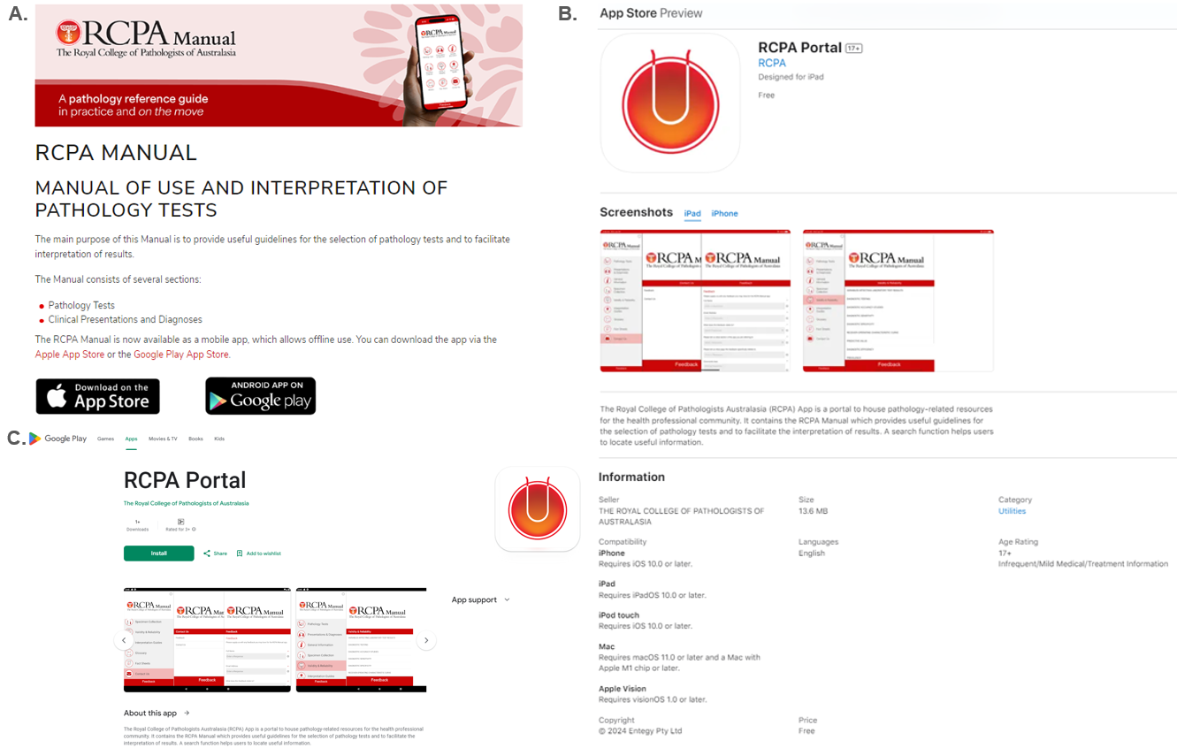
Figure 4: A. The refreshed RCPA Manual website landing page with links to the Apple Store and Google play to download the complimentary app for Apple and android devices. The RCPA portal information landing page for the RCPA Manual app in the: B. Apple Store and C. Google play.
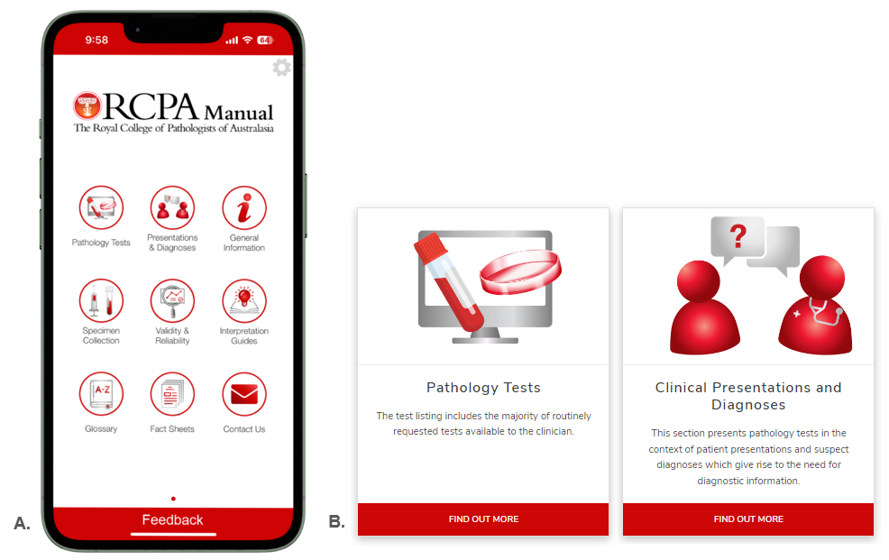
Figure 5: A. The RCPA Manual app skin with nine icons providing convenient navigation tools to the important sections of the RCPA Manual. B. The web icons for the Pathology Tests and Clinical Presentation sections.
- The “General Information” icon incorporated updates to the “How to use this Manual” section with information on the app and the new fields added to the Pathology Test entries. A “Feedback” banner was incorporated at the bottom of the screen to facilitate user comments easily and was added with the view of being an important tool to assist in improving the app in the future.
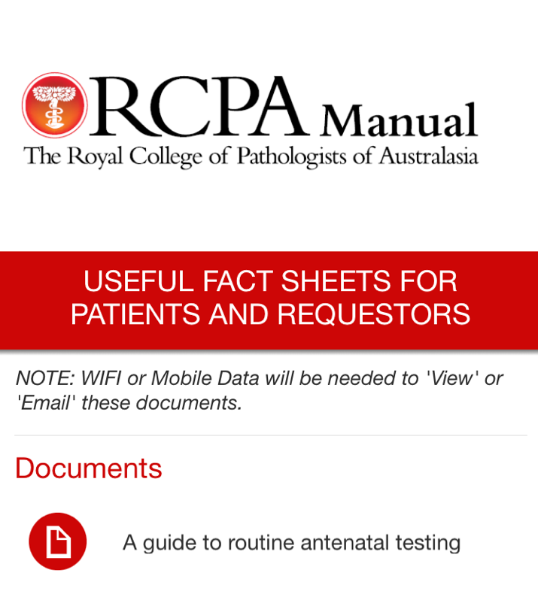
The most significant additional feature of the digital app that improves RCPA Manual functionality and usability is that it offers offline access to the Pathology Tests and Clinical Presentations and Diagnoses sections, a handy feature for rural and remote healthcare workers. Testing by the Project Team and external volunteers verified this capability, with highly positive feedback on this feature. Hyperlinks to resources and PDFs are not accessible without Wifi, and the developer added a note to the respective app pages to inform users (see right).
- A “Back” button, as shown in the images below, was incorporated to improve the user’s navigation experience in direct response to the tester’s feedback (Figure 7).
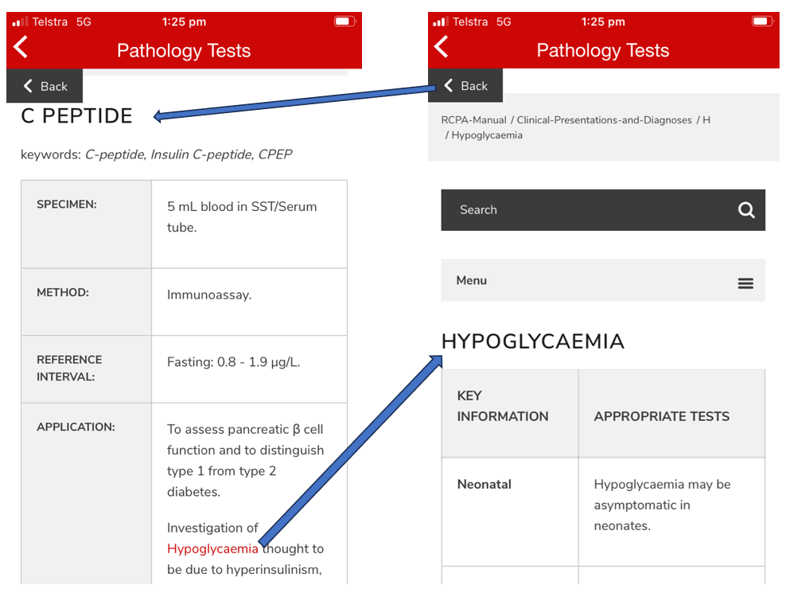
Figure 7: iPhone screen grabs showing the “Back” button which returns the user to the entry they were looking at after clicking on hyperlinks of an entry, helping to mirror the web user experience.

Education & promotion of RCPA Manual app to GPs and other referring practitioners.
- A promotional education campaign launching the RCPA Manual and app was delivered via a refreshed website landing page (Figure 4 A), website banner (Figure 8), promotional pieces in college publications (Figure 9), social media posts (Figure 11), a promotional competition (Figure 12) and a major launch at “Pathology Update 2024: Answers in Adelaide”, the RCPA’s premier scientific annual conference. The uptake of the app has grown steadily since release and distinct spikes have been observed after each promotional activity (Figure 13). Downloads of the RCPA Manual app to date are a positive indication the latest edition is a welcome resource.
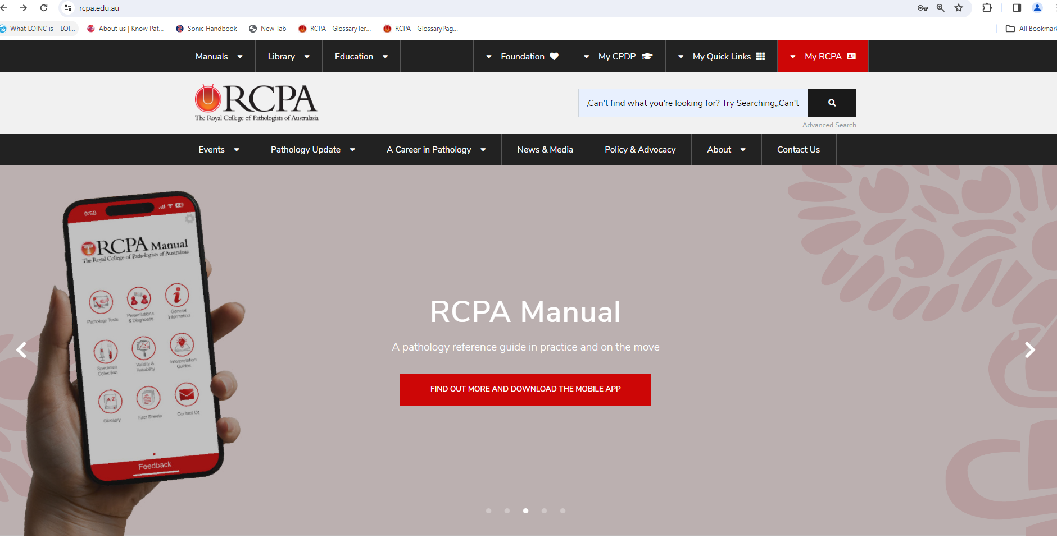
Figure 8. The banner for the RCPA webpage promoting the 8th edition of the RCPA Manual and the digital App with the tagline “A pathology reference guide in practice and on the move”.
- A variety of activities were also undertaken to establish working relationships and links with the key stakeholder organisations RACGP; RACP; ACRRM and ACD. President to president letters were sent these key organisations informing them of the RCPA Manua 8th edition and app and requests to collaborate on promoting the app. The RACP posted a links on the RACP Online Community (ROC) and ACD indicated they would put links in their weekly newsletter. GPs were made aware of the new Edition and app via an online article published in NewsGP, the Royal Australian College of General Practitioners member newsletter (Figure 14).
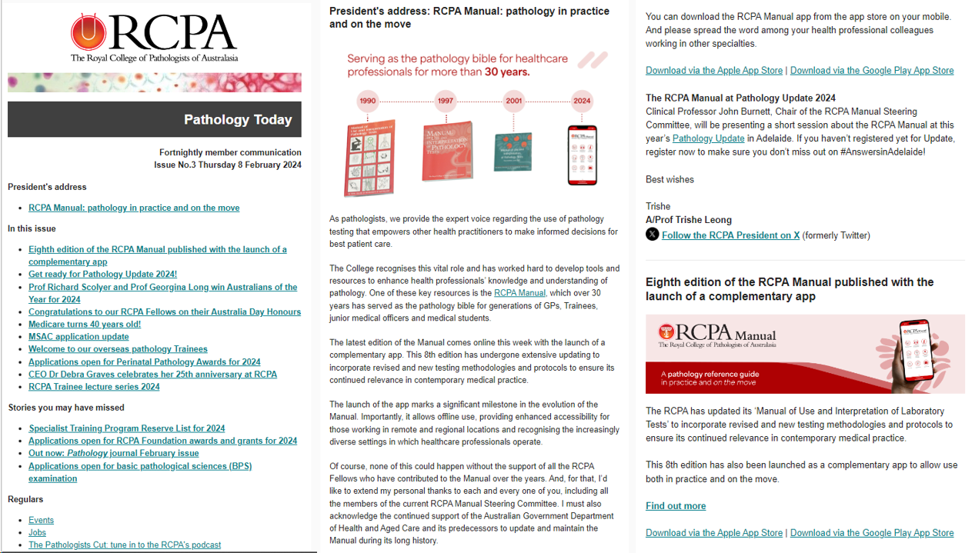
Figure 9: Exerts from Issue No. 3 of the fortnightly member newsletter “Pathology Today” published on 08 February 2024 including President’s address announcing the 8th edition of the RCPA Manual.
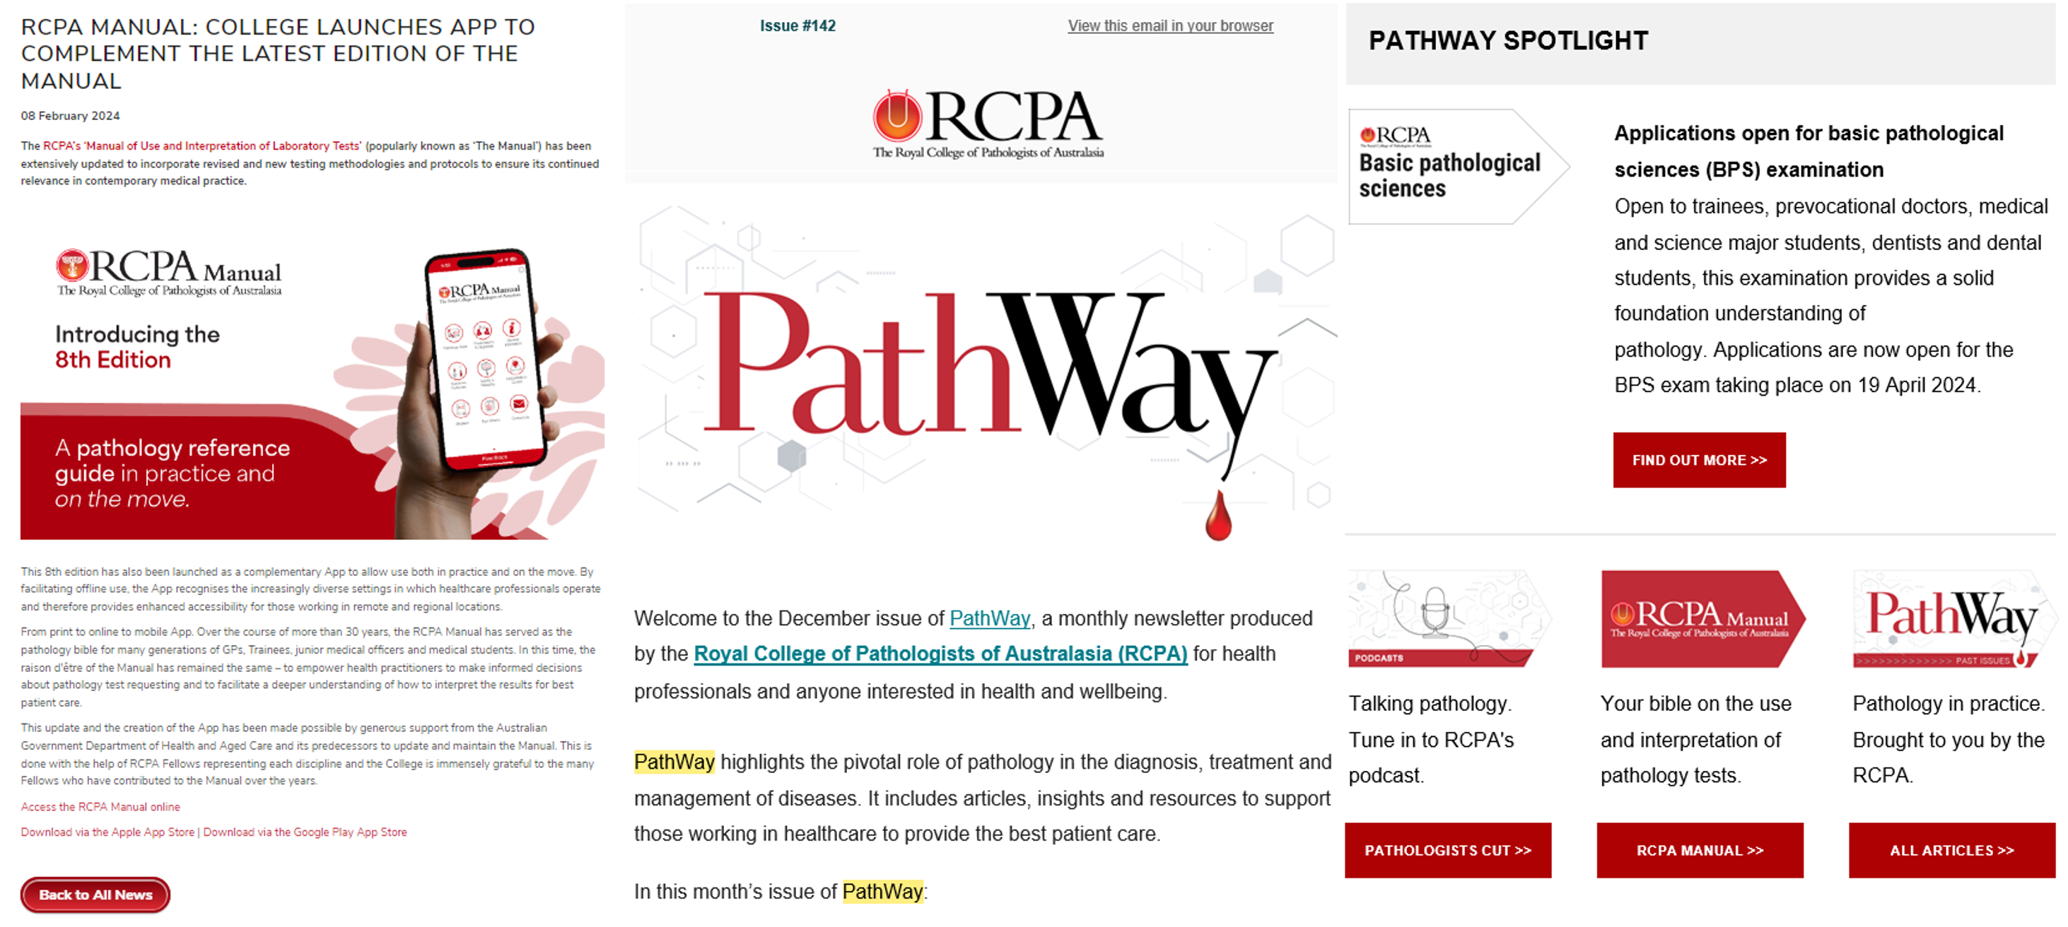
Figure 10: Pathway article announcing 8th Edition from 08 Feb 24, plus previous issue showing RCPA Manual promotional tile featured in several editions.
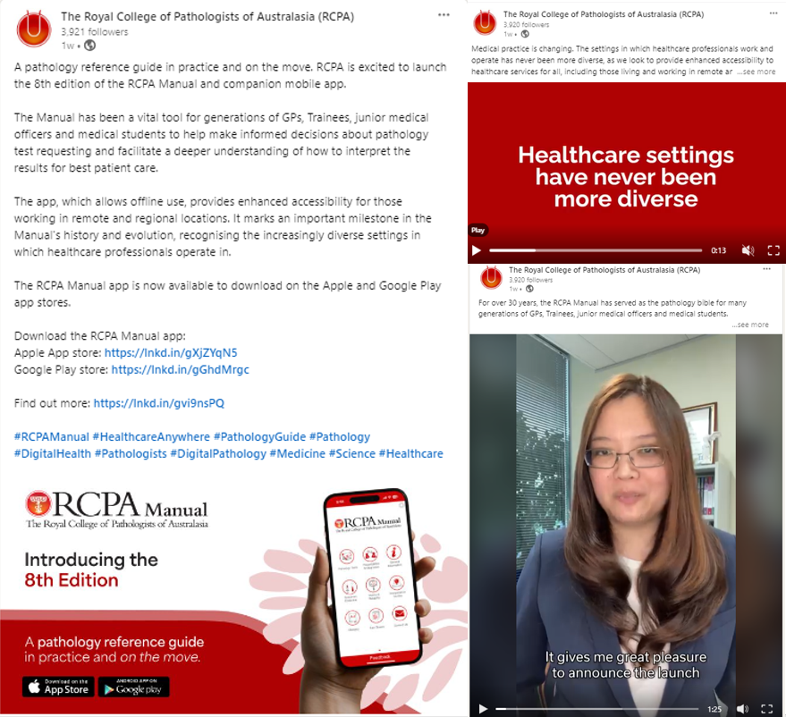
Figure 11: A sample of the social media posts made on the RCPA accounts to promote the 8th Edition of the RCPA Manual and the new app, including video pieces.
A.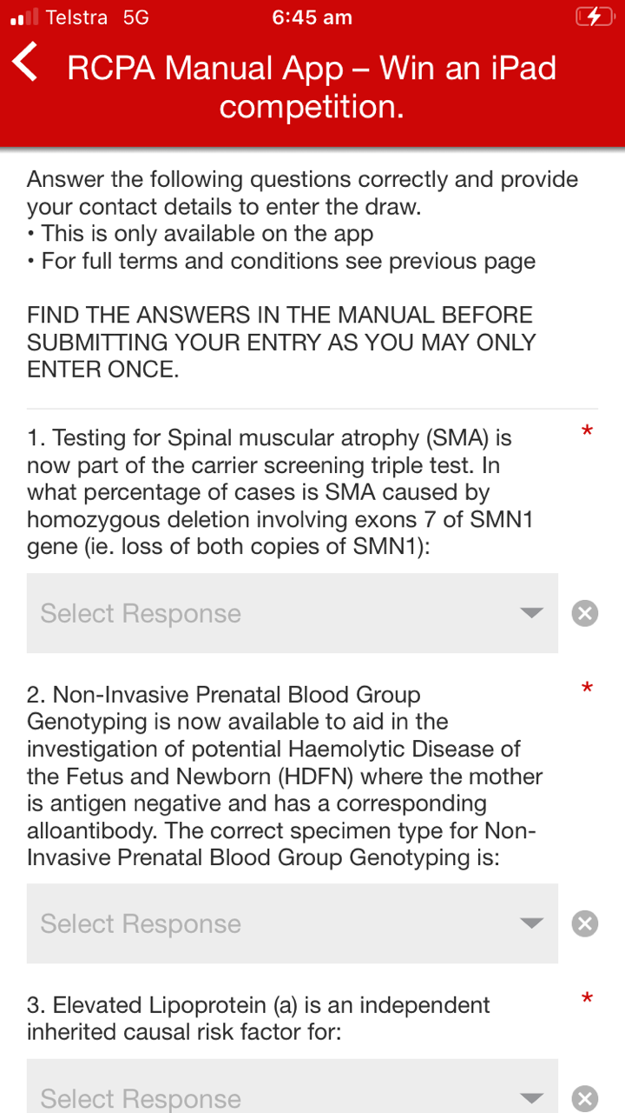B.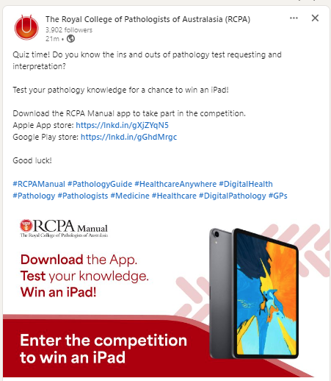
C. 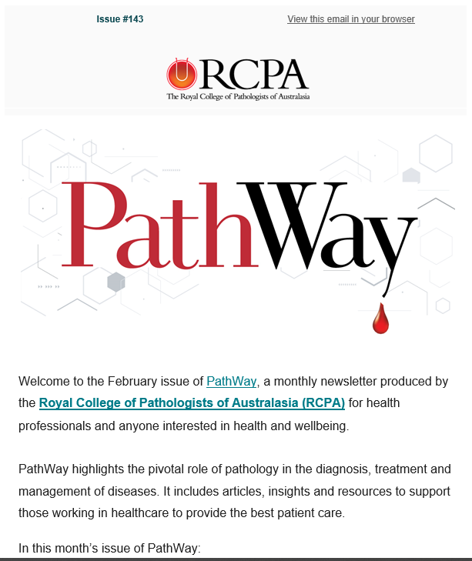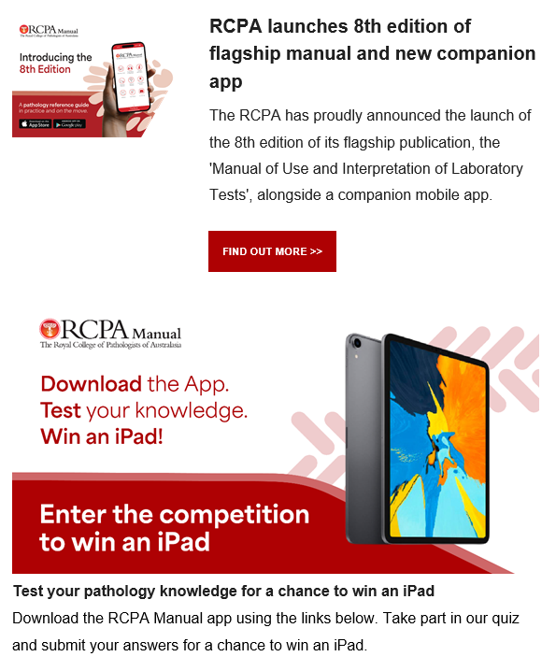
Figure 12: A. Promotional quiz created in the app, B. an example of a social media post to promote the competition, and C. RCPA Pathway newsletter with a section on the competition.
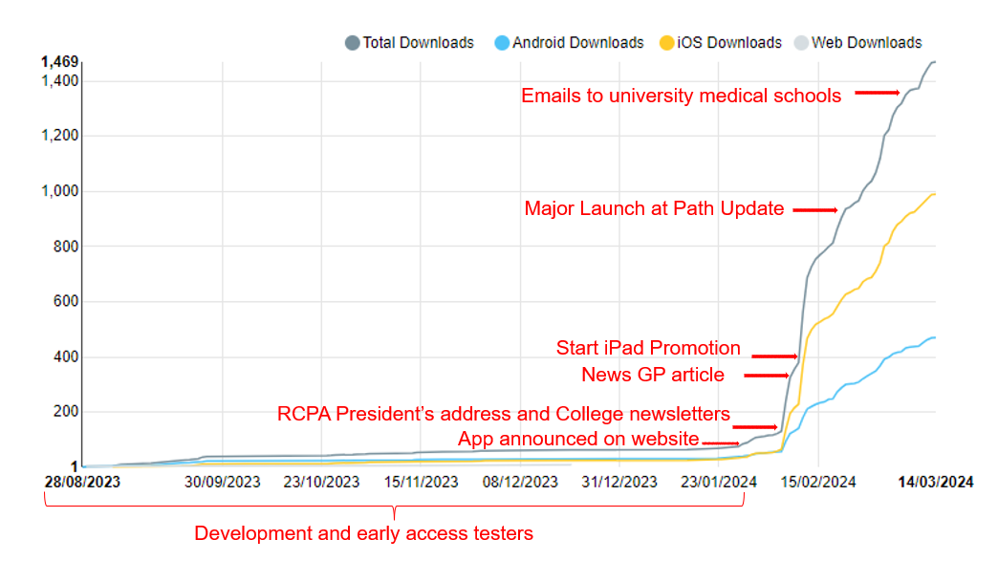Figure 13: Downloads of RCPA portal app for 8th edition of RCPA Manual over time including development, testing and preview access overlaid with arrows indicating key promotional activities.
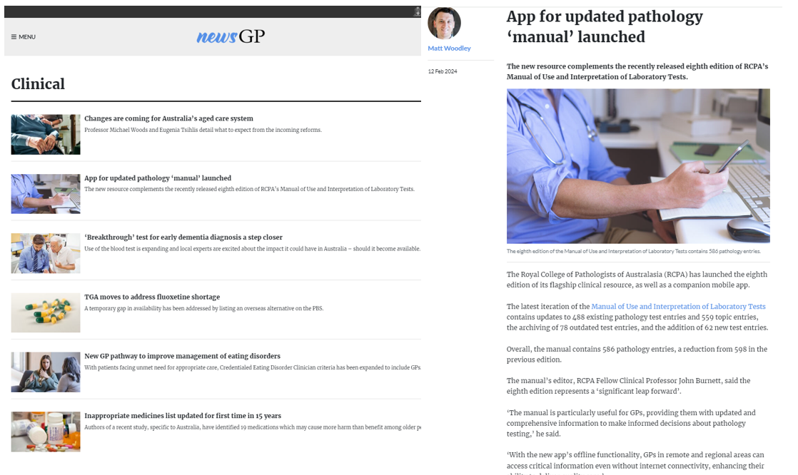
Figure 14: Article in News GP published promoting the 8th edition of the RCPA Manual online 12 February 2024.
- The organisation Choosing Wisely was approached, however, responded that they were not able to promote the RCPA Manual at this time. They explained that following the transition of the Choosing Wisely initiative from NPS MedicineWise, the Commission is reviewing the stewardship of the program and that they are working with key groups to understand how the program is used and to identify opportunities for improvement.

Issues addressed
The main challenge for the Project was the volume of content that required updating and SC's capacity to volunteer the time required to review and update the information. The last update was in 2015 and the volume of content requiring updating is a direct consequence of the time elapsed between updates and is addressed in the Recommendations section of this report. The “Clinical Problems” section review extended into the second half of 2023 and impacted some members of the SC, with their competing work priorities preventing them from completing their assigned reviews withing the timeframe required. The Project Team employed two strategies to mitigate delays. Firstly, the Project Manager sought recommendations from RCPA Discipline Advisory Committee heads for experts to assist with the list of unreviewed entries, with the POs contacting these experts. Additionally, the POs searched for recent publications on the topics for the remaining unallocated entries to identify Australian subject matter experts to approach. These approaches to co-opt additional volunteers ensured all entries underwent a review and avoided serious delays.
Another issue that arose during the review and update was the actual name of the “Clinical Problems” section. It drew feedback from some sections of the Pathology community who felt it did not accurately reflect the content. In the second half of 2023 the SC requested that users of the RCPA Manual, including GPs, be consulted before finalising the name. A consensus was reached to change the section name to “Clinical Presentations and Diagnoses” to better reflect the content of the section. This seemingly simple title change also introduced an IT challenge as all associated hyperlinks to entries in this section also required correction throughout the entire content of the RCPA Manual.
This highlighted the complexity of the IT component of the Project and associated IT resourcing requirements. Another similar issue that had to be addressed occurred after the external website Pathology Tests Explained changed its name/structure requiring these external links to be manually recoded in the second half of 2023. To reduce the burden on the RCPA IT staff, cross training of the POs was undertaken so they could assist with updating the content.
There were some significant delays from the developers in providing a final test version of the app with the offline content enabled. This compressed the testing time available for the Project Team agreed to enable general feedback to be provided and incorporated whilst the offline capability was addressed to mitigate further delay.
There were also some IT technical challenges ensuring the app content matched the website. Most tables and graphics on the RCPA Manual web edition were found to be incompatible with the app during testing. This resulted in the need for a large amount of website customisations as a work around for the app’s limitations. For example, all the tables in the Interpretation Guides section that accurately presented on the website as PDFs weren’t accessible in the initial test versions of the app. The RCPA IT Team recreated these effected Tables as HTML files on the website to enable accurate presentation on the App. Similarly interactive PDF charts and figures needed to be re-created as SVG images for app compatibility.

Evaluation Strategies
The high utility of the RCPA Manual is reflected in the analysis of the RCPA website statistics, RCPA Manual specific analytics and in downloads of the new app. The RCPA Manual is one of the highest viewed areas of the RCPA website accounting for 31% of the total website page views (Figure 15) with Pathology Tests dominating the top 20 pageviews for the area (Figure 16).
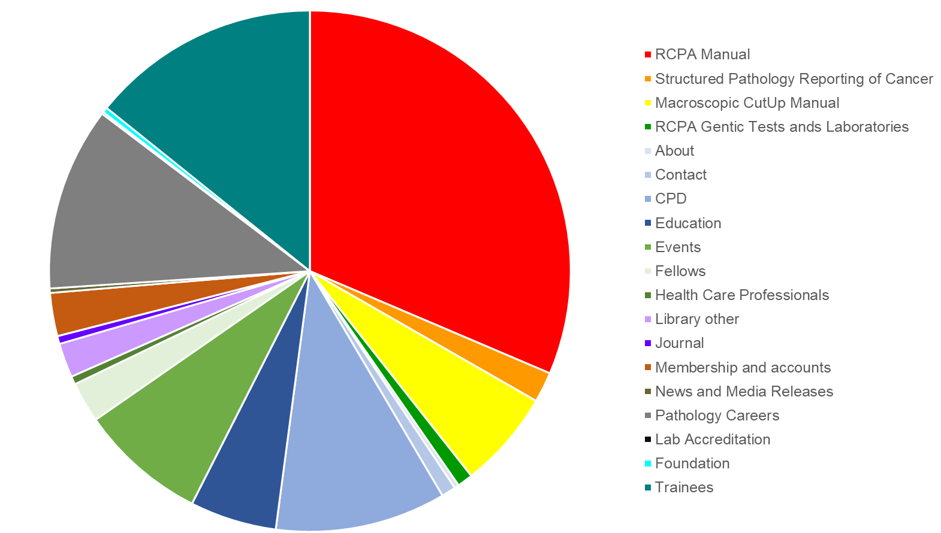
Figure 15: RCPA website traffic by section with RCPA Manual usage shown in red.
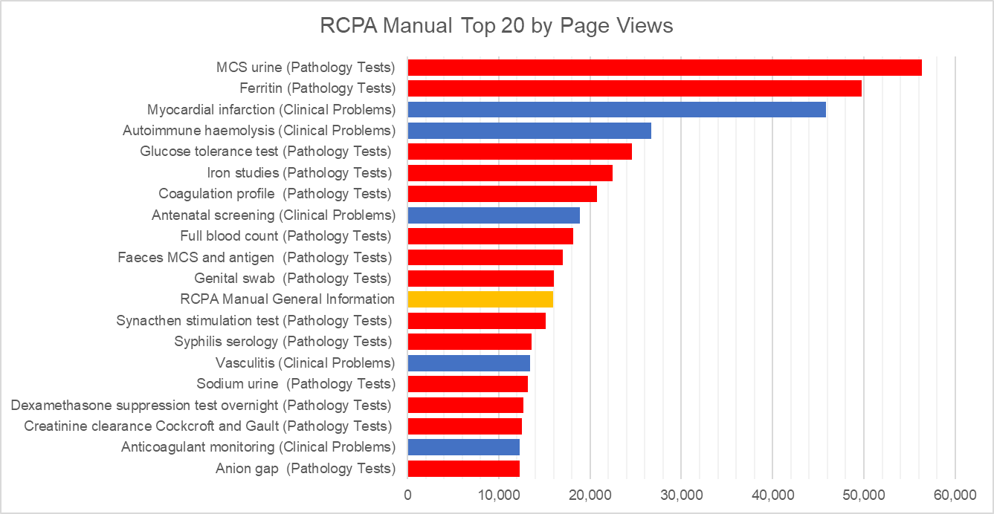
Figure 16: The top 20 utilised sections of the Manual by page views are predominantly specific pathology tests interspersed with clinical problems.
Over the last 5 years, the RCPA Manual has been viewed over 3,446,429 times with use steadily increasing year on year. The release of the 8th Edition of the RCPA Manual online has seen an unprecedented amount of website traffic for the first 2 months since released with 101,610 page views which is tracking higher than for the same period in 2023.
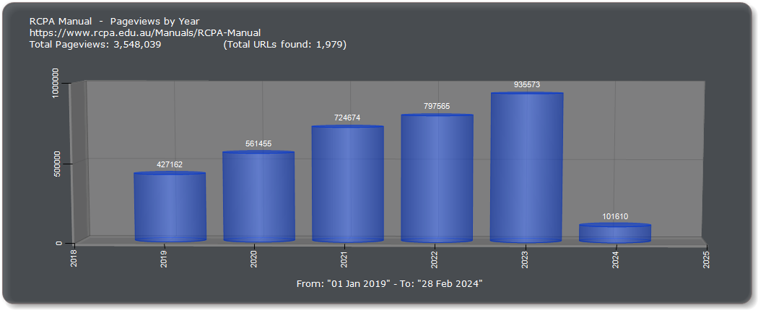
Figure 17: RCPA Manual website pageviews by year (2019 – February 2024)
The app download numbers over time (Figure 13) reflect the successful uptake of the new RCPA Manual app. Over 1000 downloads of the App were observed in the first month of since release, with 20,166 total views and 8,616 unique page views. Spikes in app downloads were apparent and mirrored the timings of the educational campaigns targeting the key user groups. There have now been 2010 app downloads, 25,001 total page views and 11,360 unique pageviews at the end of the reporting period.
The app specific “Win an iPad” promotional competition provided excellent insight into the demographics of Manual users. The quiz built into the app required entrants to answer three quiz questions about new Pathology tests in the RCPA Manual. The activity captured end-user demographic information with entries submitted by GPs, Medical Students, Lab technicians, Pathologists, Trainees, Scientists and Academics across Australia, New Zealand, Malaysia, Scotland, Saudi Arabia and Hong Kong. Two hundred thirty-four entries were received, equating to approximately 15% of overall app downloads. The results show key target groups have begun to utilise this resource and that it is beneficial for the wider healthcare community.
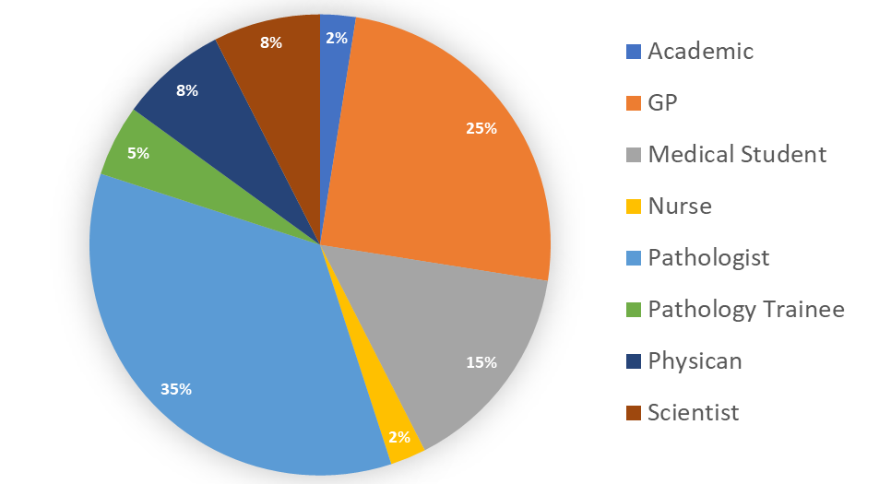
Figure 18: Profession nominated by app competition entrants.
A key feature of the app was the incorporation of a Feedback button on the main screen to facilitate user feedback in a streamlined manner. This feature has already been taken up by users to provide positive feedback on the Manual including comments such as:
“I like this summary style commentary; succinct but has enough description to be beneficial to many groups. I’ll recommend this to my scientific staff as a useful tool”
“It’s a great idea, and even very informative to pathology trainees and pathologists who work in different specialties. A great, simple reference. Very easy to navigate”.
“Generally very clear content structure and detailed instructions that is very important.
Easy to use and find information, the glossary was a good addition - no need to remember everything. It's a very nice app. Well Done”.
The feedback button has also already been utilised to provide specific content feedback and resulted in the rapid update of specific entries in consultation with the Manual editor. This feature will aid in continuous improvement of the content into the future and will be employed for ongoing evaluation together with app and web analytics.

Findings and recommendations
The RCPA Manual is a highly utilised and valuable digital resource, serving the healthcare community as demonstrated by RCPA website traffic, app downloads and demographics of the RCPA Manual users. Early access to the RCPA Manual app was provided to a small group of rural and regional GPs, JMOs and medical students who found that:
“The app was very user-friendly, with accessible and understandable content that was easy to navigate on the platform. The nine general content headings were reflective of their function and purpose, which assists in time-pressured searching/use of the app.” (Medical Student)
“Most useful thing about the app was the patient fact sheets, that I use in everyday work. I thought it was easy to use and I can imagine that for example the "presentations and diagnoses" part would be very useful, especially if you get stuck in your head and need a bit of a push forward and to check that you've thought about everything.” (GP)
“Ongoing addition of relevant content would be much appreciated. It is a really valuable resource for all medical officers.” (Physician).
A key feature of the update is the addition of fields that support The Department of Health and Aged Care Digital Health Blueprint and Action Plan 2023-2033. The RCPA Pathology Informatics Project noted:
“The ability to interpret pathology results has been greatly facilitated by the addition of Specimens, Methods, Reference Intervals, SNOMED CT and LOINC codes from the Standardised Pathology Informatics in Australia (SPIA) Pathology Terminology Reference Sets and Information Models into latest edition of the RCPA Manual. These additions, along with links to resources such as Pathology Tests Explained and the Medicare Benefits Scheme for Pathology Services, further enhance the value of the RCPA Manual as an essential companion aid for pathologists and General Practitioners alike, ensuring they are able to select the most appropriate test for their patient during consultation, and interpret the results without ambiguity”.
In addition, the RCPAQAP CIO recommended future iterations would benefit from including the SPIA LOINC, UCUM and SNOMED coding in the RCPA Manual so that it makes pathologists, trainees and scientists aware that standard coding exists and they can use the RCPA Manual as a reference to easily find codes and supply them to their IT departments if needed.
A key finding from the Project Team is a solid need to maintain currency to demonstrate integrity ad commitment to best practice for the RCPA Manual. It is evident that reviews cannot be adhoc, and rather regular reviews and updates are essential. The Project Team propose a variety of mechanisms that could be employed to ensure that the RCPA Manual continues to be a contemporary resource that maintains its currency as illustrated in the diagram below. Four different mechanisms for maintenance were identified to facilitate this:
Periodic Major Review (ideally annual review as outlined in Appendix C)
RCPA Advisory Committees
External advisory briefs
User Feedback
The RCPA Manual Steering Committee suggested that annual updates of the RCPA Manual should be the main approach for maintaining content and currency. Additionally, three other mechanisms (RCPA advisory committees, external advisory briefs and user feedback) have been identified to allow for ad-hoc changes ensuring that content can be adjusted to keep abreast of any emerging health issue such as pandemics like SARS-CoV-2. Implementing such an approach would also be subject to funding.
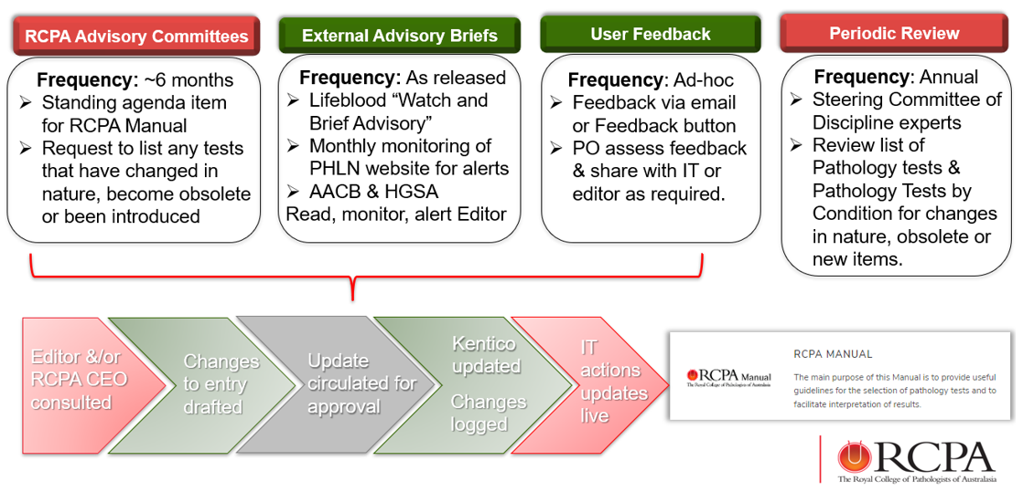
The RCPA app portal developed for the RCPA Manual has been developed and designed in a way such that other College resources can be added in the future. Another recommendation of the Project is that the portal be considered for future projects to also add other digital content helpful to the wider healthcare community.

Appendices

Appendix A – Contributors to the RCPA Manual 8th Edition.
The Steering Committee members were listed as the Editors with additional volunteer reviewers included in the RCPA Manual Acknowledgements along with the RCPA Project Team.
Editors
Clinical Prof John Burnett (Chair), A/Prof Rob Baird, Dr Pak Leng Anthony Cheong, Dr John Giannoutsos, Dr David Gillis, Adjunct A/Prof Amanda Hooper, A/Prof Diane Kenwright, Prof David Roxby, Prof Nelson Tang.
Acknowledgements
Dr Stephanie Anderson, Ms Nicole Bain, A/Prof Damon Bell, Dr Nick Bingham, Ms Vanessa Cameron, A/Prof Janine Campbell, Dr Adrian Charles, Mrs Corrina Cliffe, Dr Danielle Clucas, Dr Jason Conn, Dr Briony Cutts, Prof Jane Dahlstrom, Dr Caroline Dix, Dr Kristen Estabrooks, Dr Emmanuel Favaloro, Dr Jill Finlayson, Dr Helen Freeborn, Dr Debra Graves, Mr Lawrence Greed, Prof David J Handelsman, Ms Marion Higginson, Dr Shir-Jing Ho, Prof Geoff Isbister, Dr Giles Kelsey, Dr Jenna Langfield, Dr Nora Lee, Prof Andrew Lloyd, Ms Helen Membry, Dr Tina Noutsos, Dr Peter O'Leary, Ms Susan Oliver, Dr Sarah Parsons, Ms Lynda Richardson, Dr Niina Tujula, Ms Linda Vinski, Ms Vanessa White, Dr Helen Wordsworth.

Appendix B – Activity work plan progress
In progress Completed
 | Contractual Activity | Activity Owner | How will Contractual Activity be achieved and measured | Date Due | Status
1 | Project Kick-off
1.1 | Appoint Project Officer | Project team | - Advertise position  - Interview prospective candidates  - Project Officer appointed | 30 October 2022 | Completed 01 Sept 2022  RCPA reappointed new PO 09 January.  A casual PO has been assisting since 11 November 2022.
1.2 | Establish Steering committee | Project team | - EOI round for representative from each discipline  - Confirm SC representatives  - Appoint Chair | 30 October 2022 | Completed
1.3 | Steering Committee Meeting - Online | Project team | - SC to agree:  - Project Scope and deliverables  - Governance and Reporting  - Project progress meetings – frequency and duration  - Process to review tests and clinical problems  - Assignment and update data  - Consensus and Approval  - App design | 30 October 2022 | Completed  12 October 2022
1.4 | Present Activity Work Plan and Project Plan | Project Team | - Consensus on Activity Working Plan  - Agreed Project Plan, monitor and report by exception | 30 October 2022 | Completed
2 | DOHAC Performance and Final Reports
2.1 | Activity Work Plan 1 | Project team | - Submission to DoHAC  - Approval from DoHAC | 30 September 2022 | Completed  30 September 2022
2.2 | Performance Report 1 | Project team | - Submission to DoHAC  - Approval from DoHAC | 15 December 2022 | Completed  15 December 2022
2.3 | Activity Work Plan 2 | Project team | - Submission to DoHAC  - Approval from DoHAC | 12 July 2023 | Completed  12 July 2023
2.4 | Performance Report 2 | Project team | - Submission to DoHAC  - Approval from DoHAC | 30 July 2023 | Completed  30 July 2023
2.5 | Financial Acquittal Report 1 | Financial Controller | - Submission to DoHAC  - Approval from DoHAC | 30 July 2023 | Completed  30 July 2023
2.6 | Other Special Purpose Report | Project team | - To be confirmed | 30 April 2024 | Completed  15 April 2024
2.7 | Financial Acquittal Report 2 | Financial Controller | - Submission to DoHAC  - Approval from DoHAC | 31 May 2024
2.8 | Final Report | Project Team | - Submission to DoHAC  - Approval from DoHAC | 31 May 2024
3 | Work activities
3.1 | Undertake a gap analysis of the existing RCPA Manual to review pathology tests and clinical information for inclusion
3.1.1 | Review RCPA website analytics for RCPA Manual to determine frequency of use/reference | Project Officer | - Extract analytic data from RCPA website and sort by most referenced to least  - Provide analytics to SC for review and comment  - Comments and observations minuted and used to inform review | 30 October 2022 | - Completed and distributed to SC 30 October 2022  - Completed 08 December 2022  - Completed 08 December 2022
3.1.2 | Extract and collate existing pathology test data in RCPA Manual by discipline and assign to relevant SC discipline expert to determine inclusion or exclusion and review process | Project Officer + SC | - Assign data to SC relevant to discipline  - Agree mechanism and parameters for review (e.g. working party; individual; etc)  - Review each pathology test; agree currency for inclusion and agree obsolete for exclusion  - Include SNOMED coding where appropriate and available  - Consensus reached for pathology test inclusions in 8th Edition RCPA Manual 2022-2024 | 30 November 2022 | - Completed 04 November 2022  - Completed 08 December 2022; SC discipline representatives delegated as responsible party and can co- opt other representatives to assist as required.  - Completed; 533 existing Pathology test tests entries reviewed, updated, and agreed for inclusion. 79 pathology tests agreed as obsolete and archived in RCPA website “TEST” environment.  -Completed; SNOMED coding added where appropriate and available; LOINC codes additionally included.  - Completed; Consensus reached with Pathology tests uploaded to RCPA website “TEST” environment.
3.1.3 | Extract and collate existing clinical problem data in RCPA Manual and assign to relevant SC experts to determine inclusion or exclusion | Project Officer + SC | - Agree distribution and review mechanism and parameters (eg alphabetically assigned; other)  - SC representatives review clinical problems; agree currency for each clinical problem and identify clinical problems for exclusion (ie obsolete)  - Consensus reached for clinical problem inclusions in 8th Edition RCPA Manual 2022-2024 | 30 November 2022 | -Completed; SC agreed to assign each Clinical problem by discipline and distribute.  - Completed; 624 Clinical problems files distributed for review with 71 entries archived.  - Consensus reached by SC to change section name from “Clinical Problems” to “Pathology Tests by Condition”
3.1.4 | New pathology tests identified and developed for inclusion | Project Officer + SC | - SC identify and agree new pathology tests, including molecular tests not currently in 7th Edition for inclusion  - Responsibility for development assigned  - New tests entered in a standardised template  - Include SNOMED coding where appropriate and available  - New pathology test information developed and reviewed for approval and inclusion  - 100% of agreed new pathology tests included in 8th Edition RCPA Manual 2022-2024 | 30 June 2023 | - Completed 08 March 23; 64 new tests agreed for inclusion.  - Completed 08 March 23; Disciplines assigned to develop new tests.  - Completed 29 May 23; New tests created in Word template  - Completed 15 June 23. SNOMED and LOINC coding included.  - Completed 15 June 23. New Pathology tests uploaded to RCPA website “TEST” environment
3.1.5 | New clinical problems identified, and development agreed for inclusion. | Project Officer + SC | - SC agree new clinical problems, not currently in 7th Edition for inclusion  - Responsibility for development assigned  - New clinical problem data developed and reviewed for approval and inclusion  - 100% of agreed new clinical problems included in 8th Edition RCPA Manual 2022-2024 | 30 August 2023 | - Completed 21 March 23: 7 new Clinical Problem entries agreed for inclusion  - Completed 21 March 23. SC Discipline experts assigned.  - Completed
3.1.6 | Ongoing review and maintenance of pathology tests and clinical problems for currency and best practice | Project Officer and SC | - Frequency and process for review determined (eg annual; ad hoc; other)  - RCPA maintenance and review strategy finalised including assigning responsibilities for review and approval processes  - Log of required changes maintained by RCPA and frequency of updates agreed [6 monthly or annually (TBC)] | 30 June 2023 | - Completed 03 May 23; Annual updates agreed upon by SC with mechanisms for ad-hoc changes to keep abreast of any emerging health issues.  - Completed 03 May 23; Review and maintenance plan developed and documented; Subject to funding  - Completed 15 June 23; Log of changes created. Annual updates agreed by SC.
3.2 | RCPA Manual Linkages: Update Manual to include links to external sources where there is a direct relationship to a pathology test
3.2.1 | Identify pathology tests in the Manual where there is a direct relationship with an MBS item. Update to include a direct web-link. | Project Officer | - Review agreed pathology tests to identify those which have an MBS item number match.  - Assign “MBS Rebatable” or “Not MBS Rebatable” in template  - 100% hyperlinks to MBS item number search assigned with wording see Medical Benefits Scheme Category 6 Pathology Services [where possible] | 30 June 2023 | - Completed 28 Feb 23.  - Completed 30 May 23  - Completed 30 May 23: Hyperlinks to MBS site added for all pathology tests where appropriate in RCPA website “TEST” environment.
3.2.2 | Identity and assign a direct link to Pathology Tests Explained (PTEx) [previously LTO] for each pathology test (where possible) to facilitate inter-operability | Project Officer | - Review agreed pathology tests to identify matches to tests in PTEx  - Assign links to relevant PTEx tests in template against Manual test  - 100% PTEx hyperlinks assigned [where possible] | 30 June 2023 | - Completed 30 May 23: Review conducted with 281 matches identified to PTEx entries.  - Completed 15 June 23: Links to PTEx site added for the 281 pathology tests in table template.  - Completed: 29 June 23: Uploaded to test website.
3.2.3 | Identify pathology tests where the pathology request relates directly to a national registry – eg Cervical cytology & NCSP; Small bowel biopsy & NBCSP and include the links | Project Officer | - Review agreed pathology tests to identify matches to test requests in a national registry  - Assign links to relevant registry test requests in template against Manual tests  - 100% registry hyperlinks assigned [where possible] | 30 June 2023 | - Completed 21 June 23: Review conducted with 7 matches identified to national health registries.  - Completed 26 June 23: Hyperlinks to assigned to relevant registry test requests in template against Manual tests.  - Completed 28 June 23: Hyperlinks assigned for the 7 pathology tests where relevant.
3.2.4 | Identify tests which can be linked to RCPA Genetic Tests and Laboratories site [RCPA – Laboratories] site or individual Cancer Protocols Request Information [RCPA – Structured Pathology Reporting of Cancer – Protocols] | Project Officer | - Genetic clinical problems and pathology tests in Manual with a match to RCPA Genetics tests and Laboratories site [RCPA – Laboratories] identified and hyperlink assigned  - Clinical problems and pathology tests in Manual with a match to [RCPA – Structured Pathology Reporting of Cancer ] identified and hyperlink assigned  - 100% hyperlinks assigned [where possible] | 30 August 2023 | - Completed 21 June 23: 20 Genetic pathology tests identified with a match to RCPA Genetics tests and Laboratories site; 100% Hyperlinks assigned and uploaded to Test website ready for launch.  - Completed 28 June 23: 16 Pathology tests identified and 100% hyperlinks to RCPA – Structured Pathology Reporting of Cancer Protocols assigned in test environment ready for launch.  - Completed 30 August 2023: Clinical problem linkages to both RCPA Genetic Tests and Laboratories site and RCPA – Structured Pathology Reporting of Cancer Protocols.
3.3 | Information Technology Requirements
3.3.1 | Create a test environment on RCPA website to manage review and update of Manual data for 8th Edition. | RCPA IT & Project Officer | - RCPA IT Team create Test environment RCPA website  - Create templates using appropriate IT software/tools (eg Kentico; HTML; Word) to assign data for review including the addition of required new fields – eg SNOMED;  - 100% new templates for review created and assigned to SC for review | 30 November 2022 | - Completed: 30 October 2022  - Completed: December 2022; Templates created in Kentico and Word with additional fields for new items including SNOMED, LOINC, MBS and resource hyperlinks.  - Completed: January 2023; 100% new templates distributed to SC for review.
3.3.2 | Launch RCPA Manual 8th edition. | Project Team | - RCPA IT Team create checklists to test data accuracy  - Data testing undertaken, errors identified and rectified  - Rollback procedure developed  - Manual 8th Edition live | 31 January 2024 | - Completed: Checklists drafted  - Completed: Testing conducted and errors addressed.  - Completed: Standard rollback procedure employed  - Completed: 14 Dec 2023; 8th Edition live on website.
3.4 | Develop digital app to improve online functionality and usability
3.4.1 | Source external app developer and develop digital templates for Manual app | Project Team | - EOI developed and sent to prospective suppliers  - Successful supplier appointed  - Specifications for app agreed and developed  - Supplier designs and develops templates for clinical problems and pathology tests based on agreed specifications  - Testing demonstrates 100% access and functionality | 31 January 2024 | - Completed: Dec 2022  - Completed 03 March 2023; Eventium appointed as supplier.  -Completed 03 March 2023; Specifications and timeline agreed for app development.  - Completed 02 September 2023: templates developed  - Completed 25 Jan 2023: Testing completed by Project team.
3.4.2 | App reflects functionality and links within RCPA Manual hosted on RCPA website | Project Officer & RCPA IT and Developer | - Testing demonstrates 100% access and functionality | 31 January 2024 | - Completed 15 Jan 2023
3.4.3 | Verify links to external resources such as PTEx, MBS, and cancer registries are appropriate | Project Officer | - Testing demonstrates 100% access and functionality | 30 November 2023 | - Completed 15 Jan 2023
3.4.4 | Launch RCPA App – 8th Edition RCPA Manual | Project Officer & RCPA IT and Developer | - Project Officer, RCPA IT Team & Developer create checklists to test App accuracy  - App testing undertaken, errors identified and rectified  - App of Manual 8th Edition live | 31 January 2024 | - Completed 02 Feb 2023
3.5 | Education & promotion of RCPA Manual app to GPs and other referring practitioners
3.5.1 | Develop integrated print and digital campaign to promote the RCPA Manual with target audiences | Project Team and Marketing and Communications Coordinator | - Approach Australian Doctor Group (ADG) to collaborate on an integrated print and digital campaign – [reach is approximately 19,000 GPs]  - Approach NSW JMO Forum Chair to collaborate with JMOs to maximise engagement, efficacy, efficiency, and channels for promotion  - Promote the Manual through “Choosing Wisely” website that has member linkages to RACGP; ACEM; RACP; ACD  - Initiate new relationships with rural GPs through the ACRRM by recommending and promoting the Manual as a resource for rural practitioners  - RCPA website analytics to track usage and user demographics | 29 March 2024 | - Completed. 13 Feb 2024  - Completed. 13 Feb 2024  - Completed. 13 Feb 2024 Choosing Wisely no longer available however have promoted via RACGP in News GP.  - Completed  - Completed 15th March. Used IPad competition data from App as this provided better demographic information.
3.5.2 | Promote Manual app via RCPA publications, events and social media | Project Team and Marketing and Communications Coordinator | - Promote Manual at “RCPA Career Days”; RCPA conferences; RCPA Trainee Induction events;  - RCPA newsletter – Pathology Today, to promote App  - RCPA website to provide users with update on App development and proposed launch date  - RCPA social media, events and conferences to provide membership and other stakeholders with update on App development  - RCPA website analytics to track usage and user demographics [pending any privacy law restrictions] | 29 March 2024 | - Completed: 03 March 2024  - Completed: 15 February 2024 President address launching Manual App appeared in Pathology Today.  - Completed: 30 Jan 2023 Message on Website  - Completed: 20 March 2024  - Completed: 15 March 2024

APPENDIX C – Infographic on the process
The infographic below abridges the process involved in conducting a major periodic review. It begins with the formation of a Steering Committee comprised of Pathology Discipline experts – RCPA Fellows, led by a nominated Chair together with RCPA staff led by the Project Manager and supported by Project Officers and IT. The steps shown in the flowchart below apply separately to each section of the Manual, i.e. the “Pathology Test” entries and the “Clinical Presentations and Diagnoses”. The approximate times shown for each step are based on the current update project and are reflective of the 7 years lapsed since the last review. It is anticipated that frequent, regular reviews would significantly reduce the time required for reviewing content and making the associated changes. A key recommendation of this report is that a regular funding stream is sourced to enable staffing for regular reviewing, including IT staff and a dedicated caretaker of the RCPA Manual, plus other digital resources.
