
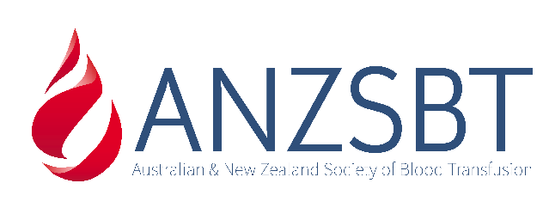

Quality Use of Non-Invasive Prenatal RHD Testing
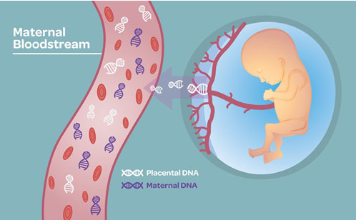
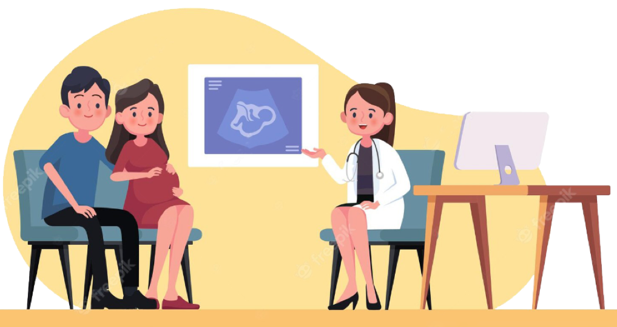
15th February 2024 - Final Report

Contents
1 Glossary 4
2 Abbreviations 5
3 Executive Summary 7
4 Project Statement 9
4.1 Background 9
4.1.1 Current Status of RHD NIPT Availability 11
4.2 Project Outline 11
4.3 Project Achievements Against Objectives 12
5 Scope 14
6 Governance and Reporting Structure 15
6.1 Governance Structure 15
6.2 Steering Committee 15
6.3 Stakeholders 15
7 Project Activities 17
7.1 Engagement with Health Networks 17
7.2 Engagement with Key Societies and Colleges 17
7.3 Engagement with Consumer and Patient Advocate Groups 17
7.4 Review of Antenatal Care Pathways 18
7.5 Development of Testing Pathways 20
7.6 RHD NIPT Results Reporting 23
7.7 Development of RHD NIPT Guidelines 23
7.8 Development of Clinical, Consumer and Laboratory Resources 23
7.9 Production of an RHD NIPT Podcast 23
7.10 Development of an e-learning RHD NIPT module 23
7.11 Development of a Web Based Interactive RHD NIPT Tool 24
7.12 Development of Evaluation Tools 24
7.13 Development of Audit Tools 24
7.14 Haemovigilance Reporting 24
7.15 Development of a Failure Modes and Effects Analysis Tool 24
7.16 Development of an RHD NIPT Education PowerPoint Presentation 24
7.17 Education - Conference Presentations 25
8 Project Outcomes 26
8.1 Knowledge Development 26
8.2 RHD NIPT Resources 26
8.3 RHD NIPT Accreditation and Quality Assurance 27
8.3.1 RHD NIPT Accreditation 27
8.3.2 RHD NIPT Quality Assurance 27
9 Project Challenges and Future Directions 28
10 Appendices 30
11 Acknowledgements 32

Glossary
Antenatal record A unique healthcare record containing all relevant pregnancy information
False-positive: A RHD NIPT on a RhD negative fetus incorrectly classified as RhD positive
False-negative: A RHD NIPT on a RhD positive fetus incorrectly classified as RhD negative
Hand-held pregnancy record: The hard-copy personal record provided to women where clinical pregnancy and
postnatal visits are documented
Healthcare professionals: The term healthcare professionals refer to all clinical care providers, including
general practitioners, midwives, nurses, medical officers and obstetricians
Healthcare record: Documentation unique to the patient, containing transcripts of patient care and
progress, investigation data and consultations, which is retained by the managing
healthcare professional or health service
Lifeblood Australian Red Cross Lifeblood
Medical Record Number (MRN): A number used by a hospital or health facility to identify an individual and their
health records
My Health Record: The digital health record, unique to everyone, that enables direct uploading of
digital medical and diagnostic reports
Non-Invasive Prenatal Test: A screening test which analyses fetal DNA obtained from a maternal blood
sample
Partial D RhD group: RhD antigen with fewer antigen sites or missing epitopes leading to weak(er) or
absent reactions with anti-D sera
Patient: The term patient refers to both woman and infant in the context of healthcare
provision and is not intended to imply ill health
Pathology laboratory: The pathology or laboratory service that completes the testing and resulting of a
specimen
Referring pathology laboratory: The laboratory/pathology service that transports a specimen to another
pathology/laboratory service for testing. This may be within the pathology service network or an external provider
RHD: The gene symbol for RhD gene (italicised)
RhD: Refers to the RhD blood group antigen
RHD NIPT: A test which analyses fetal DNA obtained from a maternal blood sample, to determine the fetal RhD blood group
Antenatal shared care: A collaborative agreement for agreed goal/s and treatment plan between a team
of health healthcare professionals and the woman throughout the antenatal and postnatal period
Specimen: Any tissue or fluid (including blood) from an individual that is submitted to the
pathology service for testing

Abbreviations
ACCHS Aboriginal Community Controlled Health Services
ACM Australian College of Midwives
ACRRM Australian College of Rural and Remote Medicine
ANZSBT Australian and New Zealand Society of Blood Transfusion
cffDNA Cell free fetal DNA
CALD Culturally and linguistically diverse
CHF Consumer’s Health Forum of Australia
CPD Continuing professional development
DNA Deoxyribonucleic acid
dPCR Digital polymerase chain reaction
FMEA Failure Modes and Effects Analysis
GP General Practitioner
HDFN Haemolytic disease of the fetus and newborn
IBGRL International Blood Group Reference Laboratory
Ig Immunoglobulin
JBC Jurisdictional Blood Committee
KEMH King Edward Memorial Hospital
LIS Laboratory information system
MBS Medicare Benefits Schedule
MHSS Coordinator for Multicultural Health & Support Service
MoC Model of Care
NEQAS National External Quality Assessment Scheme
MRN Medical record number
MSAC Medical Services Advisory Committee
NACCHO National Aboriginal Community Controlled Health Organisation
NATA National Association of Testing Authorities
NBA National Blood Authority
NIBSC National Institute for Biological Standards and Control
NIPA Non-invasive prenatal assessment
NIPT Non-invasive prenatal testing
PBM Patient Blood Management
PHN Primary health network
QUPP Quality Use of Pathology Program
RACGP Royal Australian College of General Practitioners
RANZCOG Royal Australian and New Zealand College of Obstetrics and Gynaecology
RCPA Royal College of Pathologists of Australasia
RCPAQAP Royal College of Pathologists of Australasia Quality Assurance Program
RhD Ig RhD immunoglobulin
TGA Therapeutic Goods Administration

Executive Summary
The Quality Use of Non-Invasive Prenatal RHD testing Project reached its completion date on 30th November 2023.
The Project has successfully completed the following activities:
- Identified and met with different Consumer Advocate Groups to reach vulnerable and minority populations to ensure equity of access to the RHD NIPT for community-based pregnancy care in regional and remote parts of Australia, for different socio-economic and ethnic groups, vulnerable and minority populations and to be aware of cultural sensitivities, and use of simple language and diagrams in published resources
  - Reviewed the multiple antenatal clinical care pathways gathered from metropolitan, regional and remote antenatal centres
  - Developed antenatal clinical care and laboratory testing pathways with incorporation of RHD NIPT and including considerations for variations related to geographical location and minority populations that led to the development and publication of the numerous resources on the ANZSBT website (https://anzsbt.org.au/resources/rhd_in_pregnancy/). These resources guide and facilitate RHD NIPT at all stages of the testing cycle:
- Clinical care pathways and flow charts
- Guidance for RHD non-invasive prenatal testing (NIPT) for fetal RhD blood group prediction in pregnancy - ANZSBT National Guidance document
- Consumer resources and brochures
- Web-based Interactive Flow Pathways
- RHD NIPT podcast
- RHD NIPT e-learning module
- Local, state and national haemovigilance reporting systems were reviewed in relation to pregnancy care pathways to better understand the existing data captured, as well as state and territory variations. A recommendation was made to include and report RHD NIPT incidents through either national, state, local or laboratory haemovigilance reporting systems, in addition to primary health care monitoring and evaluation systems.
The lack of RHD NIPT availability has been an issue concerning the Steering Committee for the duration of the Project which limited our ability to evaluate and use the developed resources in various clinical and laboratory settings.
The Steering Committee is aware of two jurisdictions (WA and NSW) where decisions have been made to establish RHD NIPT testing through public providers, with WA having started a pilot program in October 2023. NSW continues to develop and validate their RHD NIPT with no implementation date available and uncertainty whether other states can use their service.
Currently no other jurisdictions are pursuing RHD NIPT development because of low MBS rebate and/or relatively low test numbers leading to unacceptable financial costs and inefficiencies. Similarly, there are no TGA registered RHD NIPT kits approved in Australia and currently no commercial test kit providers are seeking TGA approval that we are aware of; again, due to the low MBS rebate.
The ANZSBT and Steering Committee have taken a progressive approach to advocacy for RHD NIPT, hoping that ANZSBT’s independent voice will encourage governments to re-evaluate their positions. ANZSBT has tried to highlight the public benefits of the RHD NIPT program through a national provider or interested local providers, with the associated decreased demand for RhD Ig and the benefits for women, which may not have been considered when previous jurisdictional decisions were made.
The final report highlights in more detail how the Project achieved the Project Objectives. ANZSBT believes this substantial body of resources will facilitate prompt, safe and equitable integration of RHD NIPT once issues around test availability are resolved.

Project Statement

Background
There are approximately 300,000 births in Australia annually. Fifteen percent of the women who give birth to these infants are RhD negative (i.e., 45,000). During pregnancy, some of these women are at risk of developing antibodies to the RhD blood group antigen if the fetus is RhD positive (65% of pregnancies, approximately 29,000 at risk pregnancies per annum). If maternal anti-D antibodies are produced, they will be directed against fetal red blood cells that express the RhD blood group leading to haemolytic disease of the fetus and newborn (HDFN). This can be catastrophic as it leads to severe anaemia, causing fetal hydrops (heart failure) and jaundice potentially leading to kernicterus, death or long-term disability.
Current routine practice is for RhD immunoglobulin (Ig) prophylaxis to be given to all RhD negative women at 28- and 34-weeks’ gestation, regardless of the blood group of the fetus. At the time of birth, a subsequent dose of RhD Ig is given to RhD negative women who have delivered a RhD positive infant. This universal approach to prophylactic RhD Ig administration means that approximately 16,000 RhD negative women who are not carrying a RhD positive fetus are receiving RhD Ig unnecessarily and undergoing an unnecessary procedure and is at significant variance to accepted Patient Blood Management (PBM) practices.
The routine use of RhD Ig for all RhD negative women has been recognised by the National Blood Authority (NBA) as potentially unsustainable as Australia faces challenges in maintaining a sufficient RhD Ig supply. The only source of RhD Ig, a human blood product, is from approximately 120 dedicated plasma donors who have been immunised against RhD. To address the possibility of lack of supply, in May 2021 the NBA introduced new guidelines “Prophylactic Use of RhD immunoglobulin in pregnancy care” (https://blood.gov.au/anti-d-0). This document was developed to ensure RhD Ig is restricted to those RhD negative women who are predicted to be carrying a RhD positive fetus and requires prenatal testing for fetal RhD status for all RhD negative women.
NIPT for RHD genes in maternal plasma has been recommended in the NBA guidelines and was recently recommended by the Australian Government Medical Services Advisory Committee (MSAC - Application No. 1574) as a Medicare funded test. Funding through the Medicare Benefits Schedule (MBS) has been available since July 2022.
RHD NIPT is a blood test that uses cell free fetal DNA (cffDNA) circulating in the mother’s circulation to determine the baby’s RhD blood group. cffDNA level increases with gestational age, with adequate levels of cffDNA from 11 weeks gestation to perform the RHD NIPT. Therefore, testing of maternal blood must only be performed from 11 weeks’ gestation to determine the RHD genetic status of the fetus.
Identifying RhD positive fetuses in utero enables targeted use of prophylactic RhD Ig (Figure 1). Administering RhD Ig only to RhD negative women carrying an RhD positive fetus will optimise RhD Ig use. This strategy will reduce the unnecessary use of a scarce blood product, follow PBM practices, conserve supplies for those for whom it is essential and provide significant public health and financial benefits while reducing unnecessary interventions for pregnant women. It will also keep Australia self-sufficient in this essential blood product.
Appropriate implementation of the NBA guidelines (https://blood.gov.au/anti-d-0) requires correct ordering, use and interpretation of the prenatal testing for fetal RHD.
Figure 1. The changes proposed to the current standard of care RhD Ig prophylaxis following introduction of RHD NIPT
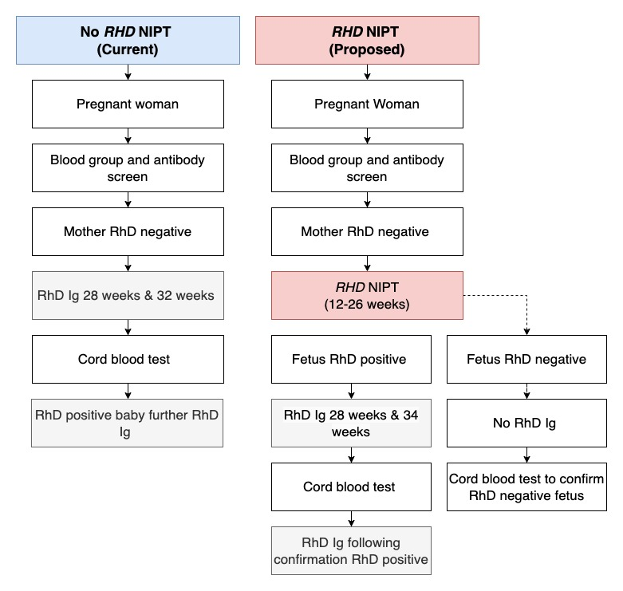
There are many benefits to the introduction of RHD NIPT which are outlined below:
  - Prevention of unnecessary RhD Ig prophylaxis and risks associated with administration of blood products
  - Avoiding painful injections when the fetal RHD genotype is predicted as RhD negative
  - Reduced appointments and time to attend for administration of RhD Ig where it is not required
  - Increased availability of RhD Ig for those women who require it
  - Reduced anxiety associated with potential sensitising effects for women where the fetus is predicted as being Rh negative and greater compliance of women with a known RhD positive fetus to receive the RhD Ig prophylaxis they should
  - Cost saving – each 625IU dose of RhD Ig (currently $87.62 at the time of this report [https://blood.gov.au/national-product-price-list]), along with time and resources to obtain RhD Ig, administration and other intangible costs
  - Donors – RhD Ig is sourced from a small number of donors who attend regularly to donate their plasma which is then used to produce RhD Ig. These donors are reducing in number and eventually supply may need to move to imported RhD Ig to maintain the supply increasing the cost further if strategies to reduce demand are not adopted (https://blood.gov.au/national-product-price-list).
However, RHD NIPT is not readily and easily accessible nationally in Australia.

Current Status of RHD NIPT Availability
Australia significantly lags numerous European countries (UK, France, Germany, Denmark, Netherlands, and others) where RHD NIPT has been the antenatal standard of care for RhD negative women for more than 10 years. The New Zealand Blood Service will be offering RHD NIPT nationally from April 2024 and the Canadian Blood Service is presently adopting a similar single national provider model for RHD NIPT for Canada.
Two Australian jurisdictions (WA and NSW) have made decisions to establish RHD NIPT testing through public providers at significant public cost, with WA having started a pilot program in October 2023 for WA residents only. NSW continues to develop and validate their RHD NIPT with no implementation date yet available and uncertainty whether other states can use their service.
Australian Red Cross Lifeblood, a world leader in blood group molecular testing, has previously developed and validated an in-house RHD NIPT which has been available since 2014. As a potential national provider, they have the potential for economies of scale, cost-effective testing, well developed infrastructure and reporting systems and extensive clinical, scientific and technical Transfusion Medicine support. However, over the last ten years and currently, they are not permitted to provide the test within their current Deed of Agreement with the Australian Government.
Highly specialised non-invasive prenatal assessment (NIPA) which is different to RHD NIPT is currently provided for all Australians who need it by Lifeblood from its Queensland facility for women already sensitised to clinically significant antibodies (anti-D, -c, -C, -E, -K, -k, -Fya, -Fyb) capable of causing HDFN.
To date, no other Australian health services or pathology laboratories (public or private) are offering RHD NIPT and the majority have stopped consideration of developing the test. There are no TGA licenced test kits in Australia and the current funding environment, the MBS rebate for RHD NIPT is considerably underfunded based on costs from Australian public not for profit pathology providers and overseas experience, as well as commercial industry. The establishment of the accredited test takes an extremely long time due to the need to develop the test, gather the maternal and baby’s samples, validate and accredit the test and the significant associated logistics and infra-structure that is required. Realistically to commence developing the test, validation and roll out takes more than 2-3 years.
The ability to gain the benefits of decreased need for RhD Ig prophylaxis, decreased demand on blood donor resources and decreased financials is not achievable at this time because of lack of a national test or co-ordinated testing program.
This Project has developed a sound platform for rapid, safe effective and equitable implementation once issues of test availability are resolved.

Project Outline
The Project Aims were to identify and map all steps in the pathology testing process for RhD negative women, including patient identification, requesting information, sample collection and transport, laboratory information systems and result reporting. The actual technical aspects of RHD NIPT development, test sensitivity and specificity and validation were out of the Project scope.
The outcome is a standardised and optimised clinical testing pathway applicable and available nationally, to meet the needs of General Practitioners, Obstetricians and pathologists resulting in effective implementation of RHD NIPT in Australia once the test is more readily available.
Whilst these points are critical from a clinical perspective, the underpinning of all aspects of the RhD Ig prophylaxis program requires quality pathology services. Pathology is crucial to the implementation process and multiple factors and services are critical including:
- Correct testing pathway allocation and timing for pregnant women
- Request form information, including risk stratification
- Sample requirements
- Transportation of specimens to centralised (possibly national) laboratories
- Laboratory staff training of testing requirements
- Standard operating procedures
- Laboratory information systems (LIS) for sample accessioning
- Result reporting via laboratory information systems (LIS) and My Health Record to the clinician and tested women, including guidance on subsequent testing and RhD Ig prophylaxis
- Communication between the testing facility, pathology service and clinical care provider

Project Achievements Against Objectives
The Objectives of the Project were to identify all steps in the pathology testing process and map the clinical care pathways and processes for RHD NIPT that would lead to a standardised clinical testing pathway for RhD negative women. This would support effective implementation of Medicare-funded RHD NIPT in Australia and ensure appropriate RhD Ig prophylaxis in accordance with the NBA guidelines (https://blood.gov.au/anti-d-0).
The Project has met the stated objectives and completed the following:
- Process mapping to understand the entire workflow for RHD NIPT to guarantee its efficiency and accuracy leading to a standardised clinical testing pathway:
  - Mapping the numerous different antenatal care pathways and jurisdictional variations
  - Mapping the process from the first antenatal testing sample collection onwards and test turnaround times
  - Identifying and mapping all steps in the pathology testing process for RhD negative women
  - Understanding all the key stakeholders, component factors and logistics of the process
  - Mapping scenarios at each stage of the process, including methodology and key decision points
  - Understanding jurisdictional variations and requirements, public and private providers, and population and geographical constraints (metropolitan, regional, rural and remote) ensuring equitable access to:
- First nations people
- Culturally and linguistically diverse (CALD) people
- Refugee/migrants
  - Identifying where errors or inefficiencies occur
  - Communication, education, documentation processes
  - Audit of process
  - Failure Modes and Effects Analysis (FMEA)
- Development of educational materials and document templates for health care consumers, pathology laboratories and maternity care services
- Implementation of best practice outcomes
- Project reporting

Scope
This Project contributes to targeted RhD Ig prophylaxis in RhD negative women to ensure that all RhD negative pregnant women in Australia receive appropriate antenatal administration of RhD Ig. This is of benefit to Australian women and provides significant public health benefits leading to quality use of a funded Medicare test and appropriate use of a blood product (RhD Ig) following Patient Blood Management practices.
The purpose of reviewing the different antenatal clinical pathways, laboratory testing pathways and models of antenatal care and publishing the various documents and consumer brochures was to provide ongoing education to GPs, Obstetricians, Pathologists, midwives, diagnostic laboratory staff, other practitioners and women and their families about RHD NIPT with clear and concise information that assists in understanding RHD NIPT and appropriate targeted RhD Ig prophylaxis.
Failure to do this has potential to result in several serious consequences, including:
- Incorrect decision making and clinical errors during pregnancy
- Failure to do the RHD NIPT
- Incorrect ordering of RHD NIPT (e.g., for RhD positive women)
- Excess expenditure on Medicare through inappropriate testing
- Women who require RhD Ig may not receive it leading to HDFN, with potential catastrophic consequences
- Women may receive RhD Ig who do not require it

Governance and Reporting Structure

Governance Structure
Figure 2. Quality Use of Non-Invasive Prenatal RHD Testing Steering Committee
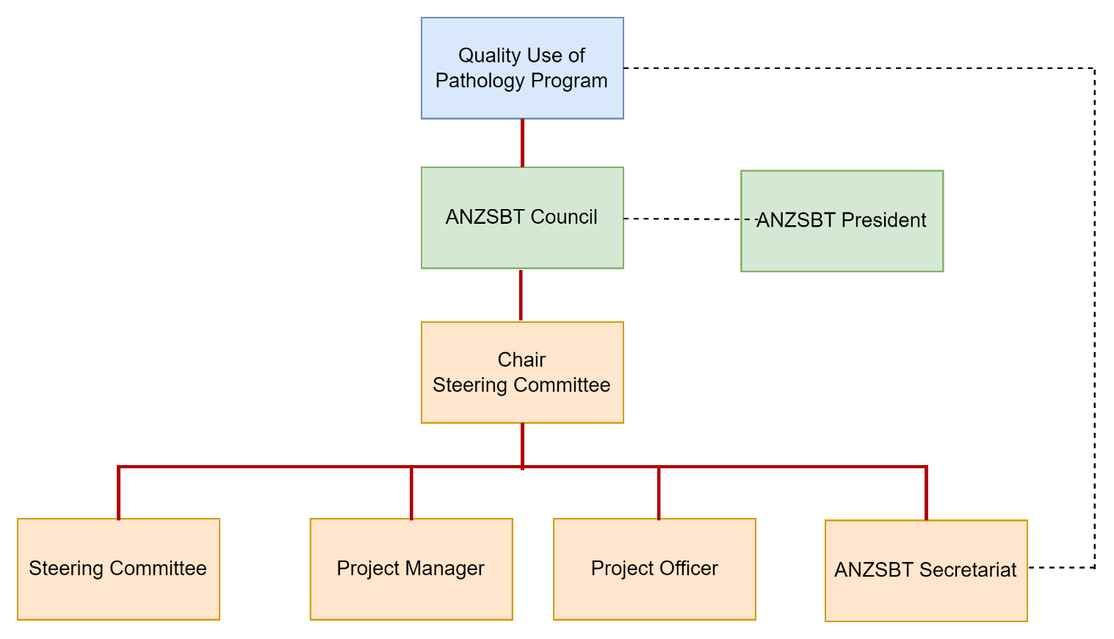

Steering Committee
The Steering Committee, comprising qualified clinicians and representatives from peak bodies, was responsible for the co-ordination and oversight of the Project and provided directions to the Project Team
Dr Philip Crispin | Steering Committee Chair, ANZSBT
Simon Benson | President, ANZSBT
Prof David Roxby | Project Manager, ANZSBT
Anne Wiseman | ANZSBT Secretariat
Kristen Brown | Project Officer, ANZSBT
Dr Janney Wale | Australian Consumers Health Forum of Australia
Prof Wendy Erber | University of Western Australia, Pathology & Laboratory Medicine
Dr Ania Samarawickrama | Royal Australian College of General Practitioners (RACGP)
Dr (Jerry) Abraham Alex | Australian College of Rural and Remote Medicine (ACRRM)
Dr Ellen Maxwell | Royal College of Pathologists of Australasia (RCPA)
Tani Paxton | Australian College of Midwives (ACM)
Dr James Daly | Australian Red Cross Lifeblood
Dr Shin Lee | Royal Australian & New Zealand College of Obstetricians & Gynaecologists (RANZCOG)
Dr Helen Savoia | Royal Children's Hospital and Royal Women's Hospital, Obstetric, Neonatal & Paediatric Haematologist

Stakeholders
Stakeholder representatives including the following, have had the chance to contribute to the Project and all Stakeholders have the opportunity for enhanced education, understanding and improved medical practice with the availability of the resources published by the ANZSBT (https://anzsbt.org.au/resources/rhd_in_pregnancy/) as part of this Project
- Women
- Families
- GPs
- Obstetricians
- Midwives
- Pathologists
- Laboratory staff
- The community
- Australian Red Cross Lifeblood
- National Blood Authority
- Australian Government
- Consumer Advocate Groups
- Health Networks

Project Activities

Engagement with Health Networks
Engagement was essential in understanding key processes, potential issues and opportunities to support RHD NIPT testing within existing antenatal clinical care pathways.
The Steering Committee worked closely with states and territories, public and private health systems, and community and primary care networks in both the pathology and clinical health settings. The Steering Committee provided representation for key stakeholder networks, with additional personal and professional networks which were utilised as an opportunity for wider engagement. Consultation was sought throughout the Project process mapping and resource development phases. Extensive feedback was received, collated and integrated, with the guidance document and consumer resources receiving the most interest.
Throughout the Project, the Project Team and Steering Committee communicated regularly and collaborated with Western Australian Health Services (King Edward Memorial Hospital [KEMH]) to gain a better understanding of issues and limitations of development of their RHD NIPT. Resources were provided to the WA project team for utilisation/adaption as requested in addition for review of feasibility and applicability.
The Project Team liaised with several overseas national RHD NIPT providers, including the International Blood Group Reference Laboratory (IBGRL) UK, and the Rigshospitalet, Copenhagen University Hospital, Denmark, where RHD NIPT is well established as part of routine antenatal care and has been in routine use for more than 10 years. These interactions proved very useful, providing background information on their approaches to how the test was introduced and steps taken to educate clinicians, midwives, laboratory staff and women.
Also, the Project Team communicated with the Canadian Blood Service and shared resources as they are developing a national system for RHD NIPT and have similar logistical challenges as Australia.

Engagement with Key Societies and Colleges
Engagement with key societies and colleges was maintained and accessed through the Steering Committee membership, with consideration of general practice, pathology, medical, maternity, public and private health, the Australian Red Cross Life Blood, and consumer advocacy. This enabled endorsement of key resources and documents, ensuring alignment with existing National and State guidance documents and was integral in the implementation phase to gain traction of relevant services and organisations.
Awareness of concurrent projects and initiatives that supported or influenced the success of the Project were identified and communication established with key members of those projects.

Engagement with Consumer and Patient Advocate Groups
The Steering Committee engaged with several government and not-for-profit agencies to ensure that adequate assessment of needs for the consumer had been considered and incorporated into the development of the clinical care pathways and resources. Organisations contacted included those that were specific to the needs of minority populations and those who supported mothers with higher vulnerability during pregnancy, such as refugees. There were several organisations that provided significant feedback which was incorporated in the final clinical care pathways, guidance documents and consumer resources.
Organisations or Patient Advocate Groups consulted included:
- Aboriginal and Torres Strait Islander
- Aboriginal Community Controlled Health Services (ACCHS)
- National Aboriginal Community Controlled Health Organisation (NACCHO)
- Aboriginal and Torres Strait Islander Liaison Officer Badjurr-Bulok Wilam – Royal Hospital for Women, Victoria.
- Multicultural Centre for Women’s Health – Research, Advocacy and Policy Manager
- Centre for Culture, Ethnicity & Health – Coordinator for Multicultural Health & Support Service (MHSS)
- Centre for Culture, Ethnicity & Health – Policy, Research and Evaluation Officer
- Victorian Refugee Health Network Program coordinator and Statewide Facilitator for the Refugee Health Program
- Consumer Advocacy Group Representation – Steering Committee representative
- Australian Red Cross Lifeblood Communications and Consumer Engagement Lead

Review of Antenatal Care Pathways
There are over 200 recorded variations of maternity-care models in Australia that were categorised into 11 key models of care. Each core model of care was mapped to ensure that the proposed clinical care pathways for RHD NIPT were feasible and aligned with the current antenatal schedule of visits. Examples of models of care are shown in Figures 3 and 4. This was achieved through contact with women who had chosen different models of care for their pregnancy care journey and care providers from the following models:
- Private
- Shared care
- Midwifery-led care
- Private practice midwives
- Rural and remote
- Culturally specific care (Aboriginal and Torres Strait Islander midwifery-led services)
- Community-based care
This was essential in understanding the key touch points with the services and for RhD negative women in pregnancy to ensure that test timing and management would fit safely and effectively within existing antenatal care visits for all services and locations.

Figure 3. Model of care for privately practicing midwives
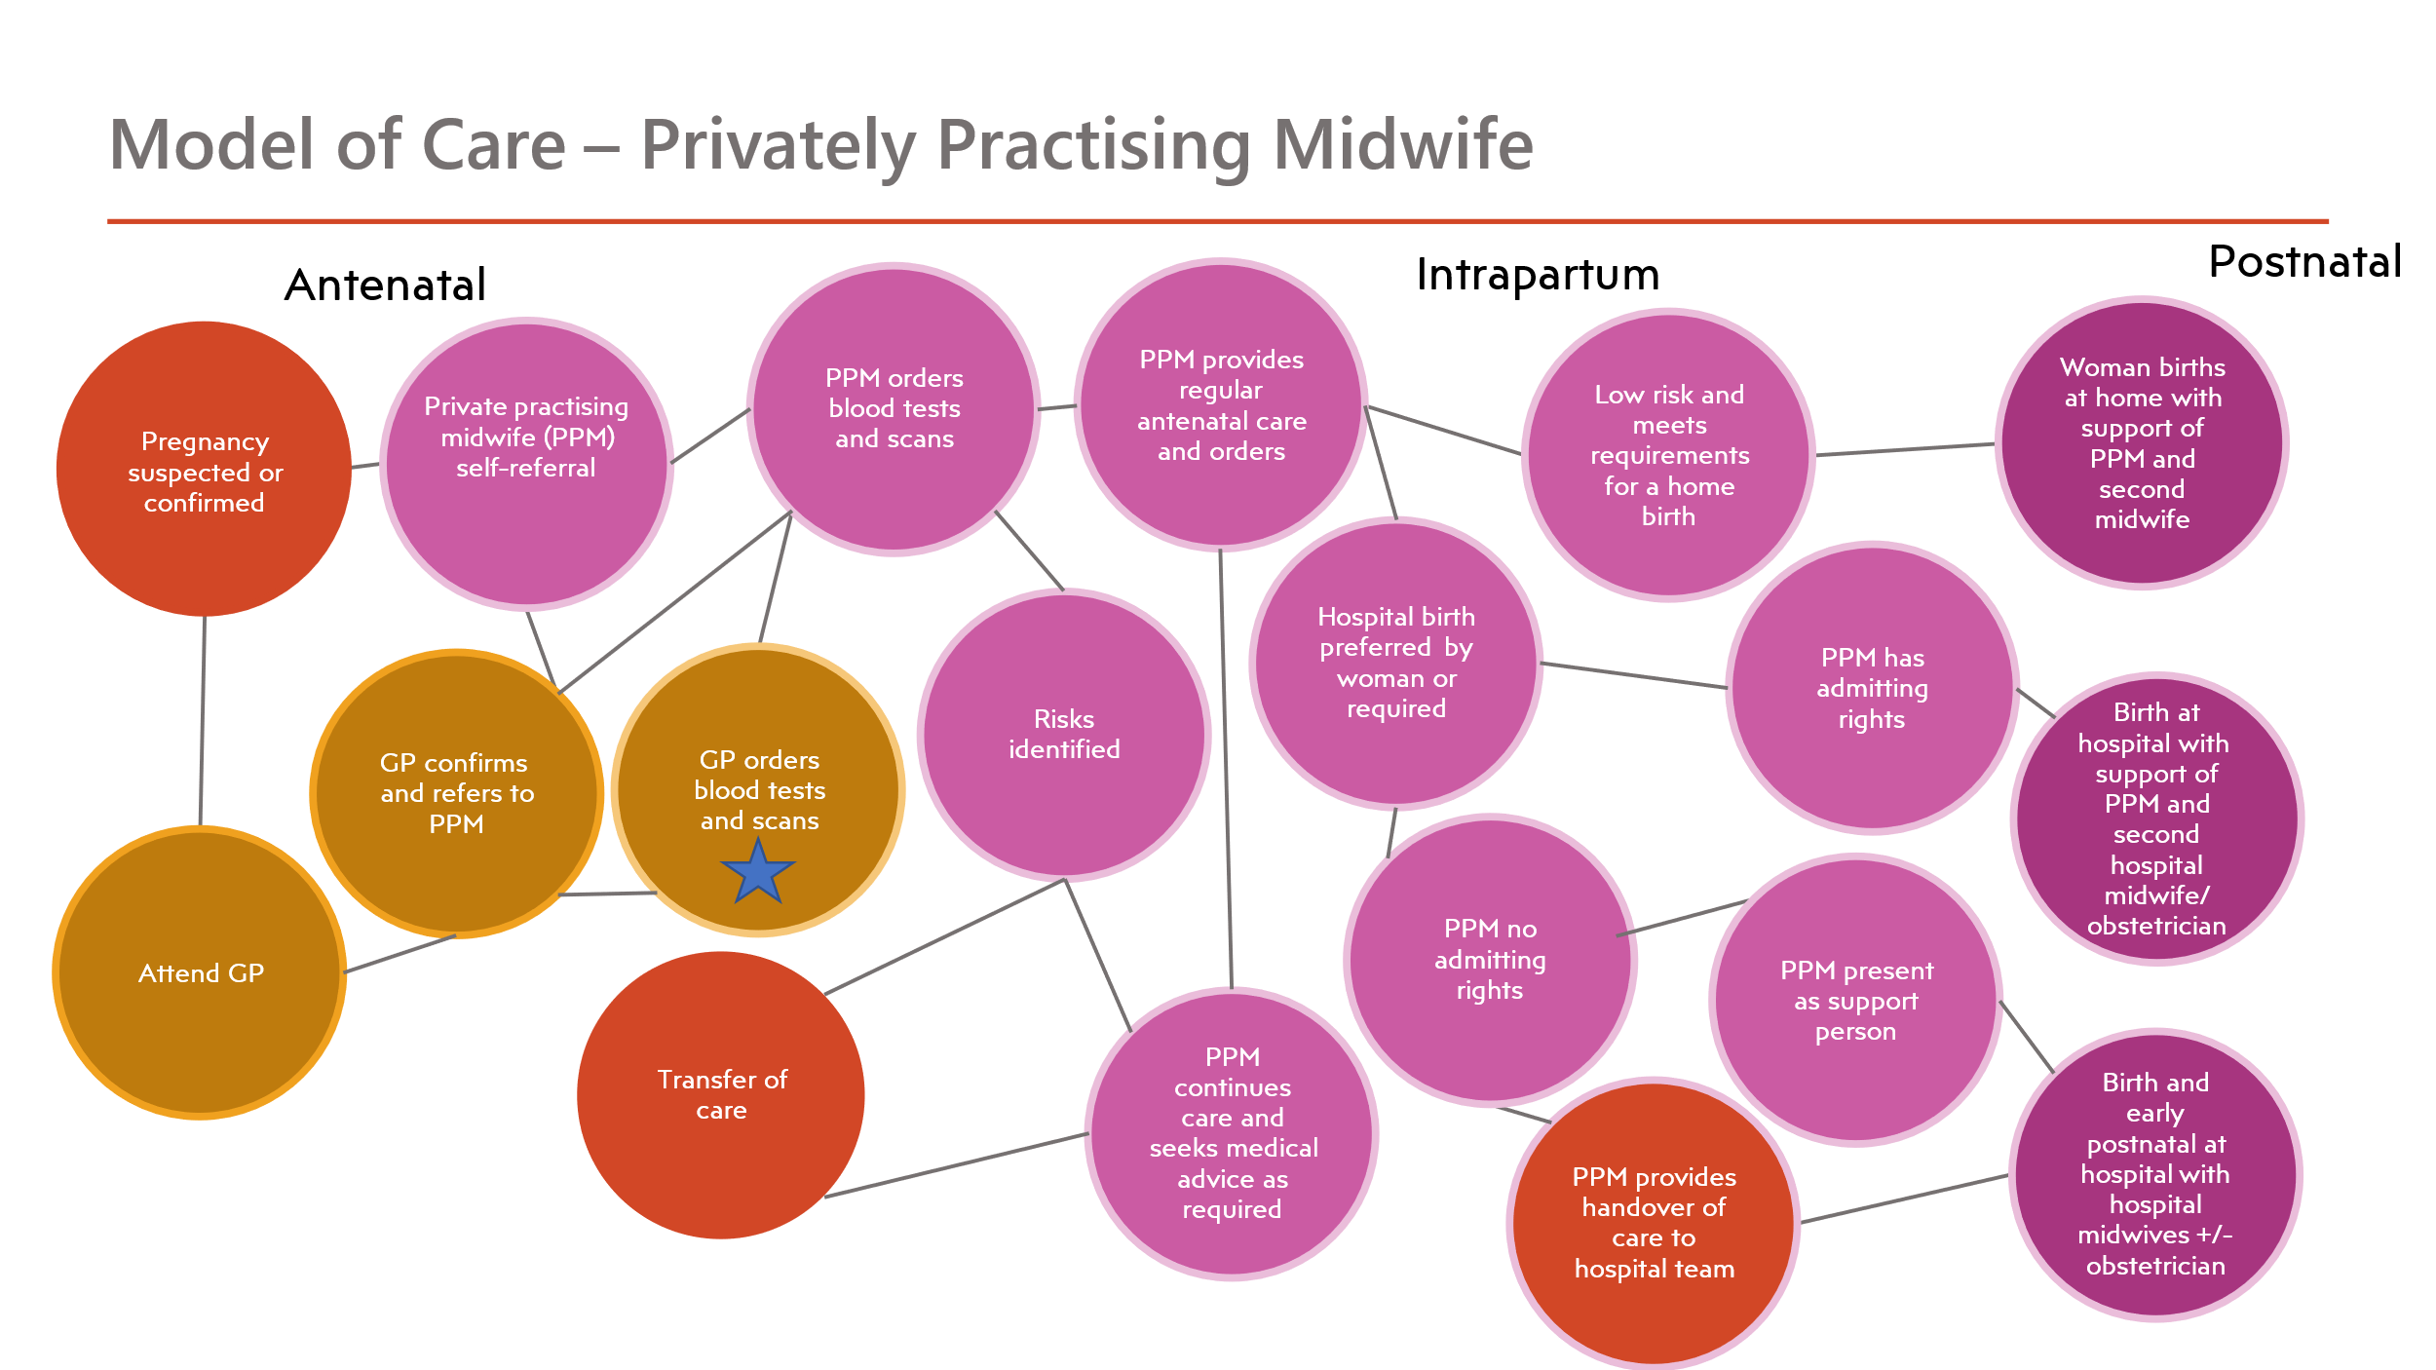

Figure 4. Example of a regional/rural health antenatal model of care
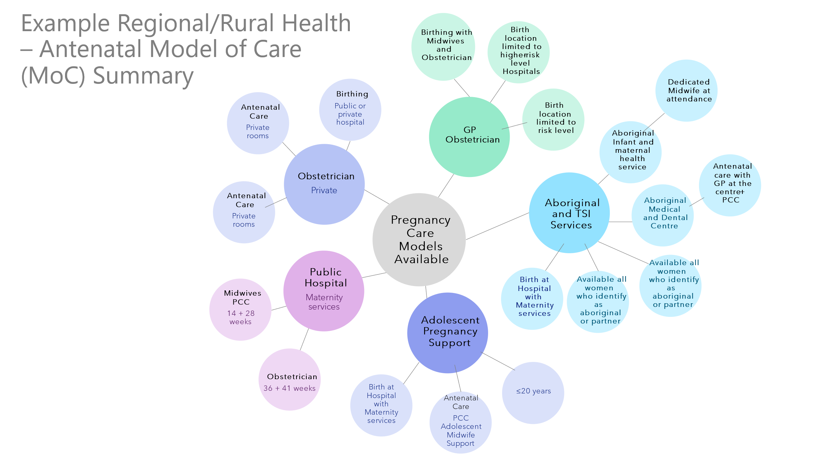

Development of Testing Pathways
The Steering Committee consulted with pathology services and antenatal care providers to complete process mapping of the antenatal screening and laboratory screening processes to determine how RHD NIPT would seamlessly fit within existing laboratory pathways (Figures 5 and 6). The Project identified all possible variations and developed visual flow pathways that have been incorporated within the Guidance for RHD NIPT for Fetal RhD Blood Group Prediction in Pregnancy document (https://anzsbt.org.au/guidelines-standards/anzsbt-guidelines/) and RHD NIPT interactive web-based tool (https://rhdnipt.anzsbt.org.au) available on the ANZSBT web site for utilisation and adaption by health services and organisations. The flow pathways include (https://anzsbt.org.au/resources/rhd_in_pregnancy/):
- Simplified flow pathway for RhD negative women with no alloantibodies
- Flow pathway for RHD NIPT in pregnancy
- Flow pathway for RHD NIPT for RhD negative women in pregnancy
- Flow Pathway for RhD Ig prophylaxis with the introduction of RHD NIPT (including sensitising events)
- Flow Pathway for women with a weak D or partial D RhD blood group
- Flow pathway for women with potentially clinically significant red cell alloantibodies or a history of fetal anaemia / haemolytic disease of the fetus and newborn (HDFN)
- Flow pathway for laboratory / pathology for RHD NIPT specimen management

Figure 5. RHD NIPT flow pathway in pregnancy
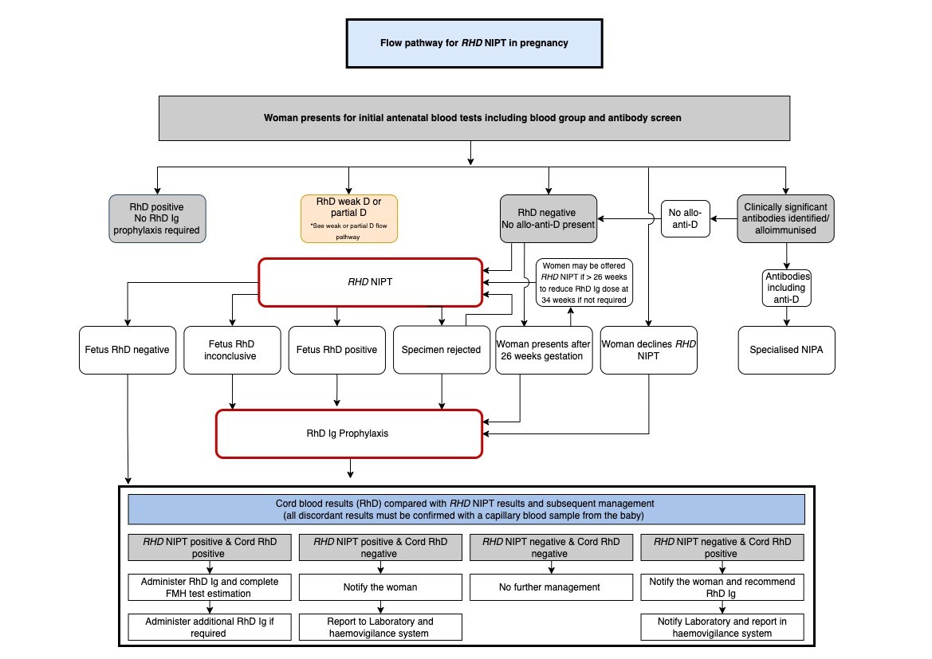

Figure 6. Flow pathway for laboratory/pathology for RHD NIPT specimen management

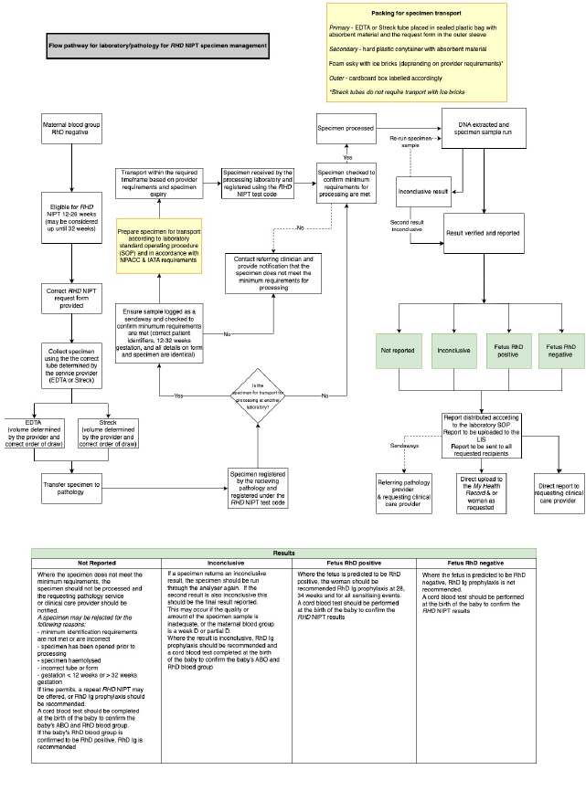

RHD NIPT Results Reporting
Poor interconnectivity and ability to safely communicate the results of the RHD NIPT test was identified as a prominent and significant risk to safe implementation of RHD NIPT. The Project Team met with the Digital Health Agency to discuss potential solutions through the electronic My Health Record, with further recommendations included in the Guidance Document promoting use of the My Health Record. There were further recommendations regarding documentation requirements and utilisation of handheld records and providing copies of results to the women which would better support shared-care and transfer of care arrangements.

Development of RHD NIPT Guidelines
The RHD NIPT Guidance document (https://anzsbt.org.au/guidelines-standards/anzsbt-guidelines/) was developed to provide high-level, broad recommendations which would support the safe introduction of RHD NIPT as part of the complete pregnancy care journey. The document includes information for laboratory staff, health care providers and services involved in the provision of pregnancy care. It incorporates all relevant resources and clinical care pathways to assist with the development of localised policy and procedures which can be adapted to support the needs of the different organisation and services. The document contains recommendations which were developed following thorough risk assessment (see Section 7.15 Development of a Failure Modes and Effects Analysis Tool [https://anzsbt.org.au/resources/rhd_in_pregnancy/]) which identified a need for risk mitigation, particular in the areas of safe transfer of care and communication of results and associated management.

Development of Clinical, Consumer and Laboratory Resources
Numerous resources were developed and adapted for clinical care providers, laboratory and consumers as the target audiences (see Appendices and https://anzsbt.org.au/resources/rhd_in_pregnancy/). The resources have broad application thereby avoiding limited use to a particular group or service. It was also understood from process mapping activities that there was considerable overlap between interaction and knowledge of the test and processes that applied to the clinician, consumer and the laboratory worker.

Production of an RHD NIPT Podcast
The Australian Red Cross Lifeblood Technical and Events Project Manager and the Communications and Consumer Engagement Manager, assisted with the development of a podcast interviewing the Australian College of Midwives (ACM) and Royal Australian College of General Practitioner’s (RACGPs) Steering Committee representatives. The key focus of this podcast is the introduction of RHD NIPT in the context of the GP and Midwife, and the knowledge that is required to determine which women will benefit from the test, how the test works and how the results will determine the care provided in relation to RhD Ig prophylaxis. Representation from a Midwife and GP were considered based on review of the current models of care and the likelihood of RhD negative women having contact with these clinical care providers throughout their pregnancy.

Development of an e-learning RHD NIPT module
In collaboration with the ACM, an RHD NIPT e-learning module has been developed which is targeted at midwives working independently, privately and within the hospital setting (https://www.midwives.org.au/ItemDetail?iProductCode=RHDNIPT&Category=ELEARN). The module is available to other health care professionals and is featured alongside other ACM e-learning modules. Continuing professional development (CPD) points and Certificate of Completion are available on completion of the module.
Location on the ACM website with a link on the ANZSBT website (https://anzsbt.org.au/resources/rhd_in_pregnancy/) was agreed to as an opportunity to reach a large percentage of Australian Midwives owing to the high visibility and membership of the College, and utilisation of the College’s recommended education modules by midwives.
The content of the e-learning module is based on the core concepts of the RHD NIPT and provides an understanding of how this test fits within the current care provided for RhD negative women in pregnancy and the changes that will occur following implementation of RHD NIPT in routine antenatal care.

Development of a Web Based Interactive RHD NIPT Tool
The RHD NIPT interactive web-based tool is a decision-support and information tool that has three separate pathway options for the clinician, consumer or the laboratory worker. The content has been based on the content specific needs for each audience and appropriate health language.
The tool links to additional resources developed by the Project Team and to resources available through external organisations.
The interactive tool sits within the ANZSBT website (https://rhdnipt.anzsbt.org.au/) and is promoted through the podcast, e-learning module and Guidance document.

Development of Evaluation Tools
Clinician and consumer evaluation tools have been developed to assist services and organisations in evaluating the quality of care and clinical support provided during and following implementation of RHD NIPT and are available on the ANZSBT website (see Appendices and https://anzsbt.org.au/resources/rhd_in_pregnancy/). With an increased focus on consumer satisfaction and clinical support as a key to providing quality of care, these tools allow organisations to better understand the needs of their consumers and health care workers. The surveys are in an Excel format, using Likert scaling for response and are brief to increase utilisation. The tools can be easily formatted for use in electronic based surveys and across multiple settings such as general practice and hospital services.

Development of Audit Tools
A clinical audit tool was developed in a simple Excel format to enable assessment of adherence to best practice and safe delivery of care relating to RHD NIPT. This audit tool has a total of 13 questions which assess consent, information provision, recommended management, quality and accessibility of documentation and adverse events. The audit tool contains an instruction sheet to assist with its use and is located on the ANZSBT website (see Appendices and https://anzsbt.org.au/resources/rhd_in_pregnancy/).

Haemovigilance Reporting
The Steering Committee consulted with state and national health services and organisations to determine existing haemovigilance reporting systems across health services in the hospital, primary care, public/private and pathology settings. The information gathered was utilised to develop haemovigilance reporting and management recommendations that were possible within the existing reporting structures. It was identified that RhD Ig and other fractionated products were not currently reported in many states, however there was future capacity and therefore recommendations were based on best practice whether this aligned with the current reporting processes.

Development of a Failure Modes and Effects Analysis Tool
A risk assessment tool was developed to determine all possible variation/issues and risks at each key step of the RHD NIPT process and used by the Steering Committee to determine risks and those which mitigation strategies should be recommended (see Appendices and https://anzsbt.org.au/resources/rhd_in_pregnancy/).
Following detailed process mapping, a FMEA risk assessment tool was utilised to identify, prioritise and develop mitigation strategies. All possible variations and potential issues/risks associated with the implementation of the RHD NIPT were stratified and mitigation strategies determined by the Steering Committee.

Development of an RHD NIPT Education PowerPoint Presentation
A PowerPoint education resource was created to support the implementation of RHD NIPT in both the clinical and pathology setting. The information incorporated was for both laboratory and healthcare providers across all services and settings, to enable adaption and localisation of the resources for sites wishing to use the resource. The presentation is available on the ANZSBT website (see Appendices and https://anzsbt.org.au/resources/rhd_in_pregnancy/).

Education - Conference Presentations
- RCPA Pathology Update meeting, Sydney, February 2023
- Sydney HOW Collaborative meeting, Sydney, March 2023,
- WNSWLHD weekend workshop Bathurst, August 2023
- Blood 2023 Conference Melbourne, November 2023: a session consisting of three presentations on Antenatal Care and RHD NIPT

Project Outcomes

Knowledge Development
There have been many resources created to enable accessible, adaptable and targeted knowledge development tools for consumers, clinicians and laboratory staff. The resources enable services and organisations to utilise the resources and adapt them for organisation level knowledge development to support safe test implementation when it becomes available. It remains the responsibility of the services and organisations implementing RHD NIPT to provide access to education and training which allows for safe introduction of the test as part of the pregnancy care pathway.
All key concepts and relevant knowledge has been provided in document, brochures, PowerPoint presentation, interactive web-tool and e-learning module to support all learning styles and are endorsed by key organisations.

RHD NIPT Resources
The following documents and resources developed as part of the Project will guide and facilitate RHD NIPT at all stages of the testing cycle:
- Guidance for RHD non-invasive prenatal testing (RHD NIPT) for fetal RhD blood group prediction in pregnancy. An implementation guidance document, covering collection, identification, reporting and actioning results is now available on the ANZSBT website (https://anzsbt.org.au/guidelines-standards/anzsbt-guidelines/)
- Resources for laboratories, clinicians and consumers are available on the resources section of the ANZSBT website (https://anzsbt.org.au/resources/rhd_in_pregnancy/) including links to other websites
- DL 6pp brochure
- Postcard A6
- Poster
- Audit tool
- Clinician & consumer survey tool
- Flow pathway for clinically significant alloantibodies and or history of HDFN
- Flow pathway for pathology for RHD NIPT specimen management
- Flow pathway for RHD NIPT in pregnancy
- Flow pathway for women with a weak or partial D RhD blood group
- Flow pathway RhD Ig prophylaxis with the introduction of RHD NIPT (including sensitising events)
- Simplified flow pathway RhD negative women in pregnancy
- An education PowerPoint presentation ‘RHD non-invasive prenatal testing (NIPT) for fetal RhD blood group prediction in pregnancy’ is available
- RHD NIPT podcast
- RHD NIPT e-learning module linked to ANZSBT website and at https://www.midwives.org.au/ItemDetail?iProductCode=RHDNIPT&Category=ELEARN
- Interactive RHD NIPT web tool is available at https://rhdnipt.anzsbt.org.au/

RHD NIPT Accreditation and Quality Assurance

RHD NIPT Accreditation
With any new diagnostic pathology test there is a legal requirement that it must be accredited by the National Association of Testing Authorities (NATA) prior to being introduced into routine diagnostic use and the ability to claim the test as a Medicare funded test. Once the test is accredited by NATA, the test is then added to the laboratory’s Scope of Practice by NATA and the laboratory becomes eligible to claim it as a Medicare funded test. The same applies when introducing RHD NIPT.
The in-house RHD NIPT developed by PathWest (King Edward Memorial Hospital [KEMH], Perth) and in limited use as part of a pilot program has gone through vigorous validation and has been accredited by NATA and now forms part of the PathWest KEMH pathology laboratory’s Scope of Practice.
The NIPA offered by Lifeblood for alloimmunised women with clinically significant antibodies capable of causing HDFN, which is different to RHD NIPT, has been accredited by NATA. Lifeblood have not pursued NATA accreditation for their validated RHD NIPT as they are not presently permitted to provide the test within their current Deed of Agreement with the Australian Government.
Lifeblood is changing their current molecular technique for blood group genotyping and NIPT/NIPA to a fully automated third generation digital polymerase chain technology (dPCR) that allows RHD NIPT and other forms of NIPT/NIPA and blood group genotyping to be performed on the same instrument using the same technology. dPCR is highly sensitive, accurate in molecular detection, more cost effective, and has a higher throughput. Once this new technology has been validated by Lifeblood, it is their intent to seek NATA accreditation for RHD NIPT.

RHD NIPT Quality Assurance
Diagnostic laboratories must participate in Quality Assurance Programs that cover the range of diagnostic tests offered as part of their Scope of Practice. This would include RHD NIPT if offered by the laboratory.
Currently, in Australia there are no local RHD NIPT quality assurance programs due to lack of wide availability of the test and only one local test provider. In the future if the test becomes more readily available with more test providers, the Royal College of Pathologists of Australasia Quality Assurance Program (RCPAQAP) may consider developing a suitable program. In the meantime a plasma standard from the National Institute for Biological Standards and Control (NIBSC) for sensitivity testing is available and the UK National External Quality Assessment Scheme (NEQAS) offers an annual RHD NIPT Quality Assurance Program which KEMH is enrolled.

Project Challenges and Future Directions
The lack of RHD NIPT availability has been an issue concerning the Steering Committee for the duration of the Project. At the start of the Project there was a clear plan from the Commonwealth Government for access to RHD NIPT through the MBS, however this has proven insufficient to fund testing. ANZSBT and RCPA have been seeking a review of the reimbursement from MBS. In addition, ANZSBT has been advocating for a reconsideration of a national provider (Australian Red Cross Lifeblood), where expertise and technology already exists and could have enabled a validated RHD NIPT roll out nearly 10 years ago had approval been given.
There are several reasons why funding testing through Australian Red Cross Lifeblood rather than MBS would be a preferred approach. From a practical viewpoint, Lifeblood has expertise and has performed the necessary studies to have a test approved and implemented, making this the fastest pathway for widespread availability. It would enable access for all, as all transfusion laboratories across Australia have referral pathways to Lifeblood in place for specialised transfusion laboratory support. As only one validation process is needed, testing will become available to all women simultaneously while the significant overheads will be reduced without multiple laboratories having to undertake their own individual validation procedures. Lifeblood already provides NIPA for pre-sensitised women for RHD as well as other antigens associated with HDFN, which other laboratories will be unable to validate without Lifeblood’s national referral base. Finally, testing within Lifeblood is consistent with the function of the organisation in maintaining the blood supply. While there is a benefit to women in not having to have RhD Ig, there is an equal community benefit in reducing use of this scarce blood product, a public health function that usually sits with Lifeblood and public health departments rather than placed upon women and supported through MBS.
The Steering Committee and ANZSBT are aware of two jurisdictions (WA and NSW) where decisions have been made to establish RHD NIPT testing through public providers, with WA having started a pilot program. It is acknowledged that validation of new tests is a very lengthy process and currently no other states or territories are contemplating developing their own RHD NIPT.
While one application from a commercial vendor has been previously made to TGA, there are no providers pursuing commercial test approval that we are aware of, due to the low MBS rebate.
Once the RHD NIPT is validated by the laboratory, there is a legal requirement that the test must be accredited by the National Association of Testing Authorities (NATA) prior to being introduced into routine diagnostic use and the ability to claim it as a Medicare funded test. Another requirement for RHD NIPT once in routine use is the participation by the testing laboratory in a quality assurance program.
Currently, in Australia there are no RHD NIPT quality assurance programs due to the lack of the test, although in the future when the test becomes more readily available, the Royal College of Pathologists of Australasia Quality Assurance Program (RCPAQAP) may consider developing a suitable program. In the meantime a plasma standard from the National Institute for Biological Standards and Control (NIBSC) for sensitivity testing and a quality assurance program from NEQAS, UK are available.
Not only has a significant public health opportunity been missed to save approximately 340,000 doses of RhD Ig (~$29,000,000) and significant financials over the past 10 years, but certain RhD negative pregnant women continue to be exposed to an unnecessary blood product and invasive procedure without the availability of a national RHD NIPT.
In addition to delivering on this Project, ANZSBT and the Project Steering Committee have taken a progressive approach to advocacy for RHD NIPT, hoping that ANZSBT’s independent voice will encourage governments to re-evaluate their positions. This has included representations to all state, territory and Commonwealth Health Ministers, QUPP, NBA (noting they are not decision-makers on this policy), MSAC and to members of JBC.
ANZSBT has highlighted the need for a substantial increase in the MBS rebate to enable provision on a commercial basis through the MBS. ANZSBT has not taken a formal position on whether MBS pathway or funding through Lifeblood should be pursued. Instead, we have highlighted the pros and cons of each, including timelines for earlier implementation, economies of scale, standardisation, equity of access and redundancy of testing sites and platforms.
With extremely limited interest from both public and private pathology laboratories to develop, validate and roll out the RHD NIPT we continue to provide RhD Ig to approximately 17,000 pregnant women annually unnecessarily, when a fully validated RHD NIPT could be rolled out nationally by Lifeblood within 6 months of gaining approval.
In the meantime, and thanks to the Quality Use of Pathology Program (QUPP) Grant from the Australian Government Department of Health there is a broad suite of resources and education materials readily available for use when the RHD NIPT becomes more widely available leading to a standardised clinical testing pathway.

Appendices
- Guidance for RHD non-invasive prenatal testing (RHD NIPT) for fetal RhD blood group prediction in pregnancy is available on the ANZSBT website (https://anzsbt.org.au/guidelines-standards/anzsbt-guidelines/)
- An interactive RHD NIPT web tool is available at https://rhdnipt.anzsbt.org.au/
The following documents and resources are available or linked on the ANZSBT website (https://anzsbt.org.au/resources/rhd_in_pregnancy/)
- RHD NIPT podcast
- RHD NIPT e-learning module (https://www.midwives.org.au/ItemDetail?iProductCode=RHDNIPT&Category=ELEARN)
- DL 2pp brochure
- DL 6pp brochure
- Postcard A6
- Poster
- Flow pathway for clinically significant alloantibodies and or history of HDFN
- Flow pathway for pathology for RHD NIPT specimen management

- Flow pathway for RHD NIPT in pregnancy
- Flow pathway for women with a weak or partial D RhD blood group
- Flow pathway RhD Ig prophylaxis with the introduction of RHD NIPT (including sensitising events)
- Simplified flow pathway RhD negative women in pregnancy
- An education PowerPoint presentation ‘RHD non-invasive prenatal testing (NIPT) for fetal RhD blood group prediction in pregnancy’ is available
- Audit tool
- Clinician & consumer survey tool
- Failure Modes and Effects Analysis

Acknowledgements
The Quality Use of Non-Invasive Prenatal RHD Testing Project was supported by a Quality Use of Pathology Program (QUPP) Grant from the Australian Government Department of Health. The Australian & New Zealand Society of Blood Transfusion (ANZSBT) would like to acknowledge the support and opportunity provided by the Australian Government Department of Health to be involved in the development of a roadmap and resources assisting the introduction of RHD NIPT as part of the complete pregnancy care pathway in Australia
We would like to thank the following organisations and individuals who assisted over the course of the Project:
- Australian Red Cross Lifeblood and Cassie Hennig for their assistance with graphic design of the clinical, consumer and laboratory resources
- Australian College of Midwives for assistance with the development of the RHD NIPT e-learning module
- Damian Märken for assistance with the development of the interactive RHD NIPT web based tool
- Helen Kish and Nanette Walsh for production of the RHD NIPT podcast
- Dr Ania Samarawickrama and Tani Paxton for participating in the RHD NIPT podcast
- Steering Committee members who generously provided their time and expertise
- All not for profit organisations, consumers and clinicians who assisted with process mapping and content review

