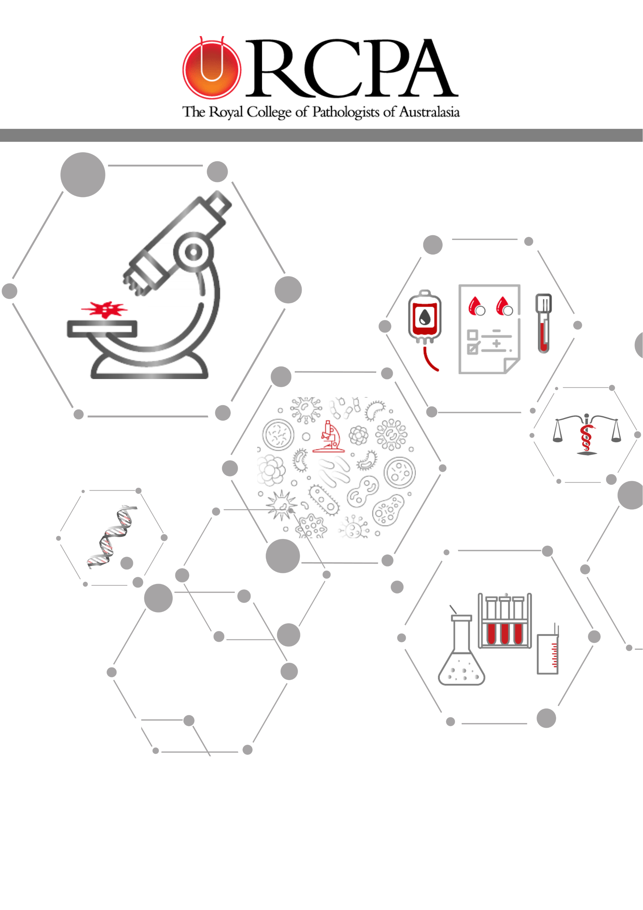

15 January 2025
Final Report
Pathology Informatics Interoperability Pilot: Pathology and the Patient

Document Control
Date | Version | Status | Action | Responsible
13 January 2025 | V0.1 | Final | Updated Chair PI Pilot 22-24 | G Jones & V Cameron
14 January 2025 | V0.2 | Final | Final review | V White & V Cameron
14 January 2025 | V0.3 | Final | Final review | V White
15 January 2025 | V1.0 | Final | Final Approved | CEO
13 March 2025 | V1.1 | Final | Updates requested by DoHAC | V Cameron
04 April 2025 | V1.2 | Final | Update to Survey 2 SPIA compatibility outcomes for SNP | V Cameron

Contents

Document Control 2
1. Glossary of terms & acronyms 5
2. Introduction 6
3. Project Objectives 6
4. Project Statement 7
5. Scope 7
6. Activities and Outcomes 8
6.1 Objective 1: 8
6.2 Objective 2: 9
6.3 Objective 3: 9
6.4 Objective 4: 13
6.5 Objective 5: 14
6.6 Objective 6: 14
6.7 KPI Objective: Terminology development and maintenance 16
7. Findings 18
7.1 Planning and Resource Requirements 18
7.2 Knowledge and experience sharing 20
7.3 Leadership and Governance 21
7.4 Consumer advocacy 22
8. Issues and challenges 22
8.1 Pilot site challenges 22
8.2 SPIA adoption challenges 24
8.3 Funding for ongoing terminology work 25
8.4 Subject matter expert availability 25
9. Evaluation Strategies 26
9.1 Pathology Terminology and Information Standardisation Projects website statistics 26
10. Conclusions and Recommendations 28
10.1 Conclusions 28
10.2 Recommendations 29
11. Appendices 31
11.1 References 31
11.2 Activity Work Plan Progress 31
11.3 Project One Page Plan 31
11.4 Governance and Reporting 32
11.5 Steering Committee 32
11.5.1 Discipline-specific Terminology Working Groups 32
11.6 Stakeholders 33
11.6.1 Partner Organisations 33
11.6.2 Standards Development Organisations 33
11.6.3 Regulators and Funders 33
11.6.4 Consumers 33
11.7 Barriers to SPIA adoption, Impacts and Resolution/Pilot site proposals 34
11.8 Sullivan Nicolaides Pathology RCPAQAP Validation Report v1.1. 37
11.9 SA Pathology RCPAQAP Validation Report v1.1. 37

Glossary of terms & acronyms
Acronym | Detail
AACB | Australian Association for Clinical Biochemistry and Laboratory Medicine
ADHA | Australian Digital Health Agency
ADRM | Australian Diagnostics and Referral Messaging – Localisation of HL7 v2.4
BPPQ | RPCA Board of Professional Practice and Quality
CAC | Community Advisory Committee
CHF | Consumers Health Forum
CPD | Continuing Professional Development
CSIRO | Commonwealth Scientific and Industrial Research Organisation
DoHAC | Department of Health and Aged Care
eCDS | electronic Clinical Decision Support
FHIR^{R} | Fast Healthcare Interoperability Resources
HL7^{R} AU | Health Level Seven Australia
IHE | Integrating the Healthcare Enterprise Australia
LIS | Laboratory Information System/s
LOINC^{R} | Logical Observation Identifiers Names and Codes (Regenstrief Institute)
MSIA | Medical Software Industry Australia
MHR | My Health Record
NATA | National Association of Testing Authorities
NCTS | National Clinical Terminology Services
NPAAC | National Pathology Accreditation Advisory Council Australia
Panel | A group of pathology test results displayed together in the same report
PTEX AU | Pathology Tests Explained Australia
PIC | Pathology Informatics Committee
PITUS | Pathology Information Terminology and Units Standardisation
PMO | Project Management Office
RACGP | Royal Australian College of General Practitioners
RCPA | Royal College of Pathologists of Australasia
RCPAQAP | Royal College of Pathologists of Australasia Quality Assurance Programs
SNOMED-CT | Systematized Nomenclature of Medicine - Clinical Terms
SPIA | Standardised Pathology Informatics in Australia
UCUM | Unified Code for Units of Measure
WG | Working Group/s

Introduction
This Project was designed to follow on from earlier RCPA Pathology Information Terminology and Units Standardisation (PITUS) Projects which unified the pathology sector in creating the RCPA Standardised Pathology Informatics in Australia (SPIA) Guidelines, by initiating a Pilot to assess SPIA reporting compliance for a limited number of laboratories and a limited number of pathology tests and panels (a panel is a group of pathology test results displayed together in the same report).
The Pathology Informatics Interoperability Pilot: Pathology and the Patient (PI Pilot 22-24) worked with pathology laboratories, general practitioners, consumers and government to demonstrate the advantages of interoperability and its impact on the pathology sector, and to identify both the tangible benefits and barriers to adopting the RCPA SPIA Guidelines in an Australian context. The Project was able to document the real-time operational and financial barriers to adoption encountered by Pilot laboratory sites as well as the challenges facing various stakeholder groups including patients, pathologists, referring clinicians, registries, and pathology laboratories where standardised pathology requesting and reporting practices are not available.
Over a period of 24 months, the Project worked with the Royal College of Pathologists of Australasia Quality Assurance Programs (RCPAQAP) to formulate a comprehensive SPIA compliance report card for Pilot laboratory sites that will be invaluable in guiding other laboratories as they embark on their SPIA implementation pathway. It is expected that this work will further guide the RCPA in considering and recommending the resourcing requirements laboratories can anticipate to meet accreditation standards e.g. National Association of Testing Authorities (NATA) and National Pathology Accreditation Advisory Council Australia (NPAAC) to support SPIA implementation and adoption.

Project Objectives
The objectives of the project were to:

- Identify two Pilot laboratories (network) sites with different degrees of current SPIA Guideline adoption and readiness.
- Identify five tests and five panels for the Pilot.
- Identify all barriers to adoption – organisational, risk aversion, prioritisation, and financial through a series of workshops.
- Implement SPIA Guidelines for the tests and panels identified with the two selected Pilot sites, initial survey and analysis pre-pilot, and participation by at least one pilot site for the second survey and analysis post-pilot implementation.
- Support the RCPAQAP to assess Pilot sites' compliance with the standards.
- Publicise the project findings via RCPA communication channels to promote and drive the adoption of the standardised terminology for requesting and reporting and standardised units of measure for reporting as part of laboratory practices.
The Project was progressed under the Department of Health and Aged Care Grant, as outlined in the Quality Use of Pathology Program Targets Project Grants 2022-2023 Grant Opportunity Guidelines GO6060 (the Grant).

Project Statement
Currently, the SPIA Guidelines are published and publicly available via the RCPA website. Work on standardising terminology and developing these Guidelines by the pathology profession is an ongoing effort currently undertaken by pathologists, scientists, laboratory project staff and informaticians in a voluntary capacity. Terminology development will continue to play a vital and ongoing role for the RCPA to support the interoperable delivery of healthcare information for the broader pathology and consumer community, including for the patient, pathologist, referring clinicians, registries and quality control in laboratories.
Patients should not need to be concerned about the origin of pathology provider results, rather that terminology and results are consistent amongst all pathology providers. Focusing on interoperability, consistent use of terminology and pathology report presentation for consumers and the referring clinician are core when considering and establishing valuable outcomes for the patient, healthcare clinicians and at a population-level for quality monitoring, benchmarking, interventions and benefit analyses in public health (Ellis & Srigley, 2016).¹
Current reporting variation occurs at the test level (test name, reporting units, reference intervals), the report formatting level (location of items on the page, sequence of information across and/or down the page), and at the panel content level (which tests are combined on a report, what the report is named). Minimising variation at all levels reduces the possibility for misunderstanding and potential clinical error, or for time-wasting, ensuring correct reading of the report. Specifically, variation in the panel content or name can make it difficult for a doctor to find previous results on a patient from different providers, leading to unnecessary repeating of tests or failure to follow-up important previous abnormalities.
Convincing key stakeholders of the need for laboratory harmonisation in adopting the SPIA Guidelines is time critical. With the rapid advancement of electronic health record systems in Australia, the inter-laboratory variation in quantification and reporting of pathology tests can impact multiple stakeholders across all aspects of healthcare; from impacting patient care, when the patient uses different laboratory services for monitoring their disease response, to preventing efficient and timely analysis of health information, to driving change due to reporting differences.
Without widespread adoption, the digital health advantages of the SPIA Guidelines are limited. Currently, the NPAAC Requirements for Information Communication and Reporting (Fifth Edition 2022)² strongly recommends but does not mandate pathology terminology standardisation. However, the foundations for a nationally consistent approach to standardisation are freely available in the form of the SPIA Guideline and Terminology Reference Sets. The current environment requires additional incentives and evidence to encourage adoption by pathology providers and the medical software industry.
This Pilot aims to provide Australian-based evidence on the tangible benefits of SPIA adoption, including those demonstrated by overcoming operational barriers to implementation, such as cost effectiveness for laboratories through both hard (financial) and soft outcomes (for example, reduction in interpretation errors, increased consumer engagement, decreased reporting delays), as well as the observed operational benefits and challenges faced by laboratories to implement the RCPA SPIA Guidelines.
In addition, the benefits for the broader pathology community, including for the patient, pathologist, referring clinicians, registries, and pathology laboratories will be explored.

Scope
The Project provides an assessment of the level of SPIA compliance for a limited number of pathology tests and panels as part of a Pilot program with two laboratories at differing levels of SPIA adoption.
To do this, the Project formed a Steering Committee with representation from leading experts in the healthcare and software industry e.g. pathologists from the public and private sector, the RCPA, RCPAQAP, Medical Software Industry Australia (MSIA), Royal Australian College of General Practitioners (RACGP), healthcare informaticians, consumers and government to oversee the SPIA adoption Pilot program, expertise in agreeing on the top five most requested tests and panels, and to provide guidance and input in the delivery of a series of workshops focussed on identifying barriers and benefits to SPIA adoption.
The Project formed Working Groups (WG) with each Pilot site, which included pathologists, laboratory and IT expert representatives to carry out two SPIA compliance surveys, and additional expert working groups will be formed to continue terminology development.
The Project worked with the RCPAQAP to develop the compliance software tool and corresponding reporting tool that was used for the SPIA compliance assessment for each Pilot site.
Upon completion of the Pilot, the RCPA will promulgate the outcomes of the survey findings via the RCPA website and the final edition of the Project newsletter as a supplementary opportunity to educate software vendors, clinicians and laboratory staff about the tangible benefits of SPIA adoption,
including the barriers to adoption found at both Pilot sites and resources required to achieve SPIA compliance.
The Project did not undertake any activities outside of the scope statement.

Activities and Outcomes
The Project formally commenced on 12 December 2022 with the signing of the Contract, with Project activities finalising on 30 November 2024. Over that period, there was significant consultation to inform the findings and recommendations. This Final Report outlines the activities completed with respect to delivering the agreed Milestones for the Project as outlined in the Agreement and Deed of Variation 1, executed 22 November 2023, and Deed of Variation 2, executed 25 July 2024.
Over a period of 24 months, the Project included over 70 sources of input from industry experts to complete all the activities outlined by the Department and inform the findings and recommendations of this report. Consultation activities included Steering Committee meetings, terminology working group meetings, informatics-related meetings, Pilot site meetings, informatics workshops and webinars.

Objective 1:
Identify two pilot laboratory (network) sites with different degrees of current SPIA Guideline adoption and readiness
The Project undertook a range of communication methods to recruit pathology laboratories for the Pilot. Expressions of interest were promoted via the Project Newsletter by direct email to all prior RCPA pathology informatics workshop delegates. All laboratories that had previously demonstrated interest in SPIA were contacted directly. In Meeting 1 of the Project Steering Committee, an open invitation was extended to all laboratories to participate in the Pilot. Additionally, an open invitation to participate was extended to all laboratories via the 2023 Pathology Informatics Workshop.
Sullivan Nicolaides Pathology (SNP) in Brisbane was approached early in the Project to participate as a Pilot site. SNP is a member of the Sonic Healthcare Group, providing 24/7 pathology testing to the communities of Queensland, northern New South Wales and the Northern Territory. SNP is one of Australia’s largest private referral laboratories, which has demonstrated steadfast support with previous RCPA informatics workshops and ongoing terminology development and holds a clear vision toward interoperability by being an early adopter of RCPA SPIA terminology within their Apollo Laboratory Information System (LIS). SNP were enthusiastic and immediately offered to participate in the Pilot.
SA Pathology was the second Pilot site, offering 24/7 pathology testing for the public health sector across the entire state, in addition to including anatomical pathology, perinatal pathology and cytology resulting for the Northern Territory. SA Pathology delivers quality pathology to medical practitioners as well as public and private hospitals through a linked system of laboratories across the State – from branch laboratories in rural and regional hospitals, general laboratories in metropolitan hospitals and specialist laboratories responsible for tertiary referral – and through a network of collection centres covering all the State’s major population centres. SA Pathology is currently investing in interconnected ICT/computer systems across its laboratories. This includes the development of a harmonised test ordering catalogue across various clinical information systems and improving electronic test ordering via the Sunrise Electronic Medical Record system. Although SA Pathology has yet to implement the RCPA SPIA pathology terminology reference sets into its laboratory information systems, they were very interested in participating in the Pilot to gain an understanding of the amount of effort and resources likely required to become SPIA compliant, a goal they had already identified in their pathology project space for future implementation.

Objective 2:
Identify the five tests (top 5 most requested tests – glucose, HbA1c, HBsAb, and SARD-DoV-2 Nucleic Acid Testing + SARS-CoV-2 Serology) and five panels for the pilot
In collaboration with the Australian Digital Health Agency (ADHA)’s My Health Record (MHR) implementation, and via endorsement at the first Project Steering Committee (including members of the Department of Health and Aged Care), the final number of tests and panels exceeded that initially contracted to better represent those tests of extremely high requesting numbers in the majority of pathology laboratories to cover seven pathology tests and six pathology panels, see Table 1 below:
Pilot tests | Pilot panels
INR | Electrolytes Urea Creatinine
Haemoglobin A1c | Full blood count
Glucose | Hepatic function tests
SARS-CoV-2 nucleic acid | Iron studies
SARS-CoV-2 total antibody | Lipids
Respiratory syncytial virus nucleic acid | Thyroid function tests
Hepatitis B surface antibody

Table 1: PI Pilot 22-24 tests and panels for SPIA compliance testing

Objective 3:
Identify all barriers to adoption – organisational, risk aversion, prioritisation, and financial through a series of workshops
A total of four hybrid workshops were held during the Project activity timeline to safeguard the highest possible number of delegates able to attend each event.
Workshop 1 (30 November 2022): The first formal engagement for the Project was the Pathology Standards Refresher Workshop, undertaken in collaboration with the Victorian Department of Health. With the State in the early stages of implementing a new LISConnect project, embarking on a proposed three LIS network arrangement, the Victorian Department of Health identified the need to incorporate SPIA Guidelines as part of this implementation and requested RCPA experts to provide practical insights. Three pathologists provided perspectives on the role of the RCPA with respect to SPIA, the SPIA Guidelines and practical issues of interoperability, and getting started on interoperability solutions.
A total of 47 delegates attended the first workshop, representing each Victorian health service, LIS project team members, Victorian Department of Health, and RCPA members.

Workshop 2 (27 April 2023): Pathology informatics experts, including pathologists, software developers, academics and scientists, presented at the second Pathology Informatics Workshop. Session materials covered practical interoperability issues and their barriers; the importance of technology in addressing interoperability; the importance of standardisation and its role in ensuring patient safety and data quality; and the role of artificial intelligence (AI) and machine learning in pathology, highlighting their potential future impact within the pathology sector. 117 delegates attended the second workshop (in person or on-line) where practical and personal experiences were shared regarding the urgent need for pathology interoperability and some of the more significant barriers to adoption.

Workshop 3 (14 June 2023): The third workshop was held in collaboration with the RCPA Community Advisory Committee, the Australasian Association for Clinical Biochemistry and Laboratory Medicine (AACB), the ADHA, and The Public Relations Agency. Its aim was to raise awareness of current community healthcare concerns regarding immediate access to evidence-informed pathology testing for consumers, shared decision-making and access to pathology results with respect to the management of diseases and treatment pathways. 22 delegates attended. ADHA provided evidence that consumers are increasingly looking to the MHR to see their pathology results and, as a result, advised that the Department would be developing and implementing an “upload by default” policy by 2024/2025. Attendees agreed that with evidence provided from research in this area, immediate access to pathology results for consumers needed urgent attention; however, the RCPA maintains its position on retention of the 7-day delay for selected tests to help patients understand and interpret results in a safe and caring setting as per the Media Release on 09 January 2024. Discussions from the meeting resulted in the review of the language and content of the Release of Pathology Results to Patients and Consumers Guideline. The AACB informed the workshop their Annual General Meeting in October 2023 was to be titled ‘Patient Centred Pathology’, a nod to the pathology industry’s recognition of the importance of patients being able to access their own pathology results.

Workshop 4 (16 May 2024): A collaboration with AACB and RCPAQAP, “Our Digital Future” focussed on the current state of pathology informatics within laboratories and for the consumer e.g. results being uploaded to My Health Record, and most importantly, pragmatic solutions to interoperability issues likely to be encountered by laboratories when implementing SPIA. Sessions were specifically aimed at disseminating the Pilot findings, both from the RCPA’s perspective and that of the two Pilot sites. Workshop organisers expressed interest in facilitating annual interoperability forums, suggesting day one targeting SPIA implementation for ‘beginners’ (RCPA and RCPAQAP, pathologists, scientists, information system analysts and developers, software vendors, etc), and day two targeting those ‘more advanced’ in this space (RCPA and RCPAQAP, pathologists, scientists, information system analysts and developers, software vendors, HL7 Australia, CSIRO, ADHA, RCPAQAP, etc). These annual forums would be ideal opportunities to leverage the knowledge gained through all stages of SPIA implementation, ensuring all relevant information is shared and documented, including implementation tips and tricks, and methods to overcome barriers or pitfalls encountered along the implementation journey.
175 delegates attended the final workshop, including representatives from medical software vendors, international and Australian private and public laboratories, DoHAC, ADHA, laboratory information system experts, HL7 Australia, CSIRO, the Ministry of Health Malaysia, Curtin University, Siemens Healthineers, and Pulse +IT magazine. This is the largest audience to date for any RCPA Pathology Informatics Workshop.
Workshop 5 (03 December 2024): Although outside of the Pilot’s activity timeline, the RCPA hosted a Digital Strategy and Roadmap Workshop in collaboration with the DoHAC Digital Health Branch, chief pathologists from Victoria, South Australia and Brisbane, ADHA, RACGP and the RCPA Community Advisory Committee with 45 delegates attending. One aim of the workshop was to discuss the role of the RCPA in developing and maintaining terminology and national digital resources that provide foundational datasets for interoperability, including the Sparked work on FHIR standards. As noted by the RCPA President in Pathology Today on 12 December 2024: “This workshop was incredibly useful to inform our thinking around the role of the RCPA in relation to the governance and guidance requirements for the use of new digital technologies and how the work undertaken by the RCPA in this space should be prioritised.”
Input and feedback collected by the Project from Pilot sites, workshops and forums and Steering Committee meetings identified a series of barriers and benefits to SPIA adoption. A table listing all the barriers to SPIA adoption identified during the Pilot and workshops is included at Appendix 11.7.
The high level potential barriers identified by the Project were categorised as Organisational, Risk aversion, Prioritisation, or Financial and a high-level summary of these is outlined below:
Summary of high-level potential barriers to SPIA adoption
Organisational:
- Minimum of HL7 v2.4 required to undertake SPIA compliance testing as per RCPAQAP survey design (based on NPAAC Requirements S4.1)
- An integration engine or similar required to convert HL7 v 2.3.1 messages to HL7 v 2.5
- Security assessment (or similar) required for any new infrastructure or services within Public laboratories as per governance (internal or hierarchical within Government)
Risk aversion:
- Most clinicians are familiar with the formatting of results from their usual pathology provider, therefore changing any formatting causes a risk for a period of time whereby that report may be misread or misinterpreted - laboratories are concerned to minimise this risk for usual clients
Prioritisation:
- Managing competing priorities of multiple IT system builds/updates e.g. security assessment needed to build new OntoServer, eRequesting platform, etc
- Competing priorities with routine laboratory IT system workload as system upgrades or implementing new hardware/software is required
- Vendor and clinician engagement often challenging for laboratory staff; low priority
Financial:
- Laboratories (particularly public) do not have ready access to level of funding required to perform LIS enhancements/upgrades to incorporate SPIA terminologies
- Security assessment (or similar) required for any new infrastructure or services within Public laboratories as per governance (internal or hierarchical within Government)
- How to support laboratories who wish to maintain SPIA compliance for their SNOMED & LOINC codes when PITUS projects are only run when Government funding is available?

Table 2: Summary of high-level potential barriers to SPIA adoption

However, the Project also acknowledges that many potential benefits were identified during the series of workshops as attainable for laboratories pursuing SPIA compliance. A table of all potential benefits identified are outlined below.
Potential benefits attributed to SPIA adoption | Stakeholders benefitted
Reduction in the number of pathology request form transcription and interpretation errors. | Consumers  Specimen reception/Data entry staff  Laboratory staff - Scientists & Pathologists  GPs/Clinicians  Government – via Medicare
Improved pathology reporting turnaround times by providing a universal basis for e-requesting. | Laboratory staff - Scientists & Pathologists  Consumers/Guardians  GPs/Clinicians  Researchers  Notifiable disease registries/Cancer registries
Reduction in unnecessary duplicate testing (paper and electronic results):  - Duplicate venipuncture/loss of blood  - Duplicate phlebotomy & lab consumables  - Additional phlebotomy & laboratory time  - Scientist/Pathologist/ time to review and validate additional results  - Additional GP consultations to write referrals for additional tests and to review results. | Consumers  Laboratory staff – Phlebotomists, Scientists & Pathologists  Medicare  GPs/Clinicians
Increase in the integrity of pathology data to improve clinical decision support and overall health outcomes. | Consumers/Guardians  GPs/Clinicians  Researchers  Notifiable disease registries/Cancer registries  RCPAQAP
As atomic reporting is implemented within MHR, more pathology reports will be uploaded with SPIA-compliant SNOMED (requesting) & LOINC (reporting) terms. | Consumers/Guardians  GPs/Clinicians  Researchers  Notifiable disease registries/Cancer registries  RCPAQAP
Increase in consumer engagement with MHR. | Consumers  GP/Clinicians
Cost-effectiveness for laboratories (longer term) as they progress towards being SPIA compliant to receive NPAAC/NATA accreditation (currently noted as desirable and achievable outcomes) | Laboratories  Government
Adherence to NPAAC Requirements for information communication and reporting (5th Edition) to facilitate NATA accreditation. | Laboratories  NATA accreditation auditors  RCPAQAP
Opportunity for quality improvement via the use of standardised terminology and report formatting regardless of pathology provider reporting template. | Laboratories  Consumers  GP/Clinicians  Notifiable disease registries/Cancer registries  Researchers  RCPAQAP
Participating in the Pilot provides laboratories with an indication of the real-world scenario in relation to SPIA and ADRM messaging compliance and likely resources and timelines necessary to achieve full SPIA compliance – it also provides a competitive edge over other laboratories who are not SPIA compliant with respect to NATA accreditation. | Laboratories  NATA accreditation auditors  RCPAQAP
Both Pilot sites were able to improve their levels of SPIA compliance, therefore, improving their overall levels of interoperability; however, it was noted that large public laboratories may not be able to pivot as readily as private laboratories who typically have greater resources at any given time. | Laboratories  Consumers  GP/Clinicians  Notifiable disease registries/Cancer registries  Researchers  RCPAQAP

Table 3: Potential benefits of SPIA adoption

Objective 4:
Implement SPIA Guidelines for five tests and five panels identified with two select pilot sites

Both Pilot sites completed both SPIA compliance surveys, largely due to the extension granted under the second Deed of Variation. [Due to the size of the full survey reports for each Pilot site, the complete reports are provided as attachments 1 and 2 – refer appendices 11.8 and 11.9.
A summary of both Pilot sites’ major SPIA compliance points are outlined in Tables 4 and 5 below.
SPIA compliance point | Survey 1 SPIA Compliance Results | Survey 2 SPIA Compliance Results | Improvement
SNOMED CT coding (requests) | 0% | 100% | 100%
SPIA Preferred Terms | 72.7% | 79.6% | 6.9%
LOINC coding (results) | 89.8% | 100% | 10.2%
SPIA Units | 100% | 100% | NIL
UCUM Units (HL7 messages) | 0% | 0% | NIL
Table 4: Pilot Site 1: SNP survey results summary

SPIA compliance point | Survey 1 SPIA Compliance Results | Survey 2 SPIA Compliance Results | Improvement
SNOMED CT coding (requests) | 0% | 0% | NIL
SPIA Preferred Terms | 53.7% | 53.7% | NIL
LOINC coding (results) | 72.2% | 82.2% | 10.2%
SPIA Units | 78% | 78% | NIL
UCUM Units (HL7 messages) | 0% | 0% | NIL

Table 5: Pilot Site 2: SA Pathology survey results summary
SNOMED CT coding and UCUM Units are not yet incorporated within routine Australian HL7 message structure, thus were not a focus of the participants as there would be no clinical benefit in undertaking this body of work at this time.

Objective 5:
Support RCPAQAP staff to assess compliance with the standards
The RCPA provided the RCPAQAP with the latest version of the SPIA Requesting Pathology Terminology Reference Set at the time of the first Pilot (v4.2) and correlating SPIA Reporting Terminology Reference Sets for Chemical Pathology, Haematology, Immunopathology, Anatomical Pathology, Cytology, Microbiology and Serology (v4.0). Along with the Reference Sets, a copy of the updated SPIA Guidelines (v4.1), Best Practice Guidelines, and Exemplar Pathology Reports were supplied to enable the creation of the SPIA validation tool and the generation of the validation reports. As pathology related questions were raised throughout this process, Project staff assisted to ensure the validation testing would safeguard SPIA compliance in the modern laboratory setting.

Objective 6:
Publicise project findings via RCPA communication channels to promote and drive the adoption of the standardised terminology and units for requesting and reporting as part of laboratory practices
The RCPA publicised the findings of the Project via a number of channels including workshops and events, newsletters, social media and RCPA website updates.
The RCPA dedicated four presentations at the Informatics Workshop on 16 May 2024 to the initial findings of the Pilot’s first SPIA Compliance Survey. All presentations from this workshop are available via RCPA - Presentations along with a recording of the day’s sessions. Figure 1 below depicts one presenter from this workshop.

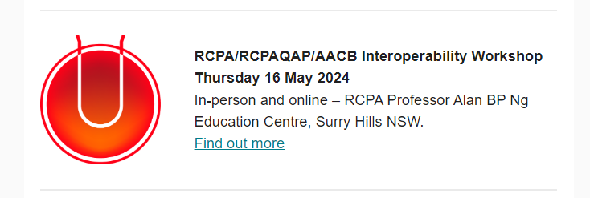

Figure 1: Dr Travis Brown presenting at the Informatics Workshop on 16 May 2024 and the associated Pathology Today Event listing

Issue 20 of the PITUS Newsletter included a summary of Survey 1 SPIA compliance findings. This was published on the RCPA website and distributed to over 180 newsletter subscribers. A final PITUS Newsletter is expected to be published by 30 January 2025 where the findings of both SPIA compliance surveys; barriers to SPIA adoption; and anticipated benefits of SPIA adoption will be detailed. Additional promotional opportunities via RCPA social media channels (Facebook, Instagram, Twitter, LinkedIn and YouTube), Project newsletter and Pathology Today. Delegates from the RCPA also attended various HL7 Sparked Accelerator events during which terminology standardisation for diagnostic imaging and pathology was at the forefront of most agendas. Figure 2 below promotes the Pathology informatics workshop via the RCPA Newsletter – Pathology Today.
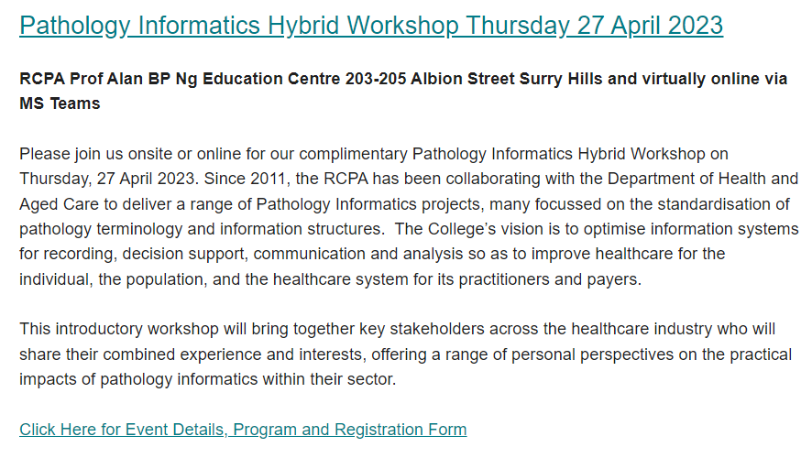
Figure 2: Pathology Today promotion for Informatics Workshop 27 April 2023

The RCPA promoted the SPIA compliance work undertaken by the RCPAQAP, advising all laboratories of the opportunities to have their LIS software checked for SPIA compliance via the RCPA SPIA Coding Performance Reporter tool (currently only available in test platform) without the need to enrol in the Project surveys. To date, a number of interested laboratory staff have contacted the RCPAQAP to obtain access to this tool once it is available via the live website.
A new logo was created in 2022 to promote pathology informatics work. (see Figure 3 below).

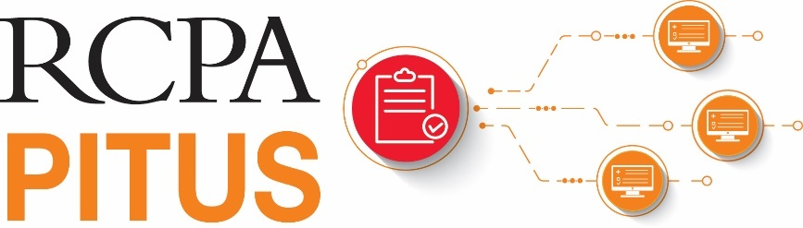
Figure 3: New PITUS logo

The NPAAC Chair, A/Prof Beverley Rowbotham addressed delegates attending the Integrating the Healthcare Enterprise (IHE) Information session on 28 November 2024, specifically to reinforce the requirements for laboratories as outlined in Appendix A (Report format requirements) of the Requirements for information communication and reporting (5th edition). These requirements which are based on the RCPA SPIA Guidelines, provide a strong directive that laboratories should adopt these standards. However, it also states that where there are circumstances in which this is not achievable, a risk assessment should be conducted. A/Prof Rowbotham indicated the standardisation of pathology terminology and units in Australia is desirable and achievable.

The RCPAQAP’s Chief Information Officer also presented at this forum to discuss NATA assessments for SPIA and Australian Diagnostics and Referral Messaging (ADRM). Figure 4 below is one slide from the presentation supporting this.

Figure 4: Interconnectivity of NPAAC requirements, NATA assessment and SPIA compliance

KPI Objective: Terminology development and maintenance
Development and/ or update of SNOMED-CT and LOINC terminology as required during the project activity period
The Project continued to review both SNOMED requesting terms and LOINC reporting terms during the activity period. For context, the table below has been updated to include a summary of the terminology review and development work undertaken by the SPIA wg members during PITUS 18-20 and that undertaken during PI Pilot 22-24. A listing of the number of terms reviewed, those endorsed, and the total number of meetings is represented in Table 6 below. A significant portion of terms were pre-mapped by the Project Officer prior to commencing the terminology review work in PI Pilot 22-24; by doing this work in advance, volunteer subject matter expertise was more efficiently utilised and consensus endorsement was faster overall.

Discipline | # SNOMED requesting terms reviewed / total # requesting terms submitted for review  PITUS 18-20 | # SNOMED requesting terms reviewed / total # requesting terms submitted for review  PI Pilot 22-24 | # LOINC reporting terms for reviewed / total # requesting terms submitted for review  PITUS 18-20 | # LOINC reporting terms for reviewed / total # requesting terms submitted for review  PI Pilot 22-24 | Meetings held  PITUS  18-20 | Meetings held  PI Pilot  22-24
Anatomical Pathology & Cytology | 0 | 31/31 | 0 | 23/23 | 0 | 3
Andrology | 0 | 4/4 | 0 | 209/209 | 0 | 5
Chemical Pathology | 24/30 | 403/403 | 484/775 | 74/227 * | 29 | 14
Flow Cytometry | 0 | 0/17 | 0 | 0/168 | 0 | 0**
Genetic Pathology | 0 | 0/322 | 0 | 0/308 | 0 | 1 ***
Haematology & Transfusion Medicine | 54/133 | 60/60 | 45/110 | 62/62 | 7 | 5
Immunopathology | 297/316 | 114/114 | 148/177 | 73/74 | 8 | 8
Microbiology, Molecular Biology & Serology | 81/301 | 154/163 | 193/361 | 0/52 | 14 | 3 ****
Total # terms reviewed/ total # terms submitted for review | 456/780 | 766/1,097 | 870/1,423 | 436/955 | 58 | 38

Table 6: Terminology review work comparison PITUS 18-20 and PI Pilot 22-24
* Many terms not reviewed due to insufficient information provided by the originating laboratory
** Unable to source Flow Cytometry subject matter experts to review submitted terms
*** Initial meeting suggested standardised terminology template to be drafted offline
**** Unable to meet quorum for several meetings

The Project initiated and agreed on a new approach to the terminology review process, and the revised process is outlined in the graphic below, Figure 5:
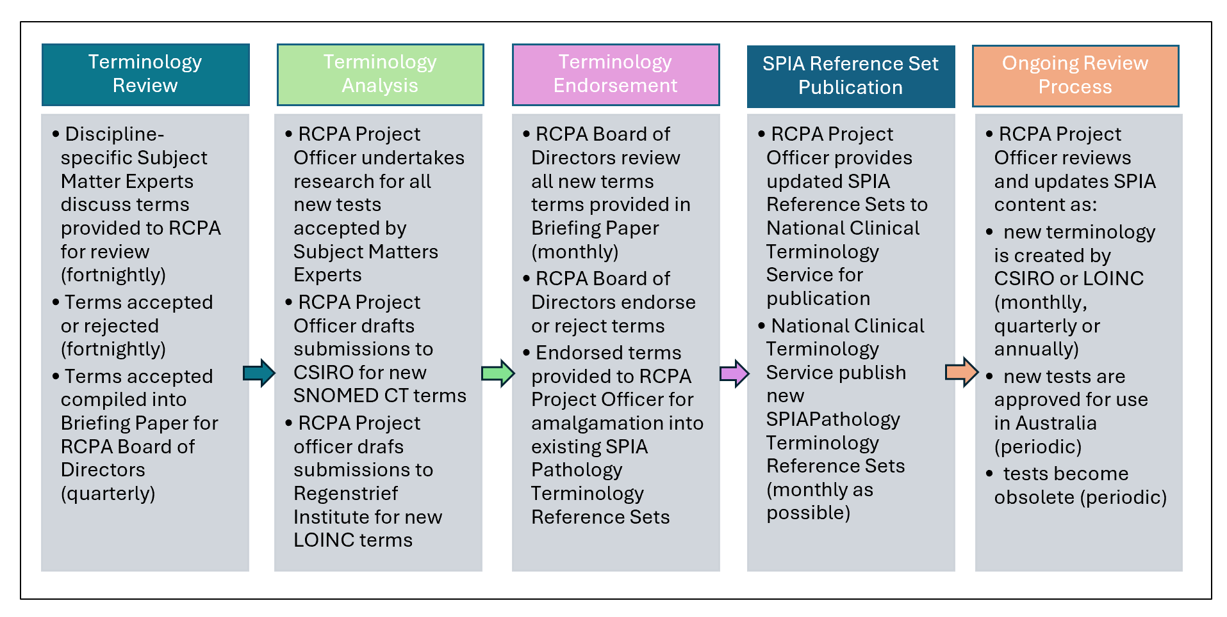Figure 5: SPIA terminology review process
PI Pilot 22-24 successfully developed the first RCPA Diagnostic Andrology Information Model for the most commonly requested Andrology tests and panels.
The Project requires the Regenstrief Institute to create new LOINC reporting terms before these new Diagnostic Andrology Information Models can be published to the National Clinical Terminology Service (NCTS) and is currently awaiting confirmation of this terminology. In total, there are now 1568 requesting terms, 1639 reporting terms, and 2766 microorganisms available in the RCPA SPIA terminology reference set resources which are freely available via the RCPA resources - National Clinical Terminology Service of the NCTS website. All new terminology developed for the SPIA Reference Sets is awaiting final endorsement from the RCPA Board of Directors, with the next publication anticipated for the end of February 2025. As the source of truth maintaining versioning of the RCPA SPIA Pathology Terminology Reference Sets, the NCTS website has a page dedicated to the RCPA SPIA resources, refer to Figure 6 below. Requests were submitted to the NCTS on RCPA Resources downloads where information is available to interested parties (after registering for the site), however, this information was unavailable at the time of this report.
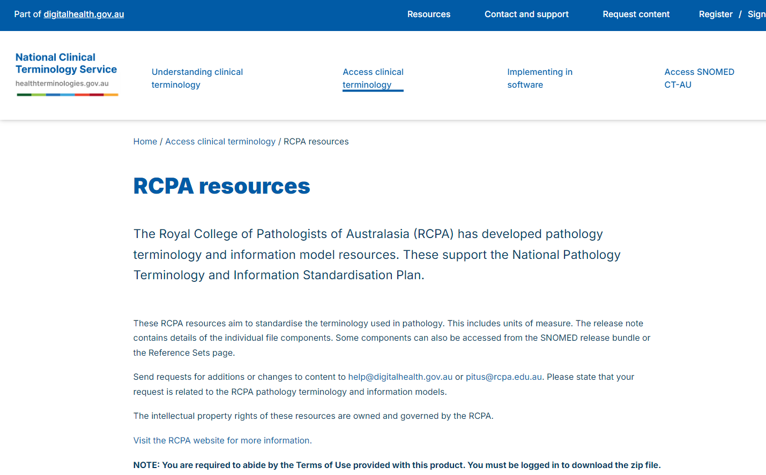
Figure 6: NCTS website promotion of RCPA SPIA Pathology Terminology
Reference Sets and Information Models
Informaticians at RCPAQAP have begun mapping measurands within their Chemical Pathology Diagnostic Programs to SNOMED-CT (requesting terms), LOINC (reporting terms), and UCUM units (Unified Code for Units of Measure), leveraging the work of the RCPA published in the RCPA Pathology Terminology Reference Sets (and reporting). Where RCPAQAP Diagnostic Program terms have not yet been modelled for the RCPA Pathology Terminology Reference Sets, the RCPA undertook the submission work to have the new terms created on behalf of the RCPAQAP.
The SPIA Guidelines were updated to v4.1 in March 2024. The updates included document restructuring, renumbering of guidelines and related guideline commentary reflecting the document restructuring, updates to reference documents, updated guidance for the development of therapeutic drug requests and results, and guidance on reporting for haemolysed specimens. Version 4.1 of the SPIA Guidelines was endorsed by the RCPA Board of Directors on 08 April 2024.
The RCPA Best Practice Guidelines were updated to v2.2 to incorporate the AACB’s recommendations for Test Result Sequence “Down the Page” for common Chemical Pathology tests (22 July 2023). This will further assist consumers in viewing their pathology results via My Health Record (MHR) due to reduced variation in rendered pathology reports. Of the total 2,151 downloads for the RCPA Guidelines and Tools webpage over the Project period, 739 were for SPIA Guidelines V4.0, 588 were for SPIA Guidelines V4.1, 688 were for Best Practice Guidelines, and 136 were for NCTS Tool development requirements. (see Figure 7 below).

Figure 7: Guidelines and Tools downloads for February – November 2024.

Findings
The findings from the Project align to Planning and resource Requirements (Objectives 1, 3 & 4); Knowledge and experience sharing (Objectives 5 & 6); Governance and Communication (Objectives 3 & 4) and Consumer advocacy (Objectives 2, 3 & 6).

Planning and Resource Requirements
- SPIA implementation and adoption within laboratories information systems is resource intensive and costly. All system enhancements need to be fully planned, cost and resourced to ensure success. It should be noted that SNP was quite advanced in relation to SPIA compliance as compared with SA Pathology; the estimated costs and resources listed in Table 7 below reflect this variation.

SPIA Implementation Expense | SNP Estimates | SA Pathology Estimates
LIS software enhancements  Includes testing & quality checking | $4,800 (40 hours) | $49,800 (415 hours)
Management oversite  Includes executive management, internal planning and system testing, pathologists, scientists, IT staff, project staff, marketing & communications | $43,200 (75 hours) | $179,712 (312 hours)
RCPAQAP survey 1 and 2 (SPIA compliance assessment) | $6,000 (50 hours) | $27,600 (230 hours)
Administrative costs | $720 (10 hours) | $1,800 (25 hours)
Integration messaging for HL7 | N/A | $576 (6 hours)
Ontoserver infrastructure build | N/A | $10,000 (no hours provided)
Terminology training | N/A | $8,000 (40 hours)
Estimated total implementation cost | $54,720 | $277,488

Table 7: Pilot Site SPIA Implementation Estimate.
Note: the estimates provided by Pilot sites are conservative estimates only and cannot be used or extrapolated as the basis for calculating real costs for SPIA implementation.

- There is a need for continued maintenance and updates to the RCPA SPIA Pathology Terminology Reference Sets and Information Models to demonstrate integrity and commitment to best practice for the RCPA SPIA Guidelines. It is evident that terminology development and review cannot be ad hoc, rather, regular reviews and updates are essential. Maintenance of the SPIA work is vital to ensure the currency of the terminology assigned to tests and panels. This is particularly important in areas such as genetic terminology which, is being developed at an extremely fast pace, and microorganisms, which are updated often as taxonomic classifications change via molecular discoveries and novel organisms are discovered. In addition to the volunteer domain experts, two dedicated resources (one scientific, one administrative) are required to continually review all SPIA terminology, which includes the following responsibilities:
  - Scheduling and convening terminology review meetings and drafting minutes.
  - Aligning requesting terms with reporting terms developed out of sync.
  - Drafting submissions to CSIRO (new SNOEMD CT terms) and The Regenstrief Institute (new LOINC terms).
  - Following up outstanding terminology submissions.
  - Updating SPIA Reference Sets for publication by CSIRO to the NCTS as terminology is developed.
  - Checking CSIRO publications for errors.
- Development of national resources aligns with the Australian Digital Health Agency’s National Digital Health Strategy (2023 – 2028) and Delivery Roadmap Priority area 1.3 “Enhance and maintain modern and integrated digital solutions. Initiative underway: 1.3.2 Develop accurate terminology, interoperability standards and conformance for sustained and widespread use by 2028; and 1.3.5 Co-design technical, clinical terminology and exchange standards for a national electronic requesting capability for diagnostic imaging and pathology by 2025”. The NCTS is operated by ADHA, and is responsible for managing, developing and distributing national clinical terminologies and related tools and services to support the digital health requirements of the Australian healthcare community. The CSIRO terminology team manages the development of new SNOMED CT pathology requesting terms on behalf of the NCTS. SNOMED CT is the world’s most comprehensive clinical terminology, providing both human-readable and logical computer concepts which enable the creation of unambiguous, data-rich interoperability between any number of clinical and laboratory information systems. Implementation of the SPIA Pathology Terminology Reference Sets will safeguard this data exchange for electronic pathology requests; however, ongoing commitment and funding are required for the RCPA to continue this work, ensuring alignment with the National Digital Health Strategy.
- Current use of Unified Code for Units of Measure (UCUM) in Australia: There are at least two components to units outlined in the SPIA Guidelines. The human-readable format is displayed on rendered reports; the other is for use via HL7 messaging for machine interoperability, whereby results with the same units can be recognised, or results with different units converted to be the same e.g. incorporating ^LN^ within the LH7 message to identify LOINC as the terminology binding for results reporting. The "machine interoperability" use of UCUM units is not yet in place in Australia, as was evidenced in the RCPAQAP survey results for both sites. SNP’s IT team put significant effort into trying to resolve this issue but were unable to do so during the timeline of both surveys. IT resources at the RCPAQAP have indicated their willingness to assist with resolving issues relating to HL7 messaging display and ADRM compliance via the use of their RCPA SPIA Coding Performance Reporter compliance tool. Australian laboratories need to be ready, both with the UCUM coding for the units and HL7 message structure.

Knowledge and experience sharing
- The Findings from the Project and SPIA compliance survey results demonstrated the breadth of variability in SPIA compliance typically seen within the Australian pathology industry. This was reinforced through Workshop 4, Our Digital Future, whereby both organisers and participants noted the lack of opportunity for those interested in SPIA implementation to meet regularly and to actively leverage knowledge gained through all stages of SPIA implementation. The need to develop and implement platforms to share “tips and tricks”, and methods to overcome barriers or pitfalls encountered along the SPIA implementation journey was considered advantageous to facilitate and ensure all relevant information is shared and documented.
- The extrapolation of the Survey results and site issues register indicated both Pilot sites would benefit from achieving full SPIA compliance. Pathology terminology within Australia is not standardised as is evidenced by the existing uploads to MHR and from the slides in Prof Graham Jones’ presentation at the informatics workshop on 16 May 2024 (refer to Figures 8 and 9 below). Standardised clinical terminology is necessary to ensure that healthcare data is presented and interpreted with its intended meaning when shared with a range of databases and stakeholders, including the consumer, and to enable full interoperability across various systems in the future.
- Sharing of the potential benefits and barriers to SPIA adoption as per the experiences and presentations from both Pilot sites at the Informatics Workshop on 16 May 2024, is indispensable for any laboratory commencing their SPIA implementation journey. Many delegates attending this workshop contacted the RCPA after the event to gain access to the presentations and recordings to assist with planning SPIA implementations. Additionally, creating a “forum of experts” to progress knowledge sharing and awareness surrounding SPIA implementation was expressed as an outcome of this workshop. The proposed “forum” would allow software vendors and laboratories/IT staff to tackle the lack of standardisation in pathology reporting, an ongoing problem. Another suggested use for the “forum” was as an annual SPIA code update day, whereby all delegates are provided with the latest code updates in an “annual rollout cycle”, enabling them to plan communications and software enhancements rather than the current piecemeal approach as SPIA terminology updates are published to the NCTS.
- The RCPAQAP, through the development of their SPIA Coding Performance Reporter tool, can provide SPIA compliance reports to any interested laboratory or clinical information system administrator, highlighting areas where compliance is lacking and providing guidance for the SPIA implementation processes.
- Delegates from the Informatics Workshops expressed interest in participating in an annual interoperability forum, ideally facilitated by the RCPA, suggesting a one-day forum targeting SPIA implementation for ‘beginners’ (RCPA, pathologists, scientists, information system analysts and developers, software vendors, etc), with a second day targeting those ‘more advanced’ in this space (RCPA, pathologists, scientists, information system analysts and developers, software vendors, HL7 Australia, CSIRO, ADHA, RCPAQAP, etc). Initiating these annual forums could provide an opportunity for SPIA implementers to share common SPIA compliance difficulties, e.g. identification of the use of LOINC coding within HL7 messages (as evidence in the RCPAQAP Survey reports for both Pilot sites). It also provides the ability for RCPA and the RCPAQAP to guide and assist SPIA implementers through any barriers they may encounter or anticipated barriers as they commence their SPIA implementation journey.

Leadership and Governance
- Widespread SPIA adoption via top-down leadership is vital for laboratories to progress SPIA implementation. Both Pilot sites were fortunate to have the backing of executive decision makers within the organisation as the impost on resources and budget required is significant, and progress is unlikely if support is not garnered in advance.
- The requirements under the Fifth Edition of the Australian Commission on Safety and Quality In Health Care Requirements for Information Communication and Reporting (formerly published under the National Pathology Accreditation Advisory Council (NPAAC), do not mandate the use of RCPA SPIA Guidelines for laboratories to attain National Association of Testing Authorities (NATA) accreditation. Until a national requirement for SPIA adoption is legislated, significant progress towards implementation of standardised pathology requesting and reporting is unlikely.
- In addition to support and adoption of SPIA guidelines by pathology companies, there is a reciprocal and equal need for adoption by clinical computer systems sending requests messages to and receiving result messages from pathology systems (via MSIA).
- The need for key organisational leaders to engage in laboratory harmonisation by adopting the RCPA SPIA Guidelines is time critical. The RCPA will continue to advocate for SPIA adoption and interoperability to assist with realising the benefits of safe sharing and use of information between pathology providers and associated stakeholders.
- Greater interoperability and standardisation have the potential to reduce test request duplications and inappropriate pathology requests, which in turn will likely reduce the burden on Medicare. Interoperability will also improve report analysis and interpretation, thereby increasing system efficiencies with direct benefits for the patient, pathology providers and clinicians.
- Widespread investment in structured pathology requesting and reporting capability by Australian laboratories is not considered to be achievable without government mandates to regulate the modernisation and enhancements required in LIS.
- The valued contributions the RCPA Pathology Informatics Project has made to other RCPA Projects were noted as part of the recent review and upgrade of the RCPA Manual. That Project noted:
“The ability to interpret pathology results has been greatly facilitated by the addition of Specimens, Methods, Reference Intervals, SNOMED CT and LOINC codes from the SPIA Pathology Terminology Reference Sets and Information Models into the latest edition of the RCPA Manual. These additions, along with links to resources such as Pathology Tests Explained Australia and the Medicare Benefits Scheme for Pathology Services, further enhance the value of the RCPA Manual as an essential companion aid for pathologists and General Practitioners alike, ensuring they are able to select the most appropriate test for their patient during consultation and interpret the results without ambiguity”. This endeavour additionally supports The Department of Health and Aged Care Digital Health Blueprint and Action Plan 2023-2033.

Consumer advocacy
- The rapid advancement of electronic medical record systems in Australia, combined with the inter-laboratory variation in quantification and reporting of pathology tests can impact multiple stakeholders across all aspects of health care; from impacting patient care, when the patient uses different laboratory services for monitoring their disease response, to preventing efficient and timely analysis of health information. The RCPA will continue to focus on advancing laboratory information system interoperability between pathology providers and consumers (General Practitioners, pathology stakeholders, and patients) via SPIA adoption and compliance.
- Access to direct-to-consumer results is a change in the traditional approach to “duty of care” by treating clinicians. Health literacy levels amongst consumers are variable, and a consumer does not always know how to interpret pathology results. The health system needs to be less siloed, providing information to patients/consumers in a safe way and allowing consumers access to digestible health literature that is educational as well as appropriate and targeted for the intended audience. PTEx patient information sheets were identified as one relevant and useful tool for both consumers and GPs. However, there are only 57 information sheets available at this point for selected conditions, and tests and suggestions were made as to whether there is an opportunity for greater interactive use of these within GP vendor software.
- Equity of access for all consumers is important – as many consumers, particularly in remote communities, still do not have access to a smartphone/laptop as noted in the recent ABC news article Digital divide report shows thousands of Australians in remote communities still don’t have internet access³. Community processes need better systems to inform patients of results, and considerations to partner with consumer organisations to assist with this is important for a patient centred health care system. Overcoming these barriers has the ability to assist patients:
  - Keep a record of their health information to refer to in the future
  - Organise their care needs and appointments
  - By providing information for their care and treatment decisions
  - By preparing them for talks with healthcare teams
  - Participate more fully in their care and improve their overall health
  - To share information with family members, healthcare professionals
  - To communicate with their healthcare team.

Issues and challenges
The greatest challenge in delivering this Project was directly related to the resourcing requirements available at each laboratory to undertake Pilot activities.

Pilot site challenges
Competing priorities amongst Pilot site laboratory staff, whose main duties are clinical pathology reporting, along with the continuity and integrity of all software programs, remained unchanged for the duration of the Pilot – and the effort required cannot be underestimated for any laboratory considering and undertaking SPIA compliance. Laboratories planning to implement SPIA must be fully aware that careful planning and resource allocation need to be in place ahead of undertaking any related software or hardware changes required to enable full SPIA compliance.
Table 8 below provides a listing of the issues and challenges encountered by the Pilot sites during the Project and the proposed mitigating strategies which, if followed, are expected to facilitate the SPIA implementation process regardless of a laboratory’s SPIA compliance maturity.
Issue/Challenge Description | Mitigating Strategies
Resourcing  - No allowance for additional workload created by Pilot.  - Laboratory staff still responsible for performing business as usual core duties whilst planning and implementing LIS system or hardware changes. | - Careful planning and resource allocation need to be in place ahead of undertaking any hardware or software changes.  - Manual data cleansing should be completed in advance of LIS changes.  - Artificial Intelligence (AI) could be utilised for full end-to-end workflow updates if data is cleansed in advance.  - Timing changes with other updates, e.g. computer system upgrade.
Executive management investment and oversight  - Resistance to change encountered despite executive management approval.  - The importance of governance was recognised in order to implement the required changes.  Laboratories using LIS third-party software require permission and often need additional security checks prior to system enhancements. | - Top-down lead approach key to success.  - Risk assessments and security checks to be undertaken for any LIS changes.  - Global or corporate software configuration constraints to be identified and managed in advance.
Patient safety  - Changes in reporting can present challenges and clinical risk – e.g. report misinterpretation.  - LIS changes may have knock-on effect for downstream systems – e.g. tests may display in different order or have different reporting units which may impact report interpretation.  - LIS changes increase the potential for misinterpretation and communication of pathology data for downstream users. | - Timeliness of communications and marketing campaigns.  - Substantial lead time necessary for lab staff, clinicians, and IT experts and Communication/marketing staff to enable extensive promulgation of impending changes.  - Consideration of all methods of result delivery and all recipients.  - Extensive testing is imperative prior to going live.
HL7 versioning and system immaturity  - Laboratories not using a minimum of HL7 V2.4 will experience gaps in terminology which require significant time to manually re-key data.  - Immature systems will likely need additional infrastructure to commence SPIA implementation e.g. build and enable a FHIR server. | - HL7 V2.4 upgrades to be implemented prior to SPIA compliance testing.  - Engagement and agreement with third party software providers in advance of laboratories embarking on introducing system changes.  - Partnering with an experienced external consultant can save time and money.
Funding for software or hardware upgrades  LIS changes and enhancements incur significant expenditure and availability of funding required to facilitate LIS upgrades in addition to resourcing requirements can be substantial (refer to Table 7: SPIA Implementation estimates). | - Secure funds ahead of LIS changes for: software and hardware, resources, testing, communications and marketing etc.  - Partnering with an experienced external consultant can save time and money.  - Provision of compliant LIMS products by vendors may reduce local workload.
RCPAQAP SPIA compliance assessment tool processes and documentation  - Survey 1 development and deployment delayed by three months due to resource shortages.  - Pilot sites encountered difficulty in interpreting survey instructions. | - RCPAQAP Survey design issues found from Survey 1 were resolved for Survey 2.  - RCPAQAP to develop clear and unambiguous instructions for SPIA compliance tool usage.  - Clarify role of NATA in required response to compliance testing.

Table 8: PI Pilot Issues and Challenges

SPIA adoption challenges
Whilst great variation is known within Australian laboratory requesting and reporting practices and LIS software, the adoption of standardised pathology terms via the RCPA SPIA terminology reference sets (using LOINC, SNOMED) has been proven to enhance interoperability. Although the expansion of the RPCA SPIA terminology reference sets under PITUS 18-20 increased the value of this tool, PITUS working group members as well as broader ranging contributing stakeholder groups including ADHA, RCPAQAP, HL7 Australia, medical software vendors, public and private laboratory pathologists, senior scientists, health informaticians etc, support the requirement for an NPAAC mandate for SPIA adoption and financial support, as without this, software vendors are unable and unlikely to assign overstretched resources for this body of work. An example of the need for standardisation is demonstrated in Figure 8 below.

Figure 8: Example of current Australian pathology report variations for cumulative sodium results
The first slide above from Prof Graham Jones’ presentation at the Informatics workshop 16 May 2024 depicted report variations seen with sodium results from a survey undertaken with 26 Australian laboratories. The test name (Sodium) appeared in three (3) different columns; the results appeared in four (4) different columns); the units of measure appeared in five (5) different columns; the Reference Intervals appeared in three (3) different columns; and the flags appeared in five (5) different columns, also noted were three (3) different types of flags utilised e.g. *, ^{H} and H. The second slide (Figure 9 below) from Prof Jones’ presentation depicts the variation seen with sequence of Liver Function Tests down the page in current Australian pathology reports.
The AACB has published its Recommendation for test results sequence “down the page” for common chemical pathology tests in an effort to “facilitate report reading with the aim of minimising reading errors, and therefore, possible patient management errors, and minimise the time taken to read the report.” The Proposed listing of measurands down the page is displayed in the middle box.

Figure 9: Example of current Australian report variations for Live Function Test results and the AACB proposal for standardisation

Funding for ongoing terminology work
The continued need for ongoing terminology development and maintenance remains a challenge without funding and resources for the RCPA to continue this work. The terminology developed by RCPA volunteers now forms the foundational building blocks for CSIRO Sparked which is in its infancy with respect to the development of FHIR Pathology Value sets using RCPA’s SPIA requesting terminology and SNOMED CT codes. With pathology service providers being mandated to upload all results to My Health Record, the need to routinely maintain the SPIA Reference Sets is imperative.
Currently, all terminology work is undertaken as Grant funding becomes available, which in turn means terminology review and development is prone to significant delays, often years between DoHAC contracts. With support from the DoHAC, the RCPA aims to appoint permanent resources for ongoing terminology work.

Subject matter expert availability
Managing the availability of “volunteer key subject matter and technical experts” for the terminology WGs continued to be problematic due to conflicting work and other professional commitments.
Initial Immunopathology, Chemical Pathology, and Microbiology/Serology WG meetings did not reach quorum, delaying terminology review work significantly. To increase interest in terminology development work, the RCPA Board of Professional Practice and Quality (BPPQ) endorsed a brief for pathologists, trainees and scientists to utilise WG terminology review meeting hours for CPD points. This new incentive proved successful in gaining additional members from selected RCPA Discipline Advisory Committees.

Evaluation Strategies
The Pilot Project and workshops held by the RCPA during the Project, which actively promoted the Pilot, were useful in driving traffic to both the NCTS and RCPA websites to download (access) the RCPA SPIA Guidelines. This was reflected in the RCPA website statistics when comparing activity recorded in previous years. The practical implementation experiences shared by both Pilot sites combined with CSIRO’s Sparked FHIR Program have also spurred this activity.

Pathology Terminology and Information Standardisation Projects website statistics
Over the timeline of the Pilot, the Pathology Terminology and Information Standardisation Projects webpage on the RCPA website has been viewed over 14,756 times. The month of August 2023 had the greatest number of page views (1,034), followed by January 2024 (818), then May 2024 (789) (refer to Figure 10 below). The May 2024 spike is likely to be attributed to delegate interest from the Informatics Workshop on 16 May 2024, with the other spikes likely attributed to corresponding PITUS Update Newsletters.
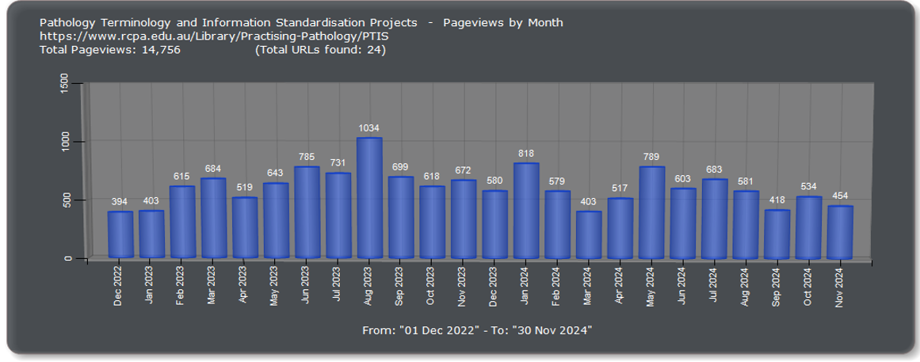
Figure 10: RCPA Pathology Terminology and Information Standardisation Projects
website traffic 2022-2024
By comparison, the total number of page views to the RCPA PITUS webpage during PITUS 18-20 was only 2,271 (refer to Figure 11 below), with the greatest number of page views seen in July 2020 (237). The increase in each month’s page views noted throughout the current PI Pilot Project is significantly greater (650% higher), demonstrating a definite increase in interest in pathology terminology and information standardisation.
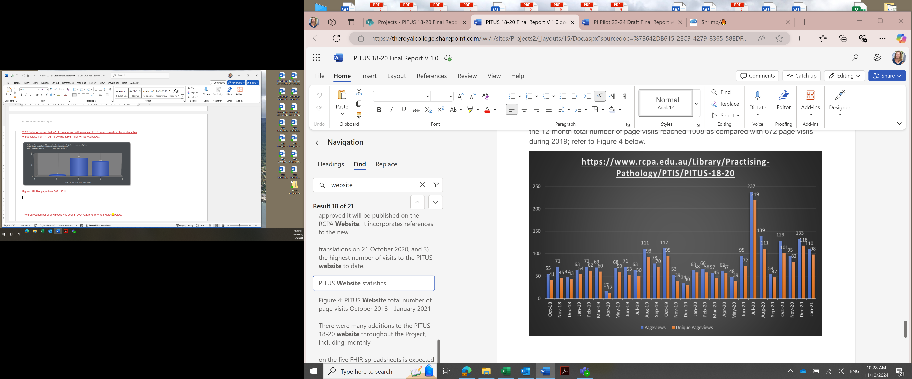
Figure 11: PITUS 18-20 pageviews 2018-2020

The statistics available on the number of page visits for the PITUS Newsletters, RCPA Presentations, SPIA Compliance Checklists, SPIA Exemplar Reports, SPIA Guidelines and Tools, and the RCPA SPIA Reference Sets and Information Models, are represented in Figure 12 below. The total number of page views for these resources throughout the PI Pilot was 3,401.
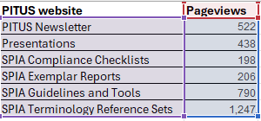
Figure 12: RCPA website traffic by resource February – November 2024
SPIA implementers have access to updated SPIA Guidelines (v4.1), Best Practice Guidelines for SPIA Implementation (v2.0), and SPIA Exemplar Reports for the Pilot which are crucial resources to support interoperability, thus improving pathology reporting for clinicians and consumers using MHR and other clinician systems receiving data from multiple pathology providers.
Further, PI Pilot 22-24 facilitated knowledge sharing via collaborations with the QUPP funded RCPA Manual Update and electronic Clinical Decision Support 2022-24 projects and selected RCPAQAP Diagnostic Programs for Chemical Pathology to align requesting and reporting Preferred terms, Synonyms, methodologies, specimen types, units of measure, SNOMED CT terms, and LOINC reporting terms with those published in the RCPA SPIA Pathology Terminology Reference Sets and Information Models. These alignment activities facilitate the delivery of electronic data exchange within Australia, providing pathologists, referring clinicians, registries, researchers and consumers with increased quality pathology terminology.
The benefits and effects of the various engagement and promotional activities undertaken with stakeholder groups throughout the Project have been realised with rising PITUS and SPIA awareness evidenced in a number of ways:
- The large number of delegates attending RCPA informatics workshops i.e. 175 delegates attending the RCPA/RCPAQAP/AACB Informatics Workshop in May 2024 and 117 delegates attending Workshop 2 in April 2023.
- An increase in the number of laboratory IT staff requesting SPIA compliant terms to be created for new tests and panels: Eastern Health (VIC), NSW Health Pathology, PathWest (WA), RCPAQAP, Royal Brisbane and Women’s Hospital (QLD), Sonic Healthcare, and Virtus Diagnostics.
- An increase in the number of emails received requesting access to the SPIA Pathology Terminology Reference Sets and Information Models i.e. Mater Health Services (QLD); NSW Health Pathology (NSW); Eastern Health (VIC); SA Pathology (SA); and CSIRO.

Conclusions and Recommendations

Conclusions
The overall purpose of the Project was to identify both factors that support, and barriers that prevent, SPIA adoption and compliance for a limited number of pathology tests and panels within two laboratory settings with varying levels of readiness. Potential benefits to SPIA adoption have also been extrapolated from the Pilot activities and learnings, from perspectives of the laboratory and those of the broader pathology community, including for the patient, pathologist, referring clinician and registries. The Project used a variety of mechanisms to identify these factors and barriers including direct feedback from Pilot participants, tailored assessment tools, workshops and consumer forums; and advice from Steering Committee members.
The Project consultation was significant and included pathologists, scientists and IT experts from each of the Pilot sites; software vendors responsible for managing and maintaining laboratory information systems; RCPAQAP IT developers and NATA assessors; GPs and patient consumers; Government; ADHA; and the CSIRO. Both Pilot sites shared valuable site specific implementation experiences within Workshop # 4 with 175 interested delegates, sparking recognition of the urgent need to establish a forum of laboratory IT experts who can share knowledge and reach out to software vendors in a coordinated way to drive SPIA updates and implementations. The Project Team acknowledges the enormous collective input, and thanks all contributors for their efforts.
Overall, the project was successful, using the information gathered from both Pilot sites to understand the current impediments to widespread SPIA adoption and provide recommendations for future directions. Noting the successful development of the RCPAQAP SPIA compliance assessment tool, other pathology laboratories embarking on SPIA implementation to satisfy NATA accreditation proficiency testing via the NPAAC requirements, will be the beneficiaries of this tool. The RCPA continues to be actively involved with digital health initiatives, including the Sparked FHIR Accelerator Initiative and the ADHA Top 50 Priority list for SPIA adoption to focus laboratory efforts in implementing SPIA.

Recommendations
That the Department notes the advantages of SPIA adoption and interoperability identified by the Project as outlined in Table 3 and the real time organisational, risk aversion, prioritisation, and financial barriers to adoption encountered by Pilot sites as outlined in Table 2. These factors identified, and the SPIA Compliance Assessment tool that has been developed, will certainly be useful resources and guides for future laboratories planning SPIA implementation.
In setting the context for these recommendations, it is important to consider the future of interoperability for pathology providers, requestors, consumers and government in the context of modern, contemporary digital health strategies, including alignment to the Australian Government Digital Health Blueprint and Action Plan 2023-2033. The Blueprint identifies four outcomes:
- Australians have a choice in how they manage their health and wellbeing and can navigate the health system knowing their story follows them.
- Australia’s health workforce is digitally empowered to provide connected care with confidence, whenever or wherever it is needed.
- Data and information are shared and reused securely to deliver a sustainable learning health system.
- Modern digital foundations underpin and strengthen a collaborative, standards-based health system that is safe and secure.
This Report’s recommendations align with and contribute to these outcomes, in particular with outcome 4, through the provision of foundational terminology to support the Sparked FHIR project. The recommendations below relating to SPIA compliance, the national requirement for system interoperability, and advocating for better-informed consumers, can progress future work on SPIA adoption and ongoing terminology development.
The recommendations are listed below:
- The Department notes the development of the RCPAQAP SPIA Compliance assessment tool, and the potential for future use in SPIA compliance activities.
- The RCPAQAP can facilitate opportunities for any laboratory to evaluate their level of SPIA Compliance through the development of their SPIA Coding Performance Reporter tool, further, the RCPAQAP can provide guidance with SPIA implementation issues as needed.
- RCPAQAP Labgnostic report to be updated to include a recommendation for laboratories to adopt SPIA.
- Reports for pathology need to be rendered in a standard and consistent (SPIA recommended) format to reduce the time required for interpretation e.g. chronological display of cumulative reports from left to right, and standard listing of tests “down the page” to reduce misinterpretation of non-standardised terminology and units of measurement; to reduce errors relating to non-standardised date formatting; and to reduce ambiguity of report names displayed within MHR.
- The Department notes RCPA SPIA Pathology Terminology Reference Sets V4.2 is now embedded within national digital health core datasets as part of the Sparked FHIR initiative, which requires the ongoing commitment and provision of ongoing resources to ensure maintenance and currency.
- The RCPA should develop a template for genetic test/panel requesting and reporting terms in an effort to standardise these complex scientific terms for ease of report interpretation and clinical system implementation and design an information model to assist with standardised reporting templates (currently piecemeal) for ease of interoperability with reporting to various cancer registries.
- SPIA readiness for adoption and implementation for many laboratories is time-consuming and resource intensive process with associated clinical risk and therefore, requires varying levels of support [both funding and resourcing] to fully realise the benefits of interoperability for the pathologist, referring clinician, patient and government. The Digital Health Blueprint and Action Plan supports this recommendation by stating “We will optimise Australia’s benefits by leveraging and driving greater adoption of existing investments, such as the Healthcare Identifiers Service and MHR system. Shared national infrastructure will reduce the costs related to duplicate systems”.
- Annual forums should be hosted for SPIA implementation – focussing on implementation for ‘beginners’ (RCPA, pathologists, scientists, information system analysts and developers, etc); and a second day targeting those ‘more advanced’ in SPIA requirements (RCPA, pathologists, scientists, information system analysts and developers, software vendors, HL7 Australia, CSIRO, ADHA, RCPAQAP etc). These annual forums are both purposeful for benefits realisation and practical opportunities to work through issues encountered during SPIA implementation to provide guidance to those yet to undertake the implementation journey.
- RCPA to coordinate a forum of laboratories/IT experts to reach out to downstream software vendors in a more organised way, and consideration be given for groups of laboratories to have a rollout cycle for annual updates in an effort to streamline the process for incorporating updates. Consider the introduction of the National SPIA code update day to coordinate communications to all vendors to do this at the same time rather than the current piecemeal approach.
- Laboratories to consider employing a designated Chief Informatics Officer (CIO) as part of ongoing NPAAC Requirements for supervision in the clinical governance of medical pathology laboratories (Seventh Edition 2023) in addition to the required Designated Person e.g. a pathologist or medical specialist.
- The Department to consider funding two dedicated resources at the RCPA (one scientific, one administrative) to review of all SPIA terminology on a continuing basis, which includes the following tasks: scheduling and convening terminology review meetings and drafting minutes; aligning requesting terms with reporting terms developed out of sync; drafting submissions to CSIRO (new SNOMED CT terms) and The Regenstrief Institute (new LOINC terms); following up outstanding terminology submissions; updating SPIA Reference Sets for publication by CSIRO to the NCTS as terminology is developed; checking CSIRO publications for errors, etc.
- The RCPAQAP recommended both laboratories review their current implementation LOINC identification within HL7 messages and prepare for use of UCUM units as needed in the future.
- In addition, the RCPAQAP CIO recommended future iterations would benefit from including the SPIA LOINC, UCUM and SNOMED coding in the RCPA Manual so that it makes pathologists, trainees and scientists aware that standard coding exists, and they can use the RCPA Manual as a reference to easily find codes and supply them to their IT departments if needed.
- The RCPA to make available via the RCPA website Australian based evidence on the tangible benefits of SPIA adoption, including those demonstrated by overcoming operational barriers to implementation, such as cost-effectiveness for laboratories through both hard (financial) and soft outcomes (for example, reduction in interpretation errors, increased consumer engagement, decreased reporting delays), as well as the observed operational benefits and challenges faced by laboratories to implement the RCPA SPIA Guidelines.

Appendices

References
- Ellis, D. and Srigley, J. 2015. Does standardised structed reporting contribute to quality in diagnostic pathology? The importance of evidence-base datasets. Virchows Archiv, 468(1), pp. 51-59.
- Australian Commission on Safety and Quality in Health Care. Requirements for information communication and reporting. 5th ed. Sydney: ACSQHC; 2022, pp. 6. [online] Available at: Requirements for information communication and reporting (Fifth Edition) (safetyandquality.gov.au).
- Parke, E., ABC News, 09 December 2024. Digital divide report show thousands of Australians in remote communities still don’t have internet access. Available at ABC News.

Activity Work Plan Progress
Due to the size of this document, the Activity Work Plan is provided at Attachment 3.

Project One Page Plan

Figure 13: Project One Page Plan

Governance and Reporting
The governance structure provides the decision-making framework for all levels of the Project which supports collaboration and communication in addressing the Project deliverables. The structure allows interconnectivity between the RCPA Informatics Advisory Committee, Steering Committee, Project Team, and RCPAQAP.
The RCPA Head of Project Management / Director acted as the key touchpoint for all communications throughout the Project.
Figure 14: PI Pilot 22-24 Project Governance structure

Steering Committee
The Steering Committee is responsible for co-ordination and oversight of the Project and for providing professional and subject matter expertise. The Project will seek their endorsement of the main project deliverables as well as leverage their professional capacity to promote the outcomes of the Project through their associated networks. The frequency of meetings for this group is a minimum of twice per year, and more often if required.

Discipline-specific Terminology Working Groups
The remit of the WGs is the review, maintenance and expansion of the RCPA Standardised Pathology Informatics in Australia (SPIA) pathology terminology reporting and requesting reference sets, information models and protocols. All new terminology developed by WG subject matter experts from both public and private pathology laboratories is aligning with existing SNOMED-CT and LOINC^{R} terminology standards and the RCPA SPIA Guidelines. Where necessary, application for new terms has been undertaken by the Project to ensure the correct test name, specimen type, methodology, measurement and reporting units are reflected as per current Australian laboratory practices. The WGs also provide advice to ADHA’s NCTS for all pathology reference set queries as required.

Stakeholders
RCPA members, advisory committees and staff
The RCPA is contracted to undertake the PI Pilot 22-24 Project. Its involvement in this Project is vital, not only to manage processes, but also to drive SPIA Guidelines uptake and SPIA adoption rates, and promote the benefits of interoperability for laboratories, clinicians, researchers, registers, and consumers alike. RCPA representation from the following committees will drive these improvements for the betterment of pathology requesting and reporting and to advance overall healthcare for the consumer:
- RCPA Board of Professional Practice and Quality (BPPQ)
- RCPA Community Advisory Committee (CAC)
- RCPA Discipline Advisory Committees
- RCPA Pathology Informatics Committee (PIC).

Partner Organisations
Subject matter expertise, support, promulgation and endorsement of Project outcomes from the following organisations improves the value and content of the Project deliverables:
- Australian Association for Clinical Biochemistry and Laboratory Medicine (AACB)
- Australian Pathology (AP)
- Commonwealth Scientific and Industrial Research Organisation (CSIRO)
- Medical Software Industry Association (MSIA)
- Pathology Tests Explained AU (PTEx)
- Public Pathology Australia (PPA)
- Royal Australian College of General Practitioners (RACGP)
- RCPA Quality Assurance Program (RCPAQAP).

Standards Development Organisations
Technical input from the following organisations safeguards the quality and safety of all Project deliverables:
- Australia Digital Health Agency (ADHA)
- Health Level 7 Australia (HL7.au)
- National Pathology Accreditation Advisory Council Australia (NPAAC)
- Regenstrief Institute (LOINC)
- SNOMED International (SNOMED-CT).

Regulators and Funders
All Project deliverables must comply with the standards and requirements of the following regulators and funders ensuring they are safe, of the highest quality, and are effective to protect all relevant consumers:
- Government Departments
- National Association of Testing Authorities (NATA).

Consumers
Health consumers are the ultimate beneficiaries for improving the quality of use of pathology services under this Project. The advice provided by consumers from the Consumers Health Forum (CHF) will bring a keen focus to this perspective throughout the Project.

Barriers to SPIA adoption, Impacts and Resolution/Pilot site proposals
Issue# | Issue Description | Impact(s) | Resolution/Proposals
1 | Minimum of HL7 v2.4 required to undertake SPIA compliance testing as per RCPAQAP survey design (based on NPAAC Requirements S4.1) | - Multiple error messages will be created for all HL7 files uploaded to survey  - Message version change has implications for the broader health system who are using the same version  - Expenses relating to system upgrade may not be anticipated, creating IT budget overspend  - System testing required  - System downtime may be required | - All laboratories embarking on SPIA compliance must be using a minimum of HL7 v2.4  - All laboratories embarking on SPIA compliance need appropriate resources to assist the update to HL7 v2.4
2 | To elevate HL7 v2.3.1 messages to HL7 2.5 requires an integration engine or similar for message conversion | - Requires engagement of high-cost specialist resources to exchange electronic data  - Gaps expected in supplied data  - Expenses relating to new system implementation may not be anticipated, creating IT budget overspend  - System testing required  - System downtime may be required | - HL7 upgrade resources (IT specialists, system downtime, testing etc) needs to be scheduled into the laboratory budget  - Consider the use of middleware to provide a centralised drop-off point for submissions to enable conversion and address data gaps
3 | Security assessment (or similar) required for any new infrastructure or services within Public laboratories as per governance (internal or hierarchical within Government) | - Need for third-party subject matter expert input will increase the timeline for any proposed implementation  - Need for third-party subject matter expert resources will increase overall costs for any proposed implementations  - Data recipient assessment and review requires an extension on anticipated implementation timelines  - System testing required  - System downtime may be required | - Deidentify data sent to external organisations to prevent privacy/governance breaches  - Confirm and schedule additional infrastructure, software, or services that may require approval prior to commencement  - Create a checklist of requirements for site use and address gaps prior to commencement
4 | Managing competing priorities of multiple IT systems builds/updates e.g. security assessment needed to build new OntoServer, eRequesting platform, etc | - Competing priorities for Project staff delay timelines for IT implementations  - Inadequate resourcing contributing to timeline extensions or full/partial failure of the work program  - Project budget overspending likely | - Overtime/Time off in Lieu considered for short-term activities and achievement of fixed-time tasks  - Utilising alternate staff to undertake required work where possible  - Leveraging the exchange of ideas/knowledge from targeted external contractors where possible  - Project reprioritised allowing resource reallocation where possible  - Review IT project work on a regular basis to remedy potential resource constraints/delays ahead of time  - Executive escalation internally and externally (third-party services) strengthens engagement and reduces potential blockages
5 | Review of the old test catalogue is likely necessary to incorporate new orders/results codification (SNOMED/LOINC) as part of SPIA and/or FHIR-capable test catalogue implementation | - Competing priorities for IT, Project and laboratory staff who are committed to daily operational tasks to comply with Turnaround time targets | - Utilise test catalogue content from other laboratories (if comparable) as a baseline rather than creating content from scratch
6 | All new requesting (SNOMED) or reporting (LOINC) codes needed for SPIA compliance will require a formal process of adoption to implement e.g. laboratory validation, formal communications to GPs, clinicians and downstream systems | - Additional workload for laboratory and IT staff  - Formal system chance communications will likely need to be drafted and circulated by the hospital/laboratory communications team, which may delay implementation  - System testing required  - System downtime may be required | - Focus on RCPA Top 50 tests/panels for SPIA Implementation for initial benchmarking
7 | Adoption of SPIA may have unexpected consequences for legacy systems owned by State DoH, not laboratory | - Changes required for SPIA compliance impact historical results e.g. display of result values  - Resources required to validate current/historical clinical data within patient records via an audit process | - Identify changes to SNOMED & LOINC codes to minimise audit work and ensure historical integrity
8 | Competing priorities – having to do a workaround with Cerner Millennium to enable results notifications to referrers & patients | - All workarounds require resourcing which cost additional funds  - Unexpected system changes may be required to ensure SPIA compliance | - Use an alternate system to accommodate coding changes i.e. Test Catalogue as a working domain  - Prioritise work to meet agreed timelines  - Manage critical incidents quickly to reduce potential timeline blowout  - Identify as part of the Risk Management Plan to manage prioritisation
9 | LOINC reporting code changes identified as highest risk for high-volume analytes | - Requires significant planning, collaboration & communication between labs, software vendors, etc to anticipate downstream impact  - Need sufficient resources to undertake all pre-implementation changes (planning meetings, staff, funds, comms, etc) and implementation changes | - Lab Executives need to be on board to ensure change happens as planned, along with other key staff (Marketing, Client IT Support, scientific staff, lab IT)
10 | Manual factoring calculations are currently being performed in labs identified via SPIA Compliance surveys | - Introduces risk of human error  - System testing required  - System downtime may be required | - RCPAQAP & Labnostics developing an automated factoring solution
11 | Vendor engagement often challenging for laboratory staff | - Difficult to communicate and co-ordinate terminology changes and explain why necessary amongst BAU | - Need software vendors to understand issues & be prepared for change  - Need forum for improved vendor engagement – RCPA to consider annual engagement event with MSIA, scientific & IT staff & lab executives
12 | Not all labs have a national IT Team working toward standardised SNOMED requesting codes & LOINC reporting codes | - Standardisation work is only one aspect of BAU within laboratories and their IT and Communications staff, typically taking a backseat to meeting KPIs on results reporting | - Change management to be undertaken as a whole rather than smaller vs larger sites for laboratories with multiple sites/multiple catalogues
13 | Identification of UCUM missing with HL7 messages in most laboratories (as per SPIA and NPAAC requirements) | - UCUM implementation work by lab IT staff proved too challenging for both Pilot sites within the project timeline  - UCUM programming likely requires additional expertise & funding | - Recommend the need for greater education for laboratory professionals to understand NPAAC & SPIA Guidelines
14 | New NPAAC standards assessments are being implemented incorporating HL7 messaging requirements and SPIA recommendations | - Majority of quality managers & lab staff are unfamiliar with HL7 messaging  - Adds a level of complexity surrounding the need for SPIA compliance work  - Labs will be required to be HL7 & SPIA compliant; staff training imperative | - Recommend the need for greater education for laboratory professionals to understand basic HL7 messages and FHIR training ASAP  - RCPA to assist via educational forums discussed above
15 | My Health Record (MHR) will eventually be able to consume HL7 atomic messages instead of PDFs | - LIS will need to implement SNOMED (requesting) & LOINC (reporting) to import pathology report data into MHR  - Non-SPIA compliant labs may put patients at risk of result misinterpretation | - MSIA to promote: need for all Australian LIS & CIS to have implemented HL7 v2.5 at a minimum  - RCPA to promote: labs to implement all SPIA Terminology Reference Sets
16 | One test can be performed on various analysers & use different methodologies | - Displaying cumulative data safely on patient reports may be extremely risky | - All labs to implement SPIA Guidelines e.g. ‘traffic lights’ to indicate when it’s safe to report different LOINC codes together
17 | How to support labs who want to make changes to SNOMED & LOINC codes when PITUS projects are only run when Government funding is available? | - Significant hindrance to implementing LIS changes for SPIA compliance, also NPAAC & NATA accreditation | - RCPA to employ permanent PITUS resource (minimum 1 FTE)

Table 9: Barriers to SPIA adoption, Impacts and Resolution/Pilot site proposals

Sullivan Nicolaides Pathology RCPAQAP Validation Report v1.1.
Due to the size of this document, the Validation Report is provided at attachment 1.

SA Pathology RCPAQAP Validation Report v1.1.
Due to the size of this document, the Validation Report is provided at attachment 2.

