FINAL REPORT
4-GY32AAH

Developing interpretive quality assurance module for genomic testing for childhood syndromes and intellectual disability
The Royal College of Pathologists of Australasia Quality Assurance Programs

Introduction
With the Australian Government expected to increasingly approve item numbers of Medicare rebate to cover the cost of genomic tests, there needs to be quality assurance (QA) processes in place. RCPAQAP partnered with Australian Genomics on a QA project to pilot the delivery of an interpretive module to test a laboratory’s ability to correctly prioritise and interpret variants from genomic investigation (whole exome or whole genome) relating to the Medicare item number for childhood syndromes and intellectual disability. A working group was formed with representation from diagnostic genetics laboratories in each state and RCPAQAP. Members of the working group are:
Bruce Bennetts  The Children’s Hospital at Westmead, NSW | Dimitar Azmanov  PathWest Laboratory Medicine, WA
John Christodoulou  Australian Genomics  Murdoch Children’s Research Institute, VIC | Sebastian Lunke  Australian Genomics  Murdoch Children’s Research Institute  Victorian Clinical Genetics Services  University of Melbourne, VIC
Karin Kassahn  SA Pathology, SA | Ben Lundie  Pathology Queensland, QLD
Bryony Thompson  Royal Melbourne Hospital, VIC | Alicia Byrne  Broad Institute of MIT and Harvard, USA
Matilda Haas  Australian Genomics, VIC | Tony Badrick  RCPAQAP, NSW
Ami Stott  Australian Genomics, VIC | Sze Yee Chai  RCPAQAP, NSW

This initiative aims to:
- Develop an initial pilot external quality assessment (EQA) to assess the analysis and reporting processes of Australian laboratories in childhood syndrome genomic testing.
- Establish the foundation for a sustainable assessment method, with potential expansion to encompass a broader range of genetic disorders.
- Identify strengths and areas for improvement in the analysis and reporting of genomic data.
This report is prepared for the Commonwealth Department of Health on the Quality Use of Pathology Program (QUPP) funded project, “Developing interpretive quality assurance module for genomic testing for childhood syndromes and intellectual disability – 4-GY32AAH”. Project activities and progress status are listed in Table 1.
Table 1. Project activities and progress status.
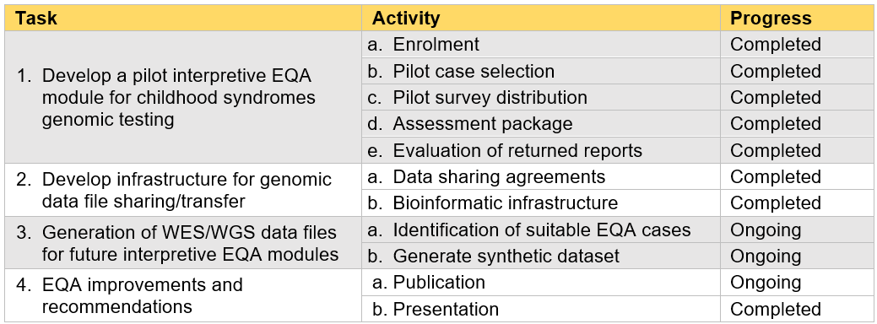

Task 1: Develop a pilot interpretive EQA module for childhood syndromes genomic testing
Activities related to this task were the recruitment of laboratories in the first pilot EQA, selection of potential cases, survey distribution and establishing an assessment package (assessment criteria, scoring and performance report template). Two laboratories were recruited to provide support in case selections, and six laboratories representing the major diagnostic exomes services within Australia were invited to participate in the first pilot EQA. Participating laboratories are de-identified in this report to maintain confidentiality.
Potential cases for the pilot EQA were sourced from the Australian Genomics Genomic Data Repository. To address the legal, ethical, and privacy considerations associated with genomic data, all parties involved in case selections and EQA participation were required to sign a Data Access and Sharing Agreement with Australia Genomics (see Task 2). The Australian Genomics data team generated an encrypted export of 43 potential cases. A single case was selected for the initial pilot EQA based on the eligibility criteria for the first genomic test approved for the MBS item numbers 73358/9 “suspected monogenic childhood syndrome, for children up to 10 years of age”.
The pilot EQA survey was made available to all six participating laboratories between May to July 2023. Data file of a trio-based genomic testing was provided for laboratory analysis. An information sheet containing artificial personal information, basic demographic information and phenotypic data was also provided (see Table 2).
Table 2. Information provided to laboratories participating in the pilot EQA.
Patient name | Reason for referral
Sample ID | Age of onset of presenting symptoms
Specimen type | Regression of motor skills (yes/no) + age of onset
Date of birth | Clinical comment
Age | General examination findings
Sex | Laboratory investigations
Consanguinity (yes/no)
Participating laboratories were required to analyse the case provided using their existing analytical and interpretation pipelines and submit a diagnostic report of their analyses within six weeks of accessing the genomic data file. It was anticipated that all reports will be received by mid-August 2023. However, the final submission was received on October 2nd, 2023.
Assessment criteria and scoring were drafted based on the European Molecular Genetics Quality Network (EMQN) assessment scheme, as described in the Performance Report submitted on December 15th, 2022. There are three main assessment categories: genotyping, clinical interpretation, and patient identifiers. The main categories are further segmented into subcategories, each with specific criteria (see Table 3). Subsequent meetings were held on April 13th and May 25th, 2023 with the sub-working group members to refine the criteria and scoring. A finalised performance criteria and scoring metrics were distributed to all members of the working group on June 5th, 2023.
Table 3. Assessment categories for the Interpretive EQA pilot.
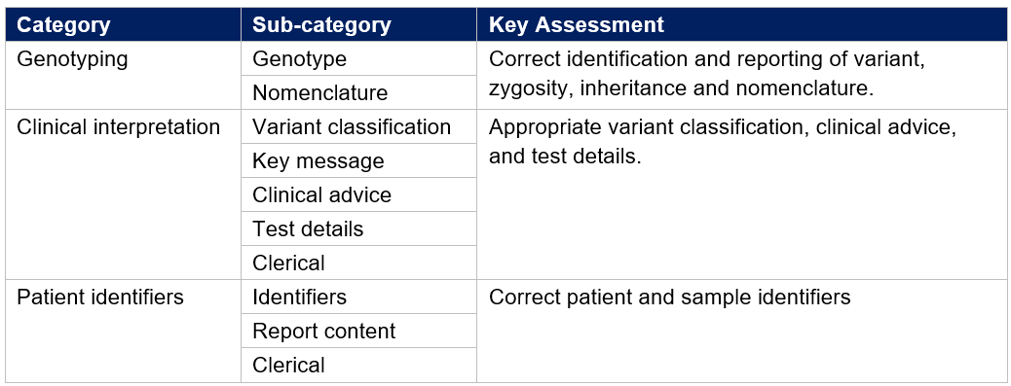
Target result including the expected variant classification evidence for the pilot case was established by expert members of the working group. An assessment preparation meeting was held on the September 28th, 2023. All six laboratories were able to complete their analysis and interpretation of the genomic data provided. Routine diagnostic report was submitted by each participating laboratory. Submitted reports were distributed to all working group members via SharePoint on the October 6th and 12th, 2023. Evaluation of submitted reports using the points-based framework were completed by October 27th, 2023. Reports were assessed against the ‘gold-standard’ consensus variant classifications established by the expert working group members. Assessment and scoring of the pilot EQA survey results were completed on November 8th, 2023. All participating laboratories correctly identified the expected variants for the pilot case. Variations in scoring were identified and discussed on November 10th, 2023.
The evaluation and scoring of laboratories’ reports against the predefined criteria were conducted by both non-expert and expert members of the working group. This approach aimed to thoroughly examine and validate the effectiveness of the assessment strategy. The inclusion of both non-expert and expert perspectives ensured a comprehensive evaluation, testing the robustness of the assessment method from diverse viewpoints and expertise levels. While there was generally a strong agreement in the overall scores assigned by both non-expert and expert reviewers (see Table 4), the qualitative evaluation of variant classifications posed challenges for the non-expert reviewers. The final score for each assessment category was determined by averaging the assigned scores from both the non-expert and expert groups.
Table 4. Pilot EQA average scores.
Participant | Non-expert average | Expert average | Overall average
Lab 1 | 5.7 | 5.4 | 5.5
Lab 2 | 5.3 | 5.5 | 5.4
Lab 3 | 5.9 | 5.4 | 5.6
Lab 4 | 5.0 | 5.1 | 5.1
Lab 5 | 5.5 | 6.0 | 5.8
Lab 6 | 5.0 | 5.0 | 5.0
The purpose of this pilot EQA was to identify potential issues and refine the assessment process. Therefore, the focus of the performance report is primarily on understanding the overall performance landscape rather than categorising performance. Performance reports for the pilot EQA were distributed to participating laboratories on February 16th, 2024.
Key elements in the performance report are:
- Assessment criteria
Under this section, a description of the general assessment criteria and review approach is provided. Participants’ performance was assessed on three categories: genotyping, clinical interpretation, and patient identifiers. Each category is scored out of 2.0 with point deduction for each error, with a maximum total score of 6. A review cut-off value is determined based on 80% of participants falling within a set range. Performance score below the cut-off value is highlighted for participant’s review.
- Expected result
In this section, the anticipated genotyping results are detailed, including:
- HGVS variants: The section lists the Human Genome Variation Society (HGVS) variants, which are the standardised nomenclature for describing genetic variations.
- Genomic coordinates: The genomic coordinates specified in this section serve as a reference to the specific positions on the chromosomes where the variants are expected.
- Inheritance: The expected inheritance pattern of the expected variant is outlined.
- Allele: This section described the alleles associated with the genetic variants.
- Pathogenicity criteria: Pathogenicity criteria are specified to indicate the expected clinical significance of the variants. This information helps to assess whether the variants are likely to contribute to the development of a genetic disorder.
- Summary of performance & assessors’ comments
This section presented individual laboratory performance and review cut-off scores for each assessment category (see Figure 1 example). Additionally, reviewer comments are provided in this section to offer additional context of the assessment. These comments may highlight specific strengths or areas for improvement identified during the review process. They serve as feedback for laboratories to understand the rationale behind the assigned scores.
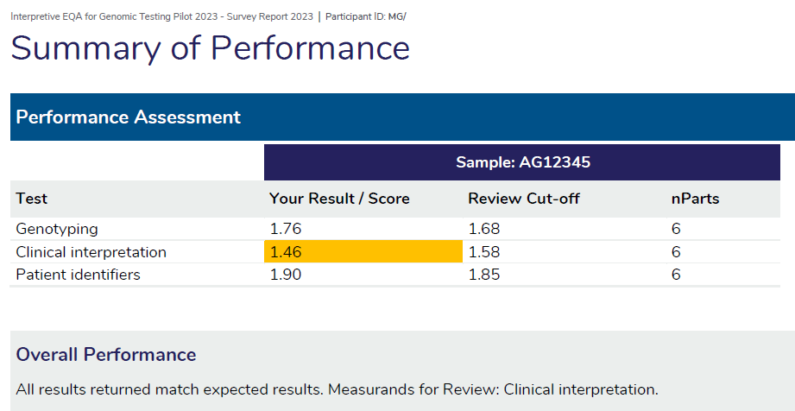
Figure 1. Example of the summary of performance section in the performance report. Areas where the scores fall within the lower 20% of the overall performance is highlighted for participant review.
- Overall performance
In this section, the scores obtained by a laboratory are compared to the scores of other participating laboratories (see Figure 2 example). This comparison aims to provide context to individual performance by assessing how it aligns with the broader group. Peer group comparison can highlight any significant deviations in laboratory performance. By assessing performance relative to peers, laboratories can identify areas for improvement.
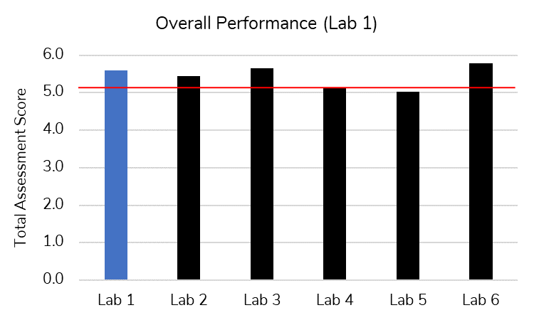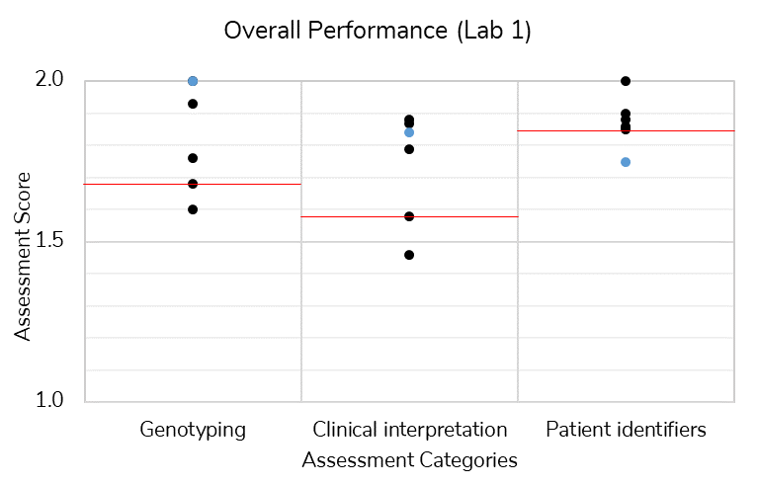
Figure 2. Example of overall performance (peer group comparison) of participating laboratories. Left – total assessment score; Right – assessment score for assessment categories genotyping, clinical interpretation, and patient identifiers. Individual laboratory scores in blue, review cut-off in red.

Task 2: Develop infrastructure for genomic data file sharing/transfer
For the initial pilot EQA, potential cases were sourced from the Australian Genomics Genomic Data Repository. Australian Genomics, administered by the Murdoch Children’s Research Institute of the Royal Children’s Hospital, supports the sharing of de-identified genomic and clinical data from their Flagship studies for ethically approved projects. To address the ethical concerns relating to genomic data, an initial low-risk ethics approval was sought from the Royal Children’s Hospital human research ethics committee (HREC), which was approved on August 3rd, 2022 (reference HREC/81777/RCHM-2022). The main reasons for this ethical review were: (1) To publish the pilot project findings in an academic journal, (2) To document policy/procedure in relation to any new genetic findings that might arise through analysis of the data during the QA process, and (3) to enable formal evaluation of the pilot by a survey of participating laboratories. Upon receiving the HREC ethics approval, the Australian Genomics data access request submitted on July 11th, 2022 was also approved. With both the ethics and data access approvals in place, data access and sharing agreements (DSAs) was sent to laboratories for their legal review on August 4th, 2022. The acceptance of DSAs was necessary before case selection and genomic data sharing can take place.
By February 17th, 2023, a request was submitted to amend the existing HREC approval from single-site to multi-site project and obtain site specific assessment approvals for sites that have requested for it. Navigating the ethics approvals required for the project, complying with individual site governance requirements and review and sign off DSAs for all participating organisations has been a significant challenge and barrier to progress for this project. The delivery of pilot EQA was delayed as all DSAs must be signed off before genomic data can be shared. To avoid further delay to the pilot EQA, distribution of the pilot EQA genome data was staggered throughout the May to July 2023 period. Laboratories with signed DSA were able to access and download the pilot case data, with a six-week turnaround for results submission. Despite delays in obtaining ethics approval and reviewing data sharing agreements, all six laboratories secured governance authorisation by June 30, 2023.

Task 3: Generation of WES/WGS data files for future interpretive EQA modules
This project considered various potential sources of genome data, (1) Australian Genomics Flagships data, (2) international data, and (3) synthetic data. Potential patient cases for future EQA surveys were identified by the Australian Genomics data team, as described in the Performance Report submitted on December 15th, 2022. Sourcing of patient cases is and will be an ongoing process. Current HREC ethics approval will cover access for up to six cases from the Australian Genomics data.
The working group explored the potential use of data from the Rare Genomes Project at Broad Institute of MIT and Harvard. The aim of the Rare Genomes Project is to use genomic sequencing of affected individuals and their family members to identify the genetic causes of rare disease. This cohort is consented for use in research, however QA-related research is not explicitly in the scope of permitted future research use. As QA activity does not fit the purpose of the Rare Genomes Project, Broad Institute is unable to accommodate request for data sharing.
The working group also considered the possibility to create and edit synthetic DNA sequences. In pursuit of this, the Commonwealth Scientific and Industrial Research Organisation (CSIRO) was contracted to generate a workflow that will allow the working group to spike variants into synthetic genomes for EQA purpose. Table 5 lists the synthetic data project deliverables and status. Project activities and timeline are listed in Table 6.
Table 5. CSIRO synthetic data project deliverables and status.
Date | Milestone | Deliverable | Status
30/04/2023 | Design capability to generate genomic backbones | Genomator – a tool which uses a SAT solver to generate synthetic genomic data from an input dataset | Completed
31/05/2023 | Design capability to “spike” variants at specific locations and generate FASTQ files | Script to insert “spikes” based on user designed configuration | Completed
30/06/2023 | Design a platform that generates “challenge sets” | Automated platform to generate FASTQ of individuals with manually selected variants | Completed
31/07/2023 | Integrate with RCPAQAP developed scoring metrices and evaluation criteria | Meetings with RCPAQAP to integrate scoring metrices and evaluation criteria | Completed
31/08/2023 | Conduct trainings for RCPAQAP to operate the platform – Project reports and closure | Project completion reports and trainings | Completed
Table 6. CSIRO synthetic data project activities and timeline.
Date | Activity
25/01/2023 | Service agreement signed.
01/04/2023 | Project start.
26/04/2023 | Project plan and deliverables provided to RCPAQAP.
10/05/2023 | Project kick-off meeting. CSIRO briefed the working group on the proposed project plan and addressed concerns on creation of pathogenic variants under the American College of Medical Genetics (ACMG) guidelines and parent genomes.
23/05/2023 | Meeting between CSIRO and AG re: creation of synthetic genome and variants. Three synthetic individuals created using the 1000 genome data.
01/06/2023 | Variant creation meeting #1.
10/06/2023 | Variant creation meeting #2. Variants created, including variant classification criteria; tested by working group members (Mendeliome sequencing).
31/08/2023 | Performance criteria and scoring framework provided to CSIRO.
01/09/2023 | Project delivery.
04/09/2023 | Final report draft for the synthetic data project provided to the working group.
06/09/2023 | Meeting to discuss integration of scoring framework, which will allow for the automated evaluation of variants identified and use of correct Human Genome Variation Society (HGVS) nomenclature for variant reporting.
14/09/2023 | CSIRO provided training to RCPAQAP to install, build and run the pipeline created.
18/09/2023 | Final report handover and future directions were discussed.
09/10/2023 | Case study on the project published on CSIRO blog.
30/10/2023 | Docker (platform to deliver software packages) installed on RCPAQAP equipment. RCPAQAP encountered errors with running the spiking pipeline.
01/11/2023 | CSIRO advised running errors are fixed.
Ongoing | Validation of spiking pipeline.
The primary objective of the CSIRO synthetic data project is to develop an automated quality control (QC) pipeline for creating synthetic genome. This enables RCPAQAP to customise the synthetic genome to fit any desired inheritance pattern. This pipeline initiates by generating synthetic genomes that are indistinguishable from real genomes and are free of pathogenic variants known to cause Mendelian disorders, as reported in the ClinVar database. Utilising these “healthy” genomic backbones, artificial variants can be inserted at specified genomic locations, allowing laboratories to evaluate their detection capabilities against known targets. The synthetic genomes generated were tested by members of the working group at their laboratories.
Keys steps in running the QC pipeline:
- Generate synthetic genome backbone from a set of ethnicities (Italians from Tuscany, Indians from Punjab, and Han Chinese) using the Genomator tool.
- Create a spiking configuration file to specify genomic location and type of variants desired. The pipeline scripts will ensure modifications are VCF compatible and subsequently incorporate the specified variants into the corresponding positions in the backbone VCF file.
By creating a comma separated values (CSV) configuration file specifying the inserted variants by chromosome position and specifying alteration with respect to reference and alternate genotypes. The pipeline scripts will then parse the CSV file, ensuring its modifications are Variant Call Format (VCF) compatible and then insert the specified variants into the corresponding positions in the backbone VCF file.
- Generate FASTQ files for laboratory bioinformatics analysis.
A scoring pipeline was also created that automates the genotype sub-category specific in the scoring table. Scoring of the clinical interpretation (including variant prioritisation and interpretation) and patient identifiers is outside of the scope of the synthetic data project. Genotyping assessment categories integrated into the automated scoring pipeline are critical genotyping error, no or incorrect zygosity, benign variants, inheritance mode and variant of uncertain significance reporting.
The testing and validation of the pipeline was delayed due to network upgrade at the RCPAQAP. IT resources were focused on the building of new servers and commissioning a new certificate service. For this reason, testing of the spiking pipeline only began in late October 2023. There were issues with docker installation, and then with running the pipeline to generate genome with spiked variants. The errors were due to an incorrectly formatted spike.csv file. The validation of the spiking pipeline is currently in progress.

Task 4: EQA improvements and recommendations
During the evaluation and scoring of the pilot survey data, it was identified that comments on specific criterion could be improved with case-specific expectations or examples in future surveys. This will assist in harmonising scoring from each assessor. Furthermore, the working group intends to prepare publication on the pilot EQA and post-EQA evaluation survey data in the future.
Members of the working group submitted two abstracts from this project:
- An abstract titled “Piloting an Australian Quality Assurance Program Interpretive Module for Genomic Testing” was accepted for an oral presentation at the Australasian Society of Diagnostic Genomics (ASDG) Special Interest Group day in November 2023. This was presented by Clinical Professor Bruce Bennetts.
- A second abstract (same title) focusing on the variant curations aspects of the project was accepted for a poster presentation at the American College of Medical Genetics (ACMG) Annual Clinical Genetics Meeting to be held in March 2024 in Canada.
An evaluation survey is currently underway to assess the processes involved in EQA participation and assessment approach. The valuable insights gathered from the responses to this survey will inform and further guide improvements to the EQA program.

Conclusion Remarks and Future Directions
Despite major setback due to delays in obtaining governance and the legal review of data sharing agreements, this project has accomplished the successful implementation of a pilot EQA for genomic interpretation in Australia. Planning for a second pilot EQA has begun, to be led by the RCPAQAP Molecular Genetics team. The second pilot will utilise synthetic genome data generated through the spiking pipeline developed by CSIRO. This approach will minimise potential complexities associated with incidental findings when using actual patient data. Ultimately, the aim is to expand the interpretive EQA program to cover a broader spectrum of genetic disorders and to extend the provision of the interpretive EQA program on a global scale in the future.
Lastly, we want to acknowledge and thank all members of the working group for their valuable contributions to this project.

Appendix Item 1: Meeting Schedule and Activities
Date | Activity
28/06/2022 | Working group meeting to discuss ethics application, case selection criteria, data transfer agreement and performance criteria
16/08/2022 | Working group meeting with updates on ethical and research governance, data access and sharing agreements for Australian Genomics data and to discuss other potential data sources
21/09/2022 | Working group meeting to review performance criteria to identify key elements of performance report
11/10/2022 | Working group meeting with updates on synthetic data, performance report format and data agreements
24/10/2022 | Meeting with Australian Genomics to discuss collaboration agreement
03/02/2023 | Working group meeting with updates on synthetic data project, EQA performance criteria and scoring framework, and data sharing agreements
13/04/2023 | Sub-working group meeting to refine assessment criteria and scoring, and review drafted report template
10/05/2023 | Meeting with CSIRO development team for briefing on proposed plan for the synthetic data project
25/05/2023 | Sub-working group meeting to finalise assessment criteria and scoring
30/06/2023 | Working group meeting for briefing on scoring process and review evaluation survey drafted to collect participant feedback post-survey
18/08/2023 | Internal meeting with Chief Informatics Officer to discuss IT resources available for storing and sharing genomic data files
06/09/2023 | Meeting with CSIRO development team to gather requirements for an automated analysis
14/09/2023 | Training on the installation and execution of the spiking pipeline by CSIRO
18/09/2023 | CSIRO final handover meeting and future directions
29/09/2023 | Working group meeting to prepare for pilot EQA assessment
27/10/2023 | Working group meeting to follow up on assessment progress
10/11/2023 | Working group meeting to compile and finalise assessments
23/11/2023 | Pilot EQA performance feedback review
19/12/2023 | AG pilot handover and manuscript preparation
07/02/2024 | Pilot EQA performance feedback review
Other meetings organised by the Australian Genomics with other parties where RCPAQAP representative was not present are not listed above.

Appendix Item 2: Abstract Publication
Title: Piloting an Australian Quality Assurance Program Interpretive Module for Genomic Testing
Alicia B. Byrne¹, Dimitar Azmanov², Sze Chai³, John Christodoulou^{4,5}, Matilda Haas^{4,5}, Karin Kassahn⁶, Ben Lundie⁷, Sebastian Lunke^{4,5,8,9}, Ami Stott⁴, Bryony Thompson¹⁰, Tony Badrick³, Bruce Bennetts¹¹.
- Program in Medical and Population Genetics, Broad Institute of MIT and Harvard, Cambridge, MA, USA
- Department of Diagnostic Genomics, PathWest Laboratory Medicine, Perth, WA, Australia
- RCPA Quality Assurance Programs, Sydney, NSW, Australia
- Australian Genomics, Parkville, VIC, Australia
- Murdoch Children’s Research Institute, Parkville, VIC, Australia
- Genetics and Molecular Pathology, SA Pathology, Adelaide, SA, Australia
- Pathology Queensland, Brisbane, QLD, Australia
- Victorian Clinical Genetics Services, Parkville, VIC, Australia
- Department of Pathology, University of Melbourne, VIC, Australia
- Department of Pathology, Royal Melbourne Hospital, Parkville, VIC, Australia
- Sydney Genome Diagnostics, Western Sydney Genetics Program, The Children’s Hospital at Westmead, Sydney, NSW, Australia

Introduction
In recent years, the Australian Government-funded healthcare scheme, Medicare, has approved the provision of genomic testing (exome or genome sequencing-based tests) as part of the Medicare Benefits Schedule (MBS) which provides publicly-subsidised healthcare services where patients meet eligibility criteria. With the number of MBS funded genomic tests expected to increase, there needs to be robust quality assurance processes in place. While Australian laboratories participate in current Quality Assurance Programs (QAPs), none are directly fit for purpose for genomic testing. This project is therefore piloting a program to deliver an interpretive module, based on raw sequence data, to assess laboratories’ ability to correctly prioritize, classify, and interpret variants detected from broad genomic investigations, with the aim of developing a sustainable program to be delivered by the Royal College of Pathologists of Australasia Quality Assurance Programs (RCPAQAP).

Methods
Data for the pilot was sourced from the Australian Genomics’ Genomic Data Repository, with 1 case selected based on the eligibility criteria for the first genomic test approved for the MBS; ‘suspected monogenic childhood syndrome, for children up to 10 years of age’. Genomic and phenotypic data (including basic demographic information and artificial personal information) was provided to 6 clinically-accredited genetics laboratories across Australia, and each laboratory used their existing analytical and interpretation pipelines to review the case and produce a diagnostic report.
Reports were evaluated by expert and non-expert reviewers using a points-based scoring framework developed by working group members, and assessed in comparison to ‘gold-standard’ consensus variant classifications, established by expert working group members. Participating laboratories also evaluated the pilot in a survey, the results of which, alongside findings from the pilot, were incorporated as recommendations for the development of a sustainable program.

Results
All 6 participating laboratories correctly identified the biallelic causative variants and correctly classified both as ‘pathogenic’ however, there was variability in the ACMG/AMP evidence codes used and the strength at which they were applied. Additionally, while all laboratories described the supporting evidence considered, not all noted the corresponding evidence code and/or strength, or used the classical ACMG/AMP sequence variant classification standards. Although there was generally good concordance in the overall point-based score assigned by expert and non-expert reviewers, qualitative assessment of variant classifications was challenging for non-expert reviewers. A quantitative scoring system will therefore have utility in ensuring the sustainability of an interpretative QAP module, as well as allowing for straightforward comparisons across laboratories and clearly flagging grossly wrong and thus unsafe results. However, it is the qualitative feedback on variant classification methodology that will provide the greatest educational utility for participating laboratories and allow for improvements to, and increased consistency in, service provision, suggesting that both expert and non-expert review will be required.
In addition to the development of a QAP module, the opportunity to review reports from different laboratories for the same clinical scenario, has also allowed recommendations for best-practice report formats to begin to be developed, and for further clarification to be given to existing guidance for requirements for clinical interpretation, counselling recommendations and familial implications, and test limitation statements.

Conclusions
This end-to-end pilot will inform adjustment of the RCPAQAP quality assurance framework to support assessment of exome- and genome-based testing, ensuring the nation-wide provision of high quality genomic interpretation service.

