
Further development of Pathology Tests Explained (PTEx) website


Final Report June 2024
A project funded by the Quality Use of Pathology Program
Delivered by the Australasian Association for Clinical Biochemistry and Laboratory Medicine

Consumer information strategies that will provide an improved understanding of pathology tests and facilitate informed choices – Further development of Pathology Tests Explained (PTEx) website

Introduction
The activities associated with this project were as follows:
- Support the continued operation and improvement of the pathology test information resource PTEx for a short-term period in the interim of AACB securing sustainable funding.
- Improve strategic direction of PTEx and improve the content, by the inclusion of an additional 40 Patient Information Sheets on pathology tests that are of interest to consumers, or tests relevant to the national health context.
- Improve the strategic direction of PTEx, including demonstrated extended reach through partnerships with other health organisations to further promote the utility of the PTEx website for the benefit of consumers. This will involve establishing a corporate entity with a fully constituted Board to develop the governance of PTEx and to increase the number of contributing organisations to make PTEx financially sustainable, without further funding from the Quality Use of Pathology Program.
- Demonstrated increase in the number of visitors/ users accessing the PTEx website (in both raw data and percentage increase in website statistics).
The project commenced in June 2023 and lasted for 12 months until May 2024.

Project statement
In 2022, the Australasian Association for Clinical Biochemistry and Laboratory Medicine (AACB) took the decision to establish a new, web-based information service about pathology tests for the Australian public. This service would replace Lab Tests Online Australia (LTOAU).
The catalyst for the decision was the change in the corporate direction of the American Association of Clinical Chemists (AACC), who were the owners of the Lab Tests Online (LTO) franchise. The changes were incompatible with pathology practice in Australia as well as not being sufficiently independent for the Australian public to be confident about the veracity of the provided information.
In establishing a new information service, to be called Pathology Tests Explained (PTEx), two specific goals were of importance:
- To provide information that would be understood by the general public – the prime focus of the service. The goal was to help people better understand their health condition and how their body works by explaining what their pathology tests are measuring or investigating and what their test results can indicate.
- To widen the governance and responsibility for PTEx to include other appropriate pathology-related organisations and reduce its dependency upon the AACB.
At the commencement of this QUPP-funded project, PTEx was in its infancy, with a website that was being built and not yet launched. Meanwhile, discussions were ongoing between AACB and other key pathology bodies about their interest in establishing and contributing to a PTEx organisation.
This QUPP Grant contributed much-needed resources for the writing of new material that would both facilitate the launch of the new website and enhance the content for the consumer . It also allowed for the development of the structure and governance of the organisation and the establishment of a Board comprised of representatives of the participating pathology organisations, as well as seek funds to sustain its development.

Scope
The scope of the project is essentially defined by the activities outlined below. There are no inclusions and exclusions of note. Grant

Results

Activity 1 – Support the continued operation and improvement of the pathology test information resource PTEx for a short-term period in the interim of AACB securing sustainable funding.
The new PTEx website (https://pathologytestsexplained.org.au/) was launched in June 2023, shortly after the commencement of this QUPP Grant.
The QUPP Grant provided funding for:
- Two professionals, including a medical writer to write new content, principally in the form of information sheets, but also other test content specifically written for the consumer in plain English which was clear, focused, useable and evidence-based information.;
- a graphic designer to design and produce the patient information sheets to a professional quality; and
- a professional to manage the overall project including ensuring the organisation met its obligations in terms of new content, monitoring website statistics to set strategic directions, and assisting the newly established Board in ensuring good governance and a culture of integrity.
Funding has also been provided to PTEx by the Australian Digital Health Agency (ADHA) in the financial years 2023, 2024 and 2025. The present contract, which will run from May 24 to June 25, is funding the preparation and writing of new test content.
A timetable of writing and reviewing activities was prepared at the commencement of the Grant to ensure that the largest portion of work, the delivery of 40 new information sheets, was delivered on time.
New content has been steadily added to the website since that time. This includes 80 of the more commonly used tests being made available at a literacy level that ensures information can be easily understood by the broader Australian public. Content is written in plain English and avoids medical jargon and expressions.

Activity 2 – Improve strategic direction of PTEx and improve the content, by the inclusion of an additional 40 Patient Information Sheets on pathology tests that are of interest to consumers, or tests relevant to the national health context.
As of 1 May 2024, 40 new information sheets have been written and are now on the website, together with 18 others, making 58 sheets in total.

New test content
Illustrations and diagrams have been added to help make the presentation of complex information easier for the reader to comprehend.
Each test page begins with a summary which, of its own, should provide a basic understanding of the purpose of the test (see Fig. 1.)
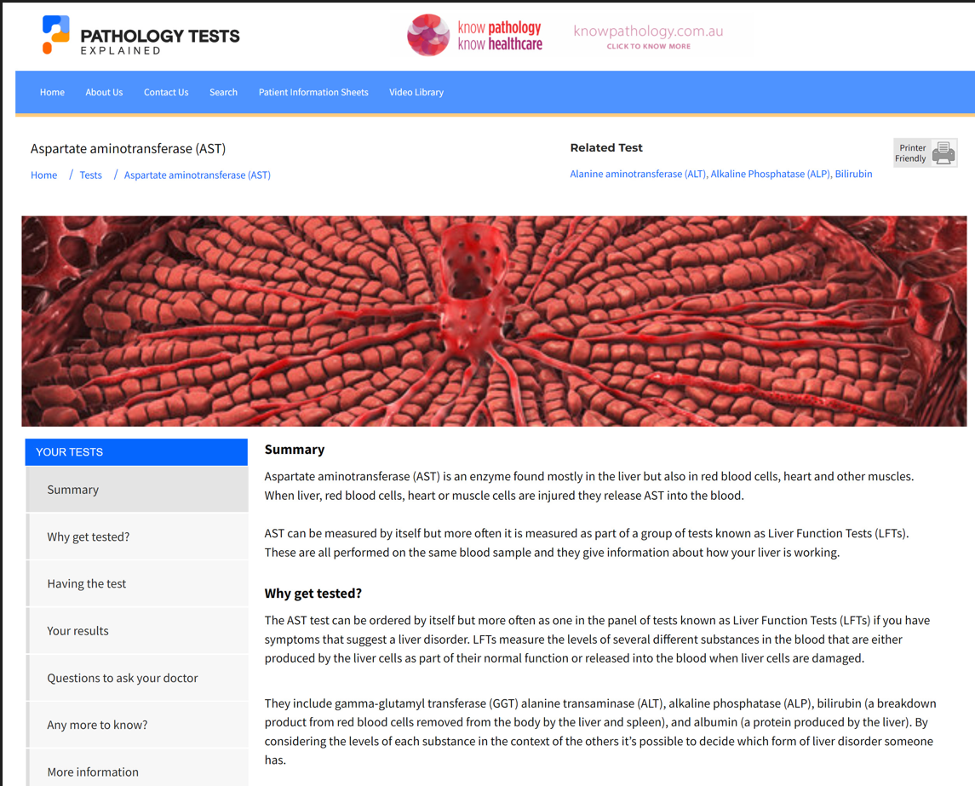
Fig. 1. A typical simplified test page for the test, AST, a commonly requested liver function test.
As well as the Summary and Why get tested? sections (see Fig. 1) information is also provided on:
- what the test does and how it is used
- what the results may mean
- important questions to ask
- further related information
There are now three levels of test information available on PTEx (see Fig. 2.). These are: consumer-focused information; more detailed information; and quick read information sheets.
Simplified content, where available, is the default page where visitors land – a clickable button on the left-hand side of the page takes them to the more detailed content.
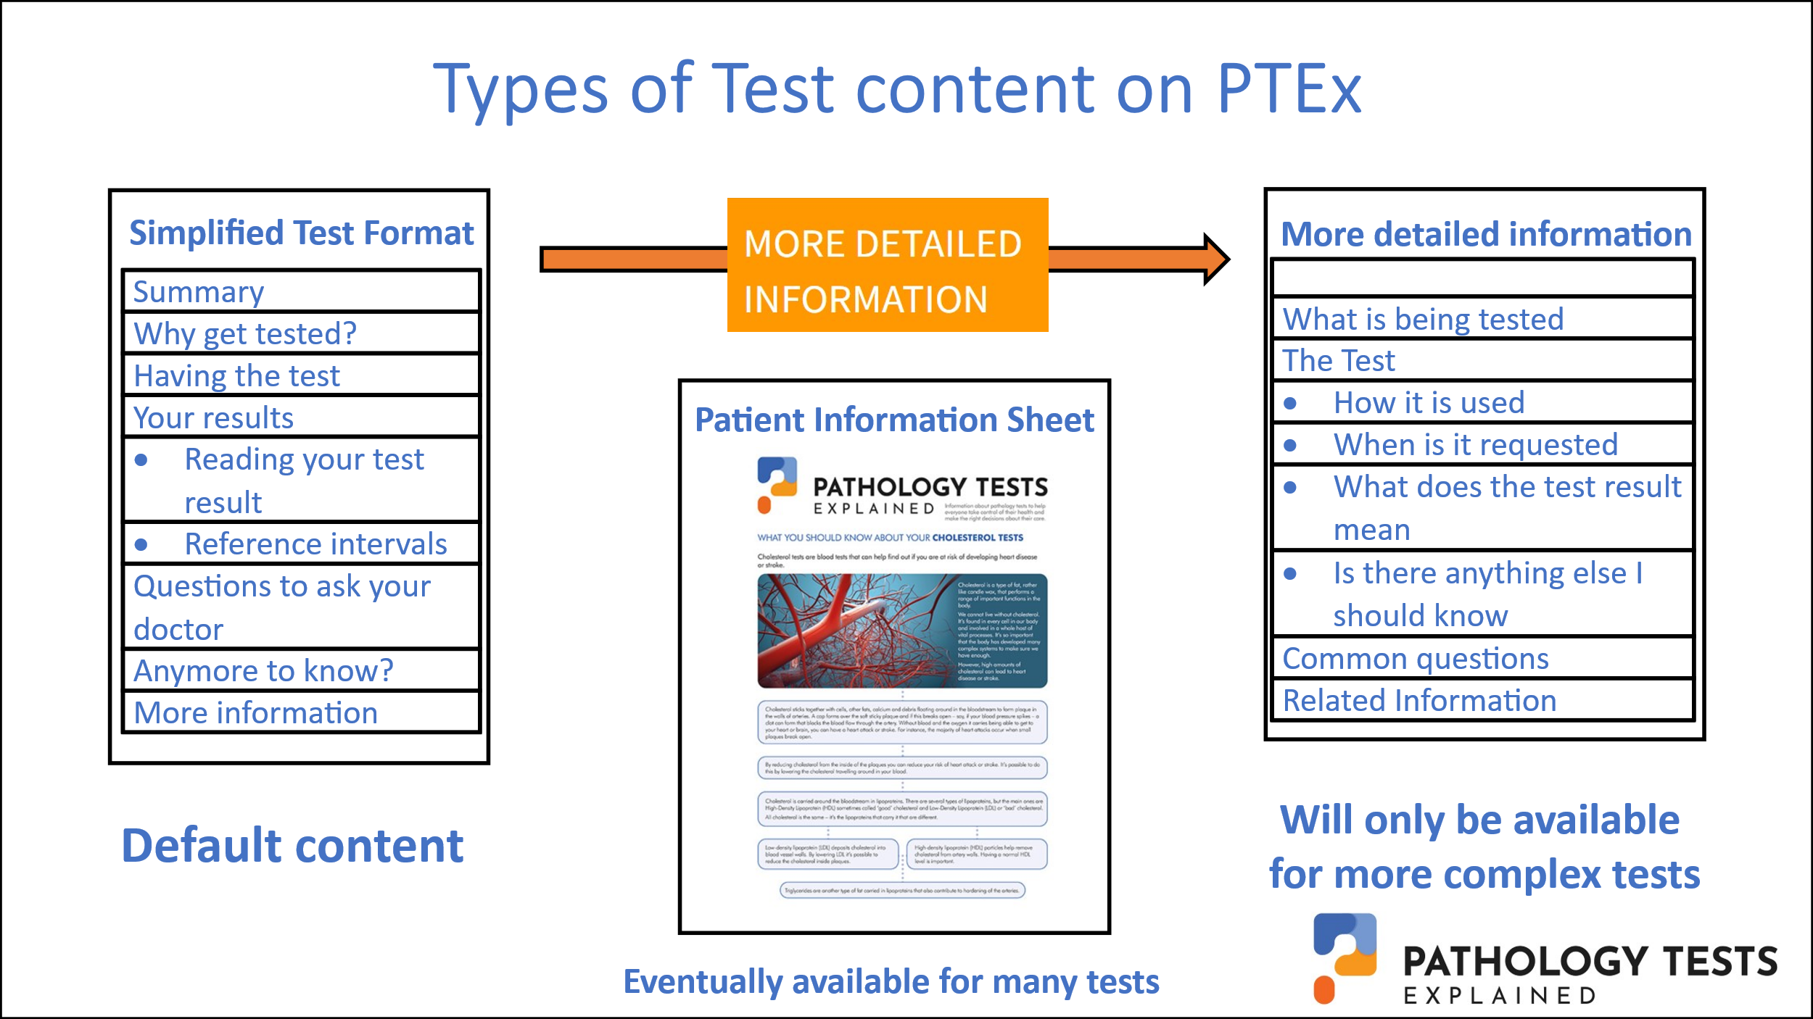
Fig. 2. Three types of test content are now available on the PTEx website.
The concept of an information sheet was introduced under Lab Tests Online Au. The goal was to meet the literacy needs of consumers as recommended by the 2018 Medicare Review Committee which emphasised the need for written information about tests to be made available for consumers.
Information sheets (see Fig.3.) follow a standardised format and information chronology.
- Each is presented as single double-sided A4 sheet.
- An illustration or diagram is shown on the front page to help explain the text.
- Content is written in plain English to a literacy level of a reading age of between year 6 and year 8. It avoids medical jargon and uses words and expressions that are familiar to most people.
- The goal is to help people better understand their health condition, how their body works and how tests can affect them.
- information is actionable and helps consumers and carers to ask questions and make decisions about their on-going management.
- Some key questions are included to prompt a conversation between the consumer or carer and their health professionals.
The majority of the selected tests are those that are commonly requested by GPs. There are others, which are less common, but were selected because of an expressed need by clinicians for specific information to support their patients. These include some genetics-related tests or procedures.
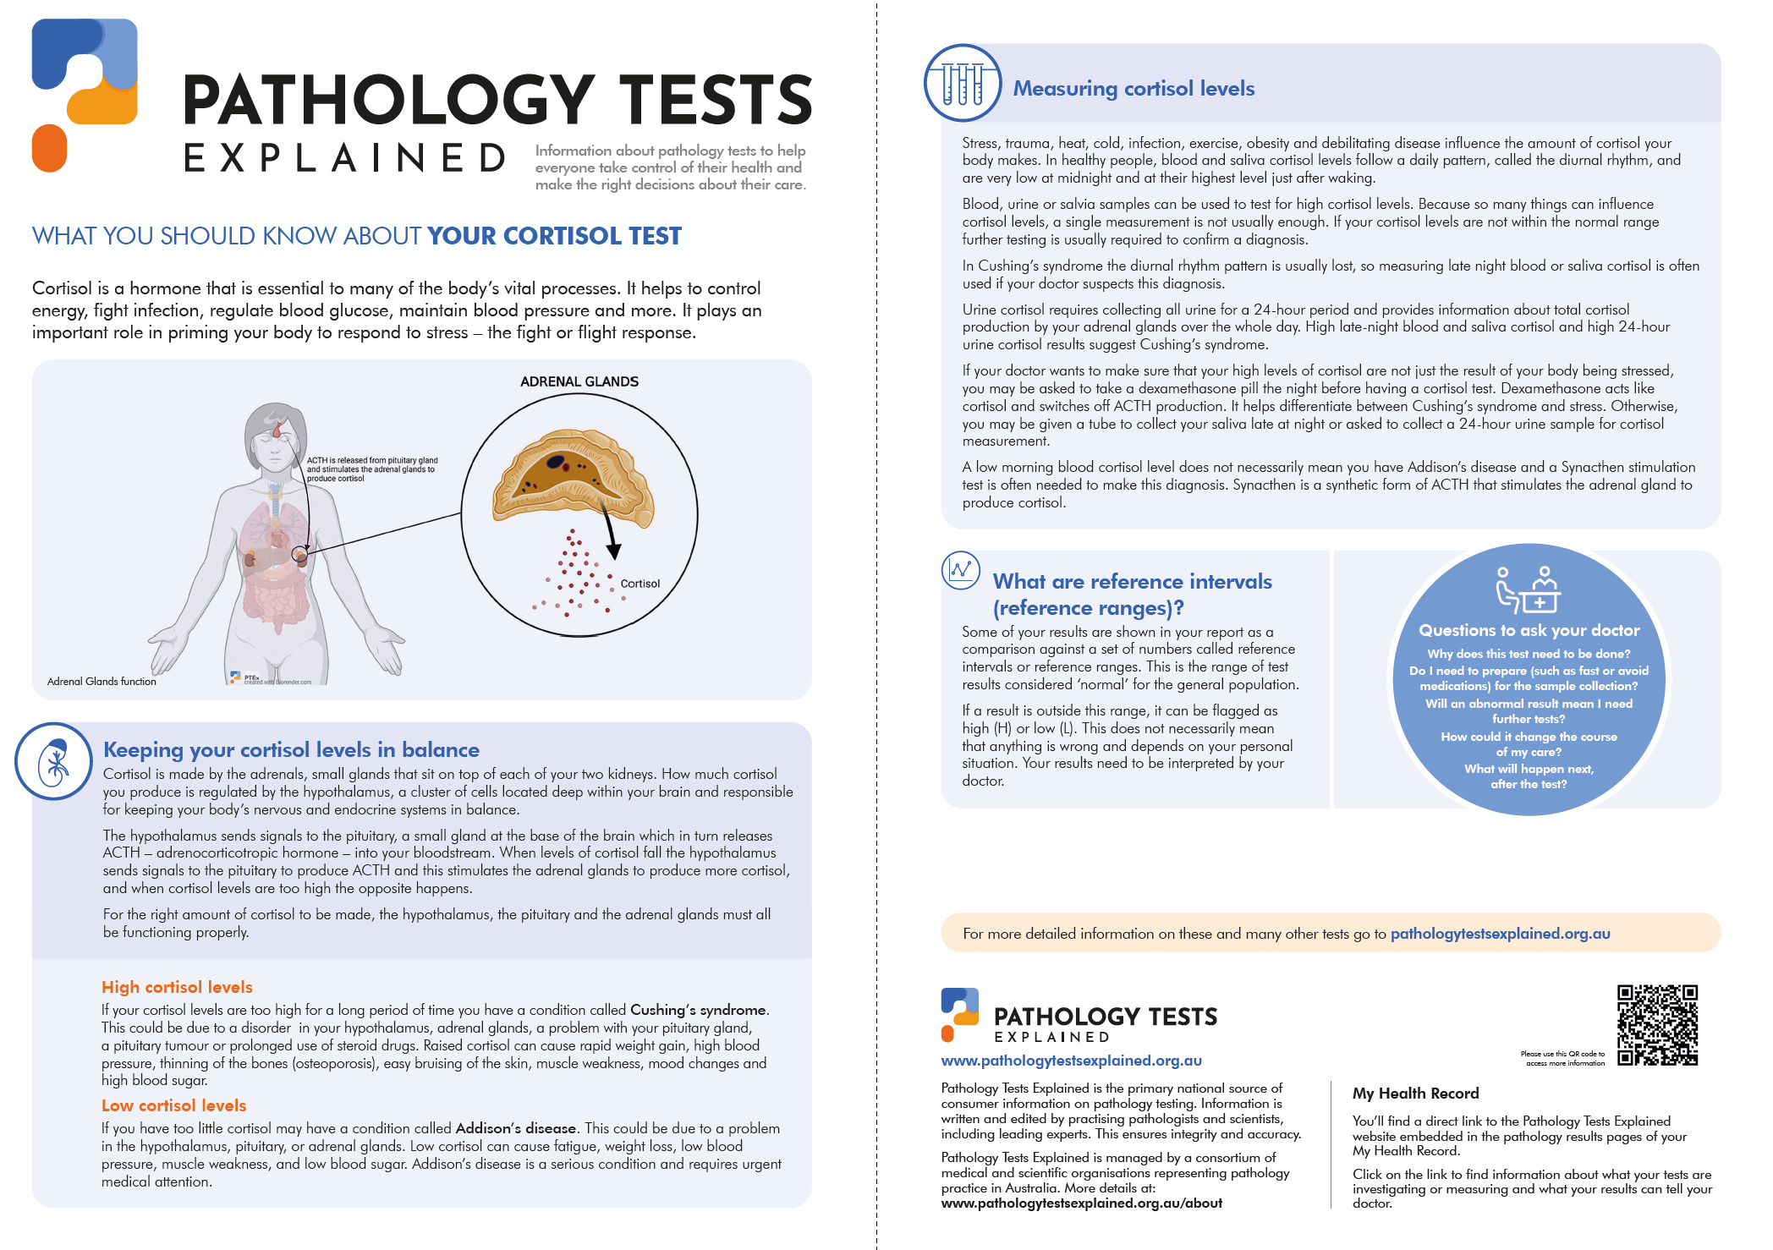
Fig. 3. Patient information sheet for the Cortisol test.
A list of the Patient Information Sheets produced as part of this QUPP Grant are shown Table 1. Patient Information Sheets can be downloaded from the PTEx website (see statistics in Activity 4 Results).
One of the original aims of producing single-page information sheets was to provide GPs with trustworthy information to give to patients during their consultation. These could be printed off or shared digitally. It was thought that patients, who are often under some stress, may find it difficult to recall what they had been told by medical professionals and these sheets could be read later in their own time, as often as they needed to refer to them.
Table 1. List of tests available as information sheets and produced in this QUPP Grant 2023-24.
Anti-Mullerian Hormone | Follicle stimulating hormone | RAS gene mutation testing
Allergies & IgE | Hemochromatosis | Reticulocyte count
Arthritis | HbA1c | Reproductive carrier screening
Blood transfusion | Helicobacter pylori | Respiratory syncytial virus (RSV)
Bone markers | Herpes | Rubella
Bone marrow aspiration & biopsy | HER2 genetic mutation | Somatic tumour testing
Bowel cancer & FOBT | HIV genotypic resistance | Syphilis
Calprotectin | Human papilloma virus (HPV) | Uric acid and gout
Coeliac disease | IgE (Allergy) | Urine albumin ratio
Cortisol | Influenza | Valproate
CSF lumber puncture & testing | Measles and mumps | Vitamin D
Diabetes | Platelet count | White cell count
Electrolytes | Potassium and aldosterone | Whole Genome & Exome Testing
Familial Hypercholesterolaemia

Activity 3. Improve the strategic direction of PTEx, including demonstrated extended reach through partnerships with other health organisations to further promote the utility of the PTEx website for the benefit of consumers. This will involve establishing a corporate entity with a fully constituted board to develop the governance of PTEx and to increase the number of contributing organisations to make PTEx financially sustainable, without further funding from the Quality Use of Pathology Program.
At the time this Grant was awarded in May 23, discussions were continuing between the AACB and other pathology organisations about the possibility of forming an independent entity called Pathology Tests Explained which would be responsible for development and management of the information website.
Those discussions culminated in five organisations becoming involved, with a company formally established and registered on 20th June 2023. Each member organisation has equal representation on the Board of Directors. The individual organisations are: the Australasian Association for Clinical Biochemistry and Laboratory Medicine (AACB), Public Pathology Australia (PPA), The Royal College of Pathologists of Australasia (RCPA), the Human Genetics Society of Australasia (HGSA), and Pathology Awareness Australia (Know Pathology, know healthcare) (see Fig. 4.).
The day-to-day activities of PTEx are carried out by the PTEx Management Team. Formation of an Editorial Board, also shown in Fig. 4. and is approaching completion.
The five organisations make an equal financial contribution which in total supports the following activities:
- Website management and domain fees.
- Honoraria for website manager, content placement and Editor-in-Chief personnel.
- Administrative and support services.
This means that PTEx can continue to function in the absence of other funding and this arrangement is a significant step towards making the organisation more sustainable. The goal remains to attract other pathology-related bodies to be contributors to PTEx both at a Board or editorial level, including ongoing funding from the Australian Government.
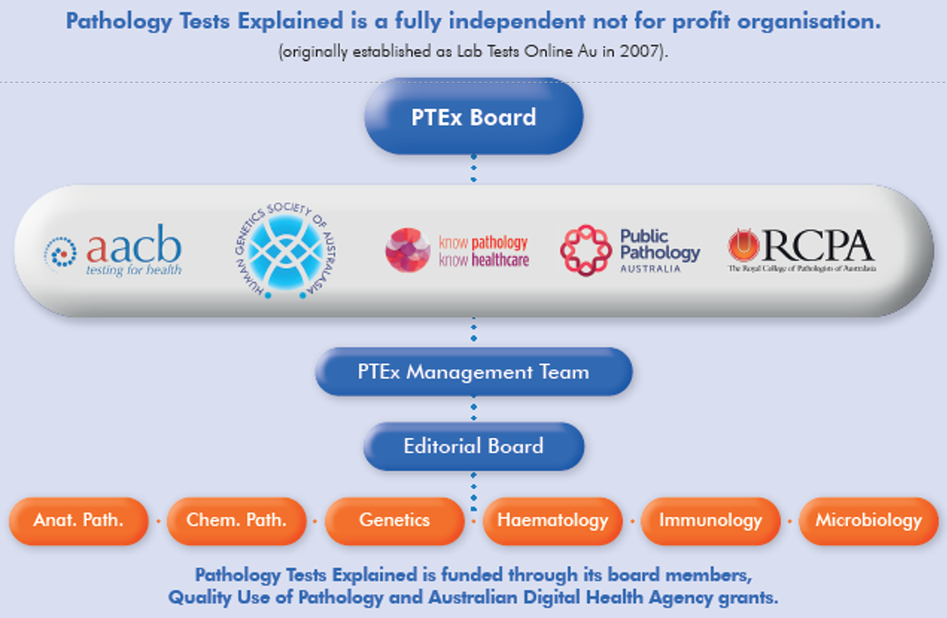
Fig. 4. Five organisations have oversight of the Pathology Tests Explained organisation.
The PTEx Board has met monthly since its establishment and in May 24 organised its first strategic planning session. As well as members of the Board and Management group, representatives attended from a range of relevant organisations including consumer health, academic research, pathology providers and the Australian Digital Health Agency (ADHA).
Key outcomes from the strategic planning session included identifying the strengths, weaknesses, opportunities and threats associated with the PTEx organisation and website.
Following the strategic planning session, the Board has endorsed key priorities including: measuring consumer engagement and acceptability of resources, and developing a plan to raise awareness of PTEx with primary care providers, and seek opportunities to integrate our resources with GP software platforms.

The Australian Digital Health Agency and My Health Record
The partnership between PTEx and the ADHA is significant and impacts on our decision-making around future content and website improvement and development.
The Australian Government My Health Record (MHR) already includes a link to PTEx within the pathology results page of a person’s My Health record. It also already includes a link from the pathology results section of the My Health app.
Currently, consumers in most Australian jurisdictions experience a seven-day delay before their pathology test results become available on MHR. The ADHA plans to remove this rule, possibly within months, meaning that the Australian public will be able to see their pathology test results in MHR at the same time as their health providers.
The ability to access pathology results, together with complexity of pathology reports, which are intended for professional use, means that consumers require extensive support in understanding and navigating the information displayed in pathology test results. Moreover, different Pathology service providers use different layouts.
PTEx is working closely with the ADHA to ensure MHR consumers can easily and seamlessly find the information they need to better understand their pathology reports and ask the right questions of their doctors. Importantly, although well-documented international studies have shown that the vast majority of consumers have enthusiastically embraced immediate access to results, concerns have been raised in Australia about the potential for confusion and anxiety. PTEx has a significant role to play in mitigating this.

Other important partnerships
Other partnerships have been developed as part of determining the strategic direction of PTEx.One of these is with New South Wales Health Pathology (NSWHP). Under an MOU, the NSWHP pathology test catalogue includes links to PTEx-developed content and graphics (for example, Fig.5) to provide explanatory information to patients .
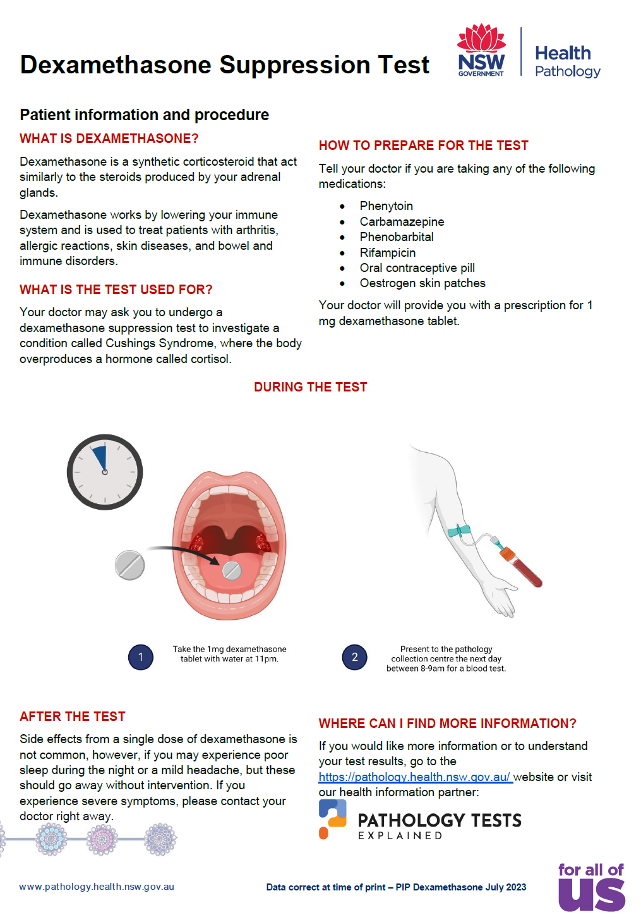
Fig. 5. Patient information sheet on the Dexamethasone Suppression Test used by NSW Health Pathology and using information from PTEx.
It is the goal of the PTEx Board to establish similar collaborative relationships with the other pathology providers and similar organisations in the public and private sector.
Another important relationship is with the academic sector for the purposes of conducting research into developing better ways to provide information about pathology testing to the lay public. A joint grant submitted by Dr Patti Shi, a social sciences researcher at the University of Wollongong, and involving both PTEx and Wiser Healthcare at the University of Sydney, was submitted as part of the latest applications to the Quality Use of Pathology program.
The project planned to use members of the Australian public to co-design with academic researchers and pathology professionals, better ways to provide information about pathology tests. While this recent application was unsuccessful, a reduced version of the project will proceed with contributions from all the partners.

Future partnerships
The PTEx Board is presently exploring possible joint projects with the RCPA. These will draw on the exceptional expertise of RCPA Fellows and Registrars, possibly in wider collaboration with other medical colleges and peak bodies, to produce unparalleled authoritative content for the consumer.

Activity 4 – Demonstrated increase in the number of visitors/ users accessing the PTEx website
Since the launch of new PTEx website in June 23, the visitor numbers have grown steadily (see Fig. 6.).

Fig.6. Monthly visitors to PTEx from launch in Jun 23 to May 24
The underlying trend is about a 10-12% increase per month with the occasional month of decreased visitor numbers (Nov 23 and April 24) due to unknown causes. The total number of visitors over the 12-month period was about 900,000.
In the first six months of the Grant period, there was some promotion of the site through Google Ads but the return on the investment was not seen as worthwhile and they were discontinued. Thus, while promotion of the site is relatively minimal, traffic has continued to increase which suggests that some concerted promotion, possibly through social media, may deliver substantial increases in traffic.
We are pleased to say that all the 40 newly published patient information sheets have been downloaded, but the highest numbers of downloads are, as expected, for the most commonly requested tests (see Fig. 7.).
From August 2023 until June 2024 a total of 27,590 patient information sheets were downloaded.

Fig.7. Downloaded patient information sheets, Jan-Jun 2024.

Challenges
There were no serious challenges to delivering the activities described previously other than some delays in the delivery schedule. This was more of a challenge in the first six months of the Grant when some key personnel were not available.

Conclusion
The overall trend over the 12 months of the Grant of increasing visitor numbers to the new PTEx website suggests that PTEx is providing information which the Australian public wants to read in relation to their pathology tests.
As mentioned, visitor numbers have been achieved with negligible promotion and we have anecdotal evidence that many in the community are still unaware of this information source. This is an area that is being addressed as part of the ADHA funding for 2024-2025.
The large number of downloaded patient information sheets is further confirmation that we are providing information that is desired by the Australian public.
Of importance is that the Grant has facilitated the development of a sustainable organisation which will continue to manage and develop the website.
A key feature of the new PTEx organisation is that it is shared across five of Australia’s most important pathology organisations which is crucial to its long-term sustainability.

Future directions
While visitor and download numbers are gratifying and important, they tell us nothing about whether the information that is supplied by PTEx is understood by our audience.
Therefore, an important future direction for PTEx is to seek more input and feedback from the Australian public and the health consumer community in relation to the design of our content, how easily they can find the information they need, and how it is presented on the website.
Pursuing this strategic direction will start with the possible appointment to the PTEx Board of a representative from the health consumer community. Other related initiatives will include seeking feedback from consumer panels, either individually, or as part of focus groups.
Our research plans with the University of Wollongong and Wiser Healthcare, including the concept of co-design of content, will be an important part of seeking greater feedback on our content from our primary audience.
Other and more general future directions will be guided by the outcomes from our strategic planning session, briefly described under Activity 3, with the PTEx Board planning to develop a detailed strategic plan by August 2024.

