EMERGENCY DEPARTMENT PATHOLOGY ORDER SUPPORT TOOL (ED-POST)
Final report of a Quality use of Pathology Program (QUPP) Project grant (2021-2023)
February 2024

Table of Contents
Glossary of Terms and Acronyms 3
EXECUTIVE SUMMARY 4
Introduction 6
Grant Purpose and Objectives 6
Grant Governance 6
Key Dates 6
Project Statement 7
Scope 7
Results 8
Scenario 1 – 30 year old male presenting with chest pain 9
Scenario 2 – 45 year old male presenting with fever 10
Scenario 3 – 59 year old female presenting with abdominal pain 11
Scenario 4 – 88 year old female presents after a fall 12
Challenges 12
Conclusion 13
Future Directions 13
Bibliography 14

Glossary of Terms and Acronyms
Term | Meaning
DOI | Digital Object Identifier
ED | Emergency Department
ED-POST | Emergency Department Pathology Order Support Tool
IT | Information Technology
LHD | Local Health District
PSG | Project Steering Group
PMT | Project Management Team
QUPP | Quality Use of Pathology Program

EXECUTIVE SUMMARY
This report presents the findings from a Quality Use of Pathology Program (QUPP) Grant 2021-2023 for a project titled ‘The Emergency Department Pathology Order Support Tool (ED-POST) - an intelligent and dynamic electronic tool to facilitate appropriate and effective use of pathology’.
ED-POST was conceptualised as an electronic decision support tool that could be used by Emergency Department clinicians, at the point of care, to support effective laboratory test ordering. The project was undertaken to realise this concept through the prototyping of ED-POST by researchers and NSW Health Pathology, in close collaboration with key stakeholders including Emergency Department (ED) clinicians, and Pathology Directors, management and data scientists. The project was conducted in stages to provide an opportunity for key stakeholders from Emergency Department/s within an ethics approved NSW Local Health District (LHD), to provide input prior to the development of the prototype (to inform the initial development) and during the evaluation of the prototype design (to inform subsequent development). The project used qualitative research methods to collect and evaluate stakeholder feedback throughout the duration of the project.
Interviews and observations conducted at the study site to identify key characteristics and features of ED-POST to inform design specifications, resulted in the development of a specifications/Prototype Development document that was shared with developers of the application (NSW Health Pathology). Clinicians expressed the need for more rational ordering and the reduction of unnecessary laboratory tests. Participants identified peer behaviour as a factor which could change personal decision making. Further, the introduction of any digital health intervention should be integrated with existing workflows and systems.
Feedback from participants following the development and an onsite demonstration of the ED-POST tool was mixed. Triage nurses and junior doctors were more likely to see value of the tool in guiding and validating test requesting decisions. However, senior staff specialists who ordered tests further along the patient journey saw limited utility of the tool for decision support, but rather as a quality assurance tool for review and assessment of departmental ordering trends.
Over the 18 months of the ED-POST project (late June 2022 to December 2023), the following objectives were achieved:
Objective 1- Ethics approval from Macquarie University Human Research Ethics Committee. Ethics approval from the participating Local Health District Research Ethics committee was received on 26th September 2022.
Objective 2- Development of ED-POST based on user needs. Site visits and interviews with clinicians were completed by 5th April 2023. A requirements specifications matrix was produced to inform Objective 3.
Objective 3- Design of ED-POST. A series of meetings were held to establish the specifications for the prototype design. The initial design was developed by NSW Health Pathology and the prototype user interface was designed by the Macquarie University research team. The prototype was demonstrated to a combined Project Steering Group and Project Management Team on 26th September 2023.
Objective 4- Undertake ED-POST trial and evaluation. Feedback from onsite demonstrations of the prototype to frontline clinicians involved in the laboratory test ordering process were collected by 3rd October 2023. Demonstrations of the prototype and feedback from participants at the study site were presented to senior ED representatives at two additional sites as part of a virtual stakeholder forum on the 22nd December 2023.
During the activity period the following milestones were achieved:
Ethics approval for the project to commence.
Establishment of the project governance structure including terms of reference.
The identification of key characteristics and features of ED-POST to contribute to the design specifications.
The development of the prototype.
Prototype trial at the study site/s.
Review and evaluation of ED-POST prototype trial.
All project reporting requirements were met and submitted on time.
The issues/challenges addressed during the grant activity were:
When developing the ethics submission for the project, it was identified that approval was required from the study site ethics committee, not the Macquarie University ethics committee as originally anticipated. This had minimal impact on the project with ethics submissions approved by the participating local health district research ethics committee.
The prototype trial objective- ‘Undertake ED-POST trial and evaluation’ was originally planned to take the form of a focus group. However, during a meeting with the site Principal Investigator, it became apparent that the approach may not be feasible due to the time-sensitive frontline commitments of participants. An alternative approach involving a series of demonstrations to individual clinicians (rather than a group) was suggested and this approach was adopted.
Recruitment for a stakeholder forum comprising senior ED representatives from two other EDs in Phase 3 initially posed a challenge owing to conflicting schedules and limited availabilities. However, this was assuaged by increasing flexibility of forum structure, including delivery of prototype demonstrations to individual representatives, minimising forum duration, and offering a variety of virtual attendance options.
The ED-POST project is now complete, and the outcomes of the project are currently being prepared in manuscript format for submission to relevant journals for consideration for publication.

Introduction

Grant Purpose and Objectives
The ‘The Emergency Department Pathology Order Support Tool (ED-POST) - an intelligent and dynamic electronic tool to facilitate appropriate and effective use of pathology’ QUPP grant activity commenced in late June 2022. The purpose of the project was to develop a prototype digital health tool, customised for the emergency department setting, which would provide information to clinicians to support pathology/laboratory test ordering.
The grant activity was undertaken in phases to achieve the following objectives:
Objective 1- Ethics approval for the project (before commencing qualitative research or prototype design).
Objective 2- Development of ED-POST based on user needs.
Objective 3- Design of ED-POST.
Objective 4- Undertake ED-POST trial and evaluation.
The project was planned as a collaborative, qualitative, research undertaking to ensure the development and testing of the prototype were informed by key stakeholders’ (Emergency Department clinicians (medical and nursing), Pathology Directors, managers and data scientists) input and feedback.

Grant Governance
A governance structure was established to oversee the grant activity. At the strategic governance level, a Project Steering Group (PSG) was formed with representation from the grant chief investigators from Macquarie University and NSW Health Pathology, and representatives from partner organisations Beamtree and Abbott. The PSG monitored the strategic direction of the project’s progress, milestones and outcomes. At the operational level, a Project Management Team (PMT) comprising representation from the grant chief investigators, research staff and site investigators, reviewed, planned and undertook the grant activities associated with achieving the project outcomes. Recruitment for a stakeholder forum comprising senior ED representatives from two other EDs initially posed a challenge owing to conflicting schedules/limited availabilities, however, as previously indicated, this was addressed by increasing flexibility of forum structure, including delivery of prototype demonstrations to individual representatives, and offering virtual attendance options.

Key Dates
Project milestones and the dates they were achieved were:
Grant awarded- June 2022
Ethics approval granted- September 2022
Establishment of the project governance- October 2022
LHD site specific approval received- December 2022
The identification of key characteristics and features of ED-POST to contribute to the design specifications- April 2023
The development of the prototype (initial design demonstrated to governance committees)- September 2023
Prototype trial at the study site/s. Feedback from sites completed- October 2023
Review and evaluation of ED-POST prototype trial including additional site representatives- December 2023

Project Statement
Laboratory services are involved in the study of the nature and causes of disease, and play an essential part in the detection, diagnosis, treatment, and ongoing management of disease.(1) Although diagnostic testing plays an integral role in the delivery of quality health care,(2, 3) research evidence indicates there may be excessive and/or variations in diagnostic testing, including laboratory pathology tests, particularly in emergency department and intensive care unit settings.(4, 5)
A 2018 Commonwealth Department of Health Medicare Benefits Schedule (MBS) Review Taskforce(6) highlighted key mechanisms for enhancing the management of diagnostic (pathology and medical imaging) tests. These include electronic decision support, feedback and requesting restrictions,(6) each of which is connected to the involvement of diagnostic stewardship and informatics in the generation, interpretation and communication of information. While electronic decision support systems are often described as key to reducing misdiagnosis, their impact has not been strongly validated against patient outcomes, and their diffusion is patchy.(7) There is also a long history of failure associated with the use of computer-based tools.(7) These tools are often introduced to a clinical setting with limited pilot testing and little understanding of how they affect workflow.(7) Establishing effective health information technology (IT) interventions must ensure the acceptance and usability of the IT system, and include systematic feedback of their performance to users.(8, 9) The validity of the IT intervention must also be measured in relation to its impact on key indicators of patient care and outcomes.(10)

Scope
As its name suggests, the Emergency Department Pathology Order Support Tool (ED-POST) was specifically prototyped for pathology test ordering in the Emergency Department setting. The development of the prototype was based on understanding workflows in an Australian emergency department setting.
The project methodology was prepared as a manuscript for publication as a project protocol paper. The paper, titled: Emergency department pathology order support tool (ED-POST): a protocol using qualitative inquiry to inform design and development of a prototype to reduce low value care(11) was published in the Health Services and Outcomes Research Methodology Journal. The paper was published ‘open access’ and is available online using the digital object identifier DOI: 10.1007/s10742-023-00314-1
The protocol paper(11) presents a detailed description of the qualitative methodology for the grant activities including-
A detailed overview of the ED-POST concept
The aims, objectives and stages of the qualitative research undertakings.
The design of the qualitative aspects of the study.
The setting and participants for the qualitative research.
A detailed description of the qualitative methods to be used in the research.
The methods of analysis of qualitative data.
An explanation of how quality and rigor are addressed.
The project governance.
During the development of the ED-POST prototype, an existing emergency department data source was used, namely, the New South Wales Health Pathology Atlas of Variation (described in existing literature(12-14)). The Pathology Atlas of Variation application was developed by NSW Health Pathology in collaboration with the Emergency Care Institute, eHealth NSW and Macquarie University. The Pathology Atlas of Variation application provides access to one of the largest integrated public health research resources in Australia. The application links data from different hospital Emergency Departments and laboratory systems as a means of identifying variations across hospitals, and the impact of those variations on patient outcomes (e.g., length of stay, readmission rates) and expenditure. This information, in turn, can be used to inform the design of electronic decision support tools (such as ED-POST) for clinicians as a means of optimising the appropriateness and timeliness of diagnostic tests ordered for patients presenting at an ED.

Results
Interviews and observations at the study site to identify key characteristics and features of ED-POST to inform design specifications were completed in April 2023. Existing diagnostic test requesting processes were explored and mapped, and clinicians were probed regarding any perceived issues with current processes, and expectations for electronic support. Findings resulted in the development of a specifications/Prototype Development document that was shared with developers of the application (NSW Health Pathology). Clinicians expressed the need for more rational ordering and the reduction of unnecessary laboratory tests. They discussed mechanisms that were likely to influence ordering habits, and identified peer behaviour as one factor which could change personal decision making. Further, respondents suggested that the introduction of any digital health intervention should not disrupt workflow efficiency, ideally integrating with existing workflows and systems.
The design of the ED-POST prototype was initially developed by the grant chief investigators from NSW Health Pathology and the prototype user interface was designed using Tableau (Tableau Software LLC, Professional Edition v2023.2.1) by the Macquarie University research team. The ED-POST decision support tool (sample outputs presented in Scenarios 1-4 below) functions by drawing certain patient data entered at triage (presenting problem, triage category, age, gender) and calculating the probability of certain laboratory tests being ordered (e.g., CRP, LFT, EUC etc.) based on statewide test ordering data on patients of an identical presenting profile. Users will see ordering trends for their ED in comparison with the state average, and can toggle between hospitals in a drop-down menu.
Onsite demonstrations of the prototype to frontline clinicians involved in the laboratory test ordering process at the study site were conducted in October 2023. Feedback from participants indicated that value of the tool was perceived differently based on staff groups and their role along the ordering process. Triage nurses and junior doctors who ordered tests near the beginning of the patient journey saw value of the tool in guiding and validating test requesting decisions. However, senior staff specialists who ordered tests further along the patient journey (often with results of many initial tests already available) saw limited utility of the tool for decision support during their day-to-day practice, but rather as a quality assurance tool for review and assessment of departmental ordering trends and identification of areas of concern. Although the tool did not currently include ordering data for departments beyond the ED, junior doctors saw potential value in the use of the tool in facilitating patient admission if it also incorporated ordering patterns on the wards.
The ED-POST prototype and feedback from the trial were presented to ED Directors from two additional sites within the same Local Health District as part of a virtual stakeholder forum in December 2023. Participants discussed their thoughts on the tool, and its applicability to their own departments. Feedback from the forum largely echoed the views of the senior physicians at the study site.
A key outcome of this project is the design and initial evaluation of an innovative diagnostic test ordering decision support tool based on clinical analytics, quality improvement and a real-time, dynamic dashboard approach to decision support. The tool and results of this project will be disseminated through journal publications and wider forums including international conferences for further triangulation of results and to improve scalability of the intervention.

Scenario 1 – 30 year old male presenting with chest pain
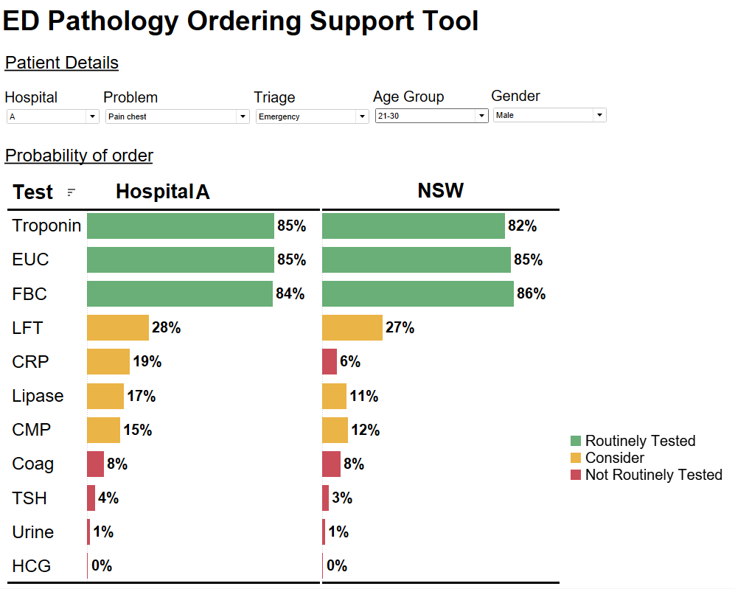

Scenario 2 – 45 year old male presenting with fever
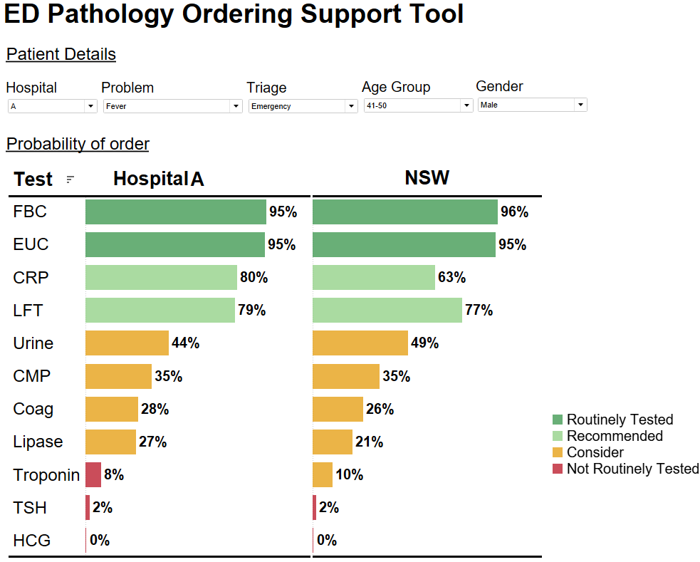

Scenario 3 – 59 year old female presenting with abdominal pain
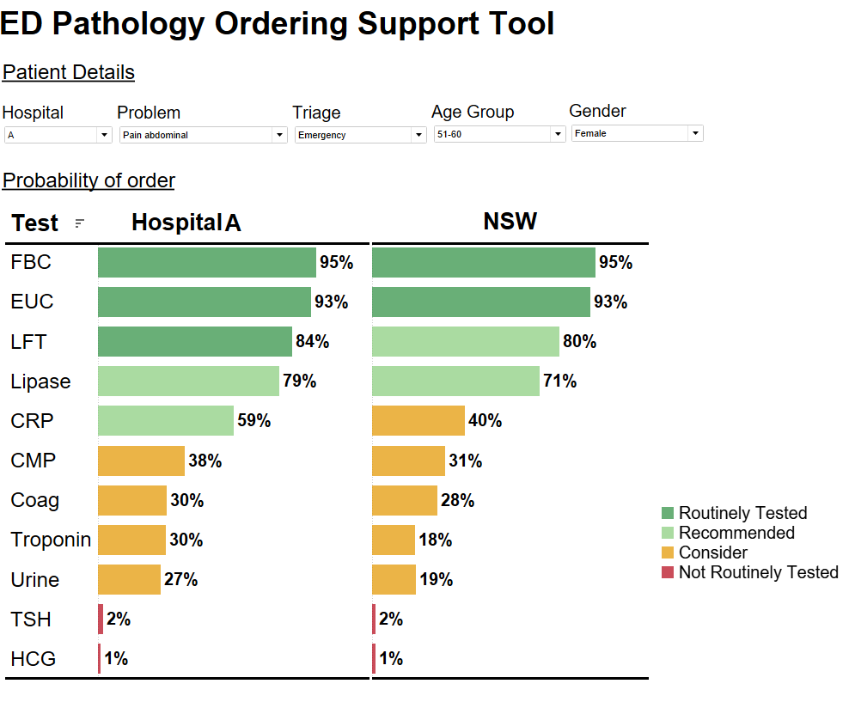

Scenario 4 – 88 year old female presents after a fall
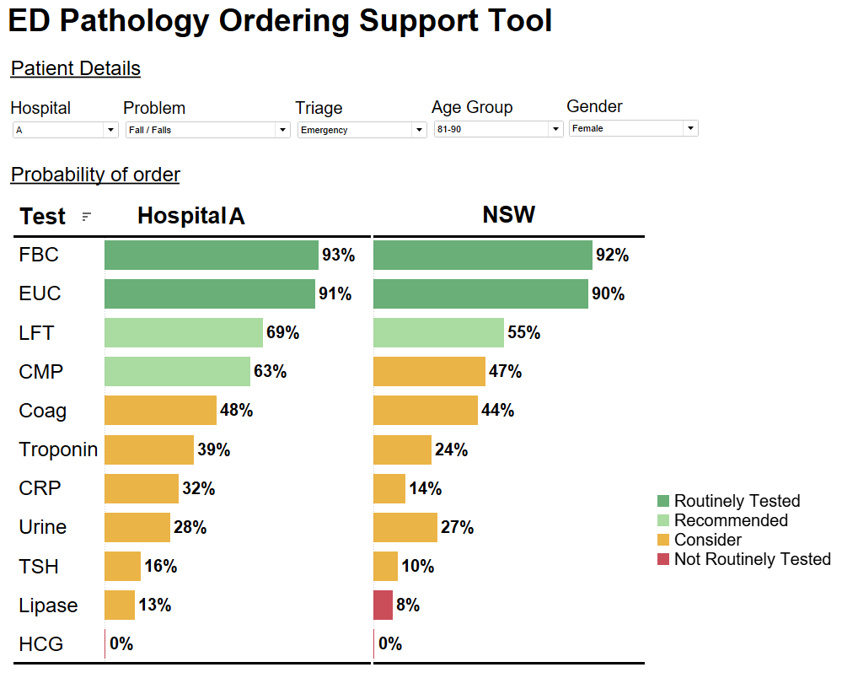

Challenges
As previously indicated, a number of issues/challenges occurred during the grant activity, however, all issues were addressed and had minimal impact on the grant activity.
When developing the ethics submission for the project, it was identified that approval was required from the study site ethics committee, not the Macquarie University ethics committee as originally anticipated. This had minimal impact on the project with ethics submissions approved by the participating local health district research ethics committee. Following ethics approval, site specific approval was then obtained before the qualitative research could commence.
The prototype trial objective- ‘Undertake ED-POST trial and evaluation’ was originally planned to take the form of a focus group. However, during a meeting with the site Principal Investigator, it became apparent that the approach may not be feasible due to the time-sensitive frontline commitments of participants. An alternative approach involving a series of demonstrations to individual clinicians (rather than a group) was suggested and this approach was adopted by the research team.
Recruitment for a stakeholder forum comprising senior ED representatives from two other EDs in Phase 3 initially posed a challenge owing to conflicting schedules and limited availabilities. However, this was assuaged by increasing flexibility of forum structure, including delivery of prototype demonstrations to individual representatives, minimising forum duration, and offering a variety of virtual attendance options.

Conclusion
The ED-POST prototype was designed as a tool to address over-ordering for lower risk patients and decrease instances of under-ordering for those in higher risk categories, thus helping to harmonise testing profiles whilst leaving the control and ultimate decision-making in the hands of clinicians. The qualitative research methodology utilised in the grant activity to inform design of the digital health intervention will facilitate future implementation and adaptiveness of the tool to different sites.
The grant activity outcomes will also contribute to the value of pathology testing in patient care and appropriate requesting behaviours and are aligned with recommendations from the MBS Review Taskforce.

Future Directions
The ED-POST project is now complete, and the outcomes of the project are currently being prepared in manuscript format for submission to relevant journals for consideration for publication. The ED-POST tool is now ready to be integrated for quantitative evaluation once an electronic medical record system is implemented at the study site. ED-POST has the potential for wide applicability to other hospital settings (e.g., intensive care, inpatient wards) across NSW and potentially, nationwide.

Bibliography
1. The Royal College of Pathologists of Australasia. What is Pathology? https://www.rcpa.edu.au/Media/What-is-Pathology Accessed January 2017.
2. Jha A. World alliance for patient safety- summary of the evidence on patient safety: Implications for research. Spain: World Health Organization. 2008.
3. Callen J, Georgiou A, Li J, Westbrook JI. The safety implications of missed test results for hospitalised patients: a systematic review. BMJ Quality & Safety. 2011;20(2):194-9.
4. Wabe N, Dahm MR, Li L, Lindeman R, Eigenstetter A, Westbrook JI, et al. An evaluation of variation in pathology investigations and associated factors for adult patients presenting to emergency departments with chest pain: An observational study. International journal of clinical practice. 2019;73(3):e13305.
5. Spence J, Bell DD, Garland A. Variation in diagnostic testing in ICUs: a comparison of teaching and nonteaching hospitals in a regional system. Critical care medicine. 2014;42(1):9-16.
6. Department of Health and Aged Care. Medicare Benefits Schedule Review Taskforce- Report from the Diagnostic Medicine Clinical Committee. https://www.health.gov.au/sites/default/files/documents/2021/06/final-clinical-committee-report-for-diagnostic-medicine.pdf Accessed 24 February 2024.
7. Garg AX, Adhikari NK, McDonald H, Rosas-Arellano MP, Devereaux PJ, Beyene J, et al. Effects of computerized clinical decision support systems on practitioner performance and patient outcomes: a systematic review. JAMA. 2005;293(10):1223-38.
8. El-Kareh R, Hasan O, Schiff GD. Use of health information technology to reduce diagnostic errors. BMJ Quality & Safety. 2013;22(Suppl 2):ii40-ii51.
9. Georgiou A, Prgomet M. E-health: Developing trust, confidence, quality and sustainability. Health Information Management Journal. 2019;48(2):59-61.
10. Georgiou A, Prgomet M, Paoloni R, Creswick N, Hordern A, Walter S, et al. The Effect of Computerized Provider Order Entry Systems on Clinical Care and Work Processes in Emergency Departments: A Systematic Review of the Quantitative Literature. Annals of Emergency Medicine. 2013;61(6):644-53.
11. Thomas J, Li J, Scowen C, Eigenstetter A, Georgiou A. Emergency department pathology order support tool (ED POST): a protocol using qualitative inquiry to inform design and development of a prototype to reduce low value care. Health Services and Outcomes Research Methodology. 2023;1-13.
12. Scowen C, Wabe N, Eigenstetter A, Lindeman R, Miao M, Westbrook JI, et al. Evaluating the long-term effects of a data-driven approach to reduce variation in emergency department pathology investigations: study protocol for evaluation of the NSW Health Pathology Atlas of Variation. BMJ Open. 2020;10(10):e039437.
13. Wabe N, Thomas J, Scowen C, Eigenstetter A, Lindeman R, Georgiou A. The NSW Pathology Atlas of Variation: Part I—Identifying Emergency Departments With Outlying Laboratory Test–Ordering Practices. Annals of Emergency Medicine. 2021;78(1)150-162.
14. Wabe N, Scowen C, Eigenstetter A, Lindeman R, Georgiou A. The NSW Pathology Atlas of Variation: Part II—The Association of Variation in Emergency Department Laboratory Investigations With Outcomes for Patients Presenting With Chest Pain. Annals of Emergency Medicine. 2021;6(1).

Macquarie University is a vibrant hub of intellectual thinkers, all working towards a brighter future for our communities and our planet.
A PLACE OF INSPIRATION
Macquarie is uniquely located in the heart of Australia’s largest high-tech precinct, a thriving locale which is predicted to double in size in the next 20 years to become the fourth largest CBD in Australia.
Our campus spans 126 hectares, with open green space that gives our community the freedom to think and grow. We are home to fantastic facilities with excellent transport links to the city and suburbs, supported by an on-campus train station.
RENOWNED FOR EXCELLENCE
We are ranked among the top two per cent of universities in the world, and with a 5-star QS rating, we are renowned for producing graduates that are among the most sought after professionals in the world.
A PROUD TRADITION OF DISCOVERY
Our enviable research efforts are brought to life by renowned researchers whose audacious solutions to issues of global significance are benefiting the world we live in.
BUILDING SUCCESSFUL GRADUATES
Our pioneering approach to teaching and learning is built around a connected learning community: our students are considered partners and co-creators in their learning experience.

FIND OUT MORE
Macquarie University NSW 2109 Australia
T: +61 (2) 9850 7111
mq.edu.au
ABN 90 952 801 237
CRICOS Provider 00002J

Full URL to access the protocol paper: https://link.springer.com/article/10.1007/s10742-023-00314-1

