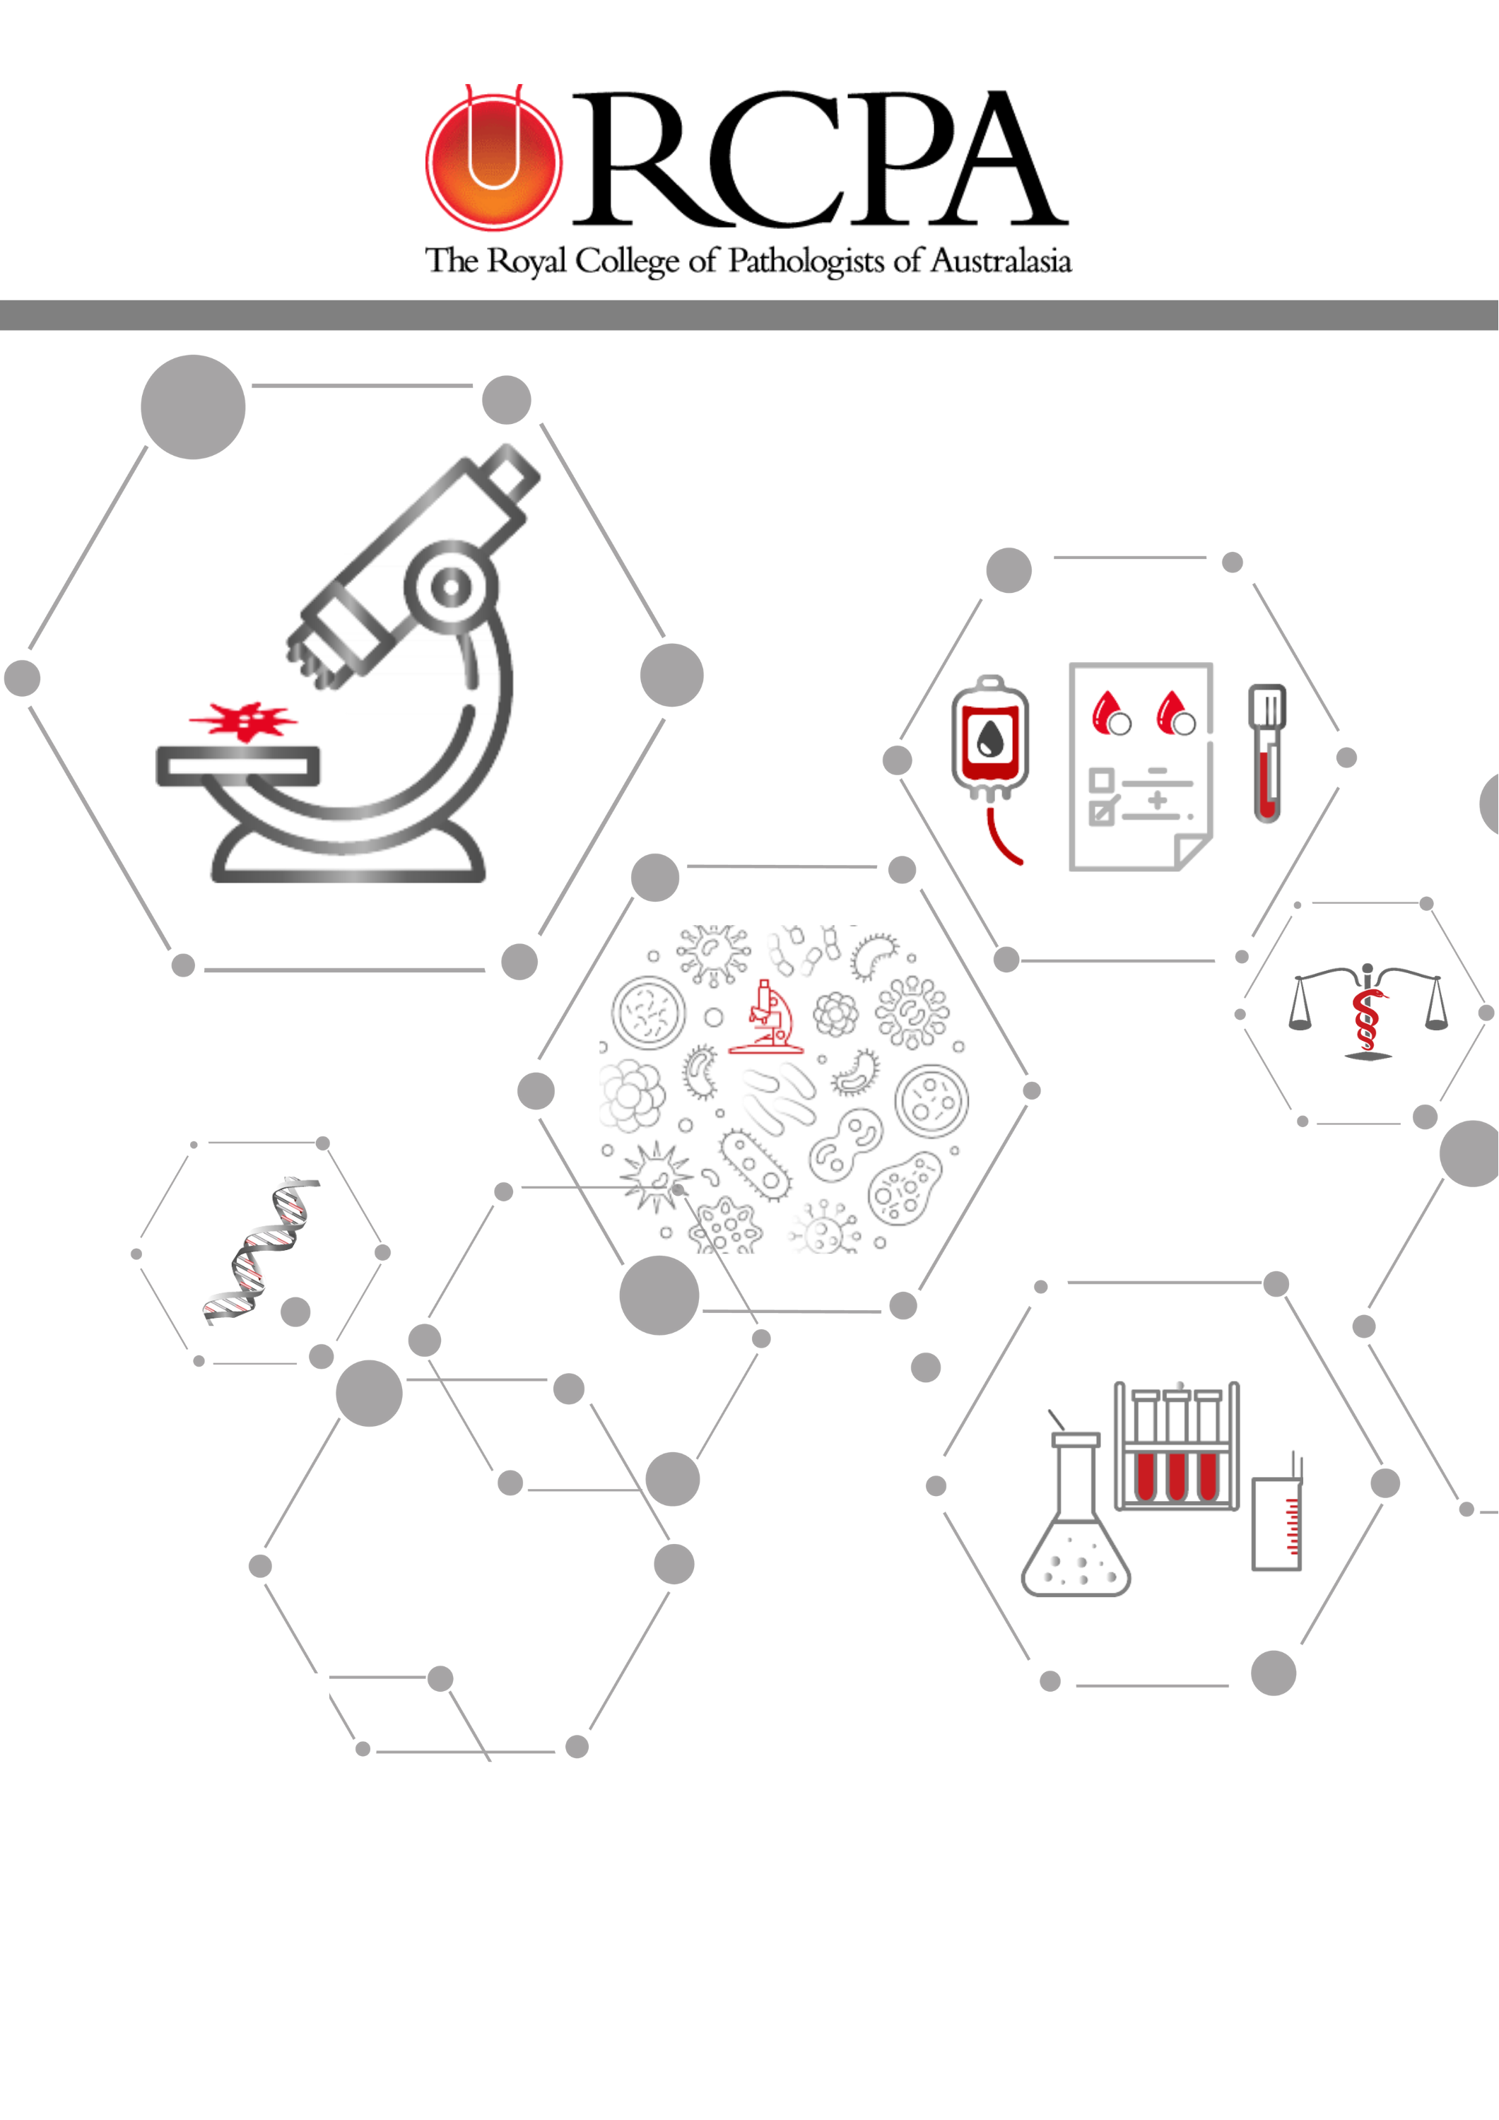

31 JULY 2024
Final Report – RCPA Stream 3 Performance- 4-II1R12D Clinical Decision Support 2023-2024

Document Control
Date | Version | Status | Action | Responsible
11/06/2024 | 0.1 | First Draft | First draft of content for internal review | David Willock
13/06/2024 | 0.2 | Review First Draft | Review | Vanessa White
01/07/2024 | 0.3 | Update post review | Third draft | David Willock
15/07/2024 | 0.4 | Review Draft | Review | Vanessa White
18/07/2024 | 0.5 | Update post review | For review | David Willock
22/07/2024 | 1.0 | Final Version | For Release to Department of Health and Aged Care | David Willock

Contents
1. Glossary [Add in a Glossary of Terms and Acronyms] 4
2. Introduction 6
Project Objectives 6
3. Project Statement 7
4. Scope 8
Inclusions (In scope): 8
Exclusions (Out of scope): 9
5. Activities 9
6. Findings 13
Pathology Workflows (Objectives 1,2) 14
MHR Findings (Objective 3) 16
SNOMED CT Compliance (Objectives 1,4) 17
eCDS findings (Objective 4) 17
7. Challenges 18
8. Conclusions and Recommendations 19
Conclusions 19
Recommendations 20
9. Appendix A – Activity Work Plan 22
10. Appendix B: Pathology end-to-end Workflows 29

Glossary
Acronym |  | Detail
ADHA |  | Australian Digital Health Agency
CME |  | Continuing Medical Education
CSIRO |  | Commonwealth Scientific and Industrial Research Organisation
DI |  | Diagnostic Imaging
eCDS |  | electronic Clinical Decision Support
EMR |  | Electronic Medical Record
FHIR |  | Fast Healthcare Interoperability Resources
GBR |  | Guidance Based Requesting
GP |  | General Practitioner
HL7 |  | Health Level Seven
HL7 AU |  | HL7 Australia
LIS |  | Laboratory Information System
LOINC |  | Logical Observation Identifiers Names and Codes (Home – LOINC)
MBS |  | Medicare Benefits Schedule
MSIA |  | Medical Software Industry Association
MHR |  | My Health Record
NATA |  | National Association of Testing Authorities
NPAAC |  | National Pathology Accreditation Advisory Council
PHNs |  | Primary Health Networks
PMS |  | Practice Management System
POC |  | Proof of Concept
PSPs  PTEx |  | Pathology Service Providers  Pathology Tests Explained
QUPP |  | Quality Use of Pathology Program
RACGP |  | The Royal Australian College of General Practitioners
RCPA |  | The Royal College of Pathologists of Australasia
RCPAQAP |  | RCPA Quality Assurance Programs
SNOMED CT |  | Systemized Nomenclature of Medicine – Clinical Terms
SNOMED CT - AU |  | Systemized Nomenclature of Medicine – Clinical Terms - Australia
SPIA |  | Standardised Pathology Informatics in Australia

Introduction
This Project was designed to undertake a comprehensive analysis of the current manual and digital workflow processes for pathology tests and identify the requirements for an end-to-end digital workflow process. As part of the consultation and analysis process, the Project engaged with key stakeholders, including a range of General Practitioner (GP) requestor groups, medical software vendors, pathologists, RCPA Quality Assurance Programs (RCPAQAP) and digital health experts to ensure all aspects of the pathology request-test-report workflow processes were considered.
The Project expanded on previous development work undertaken and recommendations made on the use of pathology clinical decision support (PathSupport) for clinicians as a starting point and leveraged new development work assessing the compliance of laboratory information systems against the RCPA SPIA Guidelines for receiving and reporting e-requests to assist with determining digital workflow and usability. In seeking to “test” the useability of electronic decision support tools available to clinicians, the extent to which these are/can be integrated within existing software was identified as a key determinant to usefulness and uptake by referring clinicians, including access through the My Health Record.
Over a period of thirteen months, the Project formulated a comprehensive end-to-end pathology request-test-report workflow process based upon expert input from clinicians, pathologists, and quality and IT experts that provides guidance on the most appropriate, efficient, best practice pathology requesting. It is expected that this work will further guide the RCPA in considering and recommending requirements to meet minimum accreditation standards e.g., NATA and NPAAC, that laboratories could implement to support eCDS and eReferrals.

Project Objectives
The objectives of the project were to:
- Undertake a comprehensive analysis of the current manual and digital workflow processes for pathology tests and the requirements for an end-to-end digital workflow process. This will include identification of current processes for the ordering of a pathology test to the generation of test results, and analysis of compliance with the SNOMED CT / LOINC aligned RCPA SPIA (Standardised Pathology Informatics in Australia) Guidelines for electronic pathology requests (eReferrals) and electronic reporting of pathology tests.
- Undertake a survey at least 90% of pathology service providers on current workflow processes and capacity, to inform the analysis of the workflow processes towards identifying an end-to-end digital workflow process.
- Identify any gaps and/or barriers that would facilitate and support increased access to atomic or discreet data through My Health Record (MHR) and provide insights on known complexities, limitations and risks to uploading.
- Develop a pilot to test the usability of electronic clinical decision support tools for pathology requesting by clinicians and develop strategies to support engagement, encourage best practice, and reduce inappropriate pathology requesting. This will include surveying a diverse range of GPs, including overseas trained GPs, newly trained doctors, mature GPs, GPs close to retirement and GPs from different geographic locations (metropolitan, rural and remote areas).
This Project was progressed under a Department of Health and Aged Care Grant (the Grant), as outlined in the Quality Use of Pathology Program Targeted Project Grants 2022-23 Grant Opportunity Guidelines GO6060 (the Grant).

Project Statement
Currently, General Practitioners (GPs) have access to e-requests with electronic Clinical Decision Support (eCDS) at a range of levels and through a variety of software vendors, with uptake largely dependent upon medical vendor software functionality and version, ease of use, integration into workflow, cost, demographics, location, resources, clinician enthusiasm, and time.
PathSupport, through the use of eCDS tools for clinicians, has the potential to assist workflow, guide electronic pathology requests (e-requests), increase efficiencies of the use and consumption of pathology-related Medicare services, and enhance the delivery of pathology services. End-to-end digital workflow processes for pathology requesting through to the generation of test results need to be guidance-based, and clinician lead to provide the foundations for a nationally consistent approach to e-requesting and to facilitate widespread support and adoption [in the absence of any mandatory requirement].
Currently, the NPAAC Requirements for Medical Pathology Services (Third Edition 2018) and NPAAC Requirements for Information Communication and Reporting (Fifth Edition 2022) address guiding principles for pathology requesting and set minimum requirements for pathology request data components. Additionally, the RCPA Best Practice Guideline published in 2021 was developed to improve the use and interpretation of pathology test results by enabling clinicians to compare pathology test results from different providers within the MyHR. However, to date, practical implementation has focused largely on reporting through the development and implementation of the RCPA SPIA Guidelines V4.1 published in 2024, and this Project provided the opportunity to apply this same approach to the principles of e-requesting.
In undertaking this body of work, one of the priorities of this Project was to identify barriers and levers to digital health adoption, including uploads to My Health Record (MHR) in progressing e-requesting, e-reporting, and clinical decision support for pathology.

Scope
The Project will provide an overview of the maturity of pathology eCDS within Australia and some recommendations for consideration to positively drive forward greater development, implementation and use of eCDS.
The Project will work with stakeholders to understand potential barriers, including what differing factors affect the use of eCDS, for example trust, awareness, peer support (as opposed to eCDS), provider length of time in practice, clinical practice time pressures; geographic location, software configuration constraints, multiple standalone solutions, ease of navigation; etc. The Project will be informed by several work streams (see inclusions below).
eCDS in the context of this body of work is the use of eCDS for pathology e-requesting:
- integrated as a tool within General Practice Software and Electronic Medical Records (EMRs); and
- the use of existing tools (including availability, and integration) to support e-requesting such as the RCPA Manual of Use and Interpretation of Pathology Tests (RCPA Manual); Pathology Tests Explained AU (PTEx); MBS Online; and my health mobile app.
Proof of Concept (POC) in the context of this Project refers to expanding existing work being undertaken with the RCPAQAP under the RCPA Pathology Informatics Interoperability Pilot Project to assess electronic reporting compliance for 7 pathology tests and 6 pathology panels, and use these to assess RCPA SPIA compliance for requesting – thereby demonstrating an end-to-end digital workflow and identify requirements to facilitate best practice.

Inclusions (In scope):
- Workflow Analysis: Survey Pathology Service Providers (PSP)
Surveyed at least 90% of providers on existing workflow process and capacity (and digital maturity), as well as barriers to currently achieving interoperability and uptake of the RCPA SPIA Guidelines V4.1.
- Workflow Analysis: GP Survey
Surveyed a diverse range of GPs to understand requirements for, benefits of and barriers to eCDS as part of the consultation process. This aimed to understand different cohorts’ use of eCDS, including its use as a tool to assist with e-requesting and e-reporting.
- Digital Readiness and Adoption: RACGP and selected PHNs
Consulted with the RACGP and some selected PHNs to discuss
- current status of the digital pathology processes including eCDS within practice software,
- barriers to adoption of eCDS (and the use of digital resources more broadly)
- strategies to support General Practitioner engagement and
- mechanisms that could be used to enhance appropriate pathology requesting (right test, right patient, right time).
- Digital Readiness and Adoption: Medical Software Industry Association
Consulted with the MSIA to understand readiness and adoption from a range of GP software vendors.
- Informatics: My Health Record and Standards
Identified gaps and/or barriers that facilitate and support increased access to atomic or discreet data through the MHR and provide insights on known complexities, limitations and risks to uploading patient pathology information.
- Digital Readiness and Adoption: Jurisdictions
Met with two States / Territories health services to discuss - compliance with RCPA SPIA Guidelines within both their public laboratories and within their Electronic Medical Record (EMR) implementations.
- eCDS Pilot: SPIA Compliance and Pilot eCDS
In addition to the above streams of work, the Project will leverage SPIA compliance work undertaken by the RCPA Pathology Interoperability Pilot Project in assessing the electronic reporting compliance for 7 tests and 6 panels in assessing the quality and consistency of e-requesting data against the same limited subset of tests and panels.

Exclusions (Out of scope):
The Project did not undertake any activities outside of the scope statement.

Activities
The Project formally commenced on 21 April 2023 with the signing of the Contract, finalising in June 2024. Over that period, there was significant consultation to inform the findings and recommendations. That consultation included GPs, Pathology Service Providers, the Medical Software industry, Primary Health Networks and others. With over 100 sources of input, including webinars, surveys and meetings, and in excess of 150 hours of contributed time, valuable insights were gained into the use of technology for pathology requesting and supporting decisions for requesting.
Objective 1: Undertake a comprehensive analysis of the current manual and digital workflow processes for pathology tests and the requirements for an end-to-end digital workflow process, including ordering and results. This will include the identification of current processes for the ordering of a pathology test to the generation of test results and analysis of compliance with the SNOMED CT / LOINC aligned RCPA SPIA (Standardised Pathology Informatics in Australia) Guidelines for electronic pathology requests (eReferrals) and electronic reporting of pathology tests.
The Project worked with the RCPA PathSupport eCDS Working Group to undertake analysis and document the end-to-end current Pathology Workflow Process. The Working Group had broad representation, including Pathologists, GP, Medical Software representation, and the Australian Department of Health and Aged Care (Department). Discussions were held with a broad range of stakeholders in relation to what works well today, and where there are ‘blockers’ or areas for improvement. A simplified rendition is below, and the detailed workflows identified by the Project for both Requesting and Reporting are attached at Appendix B.
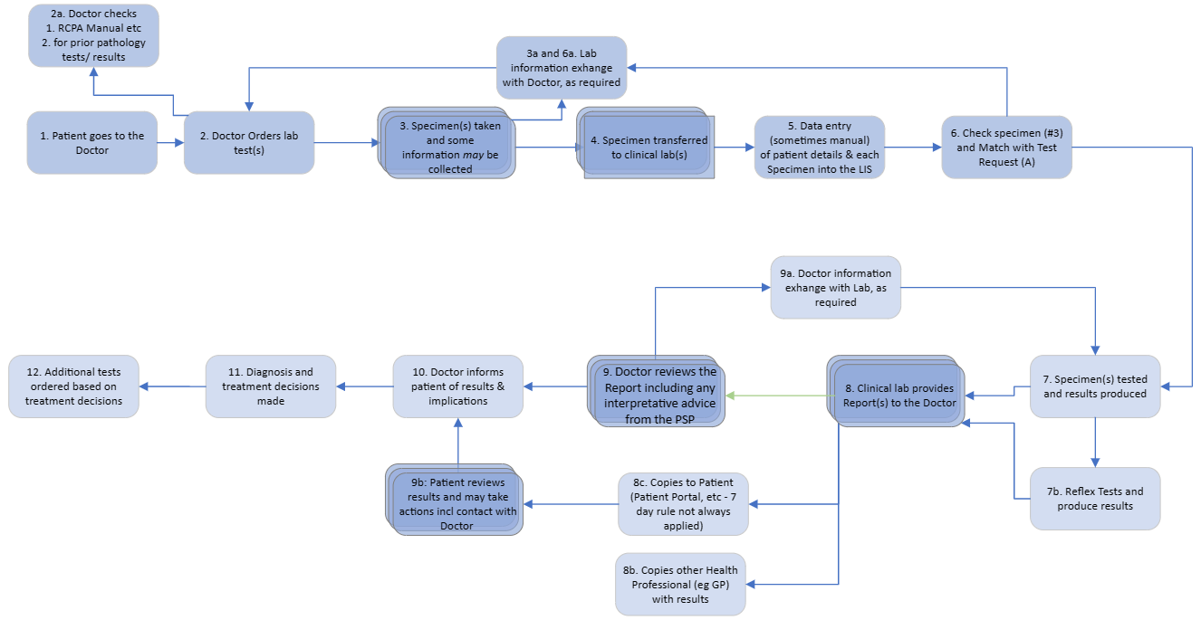
Within the workflows at Appendix B there are notes in relation to steps within the workflow which inform the Findings of the Project.
Please note that SPIA Compliance activities are reported under Objective 4 below.
Objective 2: Undertake a survey of at least 90% of pathology service providers on current workflow processes and capacity to inform the analysis of the workflow processes towards identifying an end-to-end digital workflow process.
The Project developed and released a Survey to all 37 PSPs across Australia; 10 responses were received. The outcomes of the survey are outlined in detail in the attached Final Report (Appendix C - e-Clinical Decision Support Final Report V1.0), and highlights include that whilst 90% of respondents could receive electronic requests, only 13% of them receive electronic requests 75-100% of the time. Just under two-thirds of responding PSPs could accept SNOMED CT codes, and they noted their ability to implement new national standards had a relatively short lead time.
The main confirmation was the 2015 finding from the RCPA Electronic Decision Support Tools (EDST) for Pathology Requesting: PathSupport Project (PathSupport), funded through the QUPP, that approximately 50% of all requests received did not include clinical information or reason for the pathology request, remains true today. Clinical Information on the request is still seen by PSPs as the most important missing information today, and was considered essential for interpreting results in the clinical context by the vast majority (88%).
In relation to My Health Record, all noted that they could upload to MHR. However, only half of PSPs rendered the report in the same manner as is provided to the GP. MHR was rarely used to look at previous lab results or clinical history, with 12% who do and the vast majority (88%) who do not.
Objective 3: Identify any gaps and/or barriers that would facilitate and support increased access to atomic or discreet data through My Health Record (MHR) and provide insights on known complexities, limitations and risks to uploading.
GPs engaged with the Project through four channels, namely on the Working Group, via a Survey, participating in a Webinar or individually.
In terms of the Survey, 55 GPs provided information on their use of MHR. 43 GPs (or 78%) requested upload to MHR by default. The reasons they identified using MHR include mobility, improved communication, access to hospital information, and reduced duplication. Reasons for non-use include the functionality of MHR being ‘clunky” and difficult to navigate; similarly, the search functionality was seen as hard and time-consuming to find patient information. Pathology, Discharge Summaries, Diagnostic Imaging and Medications were the main items that GPs who use MHR viewed. Of the 55 Respondents, 7 (or 12%) did not look at MHR at all.
Two Webinars were held for GPs, with 16 attendees. A GP who worked in Palliative Care noted they used MHR far more in that field than in regular General Practice, as they knew the information would be available (from the Public facilities). This is one of the main issues that was reported with MHR, that GPs simply don’t know if or when patient information will be there; additionally, there is consumer expectation that everything is on MHR and therefore the GP should be able to access it. GPs also echoed the findings from the Survey in terms of use and searching for information on MHR. Information being available immediately outside of MHR was noted as a concern for some patients who viewed their results in advance of their GP, leading to heightened anxiety.
Themes noted for using the MHR, by one of the three PHNs that the Project met with, include
- Larger, multi-GP Practices are more likely to use national tools, given they have more time, capability, and resources
- Digital literacy
- Resource availability impacts on usage of MHR
- The overall use of MHR was increasing.
Feedback on MHR from pathologists surveyed was they noted that they could upload to MHR. However, only half of PSPs rendered the MHR report in the same manner as is provided to the GP. MHR was rarely used to look at previous pathology results or clinical history, with 12% who do and the vast majority (88%) who do not.
Objective 4: Develop a pilot to test the usability of electronic clinical decision support tools for pathology requesting by clinicians and develop strategies to support engagement, encourage best practice, and reduce inappropriate pathology requesting. This will include surveying a diverse range of GPs, including overseas trained GPs, newly trained doctors, mature GPs, GPs close to retirement and GPs from different geographic locations (metropolitan, rural and remote areas).
As defined above, the Project undertook an analysis of requests received by 1 private PSP and 1 public PSP to ascertain compliance with the use of RCPA SPIA Guidelines V4.1. Four request sets (from different requesting software) were analysed. One set only contained SNOMED CT, and that was not completely mapped. This analysis confirms that the use of RCPA SPIA approved SNOMED CT codes, is not widespread within Australian electronic requesting software; the use of or mapping to the e-requesting Value set to be released on the NCTS as part of the Sparked initiative should see a marked increase in the use of SNOMED CT.
In terms of clinical decision support software in use, the main one found is Guidance Based Requesting (GBR), which has been co-developed by Sonic Healthcare and Best Practice. This was discussed and demonstrated to the Project Team as a living example of practical/integrated eCDS. GBR was trialled extensively and is now available for some Best Practice users to access, and some GPs noted its use during our discussions. GBR is a clinical decision support knowledgebase that has been developed using an evidence-based approach and peer-reviewed by Pathologists. GBR has been developed based on the RCPA findings from the 2015 PathSupport Project:
that clinical decision support is integrated into the workflow, is based on peer-reviewed evidence, clinical autonomy is maintained, and the requestor can choose to accept or reject any/all suggestions either in part or in full.
The other often referred to decision support is Health Pathways, which has been implemented by many PHNs across Australia, and this is mainly to support local referral pathways rather than specifically for Pathology.
The following User Story provides an overview of how eCDS may support GPs (and others) in ordering more appropriate pathology tests:
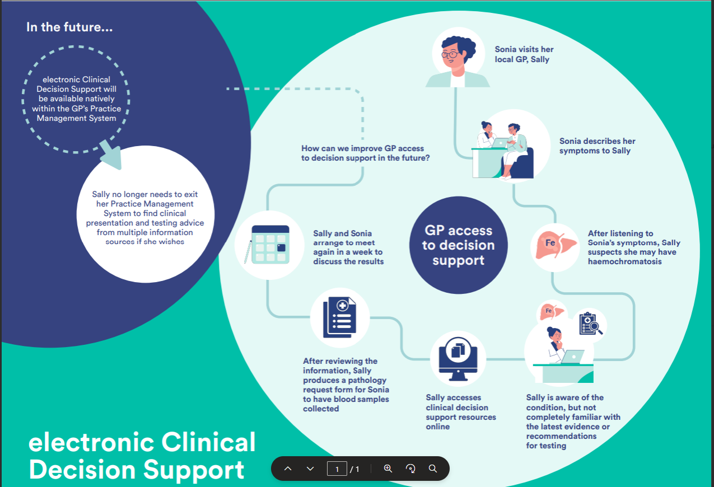
In relation to “passive” decision support i.e. tools which are not integrated into the workflow and practice management software, the RCPA Manual of Use and Interpretation of Pathology Tests (the Manual) was the leading source of information on pathology requesting based on the GP Survey; 30 of the 55 survey Respondents used the Manual. The other leading sources of information are RACGP Red Book (20 users, 36%), Health Pathways (18 users, 33%), My Health Record (16 Users, 29%), Therapeutic Guidelines (17 users, 31%) and Pathology Service Providers Manuals/ Catalogues (12 users, 22%).

Findings
The Findings from the Project align to Pathology Workflows (Objective 1 and 2); My Health Record (Objective 3); SNOMED CT compliance (Objective 1, 4); and eCDS (Objective 4). The findings from the surveys and consultations presented in the attached Final Report are ordered differently, sectioned into e-request, eCDS and MHR.

Pathology Workflows (Objectives 1,2)
- Paper pathology requests will remain for many reasons, including patient preference.
- e-requesting is used by many GPs, where it is available, and would be adopted by more with the use of telehealth. e-requesting solutions can further support GPs by providing more appropriate test list search functionality (including enhancements such as clinical decision support at the point of pathology request generation), providing an option to switch off paper requests, and providing advice on MBS rebated items.
- The availability of e-requesting does not lead to its use by some GPs for many reasons, including not being set up for all pathology providers, preference to use a hard copy to allow for choice, etc. Findings suggest that more technical work is required to ensure that fully functioning e-requesting functionality is available on the GP PMS, and that e-requesting must provide for patient choice of provider. Equally importantly there will be a need to undertake change management activities to progress the use of e-requesting by GPs. The following User Story highlights the future for patient choice:
- 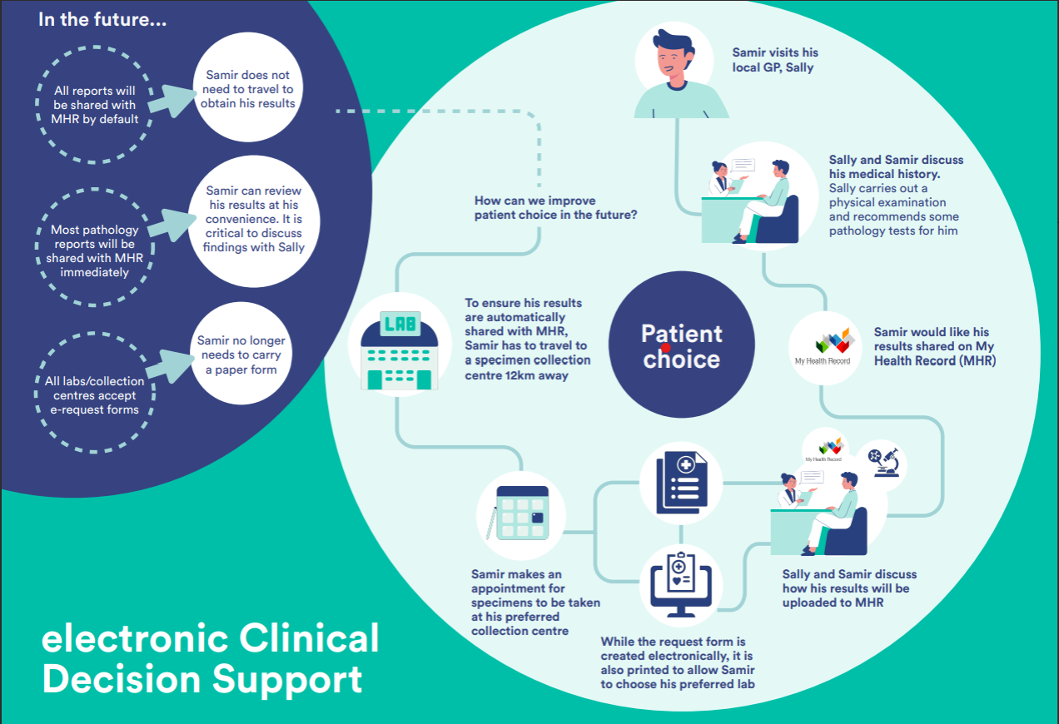A benefit that could be built into an e-requesting solution is the ability for the PSP to provide immediate feedback to, or seek clarification from, the requestor. This functionality is currently not available; if a digital information exchange was possible between the GP/ordering clinician and PSP (or pathology collection centre) this could benefit all by reducing the need for recollection, and improving the management, delivery and/or consumption of Medicare pathology related services. This would require a move away from HL7 batch processing to using modern information exchange standards.
- There is a requirement for e-requesting software to include information on MBS requirements, as GPs (and others) need to be able to access that information quickly within the consultation to inform patients.
- If telehealth services are provided at the clinician’s home address, the pathology request lists that address. If, as a workaround, a Head office is used, the reports go to the Head Office, not the requestor. Consideration needs to be given to the use of and access to personal information for GPs and other clinicians working from home, for example, in the case of telehealth services.
- For national telehealth providers, ordering and reporting of Diagnostic Imaging and Pathology is currently an issue. To receive secure e-requests, these providers need to subscribe to multiple services, so they simply use the larger providers.
- Feedback from PHNs on e-requesting is it is used intermittently, even when it is readily available. There are several IT steps that must be completed in a medical centre’s software for each PSP used by the practice, and often, this involves the enlistment of IT service providers both at the medical centre and the pathology provider end. It is not a simple “switch” in the software. Whilst this is currently a disincentive to use e-requesting, national digital standards for e-requesting could assist in resolving this issue.
- PHNs offer some digital support to GPs and should be considered as a local support resource in any campaign to broaden the use of e-requesting. PHNs have a detailed understanding of their stakeholders and local issues and are well positioned to provide valuable insights on the implementation of e-requesting within the GP desktop software.
- Any campaign to broaden the use of e-requesting should be implemented and funded for an ongoing period, not for a single year, to allow PHNs and others to support requestors on a more stable and productive basis.
- Whilst the majority of PSPs can receive e-requests, an e-receipt is not always provided. E-requests would benefit from e-acknowledgement, in accordance with RCPA SPIA Guidelines V4.1 (12.05 and 12.02b). Only half of PSP Survey respondents indicated this was currently in place.
- Feedback from PSPs suggests that if a national standard for e-requests was introduced and properly resourced (fiscally and with skilled resources), it could be implemented within a 5-year timeframe for the majority of PSPs, and 76% could be implemented in 3 years or less.
- Anecdotally, circa 50% of pathology requests contain clinical information or the reason for the request. However, follow up by laboratories to clarify or gather further information occurs significantly less than that, possibly due to PSPs experience and the time required for the pathologist to do so.
- The most important information to include on requests is current symptoms, relevant family/ genetic history, management of a known condition, and medication information.
- The primary reason, and one that’s seen as essential by most, for providing clinical information is to enable PSPs to interpret results in the appropriate clinical context.
- Jurisdictions are at differing stages of implementation for e-requesting, however feedback from the two consulted with (and the Project suspects others) significant advances are being made.
- Jurisdictions (and others) would benefit from assistance to map terminology (SNOMED CT, LOINC) to local order catalogues.
- Lack of FHIR expertise is a barrier to entry for the development of FHIR-based services for Jurisdictions (and likely others).
- The landscape for e-requesting is changing rapidly, including the Sparked Program initiative managed by CSIRO to progress standards for e-requesting, along with industry providing e-requesting capabilities. For example, Sonic Healthcare, and Magentus worked together to develop an e-requesting solution that enables referring specialists to provide laboratories with all relevant patient information electronically and in the future for patients to receive a digital version of their pathology request. Furthermore, the requestor can track the request, to see if it has been fulfilled. Sonic Healthcare Global CIO stated (ref: Genie Solutions partners with Sonic Healthcare to release e-request solution | Magentus| )
“As a digital-first workflow for diagnostic requests, e-requests have been helping clinicians provide digital pathology requests to patients, enabling tracking from the moment of creation to the delivery of results.
“The status of tests is also visible from the referring practice, which helps build more collaborative relationships by improving transparency between practices and laboratories.
“This is the perfect example of the kind of solution benefiting specialists and patients alike that can be developed in this interoperability space.”

MHR Findings (Objective 3)
- The majority of GPs do use MHR. Pathology results are the main data reviewed by GPs on MHR, although there are close contenders for views, including Discharge Summaries, DI Reports, and Medications. The volume of information on MHR is increasing; for example, a 40% increase in the volume of pathology reports uploaded in the last year to December 2023 (ref Australian Digital Health Agency Statistics (digitalhealth.gov.au).
- MHR would be used more readily if GPs were assured information was consistently available; if it was better integrated into the PMS; if it was easier to search and navigate; and whilst there is a single view for a pathology report, named “Pathology Overview”, the functionality could be improved upon for example navigation. Additionally, atomic data being available would allow for longitudinal analysis, the ability to download from MHR into the investigations section of the PMS directly (currently this goes to the Correspondence section for some), and that reports be presented in a consistent format.
- In relation to My Health Record, all PSP survey respondents noted that they could upload to MHR. However, only half rendered the report in the same manner as is provided to the GP. MHR was rarely used to look at previous laboratory results or clinical history, with 13% who do and the vast majority (88%) who do not.

SNOMED CT Compliance (Objectives 1,4)
Based on the analysis undertaken,
- there is currently little adoption of SNOMED CT-AU for e-requesting of pathology.
- Just under two-thirds of laboratory information systems are able to accept SNOMED CT
Note that whilst there are relatively few findings for SNOMED CT use, its use bears a direct relationship with e-requesting and eCDS. To exchange information unambiguously requires agreed terminology to be used in the data exchange.
The current initiatives being introduced under the Sparked FHIR Accelerator should see a marked increase in the use of SNOMED CT with the adoption of the RCPA SPIA Requesting Pathology Reference Set V4.2 (RCPA Resources).

eCDS findings (Objective 4)
- Whilst there was insufficient information (responses) to inform a position on eCDS use, there was a suggestion that it would support some GPs some of the time, depending on many factors including familiarity with the condition being managed. Future investigations should focus on those who would use eCDS and resource change management strategies to encourage use.
- The above finding from the survey was supported in the GP webinars; that is, whilst eCDS is generally supported, it will not be universally used, and when it is used, it will be more likely be for complex cases. There remain levels of concern about how Medical Software Providers may implement eCDS (with respect to associated quality and compliance issues), whether it will be complex and what the ‘drivers’ will be for the provision of eCDS.
- GPs need to be assured that evidence is up to date for both Active and Passive eCDS.
- The reasons for implementing eCDS need to be clearly stated; clinical autonomy is mandatory for any implementation of eCDS.
- GPs need to be confident that the development and implementation of eCDS is safe, current, evidence-based, clinically lead and trusted; concerns that it may do harm must be addressed.
- GPs use a wide range of passive decision support tools (which are effectively resources), and the RCPA Manual is one of these that is well recognised as a source of truth. eCDS knowledgebases should consider a wide range of information sources, which are evidence-based and relate specifically to General Practice (not imposing hospital or specialty based CDS which don’t translate to primary care)
- In terms of eCDS, PHNs have invested heavily in the implementation of Health Pathways, working with local hospitals and health services, and two of the PHNs consulted noted the integration into the PMS was useful in supporting local referrals.
- 88% of PSP survey respondents believed that eCDS would provide a more effective pathology service, with the remainder unsure. The main reasons for supporting eCDS were to improve efficiency, reduce unnecessary tests, identify under-utilisation (i.e. useful tests not ordered,) and reduce duplication.
- As with e-requesting, there are initiatives underway to advance eCDS. A prime example of this is Guidance Based Requesting, co-developed between Sonic Healthcare and Best Practice Software.
- This eCDS is now available for some Best Practice users who refer to Sonic Healthcare, and Sullivan Nicolaides Pathology noted the following key features (ref: Guidance Based Requesting | Sullivan Nicolaides Pathology (snp.com.au)):
  - Improve patient communication with customised resources and pre-test information.
  - Expand requestor scope of pathology investigations based on current and Medicare-compliant guidelines.
  - Refresh requestor clinical knowledge with access to up-to-date and reputable sources.

Challenges
Clinicians (and others) have multiple competing demands on their time. Whilst the level of support for the Project has been very high, in some cases, for example, the responses to the PSP Survey and attendance at the Medical Software Providers webinars, there was perhaps insufficient information to draw robust conclusions, and therefore some findings within the Report need to be considered in this context.
As with Stakeholder input above, there were also challenges with availability leading to an inability to attend meetings or provide input in a timely manner to meet project timeframes/deadline for the College to consider.
Whilst over 80 GPs did provide input into the Project, no responses were received from very remote communities, 2 from remote communities and 4 each from large rural centres and rural centres. Whilst this is likely reflective of the distribution of GPs, it meant that the hypothesis that e-requesting and eCDS would benefit more remote locations could not be readily tested. Similarly relatively few responses to the survey (9%) were received from GPs early in their practice, and this was a further target group; anecdotally, the PHNs did confirm that GPs tend to adopt digital tools earlier on in their practice and therefore are more likely to use them.
The Project was keen to engage with Medical Software vendors and contacted the MSIA on several occasions seeking assistance. As a final step, the Project contacted an MSIA Board member to obtain support and subsequently used that contact to then engage with several members of the medical software industry. However, initially, it was difficult to engage with ‘industry’ via the MSIA.
A future challenge will be to secure funding to support technical changes, and equally if not more importantly the support for greater use (change, engagement, adoption activities) with clinicians who request pathology.

Conclusions and Recommendations

Conclusions
The overall purpose of the Project was to identify factors that support, and barriers that prevent, digital health adoption in the Australian pathology sector. The project used a variety of mechanisms to identify these factors and barriers including mapping workflows and consulting broadly, as well as input, review and advice from the Working Group members.
The Project Consultation was significant and included GPs, Pathology Service Providers, the Medical Software industry, Primary Health Networks and others. With over 100 sources of input, including webinars, surveys and meetings, and in excess of 150 hours of contributed time, the Project team gained valuable insights into the use of technology for requesting and supporting decisions for requesting. The Project team acknowledges the input and thanks all contributors for their efforts.
Overall the Project was successful, using the information gathered to understand the current use and provide recommendations for future directions (below). Noting the success of the Project, there is a need to progress both e-requesting and eCDS to provide benefits for clinicians, Pathology providers and consumers, along with Federal, State and Territory Governments.
The RCPA continues to be actively engaged with digital health initiatives, including the Sparked FHiR initiative (Sparked (csiro.au)); and the Final Report (Appendix C) will be a useful summary for the Sparked Project and others to inform future directions.

Recommendations
The Department notes the end-to-end Workflows attached in Appendix B. The workflows provide details of each step within the Pathology request-test-report process, linkages to RCPA SPIA Guidelines V4.1, where paper and digital exchanges occur today and a series of notes on specific workflow steps.
Whilst there are a range of specific recommendations that have been made within the Final Report (Appendix C), and these should be referred to for further detail, some overarching recommendations are made below.
- The Department notes the outcome of the SPIA analysis and the need to progress SNOMED CT and LOINC for the requesting and reporting of Pathology.
- The Department notes the development of the SPIA Compliance tool, by the RCPAQAP and its potential for future use in SPIA compliance activities.
- The RCPA SPIA Guidelines V4.1, including but not limited to terminology, could be adopted as national standards; the inclusion of such standards as mandatory laboratory accreditation and assessment criteria under NPAAC should be considered.
- Exchanges of pathology requesting information would benefit from further information being provided where appropriate (for example current symptoms); supporting requesting with a series of business rules would also be beneficial, for example on additional tests.
- Exchanges of information should be asynchronous and bi-directional between the provider and requestor.
- Consideration is given in future developments and releases of MHR to address the findings outlined in relation to MHR usability. Use of MHR is increasing; however, greater certainty that information is available, better functionality and navigation (user experience), information structure, e.g. atomic data for longitudinal analysis, and integration into the clinical desktop and workflow would all lead to greater use.
- Report rendering on MHR is not always in the same format as provided to pathology requestors. Reports need to be rendered in a standard and consistent format, as per RCPA SPIA Guidelines V4.1, to reduce the time required for interpretation and reduce the risk of misinterpretation.
- eCDS should be progressed, as it assists many requestors some of the time, but not all requestors all of the time, with more appropriate ordering of pathology. There are a range of activities to support national clinical decision support knowledgebases, including governance, peer review of guidance, support and maintenance, and funding.
- A national Business Case should be developed to investigate models for an RCPA-endorsed national eCDS knowledgebase for implementation and use within the Australian health system.
- Implementation of e-requesting and eCDS be supported, including multi-year change management activities for implementation and adoption; national upskilling in FHIR resources; support for entities that contribute to national informatics content.

Appendix A – Activity Work Plan
 | Activity | Activity Owner | How will Contractual Activity be achieved and measured | Date Due | Status
1 | Project Kickoff
1.1 | EOI / Advertise for Project Officer/Consultant | PMO Manager | - Identify appropriate resource/s  - Appoint Project Officer/Consultant  - Project Officer appointed | Jul-23 | Completed
1.2 | Establish Overseeing Committee | Project Officer | - Identify appropriate stakeholders representative of key sectors and disciplines  - Appoint Steering Committee members  - Steering Committee members appointed | Jul-23 | Completed
2 | DOHAC Performance and Final Reports
2.1 | Performance Report 1 | Project Team | Submission to DoHAC | 30 January 2024 | Complete
2.2 | Performance Report Final | Project Team | Submission to DoHAC | 31 July 2024 | Complete
2.3 | Financial Acquittal Report | Project Team | Submission to DoHAC | 30 September 2024 | Complete
3 | Work Activities
3.1 | Undertaking a comprehensive analysis of the current manual and digital workflow processes for pathology tests and the requirements for an end-to-end digital workflow process. This will include the identification of current processes for the ordering of a pathology test to the generation of test results and analysis of compliance with the SNOMED CT / LOINC aligned RCPA SPIA (Standardised Pathology Informatics in Australia) Guidelines for electronic pathology requests (eReferrals) and electronic reporting of pathology tests.
3.1.1 | Mapped high level workflow processes for review and input by Project Team | Project Team | - Initial draft of the 12-step process including identification of manual and digital pathology information exchanges.  - Draft Workflows | 14 December 2023 | Complete
3.1.2 | RCPA SPIA Guidelines V4.1 and HL7 Standards Alignment | Project Team | - Workflows updated to include SPIA Guidelines and their relevant placeholder in the Workflow  - Workflows updated to include use of SNOMED CT and LOINC terminology within the Workflow  - Second draft of workflows | January 2024 | Complete
3.1.3 | Working Group initial review | Project Team | - Presented at Working Group and feedback incorporated  - Updated Workflows including notes and exception pathways  - Third draft of workflows | 6 February 2024 | Complete
3.1.4 | Working Group final review | Project Team | - Presented at Working Group  - Minor edits incorporated and endorsed as final  - Workflows finalised | 21 March 2024 | Complete
3.1.5 | Consultation as input to Workflows | Project Team | - Consultation with Pathology Service Providers (see 3.2 below)  - Consultation with GPs  - 69 GP responded to survey (against a target of 50)  - GP Webinars with 16 attendees  - Consultation with 3 Primary Health Networks  - Webinars with Medical Software Industry  - Significant consultation completed |  | Complete
3.2 | Undertake a survey of at least 90% of pathology service providers on current workflow processes and capacity to inform the analysis of the workflow processes towards identifying an end-to-end digital workflow process.
3.2.1 | Designed survey | Project Team | - Survey questions drafted and reviewed by RCPA Executive  - Draft PSP Survey | 26 September 2023 | Complete
3.2.2 | Tested survey with pathology key stakeholders | Project Team | - Survey content reviewed and agreed with by Pathologists  - Final PSP Survey for release | 3 October 2023 | Complete
3.2.3 | Compiled contact list for all pathology service providers at a state and national level | Project Team | - Identified key contacts for all Public and Private Pathology Service Providers  - PSP Contact List | 24 October 2023 | Complete
3.2.4 | Distribution; communications | Project Team  + RCPA Communications Team | - Online Survey distributed to all Public and Private Pathology Service Providers  Survey released to all Australian PSP | 9 November 2023 | Complete
3.2.5 | Analysis of survey responses | Project Team | - Survey responses analysed  Analysis used to inform workflows and recommendations in Final Report | 29 November 2023 | Complete
3.3 | Identify any gaps and/or barriers that would facilitate and support increased access to atomic or discreet data through My Health Record (MHR) and provide insights on known complexities, limitations and risks to uploading
3.3.1 | My Health Record interactions noted on Pathology Workflows (3.1 above) | Project Team | - Current state requesting and reporting information uploads to MHR identified on Pathology Workflows  - Future state requesting and reporting information uploads to MHR identified  - Target state for My Health Record for pathology requesting and reporting documented | 21 March 2024 | Complete
3.3.2 | GP Survey  GP Webinar | Project Team | - 69 GPs surveyed  - 16 GP Webinar attendees  - MHR usage and barriers identified within findings within the Final Report | 10 Nov 2023  29 Nov 23 | Complete
3.3.3 | PHN Consultation | Project Team | - Met with 3 PHNs  - Barriers to MHR uploads identified by PHNs (lack of auto uploads, etc) | November 2023 – January 2024 | Complete
3.3.4 | PSP Survey | Project Team | - PSP survey identified use (or otherwise) of MHR by PSP  - Feedback on use of MHR as source of clinical information, with findings within the Final Report | 29 November 2023 | Complete
3.4 | Develop a pilot to test the usability of electronic clinical decision support tools for pathology requesting by clinicians and develop strategies to support engagement, encourage best practice, and reduce inappropriate pathology requesting. This will include surveying a diverse range of GPs, including overseas trained GPs, newly trained doctors, mature GPs, GPs close to retirement and GPs different geographic locations (metropolitan, rural and remote areas).
3.4.1 | GP Survey designed | Project Team | - Survey questions drafted and reviewed by RCPA Executive  - Draft GP Survey | 27 September 2023 | Complete
3.4.2 | RACGP engagement  (Identify participating GPs through RACGP) | Project Team | - Consultation with RACGP on release of Survey to their members  - Draft communications to RACGP for release  - Survey released by RACGP  - GP Survey content finalised and released | 12 October 2023 | Complete
3.4.3 | GP Survey Analysis | Project Team | - GP responses analysed  - GP survey findings presented to Working Group for discussion  - Analysis used to inform workflows and recommendations in Final Report | 14 December 2023 | Complete
3.4.4 | POC – SPIA Compliance: Planning | Project Team + RCPAQAP | - Plan work with RCPAQAP and PI Pilot to understand the end-to-end SPIA Compliance for 7 tests and 6 Panels  - Plan for SPIA analysis agreed | 29 August 2023 | Complete
3.4.5 | POC – SPIA Compliance: work with PI Pilot | Project Team + RCPAQAP | - Leverage Pathology Informatics Pilot tests / panels for reporting to test SPIA compliance for requesting  - Agreed Panels and Tests to check for SPIA compliance | 29 August 2023 | Complete
3.4.6 | POC – SPIA Compliance: RCPAQAP development (quality indicators developed) | Project Team + RCPAQAP | - RCPAQAP developed SPIA compliance report for e-requests for pilot sites to assess the POC  - SPIA Compliance Report available | 31 January 2024 | Complete
3.4.7 | POC – SPIA Compliance: PSP participation (vendor participation) | Project Team + RCPAQAP | - Onboarding of SNP and SA Path  - SNP and SA Path provide sample test requests  - Participation in SPIA Compliance activities agreed with one public and one private PSP | November 2023 to February 2024 | Complete
3.4.8 | POC – SPIA Compliance: data validation | RCPAQAP | - RCPAQAP, SNP and SA Path undertake validation of requesting data  - e-requesting SPIA Compliance analysis complete | March 2024 | Complete
3.4.9 | POC – SPIA Compliance: Report | RCPAQAP | - RCPAQAP provide the SPIA Compliance Report for e-requesting  - Report on e-requesting SPIA Compliance analysis complete. Understanding of use of SNOMED CT within e-requests known. | June 2024 | Complete
4 | Communication & promotion of eCDS amongst stakeholders
4.1 | Communications Plan | RCPA Communications Team | - Engage with RCPA Communications Team to deliver the Communications Plan  Communication activities and audiences agreed | August 2023 | Complete
4.2 | Project awareness | RCPA Communications Team | - Project Web Page published  - RACGP Newsletter released (by RACGP Communications Team)  - Communications released on RCPA Pathology Today  - Promote via digital and newsletter | August 2023  October 2023  October 2023 | Complete
4.3 | Project Awareness | Project team | - Emails to other national bodies (ADHA, CSIRO, RACGP and MSIA)  - Promote via emails to Chief Executives of key stakeholders | September 2023 | Complete
4.4 | Project messaging | RCPA Communications Team | - Engage with RCPA Communications Team to develop user stories based on digital and manual pathology requesting workflows | April 2024 | Complete

Appendix B: Pathology end-to-end Workflows
