Quality Use of Pathology Program (QUPP) Final Report Prepared for the Commonwealth Department of Health
  - Project title: Developing an EQA to measure the Quality of Genomic Pathology Reports
Tony Badrick, Jason Tseung, Maddison Frogley and Brett A. Lidbury


Table of Contents | Page
Acknowledgements | 3
Objective and Aims | 3
Executive Summary | 3
Glossary | 4
Scope of Work | 5
Changes and limitations experienced during the QUPP funding period | 5
- Introduction | 6
- Methods | 9
- Results | 11
Narrative and manual report review | 11
Text-mining and clustering | 12
Model selection and validation | 20
Genetic pathology report template | 22
- Conclusions and Discussion | 25
- Future Research | 25
- References | 26
- Appendices | 28
Summary – Evaluation of the Activity against the Performance Indicators | 28
Additional text-mining results – Melanoma reports groups A, B and C | 29 – 33

Title: Developing an EQA to measure the Quality of Genomic Pathology Reports
Project Leaders:
Tony Badrick, CEO, Royal College of Pathologists Quality Assurance Programs (RCPAQAP), St. Leonards, NSW;
Brett A. Lidbury, Associate Professor, National Centre for Epidemiology and Population Health, The ANU College of Health and Medicine, The Australian National University.
Co-Investigators: Jason Tseng, Maddison Frogley, RCPAQAP, St Leonards, NSW.
Acknowledgements: The authors wish to thank RCPAQAP staff Sze Yee Chai for assisting with labelling of pathology reports for machine learning and preparation of reports, and Stella Lovell for project management.
Thanks to the staff in the NCEPH – College of Health and Medicine Research Offices (ANU) for general administrative support and the facilitation of contracts, payments and agreements between the ANU and the Commonwealth Department of Health.

Objective and Aims:
(1) The Objective of the Activity is to provide the Department with a model that will autonomously analyse genomic pathology reports against a list of elements that are considered representative of best practice in text-based patient reports, and
(2) The Aim of the Activity is to develop scoring routine for text-based genomic reports using machine learning technology.
For noting – The above-stated Aims/Objectives are not concerned with identifying individual laboratories or practitioners, but to develop system-level templates to allow the development of an effective and consistent communication channel for genetic pathology results. With the avalanche of genetic research and the advent new disease markers and innovation, this advance is vital to ensure rigorous but consistent reporting of complex results.

Executive Summary:
A standard for the reporting of genetic pathology results currently does not exist as a consensus, and often reflects an individual practitioner’s preferences. While some excellent reports are produced, there is an overall a lack of consistency on which details to report or to emphasise. With genetics knowledge being so complex, poor and/or inconsistent reporting could make the translation of pathology results to patient welfare more challenging than necessary.

Glossary:
Abbreviation | Description
ACMG | American College of Medical Genetics
AI | Artificial Intelligence
AMP | Association for Molecular Pathology
ASCO | American Society of Clinical Oncology
CAP | College of American Pathologists
cDNA | Complementary DNA
CRC | Colorectal Carcinoma
EGFR | Epidermal Growth Factor receptor
EQA | External Quality Assessment
ESHG | European Society of Human Genetics
FFPE | Formalin-fixed, Paraffin-embedded
GPT | Generative Pre-Trained Transformers
HGNC | HUGO Gene Nomenclature Committee
HGVS | Human Genome Variation Society
NCBI | National Center for Biotechnology Information
NGS | Next Generation Sequencing
NPACC | National Pathology Accreditation Advisory Council
NSCLC | Non-small cell lung carcinoma
QA | Quality Assurance
QAP | Quality Assurance Program
R-CNN | Region-based Convolutional Neural Network
RCPAQAP | Royal College of Pathologists of Australasia Quality Assurance Programs
RPAH | Royal Prince Alfred Hospital
VAF | Variant Allele Frequency
VUS | Variant of Uncertain Significance

Period of activity:
Total Project (October 2022 - August 2023); Final Report (October 2023).

Scope of Work:
This document will report on the aims, subsequent research activities and results, as stated in the original Funding Agreement (2022), and in accord with any subsequent mutually agreed updates.
As stated in the above agreements, the following activities were conducted and project aims achieved (Full details - Appendix A):
- Compile, clean anonymised records - (a) Includes conversion of PDF to text (.txt) format pre-analysis, and (b) Decide on keywords and definitions, as per Best Practice standards – informed by scoping review of literature and RCPA experience (subsequently supported by text-mining).
- Modelling of word patterns via text-mining and random forest pattern recognition algorithms - (a) For this activity random forest (RF) analyses were replaced by cluster analysis; (b) Develop and train machine learning model to identify key sections, and subsequently headings, of genetic pathology reports; (c) Develop scoring routines for reports.
- Final reporting and evaluation.
Context: Previous reports produced in response to samples sent by the RCPAQAP for quality assurance purposes were compiled for word – text retrospective analyses to determine the variety of reporting styles, including text patterns and report formatting, with a focus on genetic aberrations associated with melanoma.

Changes and limitations experienced during the QUPP funding period:
ANU ethics review was required to allow the involvement of ANU staff (i.e., Lidbury). Since the QAP has ongoing ethics approval via the Royal Prince Alfred Hospital committee (RPAH, Sydney) for access to tissues samples for quality assurance (QA) purposes, it was expected that ANU approval would be automatic under the “Projects with Prior Approval” condition as stated in the NHMRC National Statement (Chapter 5.3). However, approximately 5-6 weeks elapsed before approval was granted (first enquiry 16th August 2022, final approval 27th September 2022 - communicated by committee Chair on the 5th October 2022).
The delay was due to the ANU Human Ethics Committee’s (HREC) concern on participant consent to allow researcher access to their tissues. Ultimately, the HEC was convinced by the appropriate clauses of the NSW “Tissue Act” (1983), and our willingness to apply for a “Consent Waiver” for this project, which assured them that access to confidential patient information was impossible via their tissues and subsequent QAP reports (Consent Waiver document available upon request). The HREC was also insistent on the provision of original ethics documents submitted by the RCPAQAP to the RPAH committee some years earlier, which could not be located. However, in the end, approval was granted by the HREC Chair as a “Straightforward consent waiver – research arising from approved QA work with RPAH in Sydney”. This situation led to the longer than anticipated delay in analysing QAP sample reports derived from anonymous tissue samples, which is key to achieving our stated project aims (initially communicated in December 2022, Performance Report 1).

(1) Introduction
The pathology report is the principal means of communication between the pathologist and the clinician. However, there are few published guidelines on reporting structure and heterogeneity in actual practice. A 2018 review of 16 US laboratories found wide variability in content, format and length both within individual laboratories and across different ones (1), and this reflects the situation in Australia.
The National Pathology Accreditation Advisory Council (NPAAC) sets the standards of medical pathology practice in Australia, and these should form the basis of quality assessment of any RCPAQAP program. The requirements for Genetic Pathology reports are described in their Tier 2 (Requirements for Pathology Services) and Tier 4 (Requirements for medical testing of human nucleic acids) documents (2, 3). While the latter document is in the process of revision as “Medical testing for human genetic variation standard”, the section on pathology reports is not expected to change significantly.
For cancer somatic variant testing, the most relevant requirements are listed below (Table 1). Both the American College of Medical Genetics (ACMG) and European Society of Human Genetics (ESHG) recommendations cover similar headings (4, 5).
TABLE 1: The most relevant requirements to apply for thorough cancer somatic variant testing according to human/medical genetics societies from the US and Europe.
Report requirements for cancer somatic variant testing according to the
ACMG and ESHG - In order of report format
1. Identity of laboratories performing testing and issuing report, if different
2. Patient demographics (name, gender, age)
3. Unique identifier for each sample
4.Type of tissue tested and state (fresh, frozen, fixed)
5. Clinical details provided by referrer (history, purpose of testing)
6. Validated results
i. Must unambiguously identify genetic loci being assayed and reference sequence used
ii. Use of standard gene symbols and nomenclature from HGNC/HGVS/NCBI recommended. Common synonyms should not be the sole identifier.
iii. Interpretation of biological significance of rare variants should be provided and must address clinical question
7. Must state in simple terms scope of analysis performed
i. Coverage (targeted genes, exons, selected variants)
ii. Methodology, limitations and relevant kit set specifications
8. Date and time of report release
Han et al (2017) performed formal scoring of lung cancer EFGR testing reports as part of a proficiency testing scheme (6). While their cohort showed improvement in performance from 2014 to 2016, recurrent errors in analytical and clinical interpretation were present. A similar RCPAQAP pilot project on assessing the quality of 2021 solid tumour genetics report is in progress, which scored reports based on the headings summarised in Table 2.
Clinical reporting of somatic variants in tumours is largely driven by underlying actionability. The AMP/ASCO/CAP has derived an evidence-based classification standard (7) as below (Fig. 1). In addition, they recommended inclusion of sequencing depth and variant allele frequency (VAF) in reports. The ClinGen somatic working group has recently published as adjunct for assessment of novel variants, based on the ACMG germline classification guidelines (8). We do not expect laboratories to include adjunct classifications at this stage.
Somatic cancer variants are also curated in online databases (9). These contain information beyond the scope of individual pathology reports, but provide clinically relevant data headings.
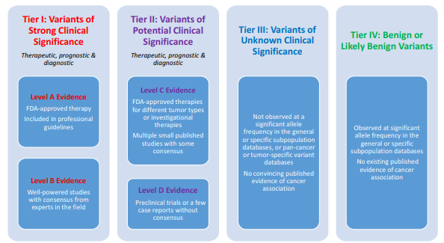
Figure 1: ASCO/AMP/CAP clinical classification tiers for somatic cancer variants.(Conceived by Li et al. (7)).
TABLE 2: Headings utilised by the RCPAQAP to score solid tumour genetics reports (2021) while assessing report quality.
Referrer name | Referrer contact details | Reporting lab logo/name
QA Program participant ID | Date sample received | QA Program sample ID
QA Program sample subset | Internal sample ID | Tumour site
Tumour type | Tissue type (FFPE) | Tissue form (slides/ribbon)
Tumour purity | Test requested by QAP | Test performed
List of genes tested | List of specific loci tested | Covers requested genes
Result | Genomic coordinates | Reference sequence
Reference sequence location | cDNA position | Protein change
Exon location | Correct diagnosis | Relevant negatives stated
Additional variants reported | Sequencing depth (NGS) | VAF (if NGS based)
Result summary | Variant description | Gene function
Protein domain | Predictive/prognostic value | Variant classification
Variant database cited | References cited | Instrument used
Limitations of method | Scientist responsible | Pathologist responsible
Stated as verified/complete | Completion date | Page numbering
 | Errors
Definitions: QAP (Quality Assurance Programme); NGS (Next-Generation Sequencing); FFPE (Formalin-fixed, Paraffin-embedded); VAF (Variant Allele Frequency).

(2) Methods
Data: A collection of 118 anonymous melanoma genetics reports submitted in April 2021 for the RCPAQAP Mutation Detection in Melanoma external quality assessment (EQA) program formed the text corpus for investigation, and represented reporting styles from private and public pathology departments from each Australian state and territory, and New Zealand, as well as the UK, Hong Kong and South Africa. As described above, full human ethics approval was granted under the established protocol in NSW, as well as by the ANU human research ethics committee (HREC) after some discussion (explained above).
Analysis: To achieve the aim of developing a standard report template to ensure the highest quality transmission of genetic pathology results, three strands of investigation were employed. They were -
(a) Narrative review and analysis of the field specific peer-reviewed academic and professional literature, as well as pertinent NPACC regulations, by a genetic pathologist;
(b) Text-mining supported by cluster algorithms to identify consistent word patterns within sample reports;
(c) Application of machine learning models to predict and identify document features;
Based on results from (a) - (c), then
(d) Establish a prototype report template to embed into pathology online reporting networks.

(a) Narrative Review
A literature search using internet services (PubMed, Google) and professional body (ACMG, NPAAC, ESHG) guidelines highlighted eight headings pertinent to best practice in genetic test reporting, summarised in Table 3. The headings were used to label targeted sections of participant reports for text mining and machine learning. Two key studies (1, 6) assessing reports using similar headings were identified and reviewed as a component of this investigation.

(b) Text-mining and clustering
From a corpus of 118 genetic pathology (melanoma) reports previously submitted to the RCPAQAP for quality assurance evaluation, word cluster patterns were detected via text mining (R statistical programming, “tm”, “cluster”, “SnowballC” etc packages), representing the most prominent word frequencies and associations (10, 11). These analyses allowed the detection of the most frequent words in the corpus, as well as cluster (association) patterns summarised by dendrogram and 2-dimensional cluster axes. With word (i.e., definition, heading, term) clusters identified, these were aligned with the results of the narrative review (a) and used to populate the optimal format as derived from the machine learning investigations (c).

(c) Prototype report template
With reference to Tables 1 - 3 and Figure 1, establish report headings with cross-reference to text-mining results that identified common past report terms, words and definitions. Similarly refer to the narrative review results and text-mining to recommend sub-headings as well as questions to guide genetic pathology reporting. Once developed to this point, the resulting template will be validated by the results of report structure analyses as determined via Transformer models (Vaswani A. et al, 2023).
TABLE 3: Eight report headings and attached information used to guide the genetic pathology narrative review of the literature by an expert pathologist (with reference to ACMG, NPAAC, ESHG guidelines).
Heading | Relevant fields within
Administrative | Lab name, referrer, verification personnel, collection date, report date
Patient & sample information | Name, DOB, lab accession, sample type, histological diagnosis, % tumour content
Clinical question | Clinical history, test requested and indication
Result | HGVS nomenclature, reference sequence, genome built, VAF, sequencing depth
Interpretation | Gene function, variant effect, population data, literature evidence, classification
Recommendation | Treatment/further testing implications, clinical trials, literature evidence
Test scope & limitation | Methodology, limits of detection, target gene/variants
Summary | Succinct conclusion of findings
Supported by Makhnoon et al 2018 (1) and Han et al 2017 (6).

Model Selection and Validation Process:
- Model Selection – The models chosen for assessment encompass Fast-RCNN, Fastr-RCNN, cascade-RCNN, LayoutLMv3, and LiLT (Wang, J et al, 2022). These models were selected as they are commonly used in document AI tasks and have demonstrated promising results in previous studies. All models chosen for assessment were previously finetuned against either the FUNSD (G. Jaume et al, 2019) or DocLayNet (B. Pfitzmann et al, 2022) Datasets.
- Custom Dataset Preparation – Melanoma reports were imported into LabelStudio (M.Tkachenko et all, 2020) and manually labelled with bounding boxes for document layout and named entity recognition.
- Model Fine Tuning – To further enhance the models' performance and adaptability, they were subsequently fine-tuned against the custom labelled dataset. This custom dataset is specifically designed to address any shortcomings or specific requirements of the document AI tasks being performed.
- Model performance was then validated using the F1 Score (SA Hicks et al, 2022), a harmonic mean of precision and recall.

(3) Results – Project Activity Reports
The project results comprise three separate investigations (narrative review, text-mining, report formatting via AI), with the consolidation of results from these three themes contributing to the final outcome, namely, a standard reporting structure for genetic pathology (report template).

Narrative and manual report review:
Table 3 above summarises results from the narrative review of the guidelines and literature, and provides the basic heading structures and associated details. Under this rubric, solid tumour genetic pathology reports submitted for EQA modules at RCPAQAP were reviewed (Tables 4 and 5) using binary scoring of whether data from specific categories was present or absent. The manual review found significant inconsistency in reporting (Table 4). The best reported details (included in 100% of reports) were; QA Program sample ID, Test performed, and Result. Conversely, Genomic coordinates, Protein domain and Variant database cited were recorded in fewer than 25% of reports evaluated, with only <1% (14/655 reports) including Genomic coordinates. Furthermore, none of the reports provided the genome build used, which is necessary to interpret the genomic coordinates correctly.
χ² testing was used to look for differences in report quality across different times and laboratories. When looking at performance over time, only melanoma reports were examined to match the dataset used for machine-based learning assessment. Aside from feedback provided by standard assessment provided by RCPAQAP, EQA participants received no additional active intervention or education and we hypothesised the quality of the reports would remain largely unchanged. Indeed, for melanoma reports submitted in 2021, 2022 and 2023, there were no significant difference (p <0.05) between the quality of reporting in 37 of 45 categories.
The 8 categories showing significant difference were inclusion of QA sample subset, tissue type, test requested by referrer, tumour type, tumour site, associated therapy and use of variant database and references. Individual reports were reviewed to try and identify the underlying cause for these differences.
In 2021, 2 of the 24 participating laboratories did not provide information on associated therapy and literary references. One of these laboratories only submitted instrument generated reports and did not re-participate in 2022 and 2023. The other laboratory participated EQA in 2021, 2022 and 2023, but only incorporated the information in their reports from mid 2022 onwards. Also, 4 glass sections and 1 tissue ribbon sample was used in the EQA program in 2021. Tissue ribbon samples were not used in the other years and many laboratories failed to document this particular tissue type – it was only documented in 48% of reports in 2021, as opposed to 63-72% in the other years.
In 2022, only “melanoma” was given as the clinical history for 2 of the 4 EQA samples. This minimal history paradoxically led to a higher inclusion of tumour type and tumour site that year (86-93% compared to 61-79% other years). Two of the samples carried RAS mutations and were BRAF wildtype. At that time, RAS mutations had no associated therapy and many laboratories elected to include additional background information on RAS variant descriptions comments (57% vs 22-35% other years).
No convincing explanation were postulated for the difference in QA sample subset and test requested by referrer. The % inclusion were variable across all three years and did not show a continuous trend (92, 72, 82% for QA sample subset and 13, 25, 7% for test requested by referrer for 2021, 2022 and 2023 respectively).
The number of modules enrolled by laboratories were used as a surrogate for the size and possibly, expertise of individual laboratories. We compared the performance of laboratories enrolled in one module against laboratories enrolled in all nine modules over this period. Their performance differed in 22 out of 45 categories, and 9 module-laboratories performed better in 20 of these compared to 1 module-laboratories. The only two categories where 1 module-laboratories were superior were administrative only – the inclusion of their laboratory name and the primary analyst. The 9 module-laboratories used a variety of testing methods including next generation sequencing (NGS). On the other hand, none of the 1-module laboratories used NGS for their testing methods, explaining the total discordance in VAF and sequencing depth comparisons. These results were only possible using NGS.

Text-mining and clustering:
Via R statistical programming, text analyses of a RCPAQAP melanoma report corpus (n = 118 separate reports) was achieved through text-mining algorithms and supporting cluster methods. For the evaluation of word consistency, the reports were randomly divided into three sub-groups for primary investigation and subsequently analysed as an entire combined corpus. The resulting word frequencies and associations are summarised in Table 6.
Results were generally consistent across individual sub-groups, and were divided into strong, moderate or weak cluster associations. The strongest were patterns of common words expected from a report – for example, “collect”, “refer”, “clinic”, “sample”, with scattered context words (e.g., “tumour”). Such contextual words, e.g., “clinic”, overlapped with the moderate cluster group, while others were unique to this class as more specialised terms (“sequence”, “gene”). “Melanoma” featured for the moderate and weak classes. The weakest cluster associations were highly technical terms focussed on the tumour, namely, the key mutation, BRAF, supported by reference to “mutation” and “variants”. Interestingly, NRAS did not feature at sufficient frequency.
Table 6 results were derived from cluster plots and dendrograms generated from the analysis of the entire melanoma corpus (Figures 2 a-b), with word frequency summarised by Figure 3. The separate Group results (A, B & C) are presented in Appendix B.
Figure 2a presents word clusters via a dendrogram format, with word cluster distance (d) on the x-axis and the measure of similarity (Height) on the y-axis, while Figure 2b displays the same results as a component 1 versus 2 cluster plots. Figure 2b shows dense word clustering for cluster 2, with the least density for cluster 1. Inspection of the Figure 2a shows words like “patient”, “type”, “use” and “result” (red boxes) as ranging at less than 50 to less than 20 on the Height scale, indicating tight associations between those and other terms clustered nearby. Alternatively, cluster 1 comprises “BRAF”, “mutat(ion)” and “variant” with height and distance showing greater Euclidian distance between these terms, which as indicated (Table 6), is related to specialist genetic terminology. The “mutant”, “BRAF”, “melanoma” relationship (blue box - Figure 2a) is illustrative of this point, with greater specialisation linked to sparser associations.

TABLE 4: Results from an RCPAQAP pilot study (unpublished data) summarising variable quality within reporting categories (pages 14 – 15).
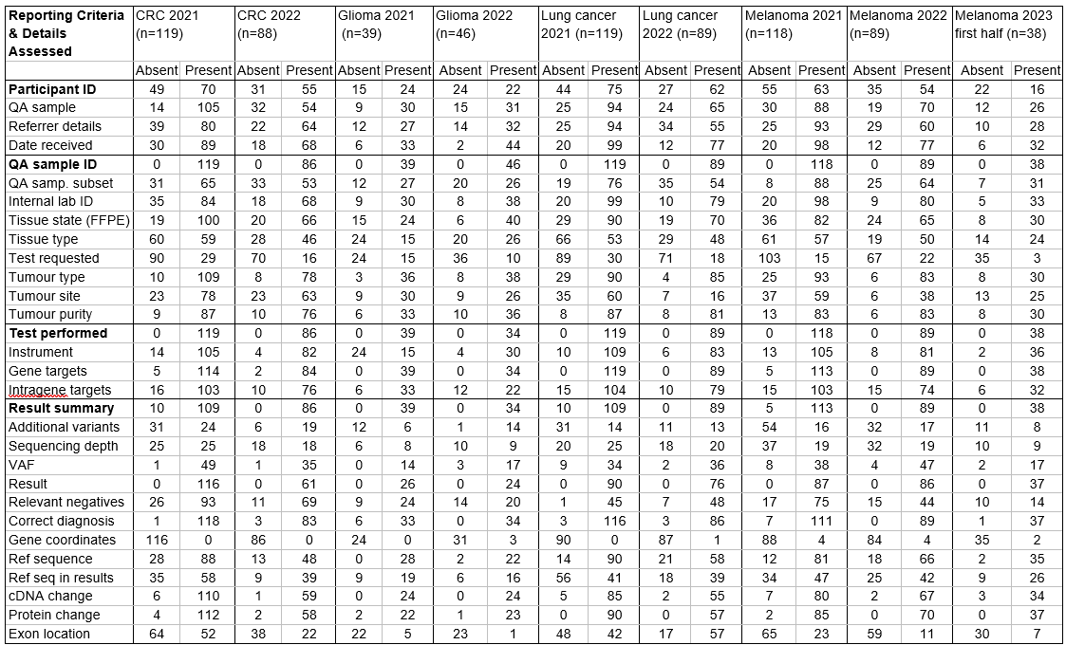
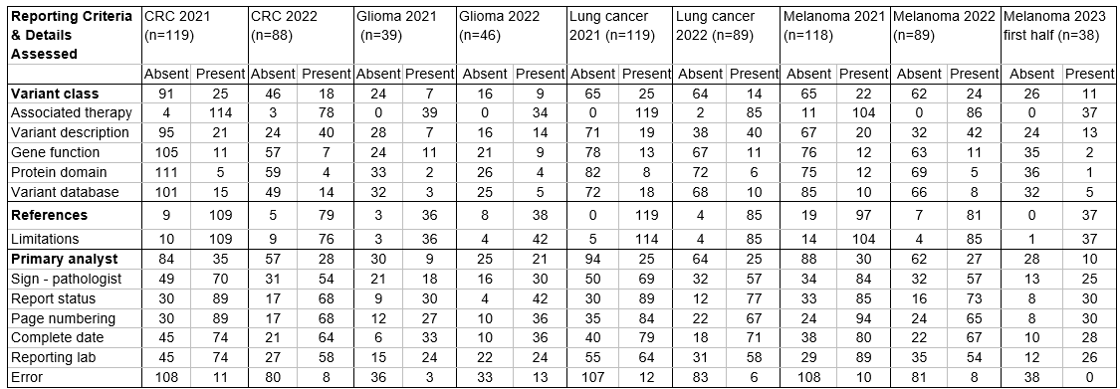
655 reports from nine EQA surveys collected between April 2021 to April 2023 were available. 45 categories were reviewed, grouped according to headings provided in Table 3. The sum of reports where categories were present/absent would not match the total when these were irrelevant in the context of the result, such as cDNA or protein changes when no mutation was present. Absolute counts were provided to facilitate comparison by X² testing (Table 5). Error was a reverse coded category where absence reflected good performance.
A significant difference between comparison groups is represented by a p-value < 0.05. The quality of melanoma testing reports in 2021, 2022 and 2023 showed differences in only 8 categories. Possible explanations were provided in the discussion above. Conversely, differences exist in 20 categories between laboratories enrolled in only one EQA module and those enrolled in all nine available modules over the same period.

TABLE 5: χ² test comparing (1) Performance of melanoma testing EQA results between 2021-23 and (2) Laboratories enrolled in one module versus all nine modules over the same period.
Report Criteria | Melanoma reports 2021, 2022, 2023 |  | 1 enrolment labs vs 9 enrolment labs
Report Criteria | c² statistic | p-value | c² statistic | p-value
Participant ID | 3.77 | 0.15 | 14.87 | <0.005
QA sample stated | 1.52 | 0.47 | 0.56 | 0.46
Referrer details | 3.42 | 0.18 | 15.43 | <0.005
Date received | 0.47 | 0.79 | 17.92 | <0.005
QA sample ID | Total concordance |  | Total concordance
QA sample subset | 12.25 | <0.005 | 0.2 | 0.66
Internal lab ID | 2.00 | 0.37 | 33.14 | <0.005
Tissue state (FFPE) | 1.33 | 0.52 | 1.89 | 0.17
Tissue type | 10.91 | <0.005 | 2.19 | 0.14
Test requested | 7.69 | 0.02 | 0.25 | 0.62
Tumour type | 8.79 | 0.01 | 72 | <0.005
Tumour site | 8.85 | 0.01 | 29.16 | <0.005
Tumour purity | 5.45 | 0.07 | 70.1 | <0.005
Test performed | Total concordance |  | Total concordance
Instrument | 1.14 | 0.56 | 1.49 | 0.22
Gene targets | 5.49 | 0.06 | 33.53 | <0.005
Intragene targets | 0.74 | 0.69 | 2.54 | 0.11
Result summary | 5.49 | 0.06 | 4.18 | <0.005
Additional variants | 3.55 | 0.17 | 16.77 | <0.005
Sequencing depth | 1.10 | 0.58 | Total discordance
VAF | 2.13 | 0.34 | Total discordance
Result | Total concordance |  | Total concordance
Relevant negatives | 5.71 | 0.06 | 0.01 | 0.91
Correct diagnosis | 5.71 | 0.06 | 3.3 | 0.07
Gene coordinates | 0.07 | 0.97 | 0.91 | 0.34
Ref sequence | 5.73 | 0.06 | 13.98 | <0.005
Ref seq in results | 2.77 | 0.25 | 21.45 | <0.005
cDNA change | 2.03 | 0.36 | 20.29 | <0.005
Protein change | 2.49 | 0.29 | 1.1 | 0.29
Exon location | 2.67 | 0.26 | 0.19 | 0.67
Variant class | 0.30 | 0.86 | 29.65 | <0.005
Associated therapy | 12.34 | <0.005 | 50.36 | <0.005
Variant description | 19.52 | <0.005 | 1.95 | 0.16
Gene function | 2.17 | 0.34 | 12.88 | <0.005
Protein domain | 4.64 | 0.10 | 5.14 | 0.02
Variant database | 0.25 | 0.88 | 10 | <0.005
References | 8.98 | 0.01 | 61.98 | <0.005
Limitations | 5.50 | 0.06 | 3.69 | 0.055
Primary analyst | 0.64 | 0.73 | 33.64 | <0.005
Signing pathologist | 1.26 | 0.53 | 0.43 | 0.51
Report status | 2.96 | 0.23 | 3.69 | 0.055
Page numbering | 1.35 | 0.51 | 2.65 | 0.10
Complete date | 1.50 | 0.47 | 0 | 0.97
Reporting lab | 5.16 | 0.08 | 10.25 | <0.005
Error | 3.59 | 0.17 | 3.05 | 0.08
(a)

Distance (d)
(b)

Figure 2: (a) Dendrogram presentation of word clusters detected in 118 melanoma genetics reports previously submitted to the RCPAQAP for quality assurance purposes (b) The same results as for (a) but presented as two-dimensional clustering patterns (71.54% point variability explained).

TABLE 6: Strongest to weakest word clusters found in previously submitted RCPAQAP Melanoma reports (n = 118), as informed by text clustering analyses. The report sample was divided randomly into approximately equal sub-groups (Groups A, B, C) prior to analysis, and investigated individually and finally as a combined total sample.
Report Group Analysed | Strongest Associations | Moderate Associations | Weakest Associations
Group A | Collect  Refer  Inhibitor  Sample  Tumour  Clinic  Number  Result  Metastat(ic)  Interpret  Page  Molecular | Report  Test  Detect  (Variant) | BRAF  Mutat(ion)  Melanoma
Group B | Molecular  Interpret  Inhibitor  Number  Result  Patient  Sampl(e)  Type  Receiv(e)  Request  Refer  Dob (date of birth)  Collect  Page | Melanoma  Sequence  Clinic  Gene  Test  Detect | BRAF  Mutat(ion)  Variant  Report
Group C | Type  Patient  Tumour  Number  Result  Collect  Request  Inhibitor  Interpret | Sequence  Melanoma  Report  Clinic  Test  Detect  Gene | BRAF  Mutat(ion)  Variant
Groups ABC | Type  Patient  Tumour  Number  Result  Collect  Request  Inhibitor  Interpret  Patholog(y)  Sampl(e)  Refer  Molecular | Sequence  Melanoma  Report  Clinic  Test  Detect  Gene | BRAF  Mutat(ion)  Variant
As well as clusters (Figures 2a.b), word frequency (count of individual words within the total corpus of 118 reports) was assessed (Figure 3).
Figure 3: Individual word frequencies found in the corpus of 118 individual RCPAQAP melanoma reports (Groups A, B & C) previously submitted for quality assurance evaluation. Only words with a frequency of > 150 were included.

The most frequent words (in order) for the melanoma corpus were; “mutat..”, “BRAF” (> 750 occurrences), “variant”, “detect”, “report”, “test”, “melanoma”, (> 500 occurrences). Other words with a frequency > 150 appearances were emblematic of genetic and molecular investigations in the medical context, such as “gene”, “inhibitor”, “sequence”, “clinic”, “result”.
From 118 reports, 12 did not mention the primary gene of interest, “BRAF”, with 9/12 incidences due to incomplete or failed PDF to text (.txt) scans, and the three others stating either “No mutation detected”, or only reported NRAS and/or other melanoma associated genes. On cross-checking the original PDF reports, the 9 empty scans did mention BRAF in text. The frequency of BRAF when stated in reports (n = 106) ranged from 1 to 16 separate occurrences per report, reflecting the range of analytical depth applied by the various laboratories.
The word frequency results (Figure 3) suggest an interesting feature of these reports. BRAF for example, is the second most frequent word in the examined corpus, which makes sense as the leading gene of interest in melanoma. However, as found via cluster analysis the association with other specialised genetics terms was there, but not as strongly as found for other common report terms. Taking the 106 reports that featured BRAF, at an estimated total frequency of 800, proposes an average of approximately 7.5 occurrences per report (which agrees with the calculated median BRAF frequency of 7.0 and mean of 7.14 per report). This suggests that while BRAF is a frequent word, it does not fit a regular pattern within the structure of the reports analysed.

Model Selection and validation:
Model selection and validation are significant stages in any machine learning process, more so for complex tasks such as Document Artificial Intelligence (AI). Document AI primarily involves tasks like layout detection, form parsing, and Named Entity Recognition (NER) which determine the structure, content and relevance of information in a document. This article will delve into the process of model selection – the comparative analysis of model capabilities and the validation process which determines the accuracy, precision, and overall performance of chosen models.
To illustrate the model selection and validation process, we focus on five models – Fast-RCNN, Fastr-RCNN, cascade-RCNN, LayoutLMv3, and LiLT. These models were fine-tuned on the 'docLay' dataset, a dataset that primarily focuses on document layout analysis. Following the initial fine-tuning, the models were further finetuned on a custom-labelled dataset, created exclusively to meet the unique needs of our project.
Fast-RCNN, Fastr-RCNN, and cascade-RCNN are all variants of the Region-CNN (RCNN) model that uses region proposals to identify objects within an image, in this case, components within a document for layout detection. Fast-RCNN improves upon the RCNN model by introducing a Region of Interest (RoI) pooling layer and adding a fully connected layer after it. Fastr-RCNN takes it a step further by including an additional Region Proposal Network (RPN) stage for generating object proposals. Cascade-RCNN introduces cascading stages in the RCNN architecture to enhance the localisation capacity of the model.
LayoutLMv3 and LiLT, on the other hand, are transformer-based models that consider both the textual content and positional information of the components for document understanding. LayoutLMv3 builds on the LayoutLM model by adding improved positional embeddings while LiLT uses a language-independent approach, incorporating Bi-Directional Attention Complementation (BiACM), and self-supervised pre-training tasks to improve joint text-layout understanding.
A primary aspect to consider in model selection is the performance of these models. In this case, the Fast-RCNN, Fastr-RCNN, and the cascade-RCNN models suffered from poor performance. While they offer some beneficial aspects like the capacity for object detection and localisation, they fall short when handling complex document layouts which require careful analysis of both text and positional information. They were unable to efficiently analyse and differentiate between multiple components with similar characteristics within a document.
LayoutLMv3 and LiLT had superior performance outcomes compared to the RCNN variants. These models, with their advanced understanding of the relevance of text and layout, were more adept at identifying, categorising, and analysing document structure and content. However, it is also essential to consider licensing restrictions when selecting a model. LayoutLMv3 is under the restrictive Creative Commons License CC BY-NC-SA 4.0, which limits the use of this model for commercial purposes. In contrast, the LiLT model carries an MIT license, which offers broad permissions including for commercial use, making it a more viable choice for wide-ranging applications.
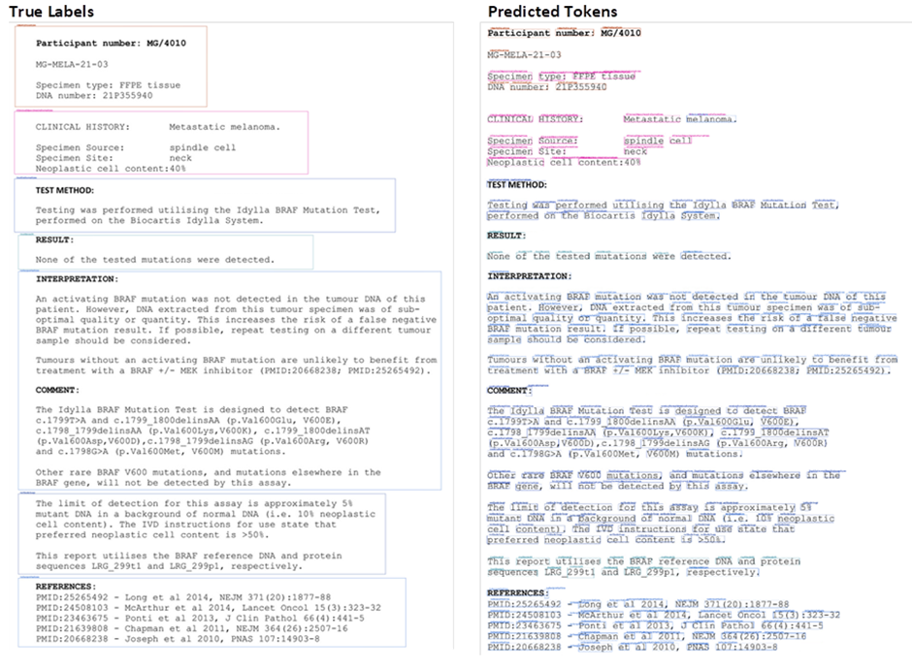Figure 5: Side by side comparison of an example document for the document Layout task. Left the true labelled document, Right the predicted token classes.
During model validation, the performance metrics of the chosen models are assessed. For our task, the primary metric was the F1 score, a harmonic mean of precision and recall, which gives a better measure of the incorrectly classified cases than the accuracy metric. For the task of document layout detection, the LiLT model achieved an impressive F1 score of 0.75. For Named Entity Recognition (NER), a task that identifies entities of interest within the text, the LiLT model scored above 0.9 on the Layout Detection task.
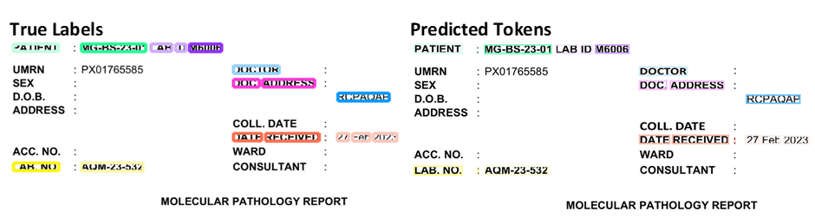
Figure 6: Side by side comparison of an example document for NER on a given report section. Left the true labelled document, Right the predicted token classes.

The high scores on these validation metrics indicate the LiLT model is adequately optimised to balance precision and recall, making it an effective tool for structured document understanding tasks. These validation results further cement the choice of the LiLT model over the others for tasks of document layout detection and NER.

Genetic Pathology Report Template:
Based on the results from (a) narrative reviews, (b) text-mining and clustering, and (c) GPT field analyses, the proposed report structure and content are as follows (Tables 8 and 9).
Table 8 summarises administrative headings in relation to terms identified via narrative review investigations by a genetic pathology expert and text-clustering, while Table 9 takes this model template further to a final recommendation of a genetic reporting structure after the addition of insights from Named Entity Recognition (NER) and associated form field analyses. Table 9 represents the final, standard genetic reporting tool recommended by this project.
The recommended genetic reporting template was the result of both subjective (expert) and objective (text-mining, NER) methods ultimately combined to produce a reporting structure supported by evidence obtained via melanoma reports previously submitted to the RCPAQAP.

TABLE 8: Proposed genetic pathology report template modified from the eight report headings and attached information used to guide the genetic pathology narrative review of the literature by an expert pathologist (with reference to Table 3), with cross-referencing to word clusters identified by text-mining (Table 6 and Figures 2 - 3).
Heading | Terms - Headings (Narrative) | Terms - Headings (Text-Clusters)
Administrative | Lab name, referrer, verification personnel, collection date, report date | Patient, Collect, Request, Refer
Patient & sample information | Name, DOB, lab accession, sample type, histological diagnosis, % tumour content | Patient, Tumour, Inhibitor, Sample, Type, Molecular
Clinical question | Clinical history, test requested and indication | Sequence, Report, Clinic, Test, Detect, Gene  Melanoma (or tumour of interest)
Result | HGVS nomenclature, reference sequence, genome built, VAF, sequencing depth | BRAF, Mutation, Variant, Sequence, Detect, Gene, Report, Clinic(al), (Melanoma)
Interpretation | Gene function, variant effect, population data, literature evidence, classification | BRAF, Mutation, Variant, Report, Clinic, Gene, Test, Detect, Sequence (Melanoma)
Recommendation | Treatment/further testing implications, clinical trials, literature evidence | Sequence, Clinic, Gene, Test, Detect (Melanoma)
Test scope & limitation | Methodology, limits of detection, target gene/variants | BRAF, NRAS (minimum)
Summary | Succinct conclusion of findings | Selection from all clusters - Type, tumour, molecular, gene …
Italicised text - Common words detected by narrative review and text clusters;
Underlined text - Suggestions for additional words, terms, headings.

TABLE 9: Final genetic reporting template derived from previous melanoma report (n = 118) analyses.
Major Report Heading | Information Required
Administrative | Lab name, referrer, verification personnel, collection (Request) date, report date
Patient & sample information
Clinical question
Result * | Reference sequence and database  Specific gene tests  Depth of sequencing  BRAF - (Yes/No)  Other Gene(s) - (Yes/No)  If Yes: Mutation, Variant, Sequence detected
Interpretation | Tumour Gene/Sequence detected  Variant and effects  Sequence/Gene/Protein function  Classification  Population data  Supporting literature (including mention of gene databases)
Recommendation
Test scope & limitation | BRAF, NRAS (minimum)
Summary | Tissue sample collected - gross description and histology  Clinical inferences  Sample preparation  Sequencing method  Supporting database  Gene/sequence detected  Prognosis suggested by mutation
Footnotes | * Report as NPAAC nomenclature

(4) Conclusions and Discussion
The genetic pathology reporting template presented was designed according to evidence gathered from a combination of pathologist expertise and agnostic machine learning methods, namely, text patterns and formatting structures. While the narrative review by a pathology expert considered several cancer examples for guidance (1,4,5-9), the machine learning text and structure investigations relied upon genetic pathology reports concerning melanoma only (n = 118). Therefore, whether the results reported herein can be generalised to the reporting of genetics for other conditions will need further consideration. A RCPAQAP study on this topic that commenced in 2021 is ongoing, and will provide further insights into Australian genetic reporting (solid tumours) in future (Table 2).
Interest in genetic reporting has attracted prior scholarly attention, and helps to inform current regulation via bodies like NPAAC (2,3). The study by Han et al. evaluated genetic pathology reporting (EGFR mutation) for invited laboratories and compared 53 examples each from 2014 (N = 74) and 2016 (N = 231), with improvements in reporting noted when 2016 was compared with 2014 (6). The Han et al. investigation was particularly valuable since it developed discrete metrics and evaluation criteria to score reports, and therefore identify broader quality trends under specific report headings (e.g., “Anatomical origin of sample”). Identified as in need of particular attention was the reporting of “molecular diagnosis”, as well as poor adherence to HGVS nomenclature (5 - 9). Examples of poor nomenclature practice included, “ … improper description of nucleotide change”, “ … absence of nucleotide change (e.g., “L858R, wild-type”), “ … incomplete description of an undefined deletion or insertion”. Other issues identified within the genetic reporting domain include; lack of guidelines for VUS reporting (1); alignment with ISO15189 standards recommended to assist reporting (5); suggestion of a four-tier system of classification (7 - see Figure 1). Some publications suggest a range of databases, either existing or developed by them, as reference tools to support contemporary genetics interpretation and reporting (7 - 9).

(5) Future Research:
The results presented were drawn from investigations of melanoma reports previously submitted the RCPAQAP for quality assurance monitoring. Future studies will similarly evaluate reports for other tumours submitted to the RCPAQAP under the EQA requirements. Other tumour examples available via the RCPAQAP are colorectal, non-small cell lung carcinoma, and glioma.
From an analytical perspective, further development of GPT tools and associated algorithms that allow the investigation of text/heading structures, with reference to the vast array of reporting structures available via the world-wide web, will further promote our capacity to synthesise evidence and apply this to a range of tasks, including additional research into the objective pursued within this project.
The immediate follow up task is to apply the reporting rubric constructed for melanoma to other tumour types, and assess whether the melanoma format is generalisable. It can be expected that the basic administrative headings and attached details will remain consistent between tumour types, but in light of ever-expanding research into human genetics the scientific and technical aspects of the reporting structure will require flexibility to accommodate advances in the field. One can speculate that in the not-too-distant future epigenetic features associated directly with tumours, or tumour suppressors - enhancers, will require space and consideration within reporting structures. Technological advances in computing and the molecular acuity of abnormality detection in DNA and RNA samples will very likely to continue at a rapid rate, and likewise, will require accommodation within reporting structures.

(6) References
1. Makhnoon S, Shirts BH, Bowen DJ, Fullerton SM. Hereditary cancer gene panel test reports: wide heterogeneity suggests need for standardization. Genet Med. 2018 Nov;20(11):1438-1445. doi: 10.1038/gim.2018.23. Epub 2018 Mar 1. PMID: 29493582.
2. NPAAC Requirements for medical pathology services (2nd ed 2018)
3. NPAAC Requirements for medical testing of human nucleic acids (2nd ed 2013)
4. Rehm HL, Bale SJ, Bayrak-Toydemir P, Berg JS, Brown KK, Deignan JL, Friez MJ, Funke BH, Hegde MR, Lyon E; Working Group of the American College of Medical Genetics and Genomics Laboratory Quality Assurance Commitee. ACMG clinical laboratory standards for next-generation sequencing. Genet Med. 2013 Sep;15(9):733-47. doi: 10.1038/gim.2013.92. Epub 2013 Jul 25. PMID: 23887774; PMCID: PMC4098820.
5. Deans ZC, Ahn JW, Carreira IM, Dequeker E, Henderson M, Lovrecic L, Õunap K, Tabiner M, Treacy R, van Asperen CJ. Recommendations for reporting results of diagnostic genomic testing. Eur J Hum Genet. 2022 Apr 1. doi: 10.1038/s41431-022-01091-0. Epub ahead of print. PMID: 35361922.
6. Han Y, Zhang R, Lin G, Zhang K, Xie J, Li J. Quality Assessment of Reporting Performance for EGFR Molecular Diagnosis in Non-Small Cell Lung Cancer. Oncologist. 2017 Nov;22(11):1325-1332. doi: 10.1634/theoncologist.2017-0042. Epub 2017 Jul 12. PMID: 28701573; PMCID: PMC5679822.
7. Li MM, Datto M, Duncavage EJ, Kulkarni S, Lindeman NI, Roy S, Tsimberidou AM, Vnencak-Jones CL, Wolff DJ, Younes A, Nikiforova MN. Standards and Guidelines for the Interpretation and Reporting of Sequence Variants in Cancer: A Joint Consensus Recommendation of the Association for Molecular Pathology, American Society of Clinical Oncology, and College of American Pathologists. J Mol Diagn. 2017 Jan;19(1):4-23. doi: 10.1016/j.jmoldx.2016.10.002. PMID: 27993330; PMCID: PMC5707196.
8. Horak P, Griffith M, Danos AM, Pitel BA, Madhavan S, Liu X, Chow C, Williams H, Carmody L, Barrow-Laing L, Rieke D, Kreutzfeldt S, Stenzinger A, Tamborero D, Benary M, Rajagopal PS, Ida CM, Lesmana H, Satgunaseelan L, Merker JD, Tolstorukov MY, Campregher PV, Warner JL, Rao S, Natesan M, Shen H, Venstrom J, Roy S, Tao K, Kanagal-Shamanna R, Xu X, Ritter DI, Pagel K, Krysiak K, Dubuc A, Akkari YM, Li XS, Lee J, King I, Raca G, Wagner AH, Li MM, Plon SE, Kulkarni S, Griffith OL, Chakravarty D, Sonkin D. Standards for the classification of pathogenicity of somatic variants in cancer (oncogenicity): Joint recommendations of Clinical Genome Resource (ClinGen), Cancer Genomics Consortium (CGC), and Variant Interpretation for Cancer Consortium (VICC). Genet Med. 2022 May;24(5):986-998. doi: 10.1016/j.gim.2022.01.001. Epub 2022 Jan 29. PMID: 35101336; PMCID: PMC9081216.
9. Danos AM, Ritter DI, Wagner AH, Krysiak K, Sonkin D, Micheel C, McCoy M, Rao S, Raca G, Boca SM, Roy A, Barnell EK, McMichael JF, Kiwala S, Coffman AC, Kujan L, Kulkarni S, Griffith M, Madhavan S, Griffith OL; Clinical Genome Resource Somatic Working Group and Clinical Interpretation of Variants in Cancer team members. Adapting crowdsourced clinical cancer curation in CIViC to the ClinGen minimum variant level data community-driven standards. Hum Mutat. 2018 Nov;39(11):1721-1732.
10. R Core Team. R: A language and environment for statistical computing. 2019. R Foundation for Statistical Computing, Vienna, Austria. https://www.R-project.org/
11. Feinerer I, Hornik K (2020). _tm: Text Mining Package_. R package version 0.7-8, https://CRAN.R-project.org/package=tm

(7) Appendices:

Appendix (A)

Summary - Evaluation of the Activity against the Performance Indicators
What are the key milestones for this project that will identify that you have achieved the objectives of the project? | Milestone Status: Dec 2022 – August 2023
1a. Compile, clean anonymised records. Convert PDF to text (.txt) format pre-analysis.  1b. Decide on keywords and definitions, as per Best Practice standards – informed by scoping review of literature and RCPA experience. | 1a. Achieved.  1b. All data compiled, cleaned and pattern rules designed post keywords and definitions established.
2a. Modelling of (1) with text-mining and random forest pattern recognition algorithms  2b. Integrate machine learning software into routine Labware software routines.  2c. Develop scoring routines for reports. | 2a. Achieved (NB. Random forest replaced by cluster analyses).  2b. Partly achieved (Machine learning model developed and trained to identify key sections of genetic pathology reports).  2c. Achieved
3. Final reporting and evaluation.  (Publish results and findings in peer-reviewed journals and other literature) | 3. Partly achieved (Final report completed; Publication pending)

Appendix (B)

Frequency, Dendrogram and Cluster plots for separate Group A, B or C tranches taken from the entire corpus of 118 melanoma reports. In-text results report the combined Group A-C analysis.

Group A:

Group B:
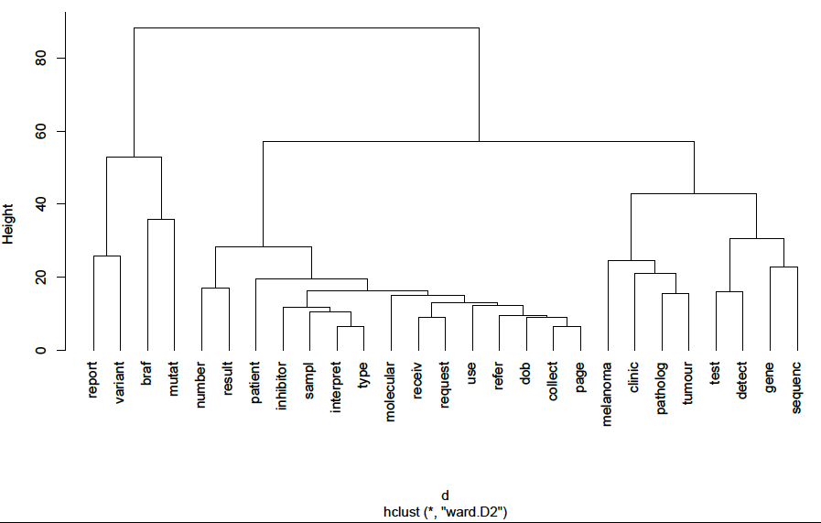
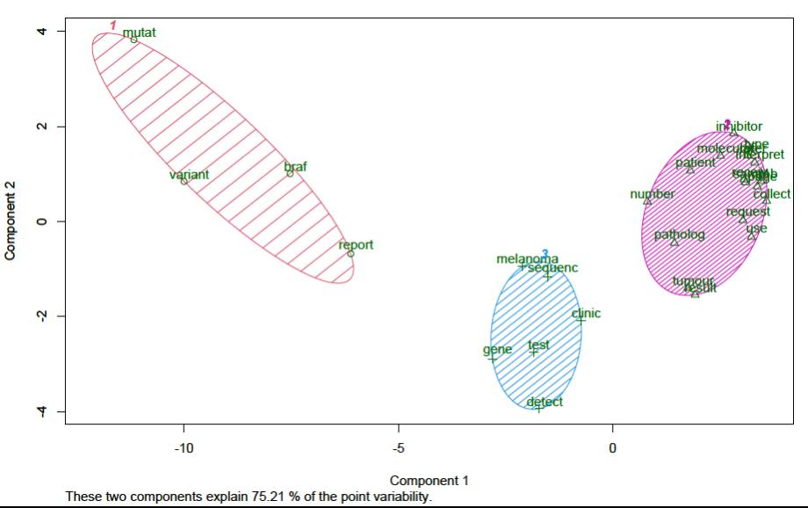

Group C:
