


Testing, testing 1, 2, 3 - Rational pathology testing in general practice
A multifaceted educational intervention for general practitioners to promote best practice in pathology ordering.
Delivered by Medcast
Final Report: 26th March 2024
Activity ID: 4-H0MGX7E
Table of Contents
1 Executive Summary 3
2 Project Introduction & Statement 5
3 Scope 6
3.1 Online Learning Modules 6
3.2 Webinars - Small Group Learning 7
3.3 In-practice activity - Mini Audit 7
3.4 Clinical opals and blogs 7
3.5 Podcasts on The Check-Up 7
3.6 Course Promotion and Communication 7
4 Results 8
4.1 Education Uptake 8
4.2 Demographics 8
4.3 Education outcomes 10
5 Challenges 11
5.1 New Accreditation Requirements 11
5.2 Common themes throughout the program 11
6 Conclusion 11
7 Future Directions 12
8 Attachments 13

Executive Summary
The Quality Use of Pathology Program (QUPP), funded by the Department of Health, provides grants for projects that improve the management, delivery or use of Medicare pathology services. Medcast was awarded a grant in 2022-2023 for an multifaceted education program to promote best practice in pathology ordering by general practitioners (GPs) across Australia.
Medcast designed, developed and implemented a successful multifaceted intervention called ‘Testing, Testing 1,2,3’, to support GPs to use pathology tests more effectively, and reduce the harms of non-rational test ordering.
The key outcomes of the project:
- Free, high-quality GP education: multifaceted education program was delivered that included eLearning, Resources, Live Webinars (Small Group Learning format), In-practice Activity (mini audit), Clinical Opals (case based blogs) and a series of Podcasts.
- Exceeded targets for enrolments and interactions: The program had a target of 1,000 GP participants. The program significantly exceeded target numbers with 2,624 unique enrolments in educational activities and 5,000+ interactions with blogs and podcasts. Medcast’s existing audience of GPs was a key driver of the success of the program.
- National reach: GPs from across Australia participated in the education with strong representation from regional and remote areas, as well as significant coverage in metropolitan areas. GPs representing all states and territories participated, helping to achieve a truly national reach.
- Over 10 hours of accredited Continuing Professional Development (CPD): The learning was designed to meet the Medical Board of Australia’s (MBA) standards enabling participants to claim CPD hours across all categories of CPD. The course was accredited with the Royal Australian College of General Practitioners (RACGP) and Australian College of Rural and Remote Medicine (ACRRM).
- Efficient delivery and exceptional user experience: The program was delivered online via Medcast’s scalable Learning Experience Platform (LXP) designed specifically for health professional education. Online delivery reduced the barriers to access and ensured cost-efficient delivery. Participants valued the interactive online format for its accessibility and the opportunity for reflection and discussion with peers.
- Improved confidence in rational use of pathology: participants reported an increased confidence in the rational use of pathology for screening, diagnosis and monitoring post-activity compared to pre-activity. In the pre-course survey an average of 67% of GPs reported they were confident or very confident in rational use of pathology. This increased to 91.5% of participants in the post course survey.
- Demonstration of test ordering behaviour change: A comparison of pre and post course case-based scenario questions revealed that GPs reduced the ordering of inappropriate or potentially harmful tests after completing the education.
- Excellent participant feedback: program participants provided excellent feedback on the course with an average Net Promoter Score (NPS) of 65 (= excellent) across the activities. Participant feedback also reflected that the program increased awareness, influenced behaviour change, and supported GPs with strategies to exercise rational test ordering in practice.
- Intention to change test ordering practice: an average of 87% participants intended to change their practice as a result of completing the live webinars, mini-audit and/or online learning module. This finding was reinforced in the qualitative feedback.
"I have already started ordering fewer tests as a result of this learning experience."
"I will pause and reconsider my test order behaviour."
"I will try and order testing based on assessment and appropriateness."
"Order less pathology tests! Less screening tests."
The program was highly successful, significantly exceeding the targets set for reach and demonstrating excellent outcomes in terms of increased knowledge and confidence and an intention to change test ordering behaviour post intervention. The multifaceted educational intervention served as a reinforcing activity for experienced GPs, whilst also supporting those newer to the profession with practical strategies for rational use of investigations in clinical practice.
There is potential to extend the impact of this education to reach even more Australian GPs with subsequent cost savings to the health system through reduced test ordering and minimisation of patient harm. A similar multifaceted educational intervention, CHIME-GP, led by Medcast was found to have potential MBS cost savings as a result of changing in pathology test ordering behaviours. Read more here.
The program content could be expanded to include education on the management of more specific presentations to General Practice that are low values or for which it is common for inappropriate test ordering to occur. In addition, there could be more education for GPs to help increase their confidence and reduce the fear of litigation if they choose not to order tests.

Project Introduction & Statement
The Quality Use of Pathology Program (QUPP) project led by Medcast in 2022 - 2023 aimed to promote best practice in pathology ordering for general practitioners (GPs) nationwide.
In Australia, the number of Medicare-funded pathology tests increased by over 50% from 2011 to 2021 according to Medicare data. While much of this increase was appropriate, a growing body of evidence suggested that overtesting is a significant problem with 70% of Medicare funded pathology tests initiated by GPs.
Overtesting is problematic for both overall health care expenditure and the potential for patient harm. There have been a number of described influences on the test ordering behaviour of doctors. These consist of doctor factors (e.g., demographics, knowledge, prior experience, personality, fear of litigation); patient factors (trust, anxiety); practice factors (billing practices); and systems factors (development of new tests).
The Medcast QUPP program aimed to change test ordering behaviour by:
- Educating GPs on the range influences on test ordering behaviour.
- Reinforcing the potential costs, adverse effects and harms of inappropriate test ordering.
- Supporting GPs to apply strategies for rational use of investigations in clinical practice.
- Reduce patient harm from inappropriate tests.
Medcast hosted and delivered a suite of online educational material for GPs over a 6 month intervention period. The online nature of the activity ensured GPs nationwide had the option to access the material at their convenience.
GPs were surveyed on their knowledge and confidence relating to test ordering in practice prior to and following educational interventions to determine the impact of the educational interventions on individuals participating.
Medcast leveraged it’s database of GPs to promote educational interventions and accredited the live interactive sessions, online learning and mini audit with the Royal Australian College of General Practitioners (RACGP) and the Australian College of Rural and Remote Medicine (ACRRM) to increase reach and ensure national educational standards were met. All educational interventions contributed to GPs annual CPD requirements under the Medical Board of Australia. The education was intentionally designed to enable doctors to record hours across all categories of CPD.

Scope
The QUPP project was a multifaceted educational program promoted to GPs nationwide. The range of activities freely available on the Medcast platform enabled GPs to select activities of interest and delivery modes which suited their schedules. In total the program offered 10+ Hours of learning to GPs.
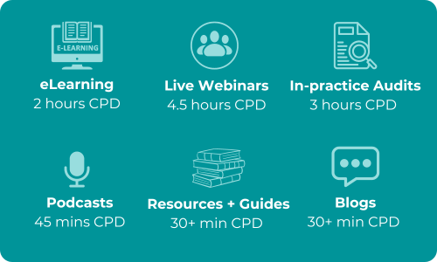

Online Learning Modules
The eLearning component of the program was a self-paced educational package hosted on the Medcast Learning Experience Platform (LXP) covering the following content:
- Influences on test ordering behaviour.
- Costs, adverse effects and harms of inappropriate test ordering.
- Strategies for rational use of pathology tests in clinical practice.
Quick reference guides
Quick reference guides were developed by the Medcast clinical team to provide GPs with a valuable, easily accessible resource which can be used in practice.
- The ‘Six Hexagons’ for rational test ordering was a simple step-by-step guide to aid GPs to implement strategies to ensure rational test ordering in day-to-day practice. (see appendix)
- Guides on rational use of specific pathology tests were also created for many common pathology tests. These were all downloadable via the Medcast platform within the course as PDF’s and contained hyperlinks to other valuable resources including the RACGP Red Book and Choosing Wisely Australia. (see appendix)

Webinars - Small Group Learning
The live component of the program consisted of 3 peer group learning sessions, one on each on the rational use of pathology.
- Session One - Screening
- Session Two - Diagnosis
- Session Three - Monitoring

In-practice activity - Mini Audit
The in-practice component of the program was a mini-audit. This activity complemented learnings from both the eLearning and Live Webinars. The mini audit on completion provided GPs with a total of 3 Hours of CPD, with accreditation allocation including 0.5 hours of ‘educational activities’ and 2.5 hours of ‘measuring outcomes’ under the 2023-25 accreditation guidelines.

Clinical opals and blogs
Numerous clinical opals and blogs were released throughout the program.
- Clinical Opals: provided clinicians with short clinical cases with best practice guidance on rational use of pathology.
- Blogs: Short updates on the program and promotional material with reference to upcoming education.

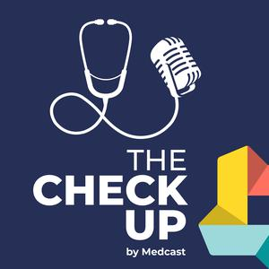
Podcasts on The Check-Up
Medcast’s podcast channel ‘The Check-Up’ hosted a 3-part series as part of the Testing, testing 1, 2, 3 program. The podcasts were hosted by Dr Simon Morgan (program clinical lead) and Dr Justin Coleman (program clinical support) and were released weekly from mid 2023.
Topics included the harms of testing, pressure to test and strategies relating to rational test ordering. All podcasts were available via popular podcast apps.

Course Promotion and Communication
With over 18,000 GPs as part of Medcast’s audience profile, the promotion of the program leveraged our existing audience through internal channels such as Electronic direct mail (eDM) targeting, newsletters and Medcast social media channels.
External promotion was also undertaken through a variety of channels including PHNs, RACGP and GP training providers.

Results

Education Uptake
The program target was 1,000 GP participants. At the conclusion of the program, targets were exceeded with 2,624 unique medical professionals enrolling in one or more activities in the ‘Testing, Testing 1,2,3’ Program. Similarly, the informal learning activities such as blogs and podcasts were consumed by clinicians with 5,000+ ‘views’ or ‘listens’ of these activities. Breakdown by learning activity is included in the table below:
 | Activity | Total Enrolments
 | eLearning | 853 (unique GPs)
 | Live Webinars | 1,006 (unique GPs)
 | Mini audit | 765 (unique GPs)
 | Sub-total (formal learning) | 2,624 (unique GPs)
 | Blog views | 2,757
 | Podcasts | 2,282
 | Sub-total (informal learning) | 5,000+

Demographics
The following charts demonstrate the demographics of health professionals that enrolled into one or more of the formal learning activities. In summary, the program participants were:
- Primarily Medical Practitioners (96%), speciality General Practice, which was the target audience for the education with a small number of Nurse Practitioners also participating in the training.
- Majority of the participants (61%) were female.
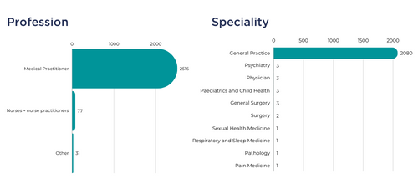
Participants were located in rural, remote and metropolitan areas across Australia. With metropolitan based participants 52% and non-metro (rural and remote) 45% of the total.
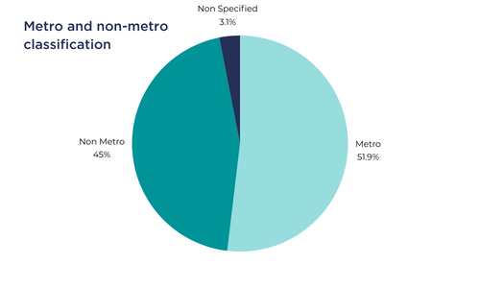
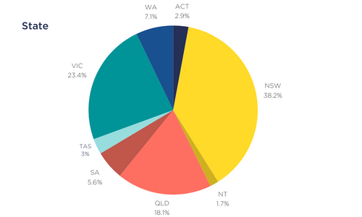

Education outcomes
The success of project objectives was measured through evaluation via pre and post quizzes, scenarios, ratings, evaluation questions and net promoter score (NPS).
Intention to change practice: At the conclusion of each intervention, participants were asked if they intended to change their practice (test ordering behaviour) as a result of completing the educational activity. Over the three educational activities, on average 87.3% participants intended to change their practice as a result of completing an activity as part of the ‘Testing, testing, 1, 2, 3’ program.
Increase in confidence: When surveyed, 91.5% of participants reported being confident or very confident in rational test ordered post-intervention, compared to 67% pre-intervention.
Increase in reported knowledge: Pre and post course quiz analysis measured change in knowledge and revealed a pre-course quiz average grade of 52% compared to a post-course quiz average of 75%. In addition, key themes in evaluation data revealed that quality use of pathology CPD is not nearly as common as other CPD types and/or topics. Completing an intervention in the QUPP program increased GP awareness of the influences of test ordering, having an almost instant impact on practice.
NPS Score: NPS scores remained strong throughout the program with the Live Webinars having the highest NPS score of 73 (see footnote for more information about NPS). The average NPS score over the program was 65.3.
Learning outcomes met: Overall, participants felt the learning outcomes and their expectations of the program were entirely met (>75% over the 3 interventions).
Participant Feedback: Qualitative feedback about the education was collected from participants. Feedback was thematically analysed and the key themes identified are further evidence that the education program successfully achieved its objectives by increasing knowledge and confidence, influencing a change in practice, making GPs aware of the influences on test ordering, emphasising the costs and adverse effects of inappropriate tests and providing practical strategies for rational test ordering. Participants also appreciated the online format for its accessibility and the opportunity for reflection and peer discussion.

Challenges

New Accreditation Requirements
The QUPP program commencement coincided with the start of the new CPD triennium for GPs. The 2023-25 triennium brought significant changes implemented by the Medical Board of Australia, including the introduction of 3 core CPD categories with various requirements (educational activities, reviewing performance and measuring outcomes).
It was a priority of the project team to ensure that the Testing, testing 1, 2, 3 program provided participants with CPD from all 3 categories. The biggest challenge was to incorporate the reviewing performance category into the live sessions. Meeting accreditation requirements meant the activity needed to be hosted as a series, with GPs having to attend all 3 sessions. This posed the challenge of offering enough times and days for the sessions to ensure it was as easy as possible for our GP audience to attend.
This issue was addressed by running the 3-part series 3 times throughout the year (with a total of 9 live sessions hosted) and running the sessions on different days of the week (Tuesdays, Wednesdays and Thursdays) to provide participants with as many options as possible.
The 3-part series was very successful and well received by the GP audience, however attending all 3 sessions was clearly a difficult commitment for a number of participants (reflected through customer service enquiries). This also contributed to overall lower completion rates of the entire webinar series.

Common themes throughout the program
Throughout the evaluations and comments made within the live webinar sessions, a common question and/or concern was pressure from patients felt by medical professionals to order tests. This brought to light other worrying factors in practice such as fear of litigation and fear of missing important diagnosis.
These factors were addressed in some components of the program, however do show a need for further support and education on quality use of medicines for our health professionals.

Conclusion
The QUPP program surpassed target numbers with 2,624 unique enrolments in educational activities and more than 5,000 interactions with blogs and podcasts.
NPS scores remained strong throughout the program with the Live Webinars having the highest NPS score of 73 (= excellent).
In all instances where confidence assessments were measurable, participants felt more confident in the rational use of pathology for screening, diagnosis and monitoring post-activity compared to pre-activity.
Overall, participants felt the learning outcomes and their expectations of the program were entirely met (>75% over the 3 interventions was achieved).
Quotes from each evaluation demonstrated that GPs were able to apply learnings from all educational activities directly into practice without delay. This demonstrates the success of achieving key program objectives; changing test ordering behaviour by supporting GPs to apply strategies for rational use of investigations in clinical practice.
Overall, the program proved to be a highly successful educational opportunity for the GP and nurse participants, reinforcing learning for GPs who have been practising for many years, whilst also supporting those newer to the profession with practical strategies for rational use of investigations in clinical practice.

Future Directions
Medcast recommends that this highly successful program continues with the aim to augment and amplify the reach. A program extension could facilitate engagement with a number of other organisations to help support the review, development and amplification of the program to target the training for GP supervisors, registrars, and consumers.
The existing educational content could be tailored for interventions with GP Supervisors and GP Registrars. In addition, consumer organisations could be consulted to ensure the education for health professionals is patient-centred and future work may include the design of complementary consumer resources.

Attachments
- The ‘Six Hexagons’ for Rational Test Ordering
- Guide - Rational Use of Specific Pathology Tests

Australian Institute of Health and Welfare. (2022). Pathology, imaging and other diagnostic services. Retrieved from https://www.aihw.gov.au/reports/diagnostic-services/pathology-imaging-and-other-diagnostic-services
NPS data is the gold standard for consumer experience metrics, with all participants of the program being asked the following question: On a scale of 0-10, how likely are you to recommend this activity to a colleague? The NPS score provides a snapshot of the overall participant experience with the higher the rating, the more likely the participant is to recommend the activity to a colleague, indicating a high level of satisfaction. The overall NPS score aggregates all individual scores and provides an overall NPS score which can be anywhere between -100 to +100. The scoring framework for NPS is as follows: - Above 0 is good - Above 20 is favourable - Above 50 is excellent - Above 80 is world-class
NPS - Above 0 = good , Above 20 = favourable, Above 50 = excellent, Above 80 = world class

