Evaluation of the Implementation Plan for the National Palliative Care Strategy
Palliative Care
27 July 2025


Nous Group acknowledges Aboriginal and Torres Strait Islander peoples as the First Australians and the Traditional Custodians of country throughout Australia. We pay our respect to Elders past, present and emerging, who maintain their culture, country and spiritual connection to the land, sea and community.
This artwork was developed by Marcus Lee Design to reflect Nous Group’s Reconciliation Action Plan and our aspirations for respectful and productive engagement with Aboriginal and Torres Strait Islander peoples and communities.
Disclaimer:
Nous Group (Nous) has prepared this report for the benefit of the Department of Health, Disability and Ageing (the Client).
The report should not be used or relied upon for any purpose other than as an expression of the conclusions and recommendations of Nous to the Client as to the matters within the scope of the report. Nous and its officers and employees expressly disclaim any liability to any person other than the Client who relies or purports to rely on the report for any other purpose.
Nous has prepared the report with care and diligence. The conclusions and recommendations given by Nous in the report are given in good faith and in the reasonable belief that they are correct and not misleading. The report has been prepared by Nous based on information provided by the Client and by other persons. Nous has relied on that information and has not independently verified or audited that information.
© Nous Group

Contents
Glossary 3
Executive Summary 5
Background and Context 9
KEQ 1 Access: How has access to palliative care changed over the five-year reporting period? 12
KEQ 2 Collaboration - To what extent has collaboration and knowledge sharing improved and what changes are evident in service delivery across care settings? 29
KEQ 3 To what extent has ACP increased and what evidence is there of improved shared decision making across care settings? 36
KEQ 4 What nationally consistent data mechanisms have been implemented over the five-year reporting period and how has this assisted in national reporting? 45
KEQ 5 Has the allocation of resources to the implementation of the Strategy been efficient? 51
Opportunities for improvement 54
Appendix A | Methodology 56

Glossary
Acronym/term | Definition
ACP | Advance Care Planning
ACD | Advance Care Directive
AIHW | Australian Institute of Health and Welfare
CCCME | Country Consolidated Client Management Engine
CRiSTAL | Criteria for Screening and Triaging to Appropriate Alternative
CPCiAC | Comprehensive Palliative Care in Aged Care Measure
EOL | End Of Life
GCfAHPC | Greater Choice for At Home Palliative Care Program
GP | General Practitioner
HAC | Hospice in Aged Care
MBS/PBS | Medicare Benefits Schedule/Pharmaceutical Benefits Schedule
M&E | Monitoring & Evaluation
NHDH | National Health Data Hub
NHMD | National Hospital Morbidity Database
NPCP | National Palliative Care Project
NPCS | National Palliative Care Strategy
NPHED | National Public Hospital Establishments Database
PACOP | Palliative Aged Care Outcomes Program
PACSA | Palliative Care Self-Assessment
PCA | Palliative Care Australia
PCOC | Palliative Care Outcomes Collaboration
PCSiA | Palliative Care Services in Australia
PEPA | Program of Experience in the Palliative Approach
PRG | Program Reference Group
PHN | Primary Health Network
PREMS/PROMS | Patient Reported Measures
RACF | Residential Aged Care Facility

Executive Summary
The National Palliative Care Strategy (the Strategy) was released in 2018 and had an overarching purpose to:
be used by all Australian governments, as well as organisations and individuals, in guiding the improvement of palliative care across Australia so that people affected by life-limiting illnesses get the care they need to live well. The National Strategy provides a shared direction and an authorising environment for the continual improvement of palliative care services throughout Australia.
The Strategy is supported by an implementation plan (the Implementation Plan), which was intended to:
provide the vital link between the higher-level vision and priorities in the Strategy and the palliative care activities funded or undertaken by Commonwealth and state and territory governments to realise the goals of the Strategy.
The Department of Health, Disability and Ageing, on behalf of all governments, commissioned Nous to undertake a national evaluation of the impact of the Implementation Plan in supporting the goals of the strategy and to advise on potential opportunities for improvement. This evaluation seeks to assess the degree to which the Implementation Plan has achieved its aims and objectives. The evaluation is not an evaluation of the National Palliative Care Strategy.
In undertaking this evaluation, a mixed methodology has been used which incorporated:
- A comprehensive literature review of academic articles, National Palliative Care Projects (NPCPs) monitoring and evaluation reports, government reports and program documents.
- Quantitative analysis of available data on Medicare Benefits Schedule (MBS) item utilisation, palliative care patient outcomes, and workforce data.
- Qualitative analysis based upon over 50 consultations with key interest groups and individuals including consumers, clinicians, academics and public servants.
Figure 1 | Snapshot of activities completed by the evaluation.
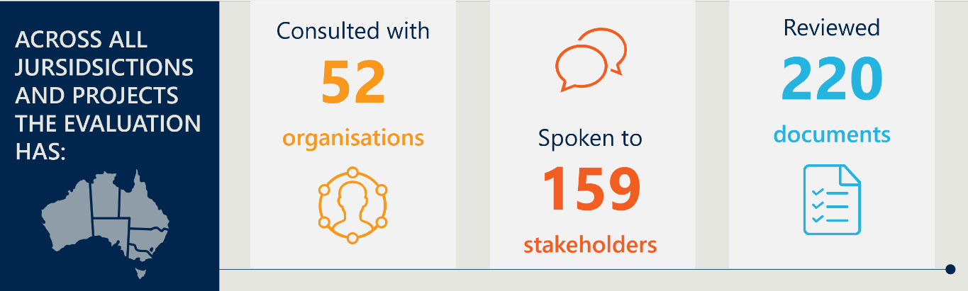
It has become clear during the evaluation there is not a universally understood definition of palliative care. Palliative care is provided in a range of settings across the care continuum including specialist hospital services, community-based care, residential and home-based care services and specialist hospice services. Many people associate palliative care with services provided immediately prior to death. The task of moving perceptions of palliative care away from primarily cancer-based End of Life (EOL) care to a more holistic approach of care for individuals with life limiting, often chronic illnesses, is a challenge. Many of the stakeholders we spoke to expressed a need for greater education of health care professionals to assist them to first identify the transition from life extending treatment to palliative treatment; and second, to consider palliative care in a broader, more holistic manner.
To undertake the evaluation a series of Key Evaluation Questions (KEQs) were developed with related specific sub questions, labelled Key Lines of Enquiry (KLEs). The KEQs corresponded to the four action items identified within the Implementation Plan, namely:
- Access to palliative care is increased, particularly for underserved populations.
- The collaboration and coordination of palliative care is improved.
- Advance care plans are being prepared by people affected by life-limiting illnesses and used to facilitate shared decision making across care settings.
- Nationally consistent data collection mechanisms are implemented, and national public reporting is underway.
In addition, the evaluation took the opportunity to assess the efficiency of resource allocation within the plan and any learnings and opportunities for improvement moving forward. A detailed description of the project methodology is included at the end of this report.
In completing this evaluation, we have been cognisant of the significant commitment of many of the providers, carers, family members, researchers and volunteers who work in palliative care. Many of the professionals we spoke to have dedicated their careers to the delivery of excellent palliative care services and many carers and family members spoke movingly about their experience within the system. This evaluation would not have been possible without the time provided by all the stakeholders we engaged with. We wanted to take the opportunity to thank them for their time and continued passion for this sector

Key Findings
Action area 1: Access to palliative care is increased particularly for underserved populations
Provision of palliative care services has increased over the last decade but the total number of visits for specialist palliative care appear to have been affected by the COVID-19 pandemic, which makes assessing trends difficult. Improvements in access have also not kept up with population increases and timeliness of access to care has not changed over the life of the plan. The data suggests additional work is required against this action area.
In evaluating this area, there are two key contextual factors:
- The population is increasing and the proportion of elderly people in the population is rising, which has increased demand on palliative care services.
- The implementation plan was in place during the COVID-19 pandemic, which placed significant strain on the health system both in terms of reducing access to health care professionals and the distribution of staff to different priority areas.
Across the period of the Implementation Plan, the number of palliative care-related hospitalisations has increased from ~83,000 to ~101,000. However, through stakeholder interviews, the evaluation found that access to care continues to be mixed, with key gaps for those aged under 65, individuals nearing the EOL accessing NDIS support, those who are palliative but not at the end of their lives, and traditionally underserved populations, such as many Aboriginal and Torres Strait Islander groups, those experiencing homelessness, incarcerated people, as well as rural and remote communities.
One area highlighted numerous times was the role of General Practitioners (GPs) in the provision of care. The GP is often the first point of access to palliative care for most people, as well as providing palliative care themselves. Stakeholders reported there are several factors that may have potentially contributed to a decline in GP involvement in palliative care – the sharp decline in home visits has adversely affected services, and the absence of specific MBS items for palliative care means that for many GPs, the provision of such services is uneconomic. Many examples were given of GPs moving away from palliative care or providing services pro bono to longer standing patients.
Action area 2: The collaboration and coordination of palliative care is improved.
Collaboration between services has improved, with many examples of improved collaboration between various palliative care programs. This is often spurred by individual efforts on the part of providers. The data suggests continued effort to maintain progress against this action area.
Palliative care operates in a complex landscape covering primary, secondary, community and aged care services, and requires a high degree of coordination. Stakeholders of large national programs and measures, such as the Comprehensive Palliative Care in Aged Care Measure (CPCiAC), reported that these programs provide natural forums for meeting other palliative care service providers. However, a key risk is that much of the collaboration is based on the efforts of individuals within programs and projects, rather than systemically driven. When these individuals move on from their current roles, collaboration is at risk of decreasing.
There are systemic examples of collaboration at the State and Territory level, such as the Queensland Palliative Care Clinical Network (within membership of over 450 people). Specifically, there have been clear examples of improvements in collaboration between PHNs, the community and services. Similarly, there has been greater information sharing through the Palliative Care Service Development Network and the Agency for Clinical Innovation End of Life and Palliative Care Network in New South Wales.
Action area 3: Advance care plans are being prepared by people affected by life-limiting illnesses and used to facilitate shared decision making across care settings.
There is clear evidence that the awareness and use of advance care plans (ACPs) has improved since the beginning of the Implementation Plan. It is apparent, however, that the increased use of ACPs is not even across all sectors. The data suggests continued effort to maintain progress against this action area, with some areas for improvement.
The overall increase in ACPs is reflected by the significant number of initiatives that have been put in place by different organisations to raise awareness and encourage individuals to create ACPs as early as possible, prior to any possible cognitive decline (e.g. loss of decision-making capacity). The use of ACPs was strongly supported across the continuum of stakeholders. In residential aged care facilities, high levels of uptake were reported (often over 80%) reflecting formal policies to talk to residents and their families about ACPs upon admission. By contrast, the use of ACPs in the general population is much lower, sitting below 30% as of 2021. One specific issue raised concerning ACPs is they can be quite complex to complete for patients and families. Anecdotally, another issue is that in some cases ACPs are not necessarily followed due to factors such as poor-quality documentation and difficulty locating physical documents. Many stakeholders also stated that whilst ACPs play an important role, the supporting conversations around death, dying, and a patient’s wishes are just as (if not more) valuable.
Action area 4: Nationally consistent data collection mechanisms are implemented, and national public reporting is underway.
Overall, the evaluation found the action area of data has seen some progress towards creating and maintaining more comprehensive datasets. However, the process of doing so remains very challenging, with many stakeholders describing data as the least progressed area of the Implementation Plan. The data suggests substantial effort is required against this action area.
An individual’s palliative care journey can involve numerous health services, such as primary care, community care, hospitals, RACFs, and more. However, the system is very fragmented, meaning data is difficult to centralise. This is compounded by jurisdictional differences with respect to ACP and service delivery. Therefore, there is no comprehensive national palliative care data source.
A number of programs and projects have been developed to fill gaps in data, such as Palliative Care Outcomes Collaboration (PCOC), Palliative Aged Care Outcomes Program (PACOP), and certain Australian Institute of Health and Welfare (AIHW) datasets, among others. However, many of these are only able to gather data from participating organisations within their specific scope, on a voluntary basis. This necessarily limits the degree to which data may be generalised. A further complicating factor is the lack of agreement on data definitions. Stakeholders expressed a desire for a rigorous national framework for data definitions, collection and storage to be developed, with strong governance.

Background and Context
Palliative care is care provided to individuals with life limiting illnesses. It can be provided in a variety of settings including community-based services, hospitals, residential aged care facilities and hospices. It can be provided to individuals of any age. The national strategic direction for the development and delivery of palliative care services in Australia is outlined in the Palliative Care Strategy 2018 which has the aim to:
…be used by all Australian governments, as well as organisations and individuals, in guiding the improvement of palliative care across Australia so that people affected by life-limiting illnesses get the care they need to live well. The National Strategy provides a shared direction and an authorising environment for the continual improvement of palliative care services throughout Australia.
In April 2024, the Federal Department of Health and Aged Care (the Department) engaged Nous Group (Nous) to undertake an independent evaluation of the Implementation Plan for the Strategy.
Publicly launched in October 2020, the Implementation Plan sought to: provide the vital link between the high-level vision and priorities in the Strategy and the palliative care activities funded or undertaken by Commonwealth and state and territory governments to realise the goals of the Strategy. The way that the Implementation Plan sought to support the Strategy was to set four Action areas with supporting activities that would contribute to specific goals within the Strategy. The four action areas were:
- Access to palliative care is increased, particularly for underserved populations.
- The collaboration and coordination of palliative care is improved.
- Advance care plans are being prepared by people affected by life-limiting illnesses and used to facilitate shared decision making across care settings.
- Nationally consistent data collection mechanisms are implemented, and national public reporting is underway.
The aim of this evaluation is to produce a full, independent evaluation of the Implementation Plan highlighting the degree to which it has achieved its objectives. In the context of this document the objectives have been taken to be the degree to which progress had been made on the four action areas. The evaluation also sought to provide insights and potential opportunities for improvement that were grounded in evidence and reflective of stakeholder sentiment.
The evaluation examined the four Action areas outlined in the Strategy, as well as a fifth area around the efficiency and effectiveness of resource allocation by governments against the Implementation Plan.
Nous adopted a mixed-methods approach to conduct the evaluation and developed Key Evaluation Questions (KEQs) with sub key lines of enquiry (KLEs) to guide research and analysis. KEQs and KLEs are a standard evaluation tool used to structure analysis by focussing research efforts on the elements of performance being assessed. The KLEs were used to consider:
- the degree to which each of the action areas in the Implementation plan were achieved,
- any key barriers or enablers that affected uptake,
- lessons learned, and
- potential areas for future development.
The key findings of the evaluation are reported in the next five sections. A detailed description of the methodology employed including stakeholder consultation is given in at the end of this report.
There are several important contextual issues that are important to recognise which have impacted the approach to the evaluation and provide context behind the findings. These contextual issues do not fit neatly within the KEQs but were repeatedly raised in consultations and are outlined below.

The delivery of palliative care services extends beyond specialist models of care
Traditional perceptions of palliative care have centred around EOL care for cancer and aged care. The scope of practice for palliative care is, however, very broad, and includes care of people with life limiting illnesses and those who may have life expectancies of years, not just months or days. Therefore, the settings in which palliative care is provided vary widely, ranging from at home, visiting local clinics (such as GPs), residential and aged care facilities, hospices, and hospitals. It is normal that in a patient’s journey, they access many parts of the system, such as initially visiting their GP for management, progressing to at home care, and moving to a hospice or hospital for EOL care.
To service these broad care settings, the palliative care workforce is composed of a wide range of professional roles, many of which may not traditionally be associated with end-of-life care. Key healthcare providers in this sector include not only the specialised palliative care physicians, nurses and allied health professionals but also extend to encompass individuals involved in community engagement and education, those offering bereavement support, and the valuable informal workforce which includes volunteers, family members and carers providing direct care to patients.
Additionally, the composition of the palliative care team reflects a high degree of diversity. Allied health professionals, social workers, and counsellors play integral roles in delivering comprehensive care that addresses the complex needs of individuals and their families. Furthermore, medical specialists whose primary focus may not be palliative care, as well as aged care workers, contribute expertise and support to enhance patient care. This reflects the multi-faceted nature of palliative care, aimed at improving the quality of life for patients with advanced illnesses as well as support for their families.
When considering the effectiveness and impact of the evaluation plan, it is important to appreciate there is a lack of understanding of the full scope of practice and the diverse workforce who operate within palliative care. This is necessary to keep in mind when considering progress across access, collaboration, ACPs, and data.

COVID 19 has been a significant disrupter
During the commencement of the Implementation Plan, the COVID-19 pandemic began and was a major disrupter of services across the continuum of services. Many people previously working in palliative care were diverted to other areas for significant periods of time and mobility issues affected the ability of people to access services. Additionally, rollout of new services was disrupted (such as many of Victoria’s CPCiAC initiatives).

Australia has an ageing population
The Australian population is increasing, and the number of older people is increasing at a faster rate than the population as a whole. Although palliative care services are appropriate to all age groups, there is a disproportionate number of people requiring palliative care in older age groups. The implication of this is that whilst palliative care provision and the workforce may expand, it needs to expand at a rate faster or at least equal to population growth. As an illustration of the effect of this, Figure 2 shows workforce rates per 100,000 population with numbers remaining fairly static whilst Figure 3 shows the changing population profile.
Figure 2 | Palliative care workforce trends
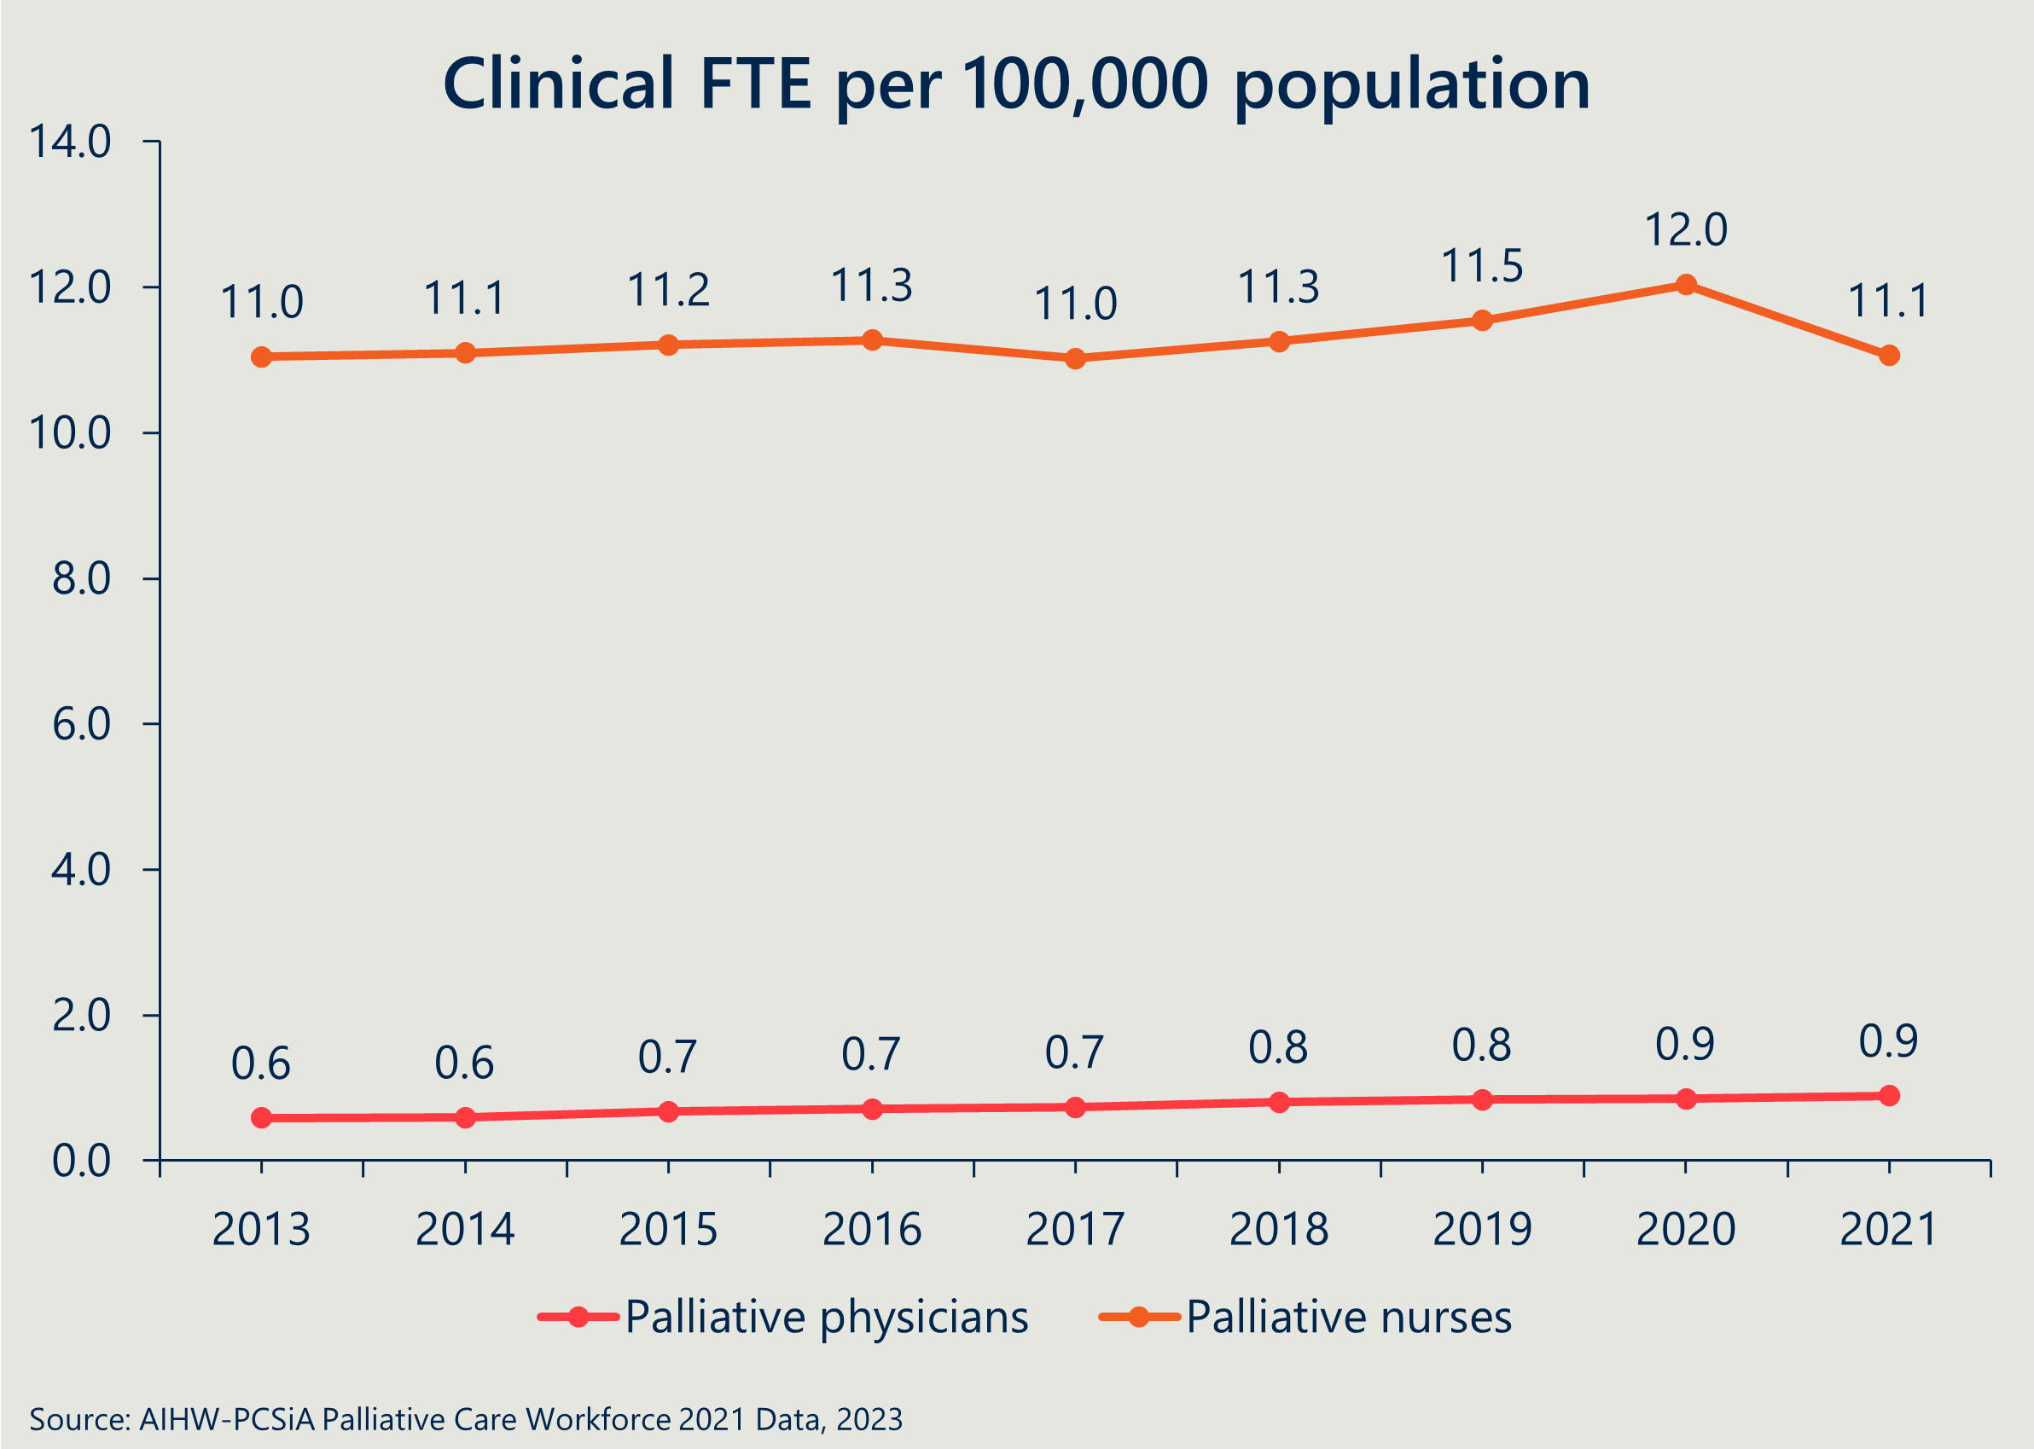
Figure 3 | Population pyramids 1901 versus 2021
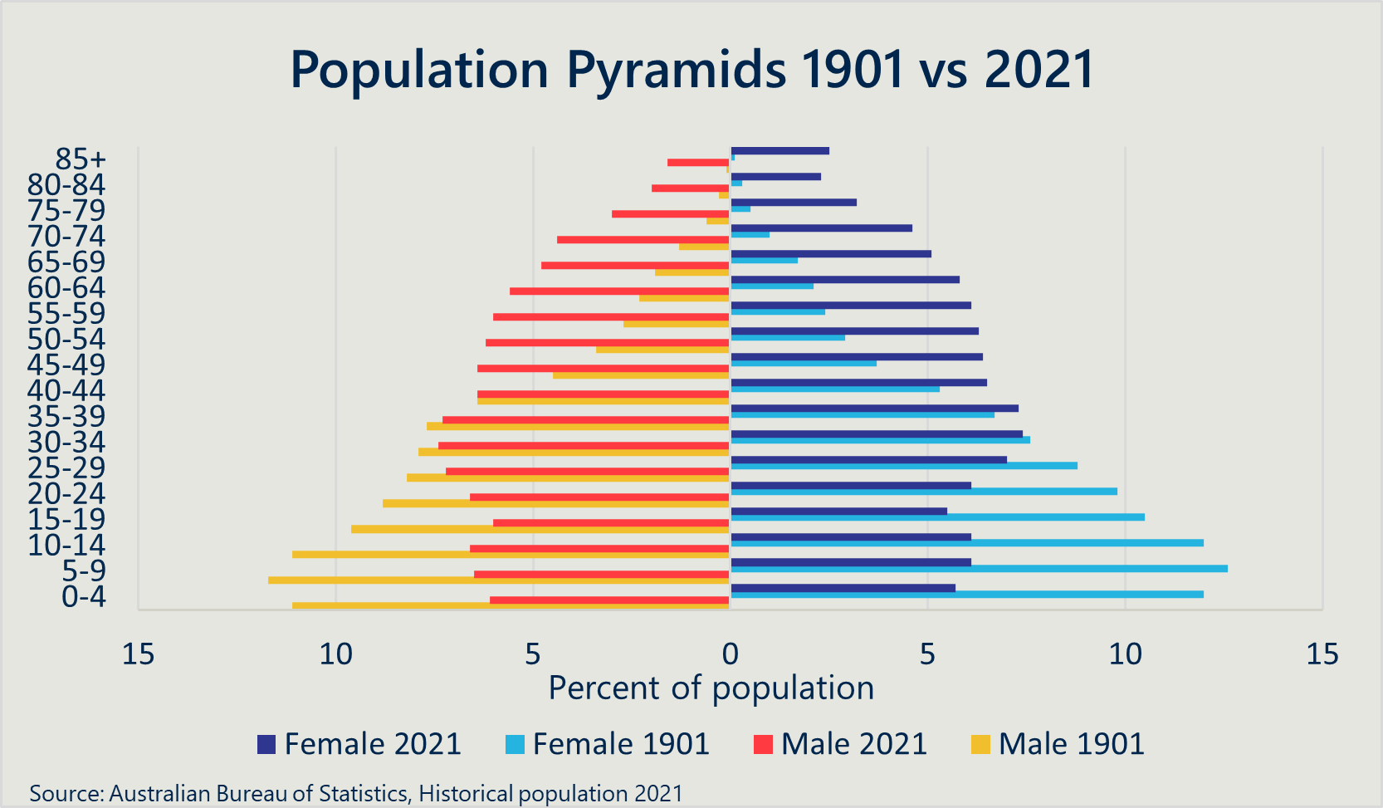

KEQ 1 Access: How has access to palliative care changed over the five-year reporting period?
Action area 1: Access to palliative care is increased, particularly for underserved population.
“A focus on supporting access to palliative care will help people affected by life-limiting illnesses, and particularly groups that are currently underserved, to get care where and when it is needed. It will also build the understanding and capability of service providers. Ways of delivering palliative care will align with the needs of communities to ensure that people can access consistent, high quality care that is evidence-based.”

Key Points
- There has been a general increase in the absolute number of specialist palliative care physicians and nurses during the implementation plan, but the FTE per 100,000 people has remained relatively consistent.
- Within the context of needing more workers skilled in the approach to palliative care to increase access, workforce development programs have been wide reaching.
- There remain systemic challenges impacting the number of skilled workers in the sector.
- GPs have traditionally provided palliative care services but in recent years this has declined in part related to declines in home visiting and the absence of specific MBS items for palliative care.
- Timeliness of access remains an issue with rates of access to specialist palliative care remaining stationary over the five-year period of the Implementation Plan.
- Access remains a sector wide challenge for underserved populations. There is a need to urgently address the situation where people receiving palliative care who are under 65 are unable to access support through the NDIS. These patients are left in a ‘limbo’ state, with the burden of care needing to be absorbed by a patient’s support network or resulting in a reliance on hospital services in the absence of community services.
- There has been continued and integrated support for carers, including in bereavement, however the impact of these services appears to have remained unchanged between 2018-2022.
- There have been notable examples of involving those impacted by life-limiting illness in the planning, delivery and evaluation of palliative care. However, there remains perpetual barriers to greater involvement, many of which are unavoidable (e.g. needing to be sensitive of individuals’ grief during periods of bereavement).

KLE 1.1 Are the right people with life-limiting illnesses being referred to palliative care services at the right time?
This KEQ is concerned with the timeliness of referrals to specialist palliative care. We note the provision of specialist palliative care services has consistently increased until 2018/19. However, in the time since the launch of the implementation plan, the total number of visits for specialist palliative care has flatlined and then decreased. Whilst not tested specifically with states and territories, it is hypothesised that the pandemic played a role in these access figures. In looking at this issue the AIHW notes that:
Between 2012–13 and 2018–19, the number of people receiving palliative medicine attendances/consultations increased by 35% and remained relatively stable in the following 2 years (2018–19 and 2019–20) before declining by 13% in the 12 months to 2021–22. This was a steeper annual decline than that for people receiving all specialist attendances (0.8% decline). While for palliative medicine case conferences, the number of people receiving these services has doubled between 2012–13 and 2021–22.
AIHW data shows that the total number of specialist and consultant physician attendances provided by palliative medicine physicians / specialists increased from 79,578 in 2013/14 to 125,619 in 2022/23 which is a significant increase. But the highest total number of services was in 2020/21 just prior to the impact of the pandemic when services reached 129,538.
However, through many of the consultations, participants highlighted ongoing access gaps for specific population groups including those:
- under 65;
- with a disability nearing end of life;
- needing access to services when not at end of life (such as those with early diagnoses of progressive chronic illnesses);
- in underserved populations, including Aboriginal and Torres Strait Islander peoples, people experiencing homelessness, and people in prison; and
- living in rural and remote communities.
When reviewing the need for palliative care services across the population, many stakeholders also advised us of the important role of primary care in supporting early referral to specialist palliative care. Anecdotal evidence collected through stakeholder consultations emphasised a significant decline in GPs involvement in palliative care attributed to:
- No specific MBS item numbers available for GPs to claim palliative care consultations.
- The non-standard length of a palliative care consultation.
- A significant decline in home visits by GPs.
Regarding timeliness of the provision of specialist palliative care services, the evaluation found there has been little change since 2018. Specifically:
- Most people who died a predictable death did not receive specialist palliative care more than three months prior to death.
- From 2018 to 2020, according to the National Palliative Care Measures, the percent of people receiving specialist palliative care more than three months prior to their death remained flat and showed little change in trends (between 20-21%).
- There has been a clear improvement in the proportion of inpatient unstable palliative phases that lasted three days or less, growing from 76.1% in 2018 to 80.7% in 2021.
- Timeliness is highly variable by socioeconomic area, with people from the highest quintile receiving timely care 24.6% of the time in 2020, and those in the lowest quintile only receiving timely care 18.1% of the time
Although there has been little change in timeliness, there has been clear progress in improving access to services across the states and territories. Some examples include:
- The Australian Capital Territory has initiated a ‘whole of hospital approach’ to palliative care in Canberra Hospital, providing information and training on early recognition of the need for palliative care in patients.
- South Australia funded 11 NGOs to undertake 13 projects, aimed at improving palliative care support to patients and practitioners, and to increase the number of primary care practitioners working in palliative care. Given the importance of primary care practitioners in early recognition and provision of palliative care, increasing the number of such clinicians is a crucial step in improving the timeliness of care.
- South Australia has also piloted the Hospice in Aged Care (HAC) model, which included training for early identification of palliative care needs, resulting in more well-timed referrals.
- Queensland’s Statewide Specialist Palliative Rural Telehealth Service (SPaRTa) enables patients in rural and remote areas to arrange a comprehensive palliative care telehealth consultation through their GP or community nurse, leading to typically underserved communities receiving more timely care.
- Victoria has established the Statewide Palliative Care Advice Service (PCAS) to provide advice and support to the whole of the Victorian community as well as health and aged care sector services.
- Staffed by specialist palliative care clinicians the Advice Service ensures that regional and rural locations have equal access to expert palliative care advice and people can be navigated to appropriate supports.
- The Comprehensive Palliative Care in Aged Care (CPCiAC) measure, which aims to support states and territories to improve palliative care for older Australians living in residential aged care through existing as well as new and innovative approaches to palliative and end-of-life care. The measure has funded an additional 99 FTE working on palliative care activities in aged care. For example, in the Northern Territory this has led to a 370% increase in palliative patients being case managed in RACFs, indicating improved referral practices.

KLE 1.2 How effective have workforce development initiatives been in increasing the number of skilled workers delivering palliative care across care settings?
The overall specialist palliative care workforce has been increasing throughout the period of the Implementation Plan (and before). Whilst a positive trend, as with KLE 1.1, this increase has not kept up with population growth. Figure 4 shows that since 2018, there has been an increase in the physician and nursing workforce but no substantive improvement in the workforce per 100,000 population, which is also reflected in the national palliative measures.
Figure 4 | National Specialist palliative care workforce trends over time
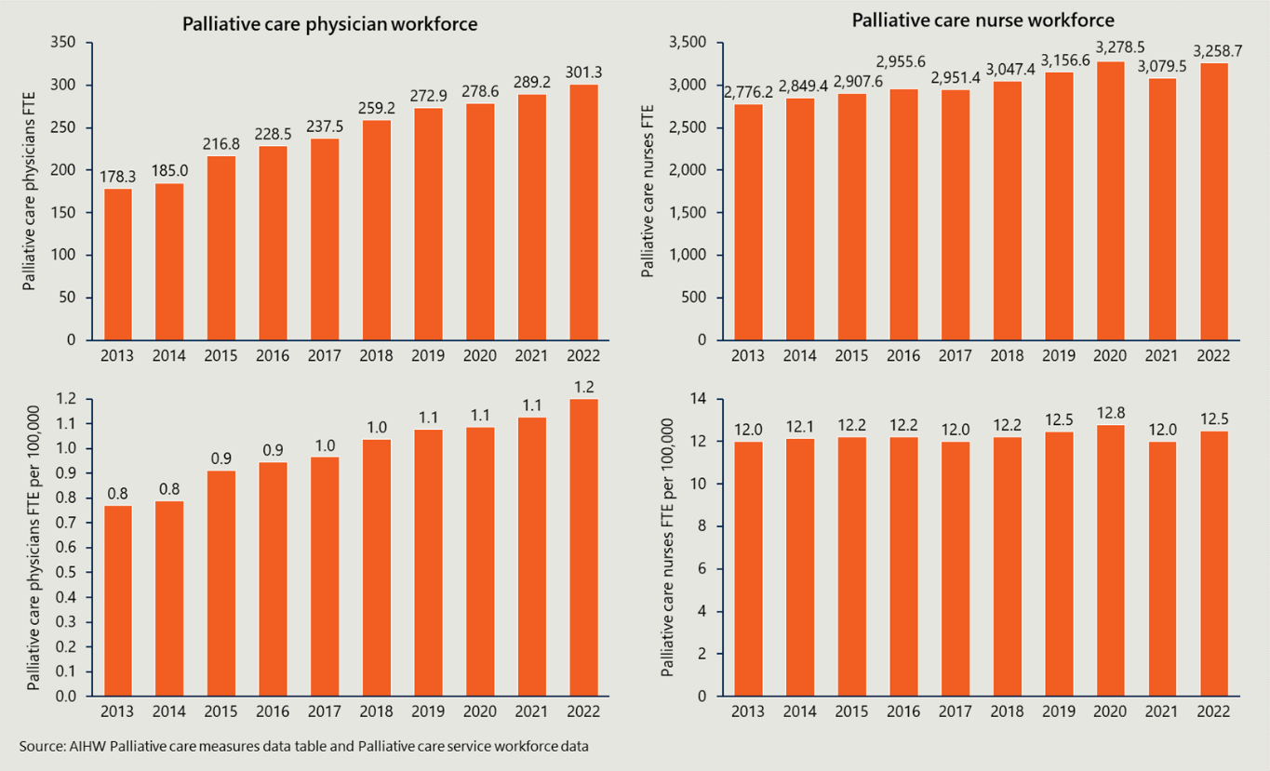
Disaggregating this by state/territory (Figure 5), whilst some metrics show better FTE per 100,000 population (Northern Territory, Australian Capital Territory, and Tasmania), these comparative metrics do not consider the geographic coverage of the workforce, patient disease burden, and the workforce critical mass needed to provide adequate care. For example, the Northern Territory is a very large region, has a higher disease burden, and necessarily requires higher levels of resourcing relative to the overall population of the territory.
Workforce shortages, especially among general practitioners and palliative care specialists, exacerbate regional disparities in service provision. - Stakeholder
Figure 5 | Specialist palliative care workforce by state and territory, year 2022
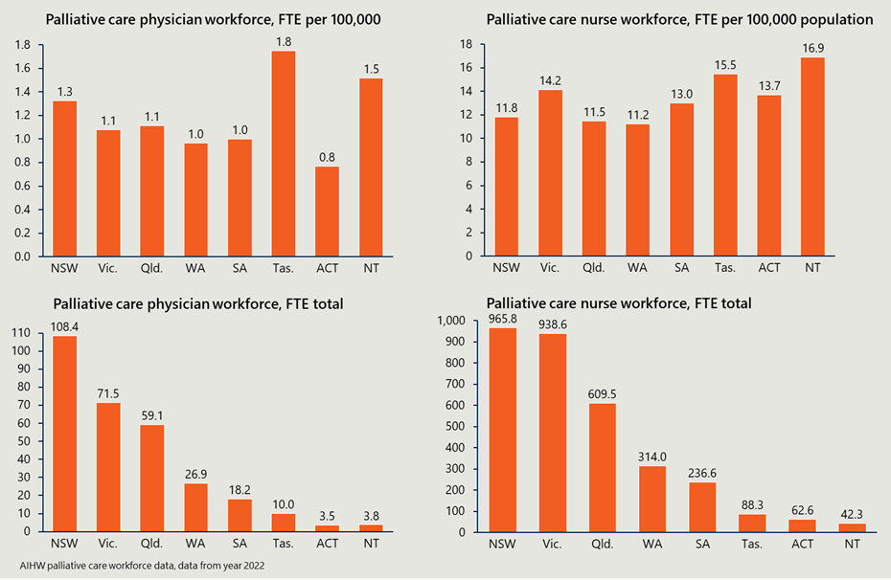

Within the context of needing more workers skilled in palliative care provision, workforce development programs have been wide reaching
Consultations and the literature showed workforce development initiatives have been delivered to a diverse workforce, including many who would not identify as palliative care workers. As outlined within the context to this report, this is of significance due to the diversity of the palliative care workforce; with some not ‘formally’ recognised within the workforce but still playing a critical role in the care of patients through their journey. Examples of the workforce impacted include:
- Specialist palliative care workers (in medicine and nursing).
- Nurses of varying qualifications and specialisations.
- GPs.
- Other medical and nursing specialists (such as oncologists and paediatricians).
- Administrative Managers.
- Allied health professionals.
- Care workers.
- Carers and families.
Recognising this progress, the evaluation considered specific workforce development initiatives from across Australia, the activities undertaken, and the selected outcomes achieved. Table 1 outlines a sample of programs which exceeded their selected outcomes, all targeted at workforce development for nurses, doctors, and other workers.
Table 1 | A sample of national workforce specific development initiatives
Project Name | Activities | Selected Outcomes
The Advance Project | Development and deployment of dementia-specific materials, train-the-trainer courses, general practice resources and training.  Trainees included nurses, managers, allied health professionals, GPs, care workers and others. | - All targets to upskill the workforce were exceeded.  - Register to access dementia-specific resources. Target = 400, Achieved = 1,258.  - Dementia-specific online training. Target = 200, Achieved = 871.  - Train-the-trainer sessions. Target = 30 sessions, Achieved > 40 sessions.  - Overall, very positive self-evaluation survey responses.
End of Life Essentials | Primary focus on supporting those who are working with people at the EOL in acute hospital settings.  Some content was also tailored to addressing diverse groups. | - All performance indicators surpassed.  - Launch of new LMS. Target = 12,500 new registrations, Achieved = 16,981.
End of Life Law for Clinicians | Training to improve clinician legal knowledge surrounding palliative care, including around advance care planning. | - Total 7,331 enrolments, 30,292 module completions.  - Embedded in mandatory curriculum in 8 Australian undergraduate medical schools.  - 90-99 per cent of participants who gave feedback agreed or strongly agreed that the training content was relevant, and all topics covered important legal issues.
Education and Assessment for Psychosocial and Existential Wellbeing in Palliative Care | The goal was to train clinicians to use screening tools and improve palliative care to patients suffering from psycho-existential symptoms such as anxiety and depression. | - 71 workshops were delivered with majority face-to-face experiential workshops.  - 629 clinicians were trained.  - 5,901 clinicians completed online training modules.
Program of Experience in the Palliative Approach (PEPA) | PEPA provides opportunities to learn from experienced specialist staff through placements, workshops and online learning materials and resources. | - Over 2020-2023 they delivered 384 (proposed 320 initially) workshops covering training for carers, aged care, Aboriginal and Torres Strait Islander Health professionals, GPs, and for Culturally and Linguistically Diverse backgrounds.  - They had 1,181 placements (960 placements initially proposed).
In addition to the above sample of programs, a range of workforce training and development initiatives have been delivered during the timeframe of the Implementation Plan. Examples include, but are not limited to:
- Improving conversations around palliative care, death and dying. The ACT launched the End of Life Education Pathway and EOL Champions program, which funds mentoring groups for nursing staff in all EOL care settings.
- Culturally appropriate practices and discussions. New South Wales funded a three year palliative care program, which aimed to increase clinician confidence and capability in providing care for underserved populations, such as Aboriginal and Torres Strait Islander groups.
- Clinical management and practice. The Greater Choices measure provided funding across PHNs to employ up to two FTE staff, enabling PHNs to facilitate a variety of programs. One program stream was capability building among workers, which five PHNs chose to pursue.
- Development of advance care plans/directives. Western Australia facilitated training and presentations for health professionals to improve their capacity to have ACP conversations, such as the Take 5 presentation series.
- Referral and coordination of services. The CPCiAC measure enabled RACFs to upskill staff, resulting in some RACFs seeing an increase in referrals to specialist palliative care services. This increase appears to indicate an improvement in staff’s ability to assess patient needs, and coordinate services to address them.
- Disease specific considerations. The Advance Care Project provided dementia specific online training modules, with 1258 people accessing them. This exceeded their target threefold.
- Population specific training. Such as paediatric, Aboriginal and Torress Strait Islander, Culturally and Linguistically Diverse, and LGBTQIA+.
- Scholarships. Tasmania invested in scholarships at undergraduate and postgraduate certificate levels for its general and specialist palliative care workforce to increase capacity and capability. Expanding the specialist palliative care workforce. Queensland has implemented the Palliative Care Workforce Capability Uplift program which focuses on enhancing access to education and training for allied health, nursing and Aboriginal and Torres Strait Islander Health Profession workforces.

The impact of workforce development initiatives on long-term skill development is not well understood
Currently, many workforce development initiatives have relied on quantified reporting, such as participant numbers, self-reported capability/confidence scores, course or module completions, and the number of training activities undertaken. However, the impacts on improved long-term capability, capacity and quality remains hard to determine.
Training programs such as the Program of Experience in the Palliative Approach (PEPA) have enhanced the capabilities of generalist staff, yet stakeholders express concern over the scarcity of officially recognised qualifications and the shortfall of specialist palliative care workers. - Stakeholder
We were able to measure skills and confidence before and after the project for GPs. But we can’t look at the outcomes. For example, we couldn’t capture data about changes in referrals practice. - Stakeholder

One measure that provides some insight on long-term skill development is the translation of workforce developments into improved patient outcomes. For example, there have been noticeable improvements in the following palliative care outcomes for services participating in PCOC since 2018:
- Benchmark 3.5 – Anticipatory care, fatigue (patient reported distress).
- Benchmark 3.6 – Responsive care, fatigue (patient report distress).
- Benchmark 3.8 – Responsive care, breathing problems (patient reported distress).
No benchmarks receded substantially over the Implementation Plan period.
Conversely, although it might seem logical to assume workforce development initiatives increase the number of skilled workers in the sector, stakeholders told us of multiple systemic components which are countering any skills gained through specific training. These factors include:
- A high turnover of staff, including due to short-term funding, means any investment in capability can be quickly lost.
- Many who engage in training have a low palliative care workload, meaning they lose capability due to a lack of regular application.
- The widespread health workforce shortage meaning it is difficult to attract and retain palliative care workers.

KLE 1.3 How accessible are palliative care services appropriate to the needs and preferences of different patient cohorts?
Through consultation and the literature, the evaluation identified the following different patient cohorts:
- Aboriginal and Torres Strait Islander people,
- people experiencing homelessness,
- people in prison,
- people who identify as LGBTQIA+,
- people who are culturally and linguistically diverse,
- people living in rural and remote communities,
- those under 65,
- patients with a non-cancer diagnosis, and
- those seeking support with a short life expectancy.
Through consultations across the sector, it was understood that the needs and preferences for each of these cohorts were naturally different. This KLE outlines our overall understanding of patient needs (at a system level), the challenges with measuring the appropriateness of service delivery for these cohorts, and key observations about accessibility. This KLE is complemented by KLE 1.4, which dives into each of these patient cohorts (many of which are underserved) and outlines specific programs and impacts.

There is a growing understanding of the breadth of patient needs but it remains challenging to know if we are meeting this need
Patients’ preferences cover many aspects outside a ‘traditional’ view of palliative care. Through our consultations, we were advised of the most important domains for patients receiving palliative care. These included:
- effective communication and shared decision making,
- an adequate environment for care,
- family involvement in care provision,
- support with financial affairs,
- maintaining a sense of self/identity,
- seeking to minimise burden,
- respect and compassion,
- a sense of trust and confidence in clinicians,
- maintaining patient safety,
- meeting nutritional needs, and
- access to medical and nursing specialists.
Whilst there may be an appreciation of the different needs of patients, there is a systemic challenge for the sector in measuring the current demand for palliative care. There has been progress, demonstrated through the development of the National Palliative Care Measures (NPCMs), which brought together palliative care experts, clinicians, government, and sector stakeholders to monitor and report on the quality, accessibility and outcomes of palliative care services in Australia. Specifically, the NPCMs and scoping work are aligned with the Strategy and are designed to track if ‘people affected by life-limiting illnesses get the care they need to live well’. But, as noted in the NPCMs, we currently have no data to understand whether demand is met, therefore, we are unable to determine if needs are being met.

Assessing appropriateness is challenging due to the sensitivity of palliative care and diversity in evaluation approaches
Although there has been significant investment from government sources into various palliative care initiatives - including training, education, and ACPs - there is a marked difficulty in evaluating the impact of these initiatives on patient outcomes.
The sensitivity of palliative care can mean it is inappropriate/challenging to collect data about service quality from patients and families on their experience and outcomes, such as through Patient Reported Experience Measures (PREM) and Patient Reported Outcome Measures (PROM).
Further, public reporting by states and territories is not as robust as necessary to capture access outcomes, reducing transparency and the potential to disseminate best practices. Patient advocacy bodies do exist, yet there remains a shortfall in actionable intelligence regarding patient demographics, life expectancy, and care requirements.
Similarly, there are variations in program offerings and non-standardised approaches to patient evaluations and outcomes. This naturally complicates the measurement of service appropriateness.

Residential aged care is experiencing improved access to palliative care services
Improving access to palliative care in residential aged care has been a significant focus of governments during the lifespan of the Implementation plan, in part due to the Royal Commission into Aged Care Quality and Safety and the Government’s response to the findings of the Commission. This includes the introduction of the Australian National Aged Care Classification (AN-ACC) which replaced the Aged Care Funding Instrument (ACFI) , 24/7 registered nursing and minimum care minute requirements. Similarly, the Aged Care Bill 2024 (introduced to Parliament in September 2024) is seeking to drive universal access to high-quality care and strengthen provider accountability.
Commencing before the Government’s response to the Royal Commission, the CPCiAC measure is one of the largest joint investments across Commonwealth and State and Territory Governments, and is an excellent example of a collaborative and wide-ranging program that seeks to address the palliative care needs of this population group. A total of $82.1 million has been committed by the Australian Government for the CPCiAC measure from 2018-19 to 2025-26.
Several jurisdictions reported that the Measure has enabled them to implement or expand palliative care services that would not have otherwise been possible – Nous Interim Report

The Measure operates as a matched-funding agreement, meaning it is funded on a 50:50 cost shared basis with states and territories. As at November 2024, across all jurisdictions, CPCiAC has funded 54 projects and 99 FTE and has impacted over 1,250 RACFs in Australia. Successes include:
- an increased and improved collaboration with RACF staff, GPs, and specialist palliative care providers as well as at the health and aged care interface;
- an increased confidence of RACF staff to identify and respond to palliative care of residents;
- improved advance care planning for residents;
- increased knowledge sharing; and
- expanded aged care workforce capacity.
Other projects have also been deployed to improve palliative care in aged care. South Australia piloted the HAC model, which included training for early identification of palliative care needs, resulting in more well-timed referrals. It was piloted in 15 regional sites, reaching 550 residents. The model brings specialist expertise into the Rural Support Services and builds workforce capability through training. Eldercare Inc (a RACF provider) also completed a pilot of the HAC model in seven out of 11 sites, reaching 770 residents.

Stakeholders emphasised the importance of community palliative care as an avenue for access
A unifying theme from consultations was that community care should be made widely available to enable patients to choose their access to care and place of death. One of the key programs in this space is the Greater Choice for At Home Palliative Care (GCfAHPC) program, which aims to support improved access to palliative care at home. All 31 Primary Health Networks (PHNs) receive Australian Government funding for FTE to coordinate activities aimed at facilitating collaboration, integration and linkages across the health and aged care systems to improve access to palliative care at home.
Activities being implemented by PHNs fall into four broad activity workstreams: Workforce education and awareness, coordination and integration, awareness in the community and needs and preferences.
Under the GCfAHPC program, PHNs are delivering a diverse range of innovative activities that are designed to meet local needs. This investment and dedication to local palliative care needs is enabling PHNs to build and strengthen key partnerships, collaborations, and engagement to help facilitate improved access to palliative care at home, in their regions.
Given the constraints on the primary care system, especially GPs, stakeholders identified alternative models of care which may be appropriate to increase access and meet the needs of patients. Examples provided include:
- A model of care for ACPs where nurses complete ACPs with patients, and GPs sign off the final plan.
- Enhancing the palliative care capabilities of home care providers, enabling them to identify and support individuals who may benefit from generalist palliative care. This can include the use of telehealth services to deliver palliative care, in conjunction with on the ground staff and/or carers.
- Expanding scope of practice, for example the use of paramedics in community and end-of-life community care settings.
- The Compassionate Communities approach within the GCfAHPC program, which includes a focus on interdisciplinary partnerships across regional health services, hospices, volunteer organisations, and others, to deliver coordinated, community-driven care.

KLE 1.4 How effective have strategies been to increase access to palliative care, especially for underserved populations?
This KLE addresses the strategies employed to increase access to palliative care services for underserved populations. From the evaluation consultations and literature, it was determined that whilst there are specific programs that are trying to address the disparate needs for underserved populations, much more remains to be done. This is no surprise provided the growing needs across the health sector in general.
Within this context, this section speaks specifically to the following:
- Aboriginal and Torres Strait Islander people,
- people living in rural and remote communities,
- those under 65, and
- other underserved populations.

There has been training, education and development of materials for both Aboriginal and Torres Strait Islander peoples, and the workforce supporting them
During the lifespan of the Implementation Plan, a number of activities have been undertaken to assist Aboriginal and Torres Strait Islander peoples in caring roles, workers to engage in a culturally appropriate manner, and in local-language resources. Examples of these include:
- Western Australia’s investment in the development of the Aboriginal EOF and Palliative Care Framework to provide culturally safe care for Aboriginal and Torres Strait Islander peoples.
- New South Wales’ distribution of 1,330 copies of the Journey to Dreaming Toolkit, designed for Aboriginal and Torres Strait Islander communities, to enhance understanding and engagement with palliative care.
- The Australian Capital Territory’s development of the Cultural Aspects of Death and Dying toolkit to ensure palliative care services are culturally appropriate for diverse populations.
- South Australia’s NGO Grants Program, which funded projects aimed at improving palliative care access for Aboriginal and Torres Strait Islander populations, extending support to patients and practitioners treating non-malignant diseases.
- Program of Experience in the Palliative Approach (PEPA), including Indigenous Program of Experience in the Palliative Approach (IPEPA), which provided materials and workshops for Aboriginal and Torres Strait Islander health professionals, and for those caring for this population.
Many of these workforce development initiatives have been well received. They are also timely provided the higher demand for palliative care for Aboriginal and Torres Strait Islander peoples, in line with the overall increased chronic disease burden. However, when considering representation in the workforce, it was notable that in 2021, there were no palliative care physicians who identified as Aboriginal or Torres Strait Islander, and only 41 palliative care nurses (1.2% of the total workforce). Acknowledging that New South Wales and Queensland have invested in initiatives to support the growth and capacity of the Aboriginal and Torres Strait Islander palliative care workforce.

Rural and remote areas continue to face challenges in accessing specialist palliative care workers.
The Access to specialist palliative care services in rural and remote regions remains lower than metropolitan areas, and these trends have not changed substantially since the onset of the Implementation Plan (Figure 6). These workforce challenges are also most prolific across the states and territories with a high level of rural and remote populations. As previously shown in Figure 5, the Northern Territory, Australian Capital Territory, and Tasmania have very low FTE counts of palliative medicine specialists. Importantly, these numbers have barely increased, and in the case of Northern Territory, have gone backwards since 2018. This may somewhat be offset by an increase in the nursing specialist workforce, but again, in the Northern Territory this has gone backwards since 2018.
In major cities, there are 1.3 FTE palliative care physicians per 100,000 population and 12.5 FTE palliative care nurses, however in remote and very remote areas, this drops to 0 FTE and 5.4 FTE respectively. Some stakeholders report there are no referral pathways for some rural and remote patients. For example, access to hospices is highly variable, which at times will necessitate patients to access hospitals instead.
Figure 6 | Palliative care specialist workforce by region
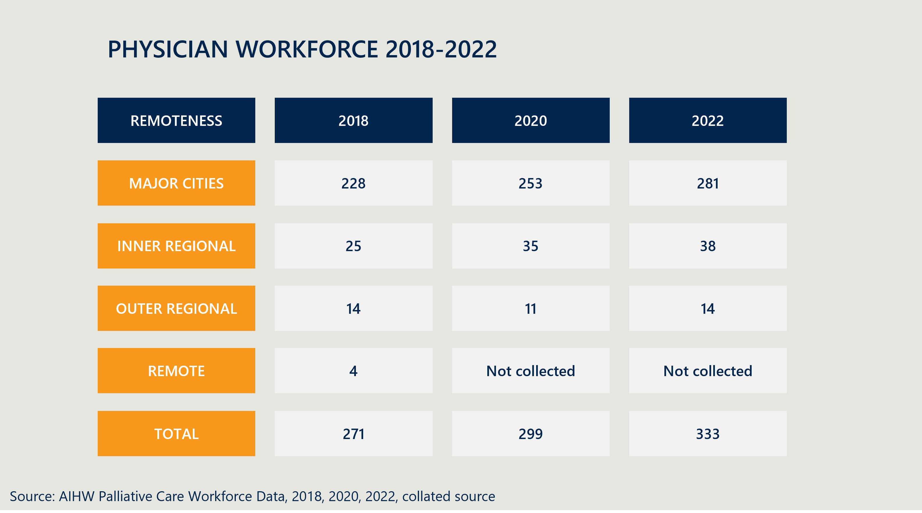
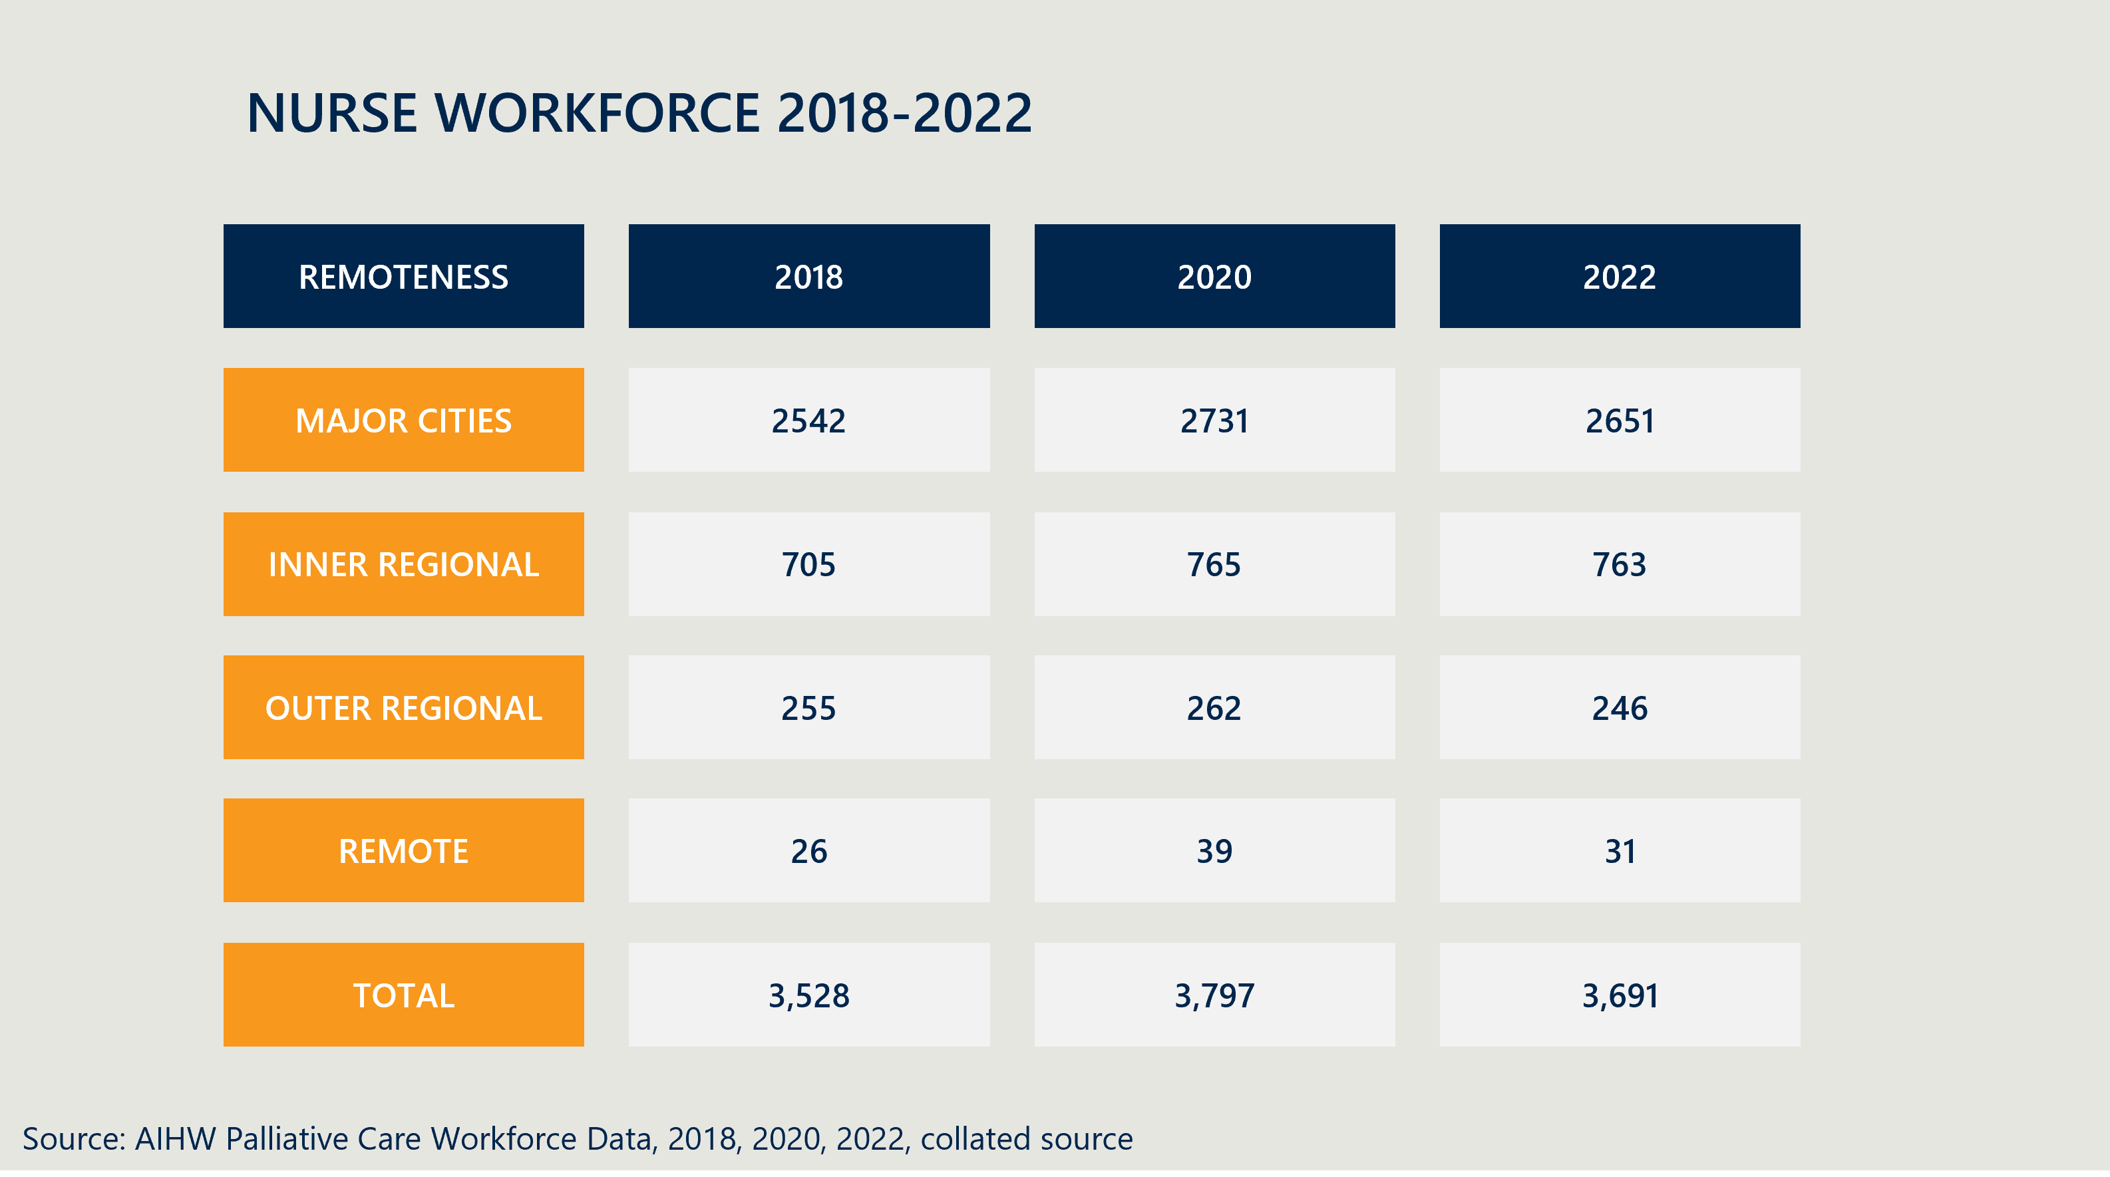
Initiatives, such as Project ECHO (Extension for Community Healthcare Outcomes) in palliative care are working to enhance knowledge and capacity for those in rural or underserved areas through virtual mentorship and peer learning. Similarly, there are virtual care models which are supporting people where they are. However, one of the key challenges for rural and remote areas remains in workforce recruitment, with reports of positions being funded but remaining unfilled. Underserved areas find it hard to compete in a highly competitive recruitment environment, where they cannot offer the same types of incentives (such as workforce attraction grants).
Stakeholders raised concerns that rural and remote communities rely more heavily on transient/temporary workforce arrangements, which may result in issues with continuity of care, timely access to care, and lack of awareness of local needs and community services.
There are significant challenges in palliative care – with a very limited rural and remote staff load to cover a very large geographic area and case demand. - Stakeholder
Some remote areas are lacking access to specialist skills and are managing without oversight. - Stakeholder

There are critical gaps in services for adults under 65 who are also unable to access the NDIS
A key priority for improvement at the system-level for stakeholders has been improving access for the under 65 population and those with non-cancer diagnoses. Currently 23% of the palliative care population receiving specialist palliative care is under 65. There are reports that under 65s have trouble accessing services, with the non-clinical care need gap then shifting to social and primary care systems, or people aged under 65 years being admitted to hospitals unnecessarily due to difficulties in accessing appropriate community-based services. Stakeholders have reported this is due to a number of factors including an inability to access aged care services (as they are not over 65 years old) or hospices. Stakeholders also stated people aged under 65 years face difficulties attracting NDIS funding, even with a diagnosed disability, as the NDIS sometimes refers them to the broader health care system. This creates a cyclic problem for those with a life-limiting illness not being able to access the care they need due to shifting of care responsibilities by providers to ‘others’ in the system. Multiple stakeholders emphasised this as one of largest, if not the largest, challenge the palliative care sector needs to tackle with immediacy, given the shifting burden of care (including financial) onto a person’s support network.
There is little offered for those under 65 who are not in an aged care package in many places across the country. - Stakeholder

People under 65 have it worst of all. NDIS is a problem in this area so under 65s are getting worse services. - Stakeholder

Other underserved populations remain largely unaddressed
Significant parts of the palliative population are underserved and currently have few interventions to increase their access. Whilst workforce and community materials and training have improved the ability to deliver care, they have not addressed the systemic challenge of access.
Stakeholders highlighted the needs of a number of additional underserved populations (in general) remain largely unaddressed, with a leading reason being there is little residual capacity in the mainstream system, making it difficult to meet the specific needs of underserved populations (including those experiencing homelessness, imprisoned, multicultural and LGBTQIA+ communities). As with other population groups, there is very little known about the overall demand for services within these populations.
The CarerHelp Diversity Scoping Study Report did identify 42 resources for review relating to Culturally and Linguistically Diverse (CALD) communities, Aboriginal and Torres Strait Islander peoples, LGBTQI+ people, people experiencing homelessness, people living with a disability, people in prison, and refugees/asylum seekers. Their study found that whilst the general resources they had were suitable for the public, there was need for improvement in resources for diverse populations. For example, the development of Aboriginal and Torres Strait Islander materials cannot be considered as a single solution. They must be designed and tailored for the individual communities, and materials for one community may not be culturally appropriate in others.
There is a call for further research to explore and understand why the prevalence of life-limiting conditions for children and young people who identify as Aboriginal or Torres Strait Islander is greater than for individuals who do not identify as such.
Literature review and stakeholder feedback
There is a call for further research to explore and understand why the prevalence of life-limiting conditions for children and young people who identify as Aboriginal or Torres Strait Islander is greater than for individuals who do not identify as such [Literature review]

Underserved populations, including Aboriginal and Torres Strait Islander peoples, those with dementia, and younger patients with life-limiting illnesses, require targeted strategies to improve access to appropriate palliative care services.
Stakeholder feedback

Paediatric palliative care is in a better position than most areas
Finally, although not one of the aforementioned underserved populations, we felt it important to discuss paediatric palliative care, as it was raised during evaluation consultations.
Paediatric palliative care has very different considerations and resourcing compared with other parts of the palliative care system. Stakeholders report a better wrap-around approach for paediatrics than other sectors, which may be attributed to a more specialised workforce, and concentration of services into relatively few service locations – such as children’s hospitals. However, the breadth of scope of paediatric palliative care varies widely between states and territories. As the Paediatric Palliative Care National Action Plan notes, “availability of services varies state by state…not all states have a children’s hospice…[and] specialist services are ‘city-centric’.” It also recognises the important role telehealth can play in bolstering service availability, as well as other initiatives regarding timeliness, coordination, and responsiveness for different cultural and vulnerable populations. Palliative Care Australia also works closely with Paediatric Palliative Care Australia and New Zealand (PaPCANZ), who are in the early stages of delivering their latest flagship project, the ’Shaping the Future’ Project. The project will encompass workforce development in the paediatric space, accessibility, advocacy, awareness raising and inclusive involvement. The project‘s four key action areas are:
- Support healthcare providers through structured communication training to initiate difficult conversations with empathy and compassion.
- Develop and implement Paediatric Palliative Care Clinical Guidelines to support best practice and holistic care.
- Develop and implement an optimum Transition Pathway between paediatric and adult palliative care services.
- Develop strategies that overcome barriers and improve timely referral to paediatric palliative care.
Paediatric Palliative Care also provide numerous resources for health professionals, carers, and young people, on their website. These resources range from guidance on navigating the NDIS, to support for young people with a sibling who is receiving palliative care. Quality of Care Collaborative Australia (QuoCCA) also deliver training and resources focused on paediatric palliative care to GPs and other clinicians. They also capture data on ACP completion in paediatric care, working with groups such as the AIHW to create a more complete data picture. The transition period of children from paediatric care to adult care has been noted as difficult, given the young age of the patients, and transition to a more devolved, self-navigated patient journey. An overarching sentiment in discussions surrounding paediatric palliative care is that while there are some constraints on the capacity of services, it remains better than the adult services and offers better wrap-around support.
Young people are in specialist palliative care for years, but when they become adults there are no longer enough staff to support them. They stop meeting the criteria of specialist palliative care services. Child to adult transition in the system is an issue and big change in resourcing. - Stakeholder

KLE 1.5 How has support increased for carers, including in bereavement?
Bereavement support for palliative care is a process rather than a point-in time. Stakeholders told us effective support for carers and families means receiving wrap around care during the process of dying, and not just after death. This support includes education, sensitive conversations with healthcare professionals, formal counselling, and the development of documentation such as Advance Care Plans. Conversely, whilst this support is ideal, many stakeholders told us that healthcare workers, carers, families, and patients can be uncomfortable with the bereavement process and knowing where to begin.
A key example of an initiative that seeks to provide targeted support for carers is through the Australian Government funded caring@home initiative. The caring@home project provides practical evidence-based clinical resources for health professionals to support families to help manage end-of-life symptoms at home so that a patient can be cared for in the place of their choice. To access caring@home, families are required to be linked with a health professional for advice. This can be through primary, acute, community or palliative care services. From a family and patient perspective, South Australia launched Palliative Care Connect, a suite of services that provides information, links and support people to access palliative care and bereavement support. This is a Commonwealth funded, limited time pilot. In practice, “Palliative Care and Bereavement Navigators (registered nurses and allied health professionals) are available via telephone and face-to-face to connect people to the services they need, and empower individuals to make choices in alignment with their culture and preferences.”.
The AIHW national palliative care measures shows carer wellbeing remained unchanged between 2018-2022 (75% in 2018 and 73.6% in 2022). Room for improvement in bereavement support was qualitatively reflected in consultations with healthcare professionals, advocacy groups and peak bodies.

KLE 1.6 How have those impacted by life-limiting illness been included in the planning, delivery, and evaluation of services?
Stakeholder feedback and the literature revealed varied and inconsistent efforts to include those affected by life-limiting illnesses in the planning and delivery of palliative care services, across different jurisdictions and programs. Whilst those with life-limiting illness were not uniformly involved in the planning, delivery and evaluation of services, there have been instances where they have:
- The Australian Capital Territory has developed a ‘whole of hospital approach’ to palliative care, which includes the implementation of the Digital Health Record and the End-of-Life (EOL) Champions program, potentially increasing the involvement of patients and families in care planning.
- Tasmania’s implementation of patient-reported experience measures offers a valuable insight into patient experiences, which is crucial for enhancing quality assurance and service improvement. There is an opportunity for expanded patient-reported experiences, including a standard of care. Some resources have become available to capture patient outcomes, such as the consideRATE, which enable capturing of people’s experiences when they are seriously ill.

There is an opportunity for greater involvement of those impacted by life-limiting illness in the evaluation of services
Evaluating the effectiveness of palliative care services requires the perspectives of those directly impacted by life-limiting illnesses, yet there is a noted lack of reporting on client outcomes, which challenges the assessment of service efficacy.
There is a growing body of work identifying both what is valuable to palliative care patients and their families, and developing tools to capture them. For example, systematic reviews of PREMs for palliative care have been undertaken and national quality indicators of end-of-life care have been developed. Furthermore, whilst implementation of PREMs and quality indicators can be challenging, significant effort has been made to identify methods to incorporate these into hospital practice. There is also a role for other established outcomes measurement systems, such as PCOC and PACOP, to include those impacted by life-limiting illness in the evaluation of services.
There is an opportunity to embed quality indicators and patient experience into the evaluation of palliative care services. However, such processes need to be designed cognisant of the key barriers to inclusion, and the need for a patient centred approach to data collection. This means overcoming challenges to patient and carer/family inclusion, such as communication issues within the healthcare system, an increased burden of participation, and the sensitivities of bereavement.
The feedback from stakeholders suggests that while there is a desire to involve patients and families, the practicalities of doing so are complex and require careful consideration of the capacity and willingness of individuals to participate.
Stakeholder Feedback

The burden of participation on patients and families, who are already dealing with the demands of life-limiting illness, can limit their ability to engage in service planning, delivery, and evaluation.
Stakeholder Feedback.

KEQ 2 Collaboration - To what extent has collaboration and knowledge sharing improved and what changes are evident in service delivery across care settings?
Action area 2: The collaboration and coordination of palliative care is improved.
“Improving collaboration will help service providers clarify how they can work with others to ensure that a person affected by life-limiting illnesses gets the care they need.”

Key Points
- There has been an overall improvement in collaboration. However, this appears to rely on individual passion for/championing of palliative care, and is effected by high workloads, funding priorities, and the lack of formalised structures. Each of these components present barriers to the systemic success of not only collaboration, but the sector more broadly.
- Data collection and sharing remain foundational challenges for collaboration across the sector.

KLE 2.1 How effective have efforts been to improve collaboration between service providers and palliative care specialists?
Systemically, the Implementation Plan has spurred collaboration. This has been through a wide range of mechanisms, such as the creation of governance groups, innovative programs, widespread consultation, and mandatory reporting structures. Examples include projects such as the Greater Choice for at Home Palliative Care Program, CPCiAC, as well as collaboration between states and territories and palliative care programs such as Project ECHO. Such projects create natural forums for collaboration between service providers and care specialists due to their broad and interjurisdictional nature.
Outside of these macro-forms of collaboration, many stakeholders observed an increase in day-to-day discussions between providers of palliative care across primary, secondary, and specialist care, as well as between providers of palliative care and palliative care project facilitators.
The benefits of this enhanced collaboration are well known and appreciated across the sector, including:
We now have excellent day-to-day discussions. Palliative care interactions are much better, with less duplication in webinars and workshops. – Stakeholder
- reduced duplication of effort,
- greater effectiveness through sharing of lessons learnt, and
- heightened visibility of state and territory program delivery and alignment with national objectives.

Given the breadth of the palliative care sector, some key challenges remain
Improved collaboration across the sector remains stymied by several factors:
- Many cases of collaboration are driven by individuals rather than systemic structures | Many stakeholders told us collaboration at a local level is often self-generated via professional contacts rather than through formal programs. Whilst individual efforts are commendable, they need to effectively exist alongside a formalised collaborative structure to minimise risks of losing knowledge should these people leave the sector.
It has been a self-generated result for the collaboration, rather than structural. - Stakeholder

There are centralised risks due to individual corporate knowledge. - Stakeholder
- Short term funding of programs has a secondary impact on collaboration | There is a concern from stakeholders that collaboration is not sustainable without ongoing funding. Once funding ceases, it becomes difficult to maintain relationships due to resourcing constraints. Additionally, the collaboration between service providers and palliative care specialists is often dependent on the availability of funding, which can lead to competition and a lack of transparency in the sector. The funding arrangements of flexible positions (for FTE) for PHNs through the Greater Choice program is a useful approach, as this has enabled PHNs to pursue collaboration and linkages between service providers and palliative care specialists in line with local needs.
Once funding goes it will be hard to apply resources to continue relationships and working in palliative care. - Stakeholder

There is a risk this legacy may end with end of funding. - Stakeholder

- Service providers and specialists are time poor | Capacity constraints, particularly in relation to the availability of trained professionals and the time they can dedicate to collaboration, are also significant barriers. Capacity constraints apply to both the specialist and non-specialist palliative care workforce,, including GPs and primary care within specialist services. This decreases the appetite and capacity of staff to spend time on non-service delivery related tasks, such as collaboration.
- Workforce turnover limits the opportunity for collaboration | The healthcare system is facing high demand for workers, and a high rate of turnover. This creates challenges for collaboration because staff who may have formed relationships across the sector leave, leading to a breakdown of links between services. The high turnover of staff, especially in rural and regional areas, disrupts the establishment of collaborative relationships
- Substantiated communication pathways from local service providers up to the national level | The overarching sentiment we heard form service delivery providers was the Implementation Plan had little influence over how they delivered services. Whilst providing an overarching vision, it did not directly change their delivery model or prioritisation process – even though there was (conveniently) strong alignment. Provided this context, there appears to be a lack of connection between local initiatives and national objectives, and subsequently collaboration across each of the core groups of stakeholders. The Commonwealth, National Palliative Care Projects (NPCPs), Primary Health Networks (PHNs), Palliative Care Australia (PCAs), state and territory governments, and local programs and services all have their own reporting and communication structures – some of which cross over. However, each party generally ‘plays at their own level’, with less systemic reporting lines to link national directions with local delivery (and vice versa); not from a command-and-control model but rather as a mechanism to share lessons, reduce duplication, and to bring knowledge up so it can be shared more widely.
If there has been local innovation, it is difficult to get it to the national level. PHNs and PCA move in different ecosystems. - Stakeholder

KLE 2.2 How effective have efforts been to improve the sharing of patient data across service providers?
This KLE should be read in conjunction with KEQ 4, which provides a more comprehensive description of current data sharing practices within the palliative care sector.
Noting it briefly here, nearly every stakeholder we spoke to told us of the perpetual challenges of data collection and sharing within palliative care. There was an overwhelming sentiment about the importance of data (including its collection and dissemination), however it was clear there were limited systemic processes in place for this to occur.
This said, there are some clear standouts for data sharing, including the National Paediatric Palliative Care project successfully sharing insights and educational materials across states. Similarly, PCOC has seen an increase in longitudinal patient data from 427,527 to 590,117 (+38%).
Overall, however, data collection and sharing processes are highly variable, both at the state/territory and service provider level. Each hospital network, RACF, or other care provider can have variations in data collection fields, method, and even software. Again, even the nationally recognised leader, PCOC, has limitations, such as being a voluntary program and data shared between providers is at a deidentified aggregated level.
Collaboration with PHNs is primarily limited to the Greater Choice for At Home Palliative Care (GCfAHPC) program, with significant variability across PHNs, resulting in non-uniform data sharing practices. - Stakeholder
Moving to the broader palliative care network, GPs and other primary care providers are not uniformly equipped or incentivised to engage in data sharing activities.
When GPs are engaged in palliative care, they tend to lose money on doing it. - Stakeholder

KLE 2.3 To what extent has the capacity for service providers to provide care improved, and in what ways? Does this also include drawing on specialist palliative care services as needed?
This KLE should be read in conjunction with KLE 1.2 which outlines key changes in workforce development initiatives to increase the number of skilled workers in the sector.
Our literature review indicated substantial financial commitments from both Commonwealth and State and Territory governments for palliative care initiatives and workforce development, which are essential for improving service capacity. Some specific examples include:
- The Australian Government’s investment in programs such as the PCOC, the Program of Experience in the Palliative Approach (PEPA), and the EOL Directions for Aged Care (ELDAC) has been pivotal in expanding services and improving access for underserved populations.
- State and Territory reports highlight investments in training, education, and the development of new strategies and frameworks to enhance local service delivery, such as Queensland’s commitment of $171 million and Western Australia’s release of frameworks for dementia and Aboriginal EOL care.
- Reports from New South Wales and Victoria show the creation of specialist palliative care services and increased access to palliative care in home settings, indicating a broadening of service capacity beyond traditional hospital settings.
- The Commonwealth’s investment in the Greater Choice program provides PHNs the flexibility to design locally targeted palliative care initiatives, to improve collaboration and coordination across the health and aged care system.
However, as noted in KLE 1.2, there has been little overall shift in population adjusted specialist workforce numbers since the launch of the Implementation Plan. There is also very little information on the non-specialist workforce, which likely makes up a large proportion of the system’s capacity.
Stakeholders told us of the mixed success of integration of palliative care into broader healthcare services, including primary care and specialist services; a crucial component for improving service capacity. There has been recorded success through programs such as the Queensland Palliative Care Clinical Network and Tasmania’s Palliative Care Clinical Network, which aim to enhance collaboration across the sector. However, many noted challenges such as limited success in educating and engaging GPs and primary care providers. Some stakeholders also reported the tension between Voluntary Assisted Dying (VAD) and palliative care in some regions, which is one factor that has led to a reduction in dedicated palliative care units, further complicating the continuity of care and capacity of the palliative care system.

MBS-related activity reveals complex changes in service delivery
Another way to analyse changes in capacity is by looking at service activity. One data source available is MBS data (Figure 7). The trends in MBS-subsidised palliative care are complicated:
- Palliative medicine service attendances and case conferences increased up to 2018, then decreased from then on.
- The number of people receiving palliative care conferences has seen a steady increase, suggesting an improvement in care management.
- Most noticeably however, is that the overall service attendances and people receiving care from palliative care medicine/specialists has seen a continual increase.
One suggestion from this data is palliative medicine specialists are providing care to more people but are providing less palliative care attendances overall. However, this has been offset by a general increase in the total number of services and people receiving care from palliative specialists. This finding requires closer examination to discover the source of these non-palliative attendances.
Figure 7 | MBS-subsidised palliative care activity
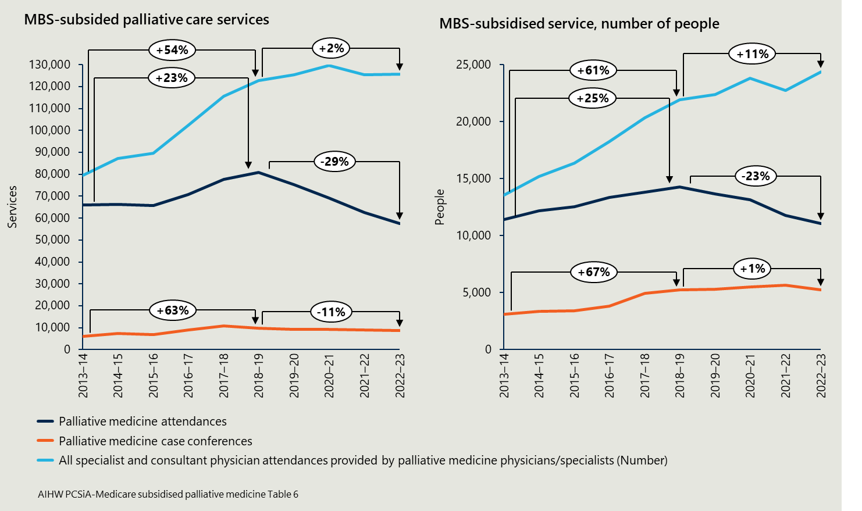

Pharmaceutical Benefits Scheme (PBS) data of palliative care-related medicines shows palliative care specialists are prescribing more often in recent years
A range of medicines commonly used in palliative care have been recommended for inclusion on the PBS Palliative Care Schedule. Analysis of prescriptions for these medications can reveal useful insights into how patients are being treated and how many. Noting that as the Palliative Care Schedule complements the general PBS Schedule, it is likely there are data gaps for prescriptions for palliative care patients from primary care providers (e.g. GPs). An overview of this is shown in Figure 8.
There are some interesting trends which have occurred over recent years:
- There has been a steep increase in prescriptions from palliative specialists since 2020/21, including an increase in pain relief medicine, from 3,632 in 2020/21 to 12,402 in 2021/22 (a +3.4x increase in one year).
- The steep increase in prescriptions was not observed in GPs or other clinicians. However, as mentioned above, this may be due to GPs prescribing via the general PBS Schedule.
- There has been a very large increase in prescriptions per person for all groups of clinicians.
A synthesis of the data suggests palliative care specialists are prescribing more now than they have been historically, and that all clinicians are prescribing more per person. These increases are encouraging regarding the capacity of care being provided to patients. However, as with all data exercises, the causes for these increases require further consideration (are prescriptions being repeated more often than before, are palliative care specialists prescribing more often, or has there simply been a wide set of data being collected).
Figure 8 | PBS prescriptions palliative-care related medications
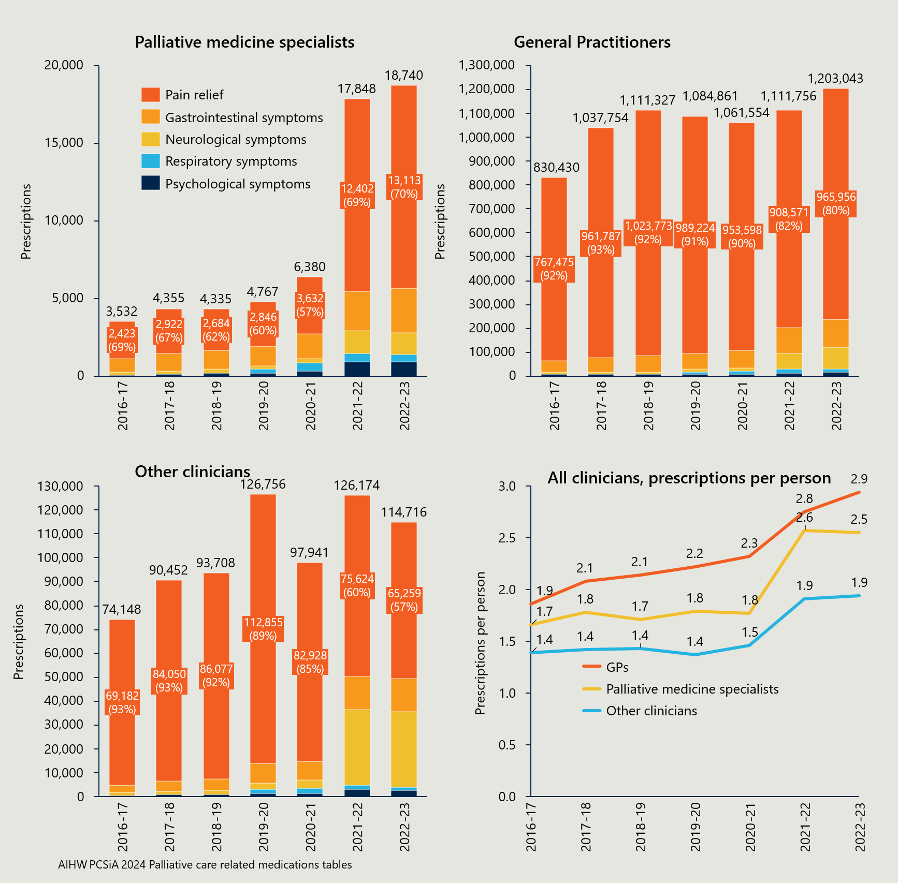

KLE 2.4 To what extent has collaboration and knowledge sharing improved the experience and outcomes for people receiving palliative care?
The diversity of programs and initiatives within and between states, as well as the lack of a unified reporting standard, complicates the assessment of collaboration’s impact on patient outcomes. It is difficult to measure change without a standardised baseline to attribute improvements from collaboration and knowledge sharing against. As outlined in KEQ 1 and identified in the palliative outcome measures, there is currently very limited data available to ascertain patient outcomes. There remain core challenges to data collection directly with those with a life-limiting illness and their care community.
As outlined in KLE 2.1, stakeholders acknowledged an increase in collaborative efforts and knowledge sharing, which has led to some improvements in palliative care delivery. Despite these improvements, there is a noted inconsistency in the extent and effectiveness of collaboration across different regions and among various service providers (which has been previously discussed).
Collaboration has improved between Primary Health Networks (PHNs), the community, and services, leading to more shared knowledge and collaborative planning. - Stakeholder
There is a risk the benefit to patients may not be able to be monitored or ascertained without sufficient follow-up. The (necessary) short-term focus on project and program evaluations has somewhat stymied collaboration, provided funding timelines. A more dedicated effort to track longer-term outcomes in a consolidated manner would be beneficial to best capture patient outcomes (discussed in KEQ 4 re palliative care data).

KEQ 3 To what extent has ACP increased and what evidence is there of improved shared decision making across care settings?
Action area 3: Advance care plans are being prepared by people affected by life limiting illnesses and used to facilitate shared decision-making across care settings.
“Continuing to support the development and use of advance care plans will help people affected by life-limiting illnesses to be involved in decisions about their own care and will support service providers to identify and meet the needs of people at the end of their life. It also supports the consistent delivery of person-centred care across different care settings.”

Key Points
- Initiatives aimed at improving community awareness and upskilling the workforce on ACP have, and continue to be, implemented at local, state and national levels.
- Increases in completion of ACP documentation have been highly variable across different cohorts and contexts, with RACFs showing the greatest increase in uptake.
- People’s ability to develop ACP documents earlier is dependent on multiple factors, such as their pre-existing knowledge of ACP and palliative care, the capacity of the primary care system to enable such conversations to take place, and the effectiveness of digital infrastructure in supporting easier uploading and access of documents.
- ACP should emphasise ongoing conversations between patients, families, carers, and clinicians about the process of death and dying.
- The degree to which patients wish to be involved in their own care exists on a spectrum. Where patients want to have a high degree of involvement, their ability to do so is determined by factors such as the staffing capacity of the palliative care system, clinicians’ training and experience in palliative care, and the patient’s and carer(s) own knowledge.

KLE 3.1 What activities have been undertaken to raise awareness of ACP? To what extent have these areas focused on diverse groups in the community?
There are many ACP focused initiatives being run by State, Territory, and Local Governments, as well as by federally funded palliative care projects. These fall into two key categories: training initiatives, and community awareness initiatives. While the abundance of initiatives being carried out is an encouraging sign for the future of ACP in Australia, the issue of program duplication and siloing present in other aspects of palliative care is present in ACP as well. Table 2 provides a non-exhaustive overview of such initiatives.
Due to the diverse nature of palliative care projects and jurisdiction-based initiatives, many programs carry out similar activities to one another. Additionally, the large number of programs can cause confusion for consumers, which in turn can necessitate resources being allocated to navigator programs, such as Palliative Care Connect in South Australia. It is important to stress this is not an ACP specific issue, but rather one ubiquitous within the palliative care sector.
Table 2 | ACP activities are generally split across training and community awareness

ACP activities (not exhaustive)
Training Activities | - Planning Improvement Toolkit in RACF and hospital settings.  - ACP learning modules online, which teach clinicians how to have ACP conversations, about the legal implications of ACP decisions, implementation guidance, and ‘train-the-trainer’ modules.  - Paediatric Palliative Care provides End-of-Life perinatal communication training online.  - PeSAS Tool Training Workshops.  - Some Victorian PHNs have placed a focus on End-of-Life Medication and ACP through the Greater Choices measure.  - The CPCiAC measure enabled some ACP activities in RACFs, such as funding consultants to provide training sessions centred on having ACP conversations.  - Training programs in GP clinics through Monash University.  - The Advance Project helps train aged care and primary care clinicians to have conversations about ACP.  - The Commonwealth’s investment in the ELDAC project, which resulted in seven practical toolkits being developed, with over 75,000 downloads.  - Some Victorian PHNs have tied ACP into their dementia learning modules.  - The PACOP project audits ACP completion rates in participating centres.
Community Awareness Activities | - ACP week campaigns on social media, reaching 6 million individuals over three campaigns.  - ACPA National service line (phone and email).  - Health Tasmania ran the “Have that awkward conversation” campaign to raise awareness of ACP.  - SA Health have invested in local councils for community awareness campaigns.  - Canberra Health Services has an ACP team, focused on community outreach and partnering with community organisations, such as Meridian and Dementia Australia.  - Some NSW PHNs run an awareness day to raise awareness of ACP.  - ACP Awareness in Aged Care campaign by the Northern Territory PHN.  - Queensland’s Office of ACP reviews people’s ACP documentation and uploads them to their digital platform ‘The Viewer’.  - Various programs and peak bodies also run ACP awareness programs, primarily through digital means.

ACP activities aimed at diverse groups have been successful, and should continue to be specifically tailored
There have been numerous ACP activities directed towards diverse groups, including Aboriginal and Torres Strait Islander communities. However, the quantum and success of these activities varies greatly by geographical location. Stakeholder feedback varied in opinion about the coverage of / success of ACP in diverse communities, with some stakeholders reporting great success, while others believe more must be done to target diverse groups.
Overall, there was consensus among stakeholders that more should be done to support diverse groups with ACP, while acknowledging the progress made with many programs. A selection of such programs is provided below:
- Many ACP Australia resources have been translated into 18 other languages on their website, such as Arabic, Greek, Chinese (traditional and simplified), Mandarin, and Vietnamese.
- A Chinese and Vietnamese “Farewell Choices” booklet was created as a resource by PCA Victoria.
- The Gwandalan Education and Training Suite includes eLearning modules to support frontline staff to deliver culturally responsive palliative care.
- Advance Care Yarning is being run by Queensland Health to teach a culturally safe and decolonised approach to ACP.
- PCA Victoria has completed six CALD community training sessions focused on having conversations about ACP.
- Compassion & Choices provide an LGBTQ+ ACP toolkit to empower members of the community who may face specific challenges in the legal and healthcare systems, and to avoid discrimination.
- ACON provide educational ACP resources for LGBTQ+ people in NSW, funded primarily by the New South Wales Government.
- Talking End of Life (TEL), a website with training modules and resources for clinicians and care workers of those with disabilities.

KLE 3.2 How effectively have activities undertaken raised awareness of the benefits of ACP in the community and service providers?
Although not a direct correlation, one of the primary indicators of raised awareness of the benefits of ACPs is through their rate of uptake. ACP uptake and awareness is increasing, but this increase is highly variable between care settings, with RACFs seeing the greatest uptake and other settings lagging. As of 2021, 29 per cent of Australians aged 65 or older have any type of completed ACP document, and only 14 percent have a legally binding directive. In some residential aged care facilities, stakeholders reported ACP documentation completion rates above 80 percent, although the average completion rate of ACP documents was 38 percent, and ~21 percent for legally binding ACP documents as of 2021. Multiple factors have influenced this increase:
- The Commonwealth’s CPCiAC measure funded RACFs to complete palliative care related activities, including hiring staff to run palliative care programs, with some RACFs utilising their CPCiAC funding to target ACP completion, including with Aboriginal and Torres Strait Islander communities.
- Many RACF providers have established a requirement upon entry for services to discuss with residents the option of completing ACP documentation, further bolstering uptake. Stakeholders raised concerns about the quality of such documentation, with some describing ACP being treated as a checkbox exercise rather than an opportunity for a person to comprehensively discuss and document their values, beliefs and preferences. This concern may be symptomatic of the wider perception of ACP as focused on document completion, rather than ongoing conversations about care. Lack of data on the rate at which ACPs are taken into consideration when making care decisions presents difficulties in assessing the degree to which this issue is affecting patients.
- Education sessions and toolkits have been positively received by clinicians in general practice, RACFs, and other settings, but this has not necessarily translated to greater awareness of the benefits of ACPs and their respective uptake. A key exception to this is Queensland, who have established the Statewide Office of ACP which uploads completed ACP documents to ‘The Viewer’. The Viewer had over 100,000 ACP documents uploaded to it as of 2023, and its linkage with ambulance services has enhanced decision-making at critical points. Stakeholder consultation also revealed the Statewide Office of ACP has enabled services and clinicians to promote greater community awareness around the benefits of ACP, due to their role in decreasing the burden placed on clinicians to manage a patient’s ACP process. Queensland’s success provides a positive example of the effect a concentrated and structural focus on ACP can have on completion rates, quality of documentation, and the rate at which these documents are actually used.
While RACFs have seen a significant increase in ACP completion, uptake in the general community has not significantly improved (based on stakeholder consultation).
In primary care settings, GPs report they face financial barriers to having ACP conversations with their patients due to the lack of awareness about dedicated MBS items, leading to such conversations often occurring too late and in too little detail to be optimally useful. Only 6.6 per cent of GP patients aged 65 or older have completed ACP documentation in their patient records as of 2021. GPs report when ACPs are completed in a comprehensive manner by GPs, it is often done on a pro-bono basis, motivated by a long-term relationships individual GPs have with patients.
The evaluation identified four supplementary components influencing this degree of awareness and adoption for ACPs:
- ACP is about more than just completing documentation, and instead should be thought of as an ongoing series of conversations.
- ACP has seen the greatest increase in uptake and awareness in contexts where it has been embedded as core business within palliative care.
- Culturally sensitive approaches are necessary to reach diverse cohorts.
- ACP completion and use by clinicians is often bottlenecked by digital platforms.

ACP should focus more on conversations about dying, not just documentation
While ACP involves the completion of ACP documentation, in its various jurisdictionally based forms, consensus among stakeholders is the nature of ACP has been misunderstood by many within the community as being solely about completion of such documents. Rather, a more holistic and useful interpretation of ACP should highlight the conversations surrounding the EOL process, between patients, families, carers and clinicians. These conversations should be occurring prior to the onset of life-limiting illnesses, to best prepare the relevant parties for palliative and non-palliative care. Conversations should focus not only on the patient’s goals of care at various stages of their EOL journey, but also what they value in terms of quality of life, who they would like to make decisions for them should they lose such capacity, and how involved they would like to be in their own care to begin with. Such ongoing conversations are difficult to capture and measure as outcome variables within a dataset, however, there must be a stronger focus of ACP to create optimal care experiences for patients and their families, as well as minimising ambiguity on the part of clinicians.
Conversations are highly important. Getting people to talk has been [our] focus. It is easy to measure outputs, but conversations are hard. – Stakeholder

ACP should be embedded as core business
While there has been significant investment in ACP across jurisdictions, ACP awareness and uptake remains lower than desired goals for the general population, both in quality of documentation and overall quantum. Simply put, people do not think about dying and ACPs until they might need one.
Training and education programs do still have a place in uplifting ACP, with clinicians across sectors responding positively, and reporting increased confidence and skill after such development sessions. Initiatives such as PeSAS, The Advance Project training, and those piloted in GP clinics by Monash University, have highlighted the value in targeted investment in development. However, without a more structural approach, such as the one taken in Queensland, the tangible effect on ACP uptake is limited.. This means smaller jurisdictions must be supported to create the nationally desired change.
Variation in skills around ACP conversations is enormous. Some do it well, some are very bad. – Stakeholder

Culturally sensitive approaches have been successful in reaching diverse cohorts
Stakeholder consultation revealed a critical requirement of success for many CALD-centred programs is the creation of community buy-in. This in turn requires trusted members of the community being consulted and empowered to bring the content to their communities in a manner deemed appropriate by them. For example, local government initiatives in regional SA have supported community-led groups to distribute ACP resources to families, indicating engagement from trusted sources can be an effective method of increasing the awareness of the benefits of ACP. Additionally, Aboriginal Community Controlled Health Organisations (ACCHOs) in some jurisdictions are developing tailored ACP documents for distribution among their communities. There is also a growing recognition of the need for trauma-informed approaches, particularly for Aboriginal and Torres Strait Islander peoples, to address historical trauma and promote respectful ACP engagement.
In other cohorts, initiatives such as the ‘Farewell Choices’ booklet for Chinese and Vietnamese communities underscore the importance of culturally appropriate materials. The LGBTQIA+ community also has seen an increase in palliative care resources tailored to their needs, led by LGBTQIA+ Health Australia, though direct engagement with these communities by ACP related projects remains limited.

ACP adoption and use is influenced by the ease of access of digital platforms and datasets
Gaps in technology hinder the logging and accessibility of ACP documents, with many stakeholders reporting ease of accessibility as one of the key barriers to greater completion and usage rates. Inconsistent and challenging integration of ACP documentation with digital health platforms like My Health Record hinders accessibility of people’s ACPs in time-critical situations, meaning they can be hard to find or not used. Efforts by the Australian Digital Health Agency to enhance My Health Record functionality for ACP uploads represent a positive step towards accessibility for both patients and healthcare providers. Queensland’s ‘The Viewer’ platform provides an excellent model to design against, with providers able to access a patient’s ACP through the platform, enabling decisions which properly reflect the desires of the patient in time-critical situations.
My Health Record works, but you need technical assistance to upload [documents] and GPs often don’t have time to do that. – Stakeholder.

KLE 3.3 To what extent are more people developing advance care plans earlier? To what extent does this vary across different groups in the community?
The number of people developing advance care plans earlier is difficult to measure quantitively due to a lack of available and comprehensive data focused on ACP. Qualitatively, stakeholder consultation revealed that while people are increasingly completing ACP documents, they are not necessarily doing so earlier in life.
The evaluation revealed three factors as prominent causes:
- General practitioners face structural barriers to facilitating the ACP process with patients, such as insufficient remuneration and training.
- The public generally regard ACP as a document to complete at the end of one’s life, rather than a series of ongoing conversations about death and dying.
- ACP completion is distributed unevenly among different cohorts, meaning members of certain cohorts often develop advance care plans later in life, or not at all.
ACP conversations and document completion is often delayed until specialist palliative care services or RACFs become involved in a patient’s care. Stakeholders repeatedly emphasised the importance of having ACP documents in place prior to palliative care treatment.

GPs have a large role to play but face structural barriers
GPs are recognised as pivotal in early ACP facilitation, as they are often the first point of contact for a patient. However, they face systemic challenges, such as insufficient remuneration and support, which hinder their ability to conduct in-depth ACP discussions in a timely manner.
First, there is no Medicare item for ACP-specific activities. This functions as a deterrent for GPs, as well as patients who often cannot afford to pay out of pocket for a longer appointment. It should be noted that there are MBS items that support ACP in general practice, such as health assessment and care planning items, including the 75+ Health Assessment, Chronic Disease Management Planning items and long consults (including level E consult).
Second, while GPs strive to provide the best care possible for their patients, the evaluation found there are instances where some GPs do not encounter palliative situations frequently, and can therefore be less prepared to have conversations about dying. Training is one avenue to help GPs to develop better skills and confidence with respect to conversations about death and dying. Some training has been developed to target this issue, such as the development and roll out of the Psycho-Existential Symptom Assessment Scale (PeSAS) tool, which enables clinicians to screen symptoms of mental distress in patients with more confidence. Approximately sixty five percent of clinicians reported a positive response from patients after utilising the PeSAS tool, with 5,901 clinicians completing online training in its use, and 629 in person. Education and skills investment must be ongoing in order to create a health workforce which feels prepared and capable of having ACP conversations.
In addition by normalising death and dying, and improving people’s understanding of death, conversations on these topics will become easier and more productive for clinicians and patients alike. This requires sustained education and awareness campaigns on the topic of palliative care in general.
If GPs are hesitant have ACP conversations with their patients, this can lead to ACP being delayed until specialist palliative care services or RACFs become involved with a patient.
GPs providing holistic care generally do that at their expense and goodwill. MBS items do not recognise the time commitment involved. – Stakeholder

ACP documentation is only one piece of the puzzle
The quantum of ACP documents being completed is not a true measure of how well people’s goals of care are being developed and addressed, as the usefulness of ACP documentation is limited by several factors.
- ACP documents may not be completed comprehensively. The patient’s state of mind when completing the document may limit the document’s useability, or family members who complete the document may not have an in depth understanding of the patient’s wishes.
- Patients’ wishes can change over time. Unless ACP documents are revisited, they can become out of date, and not reflective of the current wishes of the patient. This hampers clinicians’ ability to rely on ACP documents in time-critical situations.
- Stakeholder consultation has revealed ACP documents are sometimes not fully ‘followed’ by clinicians, due to factors such as capacity constraints within the healthcare system, or difficulty locating the document itself. Jurisdictions with a greater structural focus on ACP, such as Queensland, face this issue to a lesser degree. Queensland’s Office of ACP systematises the review and uploading of ACP documents onto The Viewer, leading to better quality, more accessible ACP documentation for clinicians and responders to use.
Consensus among stakeholders is that ACP should be about the conversation surrounding dying rather than just the document itself. Conversations about dying should ideally happen when a patient is healthy and clear minded, as this helps prepare the family, patient and carers for the EOL process.
The reality is people change their mind, so it's not something that can be set in stone. These things must be reviewed and discusses again and again. ACP has to be an ongoing process, not a document. – Stakeholder

ACP development is unevenly distributed among different cohorts
ACP development and completion is not equal among different cohorts. Some cohorts have significantly lower levels of completion than others. This means they are often completing ACPs later in life, such as in a hospital setting, or not at all.
- Jurisdictions that have placed a stronger emphasis on ACP have seen higher levels of engagement.
- ACP completion is greater among those who enter RACFs compared to those who do not. This is because many RACFs invite residents to consider completing ACP document upon entry.
- Metro residents are more likely to have a completed ACP than their rural/regional counterparts. A mitigating factor against this gap is that in rural/regional settings, GPs may have a more integrated role in their community, providing them with a more holistic view of their patients.
- Members of CALD groups are less likely to have a completed ACP than non-CALD groups. Stakeholders raised that some CALD groups have different cultural understandings and expectations of death and dying, which may serve as a barrier to completing formal ACP documentation. As discussed in KLE3.2, CALD groups benefit from tailored ACP approaches addressing their concerns about death and dying, which are not necessarily the same as non-CALD groups.
Disparities between metro and rural/regional areas, and CALD versus non-CALD, are not specific to ACP development, and are observed across all facets of the palliative care service delivery system, and therefore they are key areas for sustained attention.

KLE 3.4 To what extent do people affected by life-limiting illnesses feel they are involved in decisions about their own care? To what extent does this vary across different groups in the community and different settings?
Involvement of individuals in decisions about their own care is highly variable and is influenced by capacity of the healthcare system to support such involvement. Conceptually, patient desire to be involved in decisions about their own care exists on a spectrum. Some patients do not want to become highly involved in decisions about their treatment as they go through an emotionally challenging period. Others prefer a much more involved approach. The evaluation found that in situations where patients would like to be highly involved in making decisions about their care at end of life, their ability to do so is influenced by the following factors:
- The staffing capacity of the palliative care system they are exposed to.
- Their respective clinicians’ training and their experience in palliative care.
- The palliative care knowledge of the patient and their family/carers.
While clinicians and service providers endeavour to provide optimal care to all their patients, capacity constraints of the palliative care system may limit their ability to spend as much time as they would like on each individual patient. Time limitations can be mitigated through workforce development initiatives, or innovative models of care which better utilise clinician expertise.
Clinicians and palliative care providers who are highly trained in the most up-to-date tools and methods are better able to empower their patients to be involved in their own care. Stakeholder consultation revealed that in cases with complex patient needs, such as patients with co-morbidities, it is important that all involved clinicians who may specialise in non-palliative areas are trained and aware of palliative care best practice. For example, it is important that a patient’s cardiologist understand a patient’s palliative care goals and help achieve them.
Finally, palliative care workers and clinicians are not solely responsible for the successful involvement of patients in their own care. Patients (and their carers) who are more knowledgeable about the services available to them, and palliative care as a whole, are better able to create an effective two-way dialogue between themselves and clinicians. Stakeholders reported that due to the broad range of palliative care services and resources, patients can become overwhelmed or confused when attempting to engage with the palliative care system. Stakeholders reported that programs, such as South Australia’s Palliative Care Connect navigation pilot provided practical information, which assisted them in navigating the palliative care system more efficiently.

KEQ 4 What nationally consistent data mechanisms have been implemented over the five-year reporting period and how has this assisted in national reporting?
Action area 4: Nationally consistent data collection mechanisms are implemented and national public reporting is underway.
“Establishing this mechanism will improve the quality of the national evidence base regarding service delivery and effectiveness and support an evidence-based approach to service improvement. It will also inform a national research agenda by identifying gaps in evidence and data. This will also assist in workforce and service planning for the future.”

Key points
- The lack of availability and consistency in data were consistently raised as key issues by stakeholders.
- The most complete source of data comes from MBS items, but there is limited data available on service provision within the community and primary care sectors.
- Some outcomes data is being collected (for example through PCOC) but participation is voluntary, and the collection focusses on the specialist palliative care sector.
- The cross-sector nature of palliative care services makes it difficult to collect accurate data on a patient’s journey through their different care providers.
- There is ongoing work across the system to address data issues and data linkage (being taken forward by the Australian Digital Health Authority). This includes work to incorporate ACPs within electronic medical records.
- Short-term funding for projects incentivises ‘quick wins’, which stymies investment towards innovative, longer-term data solutions.

KLE 4.1 Are there consistent data definitions and agreement on the data collection and reporting processes for palliative care services between governments?
At a national level, there are some standard data definitions for key parameters associated with palliative care. These are led by AIHW and released through the Palliative care services in Australia (PCSIA) digital report. These data definitions are supported by some of the more comprehensive data collection methods (such as PCOC data). There is also acknowledgement of the importance of tailored data definitions and collection methods for specific areas within palliative care (e.g. different approaches for paediatrics, specific needs for bereavement care).
However, as was acknowledged through nearly all engagements within this evaluation, data remains a continual challenge with limited progress over the past five years. Across the sector, there are clear data gaps to comprehensively address central questions such as, ‘what service was provided, for whom, at what cost, and to what effect’. Although the issue of costs and outcomes is a more general issue across the health sector - some of the key reasons stakeholders told us for these gaps are:
- The palliative care sector extends beyond just specialised care, which are the primary points for more comprehensive data collection (e.g. hospital admissions). Therefore, a patient’s palliative care journey is only captured piecemeal and usually when they are requiring more comprehensive care; which is usually for a shorter period of time.
- A patient’s palliative care journey often involves multiple care providers, including community care, home care, hospitalisation, hospice care, or other modes of care. This makes the centralisation of data collection very challenging across service providers given the siloed nature of the sector. Simply, data collection and reporting are not patient centric.
- There is no national data forum, such as the former Palliative Care Data Working Group, to facilitate interjurisdictional data collection and sharing. This makes it difficult to gain a holistic understanding of the state of palliative care at a national level.
- For some of the more established data sources that do exist (such as PCOC), data entry is voluntary, impacting how comprehensive and representative they are.
- There are (appropriately) privacy, consent, and ethical data sharing considerations given the sensitive nature of some of the data collected.
Overall, there is no set agreement (or ‘north star’) on universal data collection across all levels of government, the private sector, and NGOs. For example, although each funded palliative care program has a Monitoring & Evaluation (M&E) reporting framework, these are program specific and not always aligned to national metrics. There remains a continued need to identify data gaps across the sector and to understand what it would take to fill these gaps using existing or new data.
“…improvement of palliative care information will require a multipronged approach with a range of initiatives including state and territory palliative care policies and frameworks, local level action plans, high level strategic planning and national policies, and commitment from across all levels of government to implement these improvements.”
There is a long way to go still in having consistent data definitions and agreement on data collection and reporting between governments. Importantly, the evaluation also heard from stakeholders that progress on data definitions and agreement need to balance value of data relative to the effort required for its collection. In an already pressured sector, to maximise success, data collection should not be an additional burden where possible. Some of these issues should be addressed by work being carried out by the Australian Institute of Health and Welfare who have commenced work with palliative care providers to look at data and consistent definitions across the palliative care sector.

KLE 4.2 To what extent is palliative care data being collected in a nationally consistent way?
As with nearly all sectors across the health space, the amount of data collected within palliative care is extensive. Data is made up of both palliative care specific sources as well as other general datasets within the health sector, including (not exhaustive):
- National Hospital Morbidity Database (NHMD) - data on admitted patient palliative care, with almost all hospitals in Australia providing data.
- National Public Hospital Establishments Database (NPHED) - establishment-level data for each public hospital in Australia.
- PCOC - open to all palliative care service providers across Australia. PCOC seeks to provide benchmarking to improve outcomes for patients.
- Palliative Care Self-Assessment (PaCSA) Palliative Care Australia – individual checklists for services to self-assess against the nine Palliative Care Australia National Palliative Care Standards (voluntary standards).
- National Health Workforce Data - voluntary and sent to all health practitioners registered by the Australian Health Practitioner Regulation Agency (AHPRA).
- Admitted subacute and non-acute hospital care National Best Endeavours Data Set (ASNAHC NBEDS).
- Expenditure data.
- Data from Residential Aged Care Facilities.
- MBS - for subsidised palliative specialist services.
- Palliative care-related prescriptions from PBS and RPBS.
- National Health Data Hub (NHDH), formerly the National Integrated Health Services Information (NIHSI).
- Palliative Aged Care Outcomes Program (PACOP) – voluntary participation by RACFs to screen residents’ care needs, with data captured and submitted to PACOP every six months for analysis and reporting. PACOP seeks to provide a similar benchmarking service to PCOC, with a focus on the aged care sector.
- AIHW Palliative Care Services in Australia report and data.
Whilst there are several key data sources, as outlined in KLE 4.1, many of these are incomplete. To fill these data gaps requires additional effort placed on those providing the data (health care workers), who already have high workloads. A contemporary example is the ‘Criteria for Screening and Triaging to Appropriate Alternative’ care (CriSTAL) tool used by many hospitals to flag patients at risk of their condition significantly deteriorating. This tool naturally generates data on patients’ frailty and risk of death, but is used primarily in high workload environments such as ED. This means the burden imposed on healthcare workers to log such data would have a high opportunity cost.
“Given that palliative care is delivered through specialists (palliative care and other specialists) and generalist providers and across a range of settings (not just specialist palliative care), there are some notable data gaps and limitations in current reporting to provide a comprehensive picture of the number of people receiving palliative care services in Australia.”
Taking into consideration the full breadth of the palliative care sector, there are naturally many additional data sources at a state and territory level. Many of these are localised and serve a direct purpose for the state or territory, hospital, or care setting, they are collected in. An example of this is South Australia’s metro/regional divide in data collection software, in which metro services generally use Sunrise to log patient info, whereas country services use Country Consolidated Client Management Engine (CCCME). Migrating data from one platform to another would require significant upfront investment and change management support. The roll-out of Sunrise across regional areas is progressing, but in the meantime, the two systems remain in operation.
Considering these localised data sources raises several questions:
- Is this data valuable at a national level, or is it best suited to inform localised delivery?
- If trying to bring this data to a national level, is it worth the cost (both financially and time) taking into consideration data movement, management, security, and dissemination?
- Even so, how can we use these data informed lessons-learned at a local level to drive improved service delivery nationally?
Taking a holistic viewpoint, “data related to palliative care is currently lacking across multiple settings, in particular care delivered in the community, primary care, and residential aged care.”
This challenge also extends to vulnerable populations including those living with a disability, the LGBTIQA+ population, and Aboriginal and Torres Strait Islander peoples“. Significant data gaps exist for many vulnerable populations, particularly those in the LGBTIQ+ community, people living with a disability, people in long term institutional care, and the ageing and frail.”
Many stakeholders we spoke to note the challenges and gaps in collecting data on these populations, let alone in a nationally consistent manner. One primary reason for this is cultural distrust of the healthcare system, which is a product of historical trauma many vulnerable populations have experienced.

KLE 4.3 To what extent is palliative care data being reported and used for the purposes of monitoring and identifying opportunities to improve palliative care?
There is a clear sentiment from those we spoke with to collect data for the purposes of improving the provision of and access to quality palliative care, however the data gaps across the sector are impacting the ability to systemically identify opportunities for improvement, particularly nationally.
For example, most government funded programs have monitoring and evaluation (M&E) frameworks and associated reporting. As with all M&E processes, these are designed to provide transparency regarding outcomes and to drive continual improvement. However, stakeholders told us, given the general under-funding of the sector and short-term windows of program funding (e.g. up to two years at a time), many service delivery providers are incentivised to run programs which deliver early results within the reporting window. The flow on effect of this is systemic opportunities to improve palliative care are stymied due to the need to sustain a steady stream of funding.
The evaluation also found identifying opportunities for improvements would be greater if there was more comprehensive data collected, particularly for non-admitted hospital settings. As outlined above in the KLE 4.1 and KLE 4.2, there are clear gaps across the sector where there is little to no visibility of the patient journey, particularly outside the hospital setting.
“The provision of community supports, such as allied health, can decrease avoidable hospitalisations, but these services are not captured in existing national data. Data collection and reporting of care provided to people living at home and in the community is critical for developing a more complete picture of palliative care service delivery.”
Contrary to this macro-observation, there are naturally initiatives to help address these key data gaps and to provide a more holistic picture of the palliative care sector to drive improvement. The early use of patient reported measures (PREMS and PROMS) are showing promise in identifying patient-centric opportunities in palliative care. This data is also filling a critical gap regarding carers, providing them a voice to express their views about the care delivered. However, even these data sets are limited to discrete health settings and therefore not comprehensive.
Similarly, all states and territories are undergoing data improvement projects. But many of these are in isolation or to deliver against a specific need, risking further fragmentation when considering a national viewpoint. Examples of these projects include electronic medical record (eMR) integration improvements, definition of minimum datasets, and data linkages. There have also been some improvements in the awareness and completion of ACPs, with attempts to create a national database in My Health Record receiving mostly positive feedback. However, as stakeholders told us, even these nationally adopted data sources are prone to quality issues and incomplete data, and the improvements they deliver are reliant upon broader workforce training and access.
- There are instances of State and Territory Health Departments collaborating with national agencies on the development of Palliative Care and EOL care key performance indicators and other data improvement projects. However, the palliative care sector is not immune to typical systemic data challenges, namely:
- Linking data is difficult due to inconsistent definitions and collection methods across jurisdictions.
- Data is usually collected for a specific use, making it harder to adapt it to a different need. This is particularly true as data collection moves away from being service-centric to delivering patient-centric outcomes.
- Completion rates are reliant upon patients and service providers, both of whom are time poor and often have other immediate priorities.

KLE 4.4 Are there key gaps in national data and are these being addressed?
As outlined in the preceding KLEs for KEQ 4, there are systemic data gaps across the sector. The sentiment stakeholders shared with the evaluation team was, ‘given the sector’s breadth and complexity, data collection is very difficult. We collect data where we can and where institutional support exists, but there are substantial gaps. We recognise there is a long way to go.’
Again, given the lack of nationally consistent data collection methods against standard definitions, national data is a work in progress. There are systemic approaches to address these national data gaps, with AIHW proposing data development activities:
- Explore expanded reporting in PCSIA, including other vulnerable cohorts and PHN level reporting.
- Explore new data sources for enhanced reporting, including public hospital data (expenditure, patient and staffing volumes), non-admitted patient care, and use of NIHSI for person-level hospital admissions and readmissions.
- Monitoring other streams of work that could be leveraged, including AIHW Aged care data improvements, the National Disability Data Asset, primary care health data, and jurisdictional PREMS work.
There is also a push to utilise valuable datasets that currently exist where possible, lessening the administrative burden on the palliative care workforce. Opportunities include leveraging the National Death Index, MHR, PREMS, MBS, PBS, etc. However, there remain key gaps, particularly for:
- non-specialist and unpaid workforces (including carers);
- expenditure data, particularly private expenditure and care provided in non-hospital settings;
- paediatrics, and
- underserved populations.
Through engagement with the states and territories, it became apparent there are also local efforts to address program or service specific data gaps. However, these methods require systemic commitment (through both funding and resourcing).
As we were informed, data collection cannot be reliant alone on the passion of those in the sector and needs to be pragmatic, “starting with a basic dataset and gradually expanding, to prevent overreach and ensure the data collected is manageable and meaningful.” The localised approaches to data collection and dissemination do speak to the broader challenge of the palliative care sector with data: it is recognised to have clear gaps and not yet at a point to drive systemic reforms.

KEQ 5 Has the allocation of resources to the implementation of the Strategy been efficient?

Key Points
- Investments into each action area of the Implementation Plan should not be considered in isolation, as programs and projects necessarily engage with multiple action areas simultaneously.
- Each action area has seen significant investment into it, with training and community awareness initiatives implemented across jurisdictions to uplift access and ACP.
- Some areas, such as collaboration and data remain challenging, but have shown improvement throughout the life of the Implementation Plan.
- The short-term funding cycles attached to many programs create challenges for state-level service providers, hampering their ability to engage in long-term strategic planning.

KLE5.1 - What investments have been made against each of the four action areas in the Implementation Plan?
Provided the degree of cross-over funding across the four action areas, it was determined it would be difficult (potentially impossible) to attribute proportions of any funding to a specific action area. As a result, it was agreed this KLE would present little value to the evaluation, and so was not included.

KLE5.2 - Was the process of allocating the funds completed effectively?
Whilst the evaluation was unable to ascertain a complete and accurate picture of funding agreements and the use of funds, stakeholders did comment on two components specifically when it came to funding. There are outlined below.

Short term funding cycles create uncertainty for service providers
As outlined in the previous KLEs, short term funding cycles create a barrier to strategic planning of projects and initiatives, as organisations cannot effectively plan multiple years in advance without the certainty that they will be funded for that period. This lack of long-term strategic planning means there is a focus on immediate outcomes; to show programs are delivering value quickly. This can come at the expense of longer-term goals and investment in systemic priorities, which take multiple years to realise.

More funding should be targeted at workforce development to fill the labour supply gap
Stakeholders consistently raised concerns about demand for palliative care outstripping the labour supply of trained clinicians. As the population ages, this issue will become more pronounced. As such, investment should be targeted at developing the workforce to meet this demand. Many stakeholders spoke of being unable to recruit staff to fill vacancies, indicating there are simply not enough adequately trained clinicians. Or, if recruiting, they are potentially taking staff from other jurisdictions – just ‘moving the problem around’.

KLE5.3 - Were the funds used for the purpose they were intended for?
Funds appeared to be used in alignment with the Implementation Plan, with stakeholders consistently able to speak to the goals and outcomes of projects they were involved in, usually centring on one or more action areas of the Plan. This sentiment was validated by the state and territory monitoring and evaluation reports delivered to the Commonwealth Government as part of the Implementation Plan; outlining project activities, their intended goals and the extent to which they were met. A compounding factor ensuring funds were used appropriately is the funding structure itself. Given that projects needed to secure further funding in a highly competitive environment, with short-term funding cycles, they were strongly incentivised to deliver fast and successful projects, with demonstrable outcomes.
However, given the lack of data available in the palliative care sector, it is challenging to measure true systemic changes to patient outcomes. This in turn makes it difficult to direct funding to projects with the greatest marginal benefit, decreasing efficiency. The lack of patient outcome data presents an opportunity for improvement which would help inform areas for investment in a more structured and systematic manner in the future. This sentiment was echoed by stakeholders, who expressed concerns about the lack of formal mechanisms to monitor progress against the Implementation Plan, indicating a need for more rigorous reporting and assessment processes.

KLE5.4 - To what extent does the progress made on each action area align with the investment and resources allocated to the action area?
While the Implementation Plan was created with four distinct action areas in mind, the realities of service delivery are often impossible to disaggregate in such a manner. For many programs, most of the action areas are addressed simultaneously. Assessing what investments have been made into each action area in isolation may not be possible, or an effective method of evaluation, due to their intrinsically interconnected nature. Instead, progress within each area has been assessed holistically, rather than attempting to compare outcomes and funding between programs.
The overall sentiments this evaluation uncovered about each action area are as follows:
- Access is a core component of most programs’ focus, and significant investments have been made into this area with varied success. Many stakeholders believe access to palliative care is increasing, but disparities persist across cohorts, and workforce shortages may become a concern in the future.
- Progress on increasing collaboration has been positive, particularly with large-scale programs providing a space to connect. However, much of this collaboration is driven by individual stakeholders rather than institutionally.
- Significant investments have been made to increase ACP awareness and uptake, but success is highly variable across different cohorts.
- Data remains a key challenge within the palliative care space, due to its complex and fragmented nature. However, national bodies and programs such as the AIHW, PCOC and PACOP have had success in collecting and analysing data within their chosen contexts.

Opportunities for improvement

Throughout the evaluation, we also provided the opportunity for stakeholders to comment on opportunities for improvement. Although we could not detail all the specific comments made to us, we have endeavoured to categorise these into key themes that are broadly aligned to the four action areas. The below is not exhaustive, but a sample of the key opportunities shared:
- Collaboration is crucial – This is explored in greater detail in KEQ 2, but stakeholders report collaboration between palliative care providers, general practitioners, and aged care services has ongoing benefits and is crucial for increasing access to palliative care. However, they also note that collaboration is often hindered by the lack of specific guidance on effective approaches.
- Awareness is a perpetual need – Raising the awareness of palliative care services and the scope of work is an important step to improving patient access. Initiatives that raise awareness and understanding of palliative care among the public and specific communities can lead to earlier and more appropriate referrals to palliative care services. Whilst awareness-raising activities have been a core component of funding, the outcomes on community knowledge are unclear. Awareness also extends to raising the profile of palliative care for individuals with life-limiting illnesses which are not cancer (such as those with chronic disease).
- Innovative approaches (like telehealth) are welcome – There have been positive impacts of new technology on service provision. For example, the continued development of the My Health Record system that could make inclusion of ACPs easier or the expanded use of virtual care in remote settings. Telehealth services has been a positive step towards improving access to palliative care, particularly for underserved populations in rural and remote areas. Whilst this can improve ‘removed’ access, without access to on-the-ground staff to train carers and assist with administration of care, the benefits of virtual care are valuable but will remain capped.
- Addressing data collection and management - Data collection and management remain critical challenges in the palliative care sector, hampering efforts to assess patient outcomes and the overall effectiveness of care. While some progress has been made in developing standardised data definitions, driven by Commonwealth funding to the AIHW, the collection of data is inconsistent across states, territories, and care settings. The lack of comprehensive national data on palliative care makes it difficult to evaluate the quality of care or identify areas for improvement. Data sharing across jurisdictions and care settings is also inconsistent, due to varying levels of engagement and a lack of standardised practices. To fully realise the goals of the Implementation Plan, stakeholders recognise that greater cohesion and agreement on data collection and reporting standards are needed.
- Long term planning is essential – The implementation of initiatives by state, territory and Commonwealth governments to improve access require long-term planning and timeframes to see desired outcomes. Programs that aim to improve capability and capacity may require years to see benefits in the system, some of which may not be observable in the current timeframe. This is an especially important consideration for activities recently funded by the Implementation Plan, and therefore have had less time to demonstrate outcomes.
- Greater security around funding – Linked closely to long term planning is the establishment of funding mechanisms not bound to short-term reporting periods to secure the next tranche of money. Immediate funding needs are stymieing investment in systemic change. Stakeholders highlighted the importance of ongoing funding for palliative care initiatives, expressing concern about the uncertainty of ‘funding cliffs’ and the impact this has on the ability to plan and implement long-term projects. There is a risk that initiatives that have improved access, collaboration, or data sharing may disappear or stagnate without future certainty and maintenance of funding.
- Workforce development and recruitment remain a priority – Stakeholders told us there are not enough specialist palliative care workers, and jurisdictions are competing against each other for the same ‘pool’ of specialists. This pushes additional workload on those currently in the system and can impact patient outcomes.
- Better linkages between other strategic areas – For example, the Primary Care Framework with its proposal to develop more blended funding models in primary care may assist in GPs willingness to provide more palliative care services; continued work by the Australian Digital Health Agency to improve data linkages across the health system; and continued work on expanded scopes of practice which may, for example, assist in more nurse prescribers entering palliative care.

Appendix A | Methodology
Our approach and methodology have been informed by our expertise delivering national health evaluations and using mixed methods to collect and analyse data. The underlying methodology included mixed method evaluation design, data collection and analysis; targeted stakeholder engagement; and practical and targeted review of literature and reports.
The evaluation began with a thorough literature review of over 200 documents provided by the Department, such as project monitoring and evaluation reports, as well as numerous externally sourced documents, such as academic articles and program strategy documents. These documents were each categorised by KLE, and used to inform both the evaluation itself, and the stakeholder consultations.
Stakeholder consultation sessions were held with over 50 organisations and 150 individuals working within the palliative care sector, including service providers, project coordinators, clinicians, Commonwealth, State and Territory Health Departments, consumer groups and more. These sessions supplied much of the lived experience evidence which has been used to answer each of the evaluation’s KLEs. Stakeholder engagement enabled the evaluation team to understand the nuances and complexities of the palliative care sector which are difficult to capture solely from the literature and quantitative data.
The evaluation team concluded the evidence gathering phase of the evaluation by gathering and analysing the available quantitative data, using sources such as the bi-annual PCOC National outcomes reports, AIHW data, and MBS items. The evaluation collated datapoints to form a longitudinal understanding of the direction many palliative care outcomes are trending in. A significant challenge the team faced when completing the quantitative analysis is the relative lack of available data for many patient outcomes, especially at a national level. The issue of poor data coverage and quality was a key concern for most stakeholders.

Conceptual approach
The adopted approach recognised the importance of improving palliative care across Australia so that people affected by life-limiting illnesses have access to the care their need. This was informed by the following areas:
- An approach that addressed the complexity of palliative care within the wider environment. Palliative care does not exist in a vacuum – it is intrinsically connected to the broader health sector, encompassing primary care, secondary care and specialist services. Those requiring care often receive it from palliative care providers, GPs and community based primary care services, as well as hospital and community-based specialist services, which reinforces the interdisciplinary nature of palliative care. To add to this complexity, there is a mix of responsibility around progressing actions from the Implementation Plan between the Commonwealth and State/Territory Governments.
- There is significant change happening in the sector. Including workforce changes, demographic trends, changes in regulatory settings and policy changes, all which will impact on palliative care. The Implementation Plan is being progressed in the context of these other changes in the health and aged care sectors. As such, this evaluation needed to assess the impact of the Implementation Plan’s activities in the context of these other changes.
- Diversity within the sector. There is a diversity of consumers, including Aboriginal and Torres Strait Islander peoples, those with culturally and linguistically diverse (CALD) backgrounds and those living in regional, rural and remote locations, and the varying range, scale, expertise and availability of service providers.
- Potential data limitations. The approach acknowledged there are significant data limitations in the palliative care sector – in particular trying to assess the amount of palliative care that is being delivered in non-specialised palliative care areas such as in primary and community-based care, as well as other significant quantitative data gaps.

Nous used a realist evaluation approach to understand the effectiveness of the Implementation Plan
The evaluation used a realist lens to comprehensively explore the progress made against the Implementation Plan, as well as develop practical recommendations for future refinement of the Plan. The realist framework is shown in Figure 9.
Realist evaluation planning acknowledges that the measures may not have delivered similar outcomes across all contexts, particularly given the different approaches state and territory governments took to delivering on the Implementation Plan. The initiatives may only deliver improvement to health and care outcomes under certain conditions and be heavily influenced by a range of external factors. Realist evaluation planning was appropriate for this evaluation because it enabled rigorous identification of the ‘conditions of success’ for the initiatives implemented under the Implementation Plan.
Figure 9 | Realist evaluation framework
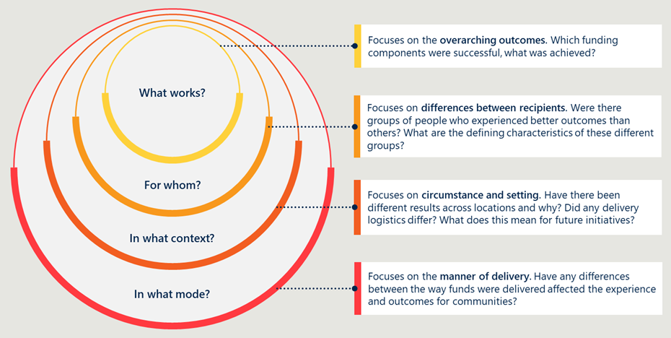

Program logic
A program logic allows a clear articulation of the way in which an intervention is intended to achieve its policy objectives, including highlighting the assumptions in design. Figure 10 below shows the program logic and respective:
- Context – what environment the Implementation Plan is operating in and what is driving its adoption?
- Inputs – what resources have been provided to deliver against the Implementation Plan?
- Activities – what has been delivered as part of the Implementation Plan over the past years?
- Outputs – what is the immediate change because of these implementation activities?
- Outcomes – what are the short and long-term changes and impacts anticipated for all parties within the palliative care system?
Figure 10 | Evaluation framework

Key lines of enquiry
Key lines of enquiry (KLEs) were developed to guide research and analysis. The key evaluation questions (KEQs) and their associated KLEs are outlined in Table 3Table 3. They represent the primary topics the evaluation will focus on and include:
- Access: How has access to palliative care changed over the five-year reporting period?
- Collaboration: To what extent has collaboration and knowledge sharing improved and what changes are evident in service delivery across care settings?
- Advance Care Planning (ACP): To what extent has ACP increased and what evidence is there of improved, shared decision making across care setting?
- Data collection and reporting: What nationally consistent data mechanisms have been implemented over the five-year reporting period and how has this assisted in national reporting?
- Efficiency: Has the allocation of resources to the implementation of the Strategy been efficient?
To note, KEQs one to four cover the four focus areas of the Implementation Plan. KEQ five addresses an additional area for the evaluation; efficiency.
Table 3 | KEQs, KLEs and respective data sources to inform the evaluation
Key evaluation questions | Key lines of enquiry | Literature and documentation | Stakeholder consultation |   Quantitative sources
KEQ 1 Access  How has access to palliative care changed over the five-year reporting period? | 1.1 Are the right people with life-limiting illnesses being referred to palliative care services at the right time? | X | X
 | 1.2 How effective have workforce development initiatives been in increasing the number of skilled workers delivering palliative care across care settings? | X | X | X
 | 1.3 How accessible are palliative care services appropriate to the needs and preferences of different patient cohorts? | X | X | X
 | 1.4 How effective have strategies been to increase access to palliative care, especially for underserved populations? | X | X | X
 | 1.5 How has support increased for carers, including in bereavement? | X | X
 | 1.6 How have those impacted by life-limiting illness been included in the planning, delivery, and evaluation of services? |  | X
KEQ 2 Collaboration  To what extent has collaboration and knowledge sharing improved and what changes are evident in service delivery across care settings? | 2.1 How effective have efforts been to improve collaboration between service providers and palliative care specialists? | X | X
 | 2.2 How effective have efforts been to improve the sharing of patient data across service providers? |  | X
 | 2.3 To what extent has the capacity for services providers to provide care improved, and in what ways? Does this also include drawing on specialist palliative care services as needed? | X | X
 | 2.4 To what extent has collaboration and knowledge sharing improved the experience and outcomes for people receiving palliative care? | X | X
KEQ 3 ACP  To what extent has ACP increased and what evidence is there of improved shared decision making across care settings? | 3.1 What activities (e.g. training, resources, infrastructure) have been undertaken to raise awareness of ACP? To what extent have these areas focused on diverse groups in the community? | X | X
 | 3.2 How effectively have activities undertaken raised awareness of the benefits of ACP in the community and service providers? | X | X
 | 3.3 To what extent are more people developing advance care plans earlier? To what extent does this vary across different groups in the community? | X | X
 | 3.4 To what extent do people affected by life-limiting illnesses feel they are involved in decisions about their own care? To what extent does this vary across different groups in the community and different settings? |  | X
KEQ 4 Data Collection and Reporting  What nationally consistent data mechanisms have been implemented over the five-year reporting period and how has this assisted in national reporting? | 4.1 Are there consistent data definitions and agreement on the data collection and reporting processes for palliative care services between governments? | X | X | X
 | 4.2 To what extent is palliative care data being collected in a nationally consistent way? | X | X | X
 | 4.3 To what extent is palliative care data being reported and used for the purposes of monitoring and identifying opportunities to improve palliative care? | X | X | X
 | 4.4 Are there key gaps in national data and are these being addressed? | X | X | X
KEQ 5 Efficiency  Has the allocation of resources to the implementation of the Strategy been efficient? | 5.1 What investments have been made against each of the four action areas in the Implementation Plan? | X | X
 | 5.2 Was the process of allocating the funds completed effectively? | X | X
 | 5.3 Were the funds used for the purpose they were intended for? | X | X
 | 5.4 To what extent does the progress made on each action area align with the investment and resources allocated to the action area? | X | X

Literature sources
Given this is the first evaluation of the Implementation Plan, it is natural that there are inconsistencies in reporting between different states and territories. The literature scan was therefore used to provide a progressive picture of how palliative care services have been implemented using the Implementation Plan. The literature selected included peer-reviewed sources, grey literature and policy documents, outlined in Table 4.
Table 4 | The three types of data for the literature scan
Type of data source | Description
Peer-reviewed literature | Peer-reviewed sources have been assessed for quality and importance by experts in the field. For example, articles published in academic journals, by professional scholarly societies, professional associations or university departments.
Grey literature | Grey literature sources are documents produced at all levels of government, academia, business and industry who are considered authorities on their content, however, are not peer-reviewed by commercial publishers. Examples include, reports, conferencing proceedings, doctoral theses/dissertations, newsletters, technical notes, working papers and white papers.
Policy documents | These are the documents provided by the Department to understand the policies, procedures and regulation associated with Palliative Care, relevant for this evaluation.

Much of the literature was provided to the evaluation from the Department. Additional literature relevant to the evaluation was identified using specific search terms and combinations in open access internet searches and specific databases.

Quantitative data sources
Due to the lack of comprehensive national data sources addressing palliative care, quantitative data was used in a supportive manner for the purposes of this evaluation. Table 5 outlines the data sources used and the purpose of each in addressing the KLEs.
Table 5 | I Quantitative data sources and their purpose
Data source | Provider | KEQs addressed | Purpose
MBS/PBS data | Department | KEQ 1: Access | Understand how general practices are contributing to the palliative care services under the new Implementation Plan.
Published data definitions and data items | AIHW | KEQ 4: Data collection and reporting | Understand the level of consistency achieved nationally for data collection and reporting because of the Implementation Plan.
PCOC data | PCOC | KEQ1: Access | Understand palliative care outcomes as reported by the PCOC.
AIHW data | AIHW | KEQ1: Access | Understand workforce trends in specialist palliative care roles over time.
MET 6th Edition data | Department | KEQ1: Access | Understand workforce trends in palliative care roles over time.

https://www.health.gov.au/resources/publications/the-national-palliative-care-strategy-2018?language=en.
https://www.health.gov.au/sites/default/files/documents/2020/10/implementation-plan-for-the-national-palliative-care-strategy-2018_2.pdf.
PCSiA 2024 Admitted patient palliative care data tables, PCSiA, AIHW
Stakeholder consultation.
Annual Report for Queensland Health (1 January 2022 to 30 June 2023), Implementation Plan for the National Palliative Care Strategy 2018
Queensland stakeholder consultation
Annual Report for New South Wales (1 January 2022 to 30 June 2023), Monitoring and evaluation plan for the National Palliative Care Strategy
Stakeholder consultation.
Buck K, Nolte L, Sellars M, et al. Advance care directive prevalence among older Australians and associations with person-level predictors and quality indicators. Health Expect. 2021; 24: 1312–1325. https://doi.org/10.1111/hex.13264.
https://www.health.gov.au/resources/publications/the-national-palliative-care-strategy-2018?language=en.
Note that at time of publication the Departments name is The Department of Health, Disability and Ageing
https://www.health.gov.au/sites/default/files/documents/2020/10/implementation-plan-for-the-national-palliative-care-strategy-2018_2.pdf.
Implementation Plan for the National Palliative Care Strategy 2018, Australian Government Department of Health, 2018
Stakeholder consultation.
https://www.aihw.gov.au/getmedia/a0350237-aeb8-4bfa-9405-c2f93bfe63a7/medicare-subsidised-palliative-medicine-attendance-and-case-conference-services_2021-22.pdf.aspx
https://www.aihw.gov.au/getmedia/a0350237-aeb8-4bfa-9405-c2f93bfe63a7/medicare-subsidised-palliative-medicine-attendance-and-case-conference-services_2021-22.pdf.aspx
Data tables: PCSiA 2024 Medicare-subsidised palliative medicine attendance and case conference services: Palliative care services in Australia, Data - Australian Institute of Health and Welfare (aihw.gov.au)
Stakeholder consultation
National palliative care measures, Continuous - Australian Institute of Health and Welfare (aihw.gov.au).
Australian Institute of Health and Welfare, National palliative care measures, measure 4.2a Timely care
Australian Institute of Health and Welfare, National palliative care measures, measure 4.2a Timely care
Australian Institute of Health and Welfare, National palliative care measures, measure 4.2b Timely care
AIHW, Timely care – Measure 4.2B: National palliative care measures, Timely care: Measure 4.2b - Australian Institute of Health and Welfare (aihw.gov.au)
Comprehensive Palliative Care in Aged Care measure, https://www.health.gov.au/our-work/comprehensive-palliative-care-in-aged-care-measure
National Evaluation of the Comprehensive Palliative Care in Aged Care Measure – Draft Interim Report, Feb 2024
Monitoring and Evaluation Plan for the National Palliative Care Strategy Annual Report for the Northern Territory, 1 January 2021 to 31 December 2021
National palliative care measures, Accessible - Australian Institute of Health and Welfare (aihw.gov.au).
Palliative care services in Australia, Trends, Palliative care outcome results in services participating in PCOC, by palliative care setting, 2014-2023
Virdun C, Luckett T, Lorenz K, Davidson PM, Phillips J. Hospital patients’ perspectives on what is essential to enable optimal palliative care: A qualitative study. Palliative Medicine. 2020;34(10):1402-1415. doi:10.1177/0269216320947570.
Development of the National Palliative Care Measures, AIHW, May 2024.
National Evaluation of the Comprehensive Palliative Care in Aged Care Measure – Draft Interim Report, Nous Group, Feb 2024.
Stakeholder consultation
Juhrmann ML, Vandersman P, Butow PN, Clayton JM. Paramedics delivering palliative and end-of-life care in community-based settings: A systematic integrative review with thematic synthesis. Palliative Medicine. 2022;36(3):405-421. doi:10.1177/02692163211059342.
Australian Government, Department of Health and phn, Primary Health Networks – Greater Choice for At Home Palliative Care
Stakeholder consultation
AIHW palliative care services data, palliative care workforce data tables.
Stakeholder consultation
Stakeholder consultation
Stakeholder consultation
Palliative Care Australia 2024 Federal Budget Submission.
Stakeholder consultation
CarerHelp Diversity Scoping Stud Report.
Stakeholder consultation
Paediatric Palliative Care National Action Plan, Palliative Care Australia and Paediatric Palliative Care Australia and New Zealand, 2021
Stakeholder consultation
Stakeholder consultation
Palliative Care Connect – New Statewide Palliative Care Navigation Service, PHN Country SA
Carer wellbeing measure 3.2: Proportion of palliative care phases for people with life-limiting illnesses for which family or carer problems improved or remained at a low level after intervention, 2018-2022 This
State and territory palliative care reports.
Catherine H. et al. User-Centered Design of the consideRATE Questions, a Measure of People's Experiences When They Are Seriously Ill Saunders, Journal of Pain and Symptom Management, Volume 61, Issue 3, 555 - 565.e5.
Virdun C, Garcia M, Phillips JL, Luckett T. Description of patient reported experience measures (PREMs) for hospitalised patients with palliative care needs and their families, and how these map to noted areas of importance for quality care: A systematic review. Palliative Medicine. 2023;37(7):898-914. doi:10.1177/02692163231169319
Virdun C, Luckett T, Lorenz KA, Phillips J. National quality indicators and policies from 15 countries leading in adult end-of-life care: a systematic environmental scan. BMJ Support Palliat Care. 2018 Jun;8(2):145-154. doi: 10.1136/bmjspcare-2017-001432. Epub 2018 Jan 4. PMID: 29305499.
Virdun C, Button E, Phillips JL, Yates P, Luckett T. Perspectives of inpatients with palliative care needs, their families, clinicians and key stakeholders on measuring quality of hospital care via patient experience measures: A qualitative study. Palliative Medicine. 2023;37(10):1498-1508. doi:10.1177/02692163231209845.
Implementation Plan for the National Palliative Care Strategy 2018, Australian Government Department of Health, 2018
Stakeholder consultation.
Stakeholder consultation
Stakeholder consultation
Stakeholder consultation.
Stakeholder consultation
⁵⁹ Annual Report for NSW Health (1 January 2021 to 1 December 2021), Implementation Plan for the National Palliative Care Strategy 2018
Annual Report for Victoria Health (1 January 2021 to 1 December 2021), Implementation Plan for the National Palliative Care Strategy 2018
Stakeholder consultation
AIHW PCSiA – Medicare subsidised palliative care medicine Table 6
AIHW PCSiA – Medicare subsidised palliative care medicine Table 6
AIHW PCSiA – Medicare subsidised palliative care medicine Table 6
Palliative care services in Australia, Palliative care-related prescriptions - Australian Institute of Health and Welfare (aihw.gov.au)
Stakeholder consultation
Implementation Plan for the National Palliative Care Strategy 2018, Australian Government Department of Health, 2018
This evaluation uses the term ACP as a catch-all for all advance care planning terms used by various jurisdictions, such as ACD, 7-step plan, etc.
ACPA Performance Report – Final Assessment Part A – Activity Summary, 30 September 2023, page 5.
ACPA Performance Report – Final Assessment Part A – Activity Summary, 30 September 2023, page 10.
Paediatric Palliative Care National Action Plan Performance Report – Final Assessment Part A – Activity Summary, 5 February 2024, page 19.
Education and Assessment for Psychosocial and Existential Wellbeing in Palliative Care – Final Report, University of Notre Dame, 26 July 2023, page 2.
Stakeholder consultation.
National evaluation of the CPCiAC Measure – Draft Interim Report, Australian Department of Health and Aged Care, 14 February 2024, pages 2-6, 33-34.
Stakeholder consultation.
The Advance Care Project Performance Report Part A – Activity Summary, HammondCare, 31 January 2024.
ELDAC Performance Report 6 – Final Report, page 4.
Stakeholder consultation.
Stakeholder consultation.
National ACP Week Creative Plan, page 35.
ACPA Performance Report – Final Assessment Part A – Activity Summary, 30 September 2023, page 8.
Stakeholder consultation.
Stakeholder consultation.
Stakeholder consultation.
Stakeholder consultation.
Stakeholder consultation.
Queensland Annual Report for Queensland Health (1 Jan 2022 to 30 June 2023), page 6.
National ACP Week Creative and Plan Report, ACPA, page 31.
https://www.advancecareplanning.org.au/other-languages.
https://gwandalanpalliativecare.com.au/elearning-modules/.
Advance Care Yarning (ACY) 2024, Weaving the past with the present to revolutionise the future, PallConsult – First Nations Care Project, 21 March 2024.
Stakeholder consultation.
https://compassionandchoices.org/resource/lgbtq-advance-care-planning-toolkit/#:~:text=A%20step%2Dby%2Dstep%20guide,to% 20your%20providers%20and%20caregivers.
https://www.aconhealth.org.au/death_planning.
https://www.caresearch.com.au/tel/Modules.
Buck K, Nolte L, Sellars M, et al. Advance care directive prevalence among older Australians and associations with person-level predictors and quality indicators. Health Expect. 2021; 24: 1312–1325. https://doi.org/10.1111/hex.13264.
Stakeholder consultation.
Detering, K.M., Sinclair, C., Buck, K. et al. Organisational and advance care planning program characteristics associated with advance care directive completion: a prospective multicentre cross-sectional audit among health and residential aged care services caring for older Australians. BMC Health Serv Res 21, 700 (2021). https://doi.org/10.1186/s12913-021-06523-z.
Stakeholder consultation.
Queensland Annual Report for Queensland Health (1 Jan 2022 to 30 June 2023), page 6.
Stakeholder consultation.
Detering, K.M., Sinclair, C., Buck, K. et al. Organisational and advance care planning program characteristics associated with advance care directive completion: a prospective multicentre cross-sectional audit among health and residential aged care services caring for older Australians. BMC Health Serv Res 21, 700 (2021). https://doi.org/10.1186/s12913-021-06523-z.
Stakeholder consultation.
Stakeholder consultation.
Education and Assessment for Psychosocial and Existential Wellbeing Final Report (26 July 2023), University of Notre Dame, page 2.
Stakeholder consultation.
Detering, K.M., Sinclair, C., Buck, K. et al. Organisational and advance care planning program characteristics associated with advance care directive completion: a prospective multicentre cross-sectional audit among health and residential aged care services caring for older Australians. BMC Health Serv Res 21, 700 (2021). https://doi.org/10.1186/s12913-021-06523-z.
Implementation Plan for the National Palliative Care Strategy 2018, Australian Government Department of Health, 2018
https://www.aihw.gov.au/reports-data/health-welfare-services/palliative-care-services/overview
Stakeholder consultation
Stakeholder consultation
Stakeholder consultation
AIHW data development: Scoping paper on addressing key information gaps in national palliative care reporting (June 2022), page 8
Stakeholder consultation
Data sources, AIHW, https://www.aihw.gov.au/reports/palliative-care-services/national-palliative-care-measures/contents/data-sources
https://www.aihw.gov.au/reports-data/health-welfare-services/palliative-care-services/overview
AIHW data development: Scoping paper on addressing key information gaps in national palliative care reporting (June 2022), page 7
Stakeholder consultation
AIHW data development: Scoping paper on addressing key information gaps in national palliative care reporting (June 2022), page 8
AIHW data development: Scoping paper on addressing key information gaps in national palliative care reporting (June 2022), page 10.
Stakeholder consultation.
Stakeholder consultation
AIHW data development: Scoping paper on addressing key information gaps in national palliative care reporting (June 2022), page 16.
Australian Commission on safety and quality in health care, Patient-reported measures, https://www.safetyandquality.gov.au/our-work/partnering-consumers/person-centred-care/person-centred-care-network/patient-reported-measures
AIHW data development: Scoping paper on addressing key information gaps in national palliative care reporting (June 2022), page 20.
Virtual care extends access to palliative care services, End of life and palliative care network, NSW government and Agency for Clinical Innovation, https://aci.health.nsw.gov.au/__data/assets/pdf_file/0004/892408/ACI-Virtual-Care-supports-palliative-care-SNSWLHD.pdf
Stakeholder consultation
Stakeholder consultation
Stakeholder consultation
AIHW data development: Scoping paper on addressing key information gaps in national palliative care reporting (June 2022), page 3.
Due to the differences in paediatric settings and care, data about these patients is not collected in PCOC. A once-off report was generated for children in specialist palliative paediatric care, but this effort in data collection in not ongoing. The Paediatric Palliative Care National Action Plan Project Report identified the complexity of data collection across Australia and the paucity of data for paediatric palliative care are noted and had recommendations for establishing a consistent national data framework to address service gaps and consumer needs.
Stakeholder consultation
Stakeholder consultation
Stakeholder consultation
Stakeholder consultation
Stakeholder consultation
Literature supplied to the evaluation
Stakeholder consultation
Stakeholder consultation.
Stakeholder consultation

