Pharmacist Factsheet: Electronic National Residential Medication Charts (eNRMC)

Electronic prescribing capability for residential aged care
The Department of Health, Disability and Ageing and the Australian Digital Health Agency are working with eNRMC software vendors to ensure electronic prescribing enabled eNRMC systems become available from October 2025.

Why the Government invested in eNRMC and what happens next?
An electronic National Residential Medication Chart (eNRMC) system is an electronic medication management system used in residential aged care homes (RACH) to electronically prescribe, supply, and track medicine administration. eNRMC systems provide increased flexibility, coordination, and access to real-time medicine information across multiple care settings, reducing the burden on care teams and patient safety risks.
In response to the Royal Commission into Aged Care Quality and Safety, the government invested significantly in eNRMC adoption through a grant supported by a temporary Transitional Arrangement in 2022. This allowed RACHs to begin using eNRMC systems before full electronic prescribing functionality was available.
However, the Transitional Arrangement is ending soon (more details on the following page), and only eNRMC systems that meet all legislative and technical conformance requirements for electronic prescribing will be permitted for continued use for prescribing purposes. RACH can continue to use non-conformant systems for medicine administration, however separate paper or electronic prescriptions will be required for PBS claiming.

What’s changing and why it matters?
The Department of Health, Disability and Ageing and the Australian Digital Health Agency have worked closely with software vendors over the past three years to develop electronic prescribing capabilities and enhanced safety features.
Electronic prescribing conformant eNRMC systems will:
- reduce manual transcription for pharmacists
- extend chart duration from 4 to 6 months
- improve coordination between aged care homes and pharmacies and enhance resident safety.
These improvements are critical for enhancing care delivery, reducing risks to residents, and ensuring systems meet national technical and security requirements.

Benefits of electronic prescribing (eP) conformant eNRMC systems
Streamlined dispensing for pharmacy
Chart-based electronic prescriptions v available via the National Prescription Delivery Service (NPDS) eliminate manual transcription. Pharmacists can now scan a token or barcode.
Fewer interruptions to dispensing workflows
Longer chart durations (6 months instead of 4) reduce gaps in prescribing and the need to follow up on telephone orders or urgent supplies.
Staggered chart updates
Charts no longer have to end uniformly at month’s end, allowing resident reviews to occur more naturally and easing pharmacy workload.
Improved accuracy and safety
Through updated clinical and system functionality.

What is changing for Pharmacists?
 | ✅ No manual transcribing  - Pharmacists will no longer need to transcribe prescription information into their dispensing software from eNRMC systems.  - Prescription information will be stored in the NPDS similarly to community based electronic prescriptions.
 | ✅ Availability of Tokens or barcodes  - As with community electronic prescriptions, to retrieve chart based electronic prescriptions from the NPDS into dispensing software, pharmacists will scan either the chart ID to view all prescriptions or an individual prescription ID to dispense against a single prescription.  - If a prescription is for a single supply of a medicine (for example, Schedule 8), sending the dispense record to the NPDS will extinguish the token so that it cannot be dispensed again.
 | ✅ Chart duration extended  - eNRMC chart duration will be increased from 4 months to 6 months, reducing the administration burden, particularly for prescribers.
 | ✅ Access and annotations  - Dispensing processes from an eNRMC are consistent, regardless of whether the pharmacist is contracted by the RACH.  - The process for accessing the eNRMC and making any annotations will vary depending on whether the pharmacist has access to the live eNRMC or is using a copy of the chart.
 | ✅ Claiming remains the same  - Most dispensing systems support chart-based electronic prescriptions for eNRMC.  - Check with your software vendor or refer to the Agency’s Electronic Prescribing – External Conformance Register to confirm your system’s compatibility.
 |  Potential need for separate duplicate scripts  - The Department and the Agency are working closely with eNRMC software vendors and expect the majority of vendors will achieve conformance with the technical and legislative requirements for electronic prescribing within the required timeframe (see table 2 for key dates below).  If your eNRMC software vendor does not meet the deadline, separate paper/electronic scripts will be required for medication orders created from 1 April 2026 (details below).

Key dates – When will electronic prescriptions for eNRMC be available?
  1 APR 2026 | Review of progress for conformance (1 Apr 2026)  - Non-conformant eNRMC vendors must demonstrate considerable progress towards achieving conformance by 1 April 2026, From 1 April 2026, orders created using non-conformant systems will require separate PBS prescriptions. Further advice regarding any changes or impacts will be provided to the sector prior to April 2026.
OCT 2025 – DEC 2026 | Implementation phase (Oct 2025 - Dec 2026)  - Transitional Arrangement remains active only for eNRMC systems that have approved electronic prescribing conformant versions available. These eNRMC systems can continue to operate under the Transitional Arrangement until RACHs can safely upgrade to the new electronic prescribing conformant version.
31 DEC 2026 | Transitional Arrangement ends (31 Dec 2026)  All RACHs using an eNRMC system must either:  - Use an electronic prescribing conformant version of their eNRMC systems  OR  - use non-conformant version of eNRMC for administration purposes only and revert to using separate paper/electronic PBS prescriptions or revert to paper NRMC.

Understanding eNRMC product types during roll out
Until 31 December 2026, pharmacists may encounter three different versions of eNRMC systems when dispensing prescriptions.
- eP conformant eNRMC system (available from 2025)
- Has been approved by the Agency as conformant with the technical and legislative requirements for electronic prescribing.
- RACHs are expected to transition to this version of their Transitional eNRMC systems by
31 December 2026.
- 2025-26 Transitional eNRMC system
- Meets the legislative and technical requirements to operate under the temporary Transitional Arrangement between October 2025 and December 2026.
- Has a more recent eP conformant version approved by the Agency by 1 April 2026.
- Does not connect to the NPDS or have prescription QR codes or tokens.
- Does not meet all of the requirements for electronic prescribing.
- Can operate under the Transitional Arrangement until December 2026.
- 2022-26 Transitional eNRMC system (or non-conformant system)
- Meets the legislative and technical requirements to operate under the temporary Transitional Arrangement between 2022 and 1 April 2026.
- Does not have an eP conformant version approved by the Agency by 1 April 2026.
- Does not meet all of the requirements for electronic prescribing.
- Must be used in parallel with separate prescriptions (paper/electronic/NRMC) from 1 April 2026.
- Medicine orders added to the chart before or on 31 March 2026 are valid prescriptions for dispense.
Identifiable features of these three systems are outlined in Table 3 below.
Table 3: Understanding eNRMC systems during roll out (October 2025 – December 2026)
eNRMC System Status |  | Identifiable features | Impact
 | eP Conformant eNRMC system | QR codes or tokens are available to scan (either the whole chart or individual prescriptions).  Listed in Table 3 of the Department’s Conformance status tracker and Agency’s Electronic Prescribing Conformance Register. | Functions similarly to community-based electronic prescriptions using the NPDS.  RACH has completed upgrade from Transitional eNRMC version.  You can electronically prescribe and dispense via eNRMC.
 | 2025-26 Transitional eNRMC system | No QR codes or tokens available.  Listed in Table 2 of the Department’s Conformance status tracker and Agency’s Electronic Prescribing – Transitional eNRMC Conformance Register | Legal to dispense from during the implementation phase (see Key dates table above).  RACHs must transition to conformant system version by 31 December 2026.
 | 2022-25 Transitional eNRMC system (non-conformant system) | No QR codes or tokens available.  NOT listed on Table 2 or 3 of the Department’s Conformance Status Tracker or on either of the Agency’s conformance registers. | Only legal for medicine administration purposes.  PBS supply requires a separate paper or electronic prescription or NRMC.  RACHs must revert to using NRMCs or separate paper/electronic prescriptions for PBS compliance.
For guidance on legal dispensing requirements for the different eNRMC system types, see Diagram 1: eNRMC supply decision tree below.

Pharmacists’ responsibilities during rollout
Speak with your RACH or software vendor to determine their advised timeframe for achieving conformance and rollout completion.
Review the Department’s Conformance status tracker and Agency’s conformance registers regularly.
When using a 2025-26 Transitional eNRMC system:
- medicine orders added to the chart on or before 31 December 2026 are valid prescriptions for dispense.
- for any medicine orders on or after 1 January 2027, a separate supporting PBS prescription (paper, electronic or NRMC) will be required for dispense.
When using a 2022-26 Transitional eNRMC system (non-conformant system):
- medicine orders added to the chart before or on 31 March 2026 are valid prescriptions for dispense.
- for any medicine orders on or after 1 April 2026, a separate supporting PBS prescription (paper, electronic or NRMC) will be required for dispense.
- Pharmacists must still review the resident’s eNRMC for clinical assessment and quality use of medicines - even when using supporting prescriptions.
Diagram 1: eNRMC supply decision tree
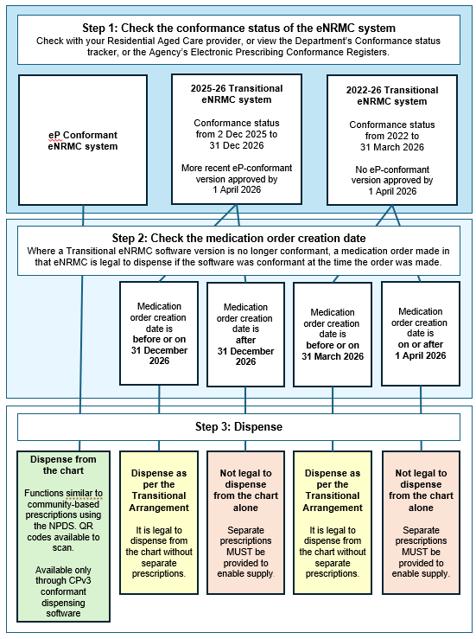

Checklist for Pharmacists servicing residential aged care homes
☐ | Speak to your contracted RACH to verify which eNRMC system they are using.  The RACH may also be able to advise if their eNRMC system has achieved electronic prescribing conformance or is likely to by the 1 December 2025 deadline.
☐ | Check the Department’s Conformance status tracker to verify the conformance status of that eNRMC system.
☐ | Ensure you have access to the required eNRMC system. If servicing multiple aged care services, this may be more than one eNRMC system.
☐ | Find out through your RACH what the available training and support is being offered via eNRMC software vendors to ensure a safe and smooth transition.
☐ | Print the workflow and decision tree above for easy access and to familiarise yourself with the new processes for dispensing from electronic prescribing conformant eNRMC systems.
☐ | Bookmark the Agency’s Electronic Prescribing – External Conformance Register and Department’s Conformance status tracker to be able to easily see which eNRMC software vendors have achieved conformance.
☐ | Explore the Department’s eNRMC User Resource and other resources for comprehensive guidance on eNRMC, including a pharmacy-specific section to support safe and effective implementation.

Further information about eNRMC
A range of targeted fact sheets about the rollout of electronic prescribing and eNRMC for prescribers, pharmacists and RACHs can be found on our website.
We have also published a comprehensive eNRMC user resource which brings together all the key information on using conformant eNRMC systems.

Contact
For further information or if you have any questions, please email enrmc@health.gov.au.

Diagram 2: Workflow for dispensing and supplying from an eNRMC
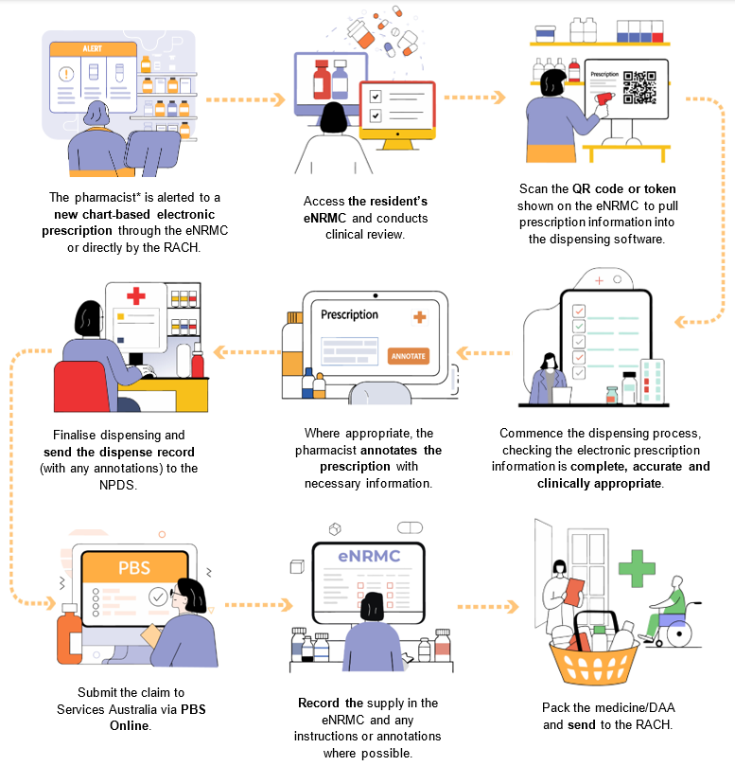
* Please note, pharmacy technicians, assistants, interns or students may also undertake some of these tasks under the supervision of a pharmacist.

