Disability Royal Commission

Progress Report 2025

Volume 6

Part 2



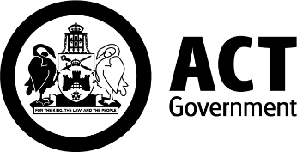 | 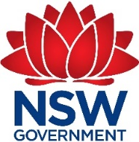
 | 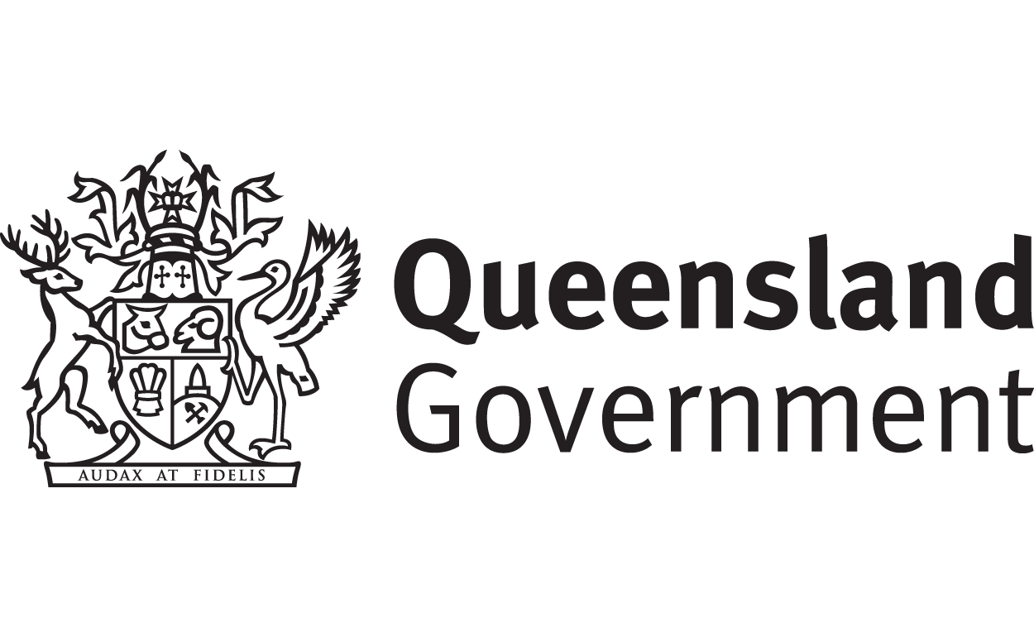
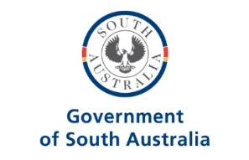 | 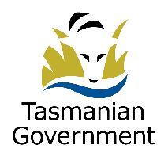
 | 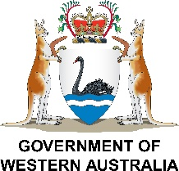

 | The Australian Government wrote this.  When you see the word we it means the Australian Government.
 | We wrote this in an easy to read way.  We use pictures to explain some ideas.
 | We have some words in bold.  This means the letters are thicker and darker.  These are important words.
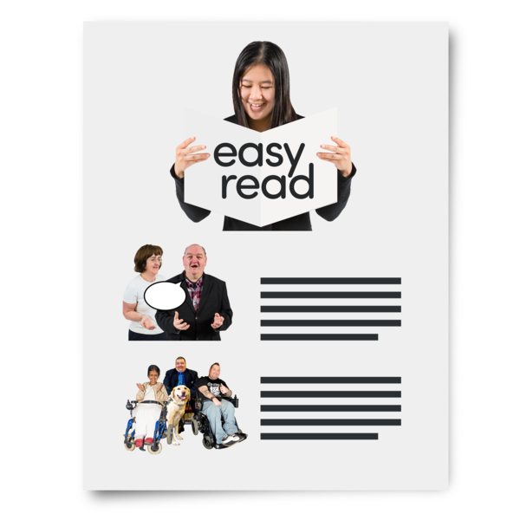 | This is an Easy Read summary of another document.  This means it has the most important ideas.
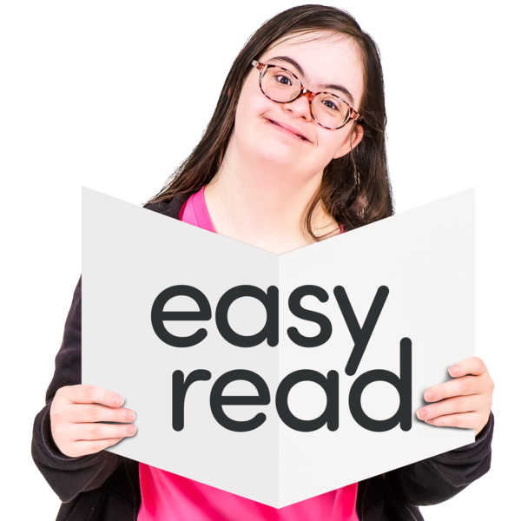 | You can look at the other updates in Easy Read.  They have information about  - Other volumes
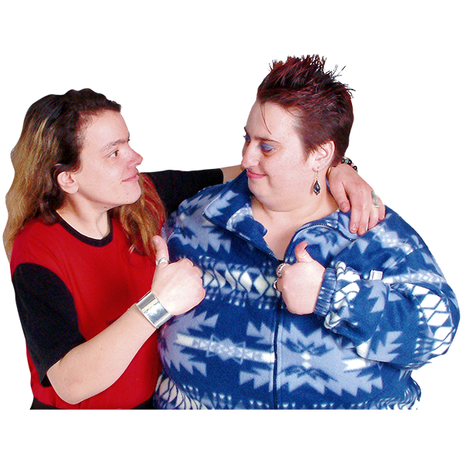 | You can ask for help to read this document.  You can ask  - A friend  - Family members  - A support person.
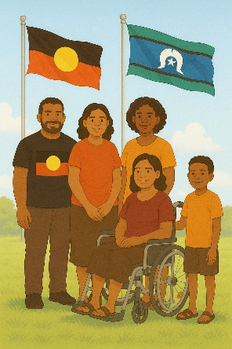 | We recognise Aboriginal and Torres Strait Islander people as the Traditional Owners of the land we live on.
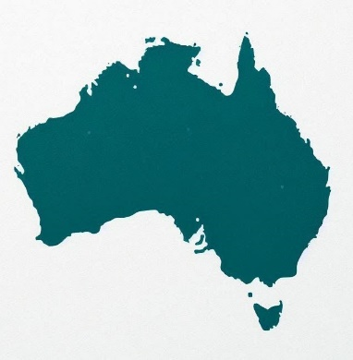 | They were the first people to live on and use the  - Land  - Waters.

Contents

Disability Royal Commission | 6
What is the Progress report | 9
About Volume 6 | 12
Advocacy programs | 15
Being culturally safe | 26
Contact us | 30

Disability Royal Commission

 | The Disability Royal Commission looked at how people with disability are treated.  We call it DRC for short.
 | DRC wrote a report.  The report was in 12 parts.  They are called volumes.
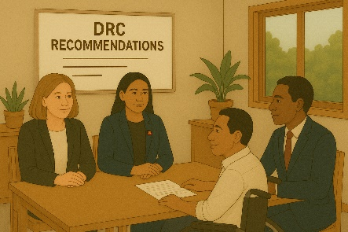 | The report had recommendations.  Recommendations are ideas to do things better.
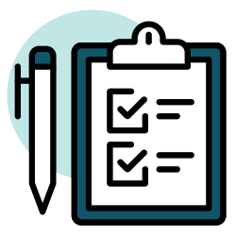 | The report had a lot of recommendations.  This will help things be better for people with disability.
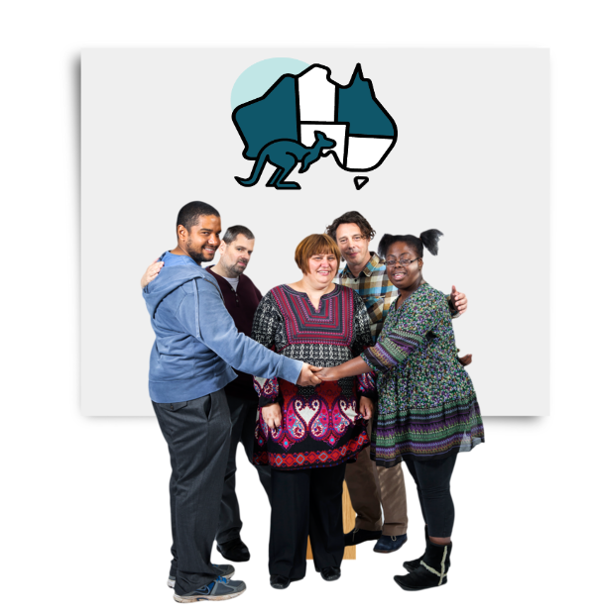 | We want Australia to be a place where people with disability  - Are safe
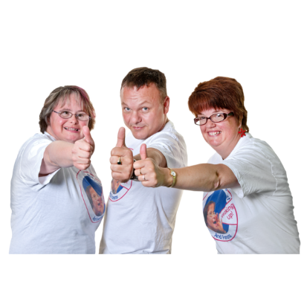 | - Have their rights protected  Rights are rules about treating everyone  - Fair  - Equally.
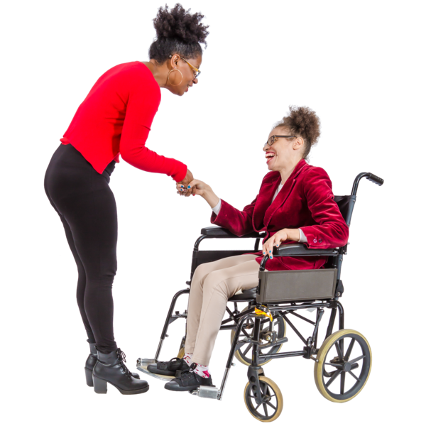 | We want Australia to be a place where people with disability  - Are respected
 | Can make their own choices
 | - Live the lives that they want to.
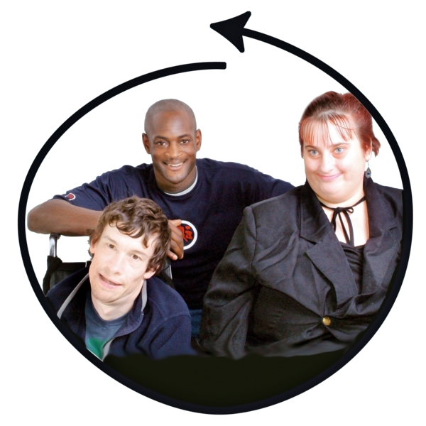 | This would make Australia an inclusive place for everyone.  Inclusive is when everyone  - Can take part  - Feel like they belong.

What is the Progress report

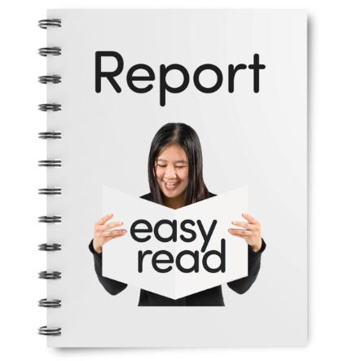 | We told DRC we will write reports about the work governments are doing.  This is the first update.
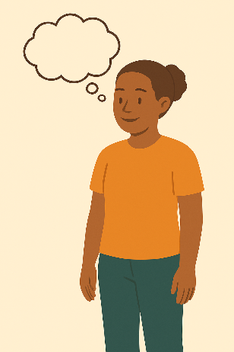 | It does not say all the things governments are doing.  It has the main things we are working on.  We started the work people with disability said was most important.
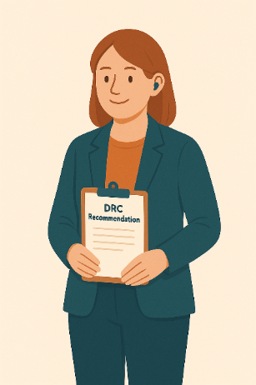 | We shared how we will make  - Changes  - Things better for people with disability.  We have started this work.  It will take a long time.
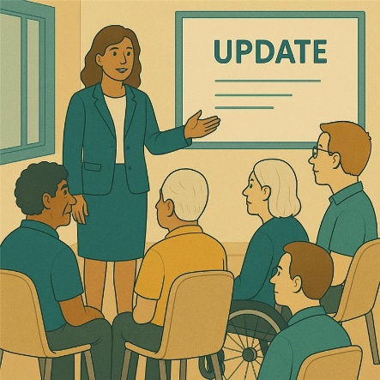 | We will say how we are going for each recommendation.
 | We will say if we  - Have finished this work  This means we  - Agreed to the recommendation  - Have finished the work to make the change.
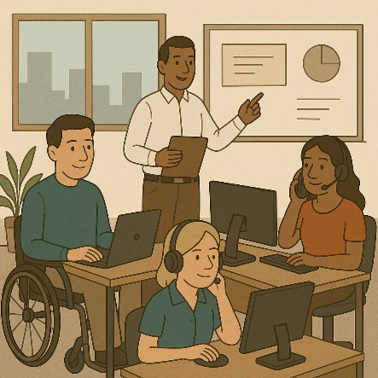 | - Still doing work on the recommendation  This means we  - Agree to the recommendation  - Have started making changes  - Need more time to finish this work
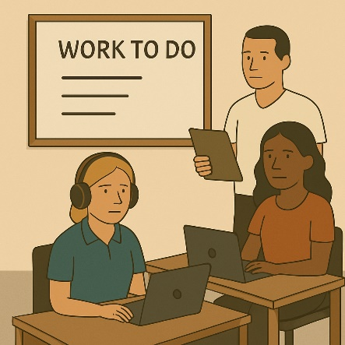 | - Have more work to do on the recommendation  This means we need more time to decide how to make the changes.
 | There are no recommendations for volumes  - 1  - 2  - 3
 | This has updates for volume 6.  You can read the updates for the other volumes on our website.  www.dss.gov.au/responses-government-inquiries/resource/disability-royal-commission-progress-report-2025

About Volume 6

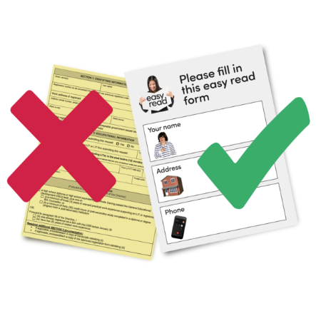 | Volume 6 talks about  - Having a plan to make accessible communication  Accessible communication is information that everyone can use.  Like Easy Read.
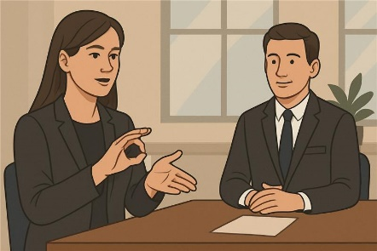 | - Having more Auslan interpreters  Auslan is Australian sign language.
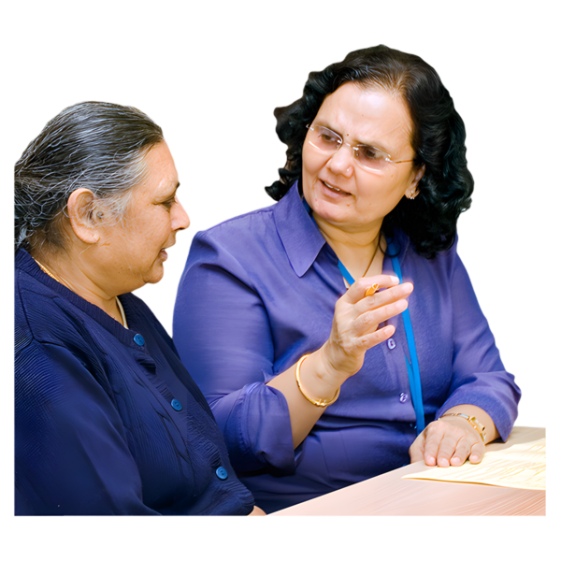 | Interpreters are people who  - Use your language  - Help you understand what someone is saying.
 | - Making sure Auslan interpreters have the right skills
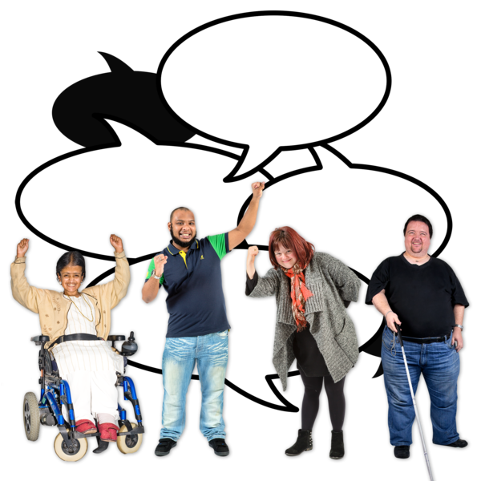 | - Having more money to support advocacy programs  Advocacy is when someone supports you to speak up for your rights.
 | - Having better data about who needs advocacy services  Data is  - Facts  - Information  - Records.
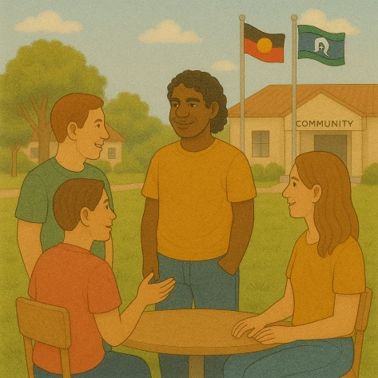 | - Making sure advocacy is culturally safe  Culturally safe means respecting peoples  - Rights  - Cultures  - Traditions.  This helps people feel safe to be themselves.
Volume 6 has 2 parts.

This is part 2.

You can read part 1 on our website.

www.dss.gov.au/responses-government-inquiries/resource/disability-royal-commission-progress-report-2025

Advocacy programs

 | The recommendation said the government should  - Give more funding for advocacy programs.  Funding is money to take part in programs.
 | - Have better data about advocacy.
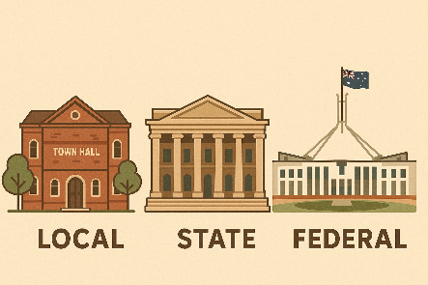 | All governments are working together to make advocacy services better for everyone in Australia.
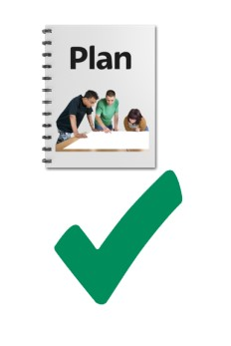 | They are doing this work in the Disability Advocacy Work Plan 2023 to 2025.
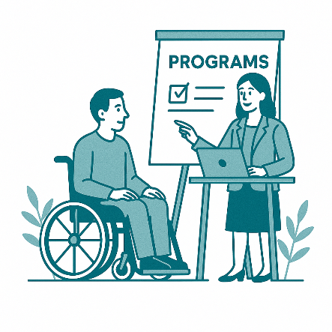 | The government is making a new advocacy program.
 | The new program will have all the advocacy services in 1 place.
 | This will make it easier for people with disability to find the support they need.
 | We will work with  - People with disability  - Their supporters  To do this work.
 | We will extend advocacy funding to 30 June 2026.  Extend means that services will continue longer.
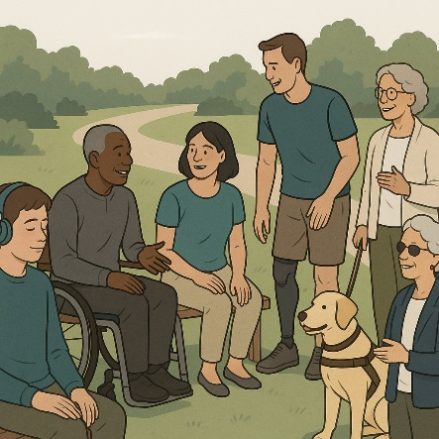 | This will only be for services that already get funding.  This will make sure people with disability can keep getting support.
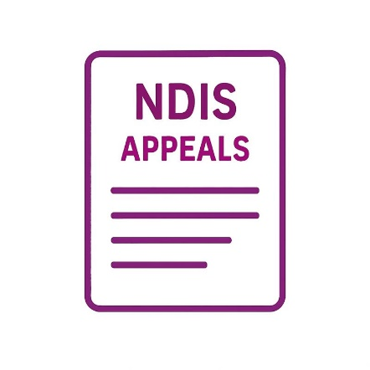 | We will also give funding to the NDIS Appeals program.
 | This will help people with  - Appeals  An appeal is when you  - Think the NDIS made the wrong decision  - Want them to look at the decision again.
 | - Dispute resolution  Dispute resolution is fixing something when 2 people do not agree.
 | In February 2025 the Disability Ministers agreed to change the Disability Advocacy Work Plan.  Ministers are leaders in an area of the government.
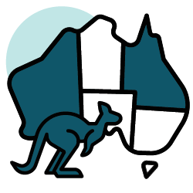 | State and territory governments are working on this.
 | Australian Capital Territory is giving money to local community organisations.
 | This will help people with disability learn different advocacy skills.
 | They will work with advocacy programs to have better data.
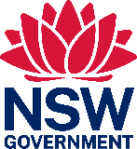 | New South Wales is extending funding for the Disability Advocacy Futures Program.
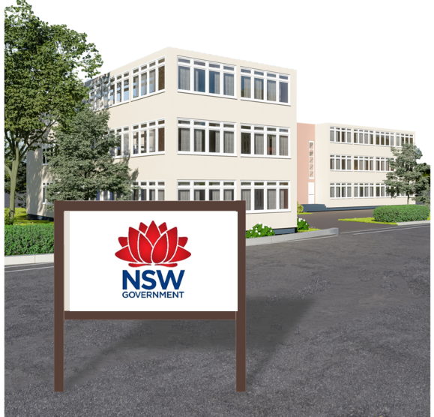 | This program supports people  - Who go to public schools in New South Wales
 | - Find services near them.
 | The Northern Territory has agreed to giving money for advocacy services.
 | Queensland will keep giving funding for their advocacy programs.
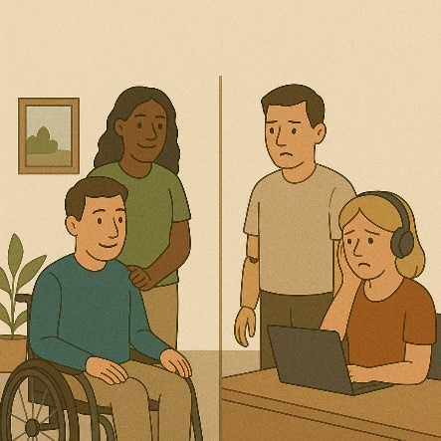 | They are working out who  - Uses advocacy services  - Wants to use advocacy services.
 | This will help them make good decisions about advocacy services.
 | Victoria will keep giving money to advocacy programs.
 | They will also work on getting good data about their advocacy programs.
This will help them work out

- Who uses advocacy services
- Who wants to use advocacy services.
 | Tasmania has agreed to give money to advocacy work.
They are working with advocacy organisations to work out who

- Uses advocacy services
- Wants to use advocacy services.
 | Western Australia gives money to advocacy programs.
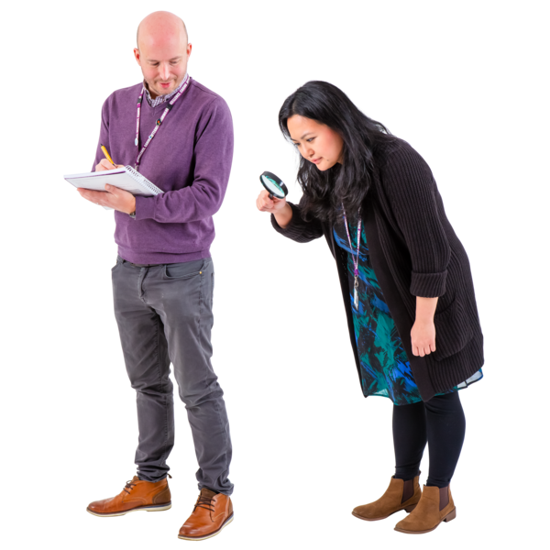 | They are reviewing the advocacy programs.  This will make sure they are right for people with disability.
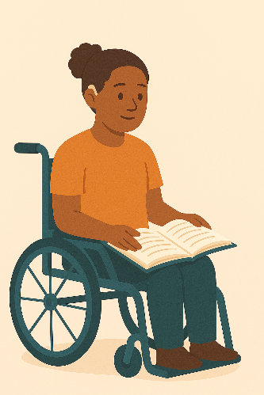 | A review is when you check what  - Works  - Needs to change.
 | We are still doing work on this recommendation.

Being culturally safe

The recommendation said governments should have culturally safe advocacy services.

Culturally safe means respecting peoples

- Rights
- Cultures
- Traditions.

This helps people feel safe to be themselves.
 | All governments are working together to make advocacy services better for everyone in Australia.
 | They are doing this work in the Disability Advocacy Work Plan 2023 to 2025.
 | State and territory governments are working on this.
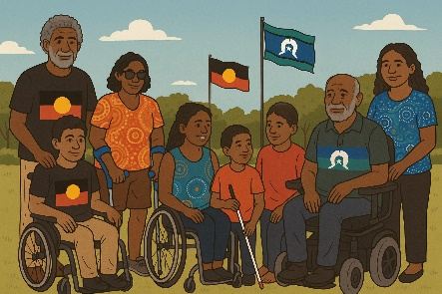 | Australian Capital Territory will work with First Nations communities.  This will help them to make a program that is  - Community led
 | - Culturally safe
 | - Inclusive.
 | They also have a program to support LGBTQIA+ people with disability.
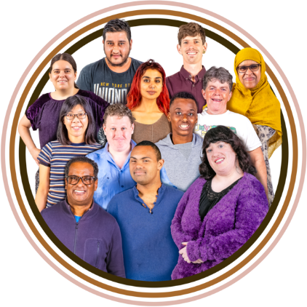 | New South Wales gives funding for advocacy organisations that help support  - People from different cultures
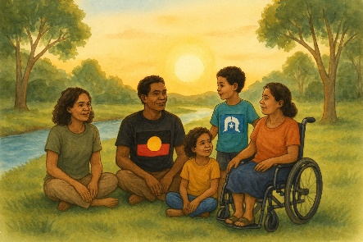 | - First Nations peoples
 | - LGBTQIA+ communities.
 | Victoria is working with First Nations advocacy organisation to make culturally safe advocacy services.
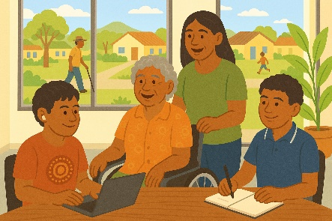 | They are testing these new ways with First Nations people.
 | We are still doing work on this recommendation.

Contact us

 | You can contact us if you need more information.
 | You can send us an email.  DRCTaskforceSecretariat@health.gov.au
 | You can look at our website.  www.dss.gov.au/DRC-Aus-Gov-Response
 | You can get help and support.  www.dss.gov.au/help-and-support-disability
Images in this Easy Read must not be used or copied without permission

