Disability Royal Commission

Progress Report 2025

Volume 6

Part 1



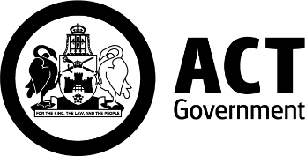 | 
 | 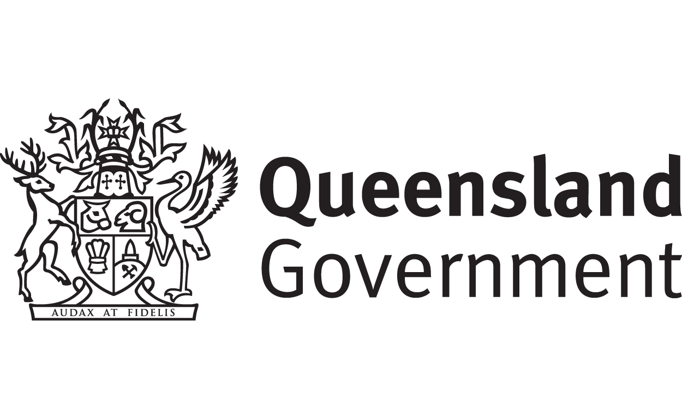
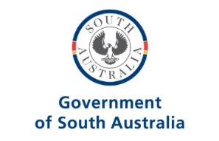 | 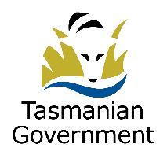
 | 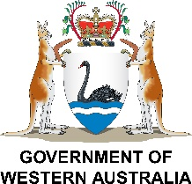

 | The Australian Government wrote this.  When you see the word we it means the Australian Government.
 | We wrote this in an easy to read way.  We use pictures to explain some ideas.
 | We have some words in bold.  This means the letters are thicker and darker.  These are important words.
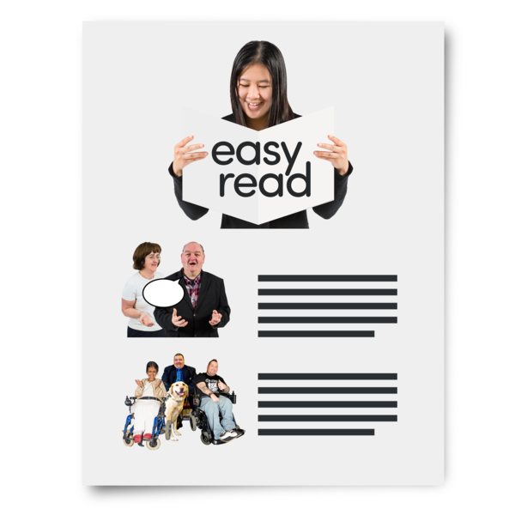 | This is an Easy Read summary of another document.  This means it has the most important ideas.
 | You can look at the other updates in Easy Read.  They have information about  - Other volumes
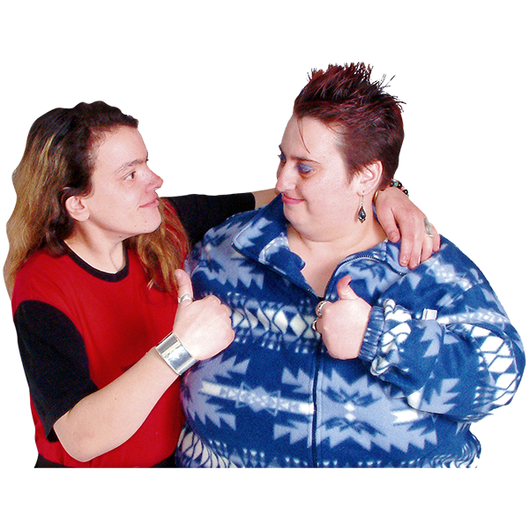 | You can ask for help to read this document.  You can ask  - A friend  - Family members  - A support person.
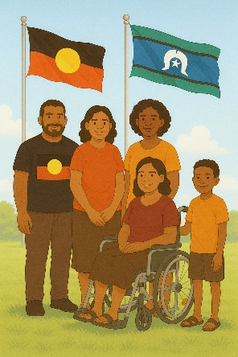 | We recognise Aboriginal and Torres Strait Islander people as the Traditional Owners of the land we live on.
 | They were the first people to live on and use the  - Land  - Waters.

Contents

Disability Royal Commission | 6
What is the Progress report | 9
About Volume 6 | 12
Accessible communication | 15
Auslan interpreters | 18
Having the right skills | 21
Contact us | 24

Disability Royal Commission

 | The Disability Royal Commission looked at how people with disability are treated.  We call it DRC for short.
 | DRC wrote a report.  The report was in 12 parts.  They are called volumes.
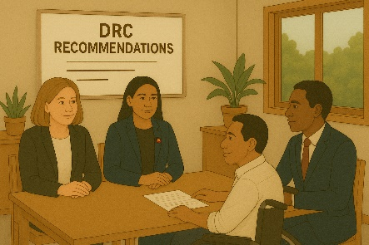 | The report had recommendations.  Recommendations are ideas to do things better.
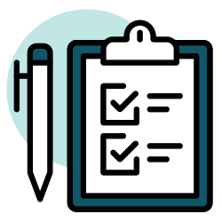 | The report had a lot of recommendations.  This will help things be better for people with disability.
 | We want Australia to be a place where people with disability  - Are safe
 | - Have their rights protected  Rights are rules about treating everyone  - Fair  - Equally.
 | We want Australia to be a place where people with disability  - Are respected
 | Can make their own choices
 | - Live the lives that they want to.
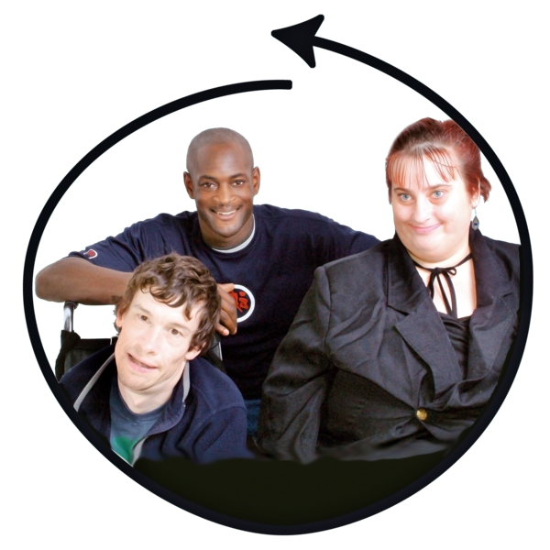 | This would make Australia an inclusive place for everyone.  Inclusive is when everyone  - Can take part  - Feel like they belong.

What is the Progress report

 | We told DRC we will write reports about the work governments are doing.  This is the first update.
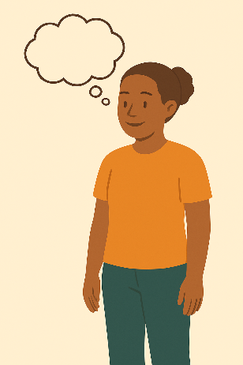 | It does not say all the things governments are doing.  It has the main things we are working on.  We started the work people with disability said was most important.
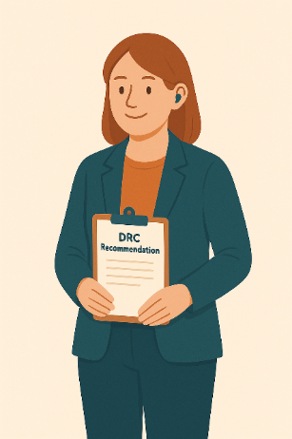 | We shared how we will make  - Changes  - Things better for people with disability.  We have started this work.  It will take a long time.
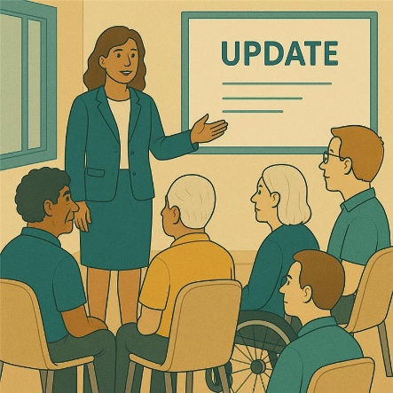 | We will say how we are going for each recommendation.
 | We will say if we  - Have finished this work  This means we  - Agreed to the recommendation  - Have finished the work to make the change.
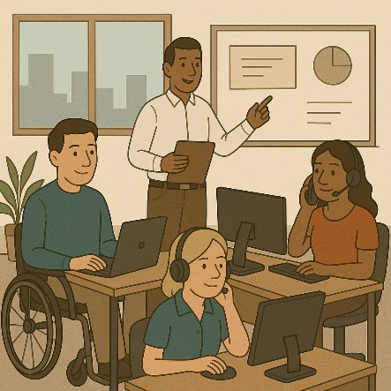 | - Still doing work on the recommendation  This means we  - Agree to the recommendation  - Have started making changes  - Need more time to finish this work
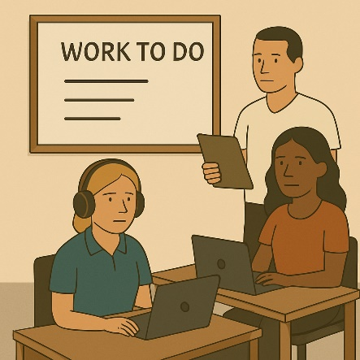 | - Have more work to do on the recommendation  This means we need more time to decide how to make the changes.
 | There are no recommendations for volumes  - 1  - 2  - 3
 | This has updates for volume 6.  You can read the updates for the other volumes on our website.  www.dss.gov.au/responses-government-inquiries/resource/disability-royal-commission-progress-report-2025

About Volume 6

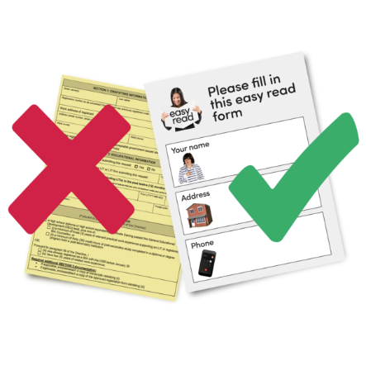 | Volume 6 talks about  - Having a plan to make accessible communication  Accessible communication is information that everyone can use.  Like Easy Read.
 | - Having more Auslan interpreters  Auslan is Australian sign language.
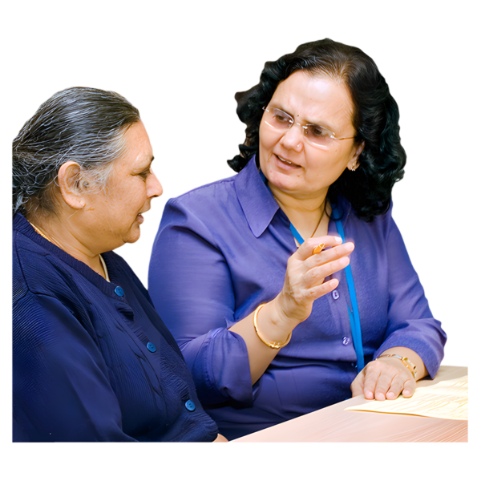 | Interpreters are people who  - Use your language  - Help you understand what someone is saying.
 | - Making sure Auslan interpreters have the right skills
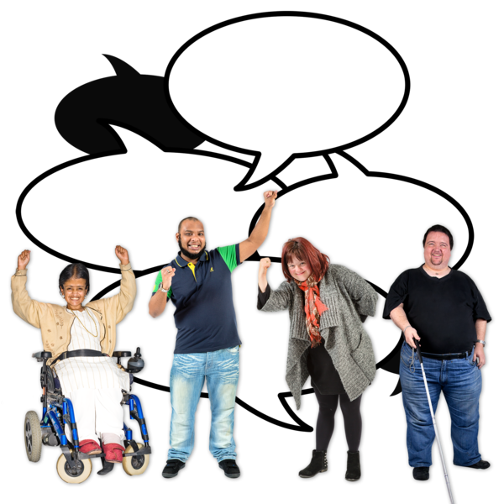 | - Having more money to support advocacy programs  Advocacy is when someone supports you to speak up for your rights.
 | - Having better data about who needs advocacy services  Data is  - Facts  - Information  - Records.
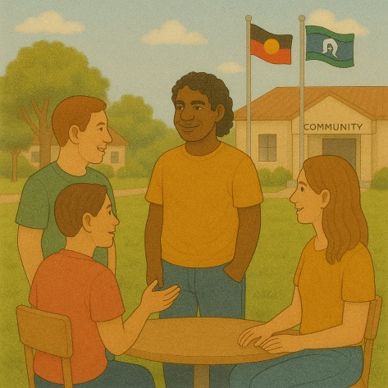 | - Making sure advocacy is culturally safe  Culturally safe means respecting peoples  - Rights  - Cultures  - Traditions.  This helps people feel safe to be themselves.
Volume 6 has 2 parts.

This is part 1.

You can read part 2 on our website.

www.dss.gov.au/responses-government-inquiries/resource/disability-royal-commission-progress-report-2025

Accessible communication

This has the most important updates about this recommendation.

The recommendation said

- There should be a plan made about making accessible communication.
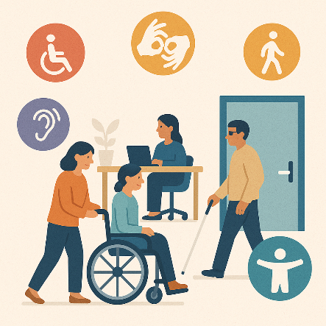 | Governments are working on a plan to make information accessible.  Accessible means everyone can use it.
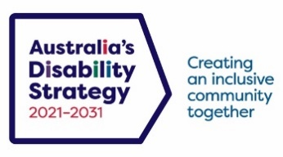 | The plan will work with Australia’s Disability Strategy.  We call it ADS for short.
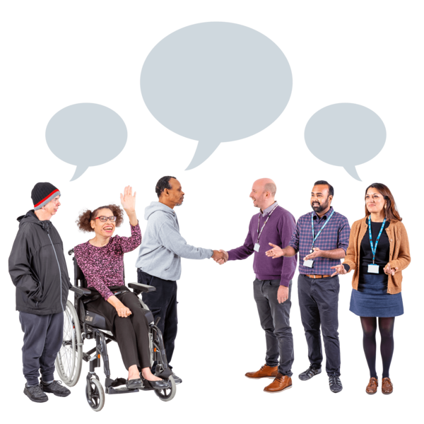 | ADS is the governments way of working together to support people with disability to live good lives.  We do this by working with  - People with disability  - The community.  This makes the community a more welcoming place for everyone.
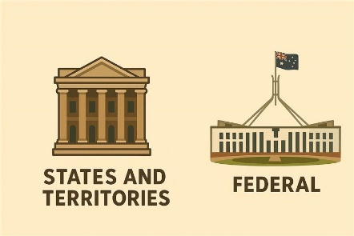 | - Australian Government  - State and territory governments  Will keep working with people with disability.
 | We are working on an engagement plan.  Engagement means the community can share their ideas with the government.
 | We are still doing work on this recommendation.

Auslan interpreters

The recommendation said

- There should be more Auslan interpreters.
 | All governments know it is important to have Auslan interpreters.  They help give information to people who are  - Deaf  - Hard of hearing.
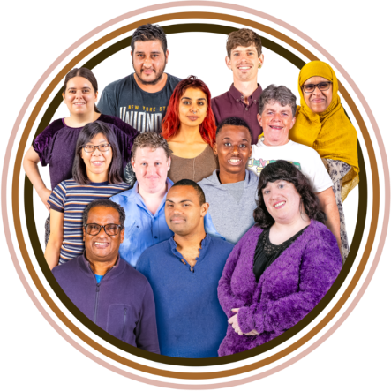 | Interpreters are important to help people  - From different backgrounds
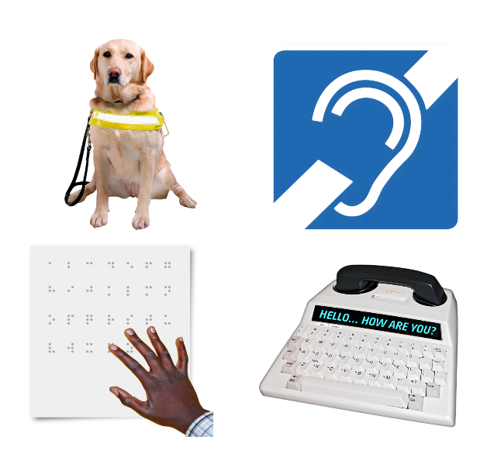 | - With a sensory disability  A sensory disability can affect how you  - See  - Hear  - Speak.
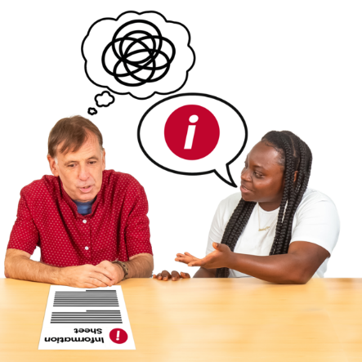 | - With a cognitive disability  A cognitive disability can affect how you  - Think  - Learn new things  - Make decisions  - Pay attention.
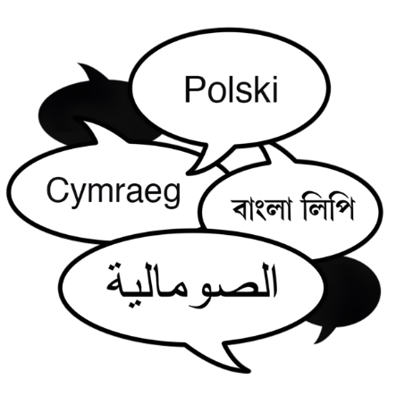 | - Who speak different languages.
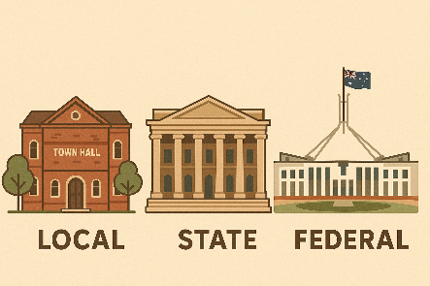 | All governments are working on having more  - Auslan interpreters  - Deaf interpreters.
 | We are still doing work on this recommendation.

Having the right skills

 | The recommendations said there should be a plan to  - Teach more interpreters  - For all interpreters to have the right skills.  - For interpreters to better understand the needs of people with disability.
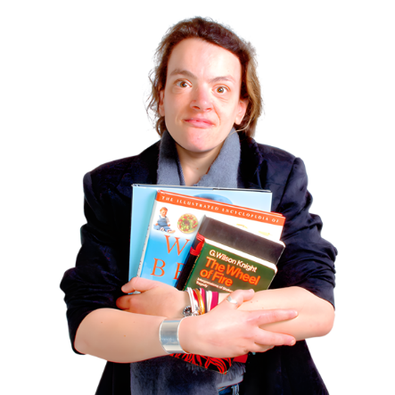 | The National Accreditation Authority for Translators and Interpreters are making the training information.  We call them NAATI for short  NAATI makes sure that there are translators and interpreters that are  - Taught the right way  - Helpful.  They will keep working on the training.
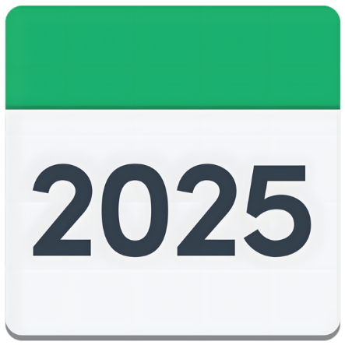 | The training will be finished in 2025.
 | The National Disability Insurance Agency is making online training.  We call them NDIA for short.  They look after the NDIS
 | The online training will be about making communication accessible.
 | It will talk about  - Different communication needs
- How to book an interpreter

This helps you to get an interpreter if you need one.
 | They will update their training for new staff.  They will also learn how to book an interpreter.
 | We are still doing work on this recommendation.

Contact us

 | You can contact us if you need more information.
 | You can send us an email.  DRCTaskforceSecretariat@health.gov.au
 | You can look at our website.  www.dss.gov.au/DRC-Aus-Gov-Response
 | You can get help and support.  www.dss.gov.au/help-and-support-disability
Images in this Easy Read must not be used or copied without permission

